Electrospun Polyethene oxide-graphite composite anode for solid-state lithium-ion batteries

Mikel Arrese-Igor^{1,2} and Norbert Radacsi¹
¹Institute for Materials and Processes, School of Engineering, The University of Edinburgh, Robert Stevenson Road, Edinburgh, EH9 3FB, UK
²CIC Energigune, Parque Tecnológico de Álava, C/Albert Einstein 48, 01510, Miñano, Spain

ABSTRACT
Current lithium-ion batteries are close to reaching their physicochemical energy density limit. Moreover, they present high operation risks regarding their liquid electrolyte. Solid-state batteries are a promising alternative to overcome these problems. They offer safe operation, and potentially improved energy and power density. The option of operating at higher voltages has led to the possibility of employing high capacity electrodes. In this study, the synthesis of a nanostructured anode through electrospinning was carried out. This electrode is based on polymer nanofibres with intercalated graphite particles. The effect of molecular weight, voltage, temperature and humidity has been studied for the formation of smooth and uniform nanofibres. At the optimized conditions, Polyethylene oxide (PEO)-Polyethylene glycol (PEG) nanofibres with diameters around 600 nm were successfully electrospun. The effect of graphite loading on the electrospinning of this solution was also studied. A 30% graphite particle loading in the final fibres was reached with a reproducible methodology. It was found that the electrospun graphite particles received a polymer coating during electrospinning. EDX analysis confirmed that most of the graphite particles are covered by a polymer layer, confirming this hypothesis. Even if it is unclear how this affects the behaviour of the graphite for energy storage, high graphite content was electrospun together with PEO nanofibres with a new methodology.

KEYWORDS: electrospinning, graphite, PEO, lithium ion battery, solid-state battery

1. Introduction

Energy storage is a key field of research in the first half of the 21st century. It is decisive for implementing and magnifying the impact of new sustainable technologies. Moreover, as the world energy demand continues to increase, higher energy supply will be required in grid and mobile applications than the current one [1,2]. Therefore, an improvement of energy storage systems is a pressing matter in research and development [3–6].
Electrochemical Energy Storage (EES) devices, mainly batteries, are currently being used in various applications; these range from vehicles to portable electronic devices, and even grid energy storage in some cases. Batteries are clearly a promising alternative to replace current fossil-fuel based energy markets. Thus, an increasing investigative effort is being put in the improvement of their capacity, cyclability and profitability [7]. A wide range of predictions regarding the final impact that batteries will be able to make on EES are made; however, most agree on the exciting prospect this technology offers in many fields [5,8–11]. Lithium-Ion Batteries (LIBs) are currently the most installed battery for grid applications [12]. Their high specific energy of 260 Wh·kg⁻¹ and 770 Wh·L⁻¹ makes them a great candidate for many mobile applications [11]. It is expected to reduce its cost of fabrication in the coming years, continuing to be the most promising alternative in the close future [13]. Moreover, the exceptionally good cycle life and advanced manufacturing technologies, make LIBs the EES device of choice in many applications [14].
Nevertheless, some challenges remain regarding the storage efficiency and capacity of LIBs. Aqueous electrolytes are stable at a maximum operating voltage of 1.5 V due to their energy of separation [15]. On the other hand, organic electrolytes generally operate bellow 4 V [16]. Therefore, LIBs present limitations on the operation voltage, besides the gravimetric and volumetric energy density barrier [17]. These properties that outline LIBs over other EES devices, will also be their major restriction for future development.
In addition to this storage barrier, current LIBs present other challenges, mainly involving safety concerns. According to different authors, the most promising alternative for a safe, stable and high-efficiency energy storage is the use of Solid-State Batteries (SSBs) [3,9,18,19]. SSBs are a new and promising alternative battery type which can offer high energy and power density [19]. These batteries use solid electrolytes instead of conductive organic liquids. This will allow increasing the power density of LIBs, as materials with larger potentials (> 4.5 V) can be used due to the larger energy of separation [16].
An increase of over 70% in energy density can be expected with SSBs if a successful implementation of a lithium metal anode happens. Unfortunately, solid electrolytes are thermodynamically unstable when in contact with lithium metal, as it is described in the literature [20,21]. Therefore, this is a long-term goal. Nevertheless, new and realistic designs have to be proposed as near future alternatives for high capacity electrodes. In this research, the design of a high-performance anode based on nanostructured materials for SSBs is suggested.
A recurring issue in SSBs is the electrode / electrolyte contact failure. Nanostructured materials are one of the alternatives to overcome this problem [3]. The increased surface area will allow a better contact in the interface. This increased surface area to volume ratio will also improve the amount of lithium storage lattice sites, compared to bulk materials. Consequently, nanostructured anodes will present a higher capacity than their bulk equivalents [22]. Nanostructured materials will also be able to accommodate electrodes in expansion and contraction reactions, given in charge and discharge processes. A key factor enhancing these nanostructured properties is the morphology of the electrode, which can be designed in different dimensions.
1D structures such as nanofibres have a large aspect ratio, which allows ion diffusion along the 1D structure. Besides the beneficial ion diffusion kinetics, these 1D materials favour the previously mentioned strain relaxation, preventing mechanical failure [23].
On the other hand, carbon anodes are successful material for anodes due to high conductivity and strong mechanical properties [24]. Graphitic carbon has a specific capacity of 372 mAh·g⁻¹, which makes it a high capacity material for Li⁺ ion storage [25,26]. Other materials such as silicon could be promising high-capacity materials, but they currently present large drawbacks [27,28].
Electrospinning was used for the intercalation of graphitic carbon in a cross-linked nanofibrous mat. The carbon will offer Li⁺ ion storage sites, while the cross-linked polymer structure will be the matrix. Electrospinning is a simple and efficient technique for the fabrication of long 1D micro and nanostructures. It is based on generating a high voltage difference between a polymer-based solution and a collector surface [29,30]. The resulting electrospun fibres will be randomly aligned in a 2D mat in the collector [31].
Conventional electrospinning setup uses a syringe and a positively charged needle to generate the required drop and Taylor cone. Nevertheless, a new approach to electrospinning uses a device that operates without a needle. Needleless electrospinning consists of two charged wires that act as electrodes; one in contact with the solution and the other as the collector [32]. This new configuration allows the scale-up of the technology with high throughput, and opens the possibility to achieve electrospun mats directly with high loads of suspended particles [33,34].
Several solution, operation and ambient parameters are critical for the successful electrospinning of nanofibres. Polymer concentration and molecular weight will determine the morphology of the resulting fibres [35]. These will range from beaded fibres, to smooth fibres and micro-ribbon structures, with increasing concentration or molecular weight [36,37]. Too high or too low viscosity and surface tension will prevent nanofibre formation; in the first case due to high solution resistance to cone formation and in the latter due to ruptures on the polymer chains generated by the high voltage [38]. Voltage is the most relevant operation parameter. A certain threshold needs to be exceeded for electrospinning to start. However, once this is surpassed, the voltage will affect fibre formation. Various studies have showed that high voltage can both, increase [39] or, decrease [40], fibre diameter; therefore, it is believed that this will depend on the solution properties [41]. Working distance is directly related to this parameter. Temperature and humidity are the two main atmospheric parameters. Roughly, high temperature or low humidity will help reduction of nanofibre diameter, due to better solvent evaporation [42,43].
Polyethene oxide (PEO) has been the selected polymer in this research, based on compatibility with the rest of components of the SSB. A wide range of PEO molecular weights are available, which is one of the factors that will affect the resulting fibres, as mentioned earlier [44]. It was described by different authors that behaviour of PEO in electrospinning followed certain patterns: Fibre diameter would increase with increasing polymer concentration; the same effect was observed with increasing electrospinning voltage [45,46].
The majority of the electrospun PEO used for LIB research is in combination with other polymers [47]. Few studies use graphite particles in the electrospun solution. Some studies generate an electrospun mat from one of the aforementioned polymers which is later carbonized [48,49]. This is an easy and simple technique to generate a structure that could potentially store lithium ions. However Zhang and Hsieh showed that the interactions between the different polymers had a significant impact on thermal and crystalline properties of the nanofibres [50].
Therefore, the addition of graphite in the electrospun solution is a promising alternative to overcome this problem. Advantages of needleless electrospinning were determining to choose this nanofibre fabrication technique [51]. The few published studies in this field have included minimum graphite content in the polymer solution so far [52].
This study investigates the fabrication of carbon-based anodes, using needleless electrospinning. The resulting electrodes will be synthesised on a one-step process; they will contain a nanofibrous polymer structure which will support a high loading of graphite particles.

2. Materials and methods

2.1 Materials
Polyethylene glycol (PEG) (MW = 20,000 g mol⁻¹) and Polyethylene oxide (PEO) (MW = 5,000,000 g mol⁻¹) were purchased from Sigma Aldrich, UK. N,N-Dimethylformamide (DMF, 99.8%) and graphite (< 20 µm) were also supplied by Sigma Aldrich, UK. All chemicals and materials were used as received, without any further treatment.

2.2 Solution and suspension preparation
The polymers were dissolved in DMF at different ratios, maintaining the overall solid concentration to 20%. The solutions were left stirring overnight at 75 ºC, as found in the literature [52]. The different molecular weight polymer ratio was varied until electrospinning conditions were achieved. Once these were reached, a parameter study was carried out.
The solutions containing graphite were prepared with a similar procedure. Graphite was added in different concentrations to achieve the maximum graphite/polymer (vol.) relation. It was added at the same time as the polymer in the preparation, with a volumetric relation ranging from 5% to 60%. The polymer weight content was maintained in 20% with the solvent and it was left stirring overnight at 75 ºC.

2.3 Electrospinning procedure
A simple home-made electrospinning setup was used for the experiments, formed by a positively charged rotating drum in contact with the solution, and a negatively charged rotating collector. The schematic setup and an image are shown in Figure 2. The drum in contact with the solution rotated at 3 rpm, while the collector rotated at 500 rpm. Both drums were separated by a fixed working distance of 15 cm.

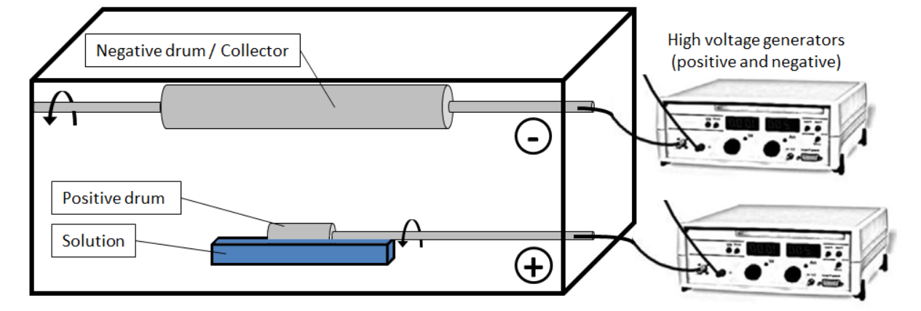
Figure 2. Schematic illustration of the needleless electrospinning setup.

The heating of the chamber was carried out by a Dewalt D26411 heat gun at a distance of 15 cm from the collector. This heat gun can achieve temperatures between 50 and 400 ºC and it is operated directly above the electrospinning chamber. The temperature and relative humidity (RH) of the chamber are controlled through a dual channel ACR TRH-1000 humidity probe. This setup also allowed the use of other gases such as nitrogen, which was used to study the effect of humidity in the process.

  - Characterization of electrospun fibres
Two different scanning electron microscopes (SEMs) were used to characterize the morphology and size of the electrospun fibres. A JEOL JSM-6010PLUS/LV (JEOL Ltd., Japan) was employed at an accelerating voltage of +20 kV. Prior to observation, the samples were coated with 16 nm of gold using a Sputter Coater (Desk III, Denton Vacuum, USA). The diameters of the fibres were measured with an image processing program (Fiji - ImageJ). The mean diameter was typically taken using more than 50 fibres per sample.
For further visualization of the nanofibres, a ZEISS Crossbeam 550 focused ion beam SEM was used at an accelerating voltage of 10 kV. The diameters of the nanofibres was also measured with the image processing program, ImageJ. An additional composition analysis using Energy Dispersive X-rays was carried out. For this purpose a 150 mm² X-Max^{N} silicon drift detector from Oxford Instruments was used at an accelerating voltage of 2-3 kV. This machine was used as an add-on to the aforementioned ZEISS microscope.

3. Results and discussion

3.1 Parameter analysis in the synthesis of polymer nanofibres
Several aforementioned highly relevant process parameters have been studied. Moreover, a study of the effect temperature and humidity has on nanofibres has also been carried out. Other parameters such as working distance or solution concentration have not been studied due to their relationship with the aforementioned conditions [38].
The effect of molecular weight was studied to optimize the PEO:PEG ratio to form smooth, uniform and narrow nanofibres. The change in molecular weight alters the formation of nanofibres in a similar way as the changes in polymer concentration. An increase of PEO would lead to a higher viscosity solution due to an increase in the molecular weight; whereas an increase in the PEG proportion would mean a less viscous solution [53]. Initial experiments showed that the maximum PEO:PEG ratio that can be electrospun is 4:96. Above this PEO:PEG ratio, there were no Taylor cones created in the solution at any voltage, most likely due to the high surface tension of the solution. Electrospinning at a relatively low voltage (30 kV) different PEO:PEG ratios (1:99, 1.5:98.5, 3:97) resulted in the fibres and diameters shown in Figure 3. These correspond to the trend described earlier; namely, fibre diameter increases with an increasing molecular weight (increased PEO:PEG ratio).
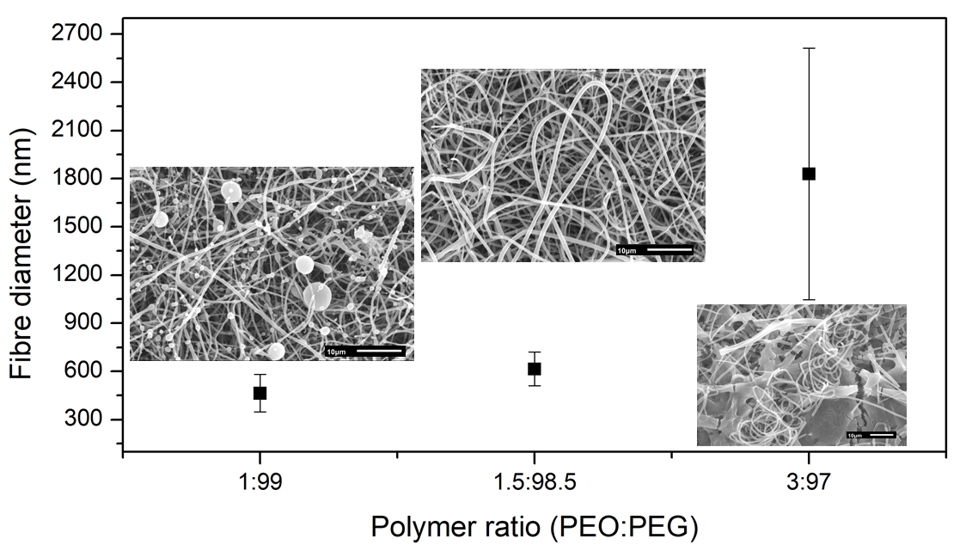
Figure 3. Variation of fibre diameter of electrospun fibres with higher Mw (different PEO:PEG ratio. Fibres were electrospun at 45 ºC, RH 65% and 30 kV.

The nanofibres electrospun with a PEO:PEG 1:99 ratio show a dominant diameter of around 550 nm. However, according to the morphology that these nanofibres present, many beads are observed. These unwanted polymer particles can be found as irregularities in the nanofibres and also intercalated in the nanofibrous mat. Beads, or beaded nanofibres, are formed by the rupture of entangled polymer chains [47]. This does not only limit the consistency of the nanofibres, but also reduces their mechanical resistance, due to strain generation that reduces tensile strength according to the different studies [48]. Increased PEO:PEG ratio leads to the formation of smooth nanofibres with a diameter around 615 nm and only occasional irregularities. Nevertheless, a further increase in fibre formation generates large diameter fibres, with uncontrollable size. The fibres make continuous turns along its 1D structure, leading to an even lower surface area for graphite intercalation.
Therefore, an optimized PEO:PEG ratio of 1.5:98.5 has been obtained, where thin, uniform and smooth nanofibres were obtained.
The potential difference also plays a highly relevant role in fibre formation. Following the explanation given in the introduction of this article, a potential difference threshold will have to be exceeded for electrospinning to take place. Therefore, the analysis of the effect of potential difference on nanofibre morphology will be subject to the ability to overcome this threshold. In the case of the particular solution chosen from the previous subsection (1.5:98.5 PEO:PEG ratio, 20 wt% in DMF), it has been observed an electrospinning threshold around 25 to 30 kV at a working distance of 15 cm. Therefore, the analysis has been done above this lower electrospinning limit. 30, 40 and 60 kV have been investigated; it was proved that higher potential difference leads to larger diameter fibres, as shown in Figure 4.
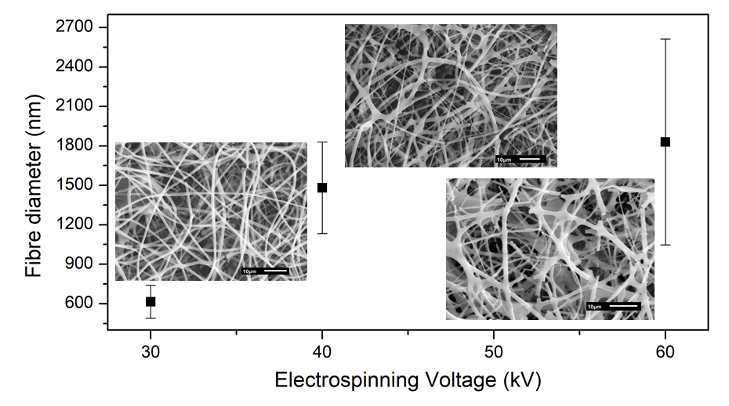
Figure 4. Effect of increasing voltage on fibre diameter for a 1.5:98.5 PEO:PEG ratio electrospun at 45 ºC and RH 65%.

Electrospinning at 30 kV has resulted in thin fibres with a diameter average around 600 nm. It can clearly be observed in Figure 4 that, with this voltage, nanofibres are independent from each other and randomly aligned. Only sporadic points in which two nanofibres are merged together in an intersection are observed. Increasing the voltage to 40 kV shows a wider fibre distribution. It is clear that more contact points between different fibres are formed under these conditions. Fibres show points in which they merge with each other, leading to wider intersections and lower surface area. Figure 4 also shows how this effect is magnified at 60 kV where multiple merging points are observed. Hence, the fibre diameter is completely inconsistent along the structure. The diameter is increased and decreased conditioned to the presence of any surrounding neighbours. It is likely that this continuous interconnection between fibres leads to the multiple fibre ruptures observed.
Therefore, uncontrollable electrospinning happens at higher voltages. As the driving force for the process in raise, the polymer travelling time from the solution to the collector is lower (fibres travel faster). This will lead to less time for solvent evaporation as described by different authors [44]. Assuming a constant solvent evaporation rate, the reduced travelling time will most likely lead to partially solvent remaining when the fibres reach the collector. Therefore, fibres will not be completely independent as part of the solvent is evaporated once the collector is reached. This will generate the observed multiple contact points among fibres. These merge points among fibres lead to a lower surface area per unit of volume of the nanostructured mat and to a much wider fibre distribution. Hence, a lower voltage is recommended for thin and smooth PEO:PEG nanofibre electrospinning.
The effect of temperature and humidity was studied and it is shown in Figure 5. High humidity and/or low temperature will lead to thicker fibre formation. According to the literature, this is due to poor solvent evaporation rate under those conditions [54]. On the other hand, reduced temperature or humidity leads to thinner nanofibre formation [55]. This is achieved, for example, when electrospinning at room temperature under an atmosphere with low humidity. This generates the same effect as increasing the temperature in a more humid ambient, as it is shown in Figure 5.

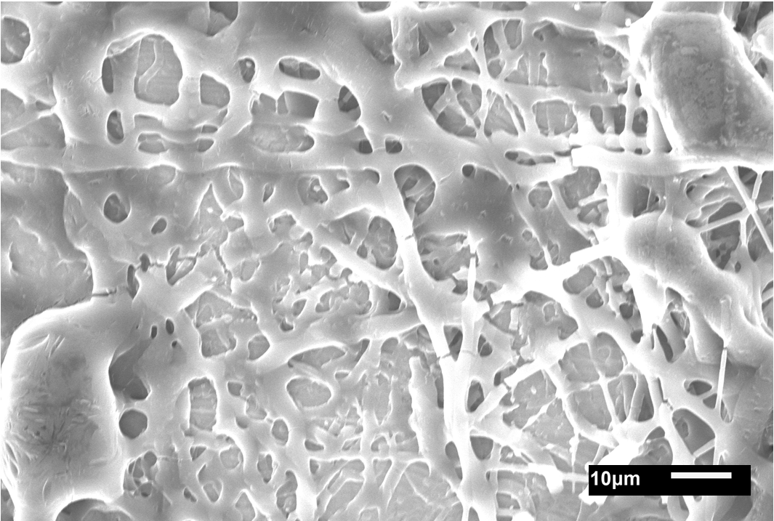  (a) | 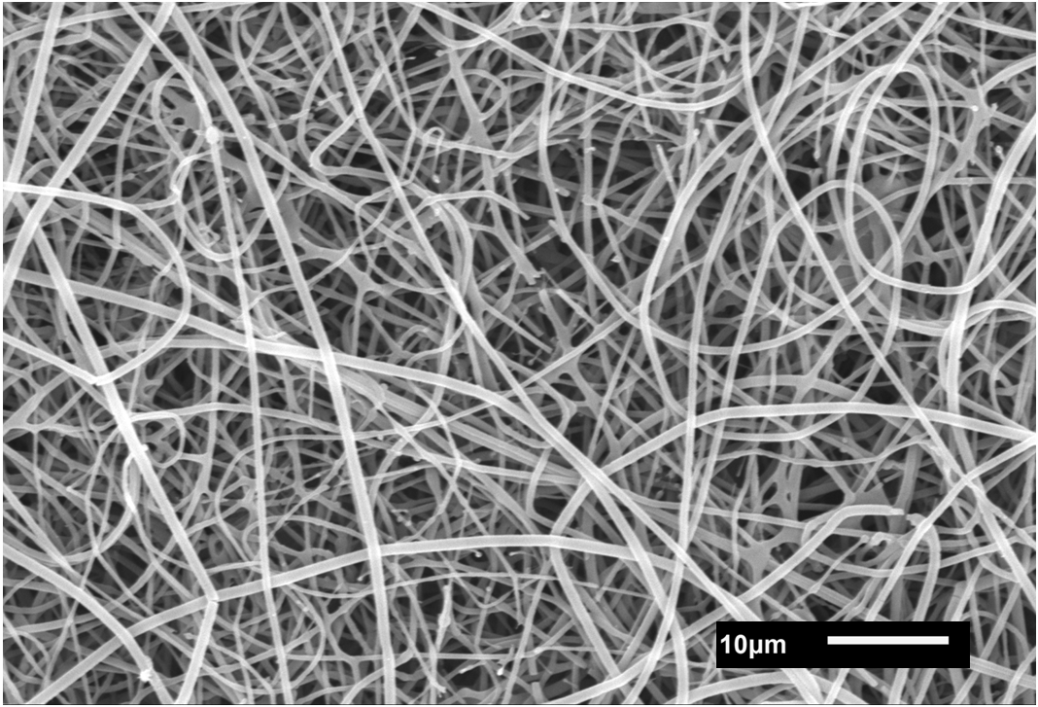  (b)
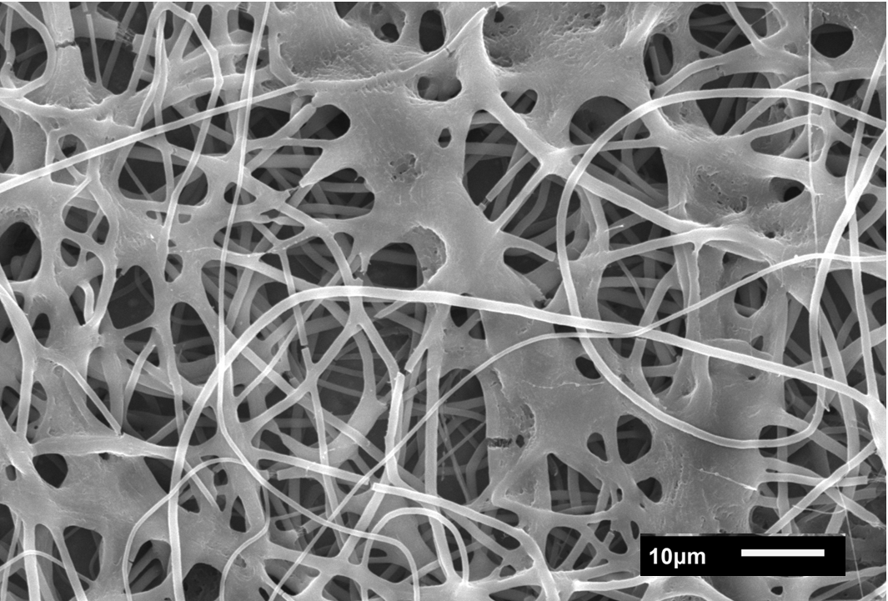  (c) | 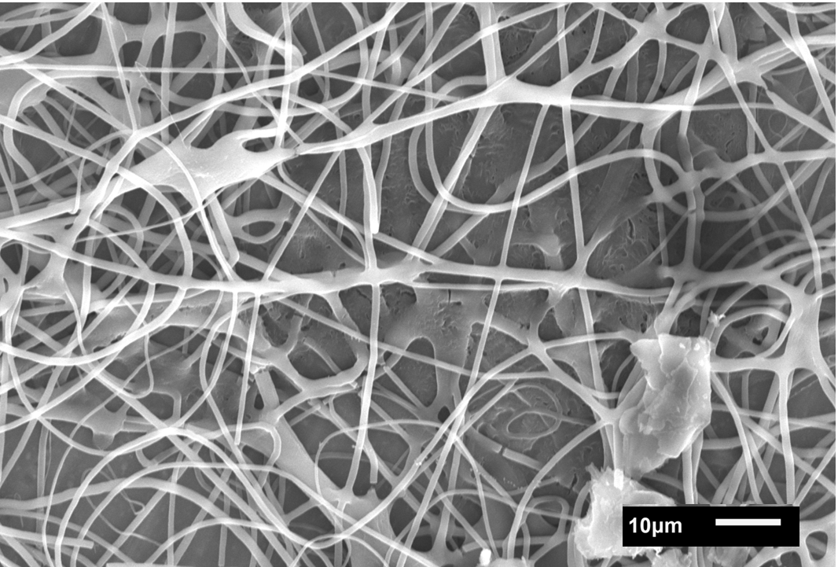  (d)
Figure 5. Fibres obtained at different temperature and RH conditions electrospun at 30 kV. The superior row shows nanofibres electrospun in air at (a) 18 ºC, RH 70% and (b) 45 ºC, RH 58%; the bottom row shows results obtained under nitrogen at (c) 21 ºC; RH 38% and (d) 30 ºC, RH 40%.

3.2 Electrospinning of polymer nanofibres with graphite particles in suspension
The next step in the generation of a nanostructured anode was to investigate the addition of graphite in the electrospinning process. The highest possible graphite loading was tried to electrospun. Graphite addition to the solution was carried out systematically, beginning from low graphite content 5 vol% (with the remaining 95% being the polymer)up to borderline conditions, where electrospinning would not occur any more. These conditions were found to be around a 40% of graphite loading in the resulting nanofibres. These ratios and the intermediate stages of 20% and 30% of graphite loading are shown in Figure 6.

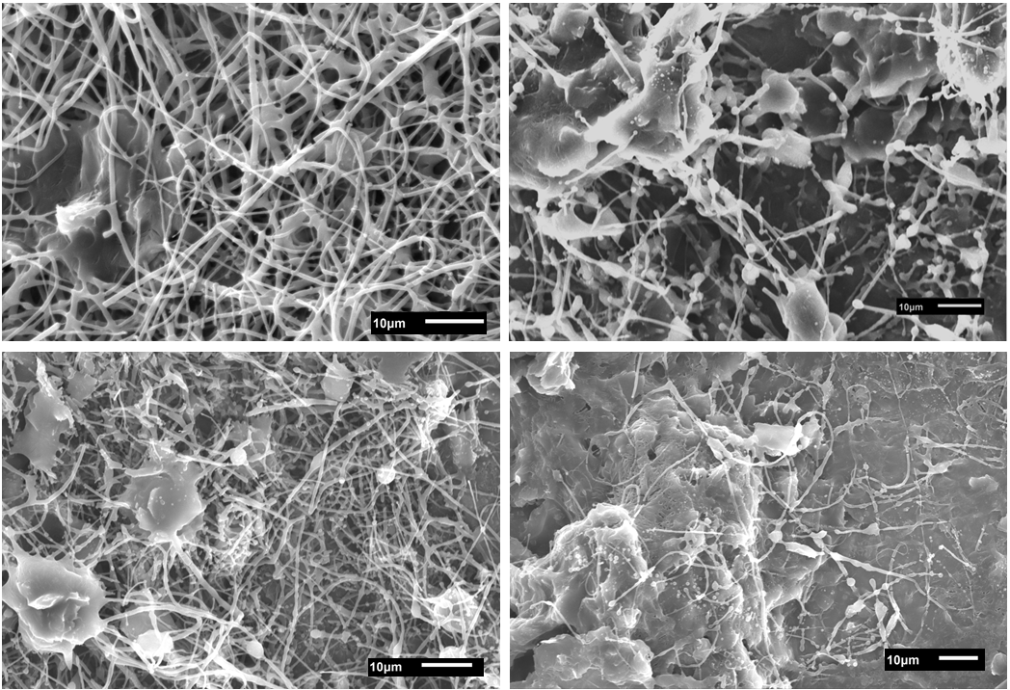
(d)
(c)
(b)
(a)
Figure 6. SEM image of (a) 5% graphite, (b) 20% graphite, (c) 30% graphite, (d) 40% graphite loading on 1.5:98.5 PEO:PEG nanofibres electrospun at 48 ºC, RH 58% and 30 kV.

Graphite seems to be intercalated between the polymer nanofibres, which surround the particles in the first 3 cases. At high graphite loading, the majority of fibres seem to be melted in the background. A polymer layer is observed there, which proves a poor electrospinning quality.
Electrospinning at 5% graphite loading shows randomly aligned smooth thin fibres, with graphite particles intercalated in between. When the graphite content is increased, satisfactorily electrospun nanofibres with higher intercalated graphite particles density is achieved. Nevertheless, some beads are formed in the nanofibres, which were not observed at lower graphite loadings (Figures 6 b and c, compared to Figure 6 a). Besides the bead formation, in the contact between the nanofibres and the graphite particles, it appears as if the nanofibres merge with the graphite. These fibres present an average size distribution of 454.8 ± 102.1 nm. Higher magnifications, as shown in Figure 7 of 30% graphite loading fibres further show these effects.

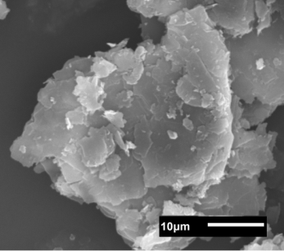
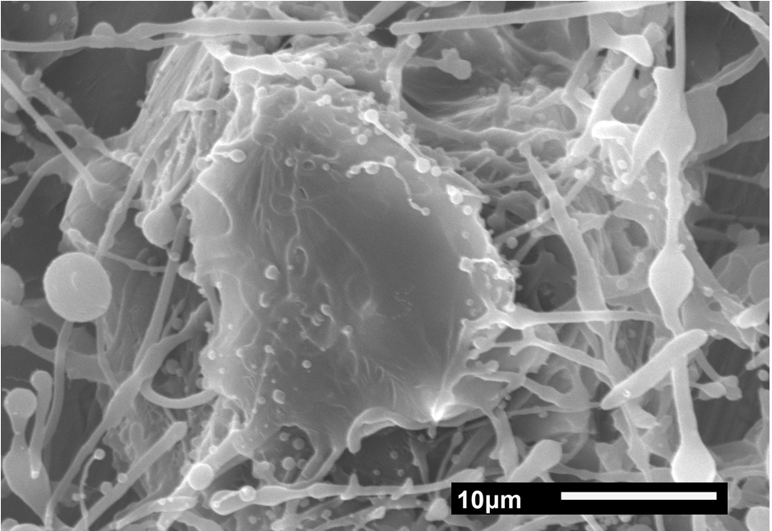
Figure 7. Magnification of the contact points between nanofibres and a graphite particle. Green arrows indicate the contact point where the “merging” effect is observed. Top right corner: graphite particle as-received.

From the amplification in Figure 7 the aforementioned bead formation is observed. Analysing the type of contact between the nanofibre and the graphite particle, it can be seen how there is no polymer / graphite surface change at any point. This effect is described as the merging effect. The main hypothesis to explain this event is that the graphite particles are covered with a polymer layer. Moreover, the shapes observed on top of the graphite particle are completely different from the ones graphite particles would have, shown in a miniature in the top-right corner of Figure 7.
Consequently, higher magnification SEM and an EDX analysis were performed, in order to determine whether this hypothesis was correct. A well-identified graphite particle was imaged using a high precision SEM. The same particle was characterized using an EDX probe, shown in Figure 8. The polymer presence on the graphite surface can be confirmed with this analysis.

(a)
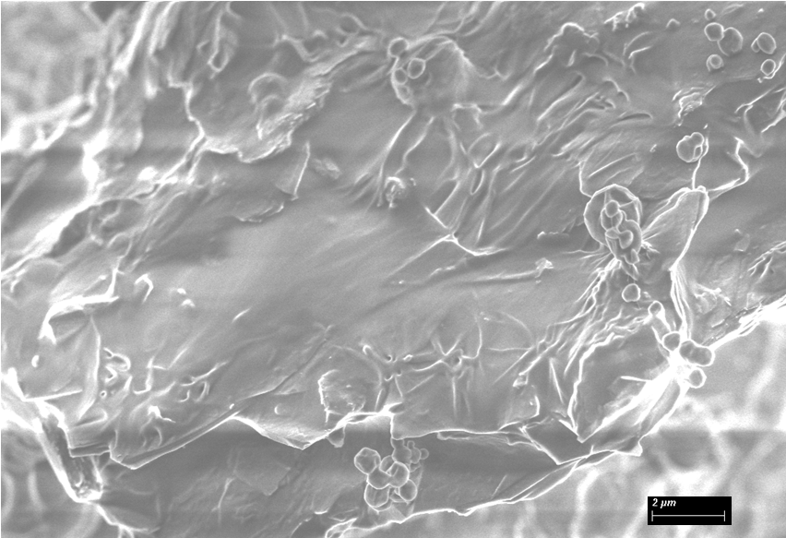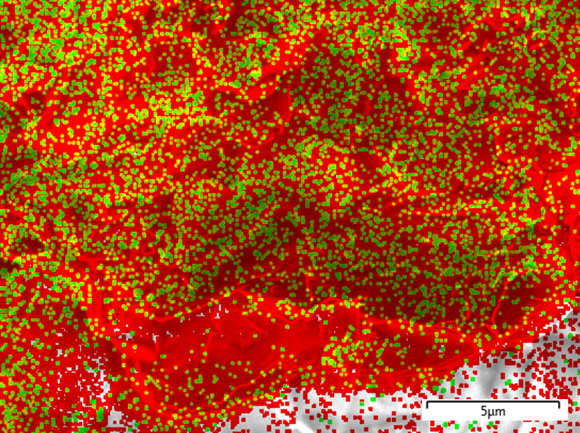
(b)
Figure 8. (a) High magnification SEM image of an electrospun graphite particle; (b) EDX analysis mapping of the previous electrospun graphite particle. Red dots show carbon presence and green dots show oxygen.

If the surface of the particle shown in Figure 8a is observed in detail, two different surfaces can be easily distinguished. Most of the surface shows a soft layer, where, hypothetically, a polymer layer is deposited. Moreover, in that section, spherical polymer nanoparticles are clearly distinguished. The second surface type is observed at the bottom of the image. A harder surface is identified with flake shape irregularities. This surface is more alike to the ones usually observed for graphite particles, such as in the miniature in Figure 7.
If this same image is subject to an EDX mapping, the just mentioned hypothesis is confirmed. The mapping shown in Figure 8b distinguishes between carbon and oxygen, the two major elements in the analysed particle. Carbon is shown in red and it is observed all along the particle. On the other hand, oxygen is shown in green, and it is observed in most of the particle, except in the hard surface identified in Figure 8a. Due to the composition of the two materials included in this sample (Graphite, which is all carbon; and PEO:PEG which is also carbon, but includes hydrogen and oxygen), it is expected to see oxygen and carbon in polymer nanofibres and just carbon in sections with graphite. Consequently, it is determined that most of the graphite particle is covered with the PEO:PEG mixture, while only a small portion of the graphite particle is actually open to the environment. This mapping is better distinguished in Figure 9, where the maps for carbon and oxygen are shown separately.
(b)
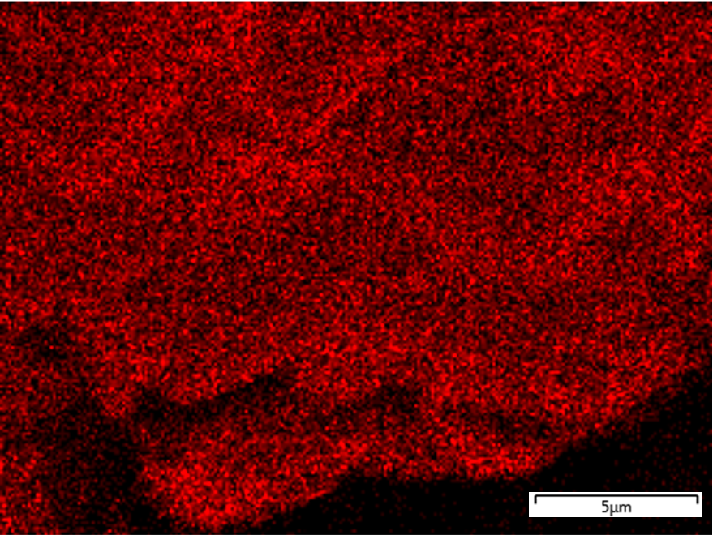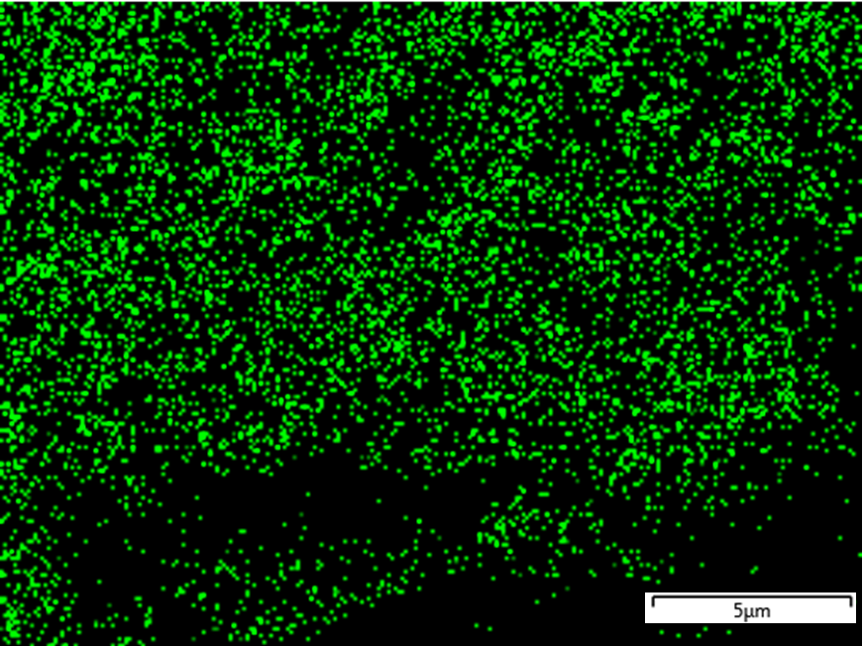
(a)
Figure 9. EDX mapping of a graphite particle: (a) map of carbon locations and (b) map of oxygen locations.

This finding could have a direct impact on the behaviour of the graphitic material for lithium-ion storage. Moreover, consequences in the result of electrospun graphite and polymer at different loadings could be observed as well.
This polymer layer on graphite particles could also be the reason for beads to appear in high graphite loading electrospun mats. It is believed that the reason for this to occur is the amount of polymer that has been found to be covering the graphite particles. As the graphite loading increases, a higher amount of polymer is employed covering surfaces. Therefore, less polymer concentration will be available for nanofibre formation. Consequently, as found and described in the literature, a lower concentration of polymer in the solution will generate the same effect as a low molecular weight, formation of beads [44,56]. As it was stated earlier, bead formation has been proved to lead to a diminution of tensile strength [57]. Moreover, this phenomenon could also potentially limit the maximum loading of graphite that can be electrospun in a solution.

4. Conclusions

The need for new battery technology that will replace the actual LIBs with liquid electrolytes has been identified. For that purpose, SSBs are one of the most promising alternatives. Furthermore, SSBs will give the possibility of achieving not only higher energy density, but a higher power density as well. This larger operating window opens the way to the use of higher capacity electrodes. This study explored the possibility of creating a high capacity nanostructured anode containing graphite particles. Needleless electrospinning has been proved to be a technique with high throughput and capable of spinning these particles in suspension.
The optimum electrospinning conditions were explored for electrospinning polymer nanofibres from a PEO:PEG solution. Homogeneous, smooth, uniform and randomly aligned nanofibres with a diameter around 600 nm were achieved. It was found that at a 1.5:98.5 PEO:PEG ratio, 30 kV, a working distance of 15 cm, 45 ºC and a RH of 50% are the most suitable conditions to obtain these nanofibres. In concordance with the results described in the literature, an increase in nanofibre diameter was found with increasing molecular weight. At low molecular weight, rupture of the entangled polymer chains with the high electric field would lead to the formation of unwanted beads, reducing the tensile strength of the nanostructured mat. Voltage was shown to affect the process directly, obtaining higher diameter nanofibres with increasing voltage. This was concluded to be due to the larger driving force and lower time for solvent evaporation. As described by various authors, temperature and humidity also played a highly relevant effect in electrospinning, regulating the solvent evaporation rate. At higher temperature and lower humidity, thin and homogeneous independent nanofibres were produced. With decreased temperature or higher humidity conditions, thicker and less independent nanofibres were created.
Successful electrospinning of the aforementioned polymer solution with graphite particles was achieved. A maximum graphite loading of 40% was electrospun, whereas the limit was set to 30% for the sake of reproducibility and homogeneity. A nanofibre diameter of 450 nm was achieved for this graphite loading; however, bead formation was found to happen with increasing graphite loading. It was proven that a polymer coating layer was created on the electrospun graphite particles. It is believed that this layer diminishes the amount of polymer available for nanofibre formation. Therefore, the same effect observed at low molecular weight ratios electrospinning is observed: bead formation. This formation of polymer particles is increased at higher graphite loadings, most likely due to the higher amount of polymer covering a larger amount of particles. Overall, this phenomenon can lead to reduced mechanical properties of the nanostructured mat and a behaviour change of the graphite particles. This less conductive coating could decrease the lithium-ion storage possibility, or provide the anode with capacitor-like behaviour, enhancing storage properties.

Acknowledgements
The authors would like to thank Dr. Anna Llordes and Dr. Lucienne Buannic from CIC Energigune for their support and guidance during the initial stages of this project. Michel Vong from The University of Edinburgh also contributed significantly on this project. In addition, Thomas Glen of The University of Edinburgh helped with the EDX and scanning electron microscopy analysis. The SEM results were partially obtained using the EPSRC Centre for Doctoral training in “Soft Matter and Functional Interfaces” SEM.

References
1. International Energy Agency (IEA). No Title Energy Efficiency Indicators 2017: Highlights. Paris; 2017.
2. Wood Mackenzie. The rise of the electric car : how will it impact oil, power and metals. 2017.
3. Armand M, Tarascon JM. Building better batteries. Nature. 2008;451:652–7.
4. Greenwood DM, Lim KY, Patsios C, Lyons PF, Lim YS, Taylor PC. Frequency response services designed for energy storage. Appl Energy. 2017;203:115–27.
5. Carnegie R, Gothan D, Nderitu D, Preckel P V. Utility Scale Energy Storage Systems: Benefits, Applications, and Technologies. West Lafayette: Purdue University; 2013.
6. Lott MC, Kim S-I. Technology Roadmap: Energy storage [Internet]. Energy Technol. Perspect. Paris; 2014. Available from: http://www.iea.org/publications/freepublications/publication/TechnologyRoadmapEnergystorage.pdf
7. Bresser D, Hosoi K, Howell D, Li H, Zeisel H, Amine K, et al. Perspectives of automotive battery R&D in China, Germany, Japan, and the USA. J Power Sources. Elsevier; 2018;382:176–8.
8. University of Waterloo. Battery research could triple range of electric vehicles. Waterloo, Canada; 2017.
9. Tarascon JM. Key challenges in future Li-battery research. Philos Trans R Soc A Math Phys Eng Sci. 2010;368:3227–41.
10. Dunn B, Kamath H, Tarascon J. Electrical energy storage for the grid: A battery of choices. Sci Mag. 2011;334:928–36.
11. Scrosati B, Garche J. Lithium batteries: Status, prospects and future. J Power Sources. 2010;195:2419–30.
12. International Renewable Energy Agency (IRENA). Electricity storage and renewables: Costs and markets to 2030 [Internet]. 2017. Available from: http://irena.org/publications/2017/Oct/Electricity-storage-and-renewables-costs-and-markets
13. Jaffe F, Adamson KA. Advanced Batteries for Utility-Scale Energy Storage. Boulder (CO); 2014.
14. Zaghib K, Dontigny M, Guerfi A, Charest P, Rodrigues I, Mauger A, et al. Safe and fast-charging Li-ion battery with long shelf life for power applications. J Power Sources. Elsevier B.V.; 2011;196:3949–54.
15. Goodenough JB, Park KS. The Li-ion rechargeable battery: A perspective. J Am Chem Soc. 2013;135:1167–76.
16. Bekaert E, Buannic L, Lassi U, Llordés A, Salminen J. Electrolytes for Li- and Na-Ion Batteries: Concepts, Candidates, and the Role of Nanotechnology. In: Rodriguez-Martinez LM, Omar N, editors. Emerg Nanotechnologies Recharg Energy Storage Syst. 1st ed. Amsterdam: Elsevier Inc.; 2017. p. 1–43.
17. Janek J, Adelhelm P. Future technology. In: Korthauer R, editor. Handb Lithium-Ionen-Batterien. Springer US; 2013. p. 199–217.
18. Janek J, Zeier WG. A solid future for battery development. Nat Energy. Macmillan Publishers Limited; 2016;1:1–4.
19. Robinson AL, Janek J. Solid-state batteries enter EV fray. MRS Bull. 2014;39:1046–7.
20. Zhu Y, He X, Mo Y. First principles study on electrochemical and chemical stability of solid electrolyte-electrode interfaces in all-solid-state Li-ion batteries. J Mater Chem A. Royal Society of Chemistry; 2016;4:3253–66.
21. Zhu Y, He X, Mo Y. Origin of Outstanding Stability in the Lithium Solid Electrolyte Materials: Insights from Thermodynamic Analyses Based on First-Principles Calculations. ACS Appl Mater Interfaces. 2015;7:23685–93.
22. Arrese-Igor Royuela M. A review on the current status and prospects of Nanoscale Solid State Batteries, focused on the anode and the synthesis method. The University of Edinburgh; 2018.
23. Goutam S, Omar N, Van Den Bossche P, Van Mierlo J. Chapter Two – Review of Nanotechnology for Anode Materials in Batteries. In: Rodriguez-Martinez LM, Omar N, editors. Emerg Nanotechnologies Recharg Energy Storage Syst. 1st ed. Amsterdam: Elsevier Inc.; 2017. p. 45–82.
24. Wu YP, Rahm E, Holze R. Carbon anode materials for lithium ion batteries. J Power Sources. 2003;114:228–36.
25. Flandrois S, Simon B. Carbon materials for lithium-ion rechargeable batteries. Carbon N Y. 1999;37:165–80.
26. Endo M, Kim C, Nishimura K, Fujino T, Miyashita K. Recent development of carbon materials for Li ion batteries. Carbon N Y. 2000;38:183–97.
27. Rahman MA, Song G, Bhatt AI, Wong YC, Wen C. Nanostructured silicon anodes for high-performance lithium-ion batteries. Adv Funct Mater. 2016;26:647–78.
28. Du FH, Wang KX, Chen JS. Strategies to succeed in improving the lithium-ion storage properties of silicon nanomaterials. J Mater Chem A. Royal Society of Chemistry; 2015;4:32–50.
29. Li D, Xia Y. Electrospinning of nanofibers: Reinventing the wheel? Adv Mater. 2004;16:1151–70.
30. Greiner A, Wendorff JH. Electrospinning: A fascinating method for the preparation of ultrathin fibers. Angew Chemie - Int Ed. 2007;46:5670–703.
31. Thenmozhi S, Dharmaraj N, Kadirvelu K, Kim HY. Electrospun nanofibers: New generation materials for advanced applications. Mater Sci Eng B Solid-State Mater Adv Technol. Elsevier B.V.; 2017;217:36–48.
32. Khan WS, Asmatulu R, Ceylan M, Jabbarnia A. Recent progress on conventional and non-conventional electrospinning processes. Fibers Polym. 2013;14:1235–47.
33. Huang X, Wu D, Zhu Y, Sun D. Needleless electrospinning of multiple nanofibers. IEEE-NANO Proc. 2007. p. 823–6.
34. Wang L, Zhang C, Gao F, Pan G. Needleless electrospinning for scaled-up production of ultrafine chitosan hybrid nanofibers used for air filtration. RSC Adv. 2016;6:105988–95.
35. Deitzel J., Kleinmeyer J, Harris D, Beck Tan N. The effect of processing variables on the morphology of electrospun nanofibers and textiles. Polymer (Guildf). 2001;42:261–72.
36. Eda G, Shivkumar S. Bead-to-Fiber Transition in Electrospun Polystyrene. J Appl Polym Sci. 2006;106:475–87.
37. Zhao YY, Yang QB, Lu XF, Wang C, Wei Y. Study on correlation of morphology of electrospun products of polyacrylamide with ultrahigh molecular weight. J Polym Sci Part B Polym Phys. 2005;43:2190–5.
38. Li Z, Wang C. Effects of Working Parameters on Electrospinning. One-dimensional nanostructures Electrospinning Tech Unique Nanofibers. 1st ed. New York: Springer US; 2013. p. 15–29.
39. Reneker DH, Chun L. Nanometre diameters of polymer, produced by electrospinning. Nanotechnology. 1996;7:216–23.
40. Yuan XY, Zhang YY, Dong C, Sheng J. Morphology of ultrafine polysulfone fibers prepared by electrospinning. Polym Int. 2004;53:1704–10.
41. Yördem OS, Papila M, Menceloǧlu YZ. Effects of electrospinning parameters on polyacrylonitrile nanofiber diameter: An investigation by response surface methodology. Mater Des. 2008;29:34–44.
42. Supaphol P, Mit-Uppatham C, Nithitanakul M. Ultrafine electrospun polyamide-6 fibers: Effect of emitting electrode polarity on morphology and average fiber diameter. J Polym Sci Part B Polym Phys. 2005;43:3699–712.
43. Casper CL, Stephens JS, Tassi NG, Chase DB, Rabolt JF. Controlling surface morphology of electrospun polystyrene fibers: Effect of humidity and molecular weight in the electrospinning process. Macromolecules. 2004;37:573–8.
44. Haider A, Haider S, Kang IK. A comprehensive review summarizing the effect of electrospinning parameters and potential applications of nanofibers in biomedical and biotechnology. Arab J Chem. King Saud University; 2015;
45. Doshi J, Reneker DH. Electrospinning process and applications of electrospun fibers. Conf Rec 1993 IEEE Ind Appl Conf Twenty-Eighth IAS Annu Meet. 1993;35:151–60.
46. Grothe T, Brikmann J, Meissner H, Ehrmann A. Influence of Solution and Spinning Parameters on Nanofiber Mat Creation of Poly ( ethylene oxide ) by Needleless Electrospinning. 2017;23:4–11.
47. Mater A, Università S, Giacomo C, Mater A, Università S, Marconi G, et al. Electrospun Membranes Based on PVdF-PEO Blends for Lithium Batteries A. La Monaca. ECS Trans. 2016;73:75–81.
48. Kim C, Yang KS, Kojima M, Yoshida K, Kim YJ, Kim YA, et al. Fabrication of electrospinning-derived carbon nanofiber webs for the anode material of lithium-ion secondary batteries. Adv Funct Mater. 2006;16:2393–7.
49. Chen T, Liu Y, Pan L, Lu T, Yao Y, Sun Z, et al. Electrospun carbon nanofibers as anode materials for sodium ion batteries with excellent cycle performance. J Mater Chem A. 2014;2:4117.
50. Zhang L, Hsieh Y Lo. Nanoporous ultrahigh specific surface polyacrylonitrile fibres. Nanotechnology. 2006;17:4416–23.
51. Zhu J, Chen L, Xu Z, Lu B. Electrospinning preparation of ultra-long aligned nanofibers thin films for high performance fully flexible lithium-ion batteries. Nano Energy. Elsevier; 2015;12:339–46.
52. Abdollahi S, Ehsani M, Morshedian J, Khonakdar HA. Morphology and physical properties of electrospun polyethylene oxide/polyacrylonitrile mats and related graphene-based nanocomposites. J Vinyl Addit Technol. 2017;23:152–9.
53. Teramoto A, Fujita H. Temperature and molecular weight dependence of the melt viscosity of polyethylene oxide in bulk. Macromol Chemestry Phys. 1965;85:262–75.
54. Park JY, Lee IH. Relative humidity effect on the preparation of porous electrospun polystyrene fibers. J Nanosci Nanotechnol. 2010;10:3473–7.
55. Pelipenko J, Kristl J, Janković B, Baumgartner S, Kocbek P. The impact of relative humidity during electrospinning on the morphology and mechanical properties of nanofibers. Int J Pharm. 2013;456:125–34.
56. Fong H, Chun I, Reneker DH. Beaded nanofibers formed during electrospinning. 1999;40:4585–92.
57. Tarus B, Fadel N, Al-Oufy A, El-Messiry M. Effect of polymer concentration on the morphology and mechanical characteristics of electrospun cellulose acetate and poly (vinyl chloride) nanofiber mats. Alexandria Eng J. Faculty of Engineering, Alexandria University; 2016;55:2975–84.

