Industrial Performance Optimization Using Artificial Neural Networks And Analytical Hierarchy Process

Hala Mellouli ¹, Pr. Anwar Meddaoui ¹, Pr. Abdelhamid Zaki ¹

1 University Hassan II, Artificial Intelligence & Complex Systems Engineering and Optimization.
Email : hala.mellouli-etu@etu.univh2c.ma;

Abstract

Performance optimization of an industrial system is constrained by several factors as efficient decision-making actions. Decision-makers are continuously facing complex problems challenging their multi-objective optimization capabilities while satisfying customer preferences. However, A first literature review showed that the majority of models established in this field are based on multicriteria analysis which is less suitable for the complex industrial context. This paper proposes a new model for decision-making to enhance industrial systems performance based on Artificial Neural Networks, Analytic Hierarchy Process and balanced scorecard approach, to identify the best decision from a set of available options using real-time performance data. Accuracy of the proposed model is validated through an empirical case study and a survey conducted among several different industries. Current research proposes a decision-making tool to assist decision in performance based on a set of independent variables, future research may use other artificial intelligence tools to enhance this approach.

Key words: Optimization; performance; Artificial Neural Network; Analytical Hierarchy Process; machine learning; multicriteria decision-making.

Introduction

As the industry transitions towards an intelligent mode, changes in conventional operations have made company management more sophisticated and demanding in terms of effort and time as operational-level decision making is challenged more than before since to ensure boarder coverage of increasingly expanding strategic objectives. Decision-makers, on the other hand, are given the opportunity to monitor and collect real-time operational performance data, which, when used appropriately, leads to more consistent and credible decisions(Duman et al., 2020).

In fact, only companies that successfully incorporate available data into their processes to become case-oriented and rule-based, making them more adaptable to a rapidly changing business environment (Banja, 2020), and that adopt measurement and management systems based on their own objectives and potentials will be able to grow, thrive, and stay afloat in the digital age(Kaplan and Norton, 1996).
A global survey carried out by Capgemini Research Institute to evaluate the use of data-driven decision-making, revealed that in 2018 no more than 38% of interviewed organizations were actively promoting data-driven decision-making. Two years afterward, the data-powered enterprises survey of the same institute informed that half of respondent organizations managed to shift their decision-making models to be completely data-driven by 2020.

Figure 1: Data-driven decision-making in organizations worldwide in 2018 and 2020.
Source: Capgemini Research Institute, Digital Mastery Survey; April–May 2018, N=1,338 respondents, 757 organizations.

Consequently, MCDM techniques have captured the interest of both researchers and industrials in recent years, while machine learning (ML) has made remarkable progress over almost the same time span, infiltrating many industrial processes (Li et al., 2022). Particularly in decision-making, artificial intelligence (AI) solutions are increasingly being used to reduce complexity and overcome cognitive burden, resulting in an intelligent decision support system capable of tackling intricate, imprecise, and poorly structured problems (Banja, 2020).
Although many studies suggest methods to support decision-making, the relevance of their outputs remains questionable since they tend to propose a general strategy that does not take into account the company's particular capabilities and goals. Having identified this gap and realizing the high demand for autonomous and automated decisional intelligence that includes more efficient multi-criteria decision-making approaches and soft computing, we developed a dynamic technique to help in this regard.

The suggested solution, consist of an intelligent decision support model that includes determining criteria, defining the problem to be solved, and searching for alternative solutions compared and contrasted with the invocation of relevant criteria while considering real-time performance data in order to choose the best action to be implemented.

The presentation of work carried out is organized around the following strategy: Firstly, related work focusing on performance measurement and MCDM applications are introduced in section II while emphasizing the paper's contribution and novelty. Section III provides details of the building blocks of the methodology. Then, section IV presents the results of the proposed methodology. Finally, the findings are summarized, and suggestions for future are outlined Section V.

Literature review

While seeking continuous performance improve- ment in today ’s increasingly competitive market, industrials are constantly faced with complex situation involving substantial amount of data, various factors and multiple objectives to be optimized simultaneously.
In the literature, operational decision-making is associated with Multiple-criteria decision-making (MCDM), with research exposing a wide range of MCDM methodologies' applications to solve variety of decision-making problems within the industrial framework. The Analytic Hierarchy Process (AHP), in particular, is being widely adopted to address a variety of decisional problems such as supplier selection considering criteria drawn from the literature namely: price, quality, delivery and service divided into sub-criterions and weighted based on experts’ opinions (Dweiri et al., 2016). Another example is IoT process selection that was similarly approached using the outputs of a biometric literature review that revealed the following decision criteria: reliability, security, business, mobility, and heterogeneity as well as their respective weights (Durão et al., 2018); AHP is also used to address maintenance strategy related problems, such as determining which equipment shall be properly maintained first based on collected sensor data and weights computed using Bayesian Networks (Lima et al., 2019). The widespread use of AHP is primarily because it is one of the outperforming and easiest methods under MCDM that detects and minimizes inconsistencies in opinion(Aziz et al., 2016; Wu and Tiao, 2018).

Another important aspect of industrial performance related decision-making is key performance Indicators (KPIs) selection, since they are used as a management tool to analyze an organization's current performance and design improvements strategies (Graham et al., 2015).
(Cagno et al., 2019) Propose an Industrial Sustainability Performance Measurement System with 104 indicators clustered into three performance areas: economic, social, and environmental. The model's refinement yielded an intermediate variant containing 76 essential indicators and a core variant with no more than 44 basic indicators more accessible considering company's level of maturity and available resources. However, the model incorporates fewer operational performance indicators as it was designed to be generic and generalizable which makes it more suited for gaining an understanding of the company's overall performance rather than operational decision-making.
In another study (Mourtzis et al., 2018) introduce a semi-objectively selected set of KPIs for decision-making within the framework of a product-service system, aided by an automated algorithm that uses the utility function to suggest appropriate KPIs from a pool of independent indicators drawn from the literature and classified into four categories: Manufacturing, Design, Environment, and Customer. The main weakness of the study is the lack of a constraint on the number of KPIs, while the optimum number of KPIs has been unanimously stated in the literature as less than 10-20 (Graham et al., 2015). Otherwise, data from monitoring too many KPIs might be overwhelming for decision makers rather than helpful, not to mention time and resource wasting(Mourtzis et al., 2018).
(Tufegdžić et al., 2020) suggest a system of 46 KPIs determined by expert opinion with respect to the balanced scorecard (BSC) approach for measuring and predicting performance using a feed-forward artificial neural network with 10 hidden neurons trained to predict overperformance based on values for financial, customer, internal processes, and learning and growth perspectives. Although the approach gives an extremely accurate prediction, it is difficult to rely on it for decision making since overall performance doesn't quite offer decision makers much information about which specific aspect is dragging down performance and ought to be prioritized.
From the aforementioned, no previous study has offered a comprehensive technique integrating ANN with AHP and balanced scorecard in the context of industrial decision making, from this vantage point, our suggested approach adds to the related literature by developing an intelligent system for best alternative prediction that employs BSC to establish evaluation criteria, AHP to compute their respective weights and ANN to overcome the complexity and cognitive burden of decision-making process. The intelligent assisted decision-making is dynamic thanks to ANN's ability to uncover features relevant to the influence of current performance on decision making and utilize prior data to increase accuracy.

Methodology and proposed model

Addressing these issues, this paper presents a holistic decision-making approach that efficiently combines BSC framework for converting corporate strategy into performance indicators (Graham et al., 2015) with the attributes of the AHP method to transcript the decider's priorities and neural network feature of non-linear mapping capability. This allows coherent and consistent decisions to take place following the right course to achieve the overall aim of optimal performance.
As a result, the model is divided into three stages including the modeling of the decisional framework, followed by the definition and hierarchization of relevant factors in order to construct the objective function and, finally, the implementation of a neural network capable of determining the most optimal solution:
- Problem modeling: this is where the difficult real-world performance optimization problem is clearly defined using a balanced scorecard, which supports the decision maker in defining following elements:
- Problem statement: Describe the vision and strategy of the firm.
- Relevant variables: establish quantifiable goals, each with its own KPI and target.
- Deviations assessment: evaluate actual performance and quantify deviations from the target
- Objective function: referring to the performance function whose parameters are the KPIs and coefficients are the AHP analysis weights.
- Optimization algorithm preparation and validation: which involves creating, training and testing the optimum neural network using the outputs from stages a and b

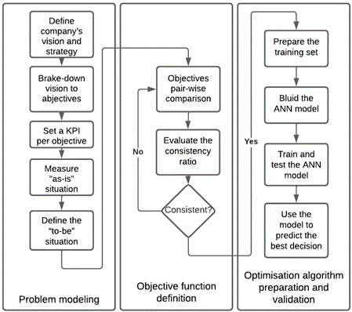
Figure 2: Flow chart of application progress for the suggested model implementation.
Source: Authors own work.

Problem modeling

In this initial step, the decision-making framework is represented in a formalized way based on the Robert Kaplan and David Norton ‘s tried-and-tested balanced scorecard approach providing decision-makers with a quick yet comprehensive overview of the company. The decision-maker is required to clearly define the company's vision and strategy before breaking it down to less than 20 measurable objectives clustered into four performance perspectives namely:
- Financial perspective, ensuring the efficient use of financial resources;
- Customer perspective for consideration of customer satisfaction and needs;
- Internal business perspective in search of efficiency being the source of competitive advantages;
- Innovation and learning perspective, performance seen from the angle of human capital, information system and company’s culture.(Kaplan and Norton, 2005, 1996)

The charter is supplemented by the current KPIs values and targets to be achieved, the gap is automatically computed and afterwards utilized to train the ANN model.
This first step, leads decision-makers to assess all essential operational KPIs together and spot whether an improvement in one area comes at the expense of another, preventing them from slipping into the trap of sub-optimization, which might be detrimental to the overall performance(Kaplan and Norton, 2005).

Objectif function

This second stage of the model aims to formulate the objective function which requires coefficients of the previously determined KPIs derived by Analytic Hierarchy Process in order to better adapt the model to specific decision-making contexts.
Analytic Hierarchy Process is a multi-criteria decision-making technique developed in 1970s by Prof. Thomas Saaty to assist decision-making through pairwise comparisons of pre-defined criteria considered by decision-makers (Saaty, 2008). Statistics based on data gathered over decades reveal that AHP is the most commonly adopted approach worldwide mainly due to the simplicity of the algorithm and ability to reflect users’ perceptions while solving complex problems (Munier and Hontoria, 2021).
The AHP algorithm rely on numerical scale to systematize and structure decision-making (Dos Santos et al., 2019) according to the following steps:

- Step1: develop a hierarchical structure with the performance goal at the top level and objectives/ criteria at the second level and the alternatives at the third level.

- Step2: determine the relative importance of different criteria with respect to the goal.
A pair-wise comparison matrix is created with the help of Saaty’s scale of relative importance

Table 1: Saaty’s scale of relative importance
Importance value | Interpretation
1 | Equal importance
3 | Moderate importance
5 | Strong importance
7 | Very strong importance
9 | Extreme importance
2,4,6,8 | Intermediate values

The pair-wise comparison matrix is then normalized to obtain criteria weights

- Step 3: evaluate the consistency
Before moving forward with analysis, the pair-wise comparison matrix is evaluated by means of the consistency index (CI) calculated using the largest eigenvalue (λmax)

$$CI=\frac{λ_{max}-n}{n-1}$$

The obtained consistency index is afterwards divided by Random Index (RI) (Saaty, 1980), If the result is less than 0.1, the comparisons are acknowledged (perfect comparisons result in CR = 0).

$$CR=\frac{CI}{RI}$$

Table2. Saaty’s Random Index table
Matrix order n | 1 | 2 | 3 | 4 | 5 | 6 | 7 | 8 | 9 | 10 | …
RI | 0 | 0 | 0.58 | 0.90 | 1.12 | 1.24 | 1.32 | 1.41 | 1.45 | 1.49 | …

If result falls out of threshold, the comparisons are qualified inconsistent and returned to user for re-calculation or redeveloping the assessment (Asadabadi et al., 2019; Veeris Ammarapala et al., 2018).

Building the ANN model

At this point, the problem has been well defined. We next proceed to build the resolution model using neural networks. Artificial neural networks (ANN) are mathematical constructs that incorporate linked artificial neurons replicating the function of organic neural networks (Tufegdžić et al., 2020). This machine learning model is becoming increasingly advantageous than convolutional regression and statistical models thanks to its efficient processing at high-speed (Tuan Hoang et al., 2021).

The proposed model ANN builds on AHP and BSC outputs to predict the best decision via a feed – forward artificial neural networks with back propagation training. Our solution’s structure is dynamic depending on number of KPIs set during the BSC phase and was determined based on experience (trial and error method) As there is no general procedure to find an optimal ANN architecture (Tufegdžić et al., 2020) . For instance, the optimal structure for a set of 12 KPIs consists of an input layer built with 24 neurons, two hidden layers with respectfully 12 and 6 neurons and one output neuron that correspond to the alternative overall score.

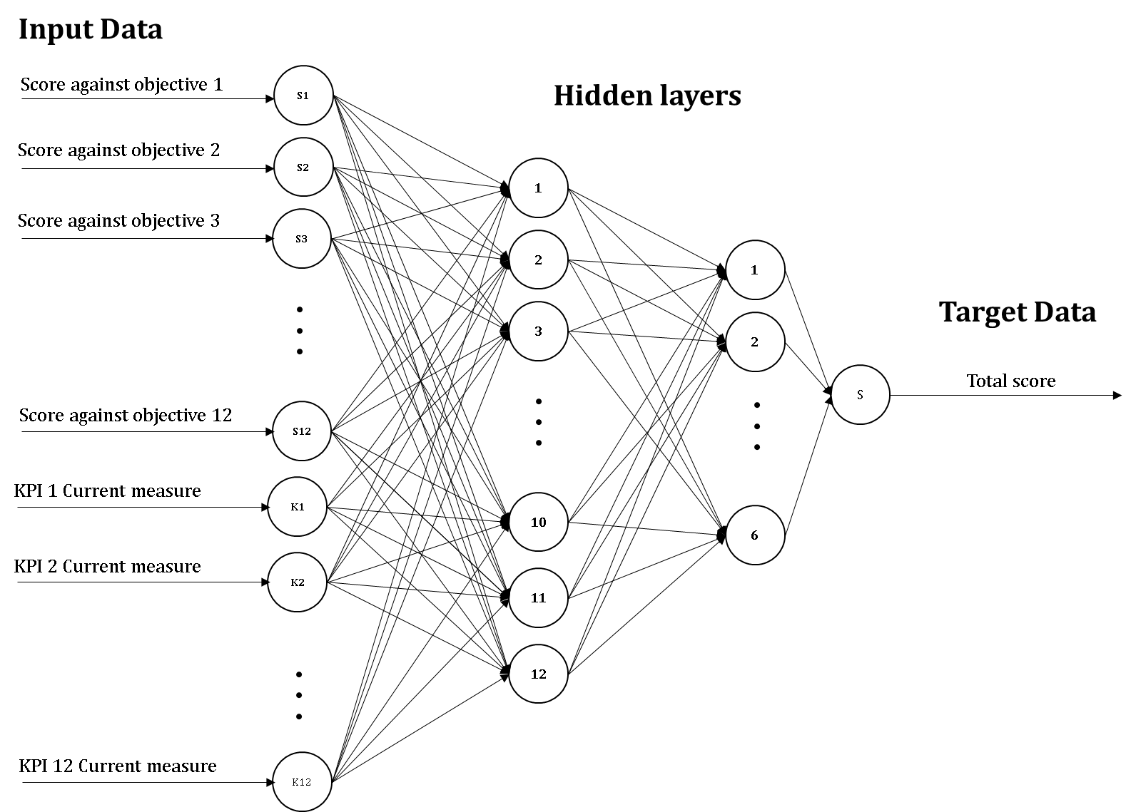
Figure 3: Architecture of the ANN model for a 12 KPIs based performance measure system.
Source: Authors own work.

The ANN training is conducted in Python through the Numpy library. Dataset was built to contain alternatives scores per objective as well as current KPIs values against the overall score calculated using AHP method and adjusted considering actual performance to prioritize the objective with the biggest gap compared to the target. The dataset was then randomly divided into training part (1600 samples) and testing part (400 samples) in proportion 80:20 and Mean Squared Error – MSE was used to evaluate the ANN performance at both training and testing stages.

Results and discussion
The suggested model employs a holistic approach assisting decision-makers in defining the decision framework, beginning with defining the overall performance goal and splitting it into quantifiable and hierarchized objectives that reflect decision-maker’s strategy and conditions overall performance optimization. While in operation, the neural network previously trained to capture the preferences of the decision-makers receives real performance data from the ERP to provide an accurate prediction of the best decision.

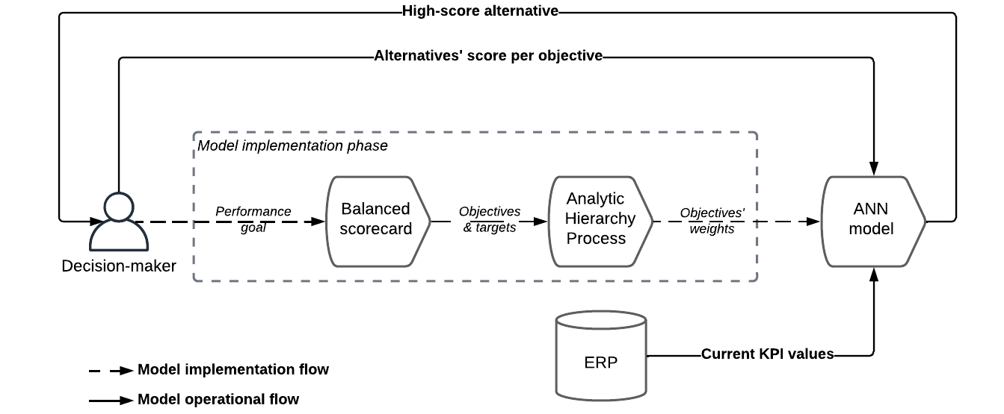
Figure 4: Data flow during the model's operation and implementation phases.
Source: Authors own work.

Empirical example

To show the findings, we will place ourselves in the context of a small local firm that manufactures and sells a specific item, and whose balanced scorecard contains 12 KPI as follow.

Table3. A balanced scorecard of a company operating in the automotive sector
 | Strategic objective | Performance measure
 | Strategic objective | Key performance indicator | Target
Financial | Obj1.Increase profit | Net profit margin | 25%
Financial | Obj2.Make profitable investments | Return on Investment (ROI) | 50%
Financial | Obj3.Increase sales | Revenue growth rate | 20%
customer perspective | Obj4.Satisfy customers | Complaints rate | 5%
customer perspective | Obj5.Increase market share | Market share index | 20%
customer perspective | Obj6.Retain customers | Customer retention rate | 90%
internal process | Obj7.Increase availability | Operational availability rate | 98%
internal process | Obj8.Have efficient processes | Performance rate | 95%
internal process | Obj9.Produce high quality products | Quality rate | 98%
learning and growth | Obj10.Have a well-trained staff | Job role competency rate | 90%
learning and growth | Obj11.Retain employees | Employee turnover | 2%
learning and growth | Obj12.Engage employees | Employee participation rate | 20%
Source: Authors own work.

We will consider that the strategy for achieving performance goals is reflected in the hierarchy of objectives below, where consistency evaluation revealed that the consistency ratio is 0.1 falls inside the threshold.

Table 4. The objectives pair-wise comparison matrix
 | Obj1 | Obj2 | Obj3 | Obj4 | Obj5 | Obj6 | Obj7 | Obj8 | Obj9 | Obj10 | Obj11 | Obj12
Obj1 | 1.00 | 1.00 | 0.20 | 1.00 | 0.20 | 0.50 | 0.33 | 0.20 | 0.20 | 1.00 | 2.00 | 3.00
Obj2 | 1.00 | 1.00 | 0.33 | 5.00 | 1.00 | 1.00 | 1.00 | 1.00 | 1.00 | 2.00 | 5.00 | 5.00
Obj3 | 5.00 | 3.00 | 1.00 | 5.00 | 1.00 | 3.00 | 1.00 | 2.00 | 1.00 | 5.00 | 9.00 | 9.00
Obj4 | 1.00 | 0.20 | 0.20 | 1.00 | 0.33 | 1.00 | 0.50 | 0.33 | 0.33 | 1.00 | 5.00 | 5.00
Obj5 | 5.00 | 1.00 | 1.00 | 3.00 | 1.00 | 1.00 | 2.00 | 1.00 | 5.00 | 3.00 | 9.00 | 5.00
Obj6 | 2.00 | 1.00 | 0.33 | 1.00 | 1.00 | 1.00 | 1.00 | 0.33 | 0.50 | 7.00 | 5.00 | 5.00
Obj7 | 3.00 | 1.00 | 1.00 | 2.00 | 0.50 | 1.00 | 1.00 | 0.50 | 0.50 | 1.00 | 1.00 | 9.00
Obj8 | 5.00 | 1.00 | 0.50 | 3.00 | 1.00 | 3.00 | 2.00 | 1.00 | 1.00 | 5.00 | 9.00 | 9.00
Obj9 | 5.00 | 1.00 | 1.00 | 3.00 | 0.20 | 2.00 | 2.00 | 1.00 | 1.00 | 3.00 | 9.00 | 9.00
Obj10 | 1.00 | 0.50 | 0.20 | 1.00 | 0.33 | 0.14 | 1.00 | 0.20 | 0.33 | 1.00 | 3.00 | 1.00
Obj11 | 0.50 | 0.20 | 0.11 | 0.20 | 0.11 | 0.20 | 1.00 | 0.11 | 0.11 | 0.33 | 1.00 | 2.00
Obj12 | 0.33 | 0.20 | 0.11 | 0.20 | 0.20 | 0.20 | 0.11 | 0.11 | 0.11 | 1.00 | 0.50 | 1.00
Source: Authors own work.

Based on the training performance results, basic conclusion follows. The developed optimal ANN model is acceptable with a mean square error value: 3.3246e-05 indicating how well the features were detected and learned by the model. Results of the test phase are presented in Figure 5.

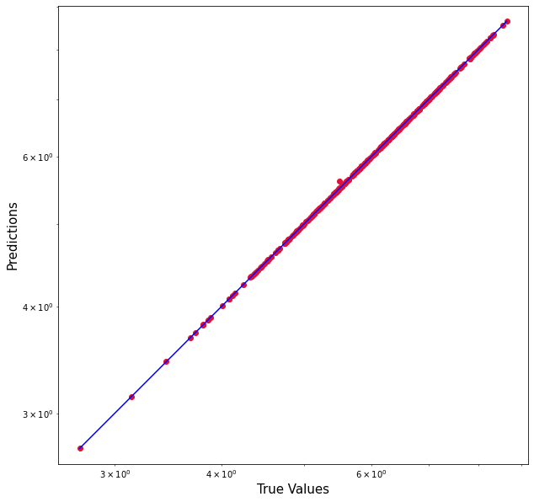
Figure 5: The ANN model’s training performance.
Source: Authors own work.

In order to evaluate the methodology’s validity, we have prepared two separate decision-making frameworks in which we will seek the optimal action to implement among 5 possible alternatives with the final goal to compare our model’s predictions to those of the standard AHP technique.

Table 5. The balanced scorecard completed with performance gap values for two decisional cases.
 | Strategic objective | Performance measure
 | Strategic objective | Key performance indicator | Gap Case 1 | Gap Case 2
Financial | Obj1.Increase profit | Net profit margin | 15% | 10%
Financial | Obj2.Make profitable investments | ROI (Return on Investment) | 35% | 15%
Financial | Obj3.Increase sales | Revenue growth rate | 15% | 15%
customer perspective | Obj4.Satisfy customers | Complaints rate | 5% | 30%
customer perspective | Obj5.Increase market share | Market share index | 15% | 15%
customer perspective | Obj6.Retain customers | Customer retention rate | 20% | 35%
internal process | Obj7.Increase availability | Operational availability rate | 19% | 19%
internal process | Obj8.Have efficient processes | Performance rate | 10% | 10%
internal process | Obj9.Produce high quality products | Quality rate | 18% | 18%
learning and growth | Obj10.Have a well-trained staff | Job role competency rate | 15% | 15%
learning and growth | Obj11.Retain employees | Employee turnover | 3% | 5%
learning and growth | Obj12.Engage employees | Employee participation rate | 14% | 10%
Source: Authors own work.

As shown in table 5, the typical AHP technique recommends equally both actions 1 and 2 as the best choice, with a total score of 3.19 in both scenarios, whereas the developed model differentiates between the two alternatives, recommending action 1 as the best choice in the first case and action 2 in the second.

Table 5. Comparison of the standard AHP technique results with the developed model
Alternatives | Performance case 1 |  | Performance case 2
Alternatives | Model prediction | Standard AHP results | model prediction | Standard AHP results
Action 1 | 3.76 | 3.19 | 3.73 | 3.19
Action 2 | 3.68 | 3.19 | 3.77 | 3.19
Action 3 | 2.92 | 2.52 | 2.95 | 2.52
Action 4 | 2.82 | 2.40 | 2.78 | 2.40
Action 5 | 3.12 | 2.68 | 3.17 | 2.68
Source: Authors own work.

Overall, these results indicate that, when compared to the traditional AHP technique, the model gives valuable predictions that best suit the actual performance while honoring decision makers' preferences.

Conclusions and Future Work
The problem of multi-criteria optimization of performance, consists in finding the best possible decision among a set of available options, by proposing a modeling of the decision-making context through the definition of the important factors and their hierarchization in order to build the objective function prior to actually building a neural network capable of determining the most optimal solution.

Industrial performance optimization is a complex process that involves choosing the most efficient options from a range of alternatives. Traditionally, this has been accomplished through a multi-criteria approach that considers multiple factors in the decision-making process. While this approach is effective to a certain extent, it has limitations that can impede its efficacy.
To address these limitations, this paper proposes a new methodology that builds upon the classic multi-criteria approach by incorporating the Analytical Hierarchy Process (AHP) and Artificial Neural Network (ANN) methods. By using AHP to classify decisions and actions, and coupling it with ANN to refine the most efficient possibilities, this methodology simplifies tasks for decision-makers and offers more precise solutions.

While this approach represents a significant advancement in industrial performance optimization, it can still be further improved through the use of artificial intelligence applications and machine learning. By incorporating these technologies, the decision-making process can become even more precise and tailored to the specific needs of an industrial application.

Acknowledgement
First and foremost, we would like to thank managers and decision makers that accepted to assess our model their contributions and expertise were invaluable in helping us to shape the direction of our research and to bring our ideas to fruition.

We would also like to express our gratitude to the members of our research team Industrial Systems Modeling and Optimization who provided valuable input, insights, and assistance at every stage of the project. Their contributions were critical to the success of this research, and we are deeply grateful for their hard work and dedication.

Declarations

Declaration of interests

The authors declare that they have no known competing financial interests or personal relationships that could have appeared to influence the work reported in this paper.

Fundings

This research work has not received any funding from whatsoever organization

Data availability statement

The data that support the findings of this study are available on request from the corresponding author HM

References
- Aziz, N.F., Sorooshian, S., Mahmud, F., 2016. MCDM-AHP METHOD IN DECISION MAKINGS 11.
- Banja, V., 2020. Artificial Intelligence Techniques in Business Decision Making.
- Capgemini Research Institute. (2018). Digital Mastery Survey; April–May 2018, N=1,338 respondents, 757 organizations.
- Cagno, E., Neri, A., Howard, M., Brenna, G., Trianni, A., 2019. Industrial sustainability performance measurement systems: A novel framework. J. Clean. Prod. 230, 1354–1375. https://doi.org/10.1016/j.jclepro.2019.05.021
- Dos Santos, P.H., Neves, S.M., Sant’Anna, D.O., Oliveira, C.H. de, Carvalho, H.D., 2019. The analytic hierarchy process supporting decision making for sustainable development: An overview of applications. J. Clean. Prod. 212, 119–138. https://doi.org/10.1016/j.jclepro.2018.11.270
- Duman, G.M., El-Sayed, A., Kongar, E., Gupta, S.M., 2020. An Intelligent Multiattribute Group Decision-Making Approach With Preference Elicitation for Performance Evaluation. IEEE Trans. Eng. Manag. 67, 885–901. https://doi.org/10.1109/TEM.2019.2900936
- Durão, L.F.C.S., Carvalho, M.M., Takey, S., Cauchick-Miguel, P.A., Zancul, E., 2018. Internet of Things process selection: AHP selection method. Int. J. Adv. Manuf. Technol. 99, 2623–2634. https://doi.org/10.1007/s00170-018-2617-2
- Dweiri, F., Kumar, S., Khan, S.A., Jain, V., 2016. Designing an integrated AHP based decision support system for supplier selection in automotive industry. Expert Syst. Appl. 62, 273–283. https://doi.org/10.1016/j.eswa.2016.06.030
- Graham, I., Goodall, P., Peng, Y., Palmer, C., West, A., Conway, P., Mascolo, J.E., Dettmer, F.U., 2015. Performance measurement and KPIs for remanufacturing. J. Remanufacturing 5, 10. https://doi.org/10.1186/s13243-015-0019-2
- Kaplan, R.S., Norton, D.P., 2005. The balanced scorecard: measures that drive performance. Harvard business review US.
- Kaplan, R.S., Norton, D.P., 1996. The balanced scorecard: translating strategy into action. Harvard business press.
- Li, C., Chen, Y., Shang, Y., 2022. A review of industrial big data for decision making in intelligent manufacturing. Eng. Sci. Technol. Int. J. 29. https://doi.org/10.1016/j.jestch.2021.06.001
- Lima, E., Gorski, E., Loures, E.F.R., Santos, E.A.P., Deschamps, F., 2019. Applying machine learning to AHP multicriteria decision making method to assets prioritization in the context of industrial maintenance 4.0. IFAC-Pap. 52, 2152–2157. https://doi.org/10.1016/j.ifacol.2019.11.524
- Mourtzis, D., Papatheodorou, A.-M., Fotia, S., 2018. Development of a Key Performance Indicator Assessment Methodology and Software Tool for Product-Service System Evaluation and Decision-Making Support. J. Comput. Inf. Sci. Eng. 18, 041005. https://doi.org/10.1115/1.4040340
- Munier, N., Hontoria, E., 2021. Uses and Limitations of the AHP Method: A Non-Mathematical and Rational Analysis, Management for Professionals. Springer International Publishing, Cham. https://doi.org/10.1007/978-3-030-60392-2
- Saaty, T.L., 2008. Decision making with the analytic hierarchy process. Int. J. Serv. Sci. 1, 83–98.
- Tufegdžić, M., Jovičić, G., Trajanović, M., Pravdić, P., 2020. Company’s performance prediction using Balanced Scorecard software and neural networks as a tool for strategic management 6.
- Wu, J.-Z., Tiao, P.-J., 2018. A validation scheme for intelligent and effective multiple criteria decision-making. Appl. Soft Comput. 68, 866–872. https://doi.org/10.1016/j.asoc.2017.04.054

