Ms. Paulo Ricardo Rodrigues Quinto – Prof. Dr. Daniel Xavier Gouveia

VLC load trigger experiment.

- Abstract

Visible Light Communication (VLC) has gained significant attention and found applications in various residential, commercial, and industrial projects, primarily due to the advancements and widespread adoption of Light Emitting Diodes (LEDs). LEDs offer numerous advantages, including extended lifespan, durability, exceptional energy efficiency, affordability, ease of installation, and the ability to transmit data rapidly. This paper presents an experiment that utilizes VLC technology to trigger a system with a high-power load, demonstrating its feasibility and practicality in diverse real-life scenarios.
Particularly, VLC proves valuable for data transmission in hostile environments where the presence of humans may be restricted or where conventional communication methods face limitations, such as in hospitals, mines, petrochemical fields, and security sites.

- Introduction

Nowadays, the major data transmitted over the Internet to homes, offices, and industries rely on the high-speed capabilities of Optical Fiber Infrastructure. This network infrastructure can achieve data speeds of Terabits per second (Tb/s). However, the deployment of traditional cable-based infrastructure for data transmission and reception is often costly and complex, and not easy to achieve [1]. As a result, Optical Wireless Communication (OWC) has emerged as a crucial component of global wireless communication systems. Indeed, RF technology played a pivotal role in the widespread adoption of wireless systems worldwide. However, its electromagnetic spectrum has inherent limitations in terms of capacity, necessitates licensing for operation, and can be costly to implement. With the increasing demand for wireless services globally, there is a growing need for alternative technologies that can serve as viable options to meet this demand [2].
Wireless devices are everywhere and become important tools to our daily existence. Smartphones and tablets, equipped with built-in Wi-Fi capabilities, have become constant companions, accompanying individuals across various locations. Whether it's enjoying radio broadcasts during car rides or watching free-to-air television programs at home, wireless technology has seamlessly integrated into our lives. It ensures our safety in urban environments and enables us to stay connected even when traversing the globe, all made possible through terrestrial wireless communication systems. Furthermore, the Internet of Things (IoT) market has witnessed exponential growth, with an estimated 7 billion devices currently in operation, based on data provided by IoT Analytics [3].
What we can see is an increased exponentially demand for wireless services, and in this context, Optical Wireless Communication (OWC) emerges as a promising solution, encompassing various segments such as infrared (IR) light, visible light, and ultraviolet (UV) light, which can effectively transmit signals. OWC is primarily employed for short-range wireless communication applications, complementing and augmenting RF technology to address the increasing global demand for wireless connectivity. By harnessing the potential of different light spectra, OWC presents itself as a viable alternative to meet the ever-growing wireless communication needs of the modern world [2].
VLC is a light-based communication system that offers numerous advantages, besides to be one significant subset of OWC is Visible Light Communication (VLC). VLC's importance in wireless communication is growing rapidly, as it finds widespread use and applications in our technologically advanced society. This is primarily due to its practicality of installation and ease of operation.
While VLC harnesses the power of visible light for data transmission, it operates alongside and complements traditional optical fiber-based communication. VLC provides an alternative wireless communication solution that can effectively transmit data using light waves. This technology has gained recognition for its ability to deliver secure, high-speed data transfer while utilizing existing lighting infrastructure. Compared to RF has some advantages when the RF has restrictions or could not be used, especially in Hospitals, security sites, mines, petrochemical industry [4].
VLC's practicality and simplicity make it an attractive choice for various applications. It can be easily integrated into indoor environments where light sources, such as LEDs, are commonly found. VLC offers the potential for seamless connectivity, enabling devices to communicate and exchange data efficiently using light signals [5][6].
As the demand for reliable and efficient wireless communication continues to grow, VLC has become an increasingly vital component of our interconnected world. Its compatibility with existing lighting infrastructure, ease of implementation, and versatile applications position VLC as a promising solution for bridging the gap between wired and wireless communication systems.Visible Light Communication (VLC) was considered a new way communication technique in Time Magazine's esteemed list of the top 50 scientific and technological inventions worldwide in 2011 [4].
In my experiment, we demonstrated the measurement of environmental light and its utilization as a trigger to activate a high-power load connected to the system used in the experiment. Then, we showcased how to trigger a high-power load using simple and low-cost electronic components with this technology.
This experiment serves as a valuable starting point for the development of potential products and applications that can be beneficial to society. One potential application inspired by this experiment is the creation of a product designed to trigger a sound alarm system in response to the luminosity emitted by initial flames during accidental fires. Such a product would be particularly useful in environments where other technologies may not be feasible or suitable, such as RF in hospitals and petrochemical industries.
The potential applications derived from this experiment highlight the versatility and value of visible light-based communication systems. Through continuous exploration and development, we can leverage the power of light to create solutions that positively impact society, ensuring enhanced safety and efficiency in a range of industries and environments.

- Methodology
To set up the circuit experiment, we start by placing a resistor and an LDR sensor on a breadboard. One end of the resistor is connected to the LDR sensor, while the other end is linked to a specific point on the breadboard that is connected to the Ground (GND) pin of the Arduino. The connection point between the resistor and LDR sensor is then connected to an analog port on the Arduino (in our case, the analog port A0).
Next, we connect the other end of the LDR sensor to another point on the breadboard, which corresponds to the 5V pin on the Arduino. This arrangement establishes the analog data input for our experiment, allowing us to measure and interpret the varying resistance of the LDR sensor in response to environmental light.
By connecting the resistor, LDR sensor, and appropriate Arduino pins in this manner, we create a circuit configuration that enables us to capture analog data related to the intensity of the surrounding light. This data can then be used for various purposes, such as triggering specific actions or controlling other components within the system.
To complete the circuit setup, we now focus on the output side of our experiment. We begin by connecting a relay module to the Arduino, which serves as a switch to control a high-power load.
The relay module consists of an input side and an output side. On the input side, we connect a digital pin of the Arduino (e.g., pin 7) to the signal pin of the relay module. Additionally, a GND pin on the Arduino is connected to the GND pin on the relay module to establish a common reference.
Moving to the output side, we connect the high-power load (such as a motor or a lamp) to the Common (COM) and Normally Open (NO) terminals of the relay module. This configuration allows us to control the flow of power to the high-power load based on the state of the relay.
Now, when the Arduino detects a specific light intensity through the LDR sensor on the input circuit, it sends a corresponding signal to the relay module. This signal activates the relay, closing the circuit between the COM and NO terminals, thus powering on the high-power load. Conversely, when the light intensity falls below the specified threshold, the Arduino sends a signal to deactivate the relay, opening the circuit and turning off the high-power load.
By establishing this output circuit, we create a mechanism that enables us to control a high-power load based on the light intensity measured by the LDR sensor. This setup allows for a range of applications where the activation or deactivation of a device or system can be triggered by changes in environmental light levels, offering a flexible and efficient solution.
Next, we will develop the Arduino program that will be uploaded to the Arduino device, which will determine the behavior of the VLC system based on the ambient light levels in its operating environment. The program will be responsible for controlling the activation and deactivation of a high-power load that is connected to the device system.
The Arduino program will be designed to monitor the analog input from the LDR sensor, which measures the intensity of the surrounding light. Based on the defined thresholds and logic implemented in the program, it will determine when to trigger the high-power load to turn on or off.
By utilizing the measured light levels, the Arduino program ensures that the VLC system operates in synchronization with the environmental conditions, providing an efficient and responsive control mechanism. This program serves as a crucial component in achieving the desired functionality of the system and enables seamless integration between the VLC technology and the connected high-power load.
Through the execution of this refined Arduino program, we establish a reliable and automated solution that effectively utilizes the VLC system's capability to respond to changes in the environment. This approach facilitates the seamless operation of the system and enhances its practicality and usefulness in a wide range of applications.

Program:

void setup() {

pinMode(A0, INPUT); //Define A0 as the input pin for reading ambient brightness
pinMode(7, OUTPUT); //Define digital pin 7 as the output for controlling the relay
Serial.begin(9600); // Start serial communication at a baud rate of 9600 bits per second

}

void loop() {

Serial.println(analogRead(A0)); // Read and print the brightness values from A0
delay(200); // Delay to allow sufficient time for data reading

// Activation/deactivation of the relay and the connected load
if (analogRead(A0) <= 13) {
delay(100);
Serial.print("Charge Activated"); // Print the message indicating that the charge is activated
digitalWrite(7, HIGH); // Set pin 7 to HIGH to trigger the relay and turn on the load
}
else {
Serial.print("Load OFF"); // Print the message indicating that the load is off
digitalWrite(7, LOW); // Set pin 7 to LOW to turn off the relay and the load
}

}

Photos of devices for electronic circuit experiments:

Picture 1 - Breadboard
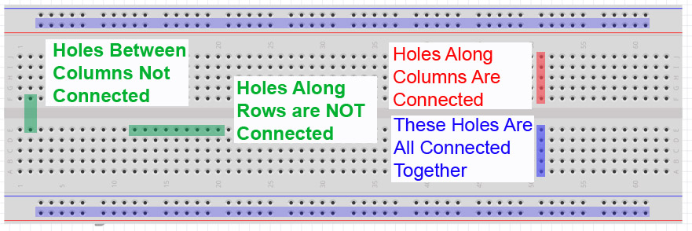
Source [7] - 2019
Picture 2 - Relay 5V - One Channel Relay Module Trigger Compatible with Arduino
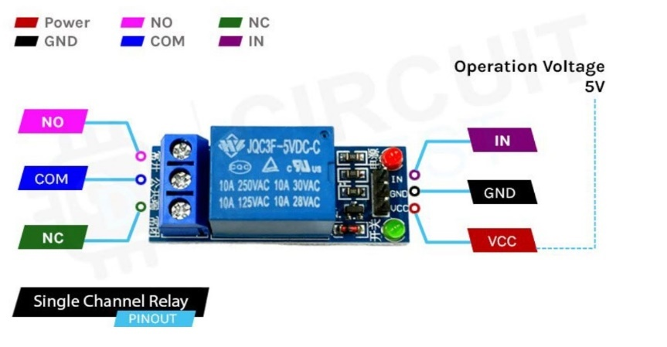
Source [8] - 2023
Picture 3 - Adjustable power supply for breadboard

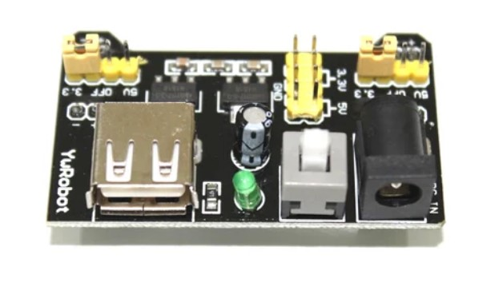
Source [9] - 2023

Picture 4 - LDR sensor

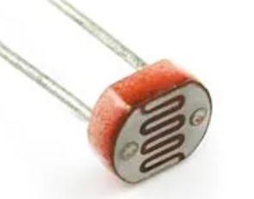
Source [10] - 2023

Picture 5 - 10K resistor

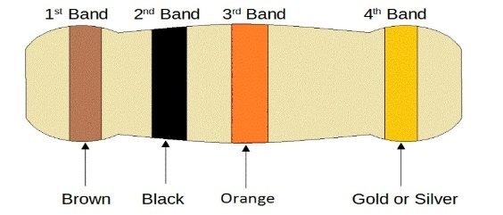
Source [11] - 2023
Picture 6 - LED lamp

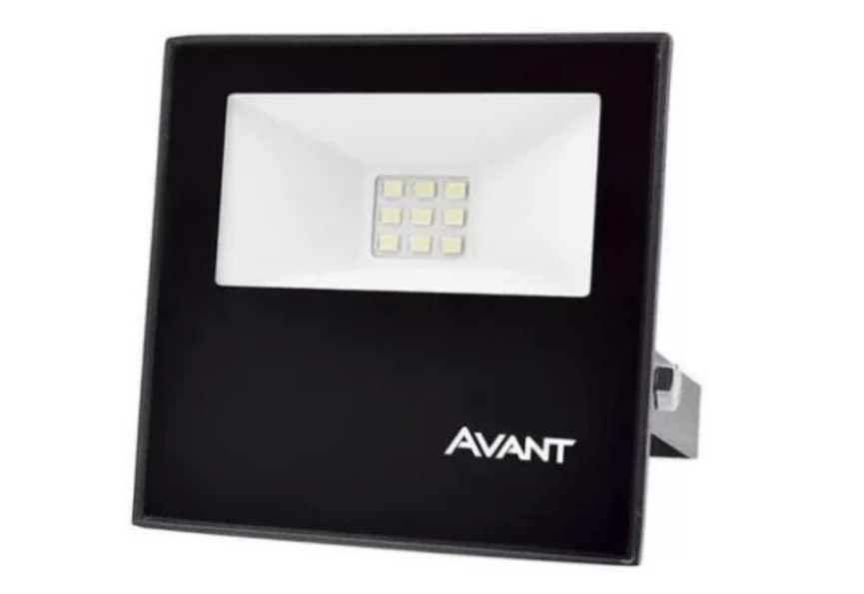
Source [12] - 2023

Picture 7 - Arduino

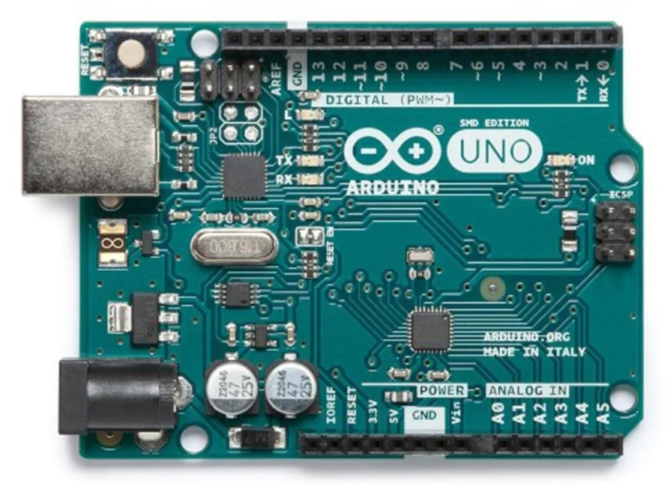
Source [13] - 2023

Picture 8 - Arduino`s USB cable


Source [14] - 2023

Picture 9 - Circuit view of all assembled electronic components devices
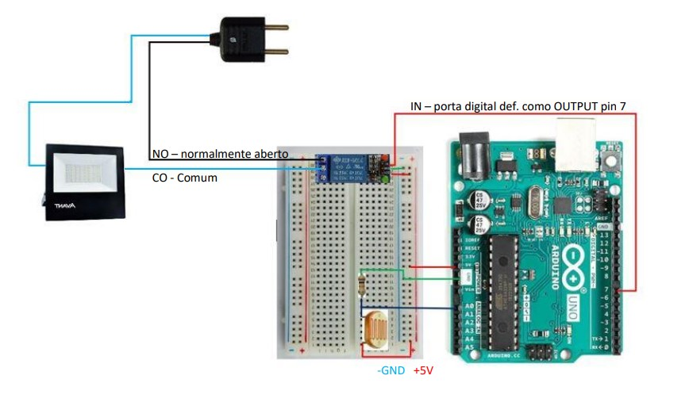
Source [15] - 2023

4. Results.

We have done this experiment at different times of the day to see its functionality with many kinds of light levels in the lab environment. The outside light that comes through the windows raises the luminosity of the area where the experiment was been tested sensibilize the LDR somehow to trigger the system and activate the high-power load connect to the system.
We turned the LED lamps on in the place where the experiment was occurring to raise the luminosity around the LDR to activate the system and consequently, the high-power load connect to it.
Next, we used a laser to heat the LDR sensor to promote the same result and raise luminosity to trigger the system and a high-power load connected to it.
In all situations, our system circuits worked as expected demonstrating that this technology has the feasibility and functionality to be incorporated in many situations in society to solve some problems and bring efficiency to productive homes, offices, and industries.
The experiment was conducted at various times of the day to test the functionality of the system under different light levels in the laboratory environment. The presence of natural light from outside, on sunny days, entering through the windows, increased the overall luminosity in the area where the experiment was conducted. This increase in luminosity sensitized the LDR (Light Dependent Resistor) and triggered the system, activating the high-power load connected to it.
To further test the system's response, we introduced additional light sources by turning on LED lamps in the vicinity of the LDR. This raised the luminosity around the sensor, leading to the activation of the system and subsequently turning on the high-power load.
In addition to ambient light sources, we also used a laser to directly heat the LDR sensor. This deliberate increase in luminosity mimicked the effect of natural light and effectively triggered the system, causing the high-power load to activate.
In all test scenarios, our system circuits performed as expected, demonstrating the reliability and feasibility of this technology. These results highlight the potential of incorporating this technology into various societal settings, offering solutions to problems, and improving efficiency in homes, offices, and industries.

5. Conclusion and Future Expectation

Now we can suggest some ideas and information about the potential applications and useful proposals of this experiment. Here are some ideas:
Smart Lighting Control: Your experiment demonstrates a practical application of VLC technology for smart lighting control. By using ambient light intensity as a trigger, you can automate the operation of lighting systems in various environments, such as homes, offices, or public spaces. This can lead to energy savings by ensuring lights are only activated when necessary.
Energy-Efficient Systems: The low power consumption and reduced electromagnetic interference of VLC make it an attractive option for energy-efficient systems. By integrating VLC-based triggers into devices or appliances, you can enhance their efficiency and contribute to sustainable energy consumption practices.
Light-Dependent Automation: Your experiment showcases the potential of light-dependent automation. This concept can be extended to various applications, such as opening/closing curtains or blinds based on daylight levels, activating/deactivating ventilation systems based on natural light availability, or triggering security systems when light conditions change.
Hazardous Environments: VLC technology's advantage in environments where radio frequencies are considered hazardous opens up possibilities for its application. For instance, in sensitive locations like hospitals, where RF interference can affect medical equipment, VLC-based triggers can provide a safer alternative for controlling devices without the risk of interference.
Finally, this experiment can be valuable for educational purposes. It can serve as a practical example to demonstrate the principles of VLC technology, analog sensor integration with microcontrollers, and relay-based control systems. Sharing this experiment and its results could inspire others to explore similar projects or understand the potential of VLC technology.
7. References and pictures sources:

[1] Harnessing Light: Optical Science and Engineering for the 21st Century. Washington, DC: The National Academies Press. - Chapter: 1 Optics in Information Technology and Telecommunications - Available at: https://doi.org/10.17226/5954.

[2] Optical wireless communication - Wikipedia - Available at: https://en.wikipedia.org/wiki/Optical_wireless_communications#:~:text=Optical%20wireless%20communication%20(OWC)%20refers,the%20historical%20forms%20of%20OWC.

[3] Terrestrial wireless communications - ITU News ​​Magazine - Available at: https://www.itu.int/en/itunews/Documents/2019/2019-04/2019_ITUNews04-en.pdf

[4] Utmel - What is Visible Light Communication(VLC)? - 13 October 2021 - Available at: https://www.utmel.com/blog/categories/optoelectronics/what-is-visible-light-communication-vlc

[5] An Overview Of Visible Light Communication Systems - Taner Cevik and Serdar Yilmaz - International Journal of Computer Networks & Communications (IJCNC) Vol.7, No.6, November 2015 DOI: 10.5121/ijcnc.2015.7610 139 - Available at: https://arxiv.org/ftp/arxiv/papers/1512/1512.03568.pdf

[6] Visible light communication: Applications, architecture, standardization and research challenges - Latif Ullah Khan - Volume 3, Issue 2, May 2017, Pages 78-88 - Available at: https://www.sciencedirect.com/science/article/pii/S2352864816300335

[7] ERC - Handbook - Breadboards - Nov 17, 2021 - Available at:
https://erc-bpgc.github.io/handbook/electronics/Basic_Electronic_Components/breadboard/

[8] Understanding How a Single Channel Relay Module Works and How to Use it with Arduino to Control AC Loads - Circuit Digest - February 24, 2023 - Available at: https://circuitdigest.com/microcontroller-projects/interface-single-channel-relay-module-with-arduino

[9] Bread Board Power Supply Module 3.3V & 5V - Juny 20, 2023 - Available at: https://www.indiamart.com/proddetail/bread-board-power-supply-module-3-3v-5v-output-10370714362.html

[10] LDR Sensor - Juny 20, 2023 - Available at:
https://www.exportersindia.com/product-detail/ldr-sensor-6321838.htm

[11] Electronics Reference - Education and References for Thinkers and Tinkerers - 10K resistor - Juny 20, 2023 - Available at:
https://electronicsreference.com/10k_resistor_color_code/

[12] Refletor de LED 10w Avant IP65 - Juny 20, 2023 - Available at:
https://www.ledtubeiluminacao.com.br/refletor-de-led-10w-avant-ip65

[13] Robotshop Everything Robotics - Infinite possibilities - Arduino Uno REV3 SMD - Juny 20, 2023 - Available at: https://www.robotshop.com/products/arduino-uno-rev3-smd

[14] Circuits Electronics - stay on track - Arduino USB programming Cable - Juny 20, 2023 - Available at: https://circuits-elec.com/products/arduino-usb-programming-cable

[15] Own font design - Juny 20, 2023.

