Static and fatigue performance of GNP coated bi-directional carbon fibre-epoxy composites under bending loads
Alok K. Srivastavaª, Chandra S. Yerramalli^{b}, Aparna Singh^{c*}
ª Centre for Research in Nanotechnology & Science, Indian Institute of Technology Bombay, Mumbai 400076, India
^{b} Department of Aerospace Engineering, Indian Institute of Technology Bombay, Mumbai 400076, India
^{c} Department of Metallurgical Engineering and Materials Science, Indian Institute of Technology Bombay, Mumbai 400076, India
Abstract
The addition of graphene nanoplatelets as a nanofiller on the surface of pristine and oxidized carbon fiber for making reinforced polymer composites has shown improvement in monotonic flexural properties. However, the fatigue response of these laminates under bending loads has not been investigated so far. The current study aims to examine the monotonic and fatigue behaviour of the graphene nanoplatelets (GNPs) coated bi-directional pristine and oxidized carbon fiber epoxy composites under bending loads. Eight layers of fabrics were used to manufacture the laminates through vacuum-assisted resin transfer molding technique (VARTM). An optimum amount of GNP addition on oxidized fiber leads to ~830-fold enhanced fatigue life at higher stresses as compared to pristine laminates. However, excessive GNP addition on pristine as well as oxidized fiber leads to a deterioration in fatigue life. In-situ optical microscopic examination was done to observe the crack initiation and propagation of all the specimens with respect to the number of cycles coupled with postmarterm SEM images of the fracture surfaces.
Keywords: Carbon fiber, Graphene nanoplatelets, Interphase/Interface, Fatigue, VARTM

Introduction
Carbon fiber reinforced polymer (CFRP) composites have a high strength-to-weight ratio but are intrinsically inhomogeneous and hence susceptible to failure by ply delamination or micro-cracks at the interface of reinforced fiber and matrix when subjected to continuous cyclic loading [1]. Nanofillers like carbon black, nano-silica particles, carbon nanotube and graphene oxides [2–5] have been incorporated in the epoxy matrix in various studies and improved strength and stiffness have been observed. However, the interface/interphase between the carbon fiber and the epoxy can selectively be strengthened by the coating of nanofiller on carbon fibers using different coating techniques e.g. layer by layer coating, solvent spraying and electrophoretic deposition [6–9]. Interphase strengthening resulting from improved adhesion between the fiber and the matrix leads to improvement of interlaminar shear strength [6,10], tensile strength [7,8,11], flexural strength [7,9,12,13], and fracture toughness [7,14] of the composites. Another way of improving the interface properties of CFRPs includes the alteration in physical and functional properties of the fibers e.g. surface roughness, surface energy, surface functionality, wettability etc. [15,16]. Desizing and the subsequent oxidation of the carbon fiber have been used to improve the surface functionality of the carbon fibers and an improvement of 20% in both flexural strength and flexural modulus of graphene nanoplatelets (GNP) coated oxidized carbon fibre reinforced epoxy composite has been reported due to the formation of larger interphase between carbon fibre and the epoxy [12]. However, the studies on flexural and tension fatigue response of GNP-reinforced carbon fibre epoxy composites are very limited [17–20]. An improvement in flexural fatigue life by up to 155% has been achieved through the incorporation of 0.1 wt.% GNP in CFRPs. The laminates have been manufactured by GNP-epoxy mixing through a 3-roll high shear mixture and subsequent hand layup and compression mould processes of 10-layer woven carbon fabrics [17]. Another study compared the flexural fatigue life of different CFRP laminates with different mixing ratios of the multi-walled carbon nanotubes (MWCNTs) and GNPs in epoxy [18]. Fourteen layers unidirectional carbon fiber epoxy laminates were made through hand layup and subsequent hot-pressing process. An improvement of 9.3% and 11% in monotonic flexural strength and fatigue limit respectively of the laminates modified with a nanofiller ratio of 9:1 (MWCNT: GNP) was achieved. Shen et al. [19] reported 37 times enhancement in tension fatigue life of CFRPs in which 0.25 wt.% GNPs-mixed epoxy was used to manufacture the laminates through hot compression molding. Another study compared the tension fatigue life of the CFRPs in which MWCNT and few-layered graphene (FLG) were added in epoxy and the laminates were manufactured through hot press molding [20]. A maximum improvement of 5- and 15- fold in tension fatigue life of the MWCNT and FLG modified CFRPs respectively was reported. However, the evolution of failure/damage of CFRPs under fatigue loading has not been explored during the test.
A novel material system which comprises of GNPs coated on oxidized carbon fibers in CFRPs was used to investigate the flexural fatigue response and compared with pristine laminates and laminates with graphene coating on pristine fibers. The GNP/CF/epoxy laminates were manufactured through the vacuum-assisted resin transfer molding (VARTM) technique and tested under monotonic flexural and continuous bending cyclic loading conditions. An in-situ examination of the crack initiation and propagation during the flexural fatigue of the CFRPs has been investigated in the current study using an optical microscope.

Materials and methods

Materials
Bi-directional 2 × 2 twill woven 3K carbon fiber (polyacrylonitrile based), graphene nanoplatelets (GNPs) and an epoxy resin were used in the study. Carbon fabric had identical yarns of 3000 filament count of diameter 7 µm each. Carbon fiber filaments coated with epoxy-compatible sizing were purchased from Bhor Chemicals and Plastics Pvt. Ltd., Mumbai, India. The tensile strength and the elastic modulus of the carbon fiber (CF) were quoted as 4000 MPa and 240 GPa respectively. Graphene nanoplatelets (purity ~99%) with an average lateral dimension of 5-8 µm and thickness ~2–5 nm was supplied by Ad-Nano Technologies Private Limited, Karnataka, India. The quoted surface area and the number of layers of GNPs were ~380 m²/g and 2-4 respectively. Laminating grade low viscosity epoxy resin (Epofine–5052) and Finehard–5052 as a hardener was provided by Fine Finish Organics Private Ltd., Mumbai, India. Epoxy resin and hardener were mixed in a ratio of 100:38 by weight as per the manufacturer’s datasheet. Sulfuric acid and nitric acid of EMSURE® grade with a concentration of 98% and 69% respectively were used to oxidize the carbon fabrics and were procured from Merck Life Science Private Ltd. India. All the materials were used as received unless otherwise stated.

Carbon fiber surface modification
The schematic of the carbon fiber fabric surface treatment is shown in Fig. 1a. Initially, the desizing of the bidirectional carbon fiber fabrics was carried out by refluxing them in acetone at 80 ºC for 48 hours. After refluxing, the fabrics were washed through deionized (DI) water and then subsequently dried in a vacuum oven at 80 ºC for 16 hours. Later, oxidation of the desized fabrics was performed by putting them in a mixture of concentrated nitric acid and sulfuric acid (1:3 by volume). The oxidation was done by keeping the acid-dipped fabric under ultrasonication at 60 ºC for 12 minutes. Afterwards, the fabrics were washed through deionized (DI) water repeatedly until pH ∼ 7 and then subsequently dried in a vacuum oven at 80 ºC for 20 hours. The desized-oxidized carbon fiber is named as DOCF12.

Spray coating of GNPs on carbon fibers
An airbrush system (Pilot power AB-15) manufactured by Manik Radiators Pvt. Ltd. India, connected through the high-performance single-piston air compressor was used for spraying the GNPs. The schematic of the spray coating procedure is shown in Fig. 1. The coating of GNPs on carbon fiber fabrics with a concentration of 0.4 wt.% in 0.4GNP and 0.4GNP-DOCF12 laminate respectively was done through a spray gun. Before spray coating, sonication of different weight percent of the GNPs in 300 ml ethanol was done for 30 minutes via probe-type sonicator (3 kHz, 250 Watts) (Fig. 1b). The GNP-ethanol suspension was first filled in the spray gun and then spraying was done on both sides of the fabric consecutively. Eight fabrics were spray-coated for each set of laminates.

Manufacturing procedure of the GNP/CF/epoxy laminates
The laminates were prepared through the vacuum-assisted resin transfer molding (VARTM) technique as shown in Fig. 1 (c). Initially, the stacking of eight carbon fabrics was done on the flat granite table to prepare the vacuum bagging. The peel ply on both sides of the fabric stack and the flow mesh on the top side of the fabric stack were placed. Two openings: one for the inlet of the epoxy-hardener mixture and another outlet for pulling out the air from bagging, were prepared with the help of a vacuum cylindrical pipe (inlet and outlet pipes in Fig. 1c ). Before infusion, the degassing of the epoxy-hardener mixture was done for the removal of the air bubbles which might get trapped during the mixing process. After degassing the epoxy-hardener mixture, the vacuum was initiated through the outlet connected with the vacuum pump and after the opening of the inlet valve, the resin mixture was infused and passed through the flow mesh. Flow mesh enables the resin to stream uniformly in all directions. The laminate was cured in two stages: in the first stage, the laminate was cured at ambient temperature for 24 hours and in the second stage, it was kept in an oven at 100 ºC for 2.5 hours. A control laminate without any treatment of the fibers or coating of GNPs has been named as “pristine” while 0.4GNP laminate implies that 0.4 wt.% GNP was coated on the pristine fabric and 0.2GNP-DOCF12 as well as 0.4GNP-DOCF12 laminates were made by coating 0.2 wt.% and 0.4 wt.% GNP respectively on oxidized fabric. Final thickness of the pristine, 0.4GNP, 0.4GNP-DOCF12, 0.2GNP-DOCF12 and 0.8GNP laminate is 1.8 ± 0.03 mm, 1.83 ± 0.02 mm, 1.82 ± 0.06 mm, 1.8 ± 0.03 mm and 1.86 ± 0.02 mm respectively.

Testing and characterization
Scanning electron microscopy (SEM) Hitachi S–3400 N model was used to investigate the morphology of the carbon fibers and failed composite fracture surfaces. The fracture samples were coated with a few nanometers layer of gold before the examination. Surface topographies of carbon fibers were observed by atomic force microscopy (AFM–MFP–3D Asylum research, USA) in tapping mode. Minimum five areas of 1 × 1 μm² of the fiber surfaces were scanned to obtain the average surface roughness (Ra) and root mean square (RMS) roughness (Rq).
Surface functional groups of the carbon fibers and GNPs were investigated through Fourier-transform infrared spectroscopy (FTIR) (Bruker, Germany–3000 Hyperion Microscope with Vertex 80 FTIR System) using powder-pressed KBr pellets. The wavenumber range of the FTIR spectra was taken as 500–4000 cm⁻¹ with a resolution of 0.2 cm⁻¹.
The flexural test was performed at a crosshead speed of 1 mm/minute using Instron ElectroPuls™ E1000 of 1kN capacity. Specimen geometry for the test was taken as 40 mm (total length) × 13.5 mm (width) × 1.8 mm (thickness) and the span to thickness ratio was maintained as 16:1 as per ASTM D790-02. A minimum of four specimens per condition was tested for flexural response. Strain gauges of 2 mm gauge length were adhered to the tension side of the specimens and connected to the P3 strain indicator and recorder to record the strains during the test. In-situ optical images were captured during the test through Redical Scientific stereo microscope (Model OM-19).
The fatigue test was carried out at different fractions of the respective flexural strength by Instron ElectroPuls™ E1000 of 1 kN capacity. The test was performed under load control mode at a frequency of 5 Hz. The R-ratio (σ_{max}/σ_{min}) was kept as +0.1 and the number of cycles to failure against the stress levels was obtained. The fractured surfaces of the tested specimens were observed under SEM to understand the failure behavior under cyclic loading. In-situ observation during the test was done using an optical microscope to record events of crack initiation and propagation.

Results and discussion

Characteristics of carbon fibers
SEM micrographs of pristine and DOCF12 carbon fiber are shown in Fig. 2. The pristine carbon fiber in Fig. 2 (a) appears to be a smoother surface compared to DOCF12 fibers in Fig. 2 (d). Both fabrics were observed at higher magnification also and in both fibers longitudinal grooves can be seen (Fig. 2 b, c, e, f). However, DOCF12 fibers seem to have rougher surfaces compared to pristine.
Fig. 3 shows the FTIR spectra of pristine and DOCF12 carbon fiber. The presence of –OH group at 3435 cm⁻¹ and 1430 cm⁻¹ is observed in both carbon fibers. However, the peaks at 1730 cm⁻¹ represent C=O group due to the presence of ketone in DOCF12. Both peaks of –OH and C=O functional groups are featured as carboxylic acid functional groups.
AFM images were taken to further observe the carbon fibers and are shown in Fig. 4. A significant difference in morphology between pristine and DOCF12 carbon fibers can be seen. Pristine carbon fiber in Fig. 4 (a) showed a relatively neat and smooth surface, and a few very fine layers of sizing agent which were used to size the carbon fibers during the manufacturing process. Narrow longitudinal grooves along the fiber axial direction were also seen in pristine carbon fibers. The layers of sizing seem to be removed after the desizing and oxidation treatment in Fig. 4 (b). Also, the longitudinal grooves in DOCF12 became deeper and coarser compared to pristine carbon fibers. The average surface roughness Ra and RMS roughness Rq of pristine and DOCF12 carbon fibers are shown in Table 1. Both Ra and Rq values of DOCF12 were found to be increased by ~3 times compared to pristine carbon fibers. These grooves are not wide and deep enough for the thin but wide GNPs to sit inside them.
Table 1. Average surface roughness (Ra) and Root mean square (RMS) roughness (Rq) of carbon fibers measured through AFM
Carbon fiber | Ra (nm) | Rq (nm)
Pristine | 2.22 ± 0.75 | 2.88 ± 0.95
DOCF12 | 6.3 ± 1.94 | 8.42 ± 2.65

Flexural Properties
The average flexural strength, flexural modulus and flexural strain at maximum flexural stress (failure strain) of the pristine and GNP-added laminates have been shown in Fig. 5. There is an improvement of ~11% and ~17% in the flexural modulus of 0.4GNP and 0.4GNP-DOCF12 laminates compared to pristine laminates. However, there is no substantial change in the flexural modulus of 0.2GNP-DOCF12 and 0.8GNP laminates. The average flexural strength of 0.4GNP, 0.4GNP-DOCF12 and 0.2GNP-DOCF12 laminates is similar to the pristine laminate. However, there is a decrease of 23% in flexural strength of 0.8GNP laminates respectively (Fig. 5a). Also, there is a reduction of 6%, 9% and 26% in failure strain of 0.4GNP, 0.4GNP-DOCF12 and 0.8GNP respectively with respect to pristine laminate (Fig. 5b). Failure strain of 0.2GNP-DOCF12 laminate did not show significant changes compared to pristine laminate. Thus, all GNP-added laminates except 0.2GNP-DOCF12 show a reduction in failure strain compared to pristine laminate.

Failure evolution under flexural loading
The specimens tested under flexural loading were examined from different perspectives in-situ and after the tests to understand the failure mechanism of the composites. The optical images of the failed specimens were shown in Fig. 6 (a, d, g, j and m) to examine the failure from fabric layers which can be seen in the thickness of the specimens under the loading ram. The images were taken after the test ended and before breaking the specimens into two parts for SEM micrographs. The number of delaminated layers along the specimen’s length is higher (indicated by the red arrow) in pristine laminate compared to 0.4GNP, 0.4GNP-DOCF12 and 0.2GNP-DOCF12 laminate (Fig. 6 a, d, g and j). 0.4GNP-DOCF12 laminate showed larger crack branching in transverse tows of fibers compared to other laminates. Major delamination at the compression and tension side of 0.8GNP laminate can be seen in Fig. 6m.
The SEM images were taken from both longitudinal and cross-sectional fiber orientation segments of the failed specimens. The adherence of epoxy to the fiber surfaces is larger in 0.4GNP, 0.4GNP-DOCF12 and 0.2GNP-DOCF12 laminates compared to pristine laminate (Fig. 6 b, e, h and k). Also, in 0.8GNP laminate, epoxy adherence along with fiber breakage is observed in Fig. 6k. The debonding gaps (indicated by yellow marks) in cross-sectional fibers of pristine laminates are larger (1 – 2.4 μm) compared to 0.4GNP (0.5 – 1.35 μm), 0.4GNP-DOCF12 (0.5 – 0.8 μm) and 0.2GNP–DOCF12 laminates (0.4 – 0.7 μm) (Fig. 6 c, f, i and l). In Fig. 6o, a crack deflection through the transverse fibers indicated by red dashed line can be seen in 0.8GNP laminate.

Fatigue properties
The fatigue tests under bending loads were performed at different stress levels keeping the stress ratio (R = minimum applied stress/maximum applied stress) as 0.1 and a frequency of 5 Hz. The tests were performed for a minimum of two specimens for each stress level and the average results are represented in Fig. 7a and b. Also, the test was not performed for 0.8GNP laminates due to its deteriorated flexural response compared to pristine and other laminates. At the highest stress levels (640 – 690 MPa), GNP-added laminates failed at a higher number of cycles compared to pristine laminate. Moreover, 0.2GNP-DOCF12 specimen shows the highest number of cycles to fail (~830-fold) compared to pristine laminate at higher loads. However, at lower stress levels (540 – 620 MPa), 0.4GNP-DOCF12 laminate failed at a smaller number of cycles when compared with other laminates. On the other hand, 0.4GNP laminate failed at a slightly higher number of cycles compared to pristine laminates at lower stress levels (540 – 580 MPa) as well. Furthermore, 0.2GNP-DOCF12 laminates failed at a similar number of cycles compared to pristine laminates at lower stress levels (540 – 620 MPa).

Damage evolution under flexural fatigue loading
Damage evolution in the laminates during the three-point bend fatigue test has been recorded using an in-situ stereo optical microscope and it has been shown for the highest and lowest stress levels in Fig. 8 and Fig. 9 respectively. Pristine laminate in Fig. 8a shows delamination (indicated by a red box) of the top ply after 2 cycles and another ply delamination is also seen after 5 cycles. Further, after a cycle, sudden failure of the pristine laminate happened and the complete laminate failure can be seen after 6 cycles. In 0.4GNP laminate, a top ply delamination after 520 cycles is shown in Fig. 8b and the final failure of the laminate happened after 1500 cycles. Delamination at multiple locations which are near and far from the loading ram can be seen after the final failure of the 0.4GNP laminate (indicated by red lines). After the final failure of the 0.4GNP-DOCF12 laminate at 32 cycles, a major shearing band along with delamination at plies which were under tension can be seen in Fig. 8c. In 0.2GNP-DOCF12 laminate, multiple delaminations at the tension plies can be seen after 2000 cycles Fig. 8d. After 3000 cycles, major delamination is seen at the compressive ply along with few transverse cracks merging with delamination in the middle. The final failure of the laminate shows major delamination along with complete ply failure through fiber breakage.
At the lowest stress level, pristine laminate in Fig. 9a shows initial delamination of the compressive ply at 1000 cycles which does not appear to be propagated till 1 × 10⁶ cycles. Also, transverse cracks are seen after 6.1 × 10⁵ cycles which also do not propagate till the final cycles. 0.4GNP laminate shows a small crush at the compressive ply after 5 × 10⁴ cycles in Fig. 9b which does not appear to be propagated till 1 × 10⁶ cycles. Similar to pristine laminate, a transverse crack within the tow appears after 6.3 × 10⁵ cycles which also does not propagate till the final cycles. However, in 0.4GNP-DOCF12 laminates (Fig. 9c), delamination at tension ply appears after 100 cycles and is propagated rapidly. After 1 × 10⁴ cycles, two different ply delamination appear and both of them propagated till 2 × 10⁴ cycles. One of the former delaminations is merged with delamination started after 100 cycles and expands till the final failure of the laminate. On the other hand, 0.2GNP-DOCF12 laminates in Fig. 9d show the initiation of multiple delaminations in the compressive and tension plies at different cycles. However, these delaminations do not appear to be propagated much till 1 × 10⁶ cycles.
SEM fractographs were taken to understand the failure mechanism(s) of specimens tested under bending fatigue loading conditions (Fig. 10 and Fig. 11). The specimens failed in two different ways; the first one got separated into two parts perpendicular to the length and the second one got delaminated from the thickness as well (Fig. 11 inset). The delamination occurred in all laminates except 0.2GNP-DOCF12 and that is the reason the corresponding image is not present in Fig. 11. The first kind of fracture surfaces at the highest stress level are shown in Fig. 10 which are further divided into two parts: longitudinal Fig. 10 (a-d) and cross-sectional Fig. 10 (e-h). In Fig. 10 (a-d), adherence of epoxy on carbon fibers in 0.4GNP and 0.2GNP-DOCF12 laminate is larger compared to pristine and 0.4GNP-DOCF12. However, in cross-sectional micrographs (Fig. 10 e-h), a lower number of fiber pull-outs are seen in 0.4GNP-DOCF12 and 0.2GNP-DOCF12 laminates compared to pristine and 0.4GNP laminates.
The delamination of the specimens occurred at 610 – 620 MPa stress level and the detailed fractographic examination was done in Fig. 11 for all the laminates except 0.2GNP-DOCF12. Pristine laminate in Fig. 11a shows the presence of a large amount of closely packed epoxy in between the fibers which can further be seen in the magnified view in Fig. 11b. Delaminated surface of 0.4GNP and 0.4GNP-DOCF12 laminates show the presence of GNP mixed epoxy clusters in Fig. 11c and e respectively. The agglomerates of GNP seen in Fig. 11d, f and g have the morphology of sharp and stacked flakes which are embedded in the epoxy.

Discussion
Pristine carbon fibers have smooth grooves and as a result small amount of GNPs e.g. 0.2 wt.% and 0.4 wt.% GNP can sit on the fibers’ surface. However, as the GNP content is increased e.g. 0.8 wt.% GNP, the surface of the fibers is not large enough to incorporate all the GNPs and as a result agglomerates are formed which are detrimental for strength and toughness. The acid-treated fibers have a grooved surface resulting in hills and valleys and as a result, the effective surface on which the GNPs can sit is reduced considerably. This increases the chances of agglomeration of GNPs even when the GNP content is not very high (e.g. 0.4 wt.%). Moreover, the functional groups in the valleys of the fibers cannot connect with the GNPs and as a result no adhesion between them results. As a result, oxidized fiber with grooves should be coated with less GNP than a pristine fiber and the same has been represented by Fig. 12.
Flexural fatigue entails that CFRPs undergo cyclic compression and tension on the top and bottom layer of the laminate respectively. The initiation of microcracks in the matrix or at the interface between the fiber-matrix of the CFRPs occurs due to the fluctuating loads. These microcracks propagate upon continuous fluctuating loads and coalesce with other transverse cracks or ply delamination at a macroscopic level. Further continuous loading leads to coalescence of inter-ply cracks, intra-ply delamination, matrix cracking and fiber breakage and at last, the CFRP is unable to withstand the fatigue loads and loses its integrity. At low values of stresses and after multiple cycles, numerous small defects can nucleate inside the composites and not propagate for a long time. However, at high stresses a less damage tolerant material is expected to fail in a few number of cycles since crack initiation is relatively easier and propagation follows since the material is not able to divert the crack internally.
It can be seen that the failure stress under monotonic flexural loading for all the laminates is not very different. However, laminates with 0.8 wt.% GNP coating on carbon fibers showed the lowest strength. Thus, increasing GNP does not necessarily enhance the strength and an optimum amount promises the highest strength [9]. This happens as a higher GNP content does not find enough surface area on the fibers to settle in and forms agglomerates due to strong π-π interplanar stacking that serve as sites for crack initiation [21,22]. However, all the GNP-coated laminates either on pristine or oxidized fibers showed lower debonding gaps after failure under monotonic loading or fatigue since addition of GNPs improves the interphase distance [11,12].
Fatigue loading done at high stresses, which in the current study tantamounts to the maximum load of around 90% of the failure strengths, results in easy crack initiation and not much propagation time is taken till failure. The delay in failure usually can be implemented if the cracks once nucleated are not able to propagate. The pristine laminate fails catastrophically at a very low number of cycles as there is very less resistance to the growing crack. As GNPs are added to laminates, the failure life is delayed as the defects that were easily nucleated at such high strengths faced resistance for propagation by graphene particles. The maximum number of cycles to failure at such high loads has been shown by 0.2GNP-DOCF12 sample which is expected to show the highest bonding between epoxy and the fiber as well due to the presence of extra ketone group as was seen in FTIR. This helps in the tolerance of multiple small delaminations and not letting them propagate between the fibers and the epoxy as can be seen in the in-situ images. However, 0.4GNP-DOCF12 did not show as high resistance towards propagation as the other GNP-coated laminates. Oxidation of the carbon fibers has a drawback in terms of deteriorating the integrity of the fabric and hence it is expected that these slightly damaged fabrics are not able to hold large GNP content easily (Fig. 12). Moreover, due to the poor integrity of the fibers, the fibers are easily cut by the crack as can be seen in the in-situ optical images.
As the stress level is decreased during fatigue, the pristine laminate showed the most drastic enhancement in fatigue life. This implies that below a critical stress, it is very difficult to initiate a crack in the pristine laminate due to its clean structure with neat fibers and without edges and discontinuities that are present in GNP-coated laminates, especially on the oxidized fiber. The in-situ optical images of the pristine laminate under the application of the lowest stress show a very limited number of defects even at a large number of cycles and hence the long life of the pristine laminates. Due to the multiple interfaces in GNP-coated laminates, it is easier to initiate a crack at low stresses. This is exacerbated in the 0.4GNP-DOCF12 laminates as GNP agglomeration due to insufficient coverage on the fiber has occurred. Moreover, the fiber itself has become rough with multiple grooves due to the acid treatment and hence provides easy sites for crack initiation. However, crack propagation is the most difficult for 0.2GNP-DOCF12 and GNP-coated laminates on pristine fibers due to GNPs providing a barrier for crack propagation. But at small stresses, the failure is crack initiation controlled.

Conclusion
This work studied the effect of GNP coating on pristine and oxidized carbon fibers on the monotonic flexural and fatigue response of GNP/CF/epoxy composites. An in-situ microscopic examination of laminates was done to record the ease of microcrack initiation and propagation during the fatigue tests. The fractured surfaces were examined under SEM to understand the GNP/CF/epoxy adhesion at the microscopic level. The key investigation of this study is summarized below.
- Among all the tested laminates, the optimal configuration for achieving the best flexural properties and fatigue response is 12-minute oxidized carbon fibers coated with 0.2 wt.% of GNP. However, increasing the GNP wt.% further e.g. 0.8 wt.% decreases the flexural strength.
- A maximum of 830-fold improvement in the mean flexural fatigue life of the 0.2GNP-DOCF12 sample as compared to the pristine laminate was observed at a fatigue stress level of 90% of the maximum strength.
- SEM fractographs revealed enhanced interfacial adhesion among GNP, CF and epoxy in GNP-added laminates. Also, at one lower stress level, agglomerates of GNP mixed in epoxy were found on the delaminated surfaces of the GNP-added laminates except in 0.2GNP-DOCF12.
- The pristine laminate performs as good or better than GNP-coated laminates at lower stress levels.
- In-situ studies showed that lower defects nucleated at low stresses but at higher stresses higher number of defects are visible but GNP-coated laminates are able to tolerate these defects till a higher number of cycles especially at the higher stresses.
Declarations of interest
All authors declare that they have no personal and financial conflict of interest regarding the publication of this paper.

References
[1] Alam P, Mamalis D, Robert C, Floreani C, Brádaigh CMÓ. The fatigue of carbon fi bre reinforced plastics - A review. Compos Part B 2019;166:555–79. https://doi.org/10.1016/j.compositesb.2019.02.016.
[2] Han S, Lin JT, Yamada Y, Chung DDL. Enhancing the thermal conductivity and compressive modulus of carbon fiber polymer-matrix composites in the through-thickness direction by nanostructuring the interlaminar interface with carbon black. Carbon N Y 2008;46:1060–71. https://doi.org/10.1016/j.carbon.2008.03.023.
[3] Blackman BRK, Kinloch AJ, Sohn Lee J, Taylor AC, Agarwal R, Schueneman G, et al. The fracture and fatigue behaviour of nano-modified epoxy polymers. J Mater Sci 2007;42:7049–51. https://doi.org/10.1007/s10853-007-1768-6.
[4] Kim MT, Rhee KY, Lee JH, Hui D, Lau AKT. Property enhancement of a carbon fiber/epoxy composite by using carbon nanotubes. Compos Part B Eng 2011;42:1257–61. https://doi.org/10.1016/j.compositesb.2011.02.005.
[5] Pathak AK, Borah M, Gupta A, Yokozeki T, Dhakate SR. Improved mechanical properties of carbon fiber/graphene oxide-epoxy hybrid composites. Compos Sci Technol 2016;135:28–38. https://doi.org/10.1016/j.compscitech.2016.09.007.
[6] Xiao L, Ao Y, Zhang M, Liu L, Fu J, Li M. Layer-by-Layer electrostatic self-assembly silica/graphene oxide onto carbon fiber surface for enhance interfacial strength of epoxy composites. Mater Lett 2018;236:69–72. https://doi.org/10.1016/j.matlet.2018.10.077.
[7] Barkoula NM, Alcock B, Cabrera NO, Peijs T. Flame-Retardancy Properties of Intumescent Ammonium Poly(Phosphate) and Mineral Filler Magnesium Hydroxide in Combination with Graphene. Polym Polym Compos 2008;16:101–13. https://doi.org/10.1002/pc.
[8] Wang C, Li J, Sun S, Li X, Zhao F, Jiang B, et al. Electrophoretic deposition of graphene oxide on continuous carbon fibers for reinforcement of both tensile and interfacial strength. Compos Sci Technol 2016;135:46–53. https://doi.org/10.1016/j.compscitech.2016.07.009.
[9] Hung P, Lau K, Fox B, Hameed N, Jia B. Effect of graphene oxide concentration on the flexural properties of CFRP at low temperature. Carbon N Y 2019;152:556–64. https://doi.org/10.1016/j.carbon.2019.06.032.
[10] Han X, Zhao Y, Sun JM, Li Y, Zhang JD, Hao Y. Effect of graphene oxide addition on the interlaminar shear property of carbon fiber-reinforced epoxy composites. Xinxing Tan Cailiao/New Carbon Mater 2017;32:48–55. https://doi.org/10.1016/S1872-5805(17)60107-0.
[11] Srivastava AK, Singh A. Effect of Graphene Coating of Carbon Fibers on the Fracture of Uni-directional Laminates. Procedia Struct Integr 2022;41:241–7. https://doi.org/10.1016/j.prostr.2022.05.027.
[12] Srivastava AK, Gupta V, Yerramalli CS, Singh A. Flexural strength enhancement in carbon-fiber epoxy composites through graphene nano-platelets coating on fibers. Compos Part B Eng 2019;179:107539. https://doi.org/10.1016/j.compositesb.2019.107539.
[13] Srivastava AK, Gupta V, Yerramalli CS, Singh A. Mechanical properties of graphene nano-platelets coated carbon fiber epoxy composites. ICCM Int. Conf. Compos. Mater., Engineers Australia; 2019, p. 163–71.
[14] Mishra K, Bastola KP, Singh RP, Vaidyanathan R. Effect of graphene oxide on the interlaminar fracture toughness of carbon fiber/epoxy composites. Polym Eng Sci 2019;59:1199–208. https://doi.org/10.1002/pen.25100.
[15] Wu Q, Zhao R, Ma Q, Zhu J. Effects of degree of chemical interaction between carbon fibers and surface sizing on interfacial properties of epoxy composites. Compos Sci Technol 2018;163:34–40. https://doi.org/10.1016/j.compscitech.2018.05.013.
[16] Wu Q, Li M, Gu Y, Wang S, Wang X, Zhang Z. Reaction of carbon fiber sizing and its influence on the interphase region of composites. J Appl Polym Sci 2015;132:1–8. https://doi.org/10.1002/app.41917.
[17] Tareq MS, Jony B, Zainuddin S, Al Ahsan M, Hosur M V. Fatigue analysis and fracture toughness of graphene reinforced carbon fibre polymer composites. Fatigue Fract Eng Mater Struct 2021;44:461–74. https://doi.org/10.1111/ffe.13371.
[18] Jen YM, Ni WL. Effect of Dispersing Multiwalled Carbon Nanotubes and Graphene Nanoplatelets Hybrids in the Matrix on the Flexural Fatigue Properties of Carbon/Epoxy Composites. Polymers (Basel) 2022;14. https://doi.org/10.3390/polym14050918.
[19] Shen MY, Chang TY, Hsieh TH, Li YL, Chiang CL, Yang H, et al. Mechanical properties and tensile fatigue of graphene nanoplatelets reinforced polymer nanocomposites. J Nanomater 2013. https://doi.org/10.1155/2013/565401.
[20] Knoll JB, Riecken BT, Kosmann N, Chandrasekaran S, Schulte K, Fiedler B. Composites : Part A The effect of carbon nanoparticles on the fatigue performance of carbon fibre reinforced epoxy. Compos PART A 2014;67:233–40. https://doi.org/10.1016/j.compositesa.2014.08.022.
[21] Zhang X, Fan X, Yan C, Li H, Zhu Y, Li X, et al. Interfacial microstructure and properties of carbon fiber composites modified with graphene oxide. ACS Appl Mater Interfaces 2012;4:1543–52. https://doi.org/10.1021/am201757v.
[22] Wang F, Cai X. Improvement of mechanical properties and thermal conductivity of carbon fiber laminated composites through depositing graphene nanoplatelets on fibers. J Mater Sci 2019;54:3847–62. https://doi.org/10.1007/s10853-018-3097-3.
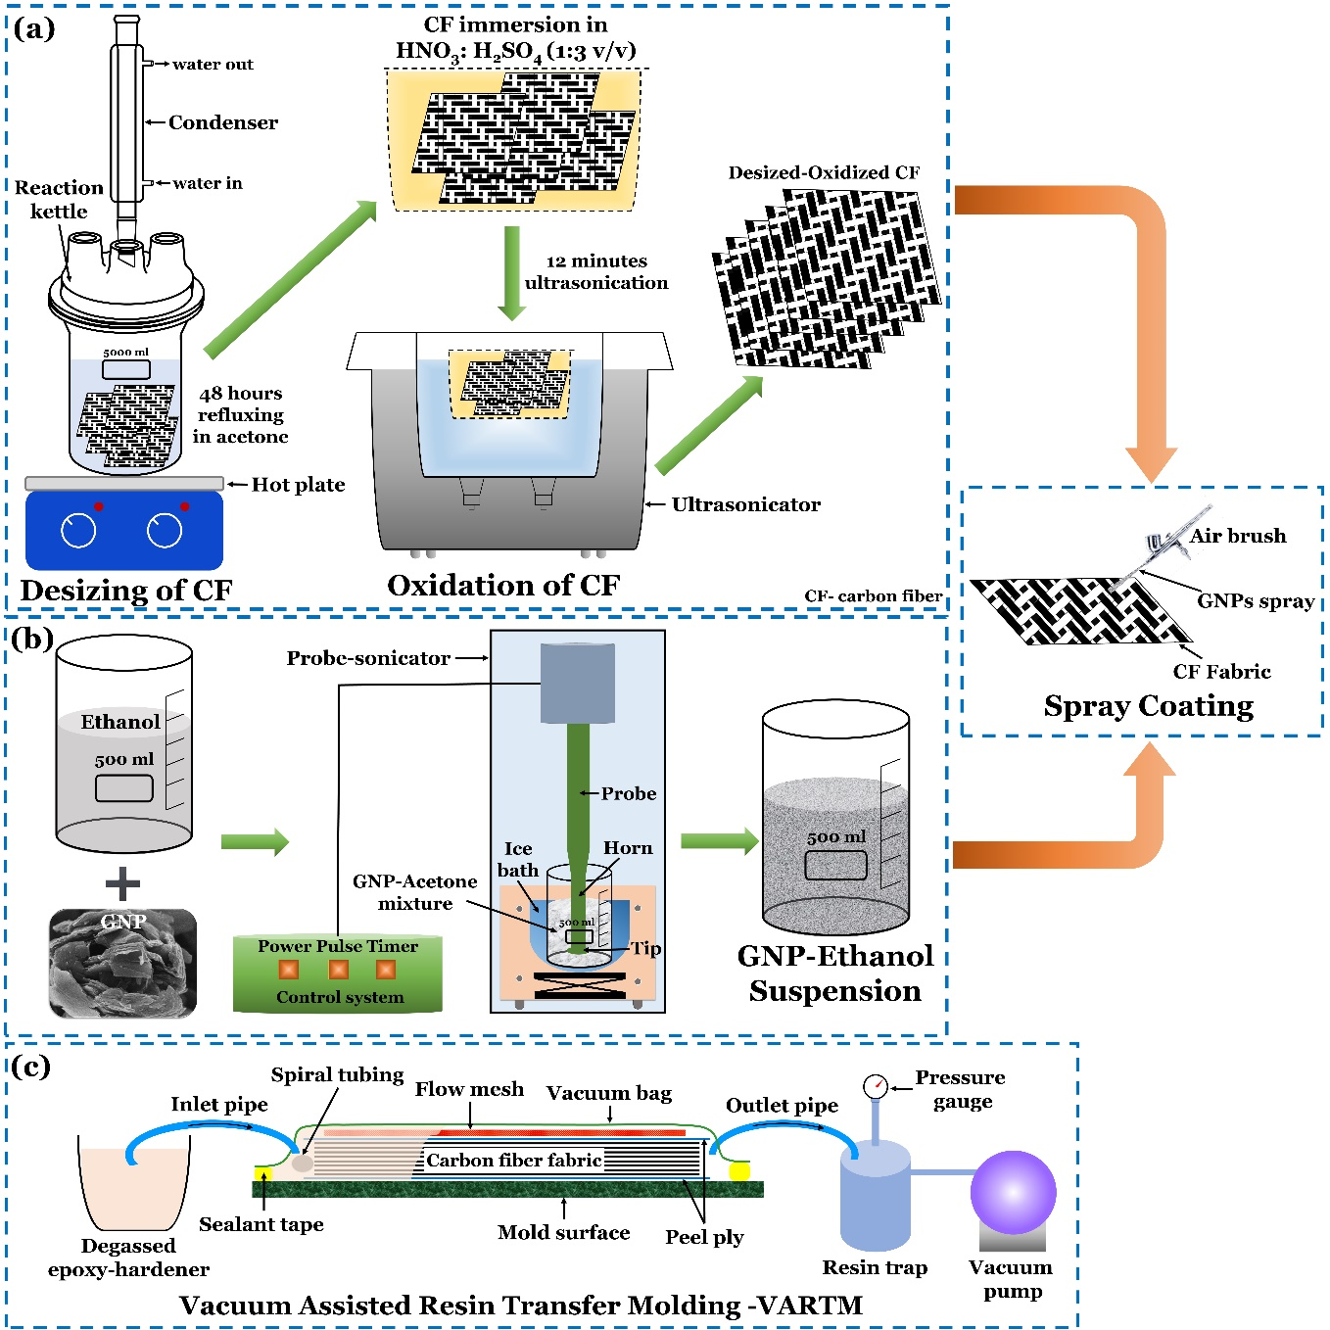
Fig. 1. Schematics of fabrication procedure of GNPs/carbon fibers/epoxy composites (a) desizing and oxidation of carbon fiber fabrics, (b) preparation of GNP-ethanol suspension by probe sonication; GNP spray coating on carbon fiber fabrics through an airbrush (subset) and (c) VARTM technique for laminate manufacturing
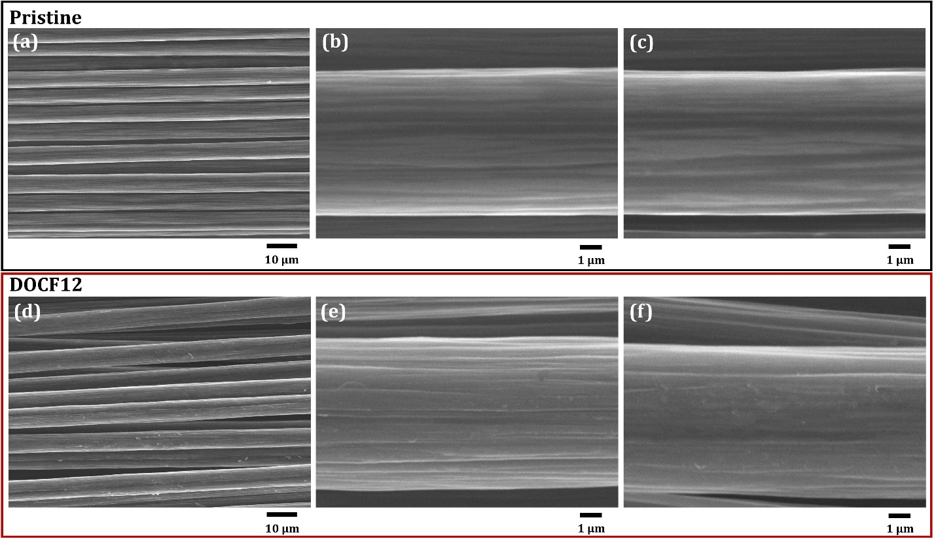
Fig. 2. SEM micrographs of carbon fibers (a-c) Pristine, (d-f) DOCF12
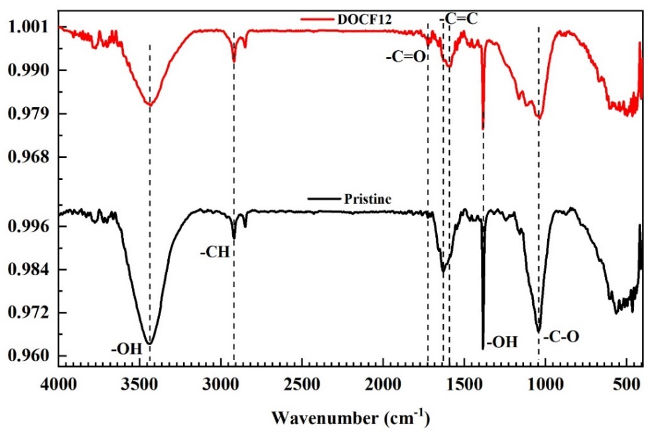
Fig. 3. FTIR spectra of carbon fibers (a) Pristine, (b) DCOF12
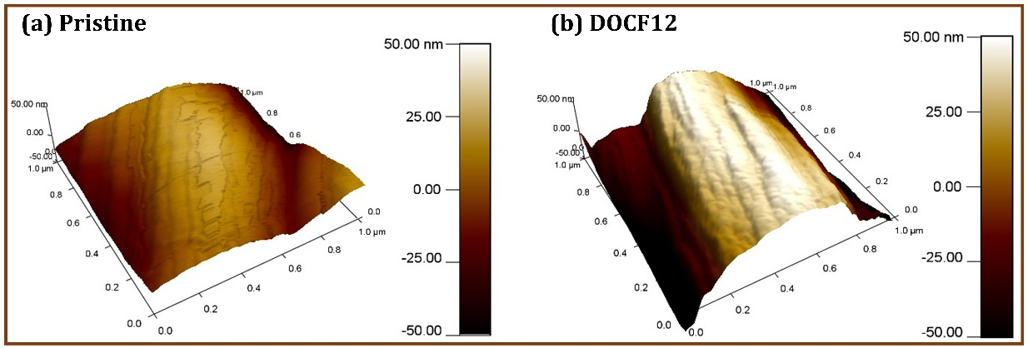
Fig. 4. AFM topography images of carbon fiber (1 μm × 1 μm) (a) Pristine and (b) DOCF12
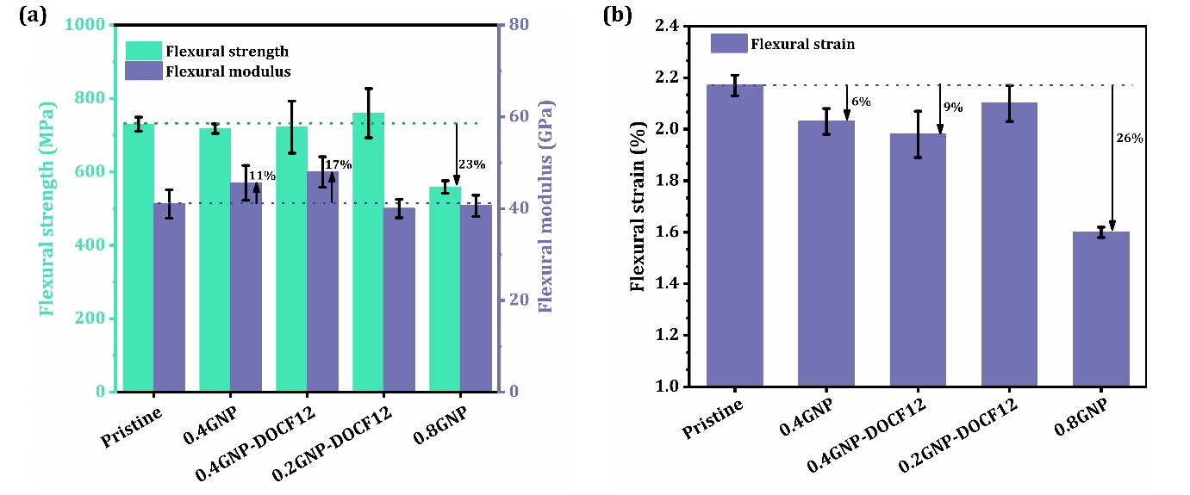
Fig. 5. Average flexural properties of GNP/CF/epoxy composite

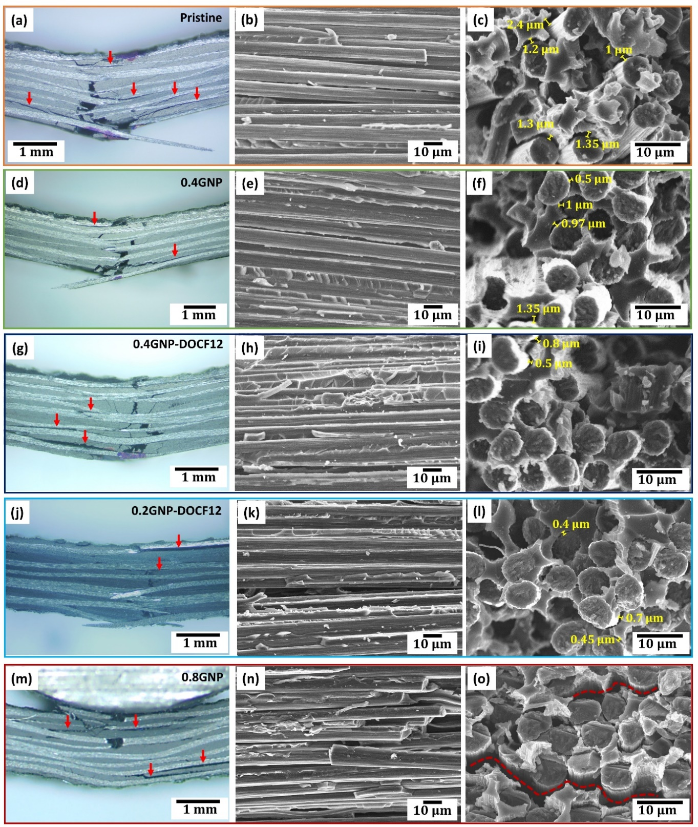
Fig. 6. Optical and SEM micrographs of specimens failed under flexural loading
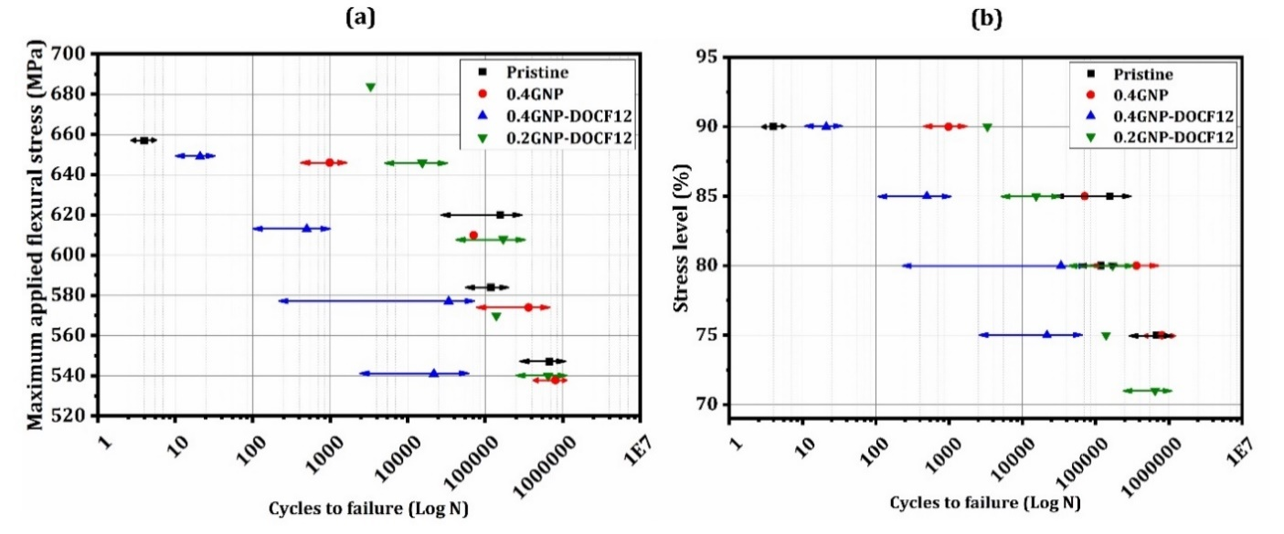
Fig. 7. Fatigue test results: (a) Maximum applied flexural stress S (MPa) versus cycles to failure (N) and (b) stress level in % (maximum applied stress/flexural strength) vs cycles to failure (N) for pristine, 0.4GNP, 0.4GNP-DOCF12 and 0.2GNP-DOCF12 laminate
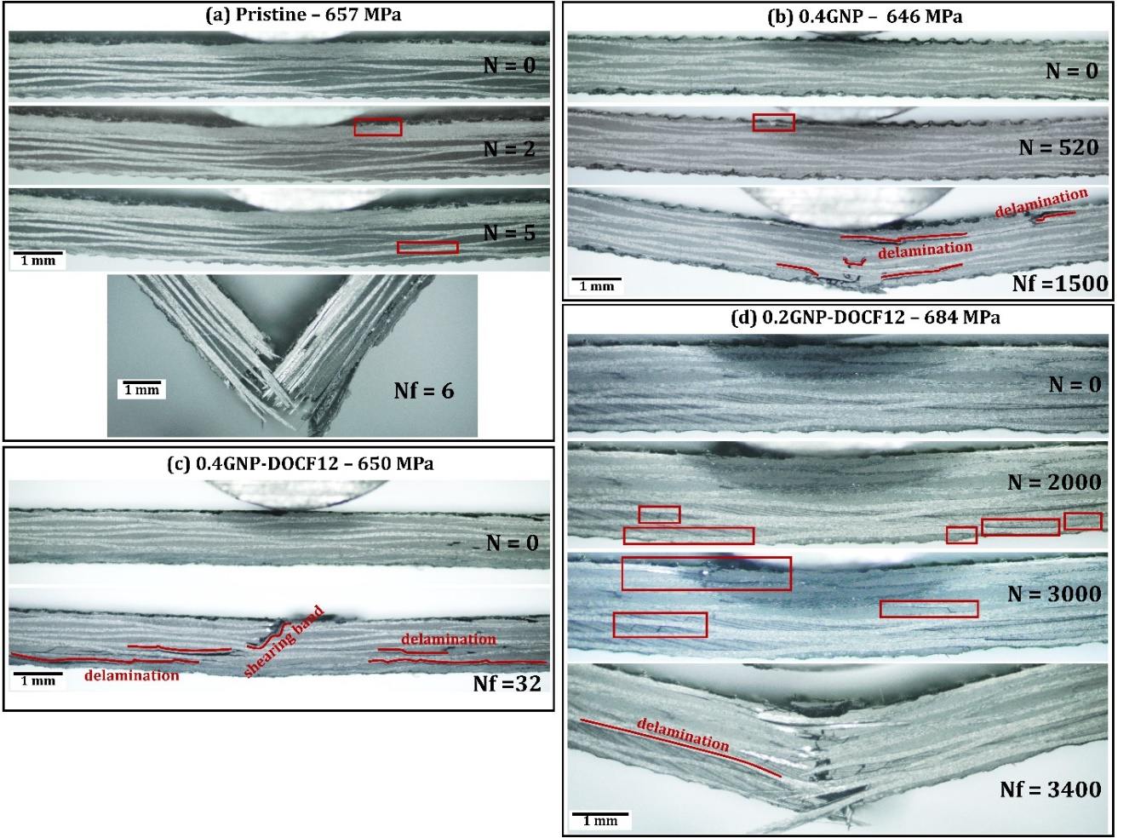
Fig. 8. Progressive damage evolutions of GNP/CF/epoxy laminates under flexural fatigue loading at highest stress level (646 – 684 MPa); N – cycles, Nf – cycles to fail
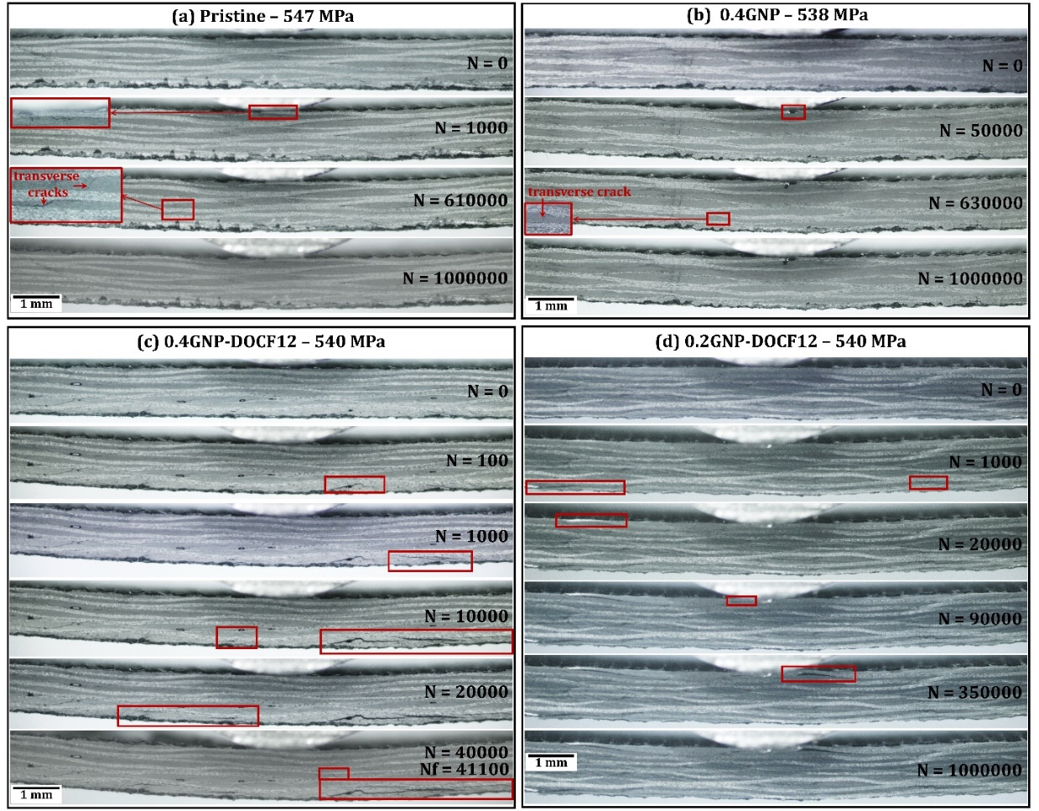
Fig. 9. Progressive damage evolutions of GNP/CF/epoxy laminates under flexural fatigue loading at lowest stress levels (538 – 547 MPa); N – cycles, Nf – cycles to fail
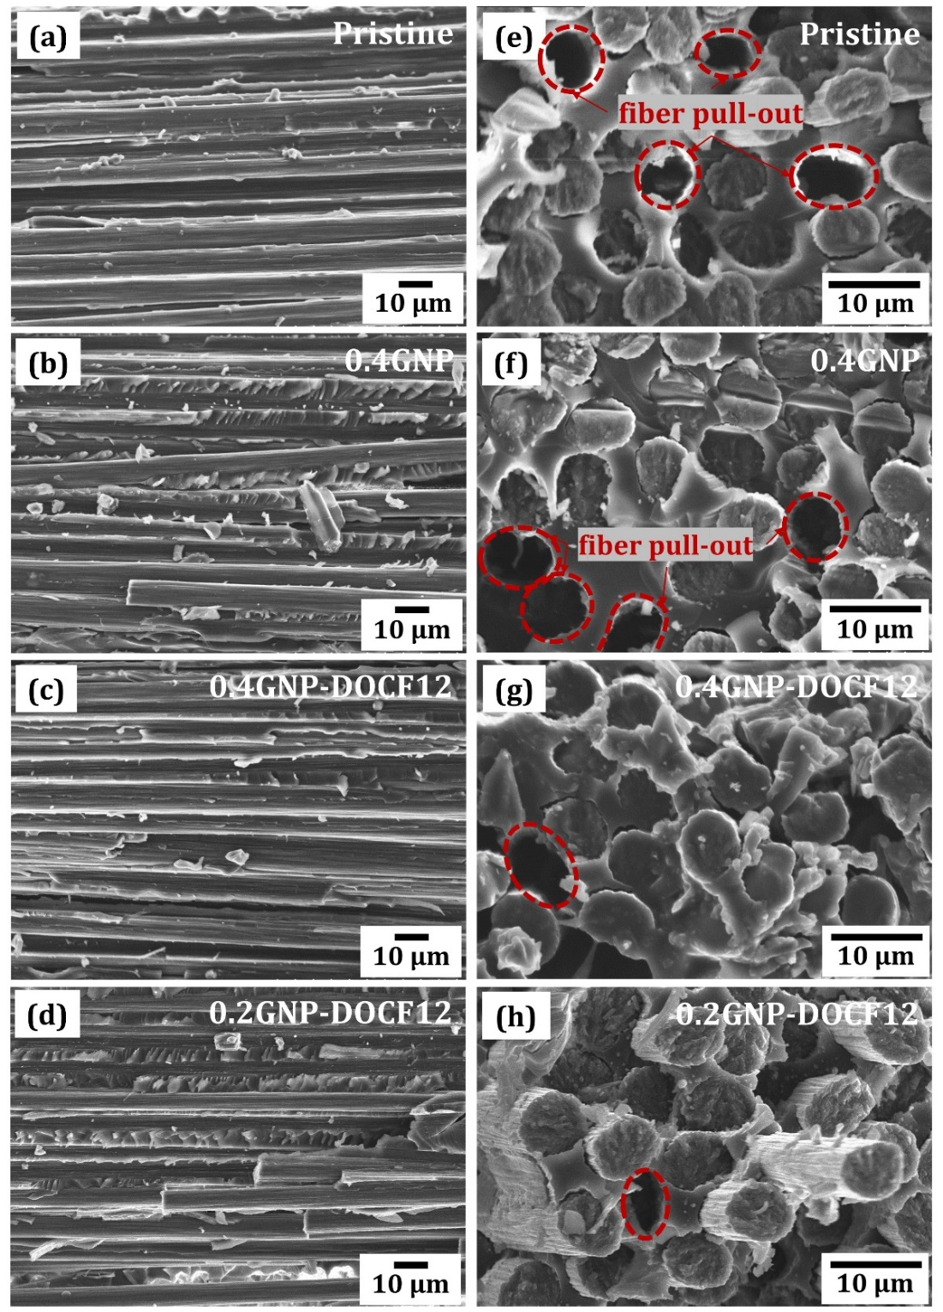
Fig. 10. SEM micrographs of failed specimens under bending fatigue loads at the highest stress level (a) Pristine, (b) 0.4GNP, (c) 0.4GNP-DOCF12 and (d) 0.2GNP-DOCF12 longitudinal section; (e) Pristine, (f) 0.4GNP, (g) 0.4GNP-DOCF12 and (h) 0.2GNP-DOCF12 cross-section
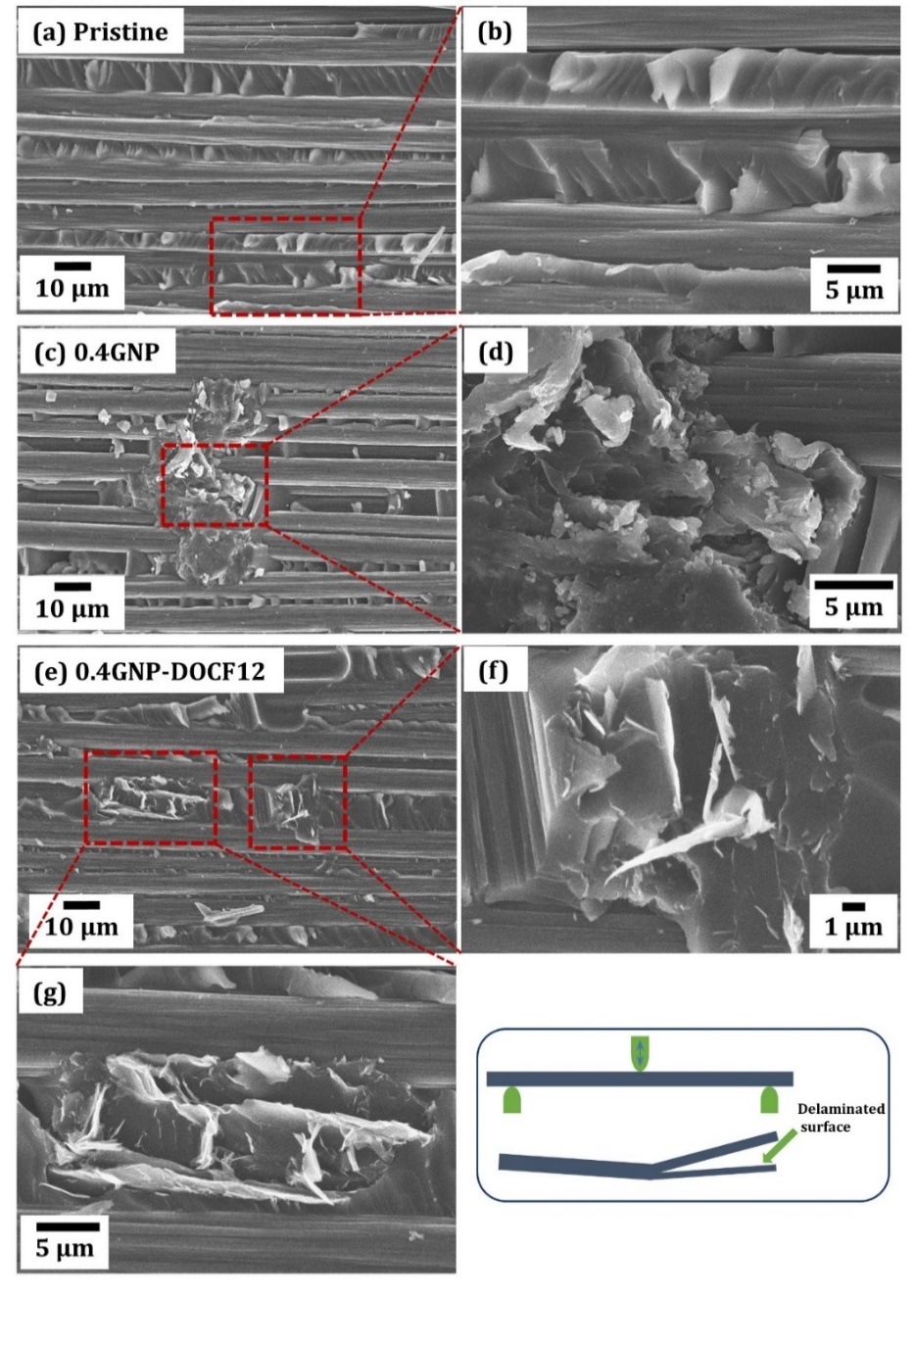
Fig. 11. SEM micrographs of delaminated specimens under bending fatigue loads at 610 – 620 MPa stress level (a-b) Pristine, (c-d) 0.4GNP and (e-g) 0.4GNP-DOCF12; inset shows the delaminated surface used to observe under SEM
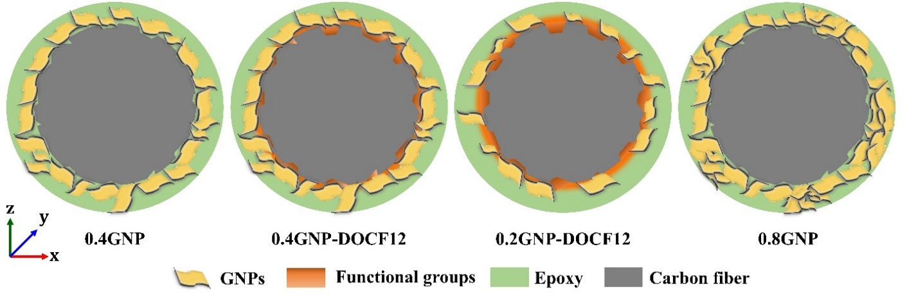
Fig. 12. Schematic of interfacial interactions in GNP/CF/epoxy laminates

