Tables & Figures
Table 1. Physiological and precipitate analysis of Nannochloropsis grown in 340-L bioreactor under improved lighting conditions*
 | Day 0 | Day 2 | Day 3
pH | 8.8 | 10.0 | 10.6
OD₇₅₀ | 1.0 | 1.2 | 1.1
Cell density  (x10⁶ cells/ml) | 37.0 | 48.8 | 48.2
Precipitate yield (g/L) | 0.012 | 0.20 | 0.03
* N. oceanica culture was collected from the second 340-L bioreactor experiment under improved lighting conditions (as described in Table S1).

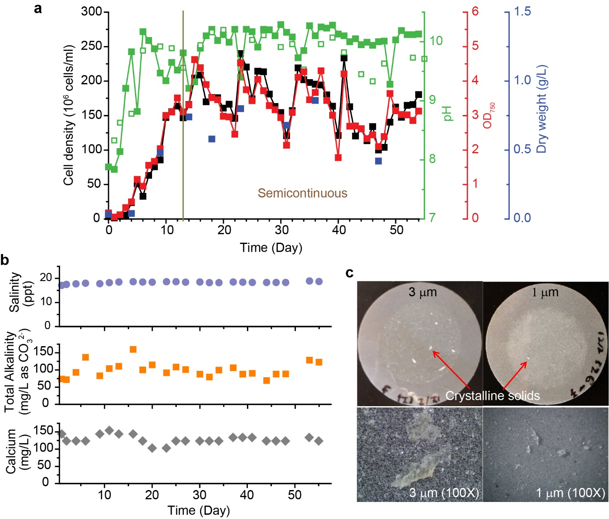
Figure 1. Growth and culture medium chemistry of Nannochloropsis oceanica IMET1 grown in the first experiment in horizontal culture chambers (Fig. S1) with f/2 media and 17 ppt salinity. (a) Cell density (10⁶ cells ml⁻², black), optical density (OD₇₅₀, red), biomass dry weight (g L⁻¹, blue), pH on the algae side (open green square) and pH on the clear side (solid green square) over time. The vertical bar at day 13 indicates the start of semicontinuous growth conditions. (b) Salinity (ppt, blue-gray), total alkalinity (mg L⁻¹ as CO₃²⁻), and calcium concentration (mg L⁻¹, gray) in the Nannochloropsis oceanica IMET1 culture fluid. Algae fluid samples were collected from the fluid side of the culture chamber for the measurements. (c) Precipitate collected on 3 µm and 1 µm polycarbonate filters. The lower panel shows the crystalline images on the 3 µm (left) and 1 µm (right) filters under a dissection microscope.

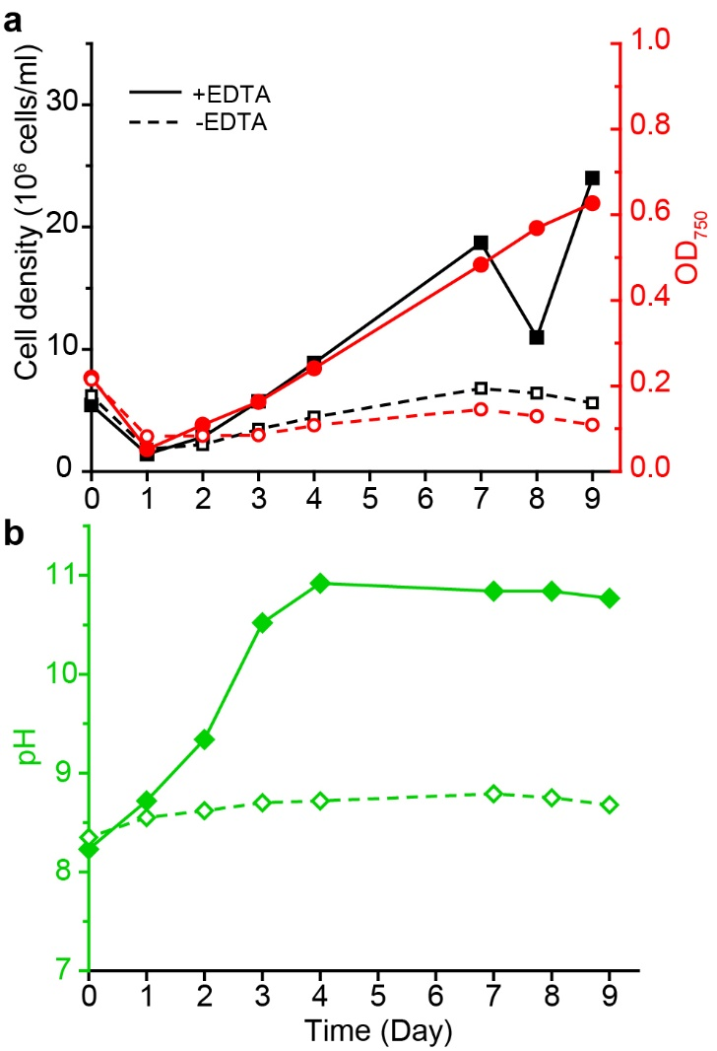
Figure 2. The culture of Nannochlorpsis oceanica IMET1 grown in 1-L bottles with f/2 media in the presence of EDTA (solid line and solid symbols) or the absence of EDTA (dashed line and open symbols). Measurements of (a) cell density (black squares) and optical density (red circles) and (b) pH (green diamonds) were made over time.

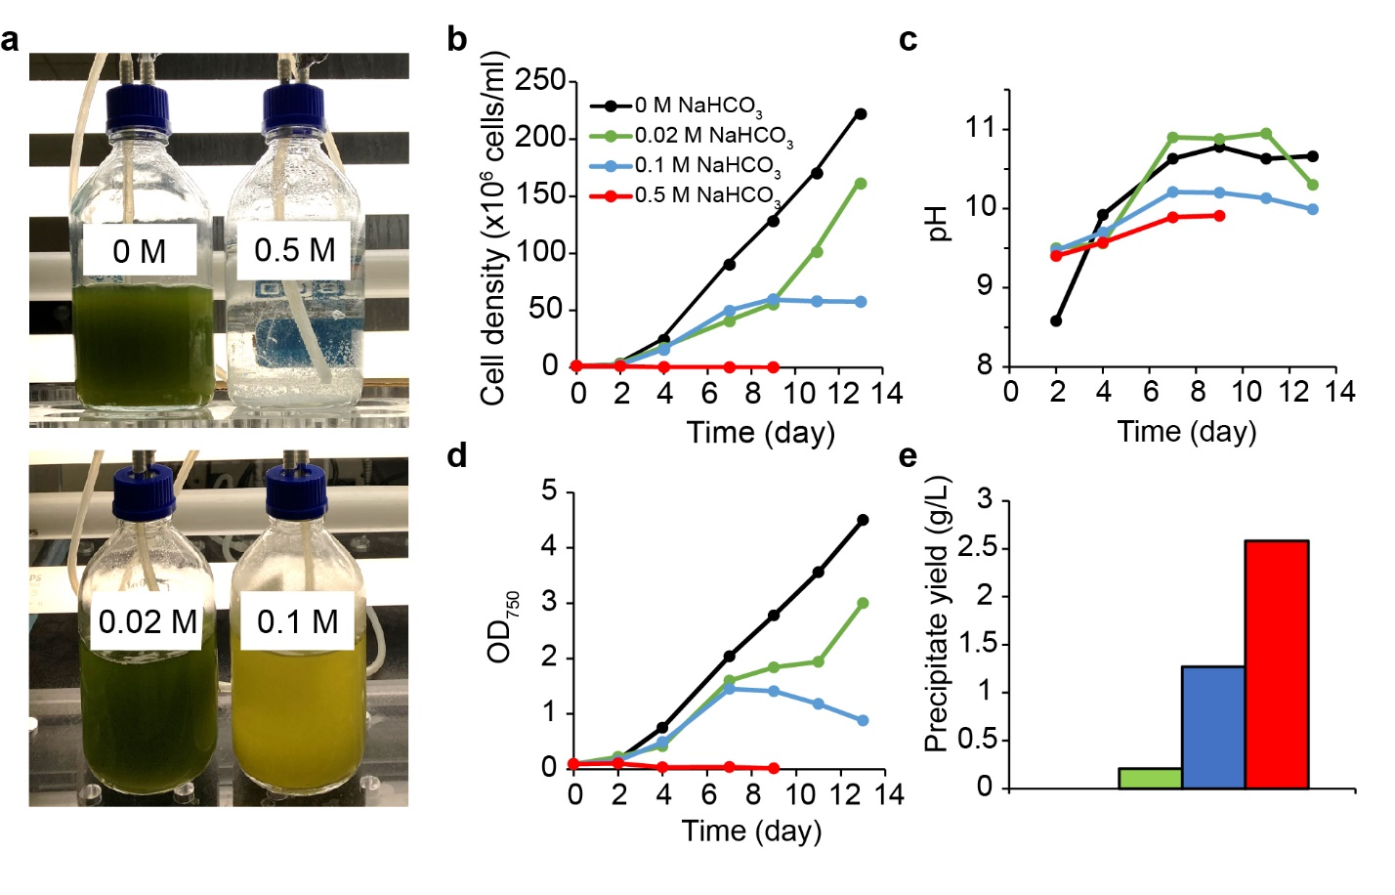
Figure 3. N. oceanica IMET1 cultures under ambient air and supplemented with sodium bicarbonate. (a) N. oceanica IMET1 were cultured in f/2 (17 ppt salinity) supplemented with 0, 0.02, 0.1 or 0.5 M sodium bicarbonate. (b) Cell density, (c) pH and (d) optical density of the cultures were followed over time. (e) Precipitates were collected and the yield was measured at day 13. The yield of the precipitates from the culture without sodium bicarbonate addition (0 M) was not detectable.

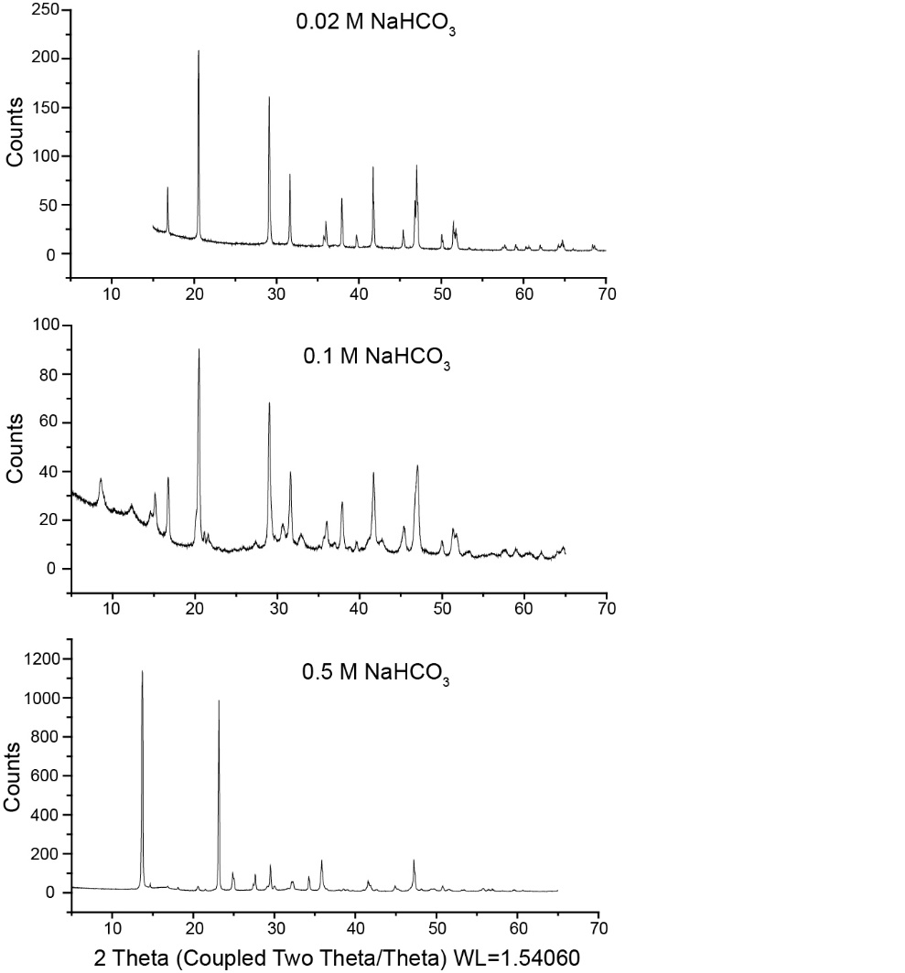
Figure 4. Compositions of precipitate crystalline from the culture supplemented with sodium bicarbonate were determined by XRD analysis. The crystalline in the precipitates collected from the culture supplemented with 0.02 M and 0.1 M sodium bicarbonate were 100% calcium carbonate (monohydrocalcite). The crystalline in the precipitates collected from the culture supplemented with 0.5 M sodium bicarbonate contained 96.5% magnesium carbonate (Nesquehonite) and 3.5% calcium carbonate (monohydrocalcite).

Figure 5. Relative abundance of closely-associated prokaryotic community (0.45 µm fraction – first ten bars) and free-living prokaryotic community (0.22 µm fraction – remaining ten bars) of N. oceanica IMET1. Sequencing was targeted on the V3/V4 hypervariable region of the 16S rRNA gene. The culture was grown over 14 days with ambient air in 1-L Pyrex bottles during the fourth experiment with sodium bicarbonate additions, with either no addition or 0.02 M addition of NaHCO₃. 16S rRNA gene sequences derived from chloroplasts have been removed bioinformatically.

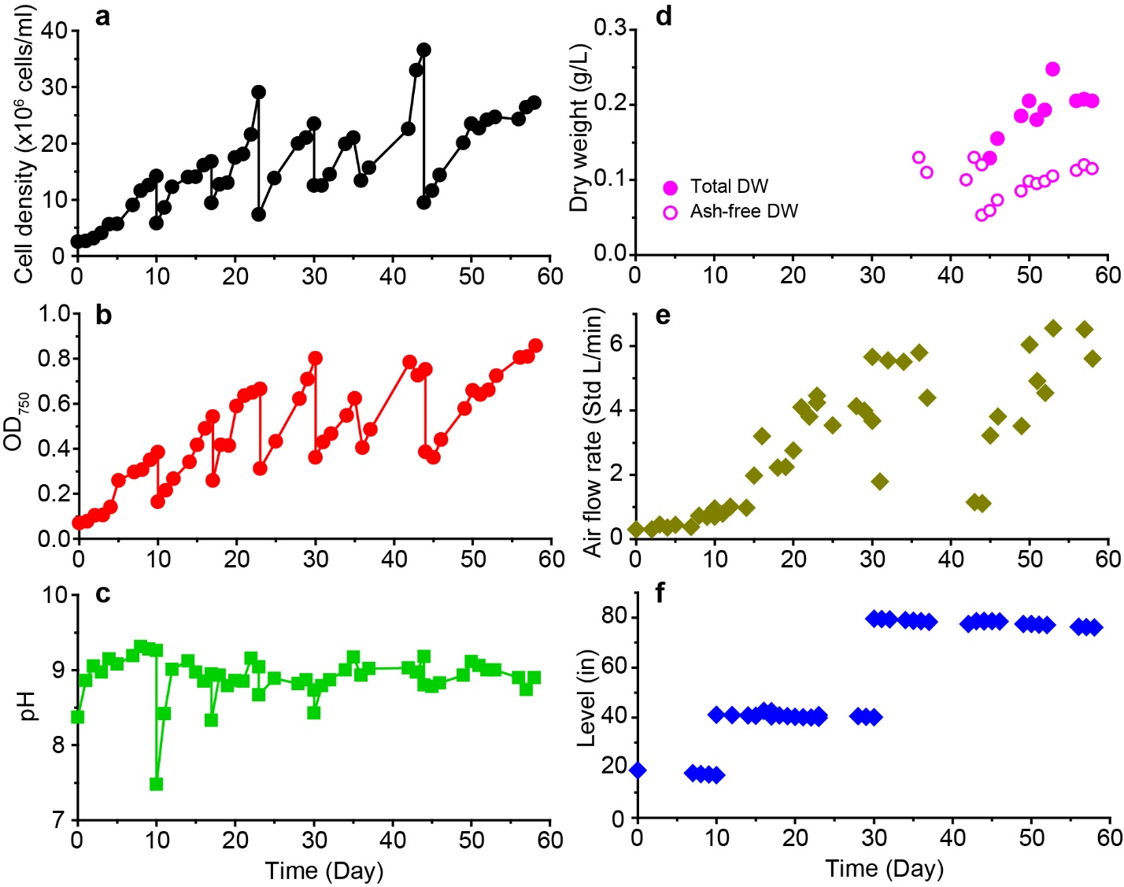
Figure 6. Growth and bioreactor indexes for the Nannochloropsis oceanica IMET1 culture in the first 340-L bioreactor experiment. (a) Cell density, (b) optical density, (c) pH, and (d) dry weight changes were measured to indicate growth. (e) Aeration intensity and (f) water level were recorded to monitor the operation of the bioreactor.

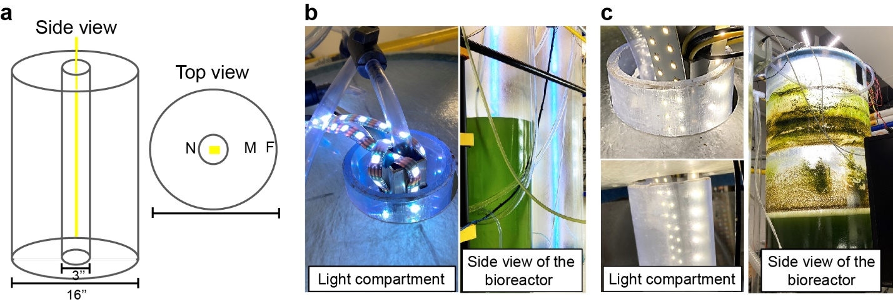
Figure 7. Improvement in lighting of the 340 L-bioreactor. (a) The bioreactor was designed as a 16-inch diameter cylinder with a 3-inch diameter cylindrical lighting compartment in the center. Both bioreactor and the lighting compartment were made of acrylic plastic. The illumination intensity in the bioreactor was measured near the lights (N), at the mid-point between the lights and outside wall (M), and the farthest point from the light source (F). The bioreactor was illuminated by (b) strips of low power LEDs or high power-LEDs. (c) The LED light strips were tied to an air-cooled square aluminum core in the middle of the light compartment.

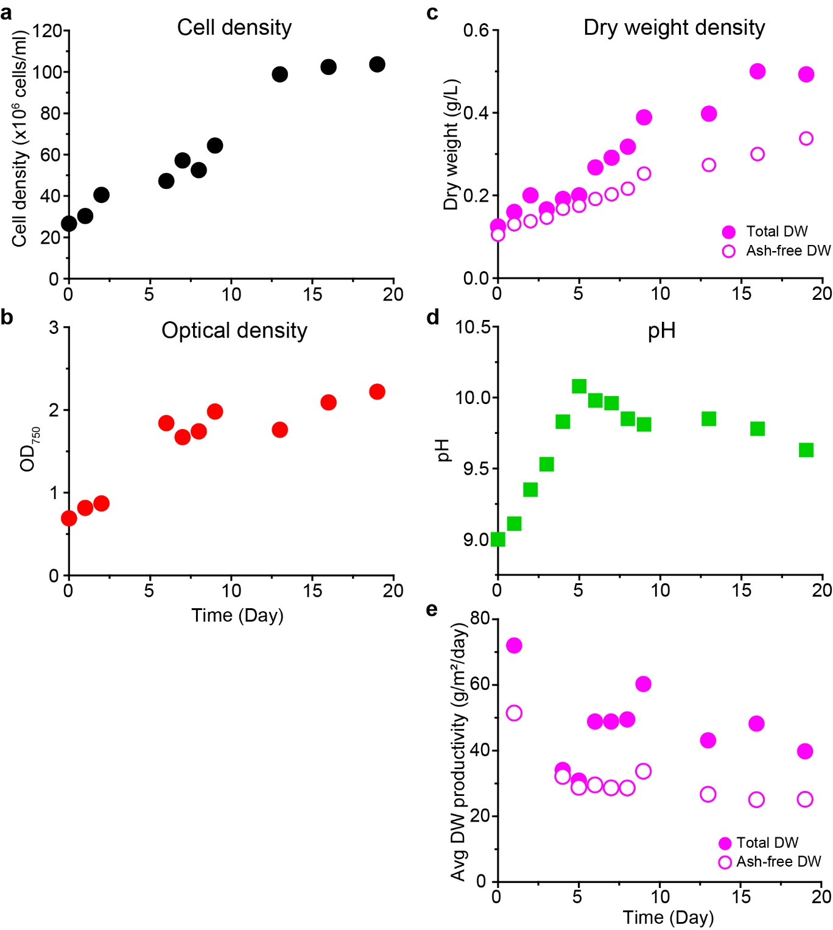
Figure 8. Growth indexes of a Nannochloropsis oceanica IMET1 culture in the second 340 L-bioreactor experiment under the improved lighting conditions. (a) Cell density (10⁶ cells ml⁻¹), (b) optical density at 750 nm (OD₇₅₀), (c) dry weight (g L⁻¹), (d) pH, and (e) dry weight productivity (g m⁻² d⁻¹) were measured to indicate the growth.
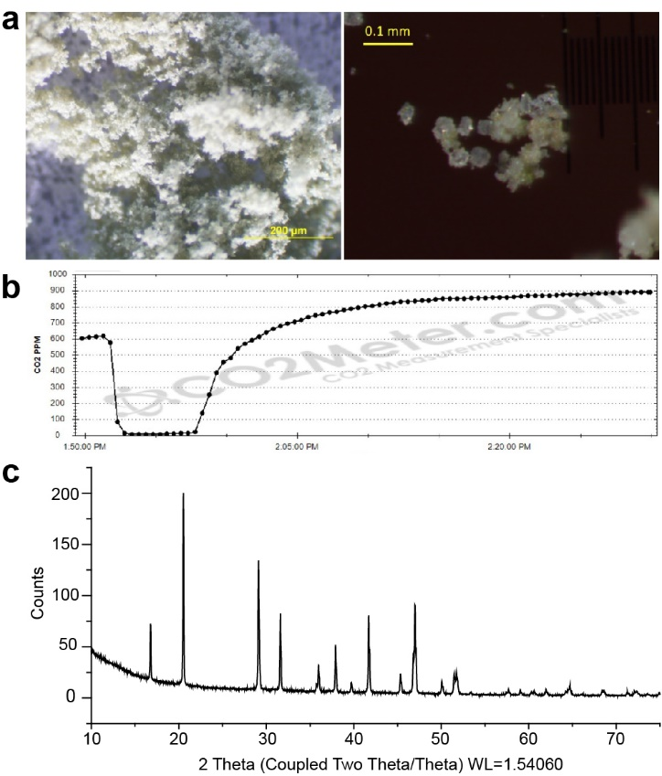
Figure 9. Examination of properties of the precipitate collected from the 340 L-bioreactor. (a) Images of the precipitate crystalline were taken under a dissection microscope. (b) The release of CO₂ over time when a sample of the precipitate was immersed in 90% phosphoric acid. Results indicated that >60% of the mass of the precipitates was carbonate (c) X-ray diffraction (XRD) analysis showed that the crystalline component of the precipitate was monohydrocalcite.

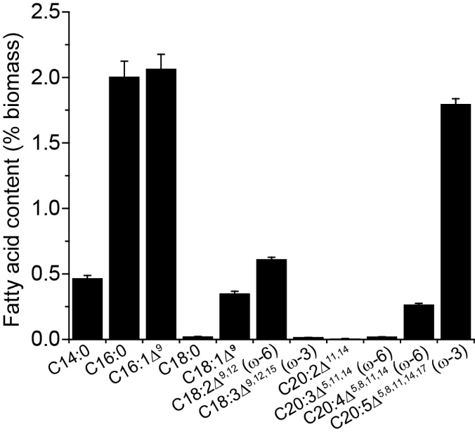
Fig. 10. Fatty acid profile of total lipids in Nannochloropsis biomass. Total lipids were extracted from three independent biomass samples that had been cultured in the second experiment of the 340 L-bioreactor. Data represents mean ± standard deviation (SD) from the three independent measurements.

