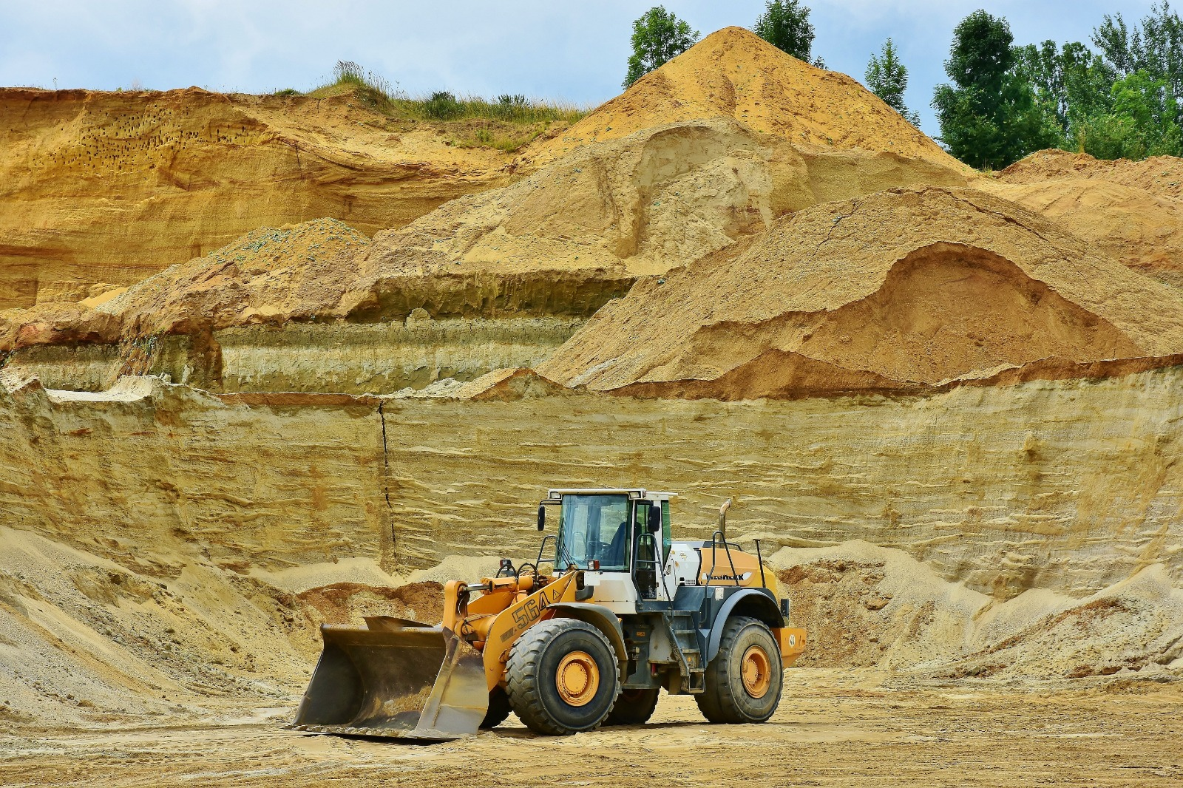

Settlment Puzzle: Fitting the pieces of Subsidence Together

Stress distribution and Settlement Analysis
Osmary Reguera

Table of Contents
Table of Contents i
Introduction 1
Chapter One: Introduction to Stress Distribution and Settlement Analysis 2
Vertical Stress 2
Horizontal Stress 3
Coefficient of Lateral Earth Pressure 3
Chapter Two: Contact Pressure and Settlement Profile 8
Chapter Three: Factors Influencing Stress Distributions 22
Soil Properties 22
Optimum Moisture Content and Maximum Dry Density 22
Dynamics of Geotechnical Engineering: Interplay of Geometry, Configurations, Load Characteristics, Groundwater Dynamics, and Construction Activities 28
Chapter Four: Techniques and Models to Analyze Stress Distributions: FEA 32
A World of Giants 32
Building Blocks of FEA 33
Exploring Finite Element Analysis (FEA) through Practical Application with Optum G2 Software 34
Chapter Five: The Boussinesq and Westergaard Solutions and Its Practical Applications in Geotechnical Engineering 41
The Boussinesq Equation 42
Foundation Shape 43
Predicting Stress and Settlement in Rectangular Foundations 44
Chapter Six: Calculation of Elastic Settlement of Shallow Foundations Under Different Conditions Based on the Theory of Elasticity 50
Chapter Seven: Mitigation Measures for Settlement 55
Conclusion 67
Bibliography 68

Introduction

As we embark on this exploration of geotechnical engineering, it is fascinating to acknowledge the role of cutting-edge technology in shaping our understanding of the subterranean realm. The journey into the buried depths of geotechnical engineering has been enriched by the collaboration with artificial intelligence. In the process of crafting this book, I turned to ChatGPT, a sophisticated language model developed by OpenAI, to delve deeper into the complexities of settlement, stress distributions, and the intricate dance between structure and soil.
ChatGPT served as a valuable companion in navigating the vast landscape of geotechnical knowledge. Its ability to generate coherent and insightful content allowed for a more nuanced exploration of historical milestones, modern challenges, and the promising horizons of geotechnical engineering. Together with the collective wisdom of engineers and researchers, the fusion of human ingenuity and artificial intelligence has illuminated the pages of this book with a unique perspective.
As we unravel the mysteries of settlement, it is a testament to the symbiotic relationship between human intellect and technological prowess. The resilience and determination inherent in geotechnical engineering are now complemented by the capabilities of AI, marking a new chapter in our quest to understand and conquer the silent yet powerful adversary that is settlement. In an era where collaboration between humans and machines paves the way for unprecedented insights, this book stands as a testament to the evolving landscape of knowledge creation

Chapter One: Introduction to Stress Distribution and Settlement Analysis

Settlement analysis and stress distribution are fundamental aspects of geotechnical engineering, a discipline focused on comprehending and managing the behavior of soil and rock materials under various loads and conditions. These concepts are pivotal in the design and construction of structures such as buildings, bridges, dams, and roads. In this chapter, we delve into the background and significance of settlement analysis and stress distribution within the realm of geotechnical engineering.

Definition of Stress in Geotechnical Engineering

Whenever soil and foundation systems are being analyzed and designed, stress is an important concept in geotechnical engineering. When soil or foundation materials are subjected to external forces or loads, stress refers to the internal resistance within their structures. To build structures upon soils and foundations that are stable and perform well, it is crucial to understand how soils and foundations deal with stress. Soil and foundation stress occurs in different forms, each with its own significance in geotechnical engineering.

Vertical Stress

As a result of the weight of overlying materials, structures, or loads, vertical stress is the force exerted vertically downward on a particular point or within a soil mass. An understanding of the behavior of soil under external forces requires this parameter. Vertical stress is directly related to the depth within the soil profile, as it increases with greater depth due to the cumulative effect of the weight of the soil or any superimposed structures. Vertical pressure also affects soil tests and geotechnical site studies. Piezometers and stress cells are tools used by geotechnical engineers to measure the vertical stress at various depths within the earth. These measurements yield useful information that may be used to construct foundations, analyze soil behavior, and judge the stability of slopes and embankments. This force is typically expressed in units of force per unit area, such as pounds per square foot (psf) or kilopascals (kPa).

Horizontal Stress

The pressure operating horizontally inside a soil mass or rock formation is referred to as horizontal stress in geotechnical engineering. This stress, which frequently operates perpendicular to vertical stress, can have a big impact on engineering projects, especially if lateral pressures or horizontal displacements must be taken into account. The self-weight of the soil or rock, external stresses placed on the surface, and geological conditions are some of the causes of horizontal stress.
The idea of lateral earth pressure, which is an immediate consequence of horizontal stress, is one of the fundamental concepts in geotechnical engineering. The force that soil or rock applies to retaining structures like retaining walls, abutments, and subterranean constructions is known as lateral earth pressure. It is a crucial factor to take into account while designing and analyzing the stability of these structures.
The kind of soil, density, depth, and loading conditions are only a few examples of the variables that might affect horizontal stress. The propensity of soil particles to transfer horizontal pressures effectively results in granular soils having a tendency to have higher horizontal stress. In cohesive soils, friction angle and internal cohesion of the soil can have an impact on horizontal stress.

Coefficient of Lateral Earth Pressure

The coefficient of Lateral Earth Pressure, often denoted as K, is a dimensionless coefficient that relates the horizontal stress ($σ_{h}$)to the vertical stress ($σ_{v}$)within a soil mass. It is a fundamental concept in soil mechanics and is used to analyze the lateral pressure exerted by soil against retaining walls, sheet piles, or other structures. The relationship between $σ_{h}$, $σ_{v}$, and K can be expressed as:
$$σ_{h}=K*σ_{v}$$
Whereas,
$$σ_{v}=γ*h$$

K varies based on the soil type (cohesionless vs. cohesive, for example) and the stress circumstances (active, passive, or at-rest, for example). K levels vary amongst different types of soil. For instance, K is frequently more than 1 in granular soils, suggesting that, under active conditions, the horizontal stress is greater than the vertical stress. In cohesive soils, K might be less than 1, suggesting that, under active conditions, the horizontal stress is lower than the vertical stress.
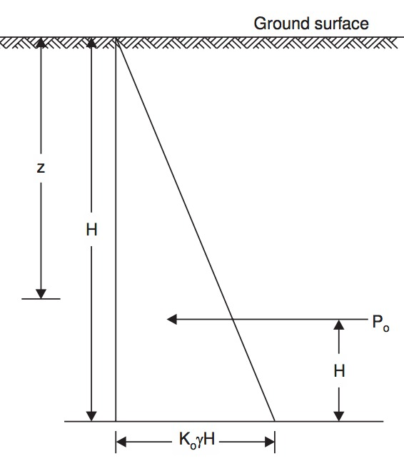
Figure 1: A sketch of stress conditions at a depth H. Image taken from “Geotechnical Engineering” by C. Venkatramaiah

Shear Stress and Its Implications in Geotechnical Engineering
Shear stress in geotechnical engineering arises when forces induce movement or deformation in one layer or section of soil or rock in relation to another. This phenomenon holds immense importance in soil mechanics and foundation engineering, significantly influencing the stability of slopes, retaining walls, and foundations. Typically measured in units like Pascals (Pa) or pounds per square foot (psf), shear stress plays a critical role in understanding and predicting the behavior of geological materials.
Shear stress manifests when lateral loads or pressures act parallel to a specific plane within the rock or soil mass. Exceeding the material's shear strength can lead to shear deformation and potential failure, resulting in consequences such as landslides, loss of bearing capacity, or foundation settlement. As such, comprehending shear stress is vital for engineers seeking to ensure the stability and resilience of various geotechnical structures.
Importance of Stress Distribution and Settlement Analysis
Beyond considerations of human safety and financial efficiency, stress distribution and settlement analysis carry environmental significance in the field of civil engineering and construction. Engineers, as stewards of the planet, navigate the intricacies of these concepts to mitigate ecological damage, prevent pollution, and ensure a sustainable future. This section delves into the environmental relevance of stress distribution and settlement analysis, emphasizing their role in preserving the precious resources of our world.
Landfills and Containment Structures
The application of stress distribution analysis is indispensable in the design of containment and landfill structures for several compelling reasons. It provides crucial insights into the mechanics of load distribution, enabling engineers to carefully examine how the substantial weight of waste materials distributes strain onto the underlying liner and foundation structures. This comprehensive examination is essential to ensure that the liner and foundation can support these substantial loads without risk of breaking or structural collapse.
Integrity of Liner System
Stress distribution analysis is paramount for determining the integrity of the liner system, comprising elements such as geomembranes, geosynthetic clay liners, and compacted clay liners. These elements serve as the primary barrier between waste and the environment. Stress analysis assesses the liner's resistance to rips, tears, and shear failures when subjected to pressure from the landfill's contents. It ensures that the liner continues to offer a robust defense against pollution.
Foundation Stability
Furthermore, stress distribution analysis significantly enhances the stability of the foundation. Engineers utilize this analytical method to ascertain if the foundation soils can support the landfill or containment building. By understanding how these soils will respond to applied loads, engineers can design suitable foundation elements like piles or footings to evenly distribute these loads, reducing the likelihood of settlement and ensuring the overall structural soundness of the system.
Dams
Dams, colossal feats of civil engineering with diverse functions, necessitate meticulous attention to stress distribution and settlement analysis for their long-term stability, performance, and safety. Stress distribution analysis protects the integrity of the foundation, preventing foundation failure and potential dam collapse by analyzing how the weight of the dam is distributed to the underlying bedrock or soil.
Seismic Considerations
Due to the vulnerability of dams to seismic pressures, stress distribution analysis is crucial for modeling earthquake scenarios, ensuring that damaging stress concentrations do not compromise the dam during seismic events. This analysis is also vital for identifying the distribution of hydraulic forces, as dams constantly contend with the pressure of impounded water. Understanding these forces is essential for guaranteeing the dam's resilience against constant hydraulic pressure without deformation or failure.
Settlement Analysis for Uniformity
Settlement analysis is crucial for providing equal settling along the length and width of the dam, avoiding differential settlement that can lead to tilting and cracking, jeopardizing structural integrity. Anticipating and managing settlement is essential for preserving homogeneity and preventing issues such as "reservoir-induced seismicity" when the dam first fills with water due to the additional weight.
Soil Erosion
Settlement analysis and stress distribution analysis play a pivotal role in preserving ecosystems and protecting natural resources. Uneven settling of structures can alter natural water and soil flow patterns, accelerating soil erosion and negatively impacting aquatic life. Rigorous settling study and precise foundation construction can mitigate these risks, ensuring that constructions interact harmoniously with the environment and safeguarding the integrity of natural landscapes.
Water Quality and Floodplain Management
Settlement and stress analysis are essential for maintaining water quality, preventing groundwater flow pattern disruptions that could lead to groundwater pollution. Contaminated groundwater poses risks to human health and aquatic habitats, making thorough settlement study crucial for preventing obstruction of areas where groundwater recharge occurs.
Floodplain Management
In floodplain management, the significance of settlement and stress analysis becomes evident in preventing devastating flooding. Poorly designed constructions can alter river flow patterns and increase the risk of flooding. Engineers can design flood control structures like levees and dams, resistant to hydraulic forces, by evaluating stress distributions. This comprehensive approach ensures the ecological health of flood-prone areas while minimizing environmental impact.

Chapter Two: Contact Pressure and Settlement Profile

The stability and durability of structures heavily rely on the foundations, making a comprehensive comprehension of their settlement behavior crucial in the field of civil engineering. Settlement may be roughly categorized into three distinct classifications: elastic settlement (also known as quick settlement), secondary consolidation settlement, and primary consolidation settlement. This chapter examines the complex interplay between the flexibility of foundations, the characteristics of the supporting material, and the distribution of contact pressure. It investigates how these aspects combined impact the process of settlement.
Elastic settlement, often known as Se, refers to the first reaction of the soil when subjected to a load, without any changes in its moisture content. It is an essential element of the comprehensive settlement, encompassing both primary consolidation settlement (Sc) and secondary consolidation settlement (Ss). The extent of elastic settlement is closely linked to the flexibility of the foundation and the characteristics of the underlying material.
The practical underpinnings diverge from the ideal circumstances delineated in the examination of settlement associations. Foundations are often characterized by limited flexibility and are commonly situated under the surface of the earth. However, it is informative to analyze the dispersion of contact pressure and settlement profiles within the context of these idealized circumstances.
The scenario under consideration involves a base that is completely flexible and is supported by elastic material, as seen in Figure 2. When exposed to a load that is evenly distributed, the pressure at the contact point remains consistent, leading to the formation of a sagging profile. In contrast, a foundation that exhibits perfect rigidity and is subjected to a comparable load, as illustrated in Figure 3, has consistent settlement with a redistribution of contact pressure. The applicability of these settlement profiles and contact pressure distributions is limited to soils that exhibit a consistent modulus of elasticity throughout their depth.

Figure 2: Elastic settlement profile and contact pressure in clay - flexible foundation.
Figure 3: Elastic settlement profile and contact pressure in clay – rigid foundation. Image taken from Braja M. Das

The behavior exhibited by foundations on various soil types introduces additional intricacies to the mechanics of settling. In the scenario involving cohesionless sand, where the modulus of elasticity exhibits an increasing trend with depth, and the absence of lateral confinement affects settlement characteristics, the foundation's reaction is particularly unique. Figures 4 and 5 depict the contact pressure and settlement profiles, respectively, for a flexible and stiff foundation on sand subjected to homogenous loads. The deflection curve of a flexible foundation displays a concave downward profile as a result of the lateral pressure exerted by the surrounding sand particles.

Figure 4: Elastic Settlement Profile and Contact Pressure Distribution: San d- Flexible Foundation

Figure 5: Elastic Settlement Profile and Contact Pressure Distribution: Sand - Rigid Foundation.

Fundamentals of Consolidation Settlement
It is essential to comprehend how soils behave when subjected to external stresses in order to construct long-lasting and sturdy structures. Terzaghi's consolidation spring analogy has made a substantial contribution to the comprehension of this phenomenon. As we start an examination of this parallel, it becomes evident that the necessity originates from the complexities inherent in the consolidation process of soils. Engineers and students frequently rely on Terzaghi's analogy as a beneficial tool in order to gain a comprehensive understanding of the intricate nature of soil action throughout the process of consolidation. This comparison provides a simplistic yet thorough depiction, enabling a more fundamental understanding of the process by which soils undergo deformation and settlement over time due to external forces. By exploring the fundamental concepts behind this parallel, we not only get a theoretical understanding of soil mechanics but also establish a practical framework for interpreting real-life situations in the field of geotechnical engineering. Hence, delving into Terzaghi's consolidation spring analogy holds significant importance beyond its academic value. It serves as a pivotal undertaking in unraveling the intricacies of soil behavior, thereby guaranteeing the durability and steadfastness of the structures we conceive and construct.
Terzaghi's consolidation theory offers a thorough conceptual framework for comprehending the response of saturated soils under the influence of stress alterations. Within the framework of this theoretical framework, it is seen that the behavior of sandy soils, which are characterized by a high degree of permeability, exhibits notable distinctions when compared to clayey soils, which possess a lower hydraulic conductivity. When subjecting a saturated sandy soil layer to an increase in stress, there is an abrupt and instantaneous rise in pore water pressure. The rapid drainage properties of sandy soils result in the swift dissipation of excess pore water pressure, which in turn causes both elastic settlement and consolidation to occur simultaneously. The process of pore water drainage is followed by a decrease in the amount of soil mass, leading to settlement.
Conversely, in the case of a compressible clay layer, the application of increased stress results in quick elastic settlement. Nevertheless, as a result of the considerably reduced hydraulic conductivity of clay in comparison to sand, the surplus pore water pressure that arises during the process of loading progressively dissipates over a prolonged duration. Consequently, the volumetric alteration that occurs, sometimes referred to as consolidation, has the potential to last for an extended period beyond the initial elastic settling. The settlement resulting from consolidation in clayey soils can exceed the immediate elastic settlement by several magnitudes.
The utilization of Terzaghi's spring-cylinder model serves as a conceptual framework for comprehending the time-dependent deformation of clayey soil that is saturated and subjected to stress. The system comprises of a cylindrical container containing water, a piston that is both frictionless and waterproof, and a centrally located spring. In the first stage, the valve is closed subsequent to the application of a load to the piston. This action results in the transfer of the full load to the incompressible water, therefore preventing any instantaneous spring deformation. The quantification of surplus hydrostatic pressure during this period can be achieved by the utilization of a particular equation.
When the valve is opened, water is discharged, resulting in a decrease in excessive hydrostatic pressure and an augmentation in spring compression. The aforementioned procedure persists until a state of equilibrium is attained, whereby the surplus hydrostatic pressure diminishes to zero. The spring-cylinder model is subsequently associated with the response of saturated clayey soil under incremental stress loading. The conceptual model facilitates the understanding of the intricate relationship between water drainage, excessive pore water pressure, and soil deformation, providing valuable insights into the time-dependent consolidation mechanism in clay-rich soils.
DIY Terzaghi’s Consolidation Spring
The recreation of Terzaghi's consolidation spring analogy is a highly helpful undertaking for anyone aiming to get a thorough comprehension of soil mechanics within the field of geotechnical engineering. Participating in this procedure facilitates a multisensory encounter that surpasses abstract explanations, presenting several significant advantages.
Initially, the practical implementation of the spring analogy facilitates a more profound engagement with the theoretical principles. By subjecting a compressible substance, such as modeling clay or playdough, to a physical stress and subsequently monitoring its corresponding reaction, one is able to establish a connection between abstract ideas and tangible experiences. The utilization of a kinesthetic technique serves to enhance the overall learning process, so facilitating a more effective retention of information and fostering a heightened sense of intuition.
Additionally, the process of replicating the spring analogy facilitates the examination of several variants and conditions. By modifying variables such as the size of the load, qualities of the soil, or the duration of the applied load, a more comprehensive comprehension of the consolidation process may be achieved, allowing for a detailed analysis of the impact of many elements. The activity promotes the exploration of multiple approaches and the use of analytical reasoning, so facilitating a deeper understanding of the many manifestations of soil dynamics across varying circumstances.
Recreating a physical experiment to model Terzaghi's consolidation theory involves a simplified version of the spring-cylinder model, which serves as an analogy for the consolidation process in saturated clayey soil. Here's a step-by-step guide to help you recreate this experiment conceptually:
Materials Needed:
- A transparent cylindrical container

- A cylindrical coil spring
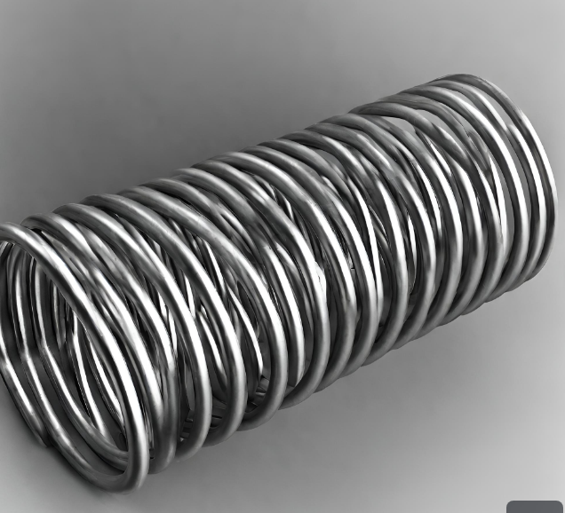
- An small object that will be placed on top of spring and will act as a load/weight
- A valve or stopper
Experiment Setup:
- Assemble the Model:
  - Place the spring at the center of the cylindrical container.
  - Fill the container with water to simulate saturated soil.
- Introduce Stress:
  - Apply a load (representing stress) to the water in the container using the piston or plunger.
  - The load is initially borne by the incompressible water, and the spring does not deform.
- Close the Valve:
  - Close the valve or use a stopper to simulate a closed drainage system.
  - This represents the initial phase where excess pore water pressure builds up.
- Measure Excess Hydrostatic Pressure:
  - Attach a pressure gauge to the container to measure excess hydrostatic pressure.
  - Record the initial pressure as per the equation provided in the theoretical context.
- Open the Valve:
  - Simulate water drainage by opening the valve.
  - Allow water to flow out of the container, representing the gradual dissipation of excess pore water pressure.
- Observe Spring Deformation:
  - As water drains and excess pore water pressure decreases, observe the deformation of the spring.
  - The spring represents the compressibility of the soil, and its deformation corresponds to settlement.
- Record Observations:
  - Record the changes in excess hydrostatic pressure over time.
  - Note the correlation between water drainage, spring deformation.
- Reach Equilibrium:
  - After some time, as excess pore water pressure becomes zero and the system reaches equilibrium, record final observations.
Analysis:
- Analyze the relationship between the applied stress, excess pore water pressure, and the settlement of the spring.
- Compare the behavior of the model with the theoretical concepts of Terzaghi's consolidation theory.

Below are figures of how the experiment should look like:

Figure 6: As see above, this how the experiments begins. The valve is closed and the load is not applied yet.

Figure 7: As seen above, the valve is closed and the load is applied
Figure 8: The valve is opened and we can see the water dissipate. Here, the spring is carrying more of the load.

Figure 9: As seen above, the experiment has now reached the point of equilibrium. The majority of load is now carried by the spring (represents soil) and the water carries nearly zero.

Terzaghi’s One-Dimensional Consolidation Theory
Terzaghi's seminal 1925 theory on one-dimensional consolidation for saturated clay soils represented a crucial advancement in soil mechanics, providing a foundational understanding of the rate of consolidation. Central to Terzaghi's formulation were six key assumptions, elucidated further by Taylor in 1948.
The first assumption asserts the homogeneity of the clay-water system, presupposing uniform properties throughout the soil mass under consideration. This assumption simplifies the mathematical modeling of the consolidation process, allowing for a tractable analysis of the system's behavior. Building upon this homogeneity, the second assumption posits complete saturation, implying that all void spaces within the clay are filled with water. This simplification facilitates the mathematical treatment of the consolidation, streamlining the representation of water movement within the saturated clay.
Negligible compressibility of water constitutes the third assumption, grounded in the understanding that water, under typical soil loading conditions, can be treated as essentially incompressible. This assumption aligns with practical considerations and contributes to the mathematical efficiency of the theory. Terzaghi's fourth assumption involves the negligible compressibility of soil grains, while acknowledging their ability to rearrange. This nuanced consideration recognizes that, while the grains themselves may not significantly compress, their rearrangement is integral to the overall consolidation process.
The fifth assumption delineates unidirectional water flow, occurring solely in the direction of compression. This directional specificity simplifies the analysis by focusing on the consolidation process along a single axis, aligning with the one-dimensional nature of the theory. The sixth and final assumption asserts the validity of Darcy's Law, a fundamental principle describing fluid flow through porous media. By assuming the applicability of Darcy's Law, Terzaghi's theory grounds itself in established principles of fluid dynamics, enhancing the theoretical framework's practical utility in describing water movement within the soil during consolidation.
These interconnected assumptions collectively form the theoretical basis of Terzaghi's one-dimensional consolidation theory. While acknowledging the simplifications inherent in these assumptions, the theory provides a robust and pragmatic framework for understanding the consolidation behavior of saturated clay soils under specific conditions. It laid the groundwork for subsequent developments in soil mechanics and remains a cornerstone in the study of soil behavior.
Terzaghi's One-Dimensional Consolidation Theory is a fundamental concept in geotechnical engineering that provides insights into the deformation of saturated soils under applied loads. The theory assumes one-dimensionality, where soil deformation and water flow occur primarily in the vertical direction, and considers fully saturated conditions. The governing equation of the theory is expressed as:

$$\frac{∂^{2}e}{∂t^{2}}=\frac{c_{v}}{1+e}*\frac{∂^{2}σ_{v}}{∂z^{2}}$$

Here, $\frac{∂^{2}e}{∂t^{2}}$​ represents the acceleration of settlement, $c_{v}$​ is the coefficient of consolidation, e is the void ratio, t is time, and $\frac{∂^{2}σ_{v}}{∂z^{2}}$ is the vertical stress gradient. The coefficient of consolidation, $c_{v}$, characterizes the soil's ability to transmit water under load.
To better understand the time-dependent behavior of saturated soils, the time factor (T) is introduced, defined as:

$$T=\frac{c_{v}t}{{\left(H\right)}^{2}}$$

Here, t represents time, and H is the thickness of the soil layer. This time factor is crucial in predicting the rate and extent of settlement over time.
The consolidation process begins with the application of a load to the soil, resulting in an immediate increase in pore water pressure. The excess pore water pressure (Δu) dissipates over time, initiating water flow within the soil. This flow, coupled with the compression of the soil matrix, leads to deformation and settlement of the soil layer.
Terzaghi's One-Dimensional Consolidation Theory is instrumental in estimating settlement and assessing the time required for consolidation in soil layers subjected to loads. The equations provide a quantitative framework for predicting settlement and analyzing the time-dependent behavior of saturated soils, forming a foundational concept in geotechnical engineering.

Chapter Three: Factors Influencing Stress Distributions

Soil Properties
Soil behavior is a multifaceted concept that delves deep into the dynamic and intricate nature of the Earth beneath our feet. Soil exhibits a level of unpredictability compared to the relatively consistent and well-understood behaviors of materials like steel and concrete. Several factors contribute to the variable nature of soil. Let’s explore some factors that influence how stress distributes in soil when a load is applied.

Optimum Moisture Content and Maximum Dry Density
Moisture content stands as a linchpin in the intricate relationship between soil behavior and stress distribution, exerting a profound influence on the mechanical properties of soil when subjected to external loads. The transformative impact of moisture is particularly pronounced in fine-grained soils like clay, where the interplay between water and soil particles brings forth distinctive characteristics.
As moisture content escalates, the nature of soil undergoes a discernible shift. In the realm of geotechnical engineering, this metamorphosis is pivotal. The cohesion of the soil, an expression of the particles' ability to adhere to one another, becomes increasingly conspicuous as moisture levels rise. This phenomenon is particularly noteworthy in fine-grained soils, where water fosters a cohesive environment among particles, enhancing their capacity to stick together. This enhanced cohesion has implications for stress distribution, as it contributes to the soil's overall strength and stability.
However, this relationship is not without its nuances. While moderate moisture content enhances cohesion and, consequently, soil strength, there exists a tipping point. Excessive saturation can lead to a loss of strength, rendering the soil vulnerable to deformations and failure. This delicate balance is encapsulated in the concept of "optimum moisture content" (OMC), a critical parameter in soil mechanics and geotechnical engineering. OMC represents the moisture level at which a particular soil attains its maximum dry density, shear strength, and load-bearing capacity.
To comprehend the intricacies of OMC, it is essential to first delve into the concept of “maximum dry density” (MDD). MDD signifies the highest mass of dry soil achievable from a given soil volume when compacted to the utmost density. The process of determining MDD involves standardized methods, most commonly the Standard Proctor Test. Upon completion of the procedure, a compaction curve is generated by plotting dry density values against their corresponding moisture contents. The moisture content at which the dry density peaks signifies the MDD, providing a crucial reference point in understanding soil behavior under varying moisture conditions.
Armed with a clearer understanding of OMC and MDD, one can navigate the intricate interplay between soil moisture and stress distribution. Shear strength emerges as a prominent factor in this relationship, influenced by the moisture content of the soil. Moderate moisture levels contribute to an augmentation of shear strength, bolstering the soil's ability to resist deformation and maintain stability under applied loads. This is a critical consideration in geotechnical engineering, where the shear strength of soil is a defining factor in assessing its suitability for construction purposes.
Furthermore, the compaction characteristics of soil under varying moisture conditions play a pivotal role in stress distribution. The ability to achieve maximum dry density is not only a reflection of soil strength but also a determinant of its load-bearing capacity. Understanding the optimal moisture content at which these characteristics peak allows engineers to tailor compaction efforts to ensure the stability and longevity of structures built upon the soil.
In practical terms, this nuanced relationship between soil moisture and stress distribution underscores the importance of site-specific considerations in geotechnical projects. Factors such as climate, drainage patterns, and the inherent properties of the soil itself become critical variables in determining the optimal moisture content for construction activities. Careful analysis and adherence to established testing procedures, such as the Standard Proctor Test, provide engineers with the tools to make informed decisions regarding compaction efforts and stress considerations.
As we traverse the complex terrain of geotechnical engineering, the role of moisture content in shaping stress distributions becomes a central theme. It is not merely a matter of wet versus dry; rather, it is a delicate equilibrium that demands a nuanced understanding of the soil's response to varying moisture levels. In this pursuit, the concepts of OMC and MDD serve as beacons, guiding engineers in optimizing soil conditions to ensure the resilience and stability of structures in the ever-changing dynamics of geotechnical landscapes.
Below, we find a summary of the information that was presented above with images. Understanding this relationship involves delving into the distinct characteristics of dry soil below the Optimum Moisture Content (OMC) and saturated soil above the OMC, as illustrated in Figures 2 and 3.

- Shear Strength Influence: a. Dry Soil (Below the OMC): In this state, typically dry or nearly so, soil particles are not fully saturated with water, and interstitial spaces are not completely occupied by water (Figure 1). This results in stronger internal cohesiveness between soil particles. The major load-bearing responsibility lies with the soil particles rather than the water, leading to more even stress distribution and predictable soil behavior.
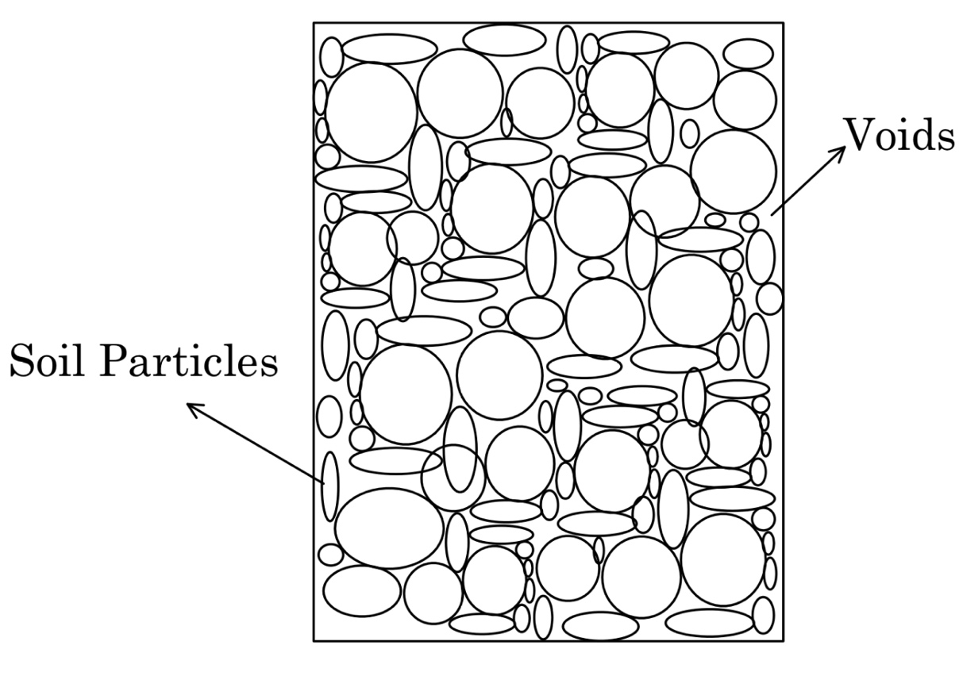
Figure 10: A soil matrix composed of soil particles and voids between them. The voids between soil particles are composed of air. This is considered to be a dry soil.

b. Saturated Soil (Above the OMC): When soil surpasses the OMC, becoming partially or completely saturated, water fills the crevices between soil particles (Figure 2). In this condition, water particles carry a significant portion of the load, disrupting the even distribution of stresses. The behavior of saturated soils becomes less predictable due to the uneven load-bearing capacity.

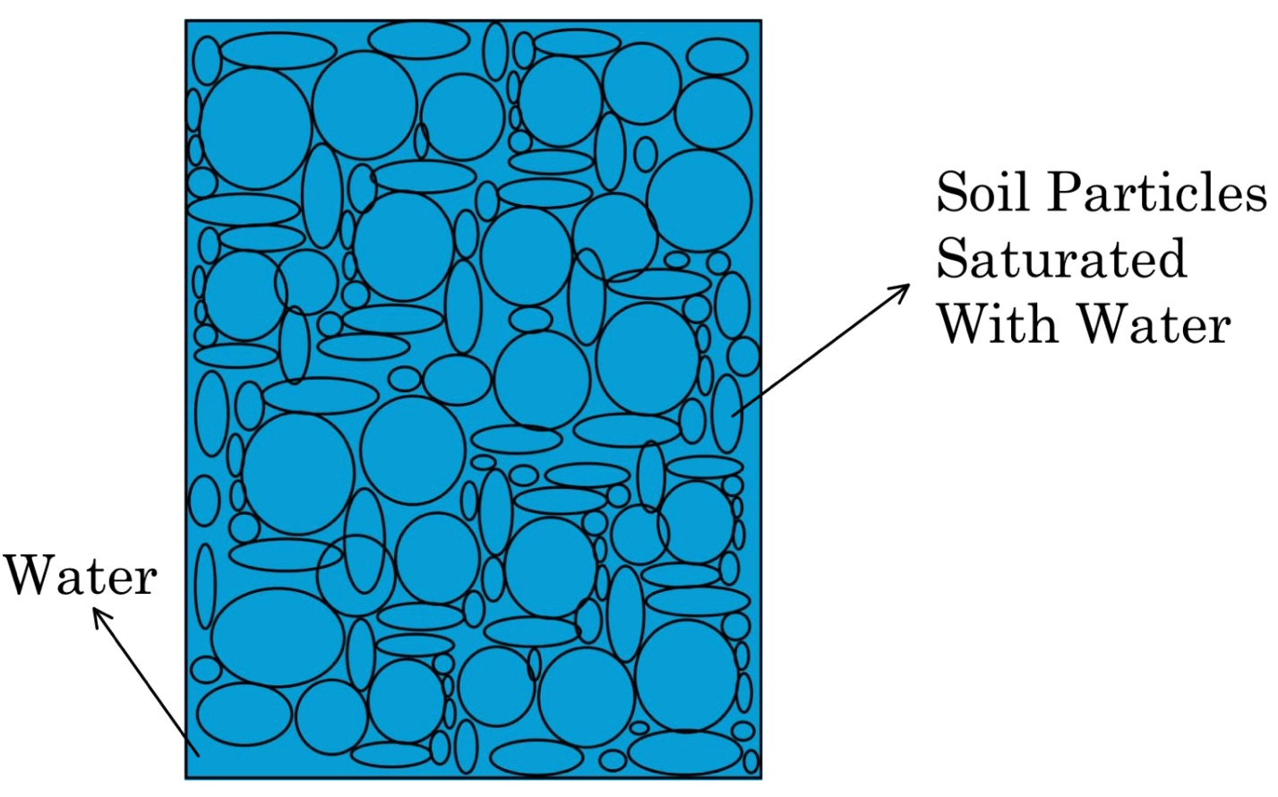
Figure 11: A soil matrix composed saturated soil particles. The voids between the soil particles are filled with water. This is considered to be a saturated soil.

- Impact on Effective Stress: a. Dry Soil (Below the OMC): Effective stress, the difference between total stress and pore water pressure, is higher in dry soil due to the limited presence of water. The soil's capacity to support loads is determined by higher effective stress, approaching total stress with low pore water pressure.
b. Soil That Is Saturated (Above the OMC): Saturated soil experiences substantially lower effective stress due to increased pore water pressure. Excessive pore water pressure reduces the soil's capacity to support loads and influences non-uniform stress distribution.
- Load Distribution: a. Dry Soil (Below the OMC): Dry soils exhibit a tendency to evenly disperse applied loads throughout the soil matrix, resulting in consistent and predictable load distribution.
b. Saturated Soil (Above the OMC): In saturated soil, non-uniform stress distribution is common due to excessive pore water pressure. The presence of extra water in the soil matrix contributes to erratic water flow, leading to varied settlements.
By elucidating the contrasting characteristics of dry and saturated soils in relation to shear strength and effective stress, these insights offer a nuanced understanding of how soil moisture influences stress distribution. Figures 1 and 2 visually encapsulate these concepts, providing a comprehensive foundation for engineers and practitioners in the field of geotechnical engineering.

To visualize how moisture content affects how stress dissipates in dry and saturated experiments, here is the DIY procedure to experiment with this concept.
Materials Needed:
- Two clear, empty plastic bottles (with caps)
- A small amount of dry, fine-grained soil (e.g., sand or potting soil)
- Water
- Ruler or measuring tape.
- Small weights (e.g., coins or marbles)
- Transparent plastic or glass container (optional)
Procedure:
- Prepare the Bottles:
  - Fill one plastic bottle about halfway with dry soil.
  - Fill the other plastic bottle with the same amount of soil but moisten it slightly, but do not make it fully saturated.
  - Cap both bottles securely
- Apply Weight:
  - Place the capped bottles on a flat surface, such as a table or desk.
  - Place a small weight (e.g., a coin or marble) on top of the cap of each bottle. Make sure the weight is centered.
- Observe and Measure:
  - Over time, observe the bottles and record any changes in their shape or deformation.
  - Measure the distance between the cap and the soil surface on both bottles regularly (e.g., every 15 minutes) using a ruler or measuring tape.
- Record Observations:
  - Note any differences in the deformation (settling) of the soil between the saturated and unsaturated bottles.
  - Record any changes in the height of the soil column as it compresses.

Dynamics of Geotechnical Engineering: Interplay of Geometry, Configurations, Load Characteristics, Groundwater Dynamics, and Construction Activities

In geotechnical engineering, the delicate dance between geometry, configurations, and construction activities emerges as a linchpin for establishing foundations and structures of enduring resilience. This intricate interplay significantly governs settlement calculations and stress distributions, necessitating an all-encompassing comprehension from engineers to adeptly address challenges like the nuanced phenomena of differential settlement and stress concentrations.
Consider the profound influence of load characteristics on stress transfer to the underlying soil—a cornerstone in geotechnical considerations. The irregular shapes of loads, characterized by sharp corners or asymmetrical arrangements, can precipitate uneven stress distributions, giving rise to the intricate challenge of "differential settlement." Ponder, for instance, a structure with a long, rectangular base, where the extended edges impart heightened strain on the adjoining soil. The consequence is an uneven settling that may manifest in structural deformities, fissures, and operational anomalies, posing tangible risks to the structural integrity of the edifice.
Moving beyond the rudiments of load considerations, the hydro-mechanical dynamics of groundwater and pore water pressure emerge as pivotal players in shaping stress distributions within the geotechnical landscape. Groundwater, permeating the pore spaces within soil and rock, introduces dynamic oscillations in stress conditions. The undulating groundwater table, responsive to variables such as precipitation and human activities, emerges as a linchpin in steering the overall stability of soils.
The concept of pore water pressure, delineating the force exerted by water within soil void spaces, rises as a critical parameter in soil mechanics. Its intricate dance with total stress births the effective stress, a determinant in the mechanical comportment of soils. A nuanced understanding of the genesis and variations of pore water pressure becomes imperative for prognosticating soil responses to external forces. Furthermore, the degree of saturation, encapsulating the volume of void spaces occupied by water, emerges as a potent force shaping stress distributions. In saturated conditions where voids are entirely water-filled, effective stress wanes, leading to diminished soil strength and an augmented potential for shear failure. This saturation level evolves into a critical factor in the delicate assessment of the stability of slopes, foundations, and other geotechnical structures.
Consider the capillary rise phenomenon, propelled by water's cohesive properties, as an additional layer of complexity. It contributes to elevated pore water pressures in finer-grained soils, particularly germane in expansive clays. This capillary action injects a further layer of intricacy into stress distributions in foundation soils, painting a nuanced portrait of the geotechnical canvas.
Delving into the transformative impact of construction activities, the excavation-induced stresses become sculptors of the natural state of soil. These induced changes ripple outward in stress distributions, an aftermath of soil removal that reduces lateral support and begets augmented vertical and horizontal stresses around excavation walls. An adept understanding of these induced stresses becomes imperative, guiding the implementation of support measures like shoring and bracing to stave off instability and potential failures during the construction phase.
Foundation loading during construction unfurls another chapter in the geotechnical saga, imposing vertical stresses on underlying soil layers. The magnitude and distribution of these stresses, beholden to factors such as foundation type, size, and soil properties, can manifest in the specter of differential settlement. Engineers, as custodians of stability, must meticulously craft foundations that orchestrate the effective distribution of loads, allaying concerns of settlement.
Compaction, a ubiquitous construction activity, recalibrates stress distributions by augmenting soil density through the application of mechanical energy. Compacted soils, in consequence, bear the imprint of higher vertical stresses and altered shear strength characteristics. The intricacies of compaction-induced stress changes necessitate astute consideration to safeguard the stability of embankments, foundations, and other structural edifices.
Enter the domain of construction equipment, wielding dynamic forces and vibrations that reverberate through the surrounding soil. The management of construction-induced vibrations acquires paramount importance, especially in urban environments where extant infrastructure might be sensitive to dynamic loading. Monitoring and strategic mitigation strategies become the bulwarks against adverse consequences on nearby structures.
Consider the explosive realm of blasting and rock excavation, where stress waves induced by controlled explosions propagate through rock and surrounding soil. The magnitude and frequency of these stress waves, if left unchecked, pose a potential threat to nearby structures. Here, the art of careful blasting design comes into play, a delicate choreography to minimize ground vibrations and stave off potential damage.
As construction activities unfold, the very properties of the soil undergo transformations, wielding a direct influence on stress distributions. The introduction of fill materials becomes a pivotal act, capable of altering shear strength, compressibility, and permeability. Engineers, akin to soil custodians, embark on a meticulous assessment and accommodation of these alterations, weaving them into the fabric of the geotechnical narrative.
The saga of geotechnical engineering further unfolds with the installation of geosynthetic materials, be they geogrids or geotextiles. This common practice assumes the role of a stabilizing force, altering stress distributions by infusing additional tensile strength into the soil. The selection and installation of these geosynthetics metamorphose into critical considerations, steering the optimal transfer of stress and effecting the desired enhancement in soil behavior.
Yet, amidst the orchestrated chaos of construction activities, soil disturbance emerges as a potent subplot, exposing surfaces to the ever-looming risks of erosion. Enter erosion control measures—silt fences and sediment barriers—playing a dual role. Not only do they staunch the flow of excessive soil loss, but they also become guardians of stability, preventing unintended stress redistributions on slopes and in other vulnerable terrains.

Chapter Four: Techniques and Models to Analyze Stress Distributions: FEA

We set out on a quest to unravel the mysteries of stress distributions in the fascinating world of geotechnical engineering, where the ground beneath our feet conceals secrets and presents difficulties. This journey is, both literally and symbolically, a journey into the very core of our planet. Welcome to a world where the art and science of geotechnical analysis bring soil, rocks, and the forces that sculpt them to life.
Finite Element Analysis (FEA), one of the geotechnical engineer's most potent tools, is at the center of this adventure. We will examine stress distributions via the lens of FEA, but we'll also learn about the multidimensional world where mathematics and computer techniques converge to create a virtual lab for comprehending how the planet reacts to the forces we apply to it.

A World of Giants
A unique breed of experts known as geotechnical engineers is essential to ensuring the towering giants, or skyscrapers, remain tall and proud in a world where concrete jungles reach the heavens. To make sure the foundation of these enormous constructions can support the weight and survive the stresses associated with vertical development, these architects of the subsurface traverse the intricate realm of soil and rock mechanics.
We can ponder how these buildings maintain stability and do not collapse under their own weight or the forces of nature as we take in the magnificent skyline of a modern metropolis. The foundation is the key to the solution, which is concealed from view but necessary for our security.
Consider the enormous amount of engineering that goes into building a skyscraper's foundation. It involves more than merely excavating a hole and pouring concrete into it. Understanding the ground, the soils, the rocks, and the forces at work in and on them is the goal. It involves ensuring that the foundation can endure earthquakes, strong winds, and gravity's unrelenting pull.
Geotechnical engineers can be useful in this situation. They are the designers of the ground, working nonstop to make sure the base is sturdy enough to hold the building above. They use a fantastic technology called finite element analysis (FEA) to do this.
As its name implies, finite element analysis (FEA) is a technique used to break down complicated structures or systems into smaller, simpler pieces. It's similar to disassembling a challenging jigsaw puzzle into digestible bits. This allows us to look at each component separately and comprehend how it works with the others.
FEA is used to simulate and study the behavior of the foundation and the surrounding soil in the field of geotechnical engineering. It entails building a digital model of the soil beneath the foundation and breaking it up into tiny components. After that, calculations are made to see how each component will react to certain loads and stresses.

Building Blocks of FEA
We must examine the FEA's foundational elements in order to comprehend how it functions for foundations. These are the crucial elements that turn this potent instrument into a paradigm-shifting tool for geotechnical engineering:
The Grid: The Digital Mesh
Making a mesh—a digital grid that encloses the foundation and the surrounding soil—is the first stage in the FEA process. This grid collects the intricacies of the foundation and the ground underneath it, much like a mesh net does for a fish. The mesh breaks up the entire space into smaller components, much like puzzle pieces.
Material Properties: Understanding Your Earth
There are certain material qualities associated with each element in the mesh. These characteristics explain how the earth and the foundation will act in certain scenarios. Consider it as being aware of the feel and durability of each puzzle piece.
Boundary Conditions: Earth in Action
We simulate how the actual world functions in FEA. Applying the forces that the foundation will encounter throughout the course of its existence is part of this. The weight of the building, the wind, earthquakes, or even neighboring construction operations, can all produce these forces. We can simulate these pressures and learn how they impact the foundation and the surrounding soil by using boundary conditions.
Equation Solving: The Virtual Lab
It's time to solve the equations now that we have our mesh, material attributes, and boundary conditions. These equations describe how each component of the mesh responds to external forces. We can forecast how the foundation and the soil will deform as well as the locations of stress and strain at different sites by resolving these equations.

Exploring Finite Element Analysis (FEA) through Practical Application with Optum G2 Software

In this tutorial, we will delve into the step-by-step process of conducting settlement analysis on a strip footing using the Optum G2 software. Optum G2 stands out as a sophisticated geotechnical analysis tool, offering engineers a powerful platform for studying soil-structure interactions. With advanced algorithms and a user-friendly interface, Optum G2 facilitates accurate settlement analysis, aiding informed decisions in foundation design and construction.
To begin, download the Optum G2 software by following the link, selecting the "Academic" option, and following the provided instructions. Once installed, open the application and initiate a new project.
- Creating a 2D Soil Profile:
  - Draw a rectangle representing a soil profile, 6 meters in height and 16 meters wide.
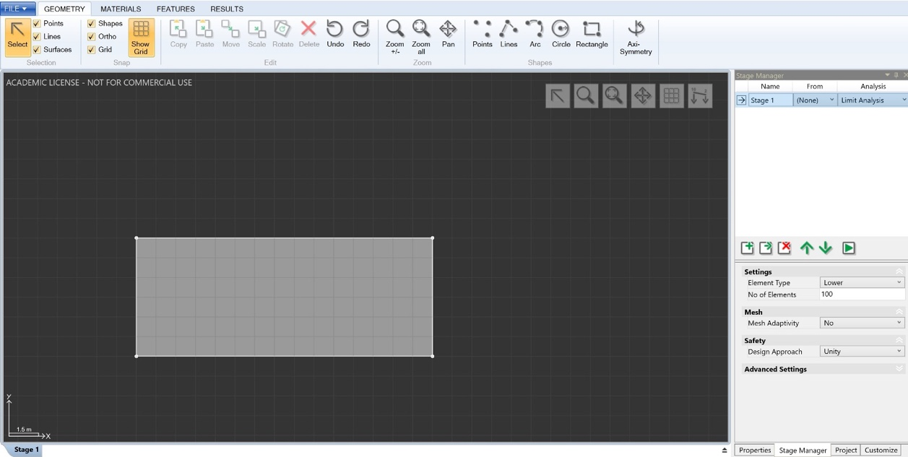
Figure 12: Image of the rectangular soil profile in Optum G2 Software
- Adding a Strip Footing:
  - Draw another rectangle on top of the soil profile, making it 2 meters wide and 1 meter in height.
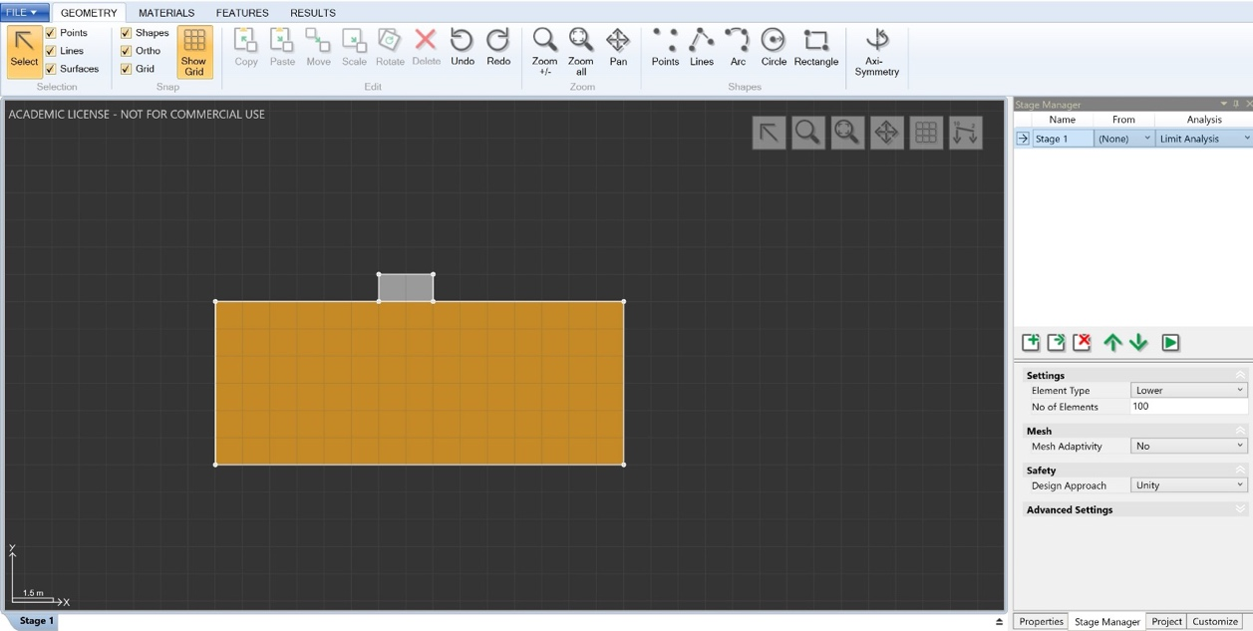
Figure 13: Image of the strip footing on top of the rectangular soil profile
- Assigning Materials:
  - Click on the "Materials" tab to assign soil types. Highlight the soil profile rectangle and choose the desired soil type (e.g., "MCC Clay").
  - Assign the strip footing material as "Rigid" and adjust properties such as unit weight (e.g., 20 kN/m^3).
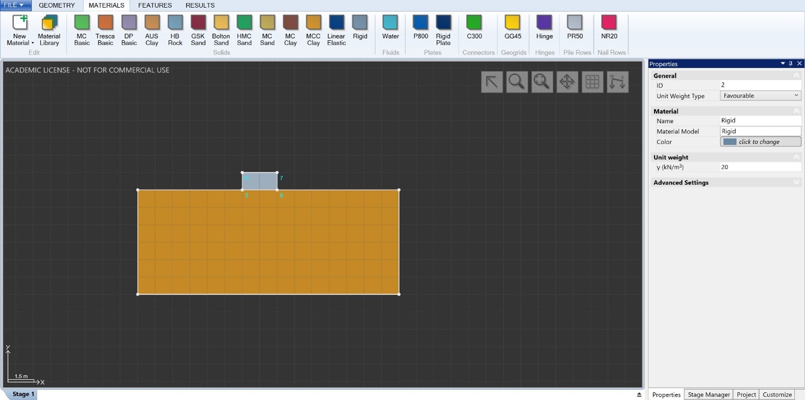
Figure 14: Assigning the Materials to the model
- Applying Boundary Constraints:
  - Navigate to "Features" and select "Standard Fixities" to add boundary constraints to the soil profile.
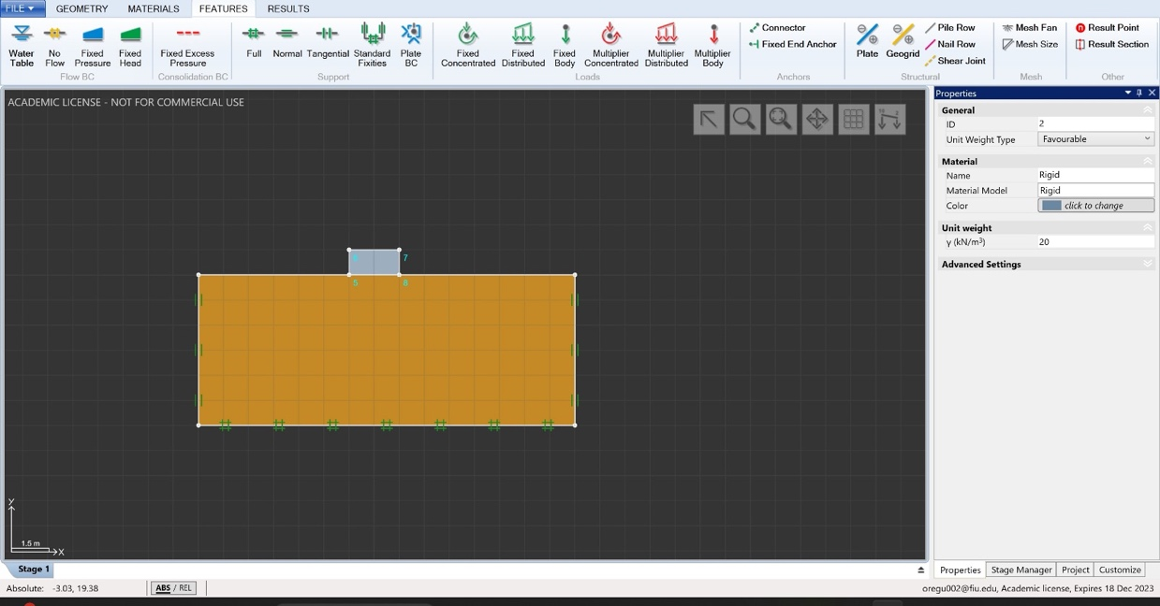
Figure 15: Soil Profile with Standard Fixities
- Applying Load to Strip Footing:
  - Click on the top line of the strip footing, choose "Fixed Distributed," and apply an evenly distributed load of 150 kN/m^2.
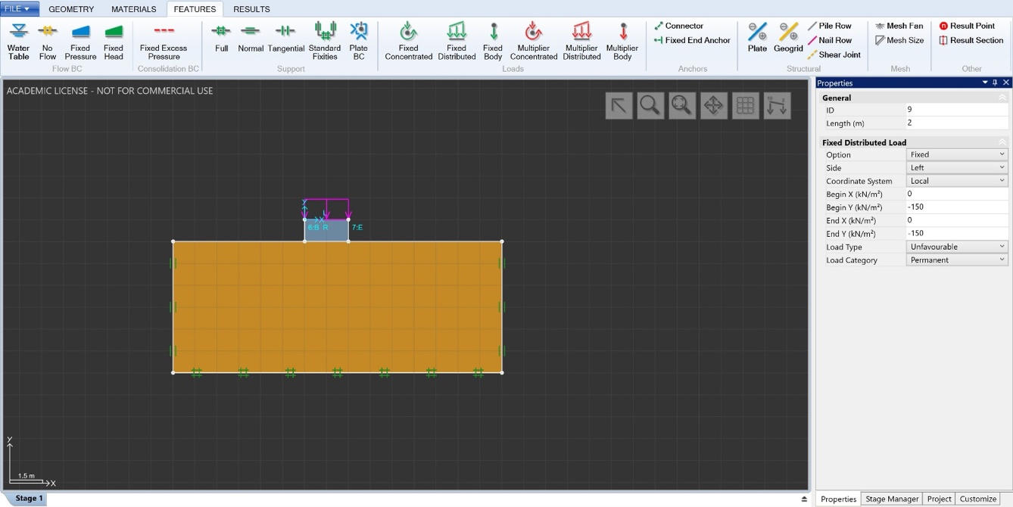
Figure 16: Strip Footing with 150 kN/m^2 load
- Selecting Analysis Method:
  - Open the "Stage Manager" on the lower right-hand side. Change the analysis method from "Limit Analysis" to "Elastic."
  - Adjust the element type from "6-node Gauss" to "Lower."
- Running the Analysis:
  - Clone "Stage 1" and select "6-node Gauss" as the element type for the new stage.
  - Initiate the analysis by clicking the play icon and await the results.
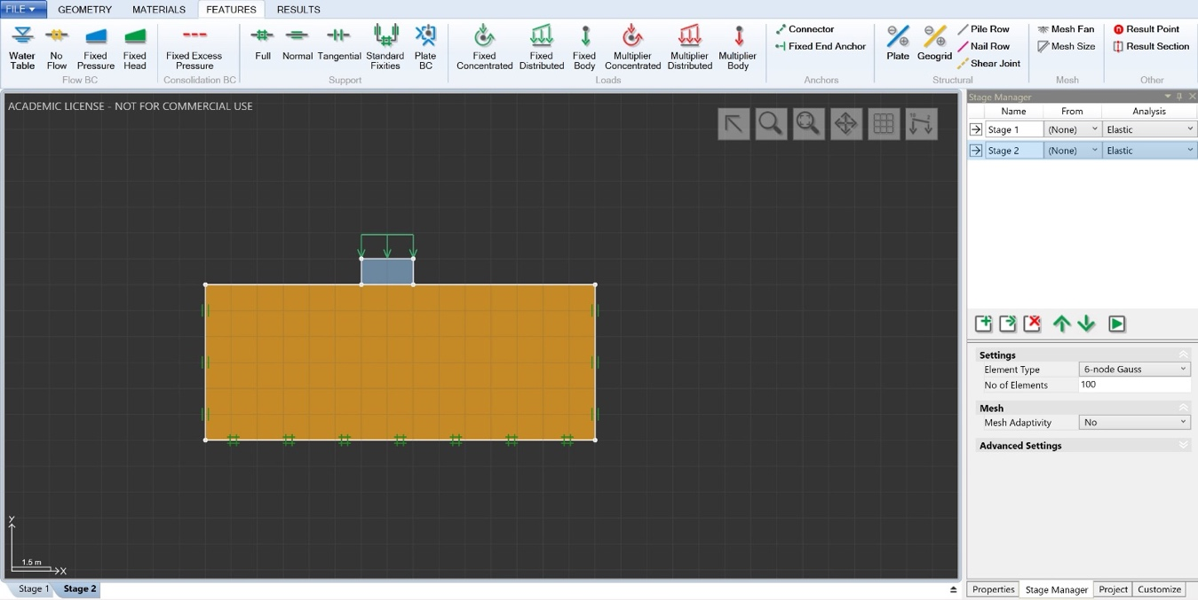
- Reviewing Results:
  - After analysis completion, review the results indicating the settlement. Note that the Lower element tends to overestimate, while the 6-node FE underestimates vertical displacement.
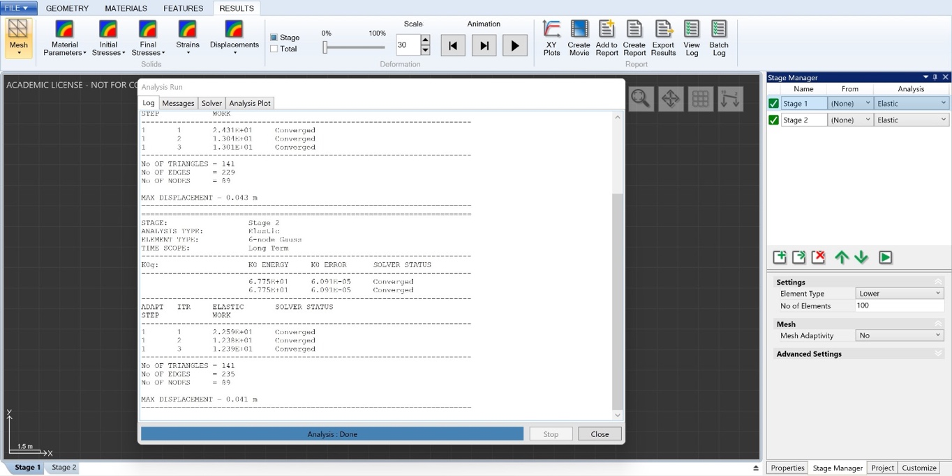
Figure 17: Results from Model
As we can see, the “Stage 1” analysis provides an overestimate of the settlement (0.043 m). “Stage 2” analysis provides an underestimate (0.041 m).
- Visualizing Settlement:
  - Close the analysis, initiate the animation, and observe the settlement of the strip footing.
By following these steps, you can gain practical experience in settlement analysis using Optum G2, enhancing your understanding of FEA in geotechnical engineering.
In addition to what was demonstrated in this sample, the software excels in shallow foundation analysis and design, employing a unique Limit Analysis type that efficiently determines bearing capacities. It offers the distinct advantage of computing rigorous upper and lower bounds, providing a built-in means of numerical verification. Moreover, OPTUM G2 facilitates elastoplastic and consolidation analysis, enabling the accurate determination of settlements in foundation structures.
For deep excavation simulations, OPTUM G2 proves to be a reliable and efficient tool. It incorporates accurate soil models and provides a comprehensive array of tools and options for modeling support systems, ranging from retaining walls to anchors and soil nails. This functionality is crucial for the meticulous planning required in potentially risky deep excavation projects.The software extends its capabilities to the design of monopile foundations, demonstrating versatility by employing the well-known p-y method and, in certain cases, conducting a full 3D FE soil-structure analysis. This comprehensive approach not only aids in optimizing designs but also contributes to a significant reduction in steel usage when deemed necessary or as per specific customer requirements.
OPTUM G2 further extends its utility to the simulation of embankment construction, offering an efficient and reliable means to model the construction process. The software calculates settlements and pore pressures, providing a straightforward assessment of overall embankment stability throughout the construction phase. In the realm of retaining wall analysis and design, OPTUM G2 excels. It accommodates various types of retaining walls, including mass gravity walls, mechanically stabilized earth walls, gabion walls, and sheet pile walls. The software's unique ability to compute rigorous upper and lower bounds on the true factor of safety, combined with mesh adaptivity, establishes it as a superior tool for the design of retaining walls. This comprehensive suite of features positions OPTUM G2 as a valuable and versatile solution for professionals engaged in geotechnical and foundation engineering, offering efficiency, reliability, and confidence in results.

Chapter Five: The Boussinesq and Westergaard Solutions and Its Practical Applications in Geotechnical Engineering

Within the large field of civil engineering, geotechnical engineering is a crucial field that focuses on the complex mechanics of soil and how it affects various structures that make up our built world. The stability and safety of any construction, be it a tall skyscraper, a complex bridge design, a large dam, or a complex network of roads, ultimately depends on the foundation to which it is attached. Geotechnical engineering excels in this area, and applications of the discipline are crucial to the efficient completion of infrastructure projects. The fundamental knowledge of how soils respond to and adapt to the many forces placed upon them is at the heart of this field. The Boussinesq equation, which bears the name of the eminent French mathematician Joseph Valentin Boussinesq, is one of the key instruments that enable this knowledge.

It is impossible to overestimate the importance of geotechnical engineering in contemporary civil engineering practice. The need for modern, cutting-edge infrastructure keeps growing as cities and cultures develop. Geotechnical engineers play a crucial role in establishing a solid and secure basis for these developments. It involves more than just building structures; it involves making sure they sustain the test of time, enduring natural forces, dynamic loads, and environmental conditions.

Geotechnical engineering's cornerstone is the Boussinesq equation, which Joseph Valentin Boussinesq developed in the 19th century. It is a crucial mathematical model that reveals the intricate underworld underneath the earth's surface. This equation provides essential insights into the distribution of stress and settlements within the soil, making it easier to understand how soils react to point loads placed on the surface. Fundamentally, it gives geotechnical engineers a strong instrument to gauge the degree of vertical stress and any quick settlements that can happen, particularly in the case of shallow foundations. The Boussinesq equation is a key component of every geotechnical engineer's toolkit due to its wide range of practical uses.

The Boussinesq equation is particularly effective at describing how soil reacts to sudden loads from constructions, especially those with shallow foundations. Only its usefulness matches its mathematical brilliance. When planning the foundations for structures, geotechnical engineers can use this model to help them make educated decisions that will ensure the stability and lifespan of the final product. The equation is useful not just for analyzing immediate settlements but also for evaluating consolidation settlements. These settlements offer insight into the long-term dissipation of surplus pore water pressure, an essential component of foundation performance (Basu et al., 98).

The Boussinesq equation offers a foundation (both literally and symbolically) upon which the architectural wonders of today and the future rest in a quickly evolving world where sustainability and structural integrity are vital. Engineers can explore the intricate interactions of forces and materials that characterize the underground environment using this mathematical model, ultimately influencing the skyline and surroundings above.

The Boussinesq Equation
Geotechnical engineers utilize the Boussinesq equation as a key mathematical tool to assess and forecast how soil will behave in the presence of external point loads. This equation is especially useful for assessing shallow foundations because it simplifies the challenging task of predicting vertical tension and settlement in soil caused by a point load on the ground surface.

$$σ_{z}=\frac{q}{2π}*(1+((\frac{z}{{\left(z^{2}+x^{2}+y^{2}\right)}^{0.5}})$$

Whereas:
σz (Vertical Stress): The vertical stress at a certain depth (z) below the ground surface is denoted by the symbol z. This stress is brought on by the external loading (q) or applied point load (q), and it is distributed throughout the soil in a complicated way.

q (Applied Point Load): The size of the point load or external force delivered to the ground surface is measured by q. A building's or other structure's weight or any other concentrated load might be this. The transmission of this load into the soil and how it influences the stress at different depths are calculated using the Boussinesq equation.

x and y (Horizontal Distances): The horizontal distances between the load application point and the spot where you want to estimate these variables. x and y represent the vertical stress (z). These distances are essential for accurately computing the vertical stress at that depth since the point load is only sometimes applied at the surface precisely above the point of interest.

The equation considers these factors to calculate how the vertical stress changes with depth below the ground's surface. To analyze the immediate impacts of point loads on shallow foundations, it offers a simplified model of the stress distribution in the soil. However, The Boussinesq equation has some assumptions and restrictions, such as assuming homogeneous and isotropic soil conditions, which may need to be considered in more intricate geotechnical assessments (Zillinger, Christian, 409). Nevertheless, it is useful for making preliminary calculations and designing the foundation in real-world geotechnical engineering applications.
The equation can be solved and modified by geotechnical engineers to analyze a variety of foundation shapes, including but not limited to rectangular, circular, and irregular geometries. Due to the rarity of uniformly distributed point loads in real-world construction projects, this adaptability is extremely valuable.

Foundation Shape
One of the most popular and useful foundation shapes in construction, rectangular foundations find extensive use in industrial, commercial, and residential structures. They are a popular option for many projects due to their straightforward form and straightforward construction. By foreseeing potential stresses and soil settlements, geotechnical engineers play a crucial part in ensuring that rectangular foundations can safely hold the specified loads. In this situation, the Boussinesq equation is quite useful after being modified to take rectangular footprints into consideration.
Characteristics of Rectangular Foundations
As the name implies, rectangular foundations are rectangular when viewed from above. They often match the building or structure they are supporting in terms of footprint. Depending on the load needs for the structure and the soil's bearing capacity, the size of these foundations can vary. They are frequently employed for single-story and multi-story structures, such as residences, retail establishments, office buildings, and other industrial facilities.
Rectangular foundations have an easy-to-understand appearance. They resemble huge, horizontal slabs or mats that equally distribute the structure's weight to the subsurface earth. Although the visible part of the foundation is a flat, rectangular surface at ground level, it is crucial to comprehend how this surface interacts with the soil beneath to ensure the foundation's performance and stability.

Predicting Stress and Settlement in Rectangular Foundations
Engineers employ a modified version of the Boussinesq equation to estimate the stresses and settlements at various locations along the perimeter of the rectangular foundation. This approach is particularly valuable when designing structures with square or rectangular footprints, where the load distribution is relatively uniform.
To understand and visualize the distribution of stresses and settlements beneath rectangular foundations, engineers often create charts and diagrams. These graphical representations provide a clear picture of how the vertical stress varies across the foundation's length and width. For instance, figure 18 below indicates a division of a rectangular loading area for determining stress by the method of corner points.
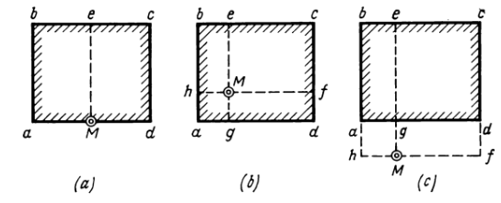
Figure 18: As seen above, this figure illustrates how divide the rectangles to find the stress increase at a single point. In this case, point M. Image taken from "Vulcanhammer.net"
Settlement contour plots show how the ground surface may change shape or settle under the weight of the foundation. The even distribution of loads and avoidance of structural problems can be achieved by using these contour plots to reveal probable differential settlements, in which one portion of the foundation settles more than another.
Engineers may also employ stress and settlement profiles, which display the variation in vertical stress and settlement along particular lines or portions of the foundation, in addition to contour plots. These profiles provide an in-depth look at how the earth reacts to the foundation's load from various angles.
By utilizing such diagrams, and profiles, geotechnical engineers can gain a comprehensive understanding of the soil-structure interaction beneath rectangular foundations. This understanding is essential for designing foundations that effectively distribute loads, minimize settlements, and ensure the long-term stability and safety of the constructed structures.
Circular Foundations

Silos, water tanks, and some bridge piers are examples of cylindrical structures that frequently use circular foundations. The soil's reaction to a dispersed load from a circular foundation can be studied using an adaptation of the Boussinesq equation. In order to determine the vertical stress and settlement at various points around the circumference of the circle, this modification considers the radial and angular distribution of load. The model accurately depicts the soil's response and considers the uneven load distribution.

Finding the vertical stress and settlement at various locations around the perimeter of the circular foundation is the main goal of this modified adaption of the Boussinesq equation. This method recognizes that the load is not applied uniformly and accounts for the load's radial and angular distribution. Instead, it is confined inside the foundation's elliptical footprint. This model provides a more accurate representation of the soil's response by taking into account both the radial and angular components of load distribution. Engineers can build structures with complete knowledge of the interaction between the soil and the structure thanks to the insights it provides on how the vertical stress and settlement change at various locations around the circular foundation.
The use of influence factors in applying the Boussinesq solution, and by extension the Westergaard solution, is highly practical in real-world engineering applications. One key advantage lies in the geometric adaptability that these factors offer. For those unfamiliar, influence factors are numerical coefficients that play a crucial role in modifying the fundamental equations to accommodate the specific geometries of loaded areas. The influence factors that are used calculated using the equations below. In engineering projects, structures and foundations come in diverse shapes and sizes, and influence factors provide a standardized approach to adapting stress distribution equations to different geometries.
This adaptability is essential, as it enables engineers to apply a unified solution without the need for deriving entirely new equations for each specific scenario. Simplification of calculations is another significant benefit provided by influence factors. While the Boussinesq equations form the foundation for understanding stress distribution, they can be complex and involve intricate mathematical expressions. Therefore, influence factors for common geometries are structured in a table for ease of use. This simplification makes the application of the solution more accessible and reduces the need for extensive and time-consuming calculations, enhancing efficiency in the design process.

$$I_{4}=\frac{2}{π}[\frac{m_{1}*n_{1}}{\sqrt{1+m_{1}^{2}+n_{1}^{2}}}*\frac{1+m_{1}^{2}+2n_{1}^{2}}{\left(1+n_{1}^{2}\right)*\left(m_{1}^{2}+n_{1}^{2}\right)}+\sin^{-1}{\frac{m_{1}}{\sqrt{m_{1}^{2}+n_{1}^{2}}*\sqrt{1+n_{1}^{2}}}}]$$

$$m_{1}=\frac{L}{B}$$

$$n_{1}=\frac{z}{b}$$

$$b=\frac{B}{2}$$

Westergaard Solution for Stress Distributions and Settlement

The Westergaard solution, a seminal contribution to this discipline, serves as a mathematical framework for comprehending stresses induced in the soil beneath loaded structures. Tracing its origins to the mid-20th century, this solution was crafted during a period of transformative growth in geotechnical engineering. Pioneered by Danish engineer Karl Terzaghi and subsequently refined by minds like Arthur Casagrande and Laurits Bjerrum, the Westergaard solution emerged as a response to the escalating need for precision in predicting soil stresses.

In the historical context, it becomes evident that the development of the Westergaard solution was prompted by a recognition of the shortcomings within existing methodologies. These limitations were most pronounced when attempting to predict stresses in real-world scenarios. The Westergaard solution, with its versatile and realistic assumptions about soil behavior and loading conditions, was designed to address these limitations. As infrastructure projects burgeoned in scale and complexity, the demand for a tool capable of assessing soil-structure interaction in a reliable manner became increasingly apparent.

Fundamentally, the Westergaard solution hinges on a set of principles and assumptions that simplify the intricate interplay between soil and structures. At its core, the solution treats the soil as an elastic material, allowing the application of classical elastic theories to predict stresses. Additionally, the assumptions regarding the geometry of the loaded area and the depth of the soil layer under consideration contribute to the mathematical formulation. While these assumptions enhance the mathematical tractability of the solution, engineers must remain mindful of their implications when applying the Westergaard method in practical scenarios.

This historical exploration and understanding of the motivations and principles behind the Westergaard solution provide a robust foundation for its subsequent application in geotechnical engineering practices. In the forthcoming sections, we will delve into the mathematical intricacies of the Westergaard solution, scrutinizing the equations and parameters that define its analytical prowess and examining its applications across diverse geotechnical scenarios.

The practical applications of the Westergaard solution extend across a spectrum of geotechnical scenarios, showcasing its versatility in addressing complex challenges. Rooted in its historical development and fundamental principles, this mathematical framework finds particular relevance in the design and analysis of foundations, retaining walls, and tunneling projects, demonstrating adaptability to different geometries such as rectangles and circles.

In the context of foundation design, the Westergaard solution proves instrumental. Its application to rectangular footings involves the consideration of the loaded area's dimensions and the depth of the underlying soil. By adapting the foundational equations, engineers can precisely estimate the stresses induced beneath rectangular foundations, ensuring a tailored approach to different structural configurations.

The Westergaard method offers a robust mathematical solution for estimating the stresses induced in the soil beneath a rectangular loaded area, a critical aspect of geotechnical engineering. The development of these equations involves a series of assumptions and adaptations, aiming to model the complex interaction between the loaded area and the underlying soil.

In its foundational assumptions, the Westergaard method considers the soil as an isotropic, homogeneous, and elastic half-space. This simplification enables the application of classical elastic theory to predict soil stresses accurately. Additionally, the loaded area is assumed to be rigid and elastic, efficiently transmitting loads uniformly to the underlying soil. The shape of this loaded area becomes pivotal in defining the stress distribution, making it crucial to adapt the Boussinesq's equations to account for the specific geometry of a rectangular loaded area.

The use of influence factors in applying the Boussinesq solution, and by extension the Westergaard solution, is highly practical in real-world engineering applications. One key advantage lies in the geometric adaptability that these factors offer. For those unfamiliar, influence factors are numerical coefficients that play a crucial role in modifying the fundamental equations to accommodate the specific geometries of loaded areas. In engineering projects, structures and foundations come in diverse shapes and sizes, and influence factors provide a standardized approach to adapting stress distribution equations to different geometries.
This adaptability is essential, as it enables engineers to apply a unified solution without the need for deriving entirely new equations for each specific scenario. Simplification of calculations is another significant benefit provided by influence factors. While the Boussinesq equations form the foundation for understanding stress distribution, they can be complex and involve intricate mathematical expressions. Influence factors simplify these calculations by offering numerical coefficients that adjust the basic equations for specific geometric conditions. This simplification makes the application of the solution more accessible and reduces the need for extensive and time-consuming calculations, enhancing efficiency in the design process.

Chapter Six: Calculation of Elastic Settlement of Shallow Foundations Under Different Conditions Based on the Theory of Elasticity

The calculation of the settlement of a shallow foundation using the theory of elasticity involves a systematic approach. The key parameters in this calculation include the net applied pressure $q_{O}$, the factor $α$ representing the location on the foundation, B′ as half the width for the center and the full width for the corner, Poisson’s ratio of the soil $μ_{s}$, and the average modulus of elasticity of the soil under the foundation $E_{s}$.
The calculation begins by determining the shape factor $I_{s}$​, which combines contributions from
$F_{1}$and $F_{2}$. $F_{1}$and $F_{2}$​ are computed from specific equations or tables based on m′, n′, and $μ_{s}$. The shape factor is a critical component in the subsequent settlement calculation. The settlement $S_{e}$ is then computed using the formula:
$$S_{e}​=q_{O}​αB^{'}Es​\left(1-μ_{s}^{2}\right)​I_{s}​I_{f}.$$

Here, $​I_{f}$ is the depth factor, and its value is obtained from tables provided in the principles of foundation engineering. This comprehensive formula considers the immediate settlement during and after construction, taking into account the soil's elasticity and the applied load on the foundation. To refine the calculation, the modulus of elasticity $E_{s}$ is evaluated as a weighted average considering variations at different depths. The weighted average is calculated using the soil modulus of elasticity within a given depth $E_{s}$​(i)) and the foundation depth (H) or 5B, whichever is smaller. This method ensures a thorough consideration of soil behavior, foundation characteristics, and loading conditions, offering a comprehensive approach to predicting settlement. It underscores the importance of accurate soil data and material properties in achieving precise and reliable settlement estimates for shallow foundations.
As a summary, all the necessary equations to calculate the settlement is as follows:
$$S_{e}=\frac{q_{0}αB^{'}}{Es}\left(1-μ_{s}^{2}\right)I_{s}I_{f}$$

$I_{s}=F_{1}+\frac{\left(1-2μ_{s}\right)}{\left(1-μ_{s}\right)}F_{2} (Shape Factor)$

$$F_{1}=\frac{1}{π}\left[A_{0}+A_{1}\right]$$
$$F_{2}=\frac{n^{'}}{2π}\tan^{-1}{(A_{2}})$$
$$A_{0}=m^{'}\ln\left\{\frac{\left[1+{\left(m^{'2}+1\right)}^{0.5}\right]{\left(m^{'2}+n^{'2}\right)}^{0.5}}{m^{'}\left[1+{\left(m^{'2}+n^{'2}+1\right)}^{0.5}\right]}\right\}$$

$$A_{2}=\frac{m^{'}}{n^{'}{\left(m^{'2}+n^{'2}+1\right)}^{0.5}}$$

$$I_{f}=f\left(\frac{D_{f}}{B},μ_{s},\frac{L}{B}\right) (Depth Factor)$$

$$E_{s}=\frac{\sum{E_{s}\left(i\right)Δz}}{Z_{0}}$$

$$E_{s}\left(i\right)=\text{soil modulus of elasticity within a depth }Δz$$
$$Z_{0} = min(H, 5B)$$
The depth factor $I_{f}$ is a function that depends on several parameters including the ratio of the foundation depth to its width $\frac{D_{f}}{B}$, the Poisson's ratio of the soil $μ_{s}$and the ratio of the length to the foundation width $\frac{L}{B}$. The specific form of the function can vary depending on the reference or engineering text used.
In the context provided earlier, the depth factor was denoted as $I_{f}$. While the exact form of the function wasn't provided, it's common for depth factors to be tabulated or graphed in engineering references. Engineers often refer to these tables or graphs to find the appropriate value of $I_{f}$​ based on the given parameters.
If you have access to the specific reference mentioned ("Principles of Foundation Engineering"), you should refer to the tables or graphs provided in that reference to find the value of $I_{f}$. based on the values of $\frac{D_{f}}{B}$, $μ_{s}$,and $\frac{L}{B}$. If you do not have the specific values for these parameters, you may need to use typical or recommended values based on the characteristics of the soil and foundation.
Let's work through an example calculation of the elastic settlement of a shallow foundation using the provided formula. In this example, we'll consider a foundation with the following parameters:
- Dimensions of the foundation: 1.5 m × 2 m
- Net applied pressure on the foundation, $q_{0}=175 kPa$
- Poisson’s ratio of soil, $μ_{s}=0.3$
- Average modulus of elasticity of the soil under the foundation, $E_{s} = 10,000 kPa$
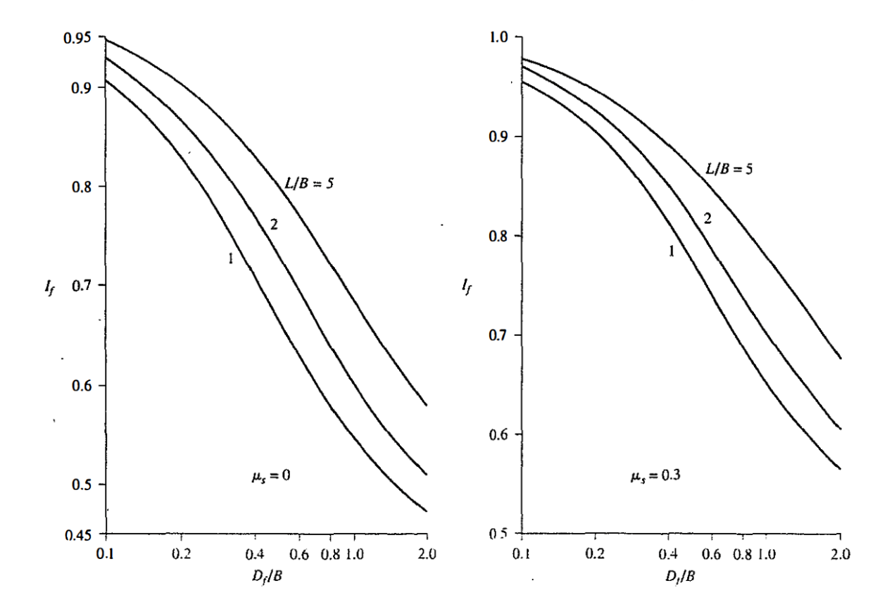
Figure 22: Variation of the Depth Factor As A Function of Three Variables. Image Taken from “Principles of Foundation Engineering” by Braja M. Das
Let's proceed with the calculations. For brevity, I'll provide the results.
$$S_{e}= 0.02m or 20 mm$$
Shallow Foundation on a Saturated Clay Layer
The settlement equation shown below is a specific formula used to estimate the elastic settlement of a flexible foundation on saturated clay soils.
$$S_{e}=A_{1}*A_{2}*\left(\left(q_{0}*B\right)/E_{s}\right)$$

This equation takes into account the unique properties of saturated clay, where consolidation settlement due to the gradual expulsion of pore water is a significant factor.
Here's a breakdown of the terms in the context of saturated clay:
- $S_{e}$: Elastic settlement of the foundation, considering both immediate and consolidation settlement in saturated clay.
- $A_{1}$​: A factor influenced by the ratio of foundation height to width (H/B) and the ratio of foundation length to width (L/B). These ratios help account for the geometric characteristics of the foundation.
- $A_{2}$​: A factor influenced by the ratio of foundation depth to width (Df​/B).This ratio reflects the depth of the foundation relative to its width.
- ​$q_{0}$: Net applied pressure on the foundation, accounting for the loads imposed on the saturated clay.
- B: Width of the foundation, a geometric parameter of the foundation.
- $E_{s}$: Average modulus of elasticity of the saturated clay beneath the foundation, representing the soil's stiffness.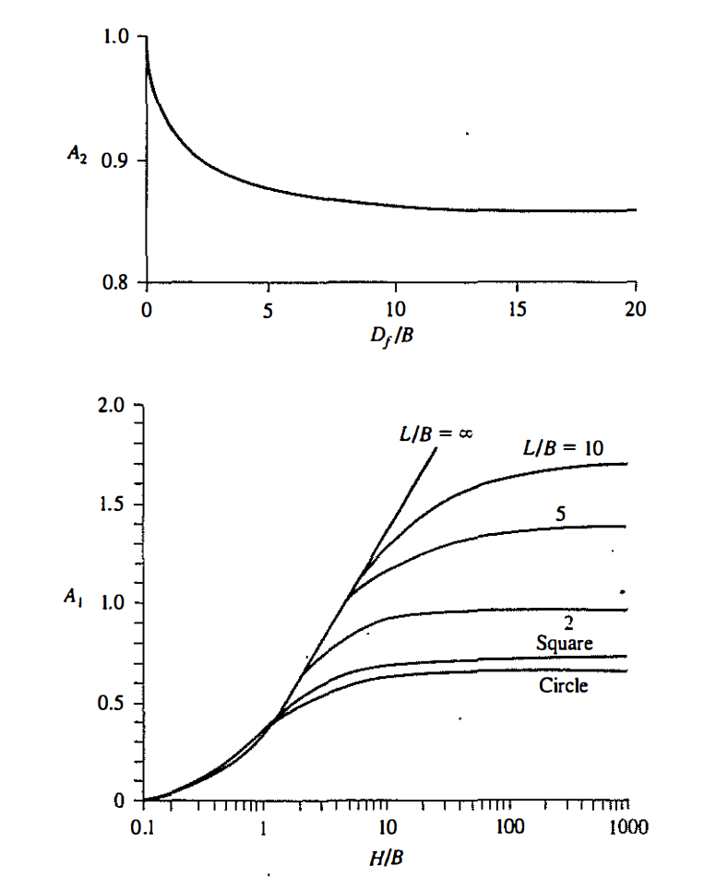
Figure 23: Values of A1 and A2 .Image Taken from "Principle of Foundation Engineering" by Braja M. Das

The significance of using this equation for saturated clay lies in its consideration of the specific behavior of clay when saturated with water. Saturated clay undergoes consolidation over time, leading to settlement.

Chapter Seven: Mitigation Measures for Settlement

The stability and longevity of infrastructure projects hinge upon the intricate dance between the ground beneath and the structures above. In the realm of geotechnical engineering, settlement and stress distributions emerge as critical determinants of a project's success. As civilizations continue to expand and urbanize, the demand for robust, resilient infrastructure intensifies. Understanding the complex interplay between the soil and the built environment is paramount to ensuring the structural integrity of foundations, roadways, and buildings. This essay delves into the multifaceted realm of settlement and stress distributions, unraveling the challenges posed by these phenomena and elucidating the arsenal of mitigation measures wielded by geotechnical engineers.
In the dynamic landscape of geotechnical engineering, the soil, seemingly inert, conceals a wealth of complexities. Settlement, the vertical displacement of the ground surface, and stress distribution, the allocation of forces within the soil matrix, pose formidable challenges that necessitate thorough investigation and strategic intervention. The stakes are high, for the consequences of overlooking settlement and stress can manifest in a spectrum of issues, ranging from superficial cracks in buildings to catastrophic structural failures. As such, this essay embarks on a journey to dissect the intricacies of settlement and stress distributions, unraveling their mechanisms, exploring the tools of analysis, and illuminating the array of mitigation measures designed to fortify the foundations upon which our structures rest.
The pursuit of effective mitigation strategies begins with a meticulous site investigation, akin to peering into the soil's soul to discern its secrets. By comprehending the behavior of soil under varying conditions, engineers can lay the groundwork for tailored mitigation measures. Immediate and consolidation settlement analyses further illuminate the temporal dimension of soil behavior, providing a roadmap for anticipating and mitigating deformation over time. Armed with insights from site investigations, engineers embark on the fascinating endeavor of modifying foundation designs to withstand the burdens imposed upon them. Whether through the adaptation of shallow foundations or the incorporation of deep foundations, the goal is to harmonize the interaction between structure and soil, mitigating settlement and redistributing stress.
Site Investigation and Understanding Soil Behavior
The journey toward effective mitigation measures for settlement and stress distributions begins with the bedrock of geotechnical engineering — site investigation. Soil, seemingly mundane, conceals a world of complexities that demands careful scrutiny. A comprehensive site investigation is akin to unraveling the mysteries of the earth, providing engineers with the crucial insights needed to navigate the challenges posed by settlement and stress distributions.
Techniques of Site Investigation
Borehole Logging
Borehole logging is a comprehensive technique employed in geophysics and geotechnical engineering to gather crucial information about subsurface formations. The process begins with the drilling of a borehole, creating a cylindrical opening in the ground. The diameter and depth of the borehole depend on the specific objectives of the investigation. Subsequently, logging tools are inserted into the borehole. These tools, attached to a wireline or cable, are designed to measure specific parameters that provide insights into the geological and geotechnical characteristics of the subsurface.
Among the commonly measured parameters are natural gamma rays, which indicate the presence of certain minerals through the measurement of natural radioactivity. Electrical resistivity logging determines the resistivity of subsurface materials, aiding in identifying rock or soil types. Neutron porosity logging assesses porosity by detecting the interaction of neutrons with hydrogen atoms in water. Sonic or acoustic logging records the speed of sound waves through the subsurface, offering information about rock density and elastic properties. Caliper logging measures the diameter of the borehole, identifying variations in hole size.
As the logging tools are lowered or raised through the borehole, they continuously collect data. This data, transmitted in real-time or stored for later analysis, forms the basis for creating a log or profile of subsurface conditions. Geologists and geotechnical engineers then interpret the collected data to understand geological formations, identify materials present in the subsurface, and assess physical properties.
The analysis of borehole logging data is a critical step that involves correlating the results with other subsurface information, such as soil and rock cores. This integration provides a comprehensive understanding of subsurface conditions, aiding in the development of geological and geotechnical models. The final step involves generating reports that document the results, which are invaluable for making informed decisions in engineering, construction, and environmental projects. Borehole logging, with its versatility and ability to reveal subsurface complexities, stands as an essential tool in the field of geophysics and geotechnical engineering, contributing valuable insights for diverse applications.
Cone Penetration Testing (CPT)
Cone Penetration Testing (CPT) is a fundamental in-situ method widely employed in geotechnical engineering for assessing soil properties and determining subsurface stratigraphy. The process begins with the setup of essential equipment, consisting of a cone penetrometer and a hydraulic pushing system. The cone penetrometer, comprising a cone with various sensors, a rod, and a data acquisition system, is then inserted into the ground at the desired location. This insertion is typically performed vertically, although variations such as inclined or horizontal tests are also possible.
As the cone advances into the ground at a constant rate, usually between 1 and 2 centimeters per second, it measures the resistance encountered. The cone penetrometer is equipped with sensors, including a tip resistance sensor at the cone's point and sleeve friction sensors along the rod. These sensors provide real-time data on tip resistance and sleeve friction, offering insights into the soil's characteristics at different depths. Additionally, pore water pressure sensors integrated into the cone measure the pressure exerted by water in the soil, contributing to a comprehensive understanding of subsurface conditions.
The acquired measurements, including tip resistance, sleeve friction, and pore water pressure, are transmitted to the data acquisition system in real-time. This continuous data logging ensures a detailed record of the soil's behavior throughout the penetration. Precise depth control is maintained throughout the testing process, allowing for accurate assessment of variations in soil type, stratigraphy, and strength at different depths.
Following the completion of the cone penetration test, the collected data is post-processed and analyzed. This analysis provides valuable insights into geotechnical properties such as shear strength, density, and the presence of distinct soil layers or anomalies. One of the key advantages of CPT is its efficiency in providing real-time data without the need for sample recovery, making it a versatile and valuable tool in geotechnical site investigations, foundation design, and environmental assessments. The detailed profiles generated through cone penetration testing contribute significantly to informed decision-making in various engineering and environmental applications.

Standard Penetration Testing (SPT)
The Standard Penetration Test (SPT) is a fundamental in-situ method in geotechnical engineering for evaluating subsurface soil conditions. The process begins with the drilling of a borehole to the desired depth using a hollow-stem auger or a split-spoon sampler. The split-spoon sampler, attached to a drill rod, is then driven into the soil at the base of the borehole using a standard hammer. The number of blows required to advance the sampler by 12 inches, known as the "blow count" or "N-value," is recorded. This N-value reflects the resistance of the soil to penetration and serves as a key parameter in geotechnical analysis.
After completing the designated number of blows, usually 30 for the first 6 inches and then 30 for every subsequent 12 inches, the split-spoon sampler is retrieved. The soil sample within the sampler is visually inspected to classify the encountered soil according to standard soil classification systems. This classification, combined with the N-value, provides valuable information about the relative density and consistency of the soils at different depths.
While the Standard Penetration Test is widely used and provides valuable insights into soil behavior, it does have limitations. It may not fully capture certain aspects, such as the undrained shear strength of cohesive soils. Therefore, the SPT is often complemented by other geotechnical tests to offer a more comprehensive understanding of subsurface conditions. The information derived from the SPT is crucial for various geotechnical applications, including foundation design, liquefaction potential assessment, and estimating soil strength parameters.
Laboratory Testing for In-Depth Understanding
Laboratory testing in geotechnical engineering is a cornerstone for gaining a comprehensive understanding of the physical and mechanical properties of soils and rocks. These tests play a pivotal role in assessing the suitability of materials for construction projects, mitigating risks, and designing foundations and structures with precision. One fundamental category of laboratory tests is soil classification, encompassing methods such as the Unified Soil Classification System (USCS) and the AASHTO Soil Classification. These tests categorize soils based on particle size distribution and plasticity, laying the groundwork for a broad understanding of soil behavior.
Atterberg limits tests further contribute to this understanding by determining the moisture content at which a soil transitions between different states—liquid, plastic, and semi-solid. These limits are crucial for evaluating the plasticity and potential volume change of soils, providing essential information for construction projects.Compaction tests, such as the Proctor compaction tests, assess the optimal moisture content and maximum dry unit weight of soils. This information is indispensable for controlling compaction during construction, ensuring that soils achieve the desired density and strength.
Triaxial tests, including consolidated drained (CD), consolidated undrained (CU), and unconsolidated undrained (UU) tests, offer insights into shear strength, stress-strain behavior, and drainage characteristics of soils. These tests are particularly valuable for designing foundations and evaluating slope stability.
Consolidation tests delve into the settlement behavior of soils under load, providing critical information about time-dependent deformation. Such insights are essential for predicting settlement in foundation design and managing potential settlement-related issues.Direct shear tests measure the shear strength parameters of soils under various normal stresses, offering crucial information for slope stability analysis and understanding the potential for soil failure.
Permeability tests assess the ability of soils to transmit water, playing a key role in evaluating drainage conditions and designing structures to manage water flow effectively. For rocks, laboratory tests such as the uniaxial compressive strength (UCS) test provide information on the rock's ability to withstand axial loads. This knowledge is critical for tunneling, excavation, and foundation design in rock formations.
Index property tests, covering parameters like moisture content, specific gravity, and particle size distribution, yield fundamental information about the composition and behavior of soils, forming the basis for more advanced geotechnical analyses. Laboratory testing offers a controlled environment for conducting detailed assessments of soil and rock properties. The data obtained from these tests contribute to the development of geotechnical models, enabling engineers to make well-informed decisions regarding site suitability, foundation design, and risk assessment across a diverse array of civil engineering projects.

Comprehensive Insights into Geotechnical Techniques: Understanding Soil Behavior for Settlement and Stress Distribution
Borehole logging, cone penetration testing (CPT), standard penetration testing (SPT), and laboratory testing represent integral techniques in geotechnical engineering, collectively enhancing our understanding of soil behavior with a specific focus on settlement and stress distribution.
Borehole logging is a comprehensive method that begins with drilling a borehole to gather insights into subsurface formations. Parameters such as natural gamma rays, electrical resistivity, neutron porosity, and sonic or acoustic logging aid in identifying soil and rock types, providing crucial information about stress distribution and settlement potential. By analyzing borehole logging data, geotechnical engineers can visualize variations in stress and anticipate settlement patterns, crucial for designing foundations and assessing overall stability.
Cone Penetration Testing (CPT) provides real-time data on tip resistance, sleeve friction, and pore water pressure as a cone penetrates the soil. This information is essential for evaluating settlement behavior and stress distribution. CPT's efficiency in offering continuous, high-quality data without sample recovery makes it a valuable tool for understanding subsurface conditions and optimizing foundation design.
Standard Penetration Testing (SPT) measures the N-value, indicating soil resistance to penetration and offering insights into settlement potential. By correlating the N-value with soil type and consistency, engineers can estimate the relative density and consistency of soils at different depths. Despite its limitations, SPT remains integral in understanding settlement behavior and stress distribution within a given soil profile.
Laboratory testing encompasses a range of methods, including Atterberg limits, compaction tests, triaxial tests, consolidation tests, direct shear tests, and permeability tests. These tests provide detailed insights into soil properties influencing settlement and stress distribution. Atterberg limits assess moisture content affecting soil states, compaction tests determine soil density and strength, triaxial tests offer insights into shear strength and stress-strain behavior, and consolidation tests provide data on time-dependent settlement. Permeability tests assess drainage conditions impacting settlement, while direct shear tests contribute to understanding shear strength parameters critical for slope stability analysis.
Collectively, these testing methods enable the creation of comprehensive geotechnical models. By understanding soil behavior through settlement and stress distribution analyses, engineers can make informed decisions about foundation design, mitigate potential settlement-related issues, and ensure the long-term stability and safety of constructed structures. The integration of data from borehole logging, CPT, SPT, and laboratory testing provides a holistic understanding of subsurface conditions, contributing to the success of engineering projects.

Foundation Design Modifications
The battle against settlement and stress-related challenges is waged through strategic modifications to foundation design. The intricate interaction between a structure and the underlying soil necessitates thoughtful adjustments to fortify against the forces at play. Shallow foundations, including spread footings and mat foundations, often bear the brunt of applied loads. To address settlement concerns, engineers may choose to enlarge the footprint of these foundations, distributing loads more evenly and incorporating stiffening elements like reinforced concrete beams to resist differential settlements.
When soil conditions present challenges for shallow foundations, the adaptation to deep foundations becomes a strategic move. Piles and drilled shafts extend into deeper, more stable soil or rock layers, effectively bypassing problematic surface soils. This transfer of loads to more competent strata mitigates settlement risks and contributes to a more uniform stress distribution.
Piled foundations, exemplified by driven piles or drilled piers, showcase the art of foundation design modifications. The insertion of piles into the ground creates load-bearing elements that resist both vertical and lateral forces. Piles can effectively transmit loads through weak or compressible soils, reducing settlement concerns. The strategic arrangement and spacing of piles contribute to a controlled stress distribution, safeguarding against localized failures.
In scenarios where expansive or compressible soils prevail, foundation mats emerge as a robust solution. These large, thick slabs distribute loads over a wider area, minimizing the potential for differential settlements. The incorporation of reinforced mats further enhances the foundation's resistance to tensile and compressive forces, providing a comprehensive strategy for settlement and stress control.
Differential settlement, where different parts of a structure settle at different rates, poses a particular challenge. Foundation design modifications to address this issue may include the use of flexible connections and articulated joints, accommodating variations in settlement and preventing structural damage that could arise from differential movement. Engineers may also design foundations with varying stiffness based on the expected settlement profile, further mitigating the risk of differential settlement.
Beyond modifications to foundation design, soil improvement techniques play a pivotal role in mitigating settlement and stress-related challenges. Compaction, grouting, vibro-compaction, dynamic compaction, chemical stabilization, and reinforcement with geosynthetics offer versatile and sustainable solutions for enhancing soil properties.
Compaction, achieved through mechanical processes like vibratory rollers, increases soil density, reducing its susceptibility to settlement, especially in granular soils. Grouting involves injecting stable materials into the soil to fill voids and improve mechanical properties, stabilizing loose or granular soils.
Vibro-compaction employs vibratory probes to compact soils in situ, reducing void spaces and creating a more stable foundation, particularly effective in loose sands and silty soils. Dynamic compaction, through controlled dropping of heavy weights, induces soil densification and consolidation, reducing settlement potential, especially in areas with loose or poorly compacted soils.
Chemical stabilization alters the soil's chemical composition by introducing additives like lime or cement, improving cohesion, reducing plasticity, and increasing strength, particularly effective in clayey soils. Reinforcement with geosynthetics, such as geogrids and geotextiles, provides tensile strength and enhances overall stability, often used in conjunction with other soil improvement techniques.
In the intricate dance between structures and the soil they rest upon, soil improvement techniques emerge as powerful choreographers, orchestrating the transformation of the ground beneath. These techniques fortify soils, enhance load-bearing capacity, and play a pivotal role in the realm of geotechnical engineering. They offer sustainable strategies to mitigate settlement and stress-related challenges, contributing to the overall resilience and stability of foundations.
The role of vegetation, introduced through bioengineering, further enhances soil stability. Vegetation along slopes or disturbed areas contributes to erosion control, stabilizes soil, and improves drainage. When integrated with traditional soil improvement methods, bioengineering techniques create a harmonious and sustainable approach to mitigating settlement and stress-related challenges.
In addition to these techniques, proactive approaches like preloading, vertical drains, and piled foundations stand as integral components of the geotechnical engineer's toolkit. Preloading involves applying a pre-determined load to the ground before construction, inducing consolidation to minimize settlement under subsequent construction loads. Vertical drains, including wick drains and sand drains, facilitate timely consolidation by enhancing drainage in compressible soils. Piled foundations, whether driven, drilled, or augured, bear the load and redistribute forces, providing a stable foundation in challenging soil conditions.
The mechanics of preloading are grounded in the concept of consolidation, where compressible soils undergo rearrangement and compaction as water is expelled. Vigilant monitoring ensures that the preloading process aligns with predictions, with adjustments made in real-time based on settlement rates and pore water pressure changes. Vertical drains, particularly wick drains and sand drains, expedite the consolidation process by providing pathways for water escape, accelerating settlement in compressible soils.
In the grand symphony of geotechnical engineering, foundation design modifications, soil improvement techniques, and proactive approaches harmonize to create resilient structures. The integration of these strategies aims to optimize load distribution, mitigate settlement risks, and enhance the stability of foundations. Whether through adjustments to foundation types, strategic soil reinforcement, or innovative bioengineering, engineers navigate a diverse toolkit to ensure the enduring strength of structures against the ever-changing forces of the earth.
Use of Reinforced Earth Structures and Geosynthetics
In the intricate landscape of geotechnical engineering, the fusion of reinforced earth structures and geosynthetics represents a groundbreaking synergy. This dynamic collaboration, rooted in innovation, offers a powerful solution to challenges related to settlement and stress. Geosynthetics, including geogrids and geotextiles, play a pivotal role as versatile reinforcing elements within reinforced earth structures. Geogrids, known for their high tensile strength and open-grid configuration, strategically reinforce soil masses. This integration leverages the inherent strength of geosynthetics to fortify foundations, enhancing stability and mitigating settlement concerns.
The components of reinforced earth structures with geosynthetics are meticulously designed to harness the unique properties of these materials. Facing elements, such as concrete panels or modular blocks, provide structural facing for the reinforced soil mass. Simultaneously, geosynthetics, strategically placed within the soil, act as reinforcing elements, imparting tensile strength to the composite structure. This holistic integration ensures a synergistic response to applied loads, optimizing stability and minimizing settlements.
The mechanism of load distribution in reinforced earth structures with geosynthetics is a testament to the effectiveness of this approach. As loads are applied, facing elements transmit forces to the reinforced soil mass. Geosynthetics engage in tension, preventing excessive deformations and redistributing loads laterally. This dynamic interplay between soil, facing elements, and geosynthetics ensures a resilient response to external forces, safeguarding against settlement and stress-related challenges.
The advantages of incorporating geosynthetics into reinforced earth structures are manifold. Geosynthetics enhance the load-bearing capacity of the soil, facilitating construction on challenging terrains. Cost-effectiveness is a notable advantage, as geosynthetics often present more economical solutions compared to traditional alternatives. The flexibility in design allows for customization to site-specific conditions, ensuring a tailored approach that optimizes the use of geosynthetics.
Looking ahead, the role of geosynthetics in reinforced earth structures is poised to expand. Ongoing research and advancements continue to refine materials, design methodologies, and construction techniques, pushing the boundaries of what is achievable. The adaptability and sustainability of geosynthetics make them indispensable in the pursuit of resilient infrastructure, symbolizing the continual evolution of human innovation in tandem with the enduring forces of the earth.
Monitoring and Maintenance: Safeguarding Resilience Over Time
Monitoring and maintenance emerge as vigilant guardians of resilience. Advanced technologies such as inclinometers, settlement gauges, and piezometers serve as eyes beneath the surface, providing real-time insights into soil behavior. Geotechnical instrumentation, orchestrating a symphony of data, translates the language of the soil into actionable insights, with sensor networks and telemetry enabling remote monitoring.
Structural health monitoring (SHM) takes center stage in safeguarding the superstructure, utilizing strain gauges, accelerometers, and displacement sensors. Routine inspections provide ground truth for resilience, complementing instrument data with visual assessments and surveys. The essence of effective monitoring lies in early intervention, proactively addressing emerging issues to prevent minor concerns from escalating into major challenges.
Maintenance strategies, ranging from routine upkeep to targeted interventions, are the tools through which engineers preserve resilience over time. These strategies encompass activities such as vegetation management, erosion control, and periodic reevaluation of foundation design parameters. Adaptive management strategies acknowledge the evolving environment, adjusting monitoring and maintenance practices to ensure foundations remain resilient against dynamic factors.
While monitoring and maintenance incur ongoing costs, they represent a strategic investment in the long-term sustainability of infrastructure. Lifecycle cost considerations weigh the expense of proactive measures against potential costs of reactive interventions or structural failure. This strategic and well-executed monitoring and maintenance plan ensures that the benefits of resilience far outweigh associated expenses, contributing to stress distribution and settlement control for enduring foundations.

Conclusion

As we draw the final curtain on our journey into the buried depths of geotechnical engineering, it is evident that the saga of resilience and determination continues to unfold. The challenges faced by civilizations of the past, present, and undoubtedly the future, echo through the layers of soil and rock that support the foundations of our built environment. Through the ages, from the architectural marvels of ancient pyramids to the towering skyscrapers and expansive infrastructure of our modern world, settlement and stress distributions have played a pivotal role.

In the tapestry of this exploration, the role of ChatGPT, a technological marvel in itself, has been instrumental. Collaborating with artificial intelligence has allowed us to navigate the complexities of geotechnical engineering with a precision and depth that transcends traditional boundaries. The fusion of human creativity and the analytical capabilities of AI has illuminated corners of knowledge that were previously shrouded in mystery.

As we reflect on the intricate dance between structures and the Earth beneath, it becomes clear that the journey does not end here. The lessons learned from the interplay of forces below ground reverberate above, guiding us toward a future where our understanding of settlement and stress distributions shapes sustainable and resilient structures. The pages of this book stand as a testament to the unwavering spirit of human exploration and the transformative power of knowledge.

In the silent yet powerful adversary that is settlement, we find not just a challenge but an opportunity—an opportunity to build a better, safer, and more sustainable world. The buried depths of geotechnical engineering hold the key, and as we conclude this chapter, let it be a prologue to the innovations, discoveries, and triumphs that await those who continue to venture into the uncharted territories beneath our feet. The saga continues, fueled by curiosity, resilience, and the ever-evolving partnership between humanity and the tools we create.

Bibliography
Basu, Dipanjan, Aditi Misra, and Anand J. Puppala. "Sustainability and geotechnical engineering: perspectives and review." Canadian geotechnical journal 52.1 (2015): 96-113.
Bogdanov, L. V., and V. E. Zakharov. "The Boussinesq equation revisited." Physica D: Nonlinear Phenomena 165.3-4 (2002): 137-162.
Cao, Zijun, Yu Wang, and Dianqing Li. "Quantification of prior knowledge in geotechnical site characterization." Engineering Geology 203 (2016): 107-116.
Das, Braja M., and Nagaratnam Sivakugan. Fundamentals of geotechnical engineering. Cengage Learning, 2017.
Das, Braja M. Principles of Foundation Engineering. Cengage Learning, 1984
Hussein, Mohamad H. "GEOTECHNICAL ENGINEERING." (2004).
Murthy, V. N. S. Geotechnical engineering: principles and practices of soil mechanics and foundation engineering. CRC Press, 2002.
Wijewickreme, Dharma. "Role of geotechnical engineering in assuring the integrity of buried pipeline systems." (2013).
Zillinger, Christian. "On enhanced dissipation for the Boussinesq equations." Journal of Differential Equations 282 (2021): 407-445.
ChatGPT
Canva

