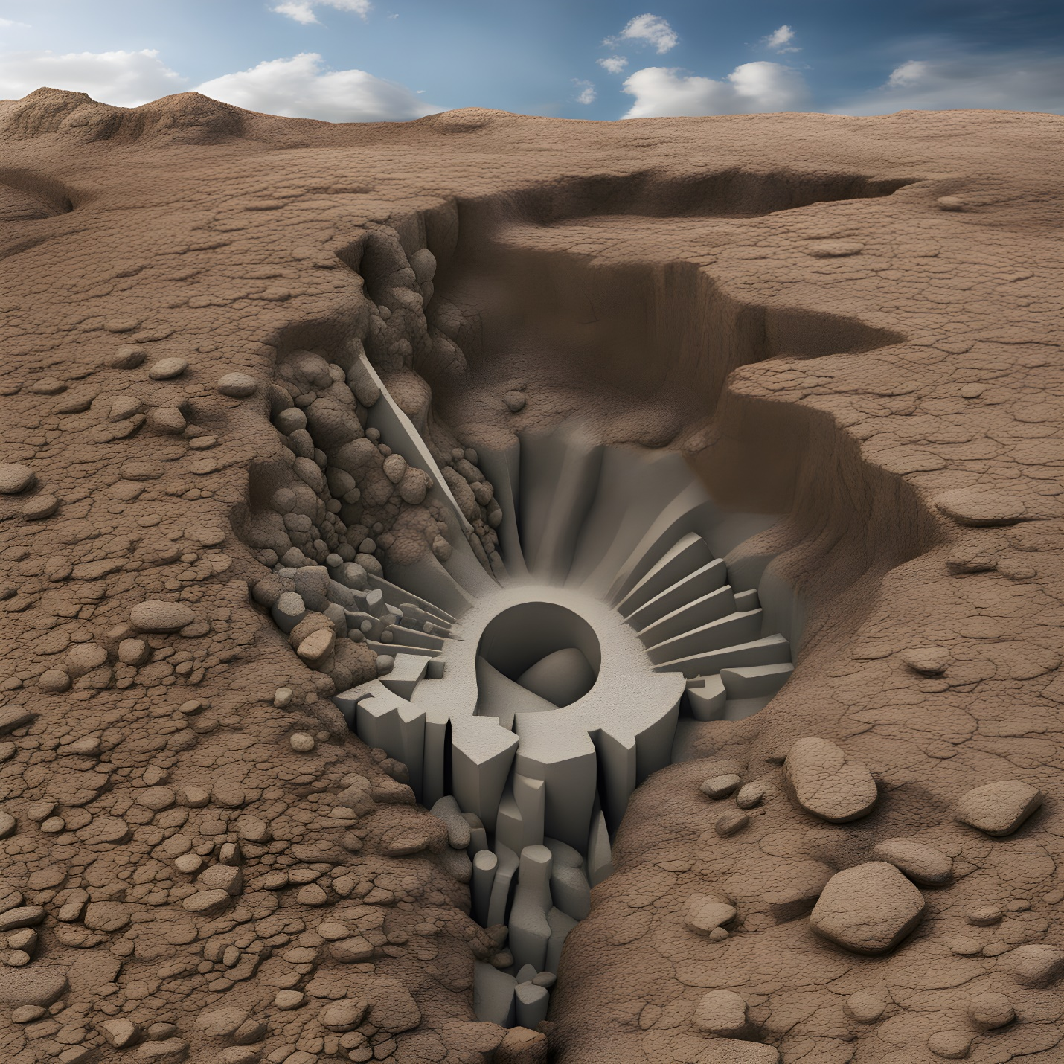
GEOTECHNICAL ENGINEERING: A JOURNEY UNDERGROUND AN BEYOND

Andres Garcia

GEOTECHNICAL ENGINEERING: A JOURNEY UNDERGROUND AND BEYOND

Andres Garcia

Table of Contents
GEOTECHNICAL ENGINEERING: A JOURNEY UNDERGROUND AND BEYOND 2
Executive Summary 6
Acknowledgements 8
Chapter 1: Introduction to Geotechnical Engineering and Soil and Rock Basics 10
1.1 The role of Geotechnical Engineering/Historical Developments and Milestones 10
1.2 Types and Properties of Soil and Rock 11
1.3 Soil Formation and Composition 13
Chapter 2: Compressibility of Soils 15
2.1 Defining Compressibility 15
2.2 Factors Affecting Compressibility and Key Concepts 16
Chapter 3: Components of Settlement 23
3.1 Defining Settlement 23
3.2 Immediate Settlement 24
3.3 Primary Consolidation Settlement 26
3.4 Secondary Consolidation Settlement 27
3.5 Consolidation Behavior 27
3.6 Determining Compression Indices (Cr and Cre) 28
Chapter 4: Pre-Consolidation Pressure and Stress History 30
4.1 Normal Consolidation, Over Consolidation, and Pre-Consolidation Pressure 30
4.2 Methods for Determining Pre-Consolidation Pressure 33
4.3 Stress History’s Impact on Compressibility 35
Chapter 5: Understanding Consolidation Testing 37
5.1 One-Dimensional Consolidation Testing 37
5.2 Significance of Consolidation Testing in Geotechnical Engineering Studies 37
Chapter 6: Methods for Analyzing Compressibility 39
6.1 Prediction of Field Consolidation Curves 39
6.2 In Situ Methods for Assessing Compressibility 40
Chapter 7: Case Studies, Future Trends, and Conclusion 43
7.1 Case Studies: Real World Applications 43
7.2 Exploring Future Trends in Compressibility Research 44
7.3 Summarizing Key Insights and Concluding Remarks 46
7.4 Additional Example Problems and Solutions 47
References 50

“The author generated this text in part with GPT-3.5, OpenAI’s large-scale language-generation model. Upon generating draft language, the author reviewed, edited, and revised the language to their own liking and takes ultimate responsibility for the content of this publication.”

Executive Summary

This comprehensive resource, "Geotechnical Engineering – A Journey Underground and Beyond" is designed to provide sophomore and junior college students with an in-depth understanding of the complex world of geotechnical engineering, with a specific focus on soil compressibility. Authored from the perspective of a senior college student, this book bridges the gap between fundamental knowledge and practical insights. It caters to students seeking to deepen their understanding of geotechnical engineering, offering a rich array of information, practice problems, video resources, and intricate details about soil compressibility and consolidation.
The primary objective of this book is to empower students to comprehend the multifaceted factors that influence soil compressibility, a fundamental concept in geotechnical engineering. As the author, I've leveraged my own academic journey to provide a unique perspective that resonates with fellow students. Through detailed explanations, real-world examples, and practice problems, this resource nurtures a deep understanding of soil mechanics.
In addition to traditional written content, this book goes the extra mile by integrating multimedia elements. It includes links to video resources that complement the textual explanations, enabling students to visualize and grasp complex concepts better. These videos serve as valuable supplementary learning tools, enhancing the educational experience.
The book begins by delving into soil types, compositions, and classifications. It explores the critical factors, both intrinsic and extrinsic, that contribute to soil compressibility. Whether it's the impact of initial void ratios, water content, overburden pressure, or load duration, each facet is examined in detail. Soil structure and fabric, often overlooked, receive due attention, highlighting their significance in soil behavior.
The culmination of this book focuses on consolidation, a time-dependent settlement phenomenon observed in cohesive soils. Detailed insights into this complex process equip students with the knowledge to anticipate and mitigate potential challenges in geotechnical engineering projects.
"Geotechnical Engineering – A Journey Underground and Beyond" is a valuable addition to any geotechnical engineering student's arsenal. With its comprehensive approach, practice problems, multimedia support, and intricate detail, this book serves as a robust reference that fosters a profound understanding of soil compressibility and its role in the broader field of geotechnical engineering. This resource is a testament to the author's commitment to enhancing the educational journey of fellow students, contributing to their success in the dynamic world of geotechnical engineering.

Acknowledgements
In the process of creating this educational resource, I have been fortunate to receive invaluable support, guidance, and inspiration from many individuals and references. Their contributions have been instrumental in shaping the content and approach of this book, "Geotechnical Engineering – A Journey Underground and Beyond" I would like to extend my heartfelt appreciation to the following:
First and foremost, I want to express my deepest gratitude to my girlfriend, Xenia. Her unwavering support, creative ideas, and encouragement have been the driving force behind this project. Xenia's patience and belief in my abilities have been a constant source of motivation throughout the journey of crafting this book.
I extend my heartfelt gratitude to my parents, whose unwavering love and support have been the cornerstone of my journey in both writing this book and pursuing my studies. Their encouragement, understanding, and belief in my capabilities have provided the strength and motivation needed to navigate the challenges of academic endeavors and the creative process of crafting this resource. Their constant encouragement has been a source of inspiration, and I am profoundly grateful for the foundation of love and support they have provided throughout this endeavor. This book is a testament to the values they instilled in me and the enduring support that has shaped my academic and creative pursuits.
I would also like to acknowledge the authors of "Introduction to Geotechnical Engineering, Third Edition," published by Pearson. The comprehensive and insightful content of this textbook, written by Dr. Robert W. Holtz, Dr. William D. Kovacs, and Dr. Thomas C. Sheahan, served as a guiding light during my research and writing process. Their work has significantly influenced the content and structure of this book.
Lastly, I am thankful for the unwavering support and encouragement from my friends, family, and fellow students who believed in the importance of creating this educational resource. Their motivation has been a constant reminder of the significance of knowledge sharing within our academic community.
Each of these individuals and references has played a crucial role in the creation of "Geotechnical Engineering – A Journey Underground and Beyond" Their contributions, whether big or small, have been essential to the successful completion of this project. I am deeply grateful for their support and assistance throughout this journey.

Chapter 1: Introduction to Geotechnical Engineering and Soil and Rock Basics

1.1 The role of Geotechnical Engineering/Historical Developments and Milestones
Geotechnical engineering, often referred to as soil mechanics, is the scientific discipline that studies the properties and behavior of soil and rocks to ensure the stability and safety of construction projects, including infrastructure such as buildings, roads, and bridges. This branch of civil engineering relies on the knowledge and understanding of geophysics, fluid mechanics, and ability to classify different types of soil and rocks to solve engineering challenges.
The Utilization of soil mechanics can be traced back to ancient civilizations such as the Egyptians, Greeks, and Romans. While their comprehension of soil properties was limited compared to today’s standards, these civilizations successfully built substantial structures and cities, indicating a rudimentary understanding of soil mechanics. The foundations of modern geotechnical engineering, as we know it today, took shape during the 18th and 19th century. Renowned engineers, including Charles-Augustin de Coulomb, Albert Atterberg, Darcy, and later in the 20th century the “father of modern soil mechanics” Karl Von Terzaghi, played pivotal roles in advancing our comprehension of soil behavior.
Nearly every civil engineering project commences with a site investigation of soil and rock properties below the surface to determine what engineering challenges are presented. Geotechnical engineers shoulder the responsibility of evaluating the associated construction risks and designing the appropriate foundation design to support the structure. Several tests can be conducted to classify soil and determine its strength characteristics. These tests involve the collection of soil sample data to characterize the condition of the site area. This information enables engineers to make informed decisions regarding the appropriate foundation type for a structure. In-situ testing is employed to analyze soil and rock in their natural state. Commonly used in-situ tests include the Standard Penetration Test (SPT), Cone Penetration Test (CPT), and Pressure-meter Test. Additionally, soil samples are extracted from various depths and subjected to laboratory testing, which typically encompasses examinations such as Atterberg limits, consolidation, particle-size analysis, and water content assessments, among others.
A famous example of what a geotechnical engineering failure can look like is the Tower of Pisa in Italy, commonly referred to as the “Leaning Tower of Pisa”. Construction of this iconic tower commenced in 1170 and for approximately two centuries, marked by interruptions triggered by seismic activity in the region. The limited understanding of soil mechanics at the time of its conception resulted in its establishment on unstable soil, ultimately leading to a gradual tilting over time. Growing apprehension about escalating settlement, which posed a potential collapse threat, prompted Italian authorities to assemble a committee dedicated to the stabilization of this historic structure.

1.2 Types and Properties of Soil and Rock
In the process of understanding the existing conditions in a site investigation, engineers must be able to proficiently classify the soil and rock present. This classification is essential for comprehending the anticipated behavior of the soil and its impact on the project.
Soil and rock encompass a diverse range of classifications, each distinguished by its distinct properties. These properties of soil, including texture, angle of repose, particle size distribution, cohesion, porosity, and permeability, provide insight into their behavior. Soil classification commonly categorizes soils into one of five primary classes: gravel, sand, silt, clay, or organic. Rocks, in contrast, fall into three main categories: sedimentary, igneous, or metamorphic. These rocks exhibit distinct properties, such as strength, porosity, density, texture, and resistance to erosion.
As discussed in section 1.1, two laboratory tests, Particle Size Analysis and Atterberg Limits, play integral roles in identifying soil properties. Particle size analysis determines the proportions of different sized particles in a soil sample. Atterberg limits tests shrinkage limit (solid to semi-solid), plastic limit (semi-solid to plastic), and liquid state (plastic to liquid), which defines soil’s plasticity and provide information for classification.
Two of the most widely used systems are the Unified Soil Classification System (USCS) and the American Association of State Highway and Transportation Officials (AASHTO) Soil Classification System. These systems serve as indispensable tools for geoscientists, engineers, and civil planners, aiding in the systematic categorization of soils based on their properties and characteristics.
USCS, initially developed by Casagrande in 1940’s, is more commonly used by geotechnical engineers. It categorizes soils into three major groups, Coarse-Grained Soil, Fine-Grained Soil, and Highly Organic Soil. The classification relies on particle size distribution and plasticity and classifies the soil as sands, silts, clays or into combinations such as sandy clay or silty sand. Coarse-grained soil, classified as gravel or sand, is classified as such if more than 50% of the soil is retained on a 0.075mm sieve. Fine-Grained soil, classified as low plasticity or high plasticity, is classified if more than 50% of the soil passes through a 0.075mm sieve. Additionally, if the liquid limit is less than 50 it is categorized as low plasticity, while on the other hand if it is more than 50, it is grouped into the high plasticity group. Highly organic soil are fine-grained soils consisting of organic material. Organic soils are also classified as low plasticity, high plasticity, and peat.
Conversely, the AASHTO Soil Classification System, developed by the American Association of State Highway and Transportation Officials, was designed specifically for highway and transportation engineering. It categorizes soils into seven groups: A-1 to A-7, primarily based on the soils' engineering properties. This system places a stronger emphasis on the fine-grained soils used in road construction and employs factors such as the liquid limit, plasticity index, and gradation characteristics. For instance, cohesive soils with high compressibility fall under Group A-7, while well-graded gravels are designated as Group A-1. The AASHTO system provides a more detailed classification of soils relevant to highway engineering needs, where factors like load-bearing capacity and compaction play a vital role.
Both the USCS and AASHTO classification systems are critical in geotechnical engineering and civil construction, enabling professionals to make informed decisions regarding soil suitability for various projects. The choice of system depends on the specific requirements of the application, as well as the focus of the engineering project. A thorough understanding of these systems equips geoscientists and engineers with the tools to assess soil properties accurately, ensuring the safety, stability, and longevity of infrastructure projects while preserving the environment.
Here are two convenient QR code links that you can easily scan with your device. They will direct you to YouTube videos providing clear demonstrations of how to classify soils using the AASHTO soil classification system and the USCS (Unified Soil Classification System).



1.3 Soil Formation and Composition
Soil, the humble yet indispensable foundation of our terrestrial ecosystem, is a dynamic product of intricate processes shaped by nature over millions of years. Soil formation, arises from a delicate interplay of five fundamental factors: parent material, climate, organisms, topography, and time. Each of these elements contributes uniquely to the composition and characteristics of soil.
Parent material is the geological substrate upon which soil formation commences. It can originate from a diverse range of sources, including weathered rocks, mineral deposits, organic materials, and even anthropogenic influence, such as urban construction. The parent material's mineral composition fundamentally dictates the soil's fertility and its ability to support life.
Climate is a pivotal driver in the soil formation process. The prevailing temperature and precipitation patterns in a region significantly influence the rate of weathering, nutrient availability, and the overall profile of the soil. For example, the difference between a desert's arid, nutrient-poor soil and a lush, fertile forest floor is largely due to climatic distinctions.
Organisms, from microorganisms to macroscopic plants and animals, interact with soils in dynamic ways. They contribute to nutrient cycling, organic matter decomposition, and the structure of the soil itself. Earthworms, for instance, play a crucial role in aerating and enhancing soil fertility by breaking down organic matter.
Topography or the physical landscape, including factors like slope and drainage patterns, profoundly shapes soil development. Sloping terrains tend to have thinner soils, while depressions often accumulate nutrient-rich sediments, leading to a mosaic of soil types in a landscape.
Lastly, the dimension of time encapsulates the notion that soil formation is a protracted process that can take hundreds to thousands of years. Soil horizons, or layers, may emerge as soils evolve, characterized by unique properties and composition.
Soil composition encompasses a mixture of solid mineral particles, organic matter, water, and air. These fundamental constituents, known as soil components, interplay to determine the soil's texture, structure, and fertility. The mineral fraction includes sand, silt, and clay particles, whose size influences a soil's texture, its water-holding capacity, and nutrient retention. The organic matter component, predominantly composed of decaying plant and animal residues, enriches the soil with essential nutrients and improves its structure. Water and air, present within the soil pores, influence its aeration and the supply of oxygen to plant roots.
Ultimately, grasping the formation and composition of soil is pivotal for understanding its significance in agriculture, ecology, geology, and land management. Soil, though unassuming, is a living testament to Earth's geological and ecological history, with its composition echoing the intricate dance of natural forces over time.

Chapter 2: Compressibility of Soils

2.1 Defining Compressibility
In the realm of geotechnical engineering, the phenomenon of soil compressibility plays a pivotal role, driving the understanding of how soils react to external forces, such as loads from structures or earth fills. This intricate behavior is essential knowledge for students embarking on their journey through earth sciences and geotechnical engineering, as it not only unveils the fundamental principles governing soil deformation but also equips them with the skills to evaluate and predict settlements, crucial for the successful design and construction of foundations.
Soil compressibility, when observed in one dimension, offers a simplified view of this complex phenomenon. To comprehend this concept, imagine a vast expanse of soil being subjected to a load, which initiates a series of deformations. When a soil is loaded, it undergoes compression attributed to three core mechanisms: the deformation of soil grains, the compression of air and water within its voids, and the expulsion of water and air from these voids. However, at the typical loads encountered in engineering, the deformation of the soil grains themselves is minimal and often negligible. This is particularly true for soils situated below the water table, which are typically treated as fully saturated, assuming 100% saturation for most settlement calculations. Consequently, it is the third factor, squeezing out water and air from the voids that contributes most significantly to the volume change of the loaded soil deposits.
The speed at which this process transpires is largely contingent upon the permeability of the soil. In the case of granular materials, such as sands, which exhibit high permeability, compression is swift. During construction, these materials can experience nearly instantaneous settlement, with water and air rapidly escaping from the voids. Conversely, fine-grained soils, like clays, feature low permeability, impeding the swift drainage of water. Consequently, their compression process, known as consolidation, unfolds over an extended timeframe, which can extend from months to years, and in some cases, even decades. This stark difference in settlement rates between granular and cohesive soils underscores the pivotal role of permeability in soil compression.

2.2 Factors Affecting Compressibility and Key Concepts
Soil compressibility, essentially how soil responds to external loading, is a critical factor influencing the deformation and settlement of the ground. This aspect becomes paramount in the construction of structures like buildings, where the foundation directly interacts with the underlying soil. The compressibility of the soil layer beneath the foundation significantly influences the potential for settlement, or vertical deformation of the ground surface, over time.
One of the foremost factors dictating soil compressibility is its inherent type and composition. Soil can be broadly classified into two categories: cohesive soils, such as clays, and granular soils, like sands and gravels. Cohesive soils, with their fine particles and substantial water content, tend to exhibit higher compressibility compared to granular soils. This is attributed to the cohesive nature of fine particles and the water-binding forces within the soil matrix. Understanding parameters like unit weight, dry unit weight, water content, porosity, void ratio, and degree of saturation is crucial in providing insights into soil behavior.
Porosity is defined as the ratio of the volume of voids in a soil to the total volume of the soil and is typically expressed as a percentage. The porosity of soils plays a critical role in influencing their compressibility and permeability. Soils with higher porosity are more compressible and less permeable than soils with lower porosity.
$$n= \frac{V_{V}}{V_{t}}$$
Where:
$$n=Porosity$$
$$V_{V} = volume of voids$$
$$V_{t}=Total Volume$$
Void ratio is defined as the ratio of the volume of voids to the volume of solids in a soil mass. It is a measure of the amount of pore space in a soil and it affects the compressibility and permeability of soils.
Where:
$$e = void ratio$$
$$V_{V} = volume of voids$$
$$Vs = Volume of solids$$
$$e= \frac{V_{V}}{V_{S}}$$
From these equations, we can see that void ratio and porosity are related by the volume of solids in the soil sample. As the volume of solids increases, the void ratio decreases, and the porosity decreases. Conversely, as the volume of solids decreases, the void ratio increases, and the porosity increases.
In the context of consolidation, void ratio is particularly relevant because it is also related to the degree of saturation of the soil. The degree of saturation is the ratio of the volume of water in a soil to the total volume of voids and solids. When a soil is loaded, the pore water is squeezed out of the soil, and the soil undergoes compression and settlement. The rate and magnitude of settlement depend on several factors, including the initial void ratio, the effective stress, and the degree of saturation. The degree of saturation is expressed as a percentage, and ranges from 0% (completely dry) to 100% (completely saturated).

$$S= \frac{V_{w}}{V_{a}+V_{v}}×100\%$$
Where:
$$S = Degree of Saturation$$
$$V_{w}=Volume of water$$
$$V_{V}=Volume of Voids$$
$$V_{a}=Volume of air$$

Effective stress, ${σ'}_{v}$, is the stress that is transmitted through the solid particles in a soil sample and is equal to the total stress minus the pore water pressure.
$${σ'}_{v}=σ_{v}-u$$
Where:
$${σ^{'}}_{v}=Effective Stress$$
$$σ_{v}=Total Stress$$
$$u=Pore water Pressure$$
As water is expelled from the voids in a soil sample during consolidation, the pore water pressure decreases, which in turn increases the effective stress. This increase in effective stress causes the soil particles to rearrange themselves, resulting in a reduction in volume and an increase in density. The rate of consolidation of a soil sample is directly proportional to the change in effective stress.
Water content is a measure of the amount of water present in a soil sample. It is expressed as a percentage of the weight of water to the total weight of the soil. Water content is a critical parameter because it significantly influences the engineering behavior of soils. The relationship between water content and soil properties is complex but essential to understand when dealing with soil mechanics. Different water contents can lead to variations in soil volume, density, and strength, making it a crucial factor in the design and analysis of geotechnical structures. Water content plays a pivotal role in the determination of important soil properties, including the specific gravity of solids, void ratio, and porosity, which are essential for geotechnical investigations and engineering applications.
$$Water Content \left(\%\right)= \frac{W_{w}}{W_{s}}$$
understanding the contrast between water content and the degree of saturation is essential. Water content signifies the quantity of water within a soil sample in relation to its total mass, often expressed as a percentage. It provides insight into the soil's moisture content. On the other hand, the degree of saturation, typically represented as "S," reveals the proportion of a soil's void spaces that are occupied by water. It indicates how thoroughly the soil is saturated with water and is also expressed as a percentage. Both water content and the degree of saturation are pivotal in comprehending soil behavior within the field of geotechnical engineering, each offering unique insights into soil characteristics and behavior.
During consolidation, the phase diagram can illustrate how changes in pore water pressure and effective stress affect soil volume and density. It provides insights into the critical relationships between stress, strain, and the physical state of the soil. The three main phases in a geotechnical phase diagram are:
Solid Phase (Soil Particles): This represents the soil particles, which can include particles of various sizes such as clay, silt, sand, and gravel. The arrangement and composition of these particles significantly influence the mechanical properties of the soil.
Liquid Phase (Water): The liquid phase represents water present in the soil. The amount of water and its distribution in the soil matrix affect the soil's compressibility, shear strength, and other engineering properties. Water is a critical component in consolidation processes.
Gas Phase (Air): The gas phase represents the air or other gases present in the void spaces between soil particles. The volume and pressure of the gas phase influence the soil's overall volume and density.

Displayed below in figure (1.1) is an illustrative example of a phase diagram, distinctly labeled to represent the three fundamental phases: solid, liquid, and gas.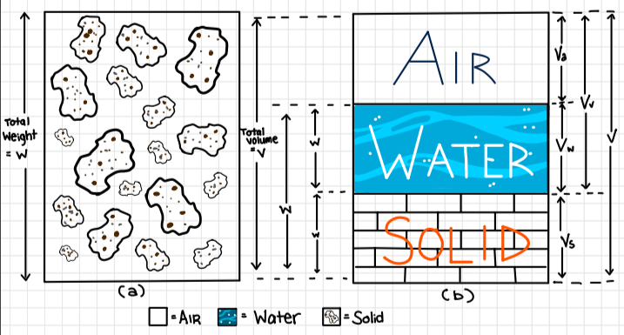
Figure 2.1

Unit weight is defined as the weight of a soil per unit volume and is typically expressed in pounds per cubic foot ($\frac{lb}{{ft}^{3}}$) or kilograms per cubic meter ($\frac{Kg}{m^{3}}$). The unit weight of a soil depends on several factors, including the density of the soil particles, the degree of compaction, and the amount of water in the soil. Weight of air is negligible.
$$γ= \frac{W_{s}+ W_{w}}{V}$$
Where:
$$W_{s}=Weight of Solid$$
$$W_{w}=Weight of water$$
$$V=Total Volume$$
Dry unit weight refers to the weight of soil in a completely dry state, and it is typically measured in the same units as unit weight. In the realm of geotechnical engineering, dry unit weight holds a crucial role as it directly influences the strength and compressibility of soils.
$$γ_{d}= \frac{W_{s}}{V}$$

Overburden pressure is the weight of the soil and other materials above a particular point in the ground. It is the total vertical stress that is exerted on a soil layer due to the weight of all the soil and rock layers above it. The magnitude of the overburden pressure depends on the thickness and density of the soil and rock layers above the point of interest. In general, the overburden pressure increases with depth, and can have a significant effect on the behavior of soils and rocks. Overburden pressure is typically expressed in terms of force per unit area and is commonly measured in units such as pounds per square foot (psf) or kilopascals (kPa). Mathematically, overburden pressure ($σ_{v}$) can be calculated by multiplying the unit weight of the soil ($γ$) by the depth ($h$) below the ground surface:

$$σ_{v}= γ×h$$

Load duration is an important factor in the compressibility and consolidation of soils. When a soil is subjected to a load, it will deform and settle over time due to the expulsion of water from the soil pores. The rate of settlement depends on the rate of pore water drainage, which in turn depends on the permeability of the soil. Prolonged loading can lead to time-dependent settlement, primarily observed in cohesive soils due to their low permeability. The longer the duration of the load, the greater the amount of settlement that will occur. This is because the expulsion of water from the soil pores is a slow process, and it takes time for the excess pore pressure to dissipate. The rate of settlement is also affected by the magnitude of the load, the thickness of the soil layer, and the compressibility of the soil. Load duration is particularly important in the design of foundations and other geotechnical structures that are subjected to long-term loads.
Soil structure refers to the arrangement of soil particles and the voids between them, while soil fabric refers to the orientation and shape of the soil particles themselves. In general, soils with a well-structured and well-organized fabric will be less compressible and more resistant to consolidation than soils with a poorly structured or disorganized fabric. This is because well-structured soils have a more interconnected network of voids, which allows water to drain more easily and reduces the amount of pore pressure that builds up under load. In contrast, poorly structured soils may have isolated pockets of voids that are difficult to drain, leading to higher pore pressures and greater settlement.
The fabric of the soil particles themselves can also affect compressibility and consolidation. For example, soils with platy or flaky particles may be more compressible than soils with more spherical particles, because the platy particles can more easily slide past each other under load. Similarly, soils with particles that are well-aligned in one direction may be more compressible in that direction than in other directions.
In terms of the environment, soils that are exposed to moisture or water will generally be more compressible and more prone to consolidation than soils that are dry. This is because water can fill the voids between soil particles, increasing the pore pressure and reducing the effective stress. Soils that are exposed to freeze-thaw cycles can also be affected, as the expansion and contraction of water as it freezes and thaws can cause soil particles to shift and settle. soils that are exposed to higher temperatures will be more compressible than soils that are exposed to lower temperatures. This is because higher temperatures can cause the soil particles to expand, reducing the effective stress and increasing the pore pressure. However, the effect of temperature on soil compressibility can be complex and depends on a variety of factors, including the type of soil and the duration and magnitude of the load.

While this video may be more extensive in duration, it provides an in-depth exploration of the concepts covered in this chapter. It also offers practical examples and problem-solving exercises related to topics that frequently appear on the FE Exam. For students aiming to proactively prepare for their FE Exam, this resource offers valuable practice and comprehensive insights.



Chapter 3: Components of Settlement

3.1 Defining Settlement
Settlement, a term critical to geotechnical engineering, refers to the vertical deformations that occur in a soil deposit when it is subjected to external loading, such as the weight of a building, an earthfill, or other man-made structures. Settlement is an essential consideration in the construction and design of civil engineering projects since it directly influences the stability, performance, and safety of structures.
Settlement, while often perceived as a single phenomenon, comprises three main components described by the equation below

$$S_{t}=S_{i}+S_{c}+S_{s}$$

Where S_{t} = Total Settlement
S_{i} = The immediate settlement
S_{c} = The Consolidation (time-dependent) settlement
S_{s} = The secondary compression (also time-dependent)
To grasp the concept of consolidation, envision a saturated sponge. When you compress the sponge, water is expelled, causing the sponge to shrink. This mirrors primary consolidation, where soil undergoes compression, expelling pore water. Yet, just as a squeezed sponge doesn't instantly return to its original size, secondary consolidation occurs in soil, resulting in ongoing settlement even after the load is removed.
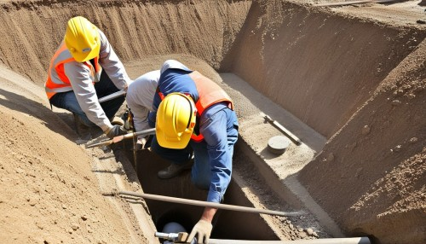
(AI Generated Image)

3.2 Immediate Settlement
Immediate settlement is a crucial concept that plays a significant role in the structural stability and safety of civil engineering projects. This type of settlement is characterized by rapid vertical deformations that occur in soil deposits upon the application of external loading. To understand immediate settlement, it's important to recognize that it's not strictly elastic but is usually estimated using elastic theory, particularly in clayey soils. Immediate settlement is particularly relevant in the context of shallow foundations, where the loading often occurs in three dimensions, leading to some distortion of the foundation soils. This distortion can be understood as a change in the configuration of soil due to the applied load, similar in principle to the deformation of a column under an axial load.
Immediate settlements typically occur in coarse-grained soils, such as sands, where the high permeability allows for the rapid escape of water and air from the soil voids, facilitating quick adjustments. In contrast, fine-grained soils, such as clays, exhibit slower immediate settlements. This phenomenon arises from the lower permeability, making it difficult for water to escape swiftly and allow the soil to compress rapidly.
The formula commonly used to estimate immediate settlement in sand is based on the elastic theory, although it's essential to note that sandy soils often exhibit non-elastic behavior.
The settlement equation for immediate settlement ($S_{i}$) in sand can be expressed as:

$$S_{i}=\frac{H_{o}}{C_{s}}\log_{10}{(\frac{σ_{vo}+∆{σ'}_{v}}{σ_{vo}}})$$
$$C_{s}=1.5\frac{C_{r}}{σ_{vo}}$$
Where:
$$H_{o}=initial thickness of soil$$
$$σ_{vo}=initial effective overburden pressure at mid depth of soil$$
$$∆{σ'}_{v}=increase in effective stress at the mid depth of the soil$$
$$C_{r}=static cone resistance$$
the immediate settlement in sandy soils tends to be relatively small compared to fine-grained soils due to their higher permeability and ability to quickly release water and air during loading.
Clayey soils, being fine-grained and typically having low permeability, exhibit distinct behavior compared to sandy soils during immediate settlement. The compression in clay is associated with the rearrangement of soil particles and the expulsion of water from the voids.
The settlement equation for immediate settlement $(S_{i}$) in clay can be expressed as:
$$S_{i}=\frac{qB}{E}(1-μ^{2})I_{f}$$
Where:
$$q=Net Foundation Pressure$$
$$B=Width of the Foundation$$
$$μ=Poisson^{'}s ration$$
$$E=Young^{'}s modulus of soil$$
$$I_{f}=Influence factor$$
It's important to note that while this formula provides a theoretical estimation, clayey soils often exhibit time-dependent behavior, and consolidation may continue over an extended period. Empirical correlations, field tests, and considerations of factors such as soil type, initial void ratio, and stress history are essential for refining the accuracy of immediate settlement estimates in clay.
The significance of understanding immediate settlement lies in its potential impact on structures. Even relatively small immediate settlements can be detrimental to structures that are sensitive to rapid deformations, emphasizing the importance of accurate estimation and prediction. Geotechnical engineers employ various methods to calculate immediate settlement, considering factors like soil type, loading characteristics, and foundation design. These analyses help ensure the safety and longevity of construction projects, as well as the structural integrity of the built environment.
The video linked below is an in-depth lecture explanation of the concept immediate or elastic settlement.


3.3 Primary Consolidation Settlement
Primary consolidation settlement is a complex process that occurs in fine-grained soils, such as clays, when they are subjected to loading. When a load is applied to a soil, the water in the pores is squeezed out, causing the soil to compress and settle. The rate of settlement depends on the rate of pore water drainage, which is controlled by the compressibility of the soil. The compressibility of the soil is influenced by several factors, including the soil type, the initial void ratio, the effective stress, and the degree of saturation.
The primary consolidation settlement is a time-dependent process that can continue for months, years, or even decades. During this process, the soil undergoes a series of changes in its physical properties, including changes in its void ratio, water content, and pore pressure. The rate of consolidation settlement can be estimated using various methods, including the use of empirical correlations and laboratory tests.
In geotechnical engineering, primary consolidation settlement is a critical factor to consider when designing structures that are sensitive to rapid settlements, such as buildings, bridges, and dams. If the rate of settlement is too high, it can cause significant damage to the structure, leading to structural failure or reduced service life. Therefore, it is essential to understand the behavior of soils under load and to design structures that can withstand the expected settlement. This requires a thorough understanding of the soil properties, the loading conditions, and the expected rate of settlement.
One of the most used equations is Terzaghi's one-dimensional consolidation theory, which relates the rate of consolidation settlement to the coefficient of consolidation, the thickness of the soil layer, and the applied load. This equation is expressed as:
$$∆H= H_{o}\frac{∆e}{1+e_{o}}$$

3.4 Secondary Consolidation Settlement
Secondary consolidation settlement is a type of settlement that occurs in soils after the primary consolidation settlement has completed. It is a time-dependent process that occurs at constant effective stress and with no subsequent changes in pore water pressure. Secondary consolidation settlement is caused by the rearrangement of soil particles and the compression of organic matter in the soil.
The rate of secondary consolidation settlement is typically much slower than that of primary consolidation settlement and can continue for many years after the primary consolidation has completed. The amount of secondary consolidation settlement depends on several factors, including the soil type, the initial void ratio, the effective stress, and the degree of saturation.
The rate of secondary consolidation settlement can be estimated using various methods, including laboratory tests, empirical correlations, and analytical solutions. One of the most commonly used equations for estimating secondary consolidation settlement is the magnitude of secondary consolidation equation, which is expressed as:
$$S_{s}=\frac{H}{1+e}e$$

3.5 Consolidation Behavior
Consolidation behavior refers to the process by which a soil undergoes deformation or settlement under load. When a soil is loaded, it will compress due to the deformation of soil grains, compression of air and water in the voids, and/or squeezing out of water and air from the voids. The amount of compression depends on several factors, including the soil type, the initial void ratio, the effective stress, and the degree of saturation. Consolidation behavior is a time-dependent process that occurs in saturated fine-grained soils that have a low coefficient of permeability. The rate of settlement depends on the rate of pore water drainage. Secondary compression, which is also time-dependent, occurs at constant effective stress and with no subsequent changes in pore water pressure.
The consolidation behavior of soils can be estimated using various methods, including laboratory tests, empirical correlations, and analytical solutions. One of the most used methods is the oedometer test, which is used to measure the rate of consolidation settlement of a soil sample under a constant load. The results of the oedometer test can be used to estimate the compression characteristics of an undisturbed representative sample and to predict the settlement of the soil layer in the field.

3.6 Determining Compression Indices (Cr and Cre)
One of the key components used to describe the compressibility of soils is the compression index $(C_{c})$. The compression index is a measure of the rate of compression of a soil under load. It is defined as the slope of the virgin compression curve when the test results are plotted as percent consolidation or vertical strain versus logarithm of effective stress. The compression index is a dimensionless parameter that ranges from 0 to 1, with higher values indicating a greater degree of compressibility.
The compression index is an important parameter in geotechnical engineering because it is used to estimate the magnitude and rate of settlement of soil layers under load. The compression index is typically determined using laboratory tests, such as the one-dimensional consolidation test. In this test, an undisturbed soil specimen is placed into a consolidometer and subjected to a load. The deformation of the soil specimen is measured over time, and the compression index is calculated from the resulting data.
Another important parameter used to describe the compressibility of soils is the recompression index $(C_{r})$. The recompression index is a measure of the rate of recovery of the soil after unloading. It is defined as the slope of the recompression curve when the test results are plotted as percent recompression or vertical strain versus logarithm of effective stress. The recompression index is also a dimensionless parameter that ranges from 0 to 1, with higher values indicating a greater degree of compressibility.
The recompression index is important in geotechnical engineering because it is used to estimate the magnitude and rate of rebound of soil layers after unloading. The recompression index is typically determined using laboratory tests, such as the one-dimensional consolidation test. In this test, an undisturbed soil specimen is first loaded and then unloaded. The deformation of the soil specimen is measured over time, and the recompression index is calculated from the resulting data.
In summary, the compression index and recompression index are important parameters used to describe the compressibility of soils. These parameters are used to estimate the magnitude and rate of settlement and rebound of soil layers under load. The compression index is a measure of the rate of compression of a soil under load, while the recompression index is a measure of the rate of recovery of the soil after unloading. These parameters are typically determined using laboratory tests, such as the one-dimensional consolidation test.



Chapter 4: Pre-Consolidation Pressure and Stress History

4.1 Normal Consolidation, Over Consolidation, and Pre-Consolidation Pressure
Normal consolidation occurs when a soil has not experienced stress beyond its current effective vertical stress in the recent past. It is characteristic of soils with stress histories close to their current stress state. The consolidation process in normally consolidated soils is governed by Terzaghi's one-dimensional consolidation theory. The loading path is along the Virgin Compression line show in Figure (4.1) and equated by the formula below
$$C_{c}= \frac{∆e}{\log\left({σ^{'}}_{vo}+∆σ^{'}\right)-\log{({σ^{'}}_{vo})}}$$

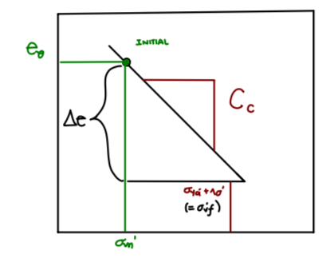
Figure 4.1

Terzaghi's consolidation equation is a fundamental expression used to quantify the settlement $(S_{c})$ of normally consolidated soils over time:
$$S_{c}=\frac{C_{c}×∆{σ'}_{v}×t}{1+e_{o}}$$
Where:
$$C_{c}=Consolidation Coefficient$$
$$∆{σ^{'}}_{v}=change in effective stress$$
$$t=time$$
$$e_{o}=initial void ratio$$

The Over-consolidation Ratio, OCR, is the ratio of the pre-consolidation stress, $σ_{p}$, to the existing vertical effective overburden stress, $σ_{υο}$.

$$OCR= \frac{σ_{p}}{σ_{υο}}$$

Soils that are normally consolidated have an OCR = 1 and soils with an OCR > 1 are overconsolidated. OCR < 1 would be under-consolidated soils. Under-consolidation can occur in soils that have been recently deposited, either geologically or by man. Under these conditions, the clay layer has not yet come to equilibrium under the weight of the overburden load. Overconsolidated soils could occur due to either a change in the total stress or a change in pore water pressure, both of which would alter the effective stress.
The figure 4.2 represents Overconsolidated clay, if the clay is overconsolidated, and remains in the recompression zone then (CASE 1):
$$∆H=H_{o}\frac{C_{R}}{1+e_{o}}\log{\frac{{σ'}_{vf}}{{σ'}_{vo}}}$$
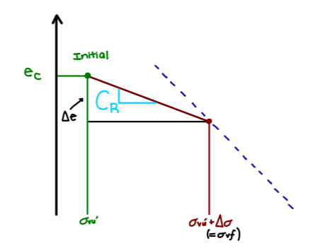
Figure 4.2
The recompression zone in overconsolidated clay is a critical aspect of soil behavior, particularly in the context of consolidation shown in figure 4.2. the recompression zone refers to a range of stress and strain conditions where the soil undergoes compression upon the application of additional load. Unlike normally consolidated clay, which typically undergoes immediate settlement upon loading, overconsolidated clay may experience an initial compression, commonly known as recompression, before any significant settlement occurs. The presence of a recompression zone has implications for foundation design, as it may influence the magnitude and timing of settlements in overconsolidated clay. Engineers must consider this unique behavior when assessing the long-term performance and stability of structures built on such soils.
If an overconsolidated clay becomes normally consolidated by the end of consolidation as represented by figure 4.3 and formula below (CASE 2):
$$∆H=\frac{H_{o}}{1+e_{o}}(C_{R}\log{\frac{{σ'}_{p}}{{σ'}_{vo}}+C_{c}\log{\frac{{σ'}_{vf}}{{σ'}_{p}})}}$$
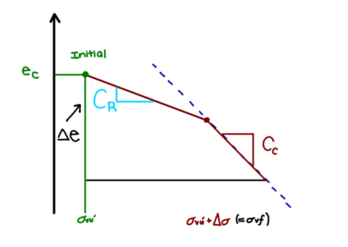
Figure 4.3

preconsolidation pressure, ${σ'}_{p}$, is the maximum vertical overburden stress that a soil sample has sustained in the past. When a soil sample is loaded to a stress level that is less than the preconsolidation pressure, the soil behaves elastically and follows the virgin compression curve. However, when the stress level exceeds the preconsolidation pressure, the soil begins to deform plastically, and the virgin compression curve is no longer valid. Instead, the soil follows a new compression curve that is parallel to the virgin compression curve but shifted to the right. This new compression curve is known as the recompression curve, and it represents the behavior of the soil during subsequent loading cycles.
Understanding preconsolidation pressure aids in differentiating between normally consolidated and overconsolidated soils. Normally consolidated soils have a preconsolidation pressure equal to the current vertical effective stress, while overconsolidated soils have a preconsolidation pressure higher than the current stress. In overconsolidated soils, the excess preconsolidation pressure can result in reduced settlements and higher bearing capacities, making them suitable for certain construction projects. Conversely, in normally consolidated soils, understanding the preconsolidation pressure is crucial for predicting settlements accurately.

4.2 Methods for Determining Pre-Consolidation Pressure
The Casagrande method, also known as the Casagrande construction, is a graphical technique used in geotechnical engineering to estimate the preconsolidation pressure $({σ'}_{p})$ of a soil sample, refer to figure 4.4. Preconsolidation pressure refers to the maximum vertical effective stress that a soil has experienced in its history. The Casagrande method is particularly useful for cohesive soils, such as clays. Understanding the preconsolidation pressure is crucial in geotechnical engineering because it provides insights into the soil's stress history. Soils that have experienced higher preconsolidation pressures are typically more resistant to further compression, influencing engineering decisions related to foundation design, slope stability, and construction planning.
Here is a step-by-step explanation of the Casagrande method to find preconsolidation $({σ'}_{p})$ using the figure below:
- Estimate Point of Maximum Curvature (pt): The first step involves examining the consolidation curve obtained from laboratory tests, typically a plot of void ratio against effective stress. Identify the point on the curve where the curvature is the greatest.
- Draw Lines Horizontal and Tangent: From the point pt, draw a horizontal line to intersect the virgin compression line (the initial part of the consolidation curve). Also, draw a tangent to the consolidation curve at pt.
- Draw a Bisector: Construct a bisector (a line bisecting the angle formed by the horizontal line and the tangent) starting from the intersection point with the virgin compression line.
- Extend Virgin Compression Line: Extend the virgin compression line beyond its original termination point using the bisector.
- Intersection is Max. Past Pressure: The intersection of the extended virgin compression line and the tangent line represents the estimated preconsolidation pressure $({σ'}_{p})$. This point indicates the maximum past pressure that the soil has experienced in its history.
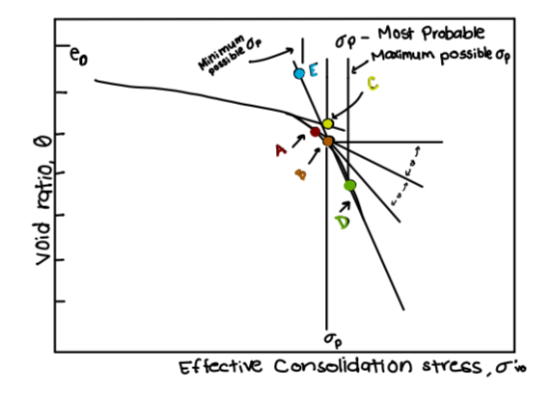
Figure 4.4

4.3 Stress History’s Impact on Compressibility
Stress history in geotechnical engineering plays a pivotal role in understanding the behavior of soils under various loading conditions. It refers to the past stress states that a soil has experienced and is a critical factor influencing consolidation, settlement, and overall geotechnical performance. The stress history of a soil is a dynamic record of the forces it has been subjected to over time, shaping its present response to new loading conditions.
The stress history of soil can be categorized into two main types: normal consolidation and overconsolidation. In normally consolidated soils, the current effective stress is greater than or equal to any stress the soil has experienced in the past. This means that the soil has not been subjected to stresses exceeding its current state, and as a result, it behaves differently compared to overconsolidated soils.
Overconsolidation occurs when a soil has experienced higher stresses in the past than the current effective stress. This can result from natural processes such as glaciation, erosion, or changes in water levels. Overconsolidated soils exhibit unique characteristics, including a recompression zone, where the soil contracts before undergoing further settlement when subjected to additional loads.
The stress history of soil is determined by factors such as past loading events, geological processes, and environmental conditions. It is often analyzed through laboratory testing, including oedometer tests and the examination of soil samples to establish the soil's stress-strain relationship.
Understanding stress history is crucial in predicting how soils will behave under current and future loading conditions. For example, in the design of foundations for structures, engineers need to consider the stress history to accurately assess settlement and ensure the stability of the foundation. The Consolidation Stress Ratio (CSR), which is the ratio of the current effective stress to the maximum past effective stress, is a key parameter used to quantify the stress history of a soil.
In normally consolidated soils, the CSR is equal to or greater than 1, indicating that the current stress state is within the historical range. In overconsolidated soils, the CSR is less than 1, signifying that the soil has experienced higher stresses in the past. The CSR provides a quantitative measure that aids engineers in evaluating the stress history and making informed decisions during the design and construction phases.
The influence of stress history extends beyond foundation design, impacting slope stability, embankment construction, and other geotechnical applications. It is also crucial in analyzing natural phenomena, such as landslides, where the stress history of the soil can be a determining factor in the occurrence and severity of slope failures.

Chapter 5: Understanding Consolidation Testing

5.1 One-Dimensional Consolidation Testing
One-dimensional consolidation testing is a laboratory test used to determine the rate and magnitude of settlement of a soil layer under load. The test is used to simulate the one-dimensional compression of soil layers covering a large area, such as those found in embankments, foundations, and landfills.
The test involves placing an undisturbed soil specimen into a consolidometer, which is a special device designed to simulate one-dimensional compression. The consolidometer consists of a confining ring, a porous stone at the top and bottom of the specimen, and a loading plate. The confining ring is relatively rigid so that no lateral deformation takes place. The porous stones allow drainage during the consolidation process.
The test is conducted by applying a constant load to the soil specimen and measuring the resulting deformation over time. The deformation is measured using a dial gauge or other displacement measuring device. The test is typically conducted in several stages, with each stage involving a different load and duration.
The results of the test are used to determine the compression characteristics of the soil, including the compression index, the coefficient of consolidation, and the coefficient of secondary compression. These parameters are used to estimate the rate and magnitude of settlement of the soil layer in the field.
One-dimensional consolidation testing is an important tool in geotechnical engineering for predicting the behavior of soils under load. The test provides valuable information about the compressibility and consolidation behavior of soils, which is critical for the design of structures that are sensitive to long-term settlements, such as embankments, dams, and landfills.

5.2 Significance of Consolidation Testing in Geotechnical Engineering Studies
The significance of consolidation testing emerges as a beacon guiding engineers through the complex terrain of soil behavior. Consolidation testing, a cornerstone in soil mechanics, delves into the temporal intricacies of soil settlement, providing invaluable insights that underpin the design and construction of structures.
One of the unique features of consolidation testing is its emphasis on time-dependent soil behavior. Unlike immediate settlements, which occur rapidly upon loading, consolidation settlements unfold gradually over an extended period. The tests enable engineers to predict the rate and magnitude of settlement, providing crucial information for designing foundations that can withstand the test of time.
The significance of consolidation testing extends beyond the laboratory, finding application in real-world engineering challenges. Consider the construction of a high-rise building on soft clayey soil. Consolidation testing informs engineers about the potential settlement of the foundation over time, allowing for proactive design measures to mitigate adverse effects. Consolidation testing serves as a risk mitigation tool, enabling engineers to optimize foundation designs based on soil behavior predictions. By understanding how different soil types respond to loads, engineers can tailor foundation designs to specific geological conditions, minimizing the risk of excessive settlements that could compromise structural integrity.

The linked video below guides you through the intricacies of a one-dimensional consolidation test conducted in a laboratory setting. The engineer, with a keen attention to detail, explains each step comprehensively, creating an immersive experience that makes you feel as though you are actively participating in the data-gathering process alongside her.


Chapter 6: Methods for Analyzing Compressibility

6.1 Prediction of Field Consolidation Curves
Prediction of field consolidation curves is a critical aspect of geotechnical engineering that involves estimating how soils will respond to loads over time. Consolidation, the process by which soils gradually deform and settle under applied stress, is a complex phenomenon influenced by various factors. Field consolidation curves provide insights into the settlement behavior of soils in real-world conditions, aiding engineers in designing foundations and infrastructure with a comprehensive understanding of potential settlement.
To predict field consolidation curves, engineers rely on laboratory testing, empirical correlations, and mathematical models. Oedometer tests, commonly used in laboratories, involve applying incremental loads to soil samples and measuring the resulting settlements over time. These tests help establish the compression characteristics of soils, forming the basis for predicting their behavior in the field.
Empirical correlations are developed based on extensive field observations and laboratory data. These correlations relate soil properties to field settlement performance, allowing engineers to make informed predictions without conducting extensive testing for every project. Examples include relationships between settlement and soil types, moisture content, or plasticity index.
Mathematical models, such as the Terzaghi-Wegman or Schmertmann methods, provide a more detailed analysis by considering the soil's stress-strain behavior and layering effects. These models use mathematical equations to simulate consolidation under various loading conditions, enabling engineers to predict settlement with a higher degree of accuracy.
The prediction of field consolidation curves involves understanding the soil's compressibility, permeability, and stress history. Compressibility is the soil's ability to undergo volume change under load, while permeability influences how water drains from the soil during consolidation. Stress history, including past loading and overconsolidation, plays a crucial role in predicting settlement behavior.

The consolidation process involves the dissipation of excess pore water pressure within the soil. As load is applied, water is expelled from the soil matrix, and the excess pore water pressure gradually dissipates over time. The rate of consolidation is influenced by the soil's compressibility and permeability, with more compressible and less permeable soils generally experiencing slower consolidation.
Predicting field consolidation curves is particularly essential in designing foundations for structures. Excessive settlement can lead to structural damage, affecting the safety and performance of buildings and infrastructure. By understanding how a specific soil type will consolidate under given loading conditions, engineers can optimize foundation designs, incorporating measures to mitigate potential settlement issues.
In addition to foundation design, the prediction of field consolidation curves is crucial in infrastructure projects such as embankments, dams, and transportation systems. Engineers must consider the settlement characteristics of soils to ensure the stability and longevity of these structures. The development of accurate predictions allows for proactive measures to be taken, reducing the risk of unexpected settlement-related problems during and after construction.
Advancements in geotechnical engineering continue to refine methods for predicting field consolidation curves. Numerical modeling, coupled with sophisticated laboratory testing and field instrumentation, enhances the accuracy of predictions. Real-time monitoring during construction projects provides valuable data for validating predictions and adjusting designs as needed.

6.2 In Situ Methods for Assessing Compressibility
Several in-situ methods have been developed to assess consolidation and compressibility directly in the field, providing valuable insights for engineering decisions.
One widely used in-situ method is the Standard Penetration Test (SPT). The SPT involves driving a thick-walled sample tube into the ground at the bottom of a borehole using a standard weight and falling distance. The number of blows required to penetrate the last 12 inches of the tube provides the SPT blow count, commonly denoted as N-value. This value offers an indication of the relative density and, indirectly, the compressibility of the soil. While the SPT primarily assesses soil resistance, correlations with empirical relationships allow engineers to estimate settlement and compressibility characteristics.
Another popular in-situ method is the Cone Penetration Test (CPT). The CPT involves pushing a cone-shaped penetrometer into the soil at a constant rate, measuring the resistance as the cone advances. This test provides continuous profiles of cone resistance and sleeve friction along the depth of the borehole. Cone resistance is particularly useful for assessing the undrained shear strength, which is critical in estimating consolidation behavior. The CPT data is often used to derive important soil parameters, such as the preconsolidation pressure and overconsolidation ratio.
Pressuremeter tests are in-situ methods that directly measure the compressibility of the soil.
The pressure meter test involves the inflation of a cylindrical probe in a borehole at a controlled rate, recording the applied pressure and resulting strain. This test provides a stress-strain relationship for the soil, enabling the determination of parameters like the modulus of elasticity and the coefficient of volume compressibility. The pressure meter test is particularly valuable in assessing the compressibility of clays and soft soils.
To investigate consolidation behavior, the Flat Plate Dilatometer Test (DMT) is a powerful in-situ tool. The DMT involves pushing a flat plate into the soil at a controlled rate and measuring the soil's response to lateral stress. The resulting data helps determine the horizontal coefficient of consolidation, providing insights into the time-dependent settlement behavior of the soil. The DMT is advantageous for assessing the anisotropic consolidation behavior of certain soil deposits.
In addition to these tests, seismic methods have been employed to indirectly assess soil compressibility. Seismic Cone Penetration Testing (SCPT) involves the use of seismic waves generated by a small hammer attached to the CPT cone. The velocity of these waves provides information about the soil's elastic properties, which can be related to its compressibility. While not as direct as other methods, seismic methods offer rapid, non-destructive assessments over large areas.
Thermal methods have also been explored for in-situ assessment of consolidation. These methods involve the measurement of the thermal properties of soil, such as thermal conductivity and heat capacity. Changes in these properties with depth can provide insights into the consolidation state of the soil. While still under development, thermal methods show promise as non-intrusive tools for assessing soil compressibility.
In-situ methods play a crucial role in assessing consolidation and compressibility directly in the field. Each method has its advantages and limitations, and the choice of method depends on the specific characteristics of the soil, the depth of interest, and the desired parameters for engineering analysis. Combining multiple in-situ methods can provide a comprehensive understanding of soil behavior, aiding engineers in making informed decisions during the design and construction of structures.

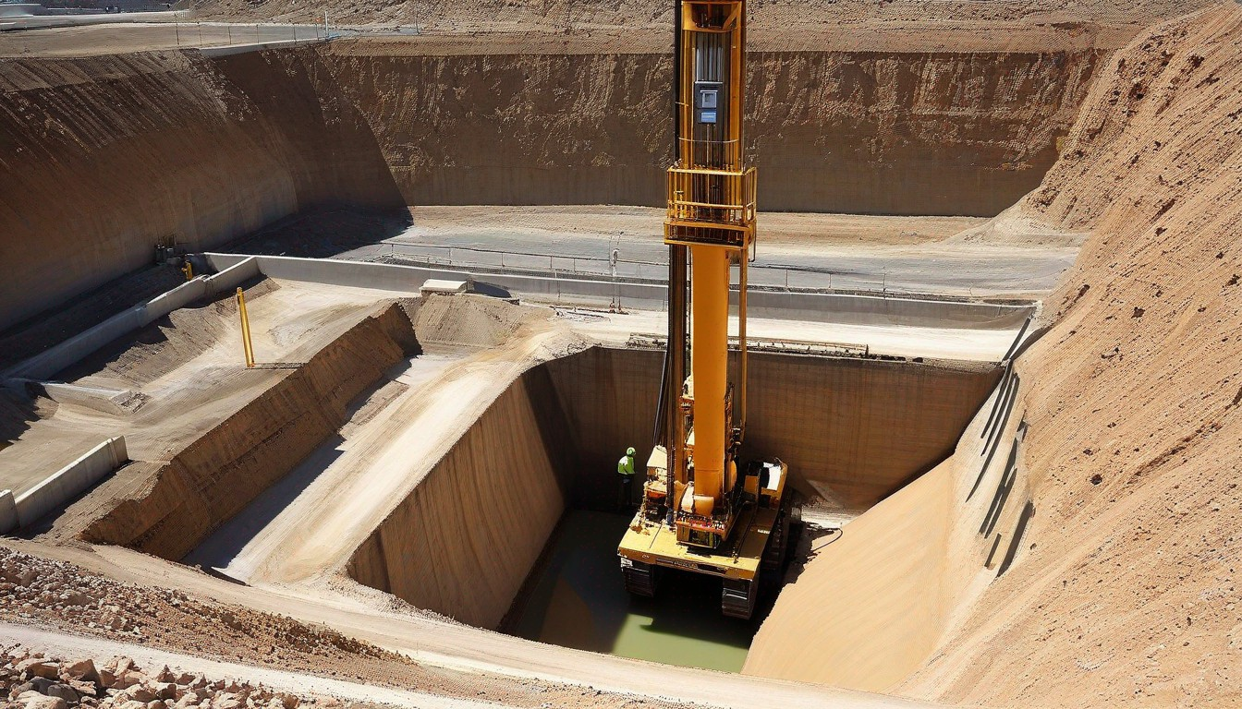

(AI Generated Image)

Chapter 7: Case Studies, Future Trends, and Conclusion

7.1 Case Studies: Real World Applications
Case studies related to consolidation in geotechnical engineering are essential for understanding real-world applications of consolidation theory and its impact on various engineering projects. These case studies provide valuable insights into how soil behavior influences construction, infrastructure, and the environment. Let's explore a couple of notable case studies in-depth.
One of the most renowned examples of soil consolidation-related issues is the subsidence problem that plagued Mexico City. The city's historical foundations lie atop the remnants of Lake Texcoco, characterized by a soft clay soil base. Over the years, the metropolis experienced explosive population growth and increasing industrialization, leading to excessive groundwater extraction. This, in turn, triggered soil consolidation, a process where the clayey soil layers were subjected to increased vertical stress.
The primary issue stemmed from the unsustainable over-pumping of groundwater resources to meet the growing demands of Mexico City's population and industries. The consequences were dramatic, with subsidence rates in some areas reaching an alarming 40 centimeters per year. As the ground subsided, buildings, roads, and underground utilities were severely affected. Infrastructure that once stood at grade level found itself sinking and tilting, causing structural instability and extensive damage.
In response to this pressing issue, Mexico City implemented several measures to mitigate the subsidence problem. Authorities took steps to reduce groundwater extraction, aiming to restore the water balance within the soil. Additionally, ground stabilization techniques were employed to counteract further subsidence. An illustrative solution involved retrofitting and elevating the Mexico City subway system to accommodate the changing landscape and prevent additional structural damage. These actions serve as a compelling example of how an understanding of soil consolidation is vital in addressing real-world geotechnical challenges, ensuring the safety and integrity of a city's infrastructure.
The 1964 Alaska earthquake serves as an illustrative example of how consolidation plays a critical role in geotechnical engineering, particularly in the context of liquefaction. This catastrophic seismic event, also known as the Great Alaskan Earthquake, had devastating consequences, with consolidation-related phenomena at its core. The earthquake, one of the most powerful ever recorded, induced violent ground shaking, which, in the geotechnical sense, triggered the liquefaction of water-saturated sands and silts. This phenomenon occurs when the soil loses its strength and behaves like a liquid under seismic loading conditions. Liquefaction wreaked havoc on entire neighborhoods, infrastructure, and buildings. The ground beneath them transformed into a fluid-like state, causing structures to sink or tilt precariously.
This case study highlights the importance of understanding consolidation and related phenomena for mitigating the effects of natural disasters. Post-disaster measures focused on enhancing foundation designs to better withstand the liquefaction risks during seismic events. Innovations included dynamic compaction techniques and ground improvement methods, which were instrumental in reducing the susceptibility to liquefaction-induced damage in future seismic occurrences. The lessons learned from the 1964 Alaska earthquake have since informed seismic risk management and geotechnical engineering practices worldwide, emphasizing the significance of consolidation knowledge in safeguarding communities and infrastructure.
These case studies illustrate the practical importance of understanding consolidation and its effects on soil behavior. Engineers and geotechnical experts use this knowledge to design and implement strategies to mitigate consolidation-related issues in various projects, ensuring the safety and stability of infrastructure. These real-world examples help students and professionals grasp the significance of consolidation theory in geotechnical engineering.

7.2 Exploring Future Trends in Compressibility Research
Exploring future trends in compressibility research involves delving into cutting-edge developments that promise to enhance our understanding and management of soil compressibility. As technology and methodologies advance, researchers are directing their efforts toward several key areas to refine existing knowledge and address emerging challenges.
One significant trend is the integration of advanced computational modeling techniques. Numerical simulations, such as finite element analysis and machine learning algorithms, enable researchers to conduct intricate analyses of soil behavior under varying conditions. These simulations not only enhance our comprehension of compressibility mechanisms but also facilitate the prediction of complex interactions within diverse soil profiles.
Incorporating environmental considerations into compressibility research is another pivotal trend. Climate change and its impact on soil conditions are becoming increasingly relevant. Researchers are exploring how shifts in temperature, precipitation patterns, and extreme weather events influence soil compressibility. This interdisciplinary approach, combining geotechnical engineering with environmental science, aims to provide a more comprehensive understanding of the long-term effects on soil behavior.
Furthermore, there is a growing emphasis on sustainable and eco-friendly geotechnical solutions. Researchers are investigating alternative foundation materials and construction practices that minimize the environmental footprint while considering soil compressibility. Sustainable engineering practices, such as geosynthetics and innovative foundation designs, are being explored to mitigate the adverse effects of compressibility on structures.
The integration of sensor technologies for real-time monitoring represents another exciting avenue. Advanced sensors, including geophysical and geospatial sensors, offer the capability to collect high-resolution data on soil conditions. This real-time data can be instrumental in assessing the dynamic and time-dependent aspects of compressibility, providing valuable insights for construction projects and risk management.
Moreover, researchers are exploring nanotechnological applications in geotechnical engineering. Nanomaterials and nanoscale phenomena are being investigated to understand their potential impact on soil properties, including compressibility. This microscopic perspective may lead to innovations in soil stabilization and improvement techniques, revolutionizing the way we address compressibility challenges.
In summary, the future of compressibility research is characterized by a multidisciplinary approach, incorporating advanced computational modeling, environmental considerations, sustainable engineering practices, real-time monitoring, and nanotechnological applications. This dynamic landscape promises to deepen our understanding of soil compressibility and pave the way for innovative solutions in geotechnical engineering.

7.3 Summarizing Key Insights and Concluding Remarks
As we conclude this exploration into the intricate realms of geotechnical engineering, our journey through the chapters has unveiled the profound significance of understanding soil and rock behavior. Each chapter has been a stepping stone, building a comprehensive foundation for aspiring engineers delving into the complexities beneath the ground. From the rudiments explored in Chapter 1, providing an introduction to geotechnical engineering and laying the groundwork with soil and rock basics, to the more advanced analyses in Chapter 6, where methods for scrutinizing compressibility have been unfolded, our endeavor has been to empower students and young engineers with a profound comprehension of the soil beneath their structures.
In Chapter 2, we navigated the nuanced landscape of soil compressibility, a fundamental property that orchestrates the deformation and settlement of soil under external loads. The diversity in soil types, ranging from cohesive clays to granular sands, illuminated the intricate relationship between soil composition and compressibility. This understanding sets the stage for informed decision-making in geotechnical projects, where the choice of foundation and construction techniques hinges on the compressibility characteristics of the underlying soil.
Chapter 3 delved into the multifaceted components of settlement, emphasizing the temporal aspect of soil behavior. Immediate settlement, consolidation settlement, and secondary compression were unraveled, each contributing to the total settlement experienced by a loaded soil. Recognizing settlement as a dynamic process influenced by time and loading conditions is imperative for designing structures that withstand the test of time without succumbing to detrimental deformations.
Chapter 4, the spotlight turned to pre-consolidation pressure and stress history, elucidating how the memory imprinted in soil layers influences their response to current loading conditions. Understanding the geological narrative of a site is akin to reading the chronicles of the ground, allowing engineers to predict and mitigate potential settlement issues. This historical perspective enhances the predictive capabilities of geotechnical analyses, guiding engineers to anticipate the future behavior of the ground.
Chapter 5 unfolded the nuances of consolidation testing, a critical aspect of assessing the compressibility of fine-grained soils. The interplay between effective stress, pore water pressure, and consolidation behavior was dissected, providing a roadmap for engineers to navigate the challenges posed by soils prone to prolonged settlement. This chapter served as a bridge between theoretical knowledge and practical applications, offering insights into the methods employed in the field to quantify soil compressibility.
Our exploration culminated in Chapter 6, where diverse methods for analyzing compressibility were laid bare. From empirical approaches to advanced laboratory testing, each method contributes to the engineer's arsenal in deciphering the compressibility puzzle. The Tangent Modulus Method emerged as a sophisticated tool, capturing the non-linear aspects of soil behavior and providing a nuanced understanding of stress-strain relationships.
Geotechnical engineering is not merely about calculating settlements or predicting compressibility; it's about deciphering the language of the ground, understanding its history, and envisioning its future. As you embark on your own geotechnical endeavors, may this book serve as a compass, guiding you through the complexities and enriching your understanding of the dynamic interplay between soil and structure.

7.4 Additional Example Problems and Solutions
Explore additional example problems and FE exam-style questions related to consolidation through convenient QR code links provided below. These resources offer practical insights and problem-solving scenarios that will enhance your understanding of the subject matter. Simply scan the QR codes to access valuable content that complements the topics discussed in this book, providing you with the opportunity to reinforce your knowledge and sharpen your skills in geotechnical engineering.











References

Sueng Lee, J 2023, Lecture notes 1: Holtz, Kovacs & Sheahan – Chapter 8 – Compressibility of Soil and Rock Distributions Florida International University.
“Introduction to Geotechnical Engineering, an, 3rd Edition.” Introduction to Geotechnical Engineering, An, 3rd Edition | eTextBook Subscription | Pearson+, www.pearson.com/store/en-us/pearsonplus/p/9780135619254.html.

