Geotechnically Fascinating

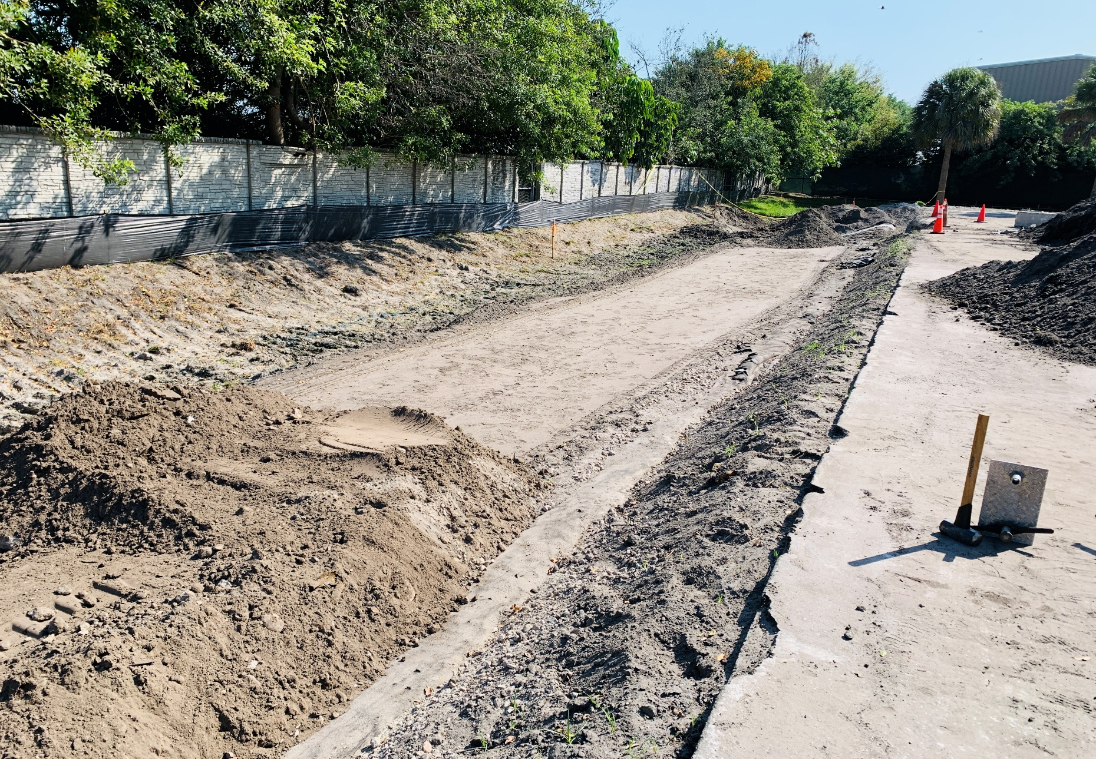

  - A short book by Kevin Garmendia
Table of Contents

Preface 3
Introduction 4
Chapter 1: Grounded Beginnings 5
Chapter 2: High Pressure, Higher Hopes 11
Chapter 3: Piles of Knowledge 19
Chapter 4: Densities of Massive Proportions 25
Chapter 5: A Completed Foundation 31
Epilogue 35
Acknowledgments 36
About the Author 37

Preface
This book came to be as a culmination of ideas, everything I’ve learned about engineering, and my experiences in the real world in relation to it. As part of a joint effort in being able to complete this book in a shorter period of time, I used the help of AI with ChatGPT to improve, lengthen, and delve into more insight on several of the topics presented in this book. All of the narrative stays true to my experiences and reflects my own life. I wanted to have something I can always look back on and remind me why I wanted to pursue this incredible career, why I stuck with it, and ultimately why I studied geotechnical engineering. A lot of people, including myself, are hesitant at first if engineering is what they want to do for the rest of their lives. Sometimes it takes a while to realize whether it’s your final decision, or if you want to back out of it. For me, it’s been something that took me a while to become comfortable in, but I knew from the start it’s what I wanted to do. My dad having studied hydraulic engineering in Cuba (which is the equivalent to civil engineering here), has helped influence me to do this. Watching as he works with plans, coordinating what needs to be done, and ultimately getting the product out to the public in a timely, orderly, and safe manner has always been mesmerizing to me since I was little. Being in a position where I get to see similar things in my shoes now that I’m in an intern position is quite a surprise, but a pleasant one. It’s allowed me to flourish and see what engineering is really like, because as most of us know it’s not all about paperwork and office work. Sometimes it’s beneficial to you as an engineer to observe the work going on in the field, because you may be able to calculate the dead load on a slab on grade, but there can be an additional factor not noted on the paper that could be present on the site, among many other factors. This is just one of many instances of a detail that could be left out that you’d never know if you only worked in the office. Everyday experiences keep showing me what there is to engineering, specifically in the geotechnical branch.

Introduction
Discovering geotechnical engineering and it becoming my favorite specialty was many years in the making, and that’s how the journey began. I will elaborate on the factors that brought me to this branch of civil engineering, and the topics that I learned that interested me the most, as well as why they’re so important to us. At the end of my junior year, I had the opportunity to attend a meet and greet, and this is where I spoke to a company, Chen Moore and Associates, who got me in contact with a private geotechnical consulting company, which I applied to. After some time, they accepted my application, I met up with them, had a formal interview, and eventually got hired as a part-time Geotech intern. As I began the job, there were a ton of new things that occurred within just the first few weeks in the position. All of these were highly beneficial to me, and I’ll describe what they were like, as well as get into the quantitative aspect of it. One of my longest-term projects so far has been a full renovation of a waste management warehouse in Deerfield Beach, consisting of density tests, proctor tests, and concrete sampling just to name a few things. I’ll go into the details of it and describe what it was like, as well as observations and calculations that needed to be done. As things wrapped up for this large project, a few key takeaways were noted, including things I could have improved upon and been more openly communicating about with my boss. This delves more into the project engineer aspect of things but still inherits some geotechnical topics which I will cover. And now, we’re back to the present day with current ongoing projects and more newfound knowledge waiting to be discovered. I’ll make sure to describe those things and show you the reader just why it’s such an interesting branch to go into.

Chapter 1: Grounded Beginnings
Civil Engineering has left a profound and meaningful impact on many people around the world. Its many specialties make it more attractive to individuals depending on what they favor, may it be transportation, construction, structural, environmental, or geotechnical to name some. A certain individual, by the name of Kevin, had always been fascinated by civil engineering. For the longest time, he was unsure which specialization he wanted to do. He took all these classes, introducing him to the different branches, and he was still left indecisive. That was until he took Geotechnical Engineering 1. It suddenly became clear that he wanted to pursue this, even just after attending the first class. But it wasn’t just that class that influenced him to pursue this specialty. Many events that have occurred in his life led him to this moment. For one, his father is also a civil engineer but specializes in construction management. As part of one of his projects, he had to analyze the construction of a new firefighter station, and the area was very susceptible to settlement. They had to hire a geotechnical firm to do the analysis for it. This is where the first topic arises: Compaction. It has become a critical process in geotechnical engineering with significant importance for various construction and civil engineering projects. Below are listed some main reasons as to why it’s so important for construction:
- Improved Soil Density: Compaction increases the density of soil, reducing the void spaces between soil particles. This densification improves the load-bearing capacity of the soil, making it capable of supporting structures and resisting settlement.
- Settlement Prevention: Properly compacted soil helps prevent settlement of structures such as buildings, roads, and bridges. Settlement can lead to structural damage and safety hazards, so compaction is crucial to maintain stability.
- Enhanced Bearing Capacity: Compacted soil has a higher bearing capacity, which is essential for supporting the weight of buildings, pavements, and other infrastructure. This ensures that structures remain stable and safe over time.
- Improved Drainage: Compacted soil typically has better drainage properties. It reduces the permeability of the soil, which can help prevent water infiltration that might otherwise lead to erosion, instability, and soil liquefaction in some cases.
- Soil Stabilization: Compaction is often used to stabilize loose or unstable soils. This is especially important in areas prone to landslides, erosion, or liquefaction, where compacted soil can help mitigate these risks.
- Uniformity of Soil Properties: Compaction helps achieve uniformity in the soil properties across a construction site. This uniformity is essential for ensuring consistent performance and load distribution in engineered structures.
- Foundation Support: Properly compacted soil provides a stable and level foundation for structures. It minimizes differential settlement, which can cause structural damage and compromise safety.
- Cost Savings: By achieving the required soil density through compaction, engineers can design more cost-effective foundations and structures, potentially saving time and money during construction.
- Regulatory Compliance: Many construction codes and regulations require specific compaction standards to ensure the safety and longevity of structures. Compliance with these standards is essential to meet legal and safety requirements.
- Environmental Considerations: Proper compaction can reduce the potential for soil erosion and the leaching of pollutants into groundwater, which helps protect the environment.
Kevin had the chance to oversee his father undergoing this project, and it was something else that led to opening his eyes to geotechnical engineering. This also brings up how important geotechnical engineering is to not only Kevin but also the entire engineering department. From the design, to the construction, to the maintenance, below is a list of reasons why it’s of such importance:
- Safety: Geotechnical engineers assess soil and rock conditions to ensure the safety of structures and their occupants. They help prevent disasters like landslides, foundation failures, and soil liquefaction that could lead to loss of life or property damage.
- Structural Integrity: Geotechnical engineers provide critical information about soil properties, which is essential for designing foundations and structural systems that can withstand the forces imposed on them over time.
- Economic Impact: Poor geotechnical engineering can result in costly construction delays, structural failures, and repairs. By ensuring proper soil analysis and foundation design, geotechnical engineers help save money in the long run.
- Environmental Considerations: Geotechnical engineers work to minimize the environmental impact of construction activities. They ensure that soil erosion, contamination, and other environmental concerns are properly managed during construction.
- Infrastructure Development: Almost all infrastructure projects, including roads, bridges, dams, and tunnels, depend on geotechnical engineering to assess soil conditions and ensure the stability of these structures.
- Urban Planning: Geotechnical studies are integral to urban planning and development, as they help determine the suitability of land for construction and guide zoning regulations.
- Resource Exploration: Geotechnical engineers are involved in mining and petroleum exploration, assessing the geology and soil conditions to locate valuable resources efficiently and safely.
- Natural Disaster Mitigation: Geotechnical knowledge is critical for mitigating the impact of natural disasters like earthquakes, tsunamis, and floods. Engineers can design structures and foundations to resist these forces.
- Infrastructure Rehabilitation: Geotechnical engineering is not only about new construction but also about rehabilitating existing structures. Engineers assess the condition of aging infrastructure and recommend repairs or upgrades.
- Longevity of Structures: Proper geotechnical engineering ensures the long-term performance and durability of structures, reducing the need for frequent maintenance and repairs.
- Regulatory Compliance: Building codes and regulations often require geotechnical studies to meet safety and environmental standards, making geotechnical engineering an essential part of regulatory compliance.
- Sustainable Development: In an era of sustainable development, geotechnical engineers work on projects that minimize the impact on the environment, such as designing foundations that require fewer materials or optimizing land use.
Many of these factors led to why he wants to pursue this. There are other things in his life that have also altered his opinion on civil engineering, which branch he wanted, and why he stuck to geotechnical. In his free time, Kevin enjoys traveling to many places with family and friends, both nationally and internationally. Some of the places he’s traveled to vary a lot in terms of the soils and subgrades that exist in them. Geotechnical engineering ties in with geology because it’s important that they evaluate and classify soils and rocks to then be able to complete a geotechnical report highlighting the differences in the terrain, and whether it’s prepped enough for what construction lies above. Many materials vary in their properties and so this is why soil classification is important, featured below are more important points for it:
- Foundation Design: Soil classification helps engineers understand the properties of the subsurface soil layers, including their composition, density, and moisture content. This information is essential for designing suitable foundations for structures. Different soil types require different foundation types and designs. For example, sandy soils may need shallow foundations, while clayey soils may require deep foundations or soil improvement techniques.
- Load-Bearing Capacity: The classification of soil allows engineers to determine the load-bearing capacity of the soil. This information is critical for ensuring that the foundation can support the anticipated loads without settling or failing. It also helps in selecting appropriate safety factors for structural design.
- Construction Material Selection: Soil classification aids in selecting suitable construction materials. For instance, it informs decisions regarding the type of backfill material to use in retaining walls, embankments, and road construction. Different soil types have varying levels of compaction and stability, which affect construction material choices.
- Earthwork and Excavation Planning: Soil classification is essential for planning earthwork and excavation activities. Engineers need to know the characteristics of the soil to determine excavation methods, slopes, and safety measures. Unstable soils may require shoring or slope stabilization.
- Soil Erosion Control: Understanding soil types is crucial for erosion control measures. Different soils erode at varying rates, and erosion control strategies depend on soil characteristics. Soil classification helps in designing erosion control structures and selecting appropriate vegetation.
- Environmental Impact Assessment: Soil classification is a key component of environmental impact assessments. It helps assess the potential impacts of construction and development on the soil and surrounding ecosystems, guiding mitigation and restoration efforts.
- Site Suitability Analysis: Soil classification is used in site suitability analyses for various purposes, such as land use planning, agricultural assessments, and assessing the feasibility of infrastructure projects. It helps identify constraints and opportunities related to soil properties.
- Geotechnical Risk Assessment: Soil classification contributes to geotechnical risk assessment. Engineers can identify and evaluate potential risks associated with soil types, such as liquefaction in earthquake-prone areas or expansive clay soils that may cause foundation heave.
- Design Code Compliance: Building codes and standards often require geotechnical investigations and soil classification to ensure that construction projects meet safety and performance standards. Compliance with these codes is essential for legal and safety reasons.
- Cost Estimation: Soil classification helps in estimating construction costs accurately. It allows engineers to factor in the cost of foundation design, excavation, soil improvement, and other geotechnical considerations when preparing project budgets.
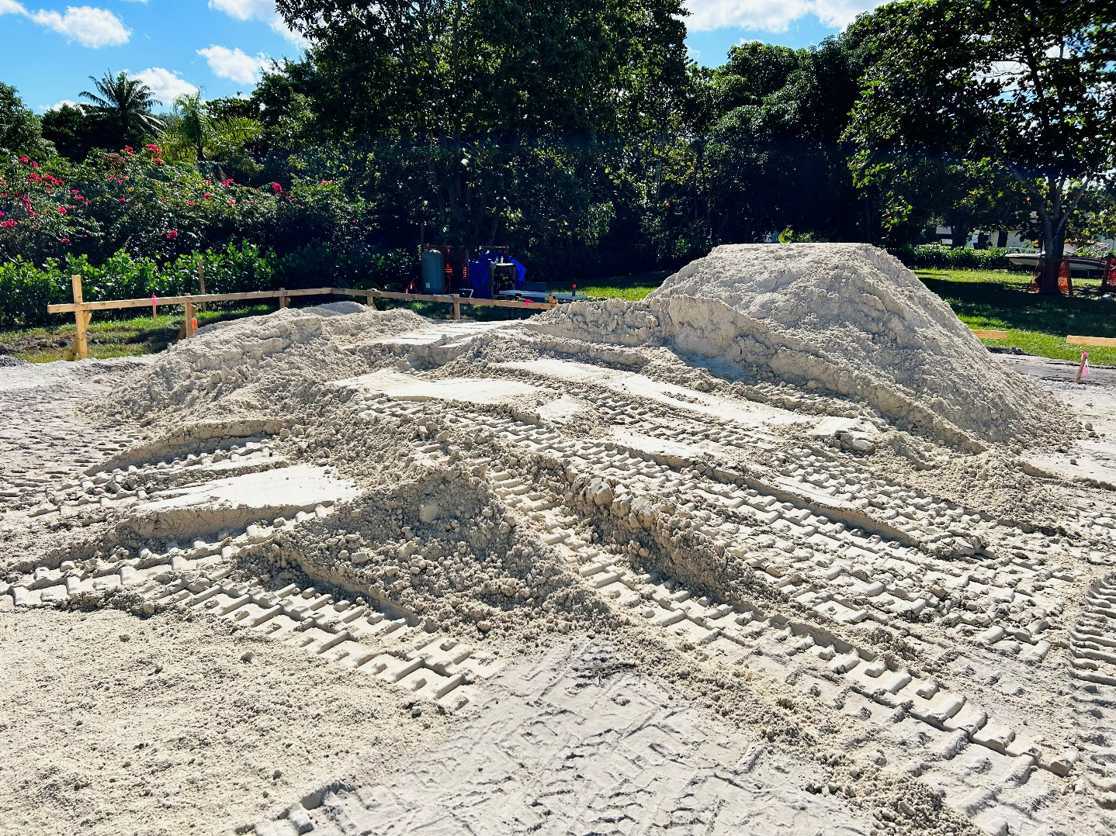
Figure 1: New material to be characterized

This is one example of a new material upon which Kevin had to identify and characterize by taking a representative sample back to a geotechnical lab for testing. It was to be used as the fill material for the foundation of a new house, where this would support the first concrete slab to be laid down for it. This was part of the project which Kevin was able to oversee with his dad, on a day where you could take your child to work day. Soon, it would be Kevin’s turn to be the one in charge of overseeing the project. Little did he know that day would come sooner than he was expecting. A lucky streak of events and activities allowed him to take up a position which would provide him with expansive knowledge in geotechnical engineering, more than any class has ever taught him.

Chapter 2: High Pressure, Higher Hopes
It was at this time that Kevin was taking his first geotechnical class at his university. He was learning much of what he had anticipated he would enjoy as part of this course. The compaction section of the course in general was very interesting to him, and led to him delving more into it, including possible geotechnical intern positions. In his findings and research, he discovered that one of the most common things that geotechnical interns perform is what’s referred to as density tests. In geotechnical engineering, density tests are conducted to assess the compactness or density of soil or other granular materials. These tests are crucial in evaluating the quality of soil compaction, which is important for the construction of structures such as roads, embankments, foundations, and retaining walls. The density of the soil directly affects its strength, load-bearing capacity, and permeability. There are several methods to measure soil density, and the choice of method depends on factors such as the type of soil, project requirements, and equipment available. Two common types of density tests in geotechnical engineering are the Proctor test and the sand cone test:
- Proctor Test (Standard or Modified):
  - The Proctor test determines the maximum dry density and optimum moisture content of a soil sample.
  - In the standard Proctor test, a specified amount of soil is compacted in layers using a standard compaction energy (standard Proctor hammer) and varying moisture contents.
  - The modified Proctor test is similar but uses a higher compaction energy.
  - The test helps establish a compaction curve, which indicates the relationship between moisture content and dry density. The point on the curve where the dry density is maximum is considered the optimum moisture content for compaction.
- Sand Cone Test:
  - The sand cone test is used to determine the in-place density of a soil deposit.
  - In this test, a hole is excavated in the ground, and the volume of the hole is measured.
  - A known weight of dry sand is then poured into the hole, and the change in volume is measured.
  - The in-place density is calculated based on the weight of the sand and the change in volume of the hole.
The most commonly used test in Florida, where Kevin resides, is the proctor test. The Proctor test is a standard laboratory method used to determine the maximum dry density and optimum moisture content of a soil sample. There are two main variations of the Proctor test: the Standard Proctor Test and the Modified Proctor Test. Here is a general overview of how these tests are performed:
Standard Proctor Test:
- Sample Preparation:
  - A representative soil sample is collected from the field and brought to the laboratory.
  - The sample is then air-dried, crushed, and passed through a sieve to obtain a uniform particle size distribution.
- Test Specimen Preparation:
  - A specific amount of the prepared soil is placed in a compaction mold in layers.
  - Each layer is compacted using a standard Proctor hammer, with a specified number of blows per layer.
- Density and Moisture Content Measurements:
  - The weight and moisture content of the compacted soil specimen are measured.
  - The moisture content is adjusted for subsequent trials to cover a range of moisture contents.
- Compaction Curve:
  - The process is repeated for various moisture contents, and a compaction curve is plotted.
  - The compaction curve shows the relationship between moisture content and dry density.
- Maximum Dry Density and Optimum Moisture Content:
  - The point on the compaction curve where the dry density is maximum is considered the maximum dry density (γ_{dmax).}
  - The corresponding moisture content at this point is the optimum moisture content (OMC).
Modified Proctor Test:
The Modified Proctor Test is similar to the Standard Proctor Test but involves higher compaction energy. The main differences are:
- The compaction energy is increased by using a heavier hammer.
- The number of blows per layer is increased compared to the standard test.
The steps for the Modified Proctor Test are essentially the same as the Standard Proctor Test, but the increased compaction energy results in higher dry densities and optimum moisture contents. Once the proctor has been obtained, this serves as the base for telling how compact a soil is. Percent compaction is a measure of how well the in-place soil density compares to the maximum dry density obtained from laboratory Proctor tests. It is expressed as a percentage and is an important parameter in geotechnical engineering to ensure that the soil meets the specified compaction requirements for construction projects. The procedure for determining percent compaction in the field involves comparing the in-place density of the compacted soil to the maximum dry density obtained from laboratory tests.
Here is a general procedure for determining percent compaction in the field:
Procedure for Determining Percent Compaction:
- Conduct Field Compaction Test:
  - Perform a field compaction test using a handheld compaction device, as discussed in the previous sections.
  - Compact the soil in layers and record the number of blows per layer.
- Measure In-Place Density:
  - Measure the in-place density of the compacted soil using the volume of the compacted soil and the field-determined moisture content.
- Calculate Field Dry Density:
  - Calculate the dry density of the compacted soil in the field using the formula:
$$Field Dry Density= \frac{Field Wet Density}{1+\frac{Field Moisture Content}{100}}$$
- Compare with Laboratory Maximum Dry Density:
  - Refer to the laboratory Proctor curve to find the maximum dry density (γ_{dmax}) corresponding to the optimum moisture content (OMC).
- Calculate Percent Compaction:
  - Calculate the percent compaction using the formula:
$$Percent Compaction= \frac{Field Dry Density}{Maximum Dry Density}*100$$
- Check for Compliance:
  - Compare the calculated percent compaction with project specifications or standards.
  - Determine whether the percent compaction achieved in the field meets or exceeds the specified minimum requirements.
Interpretation:
- If the calculated percent compaction is equal to or greater than the specified minimum compaction requirement, the compaction is considered satisfactory, and the soil is considered to have passed the test.
- If the calculated percent compaction is below the specified minimum requirement, adjustments to the compaction process may be necessary to achieve the desired level of compaction.
It's important to note that percent compaction is a critical parameter for ensuring the stability and performance of structures built on or with the compacted soil. Therefore, project specifications often include minimum requirements for percent compaction based on the type of soil and the intended use of the construction. Consultation with geotechnical engineers and adherence to project specifications are essential for successful compaction and construction practices. The device used most of the time for these tests is called a nuclear gauge, also known as a Troxler. The basic components of a nuclear gauge include:
- Radioactive Source:
  - The gauge contains a small, sealed radioactive source, commonly Cesium-137 or Americium-241/Beryllium. The source emits gamma rays.
- Detector:
  - A detector is positioned a specific distance away from the radioactive source. The detector measures the gamma rays that pass through the material being tested.
- Control Unit:
  - The control unit contains electronics for processing the data from the detector and displaying the results.
How Nuclear Gauges Work:
- Density Measurement:
  - The gamma rays emitted by the radioactive source penetrate the material (such as soil) being tested.
  - The number of gamma rays that reach the detector is influenced by the density of the material. Denser materials attenuate or reduce the number of gamma rays reaching the detector.
- Moisture Measurement:
  - In addition to density, nuclear gauges can be equipped with a second detector for moisture measurements.
  - Moisture in the soil affects the moderation of gamma rays, leading to changes in the count rate observed by the moisture detector.
Operation:
- Calibration:
  - Before use, the nuclear gauge is calibrated using materials of known density and moisture content.
- Measurement:
  - The gauge is placed on the material being tested, and the source is extended into the material.
  - The gauge emits gamma rays, and the detector measures the radiation that passes through the material.
- Display of Results:
  - The control unit processes the data and displays the results, typically providing readings for density and moisture content.
Advantages of Nuclear Gauges:
- Non-Destructive: Nuclear gauges provide measurements without disturbing the material being tested.
- Rapid Results: Measurements can be obtained quickly, allowing for efficient assessment of soil compaction in the field.
- Depth Profiling: Some nuclear gauges can be used for measuring density and moisture content at different depths within the material.
Safety Considerations:
- The use of radioactive sources requires compliance with strict safety regulations and guidelines.
- Trained and certified personnel typically handle and operate nuclear gauges.
- Proper storage and transportation procedures are followed to ensure safety.
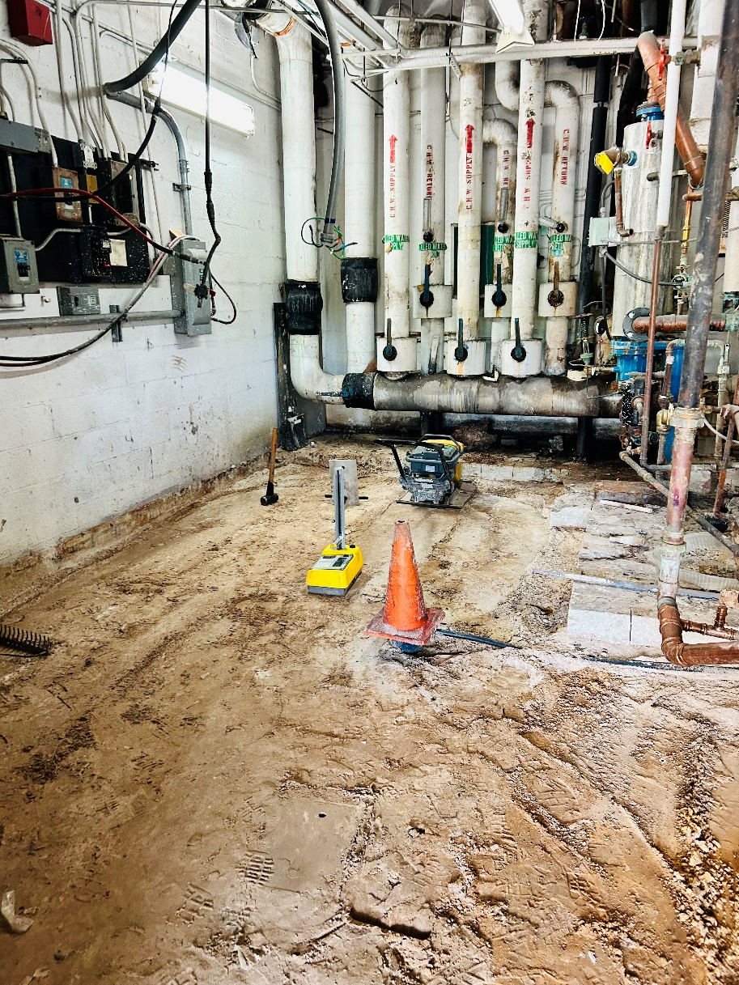
Figure 2: A nuclear gauge being used to test compaction percent

Nearing the end of his geotechnical class and the semester, Kevin attended an industry meet and greet, where he was able to talk with many companies hiring new civil engineers for intern or part-time positions, as well as some full-time for those already experienced. Kevin was able to find a private geotechnical consultant company which accepted his resume. He promptly went and got interviewed, and upon them seeing his passion for geotechnical engineering, he was hired as a paid intern. It was here where he began his endeavors in geotechnical, including his first demonstration pictured above.

Chapter 3: Piles of Knowledge
It quickly became apparent that geotechnical was what he wanted to master in the world of Civil Engineering. So many experiences and jobs to go to ended up leaving Kevin awe-inspired and motivated to work each day. From completing density tests, to sampling soils to characterize, identify, and test for strength, doing visual inspections of piles to support those extra-heavy structures where soils alone would not support it, and completing reports with appropriate information with regards to soil conditions for the client. Most importantly, he gained much field experience, which while could be taxing on the human body at times, provides an undeniably great insight into what goes on in engineering just about every day. As part of his tasks, he had to discover which were the most suitable soils for some situations or jobs present. Achieving optimal compaction strength is influenced greatly by the type of soil. Generally, cohesive soils and well-graded granular soils are considered better candidates for achieving optimal compaction strength. Here's a brief overview of these soil types:
- Cohesive Soils:
  - Description: Cohesive soils have fine particles (clay and silt) that tend to stick together due to electrostatic forces.
  - Optimal Compaction: Cohesive soils can achieve high compaction strengths when properly managed. The presence of clay minerals provides cohesive forces, allowing the soil particles to bind together.
  - Challenges: However, cohesive soils can be prone to swelling when wet and shrinkage when dry. Care must be taken to manage moisture content during compaction to avoid detrimental effects.
- Well-Graded Granular Soils:
  - Description: Well-graded granular soils contain a mix of various particle sizes, including coarse and fine particles.
  - Optimal Compaction: Well-graded granular soils often provide good drainage and can achieve high compaction strengths. The range of particle sizes allows for better interlocking during compaction.
  - Advantages: These soils typically have less susceptibility to changes in volume with changes in water content compared to cohesive soils.
  - Applications: Common well-graded granular soils include gravels and sands.
- Uniformly Graded Soils:
  - Description: Uniformly graded soils consist mainly of particles of similar size.
  - Optimal Compaction: While uniformly graded soils can be compacted effectively, they may have less favorable interlocking between particles compared to well-graded soils.
  - Applications: Common uniformly graded soils include silts and certain sands.
- Silty Soils:
  - Description: Silty soils have a high proportion of fine particles (silt) but lack the cohesive properties of clay.
  - Optimal Compaction: Compaction of silty soils is feasible, but care must be taken to manage moisture content to avoid excessive fines migration and achieve optimal compaction.
- Clayey Soils:
  - Description: Clayey soils consist primarily of clay particles.
  - Optimal Compaction: Compaction of clayey soils can be challenging due to their cohesive nature. Achieving optimal compaction strength often involves careful moisture control and mechanical compaction efforts.
Factors Affecting Compaction:
- Moisture Content:
  - The moisture content of the soil plays a crucial role in compaction. Both too much and too little moisture can negatively impact compaction.
- Particle Size Distribution:
  - Well-graded soils with a mix of particle sizes tend to compact more efficiently than uniformly graded soils.
- Soil Structure:
  - The existing structure of the soil, influenced by factors such as organic content and previous compaction efforts, can affect compaction results.
- Compaction Method:
  - The choice of compaction equipment and the compaction method used (e.g., static, vibratory) can impact the achieved compaction strength.
In Florida, the most commonly used materials consist of sandy granular soils, sometimes with or without limerock. Limerock is the phrase that is used here when referring to limestone fragments. Being a state that lays on top of a very old but solid limestone deposit, there is more than enough of the material laying around, so might as well take advantage of that right? Many times they end up adding limerock into existing sandy materials to improve its ability to handle large loads. Kevin has witnessed when different fill materials have been mixed on site to create this ideal fill. Improving soil loading capacity, also known as soil bearing capacity, involves enhancing the ability of the soil to support the loads imposed by structures or foundations. The specific strategies to improve soil loading capacity depend on the type of soil and its engineering properties. Here are some common methods to increase soil loading capacity:
- Addition of Fill Material:
  - If the existing soil has inadequate bearing capacity, adding suitable fill material can enhance the load-bearing capacity. The fill material should be well-graded and compacted to achieve the desired density.
- Grouting:
  - Grouting involves injecting a cementitious or chemical grout into the soil to fill voids and improve cohesion. This method is particularly useful in loose or sandy soils. Compaction grouting is a specific technique that involves injecting a fluid grout to compact and reinforce the soil.
- Soil Stabilization:
  - Soil stabilization aims to enhance the strength and durability of the soil. Various stabilization techniques include the addition of stabilizing agents like lime, cement, fly ash, or chemical stabilizers. These materials react with the soil to improve its mechanical properties.
- Vibro-Replacement Stone Columns:
  - In areas with weak or compressible soils, stone columns can be installed by vibrating compacted stone aggregate into the ground. This reinforces the soil and improves its bearing capacity.
- Pile Foundations:
  - Pile foundations transfer loads from a structure to deeper, more competent soil or rock layers. Installing piles can be an effective solution when the upper layers of soil have limited load-bearing capacity.
- Geosynthetics:
  - Geosynthetic materials, such as geotextiles and geogrids, can be used to reinforce the soil. They are often employed in retaining walls, embankments, and slopes to improve stability.
- Drainage Improvement:
  - Proper drainage is crucial for maintaining soil strength. Excess water can soften the soil and reduce its bearing capacity. Installing drainage systems, such as French drains or surface drains, can help manage water and improve soil conditions.
- Preloading and Surcharge:
  - Preloading involves applying a temporary surcharge load to the soil to encourage settlement before construction. This method is commonly used in soft or compressible soils to accelerate consolidation.
- Deep Dynamic Compaction:
  - Deep dynamic compaction involves dropping heavy weights onto the ground surface, inducing dynamic forces that compact and densify loose soils to improve load-bearing capacity.

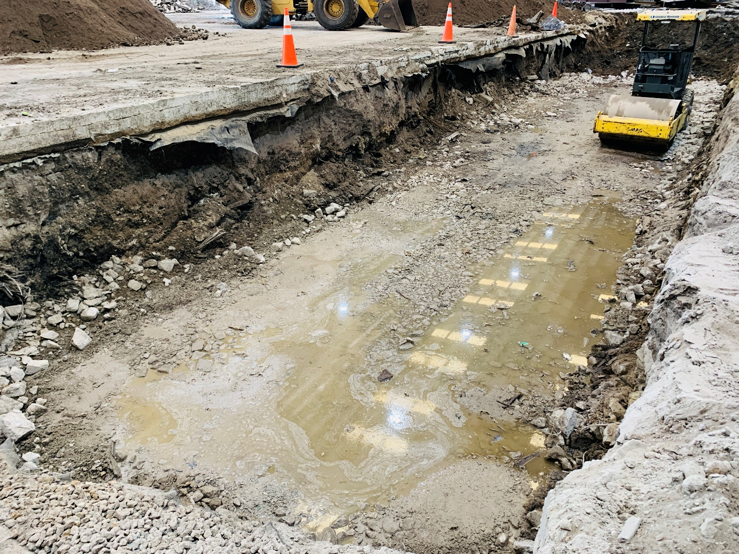
Figure 3: A trench with vibratory roller for leveling

Sometimes it takes a lot of effort to get these pre-existing soils to the ideal desired strength. In many cases, the best option is simply to dig it up and replace it with those more suitable mixed materials. As pictured above, for a new project that Kevin undertook, the proposal was to build a new reinforced concrete wall running across the entire span of the facility. The existing material was very weak and would settle too much from the weight of the solid concrete with rebar. The verdict was to excavate that material and replace with suitable mix containing limerock. This was then lifted by intervals of 12 inches, as required by regulations. Each layer was compacted and gotten to the ideal moisture content to ensure it passes density tests. Kevin was in charge of overseeing excavation and refilling efforts to make sure it was all done properly. When each was done, he did density tests using the Troxler and to nobody’s surprise, they all passed in orderly fashion thanks to the efforts done by each worker.

Chapter 4: Densities of Massive Proportions
As was mentioned briefly in the previous chapter, there was a large project on the horizon that involved many phases and steps to reach completion. This project, located in Deerfield Beach, Florida, consisted of remodeling an existing warehouse for recycling by laying down new pavement around it as well as a new reinforced concrete wall running along the inside of it. It was dubbed the “push wall”, due to it having to be strong enough to resist the pushing force of a large front-load dozer that would unload recyclable materials from Waste management trucks that would arrive frequently. There was an existing push wall but only ran throughout a small portion of the warehouse. As part of this project, that one was taken down and in its place was cast this new one. Kevin was able to fully utilize all his existing skills and even picked up new ones in doing this project. As his main tasks, he completed several density tests for subgrade lifts of pavements, the progressive lifts of the new material put into place of the previously existing weaker material, and eventually testing the concrete quality when the pours began being done. A crucial part of this project was determining the strength of said soils. The soil bearing capacity is the maximum load that a soil can support without undergoing excessive settlement or shear failure. The calculation of soil bearing capacity is crucial in the design of foundations for structures to ensure the safety and stability of the construction. The bearing capacity is influenced by various factors, including soil type, density, moisture content, and foundation depth. There are different methods to estimate or calculate soil bearing capacity, and one commonly used method is based on Terzaghi's bearing capacity equation.
Terzaghi's Bearing Capacity Equation:
Terzaghi's bearing capacity equation is widely used for shallow foundations and is expressed as:
$$Q_{ult}=c*N_{c}*S_{c}+σ^{'}*N_{q}*S_{q}+0.5*γ*B*N_{γ}*S_{γ}$$
Where:
- $Q_{ult}$​ is the ultimate bearing capacity of the soil (the maximum load the soil can support),
- $c$ is the cohesion of the soil,
- $σ^{'}$ is the effective overburden stress at the base of the foundation,
- $γ$ is the unit weight of the soil,
- $B$ is the width of the foundation,
- N_{c}​, N_{q}​, N_{γ}​ are bearing capacity factors related to the soil type and foundation shape (these factors are determined from charts or tables),
- S_{c}​, S_{q}​, S_{γ}​ are shape factors related to the foundation shape.
Steps for Calculating Soil Bearing Capacity:
- Determine Soil Parameters:
  - Obtain information on the soil properties, including cohesion ($c$), effective overburden stress ($σ^{'}$), and unit weight of the soil ($γ$).
- Select Foundation Shape:
  - Choose the appropriate shape factor (S_{c}​, S_{q}​, S_{γ}​) based on the type of foundation (e.g., square, rectangular, circular).
- Determine Bearing Capacity Factors:
  - Obtain the bearing capacity factors (N_{c}​, N_{q}​, N_{γ}​) from relevant charts or tables based on the soil type and the foundation shape.
- Calculate Ultimate Bearing Capacity:
  - Use Terzaghi's bearing capacity equation to calculate the ultimate bearing capacity ($Q_{ult}$), shown above.
- Consider Safety Factors:
  - Apply appropriate safety factors to the calculated ultimate bearing capacity to determine the allowable bearing capacity for design purposes.
It's important to note that Terzaghi's equation is applicable for shallow foundations. For deep foundations, such as piles or drilled shafts, other methods, such as the Meyerhof method or the Broms method, may be used. Additionally, due to some areas where existing soils stretched too far beneath the ground surface to be easily removable by excavation, helical piles were utilized instead, which Kevin overlooked as they were installed to ensure maximum quality. Helical piles, also known as helical piers, screw piles, or helical anchors, are foundation elements designed to provide support and stability for various structures. They are commonly used in construction and civil engineering projects for both new construction and foundation repair. The primary purpose of helical piles is to transfer loads from a structure to deeper, more stable soil or bedrock.
Key purposes and applications of helical piles include:
- Foundation Support:
  - Helical piles are used to support the foundations of structures, including residential, commercial, and industrial buildings. They are particularly effective in areas with challenging soil conditions, such as expansive clay, loose sands, or soft silts.
- Retaining Walls:
  - Helical piles can be employed to support and stabilize retaining walls. They provide additional lateral support and prevent wall movement or failure.
- Slope Stabilization:
  - In areas with slopes or embankments, helical piles can be used to stabilize the soil and prevent slope failure. They are installed at various depths to anchor the soil and resist lateral forces.
- Tower Foundations:
  - Helical piles are commonly used to support the foundations of communication towers, wind turbines, and other tall structures. They offer a reliable solution for structures in both remote and urban locations.
- Boardwalks and Docks:
  - Helical piles are suitable for supporting boardwalks, docks, and other structures in waterfront or marshy areas. They provide stability without the need for extensive excavation or traditional concrete foundations.
- Foundation Repair:
  - Helical piles can be used in foundation repair projects to underpin and stabilize existing structures that have experienced settlement or other foundation issues. They can be installed beneath existing foundations to lift and support the structure.
- Light Poles and Signage:
  - Helical piles are used to support light poles, signs, and other structures where a deep and stable foundation is required. They are often chosen for their ease of installation and minimal site disruption.
- Seismic Retrofitting:
  - In earthquake-prone regions, helical piles can be employed for seismic retrofitting to enhance the stability and resilience of structures. They provide additional support and resistance to ground shaking.
Advantages of Helical Piles:
- Versatility:
  - Helical piles can be used in a variety of soil conditions, making them versatile for different construction and engineering projects.
- Rapid Installation:
  - Helical piles can be installed quickly, reducing construction time compared to traditional foundation methods.
- Minimal Site Disturbance:
  - Installation of helical piles typically involves minimal excavation, reducing disruption to the site and existing vegetation.
- Load Testing and Monitoring:
  - The load-carrying capacity of helical piles can be easily tested during installation, providing immediate feedback on the foundation's performance.
- Ease of Retrofitting:
  - Helical piles are well-suited for retrofitting existing structures, offering a practical solution for foundation repairs or upgrades.
Overall, the use of helical piles provides a cost-effective and reliable foundation solution, especially in areas with challenging soil conditions or where traditional foundation methods may be impractical. This can sometimes be caused by external factors not relating to strength of soils, such as high-water table, existing utilities underneath that may be damaged by the piles, or other potential hazards.
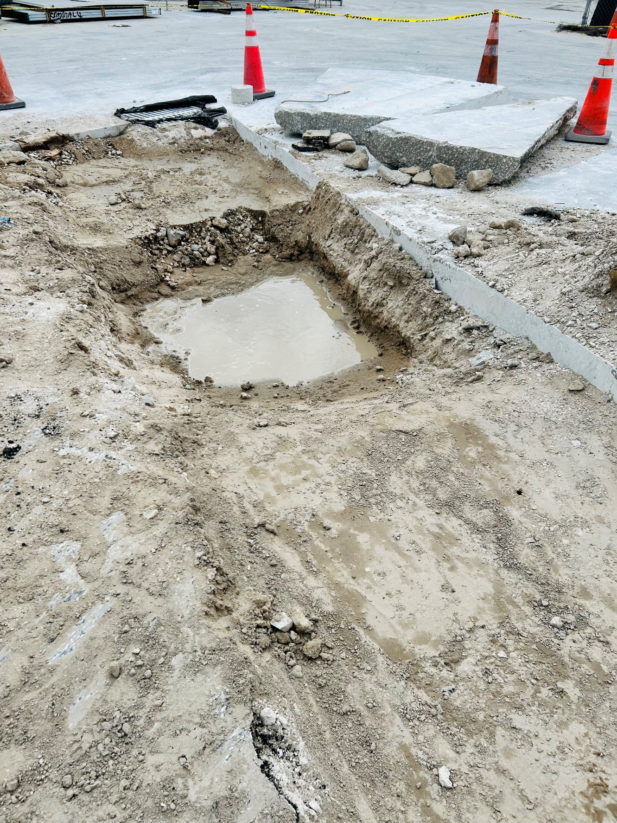
Figure 4: Existing area of high-water table on site

Demonstrated above is a test trench opened for potential helical pile drilling. This one proved to be too flooded to drill into, but also proved to us why helical piles had to be installed here. The high-water table would make excavation efforts more difficult, given how deep the material goes the water would impede the process even further. This project was a valuable effort and worth it in the end. Kevin came out with much more experience than he ever could have possibly asked for. All subsequent projects after this have been smooth sailing thanks to everything from this one.

Chapter 5: A Completed Foundation
- Chapter 5 Content: Lessons learned, things I could have improved upon, where I’m standing now in terms of pending projects, and what the future holds.
While the greatest of the projects were over with, much awaited over the horizon in upcoming projects for Kevin. Working as an intern at this consulting company meant lots of work he could handle on his own due to it being small and private. This also meant there was more room for errors though. While his boss did make sure to monitor much of his activities, some things still went overlooked. A principal example of it is in the analysis of settlement. Accounting for settlement in soils is a crucial consideration in the design and construction of structures to ensure their stability, safety, and long-term performance. Settlement occurs when the soil undergoes deformation, leading to a decrease in volume or downward movement of the ground surface. Settlement can be caused by various factors, including soil consolidation, loading, and changes in moisture content. Here are some key steps and methods to account for settlement in soils:
- Site Investigation:
  - Conduct a thorough site investigation to understand the soil profile, characteristics, and conditions at the construction site. This may involve soil borings, laboratory testing, and in-situ testing.
- Consolidation Analysis:
  - Evaluate the consolidation characteristics of the soil. Consolidation is a process by which water is expelled from the soil due to loading, leading to settlement. The consolidation settlement can be estimated using laboratory tests, such as the oedometer test, or by using empirical correlations.
- Differential Settlement Analysis:
  - Analyze the potential for differential settlement, which occurs when different parts of a structure settle by varying amounts. This can be critical for structures with rigid foundations or those spanning across areas with non-uniform soil conditions.
- Settlement Prediction Methods:
  - Use settlement prediction methods, such as Terzaghi's one-dimensional consolidation theory, to estimate settlement based on soil properties, loading conditions, and time. More advanced numerical methods and software can also be employed for complex scenarios.
- Foundation Design:
  - Design foundations with settlement in mind. Consider using deep foundations, such as piles or drilled shafts, to reach more stable soil layers. Spread footings may require larger dimensions to distribute loads and minimize settlement.
- Preloading and Surcharge:
  - Apply preloading or surcharge to the soil before construction to accelerate settlement. This process helps consolidate the soil and reduce potential future settlement under the structure.
- Use of Lightweight Fill:
  - In certain cases, the use of lightweight fill materials can reduce the overall load on the soil and minimize settlement.
- Vibro-Replacement and Compaction:
  - Employ ground improvement techniques, such as vibro-replacement or compaction, to increase soil density and reduce potential settlement.
- Monitoring and Control:
  - Implement monitoring programs during and after construction to observe actual settlement and compare it with predicted values. This allows for adjustments to construction practices and provides valuable data for future projects.
- Consideration of Building Codes and Standards:
  - Follow local building codes and standards, which often include guidelines and requirements for settlement considerations in structural design.
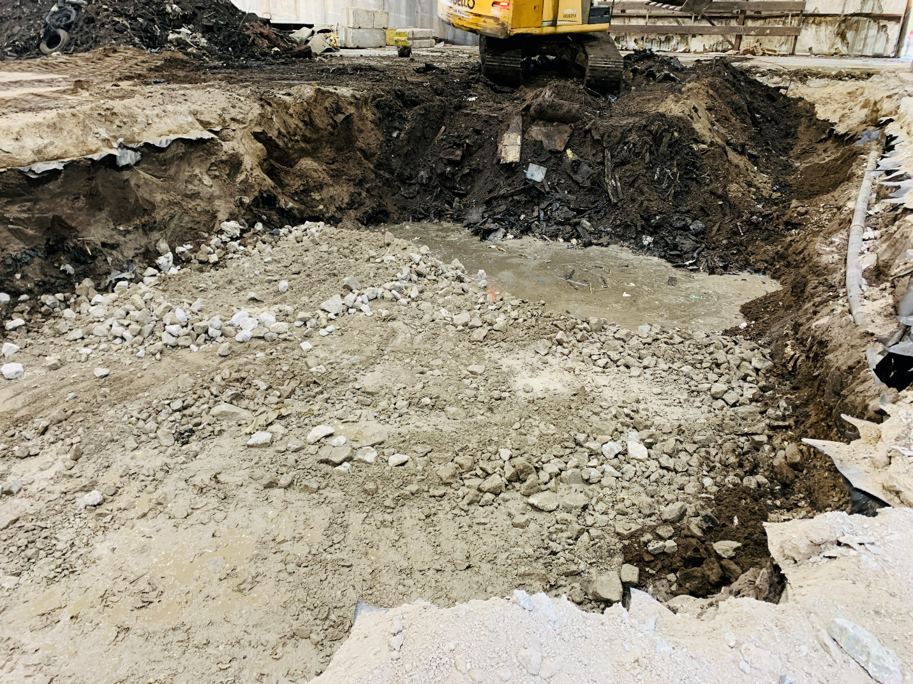
Figure 5: An area where settlement was higher than expected

Even though this area was properly excavated, and material was replaced in its full amount with the suitable one, there was still existing material much further underneath where the excavator simply could not reach. Even with compaction efforts above said material, there was only so much that could be done to strengthen the material given the budget and time constraints. Ultimately, it was observed that the settlement was still not enough to cause major problems but can cause some problems way down the road. This was discussed in full with the client and they are fully aware of possible problems related to this. At the end of the day, everyone was happy with the work done and all processes being approved. Another stellar, fascinating achievement.

Epilogue
The day of judgement was arriving sooner than he anticipated. Four years had already passed and he’s as experienced as he can possibly be in the geotechnical sector for someone of his age. The final exam that the vast majority of engineers go to take was right around the corner. The Professional Exam, or PE as they all call it, was the true test of how ready you are to become a professional engineer. While not all of them go to take it, it’s something that with each passing year becomes more of a necessity. Not only does gaining the PE title grant you a higher salary, but it also means many more opportunities and places you can apply to. In fact, it’s so beneficial to have you may just get job offers without even needing to apply to them. Before taking this PE exam, you must first past the Fundamentals Exam, called FE by many people. Kevin was already well on his way to the PE when he took the FE and passed it on his first attempt, giving him the E.I. title, or Engineer Intern. With this, he can work as a Civil Engineer at ease, but cannot grow positions that much further. This is where the PE comes into play. 6 hours, in and out. Kevin was unphased by this given the FE exam was just as lengthy, although not as difficult on the content within it. As he had been specializing in geotechnical engineering his whole work life, the PE gives a choice of which specialization you want to have on it, which means there will be more of that question on it. Of course, Kevin chose geotechnical for this. All of his cumulative ideas and techniques of geotechnical came to be useful and essential in passing the exam. 6 hours later, he’s out. How must he have felt getting this burden of an exam off his chest? It wasn’t over yet, not until his exam results would be returned. A week passes, and the special email comes in. What were the results? Is it what he had anticipated? Before any initial reactions, he reaches for his phone, dialing his parents. He had done it, passed the PE exam on his first try. An incredible feat only possible with the pride and dedication which Kevin had within him all along. To finally be done with all the exam prerequisites and have finally achieved the best engineer he can possibly become. He let out a sigh of relief and then said “Well, now that’s geotechnically fascinating!”

Acknowledgments
I would like to thank AI and ChatGPT for allowing me to really flourish out the content of this book. With it, I’ve been able to generate as much content as possible with regards to geotechnical engineering in a timely and efficient manner, as well as check my current progress, enhance it, and add to it where necessary. Given the time constraints to write this book, it became clear that I required help from someone or something else. It was here that it occurred to me that AI would be the greatest assistant, and what better than to choose ChatGPT. It has improved a lot ever since its inception in 2022, and is constantly evolving with new knowledge, tweaks, and improvements. This is something I will definitely keep using to assist me in future works or projects. I would also like to thank both of my geotechnical engineering professors from FIU, for both Geotechnical 1 and 2 classes, as well as the textbooks used in those respective classes. They have both provided me so much useful knowledge pertaining to geotechnical engineering, life tips and tricks for when I’m going into the industry, and very useful tools for both my personal and public work life. If I never had either of them as professors, I would be very behind in the industry and lacking in current knowledge for engineering, both in civil and geotechnical. Most importantly, I would like to thank my parents, Jany and Alfredo, for always being there for me, through the good and the bad, and providing me with unparalleled support whenever possible. I’ve had many times of uncertainty, both in my career path and with where I’m going in life. Thanks to my parents, they’re always steered me in the correct direction, and have allowed me to see life for what it is: your own creation. Live it to its fullest, don’t be afraid to take risks, and always stay positive, no matter the circumstances, as it will get you many places just to give a little more each day. As a final note, I would like to thank my grandpa, Carlos, for always believing in me and watching me grow into the engineer that I’ve become. I lost him to early onset schizophrenia and watched as he gravely degraded in a matter of just a few months. I will always have him in my heart, and I know he will be proud to see me become the future engineer that I’ve always aspired to be. All pictures within this book were taken by me on the respective sites I worked at.

About the Author
Kevin Garmendia is an American-born Latino. He is of Cuban descent; his entire family originates from Cuba and older dating back to Spanish origins. He is the first American-born Cuban in his family. His parents met each other in Costa Rica, where they resided for several years, from which they took a flight to Florida, where Kevin was born 4 months later. As a child, he was fascinated by the mysteries of outer space, and intrigued by the different weather phenomenon that occurs on our planet, as well as aviation and the design of planes. Growing up, he became a car enthusiast who was highly familiar with the mechanical bits and pieces of different vehicles, also being able to name a car model and brand by just looking at it for a second. Ultimately, he ended up studying Civil Engineering as his major at Florida International University (FIU). From there, he specialized in Geotechnical Engineering, a science that has always been within him from the start. He’s taken up an internship opportunity working for a private geotechnical consultant company, where he’s learned the ins and outs of engineering in the field, as well as much newfound knowledge in the geotechnical department. It was from here that he drew his inspiration to write this book, on his experiences arriving there and also while working there, as well as everything he's learned in the process. Thanks to his many endeavors and travels to several different places around the world, he’s been able to experience and see what different locations are like in terms of their terrain characteristics. This has allowed him to establish a more general knowledge of soils and their details, not just those in Florida. Additionally, he has gained much knowledge in the project engineering sector. As part of his internship and classes he’s taken, he can oversee a project and take it through to the end with relative easiness. There is of course, places where he’s still not knowledgeable in, and that’s where the field experience comes in to play, allowing him to adapt and overcome to the given situation.

