Electrophoretic deposition of LiFePO₄ for Li-ion batteries

Xavier Michaudª, Kaiyuan Shi^{b}, and Igor Zhitomirskyª*

ªDepartment of Materials Science and Engineering, McMaster University, Hamilton, Ontario, Canada, L8S4L7
^{b} Energy, Mining & Environment, National Research Council Canada, 1200 Montreal Road, Ottawa, Ontario K1A 0R6, Canada
*E-mail: zhitom@mcmaster.ca
*Phone: +1-(905)-525-9140

Abstract

An electrophoretic deposition (EPD) method has been developed for the deposition of LiFePO4-carbon black films for application in Li-ion batteries. The approach is based on the use of poly[1-[4-(3-carboxy-4-hydroxyphenylazo)benzenesulfonamido]-1,2-ethanediyl, sodium salt] (PAZONa) and carboxymethyl cellulose sodium salt (CMC-Na), as dispersing, charging and film forming agents. The individual monomers of PAZO-Na and CMC-Na created multiple bonds with metal atoms on the particle surface and allowed for efficient electrosteric dispersion and charging of relatively large commercial LiFePO4 particles. The microstructure, deposition mechanism and electrochemical performance were investigated. The LiFePO4 electrode, prepared by the EPD method, exhibited a capacity of 146.7 mAh g-1 at C/10 and enhanced cycling stability.

Keywords: LiFePO4, Electrophoretic deposition, Cathodes, Film, Li-ion batteries

1.Introduction
Electrophoretic deposition (EPD) is gaining increasing attention for the fabrication of thin films and coatings for biomedical, energy storage and electronic applications[1]. This method offers advantages for deposition of stoichiometric complex compounds at relatively high deposition rate[2]. Several investigations focused on the deposition of complex oxides, such as LiFePO₄ for the fabrication of electrodes of Li-ion batteries[3–6]. Despite the impressive progress achieved in EPD of LiFePO₄, there is a need in further development of the EPD method. Difficulties are attributed to the formation of stable suspensions of charged particles for co-deposition of LiFePO₄ and conductive additives, adsorption of dispersants and binders on the particles, development of efficient film-forming agents and formation of adherent films.
We have found a solution of these problems by the use of advanced water soluble polyelectrolytes. Previous investigations[7,8] showed promising performance of poly[1-[4-(3-carboxy-4-hydroxyphenylazo)benzenesulfonamido]-1,2-ethanediyl, sodium salt] (PAZO-Na) and carboxymethyl cellulose sodium salt (CMC-Na) for EPD of various materials, such as oxides, hydroxides, carbon nanotubes and polymers. PAZO-Na and CMC-Na showed strong adsorption on particles and allowed their good electrosteric dispersion and formation of adherent films by EPD. Moreover, it is known that the use of CMC as a binder or gel electrolyte for Li- batteries allowed improved performance[9,10].
The goal of this investigation was the EPD of LiFePO₄- carbon black films for cathodes of Li-ion batteries. The approach was based on the use of PAZO-Na and CMC-Na as dispersing, binding and film-forming agents. The individual monomers of PAZO-Na and CMC-Na created multiple bonds with metal atoms on the particle surface and allowed for efficient electrosteric dispersion and particle charging. Moreover, the ability to deposit pure polyelectrolyte films by EPD facilitated the formation of adherent films. The LiFePO₄-carbon black films, prepared using CMC-Na showed promising electrochemical performance.
2.Experimental procedures
LiFePO₄ (LFPO-S21, D50=3.5 µm, D90<15 µm, MTI Corporation), PAZO-Na, CMC-Na, LiPF₆, ethylene carbonate, diethyl carbonate (Aldrich), carbon black (Alfa Aesar) were used.
The cell for anodic EPD contained an aluminum foil substrate and a Pt foil counter electrode. The distance between the electrodes was 1.5 cm. The deposition was performed at voltages of 10-50 V for 3 to 10 min. The suspensions for EPD were prepared using 1 g L⁻¹ PAZO-Na or CMC-Na solutions in a water-ethanol mixture (25% water). LiFePO₄ and carbon black concentrations in the solutions were 4.5 and 0.55 g L⁻¹, respectively.
The electrochemical tests were performed using deposited films with mass of 4.5 mg cm-2 vs. Li/Li⁺ in 2325 coin cells (MTI Corp.) The electrolyte was 1 M LiPF₆ solution in ethylene carbonate: diethyl carbonate (3:7 volume ratio) mixed solvent. Celgard polymer film (30 μm thick, Celgard 2500) was used as a separator. Galvanostatic measurements were carried out on a multichannel Arbin BT2000 battery cycler. Cyclic voltammetry (CV) tests were conducted using a Solartron SI 1287 potentiostat.
3.Results and discussion
Fig.1 shows chemical structures of PAZO-Na and CMC-Na. The anionic properties of the polyelectrolytes are attributed to COO⁻ groups. Both materials can be deposited by EPD by a mechanism involving a local pH increase at the anode surface
2H₂O→O₂ + 4H⁺ + 4e⁻ (1)
The protonation of COO⁻ groups and charge neutralization results in the formation of insoluble films of pure polymers:

POL-COO⁻ + H⁺→POL-COOH (2)
where POL-COO⁻=PAZO or CMC.
The use of PAZO-Na and CMC-Na as dispersing agents facilitated the formation of stable suspensions of LiFePO₄. It is known[7] that individual monomers of PAZO allow for chelating or bridging bonding of metal atoms on the inorganic surfaces (Fig.1C). The salicylate groups of individual monomers created multiple bonding sites on the particle surface and allowed good adsorption of anionic PAZO macromolecules. The adsorption of CMC involved chelating or bridging bonding of COO⁻ groups of individual monomers. It is suggested that salicylate or COO- groups were bonded to Fe atoms of LiFePO₄. The strong adsorption of the polyelectrolyte allowed for efficient electrosteric dispersion of relatively large particles of commercial LiFePO₄ material. The adsorbed polyelectrolytes facilitated electrophoretic transport of the particles to the anode surface and formation of anodic films. In this approach polyelectrolytes acted as dispersing, binding and film forming agents. It is suggested that the bonding of the individual monomers to the Al atoms on the substrate surface (Fig,1C) facilitated the formation of adherent films.
Fig.2 shows SEM images of LiFePO₄ films deposited using PAZO-Na and CMC-Na. The films prepared using PAZO-Na showed significant cracking attributed to drying shrinkage. The films prepared using CMC-Na showed nearly crack-free morphology.
The adsorption of PAZO and CMC on particles and co-deposition was confirmed by FTIR. Fig.3 shows FTIR spectra of pure polymers and deposited materials. The spectrum of CMC showed absorptions at 1589, 1412 and 1322 cm⁻¹. Similar absorptions in the spectrum of deposited materials indicated that LiFePO₄ particles were co-deposited with CMC. The spectrum of PAZO showed adsorptions in the range of 1250-1650 cm⁻¹. Similar absorptions were observed in the spectrum of the deposited material.
The electrochemical performance of deposited LiFePO₄ electrodes was evaluated by CV (Fig. S1) and galvanostatic charge/discharge (Fig. 4) tests. The electrodes, fabricated by the EPD method, showed well-defined redox peaks and voltage plateaus in the range of 3.20 V–3.70 V vs. Li/Li⁺. It is attributed to the Fe²⁺/Fe³⁺ redox couple reaction, corresponding to lithium extraction and insertion in LiFePO₄ crystal structure. To demonstrate the rate performance, the cell was charged–discharged in a series of stages with different charge-discharge rates (Fig. 4A). The electrode showed a reversible discharge capacity of 146.7, 138.5, 122.9, 104.9, 87.1, and 56.1 mAh g⁻¹ at C/10, C/5, C/2, 1C, 2C and 5C, respectively (Fig. 4B). The redox voltage plateaus are maintained with increase of charging rates. The specific capacity is much higher than previous study reported, which is 125.8 and 54.0 mAh g⁻¹ at C/10 and 5C, respectively, while the decay of voltage plateaus has been observed in fast charging[5]. The cycling stabilities of LiFePO₄ electrode at C/10 are shown in Fig. 4C. The initial Coulombic efficiency was found to be 73.5%, while both the discharge and charge capacities stabilized during cycling. The deposited LiFePO₄ electrode registered capacity retention of 103.0% after 50 cycles at C/10. The cycling stability and reversible capacity of deposited LiFePO₄ electrodes were considerably improved compared to the literature data[3–5]. The excellent cycling stability and rate performance suggest that our EPD approach produced an adhesive film with tailored porosity, which facilitated the formation of a stable solid-electrolyte interface layer upon prolonged cycling. Optimization of deposition process could further improve the electrochemical performance.
4. Conclusion
A scalable, green, and low-cost manufacturing technology, based on EPD, is reported for the fabrication of LiFePO₄-carbon black films. PAZO-Na and CMC-Na were used as charging and film forming agents, which resulted in the formation of continuous and adhesive coating. The LiFePO₄ electrodes were successfully formulated using micro-size materials, without polyvinylidene fluoride binder. The EPD electrodes showed good rate performance and excellent cycling stability. The capacity of 146.7 mAh g⁻¹ was achieved at C/10 for deposited LiFePO₄.

Acknowledgements

The authors gratefully acknowledge the Natural Sciences and Engineering Research Council of Canada for the financial support.
References
[1] A.R. Boccaccini, I. Zhitomirsky, Application of electrophoretic and electrolytic deposition techniques in ceramics processing, Current Opinion in Solid State and Materials Science. 6 (2002) 251–260. doi:10.1016/S1359-0286(02)00080-3.
[2] I. Zhitomirsky, L. Gal-Or, Formation of hollow fibers by electrophoretic deposition, Materials Letters. 38 (1999) 10–17. doi:10.1016/S0167-577X(98)00124-4.
[3] H. Mazor, D. Golodnitsky, L. Burstein, A. Gladkich, E. Peled, Electrophoretic deposition of lithium iron phosphate cathode for thin-film 3D-microbatteries, Journal of Power Sources. 198 (2012) 264–272.
[4] J. Hagberg, H.A. Maples, K.S. Alvim, J. Xu, W. Johannisson, A. Bismarck, D. Zenkert, G. Lindbergh, Lithium iron phosphate coated carbon fiber electrodes for structural lithium ion batteries, Composites Science And Technology. (2018).
[5] M. Yilmaz, S. Raina, S.-H. Hsu, W.P. Kang, Micropatterned arrays of vertically-aligned CNTs grown on aluminum as a new cathode platform for LiFePO 4 integration in lithium-ion batteries, Ionics. doi.org/10.1007/s1158 (n.d.).
[6] E. Cohen, S. Menkin, M. Lifshits, Y. Kamir, A. Gladkich, G. Kosa, D. Golodnitsky, Novel rechargeable 3D-Microbatteries on 3D-printed-polymer substrates: Feasibility study, Electrochimica Acta. 265 (2018) 690–701.
[7] Y. Liu, D. Luo, T. Zhang, K. Shi, P. Wojtal, C.J. Wallar, Q. Ma, E.G. Daigle, A. Kitai, C.-Q. Xu, I. Zhitomirsky, Film deposition mechanisms and properties of optically active chelating polymer and composites, Colloids and Surfaces A: Physicochemical and Engineering Aspects. 487 (2015) 17–25.
[8] X. Zhao, A. Clifford, R. Poon, R. Mathews, I. Zhitomirsky, Carboxymethyl cellulose and composite films prepared by electrophoretic deposition and liquid-liquid particle extraction, Colloid and Polymer Science. (2018) 1–8.
[9] Y. Zhu, S. Xiao, M. Li, Z. Chang, F. Wang, J. Gao, Y. Wu, Natural macromolecule based carboxymethyl cellulose as a gel polymer electrolyte with adjustable porosity for lithium ion batteries, Journal of Power Sources. 288 (2015) 368–375.
[10] A. Tranchot, H. Idrissi, P. Thivel, L. Roué, Impact of the slurry pH on the expansion/contraction behavior of silicon/carbon/carboxymethylcellulose electrodes for Li-ion batteries, Journal of The Electrochemical Society. 163 (2016) A1020–A1026.

Figures
Figure 1.Chemical structure of (A) CMC-Na and (B) PAZO; adsorption mechanisms of (C,D) CMC, involving a carboxylate group and (E,F) PAZO, involving a salicylate group and metal ions M on the particle surface: (C,E) chelating and (D,F) bridging bonding.
Figure 2.SEM images of LiFePO₄ films, prepared using (A) PAZO-Na and (B) CMC-Na
Figure 3.FTIR spectra for (A) CMC-Na, (B) LiFePO₄ deposited using CMC-Na, (C) PAZO-Na and (D) LiFePO₄ deposited using PAZO-Na.
Figure 4. Electrochemical performance of the LiFePO₄ electrode: (A) rate capability tests and (B) corresponding galvanostatic charge-discharge curves at the current rates of C/10, C/5, C/2, C, 2C and 5C, and (C) capacity retention and Coulombic efficiency plots for cycling at C/10 rate in the potential range of 2.0–4.2 V vs. Li/Li⁺, C is the theoretical capacity of LiFePO4, (170 mAh g⁻¹)

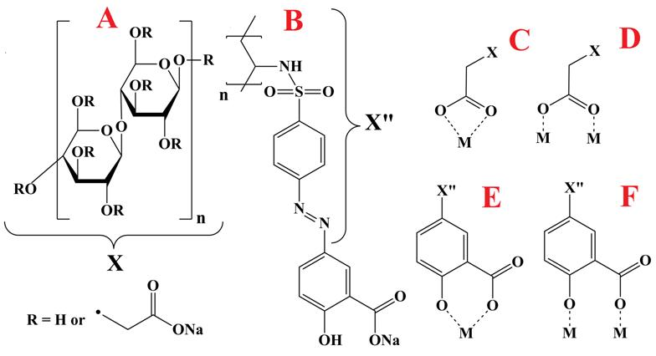

Figure 1.Chemical structure of (A) CMC-Na and (B) PAZO; adsorption mechanisms of (C,D) CMC, involving a carboxylate group and (E,F) PAZO, involving a salicylate group and metal ions M on the particle surface: (C,E) chelating and (D,F) bridging bonding.

Figure 2.SEM images of LiFePO₄ films, prepared using (A) PAZO-Na and (B) CMC-Na
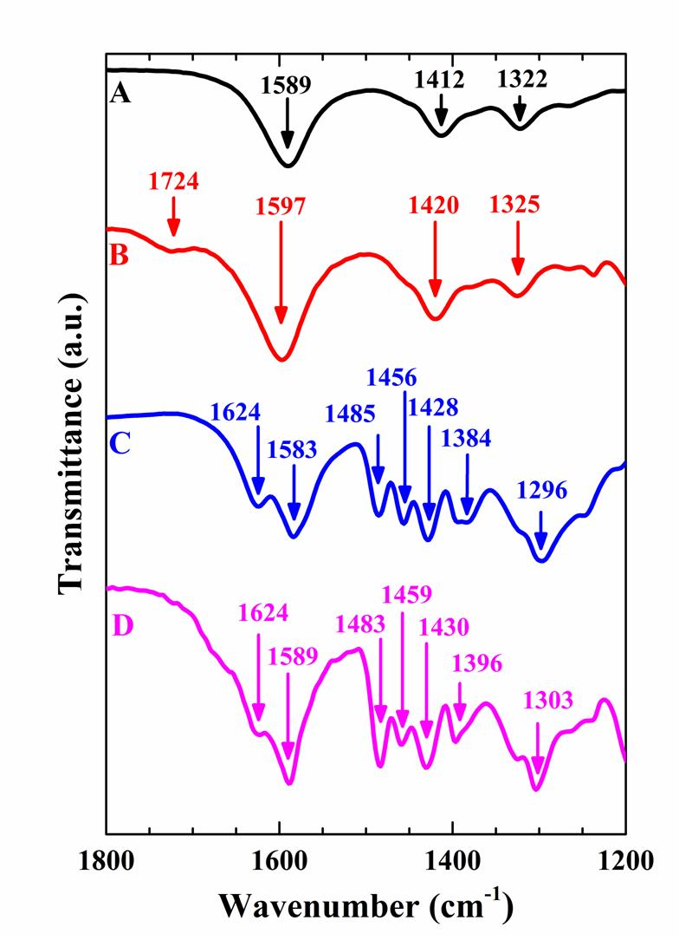
Figure 3.FTIR spectra for (A) CMC-Na, (B) LiFePO₄ deposited using CMC-Na, (C) PAZO-Na and (D) LiFePO₄ deposited using PAZO-Na.

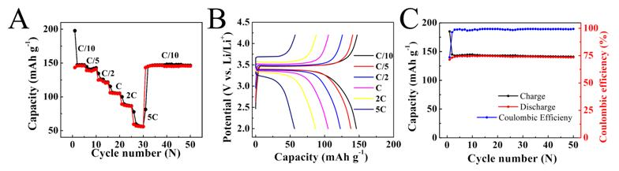

Figure 4. Electrochemical performance of the LiFePO₄ electrode: (A) rate capability tests and (B) corresponding galvanostatic charge-discharge curves at the current rates of C/10, C/5, C/2, C, 2C and 5C, and (C) capacity retention and Coulombic efficiency plots for cycling at C/10 rate in the potential range of 2.0–4.2 V vs. Li/Li⁺, C is the theoretical capacity of LiFePO4, (170 mAh g⁻¹)

