Classical Decomposition Time Series Predictive Model for the Forecast of Domestic Electric Energy Demand and Supply

Ruhiya Abubakar
Electrical/Electronics Engineering
Ghana Communicaton Technology University
Accra, Ghana
rabubakar@gctu.edu.gh
Amevi Acakpovi
Electrical/Electronics Engineering Accra Technical University
Accra, Ghana
acakpovia@gmail.com

Abstract — In modern technology and systems modeling, electric energy forecasting is extremely vital in gaining effective application of energy policies. This model is formulated after a thorough study of the power load conditions of Ghana as well as the factors that affect domestic electricity demand of supply in the Country. In Ghana, the LEAP forecast model is officially applied for electricity demand and projection of power supply which comes with forecasting errors. Thus, there exists a need to develop a forecasting model for the best energy policy and minimize an overall forecasting error compared to the LEAP model.
By virtue of the proposed study, accurate forecasting of power loads, improvement in utilization of electrical equipment, economies of scale and reduction in production cost can be attained. It is also essential to optimize power system resources for the attainment of energy conservation and overall reduction in emissions.

Keywords—Time Series, Forecast, LEAP Model, decomposition, Domestic Power Demand

Introduction

Modern electrical grids have an increasing number of integrations with renewable energy sources, which creates more uncertainty in the availability of power generation. Essentially, greater the share of renewable energy mix, higher the rate of dependency of electricity generation on weather conditions. Likewise, the uncertainty in the prediction of the generation capacity (Lago, 2019) is also associated. Thus, the demand side is affected by this state of unpredictability due to the dependency of electricity consumption on the weather conditions (Dannecker, 2014; Gaur et al. 2017; Damm, et al. 2017; Lago, 2018).
The Electricity Company of Ghana reviews the annual forecasts of electricity demand and supply by considering the changing trends in externally impactful factors to the consumption of Energy (Ghana Energy Commission, 2018). The critical reasons for this review include factors like increase in generation capacity, higher GDP growth projection as well as projection of reduction in the transmission and distribution system losses etc. (Electricity Supply Plan for Ghana, 2019, Abubakar, R, et al. 2017).
In 2019, generation of thermal power had an overwhelming dominance in the share of total electricity generation in Ghana. Essentially, the percentage share of thermal power generation is approximately 66.50% as shown in Figure. 1. However, solar PV and hydro power generation plants constitute approximately 0.3% and 33.20% respectively, which show that thermal generation in 2019 was approximately twice that of hydro in Ghana. This gives a diminishing dominance of hydro power supply in the Country’s energy mix. Thus, the cause of rising energy prices is due to the higher cost of fossil fuel used for thermal electricity generation, accompanied with dire consequences on power supply situations due to gas-supply disruptions (Electricity Supply Plan for Ghana, 2019). As well as tapping into the prospects of waste to energy (Abubakar et al., 2020) and the considering the barriers and prospects of smart grids outlined in Acakpovi, A et al. (2019).
Based on the current paradigm-shift to thermal power generation plants, the need for accurate forecast becomes much more significant. Planning energy resource is highly dependent on accurately forecasting energy demand and supply (Abubakar, R, et al. 2022). This in turn depends on choosing the right forecasting tool that fits into the existing conditions of the power loads in the Country. Figure 1 illustrates the share of energy in Ghana, as on 2019. Clearly, thermal power generation plant which makes about 66.50% (approximately 67%) of the total power generation has the higher share of the energy mix in the Country.

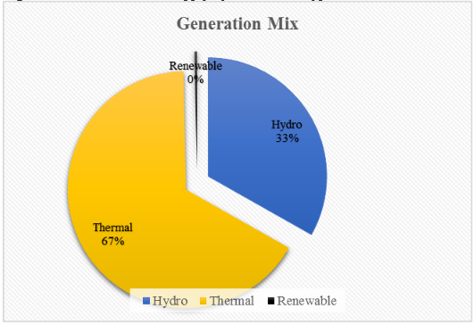
Figure 1 Contribution of Electricity Supply by Generation Types in Ghana, 2019
Source: Electricity Supply Plan for Ghana, (2019)

Also, the share of renewable source of power generation is 0.3% (approximately 0%) in 2019 and hydro plant is 33.20% which is twice lesser than thermal generation as reported by electricity supply plan, 2019. Considering the benefit of integration of renewable energy in the energy mix of a Country, Ghana has no option, but to increase renewable energy production.
Moreover, the acquisition of time series data for the forecast process is complicated and most often is not readily available. According to the master plan for integrated power system of Ghana 2018, one of the key challenges in the electricity sector is the lack of disaggregated data on the demand and supply of electricity in the Country. This implies sectoral demand of electricity is not available and one can find it difficult conducting a forecast of the sectoral electricity demand and supply of Ghana (Integrated Power System Master Plan for Ghana, 2019). Thus, considerable additional efforts must be put forth to arrive at sector-wise demand data for proper planning of the limited energy resources in the Country.

Prediction Process in the Proposed Quantitative Model Design

Utility companies stand a chance of benefiting from precise electricity demand forecasting in several ways. For instance, operational planning and programming backups can be effectively carried out (Lago, 2018) to manage resources effectively. Thus, an improved forecasting tool is very much required in the current state of forecasting notwithstanding the matching with actual demand and supply of electricity in Ghana (Integrated Power System Master Plan for Ghana, 2019).
This section presents details of a proposed prediction model based on classical multiplicative decomposition time series for an improved forecast of domestic electricity demand and supply in Accra, Ghana. Key advantage of the classical multiplication decomposition time series model includes the ease to understand and adapting the algorithm for domestic electricity forecast is clearer compared to the existing LEAP model for electricity demand and supply forecast in Ghana. Also, results from this quantitative classical multiplicative decomposition proposed procedure is comparatively precise with a reduced forecast error margin between -5%to 4.5% compared to an existing prediction error margin viz., 1% to-11% (Ghana Energy Commission, 2012-2017). Figure 2 illustrates the proposed domestic electric energy demand prediction model.
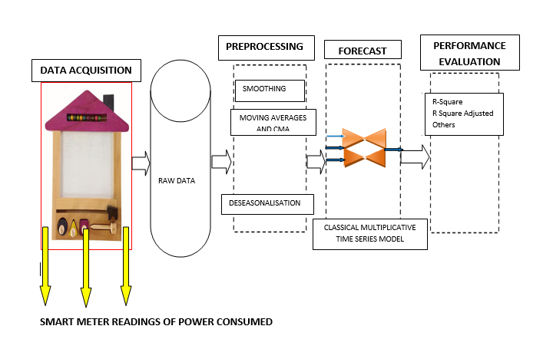
Figure 2 Proposed Prediction Model Diagram for Domestic Electric Energy in Ghana

Time series forecasting methods can be grouped into qualitative and quantitative types depending on the type of data (Nordmeyer, 2018). Besides, smoothing techniques there is another widely used methodology for analysis of time series data through decomposition of the time-series into its component parts; namely, Trend (T), Seasonality (S), Cycles (C) or Residual, and Random Variations (R) or Irregularities. The two types of decomposition models are the additive and the multiplicative time series models (Brownlee, 2017; Tylkowski and Hojan, 2019).
The proposed forecast model is the classical multiplicative time series model (decomposition), shown in Figure 2. Steps involved in the forecast of electricity demand are explained for showing the prediction process in the proposed model.

Data Acquisition Layer: This aspect of the model is where smart meters are used to record electricity consumed with precision and devoid of external influences. Data from this source is real-time and can be regulated by employing DSM techniques like load shedding and shifting based on the electricity profile of the household and use of Energy Efficient appliances. With respect to this research work, data used for the forecast was acquired from the Electricity Company of Ghana for test purposes.
Preprocessing Layer: This part is mostly over fitted, time consuming and complex, using sophisticated algorithms for prediction (Niu and Wang, 2019; Fadida-Specktor, 2018). Preprocessing activates the smooth function of the proposed model help identify the major trends in the data for forecast by choosing an appropriate parametric model and also change a non-parametric model to a parametric one and vice versa. In conducting this process, assumptions that errors in the data for prediction and methods used for calculating the prediction bounds are invalidated. Additionally, estimations on the center of the distribution of the response at each predictor are achieved through smoothing. In this case, moving average and central moving average were employed for removing the seasonal and irregular components. Whereas moving average is calculated by:
Eqn. 1
Where y[i] is the moving average of sequence i, M refers to the order of moving average, J is periods, X is sequence of time series data.Also, i and j are values of seqeunce.
The Notation of multiplicative composition model is:

Y_{t} = T_{t} x I_{t} x S_{t} = Trend_{t}* Irregularity_{t}*Seasonal_{t} Eqn. 2
Where; Y_{t}= multiplicative decomposition model,
- T_{t} = Y_{t}/Seasonality, represents an estimate of trend, also referred to as de-seasonalized data, this is realized after smoothing the data to eliminate noise and seasonal components
- I_{t} = irregularity component, represents the noise in the data, which is realized by applying moving average and cumulative moving average
- S_{t} = seasonality component, represents the seasonality of data
To forecast with the proposed model, the de-seasonalized data is fed into a regression model to obtain a linear trend model. Such a model is useful for forecasting and highly needed for prediction by applying a linear trend, of the form:
Y= a + bX, Eqn. 3
Whereby, Y represents the trend value (forecast value), a denotes an intercept (the value of the trend at time 0), b is the slope (the amount of increase or decrease per period), and X stands for time. In essence, this work has suggested an addition preprocessing step of converting monthly data records of demand of electricity into quarterly demand. Thus, twelve months electricity demand figures which represent a yearly demand, is duly converted into four quarterly demands by averaging three monthly demands into a resultant quarterly demand.
Prediction Layer: The slope’ b’ of the line and the intercept ‘a’ are given by the formulae:
Slope, b = r (S_{y}/S_{x}) Eqn. 4 SSR= ∑ Eqn. 5
And, Intercept, a = Ÿ - b  Eqn. 6
Where;
- r refers to correlation coefficient
- S_{y} is the standard deviation of Y variable
- S_{x} denotes standard deviation of X variable
-  denotes the sample mean of x variable
- Ÿ refers to the sample mean of Y variable
Equation 4.4a and 4.4b is very much needed for forecasting for model performance evaluation. These two variations help in the test of correlation and statistical significance of model using the f-test, t-test and p-test.
Obviously, forecasting using this type of time-series model, reduces to adding back the future estimates for the trend component T_{t} and the seasonal component S_{t} at a future time t without the irregularities (white noise). The predictive equation for the proposed classical multiplicative time series model is expressed as:
t > N Eqn. 7
Where F_{t} is the forecast value, T_{t} is the trend component value, C_{N’} represents de-seasonality component and S_{t} is the seasonality component. Note that, trend value= y- intercept value+ t intercept value *the quarters value.
Also, the trend value is estimated by the trend-cyclical regression using de-seasonalized data, which gives the result of values for the y and t intercepts. Finally, computing the forecast fitted values F_{t} involves multiplication of the fitted trend values T_{t} by their appropriate seasonal factors S_{t}. The C_{N’} is the de-seasonalisation component which generates the trend values for forecast.

Performance Evaluation Layer
The different predictive performance evaluation computation depends on the type of predictive algorithm applied for the forecast. With the decomposition model, the performance evaluation layer of the proposed model looks at adjusted R-Square values to measure the quality of the model constructs. R-Square is a statistical measure of how successful the fit is, in explaining the variation of the data. This is referred by measuring the correlation between the predicted value and response values. Equation 4 is the formula for R-Square and adjusted R-Square.
SSR= Sum of Square of the Regression/Explained Sums of Squares
SST=Total Sum of Squares
SSE= Sum of Square Error

Equation 4.6a is the Explained Sums of Squares, where, i and n are the number of data points is sample mean, refers to mean of each value in the set, w_{i} refers to variation of individual data points around the mean.
SST as illustrated in equation 8 is also called the sum of squares about the mean, and is defined as:

SST= ∑ Eqn. 8
Where; SST = SSR+SSE, and y denotes total mean of data and is the deviations. With these definitions, R-Square, which is the coefficient of determination, can be expressed as:

R-Square= SSE Eqn. 9
From equation 8, smaller the SSE, better the model fits to data and vice versa. Thus, value of zero for SSE means the proposed model is a perfect fit.
Overall performance of the proposed model largely depends on the type of data set forecasted. Despite the irregularities in the nature of electric power demand data, forecasting conducted by applying this model can take care of the noise and stochastic nature of the consumption pattern at the domestic level due to variations in the manner of energy usage and generation of electricity due to the intermittent nature of renewable sources of electricity, by applying the de-seasonalization approach. Consequently, this can help regularize the prediction process for precise decision and accurate energy resource planning in future.

2. 0 Block Diagram Of The Proposed Multiplicative Decomposition Design Pertaining To Quantitative Predictive Model

The main reason for choosing the multiplicative time series is due to ease with conducting multiplication of scientific quantities like mass, velocity, energy, force etc. compared to addition. Essentially, each one of the quantities has a unique unit of measurement and multiplying them can result in another unit. Thus, there is no need to convert all the quantities into same unit of measurement before multiplying the results. Considerably, a more complex approach is needed before conducting an addition of different quantities with various units of measurement. A general block diagram of the time series model is illustrated in Fig. 4.3. The first stage deals with the type of data needed to be predicted using the time series or decomposition model, Y_{t}. Multiple-step Moving Average (MMA) is then conducted in the form of moving averages and cumulative moving averages to eliminate the irregularities in the time series data. The seasonality of the data looks at averaging the difference between the original time series and the refined data conducting the MMA to de-trend the time series data. Output is then channeled through the normalization process, and seasonal component S_{t} is achieved. The seasonal component is very much needed in the forecasting process, but before forecasting the de-seasonality process is carried out. Here, a division of the original time series data Y_{t} by the seasonal component S_{t} is conducted. By virtue of this de-seasonality component, it can facilitate the calculation of the trend component. The trend component is then computed by linear regression of the data where the y and t intercept are realized. Finally values of the y- intercept and quarters of the various years of energy demand from the original time series data are applied for the forecast value by using the mathematical expression in eqn. 6
Figure 4 shows the flow chart of the algorithm for multiplicative decomposition model applied for the forecasting of the electricity demand and supply. A detailed explanation of the forecast process is illustrated by expressing the mathematical formulation of the algorithm applied to the prediction of domestic electricity demand and supply in Ghana. Even though, the classical multiplicative time series forecast model appears to be a simple process of forecasting, it has proven to have better accuracy than other complicated models for forecasting. Highlights of the computation processes with regards to the proposed multiplicative decomposition model are presented in Table 3
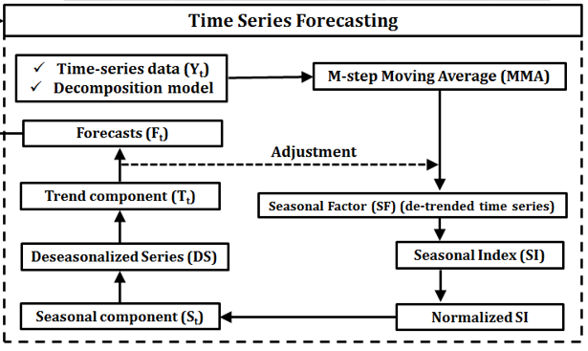 Figure 3 Block Diagram of a Decomposition Time Series Model
Source: Mirlatifi, et al. (2015)

Technically, this model needs meticulous approach to forecasting of power loads, though computation has no element of the ‘black box’ approach like in Artificial Intelligence models. Hence, classical multiplicative time series model has proven beyond reasonable doubts its ability to precisely forecast quantities.
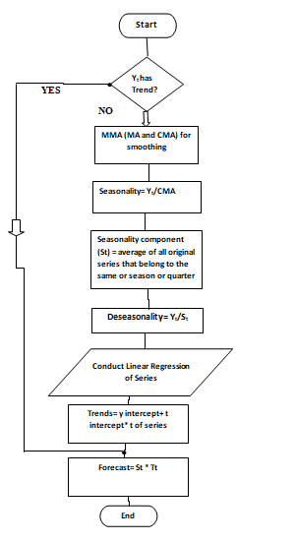 Figure 4 Flow Chart of Multiplicative Decomposition Forecast Model

The software translation in the proposed multiplicative decomposition forecast model starts by checking if there are trends in the time series data. If the series data has trend components, the forecast can be conducted without further processes. If not, its verification for realizing the trend component has to continue. In the absence of trend components, moving average and cumulative moving average computations are conducted to remove the irregularities and consequently de-seasonalise in the data. Having the de-seasonalised data can facilitate a linear regression series calculation for the trends, which is applied for forecasting.

3.0 Rationale for Classical Multiplicative Time Series as a Prediction Model

Reason for choosing this model is because of its simplicity and easy to understand method of prediction. The model has the ability to preprocess the time series data before forecasting. This is an added ability of the model over the Machine Learning type of algorithm, which has to train input data to suit a desired output, without clearly showing the preprocessing for noise reduction or irregularities in the data. But, forecast conducted relies solely on the trained data. Also, most Machine Learning algorithms are fitted to desired results without considering the regularity and the precision of results retrieved in this process. Essentially, the choice to apply the classical multiplicative model is due to its ability to show a step-by-step mathematical approach for forecasting. Thus, enhancing new user’s knowledge through a hands-on practical process of forecasting is obtained.

3.1 Identified Input and Output Data for the Proposed Predictive Model
The input and output parameters of the classical multiplicative time series model refer to the input data applied for the forecast of demand and supply of domestic power load in Ghana.
As indicated earlier, data acquired for domestic electricity demand from Electricity Company of Ghana (ECG) was duly applied for this process. Key among the factors worth mentioning is the application of the feeder numbers to identify the demand sector. Thus, the feeders responsible for domestic sector supply were used for this process. Also, the peak monthly electricity demand was selected for the forecast. The input data of electricity demand for the period of 10 years (from 2008-2018) was acquired from ECG for the forecast. Output data is the forecast results of the electricity supply and demand using the classical multiplicative (Decomposition) time series forecast model.
An important suggested additional contribution to the input data for the proposed classical multiplicative time series model is the add-on preprocessing step to the data acquired from ECG. The existing data records from ECG represent overall daily, weekly and monthly (peak demand per month). This addition contribution to the preprocessing stage of the model dealt with conversion of the monthly demands to quarterly electricity demands. Thus, an average of three months electricity demand is computed to arrive at the quarterly demands. So, each year had a total of four quarters representing the quarterly domestic electricity demand in Ghana. Key reason for this addition contribution to the existing classical time series model is the ease in managing averaged demands due to the homogeneity of domestic electricity demand. Thus, improving on the irregularities and fluctuations in the time series data obtained.
Output data on the other hand is the output results of the proposed classical multiplicative time series model which is achieved by application of various steps in the model for a forecast of electricity demand. Thus, output data is the forecasted results obtained after de-seasonalisation of the preprocessed time series data of domestic electricity demand in Ghana.

3.2 Modelling Domestic Electric and Supply Energy Demand using the Classical Multiplicative Time Series Model

In the classical multiplicative decomposition model, the Centering Moving Average Model is applied by assigning equal weights to all the observations when computing the trends and the seasonality indexes for the forecast to be conducted. Central moving average is an essential part of this proposed model, because it facilitates the elimination of the irregularity components for noise reduction. Thus, there is a need for its inclusion on the predictive graph. Essentially, prediction was conducted for all the domestic electricity demand areas of Accra, namely: Mallam, Achimota and Accra East. The notation of centering moving average model, Y_{t} is represented as follows:
Eqn. 10
Where;
- Y_{t} is the actual value
- Y _{t + 1} represents the forecasted value
- k represents the number of terms in the moving average

Tirkeş, et al. (2017) developed a time series model for long-term forecast, on monthly sales data of Jam Company. In particular, Tarihi Yudumla and sherbet from January 2013 to December 2014 was used for this study. The analysis was carried out using Hot-Winter, decomposition and trends methods. Results indicated that HW and the decomposition methods were both successful in a trendy-seasonal-cyclic data. But the trendy model was successful for data that had trend components. Moreover, decomposition or classical multiplicative model is proven to be very successful in forecasting numerous types of data because of its unique method in tackling predictive reports. Table 1 illustrates the performance of the proposed classical multiplicative decomposition model on the forecast of domestic electricity demand in Ghana.
Values for R-Square and Adjusted R-Square obtained from the linear regression indicate that data with irregularities had R-Square values being closer to zero than data that appeared consistent and regular. Despite all these observations on the proposed model, forecast values of this model were much closer to the actual values than the LEAP bottom-up and top-down algorithm forecast values. Hence, improving this model is a better choice for domestic electricity demand and supply in Ghana.
Table 1 Results of Regression Analysis for Proposed Model
Type Analysis | Type of Regression
Type Analysis | R² | R²Adjusted
Electric Power Supply Forecast
  0.34
  0.18
Electric Power Demand Forecast |  | 0.67
  0.74
Mallam Electric Power Demand |  | 0.60
  0.61
Achimota Electric Power Demand
  0.01
  0.02
Accra East Electric Power Demand |  | 0.05
  0.11

To further endorse on the validity of this classical multiplicative model, Makridakis, et al. (2018) on Statistical and Machine Learning (ML) forecasting methods reported that, performance across multiple forecasting methods are critically needed for insight into enhancing forecasting. Thus, the authors applied large data set of about 1045 time series data on ML method and eight other traditional statistical forecasting methods. Observations revealed that, computations requirements for the ML methods were greater than that of traditional statistical methods. On the contrary statistical method exhibited higher accuracy measure across all forecasting scenarios. Results obtained from this research postulated the need for choosing objectives and methods for forecasting with unbiased decisions and lead to an inferring feeling that one can achieve results through sizable and open competitions with meaningful comparisons and definite conclusion for empirical arguments.

4.0 Highlights of Minimized Forecast Gap using the Proposed Classical Multiplication Time Series Model (Decomposition) for Demand and Supply Forecast

Minimization of the prediction error is a significant need and requirement in modern technology and electrical system modeling. Further, proper planning of electrical system resources come along with demand accuracy in prediction of power loads in a Country. Thus, the choice of applying the classical multiplicative decomposition time series model is due to its obvious impact on minimizing the forecast errors. Table 2 shows a comparison of forecasting errors for both the LEAP forecast model and the proposed classical multiplicative decomposition forecast model. The error margin colored pink and blue are for LEAP model and classical multiplicative decomposition time series model respectively.
It will be appreciated that forecast obtained by using the proposed classical multiplicative model is much closer to the actual values of the supply of electricity in Ghana. This indicates that the proposed prediction model performs better and is accurate.
Finally, it is key to appreciate that a 1% reduction of forecast error and deviations can save millions of dollars (Alfares, et al. 2002). The LEAP software model used to forecast total and non-sectoral electric energy demand and supply with recurring over and under estimations in the prediction values compared to actual (error margin between 1 to 11 percent), with the application of the classical multiplicative time series model for an Improved forecast of domestic electric energy demand and supply with the de-seasonalisation of historical data before forecast, resulted in an error margin between -5 to 4.5 percent. Therefore, multiplicative time series model is a de-facto approach for electricity demand and supply forecast for Ghana.

Table 2 Highlights of Minimized Forecast Gap using the Proposed Classical Multiplication Time Series Model

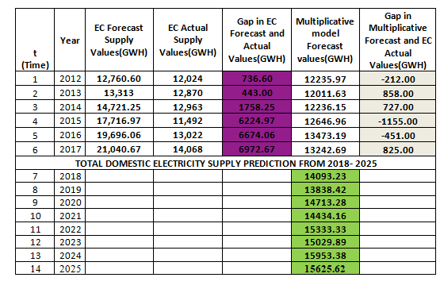
According to Ghana Energy Commission, 2018 report on energy supply and demand outlook, a total of 14,069 GWH of grid electricity including embedded generation was supplied in 2018(Ghana Energy Commission, Supply and Demand 2018). Comparing the values obtained to the predicted values (colored green) of electricity supply for 2018, using the proposed classical multiplicative decomposition time series model, which is pegged at 14,093.23 GWH. This clearly indicates how much accuracy is involved applying the proposed model for electricity demand and supply predictions.
The key and unique aspect of multiplicative time series model is described by multiplication of multifactor model such as the trend, cyclical, seasonal and error or irregularities. Considering the fact that engineers and scientists routinely apply physical quantities to represent the measured properties of physical objects are expressed in different units of measurements. Conducting multiplication of two or more of these quantities can result in a different quantity with a different unit of measurement (Sharlow, 2003). This same approach is much difficult using addition, in which case, the quantities are converted to the same unit of measurement before the operation is conducted. Fig. 4.5 illustrates a definition of the functionalities of components in decomposition of prediction model. These components are multiplied to give a resultant forecast of the electricity demand and supply by taking out the trend and the cyclical components from the actual series data. Once this is conducted, seasonality and irregular components are eliminated. The seasonal indices in this model are calculated by realizing the cyclical and the trend components through the application of centered moving average method. The seasonal indexes are the m values of seasonal periods that form the seasonal component (Hyndman and Athanasopoulos, 2018). Also, the statistically significant test for trend of the series which is the most applied component for the forecast can be tested by setting a null hypothesis as follows:
Ho: On average Y_{t} = Y_{t} - Y_{t-1} =0 (no trend),
Where, Y_{t}= actual series for period t and
Y_{t-1} refers to actual series for period t-1. For a series to be predictive, then trend ≠0.
Thus, H1: On average, Y_{t}< 0 or > 0 (negative or positive trendError! Hyperlink reference not valid.) for the forecasting to occur.

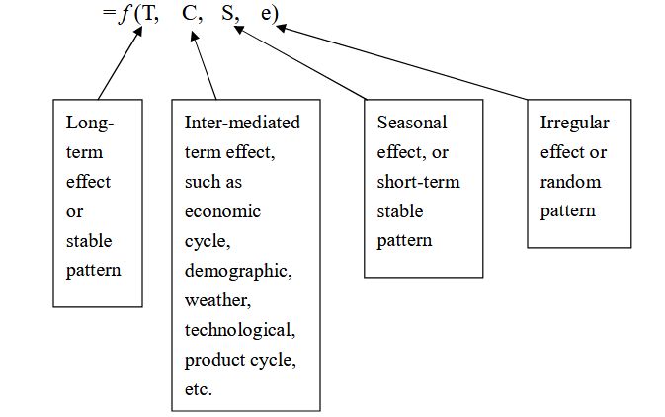

Figure 5 Description of Decomposition Multifactor Model

Many research studies have revealed that the multiplicative model fits a wider range of forecasting situations, compared to the additive model (Hyndman, 2019). Moreover, decomposition models avoid the use of training data to fit a model, which is mostly practiced by ML model. In case of ML, performance of model is evaluated on the test data set which is subjected to application of different forecast horizons (Hyndman and Athanasopoulos, 2018). Thus, making the time series decomposition a better choice, due to its clarity and simple approach to forecasting.

4.1 Results and Analysis of Proposed Classical Multiplicative Time Series Model

Applying the classical multiplicative time series prediction model has further improved on the forecast error between the forecast and the actual values of domestic electricity demand and supply in Ghana. Results on the improvement are elaborated in this section.
The graphs represented in Fig. 4.6-4.8 are the forecast, actual and cumulative average values of domestic energy demand in Ghana as per areas of bulk distribution according to Electricity Company of Ghana. Monthly domestic electricity demand data acquired from the Electricity Company of Ghana was applied to the forecast process.

Y-Axis
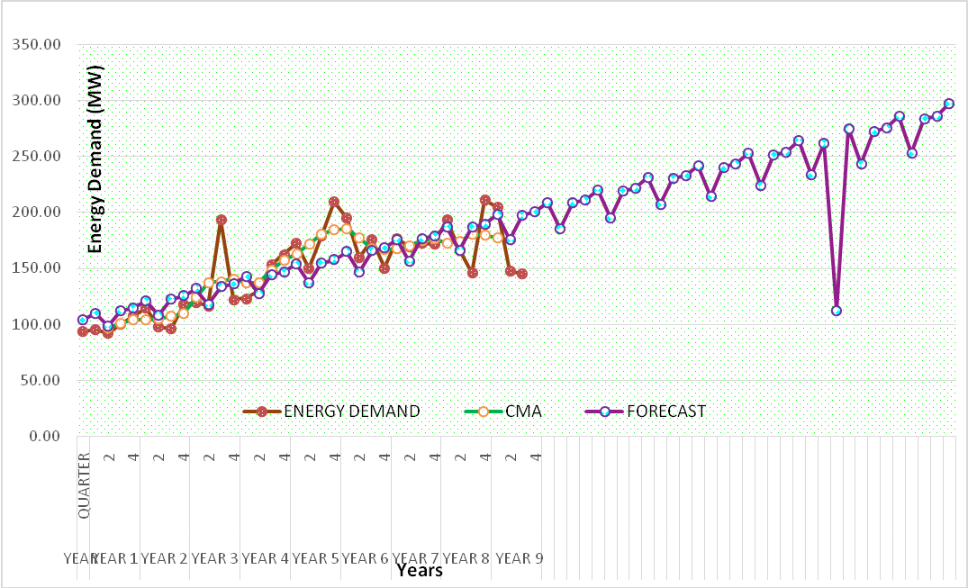

X-Axis
Figure 6 Forecast and Actual Values of Domestic Electricity Demand for Mallam

The Y-axis of the graph in Fig. 4.6 represents the peak electricity demand data acquired from Electricity Company of Ghana (ECG) on the domestic energy demand considering the assigned Feeder numbers of power distribution and X-axis is the corresponding years of demand of electricity group in quarters for easy computation. Thus, explicitly each year has four (4) quarters, which came as a result of averaging the monthly electricity demand data and an add-on to the preprocessing stage of the classical decomposition model. From graph 4.6, a total of nine (9) year data is applied in the proposed input electricity demand data modified classical multiplicative decomposition model, which is forecast to 2025. Readings from the graph of forecasted values for domestic electricity demand in Mallam distribution area shows that, the total demand for 7 years for Mallam is approximately 297.04MW.

Y- Axis 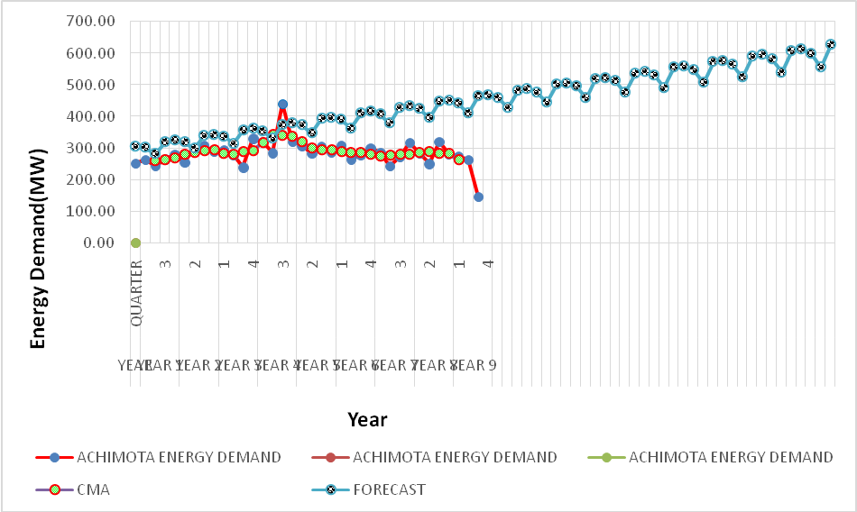

X- Axis

Figure 7 Forecast and Actual Values of Electricity Demand for Achimota

In figure 7, electricity demand for Achimota area is plotted against the corresponding year of demand. Evaluating the graph in Fig. 4.7, it is obvious that, the total electricity demand predicted from this area in 2025 is approximately 627.14 MW.

Finally, with the forecast of Accra East electricity demand, a total of four (4) year data was
applied for this forecast which is represented by series 1 on the graph. This is because it is a new distribution area created. Again, forecast indicate that the total electricity demand in 2025will be as high as 1162.97MW. This could be attributed to the class of residents in this area (Higher Class).

Y-Axis
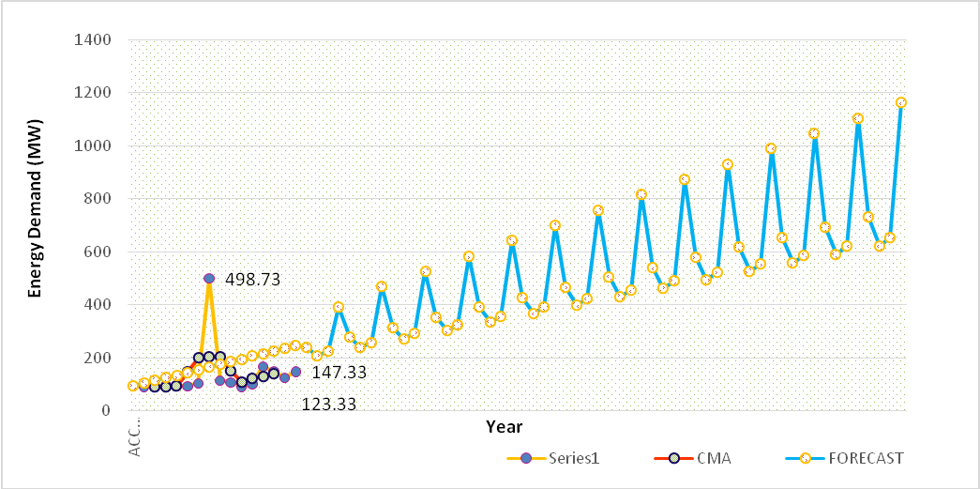X-Axis

Figure 8 Forecast and Actual Values for Domestic Electricity Demand for Accra East

Most forecasting models are complex and hardly shows how the process of prediction is carried out. More so, other algorithms need more data on different measurements like the weather, GDP, housing type and conditions to make a prediction of electricity demand, without clearly showing the steps involved. Thus, comprehension and interpretation of results are cumbersome. One of the many disadvantages of the temperature-based forecasting approach is that, relevant parts of the predictions carried out cannot be produced by agencies that have no weather data.
In summary, data from the graph of forecasted values for domestic electricity demand in Ghana shows that, the total demand for 7years in 2025 for Mallam is approximately 297.04MW, and that of Achimota is 627.14MW.Finally, Accra east has a total demand of 1162.97MW.In total, the domestic electricity demand in Ghana is the sum of the various area demands in Ghana, which is 2,087.15MWdepicting much closer to the forecast results obtained using the Matlab software for the predictions of the same data set, (details presented in the confirmatory analysis report in sub-section 4.7). Obviously, the smoothing and de-seasonalization processes have removed part of the data that is irregular and therefore the residuals. Hence, this model is a better option for electricity demand forecast in Ghana.
4.2 Key Contribution to the Proposed Classical Time Series Multiplicative Model

The main contribution to the existing classical multiplicative time series model is with the approach for fitting input data. The CMA is applied in the classical multiplicative decomposition model by assigning equal weights to all the observations. Thus, the seasonality and de-seasonalization indices facilitate the prediction of future occurrences.
Key to the modification applied to the time series data of the monthly domestic electricity demand in Ghana, happens to be the averaging of three-monthly data of demand in electricity to arrive at quarterly demand of electricity. This resulted in a total of four quarters of demand for electricity in each year.
In essence, large datasets that involves daily and monthly electricity demand are commonly difficult to interpret with models such as the classical time series decomposition models. Thus, an additional preprocessing approach that is in line with the Principal Component Analysis (PCA) technique to reduce the size of the dataset for an increased interpretability with an associated minimization of information loss and a reduced variance between the data values is adopted. This approach is involved in the averaging of the monthly data to quarterly data for an improved forecast using the classical multiplicative time series model.
Essentially, it is of essence to recommend the application of multiplicative equation when the trend increases or decreases exponentially than linearly. In this regard, the dataset meets this criterion, hence, the classical decomposition model is applied for the forecast.
Further, the differential approach in the classical model for fitting the data is the de-seasonalisation process. This is performed to test the time series data for statistically significant seasonal behavior before forecasting is carried out. Thus, a time series data without a significant seasonality pattern is not worth forecasting (Rabelo, 2019). To explain further, for a time series data to be predictable, a series with a single variable must have autocorrelation, that is, the current period must be explained based on an earlier period, which is referred to as lag (Rabelo, 2019; Fiorucci et al. 2016). This ability of the time series explains the seasonality of the data, thus, the need to test for the statistical significance of the seasonality.
According to Fiorucci et al., (2016), a time series is seasonal if:
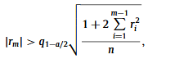 Eqn. 11

Where, r_{k} is the lag k autocorrelation function, m refers to the number of the periods within a seasonal cycle, for monthly data, m is 12, q denotes the quantile function of the standard normal distribution, n is the sample size, and(1−a) % is the confidence level (Fiorucci et al.2016). For a seasonal time, series, deseasonalisation means making ‘’n’’ deseasonalised through the classical decomposition model with a multiplicative principle for fitting the data for an improved forecast (Fiorucci et al. 2016).
The essence of this add-on approach to the existing classical decomposition model facilitated an improvement in the forecast values of domestic electricity demand in Ghana.

4.3 Verification and Validation of Classical Multiplicative Time Series Forecast Model

The use of statistical forecasting methods has progressed a great deal for some decades now. This includes exponential smoothing, box–Jenkins and ARMA models. In this research, the classical multiplicative time series model is proposed for the forecast of domestic electricity demand and supply in Ghana. In the validation process results of both the proposed forecasting method and that of the already existing model applied for the forecast of domestic electric energy demand and supply in Ghana is compared and contrasted. These are based on the performance indicator measures as well as the gap between the both forecast values (using the LEAP algorithm and the proposed classical time series algorithm) and the actual values of electric energy demand and supply in Ghana.

4.4 Analysis of Forecast using the Classical Multiplicative Method compared to LEAP

Considering the simplicity of the proposed method involved in the forecasting of electric energy demand, the accuracy level with regards to the forecasted values by applying the classical multiplicative model is overwhelming. Table 3 illustrates the steps taken to arrive at the prediction of domestic electric energy demand for Ghana. The values of actual and forecasted demand from the Ghana Energy Commission using LEAP algorithm is tabulated in Table 4 for comparative analysis of the two approaches.

Table 3 LEAP and Classical Multiplicative Time Series Forecast Values Compared to Actual Values of Electricity Demand
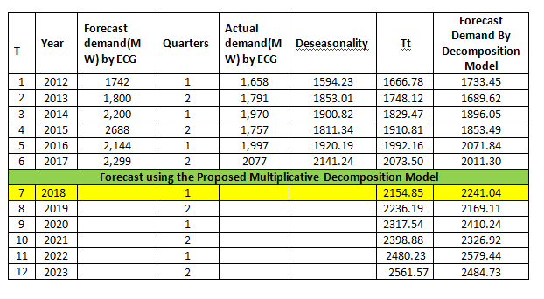
Table 4 depicts the gap or the deviation in the results of forecasting obtained by the proposed method and that of LEAP. The results of Table 4 clearly reveal that the deviation in forecast error of classical multiplicative approach is much smaller and precise than the forecast error using the LEAP obtained from the Ghana Energy Commission. The convincing part of the results obtained and validating aspect of the model is its ability to compute the forecast clearly and explanatory, without user bias for best fit and lack of black-box activities. A graph of the actual values of electric energy demand is presented in Figure 9 to reinforce the fact that the proposed classical multiplicative model performs much better in terms of forecast error margin than the sophisticated algorithm presented by LEAP, as illustrated in Table 4.
Table 4 Forecast Error of LEAP Model Compared to the Proposed Classical Multiplicative Time Series Model

 | Forecast Error with Classical  Multiplicative Model (MW) | Forecast Error with LEAP Model (MW)
 | 75 | 84
 | -101 | 9
 | -74 | 230
 | 96 | 931
 | 75 | 147
 | -66 | 222

Comparatively, the forecast error using the LEAP model by Electricity Company of model is much greater than the errors realized as a result of applying the proposed classical multiplicative time series model for the prediction of demand and supply of electricity in Ghana, from Table 4. The LEAP model has forecast gap as high as 931MW, with the lowest value being 9MW. The gap using the proposed classical multiplicative model ranged as high as 96MW and lowest being -101 MW of power.

Y-axis
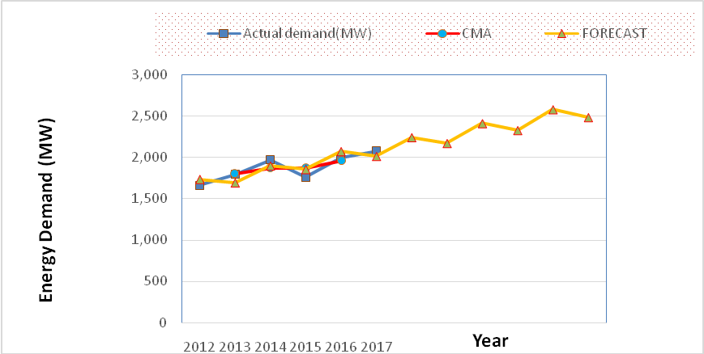

X-axis
Figure 9 Graph of Actual and Forecasted Values of Electric Energy Demand in Ghana

In figure 9, the graph of actual and forecasted values of electricity demand using the classical multiplicative time series model is presented. Results indicate that, a total of 2484.73 MW is the demand of electricity in Ghana using the actual yearly demand data report by Energy Commission of Ghana.

Table 5 Performance Analysis of the Proposed Classical Multiplicative Time Series Model

Regression Statistics
Multiple R | 0.86
R Square | 0.74
Adjusted R Square | 0.67
Standard Error | 101.27
Observations | 6

Values for adjusted r-square for the data forecasts of Energy Commission of Ghana is statistically significant, considering values for R-Square and adjusted R-Square shown on Table 5.
It is obvious the forecasted values are significant since the values of the observable time series data is about 73.80% and 67.30% of the predicted value for r-square and adjusted r-square values respectively. These results endorse on the performance of the proposed model. Further, the multiplicative model exhibits very distinct feature of prediction bounds, which the most sophisticated ML model do not have. Such a feature adds credence and basis for the improved accuracy of the measurements made with this model for prediction of domestic electric energy demand for future controls and decision making.

Table 6 LEAP and Classical Multiplicative Time Series Forecast Values and Actual Values of Electricity Supply

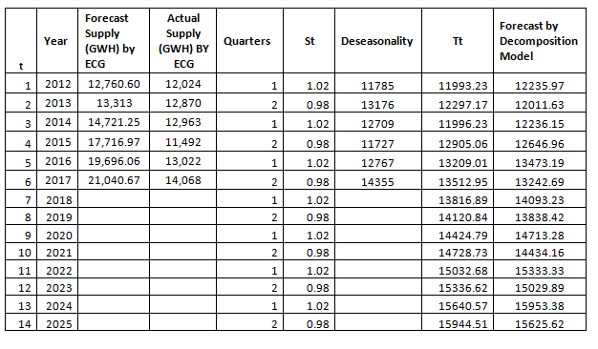

The supply-side forecast has also proved to have a minimal forecasting error when the proposed classical multiplicative decomposition model is applied for prediction. Table 6 illustrates a detailed forecasting process of the proposed decomposition model and its associated ability to reduce the forecasting error by using the decomposition model.

Table 7 Comparison of the Forecast Error in Electricity Supply using the LEAP Model by ECG and Proposed Classical Multiplicative Model

Year | Gap (GWH) from Decomposition Model | Gap (GWH) from ECG
2012 | -212 | 736.6
2013 | 858 | 443
2014 | 727 | 1758.25
2015 | -1,155 | 6224.97
2016 | -451 | 6674.06
2017 | 825 | 6972.67

Moreover, Table 7 shows the comparison of forecasting error using the LEAP and proposed classical multiplicative time series mode. It clearly displayed in Table 7 that the proposed methods have much closer approximation of the actual electric energy supply (Ranging from – 1,155 to 858 GWH). Compared to LEAP model (Ranging from 443 to 6,972.67 GWH), this is duly represented in the graph in Figure 9 with the actual electricity demand. Fig. 10 shows the actual and forecast values of electricity supply as well as the forecast gaps that resulted by using the LEAP and proposed classical multiplicative time series model. Here, X and Y-axes represent years and electricity supply in GWH, respectively.

Y-axis
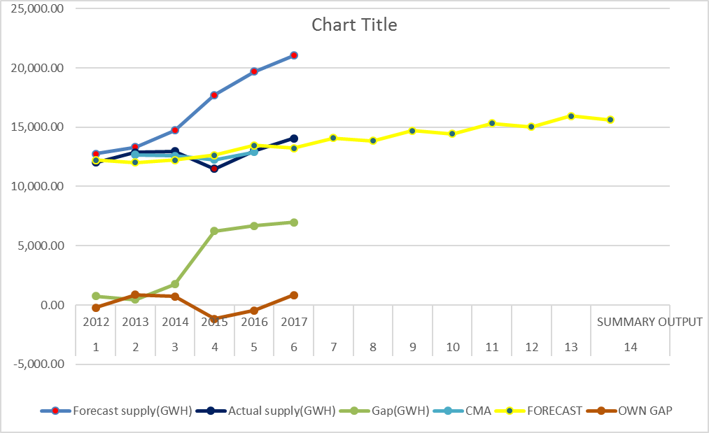

X-axis

Figure 10 Actual and Forecasted Values of Electric Energy Supply in Ghana

Finally, the regression statistics computed for the proposed classical multiplicative model is shown in Table 8 which indicates that 34% of the prediction conduction has a correlation with the actual values used for the forecast. The proposed multiplicative model performs better than the LEAP algorithm applied in the forecast of energy supply in Ghana.

Table 8 Performance Analysis of Forecast for Proposed Decomposition Model

Regression Statistics
Multiple R | 0.58
R Square | 0.34
Adjusted R Square | 0.18
Standard Error | 883.29
Observations | 6

In making a decision as to which type of forecasting model to apply for a particular environment, the error making in the forecast value should have so much emphasis.
Some of the question one needs answer to, before making a choice include:
- What is the cost involved?
- Will forecasts be available in time to use them based on the time of computation?
- How accurate is it?
In answering the last question which is very scientific and technical, one needs the standardized measuring instruments to pronounce a model accurate. Most of the accuracy levels of ML are quite generalized with lots of “backcast” decisions through arithmetic mean of errors known as bias. On the contrary, this behavior is under control in classical multiplicative time series model, hence, best for energy forecast in Ghana.

4.5 Linear Regression Analysis for Model Correlation and Statistical

Significance

According to Ogee et al. (2016), Analysis of Variance (ANOVA) is used to determine the difference between two or more variables. These variables are the dependent(Y) and independent variables (X). Though the r-square value measures the strength of the relation between the dependent variable and the model, Is it also referred to as the coefficient of determination. It is not a formal test for quality of a model. The correlation coefficient r, which explains the goodness of fit is responsible for the measurement of strength of a linear relation, with a range of -1 < r < 1. Thus, the R- Square value is the square of the correlation, with a range of 0 < r² < 1.
F-test measures the overall significance for this relationship. Thus, if a significant F-Test is achieved, the correlation between the model and the dependent variable is pronounced to be statistically significant which conclude that r-square is not equal to zero. Technically, linear regression analysis was conducted in this study with the equation, Y= mX +b.
Where;
Y denotes the dependent variable (Trend)
- m is slope of the linear relation
- X denotes independent variable (Period of time series data)
- b refers to Y-Intercept
The least squares statistical method is used to estimate the regression analysis equation with predicted values Ỹ = a + bx, where, a= intercept coefficient, b= t-coefficient and x is the period of series. Thus, for statistical significance test of the overall model, the F-Test is conducted, with the condition that, if all true slope values (m) are equal to 0, then the model has no ability to predict Y hypotheses: H₀: m1=m2=0(model has no ability to predict Y) H₁: at least one mi≠0 (at least one variable has ability to predict Y).

According to Bornes, (2017), R² = R-Square=
Where,
- RSS refers to Residuals Sum of Squares
- ESS is the Explained Sum of Squares
- TSS denotes Total Sum of Squares.

According to Cheusheva, (2019), applying Y= mX + b
Where;
- Y is the dependent variable,
- X is the independent variable
- m is slope
- b is the constant of proportionality.
The Degree of Freedom(df) is associated with the sources of variance which is also calculated by:
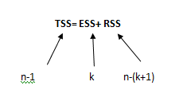

Where;
- n= number of observations = 36
- k= number of coefficients=1, since a linear regression is applied for analysis.
Thus, df= n-k-1. Table 8, shows values of the regression analysis of variance of the proposed decomposition model. The parameters of the model will be applied for statistical significance test.
Hence, df= n- k +1= 36-1-1 = 34= Degree of Freedom.
Again, according to Cheusheva, (2019), the F-test is also conducted by applying the formula =F.INV.RT (Probability, deg_freedom1, deg_freedom2), in Microsoft excel. Here, the probability of occurrence of 5% is used, degree of freedom 1 and 2 from formula refers to RSS and ESS respectively. Essentially, an F-statistical test is the ratio of two variances. In this case, it refers to the variances of Residual Sum of Squares and Expected Sum of Squares, which technically shows how the two mean squares variances account for the degree of freedom applied for estimation of the variance.
But, from the Analysis of Variance (ANOVA) in Table 8, ESS=1 and RSS=34.

Table 9 Analysis of Variance (ANOVA)

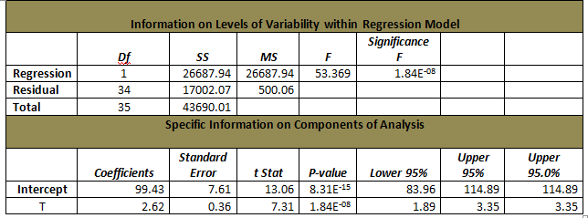

From Table 9, df is the degrees of freedom, SS is the sum of squares, MS is the mean square, F is the F statistic, or F-test for the null hypothesis, used to test the overall significance of the model, Significance F is the P-value of F.
Thus, the value for F-test is 4.13 which is then compared to the F value in Table 9. Accordingly, F-value is 53.37 on Table 8, which is comparatively higher than the calculated F-test value, meaning the model is significant. The p-value is <0.00001. The result is significant at p< 0.05 at a critical level of 4.13 from the Microsoft excel calculation and Table 9. This implies the model construct is significant and well correlated. Figure 11 illustrates a graph of the F-test conducted for statistical significance.

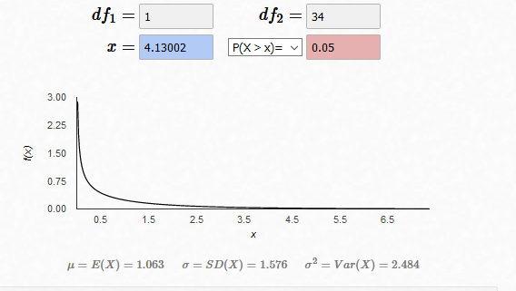

Figure 11 F-Test of Classical Multiplicative Time Series Model
Also, the probability of significance is calculated using the formulae in Microsoft excel 2016, =F. DIST.RT(x, deg. freedom1, deg. freedom2) = 0.0695, approximately, 0.07pu=7%
Hence, it proves the significance of the overall model.
Also, test for statistical significance of individual Variables (T-test) is conducted. This is to test whether an individual variable X is helping to predict Y. Formulae is =F.INV.RT(x, deg. freedom)
But, degree of freedom= n-k-1, thus, DF= 36-1-1=34
T- Test value retrieved from formulae applied resulted in 2.032. Comparatively, this value is lesser than the T- Stat value in Table 4.10, hence statistically significant. This implies that, if the value for T-test is greater than the T-Stat value in Table 8. It is statistically significant, which means that, the ability of variable X to help predict Y is insignificant with a P-value of 1.84E-08 or 0.0000000184. Figure 12 shows the graph of two tail test for T-test.
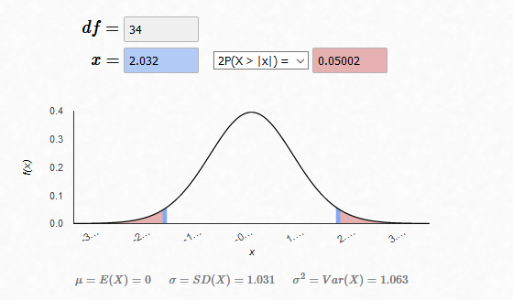 Figure 12 Two-Tail T-Test

4.9 Discussions on the Total Domestic Energy Demand and Supply Prediction in Ghana

For Mallam area, prediction for 2025 is a total average monthly peak demand of 240 MW. The corresponding figure for Achimota areas is 580MW. For Accra east, the total average monthly peak demand is about 1400MW in 2025. The prediction interval shows the distribution of values and not the uncertainty in determining the population mean. Hence the prediction bounds account for both uncertainty in knowing the predicted value and the data scattering pattern.
Thus, Ghana Electricity Company limited (ECG) needs as much as 2,220 MW of domestic energy peak demand for sustainable development in year, 2025. As mentioned earlier, data on domestic energy demand and supply is not available due to the housing type and electricity distribution systems in Ghana. This has translated into having a complex electrical infrastructure with multifarious electricity supply and demand drivers. From the historical data obtained from ECG. The highest monthly peak demand was recorded in February 2017. Essentially, all three distribution areas had their highest electricity demand recorded on this date. Accordingly, Mallam area recorded 214 MW, 272MW for Achimota and 207 MW for Accra East with a total value of 681 MW. This can be expressed mathematically as the total forecast values is about four-times the highest average peak monthly residential electricity demand for Ghana.
Also, the percent monthly increment of domestic electricity demand can be equal to (2,220-681)/12 months = 128.25, approximately, 128 MW. Therefore, percentage of monthly increment is (128/681) *100% = 18.79%, i.e: approximately 19% domestic monthly peak electricity demand increase per annum. Since the main difference between electricity demand and supply is due to fuel transformed into electricity, the domestic demand can be in equilibrium with supply side only when DSM techniques is initiated and monitored in the energy value-chain to neutralize the unabated fuel challenges Ghana keeps encountering, as proposed by the framework.
Based on forecasted values for domestic electricity demand in Ghana using the proposed classical time series model, the total demand for 7years in 2025 for Mallam is approximately 297.04MW, that of Achimota is 627.14MW and finally Accra east has a total demand of 1162.97MW. The total domestic electricity demand in Ghana is the sum of the demands of various areas and this amounts to 2, 087.15MW depicting much closer to the forecast results using Matlab model for the predictions of the same data set. The smoothing and de-seasonalisation processes, which are a preprocessing method of the proposed classical multiplicative model, have eliminated the irregular part of the data containing the noise factor and the residuals. Hence, making this model a better option for electricity demand and supply forecast in Ghana.

5.0 Chapter Conclusion and Summary

The most beneficial part of a forecasting models relies on its ability to produce less forecasting error between the actual and forecasted values. Selection of a predictive model should therefore be carried out with careful considerations. Thus, this research work dealt with all factors that need to be considered before selecting an appropriate model for the prediction of domestic electricity demand and supply in Ghana.
The classical multiplicative forecast model is selected and applied for the prediction process. Essential reasons why this model is chosen relates to simplicity and ability to eliminate the black box approach of most ML model, most importantly, the proposed model produced minimal forecasting error, ranging from -5% to 4.5%, compared to already existing LEAP forecast model used by the Energy Commission of Ghana for electricity demand and supply forecast which has a forecasting error ranging between 1% and 11%. Further confirmation on the forecasting accuracy of the proposed classical multiplication model is conducted using the MatLab curve fitting software for forecast of the same data set. Results indicated that the prediction ability of both the MatLab software and classical multiplication produced approximately, 2220 MW and 2,087.15MW respectively as the total forecasted value of domestic electricity demand in Accra, Ghana in year 2025.

References

[1] Lago J. (2018) ‘Forecasting in the electrical grid’, https://jesuslago.com/forecasting-in-the-electrical-grid/.

[2] Gaur V. and Gupta E. (2016), “The determinants of electricity theft: an empirical analysis of Indian states, Energy Policy, 93 (2016), pp. 127-136.

[3] USAID/Ghana IRRP Project and the Energy Commission, (2018) ‘integrated power systems master plan for Ghana’ http://www.energycom.gov.gh/files/Ghana%20Integrated%20Power%20System%20Master%20Plan%20_Volume%203.pdf.
[4] Fadida-Specktor B. (2018), Preprocessing Prediction of Advanced Algorithms for Medical Imaging Journal of Digit Imaging. 2018 Feb;31(1):42-50. doi: 10.1007/s10278-017-9999-9.

[5] Abubakar, R., Kumar, K.S., Acakpovi, A., Ayinga, U.W., Prempeh, N.A., Tetteh, J. and Kumassah, E.S., 2020. Convolutional neural networks for solid waste segregation and prospects of waste-to-energy in ghana.

[6] Niu, X and Wang, J, (2019), "A combined model based on data preprocessing strategy and multi-objective optimization algorithm for short-term wind speed forecasting," Applied Energy, Elsevier, vol. 241(C), pages 519-539, DOI: 10.1016/j.apenergy.2019.03.097.

[7] Meng, M and Niu, D. (2014) ‘The Relationship Between Energy Consumption and Economic Growth in China: An Application of the Partial Least Squares Method’, https://doi.org/10.1080/15567249.2011.604067.

[8] Niu, D. et al. (2018), A New Short-term Power Load Forecasting Model Based on Chaotic Time Series and SVM, Journal Of Universal Computing Science, DOI: 10.3217/jucs-015-13-2726.
[9] Abubakar, R., Anabila, S.N., Kadambi, G., Abubakar, A. and Kumar, S.K., Towards Energy Efficiency in Developing Countries: Copyrights @Kalahari Journals Vol.7 No.10 (October, 2022), ISSN: 0974-5823
International Journal of Mechanical Engineering

[10] Damm, A. et al. (2019),” Impacts of+ 2 C global warming on electricity demand in Europe,” Clim. Serv. 2017, 7, 12–30. Available online: https://www.sciencedirect.com/science/ article/pii/S2405880716300012 (accessed on 26 April 2019).

[11] Fadida-Specktor B. (2018), Preprocessing Prediction of Advanced Algorithms for Medical Imaging Journal of Digit Imaging. 2018 Feb;31(1):42-50. doi: 10.1007/s10278-017-9999-9.

[12] Tirkeş, G. et al. (2017), “Demand Forecasting: A Comparison Between The Holt-Winters, TrendAnalysis And Decomposition Models Issn 1330-3651 (Print), Issn 1848-6339 (Online),” Https://Doi.Org/10.17559/Tv-20160615204011

[13] Makridakis S. Spiliotis E. Assimakopoulos V. (2018), “Statistical and Machine Learning forecasting methods: Concerns and ways forward. PLoS ONE 13(3): e0194889. https://doi.org/10.1371/journal.pone.0194889.

[14] Makridakis S. (2000), “The M4 Competition: 100,000 time series and 61 forecasting methods, https://doi.org/10.1016/j.ijforecast.2019.04.014.

[15] Abubakar, R., Shankapul, S.R., Darkwa, N.O. and Frimpong, S.A., 2017. A review of energy demand management systems and progress of energy supply and demand matching in Ghana. International Journal of Mechanical Engineering and Technology, 8(10), pp.285-299.

[16] Sharlow M.F. (2003), “Generalizing the Algebra of Physical Quantities,” URL: http://www.eskimo.com/~msharlow, https://pdfs.semanticscholar.org/c9c5/a988575da5bfc6153b0d20dcefa756b53807.pdf.

[17] Siebert L.C. (2017),” A Behavioral Economics Approach to Residential Electricity Consumption,” Energies 2017, 10(6), 768; https://doi.org/10.3390/en10060768.

[18] Hyndman, R., & Athanasopoulos, G. (2018). Chapter 8. ARIMA Models. In Forecasting: Principles and Practice (2nd ed.). OTexts. https://otexts.com/fpp2/arima.html

[19] Abubakar, R et al. (2018), Analysis of the Inadequacies in Existing Practices and Factors Affecting Domestic Energy Demand in Ghana, International Journal Of Applied Engineering Research 13 (19), 14323-14333
[20] Abubakar, R., Effah, E.K., Frimpong, S.A., Acakpovi, A., Kadambi, G.R. and Kumar, K.S., 2019, March. Adoption of smart grid in Ghana using pattern recognition neural networks. In 2019 International Conference on Computing, Computational Modelling and Applications (ICCMA) (pp. 66-665). IEEE.

[21] Energy Commission of Ghana, (2017), ‘2017 Energy (Supply and Demand) Outlook for Ghana’, Retrieved from The Energy Commission of Ghana: http://energycom.gov.gh/files/
Energy%20Commission%20-%202017Energy%20Outlook%20for%20Ghana_final.pdf.

[22] Acakpovi, A., Abubakar, R., Asabere, N.Y. and Majeed, I.B., 2019. Barriers and prospects of smart grid adoption in Ghana. Procedia Manufacturing, 35, pp.1240-1249.

[23] Energy Commission of Ghana. (2016b) ‘2016 Energy (Supply and Demand) Outlook for Ghana’, Retrieved from The Energy Commission of Ghana: http://energycom.gov.gh/files/ Energy%20Commission%20-%202016Energy%20Outlook%20for%20Ghana_final.pdf.

[24] Energy Commission of Ghana. (2017), “2017 Energy (Supply and Demand) Outlook for Ghana,” Retrieved from The Energy Commission of Ghana: http://energycom.gov.gh/files/
Energy%20Commission%20-%202017Energy%20Outlook%20for%20Ghana_final.pdf

