Embracing Environmentalism By Assessing The Sustainability and Adoption Of Biomass As Boiler Fuel In The Manufacturing Industry

Naana Tetebea Oyirifi
Cargill Ghana Limited,
Freezone Enclave, Tema
Ghana.
noyirifi@gmail.com

Nana Agyeman Prempeh
Procurement and logistics department
Ghana Communication Technology University
nagyeman-Prempeh@gctu.edu.gh
Ruhiya Abubakar
Electrical/Electronic Engineering Department
Ghana Communication Technology University, Ghana
rabubakar@gctu.edu.gh
Amevi Acakpovi
Electrical/Electronic Engineering Department
Accra Technical University
acakpovia@gmail.com
Emmanuel Kwame Effah
Electrical/Electronic Engineering Department
Ghana Communication Technology University, Ghana
eeffah@gctu.edu.gh

Abstract— This study was designed to investigate the sustainability of using biomass as fuel for industrial boilers within the manufacturing sector, with particular reference to Cargill Ghana Limited, located within the Free zones enclave of Tema. The research was designed to achieve four specific objectives including; The identification of the social-economic benefits of using biomass as boiler fuel; Examination of the potential environmental impact of biomass as boiler fuel; Determination of the impact of fossil fuel cost on the adoption of biomass as boiler fuel; and Identification of the challenges which hinder sustainability in the adoption of biomass as boiler fuel. Adopting a convenient sampling model, a sample size of 65 was evaluated from Cargill’s population of 187 using sample calculator. The primary data was collected with the aid of interviews and questionnaires administered on suppliers and staff respectively. The acquired data was analysed with tables, pie charts, histograms and mathematical interpretations for the demographics, and tables along with central tendencies of frequencies for the main survey. The findings reveal that an average of 74.1% of the participants agree that biomass as a boiler fuel has some socio-economic benefits. While majority of the participants remained neutral, only 28.6% indicated that the adoption of biomass has environmental consequences. The findings further show that 73.1% of the people agree that the continuous increases in the prices of fossil fuel have triggered high adoption of biomass. Lastly, 54.2% of the participants believe that climatic factors such as, land allocation and land tenure; occupational accidents and illness; deforestation and land degradation; and the level of wood harvest directly affect sustainability of the production and use of biomass. In view of the findings, the research proposed some recommendations to ensure sustainability in biomass fuel. Notable among these is the use of highly efficient boilers to cut down emissions, and the investigation of factors affecting sustainability and finding solutions to them. When the recommendations are effectively implemented, the study would immensely benefit Cargill and the policy makers.

Keywords—Biomass, Boiler, Environmentalism, Renewable, Carbon Emissions, Sustainability.
1.0 Introduction

The world's principal energy sources are currently fossil fuels such as oil, coal, and natural gas. However, these energy sources are likely to run exhausted in the next 40–50 years (AIE Australian Institute of Energy, 2016). Also, the expected environmental consequences of these sources, such as global warming, acid rain, and urban smog, have enticed the world to try to cut carbon emissions by 80% and transition to a variety of less environmentally harmful renewable energy resources (RES) such as solar, wind, biomass, and others in a sustainable manner (AIE, 2016). Biomass is one of the oldest forms of energy with its own set of features.
According to the Intergovernmental Panel on Climate Change (IPCC), continued fossil fuel emissions will result in a temperature increase of between 1.4 and 5.8 degrees Celsius between 1990 and 2100 (Mahmoud et al, 2009). Fossil fuels have dominated global energy sources for decades. Currently, biomass meets 10–15 percent of this need (about 4510 EJ). In industrialized countries, biomass accounts for 9–14% of total energy sources, whereas in developing countries, it can account for one-fifth to one-third of total energy sources (Khan et al 2009). Carbon dioxide (CO2) from the combustion of fossil fuels in the boiler is the most significant source of GHG emissions from a boiler system. Methane (CH4) from natural gas distribution system leaks, as well as CH4 and nitrous oxide (N2O) produced as by-products of combustion activities, are all modest sources of GHGs (US EPA, 2008).
Steam systems are now used in almost every major industrial operation. Steam is made from 37% of the fossil fuels used in American industry. This steam is subsequently used to heat
processes, concentrate and distil liquids, or as a direct feedstock. Food processing (57 percent), pulp and paper (81 percent), chemicals (42 percent), petroleum refinery (23 percent), and primary metals (23 percent) make for a considerable portion of all major industrial energy users who contribute to fossil fuel usage (10 percent). Industrial systems are diverse, but they generally share huge steam systems, making them an attractive target for energy conservation efforts (Einstein et al 2009). Process heat contributes for around 20% of overall energy consumption in Malaysia's rubber-producing enterprises, according to Saidur et al (2010). Any organic stuff created from plants is referred to as "biomass." Forest wood, crops, seaweed, agricultural and forestry wastes, and organic industrial, human, and animal wastes are examples of plant and animal materials. Biomass is one of the original sources of energy, especially in rural areas where it is often the only and cheapest source of energy (Demirbas, 2014). Carbohydrates make up the majority of biomass, it is a type of renewable energy with its own set of features. Biomass has little concerns with energy storage when compared to other renewable technologies like solar or wind because it is already stored energy. Biomass is a multi-purpose fuel that can be used to produce biogas, liquid fuels, and electricity (Kopetz, 2007). Biomass is also referred to as a combustible resource that may be used to generate energy, it is also a renewable energy source since its supply is limitless. Garbage will always exist, and trees and crops can always be grown (Australian Institute of Energy, 2010). Biomass is the world's fourth largest energy source, accounting for around 14% of worldwide final energy consumption, higher than coal (12%) and comparable to gas (15%) and electricity (14%). Biomass is the principal source of energy for many poor countries, and the bulk of it is non-commercial (Demirbas, 2015). Congruently, Cargill Ghana Limited is a cocoa processing company located in the Free Zone Enclave in Tema. The company processes cocoa into cocoa butter, cake and powder for customers both locally and around the world. Since its inception in 2008, Cargill Ghana Limited was using residual fuel oil (RFO) and diesel to power their boilers. This was changed to biomass in 2014. The cocoa shells, which is by-product of Cargill’s processes is mainly used as the biomass fuel for its boiler operation. Unfortunately, this is not enough to meet the demand of the plant, therefore other types biomass fuel is sourced from contractors to supplement what the company produces. These include cashew nut shells, palm kennel shells and wood pellets.

1.1 Problem Statement
The deescalating cost of fuel on the global market, according to Birol et al. (2015), has had a negative influence on green energy adoption. Furthermore, businesses prefer to power boilers and other heavy equipment with fossil fuels rather than renewables. According to the Organization for Economic Cooperation and Development (OECD), 81% of global energy use accounts for nearly 90% of energy-related emissions. The usage of fossil fuels is predicted to produce up to 30 billion tonnes of CO2 globally each year. Energy crisis has posed a serious threat to the sustainability of developing countries and communities in recent decades. Between 1990 and 2000, developing countries in the Asia Pacific area had a 27 percent increase in conventional energy consumption, while global consumption climbed by 11 percent (Birol et al., 2015).
Energy demands are expected to rise in the future, and by virtue of the COVID-19 Pandemic and the Russian-Ukrainian war price of energy is projected to escalate even higher. Fossil fuels have been dominant since the birth of technology; nevertheless, the depletion of fossil fuel reserves, as well as significant environmental effects, has driven governments and authorities to place a greater emphasis on renewable energy supplies.
Biomass is one of the most important renewable energy required in modern society to help mitigate the problems created by fossil fuels and to help provide a sustainable environment for the future (Birol et al., 2015). It is against this backdrop that the research study investigates the sustainability of biomass as boiler fuel in industries, with specific reference to Cargill Company Limited, located with the Free zone enclave of Tema in Ghana.

1.2 Objectives of the Study

The main objective of the study is to assess the sustainability of using biomass as boiler fuel in the manufacturing industry with particular reference to Cargill Ghana Limited, located within the Free Zone Enclave in Tema.

2.0 Review
Any organic stuff created from plants is referred to as "biomass" (Kopetz, 2007). Forest wood, crops, seaweed, agricultural and forestry wastes, and organic industrial, human, and animal wastes are examples of plant and animal materials. The two types of biomasses are phytomass (plant biomass) and zoomass (animal biomass) (Kopetz, 2007). When the sun's energy is collected by plants and converted into chemical energy through photosynthesis, it is 'fixed' or stored in the form of terrestrial and aquatic vegetation. Plants are transformed into zoomass and excreta when animals graze (consume) them. Excreta from terrestrial animals, particularly dairy animals, can be utilized to generate energy, but aquatic animal excreta are disseminated because it is difficult to collect and process for energy production (Demirbas, 2015), as indicated in Figure 2.1.
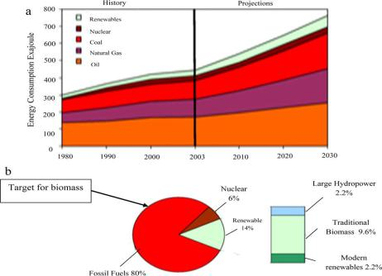
When comparing industrial fuels, the following factors should be kept in mind: (1) the cost of the raw material per BTU, (2) availability in any weather and in any international political climate, (3) the complexity of the on-site equipment required to transport and burn the fuel, (4) storage issues, (5) combustion emissions, and (6) the historical success of the technology for boilers using this fuel. Consider coal, fuel oil, and natural gas in light of these characteristics (Capehart et al., 2005). `

Figure 2.1: (a) World marketed energy consumption, (b) Different fuels contribution to total world energy consumption.
(Source: Khan et al. (2009).

Companies are constantly looking for less expensive alternatives to coal, fuel oil, and natural gas. Both manufacturing waste and agricultural waste are low-cost natural resources. Pulp mill liquor, sawdust, food processing waste, municipal waste, coal wash water, coffee grounds, cardboard, hog fuel (wet bark from plywood companies), and bagasse are all now used as fuels (sugar cane after the liquid has been extracted). Industrial wastes can be used as fuels to help with trash disposal and provide a low-cost source of heat (Capehart et al., 2005).

2.1 Empirical Review

This section reviewed literature that had facts and figures within the area of research. A case study was conducted by O.O. Jessy (2017) in Nigeria in order to understand the use of a part of biomass fuel in a combined heat power (CHP) plant for the generation of electricity and remaining portion used for food production on a farmland. It was also to determine the impact of biomass power generation on the alleviation of the energy crisis in Nigeria. To accomplish this, to scenarios were compared. The first was to evaluate the quantity of power required by the village and the mill, and the results showed that about 19% of the total available biomass fuel could generate a steam flow rate of 0.4kg/s for the community and mill. In the second case, the total amount of biomass fuel available was deployed and 2kg/s of steam flow rate was produced, translating into 1MW of electricity from the boiler. This was observed to be in excess of 81% of the energy needs both the village and the mill. This empirical data stands to confirm the capacity and efficiency of biomass as a boiler fuel.

2.2 Overview of Biomass
Sustainably produced biomass is a low-carbon fuel, and is very critical to modern manufacturing industry, but resources to achieve this are limited. It is therefore significant for users to apply it as effectively and efficiently as possible. The use of biomass has other potential negative effects such as emissions of pollutants that reduce the quality of air to a very large extent. These emissions need to be minimized, while biomass systems operated in a safe manner. Biomass boiler systems differ from those fueled by gas or oil to a very significant level. It is therefore important to address these differences during planning, design and operations phases to ensure that the system is functioning well, safe, and efficient (SEAI, 2019). This subsection seeks to find answers to these issues by discussing the biomass fuels, biomass boilers, system design, heat metering, ash handling, flues and emissions, and sustainability.
2.2.1 Biomass Fuels
There has not been any specification on fuel that ensures the best performance of every biomass system. According to Summerfield et al. (2018), a good biomass fuel for a boiler may be defined as that recommended by the manufacturer of a particular boiler. At best, the manufacturer must specify the fuel type and the acceptable moisture content, and the calorific range. This is because the combustion of biomass is a complex process and strongly depends on the quality and type of fuel administered. The designer of the biomass boiler is required to provide specifications in terms of the particular type of and grade of fuel needed to provide optimal performance. The authors indicated that, the administration of poor-quality fuel to a boiler has a high tendency of causing more problems to the system than any known factor affecting in boiler management. A wide spectrum of biomass can be used as boiler fuels; however, each type has some identifiable characteristics that influence boiler choice and design requirements for other parts of the entire system such as fuel storage and handling (SEAI, 2019). The paper goes on to caution that, the administration of unsuitable and unsafe fuels to boilers can cause:
• Damage to the boiler.
• Safety and health hazards.
• Significant reduction in operational efficiency of boiler.
• Blockage in the fuel inlet system.
• Extremely high emissions.
• High condensation of tar in the flue.
• Disruption of heat supply.

It should also be noted that reliability, availability, price, and the site characteristics such as available space for fuel delivery, scale of heat to be supplied, storage and handling, level of system automation, and air-quality restrictions in the area constitute key determinants for the choice of boiler fuel.
2.2.1.1 Types of Biomass Fuels
Biomass fuels are fundamentally divided into two main categories, woody fuels and animal waste. Woody fuels can further be grouped under six categories; Forestry residues—in-forest woody debris and slash from logging and forest management activities. Mill residues—by-products such as sawdust, hog fuel, and wood chips from lumber mills, plywood manufacturing, and other wood processing facilities. Agricultural residues—by-products of agricultural activities including crop wastes, vineyard and orchard pruning or turnings, and rejected agricultural products. Urban wood and yard wastes—residential organics collected by municipal programs or recycling centres and construction wood wastes. Dedicated biomass crops—trees, corn, oilseed rape, and other crops grown as dedicated feedstock for a biomass project. Chemical recovery fuels (black liquor)—woody residues recovered out of the chemicals used to separate fibre for the pulp and paper industry. (Hurst Boiler Inc. 2018). Wood logs represented in Figure 2.2a, are more easily acquired in rural settings and are generally used in small-sized systems, since they are mostly loaded into the boiler manually. Wood pellets, shown in Figure 2.2b can be supplied by various vendors. They are basically produced according specific standards and demand to ensure consistency in required quality and combustion efficiency. Figure 2.2d shows contaminated waste wood being prepared to be transformed to wood chips.
Energy crops as represented in Figure 2.3 are specifically grown for biomass fuel, and they include woody crops such as short rotation coppice or willow and poplar. These typically have a three-year maturity cycle, and are chipped or put into pellets after harvesting.
Miscanthus as indicated in Figure 2.3 can be baled and burnt directly as boiler fuel, but it can also be pelletized and chipped for other boiler types.

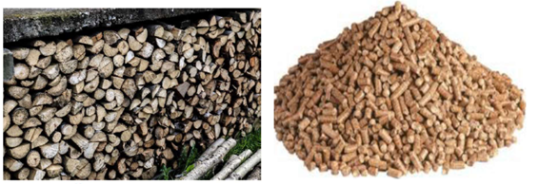
Figure 2.2a: Wood Logs Figure 2.2b: Wood Pellets
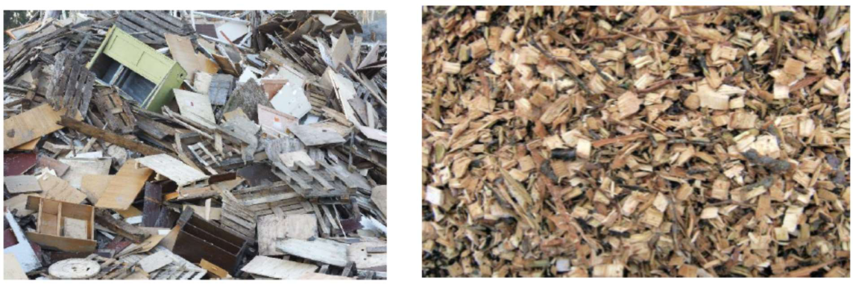

Figure 2.2c: Clean Wood Chips Figure 2.2d: Contaminated
Waste Wood ready for Chips
Figure 2.2: Samples of Biomass Fuels
(SAEI, 2019)

This is generally employed in bigger installations like power stations. Miscanthus contains low ash-fusion temperature, as such is susceptible to slag formation when burnt. It is therefore important to control the combustion temperature, while slaked lime is added to the fuel to increase the ash fusion. According to Clauser et al. (2021), renewable sources of fuels, chemicals, and energy from waste as raw materials has the capacity of reducing the greenhouse gases (GHG).
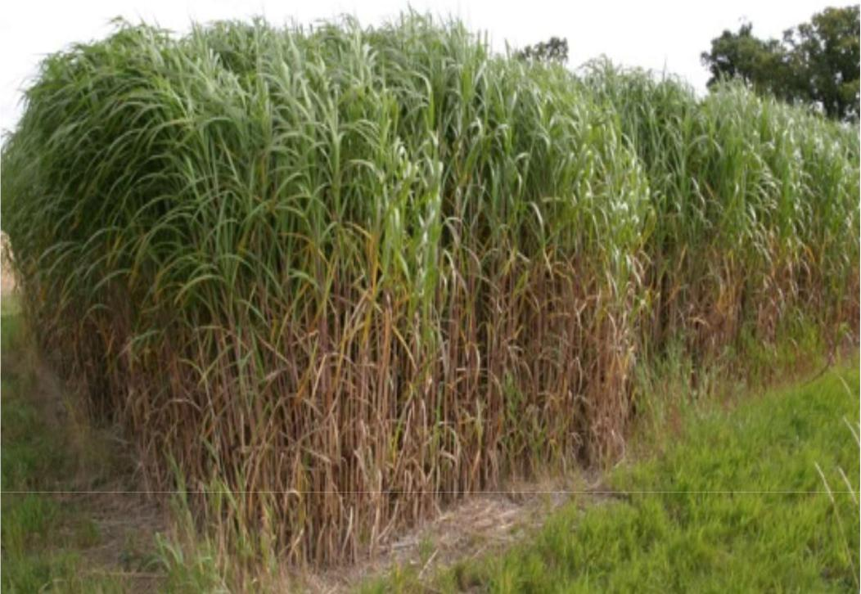

Figure 2.3: Other Fuels, energy crop
(SAEI, 2019)

Both national and international standards organizations have over the years designed standards to govern biomass fuels. The standards cover the specification of physical and chemical characteristics that crucial to handling and storage, combustion, and procedures for analysing combustion emissions. The International Organization for Standardization (ISO) biomass fuel standards were adopted, to ensure that challenges such as excessive emissions, inefficient combustion, and blockages in fuel-feed are avoided. This adopted standard is the General Requirements, represented by ISO 17225-1:29014, and its scope covers the quality of fuel classes and the specifications for processed or raw solid biofuels produced in the forestry and arboriculture, agriculture and horticulture, and aquaculture environments (Clauser et al., 2021).
2.3 Biomass Boilers
Biomass boilers are quite different from those of oil or gas-fired in a variety of ways. According to Summerfield et al. (2018), the key differences include:
- Boiler size: Biomass boilers are comparatively bigger than their oil or gas-fired counterparts. Larger surrounding area is required for biomass boiler, to make room for cleaning, fuel-feed and ash-removal system. Boiler responsiveness: The response of biomass boilers to changes in heat demand is slower. However, it can be mitigated using thermal storage, intelligent control, or the deployment of conventional boiler capacity. Biomass boilers have a lower turndown ratio compared to the others.
- Fuel storage: More fuel storage space is required on site. Boilers fired by oil or liquefied petroleum gas (LPG) need sizeable storage for fuel, but biomass systems require far more storage space since fuel has lower energy density.
- Emissions: The control of emissions are more difficult in biomass boilers than those fired by oil or gas type boilers. Because biomass boilers produce particulate matter and fly ash, there is a need to install extra abatement equipment to help mitigate risks. Additionally, nitrogen oxide (NOx) emissions per unit of heat generated by fossil fuel boilers are generally lower than those from biomass boilers. Additional flue-gas abatement equipment may be installed when the control combustion conditions fail to sufficiently managed NOx emissions.
- Biomass Combustion: There are six stages of biomass combustion including, warming, drying, pyrolysis, gasification of dry fuel, gasification of solid carbon, and oxidation of combustible gases. Figure 2.4 provides a detailed description of the phases.
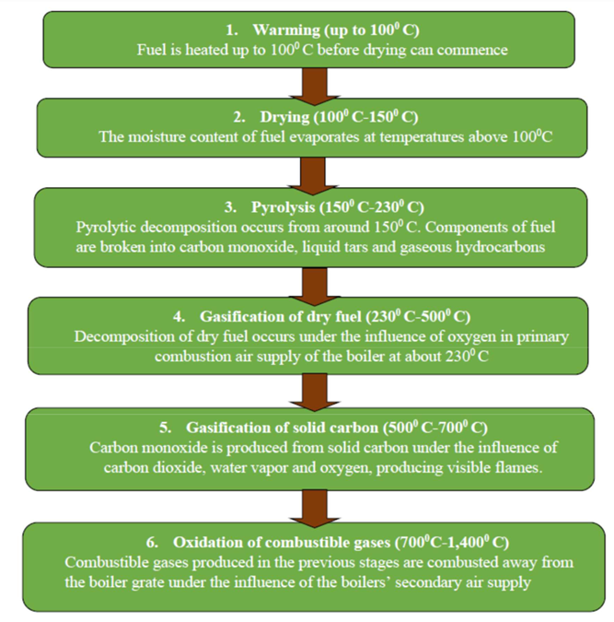
Figure 2.4: The six stages of boiler combustion (SAEI, 2019)

2.4 Types of Systems and Heat Transfer Media
The commonest biomass boiler systems possess the following:
- Biomass boilers that have thermal store
- Single or multiple biomass boilers, which usually come with buffer vessels
- Biomass boilers with buffer vessels and also have backup or top-up oil or gas-fed boilers
- Biomass with top-up or backup and thermal store

It is feasible to connect fossil-fuel and biomass boilers in series or parallel, ensuring that the latter is connected to return side of the heat distribution system. It must be noted that thermal storage and buffer vessels and completely different, and the heat exchange medium may be thermal oil, water or steam. Hot water is popular used, at a temperature of about 85ºC. The grade of heat required actually determines the choice of transfer medium, thermal oil and steam are administered in systems that operate at higher temperatures. Thermal oil and steam systems are costlier than those of steam because they are specially designed with extra safety considerations. However, for the purposes of this study, only the water system shall be discussed, knowing that the general operational principles also apply to thermal oil or steam systems.
The typical parallel and series configurations for thermal store, biomass boiler, and fossil-fuel systems connected through low loss headers to heat loads are demonstrated in Figure 2.5 (a) and (b) respectively. The series configuration can be more effective, considering that thermal store and biomass boiler combination becomes the lead boiler, leading to the maximization of boiler usage.
(a)
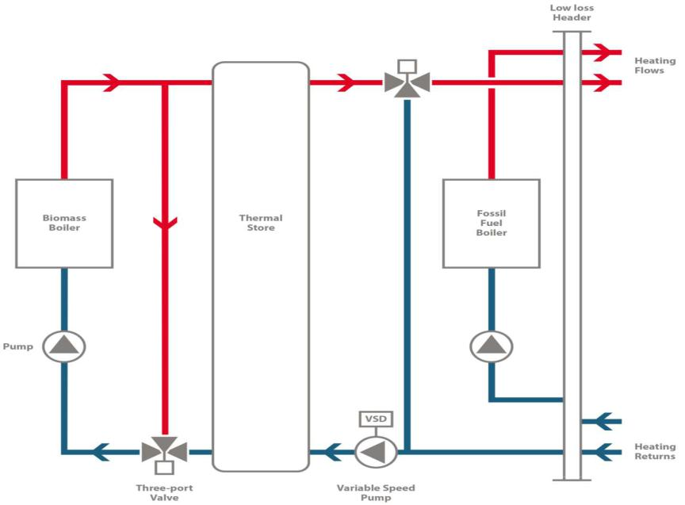

(b)
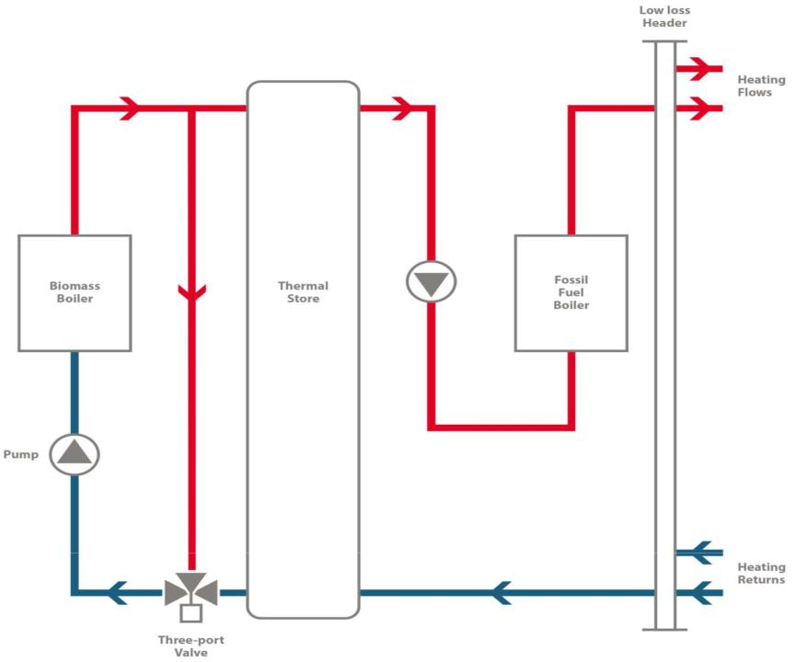

Figure 2.5 (a) Connection of Biomass boiler and its thermal store parallel to fossil fuel boiler and (b) Connection of Biomass boiler and its thermal store in series to fossil fuel boiler (Biomass Boilers Technology Guide 2019)

2.5 Thermal Stores and Buffer Vessels
Even though people use the terms thermal stores and buffer vessels interchangeably, they actually provide different functions. Also, the term accumulator is sometimes confused with other terminologies especially, log boilers.

Buffer Vessels:

These are deployed in most biomass systems to collect residual heat from the boiler when heat demand is zero. Biomass boilers usually have higher thermal capacities but much longer response times compared to their fossil-fuel counterparts due to extra refractory material. This residual heat is commonly discharged from the boiler via the heating medium when there is no heat demand. The capture and reuse of residual heat enhances overall performance, efficiency, prevents overheating, and significantly reduces the pressure within the water circuit of the boiler. Almost all biomass boilers require buffer vessels, and manufacturers specify the minimum requirements for sizing buffer vessels, which are normally dependent on:

Boiler ignition, manual or automatic, Grate type Whether feed auger has to be discharged into the grate and fuel dissipated before shut down,

The texture of the ceramic lining the boiler Based on these critical factors, the capacity ratio of buffer vessels may vary between 50 litres/kW and 60 litres/kW. Practically, buffer vessels are smaller than thermal stores.

Thermal Stores

Thermal stores are responsible for smoothing out variable heat demand, meaning a smaller boiler may be used to run for a longer time and yet maintaining peak efficiency. These structures can also be configured differently to act as buffer vessels. Thermal storage largely depends on the stratification of the heating medium, in this case water, which gives a large height to diameter ratio. Thermal stores water inlets are designed to reduce turbulence and maintain stratification.

Figure 2.6 depicts an installed thermal storage vessel in the manufacturing industry. The use of thermal storage enhances the operational demands of biomass boilers and any backup fossil-fuel boilers, thereby changing the orientation of the economics in a biomass system.

Thermal stores help smaller boilers to stay operational for longer periods than the bigger boilers which must vary the output significantly at start-up and shutdown.

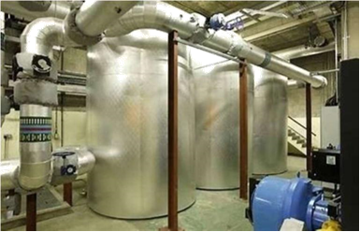
Figure 2.6: Thermal Storage Vessels
(Biomass Boilers Technology Guide 2019)

By this, smaller biomass boilers are made cheaper, and depending on the elements, size and number of boilers, heat load, size and number of top-up fossil fuel boilers, size of any thermal store, a detailed analysis is required in order to a design an optimum system.

2.5.1 Design and Sizing
In determining the design and size of a boiler system, the first most important steps to consider are, the peak heat demand as well as heat load profiles linked to daily and seasonal heat load variation. Variations in heat demand is directly related to the type of heat demand required. Heating for processes in industries and sectors such as hospitals, huge leisure centres with swimming pools and manufacturing usually have minimum variability. Places like homes where heat is dissipated for heating spaces have significantly high variability in demand for day and night, and between seasons. In the manufacturing industry however, heat demand varies according to production, which in turn depends on demand for products, this could be seasonal. This demonstrates the challenge of designing a system to be efficient over wide spectrum of heat demand that is beyond the capacity of a biomass system without augmenting it with thermal storage or fossil-fuel boiler capacity. The system design must seek to maximize the running time of the boiler within its range of turndown. This can be achieved by changing the time for peak load by deploying the thermal store facility, to ensure that the biomass system experiences a steadier and effective demand (Guidehouse, 2021).
The thermal store is sized in accordance with: Boiler size
- The difference between boiler capacity and the peak load.
- The timing coupled with the duration of loads higher than capacity of the boiler.

To design size of the boiler relative to the thermal store may require a trade-off between cost optimization and the physical space available. This could lead to the addition of some fossil-fuel system capacity to augment any heat shortfall.

2.6 Socio-Economic Benefits of Biomass

According results from a study conducted by Ahmed et al. (2021), the use of biomass offers a cheaper source of fuel, provides greenhouse energy as well as a cost-effective method for removing waste from the public space. Biomass plays an equally significant role in the socio-economic space just as it does for the environment. It is responsible for low carbon electricity, bioenergy, carbon capture and hydrogen (BEIS, 2021). According to the research, biomass provides the highest compliance coupled with sustainability criteria and waste hierarchy principles, contributes to net zero considering feedstock availability and carbon budgets. Additionally, biomass cycles GHGs emissions and provides a very high cost and social benefit to society. K.G. Apotei (2021) conducted an investigation with the aim of determining the best ways biomass can be used as an alternative energy source in Ghana that will eventually reduce the current energy crises in the country. The results show that the use of biomass offers greenhouse gas savings, as well as other environmental benefits. The use of biomass help promotes trade balances, provide opportunities for economic and social development in rural communities, and most importantly it enhances the management of waste and resources.

2.7 Environmental Impact of Biomass
Bioenergy has unique characteristics as renewable source of electricity, unlike hydropower, wind and solar. The generation of biomass power is accompanied with the emission of greenhouse gases and pollutants into the atmosphere. However, because biomass is renewable in nature, it is considered by many as carbon-neutral source of electricity and therefore cancelling its negative impact in the environment (EnergySage, 2022).
Generating electricity or heat from biomass releases carbon dioxide into the air, but biomass sources like agricultural crops and trees tend to absorb carbon dioxide during photosynthesis and sequester. If trees and other plants are able to capture all the carbon dioxide produced when biomass is burnt, then it follows that the carbon cycle will remain in balance, and there won’t be any negative effect on the environment. In actual life, things do not look that simple, carbon impact of bioenergy is supported by a number of conditions including, combustion technology, method of harvesting biomass, type of biomass deployed, efforts towards regrowth, the timing, and the energy resource being displaced. The author indicated that apart from the greenhouse gases emitted during biomass use there were other environmental consequences of biomass energy to consider, which include deforestation, pollution and water use.

Deforestation:

Many bioenergy systems use waste, be it animal or agricultural as source of fuel, but several energy firms use timber as their fuel. This is the felling of mature trees which will help remove carbon dioxide from the atmosphere if they were left uncut. The consequences are loss of habitat, destruction of natural beauty and soil erosion due to deforestation

Pollution:

The burning of biomass in any form, be it solid, liquid or gaseous form emit other pollutants and particulate matter aside of the emission of carbon dioxide. These pollutants include volatile organic compounds, carbon monoxide, and nitrogen oxides. In some cases, the burning of biomass does emit extra pollution compared to fossil fuels. Apart from carbon dioxide, most of the pollutants emitted cannot be sequestered by new plants. Such emissions may result in a number of human health and environmental issues if not promptly curtailed.
- Water Use:

As energy companies grow trees and other crops to serve their bioenergy needs, they apply a lot of water during irrigation since plants require large volumes water to grow well. Large scale farms tend to exacerbate the drought conditions, leading to the displacement of aquatic habitats and the quantity of water reserved for other uses like drinking, hydropower, and food crops.
Some of these environmental challenges resulting from bioenergy production can be resolved using sustainable methods of forest management. Deliberate and careful choices on the type of biomass to be harvested and how it should be harvested for fuel would like. Technological advancements and research, coupled with the development of good policies can lead to future investments in bioenergy to be more environmentally friendly. Ravindranath et al (2021) corroborated the findings of the previous authors by stating that the environmental impact of both traditional and modern ways of using biomass fuels as energy are serious. Traditional applications of biomass lead to deforestation, forest and soil degradation, decline in biodiversity, indoor air pollution and GHG emission.
On the other hand, Oke et al (2022) determined in their research that the production of biomass for fuel in degraded lands, using appropriate guidelines has the capacity for land reclamation, carbon sequestration, watershed protection, as well as the promotion of biodiversity. Also, the authors found that biomass conversion technologies like liquid fuels, biogas production, and gasification for electricity could result in the reduction of greenhouse gas emission, reduction in water and air pollution and land degradation, while increasing land reclamation. The increasing preference for woody biomass for fuel has raised many concerns and produced conflicting discussions about the effects on atmospheric greenhouse gas (GHG) concentrations climate and biodiversity. Birdsey et al (2018) on this account conducted a literature review with aim to among other things identify the environmental and economic effects of increasing bioenergy application of forests. It was determined that the increasing production of bioenergy and exports of pellets usually increase the net emissions of GHGs over decades or even longer. However, the use of round wood often produces larger GHGs reductions. Other effects of using wood for bioenergy were identified by the authors to be induced change in land use, changes in wood supplies, non-radiative impact of land cover on climate as well as long term impairment on soil productivity.

2.8 Impact of Cost of Fossil Fuels on Biomass Adoption
A study was conducted by Winchester et al (2017) to ascertain the influence of oil prices on the penetration of biofuels, greenhouse gas (GHG) emissions, energy production, and land use. To achieve this, a global economic analysis tool was deployed to analyse the rise in oil prices to a maximum of $124 by 2050. For a better comparison, the system was simulated with other oil prices such $50, $70, and $100 respectively, targeted through adjustment of the quantity of oil resources. The findings show that increasing oil prices result in the production of more biofuel, more land applied to bioenergy crops, and less GHG emissions. The impact of worldwide fluctuations of oil price on household fuel use was examined by Venkataramani et al (2011) in Guatemala. The variations in prices over a period of 6 months were recorded and used as intelligence to simulate the model. The results indicated that, the rise in price of oil on the international market triggered an increase in the use of biofuels. For instance, a $1, representing a 3.4%-point increase in global fuel resulted in a 2.8%-point decrease in liquid propane gasoline use, and a 0.75%-point increase in wood use.
2.8 Biomass Sustainability

The adoption of biomass has become increasingly popular, courting global acceptance because it has been seen as a greenhouse technology. The deployment of biomass fuels across industrial environment, the combination of material and the processes along the production value chain are very critical to the study of biomass. Biomass fuel are considered affordable compared to fossil fuels for domestic and industrial uses. The diverse applications of biomass, including generation of energy, construction, reinforcement in metal matrix composite, metallurgy, biochemical and traditional medicine has aroused international interest. This highlights the significance of developing a sustainable strategy to match the multifaceted applications of the technology. In view of this, A.A. Adeleke et al. (2021) conducted a review with the aim of examining the sustainability of biomass in the face of its diverse applications, and to examine the strategies necessary to ensure sustainable use of biomass. The findings show that good public policies and technological advancement in biomass production has the propensity of leading to sustained biomass demands which in turn drives supply directly. Sustainable biomass as a resource has been described by OGL (2021) as finite, generating uncertainty concerning the makeup and quantity of the resource in the short and long-term. Existing data suggest that there is a strategy to uplift the supply of sustainable biomass feedstock by the close of 2050 from both the local and global sources with respect to the UK. According to the author, the Climate Change Committee (CCC) suggested during their 6th Carbon Budget conference suggested that the potential to increase the present volumes of imported biomass by a threshold by 2050 largely depends on demand, but needs a strong global sustainability policy. The CCC’s report also show that between 0.7 and i.4 million ha of land can be committed to energy crop production in the UK, this will significantly increase the domestic production of biomass feedstock.
Biomass has a large potential as sustainable power generation fuel and to proof this, Awan et al. (2019) researched into the conservation opportunities in biomass fired boilers. Using rice husk as the base fuel and multiple analysis methods, the findings show that rice husk environmentally friendly resource with a huge potential as a sustainable cogeneration fuel.
Currently, bioenergy has been named as the largest source of renewable energy globally, and its demand is projected to rise as most countries seek sustainable low-carbon energy. These forms of energy are expected to be alternatives, deployed as mitigation strategies for national climate change. Bioenergy has the propensity to compete within the sustainable biomass space,
as most nations seek to implement broader bio-economic policies Blair et al (2021). According to the authors, with a projected demand increase for sustainable biomass, the IEA Bioenergy launched an initiated of multiple tasks seeking to identify and record best practice case studies across the globe to enhance understanding of supply chains within the biomass ecosystem. It is also to support the production of bioenergy while parallelly contributing to the realization of the Sustainable Development Goals (SDGs) as envisaged by the United Nations (UN) Agenda 2030. This research shows that it is possible to produce and use biomass fuel in the most sustainable manner as possible.

3.0 Research Design
According to McCombs (2021), research design can be defined as a well-organized and systematic and well-organized procedure adopted by researchers or scientists to undertake a scientific study. A research design is supposed to a pre-planned and well-thought process that is in line with a pre-determined type of research that will lead to an authentic and error-free conclusion. A good research design provides researchers a well-structure plan to conduct a study that efficiently assesses the cause-and-effect connection between dependent and independent variables. Apart from the efficiency offered by a good research design, it is also characterized by appropriateness flexibility for use, as well as a good strategy for answering research questions and ensures adequate match of research aims with methods used to yield the best data analysis. In an exploratory environment like this, the researcher adopted a combination of both qualitative and quantitative design because it will help find the right answers to the pre-asked questions. In addition, this research is a case study, which requires focus on a particular population to derive maximum information. The design helped to explore the sustainability of using biomass as boiler fuel at Cargill Ghana Limited. By this, both questionnaires and interviews were administered to achieve the best results from employees.
3.1 Population of the Study

According to Casteel and Bridjer (2021), population of a study can be defined as the objects or elements which have common characteristics that can be queried under a study. Cargill Ghana Limited has a staff strength about 400, representing 187 permanent staff and the rest as contract workers. For this reason, the population for this research is 187 since they are permanent staff and can easily be identified or located for the administration of questionnaire and interviews. These staff members belong to seven main departments including, Production, Technical, Supply Chain, Quality, Accounts, Human Resource and IT.

3.2 Sample Size
Kenton (2021) defines as a sample as part of a manageable version of a population. It is a subset of a domain that bears all the characteristics of the larger group. A sample is fundamentally deployed for testing statistical data when a population is too large to affect all possible elements. Additionally, a sample is supposed to be a total representation of the population such that no biases are introduced against any particular attribute. The sample size for this study was determined using the sample calculator. The population and sample size for this study per department have been represented in Table 3.1.

n=N/ (1 + N(e)²) Eqn. 1
Where, n= Sample size, N=Population (number of employees), e=Precision level or 10%, because level of confidence is 90%
Sample size is therefore:
n=187/ (1 +187(0.1)²)
n=65

Table 3.1: Population and Sample size of the study per Department

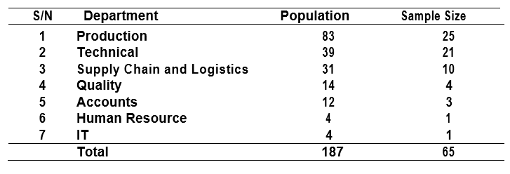

4.0 Data Presentaion And Analysis
4.1 Analysis of Demographic Data

Gender is one of most important demographic parameters in this study since it helps the researcher to understand gender affects the operations at Cargill Ghana. The data analysed are shown in Table 4.1.

Table 4.1 Gender of Respondents
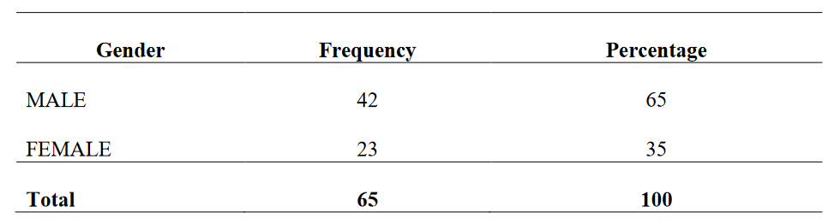

Findings reveal that out of the 65 responses received, 42 of them, representing 65% were males while 35% or 23 respondents were females. This means that major decisions taken at the company are most likely to have majority of males involved.

4.1.1 Age Profile of Respondents
The age of respondents in research is very critical as it describes maturity and capacity to take major and critical decisions. The age distribution for this research have been represented in Table 4.2.

results show that majority of the respondents during the survey were between 30 and 39 years, being 38.5% (25). This was followed by 40-49 with 32.3%, below 30 years with 15.4% (10), and 13.8% or 9 respondents for age group 50-59. There was no person with age of 60 or above, the results also show that the staff are relatively young and can support Cargill’s policy on sustainability as they still have a long time to work.

Level Of Education of Respondents

Level of education is very important with respect to research as it determines the maturity and understanding of the issue under investigation. In this case, it would enable the researcher to find out if the perception of respondents on tendering is duly influenced by level of education.

The feedback per the respondent’s analysis has been depicted in Table 4.2.

Table 4.2 Education Background

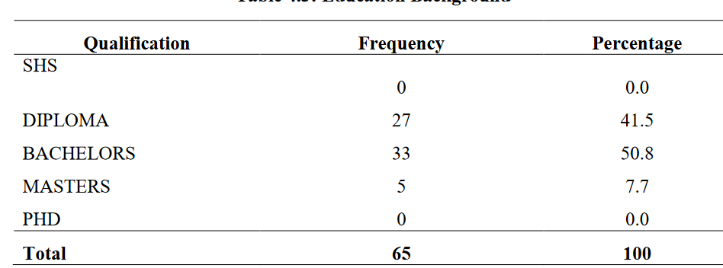

The findings indicate that out of the 65 respondents, majority of them, being 50.8% had Bachelor’s degree, followed by Diploma with 41.5%, and 7.7% for Masters. None of the respondents had education in SHS or Ph.D.

4.1.3 Working Experience Of Respondents

Work experience is one of the critical demographic elements during a survey, as it helps to unearth the deep-seated knowledge in the area investigation by respondents. In this case, the experience of staff at Cargill enables the researcher to collect appropriate data on the topic for better analysis. The analysis is represented in Table 4.3.
Table 4.3 Work Experiences of Respondents

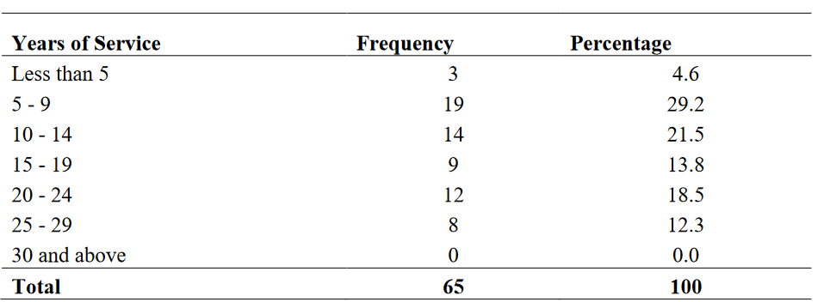

The findings indicate that a larger proportion of the respondents have worked between 5 and 9 years, this represents 29.2% of the sample size. The least was recorded by those who worked for less than 5 years, represented by 4.6%, those with experience between 30 and more years had 0.0%. Aside the youthful nature of the staff at Cargill, it is also clear that they have enough experience to take appropriate decisions on the topic under investigation.

4.1.4 Respondent’s Department

The department in which a participant works is of consequence to the understanding of a research topic and contributes to the final outcome. There are 7 departments at Cargill per the records of the human resource department as represented in Table 4.6. The results have been captured in Table 4.4.
Table 4.4: Department in which Respondent works

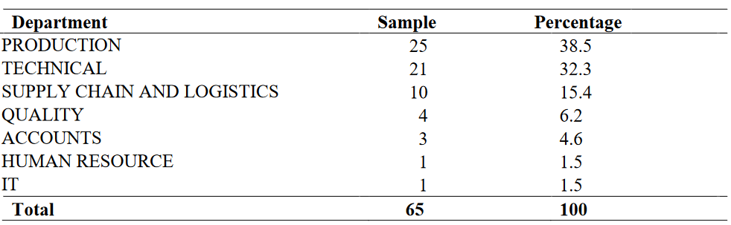

Most of the respondents, 25 or 38.5% came from the Production department, while the least of 1 was recorded by the both the Human Resource and IT departments. The rest are, 21, 10, 4 and 3 respectively for the Technical, Supply Chain, Quality and Accounts department.

4.2 Findings Related to The Research Objectives

Findings of the main survey in respect of the objectives set for the study. It is divided into four parts in accordance with the sections of the questionnaire administered, with each part represented by a specific objective. A Likert scale of 1 to 5 was designed to determine the degree to which respondents agree or disagree to a statement. The scale was calibrated as, 1 for ‘strongly agree’, 2 for ‘agree’, while 3 stands for ‘neutral’. On the other hand, 4 represents ‘disagree’ and 5 for ‘strongly disagree’. In Table 4.7 to 4.10, ‘F’ is the frequency (number of respondents) and ‘%’ represents the percentage of participants responding to the statement.
4.2.1 The Socio-Economic Benefits of Adopting Biomass as Boiler Fuel

The first specific objective was set to assess the social and economic benefits of the use of biomass as a fuel for industrial boilers used at Cargill Ghana. The responses provided to the statements by respondents under this objective have been summarized in Table 4.5.

Table 4.5: The Social-Economic Benefits of Adopting Biomass as Boiler Fuel at Cargill Ghana Limited

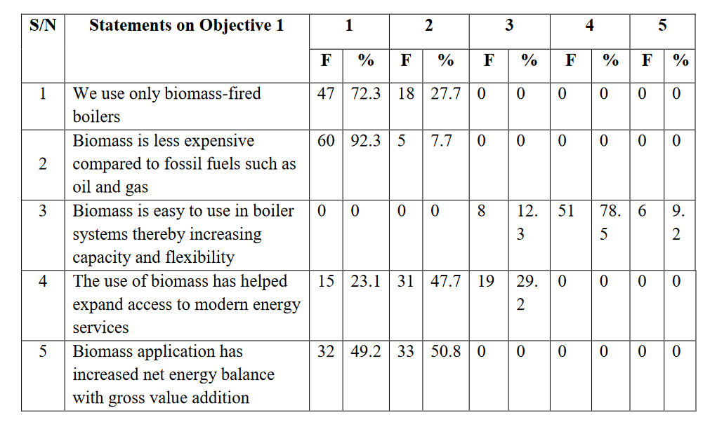

According to the results in Table 4.7, all or 100% of respondents indicate that Cargill Ghana use only biomass fired boilers for their operations, they also believe that biomass is less expensive than fossil fuels such as oil and gas. In respect of easy application of biomass in boiler systems, leading to expansion in capacity and flexibility, 8 respondents, representing 12.3% were neutral, while 97.7% disagreed with the statement. On the other hand, 70.8% of the participants agree that the use of biomass has increased access to modern energy services, but 29.2% did not comment. Finally, respondents were asked whether the application of biomass has increased the net energy balance with gross value addition. All the respondents, including 32 those who strongly agreed and 33 those who agreed, totalling 100% (65), responded positively to the question. The overall findings show that the biomass of biomass is beneficial both economically and socially, meaning Objective 1 has been achieved.

4.2.2 Potential Environmental Impact Of Using Biomass As Boiler Fuel

Objective 2 was set to examine the potential environmental impact of energizing boilers with biomass, the results are shown in Table 4.6.

Table 4.6 Potential Environmental Impact Of Using Biomass As Boiler Fuel

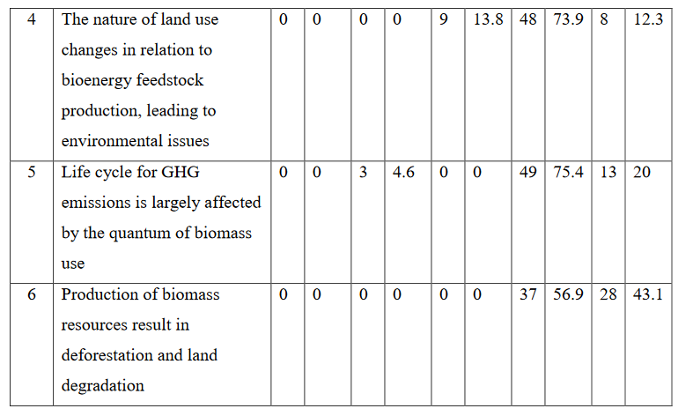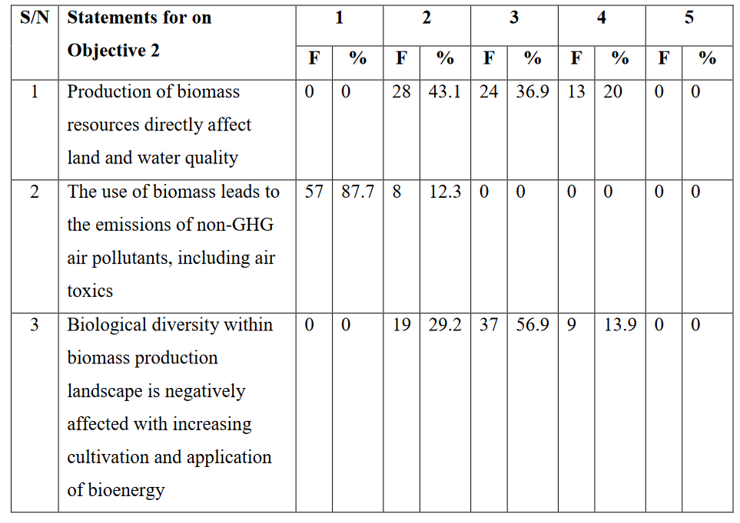

Under this objective, the researcher first and foremost wanted to know if the production of biomass resources had a direct effect on the quality of water and land. About 43%, being 28 of the participants agreed to the assertion, but 20% of them disagreed to it. However, 24 respondents, representing 36.9% remained neutral. The second statement sought to determine if the use of biomass emitted non-Green House Gasses (GHG), air pollutants and toxics, and the responses revealed an overwhelming alignment with positivity. More than 87% (57) strongly agreed, while the rest 12.3% agreed to the statement, nobody abstained and none disagreed. Next, the researcher wanted to know if the production and application of bioenergy negatively affected biomass diversity. Majority of the respondents 56.9% did not provide answers, while 29.2% and 13.9% agreed and disagreed respectively. The fourth statement had to do with land use for bioenergy resulting environmental issues. Almost 14% of the sample size did not answer, but the remaining 86.2% either strongly disagreed or disagreed. The life cycle for GHG emissions was investigated to ascertain if it directly related to the quantum of biomass deployed. Three of the participants agreed to this, but the rest disagreed with it. Lastly, researcher posed a question that suggests that biomass production leads to deforestation and land degradation. All the 65 respondents did not accept the statement, with 56.9% or 37 people disagreeing and 43.1% (28) strongly disagreeing. A review of the results shows that the 53 production and use of biomass resources has a direct impact on the environment, therefore confirming Objective 2.

4.2.3 Effect of the Cost of Fossil Fuel on the Adoption of Biomass for Boiler Fuel

The third objective was set to evaluate the impact of the cost of fossil fuel on the adoption of biomass for boiler systems. The results have represented in Table 4.7. 53 production and use of biomass resources has a direct impact on the environment, therefore confirming Objective 2.

4.2.3 Effect of The Cost of Fossil Fuel on The Adoption of Biomass for Boiler Fuel

The third objective was set to evaluate the impact of the cost of fossil fuel on the adoption of
biomass for boiler systems. The results have represented in Table 4.7.

Table 4.7: The Impact of Fossil Fuel Prices on Biomass Adoption

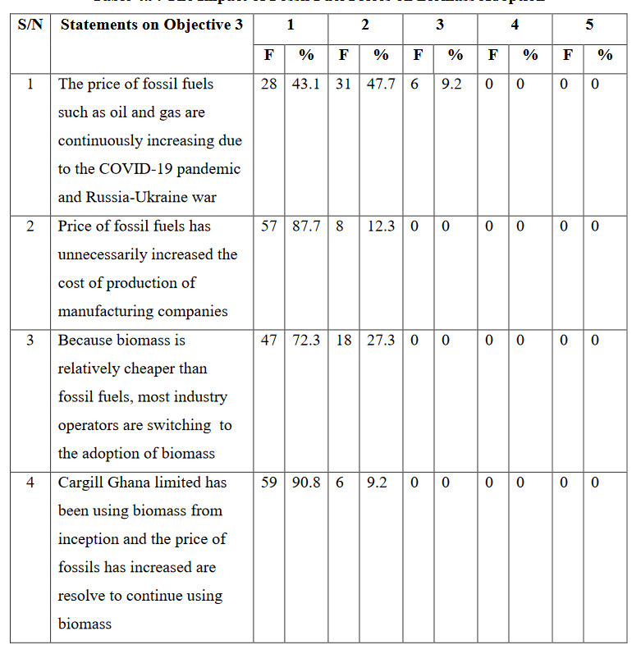

In this section, four critical statements were made requiring respondents’ attention. In the first instance, the researcher sought to understand the continuous increase in the prices of fossil fuels across the globe due to factors such as COVID-19 and the Russia-Ukraine war. More than 90% (59) of the respondents believe that the statement is true, while the rest (9.2%) were undecided. The second statement wanted to if the current prices of fossil fuels has drastically increased the cost of production of manufacturing companies. The answers provided by participants suggests that all (100%) of them confirmed that production cost has risen sharply due to the uncontrolled hikes in fossil fuel cost. The next statement indicated that biomass energy is relatively cheaper than fossil fuels, therefore attracting industry players to swiftly switch to its adoption. In the responses, 100% agreed that the statement was completely true.

Finally, the researcher wanted to know if Cargill Ghana would under the prevailing fuel situation continue to use biomass to power their boilers. Over 90%, representing 59 respondents strongly agreed while the rest simply agreed, meaning all the respondents support the idea. The findings for this objective show that it has been largely achieved because the continuous rising cost of fossil fuel has made most industry players to turn to biomass fuel.

4.2.4 The Challenges Affecting Sustainability Of the Uptake Of Biomass As Boiler Fuel

This subsection discusses the challenges associated with the sustainability of biomass as a boiler fuel.

The survey results have been published in Table 4.8.
Table 4.8 Challenges Associated with The Sustainability of Biomass as A Boiler Fuel

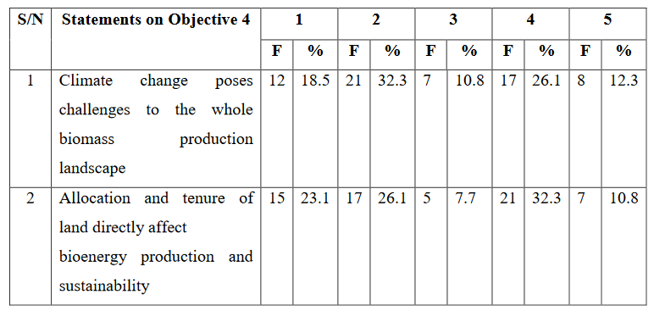

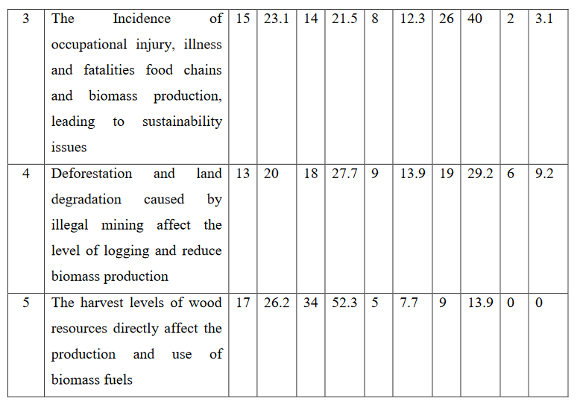

The first statement was to determine if climate change poses challenges to biomass production.

The responses show that majority of the participants, 33 or 50.8% agreed to the statement, 25 of them disagreed while 7 of them were undecided. The research also wanted to find out if land location and land tenure has direct correlation with bioenergy production and its sustainability.

While 28 out of 65 respondents were not in favour, 32 of them agreed, but 5 of them choose to answer. Further, the researcher asked whether injury, illness and fatalities in food chains and bioenergy production lead to sustainability issues. As many as 29 of the responses were in league while 28 disagreed, 8 were neutral. Illegal mining causes land degradation anddeforestation, which in turn impact directly on the quantum of logging, however, does this phenomenon lead to the decline in biomass production? The findings indicate that 31 people said yes, 9 indicated neutral, while 25 of them answered negatively.

Finally, the survey investigated the effect of the quantum of wood resources on the biomass production. More than 78% (51) of the participants responded in the affirmative, 13.9% (9) disagreed, but 7.7% (5) neutral. Per the account under this section, climate change, land allocation and land tenure occupational injuries, deforestation and land degradation, and the quantum of wood harvested are factors affecting production and hence sustainability of the uptake biomass as boiler fuel.
  - Interview With Suppliers/Contractors

A sample of interview responses from suppliers or contractors where all the five suppliers confirmed that supplies were made daily to Cargill Ghana at 25 tonnes per day. Contractors supply cocoa shells, cashew nut shells, palm kennel shells and wood pellets which they get from Cocoa Processing Company and other various sources to Cargill with a storage of 75 tones. The contractors further indicated that when not properly stored, the biomass fuel could be washed away by rains.

5.0 Conclusion and Recommendation

Summary of the findings for each objective or research question have been captured below.

Objective 1: Assessment Of The Socio-Economic Benefits Accrued From Using Biomass As Boiler Fuel.

The First Objective was to determine the socio-economic benefits of using biomass as a fuel for industrial boilers at Cargill Ghana. To achieve this, five statements were made for respondents to offer their opinion, and the findings show that 74.1% of the respondents agree that the use of biomass as a boiler fuel provide social and economic benefits. Cargill Ghana in the past, used to pay waste companies to dispose off their cocoa shells. Since the introduction of the biomass boiler in 2014, these cocoa shells are used to be produce steam for the plant. Meaning the company has seen savings by cutting down on waste management fees and scraping the use of fossil fuels. One thing apparent from literature reviewed is, savings can be made by using biomass as boiler fuel. Companies who adopt this strategy stand to win both now and in the future.

Objective 2: Examine The Potential Environmental Impact Of Biomass As Boiler Fuel

It was determined that only 28.6% were of the view that the use of biomass has environmental consequences, while most of the respondents disagreed. The impact of biomass use on the environment, in terms of the increase or decrease of GHG, can be evaluated on a long term basis. This goes to show why most respondents disagree since the environmental effects cannot be seen or felt now but in some few years to come. Also, in the case of Cargill Ghana, waste from processing agricultural products are used as biomass fuel. This confirms a positive impact on the environment as waste is being converted to a useful product.

Objective 3: Evaluate How Cost Of Fossil Fuel Influences The Adoption Biomass As Boiler Fuel.

This objective was set to determine the impact of the cost of fossil fuel on the adoption of biomass for boiler systems. Four statements were made to elicit information from the staff of Cargill Ghana, and a majority of them, representing 73.1% indicated that the continuous increases in the prices of fossil fuels have triggered high demand for renewable energy, especially biomass to power boilers. Over the past few years, the price of diesel and residual fuel oil (RFO), fossil fuels commonly used in boilers, has seen outrageous hikes. This has recently worsened as a result of the Russia-Ukraine war. In view of this, it is important that Cargill continues to use and promote the use of biomass as their boiler fuel.

5.1.5 Objective 4: Assess The Challenges That Hinder The Adoption Of Biomass Fuel Use.

The last and fourth objective was designed to identify the challenges associated with the sustainability of biomass as a boiler fuel, using five critical statements. The findings under this objective showed that 54.2% of the respondents believe that climatic factors; land allocation and land tenure; occupational accidents and illness; deforestation and land degradation; and the level of wood harvest directly affect sustainability of the production and use of biomass. This indicates that conscious efforts have to be put in place to mitigate these risk as biomass has proven to be an asset.

Recommendations

On the basis of the findings and conclusions drawn, the following recommendations are hereby made:

1. For the sake of health and safety, the researcher recommends a legislation to regulate or strengthen existing laws on emission levels from boilers.

2. Specific renewable energy directives be made to extend the scope of sustainability criteria for bioenergy to embrace biomass used for industrial heating, cooling and power generation.

3. Biomass users should deploy very high efficiency boilers to help reduce environmental ramifications.

4. It is also suggested that Cargill Ghana should use boilers equipped with post-combustion abatement equipment to help reduce emissions of particulate matter.

5. Selective catalytic reduction or selective non-catalytic reduction should be implemented at Cargill to reduce NOx.

6. The industrial performance department at Cargill has to take data over a period of time to understand the impact of biomass production on the environment.

7. In general, biomass use should ensure support for decarbonization, track climate change, and improve air quality, as well as support green industrial revolution to enhance sustainability.

It is the expectation of the researcher that beyond the implementation of these recommendations, the emissions due to the use of biomass fuels would drastically reduce, while improving sustainability in the production and use of the renewable source of energy.

References

A.A. Adeleke et al. (2021), Sustainability of multifaceted usage of biomass: A review. https://doi.org/10.1016/j.heliyon.2021.e08025 [Accessed April 17, 2022]

Ahmed et al. (2021), Socio-Economic and Environmental Impacts of Biomass Valorisation: A Strategic Drive for Sustainable Bio economy. Sustainability, Vol.13, pp.1-32.

AIE Australian Institute of Energy. Fact sheet 8: biomass (2010). Retrieved from http://aie. org.au/Content/NavigationMenu/Resources/SchoolProjects/FS8 BIOMASS

Akansha Khandelwal (2021), A Complete Guide on Sampling Techniques for Data Science. https://www.analyticsvidhya.com/blog/2021/09/a-complete-guide-on-sampling-techniques/ [Accessed January 6,2022].

Apotei Kusi Gabriel (2021), Biomass as an Alternative Source of Energy in Ghana. Energy and Environmental Engineering, University of Applied Science.

Atheendar S. Venkataramani and Brian J. Fried (2011), Effect of Worldwide Oil Price Fluctuations on Biomass.

Ben Davis (2021), What is secondary data in research methodology? https://www.mvorganizing.org/what-is-secondary-data-in-research-methodology-pdf-2/ [Accessed on December 3, 2021]. BEIS (2021), Biomass Policy Statement: Biomass Strategy. www.gov.uk/beis. [AccessedMay 4, 2022].

Biorl, G. (2015). Energy climate change. World energy outlook special report, International Energy Agency, 9 rue de la Federation, 73739 Paris Cedex 15, France.

Blair, J., Gagnon, B., and Klain, A. (2021), Biomass Supply and the Sustainable Development Goals: International Case Studies. IEA Bioenergy, https://www.iea.com [Accessed February, 2022].

Bryan Boilers (2021), Installation and Operating Service Manual: Forced Draft Steam Boilers. www.bryanboilers.com [Accessed April 11, 2022].

Capehart., B. L., Turner, W. C., & Kennedy, W. J. (2005). Guide to energy management (5th ed). New York: The Fairmont Press. 61

Clauser et al. (2021), Biomass Waste as Sustainable Raw Material for Energy and Fuels. Sustainability, Vol.13 (794), https://doi.org/10.3390/su13020794.

CROWN (2020), GUIDANCE :HEAT NETWORK (METERING AND BILLING) REGULATIONS 2014 (AS AMENDED IN 2015 AND 2020): Guidance to Heat Network (Metering and Billing) Regulations. www.gov.uk/government/organisations/office-for-product-safety-and-standards.

Demirbas A. (2014). Combustion characteristics of different biomass fuels. Programme Energy Combustion Science, 30, 219–30.

Demirbas A. (2015) Potential applications of renewable energy sources, biomass combustion problems in boiler power systems and combustion related environmental issues. Programme Energy Combustion Science; 31, 171–92.

Doris Oke, Jennifer B. Dunn and Troy R. Hawkins (2022), The contribution of biomass and waste resources to decarbonizing transportation and related energy and environmental effects. Sustainable Energy Fuels, Vol6, pp.721-735.

Dr Doreen Said Pace (2021), PROBABILITY AND NON-PROBABILITY SAMPLING – AN ENTRY POINT FOR UNDERGRADUATE RESEARCHERS. Dr Doreen Said Pace. International Journal of Quantitative and Qualitative Research Methods, Vol.9 (2), pp.1-15.

Einstein, D., Worrell, E., Marta, K. (2009). Steam systems in industry: energy use and energy efficiency improvement potentials, Lawrence Berkeley National Laboratory.http://www.osti.gov/bridge/servlets/purl/789187-uTGqsP/native/; 2009.

EnergySage (2022), Environmental impacts of biomass. www.energysage.com [Accessed, June 10, 2022]. Fuel Use and Child Respiratory Health: Evidence from Guatemala. American Journal of Public Health, Vol.101 (9).

Gaganpreet Sharma (2017), Pros and cons of different sampling techniques. International Journal of Applied Research, Vol. 3(7), pp. 749-752.

Guidehouse (2021), Unlocking the hybrid heating potential in European buildings. Vision paper Hybrid heating solutions accelerate the EU’s energy and climate agenda.

Hurst Boiler Inc. (2018), Types of Biomass Fuel. https://www.hurstboiler.com/biomass_boiler_systems/biomass_fuel types Iain Summerfield, Samuel Cottrill, Nikhil

Hardy and James Thomas (2018), Best practice guidance for biomass boiler operation: Detailed guidance for operators, maintenance and service personnel. Ricardo Energy & Environment, Energy Saving Trust, HETAS and Optimum Consultancy. www.kiwa.co.uk [Accessed May 20, 2022].

Isha Upadhyay (2021), Data Collection Methods in 2021: An Easy Guide. https://www.jigsawacademy.com/blogs/business-analytics/data-collection-methods/ [Accessed Jan. 7, 2022].

J. Zhai, I.T. Burke and D.I. Stewart (2022), Potential reuse options for biomass combustion ash as affected by the persistent organic pollutants (POPs). Content Journal of Hazardous Materials Advances 5 (2022) 100038.

Jean Blair, Bruno Gagnon, Andrew Klain (2021) Biomass Supply and the Sustainable Development Goals: International Case Studies. IEA Bioenergy, https://www.iea.org/reports/net-zero-by-2050 [Accessed May 20, 2022].

Jeffrey Alan Johnson (2020), Constructing Data Ethically. https://onlinelibrary.wiley.com/doi/epdf/10.1002/ir.20306. [Accessed on April 13, 2022].

Kenton, W (2021). Negotiation. https://www.investopedia.com/terms/n/negotiation.asp. (Accessed on May 10, 2021). Kenton, W. (2021), Sample. https://www.investopedia.com/terms/s/sample.asp. [Accessed March 7, 2022].

Khan, A. A., Jonga, W. D., Jansens, P. J., & Spliethoff, H. (2009), Biomass combustion in fluidized bed boilers: potential problems and remedies. Fuel Process Technology, 90, 21–50

Khandelwal, A. (2021), A Complete Guide on Sampling Techniques for Data Science.https://www.analyticsvidhya.com/blog/2021/09/a-complete-guide-on-sampling-techniques/ [Accessed March 7, 2022].

Kopetz, H. (2007). Biomass: A burning issue Retrieved from http//: www.refocus. Net [Accessed February 10, 2022].

Liu et al. (2021), Influence of Operating Parameters on Chlorine Release and Pollutant Emission Characteristics of a 130 t/h BCFB Combustion System. ACS Omega, Vol.6, pp.12530−12540.

Luc Pelkmans (2021), IEA Bioenergy Countries’ Report – update 2021: Implementation of bioenergy in the IEA Bioenergy member countries. ISBN: 978-1-910154-93-9.

Mahmoud., A, & Shuhaimi, M., & Abdel, S. M. A. (2009). Combined process integration and fuel switching strategy for emissions reduction in chemical process plants. Energy 2009; 34, 190–195.

M.B. Awan, T. Iqbal, S. Yaseen, S. Nawaz and C.H. Ali (2019), Techno-economic sustainability analysis of biomass fired industrial boiler: biomass evolution as heat and power generation source. IET Renewable Power Generation, Vol.13 (4), pp. 650-658.

N. H. Ravindranath and K. Usha Rao (2021), Environmental Effects of Energy from Biomass and Municipal Wastes. Encyclopaedia of Life Support Systems (EOLSS). ASTRA, Indian Institute of Science, Bangalore, India.

OGL (2021) Biomass Policy Statement. www.gov.uk/beis [Accessed May 20, 2022].

Osaghae Osakue Jessy (2017), Potential Biomass Based Electricity Generation in a Rural in Nigeria. Master’s Thesis, Department of Physics and Mechanical Engineering, Lulea University of Technology.

Peter Thompson (2021), 2021 Biomass Thermal Summit: Overview of the Biomass Thermal Industry in 2021. Biomass Thermal Energy Council, https://www.hpba.org/Portals/26/Committees/Government%20Affairs/GA%20Public %20Docs/Wood_and_Pellet_ITC_Consumer_2021_1.pdf

QuestionPro (2021), Convenience Sampling: Definition, Advantages and Examples. https://www.questionpro.com/blog/convenience-sampling/ (Accessed on December 3, 2021).

Richard Birdsey et al. (2018), Climate, economic, and environmental impacts of producing wood for bioenergy Environ. Res. Lett. 13 050201 https://doi.org/10.1088/1748-

9326/aab9d5.

Saidur, R., & Mekhilef, S. Energy use, energy savings and emission analysis in the Malaysian rubber producing industries. Applied Energy, 87, 2746–2758.

SEAI (2019), Biomass Boilers - Technology Guide. Sustainable Energy Authority of Ireland. https://www.seai.ie [Accessed 24 February, 2022].

Shona McCombes (2021), An introduction to sampling methods. https://www.studocu.com/row/document/government-college-university-64 faisalabad/financial-management/sampling-methods-types-and-techniques-

explained/21445641. [Accessed on December 3, 2021].

Simplilearn (2021), What is Data Collection: Methods, Types, Tools, and Techniques.https://www.simplilearn.com/what-is-data-collection-article –[Accessed on December 3, 2021].

Stratton, S.J. (2021), Population Research: Convenience Sampling Strategies. Prehospital and Disaster Medicine, Vol. 36 (4), pp. 373-374.

Syed Muhammad Sajjad Kabir (2016), Methods of Data Collection.https://www.researchgate.net/publication/325846997. (Accessed on December 3, 2021). T.T. Sebestyén, M. Pavičević, H. Dorotić and G. Krajačić (2020), The establishment of a micro-scale heat market using a biomass-fired district heating system. Energy,

Sustainability and Society, https://doi.org/10.1186/s13705-020-00257-2 UNIDO (2021), THE ROLE OF BIOENERGY IN THE CLEAN ENERGY TRANSITION AND SUSTAINABLE DEVELOPMENTDEVELOPMENT: LESSONS FROM DEVELOPING COUNTRIES. www.unido.org [Accessed, June 5, 2022].

U.S. Environmental Protection Agency (2008). Industrial boiler efficiency. http://www.epa.gov/climateleaders/documents/resources/industrial boiler protocol.pdf [Accessed January 6,2022].

Winchester, Niven, Kirby Ledvina (2017), The impact of oil prices on bioenergy, emissions and land use. Energy Economics, Vol.65, pp.219-277.

