ABSTRACT

This report compares the energy efficiency, carbon dioxide emissions, and overall environmental impact of two pyrolysis processes: pyrolysis of textile waste and the pyrolysis of wood chips. This report quantifies the environmental impact of each process by utilizing both primary and secondary data in a comprehensive manner to provide insight into their respective sustainability. LCA is performed according to the methodology described on "ISO 14000 series of standards (ISO 2006)" standards using Open LCA. From Aspen, input parameters and mass and energy balances were derived. Bio-oil was compared with residual fuel oil as a heating fuel using mass and energy balances input into SimaPro. To demonstrate environmental preference, equivalent functional units of 1 Kg were used for categories such as fossil fuel use and global warming potential. Wood chip-based Bio-oil was found to be near carbon neutral. By substituting wood bio-oil for cotton bio-oil, based on the carbon emissions of the two fuels, it was estimated that CO2 emissions would be 0.0596Kg for 1kg of Bio oil, in other words it will be reduced by 98.68% compared to cotton bio-oil. It is estimated that the bio-oil production life-cycle stage consumed 92 percent of the total cradle-to-grave energy requirement, while feedstock collection, preparation, and transportation consumed 4 percent. Through the application of this model, we can better understand the major factors affecting greenhouse gas emissions related to the production of bio-oil and its conversion into boiler fuel during fast pyrolysis.
Keywords: life cycle assessment (LCA); biochar; biomass; bio-oil, pyrolysis.

INTDOUCTION

The World population hit 8 billion on November 15, 2022, a new milestone in human advancement. With this population rise, the energy needs of humanity have also increased exponentially, leading to a greater demand for energy resources. This increase in energy consumption has led to a host of environmental issues, including air pollution, water contamination, and climatic changes.
In recent years, the concept of life-cycle assessment (LCA) has developed into an internationally accepted method of analyzing the complex impacts and outputs of a product and their associated environmental impact. An LCA can provide a comprehensive assessment of net carbon emissions and their associated impacts for fossil fuels and biofuels evaluated in similar circumstances. As a result of an LCA, it is possible to accurately identify the sources of impact, including where, when, and how those impacts occur during the product's lifetime. An LCA process can provide information about global warming potential (GWP) and fossil fuel consumption that may be useful on a regional, national, or global scale. Outcomes from LCAs can be used to suggest more ‘‘environmentally friendly’’ products or sustainable production methods. They may also give insight into the conservation of raw materials and the reduction of emissions and waste output. The LCIA aggregates inventory information and categorizes it according to the type of impact it has on the environment, such as greenhouse gas emissions. Carbon benefits or mitigation performances of bio-oil are determined through comparisons with a Textile cotton bio-oil.
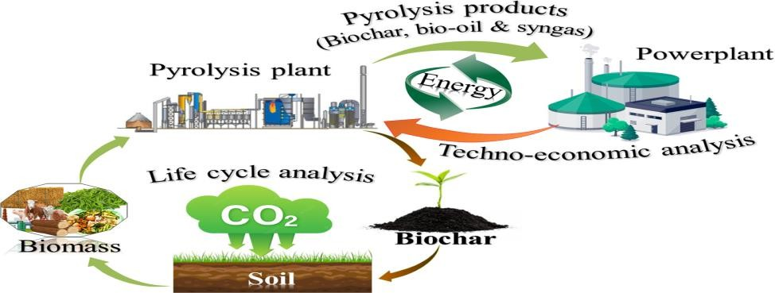

Figure 1: Biooil and biochar from the pyrolytic conversion of biomass.

GOAL, SCOPE & SYSTEM BOUNDARIES

Several previous techno economic analyses have been conducted to determine the cost of producing fast pyrolysis bio-oil; however, none of these analyses included an LCA to assess the environmental impacts of the production of bio-oil with char and syngas as coproducts used to reduce fossil fuel consumption.

GOAL OF STUDY

- To compare and assess the fast pyrolysis process of producing bio-oil from textile waste and wood chips and to assess the environmental impacts of each process.
- Utilization of Life Cycle Analysis tools for inventory data collection and its simulation
- To recommend a more sustainable and efficient production process for bio-oil production.

SCOPE OF STUDY
The scope of this report encompasses three life cycle stages:
- Collection of wood chip wastes and the Textile cotton wastes from Europe.
- Bio oil production using the Fast pyrolysis conversion technology.
- Comparative life cycle analysis of the results obtained using SimaPro modeling.

HYPTHESIS MADE
Following assumptions has been taken to ease the analysis of process under consideration:
- In SimaPro database, the raw materials of the textile wastes are not available directly for the LCA analysis. Textile cotton wastes passes through all stages as the desired textile products, therefore, the actual production process based on market data in SimaPro have been considered as input for the cotton pyrolysis process.
- Since both biomasses feeds are dried, we excluded LCA of dryer and crusher in pyrolysis process.
- France has been chosen as location of analysis because the energy inputs for analysis in SIMPRO has been taken from French energy mix database.

FUNCTIONAL UNIT
For current study the functional unit for all the analysis is taken as 1 kg of Bio-oil produced from both the sources for comparing their environmental impacts.

IMPACT ANALYSIS METHOD
EF reference package 3.1 (transition phase). The EF 3.1 package involves updates of characterization factors in the impact categories of: Climate Change; Acidification Ecotoxicity freshwater; Photochemical ozone formation; Human Toxicity cancer; and Human Toxicity non cancer.

SYSTEM BOUNDARIES
The system boundary is commonly referred to as a Cradle to Gate Analysis. And this report comprises the collection of Biomass waste i.e., Wood chips and the collection of textile cotton waste from Yarn/knitting, Spinning/Ginning and the crop field residue cotton stalks, the bio-oil production using fast pyrolysis with both biomass and textile cotton waste. Finally, the Life cycle assessment of this generated bio-oil`s environmental impact when used as a transport fuel.

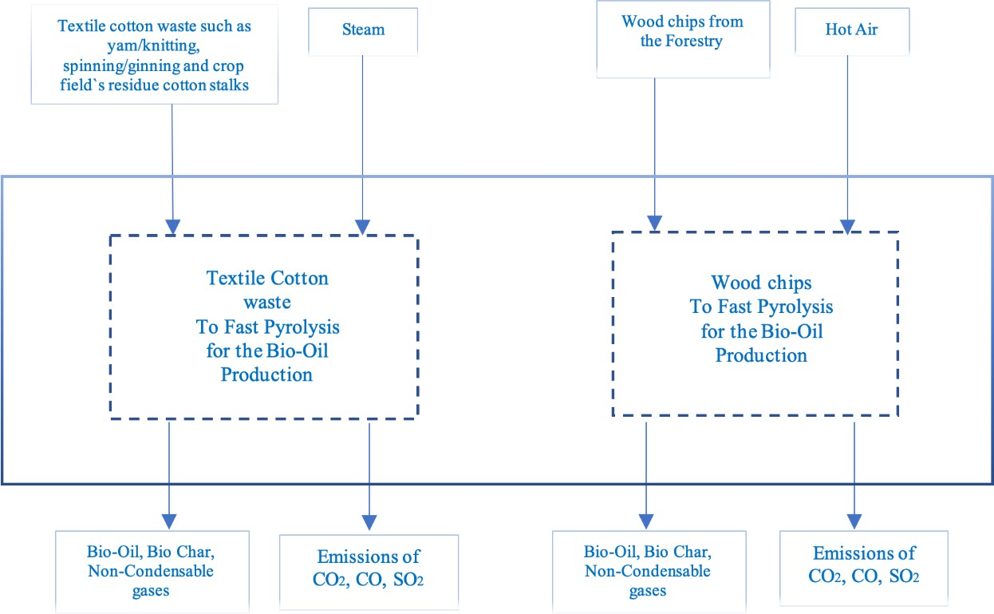

Figure 2: System boundary of biomass conversion to bio-oil

CONVERSION TECHNOLOGY

The Figure 3. shows our process using the catalytic pyrolyzer, the pyrolyzer in our process will be the circulating fluidized bed. The biomass feed is grinded, dried up and passed into the catalytic pyrolyzer. The reason why it is important to dry the feed is because the moisture content in the feed has a direct impact on the heating value of the bio-oil, if the moisture content is high then the heating value will decrease, therefore the feed is dried so that it contains 10-15% of moisture. The feed is dried for 80 mins at a temperature of 200 to 250C. The drying temperature influences the product however the time has no effect on the yield; therefore, the temperature will be fixed, and the frying time can be changed according to the moisture content. Since the thermal conductive of biomass is low, therefore, to achieve high bio-oil yield, the particles must be grinded to a size of
<1mm to achieve faster heating. The pyrolyzer contains zeolite as a catalyst to allow the reaction rate to increase. The pyrolyzer used is the fluidized bed pyrolyzer. Nitrogen is provided to the pyrolyzer to keep the particles circulating inside the tank and avoids settlement, an added benefit of nitrogen is that it maintains the stability of the reaction and helps avoid secondary cracking of the useful product. The biomass feed is heated up sent to the condenser, the vapors are condensed and collected as bio-oil and the ashes and the char are then passed into the combustor where they are heated at a high temperature and are provided back to the catalytic pyrolyzer as a heating source, the benefit of this is that less waste is produced since the heating source is provided from within the system.
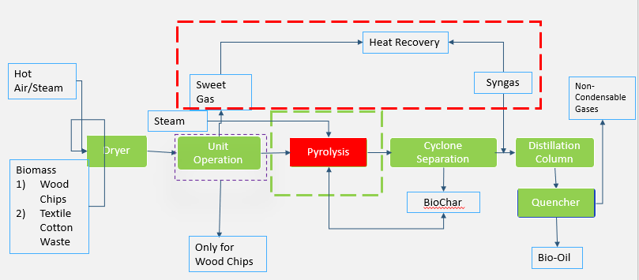
Figure 3: CFP Process for Bio-Oil from Cotton & Wood Waste

INVENTORY ANALYSIS

Since unit operations like dryer and crusher are already considered into inputs obtained from SIMAPRO database, therefore, we are only taking into account the Pyrolysis process. The Product used for this LCA is 1 kg of Bio-Oil produced from the Biomass waste which is used for Transport fuel to reduce the dependence on fossil fuels. We chose the inventory of all our input materials and processes used during this analysis. For this project, we used Biomass wastes from the forestry i.e., wood chips and the textile cotton waste from the Yarn/knitting, Spinning/Ginning and the crop field residue cotton stalks. And the Bio-Oil produced from Biomass waste has promising to be an alternative energy source.

WOOD CHIPS
The dried wood chips used as a feedstock for the fast pyrolysis process for the Bio-Oil production are from the European market of by-products in wood manufacturing activities such as Cross- laminated timber production, wooden furniture production, and plywood production. These wood chips are already produced by chopping larger pieces of wood into chips. However, for this project the chipping and drying of the wood pieces are already produced and available from the market. After performing simulation on Aspen Plus, we are able to obtain energy and mass balances for the pyrolytic oil production.

Component | Biomass In | Steam In | BIO-OIL Out
𝐶𝑂2 | 0 | 0 | 1.38936E-05
𝑁2 | 0 | 0 | 0
CO | 0 | 0 | 0.002040094
H2S |  |  | 0.000469985
𝐻2𝑂 | 0 | 0.03 | 0.075584299
Cotton | 1 | 0 | 0
Biofuel | 0 | 0 | 0.229233748
Char | 0 | 0 | 0.396761341
Hydrocarbon | 0 |  | 0.325896669
O2 | - | 0
Total | 1 | 0.03 | 1.03
 | 1.03
Table 1: Inventory Analysis of Wood Pyrolysis

TEXTILE COTTON WASTE
The natural cotton fiber waste from the processing of seed-cotton through ginning, the textile knit cotton waste for the manufacturing of the large variety of products including clothes and the natural cotton yarn made through the spinning. All these wastes generated from the European market are unprocessed without bleaching or dyeing. The mass and energy balance data obtained using Aspen Plus for the same process.

Component | Biomass | Inlet hot Air | Output
𝐶𝑂2 | 0 | 0.649437148 | 0.033302064
𝑁2 | 0 | 7.081144465 | 7.081144465
CO | 0 | 0.057223265 | 0.140712946
𝐻2𝑂 | 0 | 0 | 0.046904315
Wood | 1 | 0 | 0
Biofuel | 0 | 0 | 4.03065666
Char | 0 | 0 | 0.604598499
Hydrocarbon | 0 |  | 5.441386492
O2 | - | 1.288836773
Total | 1 | 9.076641651 | 10.07664165
 | 10.07664165
Table 2: Inventory Analysis of Textile Cotton Waste Pyrolysis

RESULT AND DISCUSSION

This LCA report will focus on the environmental impacts associated with the fast pyrolysis process of making bio-oil from textile waste and wood chips. It will cover the production, use and disposal of the materials used in the process as well as the emissions associated with the process. The report will also consider the energy requirements of the process and the sustainability of the resources used. The report will not consider other economic or social factors associated with the process.
During the interpretation phase, the results of the life cycle impact assessment of the product system are evaluated and presented to meet the requirements described in the study's goal and scope (ISO, 14000). In SimaPro database, the raw materials of wood chips waste and the textile wastes are not available directly for the LCA analysis. And so, the source from the market is assumed to be the wastes in both the case of wood chips and the textile cotton wastes since this source is also generating the wastes that are used for producing the bio-oil.

AIR EMISSION

When comparing the air emissions of bio-oil from cotton and wood, it eth that cotton waste contributes more to pollute air. The graph (Fig.4) shows the clear domination of cotton based bio- oil, the emission of CO2 by wood bio-oil is negligible in comparison. This is because of the series of operations involved in various cotton types to convert it to bio-oil like raw material collection, ranging from ginning to apparel sites. As all the processes expend energy for product at each stage. The total CO2 emission of cotton when compared with the wood is 97%.


AIR EMISSION COMPARRISON
COTTON BIO OIL WOOD BIO OIL

Air/Sulfur oxides
Air/Sulfur dioxide
Air/Particulates, > 2.5 um, and < 10um
Air/Particulates, < 2.5 um Air/VOC, volatile organic compounds
Air/Nitrogen oxides
Air/Methane Air/Methane, biogenic Air/Methane, fossil Air/Hydrogen chloride Air/Carbon dioxide, biogenic
Air/Carbon dioxide Air/Carbon dioxide, land transformation
Air/Carbon dioxide, fossil
0% 10% 20% 30% 40% 50% 60% 70% 80% 90% 100%

Figure 4: Graph Illustrating Air Emission Comparison of Wood VS Cotton Waste

However, when compared with other emissions by wood bio-oil, it contributes more in Air particulates and methane. It’s because of wood oil contains high level of volatile organic compounds. Still the Total air particulate emission by wood bio-oil is just 9%. The total methane emission from wood bio-oil is just 10% compared to cotton.

Air Emissions | UNIT | COTTON BIO OIL | WOOD BIO OIL
Air/Carbon dioxide, fossil | % | 0.0001 | 1.55E-06
Air/Carbon dioxide, land transformation | % | 1.69E-05 | 1.14E-08
Air/Carbon dioxide | % | 3.47E-10 | 0
Air/Carbon dioxide, biogenic | % | 0 | 0
Air/Hydrogen chloride | % | 1.54E-08 | 1.07E-10
Air/Methane, fossil | % | 8.78E-06 | 1.18E-07
Air/Methane, biogenic | % | 5.11E-06 | 1.08E-08
Air/Methane | % | 1.19E-11 | 1.31E-12
Air/Nitrogen oxides | % | 9.03E-05 | 1.86E-06
Air/VOC, volatile organic compounds | % | 1.72E-09 | 1.99E-11
Air/Particulates, < 2.5 um | % | 1.99E-05 | 2.43E-06
Air/Particulates, > 2.5 um, and < 10um | % | 3.41E-06 | 3.35E-07
Air/Sulfur dioxide | % | 2.42E-05 | 2.94E-07
Air/Sulfur oxides | % | 8.94E-09 | 2.0E-10
Table 3: Cradle-to-grave air emissions to produce bio-oil

WATER EMISSION

Except for the releases into the atmosphere, the bio-oil production process is a closed system. The effluents leaving the system originate from other upstream processes, such as fossil fuel production and electricity generation. As a result, water emissions (Fig. 5) were limited to those associated with the biomass collection process and the transportation stage of the life cycle.

WATER EMISSION ANALYSIS
Water/Barium Water/Barium Water/Calcium Water/Sodium formate Water/Hydrogen chloride
Water/Chloride
0% 10% 20% 30% 40% 50% 60% 70% 80% 90% 100% WOOD BIO-OIL COTTON BIO-OIL

Figure 5: Graph Illustrating Water Emission Comparison of Wood VS Cotton Waste

Wood Bio-Oil

Below is a graph (Fig. 6) illustrating the environmental impact of converting wood chips into bio- oil. The graph is plotted against the impact of 1 kilogram of bio-oil. Bio-oil contributes only 5.5% to the overall impact. As a result of wood bio-oil, 3/4th of the climatic effects is caused by the burning of fossil fuels during the transportation process.
120.
100.
80.
60.
40.
20.
0.

Analyzing 1 kg 'Wood BioOil';
Method: EF 3.0 Method (adapted) V1.03 / EF 3.0 normalization and weighting set / Characterization

Heat, district or industrial, other than natural gas {FR}| heat and power co-generation, wood chips, 6667 kW, state-of-the-art 2014 | Cut-off, U
Wood chips, dry, measured as dry mass {RER}| market for | Cut-off, U

Wood BioOil
%
Climate change Ozone depletion Ionising radiation
Photochemical…
Particulate matter Human toxicity,… Human toxicity,…
Acidification Eutrophication,… Eutrophication,… Eutrophication,…
Ecotoxicity,… Land use Water use
Resource use,… Resource use,…
Climate change -… Climate change -… Climate change -… Human toxicity,… Human toxicity,… Human toxicity,… Human toxicity,… Human toxicity,… Human toxicity,… Ecotoxicity,…
Ecotoxicity,…
Ecotoxicity,…

Figure 6: Impact Analysis of wood chips biomass conversion to bio-oil.

The dried wood chips contribute most of the total impact analysis, and they account for a third of the total impact when different scenarios are analyzed.

COTTON BIO-OIL

The graph (Fig. 7) shown below is the environmental impact during the conversion of textile cotton waste to Bio-oil. And from the analysis, cotton waste`s dominance is only on Ecotoxicity, fresh water-inorganics. As it can be seen, the contribution to climate change is accounting to 0.04% and the climate change due to the fossil fuel utilization in the process is 0.05%. The textile knit

cotton contributes 52% in total impact. Yarn Cotton contributes 52% in total impact. Cotton Bio - oil contributes 1% to the overall impact.
120.
100.
80.
60.
40.
20.
0.

ANALYZING 1 KG 'COTTON BIO-OIL';
METHOD: EF 3.0 METHOD (ADAPTED) V1.03 / EF 3.0 NORMALIZATION AND WEIGHTING SET / CHARACTERIZATION
Heat, for reuse in municipal waste incineration only {RoW}| treatment of waste textile, soiled, municipal incineration | Cut-off, U
Yarn, cotton {GLO}| market for yarn, cotton | Cut-off, U
Textile, knit cotton {GLO}| market for | Cut-off, U
%
Climate change Ozone depletion Ionising radiation
Photochemical ozone formation
Particulate matter Human toxicity, non-cancer Human toxicity, cancer
Acidification Eutrophication, freshwater Eutrophication, marine Eutrophication, terrestrial Ecotoxicity, freshwater
Land use Water use
Resource use, fossils Resource use, minerals and metals
Climate change - Fossil Climate change - Biogenic
Climate change - Land use and LU… Human toxicity, non-cancer -… Human toxicity, non-cancer -…
Human toxicity, non-cancer - metals Human toxicity, cancer - organics Human toxicity, cancer - inorganics Human toxicity, cancer - metals Ecotoxicity, freshwater - organics Ecotoxicity, freshwater - inorganics
Ecotoxicity, freshwater - metals

Figure 7: Impact Analysis of Textile cotton waste biomass conversion to bio-oil.

COMPERATIVE ANALYSIS

The wood bio-oil had less impact on acidification than the cotton bio-oil. The lower values were consistent over all life-cycle stages, suggesting that the driving force is the heat value of cotton bio-oil, which is about half that of wood bio-oil; therefore, cotton bio-oil required nearly twice as many resources to produce an equivalent megajoule of energy as wood bio-oil. Cotton bio-oil contributed nearly double the eutrophication potential of wood bio-oil, but for both acidification and eutrophication, wood bio-oil contributed 2 percent of the benchmark. According to Figure 2, bio-oil outperformed cotton bio-oil in four of the seven impact categories: climate change, human toxicity, ozone depletion, and eutrophication. Each set of bars in Figure 2 shows the benchmark (100%), and the other products are shown as a percentage relative to the benchmark. Values are relative to benchmarks rather than absolute values.


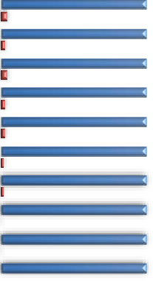







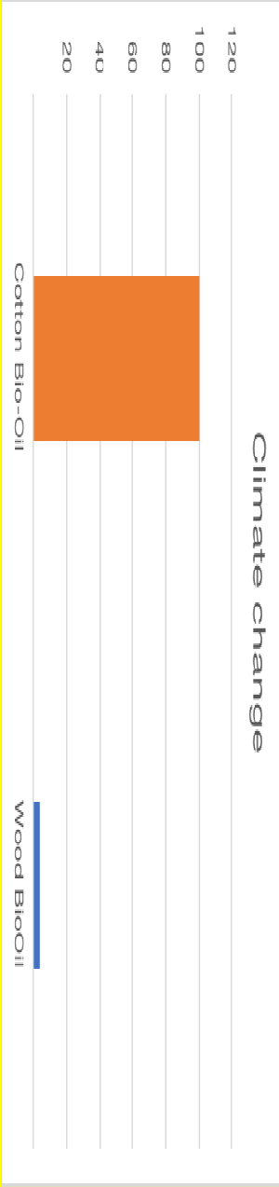

%

Climate change Ozone depletion Ionising radiation
Photochemical…
Particulate matter Human toxicity,… Human toxicity,…
Acidification Eutrophication,… Eutrophication,… Eutrophication,…
Ecotoxicity,… Land use Water use
Resource use, fossils
Resource use,… Climate change -… Climate change -… Climate change -… Human toxicity,… Human toxicity,… Human toxicity,… Human toxicity,… Human toxicity,… Human toxicity,… Ecotoxicity,…
Ecotoxicity,… Ecotoxicity,…
ENVIRONMENTAL IMPACT OF WOOD VS COTTON BASED PYROLTIC OIL
120
100
80
60
40
20
Comparing 1 kg 'Cotton Bio-Oil' with 1 kg 'Wood BioOil';
Method: EF 3.0 Method (adapted) V1.03 / EF 3.0 normalization and weighting set /
Characterization
Cotton Bio-Oil
Wood BioOil
Figure 8: Life-cycle impact categories for the cradle-to-grave production of 1 Kg of wood bio-oil and cotton bio oil.
And we found that the CO2 emission for textile cotton-based bio-oil is equivalent to 4.5kg of CO2. While for the wood-based bio-Oil we got the CO2 equivalent 0.0596 Kg. The Wood based Bio-
oil only makes 1.32% of the impact when compared with the textile cotton bio-oil.
Figure 9: Climate change
15

RECOMMENDATION FOR ECO-DESIGN

Keeping in view all the parameters considered for analysis and results derived from both Aspen Plus and SimaPro, we have proposed some eco-design ideas. These will not only make the process consistent with the environment but also optimized the process energy and economical aspects.

RAW MATERIAL COLLECTION

Collection of cotton waste from different process plants demands transportation which is major contributor to GHG and disturb the energy balance and makes the process energy negative. A separate mucoidal collection for textile industry waste could help to cope with problem.

COMBUSTION OPTIMIZATION

Proper combustion of products can improve process efficiency so that the less waste materials are produced and more of these recycled back into the process flow to be of use. This has been a major challenge up till now. Burning of Biochar and non-condensable gases can make pyrolysis process energy sufficient, but it incurs a lot of challenges in its application. Using sand as a heat career instead of steam and air could be beneficial with regards to saving of energy consumption in pumping and compression. Sand is readily available and is a sustainable solution in combustion activity.

Conclusion
LCA Studies has confirmed that flash pyrolysis plants which harness wood waste to produce pyrolytic oil are environmentally friendly as compared to oil generated from textile cotton waste. However, one must be aware that efforts still have to be made to address the global warming potential issue. This is because being environmentally friendly does not mean it is totally clean.

References

Joana, Carvalho, et al. "Life Cycle Assessment (LCA) of Biochar Production from a Circular Economy Perspective." Processes 10.12 (2022): 2684.
Zhong, Z. W., B. Song, and M. B. M. Zaki. "Life-cycle assessment of flash pyrolysis of wood waste." Journal of Cleaner Production 18.12 (2010): 1177-1183.
Steele, Philip, et al. "Life-cycle assessment of pyrolysis bio-oil production." Forest Products Journal 62.4 (2012): 326-334.
Acero, Aitor P., Cristina Rodríguez, and Andreas Ciroth. "LCIA methods Impact assessment methods in Life Cycle Assessment and their impact categories." GreenDelta GmbH, Berlin, Germany 23 (2014).

