Ligament shear strain stiffening arises from unaligned fibers and is amplified by axial strain
Jonathon L. Blank (1), Joshua D. Roth (1,2)
- Department of Mechanical Engineering, University of Wisconsin-Madison, Madison, WI, USA
- Department of Orthopedics and Rehabilitation, University of Wisconsin-Madison, Madison, WI, USA
Corresponding Author: Joshua D. Roth, roth@ortho.wisc.edu
1111 Highland Avenue Room 5009, Madison, WI 53706
Keywords: Medial collateral ligament; Shear modulus; Fiber alignment; Structure function; Finite element modeling
Abstract
The medial collateral ligament is subject to a combination of shear and tensile loading via passive joint rotation or a combination of joint rotation and valgus loading in the knee. However, empirical characterizations of ligament mechanics usually consider only pure tensile or simple shear loading, and such isolated loading conditions may not fully capture the structure-function relationships under physiological conditions. For example, stretch of off-axis ligament fibers may inherently enhance load transfer and shear resistance within the tissue. Our objectives were to characterize the effects of (1) fiber alignment and (2) axial prestrain on the shear behavior of ligaments. We modeled a medial collateral ligament as an incompressible, hyperelastic material with distributed fibers embedded in an isotropic ground matrix. We use high-throughput, probabilistic finite element modeling to determine changes in shear modulus across a broad range of fiber alignments and axial strains observed in musculoskeletal soft tissues. We then used an experimental technique capable of resolving the loaded shear modulus of human medial collateral ligaments. We found that shear modulus increased dramatically (up to 1.5 MPa) in our soft tissue model when fibers were unaligned, and that this effect was amplified when the axial strain in the soft tissue’s shear region was increased. In medial collateral ligaments ex vivo, we found that shear modulus increased by over tenfold at an axial prestrain of 9% relative to the unloaded state. These findings uncover an important structure-function relationship in ligaments that is relevant to the complex loading scenarios these tissues undergo in vivo, and thus should be considered for ongoing analyses of ligament mechanics.
1. Introduction
Ligaments are soft tissues composed of a hierarchy of fibrils, fibers, and fascicles. During joint motion, ligaments inherently undergo nonuniform deformations (Gardiner, Weiss and Rosenberg, 2001a; Willinger et al., 2020). For example, there are higher strains in the anterior portion of the medial collateral ligament (MCL) with the knee in flexion and higher strains in the posterior portion of the MCL with the knee in extension. During these nonuniform deformations, the internal ligament structures are subjected to a combination of tensile and shear loading. However, despite the complex loading of ligaments in vivo, mechanical characterization of ligaments typically consist of uniaxial, biaxial, or simple shear loading (Quapp and Weiss, 1998; Gardiner and Weiss, 2001; Danso et al., 2020).
The alignment and interaction of load-bearing structures within ligament tissue is an important determinant of its mechanical behavior (Blank et al., 2021). The shear behavior of the tissue is governed by the matrix material and constituents between fibers and fibrils. For example, in rat tail tendon fascicles, interfibrillar shearing provides for lateral force transmission between fibrils even during axial loading (Szczesny and Elliott, 2014). Due to the alignment of fibrils in rat tail tendon fascicles, the resulting shear stresses are several orders of magnitude lower than stresses observed due to axial fibril stretch (Szczesny et al., 2015). Resistance to shear in ligaments is also thought to arise due to matrix material properties and interfibrillar bonds, with similar shear stresses as those observed in tendon in the near-unloaded state (Weiss, Gardiner and Bonifasi-Lista, 2002).
Ligaments and tendons are traditionally modeled as transversely isotropic, with highly aligned collagen fibers embedded in a ground matrix (Weiss, Maker and Govindjee, 1996). The shear modulus of the ground matrix is selected to reflect interfibrillar load transfer. However, ligaments have less-aligned collagen fibrils compared to those in tendons (Amis, 1998). Therefore, ligaments may be more accurately modeled by representing their fibrous microstructure as a distribution of “mostly aligned” fibers instead of perfectly aligned fibers (Stender et al., 2018). The unaligned fibers in the tissue may facilitate increased shear resistance due to direct loading of the strain-stiffening fibrils as the tissue is sheared. Further, this effect of fiber alignment on shear resistance may be more prominent in tissues that are axially prestrained, as the tensioned fibers will have a higher stiffness prior to shearing. The combination of tension and shear, which can occur in vivo due to non-uniform loading (e.g., different engagement patterns created by changes in joint angle), may alter local tissue mechanics or modulate load transfer across the tissue and to the bony attachments. However, to our knowledge, changes in resistance to shear in ligament across axial loading levels and fiber alignments remain unknown.
Accordingly, the objectives of this study were to characterize the effects of (1) fiber alignment and (2) axial prestrain on the shear behavior of ligaments. We hypothesized that the shear modulus would increase with axial strain. We expected that the relationship between shear modulus and axial prestrain would be dependent on the tissue’s fiber alignment in the shearing region. To accomplish these objectives, we created a novel tensile-shear loading paradigm for soft tissues that we implemented in both a probabilistic finite element model and human MCLs using a custom, four-actuator mechanical testing system (Blank and Roth, 2024).

2. Methods
2.1 Finite Element Modeling
2.1.1. Overview
We created a finite element model of a representative tissue loaded by our custom, four-actuator mechanical testing system (Fig. 1). By displacing these four grips, we can subject the tissue to a combination of tension and shear at varying levels of axial strain. The representative tissue was modeled as a 10 x 10 mm section with a thickness of 1 mm. The mesh was composed entirely of hexahedral elements (Table 1).
2.1.2. Constitutive modeling
We modeled the tissue as an incompressible, hyperelastic material with distributed fibers. The ground matrix was isotropic according to a Mooney-Rivlin constitutive model ($C_{1}=C_{2}=$0.2 MPa) (Mooney, 1940). The matrix material properties were chosen with guidance from prior shear experiments in ligament and a sensitivity analysis of the same model during simple shear (Weiss, Gardiner, and Bonifasi-Lista 2002; J. L. Blank et al. 2021). The ground matrix, embedded fibers, and tissue’s volumetric response to loading were characterized using the following uncoupled strain energy density function, $Ψ$ (Eq. 2):
$$Ψ=F_{1}\left({\tilde{I}}_{1},{\tilde{I}}_{2}\right)+\int_{θ_{p}-\frac{π}{2}}^{θ_{p}+\frac{π}{2}}{P\left(θ\right){ F}_{2}\left(\tilde{λ}[θ]\right) dθ}+\frac{K}{2}{\left(\ln{J}\right)}^{2}$$ | (2)
Here, ${\tilde{I}}_{1}$ and ${\tilde{I}}_{2}$ are the first and second invariants of the right Cauchy-Green deformation tensor, $\tilde{λ}$ is the fiber direction stretch, $K$ is the bulk modulus, and $J$ is the volume change of the deformation. $F_{1}\left({\tilde{I}}_{1},{\tilde{I}}_{2}\right)$ is the contribution of the ground matrix to the strain energy density function. The parameter $θ$ is indicative of changes in fiber alignment according to the 2D unimodal von Mises distribution function, P($θ$) (Eq. 3) (Gouget, Girard and Ethier, 2012):
$$P\left(θ\right)=\frac{1}{πI_{0}k_{f}}e^{k_{f}cos⁡(2\left(θ-θ_{p}\right))}$$ | (3)
The principal fiber orientation, $θ_{p}$, represents the nominal fiber angle and was chosen to align with the longitudinal axis of the tissue (defined from the positive z-axis in the YZ-plane, Fig. 1a). $I_{0}$ represents the modified Bessel function of the first kind. The fiber concentration factor, $k_{f}$, determines the degree of fiber alignment within the tissue. Fiber concentration factors from 0 to 50 were chosen to represent fiber alignments from highly unaligned (i.e., isotropic) to highly aligned (i.e., nearly transversely isotropic), respectively. $F_{2}\left(\tilde{λ}[θ]\right)$ represents the contribution of the collagen fibers to the strain energy density function (Eq. 4):
$$\tilde{λ}\frac{∂F_{2}}{∂\tilde{λ}}=0 \tilde{λ}≤1$$  $$\tilde{λ}\frac{∂F_{2}}{∂\tilde{λ}}=C_{3}e^{C_{4}(\tilde{λ}-1)}-1 1<\tilde{λ}≤λ^{*}$$  $$\tilde{λ}\frac{∂F_{2}}{∂\tilde{λ}}=C_{5}\tilde{λ}+C_{6} \tilde{λ}>λ^{*}$$ | (4)
Here, $\tilde{λ}$ is the fiber-specific stretch during loading (a function of $θ$), and $λ^{*}$ is the stretch at which the fibers engage. C₃ scales the exponential stress and the term C₄ controls the strain-dependent rate at which the fibers uncrimp. C₅ is the elastic modulus of straightened fibers. For a transversely isotropic material, the stretch of the collagen fibers is the same as $\tilde{λ}$, which is a function of deformation in the z-direction. For tissues with unaligned fibers, this response is scaled using the 2D unimodal distribution function. Fiber constitutive properties were based on a prior sensitivity analysis and were chosen to reflect a representative ligament with a known stiffness ($λ^{*}$ = 1.04, C₃ = 1 MPa, C₄ = 50, C₅ = 600 MPa) (Blank et al., 2021).
2.1.3. Mesh convergence analysis
We performed a mesh convergence analysis to study the correspondence of our simulations with near-single element tests (Supplement Tables S1 and S2, Fig. S1-S3). We represented the tissue in the model using mesh densities ranging from 3-51,200 elements. Our convergence criteria was set so that we would pick the smallest mesh in terms of number of elements that had a change in shear modulus of less than 5% from the next coarsest mesh (Jones and Wilcox, 2008; Henninger et al., 2010).
2.1.4. Static simulation of shear-tensile loading
We performed a static simulation of combined shear-tensile loading on the representative elastic tissue. In the first step of the simulation, we loaded the tissue axially by displacing the top grips by an equal amount according to a pre-specified axial strain level between 0% and 9% (Fig. 1b). Once the desired axial strain was reached, one side of the tissue was sheared by displacing the grips on the same side by an equal amount to achieve an average grip-to-grip shear strain of 40% (Fig. 1c). We computed the average tangential shear stress as the difference in grip forces on one side of the tissue divided by the engineering cross-sectional area (Blank and Roth, 2024). We computed shear modulus using a linear fit of the shear stress-shear strain response in the linear region using a custom exponential-linear best-of-fit function (Tanaka et al., 2011). In the absence of a toe region, the entire shear stress-shear strain response was used in the shear modulus calculation.
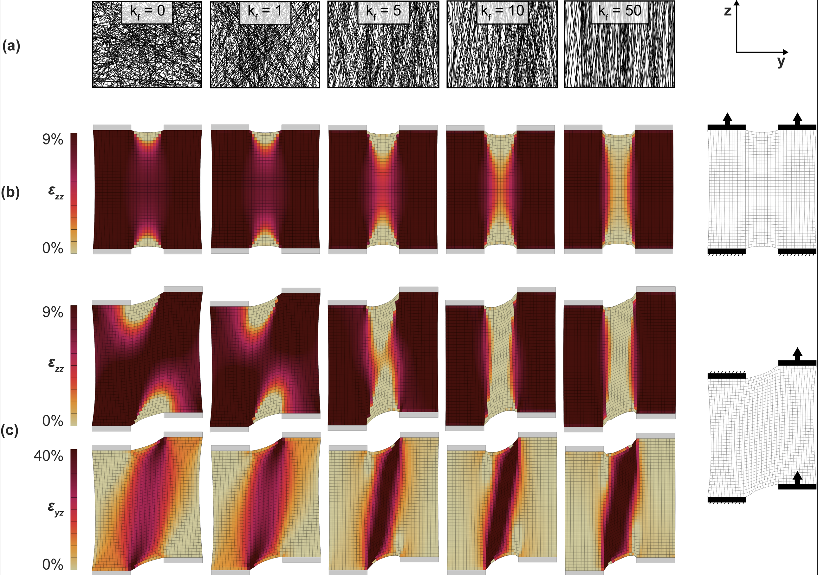
Figure 1: We used a finite element model to compute the axially preloaded shear modulus of fibrous soft tissues. (a-b) As fiber alignment (k_{f}) decreases, there is more load transmission across the tissue width, and the shearing region undergoes an axial prestrain (ε_{zz}) more similar to the prescribed grip-to-grip strain (9% shown). (c) During shearing, the axial strain in the shearing region is sustained and the elements in the shearing region are subject to shear strain (ε_{yz}).

2.1.5. Probabilistic simulations
We used high-throughput probabilistic modeling to assess a wide range of axial prestrains and fiber alignments in our finite element model, as has been done in prior studies examining the effect of fiber alignment on tissue mechanics (Blank et al., 2021; Blank, Thelen and Roth, 2023). For all models, we varied axial prestrain from 0% to 9% in increments of 0.1%, and we prescribed k_{f} values as whole numbers between 0 and 50 (4641 total simulations). We generated all model files using a custom python script, and all simulations were performed on a high-throughput computing grid (Center for High-Throughput Computing, University of Wisconsin-Madison).
2.2. Physical Experiments
2.2.1. Specimen preparation
We procured ligament specimens from the MCLs of three human donors (1M, 65.3 ± 7.0 years). Once dissected, each MCL was divided into four 20-mm long samples. We flash-froze samples in optimal cutting temperature (OCT) compound using liquid nitrogen in a 37 x 24 mm histology trays. Then, we sectioned specimens to a uniform thickness of less-than 2 mm using a rotary microtome cryostat (Leica CM1520) ensuring that collagen fibers without overlying tissue constituents were visible on either side of the sample. Specimens damaged during preparation or testing were excluded (n = 3), resulting in a total of n = 9 ligament specimens included in the present study.
2.2.2. Geometry acquisition
We acquired the sagittal thickness (i.e., shear plane) of the specimen using ultrasound. We scanned the shear ROI using a portable ultrasound system (ArtUs EXT-1H) by submerging the transducer (LF11-5H60-A3, 11 MHz frequency) in the PBS bath prior to mechanical testing. We acquired a single image with a pixel resolution of 0.026 mm. We measured the ligament thickness using a custom MATLAB segmentation script. The length of the shear area was considered as the length of the specimen prior to the axial prestrain. We used the engineering cross-sectional area (i.e., unloaded length x thickness) for all shear stress calculations.
2.2.3. Mechanical testing
We mounted ligament specimens between sandpaper grips in a 1X PBS bath on a custom, four-actuator mechanical testing system (Fig. 2a). Grips were spaced 3 mm apart according to a prior sensitivity analysis that determined the grip spacing needed to load the center of the tissue in tension prior to shearing (J. Blank and Roth 2024). The system consisted of four motor-driven linear actuators (Kollmorgen EN60034, <20 µm backlash, 2 top, 2 bottom) that could load the specimen both in axial tension and shear. One side of the system was equipped with 45-N load cells on the top and bottom grips (Futek LSB210, reported non-linearity = 0.009 N).We preloaded each specimen to between 0.05 N and 0.1 N with approximately equal tension on both sides. After preloading, we loaded the specimen in shear with a sawtooth displacement profile from 0% to 40% shear strain at a rate of 10%/s for 10 cycles. We then loaded specimens to axial strains of 3%, 6%, and 9% at a rate of 1%/s. Strain levels were chosen to reflect a range of MCL strains observed in the native knee during passive flexion (Gardiner, Weiss, and Rosenberg 2001) and failure (Bates et al., 2019; Chen, Zhou and Tang, 2024). At each axial strain, we applied the same sawtooth shear displacement profile. We recorded all measurements during the last cycle to minimize viscoelastic effects. The testing order of axial strains after 0% axial strain was randomized for all specimens to minimize any systematic effects of testing order.
2.2.4. Imaging of dynamic fiber realignment
We determined the strength of collagen fiber alignment in our ligament samples using quantified polarized light imaging (York et al., 2014; Skelley et al., 2015). We placed a high-intensity backlight below the bath and projected circularly polarized light through the thickness of the specimen. We captured polarized images at 10 Hz using a machine vision camera (FLIR Blackfly S USB3). To verify that the shearing region was axially preloaded, we computed the degree of linear polarization (DoLP), which represents the strength of fiber alignment (where an increase in DoLP indicated that fibers are being loaded), from interpolated polarized greyscale intensities (Zhang et al., 2016). The region of interest was specified as a box within the four interior corners of the grips at the end of the shearing motion (Fig. 2b).

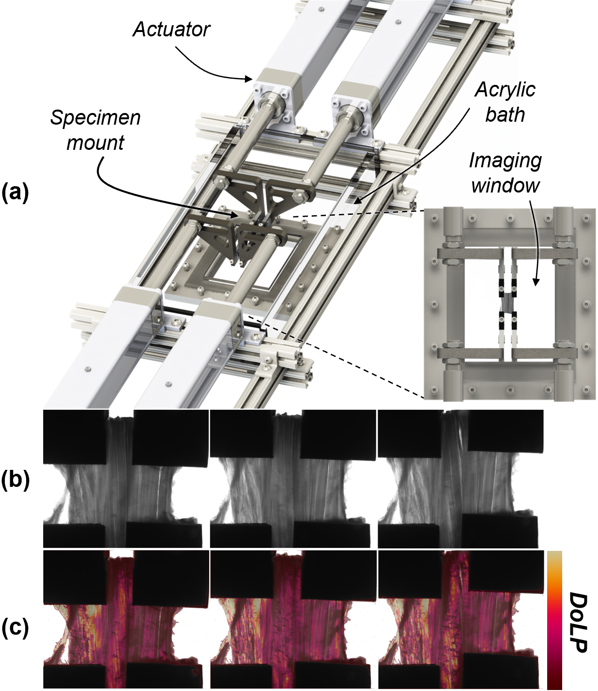
Figure 2: (a) Testing system consisting of four actuators that load a sample in combined shear-tensile loading. The system is equipped with a bath and a transparent window for polarimeter measurements. (b) Ligament sections were placed in sandpaper grips in the shear-tensile testing system. A backlight projected polarized light through the specimen. From left to right, the representative images show an unloaded, axially prestrained, and an axially prestrained and sheared ligament section. (c) We computed the degree of linear polarization (DoLP) across the ligament width to verify that the shearing region was axially preloaded. These three images correspond to the loading state of the above images in (b).

2.3. Computation of loaded shear modulus
We determined shear modulus for both finite element models and physical experiments using reaction forces at the grips, as described previously (Blank and Roth, 2024). Briefly, the shear force was computed as balance on either side of the specimen being sheared was computed in reference to the load level at the axially preloaded state, and the shear modulus as the shear force divided by the engineering cross-sectional area of the specimen in the shear plane. For the physical experiment, shear modulus was computed using the right side of the specimen (Fig. 2b-c). We determined the end of the toe region of the shear stress response using an exponential-linear optimization function (Tanaka et al., 2011). The shear modulus for ligaments was determined using a linear fit of the shear stress-strain relationship following the toe region. Shear strain was expressed in radians for shear modulus measurements in all finite element models and ligament specimens.
2.4. Statistical analysis
For each finite element simulation, we computed the change in shear modulus (Δμ) relative to the unloaded (0% strain) case. We binned Δμ across both axial prestrain (ε) levels and fiber alignment factors. For axial prestrain, we separated Δμ into bins of 0.5% increments (i.e., ε = 0-0.5%, 0.5-1%, etc.). For fiber alignment factors, we separated Δμ into bins of 5 (i.e., k_{f} = 0-5, 6-10, etc.). We computed descriptive statistics within each axial prestrain and fiber alignment bin because performing traditional hypothesis tests with the large datasets generated by high throughput probabilistic modeling always yielded significant differences.
In the human MCLs, we evaluated differences in shear modulus (µ) across axial prestrains (ε). We performed a repeated measures analysis to test the overall effect of axial prestrain on tangential shear modulus while controlling for the effect of degree of linear polarization on tangential shear modulus using an autoregressive covariance structure. We also tested differences in tangential shear modulus between axial prestrain levels using a one-way analysis of variance (ANOVAs) with α = 0.05 while achieving a power of (1-ß) > 0.8 (see Supplementary Materials S1 for more detailed descriptions of the power analysis).

3. Results
3.1. Shear modulus of probabilistic models is axial load- and fiber alignment-dependent
Our mesh convergence analysis revealed that our simulations were not substantially sensitive to mesh density (see Supplementary materials). We chose a 6,400-element mesh for all of our analyses because it was the first to satisfy the mesh convergence criteria of less than a 5% change in shear modulus (Jones and Wilcox, 2008; Henninger et al., 2010).
We observed that tangential shear modulus was dependent on both the fiber alignment in the tissue and axial prestrain level, with less-aligned fibers (i.e., lower k_{f} value) leading to a higher effective shear modulus. This effect of fiber alignment on shear modulus was amplified by axial prestrain (Fig. 3). More specifically, we observed an increase in the effective shear modulus of the structure of 1.5 MPa on average for less aligned fiber alignment factors (k_{f}) of less than 5. For more aligned fiber alignment factors (k_{f} = 46-50), we observed an increase in the effective shear modulus of less than 0.25 MPa.
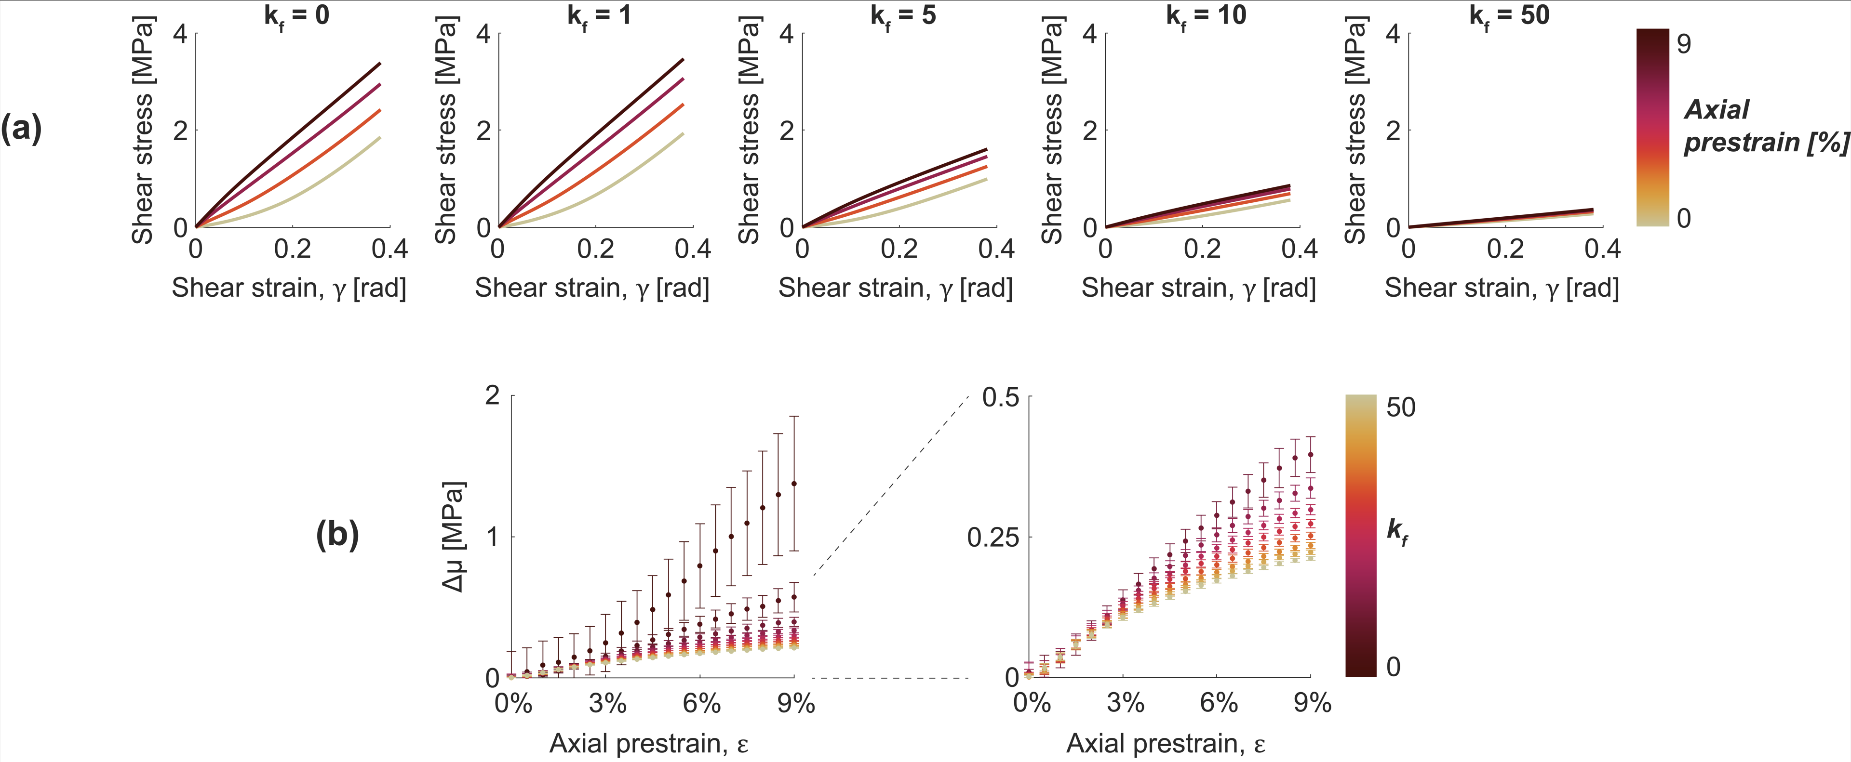
Figure 3: (a) Representative shear stress-shear strain curves. Soft tissue models had an increased shear resistance with increasing axial prestrain and decreasing fiber alignment. (b) Scatter plots show increase in shear modulus relative to the unloaded state for fiber alignment factor values split into bins of 5 (i.e., k_{f} = 0-5, k_{f} = 6-10, etc.) across axial prestrains binned in 0.5% increments (i.e., ε = 0-0.5%, 0.5-1%, etc.) from our FE models. Dots are the mean of each strain bin, and error bars are the standard deviation within each bin. The right plot shows the same data as the left plot, but the vertical axis range is reduced to show the changes more clearly at higher values of k_{f}. The key takeaways from this figure are (1) that shear modulus increased with axial prestrain, and (2) this effect was amplified in tissues with unaligned fibers.

3.2. Shear modulus of human MCLs is axial load dependent
Our cryosectioned ligament specimens had an average thickness of 1.27 ± 0.47 mm. Fibers in the shear region of all ligaments were axially preloaded with the rest of the tissue, as indicated by an increase in the average degree of linear polarization recorded in this region (see Fig. S5). We observed similar patterns of increases in shear modulus in the MCLs with axial strain as those in our finite element model predictions (Fig. 4). At 9% axial prestrain, we detected a significant increase in the tangential shear modulus in comparison to both the tangential shear modulus in unloaded state (mean ± standard error 5.9 ± 1.4 kPa vs. 75.1 ± 26.8 kPa, p = 0.0009) and the tangential shear modulus at 3% axial prestrain (mean ± standard error 13.5 ± 3.9 kPa vs. 75.1 ± 26.8 kPa, p = 0.0044). Compared to the 0% prestrain condition, we observed over a tenfold average increase in shear modulus when the ligament was subjected to a 9% axial prestrain.

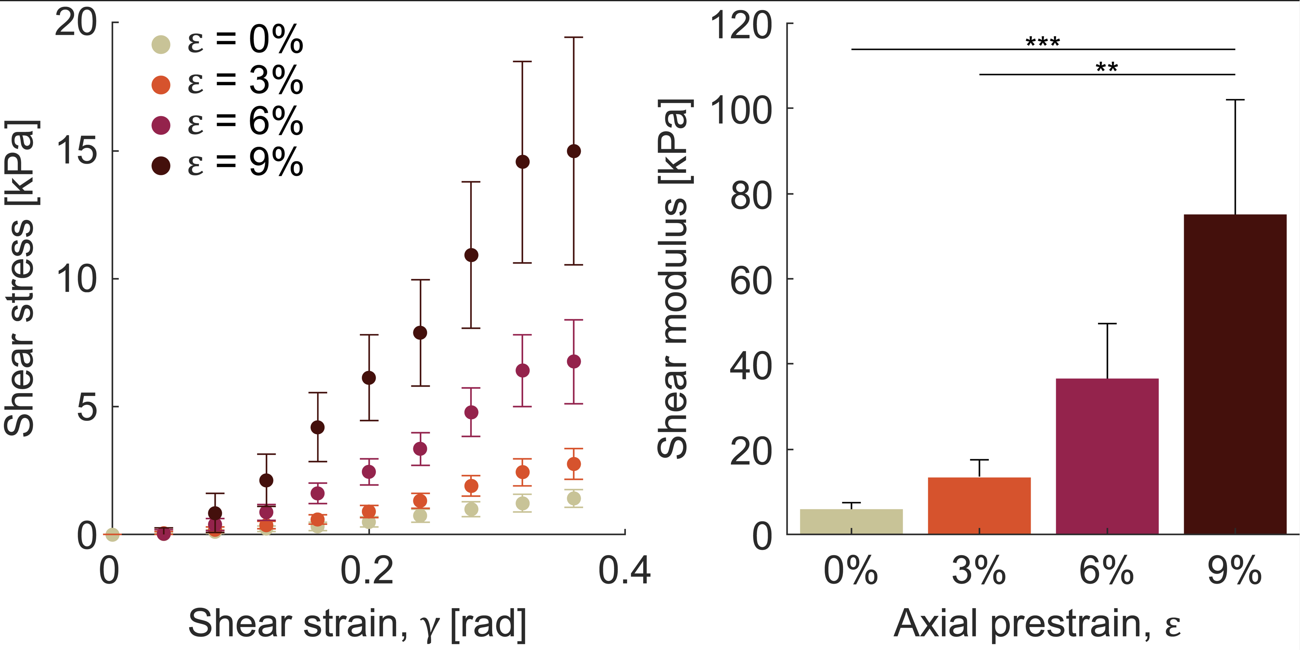
Figure 4: (a) Ligaments exhibited shear-strain stiffening behavior that increased in magnitude with increasing axial preload. Dots represent the mean, and error bars represent the standard error across the nine specimens. (b) The tangential shear modulus increased by over 10-fold from an axial preload of 0% to an axial preload of 9%. Bars represent the mean, and error bars represent the standard error across the nine specimens. Asterisks (*) indicate a statistically significant difference (p < 0.05).
4. Discussion
The objectives of this study were to characterize the effects of (1) fiber alignment and (2) axial prestrain on the shear behavior of ligaments. Using our combined shear-tensile loading paradigm, we characterized shear modulus in axially prestrained probabilistic models and human MCLs. In our probabilistic models, we found that shear modulus was dependent upon the axial prestrain and the fiber alignment of the tissue. In human MCLs, we found a comparable relationship between shear modulus and axial prestrain. These results suggests that unaligned fibers may facilitate load transfer between structures in the tissue when subjected to the complex loading paradigms that occur in vivo.
To accomplish our first objective, we implemented a probabilistic, high-throughput finite element model to systematically test the effect of fiber alignment on axially prestrained shear modulus. Our salient findings were that (1) shear modulus increased with more unaligned (i.e., isotropic) fiber alignment, and (2) this effect was amplified by increasing axial prestrain (Fig. 3). The range of fiber alignments that we examined is relevant for a variety of musculoskeletal tissues, especially in near-isotropic fibrous tissues like joint capsule (Ault and Hoffman, 1992; Ralphs and Benjamin, 1994) or scar tissue (Provenzano, Hurschler and Vanderby R., 2001). In tissues with a more highly aligned microstructure, such as tendon, we predict that the shear modulus should change minimally with increasing load. In vivo, this is likely true due to little lateral load transmission across fibers and the capacity for relative sliding between fibers (Szczesny and Elliott, 2014; Szczesny et al., 2015). However, this could change with tissue specialization, such as in the supraspinatus tendon, which transmits multiaxial loads (tension, compression, shear) across the glenohumeral joint (Lake et al., 2009, 2010). More experiments in both unaligned and aligned fiber tissues are needed to verify our model predictions, which used a 2D affine fiber representation to simulate variations in anisotropy found in biological soft tissues. Notwithstanding, our finding helps to elucidate the mechanism by which unaligned fibers can transfer load across a tissue, which may be important for transmitting multidirectional loads across a joint in vivo.
Our second objective was to characterize the relationship between shear behavior and axial prestrain. In MCLs, we found that the tangential shear modulus increased from 5.9 kPa with 0% prestrain to 75.1 kPa when prestrained to 9% prior to shearing (Fig. 4). We observed similar behavior in the model across a broad range of fiber alignments, including increases in shear modulus of 1500 kPa on average for unaligned fibers and 210 kPa when there were very few unaligned virtual fibers present (Fig. 3). This important new finding has several direct applications to the structure and function of ligament. First, as stated before, the unaligned fibers in ligament may serve to transfer load across its width to better distribute loading across the width of the ligament during complex joint motion. Our findings support this structure-function relationship, as increasing shear resistance may be the mechanism by which this load transfer occurs. Second, our findings in cryosectioned MCL specimens indicate that the fibers themselves resist shear in addition to tension, which may be important for understanding injury thresholds that occur when ligament fibers are overloaded. We observed a shear modulus in the unloaded state (5.9 kPa) that was substantially lower than those observed in an ex vivo shear test of the MCL in a prior study (45.1 kPa to 1.7 MPa, depending on shear strain level) (Weiss, Gardiner and Bonifasi-Lista, 2002). We expect that this substantially smaller shear modulus in our study could be due to different grip strategies because we examined a slip-shear paradigm rather than a simple-shear paradigm (i.e., four grips for each corner of the tissue versus two grips for the sides of the tissue). Further, our cryosectioning technique ensured that we were only loading fibers of the MCL and did not incorporate other constituents such as the epiligament (Chowdhury, Matyas and Frank, 1991) that could provide additional shear resistance. Whether these constituents significantly alter shear modulus when tested with our shear-tensile loading paradigm is an area of further study.
Our study and shear-tensile loading paradigm have a few limitations to consider when interpreting our results. First, we implemented a shear-tensile loading paradigm that relies on an axial prestrain, which is closer to in-vivo loading than prior studies but may still underestimate the shear forces acting on ligaments in vivo. A force-controlled or a hybrid control implementation that can simulate a simultaneous valgus load with joint rotation at physiological loading rates may be more representative of the physiological loading environment of the MCL. However, our quasi-static experiment of a controlled shearing under axial pretension does have functional relevance for structure-function relationships in anisotropic soft tissues. Second, concerning our finite element model, we used a von Mises distribution to represent variations in fiber alignment across tissues. A non-affine model of discrete fibers may be more appropriate for representing the gradual recruitment of fibers and their resistance to shear (Chandran and Barocas, 2006). Likewise, the resistance to shear in the finite element model may be higher than what is observed in tissues with different fiber alignments due to this limitation. However, we do not believe that alternative fiber models would alter the key take-aways from our study that effective shear modulus increases due to both unaligned fibers and axial prestrain. Concerning our physical experiment, we chose to cryosection ligaments to a less-than 2 mm thickness so that we could verify axial prestraining of the shearing region prior to shearing using quantified polarized light imaging (York et al., 2014; Skelley et al., 2015). This may have altered tissue constituents such as the epiligament, which may be important to the mechanics of ligament under shear loading. However, as mentioned previously, cryosectioning allowed us to isolate the effect of the fibers in shear loading. Finally, in this study we did not consider how shear strain and stress may vary regionally across the sample (Fig. 1) and across the entire ligament tissue, and instead considered the average shear stress across the MCL cross-section. Using digital image correlation to interpret regional shear strain in the tissue may inform regional shear properties (Driscoll et al., 2011) and scaling our technique with regard to different regions of the MCL (Willinger et al., 2020) may have produced different magnitude shear moduli.
There are several exciting applications of a load-dependent shear modulus in applications for musculoskeletal soft tissues. First, understanding tendon and ligament structure-function relationships is an ongoing area of focus in tissue biomechanics. Our findings indicate that combined shear-tensile loading should be included in these analyses because it could have important implications for tissue specialization, normal function, and failure. Likewise, understanding the pre-loaded shear behavior of ligaments could allow for better finite element modeling predictions of soft tissue mechanics during joint movement. Second, tendon and ligament form an unorganized scar region following injury or surgical intervention (Burks, Haut and Lancaster, 1990). We demonstrate in the present study that shear strain-stiffening is considerable in tissues with unaligned fibers, and our finite element model findings add to the growing body of evidence that the mechanics of degenerative tissue are abnormal. Third, concerning in vivo applications, shear wave tensiometry is a method to gauge stress in tendons (Martin et al., 2018) and ligaments (Blank, Thelen and Roth, 2020) using wearable or handheld sensors, but the relationship between shear wave speed and stress is also dependent upon shear modulus. Changes in shear modulus based on the findings of the present study should be accounted for when predicting stress based on shear wave speed, especially in tissues under high axial loads and/or those with less aligned fibers.
In conclusion, we demonstrated in both a probabilistic finite element model and human MCLs that ligament shear modulus increases when the tissue is axially prestrained, and these increases are greater in tissues with less well-aligned fibers. It is likely that these relationships arises due to unaligned fibers being stretched with increasing axial load, thus changing the local degree of anisotropy of the tissue under shear. These findings uncover an important structure-function relationship in ligaments that is relevant to the complex loading scenarios these tissues undergo in vivo, and thus should be considered for ongoing analyses of ligament mechanics.

Acknowledgments
The authors thank Dr. Darryl Thelen for his technical expertise and assistance in devising a combined tensile-shear loading paradigm and Samuel Mosiman for his assistance in designing our study and conducting the statistical analysis.
The authors would like to acknowledge the University of Wisconsin-Madison Center for High-Throughput Computing for their resources and technical insight related to this project. The authors would also like to acknowledge the simVITRO team for their support with software implementation of our unique loading paradigm.
This material is based upon work supported by the National Science Foundation Graduate Research Fellowship Program under Grant No. DGE-1747503. Any opinions, findings, and conclusions or recommendations expressed in this material are those of the author(s) and do not necessarily reflect the views of the National Science Foundation.
Funding for materials in this project came from Dr. Roth’s start-up funds through the UW-Madison Department of Orthopedics and Rehabilitation.

References
Amis, A.A. (1998) ‘Biomechanics of Bone, Tendon, and Ligament’, in Sciences Basic to Orthopaedics, pp. 222–239.
Ault, H.K. and Hoffman, A.H. (1992) ‘A composite mioromechanioal model for connective tissues: Part II-application to rat tail tendon and joint capsule’, Journal of Biomechanical Engineering, 114(1), pp. 142–146. Available at: https://doi.org/10.1115/1.2895438.
Bates, N.A. et al. (2019) ‘Multiplanar Loading of the Knee and Its Influence on Anterior Cruciate Ligament and Medial Collateral Ligament Strain During Simulated Landings and Noncontact Tears’, American Journal of Sports Medicine, 47(8), pp. 1844–1853. Available at: https://doi.org/10.1177/0363546519850165.
Blank, J. and Roth, J. (2024) ‘An Apparatus for Measuring Combined Shear-Tensile Loading in Fibrous Tissues Ex Vivo’, Journal of Biomechanical Engineering, pp. 1–31. Available at: https://doi.org/10.1115/1.4064437.
Blank, J.L. et al. (2021) ‘Sensitivity of the shear wave speed-stress relationship to soft tissue material properties and fiber alignment’, Journal of the Mechanical Behavior of Biomedical Materials, 125(November 2021), p. 104964. Available at: https://doi.org/10.1016/j.jmbbm.2021.104964.
Blank, J.L., Thelen, D.G. and Roth, J.D. (2020) ‘Shear wave speeds track axial stress in porcine collateral ligaments’, Journal of the Mechanical Behavior of Biomedical Materials, 105(January), p. 103704. Available at: https://doi.org/10.1016/j.jmbbm.2020.103704.
Blank, J.L., Thelen, D.G. and Roth, J.D. (2023) ‘Regional Shear Wave Speeds Track Regional Axial Stress in Nonuniformly Loaded Fibrous Soft Tissues’, engrXiv [Preprint]. Available at: https://doi.org/10.31224/2923.
Burks, R., Haut, R. and Lancaster, R. (1990) ‘Biomechanical Assessment of the Healing Response of the Rabbit Patellar Tendon After Removal of Its Central Third’, American Journal of Sports Medicine, 18(2), pp. 146–152. Available at: https://doi.org/10.1007/BF00387577.
‘Center for High-Throughput Computing’ (2006). Available at: https://doi.org/10.21231/GNT1-HW21.
Chandran, P.L. and Barocas, V.H. (2006) ‘Affine Versus Non-Affine Fibril Kinematics in Collagen Networks: Theoretical Studies of Network Behavior’, Journal of Biomechanical Engineering, 128(2), pp. 259–270. Available at: https://doi.org/10.1115/1.2165699.
Chen, W., Zhou, Q. and Tang, J. (2024) ‘Material Properties of Fiber Bundles of the Superficial Medial Collateral Ligament of the Knee Joint’, Journal of Biomechanical Engineering, 146(3). Available at: https://doi.org/10.1115/1.4064476.
Chowdhury, R., Matyas, J.R. and Frank, C.B. (1991) ‘The “epiligament” of the rabbit medial collateral ligament: A quantitative morphological study’, Connective Tissue Research, 27(1), pp. 33–50. Available at: https://doi.org/10.3109/03008209109006993.
Danso, E.K. et al. (2020) ‘Comparison of Biaxial Biomechanical Properties of Post-menopausal Human Prolapsed and Non-prolapsed Uterosacral Ligament’, Scientific Reports, 10(1), pp. 1–14. Available at: https://doi.org/10.1038/s41598-020-64192-0.
Driscoll, T.P. et al. (2011) ‘Fiber angle and aspect ratio influence the shear mechanics of oriented electrospun nanofibrous scaffolds’, Journal of the Mechanical Behavior of Biomedical Materials, 4(8), pp. 1627–1636. Available at: https://doi.org/10.1016/j.jmbbm.2011.03.022.
Gardiner, J.C. and Weiss, J.A. (2001) ‘Simple shear testing of parallel-fibered planar soft tissues’, Journal of Biomechanical Engineering, 123(2), pp. 170–175. Available at: https://doi.org/10.1115/1.1351891.
Gardiner, J.C., Weiss, J.A. and Rosenberg, T.D. (2001) ‘Strain in the Human Medial Collateral Ligament During Valgus Loading of the Knee’, Clinical Orthopaedics and Related Research, 391, pp. 266–274. Available at: https://doi.org/10.1097/00003086-200110000-00031.
Gouget, C.L.M., Girard, M.J. and Ethier, C.R. (2012) ‘A constrained von Mises distribution to describe fiber organization in thin soft tissues’, Biomechanics and Modeling in Mechanobiology, 11(3–4), pp. 475–482. Available at: https://doi.org/10.1007/s10237-011-0326-y.
Henninger, H.B. et al. (2010) ‘Validation of computational models in biomechanics’, Proceedings of the Institution of Mechanical Engineers, Part H: Journal of Engineering in Medicine, 224(7), pp. 801–812. Available at: https://doi.org/10.1243/09544119JEIM649.
Jones, A.C. and Wilcox, R.K. (2008) ‘Finite element analysis of the spine: Towards a framework of verification, validation and sensitivity analysis’, Medical Engineering and Physics, 30(10), pp. 1287–1304. Available at: https://doi.org/10.1016/j.medengphy.2008.09.006.
Lake, S.P. et al. (2009) ‘Effect of fiber distribution and realignment on the nonlinear and inhomogeneous mechanical properties of human supraspinatus tendon under longitudinal tensile loading’, Journal of Orthopaedic Research, 27(12), pp. 1596–1602. Available at: https://doi.org/10.1002/jor.20938.
Lake, S.P. et al. (2010) ‘Tensile properties and fiber alignment of human supraspinatus tendon in the transverse direction demonstrate inhomogeneity, nonlinearity, and regional isotropy’, Journal of Biomechanics, 43(4), pp. 727–732. Available at: https://doi.org/10.1016/j.jbiomech.2009.10.017.
Martin, J.A. et al. (2018) ‘Gauging force by tapping tendons’, Nature Communications, 9(1), pp. 2–10. Available at: https://doi.org/10.1038/s41467-018-03797-6.
Mooney, M. (1940) ‘A theory of large elastic deformation’, Journal of Applied Physics, 11(9), pp. 582–592. Available at: https://doi.org/10.1063/1.1712836.
Provenzano, P.P., Hurschler, C. and Vanderby R., J. (2001) ‘Microstructural morphology in the transition region between scar and intact residual segments of a healing rat medial collateral ligament’, Connective Tissue Research, 42(2), pp. 123–133. Available at: https://doi.org/10.3109/03008200109014254.
Quapp, K.M. and Weiss, J.A. (1998) ‘Material Characterization of Human Medial Collateral Ligament’, Journal of Biomechanical Engineering, 120(6), p. 757. Available at: https://doi.org/10.1115/1.2834890.
Ralphs, J.R. and Benjamin, M. (1994) ‘The joint capsule: structure, composition, ageing and disease.’, Journal of anatomy, 184 ( Pt 3(July 1993), pp. 503–9.
Skelley, N.W. et al. (2015) ‘Differences in the microstructural properties of the anteromedial and posterolateral bundles of the anterior cruciate ligament’, American Journal of Sports Medicine, 43(4), pp. 928–936. Available at: https://doi.org/10.1177/0363546514566192.
Stender, C.J. et al. (2018) ‘Modeling the effect of collagen fibril alignment on ligament mechanical behavior’, Biomechanics and Modeling in Mechanobiology, 17(2), pp. 543–557. Available at: https://doi.org/10.1007/s10237-017-0977-4.
Szczesny, S.E. et al. (2015) ‘Quantification of interfibrillar shear stress in aligned soft collagenous tissues via notch tension testing’, Scientific Reports, 5(December 2014), pp. 1–9. Available at: https://doi.org/10.1038/srep14649.
Szczesny, S.E. and Elliott, D.M. (2014) ‘Interfibrillar shear stress is the loading mechanism of collagen fibrils in tendon’, Acta Biomaterialia, 10(6), pp. 2582–2590. Available at: https://doi.org/10.1016/j.actbio.2014.01.032.
Tanaka, M.L. et al. (2011) ‘A continuous method to compute model parameters for soft biological materials’, Journal of Biomechanical Engineering, 133(7), pp. 1–7. Available at: https://doi.org/10.1115/1.4004412.
Weiss, J.A., Gardiner, J.C. and Bonifasi-Lista, C. (2002) ‘Ligament material behavior is nonlinear, viscoelastic and rate-independent under shear loading’, Journal of Biomechanics, 35(7), pp. 943–950. Available at: https://doi.org/10.1016/S0021-9290(02)00041-6.
Weiss, J.A., Maker, B.N. and Govindjee, S. (1996) ‘Finite element implementation of incompressible, transversely isotropic hyperelasticity’, Computer Methods in Applied Mechanics and Engineering, 135(1–2), pp. 107–128. Available at: https://doi.org/10.1016/0045-7825(96)01035-3.
Willinger, L. et al. (2020) ‘Length-change patterns of the medial collateral ligament and posterior oblique ligament in relation to their function and surgery’, Knee Surgery, Sports Traumatology, Arthroscopy, 28(12), pp. 3720–3732. Available at: https://doi.org/10.1007/s00167-020-06050-0.
York, T. et al. (2014) ‘Real-time high-resolution measurement of collagen alignment in dynamically loaded soft tissue’, Journal of Biomedical Optics, 19(06), p. 1. Available at: https://doi.org/10.1117/1.jbo.19.6.066011.
Zhang, J. et al. (2016) ‘Image interpolation for division of focal plane polarimeters with intensity correlation’, Optics Express, 24(18), p. 20799. Available at: https://doi.org/10.1364/oe.24.020799.

Supplementary Materials
S1. Power analysis
Once n = 9 specimens were tested, we performed a within factor anova to test the effect of the repeated measure (axial prestrain) on changes in shear modulus. We determined that we only needed n = 5 specimens tested at 4 different axial prestrain levels to achieve 80% power (1-β) and a level of significance (α) of 5%. Because our primary hypotheses were related to axial prestrain and shear modulus, we used the n = 9 specimens tested for all analyses of experimental results.

Table S1: Mesh densities used in the mesh convergence analysis.
Mesh Density | No. elements | Shear region width elements | Shear region thickness elements
Single element | 3 | 1 | 1
Very low | 9 | 1 | 1
Low | 800 | 6 | 2
High | 6,400 | 12 | 4
Very | 51,200 | 24 | 8

Figure S1: Mesh convergence simulations for tissues with unaligned (k_{f} = 0) fibers. Shown in the left three columns are the deformed mesh, shown on the right are the longitudinal strain (ε_{zz}) and shear strain (ε_{yz}).

Figure S2: Mesh convergence simulations for tissues with aligned (k_{f} = 50) fibers. Shown in the left three columns are the deformed mesh, shown on the right are the longitudinal strain (ε_{zz}) and shear strain (ε_{yz}).

Figure S3: Mesh convergence analysis results. Shown are shear moduli across meshes and axial prestrain levels (legend) for unaligned (left) and aligned (right) fibers.

Table S2: Mesh convergence analysis results. The high mesh density simulations were the first where the convergence criteria of a less-than 5% change in shear modulus was satisfied. Strikethrough indicates simulations that did not converge.
Mesh Density | k_{f} = 0  ε = 0% |  | k_{f} = 0  ε = 9% |  | k_{f} = 50  ε = 0% |  | k_{f} = 50  ε = 9%
 | µ [MPa] | t_{solve} [s] | µ [MPa] | t_{solve} [s] | µ [MPa] | t_{solve} [s] | µ [MPa] | t_{solve} [s]
Single element | 57.12 | 0.698 | 52.55 | 0.637 | 1.63 | 0.735 | 2.96 | 0.733
Very low | 13.04 | 5.80 | 14.67 | 7.13 | 1.06 | 6.00 | 2.16 | 6.50
Low | 6.79 | 30.59 | 8.83 | 39.12 | 0.76 | 32.94 | 0.98 | 39.20
High | 7.09 | 195.49 | 8.59 | 254.38 | 0.75 | 205.01 | 0.95 | 297.29
Very high | 6.95 | 1964.7 | 8.47 | 4886.77 | 0.74 | 2086.8 | 0.94 | 2767.66

Figure S4: (a) Shear stress-strain behavior as computed using our loaded-shear paradigm generally matched with (b) loaded shear stress-strain patterns taken from elements along the centerline of the representative fibrous tissue.

Figure S5: Degree of linear polarization of the shear region at the end of the axial loading portion of the combined shear-tensile loading. Error bars represent standard error (n = 9).

