Intelligent Partitioning Method for Free-form grid Structure Based on Generative Adversarial Networks
Jiangjun Hou, Jinyu Lu*, Xiaowei Zhai, Chen Chen, Ximing Xu, Shoufan Yang
School of Civil Engineering, Southeast University, Nanjing 210096, China
Abstract: The diverse and irregular nature of architectural free-form surfaces presents a significant challenge in grid partitioning. The prevalence of explicitly coding-oriented methods tailored to specific free-form surface features has led to a lack of comprehensive exploration of the broader intrinsic patterns of these surfaces, thereby limiting the overall generality of these methods. Therefore, we introduce GridGAN to uncover the inherent patterns in the data and facilitate the grid partitioning for free-form surfaces. First, we innovatively propose utilizing the curvature and height cloud maps of free-form surfaces as inputs to GridGAN to obtain the corresponding grid structures. Then, we utilize self-developed codes to facilitate the data dimension conversion and obtain the desired free-form grid structures. Lastly, the exceptional merits of our proposed method have been thoroughly substantiated through 12 test samples and 2 cases and a comprehensive evaluation that seamlessly combines qualitative evaluation (expert perception) with quantitative evaluation (FID score and geometric properties) methods.
Keywords: Free-form grid structure; Intelligent structural design; Deep Learning; GridGAN; Data dimension conversion

Introduction
The concept of a free-form surface pertains to a three-dimensional entity with unrestricted form (with a wide range of shapes), and typically, such a surface is represented using Non-uniform Rational B-splines (NURBS) [1]. Meanwhile, the notion of a free-form grid structure entails the subdivision of a free-form surface into a grid pattern, allowing the grids to conform to the architectural free-form surface while also providing structural integrity to withstand loads [2,3]. There is a growing preference for large-span structures within the realm of public architecture. Nevertheless, as spatial grid techniques continue to mature, conventional, uniformly structured spatial grid structures no longer suffice, and people nowadays seek more visually striking structural forms. The very nature of a free-form grid structure, characterized by a more exquisite and captivating form, perfectly satisfies the aesthetic demand of the general public.
The morphology of architectural free-form grid structures is undoubtedly gorgeous. Nevertheless, the inherent irregularity of their forms poses several challenges in grid partitioning [4–7], including aspects such as design, optimization, and reverse modeling. Of all these challenges, the most crucial and the one that garners the utmost attention from researchers is the design of grid structures. Research on grid partitioning falls within the early design phase, where mechanical properties are often overlooked for two main reasons: there is a strong emphasis on aesthetic perspectives, such as fluency and uniformity [4,6], and incorporating mechanical properties into grid partitioning can lead to grid distortion [7,8]. Various design methods have thus far been proposed to address the partitioning of grid structures on architectural free-form surfaces. The existing grid partitioning techniques, nevertheless, either rely on manual execution or automatic partitioning by explicitly coding [6,7,9]. Manual partitioning, due to its purely human-driven nature, exhibits versatility in its applicability. Yet, it entails a substantial expenditure of design time, which, to a certain degree, can be perceived as an economic loss. Therefore, it is a recourse taken out of necessity rather than an optimal solution for achieving grid partitioning.
Automated grid partitioning techniques by explicit coding, as opposed to manual grid partitioning, significantly enhance efficiency. Nevertheless, they present three conspicuous shortcomings. Firstly, it is imperative to identify the embedding point (prerequisites for the method to work) for the specific grid partitioning method proposed. Secondly, considerable effort must be expended to code for all conceivable characteristics of surfaces (in fact, it is hard to consider all scenarios). Thirdly, despite efforts to code for all possible conditions, the universality of the method remains suboptimal—resulting in a substantial number of surfaces that cannot be successfully grided. For instance, Paul [10] proposed the subdivision of surfaces through the iterative partitioning of sub-surfaces to ultimately achieve a grid structure. However, this methodology does not find the right way to calculate the intersection lines between two subdivided surfaces, overlooking specific surface characteristics. Additionally, the coarse control mesh needs to be determined empirically based on the target free-form surface, which is not an easy task. Su [7] introduced a method for grid partitioning based on the enhanced advancing front partitioning technique, utilizing the main stress trajectories to determine the partitioning direction. While this approach utilizes main stress trajectories to guide the partitioning direction, it tends to generate low-quality grids when applied to complex freeform surfaces (lack of universality). Similarly, Gao [11] utilized "guide lines" for grid partitioning. The quality of the grids in their research depends on selecting these guide lines, yet choosing appropriate guide lines is far from straightforward (challenging to find the embedding point). The grid partitioning method based on discrete conformal mappings from surface meshes to cylinders or cones, as introduced by Rörig [12], also exhibits a deficiency in universality——it finds application solely in certain architectural projects or surfaces. Within the automated methodologies for grid partitioning, numerous methods [5,6,13] are influenced by physical model principles. Yet, these strategies also grapple with challenges concerning their lack of universality or difficulty finding the embedding point. The hybrid grid partitioning approach proposed by Peng proves effective [14]. Nevertheless, in pursuit of robust universality, it engages in exhaustive contemplation of diverse conditions, resulting in substantial programming efforts and complexity. Currently, there are many solutions for architectural free-form grid partitioning from different perspectives. Still, they all have the following problems in different degrees: the difficulty of identifying suitable embedding points, the complexity of accounting for all characteristics of surfaces, and a lack of methodological universality. The underlying cause, of the limitations mentioned above, is primarily rooted in the excessive emphasis on the superficial characteristics of free-form surfaces when attempting to solve grid partitioning problems through explicit programming, which inevitably results in codes lacking generality. We believe that the current dilemma of architectural free-form grid partitioning can be solved, and we strongly advocate using the power of artificial intelligence methods, such as deep learning, to address the predicament of free-form grid partitioning.
With continuous improvement in computing power and advancements in fields like computer vision and deep learning, artificial intelligence-based methods offer fresh insights and solutions to address complex problems in civil engineering. Artificial intelligence methods, with the dedicated efforts of researchers, have found broader applications in engineering construction, operations, and maintenance (particularly in areas like monitoring), and concurrently, there have been some preliminary applications within the realm of structural design [15–19]. When it comes to deep learning, Generative Adversarial Networks (GAN), a subset of deep learning, was first introduced by Ian J. Goodfellow in 2014 [20] and quickly became one of the most popular research directions in the field of artificial intelligence [21–24]. The core concept of GAN resides in their incorporation of the "adversarial" concept—the generator is to generate convincingly realistic results (particularly, images in the original GAN article), while the discriminator continuously learns to discern the authenticity of the results—ultimately achieving a Nash equilibrium. Through the game between the generator and discriminator, the generator is able to learn and uncover the underlying distribution patterns of the given data. Consequently, the generated data can closely resemble real data, sometimes even indistinguishable from the real data.
The capability of GAN to mine latent (or high-dimensional) data, along with their existing successful applications [23,25–27], has offered profound insights. We believe that the capability of GAN to extract latent patterns from existing data and generate novel data provides a significant approach to addressing pain points in the structural design phase of civil engineering (in our case, it is grid partitioning on free-form surfaces). The data generation capability of GAN can be applied to the structural design process, resembling the generation process of explicitly code-orient methods. But distinctively, the significant advantage of the GAN approach is that it eliminates the need for designers to consider and code for surface characteristics, a requirement that is both necessary and in vogue with the currently popular grid partitioning methods. The GAN-based method signifies a new paradigm, necessitating only the provision of data that can be learned.
Nevertheless, constructing appropriate training data, the bedrock of data-driven methods like deep learning remains a challenging problem when we try to migrate and apply GAN to structural design (specifically, grid partitioning). In relevant research, Liao et al. [26–29] employed pix2pixHD [23], a variant of GAN, to successfully generate shear-wall structural drawings from architectural drawings. The ingenuity of their work lies in the fact that both architectural and structural design drawings are two-dimensional, aligning with the input-output format of the original pix2pixHD, reducing the challenges associated with data transferability. In more general scenarios, the obstacle, nevertheless, lies in constructing appropriate and rational forms of training data, which is one of the reasons for the limited application of deep learning in structural design. We, in order to create a rational data format, introduce the concept of dimension conversion—namely, converting free-form surfaces into two-dimensional representations using curvature as an intermediary. Our method can transform the data from three-dimensional to two-dimensional (Section 2.1), and make it possible to use it as the input for GAN. To further acquire free-form grid structures in spatial dimensions, self-developed codes are used to transform the two-dimensional free-form grid structures, generated by GAN, back into three-dimensional data (as outlined in Section 2.3). This step, finally, enables us to obtain free-form grid structures that possess spatial characteristics.
This paper, to all of our knowledge, is the first to employ a data-driven generative design approach, as opposed to explicitly coding-orient methods, for accomplishing grid partitioning of free-form surfaces. A series of solutions are proposed jointly to realize the process. To tackle the inherent complexities in partitioning free-form grid structures, we propose the utilization of GAN and name our model GridGAN, which is an adaptation of the renowned pix2pixHD framework [23]. Furthermore, we explore the means of applying deep learning (GAN in our research) to the design phase, intending to tackle the drawbacks of explicitly coding-oriented methods and save time in the structural design process. We elaborate on the approach for designing the free-form grid structures using GridGAN (Section 2). This section encompasses several crucial parts, including the construction of the dataset, the modifications made to the original pix2pixHD model, the methodologies employed for data dimension conversion, and the diverse evaluation metrics used to evaluate the quality of the generated outcomes. In Section 3, an explanation subsequently is provided regarding the selection and considerations of GAN models. Moreover, the effectiveness of the proposed methodology in this study is substantiated by demonstrating its efficacy using four distinct evaluation methods in conjunction with the analysis of 12 illustrative cases. Then, in Section 4, two free-form surfaces from the reference are used as case studies, evaluated by quantitative evaluation metrics, which are used to further illustrate the validity, generalization capability, and university of the method. In Section 5, we provide a comprehensive summary of our research, including the conclusions drawn from our findings, the identified limitations of the study, and the potential directions for future research.
The utilization of data-driven GAN methodology within this study effectively sidesteps the myriad challenges encountered in explicitly code-oriented methods during the grid partitioning process for free-form surfaces, markedly streamlining the grid design process and augmenting the universality of the method. In essence, this approach involves learning and extrapolating from existing data to generate solutions for novel scenarios. The procedural framework outlined herein has the potential to inspire analogous design processes within civil engineering. By fully leveraging existing design data, more efficient designs can be realized, thereby liberating productivity and reducing the reliance on experienced designers. Furthermore, this process of harnessing existing design data renders previously established "design" resources reusable.

Methodology
This section begins with an overview of the approach, furnishing an elementary introduction to the utilization and training of GAN-based methodology for grid partitioning, aimed at providing readers with an overarching grasp of the techniques delineated herein. Following this introduction, an in-depth presentation is conducted focusing on three critical aspects of the method: the preparation of the dataset, outlining the methodology for dataset preparation; the architecture of the GridGAN Model, detailing the structural composition of the GridGAN model; and the transformation of data dimensions, describing the process of converting the result generated by the model into the final aim—a free-form grid structure in three-dimensional space.

Approach overview
By leveraging the advantages of data-driven models such as deep learning, we propose a structural design method centered around GridGAN, a variant of the Generative Adversarial Network, specifically the pix2pixHD [23]. In the application stage, the essential workflow of our method is illustrated in Fig. 1. Firstly, the free-form surface is converted into curvature and height cloud maps, which are subsequently inputted into the trained GridGAN to generate the architectural free-form grid structure image. The final three-dimensional free-form grid structure can be faithfully reconstructed in the spatial domain by extracting the grid nodes and the inter-node relationships (topological relationships) from the grid structure image. To obtain a reliable GridGAN model, it is imperative to train and evaluate the model through the following steps. In the initial step, we start by acquiring the architectural free-form surfaces and subsequently derive their corresponding architectural free-form grid structures, curvature cloud maps, and height cloud maps to establish the sample dataset. Afterward, we employ the constructed sample database of architectural free-form grid structures to train GridGAN. We then subject the trained model to rigorous evaluation using various assessment methods to determine its performance. The model is considered ready for practical implementation only upon achieving satisfactory results. For guidance on training and testing the model, please visit https://github.com/GeneralHou/OA_GridGAN.
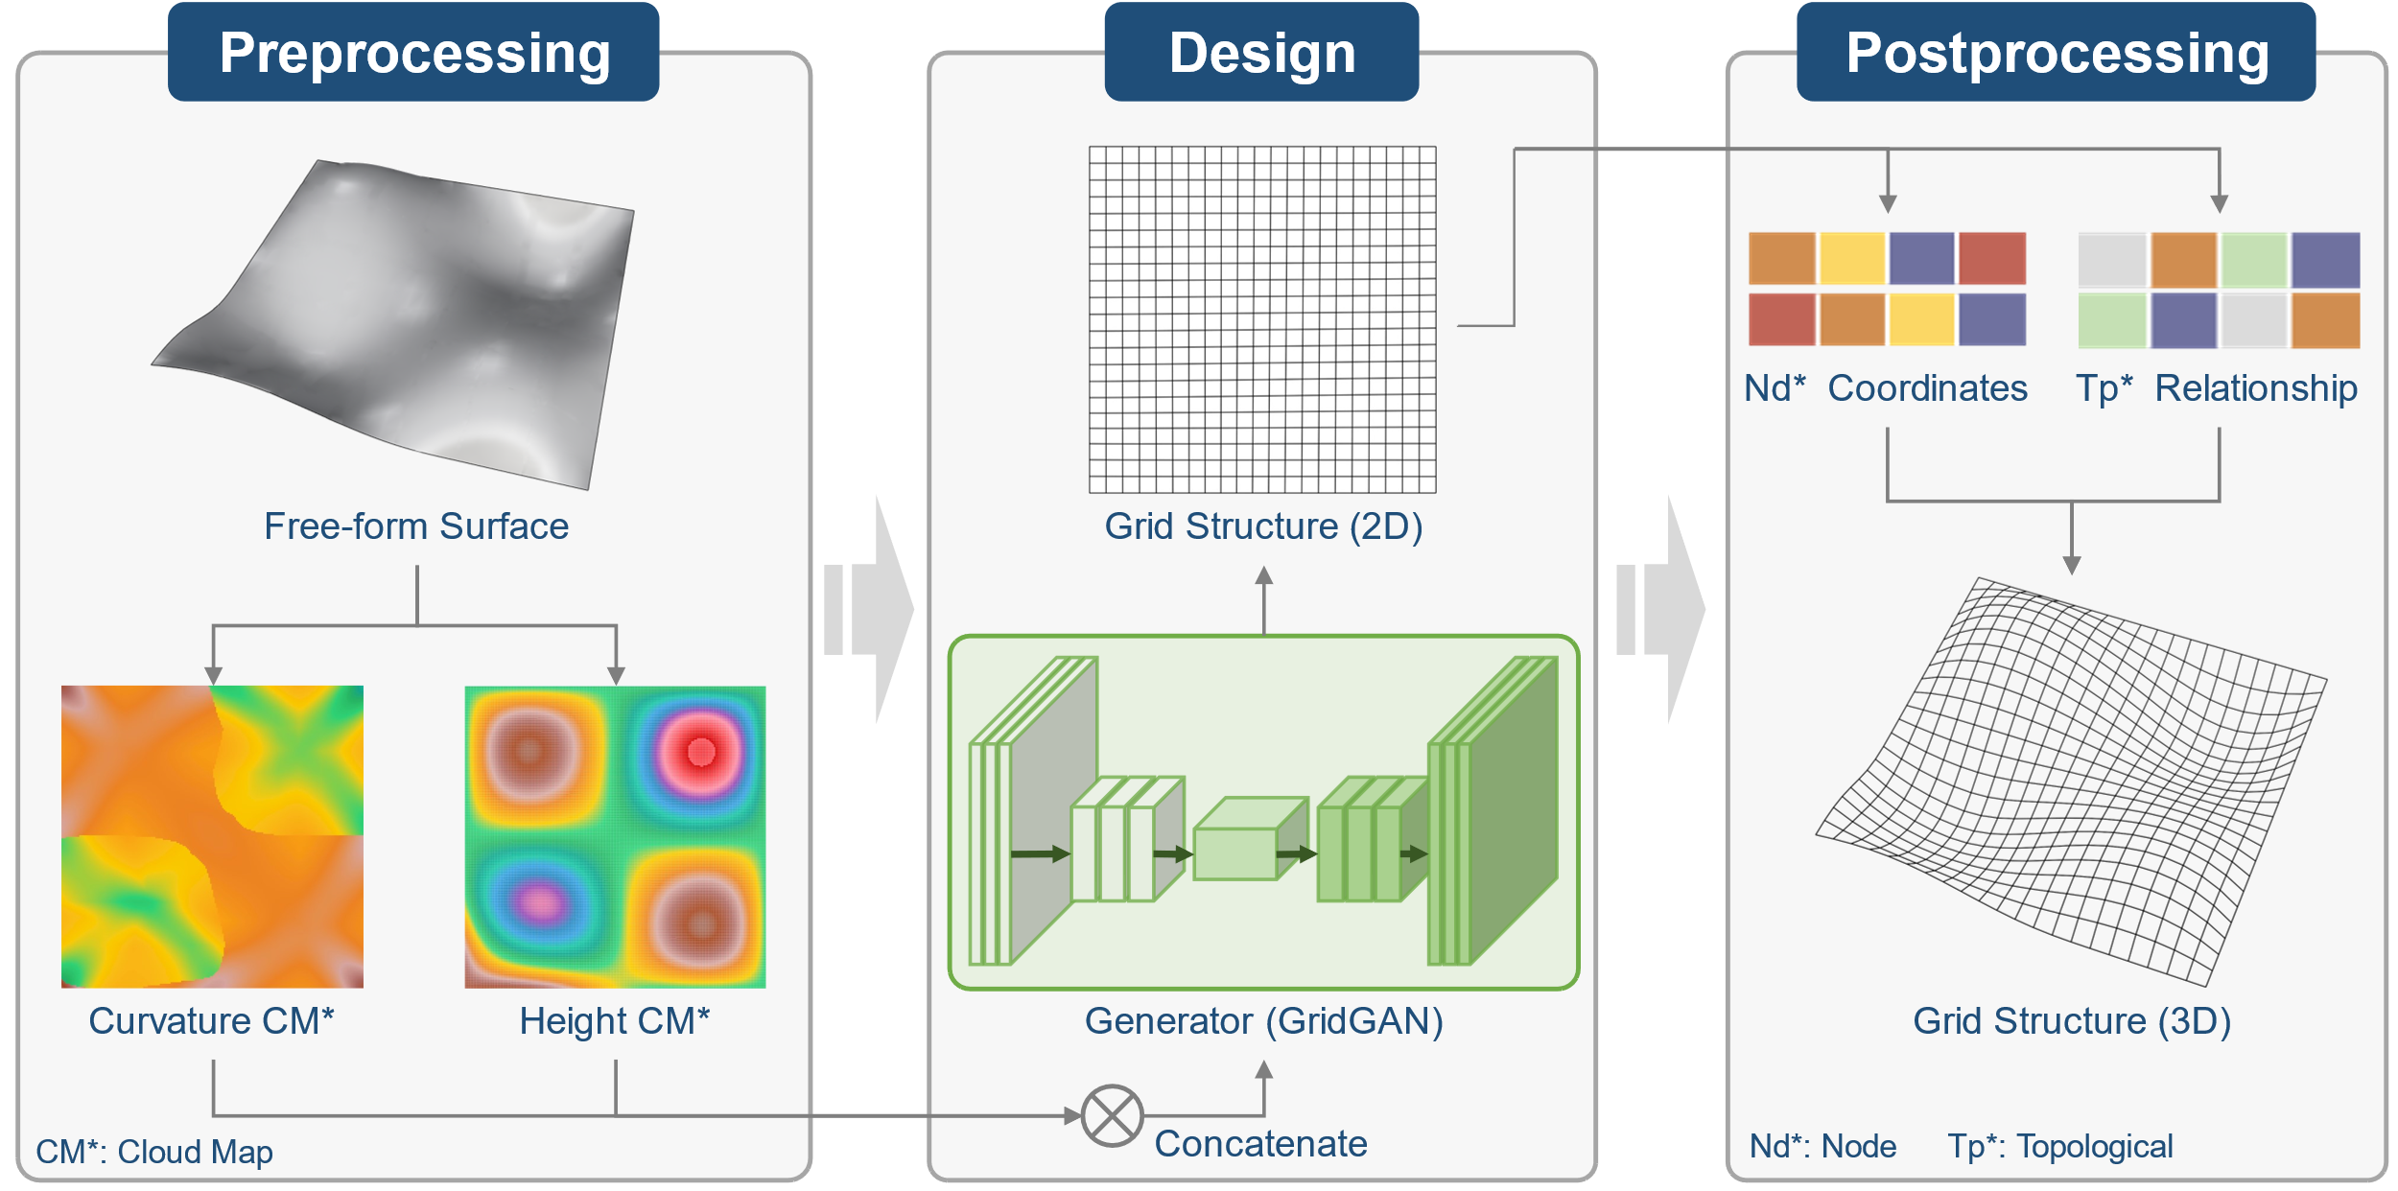
Fig. 1 The schematic diagram depicting the process of generating a free-form grid structure using GridGAN. Preprocessing: preprocessing free-form surface (to transform them from 3D to 2D); Design: generation of the grid structure; Postprocessing: retrieval of the spatial free-form grid structure (from 2D to 3D).

Dataset preparation
For generative neural networks models like GAN, the construction of appropriate training data pairs (model inputs and outputs) and a large amount of training data are crucial prerequisites for model convergence. When referring to proper training data pairs, the focus is on quality, indicating a stronger inherent logical connection between the input and output of the model. Meanwhile, having an abundant volume of training data emphasizes quantity, facilitating the model to extensively unearth various intrinsic logical connections among the data.
The objective of this article is the design of grid partitioning on architectural free-form surfaces. Therefore, the output of the model is the free-form grid structure. Unfortunately, as there has no existing research for reference, it becomes imperative to choose a suitable format as the input for GridGAN carefully. In the realm of differential geometry, curvature serves to quantify the local degree of bending of a surface [30,31]. Additionally, the curvature value at a point on the surface remains unchanged regardless of changes in the viewing angle. Concurrently, previous studies have indicated that curvature can effectively describe and reconstruct surfaces [32–35]. We, therefore, posit that curvature, which encompasses the essential geometric properties of surfaces, can be employed as a suitable input for the model. Specifically, the first step involves calculating the curvature values at various locations on the free-form surface and visualizing the curvature of the free-form surface as a curvature cloud map, which serves as the input for GridGAN. Additionally, we suggest including a height cloud map as one of the model inputs to complement the curvature information, for it provides insights into the height changes of surface points. This additional integration serves to enrich the input information of the model, enabling it to capture the geometric characteristics of the surface more comprehensively. Ablation experiments on model inputs can be found in Section 3.2.
For a given series of free-form surfaces, we utilize explicitly coding-orient methods (for instance, [5,36,37]) to perform grid partitioning, and obtain the corresponding grid structure of the free-form surfaces, which are then used as the output for GridGAN in the training state. Note that we refer to the explicitly coding-orient methods as the traditional methods for convenience. Simultaneously, utilizing the provided series of free-form surfaces, we generate the corresponding curvature (specifically, employing the maximum principal curvature) and height cloud maps. The process above mainly encompasses surface partitioning, calculation of the maximum principal curvature (or height), and data visualization (Fig. 2). For details on creating curvature and height cloud maps for free-form surfaces, see Appendix A and visit https://github.com/GeneralHou/OA_GridGAN/ for dataset usage in the model.
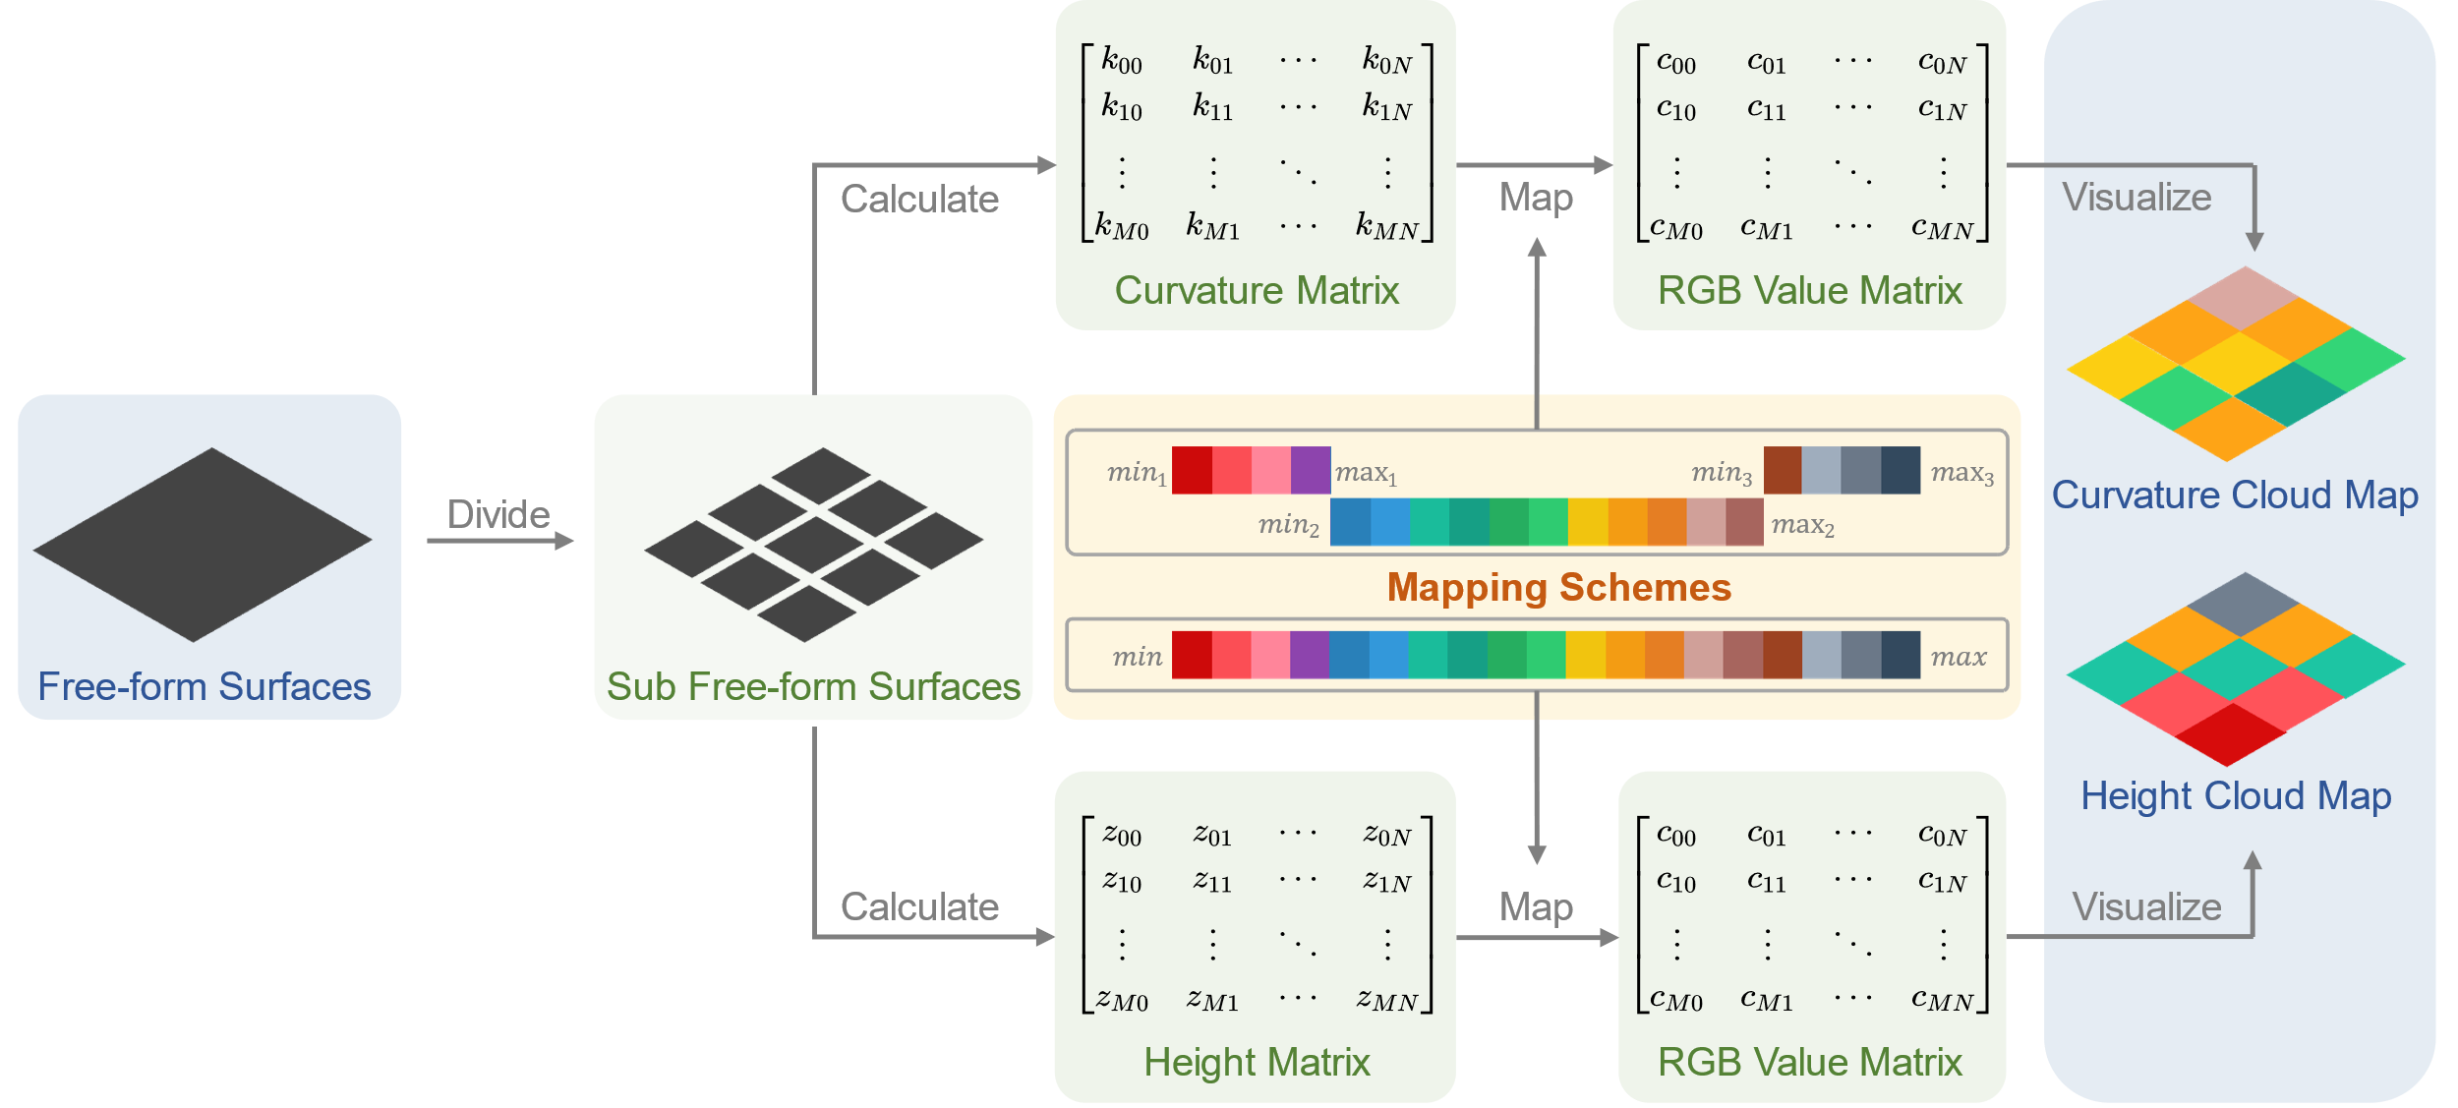
Fig. 2 Illustration depicting the procedural generation of curvature and height cloud maps.
The insufficiency of training data is a common challenge and obstacle faced by different scientific fields when adopting data-driven methods, which rely heavily on large-scale datasets [26,38–40]. Acquiring authentic engineering drawings for free-form grid design is challenging due to practical constraints (such as commercial confidentiality). Moreover, even if the design drawings for free-form surfaces and grid partitioning are available, the quantity of such drawings is insufficient for training neural networks. To tackle the issue of inadequate training data and the scarcity of data sources, A three-step approach is adopted to obtain the ultimate training and testing datasets for GridGAN. To begin with, a preliminary set of 15 free-form surfaces with significant variations in shape is constructed. Owing to the lack of explicit categorization criteria (especially from a visual standpoint) for free-form surfaces, we introduce two approaches for developing diverse free-form surfaces: firstly, generating new free-form surfaces by modifying their outlines (from the top-down point of view); and secondly, for a given free-form surface, the variation in its shape is achieved by manipulating the control points of the surface. Simultaneously, it is crucial to ensure that the height variation—the difference between the highest and lowest surface points after the operation—falls within the 10 to 25-meter range. This height variation constraint is based on the height differences observed in real-world architectures with free-form surfaces. Following the way above for the construction of free-form surfaces, geometric shape transformations are subsequently applied for each surface in this series, generating 20 derived free-form surfaces. As a result, a total of 300 different free-form surfaces are obtained (alongside their corresponding curvature and height cloud maps). In the second step, an explicitly coding grid partitioning method (the equal chord length method from [36], if not specified, is the default method) is utilized to perform grid partitioning on the aforementioned 300 free-form surfaces, and address the difficulty of obtaining real engineering design drawings for free-form grid design. The third step involves adopting data augmentation techniques commonly used in computer vision to augment the dataset size (Fig. 3, steps are elaborated in the following paragraph).
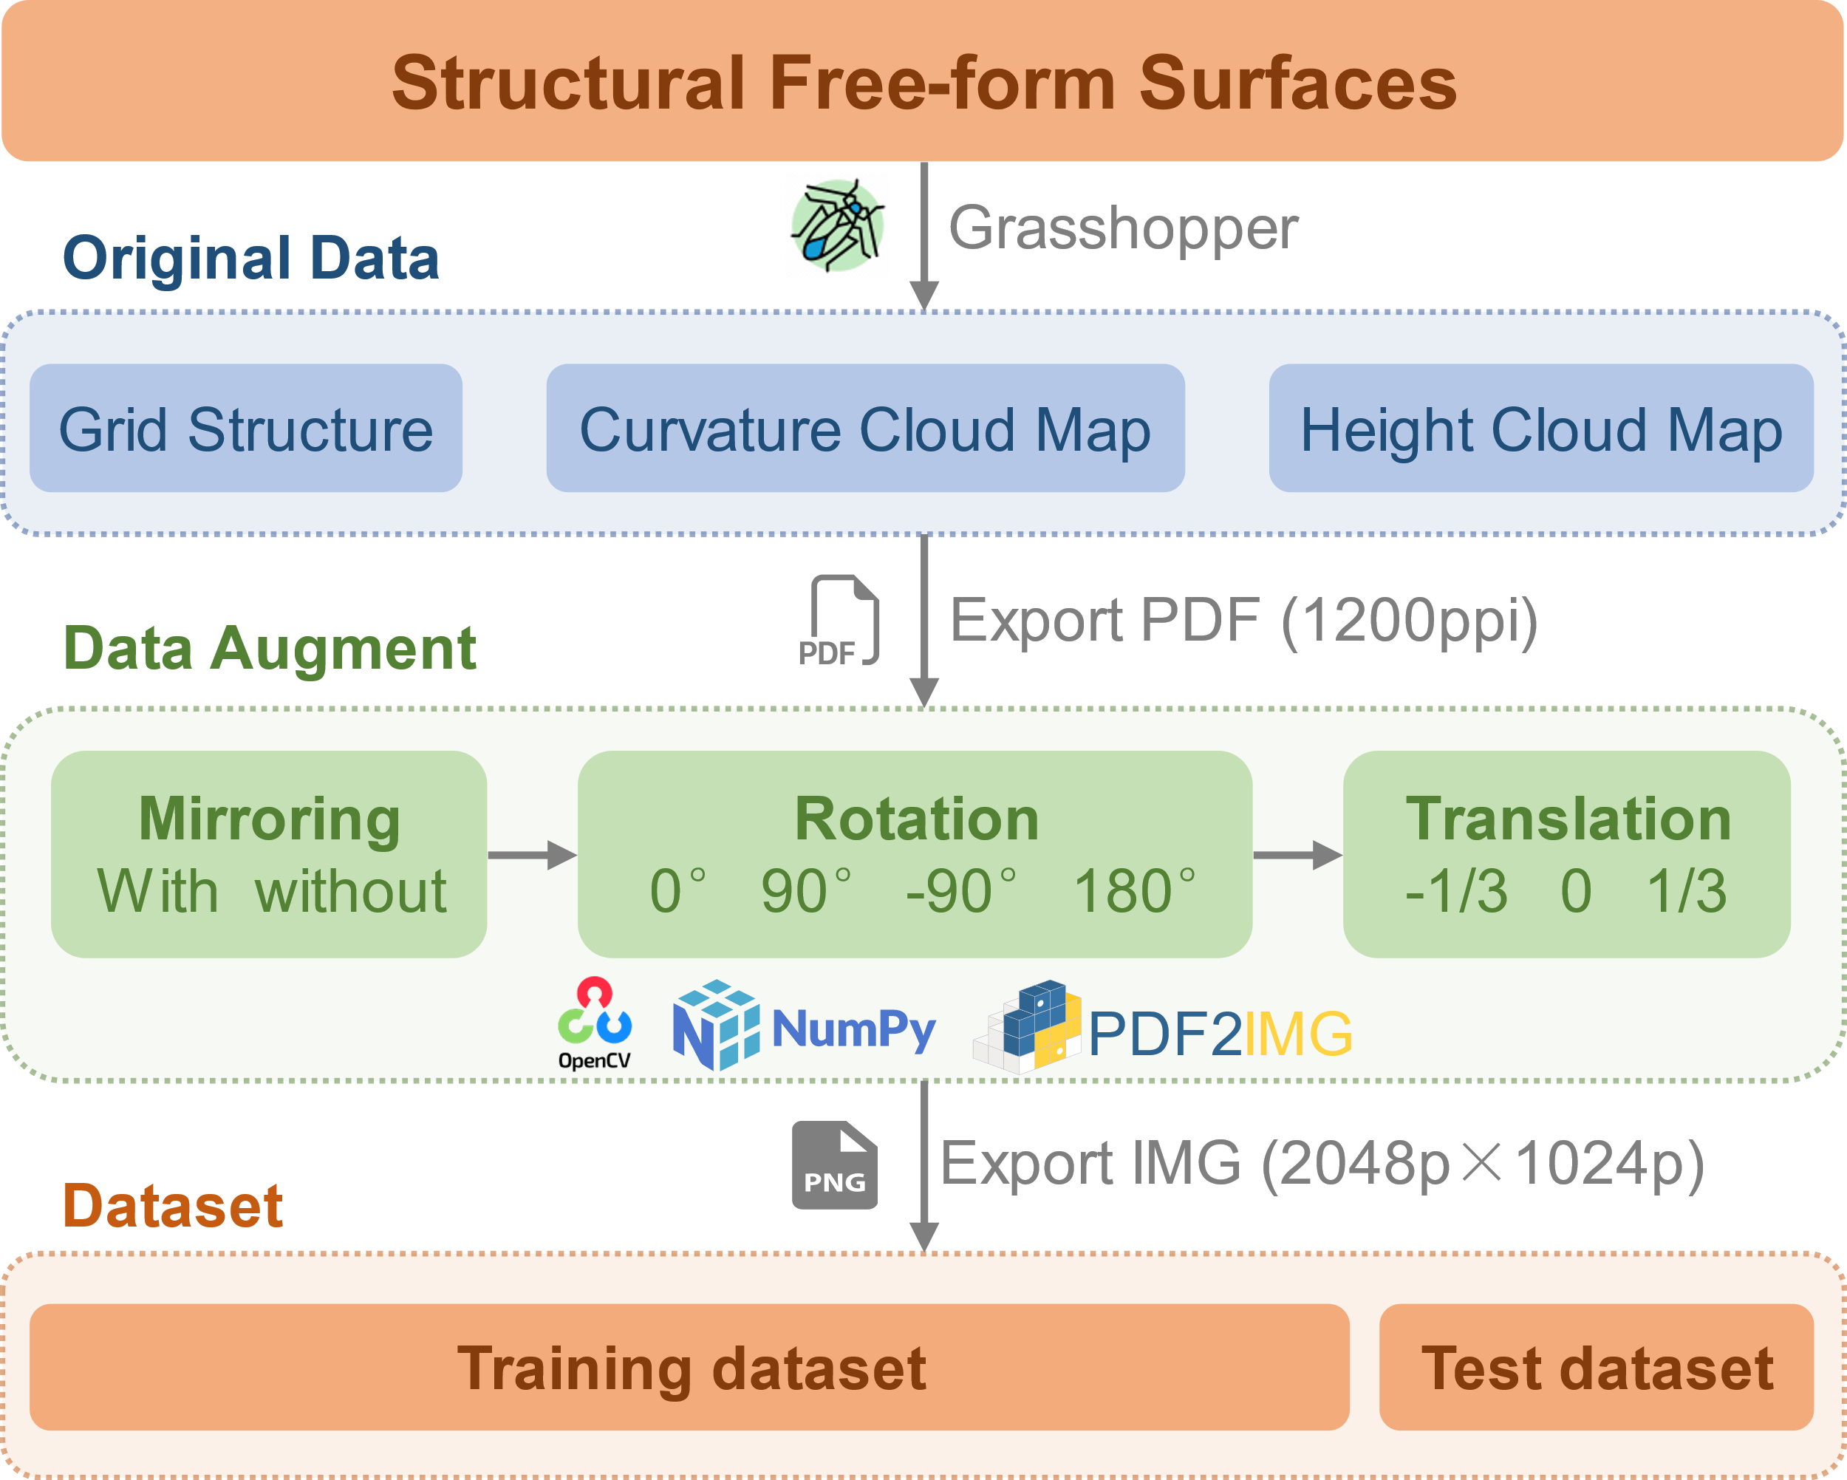
Fig. 3 Schematic of the data augmentation process.
Data augmentation techniques are applied to augment the dataset, thereby increasing the amount of data available for model training. After the completion of the initial dataset consisting of 300 samples, it is partitioned into training and testing sets in a proportion—15 samples are randomly chosen as the testing set, with each sample derived from one of the 15 basic free-form, and the remaining are allocated to the training set. The initial data is exported in PDF format, with the export resolution set to 1200 PPI. The viewpoint for the architectural free-form grid structures, curvature cloud maps, and height cloud maps are set to a top-down perspective to ensure consistent scaling and positioning of the architectural free-form surfaces across the three images. Then, the self-developed Python codes are employed to augment the training set. The code executes mirroring (with/without horizontal flip), rotation (with four different degrees: 0°, 90°, -90°, and 180°), and translation (horizontal displacement with distances: -1/3, 0, and 1/3 of the surface width) operations on each set of grid structure images, curvature cloud maps, and height cloud maps. The dataset size for model training is increased to 6840 samples following the data augmentation. Finally, the augmented images are saved in the .png format with a resolution of 2048 p × 1024 p.

GridGAN model
Once the preparation of the model training dataset is finished, it can be utilized to train the GAN model. Whereas, the dataset generated in Section 2.1 cannot be directly employed to train pix2pixHD, for it does not support the simultaneous use of two images as inputs [23]. Hence, it is necessary to modify pix2pixHD, and we name the modified version as GridGAN. The main differences between GridGAN and pix2pixHD lie in the generator and discriminator components, as depicted in Fig. 4. In GridGAN, the generator incorporates an additional image input interface to the existing single-image input. It merges the intrinsic information from the curvature and height cloud maps modules by concatenating them through the color channels, thereby blending the inherent information from both images. The modifications to the discriminator, meanwhile, involve two parts: applying identical modification methods to both the input interface of the real free-form grid structure image and the input interface of the fake free-form grid structure image generated by the generator. The modification of the discriminator aligns with that of the generator—by adding one more image input interface and concatenating the information of the two images through the color channels.
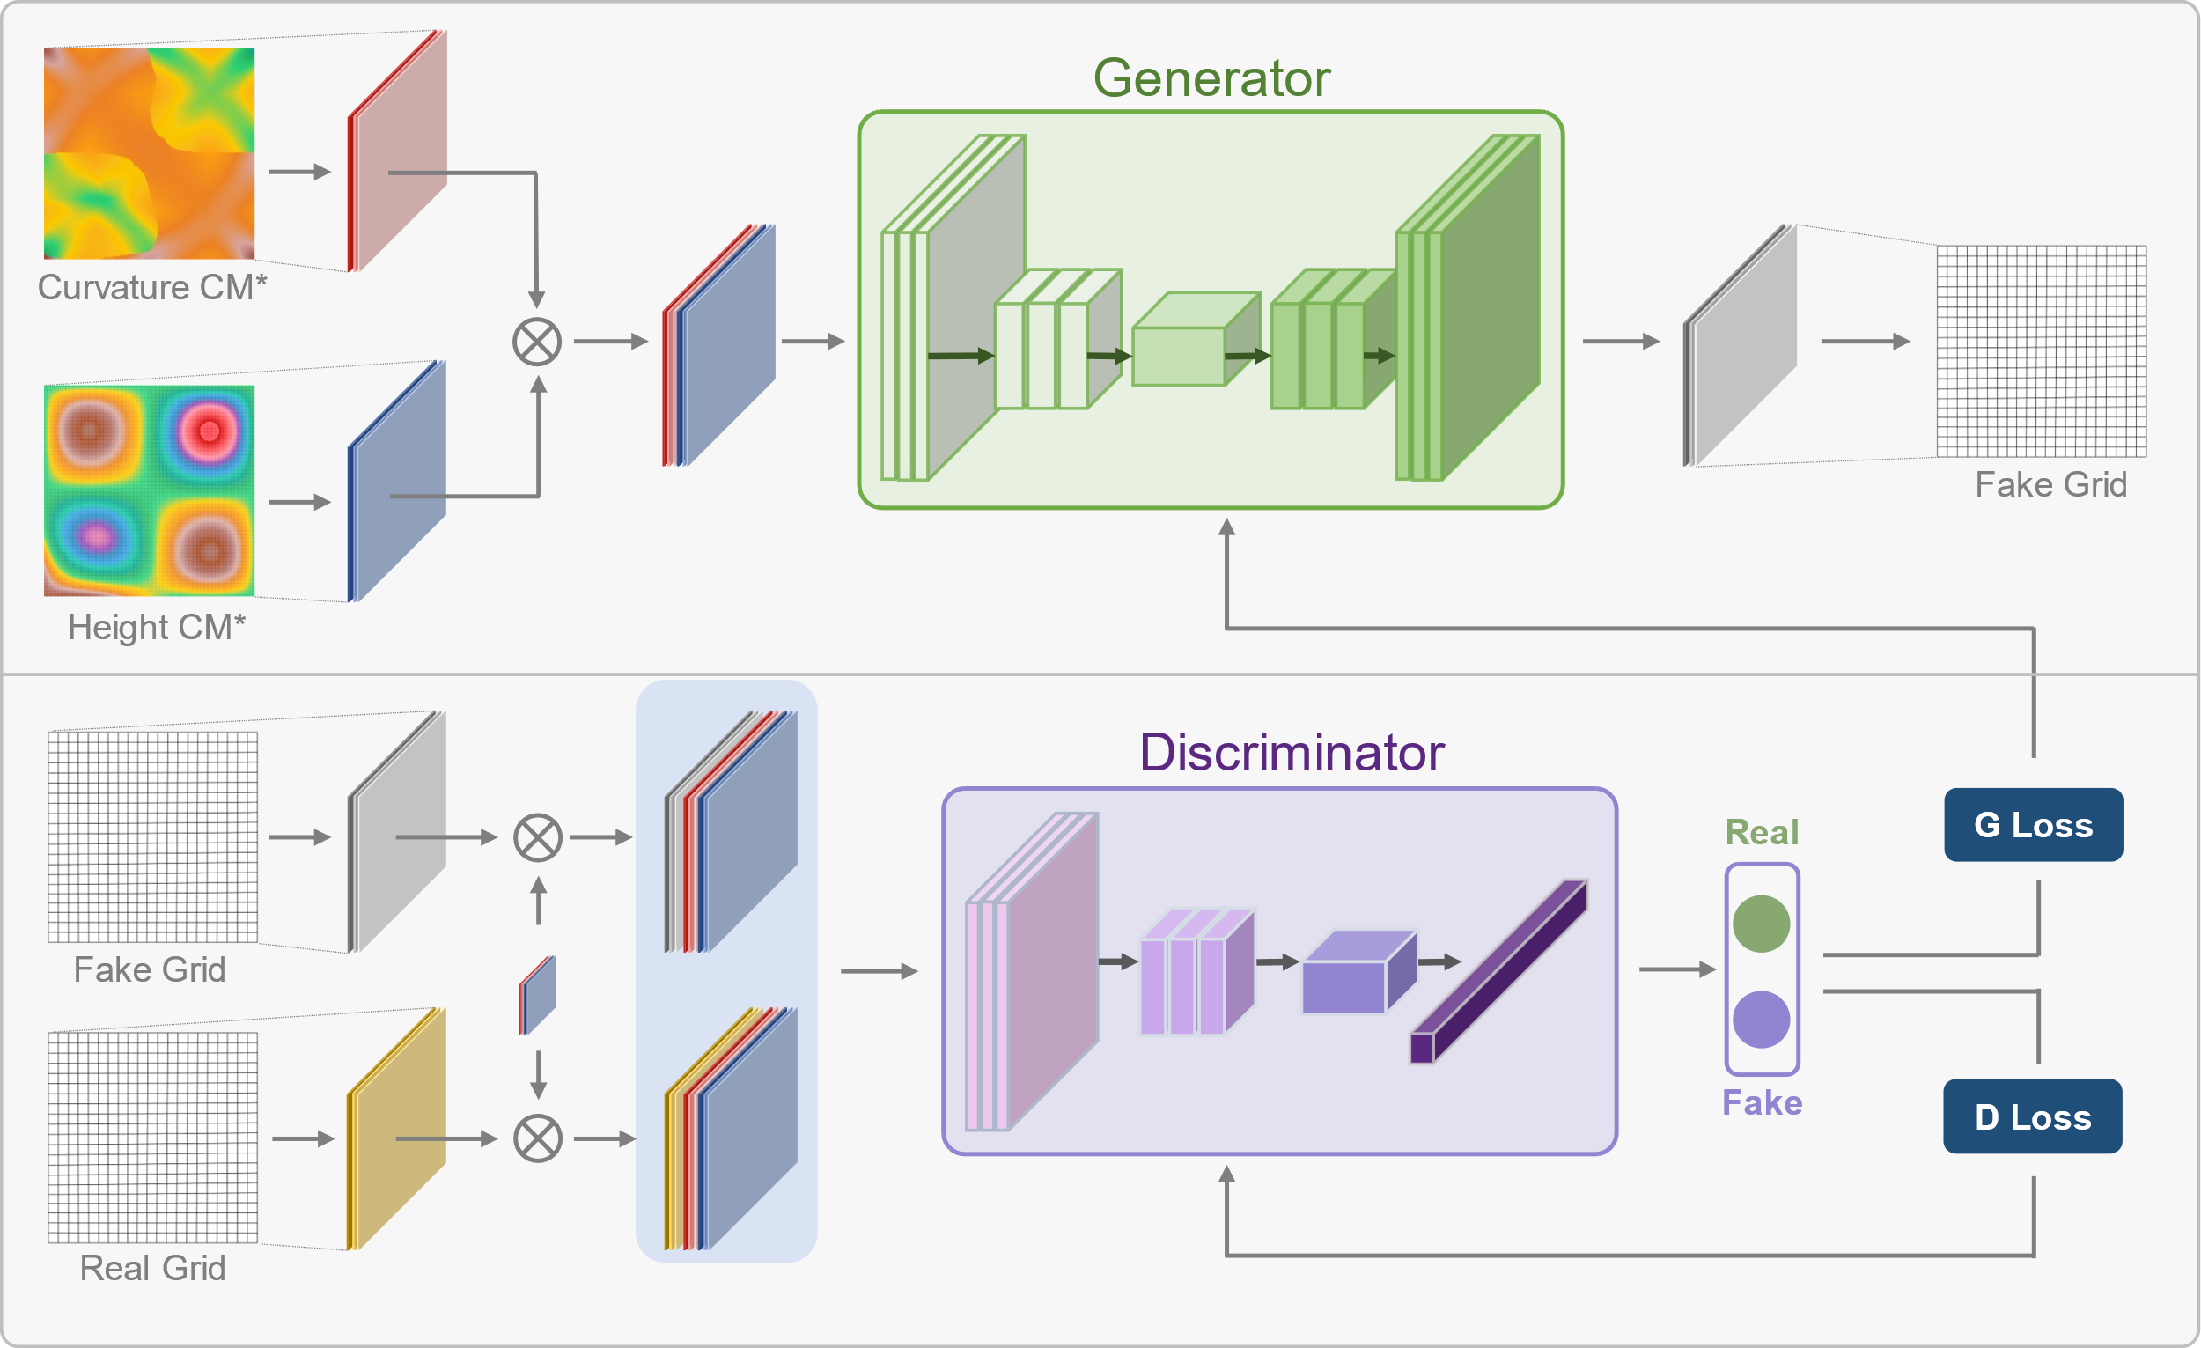
Fig. 4 Schematic of the network structure of GridGAN.
Now, with GridGAN, the improved version of pix2pixHD, aligned with the training database, the training of GridGAN can be conducted. The training process primarily involves adjusting the hyperparameters (such as the learning rate, number of epochs, network layers, and learning rate decay strategies). Nevertheless, almost all the neural network models have numerous hyperparameters, each of which affects the model to a different extent. Therefore, in this study, we refer to [26,27] and carefully select the most critical hyperparameters for analysis, including the learning rate, number of training epochs, and number of layers in the neural network. After the adjustment of hyperparameters, we have obtained the optimal parameter settings as follows: during the initial 50 epochs of training, the initial learning rate is set to $1×{10}^{-4}$ and remains constant, and the learning rate linearly decays to 0 in the subsequent 50 epochs (please refer to Table 1 for detailed information)， and the parameters not specified herein align with those in the original pix2pixHD [23]. Furthermore, we have also performed the same model modifications on the conventional GAN (pix2pix [25] and cycleGAN [41]), and the model hyperparameters have been set identical to GridGAN. Through this, we aim to demonstrate that not all GANs can achieve grid partitioning design for architectural free-form surfaces simply through model modifications and hyperparameter optimization. The reasons in detail are provided in Section 3.
Table 1 The hypermeters employed in GridGAN
Hyperparameters types | Values
Batch size | 1
Input number of channels | 3
Input height of channels* | 3
Lambda feature | 10
Load image size | 1024×512
Learning rate | 0.00025
Number of iterations | 50
Number of iterations (decay to zero) | 50
Number of blocks global | 9
Number of downsample global | 4
Note: Input height of channels* is added to incorporate the height cloud map

Data dimension conversion
By utilizing GridGAN, which has undergone rigorous evaluation, the architectural free-form grid structures are obtained by inputting curvature and height cloud maps to the deep learning model. Nevertheless, a challenging problem is how to convert the architectural free-form grid structure image obtained from the deep learning model (two-dimensional structural data) into three-dimensional structural data (the required data format in structural engineering). After analyzing the characteristics of the free-form grid structure, it can be observed that it consists of two essential elements— nodes and the connections between nodes. Therefore, taking it a step further, we transform the problem into acquiring three-dimensional Cartesian coordinate points in space and their interconnections (the topological relationships). To address the problem above, we develop the corresponding Python codes that perform data dimensionality conversion. After obtaining the three-dimensional coordinates and their topological relationships, we can finally get the free-form grid structure in the space domain. We provide a brief overview of the acquisition of grid node coordinates and the extraction of topological relationships between nodes here (please refer to Appendix B for more details, and code implementations are available in the FindCoordinate and Project3dm2Json repositories at https://github.com/GeneralHou).
Firstly, the obtaining of the grid nodes coordinates. Essentially, extracting the grid node coordinates is to locate the coordinates within the free-form grid image generated by GridGAN. We have attempted to write codes to accomplish this task directly, but found that existing algorithmics, such as the classical Harris corner detection [42], struggle to obtain node coordinates efficiently. Furthermore, their capability to extract different forms of free-form surface structures is also limited. To tackle this challenge, we propose leveraging the generation ability of original pix2pixHD to accomplish node labeling tasks that cannot be effectively performed by classical algorithms. We utilize the same training method and parameters as pix2pixHD [23] for our task. The only difference is that we train the pix2pixHD model using our self-built dataset. The input of the model is free-form grid structure images generated by GridGAN, while the output is free-form grid structure images in which the nodes are marked by red pixel dots (as shown in Fig. 5).
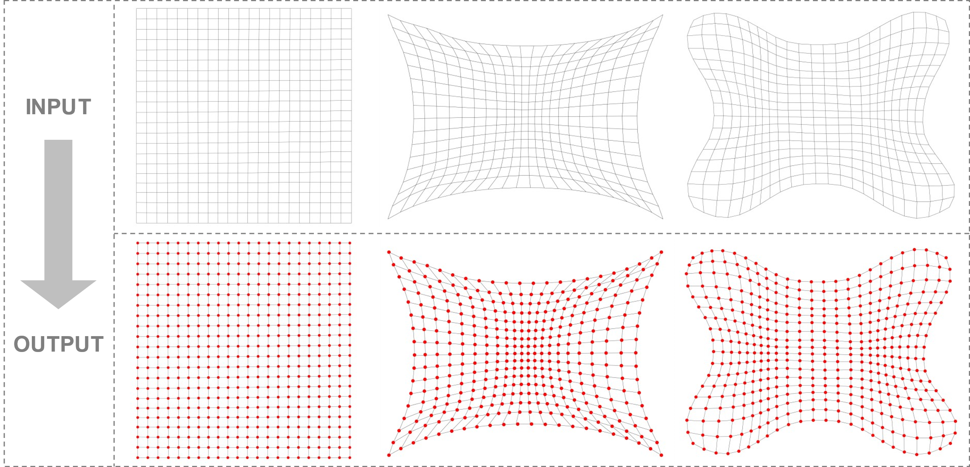
Fig. 5 Grid nodes labeling based on pix2pixHD [23]: the model takes the two-dimensional grid structure image generated by GridGAN as input and produces a labeled grid structure image as output.
The process of extracting grid coordinates involves the following steps: first, input the free-form grid structure image (generated by GridGAN) into the pre-trained pix2pixHD model. This produces a grid image with nodes marked by red dots (Fig. 6a). Then, filter the RGB values to retain only the red pixel dots in the image (Fig. 6b). By using functions like cv2.findContours in OpenCV-Python [43], extract the geometric centers of these red dots. These centers represent the pixel coordinates of the free-form grid structure (Fig. 6b). These pixel coordinates, nevertheless, are the positions of the grid nodes in the image but not their actual coordinates on the real free-form surface. To address this, we extract the corresponding corner points from the 3D real free-form surface and the planar grid structure (Fig. 6c). Using these corner points, we determine the baseline parameters—translation and scaling in x and y directions—to transform the pixel coordinates into planar real coordinates (Fig. 6b).
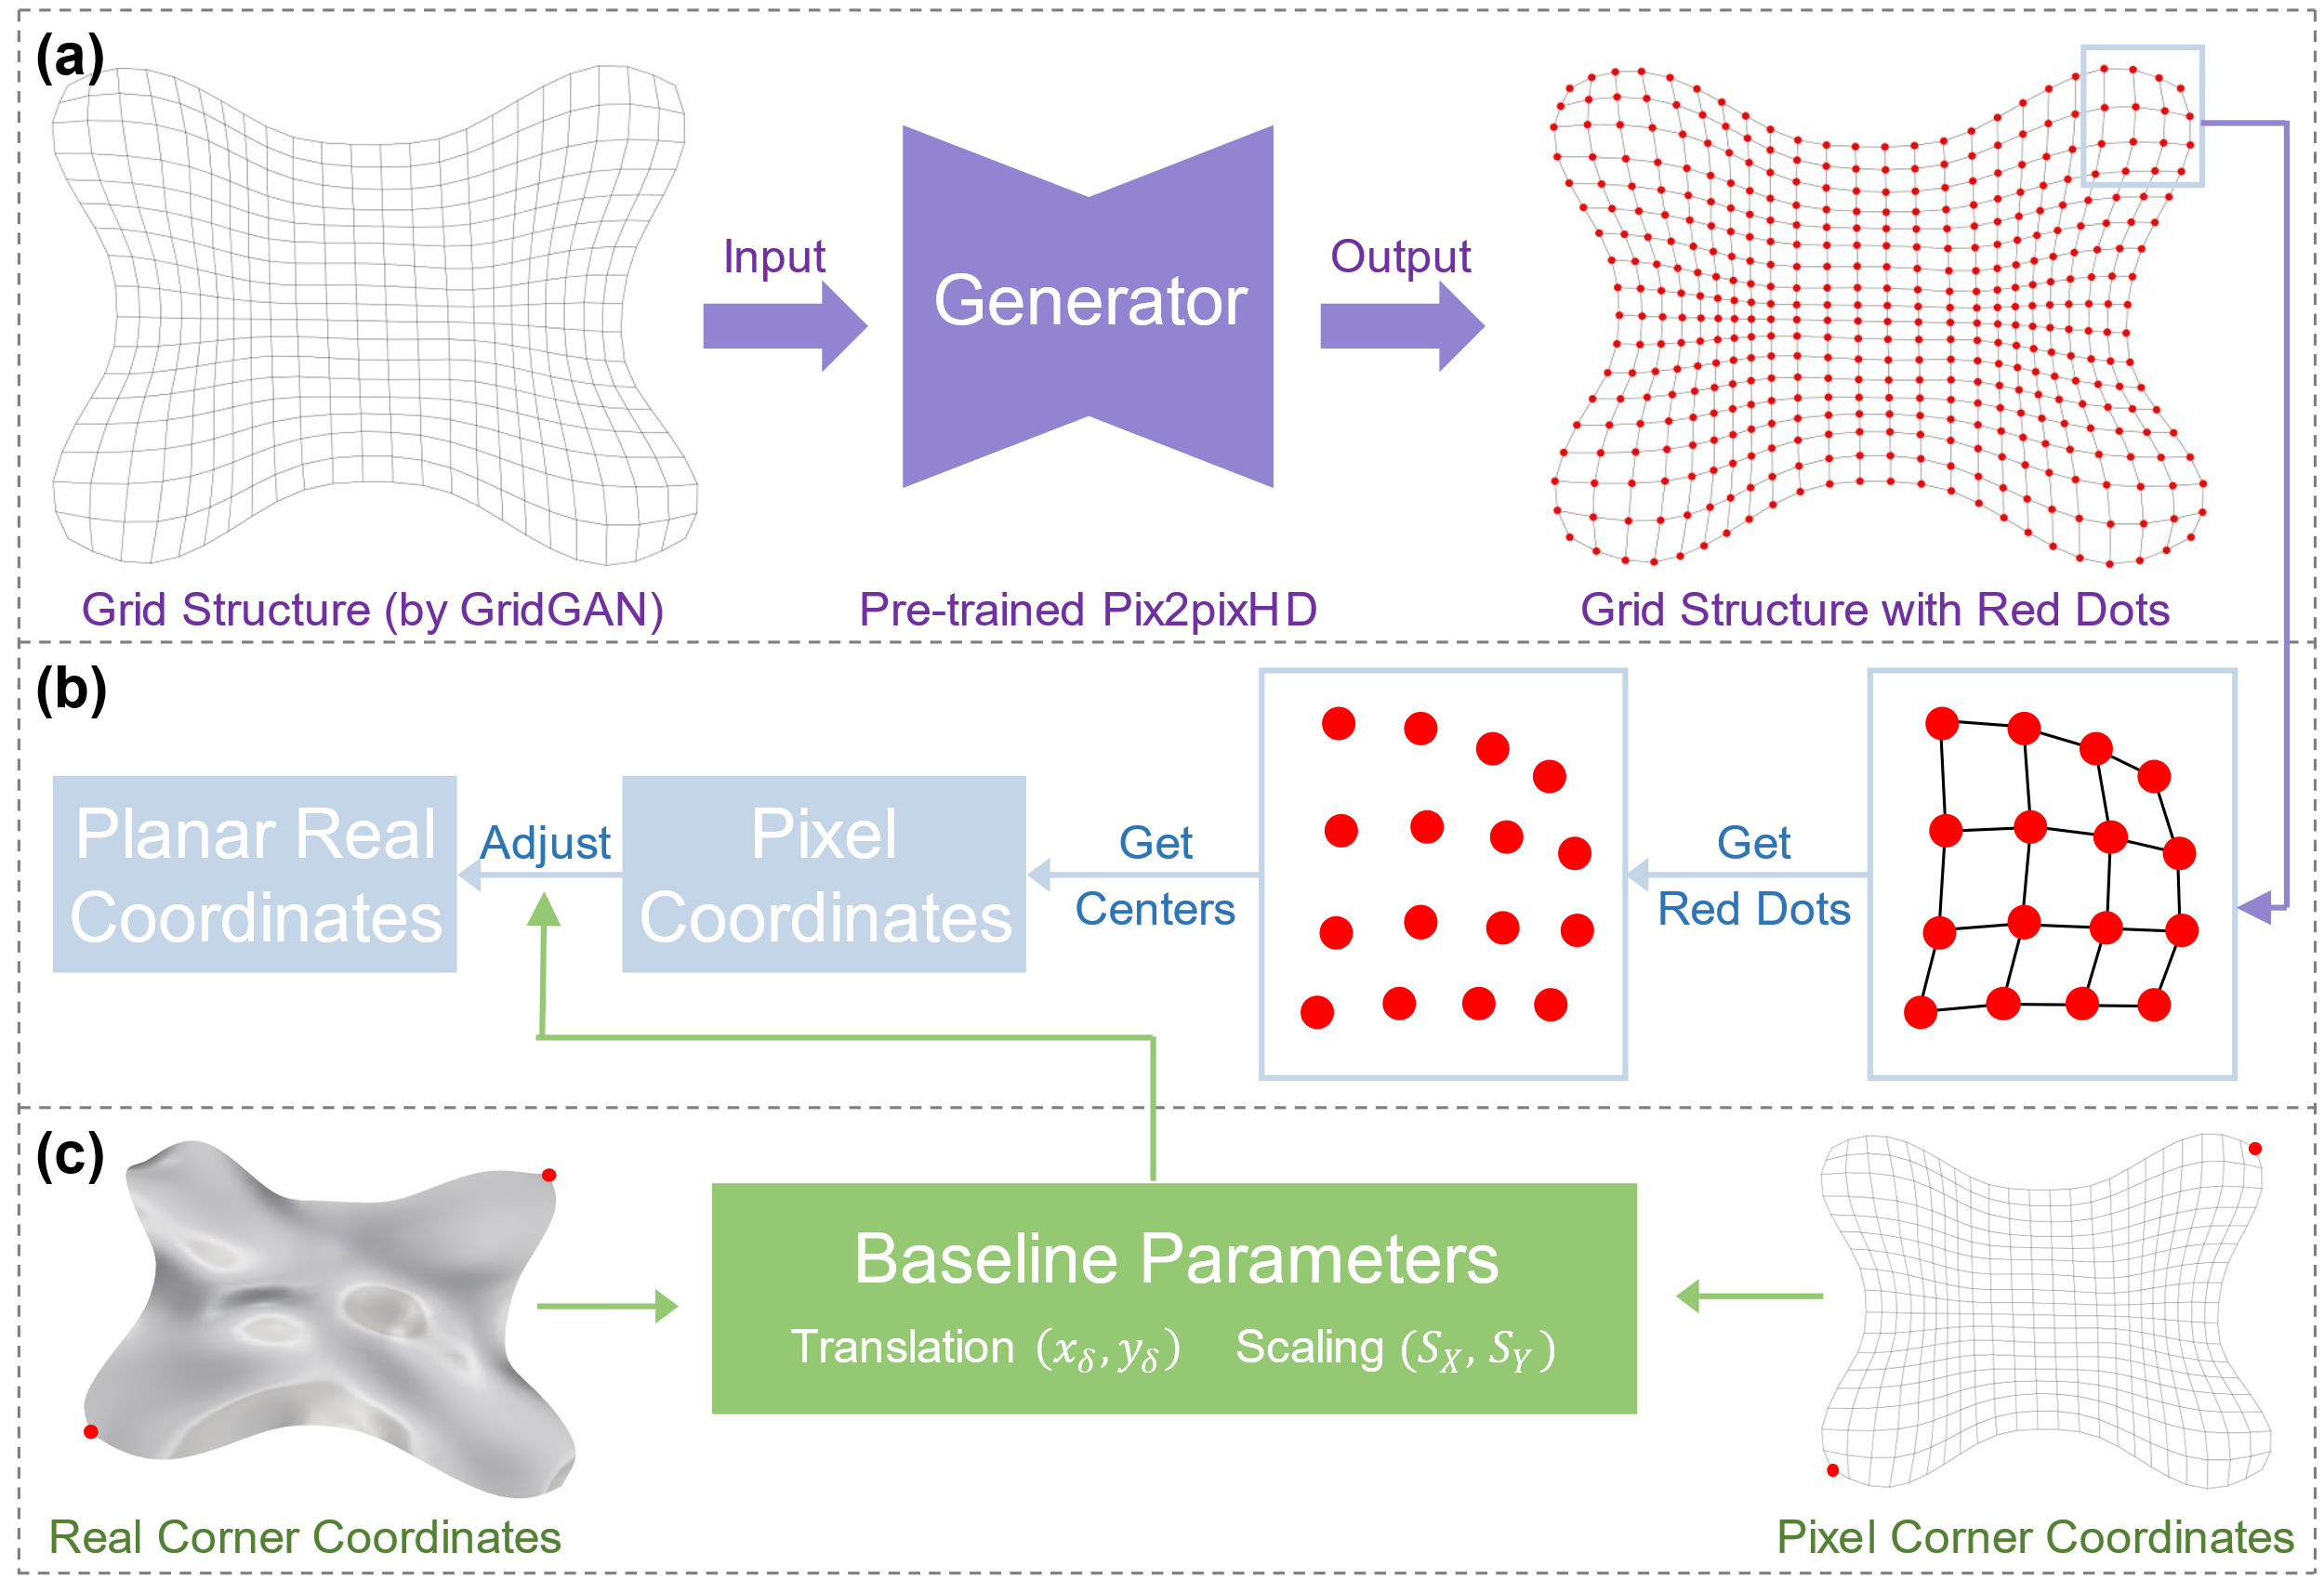
Fig. 6 Acquiring planar node coordinates: (a) Label grid nodes with red dots; (b) Extract planar real coordinates; (c) Calculate baseline parameters for translation and scaling.
Projecting the planar real coordinates onto the actual free-form surface allows us to obtain the 3D coordinates of the grid nodes (Fig. 7a), which are ultimately the ones we seek. Specially, when projecting boundary nodes onto the surface, there may be instances where the projection line from the planar node does not intersect the surface. Hence, we propose the method illustrated in Fig. 7b, in which the planar node is adjusted until it intersects with the surface.
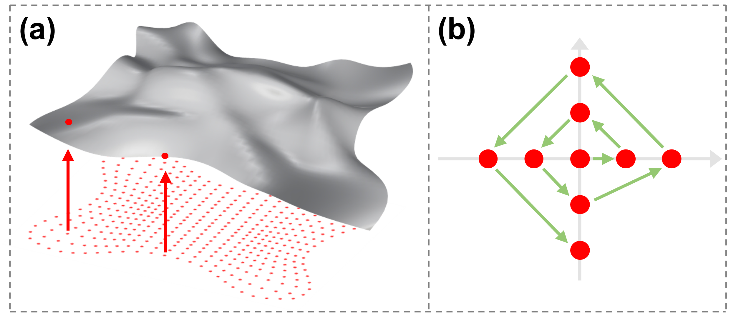
Fig. 7 Node projection: (a) Project planar nodes into three-dimensional space; (b) Adjust the projection of boundary node.
Simultaneously, another crucial step is extracting the topological relationships (Fig. 8). We identify the topological relationships of the nodes based on the pixel coordinates (acquired from Fig. 6b) and the grid structure image with red dots. Initially, we sequentially select a node according to the pixel coordinates (Fig. 8a) and crop out the selected node (Fig. 8b). To determine the number of rods connected to the node, we erase the red pixel dot (Fig. 8c). Then, using cv2.connectedComponentsWithStats from Open-CV-Python[43], we calculate the number of rods (a rod is depicted as a line in the image) connected to the selected node (namely $N_{i}$) and find their geometric centers (Fig. 8d). Lastly, starting from the geometric centers of the rods, we search in the direction away from node $N_{i}$. When we encounter a red pixel, it indicates the connected node (for instance, $N_{j1}$ in Fig. 8e). By applying these operations to all pixel coordinates, we can establish the topological connections of all nodes (Fig. 8f).
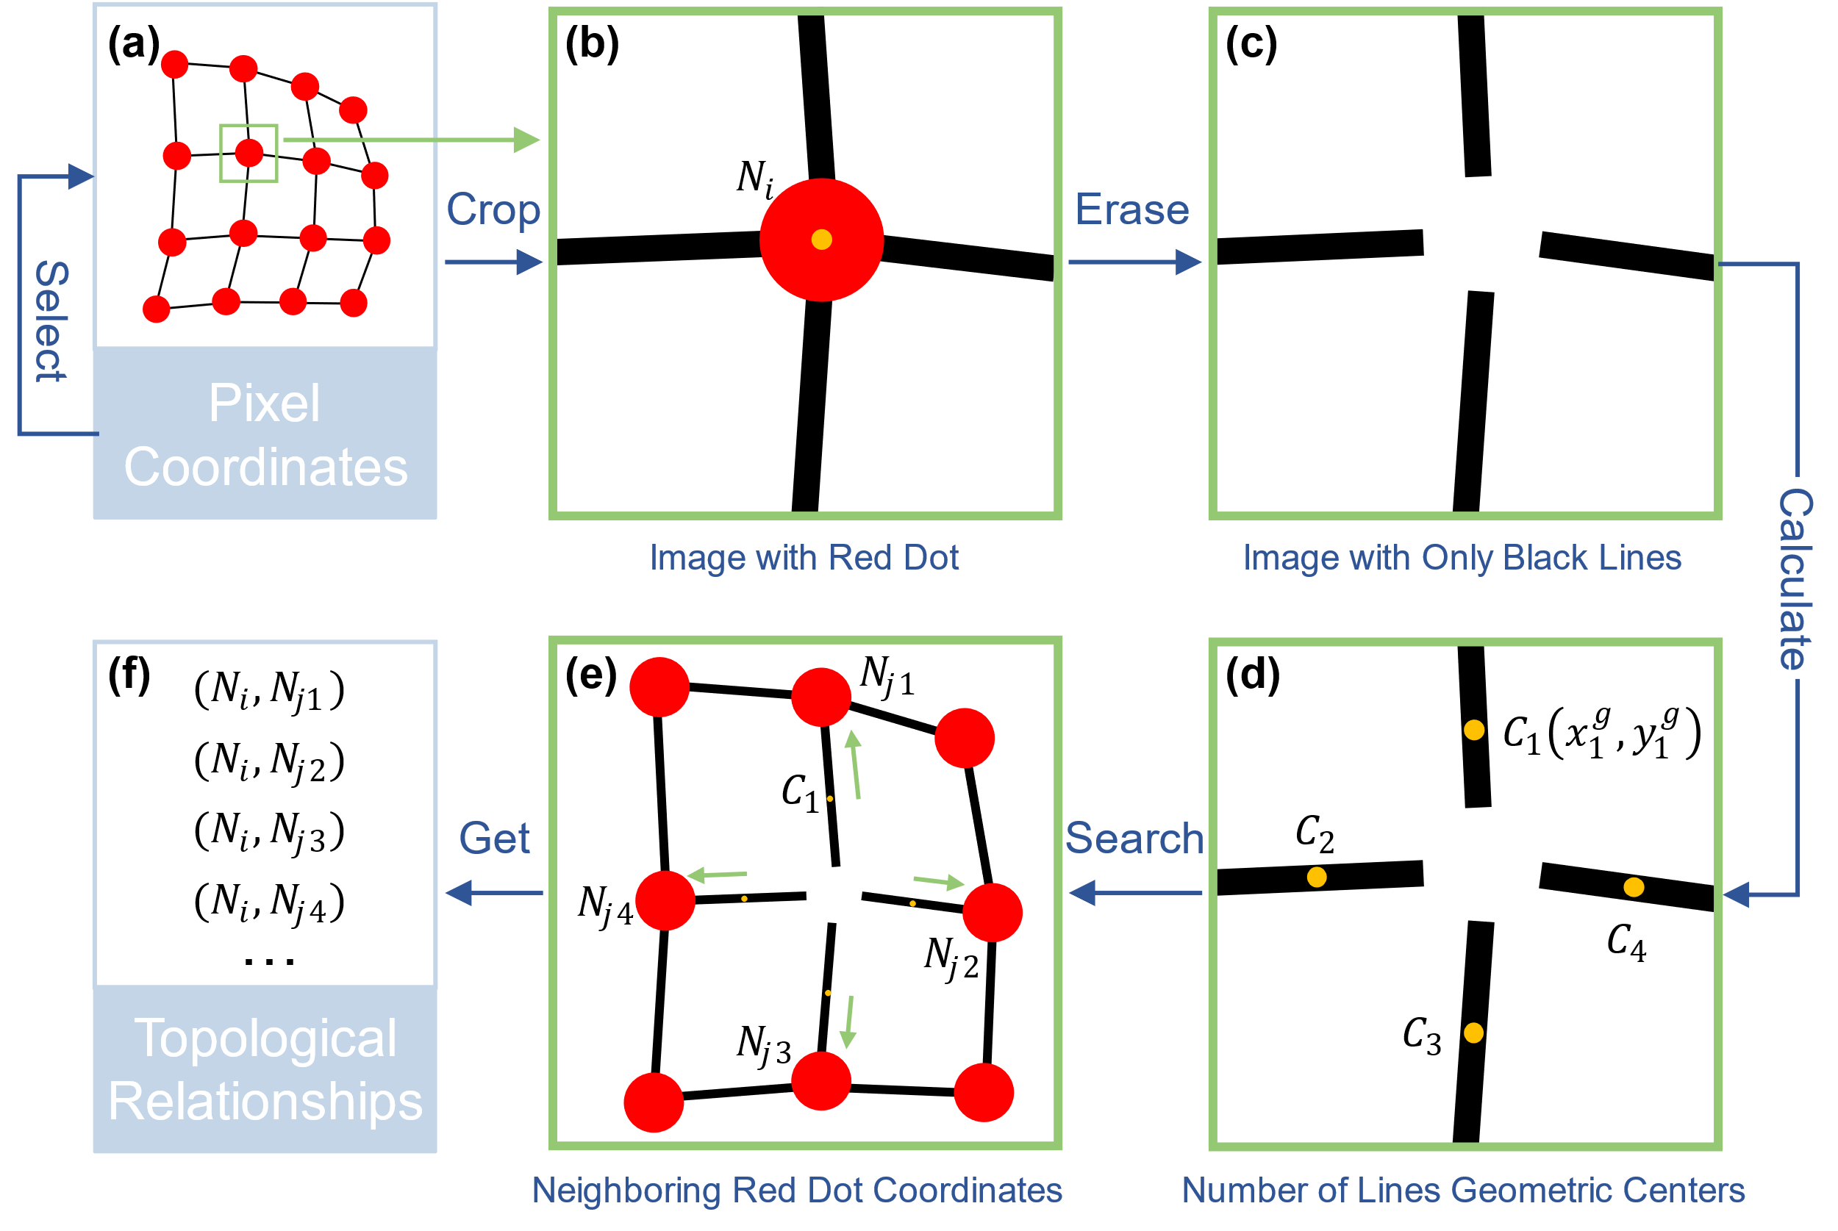
Fig. 8 Node topological relationships extraction.

Evaluation metrics
To adequately assess the quality of the generated free-form grid structure by GridGAN, this study employs four evaluation methods, categorized into three distinct perspectives: expert perception evaluation, computer vision-based evaluation, and geometric properties-based grid (rod length and shape quality factor) evaluation.

Expert perception evaluation
The assessment of human perception serves as a means to subjectively evaluate the results generated by models in computer science [23,25]. Its fundamental rationale lies in the premise that if the model-generated outputs fail to pass the essential assessment of human sensibility, they are inevitably incapable of meeting more stringent quantitative evaluations. Fluent morphology and rational structure are critical aesthetic demands that people have for free-form grid structures. One of the significant evaluation methods used to determine whether these fundamental aesthetic requirements are fulfilled is subjective perception, namely human perception assessment. Drawing inspiration from [23,26], we leverage the perception of engineering experts to evaluate the results generated by free-form grid structures.
Inspired by the methodologies outlined in [23,26], we adopt an analogous experimental procedure. Utilizing online questionnaires, we invite experts (professors, engineers, and graduate students) to evaluate free-form grids generated by both traditional method (explicitly coding-orient method) and AI (here, it is GridGAN). Nevertheless, in contrast, to provide experts with a comprehensive and vivid understanding of the entirety of the generated free-form surfaces, we use videos (rather than merely presenting images) to visually showcase the morphology of the free-form grid structures from diverse perspectives, and set no time limit for questionnaire respondents. The evaluation primarily consists of two questions (the questionnaire template is shown in Fig. 9):
1) Identifying which free-form grid structure is generated by AI;
2) How confident are you in your aforementioned judgments?
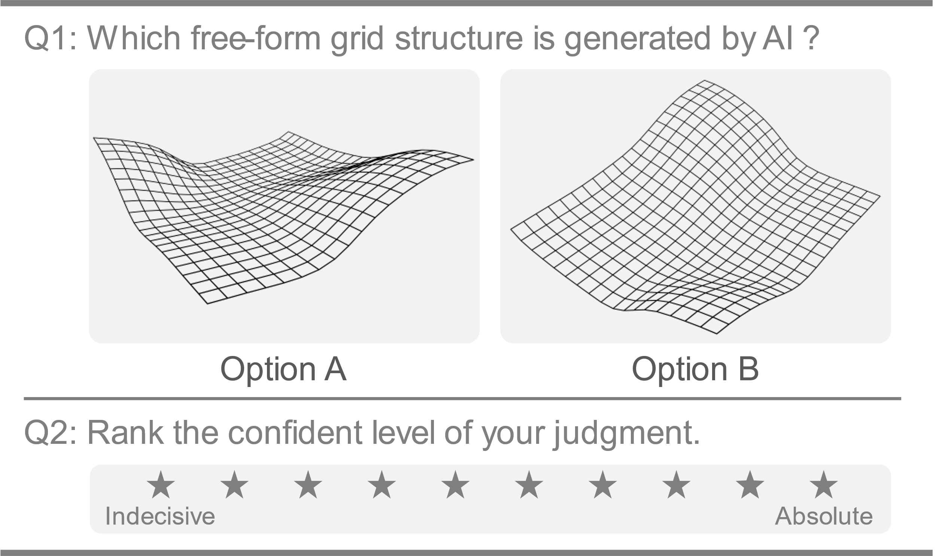
Fig. 9 Questionnaire on the free-form grid structures

Computer version-based evaluation
FID (Fréchet Inception Distance) is a metric used to assess the similarity between two sets of images based on the statistical characteristics of their computer vision features. It quantifies the distance between feature vectors of real and generated images to measure their similarity, and therefore is commonly used to assess the quality of images generated by GAN [2,3]. A lower FID score signifies a higher level of quality in the images generated by GAN. Furthermore, when the FID score reaches its minimum value of 0, it denotes complete equivalence between the two sets of images. We also incorporate FID to evaluate the generated free-form grid structures by GridGAN from a computer vision perspective. The formula for FID is
 | $$\text{FID}\left(x,y\right)=∥w-w_{w}∥_{2}^{2}+Tr\left(C+C_{w}-2\sqrt{CC_{w}}\right)$$ | (1)
where x represents the real free-form grid image, while y denotes the free-form grid image generated by GridGAN; w and w_{w} denote the mean vectors of the real free-form grid image, x, and the generated free-form grid image by GridGAN, y, respectively; Tr is the trace of a matrix; C and C_{w} represent the covariance matrices of x and y, respectively.

Geometric attribute-based evaluation
Elongated or distorted grids, for free-form grid structures, diminish the structural load-bearing performance and hinder the construction processes due to excessively small angles between rods. Existing methods for evaluating the uniformity of free-form grid structures include various approaches, such as rod length evaluation, shape quality evaluation, and smoothness evaluation [5,6,44]. Rod length and shape quality evaluations are adopted to evaluate the grid structures in our study.
As the basic units comprising the grid structure, the lengths of the rods should be as uniform as possible and close to the desired target length [5,44]. Additionally, the number of rod types should be minimized to facilitate subsequent production and construction processes [5,44]. Therefore, this study adopts the mean rod length $\overline{L}$, Eq. (2), and the mean square deviation of rod length δ_{L}, Eq. (3), to evaluate the lengths of rods. Here, n denotes the total number of rods, whereas L_{i} signifies the length of the i-th rod.
 | $$\overline{L}=\frac{1}{n}\sum_{i=1}^{n}{L_{i}}$$ | (2)
 | $$δ_{L}=\sqrt{\frac{1}{n-1}\sum_{i=1}^{n}{{\left(L_{i}-\overline{L}\right)}^{2}}}$$ | (3)
The shape quality factor of a grid element is used to evaluate the regularity of a free-form grid structure [44]. The shape quality factor for an individual quadrilateral grid element is
 | $$q=4\sqrt[4]{\frac{S_{△ABC}⋅S_{△ADC}⋅S_{△ADB}⋅S_{△CBD}}{\left({\left|AB\right|}^{2}+{\left|BC\right|}^{2}\right)\left({\left|AD\right|}^{2}+{\left|CD\right|}^{2}\right)\left({\left|AB\right|}^{2}+{\left|AD\right|}^{2}\right)\left({\left|BC\right|}^{2}+{\left|CD\right|}^{2}\right)}}$$ | (4)
where A, B, C, and D represent the four vertices of the quadrilateral. $S_{ΔABC}$, $S_{ΔADC}$, $S_{ΔADB}$ and $S_{ΔCBD}$ denote the areas of any three triangles formed by the four vertices of the quadrilateral. |AB|, |BC|, |CD|, and |AD| are the lengths of the four sides of the quadrilateral grid element. The value of q lies within the range of q ∈ (0, 1], and a higher value of q indicates the better shape quality of the grid element. When the quadrilateral grid is a perfect square, q equals 1; conversely, when q equals 0, the quadrilateral degenerates into a triangle. Calculate the shape quality factor q for all quadrilateral elements constituting the grid structure, and calculate the mean $\overline{q}$ and mean square deviation $δ_{q}$ of q. Refer to Eqs. (5) and (6) to calculate $\overline{q}$ and $δ_{q}$, respectively—m denotes the number of quadrilateral grid elements, and $q_{i}$ denotes the shape quality factor of the i-th quadrilateral grid element. If the mean of the shape quality factor for quadrilateral grids is higher and the mean square deviation is lower, it indicates a more regular shape of the free-form grid structure.
 | $$\overline{q}=\frac{1}{m}\sum_{i=1}^{m}{q_{i}}$$ | (5)
 | $$δ_{q}=\sqrt{\frac{1}{m-1}\sum_{i=1}^{m}{{\left(q_{i}-\overline{q}\right)}^{2}}}$$ | (6)

Models discussion

Model selection
The Generative Adversarial Networks (GAN) is a broad concept that encompasses various related models derived from the original GAN proposed by Ian J. Goodfellow [20], such as AttentionGAN [45], MSG-GAN [46], pix2pix [25], pix2pixHD [23], and CycleGAN [41]. This section aims to elucidate two crucial points: firstly, not all GANs are suitable for structural design tasks; and secondly, even when using the same model for different datasets, hyperparameters tuning is imperative to ensure compatibility with the new task. To this end, we select pix2pix [25], pix2pixHD [23], and CycleGAN [41] for model comparison and explain the rationale behind ultimately choosing pix2pixHD (as GridGAN is based on this model).
Pix2pix, pix2pixHD (renamed as GridGAN after modification), and CycleGAN represent three diverse variations of the same series of GANs. We train these three models using the dataset created in Section 2.1, intending to achieve optimal performance for each model through hyperparameter tuning. The partial training results for each model are shown in Fig. 10. Furthermore, to perform a quantitative assessment, we calculated the FID scores for the pix2pix, GridGAN, and CycleGAN models, and the comparative results are presented in Fig. 11.
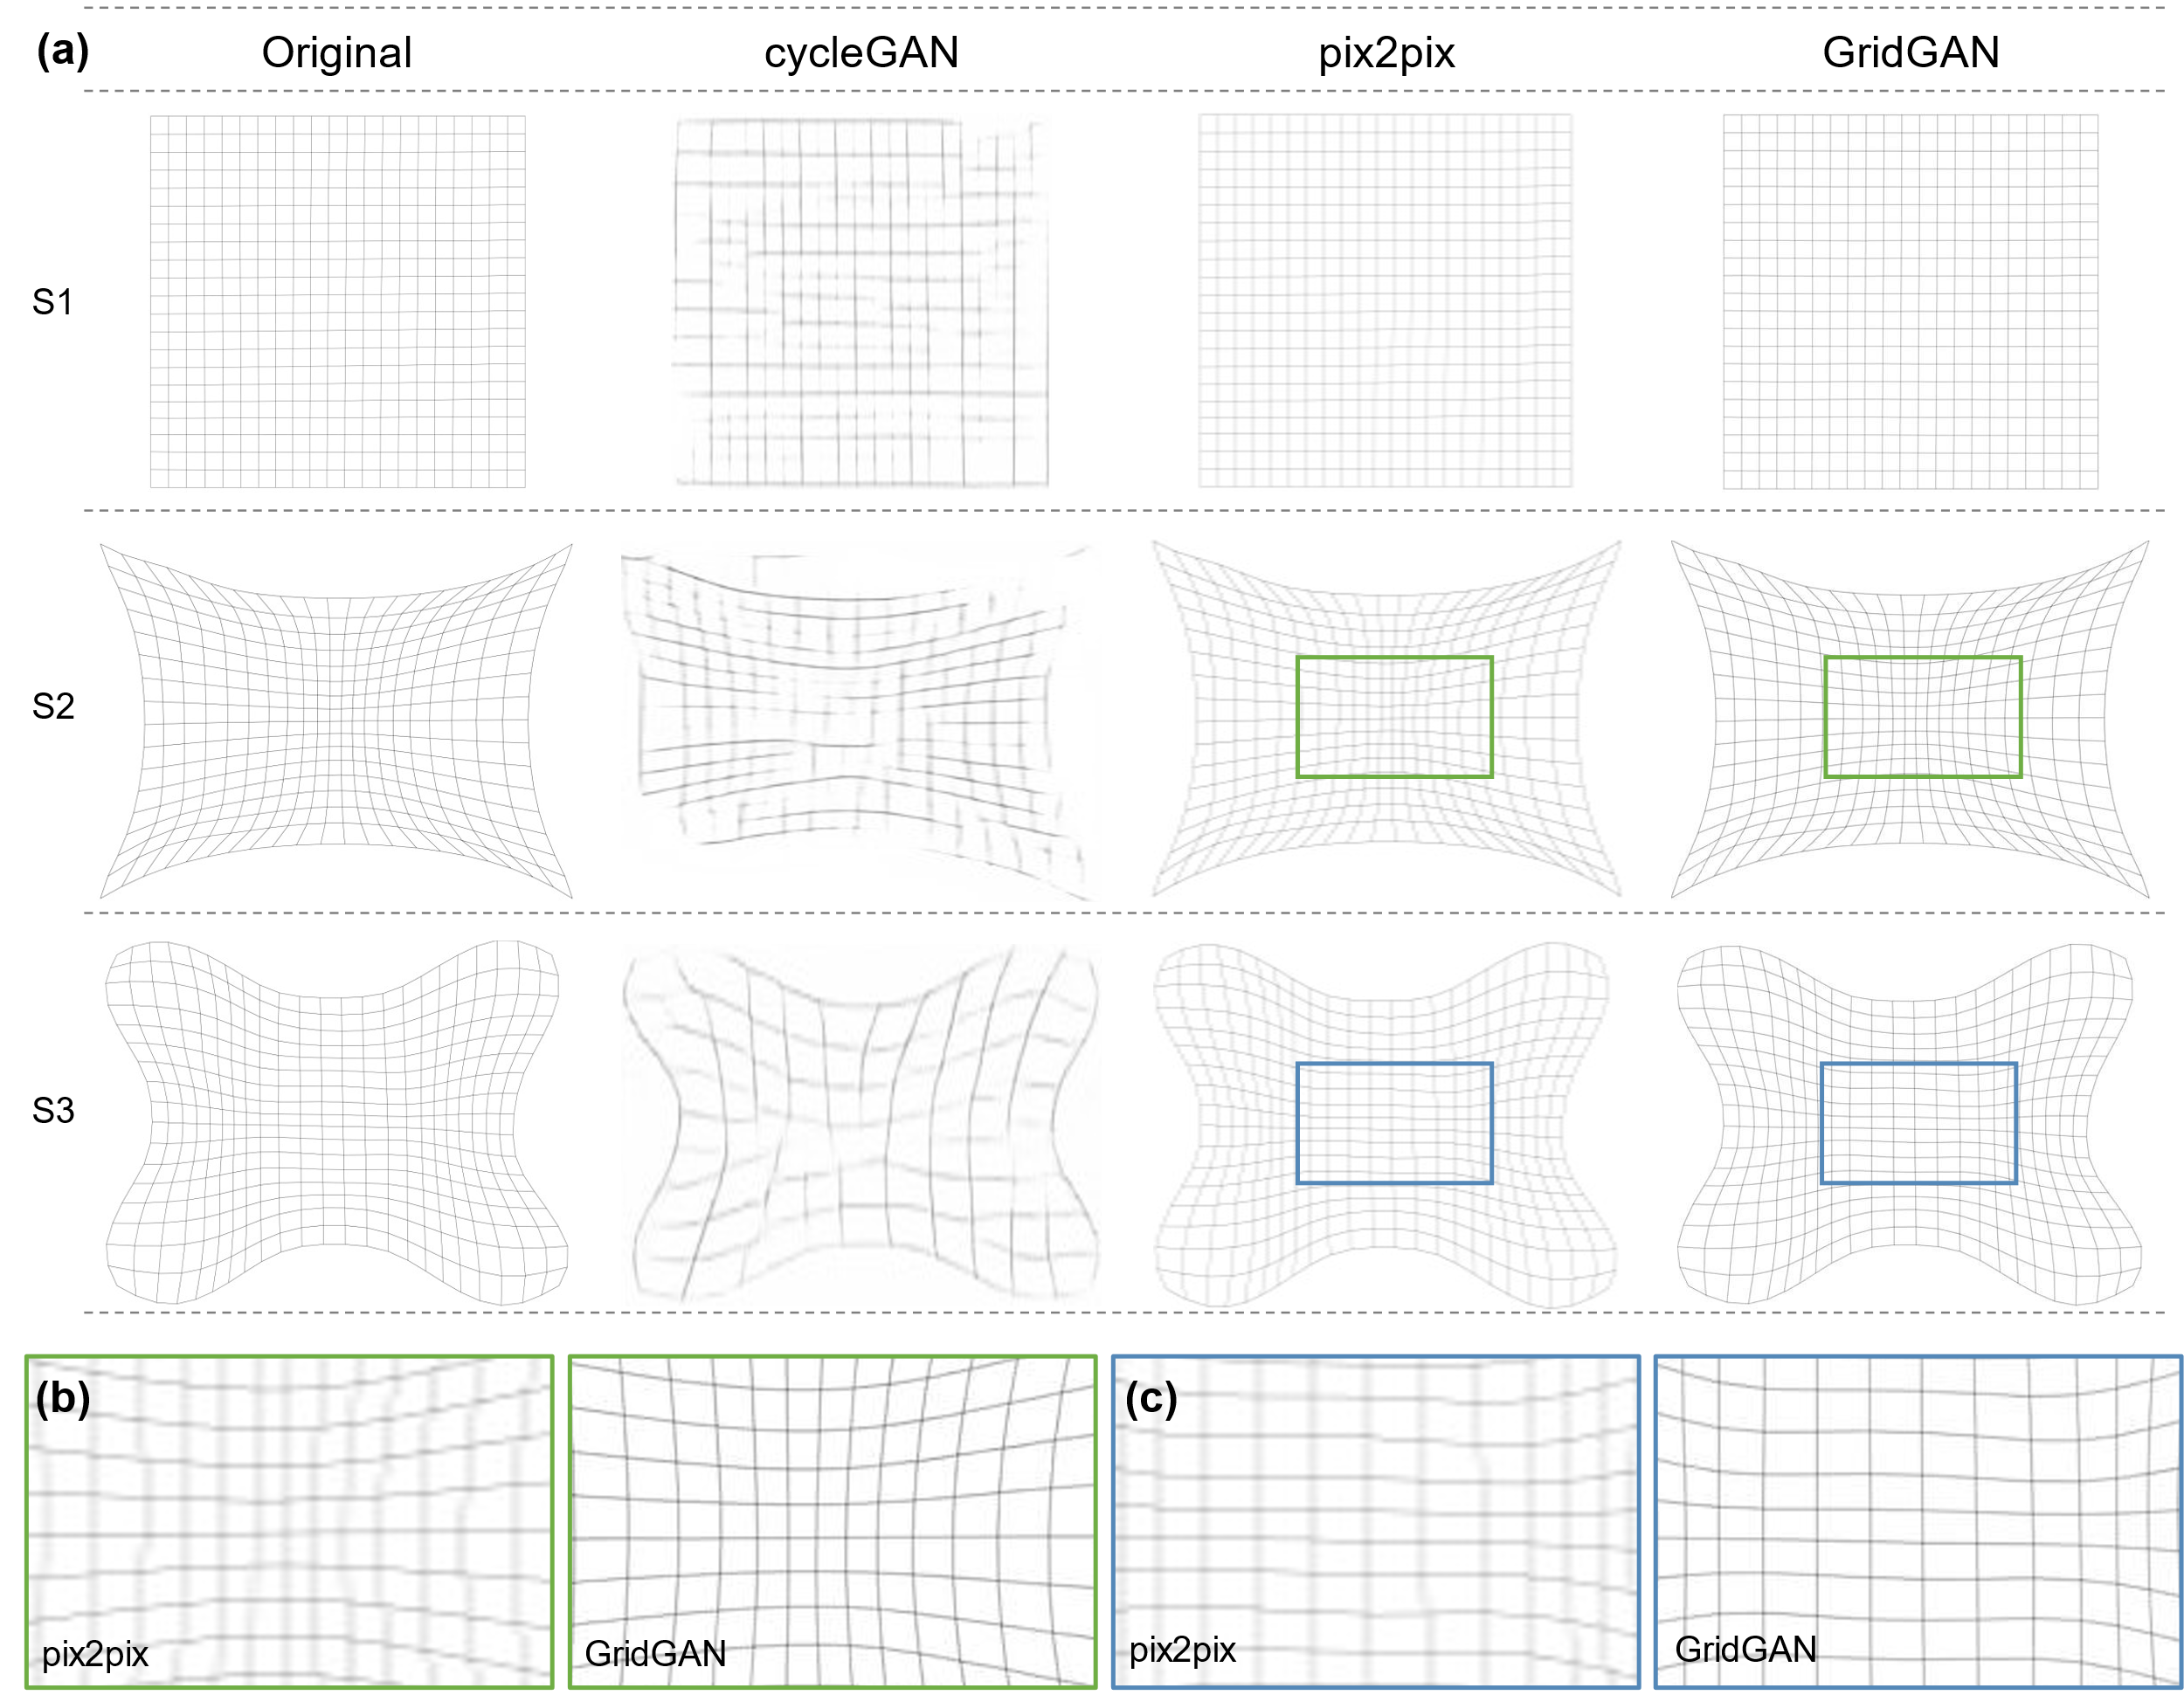
Fig. 10 Comparison of free-surface grid structures generated by different GAN Models. (a) is the overall comparison of the generated grid structures by pix2pix [25], GridGAN, and CycleGAN [41]; (b) and (c) compare the blurring effects.
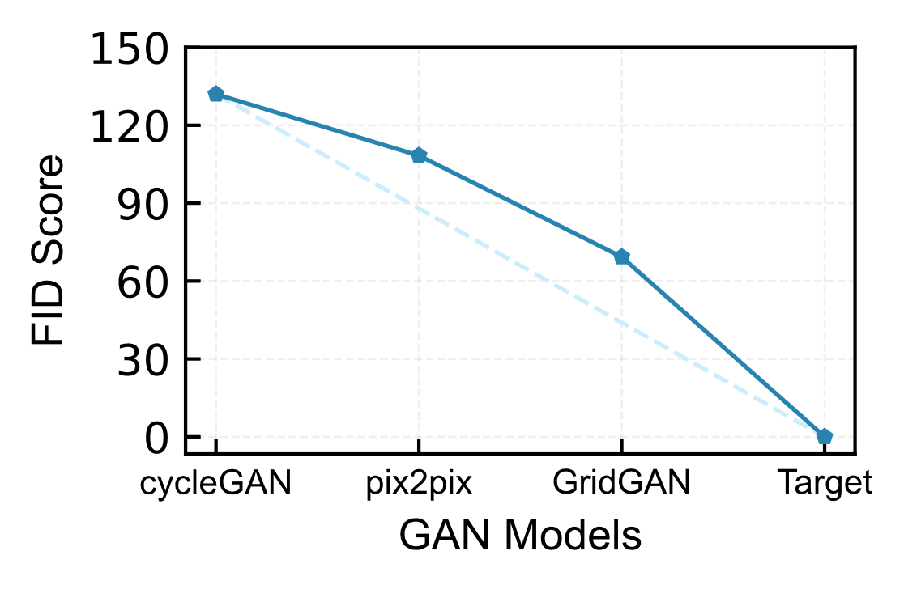
Fig. 11 FID scores for different GAN models.
By comparing the generated free-form grid structures with those obtained from the explicitly coding-orient method, it can be observed that among the three GAN models, CycleGAN exhibits the poorest performance, followed by Pix2pix, while GridGAN yields the best results. CycleGAN demonstrates limited capability in generating detailed grid structures and primarily focuses on capturing the primary form of the surfaces. By contrast, pix2pix exhibits enhanced proficiency in generating grid structures and is able to generate grid structures that closely resemble those produced by explicitly coding-orient methods. Nevertheless, upon comparing pix2pix with GridGAN (Fig. 10b and c), it is evident that pix2pix generates grid structures with significant blurriness, which poses challenges in extracting crucial structural information (node coordinates and inter-node topological relationships). Therefore, the outcome generated by pix2pix is still not aligned with our expectations.
We believe that the underlying reason for the subpar performance of cycleGAN and pix2pix lies in the distinct mechanisms of their neural networks. CycleGAN utilizes a non-matching training mechanism (unsupervised learning), which restricts its ability to establish robust intrinsic relationships between free-form surface cloud maps and grid structures. Meanwhile, pix2pix does not support high-resolution image generation (due to an inherent limitation in its network architecture), inevitably resulting in blurry grid structure images [23,25]. The GridGAN utilized in this study is an improved version based on pix2pixHD, and retains the advantages of pix2pix while simultaneously avoiding the blurry result details, thereby generating high-resolution outcomes. Moreover, the FID scores in Fig. 11 consistently decrease from cycleGAN to pix2pix and finally to GridGAN, which substantiates that GridGAN achieves a more significant similarity to the grid structures generated by explicitly coding-orient method, thereby showcasing its superior capability in generating free-form grid structures. In conclusion, our findings, from both qualitative and quantitative analyses, elucidate that not all GAN models are applicable to structural design tasks. Hence, when choosing a model, it is crucial to carefully consider the specific features of neural networks and select a model that aligns with the particular requirements of the task.

Input selection
To affirm the advantageous role of height cloud map in enhancing the capability of GridGAN for grid partitioning, we execute ablation experiments. The experimentation delineates model inputs into distinct categories: solely curvature cloud map, a combination of curvature and height cloud maps (the input of GridGAN), and purely height cloud map (Fig. 12). With solely a singular input type—curvature or height—the model architecture mirrors that of pix2pixHD. Furthermore, the model parameters employed for training in all three scenarios correspond to those discussed in Section 2.3. Typical outcomes of the free-form surface grid structures generated by each trained model are illustrated in Fig. 12.
The illustrations in Fig. 12 reveal that when only curvature cloud map or height cloud map serve as inputs, the GAN model is, on the whole, capable of accomplishing free-form surface partitioning. Nonetheless, within the generated grid results, there are invariably imperfections (as encircled in red in Fig. 12). The inability to fully generate grid lines implies that forming a coherent architectural structure is unattainable (for the structure would be non-statically determinate). Yet, when both curvature and height cloud maps are employed concurrently as inputs, it becomes apparent that the quality of the outcomes generated by the model (GridGAN) is markedly enhanced compared to scenarios with a single input, with grid lines being complete and exhibiting smooth trajectories. Meanwhile, it is noteworthy that employing both curvature and height as inputs may still result in some free-form surfaces generating structures that are not distinctly clear (as highlighted in blue in Fig. 12). Nevertheless, it is evident that such imperfections differ from the incompleteness observed when using only curvature (or height) map (highlighted in red)—the subtly emergent grid lines still meet the requisite standards.
In short, integrating the height cloud map alongside the curvature cloud map as simultaneous inputs for the GAN model is necessary. The positive impact of adding the height cloud map to the result of the model, we believe, stems from the fact that the visualization process maps numerous values (curvature or height) onto a color gradient composed of a limited number of color values (19 types), leading to a loss in the expression of surface characteristics. Hence, incorporating data that describes the attributes of free-form surfaces from different aspects (such as height) is advantageous for the partitioning of free-form surface grid structures.
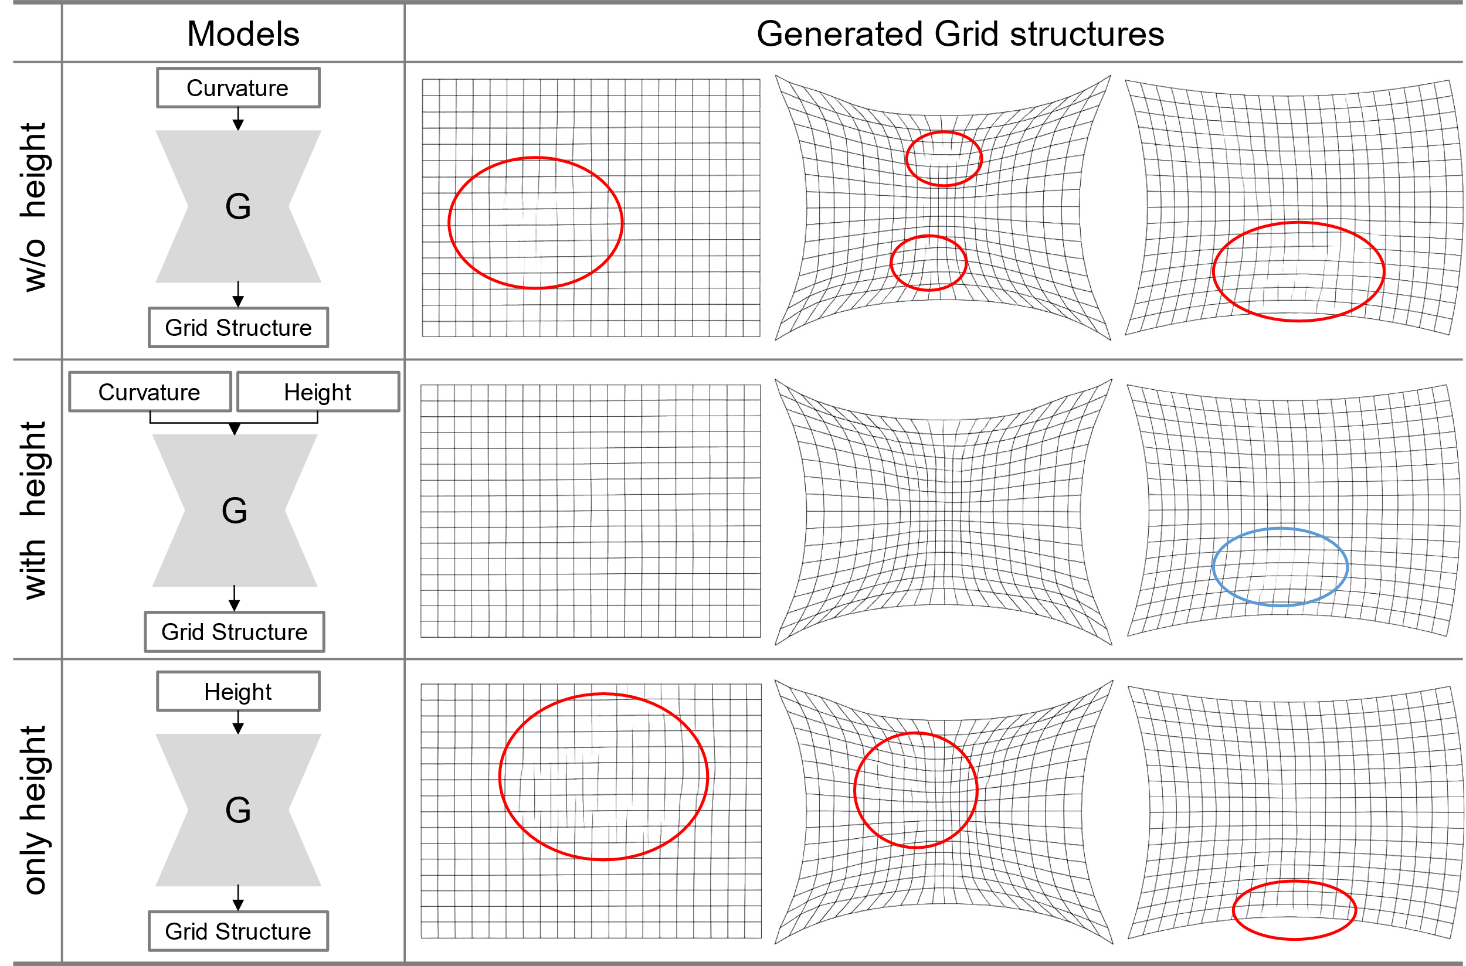
Fig. 12 Impact of the model inputs.

Model Performance
To validate the efficacy of our methodology, we have chosen 12 diverse free-form surfaces for grid partitioning from the test set (described in Section 2.2). Three representative examples from this collection are showcased in Fig. 14. In accordance with the approach outlined in Section 2, we prepare curvature and height cloud maps for each of the 12 distinct free-form surfaces (Fig. 14 GridGAN Input). These cloud maps are then input into GridGAN to obtain the corresponding free-form grid design results (Fig. 14 GridGAN Output). After the data dimension conversion, we obtain the final free-form grid structures (Fig. 14 Final Result).
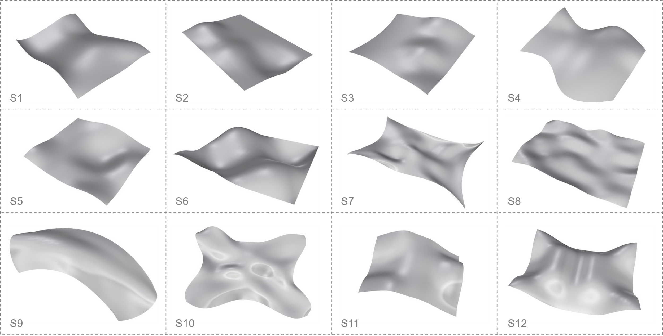
Fig. 13 12 free-form surfaces used in the case studies.
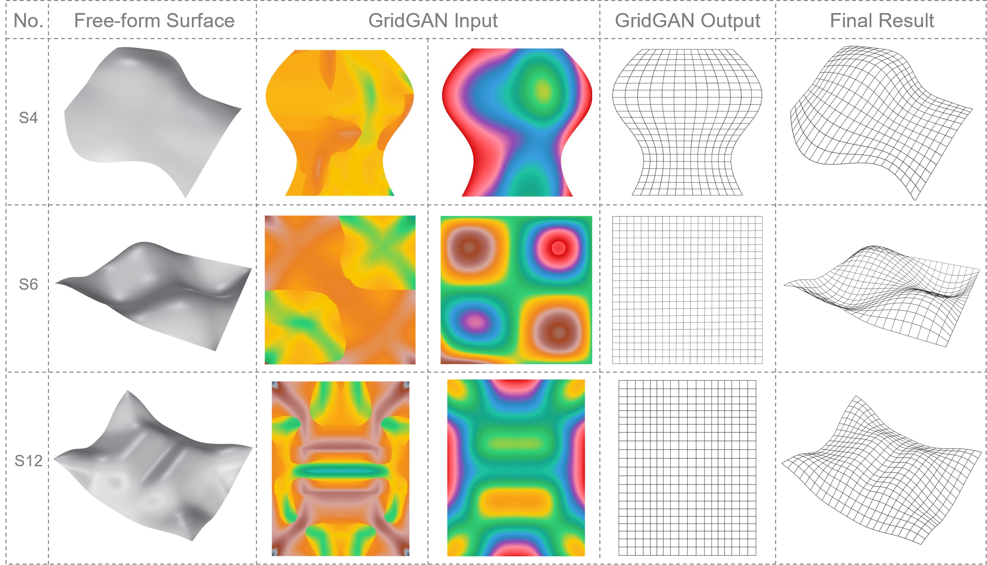
Fig. 14 Three typical surfaces among 12 diverse free-form surfaces: the second column represents the free-form surfaces, while the third column displays the input cloud maps (left: curvature cloud map, right: height cloud map) for GridGAN; the fourth column exhibits the generated grid structures by GridGAN, and the fifth column illustrates the final free-form grid structures.

Qualitative evaluation results
We, subsequently, evaluate the generated grid structures from both qualitative and quantitative perspectives. Initially, we conduct the qualitative evaluation based on expert perception—by creating dynamic showcase videos that present side-by-side comparisons of the free-form grid structures generated by GridGAN and the traditional method (the equal chord length method from [36]). It is worth noting that we alternate the placement order of the grid structures generated by the two methods to avoid respondents forming fixed location biases (Fig. 9). We distribute questionnaires to experts, including professors, engineers, and graduate students, and ask them to select one of the two grid structures generated by GridGAN and rate their confidence level in their choice (Fig. 9).
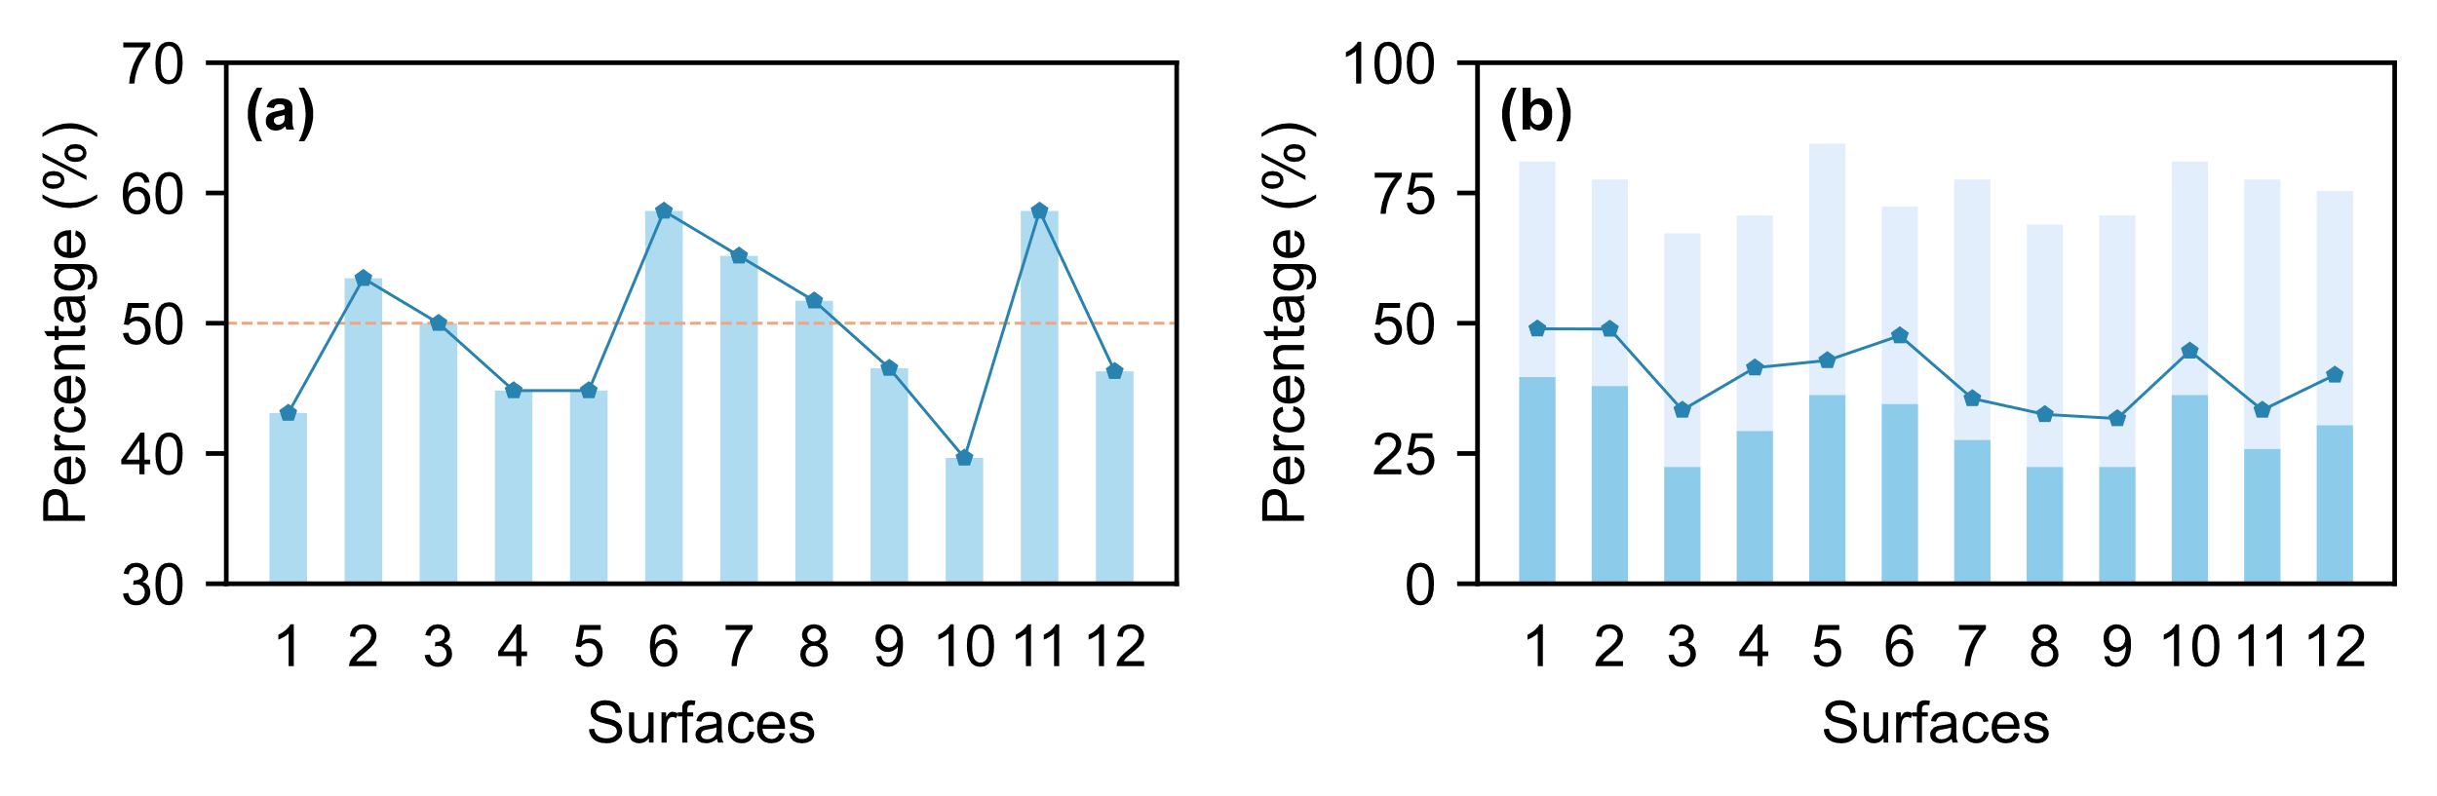
Fig. 15 Expert perception evaluation. (a) Misjudgment percentage: the proportion of grid structures generated by GridGAN being misidentified as those generated by traditional method(explicitly coding-orient method); (b) Confidence percentage: respondents with confidence levels below five stars (light blue), those with no confidence (blue), and the proportion of those with no confidence compared to those with confidence levels below five stars (dark blue line).
According to Fig. 15a, the percentage of respondents who classified the results generated by GridGAN as originating from the traditional method varies across different surfaces, ranging from a minimum of 40% (occurring in surface 10) to a maximum of 59% (occurring in both surface six and surface 11). Meanwhile, within all the grid structures, there are five generated by GridGAN that are misclassified as being generated by the traditional method, with the proportion of these misclassifications exceeding 50% (the portion above the orange dashed line in Fig. 15a). The data in Fig. 15a indicates that GridGAN successfully enables the generation of free-form grid structures, as respondents found it challenging to accurately distinguish between the grid structures generated by the two methods. Furthermore, based on Fig. 15b, it can be observed that, on average, more than 70% of the respondents exhibited a confidence level below five stars in their assessments of each grid structure (the light blue bars in Fig. 15b)—a confidence level below five stars indicates a diminished certainty in the judgment. Moreover, it is important to highlight that the percentage of respondents with complete uncertainty is significantly high (blue bars in Fig. 15b), constituting an average of 40% of the cases where the confidence level is below five stars (ranging from a minimum of 32% to a maximum of 49%). All respondents in this questionnaire are experts with a background in structural engineering. Nevertheless, as indicated by the results in Fig. 15b, there is a notable lack of confidence in their judgments when it comes to differentiating between grid structures generated by GridGAN and traditional method, even among experts, which suggests that GridGAN has achieved a level of realism that makes it difficult for even experts to discern.

Quantitative evaluation results
Qualitative evaluation serves as a subjective assessment of free-form grid structures. To achieve a more sophisticated evaluation, we further employ machine learning-based and geometric properties-based evaluation methods to evaluate the generated free-form grid structures by GridGAN. Firstly, the visual representation illustrating the qualitative changes in the generated free-form grid structures with respect to the number of epochs, along with the corresponding FID scores, is presented in Fig. 16. In the initial stages, GridGAN encounters difficulties in accurately capturing the intrinsic relationship between free-form surface cloud maps and grid structures, leading to suboptimal quality of the generated grids (Fig. 16a). Nevertheless, as the training progresses, GridGAN demonstrates an improvement in grid quality, ultimately establishing a precise relationship between the free-form surface cloud maps and grid structures. Simultaneously, with the increase in the number of epochs, there is a consistent reduction in the FID scores (Fig. 16b), which indirectly demonstrates the increasing capability of GridGAN in generating free-form grid structures.
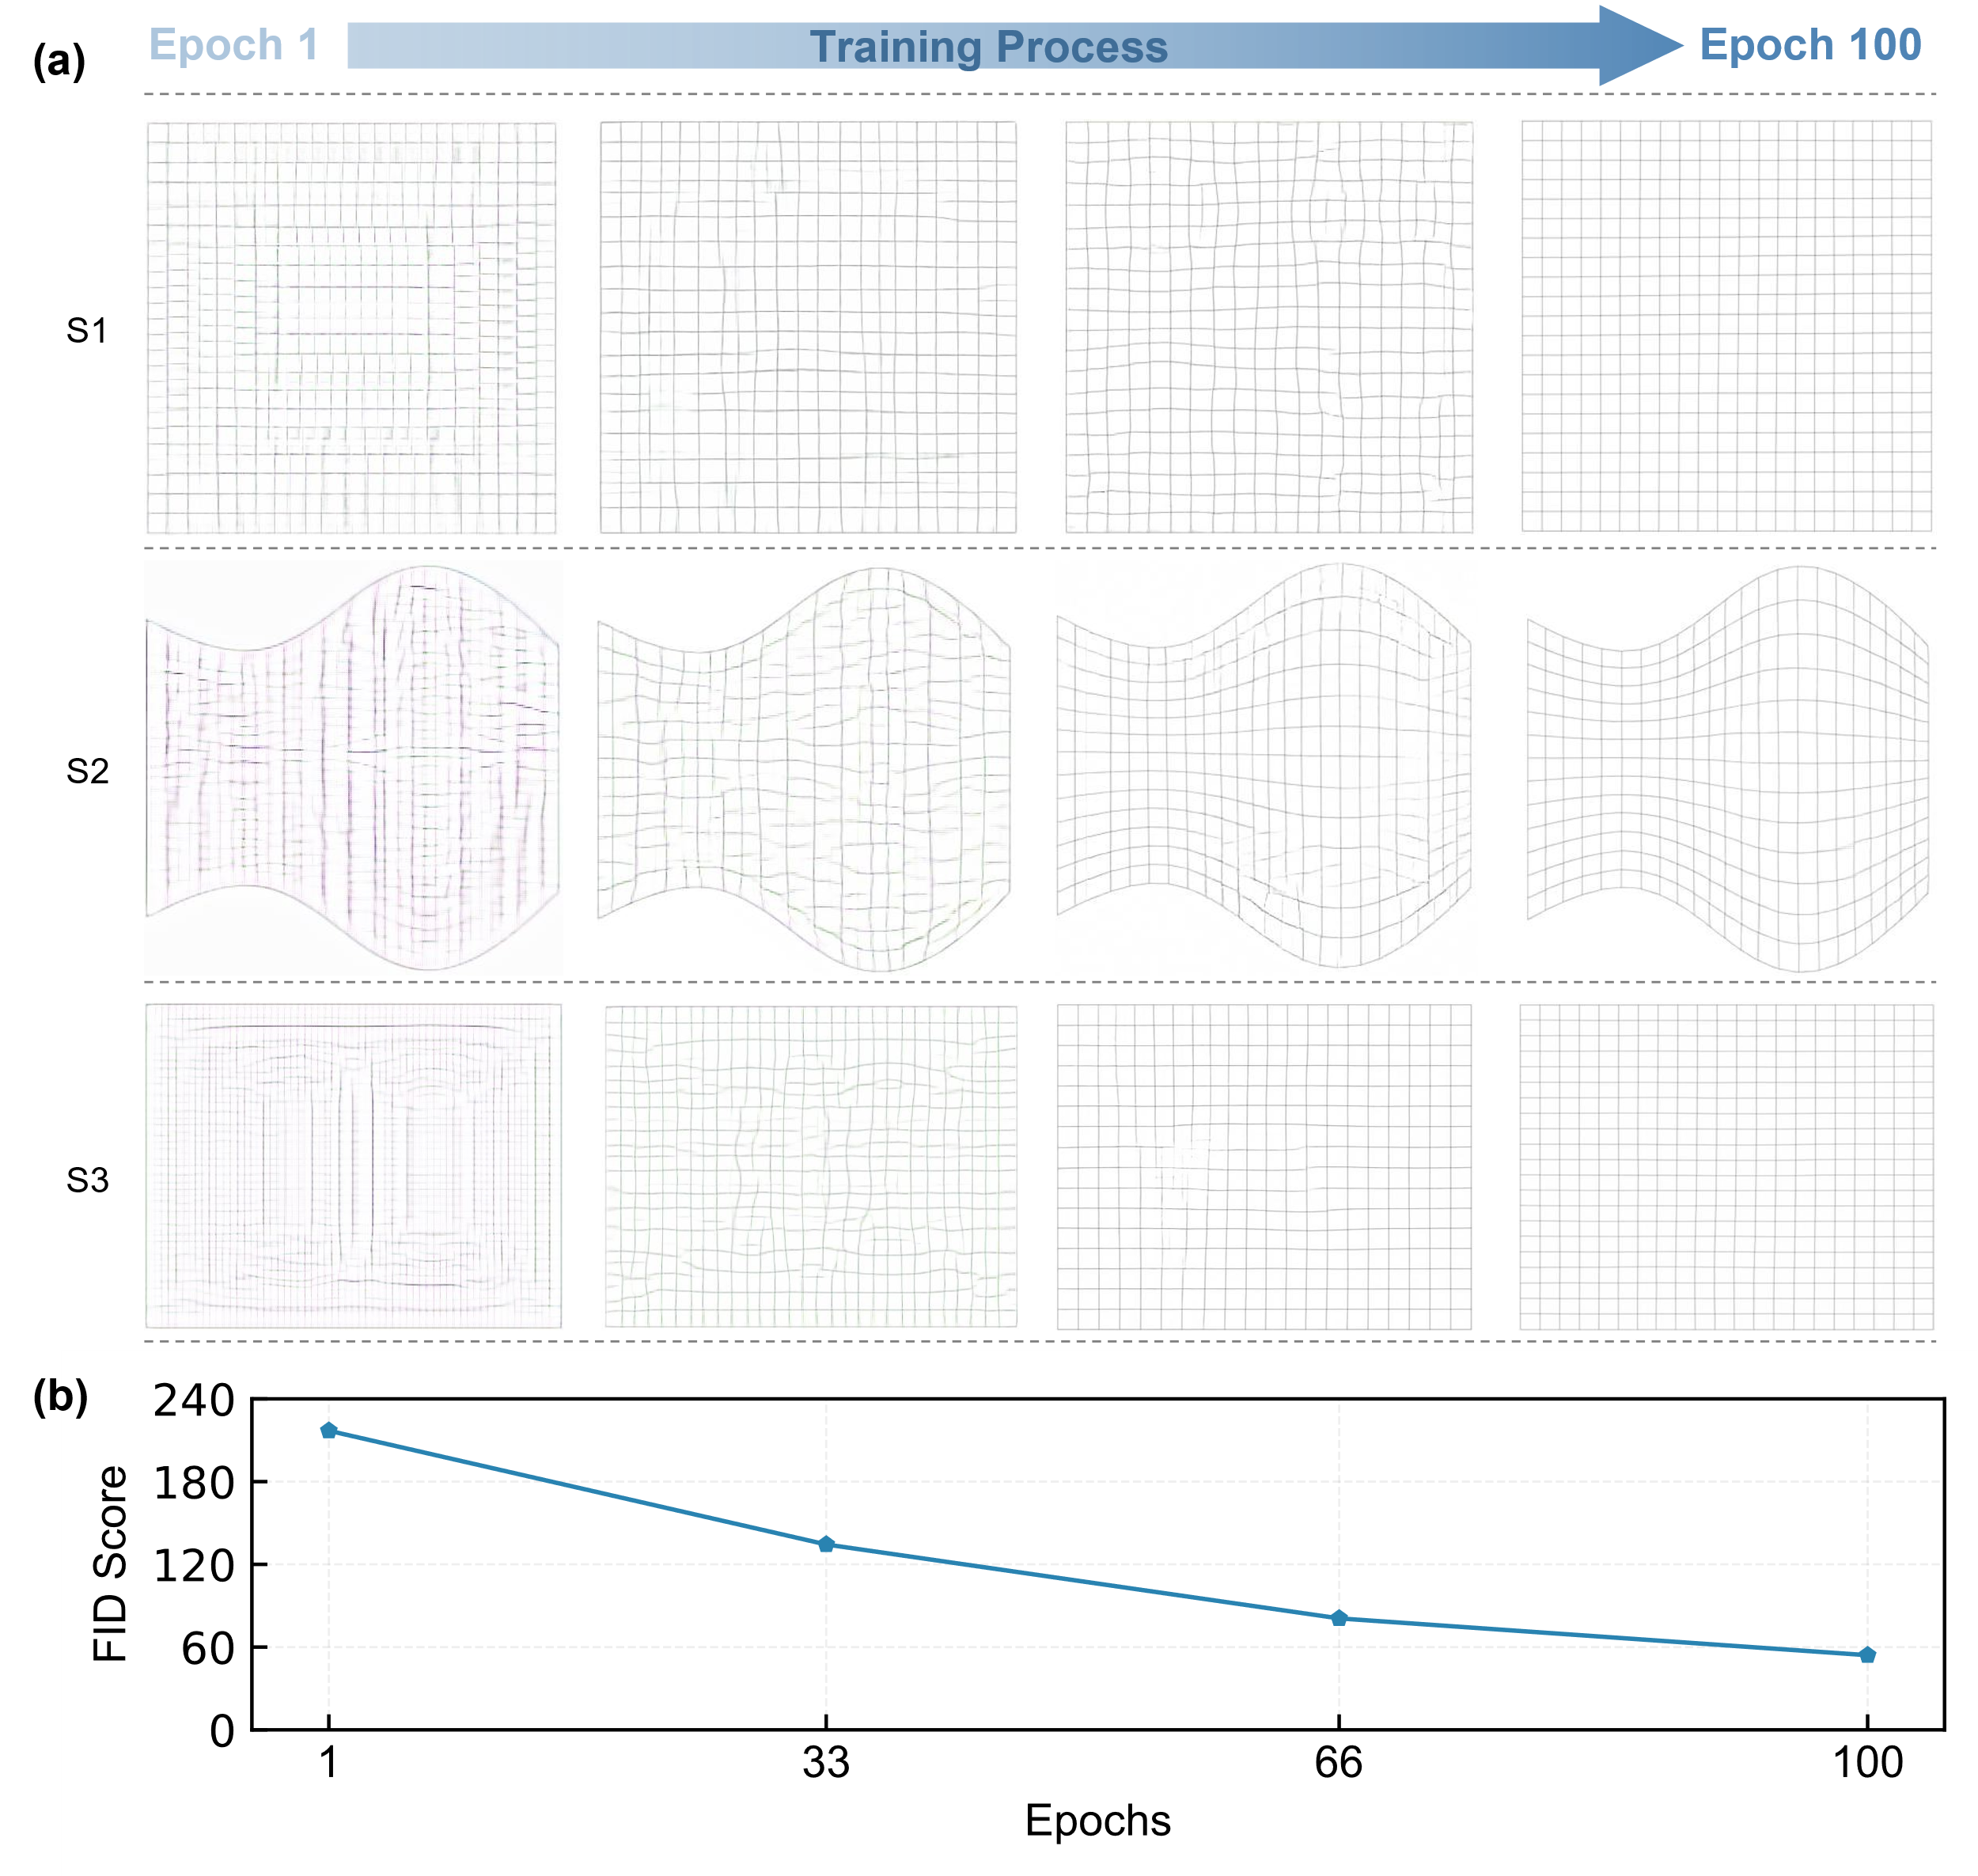
Fig. 16 The quality of GridGAN generated grid structures. (a) Variation under different epochs; (b) FID scores at different epochs.
We utilize geometric properties-based evaluation to assess grid structures generated by explicitly coding-orient method, serving as a benchmark for evaluating the quality of grid structures generated by GridGAN. The quantitative evaluation results, utilizing rod length and shape quality factor evaluations, are presented in Table 2. It is apparent that for the same free-form surface, the mean rod lengths in the grid structures generated by GridGAN and the traditional method (the equal chord length method from [36]) are almost indistinguishable.
Table 2 Quantitative evaluations of rod lengths and shape quality factors
No. | Rod Lengths |  |  |  |  |  |  | Shape Quality Factors
 | Mean |  |  | Mean square deviation |  |  |  | Mean |  |  | Mean square deviation
 | M1 | GridGAN |  | M1 | GridGAN |  |  | M1 | GridGAN |  | M1 | GridGAN
1 | 4.129 | 4.124 |  | 0.459 | 0.445 |  |  | 0.983 | 0.984 |  | 0.024 | 0.023
2 | 3.439 | 3.435 |  | 0.821 | 0.807 |  |  | 0.879 | 0.876 |  | 0.139 | 0.140
3 | 3.884 | 3.866 |  | 0.172 | 0.156 |  |  | 0.997 | 0.997 |  | 0.004 | 0.004
4 | 4.116 | 4.127 |  | 0.786 | 0.803 |  |  | 0.920 | 0.917 |  | 0.037 | 0.042
5 | 3.501 | 3.498 |  | 0.672 | 0.659 |  |  | 0.929 | 0.929 |  | 0.042 | 0.042
6 | 3.879 | 3.876 |  | 0.278 | 0.283 |  |  | 0.992 | 0.991 |  | 0.012 | 0.012
7 | 4.222 | 4.216 |  | 0.383 | 0.381 |  |  | 0.986 | 0.986 |  | 0.012 | 0.011
8 | 3.891 | 3.888 |  | 0.365 | 0.358 |  |  | 0.987 | 0.987 |  | 0.013 | 0.013
9 | 3.819 | 3.813 |  | 0.078 | 0.155 |  |  | 0.999 | 0.998 |  | 0.002 | 0.006
10 | 3.906 | 3.900 |  | 0.294 | 0.299 |  |  | 0.979 | 0.978 |  | 0.017 | 0.017
11 | 4.212 | 4.211 |  | 0.930 | 0.935 |  |  | 0.899 | 0.897 |  | 0.068 | 0.068
12 | 3.908 | 3.904 |  | 0.152 | 0.155 |  |  | 0.998 | 0.998 |  | 0.003 | 0.003
Note: M1 denotes the equal chord length method [36].
The visualized rod length evaluation result is shown in Fig. 17 to have better insights. Fig. 17a provides a more intuitive representation of the evaluation results for the mean rod length and the mean square deviation of rod lengths in the grid structures derived from the 12 test free-form surfaces—under both metrics, the evaluation results of the traditional method and GridGAN are almost identical. Across the different grid structures, the minimum error in the average rod length is 0.001 meters (Fig. 17b, 11th surface), while the maximum error is 0.017 meters (Fig. 17b, 3rd surface). Additionally, from the perspective of the relative error in the rod beam length, the maximum error corresponds to a relative error of 0.45%, with the relative errors of the other grid structures being nearly zero—indicating that the errors are negligible. Meanwhile, the statistical results of the mean square deviation of rod length suggest that the minimum error of the mean square deviation of rod length is 0.003 (Fig. 17c, 7th surface), while the maximum error value is 0.078 (Fig. 17c, 9th surface).
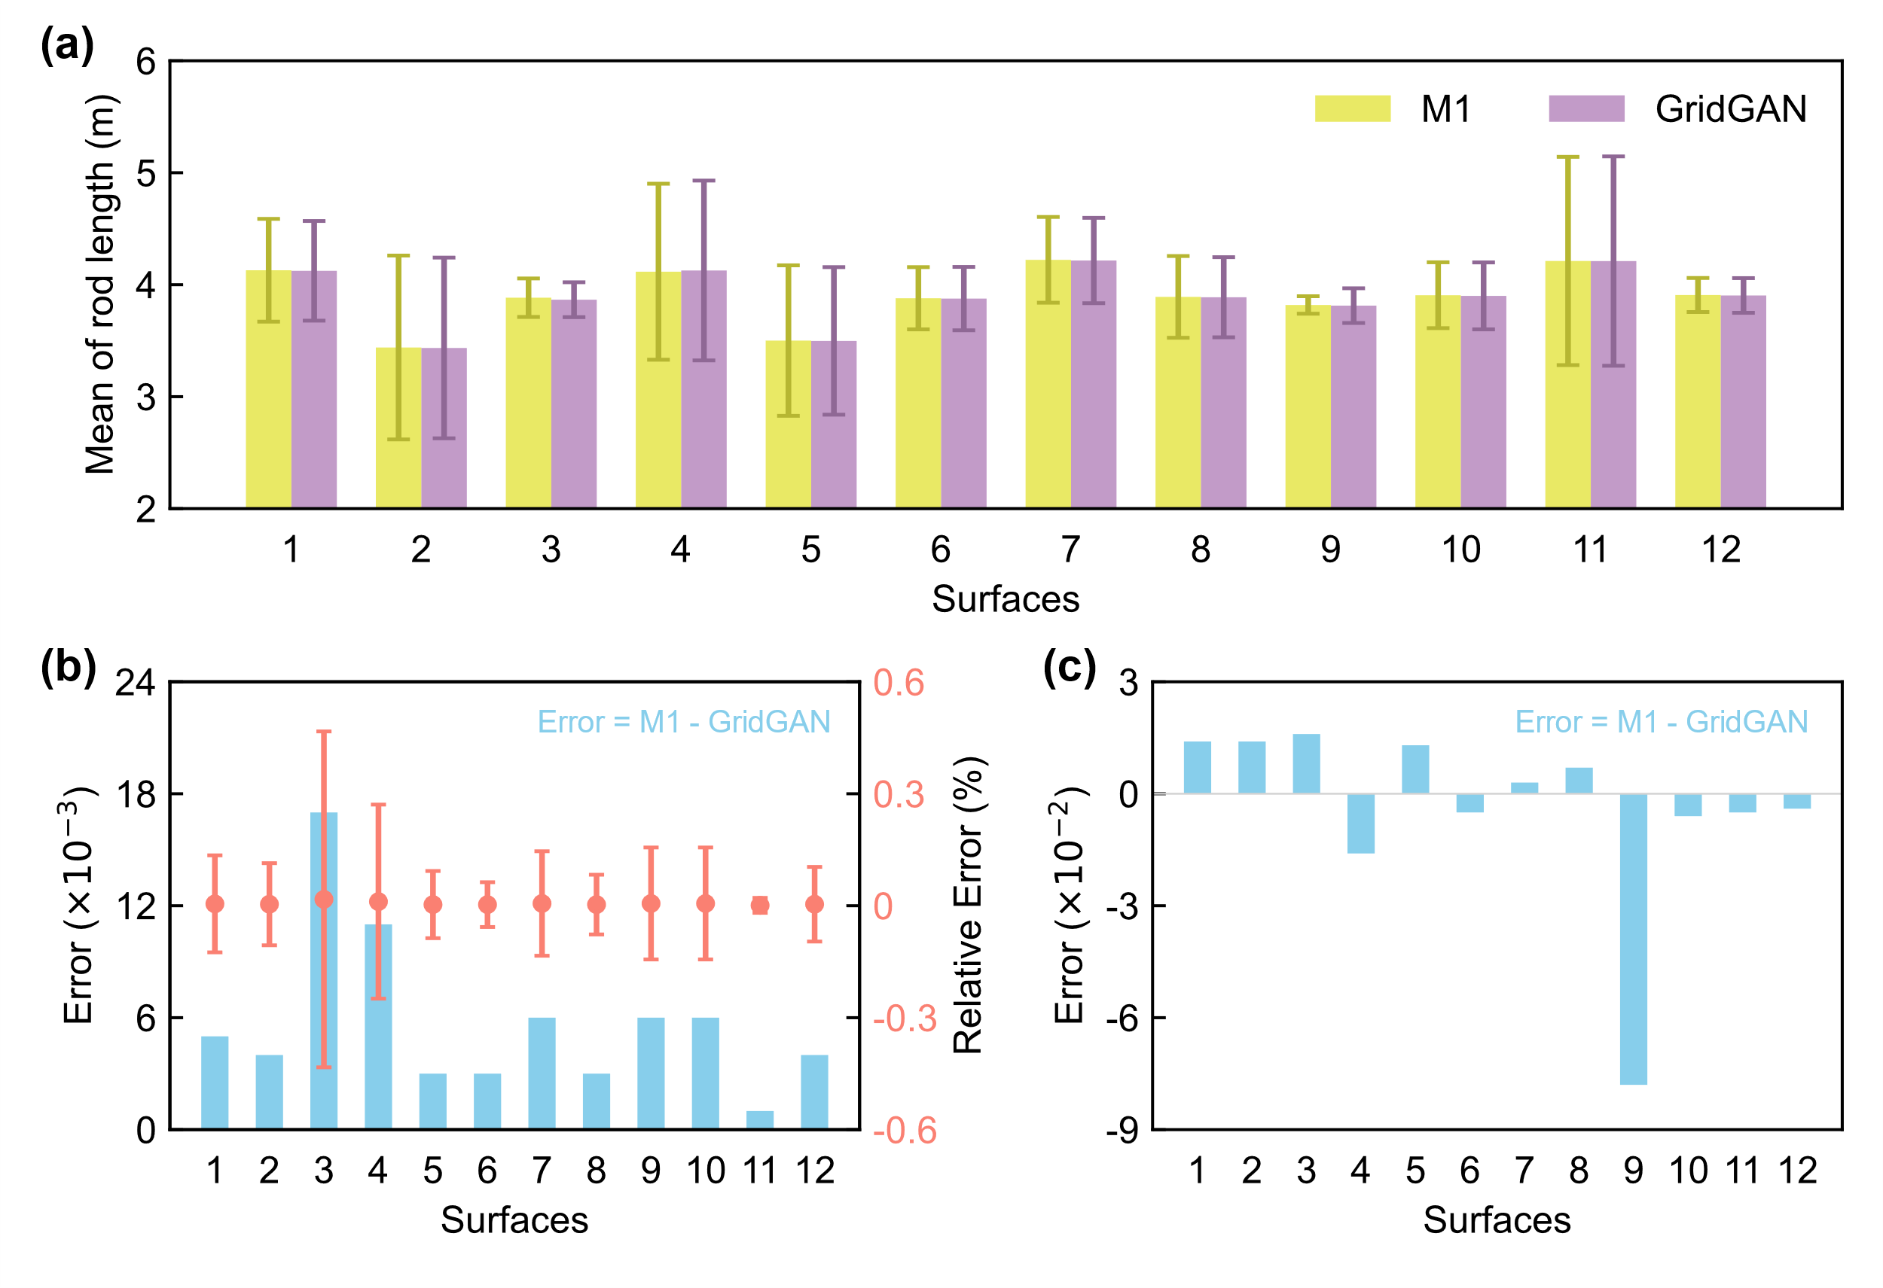
Fig. 17 Rod length evaluation. (a) The mean rod length of grid structures generated by M1 (traditional method from [36]) and GridGAN methods; (b) the error and relative error in the mean rod length between the two methods; (c) the error in the mean square deviation between the two methods.
In assessing the grid structures from the standpoint of shape quality factor, it is evident that the mean and mean square deviation of shape quality factors obtained by both methods are also highly similar (Fig. 18a). The maximum error between the two mean values is 0.004, with a maximum relative error of 0.39% (Fig. 18b, 4th surface), both within the desired range. Moreover, the maximum mean square deviation for both methods is 0.004 (Fig. 18b, 4th and 9th surfaces), which also falls within the ideal range. It is important to note that Fig. 18b and c feature several instances with zero error values. This suggests that, in terms of shape quality factor, GridGAN exhibits excellent and consistent grid partitioning performance.
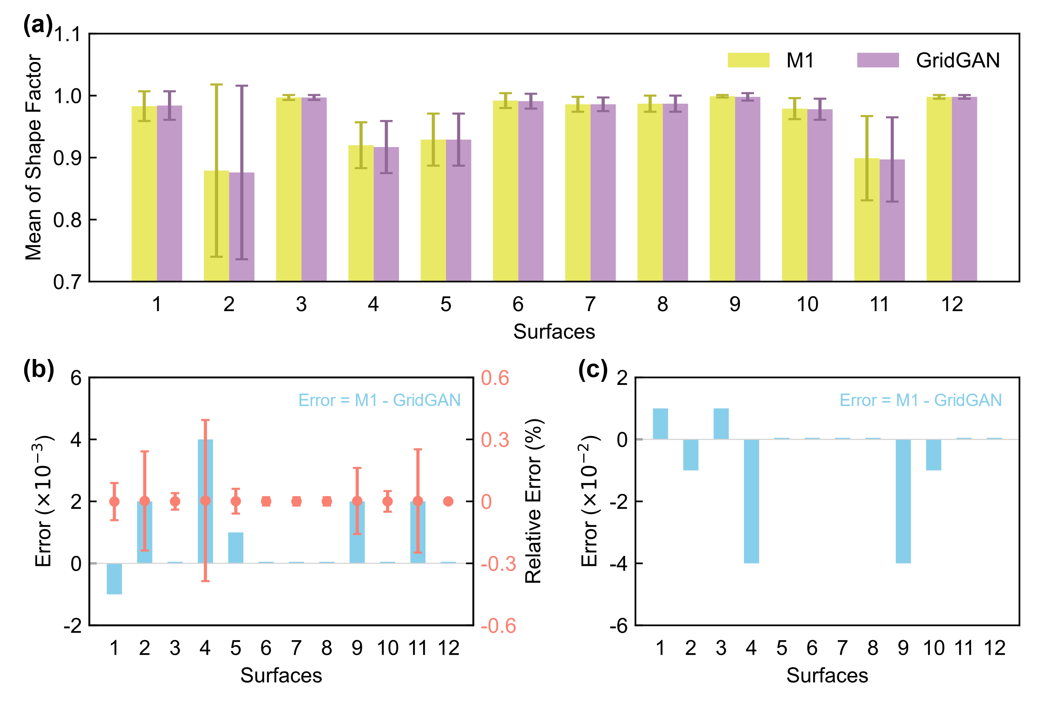
Fig. 18 Shape factor quality evaluation. (a) The mean shape factor of grid structures generated by M1 (traditional method from [36]) and GridGAN methods; (b) the error and relative error in the mean rod length between the two methods; (c) the error in the mean square deviation between the two methods.
To summarize, when evaluating the geometric properties of the grid structures (whether it is through rod length or shape quality factor), the grid structures generated by GridGAN closely align with the metrics of grid structures produced using the traditional method. The geometric properties-based evaluations provide an explanation as to why the respondents with a background in civil engineering are unable to distinguish between grid structures generated by the two methods and have low confidence in their judgments. This is because, from a precise geometric evaluation perspective, the comparison parameters of the two methods are almost identical. Therefore, relying solely on visual judgment is clearly insufficient to differentiate between these two methods correctly.
To further demonstrate the superiority of our method, we compared GridGAN with the mapping equal-division method [37]. Since qualitative evaluation results make it difficult to distinguish between GridGAN and the traditional method (as shown above), we focus only on quantitative evaluation. The results for both evaluation methods are presented in Table 3, which clearly demonstrates that the evaluation outcomes are very similar.
Table 3 Quantitative evaluations of rod lengths and shape quality factors
No. | Rod Lengths |  |  |  |  |  |  | Shape Quality Factors
 | Mean (m) |  |  | Mean square deviation |  |  |  | Mean |  |  | Mean square deviation
 | M2 | GridGAN |  | M2 | GridGAN |  |  | M2 | GridGAN |  | M2 | GridGAN
1 | 4.121 | 4.121 |  | 0.219 | 0.235 |  |  | 0.992 | 0.992 |  | 0.007 | 0.007
2 | 3.390 | 3.389 |  | 0.379 | 0.398 |  |  | 0.905 | 0.902 |  | 0.088 | 0.089
3 | 3.874 | 3.875 |  | 0.042 | 0.093 |  |  | 0.997 | 0.997 |  | 0.004 | 0.005
4 | 4.121 | 4.121 |  | 0.747 | 0.743 |  |  | 0.925 | 0.925 |  | 0.025 | 0.025
5 | 3.543 | 3.532 |  | 0.417 | 0.426 |  |  | 0.929 | 0.927 |  | 0.059 | 0.058
6 | 3.881 | 3.885 |  | 0.171 | 0.323 |  |  | 0.994 | 0.993 |  | 0.011 | 0.011
7 | 4.211 | 4.208 |  | 0.217 | 0.232 |  |  | 0.996 | 0.995 |  | 0.004 | 0.004
8 | 3.886 | 3.879 |  | 0.050 | 0.102 |  |  | 0.998 | 0.997 |  | 0.003 | 0.003
9 | 3.819 | 3.820 |  | 0.052 | 0.175 |  |  | 0.999 | 0.998 |  | 0.002 | 0.002
10 | 3.890 | 3.886 |  | 0.223 | 0.248 |  |  | 0.990 | 0.988 |  | 0.010 | 0.011
11 | 4.295 | 4.284 |  | 0.855 | 0.853 |  |  | 0.910 | 0.910 |  | 0.060 | 0.061
12 | 3.912 | 3.911 |  | 0.076 | 0.122 |  |  | 0.997 | 0.996 |  | 0.004 | 0.004
Note: M2 denotes the mapping equal-division method [37].
From Fig. 19a, it can be observed that the mean and mean square deviation of rod lengths are similar for both methods. Nevertheless, when examining the error in mean and mean square deviation for each specific surface (Fig. 19b and c), there is no apparent pattern in the errors between the two methods. The maximum difference in mean rod length between the two methods is 0.011 (corresponding to a maximum relative error of 0.3%), and the maximum error in mean square deviation is 0.153. Similarly, for the shape quality factor (Fig. 20), the conclusions are similar to those for rod length evaluation. The maximum error in shape quality factor between the two methods, corresponding to a maximum relative error of 0.42%, is 0.004, with the maximum error in mean square deviation being 0.001. Yet, comparing Fig. 17 and Fig. 19 (or Fig. 18 and Fig. 20), it is evident that the mean square deviation is significantly smaller in the latter, indicating that the latter has more uniform grid lengths and shapes overall. To summarize, GridGAN demonstrates excellent grid partitioning capabilities, but the quality of the generated grid structure is influenced by the dataset used for its model training.
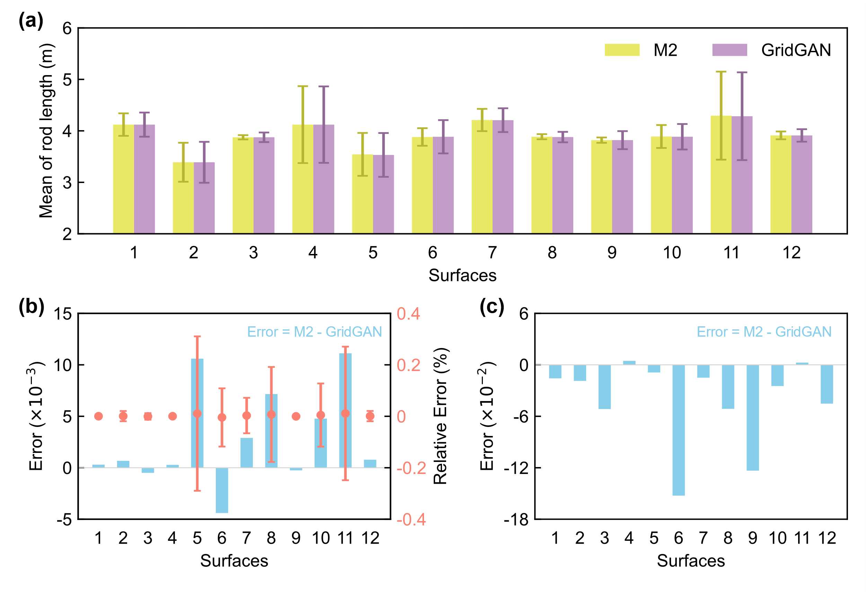
Fig. 19 Rod length evaluation. (a) The mean rod length of grid structures generated by M2 (traditional method from [37]) and GridGAN methods; (b) the error and relative error in the mean rod length between the two methods; (c) the error in the mean square deviation between the two methods.
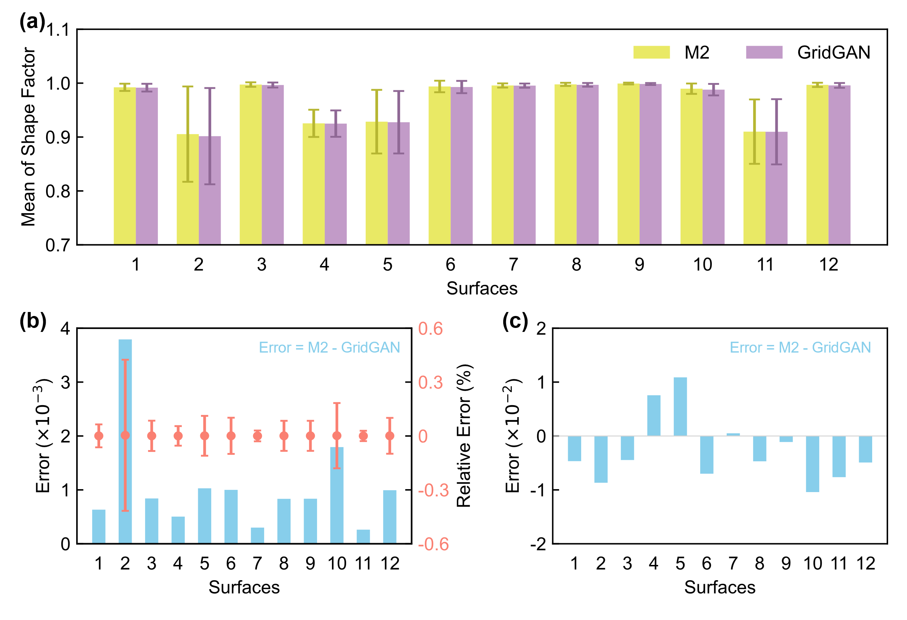
Fig. 20 Shape factor quality evaluation. (a) The mean shape factor of grid structures generated by M2 (traditional method from [37]) and GridGAN methods; (b) the error and relative error in the mean rod length between the two methods; (c) the error in the mean square deviation between the two methods.

Case studies
In Section 3.3, an exhaustive evaluation of the GridGAN-based grid partitioning technique is conducted using both qualitative and quantitative approaches, providing initial evidence for the efficacy of the approach. Nonetheless, critical reflections are necessary regarding potential issues, including the possibility of data leakage when using the test set, the generalization capability of GridGAN, and its universality. To this end, we extracted two free-form surfaces from [47]—neither of which have been featured in the training or test sets—to conduct grid partitioning. The GridGAN outcomes are shown in Fig. 21. Intuitive observations of these instances show that GridGAN facilitated effective grid partitioning, producing comparatively fluid and logically organized grids.
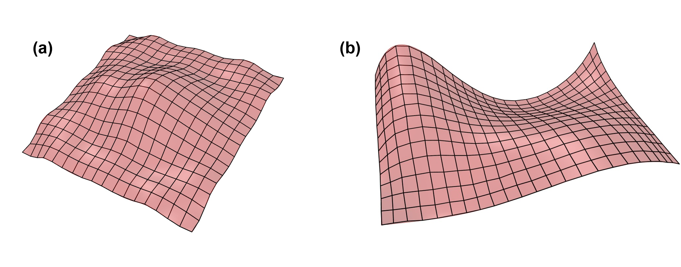
Fig. 21 Grid partitioning results (free-form surfaces from [47]). (a) denotes the surface used in Case 1, and (b) is the surface for Case 2.
Furthermore, a quantitative assessment is performed on both cases, and the findings are documented in Table 4. The results reveal that the mean rod lengths from both the traditional and GridGAN-based methods are closely matched, displaying slight variance. Yet, upon examining the mean square deviation of rod lengths, the traditional method consistently yields lower values than those achieved with GridGAN, indicating that GridGAN exhibits inferior performance in ensuring rod length uniformity. Additionally, the evaluation of grid quality through the shape quality factor shows that the traditional method nearly achieves a factor of 1, suggesting much better grid quality. In contrast, the mean shape quality factor derived from GridGAN is relatively lower, especially for Case 2, where the relative error of the average shape quality factor surpasses 13.22%. Moreover, the quality of the basic elements from GridGAN is found to be inferior, with a mean square deviation error reaching up to 0.03 compared to the traditional method. It is important to note that the relative error and mean square deviation in Cases 1 and 2 exceed those observed in the model tests directly based on the test set in Section 3.3. This suggests that GridGAN has a commendable degree of universality and generalization ability, making it applicable to various free-form surfaces. Nevertheless, it is crucial to highlight that the grid quality produced by GridGAN decreases when used on free-form surfaces that vary substantially from the training dataset.
Table 4 Quantitative evaluation of two case studies
Type | Case | Mean |  |  |  |  | Mean square deviation
 |  | M1 | GridGAN | Error | RE* (%) |  | M1 | GridGAN | Error
rod  lengths | 1 | 3.884 | 3.819 | 0.066 | -1.72 |  | 0.235 | 0.360 | -0.125
 | 2 | 3.679 | 3.765 | -0.087 | 2.30 |  | 0.240 | 0.408 | -0.168
shape  qualities | 1 | 0.994 | 0.924 | 0.070 | -7.58 |  | 0.005 | 0.011 | -0.006
 | 2 | 0.955 | 0.844 | 0.112 | -13.22 |  | 0.046 | 0.077 | -0.030
Note: M1 denotes the equal chord length method; RE* represents the relative error.

Conclusions
Presently, the partitioning methods for architectural free-form grid structures primarily rely on explicit coding. Nevertheless, this approach tends to be tailored to address specific surface-related challenges, consequently leading to a lack of universality for these methods. We propose using the generative artificial intelligence method, specifically generative adversarial networks, for data mining and learning, followed by data regeneration, with the aim of addressing the aforementioned issue. The contributions and the detailed conclusions of this paper are as follows:
(1) We present a novel approach, named GridGAN, which utilizes generative adversarial networks as a fundamental method for free-form grid partitioning, thereby eliminating the reliance on explicit coding. The corresponding grid structure can be automatically generated given a free-form surface by employing GridGAN. This method frees designers from the need to consider complex surface characteristics, avoids the tedious process of writing code specifically for those characteristics, and makes grid partitioning design an end-to-end process.
(2) A two-dimensional representation method for three-dimensional free-form surfaces is innovatively proposed. To adapt to the two-dimensional input format of GridGAN, we introduce a creative approach that employs two-dimensional curvature and height cloud maps as replacements for the three-dimensional free-form surfaces as inputs to the deep learning model. Meanwhile, we have developed the corresponding codes to realize the process above.
(3) The codes for reconstructing two-dimensional grid structures into three-dimensional grid structures are developed. Using our self-developed codes, we successfully extract grid nodes and their topological relationships from two-dimensional images, followed by their reconstruction in the three-dimensional domain.
(4) The application of the pix2pixHD model is proposed for node labeling in two-dimensional free-form grid structure generated by GridGAN (the input and output pairs are un- and labeled two-dimensional free-form grid structure images, respectively). It successfully resolved the difficulty in accurately labeling the positions in GridGAN-generated two-dimensional free-form grid structure images using conventional algorithms.
(5) The questionnaire results, which rely on expert perception evaluation, indicated that the free-form surface grid structures generated by GridGAN have attained a level of intricacy that experts find difficult to discern visually. More than 70% of the respondents expressed uncertainty about their judgments, and within this 70%, 40% indicated a complete inability to determine the surfaces generated by GridGAN.
(6) The quantitative evaluation conducted in the case studies demonstrated that the grid structures generated by both GridGAN and the traditional approaches (namely, explicitly coding-orient methods) exhibit remarkably close values across various evaluation metrics, including rod length and shape quality factor. The maximum error in the mean length of the rod lengths for the free-form grid structures from both methods is 0.017 meters, with a maximum relative error of 0.45%. Additionally, regarding the shape quality factor, the maximum error between the two methods is 0.004, with a maximum relative error of 0.42%. All metrics indicate that GridGAN is both feasible and accurate in its performance.
(7) The findings from two case studies reveal that the data-driven GridGAN is free from data leakage problems. Furthermore, GridGAN shows strong generalizability, successfully performing grid partitioning on free-form surfaces not included in the training dataset, indicating its promising application prospects.
The GAN-based method involves learning from existing data to create solutions for new situations. This procedural framework could inspire similar approaches in civil engineering, using existing data to create more efficient designs, decreasing the need for experienced designers, and making design resources reusable. It is important to note that we, in this paper, solely utilize artificial intelligence as an auxiliary tool and represent an immature exploration in pursuing a more generalized method for free-form grid partitioning. Therefore, there are still some limitations that need further improvement and refinement:
(1) Firstly, one drawback of our approach is its reliance on the absence of occluded regions in the top view of the free-form surface. The occlusions pose challenges for the accurate generation of the grid structure.
(2) Secondly, the representation of free-form surfaces using colored curvature and height is merely one method proposed in this paper that has been demonstrated to be viable. Nevertheless, the fundamental question of how to effectively represent free-form surfaces, regardless of the method used to depict curvature and height, remains a topic worthy of further consideration.
(3) Lastly, as outlined in the Introduction section, our study, like existing research, mainly focuses on the initial stages of grid partitioning design and does not take the mechanical properties of the grid structure into account. Future research incorporating mechanical properties will further enhance the grid partitioning design of architectural free-form surfaces.

Declaration of competition interest
All authors have no conflict of interest to declare.

Acknowledgment
This work was supported by High Level Talent Projects of Six Talent Peaks in Jiangsu Province, China (Grant no. JZ-010), Young Academic Leaders of Qing Lan Fund Project of the Jiangsu Higher Education Institutions of China.

References
[1] Piegl L, Tiller W. The NURBS Book. Berlin, Heidelberg: Springer; 1995. https://doi.org/10.1007/978-3-642-97385-7.
[2] Heusel M, Ramsauer H, Unterthiner T, Nessler B, Hochreiter S. GANs trained by a two time-scale update rule converge to a local nash equilibrium. NIPS, California, USA: 2018. https://doi.org/10.48550/arXiv.1706.08500.
[3] Qian WL, Xu Y, Li H. A self‐sparse generative adversarial network for autonomous early‐stage design of architectural sketches. Comput-Aided Civ Infrastruct Eng 2022;37:612–28. https://doi.org/10.1111/mice.12759.
[4] Gao B, Hao C, Li T, Ye J. Grid generation on free-form surface using guide line advancing and surface flattening method. Adv Eng Softw 2017;110:98–109. https://doi.org/10.1016/j.advengsoft.2017.04.003.
[5] Wang Q, Gao B, Li T, Wu H, Kan J, Hu B. A triangular mesh generator over free-form surfaces for architectural design. Autom Constr 2018;93:280–92. https://doi.org/10.1016/j.autcon.2018.05.018.
[6] Liu F, Feng R, Tsavdaridis KD. A novel progressive grid generation method for free-form grid structure design and case studies. J Build Eng 2021;34:101866. https://doi.org/10.1016/j.jobe.2020.101866.
[7] Su L, Zhu S, Xiao N, Gao B. An automatic grid generation approach over free-form surface for architectural design. J Cent South Univ 2014;21:2444–53. https://doi.org/10.1007/s11771-014-2198-7.
[8] Winslow P, Pellegrino S, Sharma SB. Multi-objective optimization of free-form grid structures. Struct Multidiscip Optim 2010;40:257–69. https://doi.org/10.1007/s00158-009-0358-4.
[9] Shan ZW, Chen LJ, Wang QS, Wu H, Gao BQ. Simplified quadrilateral grid generation of complex free-form gridshells by surface fitting. J Build Eng 2022;48:103827. https://doi.org/10.1016/j.jobe.2021.103827.
[10] Shepherd P, Richens P. The case for Subdivision Surfaces in building design. J Int Assoc SHELL Spat Struct 2012;53:237–45. https://purehost.bath.ac.uk/ws/portalfiles/portal/11252702/Shepherd_J_IASSS_2012_53_4.pdf.
[11] Gao B, Li T, Ma T, Ye J, Becque J, Hajirasouliha I. A practical grid generation procedure for the design of free-form structures. Comput Struct 2018;196:292–310. https://doi.org/10.1016/j.compstruc.2017.10.006.
[12] Rörig T, Sechelmann S, Kycia A, Fleischmann M. Surface Panelization Using Periodic Conformal Maps. Adv. Archit. Geom. 2014, Cham: Springer International Publishing; 2015, p. 199–214. https://doi.org/10.1007/978-3-319-11418-7_13.
[13] Wang QS, Gao BQ, Wu H. Triangular mesh generation on free-form surfaces based on bubble dynamics simulation. Eng Comput 2019;36:646–63. https://doi.org/10.1108/EC-09-2017-0352.
[14] Peng CH, Pottmann H, Wonka P. Designing patterns using triangle-quad hybrid meshes. ACM Trans Graph 2018;37:107:1-107:14. https://doi.org/10.1145/3197517.3201306.
[15] Liu W, Wang Z, Liu X, Zeng N, Liu Y, Alsaadi FE. A survey of deep neural network architectures and their applications. Neurocomputing 2017;234:11–26. https://doi.org/10.1016/j.neucom.2016.12.038.
[16] Dargan S, Kumar M, Ayyagari MR, Kumar G. A survey of deep learning and its applications: A new paradigm to machine learning. Arch Comput Methods Eng 2019;27:1071–92. https://doi.org/10.1007/s11831-019-09344-w.
[17] Gao Y, Mosalam KM. Deep transfer learning for image-based structural damage recognition. Comput-Aided Civ Infrastruct Eng 2018;33:748–68. https://doi.org/10.1111/mice.12363.
[18] Salehi H, Burgueño R. Emerging artificial intelligence methods in structural engineering. Eng Struct 2018;171:170–89. https://doi.org/10.1016/j.engstruct.2018.05.084.
[19] Li S, Zhao X, Zhou G. Automatic pixel‐level multiple damage detection of concrete structure using fully convolutional network. Comput-Aided Civ Infrastruct Eng 2019;34:616–34. https://doi.org/10.1111/mice.12433.
[20] Goodfellow I, Jean PA, Mirza M, Xu B, Warde Farley D, Ozair S, et al. Generative adversarial networks. Commun ACM 2020;63:139–44. https://doi.org/10.1145/3422622.
[21] Mao X, Li Q, Xie H, Lau R, Wang Z, Smolley SP. Least squares generative adversarial networks. Proc. IEEE Int. Conf. Comput. Vis., Venice, Italy: 2017, p. 2794–802. https://doi.org/10.48550/arXiv.1611.04076.
[22] Gulrajani I, Ahmed F, Arjovsky M, Dumoulin V, Courville AC. Improved training of wasserstein GANs. Adv. Neural Inf. Process. Syst., vol. 30, California, USA: 2017. https://doi.org/10.48550/arXiv.1704.00028.
[23] Wang TC, Liu MY, Zhu JY, Tao A, Kautz J, Catanzaro B. High-resolution image synthesis and semantic manipulation with conditional GANs. Proc. IEEE Conf. Comput. Vis. Pattern Recognit., Honolulu, USA: 2018, p. 8798–807. https://doi.org/10.48550/arXiv.1711.11585.
[24] Hong Y, Hwang U, Yoo J, Yoon S. How generative adversarial networks and their variants work: An overview. ACM Comput Surv 2019;52:10:1-10:43. https://doi.org/10.1145/3301282.
[25] Isola P, Zhu J, Zhou T, Efros AA. Image-to-image translation with conditional adversarial networks. Proc. IEEE Conf. Comput. Vis. Pattern Recognit., Honolulu, USA: 2017, p. 1125–34. https://doi.org/10.48550/arXiv.1611.07004.
[26] Liao WJ, Lu XZ, Huang YL, Zheng Z, Lin YQ. Automated structural design of shear wall residential buildings using generative adversarial networks. Autom Constr 2021;132:103931. https://doi.org/10.1016/j.autcon.2021.103931.
[27] Liao W, Huang Y, Zheng Z, Lu X. Intelligent generative structural design method for shear wall building based on “fused-text-image-to-image” generative adversarial networks. Expert Syst Appl 2022;210:118530. https://doi.org/10.1016/j.eswa.2022.118530.
[28] Zhao P, Liao W, Huang Y, Lu X. Intelligent design of shear wall layout based on attention-enhanced generative adversarial network. Eng Struct 2023;274:115170. https://doi.org/10.1016/j.engstruct.2022.115170.
[29] Liao W, Wang X, Fei Y, Huang Y, Xie L, Lu X. Base‐isolation design of shear wall structures using physics‐rule‐co‐guided self‐supervised generative adversarial networks. Earthq Eng Struct Dyn 2023;52:3281–303. https://doi.org/10.1002/eqe.3862.
[30] Hirsch MW. Differential topology. New York: Springer; 1976. https://doi.org/10.1007/978-1-4684-9449-5.
[31] Lee JM. Introduction to smooth manifolds. New York: Springer; 2012. https://doi.org/10.1007/978-1-4419-9982-5.
[32] Peet FG, Sahota TS. Surface curvature as a measure of image texture. IEEE Trans Pattern Anal Mach Intell 1985;PAMI-7:734–8. https://doi.org/10.1109/TPAMI.1985.4767733.
[33] Hilton A, Illingworth J, Windeatt T. Statistics of surface curvature estimates. Pattern Recognit 1995;28:1201–21. https://doi.org/10.1016/0031-3203(95)00002-H.
[34] Gordon GG. Face recognition based on depth maps and surface curvature. Geom. Methods Comput. Vis., vol. 1570, California, USA: SPIE; 1991, p. 234–47. https://doi.org/10.1117/12.48428.
[35] Liu Z. High Precision Reconstruction of Curved Surface with Rapidly Changing Curvature Based on Point Cloud Data. Master. Dalian University of Technology, 2020. https://kns.cnki.net/KCMS/detail/detail.aspx?dbcode=CMFD&dbname=CMFD202101&filename=1020821104.nh&v=.
[36] Li Z. Research on Quadrilateral Grid Generation and Planarization for free-form grid structures. Master. Zhejiang University, 2019. https://doi.org/10.27461/d.cnki.gzjdx.2019.002286.
[37] Wang Q, Li T, Wu H, Gao B. Grid generation for free-form surface based on mapping technique and bidirectional equal-division. J Build Struct 2018;39:18–24. https://doi.org/10.14006/j.jzjgxb.2018.07.003.
[38] Zhao P, Liao W, Xue H, Lu X. Intelligent design method for beam and slab of shear wall structure based on deep learning. J Build Eng 2022;57:104838. https://doi.org/10.1016/j.jobe.2022.104838.
[39] Cha Y, Choi W, Suh G, Mahmoudkhani S, Büyüköztürk O. Autonomous structural visual inspection using region-based deep learning for detecting multiple damage types. Comput-Aided Civ Infrastruct Eng 2018;33:731–47. https://doi.org/10.1111/mice.12334.
[40] Ronneberger O, Fischer P, Brox T. U-Net: Convolutional networks for biomedical image segmentation. Lect. Notes Comput. Sci., 2015, p. 234–41. https://doi.org/10.48550/arXiv.1505.04597.
[41] Zhu J, Park T, Isola P, Efros AA. Unpaired image-to-image translation using cycle-consistent adversarial networks. Proc. IEEE Int. Conf. Comput. Vis., Venice, Italy: 2017. https://doi.org/10.48550/arXiv.1703.10593.
[42] Ram P, Padmavathi S. Analysis of Harris corner detection for color images. 2016 Int. Conf. Signal Process. Commun. Power Embed. Syst. SCOPES, Odisha, India: 2016, p. 405–10. https://doi.org/10.1109/SCOPES.2016.7955862.
[43] OpenCV: OpenCV-Python Tutorials n.d. https://docs.opencv.org/4.x/d6/d00/tutorial_py_root.html (accessed May 25, 2024).
[44] Ding H. Research and Implementation of Grid Design Method for Free-Form Grid Structures. Ph.D. Zhejiang University, 2014. https://kns.cnki.net/KCMS/detail/detail.aspx?dbcode=CDFD&dbname=CDFD1214&filename=1014377649.nh&v=.
[45] Tang H, Liu H, Xu D, Torr PHS, Sebe N. AttentionGAN: Unpaired Image-to-Image Translation using Attention-Guided Generative Adversarial Networks 2021. https://doi.org/10.48550/arXiv.1911.11897.
[46] Karnewar A, Wang O. MSG-GAN: Multi-Scale Gradients for Generative Adversarial Networks 2020. https://doi.org/10.48550/arXiv.1903.06048.
[47] Dimcic M, Knippers J. Integration of FEM, NURBS and Genetic Algorithms in Free-Form Grid Shell Design. In: Gengnagel C, Kilian A, Palz N, Scheurer F, editors. Comput. Des. Model., Berlin, Heidelberg: Springer; 2012, p. 97–103. https://doi.org/10.1007/978-3-642-23435-4_12.

Appendix A. The detailed process of creating cloud maps
The process of creating curvature cloud maps and height cloud maps for architectural free-form surfaces is fundamentally the same. It primarily involves segmenting the free-form surface, calculating the maximum principal curvatures (or heights) of the subdivision surfaces, and visualizing the results. The visualization process of the cloud maps essentially involves representing the curvature or height values at arbitrary points on the free-form surface using colors. To establish the relationship between numerical values and colors, we employ a gradient color palette consisting of 19 equally proportioned RGB primary colors (as visually depicted in Table A.1, wherein $\left(r_{i},g_{i},b_{i}\right)$ represents the RGB numerical code corresponding to each primary color).
Table A.1 The RGB values of the 19 primary colors that form a color gradient.
No. | RGB Value | No. | RGB Value | No. | RGB Value | No. | RGB Value
0 | (205, 10, 10) | 1 | (251, 78, 85) | 2 | (255, 133, 154) | 3 | (141, 68, 173)
4 | (41, 128, 185) | 5 | (51, 152, 218) | 6 | (26, 188, 155) | 7 | (22, 159, 133)
8 | (38, 174, 96) | 9 | (47, 203, 113) | 10 | (241, 196, 15) | 11 | (243, 156, 19)
12 | (229, 126, 35) | 13 | (208, 160, 153) | 14 | (167, 101, 94) | 15 | (156, 66, 33)
16 | (159, 173, 189) | 17 | (107, 120, 136) | 18 | (51, 73, 94)
Due to the continuous nature of the free-form surface, the changes in height values are also continuous. As a result, the colors in the height cloud map exhibit relative continuity. Therefore, the height cloud map can be directly mapped (as shown in the mapping schemes in Fig. 2), allowing for the full utilization of colors within the gradient palette. Nevertheless, in practical scenarios, the curvature values of the free-form surface do not exhibit a uniform distribution but rather show a phenomenon of partial relative discreteness, with the majority of the curvature concentrated around zero (as illustrated in Fig. A.1a). Directly mapping the curvature values to colors would lead to the underutilization of colors within the color palette and result in a relatively homogeneous color problem in the cloud map (due to the concentration of curvature values). Hence, we perform probability statistics on the distribution of curvature values for each surface to identify the interval in which the curvature values tend to cluster (as shown in Fig. A.1b). Taking into account the curvature distribution of each surface in Fig. A.1b, we identify the range of concentrated curvature values as [-0.3, 0.3]. Furthermore, the color values assigned to the left and right endpoints of the color palette are -10 and 10, respectively. The gradient color palette is partitioned into three segments (as depicted in Fig. 2): the left sparse section of curvature (-10, -0.3), the middle concentrated section [-0.3, 0.3], and the right sparse section (0.3, 10). Each segment comprises 4, 11, and 4 primary colors, respectively.
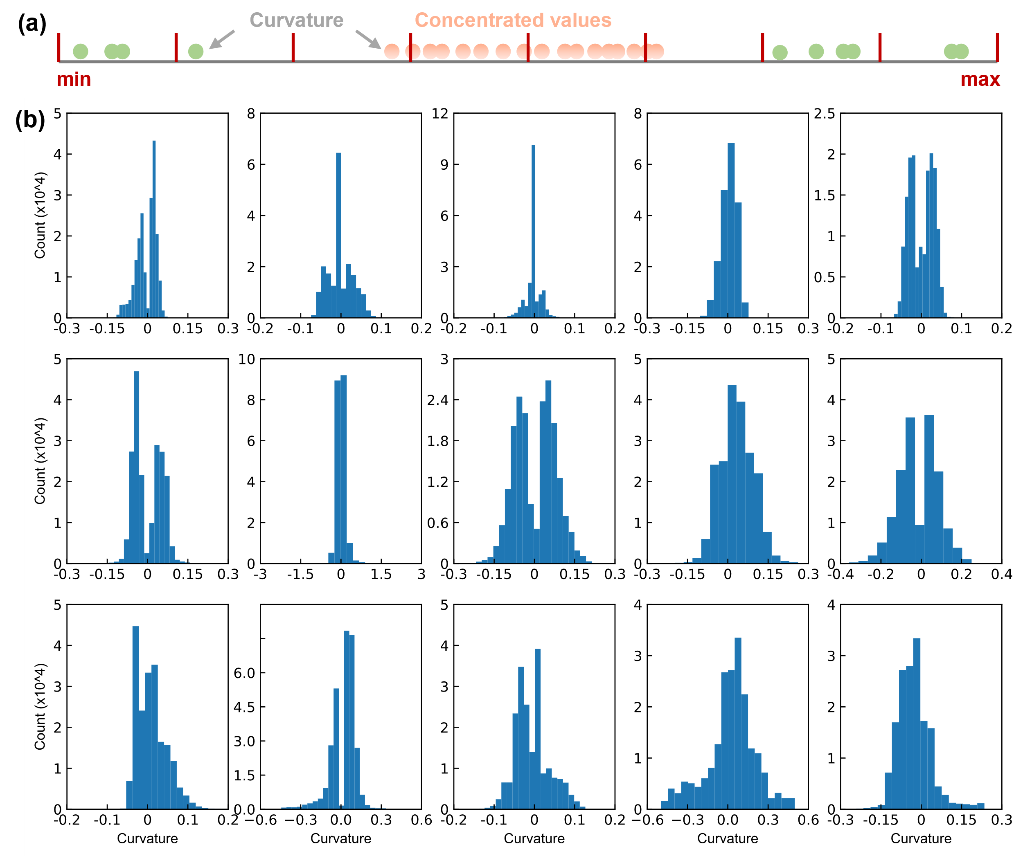
Fig. A.1 The curvature properties of free-form surfaces. (a) Curvature value concentration phenomenon; (b) Distribution of curvature values for 15 free-form surfaces.
We first elaborate on the creation process of the curvature cloud map, with a concise overview of the processing of the height cloud map.

A.1 Curvature cloud map
(1) The architectural free-form surface is partitioned into adjacent edges based on M rows and N columns, resulting in a comprehensive division of M × N distinct free-form surfaces denoted as S_{sub}, as illustrated by Eq. (A.1). The values within the matrix signify the M × N subdivided free-form surfaces, wherein M and N are positive integers.
 | $$S_{sub}=\left[\begin{matrix}S_{00} & S_{01} & ⋯ & S_{0N} \\ S_{10} & S_{11} & ⋯ & S_{1N} \\ ⋮ & ⋮ & ⋱ & ⋮ \\ S_{M0} & S_{M1} & ⋯ & S_{MN}\end{matrix}\right]$$ | (A.1)
(2) $S_{ij}$ denotes the free-form surface located in the i-th row and j-th column, where i ∈ [1:M] and j ∈ [1:N]. The maximum principal curvature $k_{ij}$ at the geometric center of each individual free-form surface among the M × N surfaces is computed. Furthermore, the overall maximum principal curvatures $k_{\text{max}}$ for all M × N free-form surfaces, calculated at their respective geometric centers, is represented by Eq. (A.2).
 | $$k_{\text{max}}=\left[\begin{matrix}k_{00} & k_{01} & ⋯ & k_{0N} \\ k_{10} & k_{11} & ⋯ & k_{1N} \\ ⋮ & ⋮ & ⋱ & ⋮ \\ k_{M0} & k_{M1} & ⋯ & k_{MN}\end{matrix}\right]$$ | (A.2)
(3) A gradient color mapping scheme is employed for the maximum curvature value $k_{\text{max}}$, wherein the gradient comprises a sequence of 19 RGB colors with equal proportions, forming a color spectrum (the RGB values can be found in Table A.1 ). Let $N_{i}\left(r_{i},g_{i},b_{i}\right)$ denotes the generalized formula for the 19 colors, where $i=0,1,…,18$ and $\left(r_{i},g_{i},b_{i}\right)$ represents the numerical code associated with each color.
(4) For any given curvature value $k_{ij}$, it is first necessary to determine the interval within the three gradient color segments in which it falls. Subsequently, the distance $d_{n}$ between the value and the leftmost side of that interval is calculated, and the decimal portion of $d_{n}$ is disregarded, and only the integer part $d_{z}$ is retained. This allows for the determination of the value of the index $i$ corresponding to the left primary color $N_{i}\left(r_{i},g_{i},b_{i}\right)$ for $k_{ij}$. Furthermore, the left and right primary colors for $k_{ij}$ can be represented as $N_{d_{z}}\left(r_{d_{z}},g_{d_{z}},b_{d_{z}}\right)$ and $N_{d_{z}+1}\left(r_{d_{z}+1},g_{d_{z}+1},b_{d_{z}+1}\right)$, respectively
(5) Let $C_{left}=r_{d_{z}}$, $C_{right}=r_{d_{z}+1}$, and by substituting them into Eq. (A.3), $C_{r}$ can be calculated. Similarly, by letting $C_{left}=g_{d_{z}}$, $C_{right}=g_{d_{z}+1}$, and substituting them into Eq. (A.3), $C_{g}$ can be acquired. Furthermore, by setting $C_{left}=b_{d_{z}}$, $C_{right}=b_{d_{z}+1}$, and substituting them into Eq. (A.3), $C_{b}$ can be calculated. Finally, we get $(C_{r},C_{g},C_{b})$, which represents the numerical code of the color corresponding to the curvature value $k_{ij}$ in step (4).
 | $$C=C_{left}+\left(d_{n}-d_{z}\right)\left(C_{right}-C_{left}\right)$$ | (A.3)
(6) By iteratively applying steps (4) and (5) to each curvature value $k_{ij}$ of the M × N architectural free-form surface, as described in Eq. (A.2), the visualization of all curvature values $k_{ij}$ can be achieved, resulting in the generation of the overall curvature cloud map $C_{sub}$ for the architectural free-form surface, as shown in Eq. (A.4). Here, the variable $c_{ij}$ is the general expression for the color attributed to the i-th row and j-th column of the free-form surfaces, $i∈\left[1, M\right]$ and $j∈\left[1, N\right]$.
 | $$C_{\text{sub}}=\left[\begin{matrix}c_{00} & c_{01} & ⋯ & c_{0N} \\ c_{10} & c_{11} & ⋯ & c_{1N} \\ ⋮ & ⋮ & ⋱ & ⋮ \\ c_{M0} & c_{M1} & ⋯ & c_{MN}\end{matrix}\right]$$ | (A.4)

A.2 Height cloud map
The making of the height cloud map follows the same six steps as the curvature cloud map, as described in Subsection A.1. However, there are two notable differences. Firstly, in step (2) of the height cloud map production, instead of calculating the curvature of the M × N architectural free-form subsurfaces, the geometric center of each subsurface is determined. From this center, the z-coordinate $z_{ij}$ is extracted and represented as shown in Eq. (A.5). Here, $i∈\left[1, M\right]$ and $j∈\left[1, N\right]$. Furthermore, due to the relatively continuous nature of the numerical values in the height cloud map, there is no need to partition the primary colors. Instead, they can be seamlessly blended to create a gradient color spectrum. Finally, replace the maximum principal curvature $k_{\text{max}}$ in Subsection A.1 with $Z_{\text{sub}}$, and follow the remaining steps outlined in Subsection A.1 to create the height cloud map.
 | $$Z_{\text{sub}}=\left[\begin{matrix}z_{00} & z_{01} & ⋯ & z_{0N} \\ z_{10} & z_{11} & ⋯ & z_{1N} \\ ⋮ & ⋮ & ⋱ & ⋮ \\ z_{M0} & z_{M1} & ⋯ & z_{MN}\end{matrix}\right]$$ | (A.5)

Appendix B. Extraction of node coordinates and inter-nod topological relationships
The free-form grid structure generated by GridGAN is presented as an image (in the two-dimensional domain). To obtain the final three-dimensional free-form grid structure, it is essential to acquire both the spatial coordinates of the nodes and the topological relationships between these nodes.

B.1 Extraction of node coordinates
The flowchart illustrating the process of obtaining mesh node coordinates is presented in Fig. B. 1, detailing each procedure step.
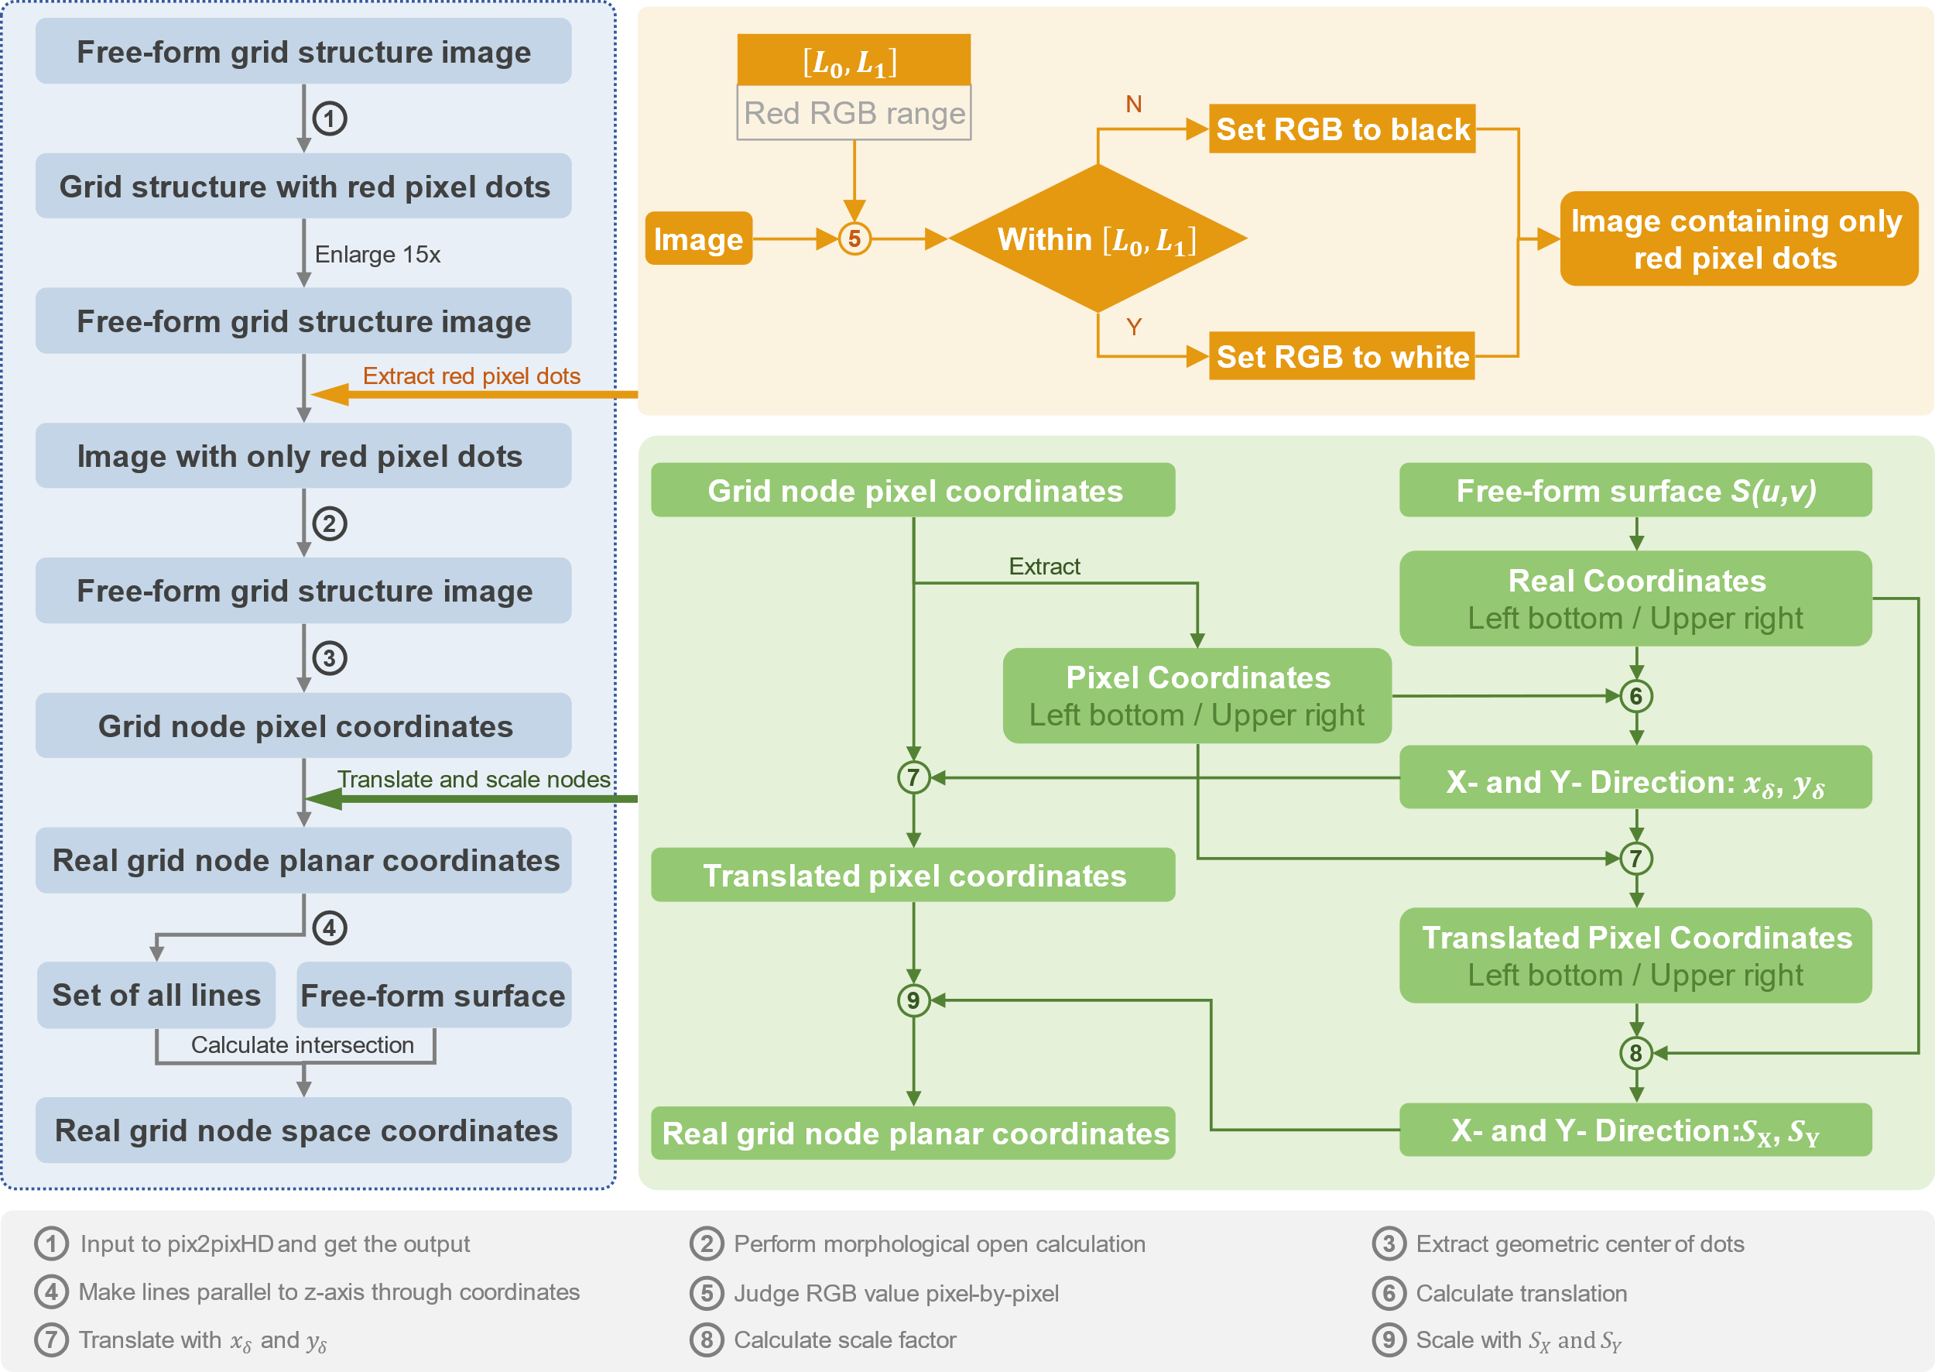
Fig. B. 1 The process of obtaining the coordinates of the grid nodes.
Step 1: marking the node positions
The free-form grid structure image generated by GridGAN is initially inputted into the pre-trained pix2pixHD (utilizing the identical hyperparameters configuration as that in the original paper). Subsequently, we obtain the output image of the free-form grid structure, wherein the grid nodes are visually marked by red pixel dots.
Step 2: extracting the coordinates of the planar pixel nodes
(1) Enlarge the free-form grid structure image marked with red pixel dots while preserving its original aspect ratio, and multiply the width and height of the image by a scaling factor of 15. The magnified image is denoted as P.
(2) The lower and upper thresholds for the RGB color values of the red pixel dots are defined as $L_{0}\left(r_{0},g_{0},b_{0}\right)$ and $L_{1}\left(r_{1},g_{1},b_{1}\right)$, respectively. By applying the specified RGB color value range $\left[L_{0},L_{1}\right]$, the red pixel dots are extracted and isolated from the enlarged image P. The resulting image, consisting solely of the red pixel dots, is denoted as $P_{r}$.
(3) The image $P_{r}$ is then inputted into Eq. (B.1), along with the morphological opening operation formula (utilizing a convolution kernel K as an n x n matrix with each element equal to 1), to perform the opening operation. This operation isolates the red pixel dots in $P_{r}$ that are connected to each other within a specified distance threshold. The resulting image, denoted as $P_{r}^{'}$, represents the output of the opening operation applied to $P_{r}$.
 | $$P_{r}^{'}=\left(P_{r}⊖K\right)⊕K$$ | (B.1)
(4) The geometric center coordinates (representing the pixel nodes in the free-form grid structure image) of each red pixel dot in $P_{r}^{'}$ are extracted and denoted as $N_{\text{pix}}$, as defined in Eq. (B.2). The coordinate of the i-th pixel grid node in the free-form grid structure image are represented as $N_{i}\left(x_{i},y_{i}\right)$, where $\left(x_{i},y_{i}\right)$ is the coordinate value. Furthermore, we designate the pixel grid coordinates representing the bottom-left and the top-right nodes of the grid structure as $N_{\text{LB}}\left(x_{\text{LB}},y_{\text{LB}}\right)$ and $N_{\text{RT}}\left(x_{\text{RT}},y_{\text{RT}}\right)$, respectively.
 | $$N_{\text{pix}}=\left[N_{1}\left(x_{1},y_{1}\right),⋯,N_{i}\left(x_{i},y_{i}\right),⋯,N_{n}\left(x_{n},y_{n}\right)\right]$$ | (B.2)
Step 3: extracting the coordinates of the planar pixel nodes
(1) Denote the free-form surface in the parameter space as $S\left(u,v\right)$, which represents all coordinate points $\left(x,y,z\right)$ in the Cartesian coordinate system. The relationship between the two is briefly shown in Eq. (B.3). By substituting the parameter space coordinates $\left(0,0\right)$ and $\left(1,1\right)$ into Eq. (B.3), we derive the Cartesian coordinates of the bottom-left and the top-right nodes of the free-form surface as $N_{LB}^{r}\left(x_{LB}^{r},y_{LB}^{r},z_{LB}^{r}\right)$ and $N_{\text{RT}}^{r}\left(x_{RT}^{r},y_{RT}^{r},z_{RT}^{r}\right)$, respectively.
 | $$(x,y,z)=(x(u,v),y(u,v),z(u,v))=S(u,v)$$ | (B.3)
(2) Calculate the difference in distance, denoted as $\left(x_{δ},y_{δ}\right)$, between $N_{\text{LB}}^{r}\left(x_{\text{LB}}^{r},y_{\text{LB}}^{r}\right)$ and $N_{\text{LB}}\left(x_{\text{LB}},y_{\text{LB}}\right)$, specifically, $x_{δ}=x_{\text{LB}}-x_{\text{LB}}^{r}$ and $y_{δ}=y_{\text{LB}}-y_{\text{LB}}^{r}$. By substituting the n pixel grid nodes $N_{i}\left(x_{i},y_{i}\right)$ from the grid structure image into Eq. (B.4) sequentially, we get the translation-aligned pixel node coordinates $N_{i}^{m}\left(x_{i}^{m},y_{i}^{m}\right)$, and collectively denote the translated pixel grid node coordinates as $N_{\text{pix}}^{m}$, shown in Eq. (B.5). Specifically, the translated pixel coordinates of $N_{\text{LB}}\left(x_{\text{LB}},y_{\text{LB}}\right)$ and $N_{\text{RT}}\left(x_{\text{RT}},y_{\text{RT}}\right)$ are denoted as $N_{\text{LB}}^{m}\left(x_{\text{LB}}^{m},y_{\text{LB}}^{m}\right)$ and $N_{\text{RT}}^{m}\left(x_{\text{RT}}^{m},y_{\text{RT}}^{m}\right)$, respectively.
 | $$\left(x_{i}^{m},y_{i}^{m}\right)=\left(x_{i}-x_{δ},y_{i}-y_{δ}\right)$$ | (B.4)
 | $$N_{\text{pix}}^{m}=\left[N_{1}^{m}\left(x_{1}^{m},y_{1}^{m}\right)⋯,N_{i}^{m}\left(x_{i}^{m},y_{i}^{m}\right),⋯,N_{n}^{m}\left(x_{n}^{m},y_{n}^{m}\right)\right]$$ | (B.5)
(3) Utilizing Eq. (B.6), the scaling factors $S_{\text{x}}$ and $S_{\text{y}}$ are obtained to scale the translated pixel node coordinates $N_{\text{pix}}^{m}$ of the free-form grid structure image in X and Y directions. By substituting the pixel grid node coordinate $N_{i}^{m}\left(x_{i}^{m},y_{i}^{m}\right)$ sequentially into Eq. (B.6), we can determine the corresponding real grid node planar coordinate $N_{i}^{r}\left(x_{i}^{r},y_{i}^{r}\right)$. These real grid node coordinates can be collectively denoted as $N_{\text{pix}}^{r}$ in Eq. (B.8).
 | $$(S_{x},S_{y})=(\frac{x_{RT}^{m}-x_{LB}^{m}}{x_{RT}^{r}-x_{LB}^{r}},\frac{y_{RT}^{m}-y_{LB}^{m}}{y_{RT}^{r}-y_{LB}^{r}})$$ | (B.6)
 | $$(x_{i}^{r},y_{i}^{r})=(\frac{x_{i}^{m}-x_{LB}^{m}}{S_{x}}+x_{LB}^{r},\frac{y_{i}^{m}-y_{LB}^{m}}{S_{y}}+y_{LB}^{r})$$ | (B.7)
 | $$N_{\text{pix}}^{r}=\left[N_{1}^{r}\left(x_{1}^{r},y_{1}^{r}\right)⋯,N_{i}^{r}\left(x_{i}^{r},y_{i}^{r}\right),⋯,N_{n}^{r}\left(x_{n}^{r},y_{n}^{r}\right)\right]$$ | (B.8)
Step 4: extracting the real 3D coordinates of the grid nodes
(1) Expand the obtained real grid node planar coordinates $N_{\text{pix}}^{r}$ to spatial coordinates by adding a z-coordinate value of 0, namely, every coordinate changing from $N_{i}^{r}\left(x_{i}^{r},y_{i}^{r}\right)$ to $N_{i}^{r}\left(x_{i}^{r},y_{i}^{r},0\right)$. A line $l_{i}$ is constructed by passing through the point $N_{i}^{r}\left(x_{i}^{r},y_{i}^{r},0\right)$ and parallel to the Z-axis of the Cartesian coordinate system. The overall collection of these lines is denoted as $L_{\text{Z}}=\left[l_{1},l_{2},⋯,l_{i},⋯,l_{n}\right]$.
(2) Calculate the intersection point between any line $l_{i}$ in $L_{\text{Z}}$ and the free-form surface $S\left(u,v\right)$, as indicated in Eq. (B.9), and denote the obtained intersection point as $N_{i}^{r}\left(x_{i}^{r},y_{i}^{r},z_{i}^{r}\right)$. Obtain the intersection points between all the lines in the line set $L_{\text{Z}}$ and the free-form surface $S\left(u,v\right)$, as expressed in Eq. (B.10). These intersection points, referred to as $N^{r}$, are the three-dimensional coordinates of the real grid nodes of the free-form surface.
 | $$\left\{\begin{matrix}l_{i} \\ S\left(u,v\right)\end{matrix}\right.$$ | (B.9)
 | $$N^{r}=\left[N_{1}^{r}\left(x_{1}^{r},y_{1}^{r},z_{1}^{r}\right),⋯,N_{i}^{r}\left(x_{i}^{r},y_{i}^{r},z_{i}^{r}\right),⋯,N_{n}^{r}\left(x_{n}^{r},y_{n}^{r},z_{n}^{r}\right),\right]$$ | (B.10)

B.2 Extraction of inter-node topological relationships
The flowchart for obtaining the inter-node topological relationships can be found in Fig. B. 2, which includes the detailed steps of the process.
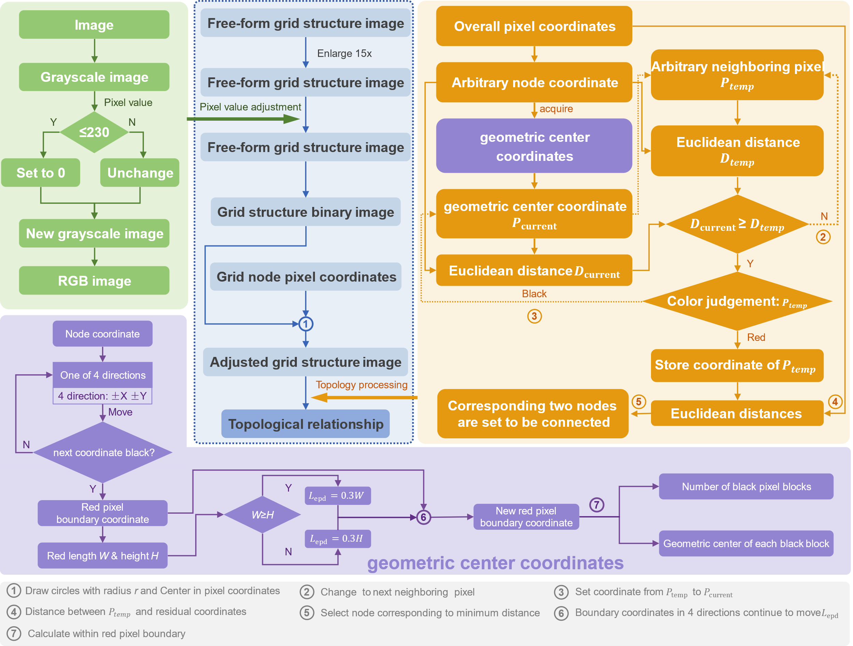
Fig. B. 2 The process of obtaining the inter-node topological relationships.
(1) Image preprocessing. Convert the acquired grid structure image $P$ (of the free-form surface) into a grayscale image. Apply the processing described in Eq. (B.11) to each pixel in the grayscale image, where $v_{ij}$ represents the grayscale value of the pixel at the i-th row and j-th column in the image, and $v_{ij}^{'}$ is the corresponding new grayscale value. Convert the preprocessed grayscale image of the free-form grid structure into an RGB image, designated as $P_{1}$, wherein all pixels except the white background solely consist of black pixels representing the free-form grid structure.
 | $$v_{ij}^{'}=\left\{\begin{matrix}\begin{matrix}0, & \text{ if} v_{ij}≤230\end{matrix} \\ \begin{matrix}v_{ij} & \text{if} { v}_{ij}>230\end{matrix}\end{matrix}\right.$$ | (B.11)
(2) Utilizing the obtained $P_{1}$ image, depict n red dots with a radius of r at the coordinates of the pixel grid nodes $N_{\text{pix}}$ from Eq. (B.2). We set the RGB value for the red color used in the dots as (255, 0, 0), and denote the image of the free-form grid structure with the red dots as $P_{2}$.
(3) Conduct a pixel search in the positive X-axis, negative X-axis, positive Y-axis, and negative Y-axis directions starting from any given node coordinate $N_{i}\left(x_{i},y_{i}\right)$ within $P_{2}$. Continue the search until reaching the boundary of the red pixels. Sequentially record the coordinates of the pixels at the red pixel boundaries in each direction as $\left(x_{i}^{R},y_{i}\right)$, $\left(x_{i}^{L},y_{i}\right)$, $\left(x_{i},y_{i}^{T}\right)$, and $\left(x_{i},y_{i}^{B}\right)$.
(4) Calculate $\left(x_{i}^{R}-x_{i}^{L}\right)$ and $\left(y_{i}^{R}-y_{i}^{L}\right)$, take the maximum value between the two, and multiply it by the coefficient 0.3 to obtain $L_{\text{epd}}$, as described in Eq. (B.12). Let $\left(x_{c}^{L},y_{c}^{L}\right)$ and $\left(x_{c}^{R},y_{c}^{R}\right)$ represent the two endpoints of the diagonal of a rectangle, and express them using Eq. (B.13) and Eq. (B.14), respectively. Calculate the values of $\left(x_{c}^{L},y_{c}^{L}\right)$ and $\left(x_{c}^{R},y_{c}^{R}\right)$, crop the corresponding image region of the rectangle in $P_{2}$, and designate this cropped region as $P_{\text{crop}}$. Extract and quantify the number of black lines within the cropped image region $P_{\text{crop}}$, represented as m. Additionally, calculate the geometric center of each black line as $C_{i}\left(x_{i},y_{i}\right)$. Consequently, it can be determined that there are m black lines connected to the node coordinate $N_{i}\left(x_{i},y_{i}\right)$.
 | $$L_{\text{epd}}=0.3⋅max\left(\left(x_{i}^{R}-x_{i}^{L}\right),\left(y_{i}^{R}-y_{i}^{L}\right)\right)$$ | (B.12)
 | $$\left(x_{c}^{L},y_{c}^{L}\right)=\left(x_{i}^{L}-L_{\text{ep}\text{d}},y_{i}^{L}-L_{\text{epd}}\right)$$ | (B.13)
 | $$\left(x_{c}^{R},y_{c}^{R}\right)=\left(x_{i}^{R}+L_{\text{epd}},y_{i}^{R}+L_{\text{epd}}\right)$$ | (B.14)
(5) Obtain the coordinates of the m endpoints of the black lines connected to the selected node coordinate $N_{i}\left(x_{i},y_{i}\right)$ in step (3) through the following sub-steps.
(5.1) Convert the geometric center coordinates $C_{i}\left(x_{i},y_{i}\right)$ of the m black lines in step (4) from the local coordinates within the $P_{\text{crop}}$ image to the corresponding global coordinates $C_{i}^{g}\left(x_{i}^{g},y_{i}^{g}\right)$ within the $P_{2}$ image, using Eq. (B.15).
 | $$\left(x_{i}^{g},y_{i}^{g}\right)=\left(x_{i}+x_{c}^{L},y_{i}+y_{c}^{L}\right)$$ | (B.15)
(5.2) Start with the first term $C_{1}^{g}\left(x_{1}^{g},y_{1}^{g}\right)$ of the general expression $C_{i}^{g}\left(x_{i}^{g},y_{i}^{g}\right)$ in step 5.1, and label it as the initial point, referred to as $P_{\text{current}}$.
(5.3) The pixel point next to $P_{\text{current}}$ is referred to as $P_{\text{temp}}$, and the eight adjacent pixel points to $P_{\text{current}}$ include those positioned to the left, upper-left, upper, upper-right, right, lower-right, lower, and lower-left. Following the order mentioned above, we set the pixel point on the left side of $P_{\text{current}}$ as $P_{\text{temp}}$.
(5.4) Compute the Euclidean distance between the node $N_{i}\left(x_{i},y_{i}\right)$ and the point $P_{\text{current}}$, representing it as $D_{\text{current}}$. Likewise, calculate the Euclidean distance between the node $N_{i}\left(x_{i},y_{i}\right)$ and the point $P_{\text{temp}}$, and denote it as $D_{\text{temp}}$.
(5.5) If the current pixel point $P_{\text{temp}}$ is black, and $D_{\text{temp}}$ is greater than $D_{\text{current}}$, then designate the current attempted pixel point $P_{\text{temp}}$ as $P_{\text{current}}$, and restart the sub-step from (5.3).
(5.6) If the current pixel point $P_{\text{temp}}$ is black, and the calculated Euclidean distance $D_{\text{temp}}$ is smaller than $D_{\text{current}}$, switch to the next adjacent pixel point to $P_{\text{current}}$, designate it as $P_{\text{temp}}$, and restart from step (5.4).
(5.7) If the current attempted pixel point $P_{\text{temp}}$ is red, compute the Euclidean distance between the n-1 nodes $N_{j}\left(x_{j},y_{j}\right)$ in $N_{\text{pix}}$ (excluding $N_{i}\left(x_{i},y_{i}\right)$), and the pixel point $P_{\text{temp}}$. Here, $j=1,2,⋯,n$ and $j≠i$. Among these n-1 computed Euclidean distances, the node coordinates corresponding to the minimum distance represent the coordinates connected to the node $N_{i}\left(x_{i},y_{i}\right)$. Assuming that the node coordinates corresponding to the minimum Euclidean distance are represented by $N_{j_{1}}\left(x_{j_{1}},y_{j_{1}}\right)$, we establish a connection between $N_{i}\left(x_{i},y_{i}\right)$ and $N_{j_{1}}\left(x_{j_{1}},y_{j_{1}}\right)$, which is denoted as $\left[i,j_{1}\right]$.
(5.8) For the m coordinates $C_{i}^{g}\left(x_{i}^{g},y_{i}^{g}\right)$, specifically $C_{1}^{g}\left(x_{1}^{g},y_{1}^{g}\right)$, $C_{2}^{g}\left(x_{2}^{g},y_{2}^{g}\right)$, ..., $C_{m}^{g}\left(x_{m}^{g},y_{m}^{g}\right)$, sequentially calculate them using the aforementioned sub-steps (5.2) to (5.7) to determine all the nodes connected to the node $N_{i}\left(x_{i},y_{i}\right)$. Representing this connection as $R_{\text{topo}}^{i}$, as shown in Eq. (B.16), where $j_{1}$, $j_{2}$, ..., $j_{m}$ belong to $j=1,2,⋯,n$, and $j_{1}$, $j_{2}$, ..., $j_{m}$ are all distinct.
 | $$R_{\text{topo}}^{i}=\left[\left[i,j_{1}\right],\left[i,j_{2}\right],⋯,\left[i,j_{m}\right]\right]$$ | (B.16)
(6) For the n nodes in the pixel grid $N_{\text{pix}}$, iterate through steps (3) to (5) in sequence to obtain the mutual connectivity between all nodes, establishing the topological relationship. This topological relationship between all nodes can be denoted as $R_{\text{topo}}$, as depicted in Eq. (B.17), where $R_{\text{topo}}^{i}$ represents the connection topology of the nodes linked to $N_{i}\left(x_{i},y_{i}\right)$, as defined in sub-step 5.8.
 | $$R_{topo}=[R_{topo}^{1},⋯,R_{topo}^{i},⋯,R_{topo}^{n}]$$ | (B.17)

Appendix C. Data availability statement
The raw data (including the curvature cloud maps and height cloud maps) and the self-developed Python codes (used to realize the data dimension conversion), can be accessed at the GitHub repository of the author, Jiangjun Hou (https://github.com/GeneralHou). The deep learning model employed in this study, as mentioned earlier, heavily relies on pix2pixHD (GitHub repository: https://github.com/NVIDIA/pix2pixHD). Hardware information: Nvidia Tesla V100 GPU (32GB), Intel XeonGold 6130 CPU (25G). Software information: Ubuntu 18.04.5 LTS, Python 3.6.13, pytorch 1.7.0, opencv-Python 4.2.0.32. Any additional and reasonable inquiries related to this study can be obtained by contacting the corresponding author, Jinyu Lu.

