Climate model forecasts of solar spectrum variation: effects on photovoltaics and crop photosynthesis
G.S. Kinsey

Abstract
Accumulation of greenhouse gases in the atmosphere alters the spectrum of sunlight that reaches the surface. Atmospheric parameters forecasted by five climate models from the Coupled Model Intercomparison Project were input to the radiative transfer model SMARTS to generate spectra over six decades (2018-2082). The potential geographic and temporal variation of photovoltaic and photosynthetic output was forecast for the spectral responses of one-, two- and three-junction PV cells, and three crop plants: corn, wheat, and rice.

Introduction
As sunlight passes through the Earth’s atmosphere, it’s spectrum modulated by the gases and larger particles it encounters before reaching the surface. As heat trapping from climate change accelerates, actions and interactions across the planet are shifting the atmospheric composition. The role of water vapor (as well as CO₂) to absorb solar radiation was demonstrated by Eunice Foote in 1856¹. In addition to accumulation of carbon dioxide and increasing atmospheric pressures², the water content is rising due to enhanced air and water temperatures. The burning of fossil fuels produces both waste gases and particulates (aerosols). The transition towards cleaner fuels leads to a reduction in aerosols, which may be compounded by decreases in wind speeds³.
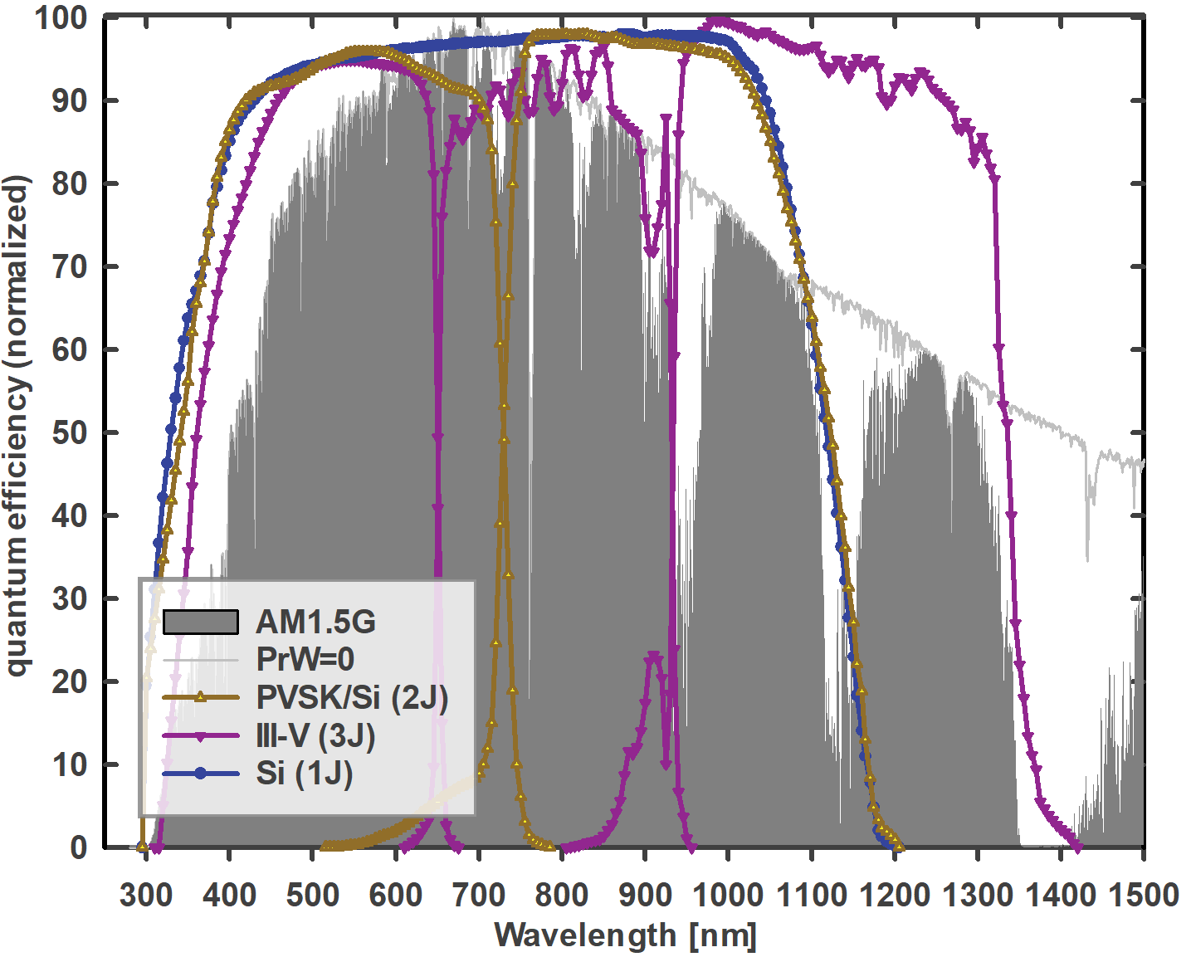 | 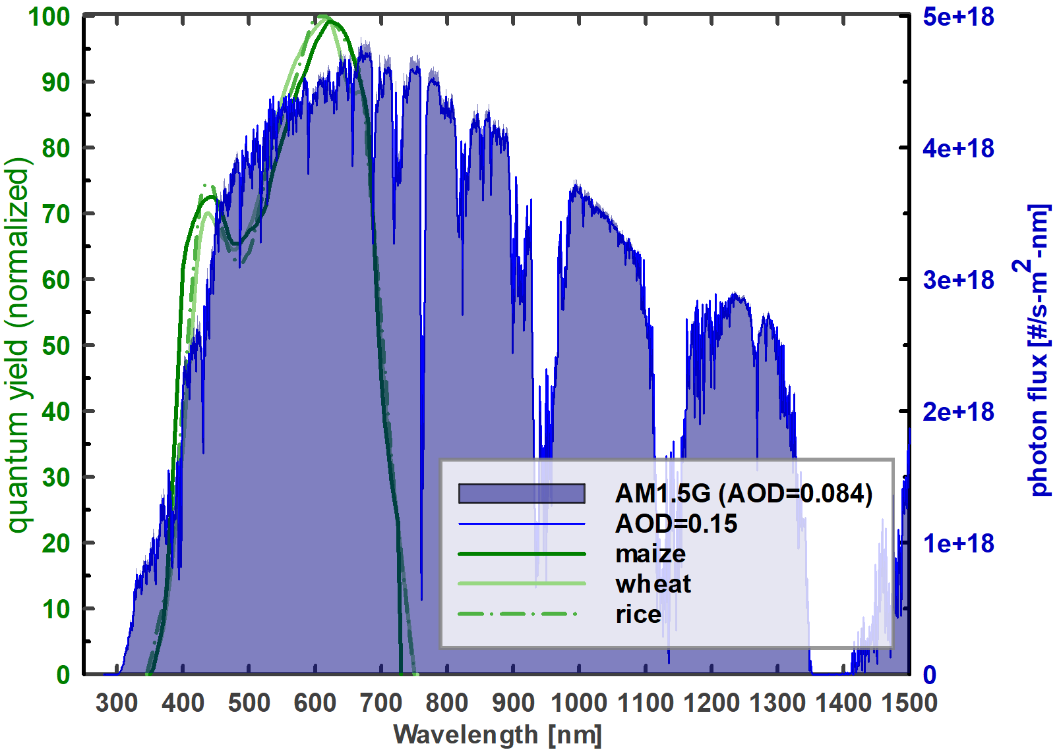
(a) | (b)
Figure 1. (a) Quantum efficiencies of a single-junction (1J) silicon (Si), tandem (2J) perovskite-silicon (PVSK/Si) and three-junction (3J) III-V multijunction cells^{4–6}. The standard spectrum (AM1.5G) is shown against a spectrum for which the precipitable water (PrW) has been changed from 1.42 to 0.00.
(b) Relative quantum yields of maize, wheat, and rice⁷ shown against the standard spectrum and a spectrum for which the aerosol optical depth (AOD) at 550 nm has been changed from 0.084 to 0.15.
Efforts to both measure and model these trends, and their interactions, span decades. The Coupled Model Intercomparison Project (CMIP) was established in 1995 to improve model accuracy and provide a knowledge base to inform international action to mitigate climate change damage. The sixth iteration (CMIP6⁸) began in 2013 and comprises 23 models which provide the underlying data for multi-decade forecasts by the Intergovernmental Panel on Climate Change (IPCC)⁹. Various future scenarios (Shared Socioeconomic Pathways, SSPs) are evaluated based on the expected level of radiative forcing of climate changes based on the additional solar radiation being retained in the atmosphere, land, and water. The scenarios are numbered sequentially by the expected forcing by 2100: scenario 1 assumes aggressive carbon reduction and low forcing of 1.9 W/m² (SSP119); with continued expansion of fossil-fuel combustion, scenario 5 expects forcing to reach 8.5 W/m² by 2100 (SSP585). An intermediate condition considered here is scenario 2, at 4.5 W/m² (SSP245).
CMIP6 models produce over a thousand parameters for forecasting changes to the geosphere. The five models selected here produce the atmospheric parameters used by the radiative transfer model SMARTS to generate representative solar spectra the Earth’s surface. The parameters of interest are the aerosol optical depth at 550 nm (AOD), carbon dioxide, relative humidity, ozone, precipitable water, surface pressure, surface air temperature, and surface maximum temperature. Inputs were drawn from: ESM2-1 (National Centre for Meteorological Research, “CNRM”), UKESM1-0-LL (Met Office Hadley Center, “MHOC”), ES2L ( Japan Agency for Marine-Earth Science and Technology, Centre for Climate System Research / National Institute for Environmental Studies “MIROC”), GISS-E2-1-G (National Aeronautics and Space Administration, “NASA”), and GFDL-ESM4 (National Oceanic and Atmospheric Administration, “NOAA).
Table 1. Predicted 2020 solar cell short-circuit current relative to that under the standard spectrum (AM1.5G). Currents are normalized to 1000 W/m² irradiance. “Summer”/ “winter” correspond to months 7-9/1-3 in the northern hemisphere and 1-3/7-9 in the southern hemisphere.
 |  | CNRM | MOHC | MIROC | NASA | NOAA
Si (1J) | winter | 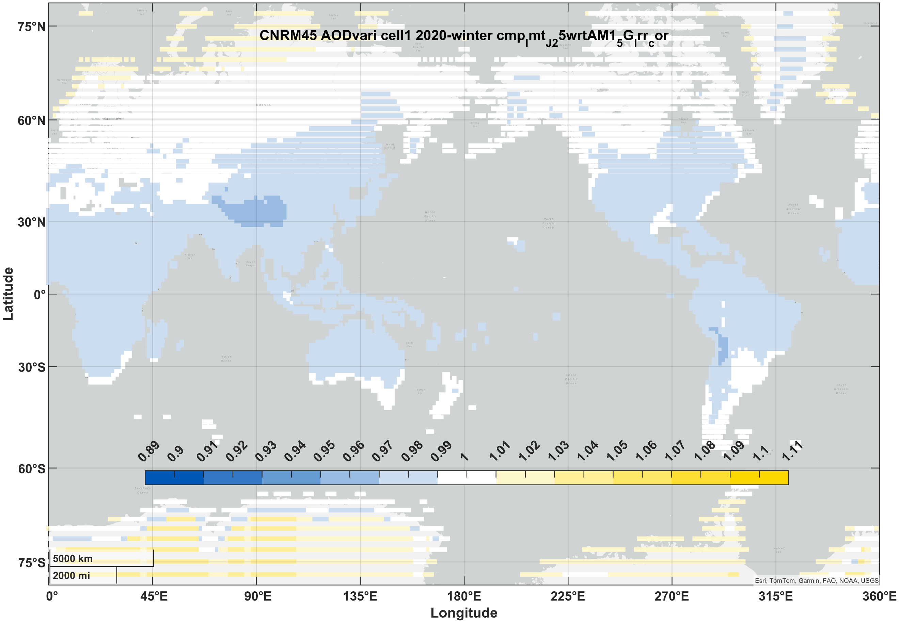 | 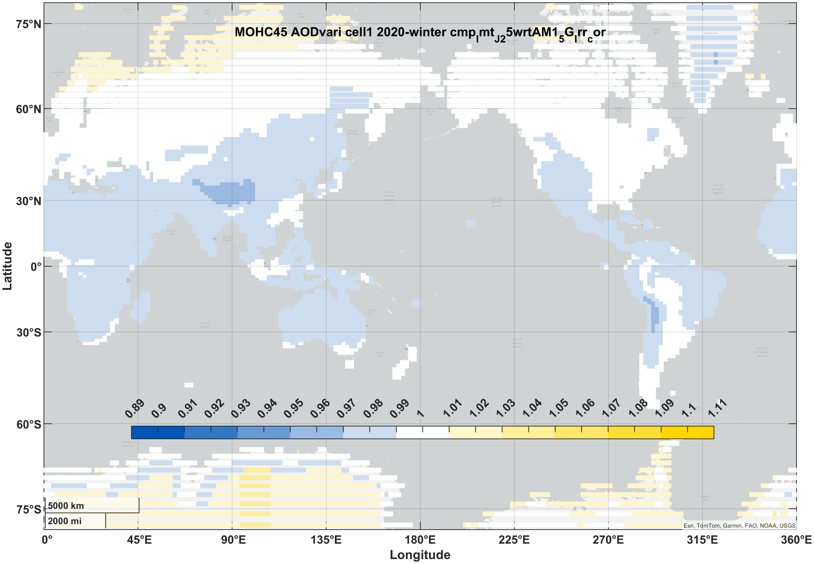 | 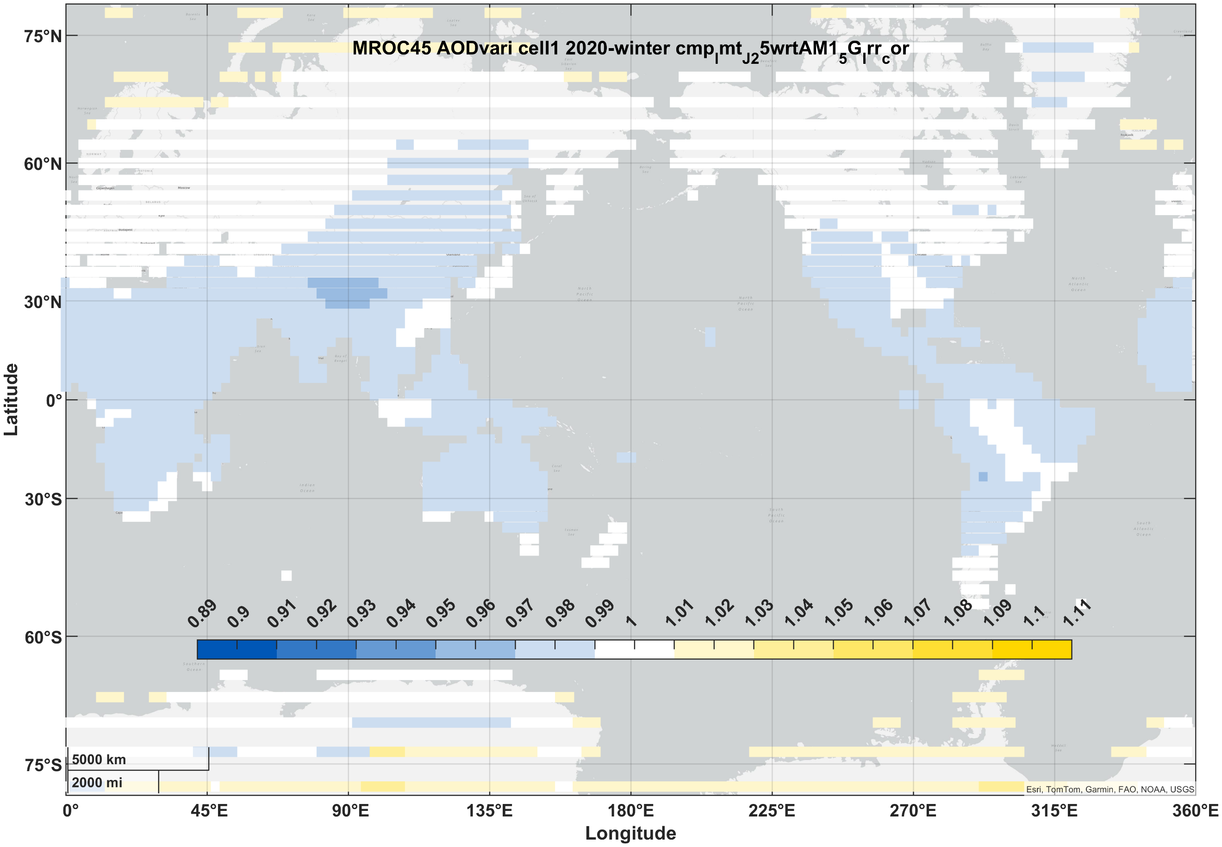 | 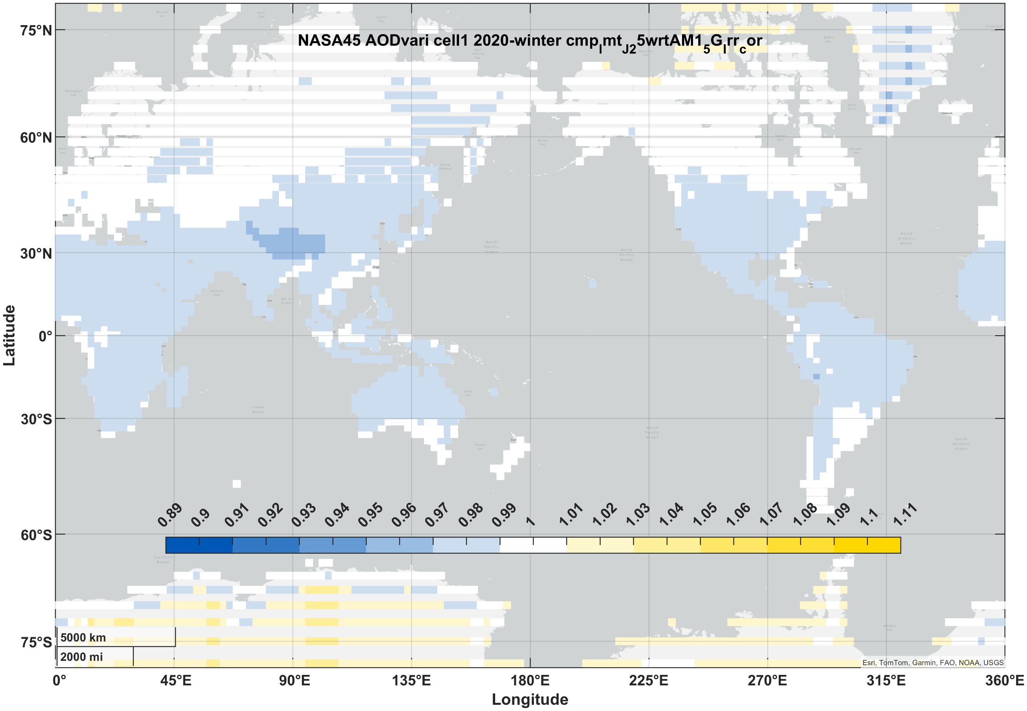 | 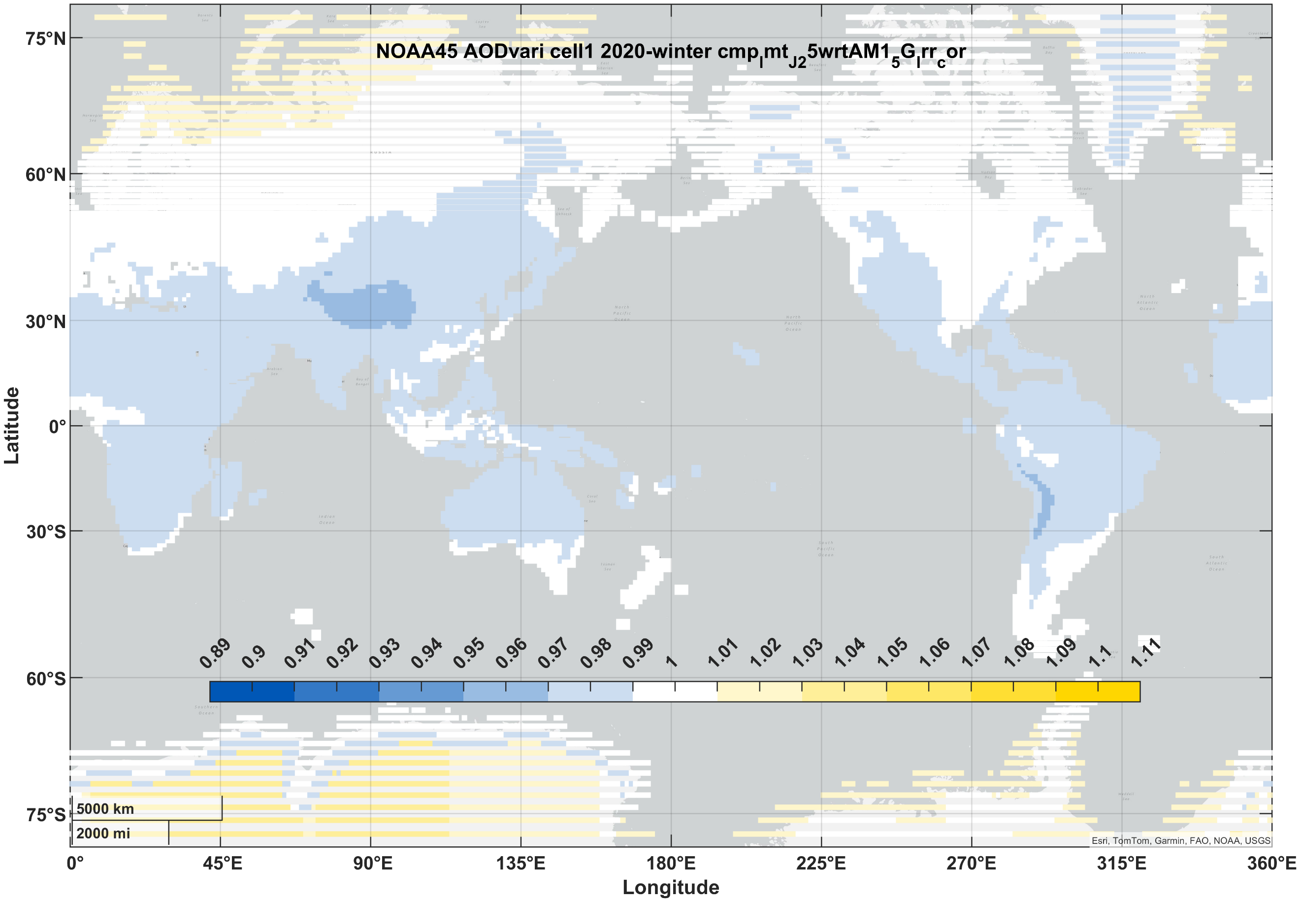
Si (1J) | summer | 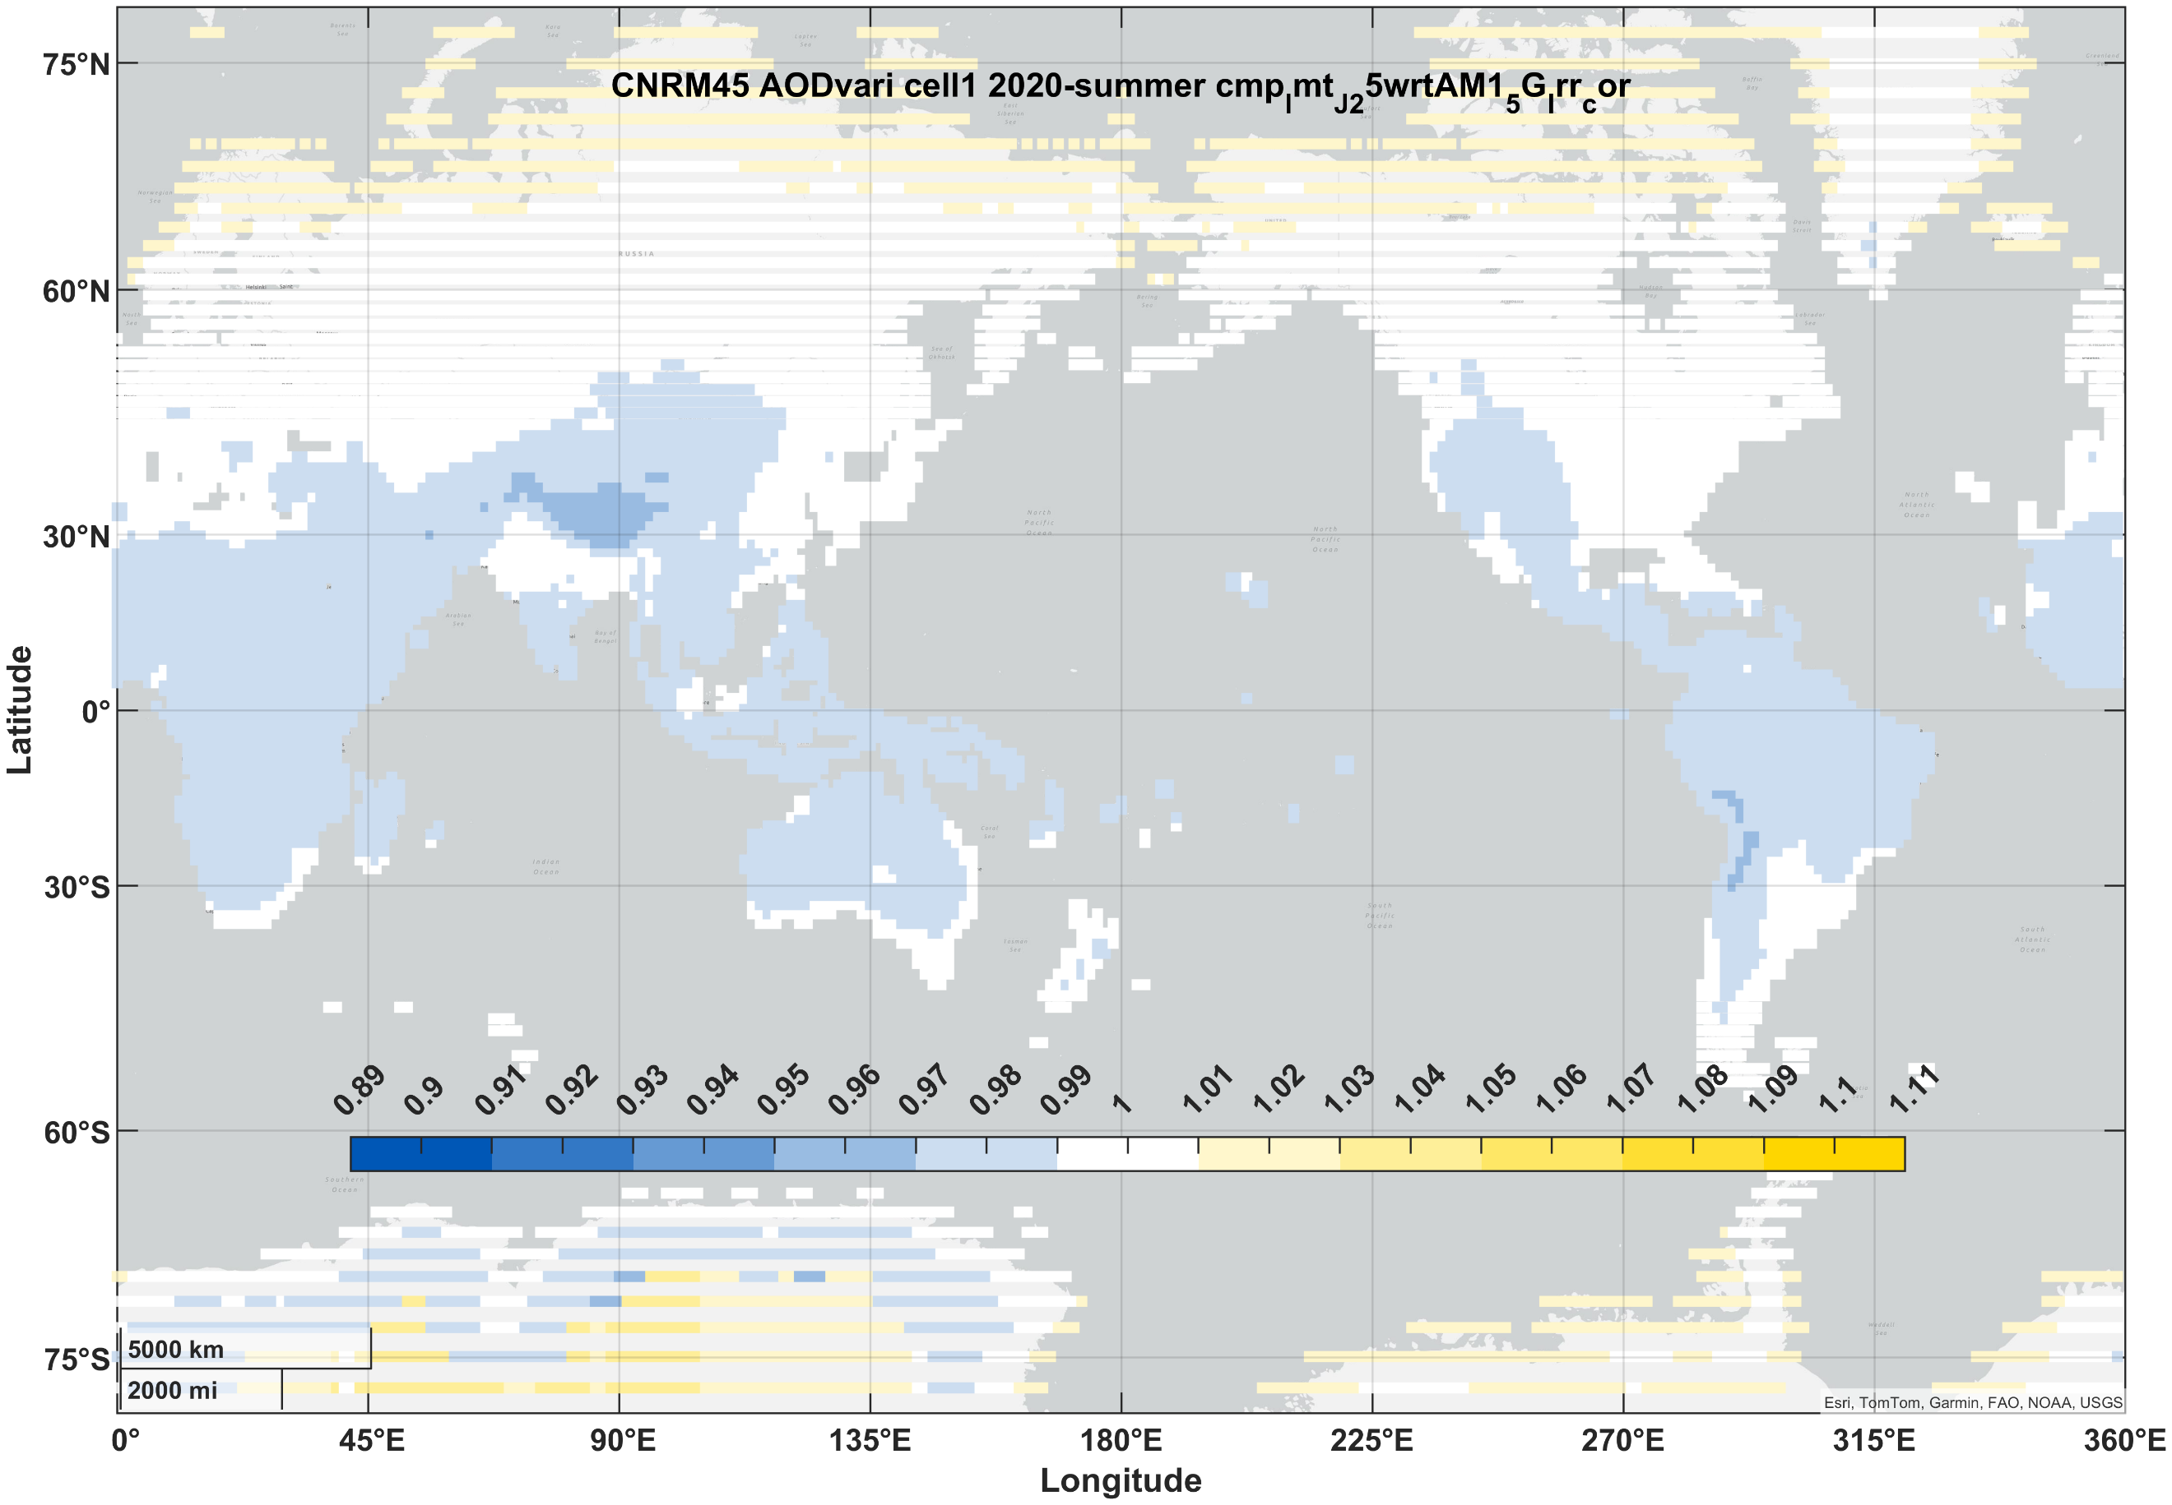 | 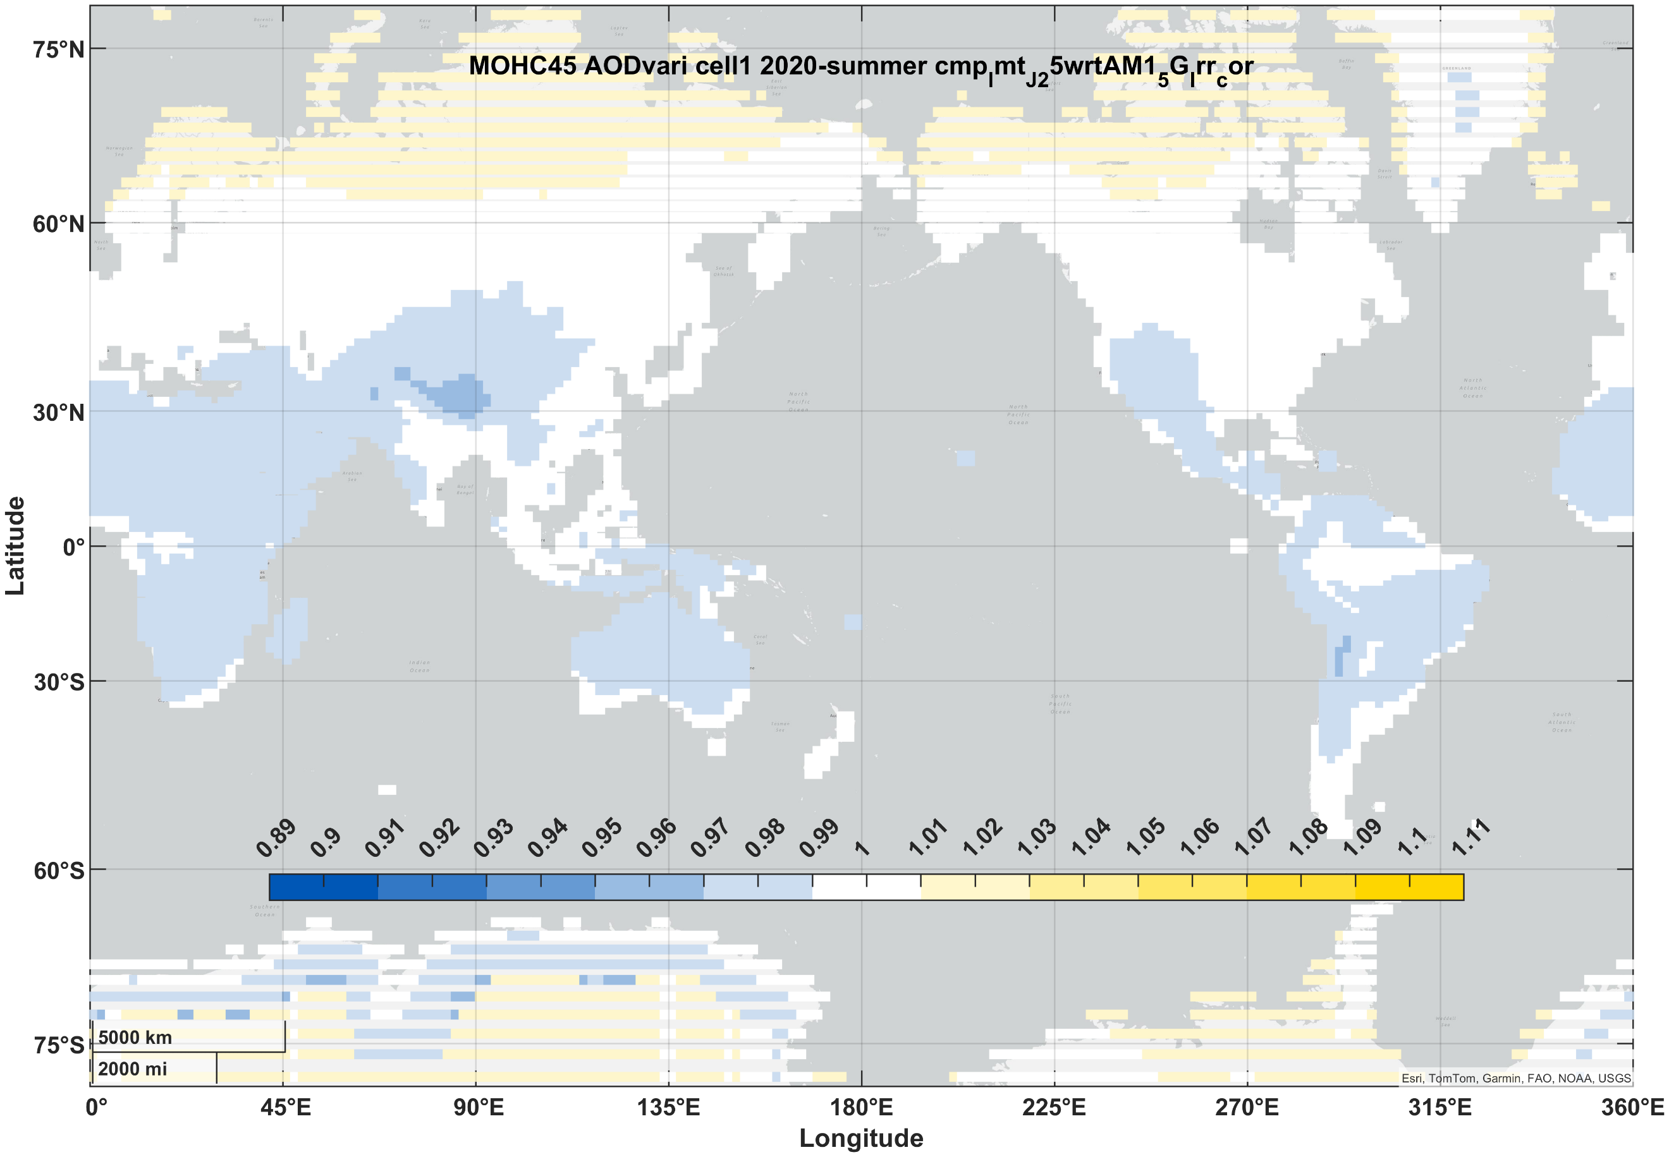 | 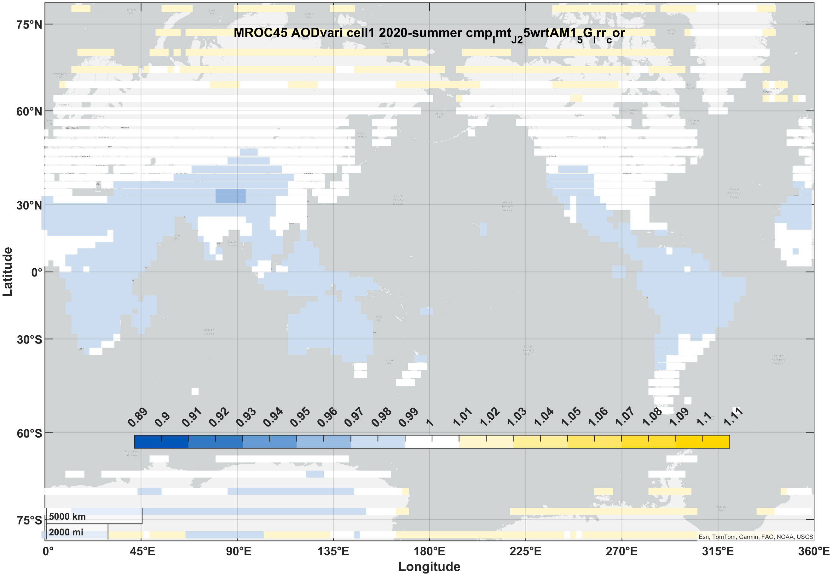 | 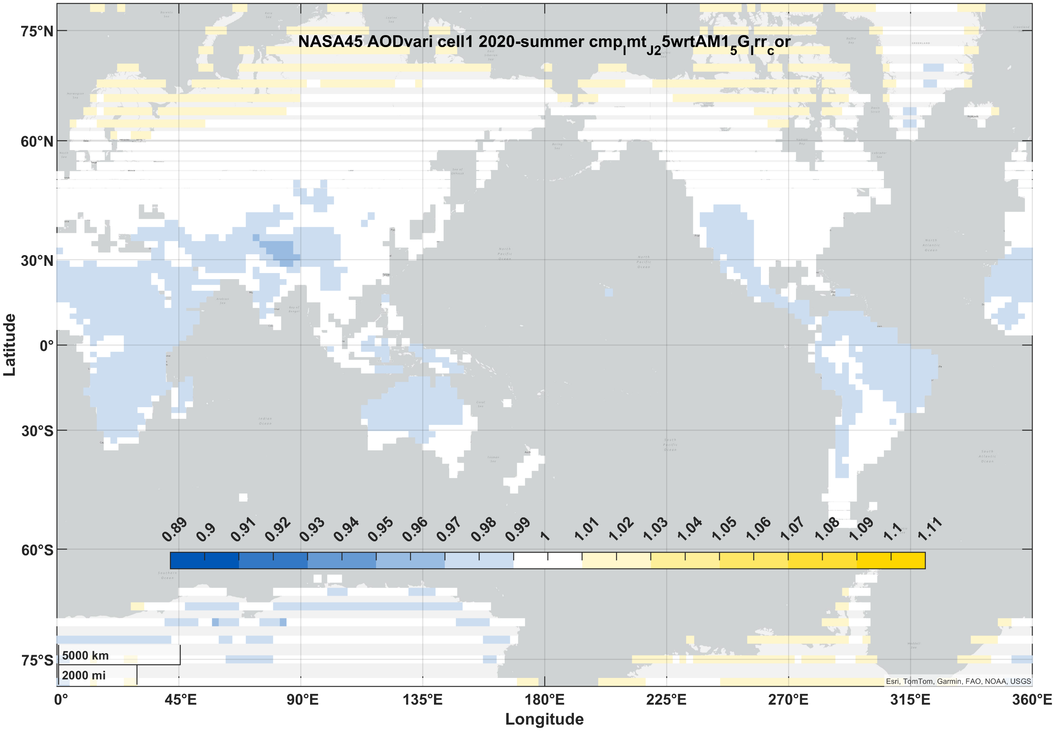 | 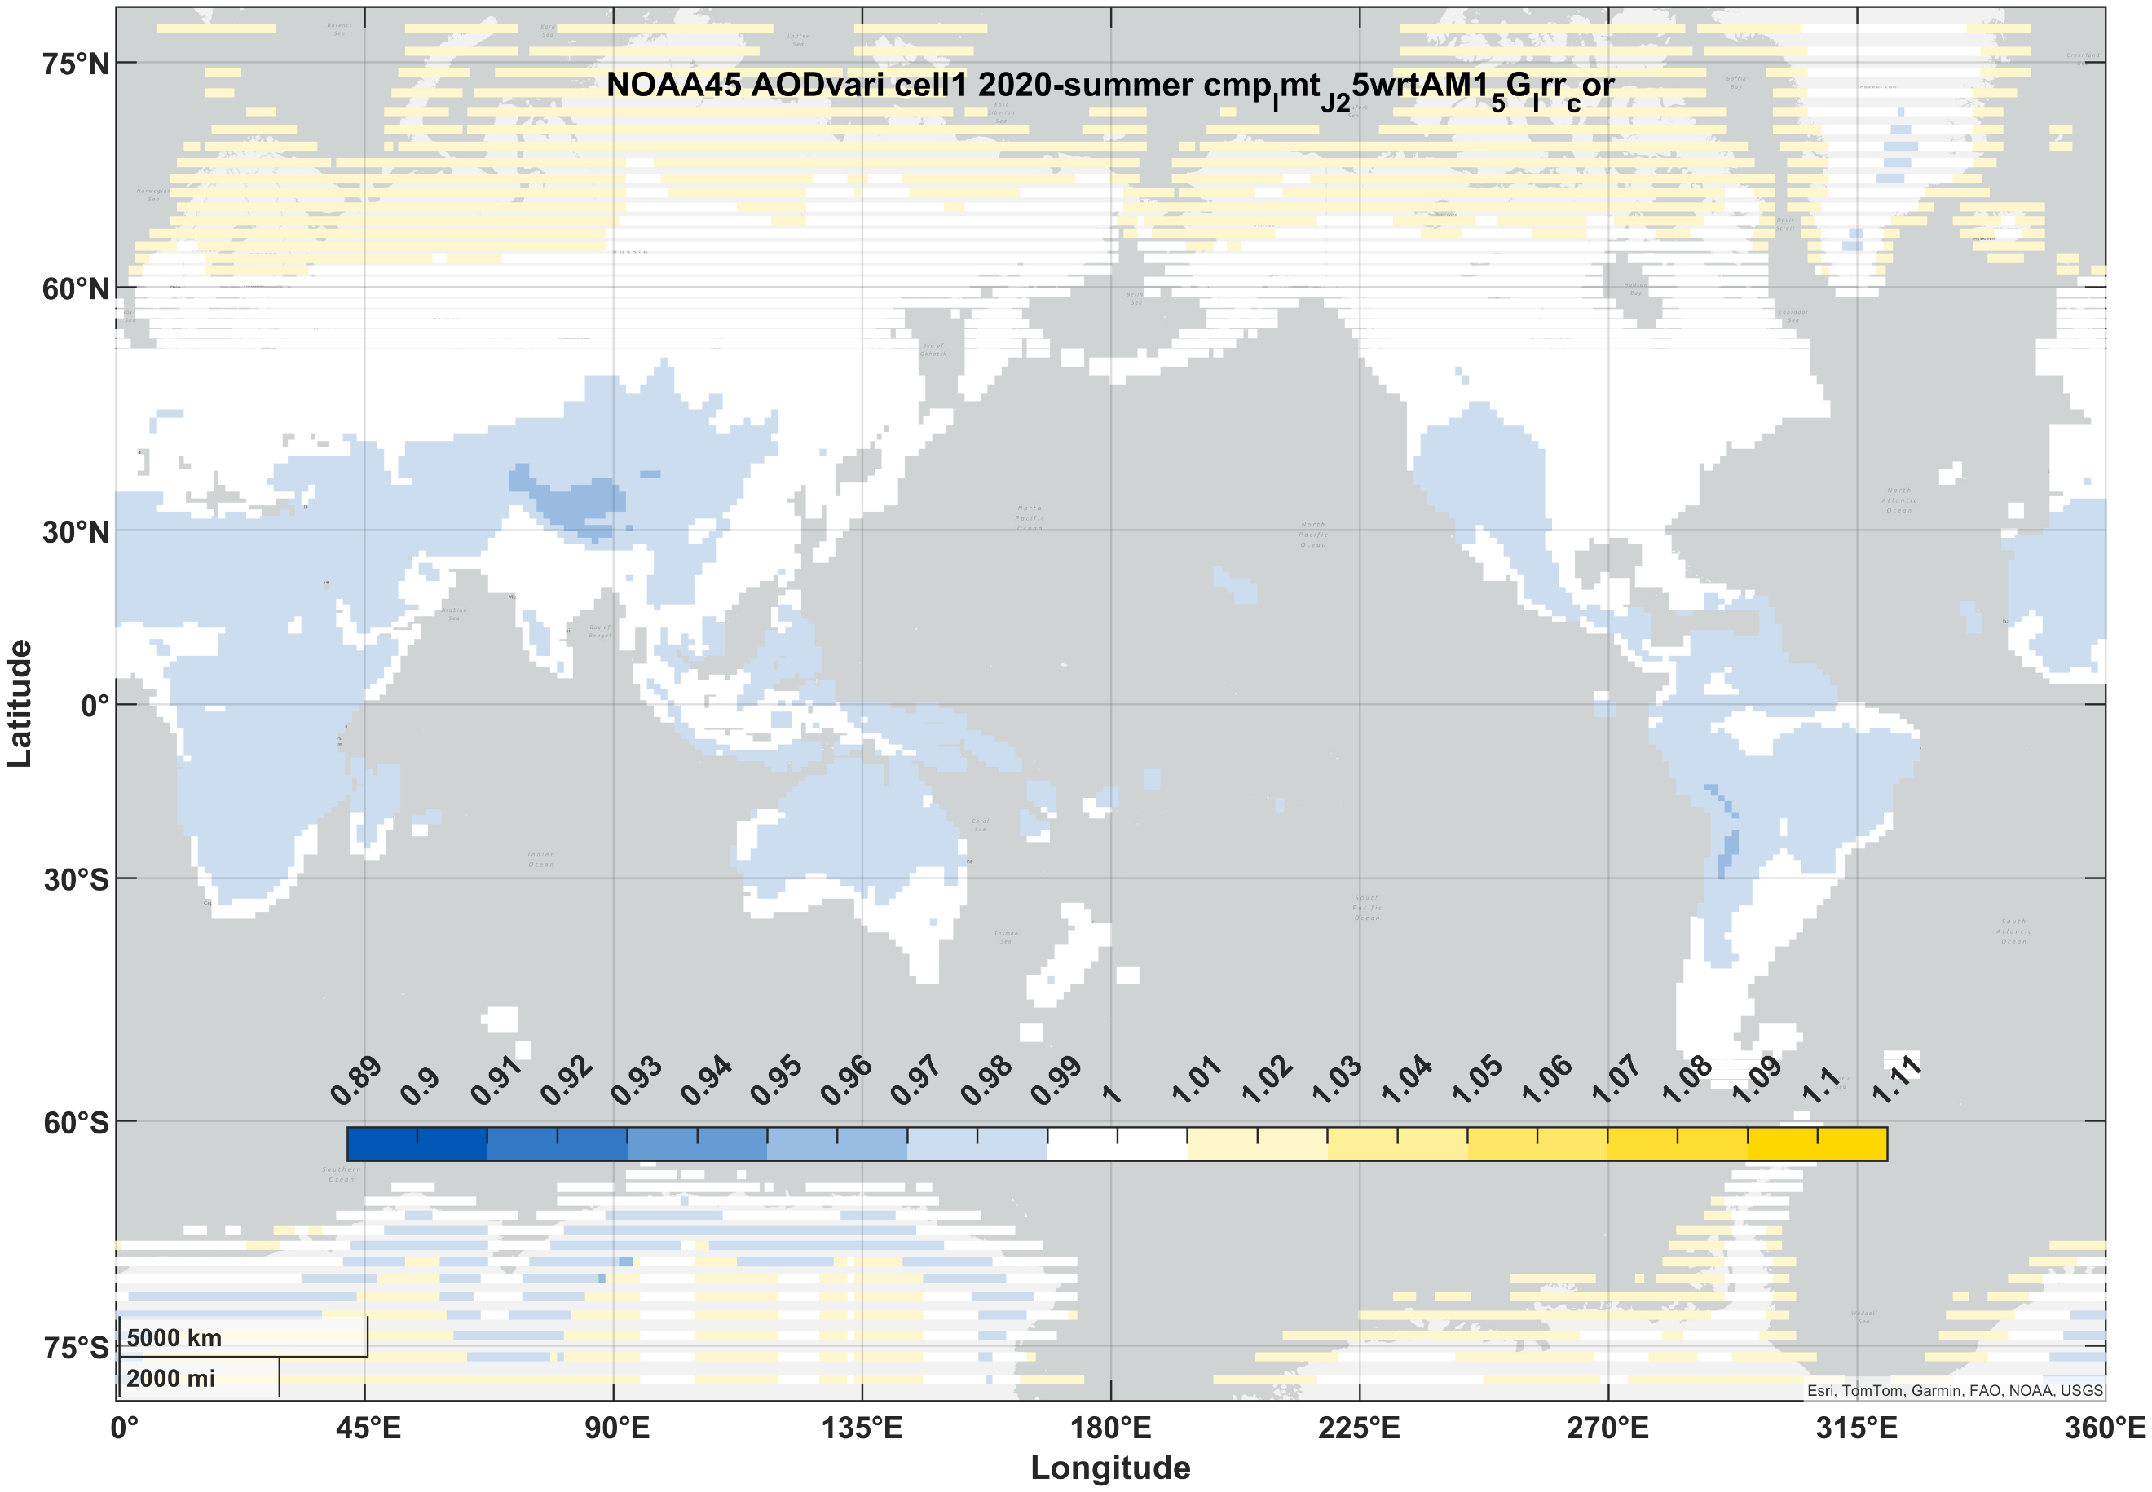
PVSK/Si (2J) | winter | 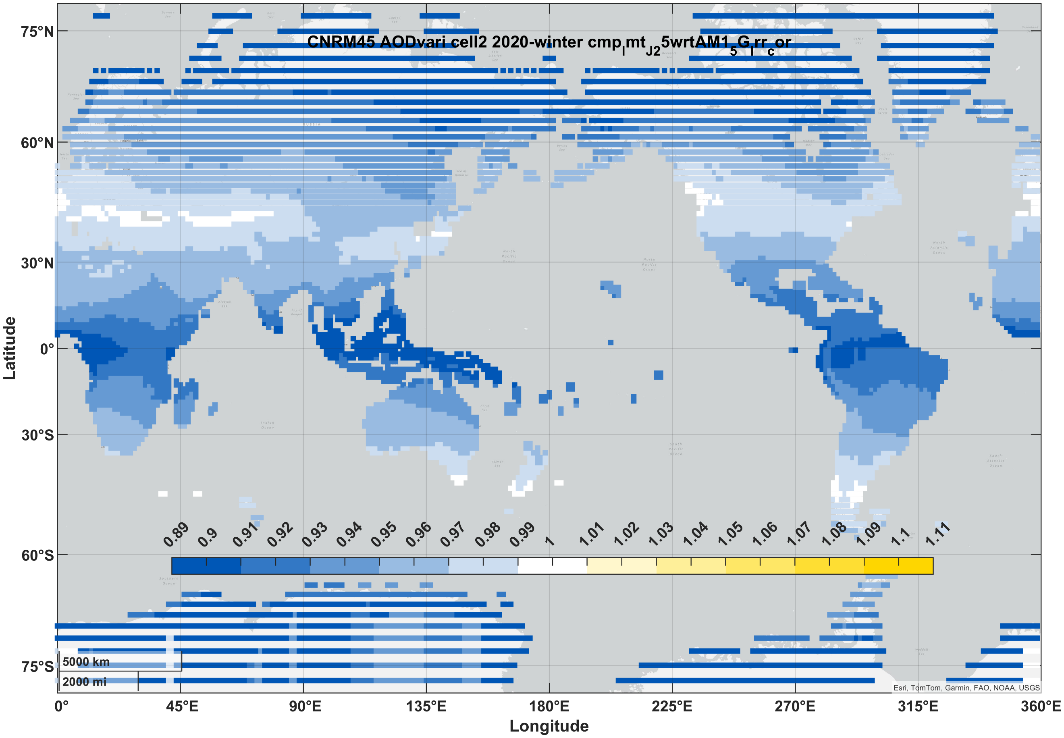 | 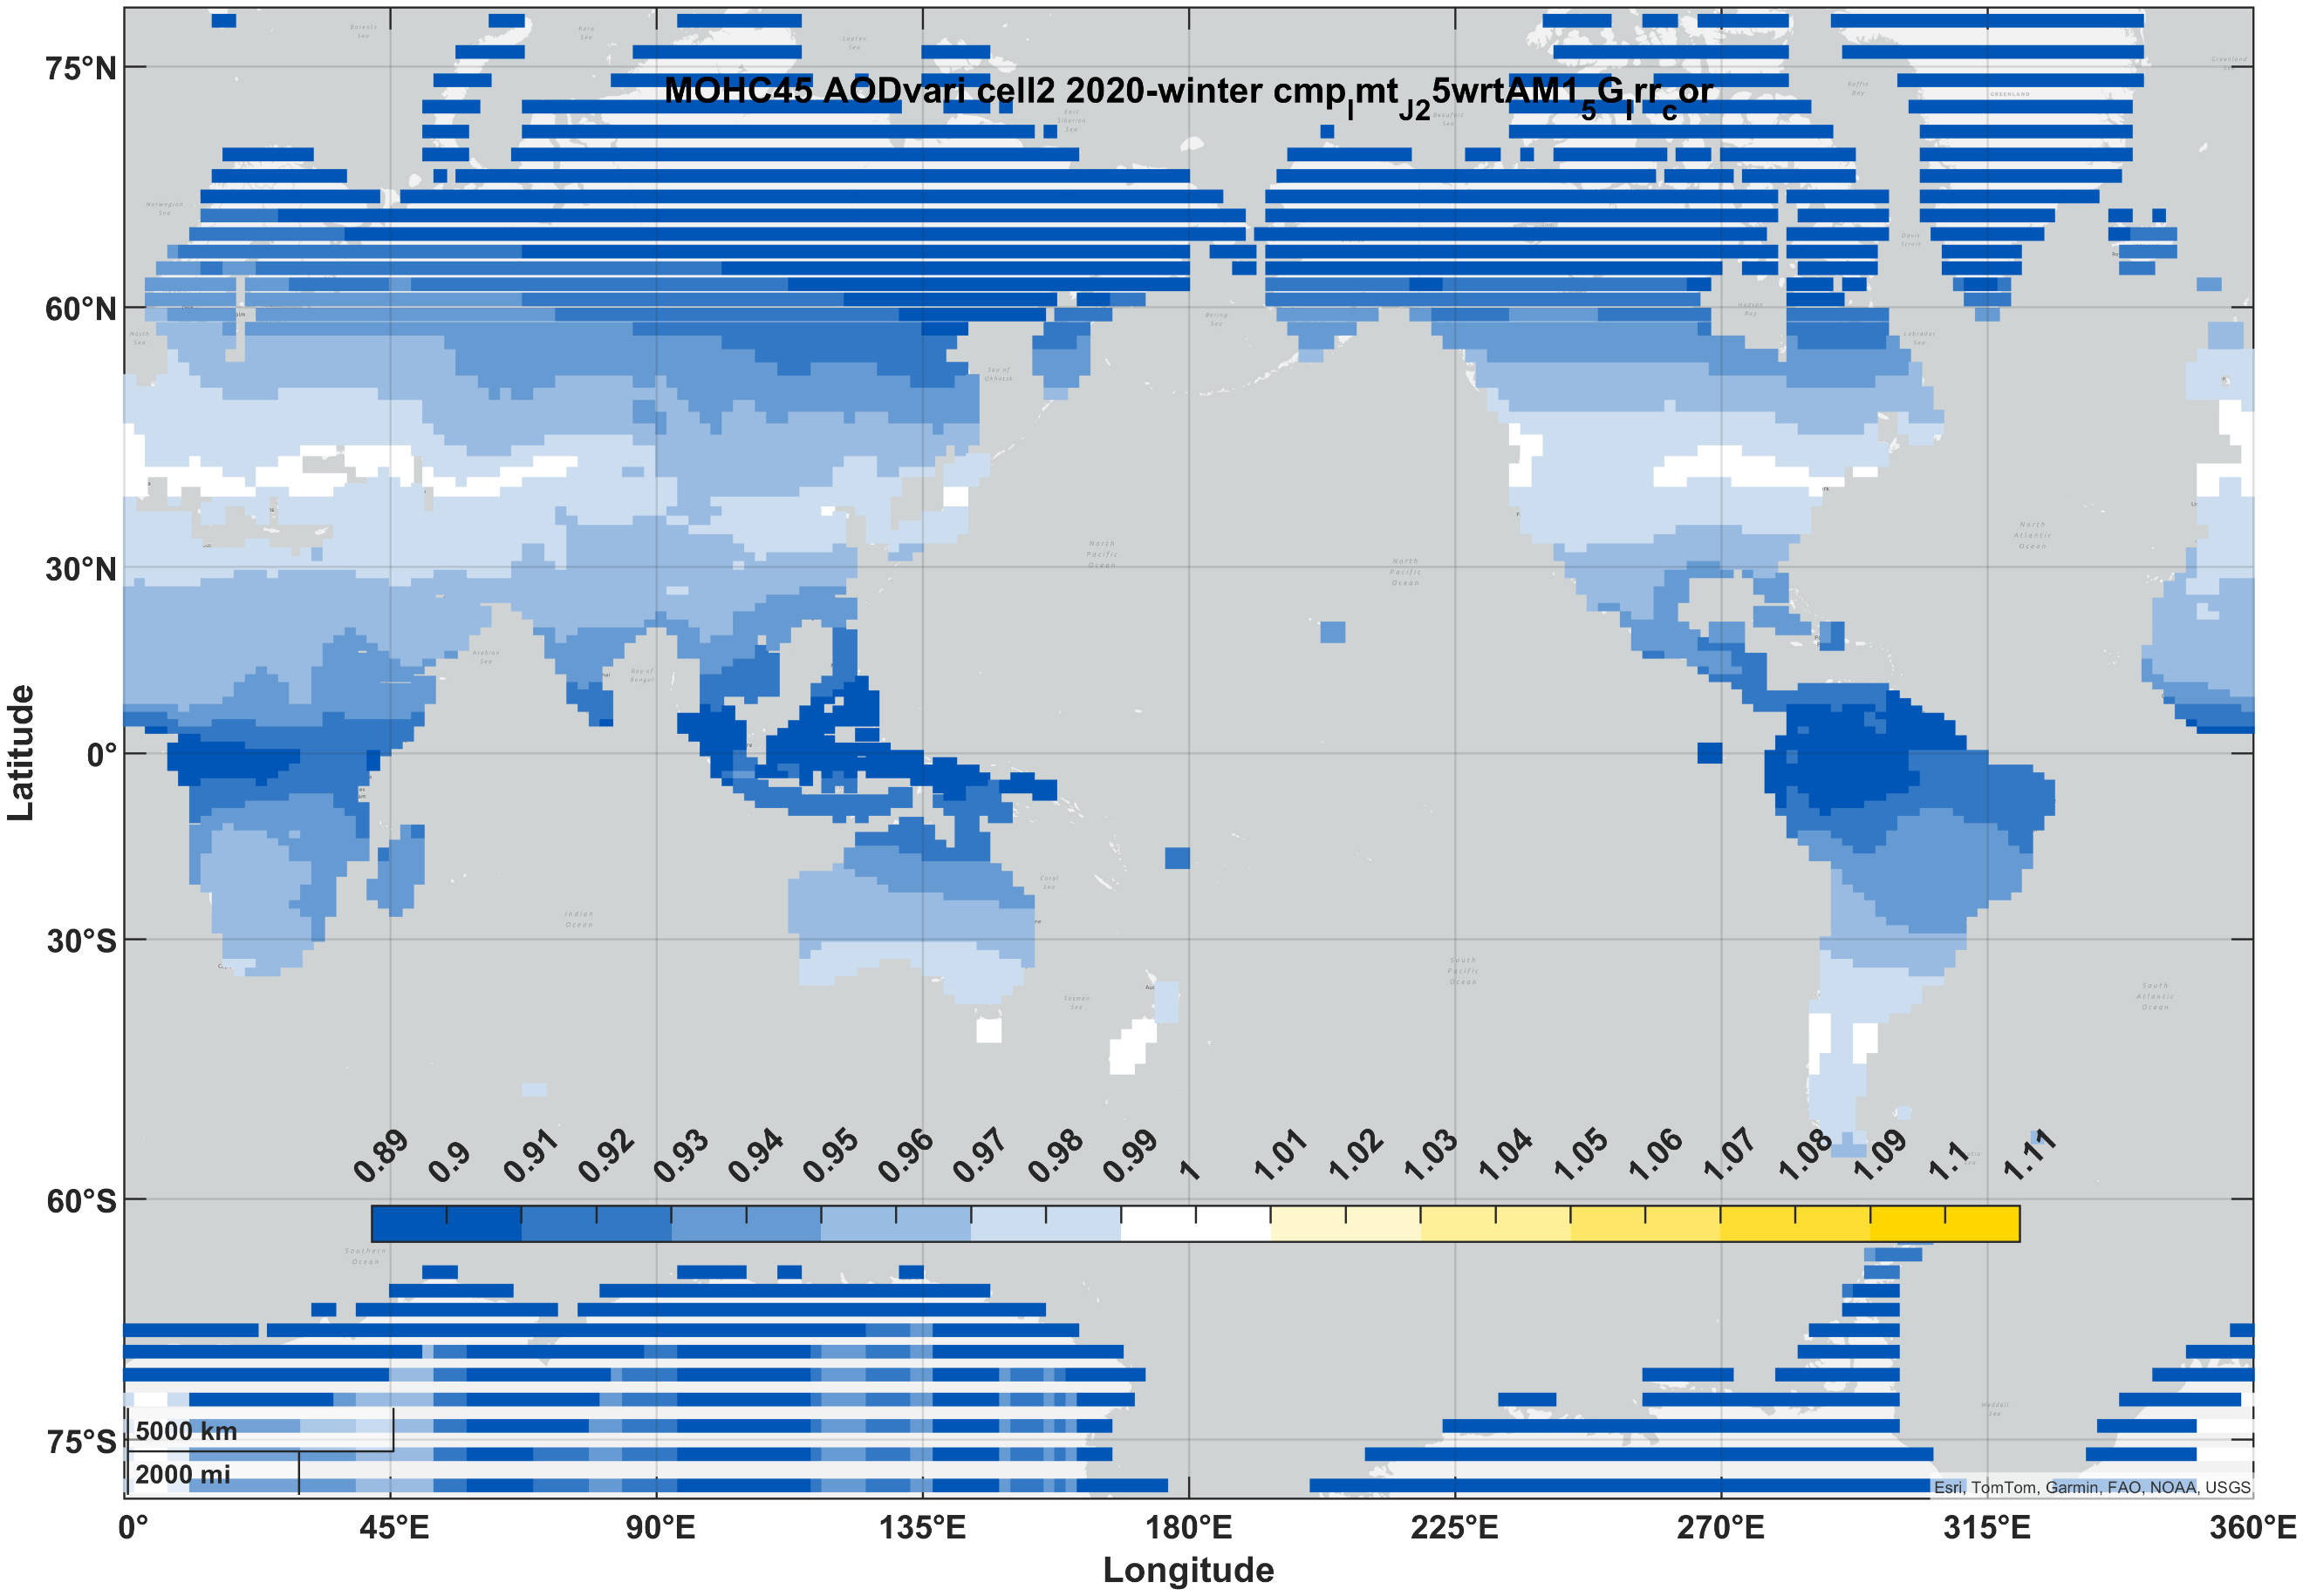 | 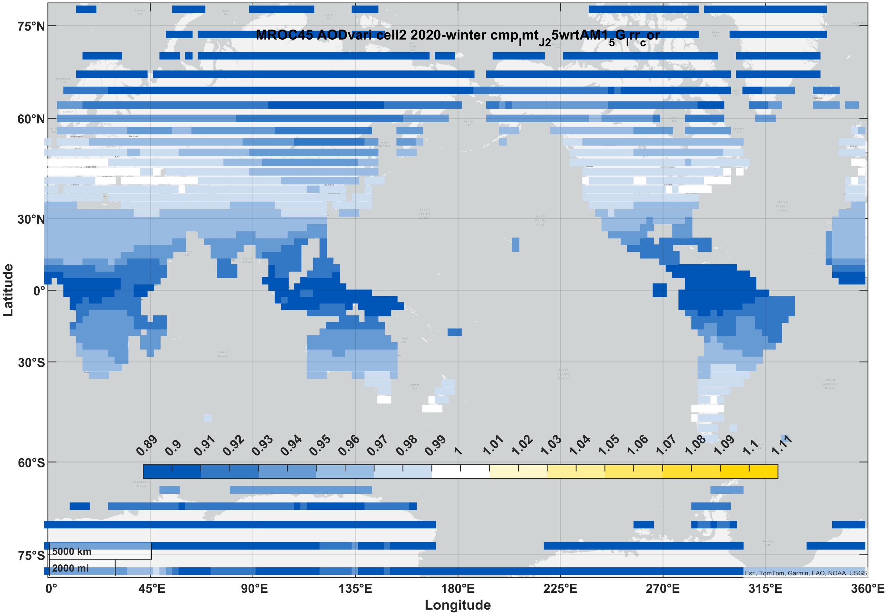 | 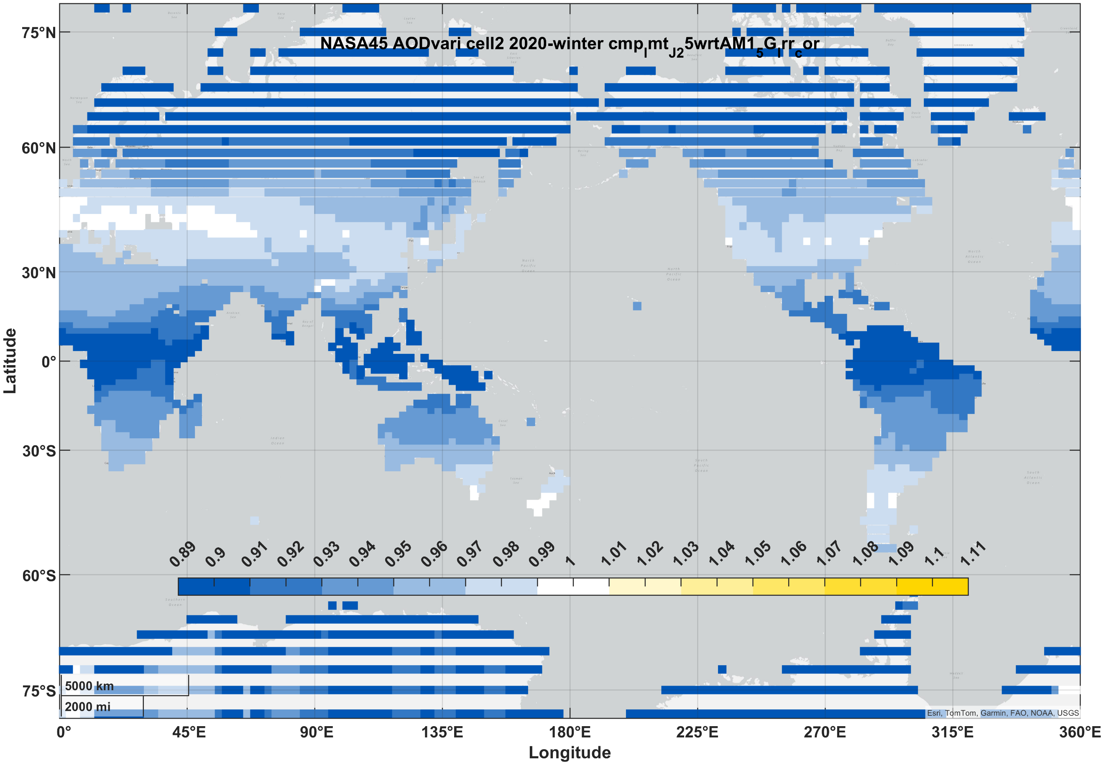 | 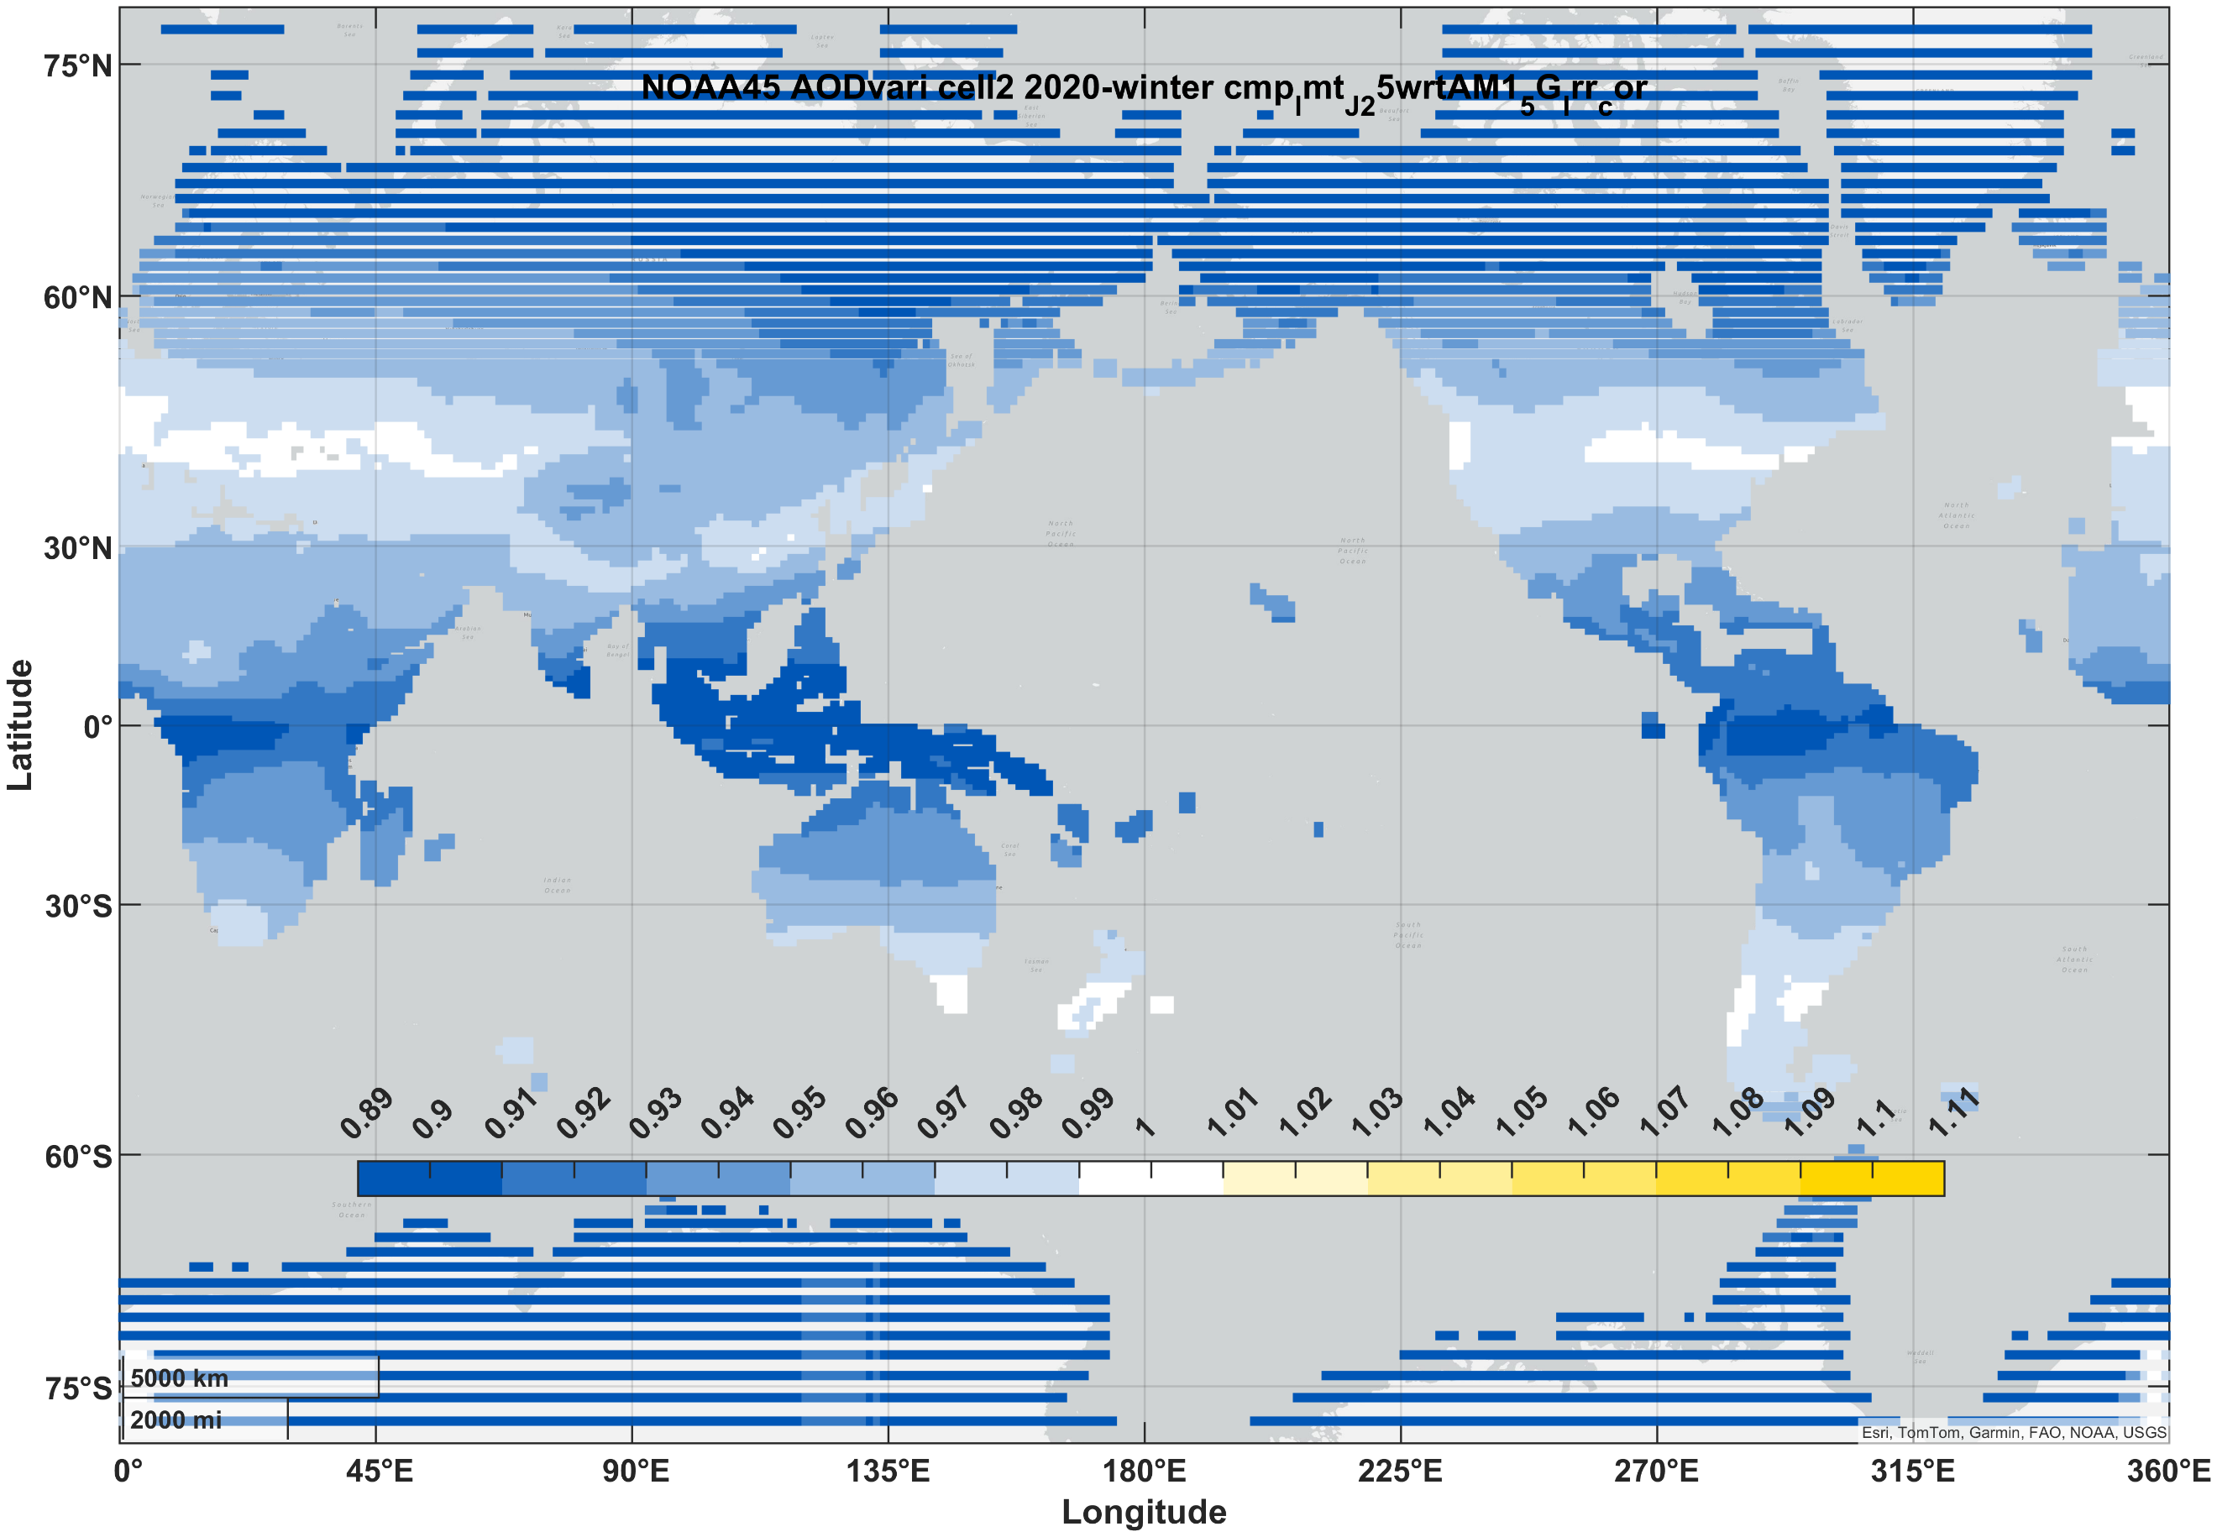
PVSK/Si (2J) | summer | 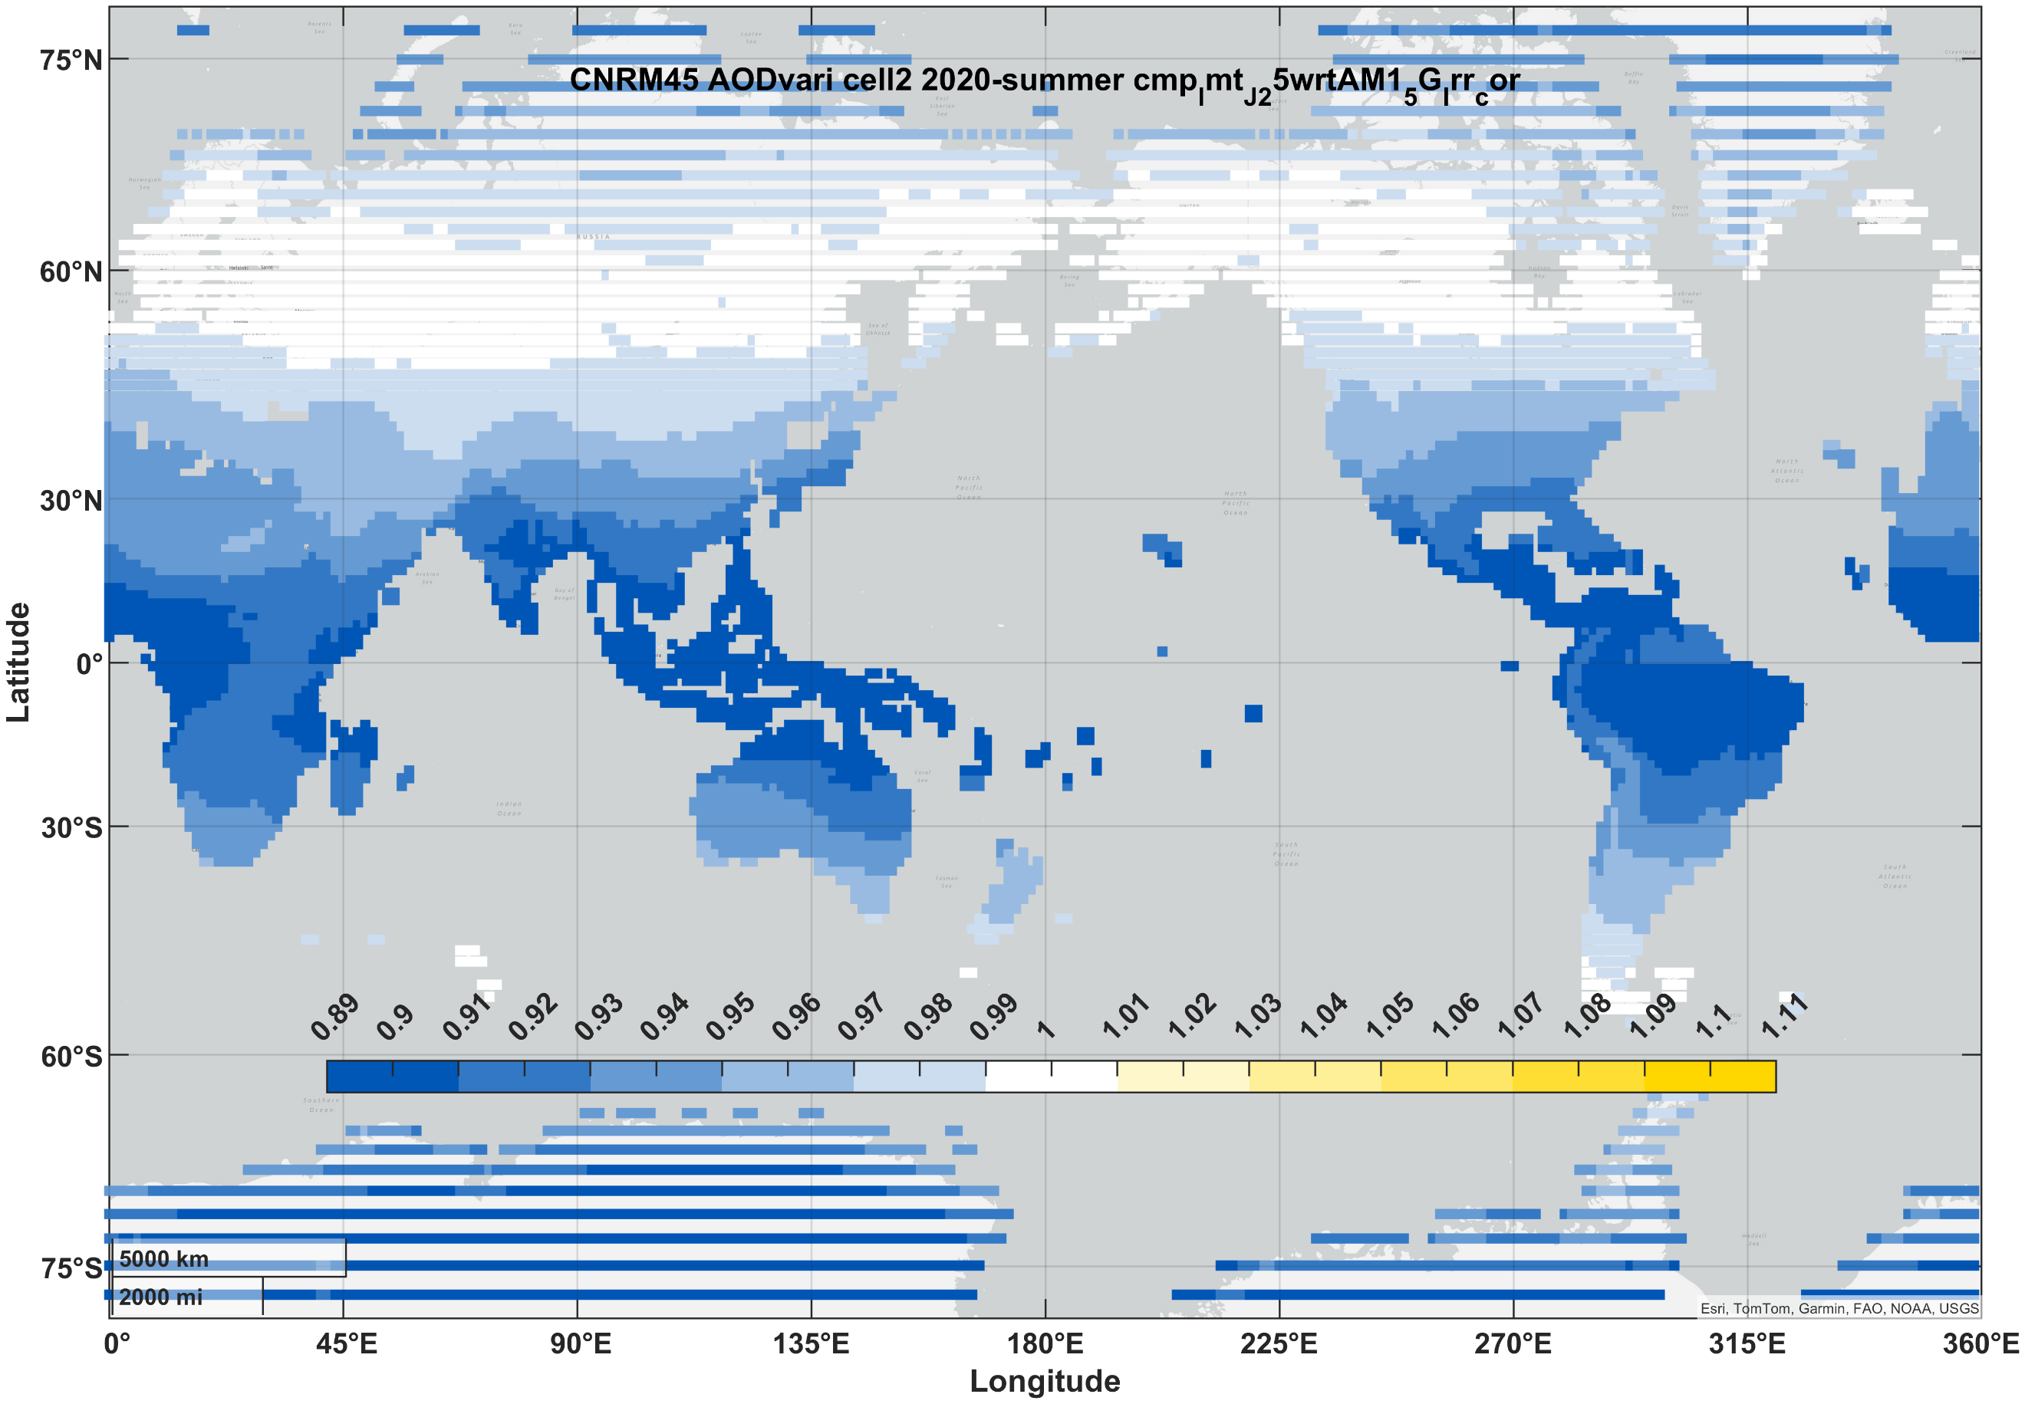 | 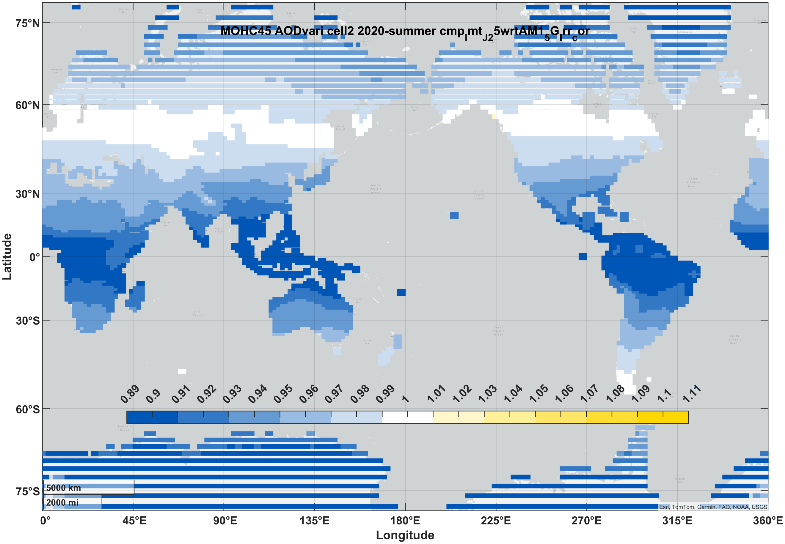 | 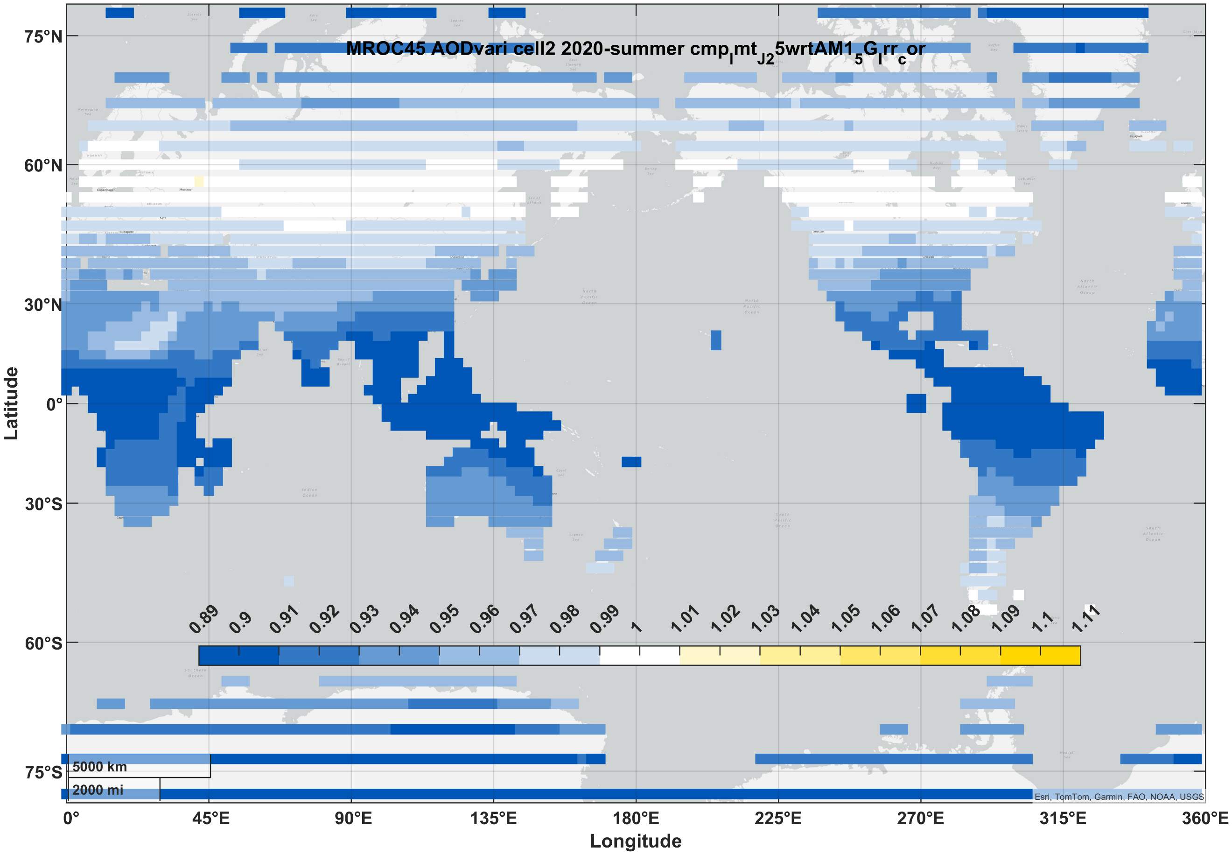 | 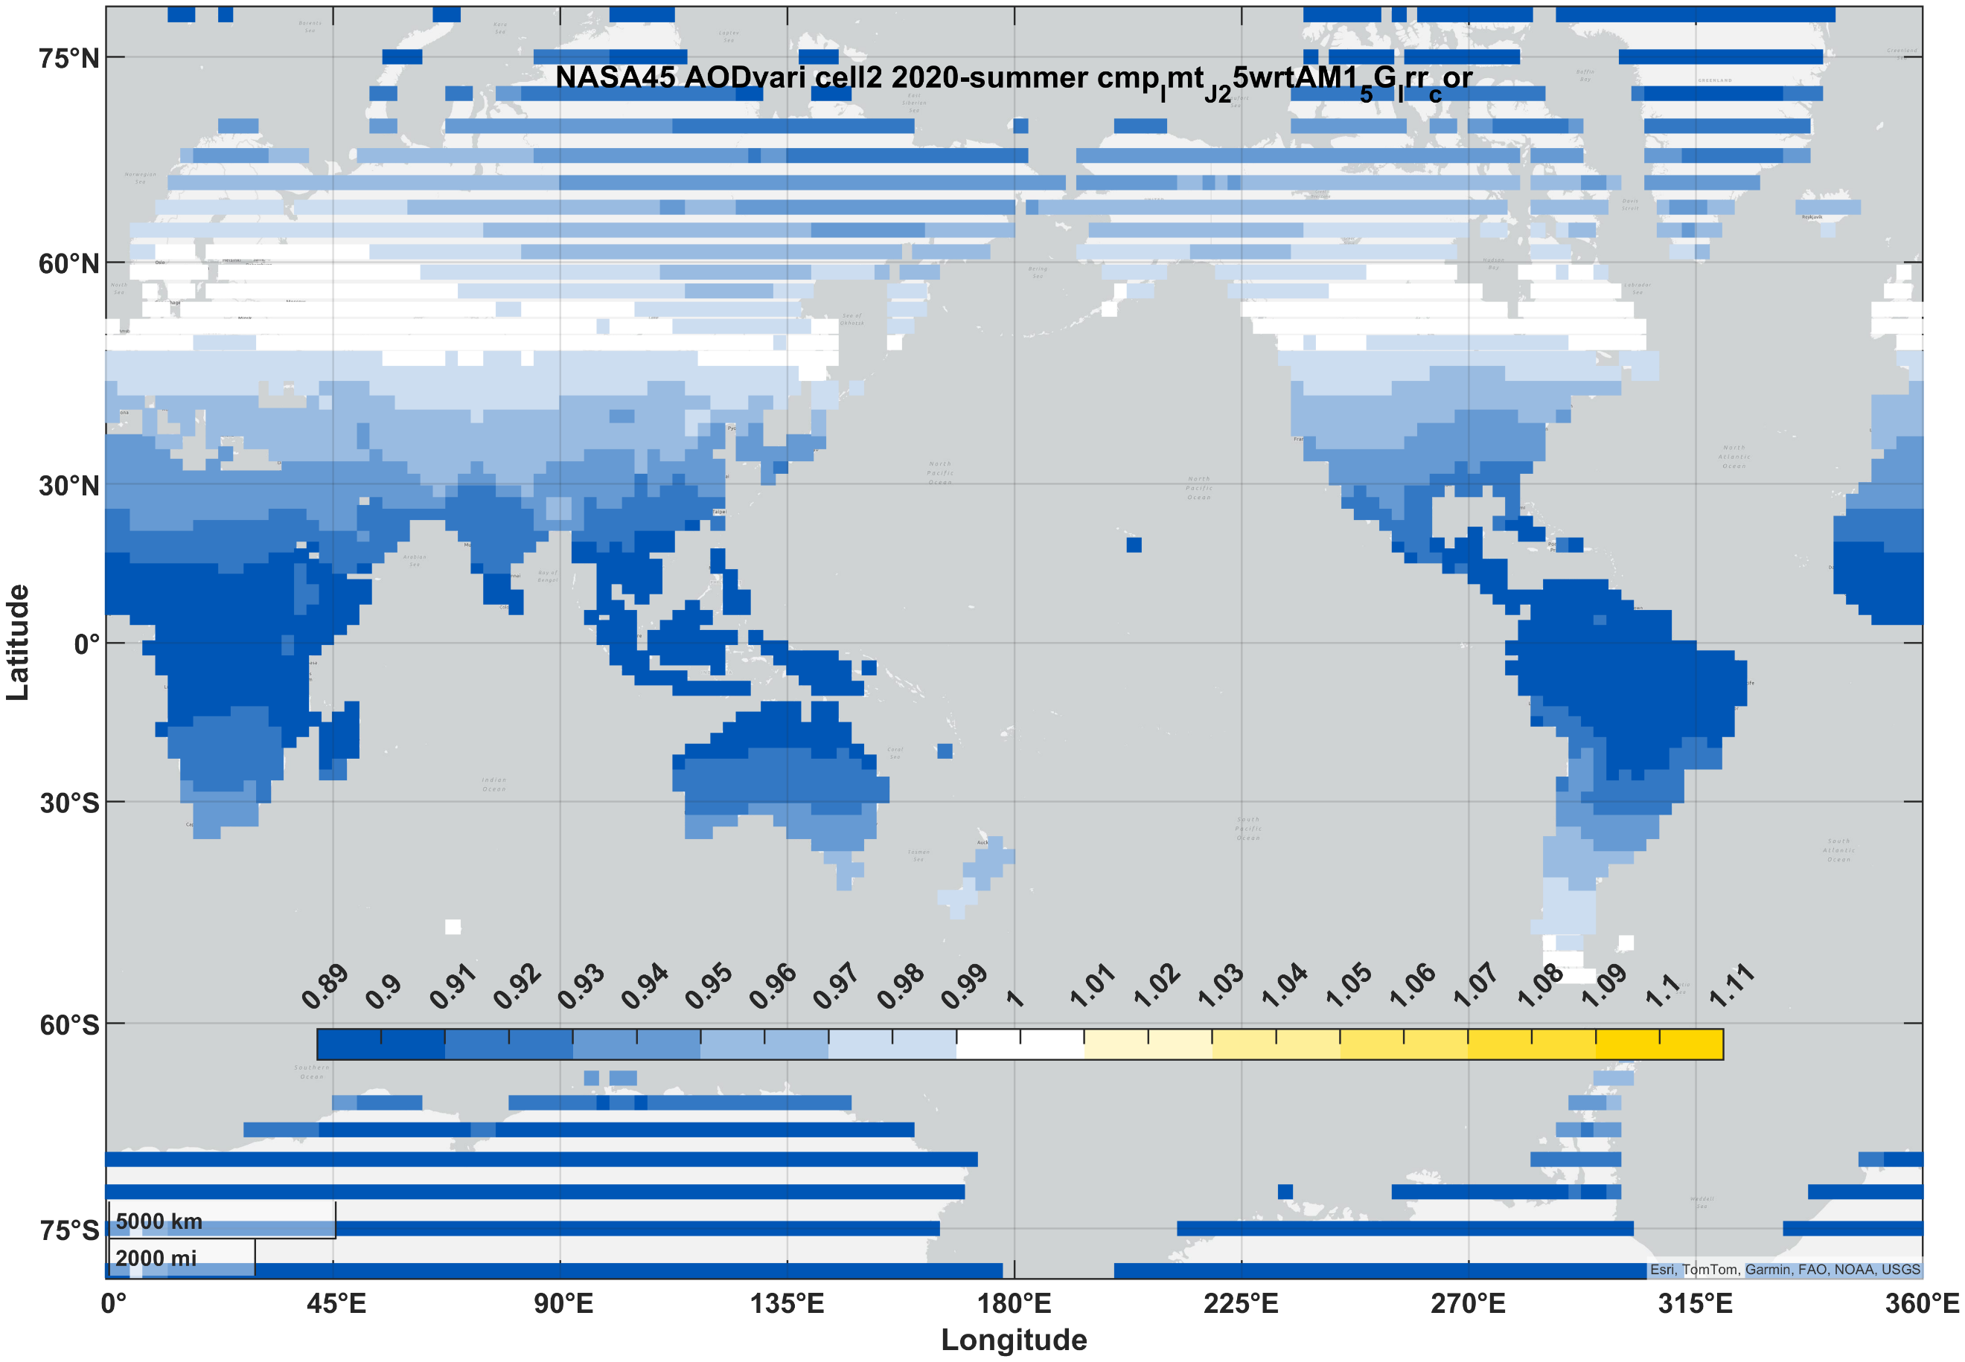 | 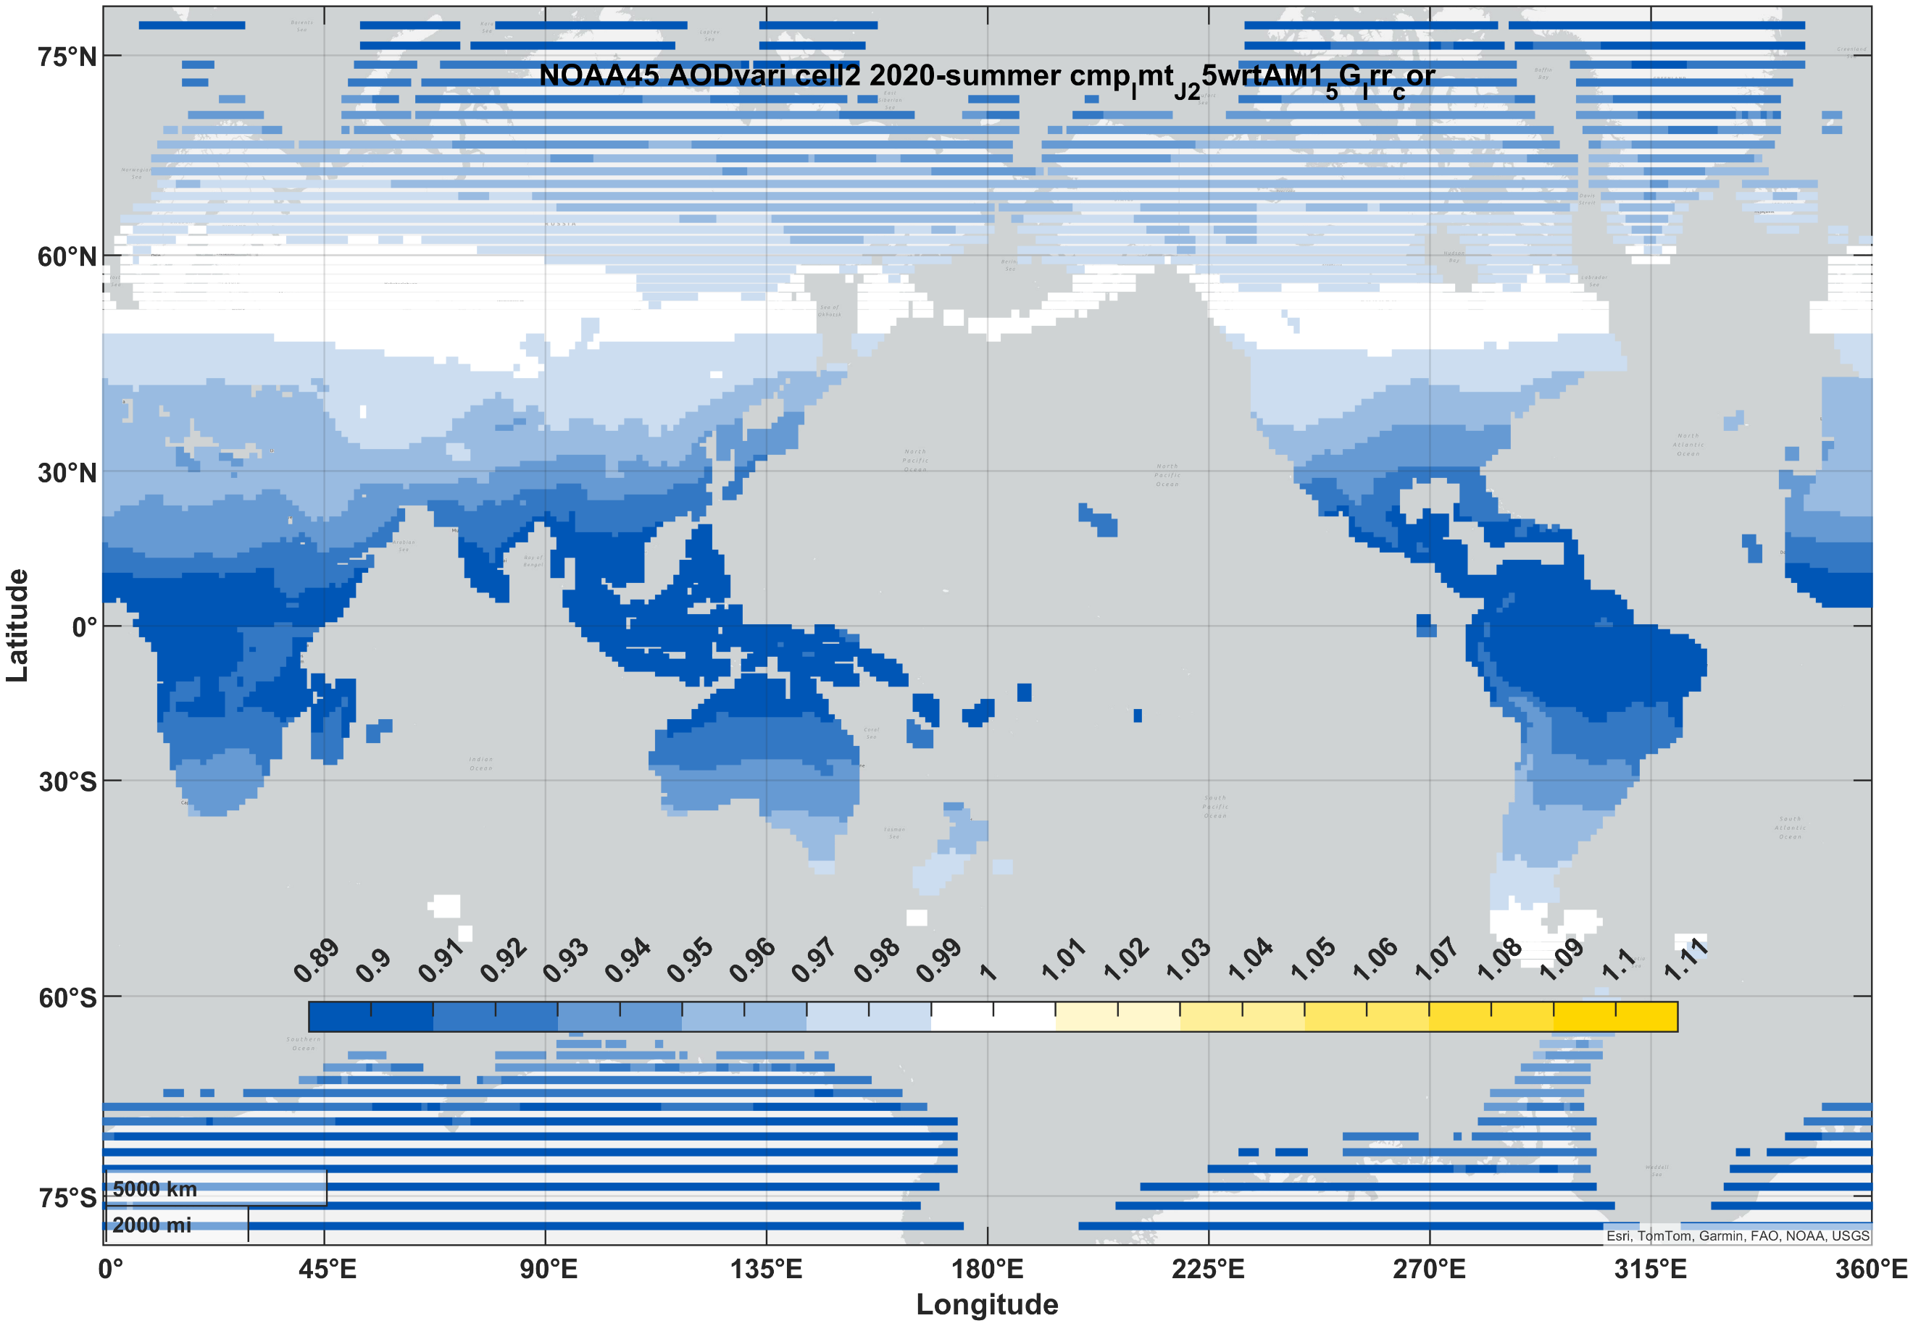
III-V (3J) | winter | 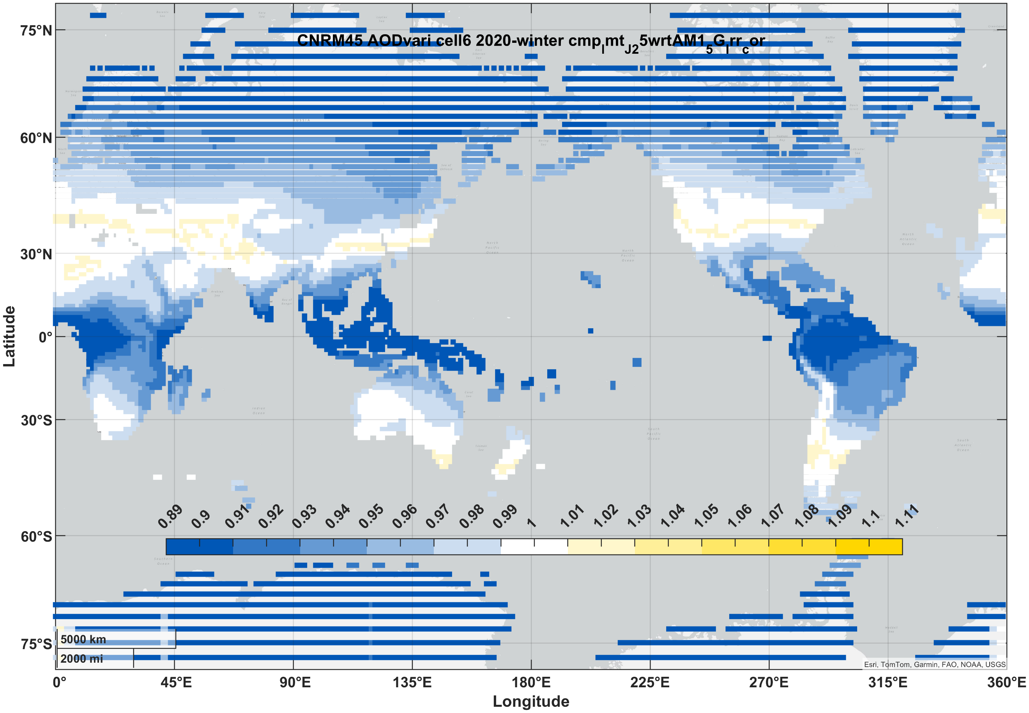 | 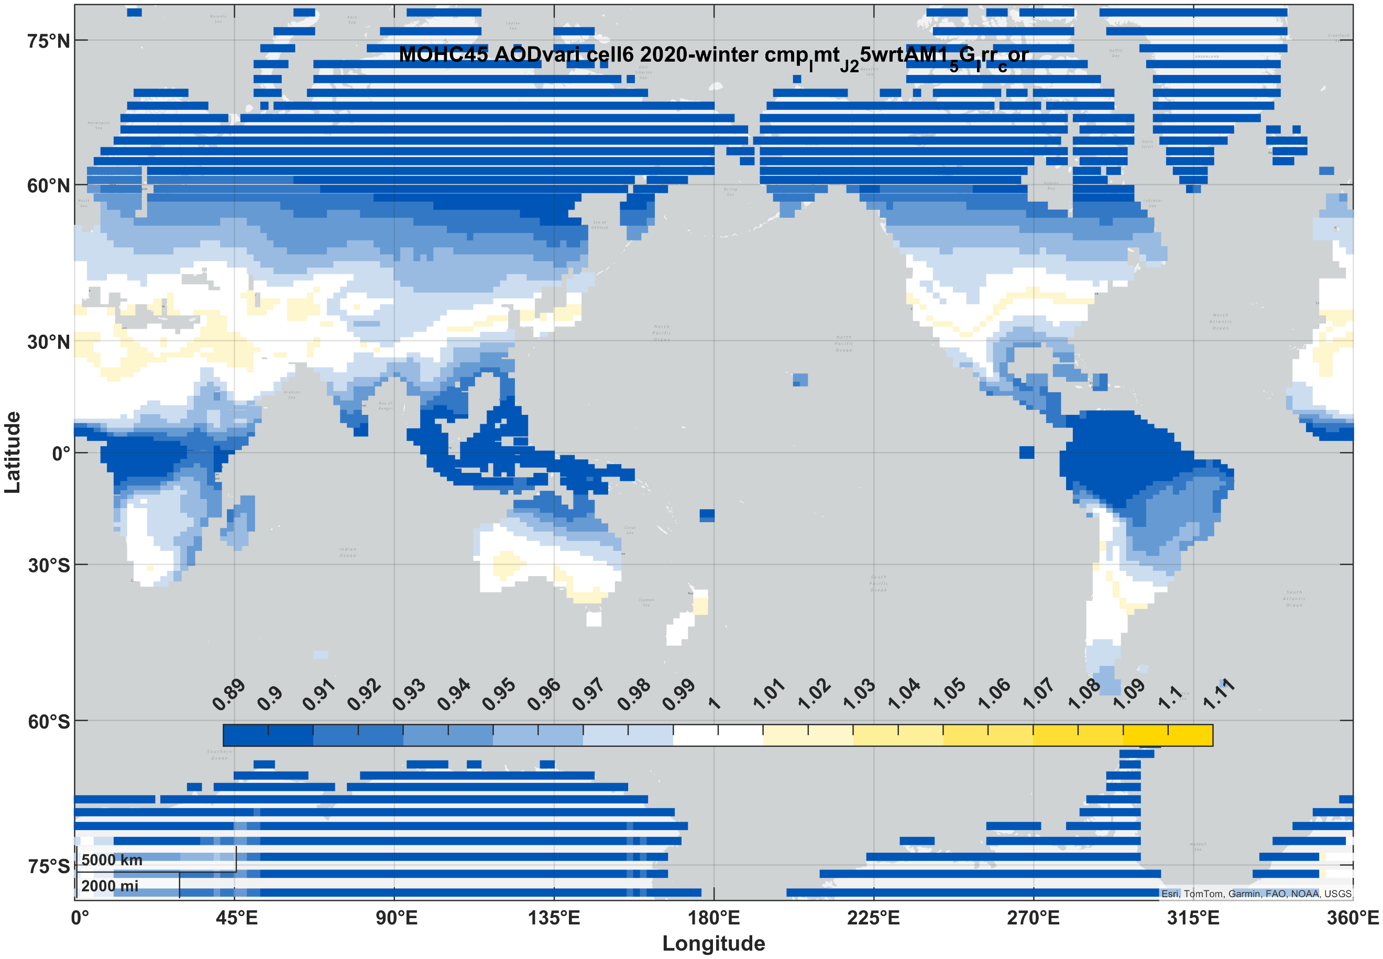 | 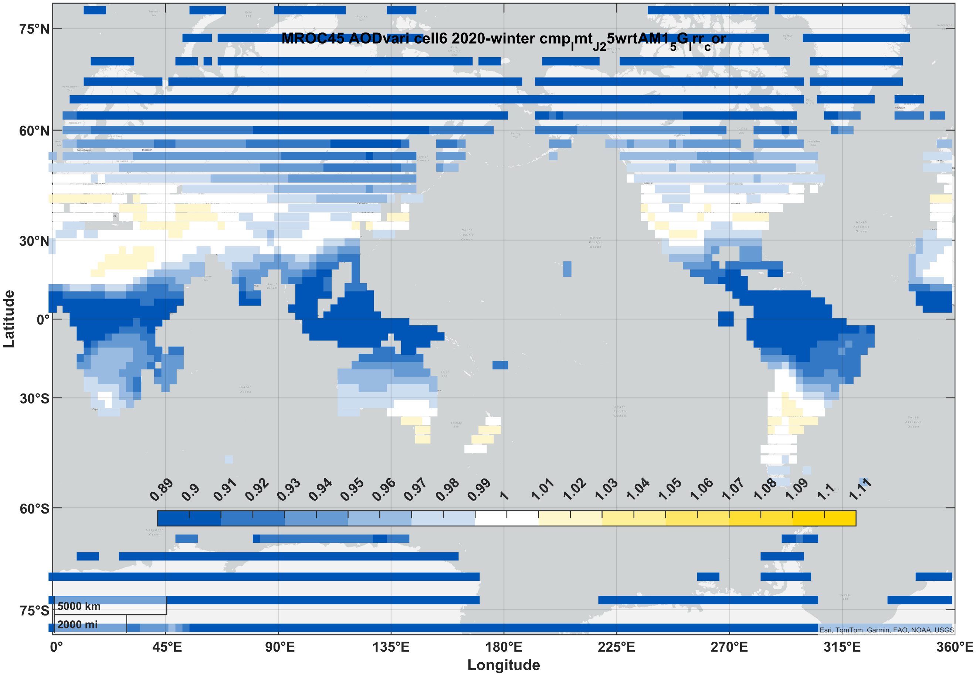 | 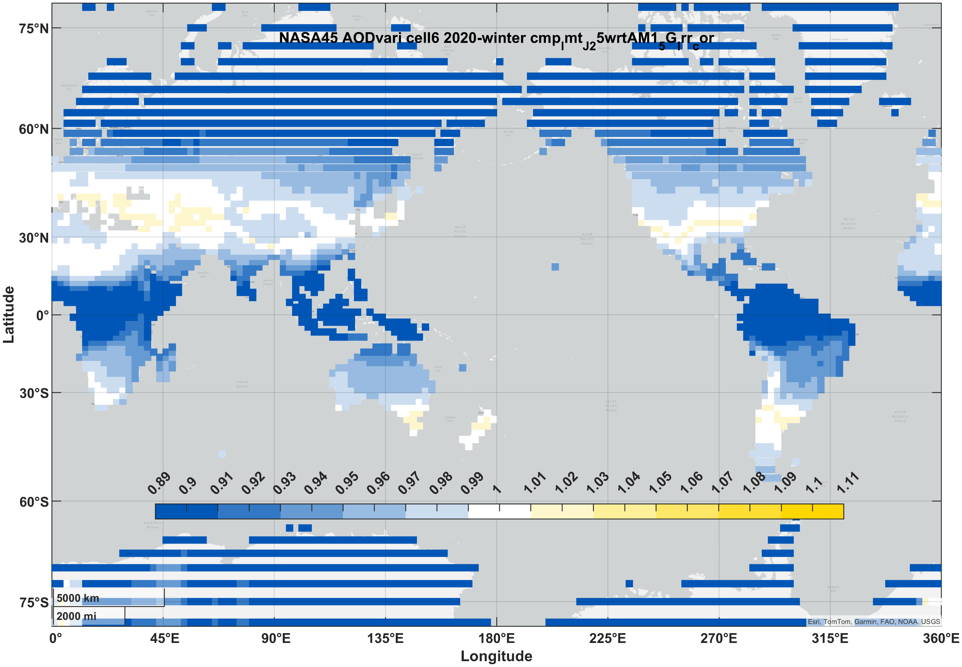 | 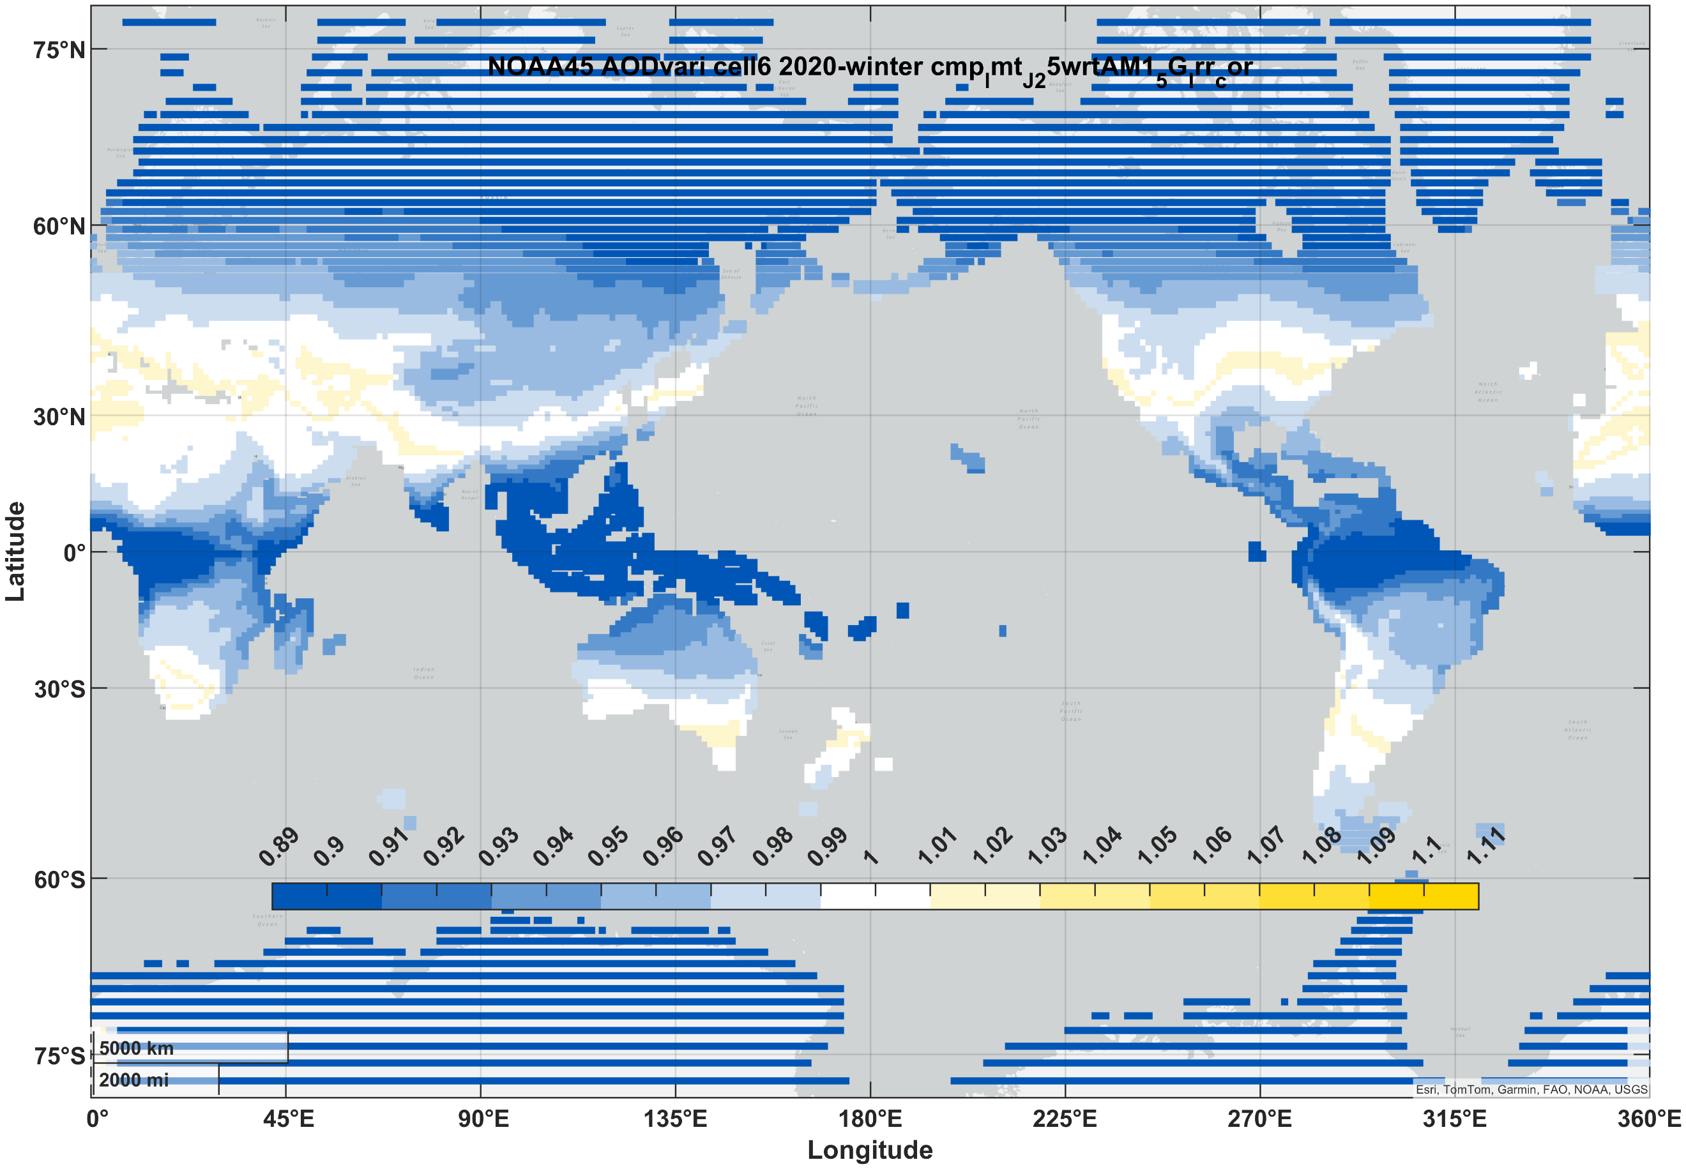
III-V (3J) | summer | 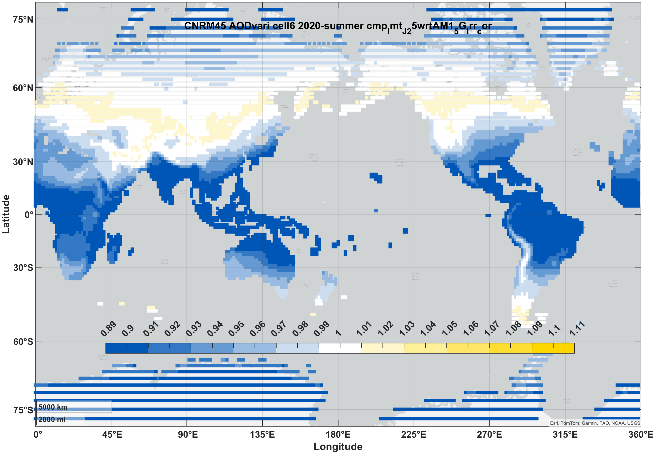 | 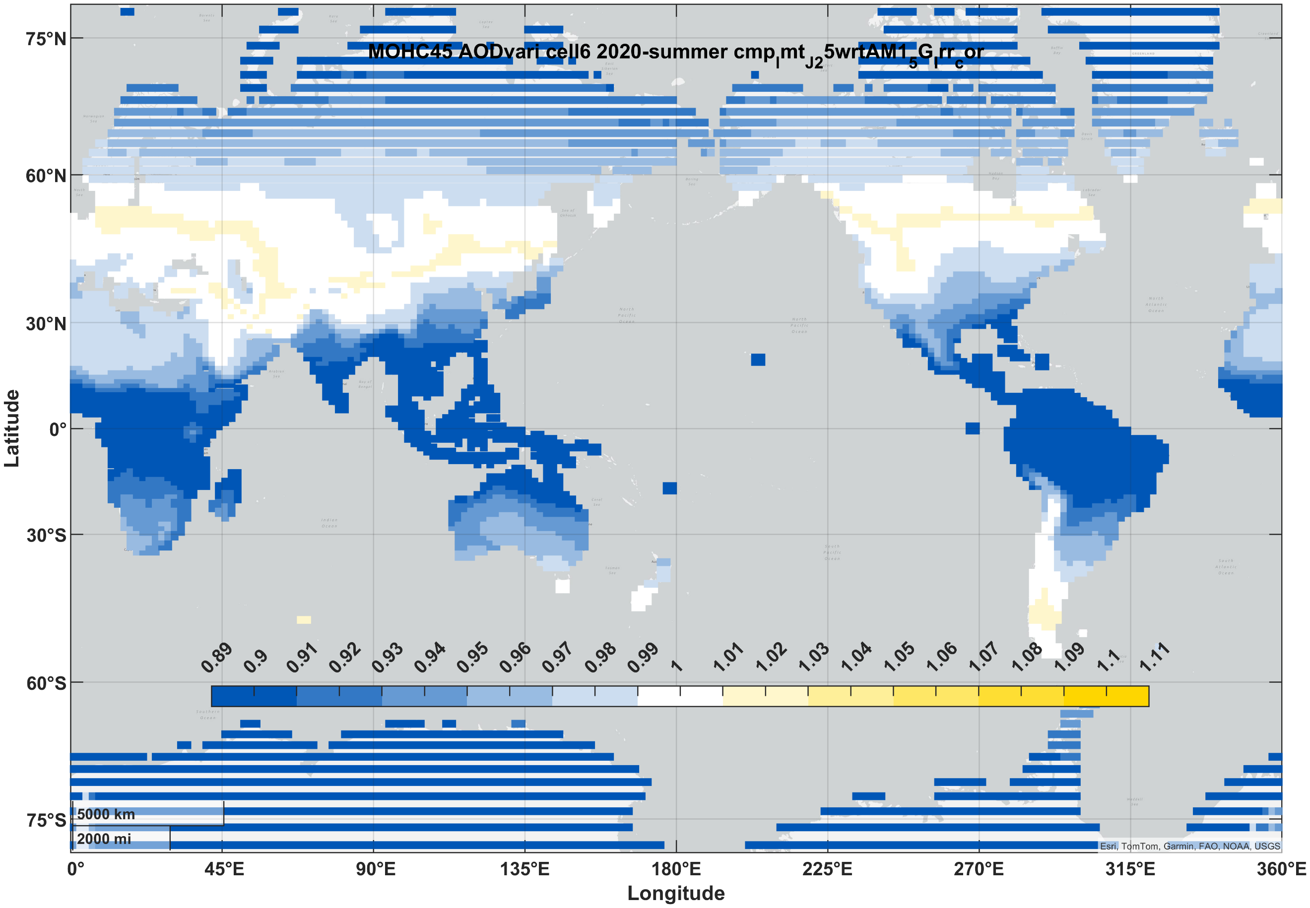 | 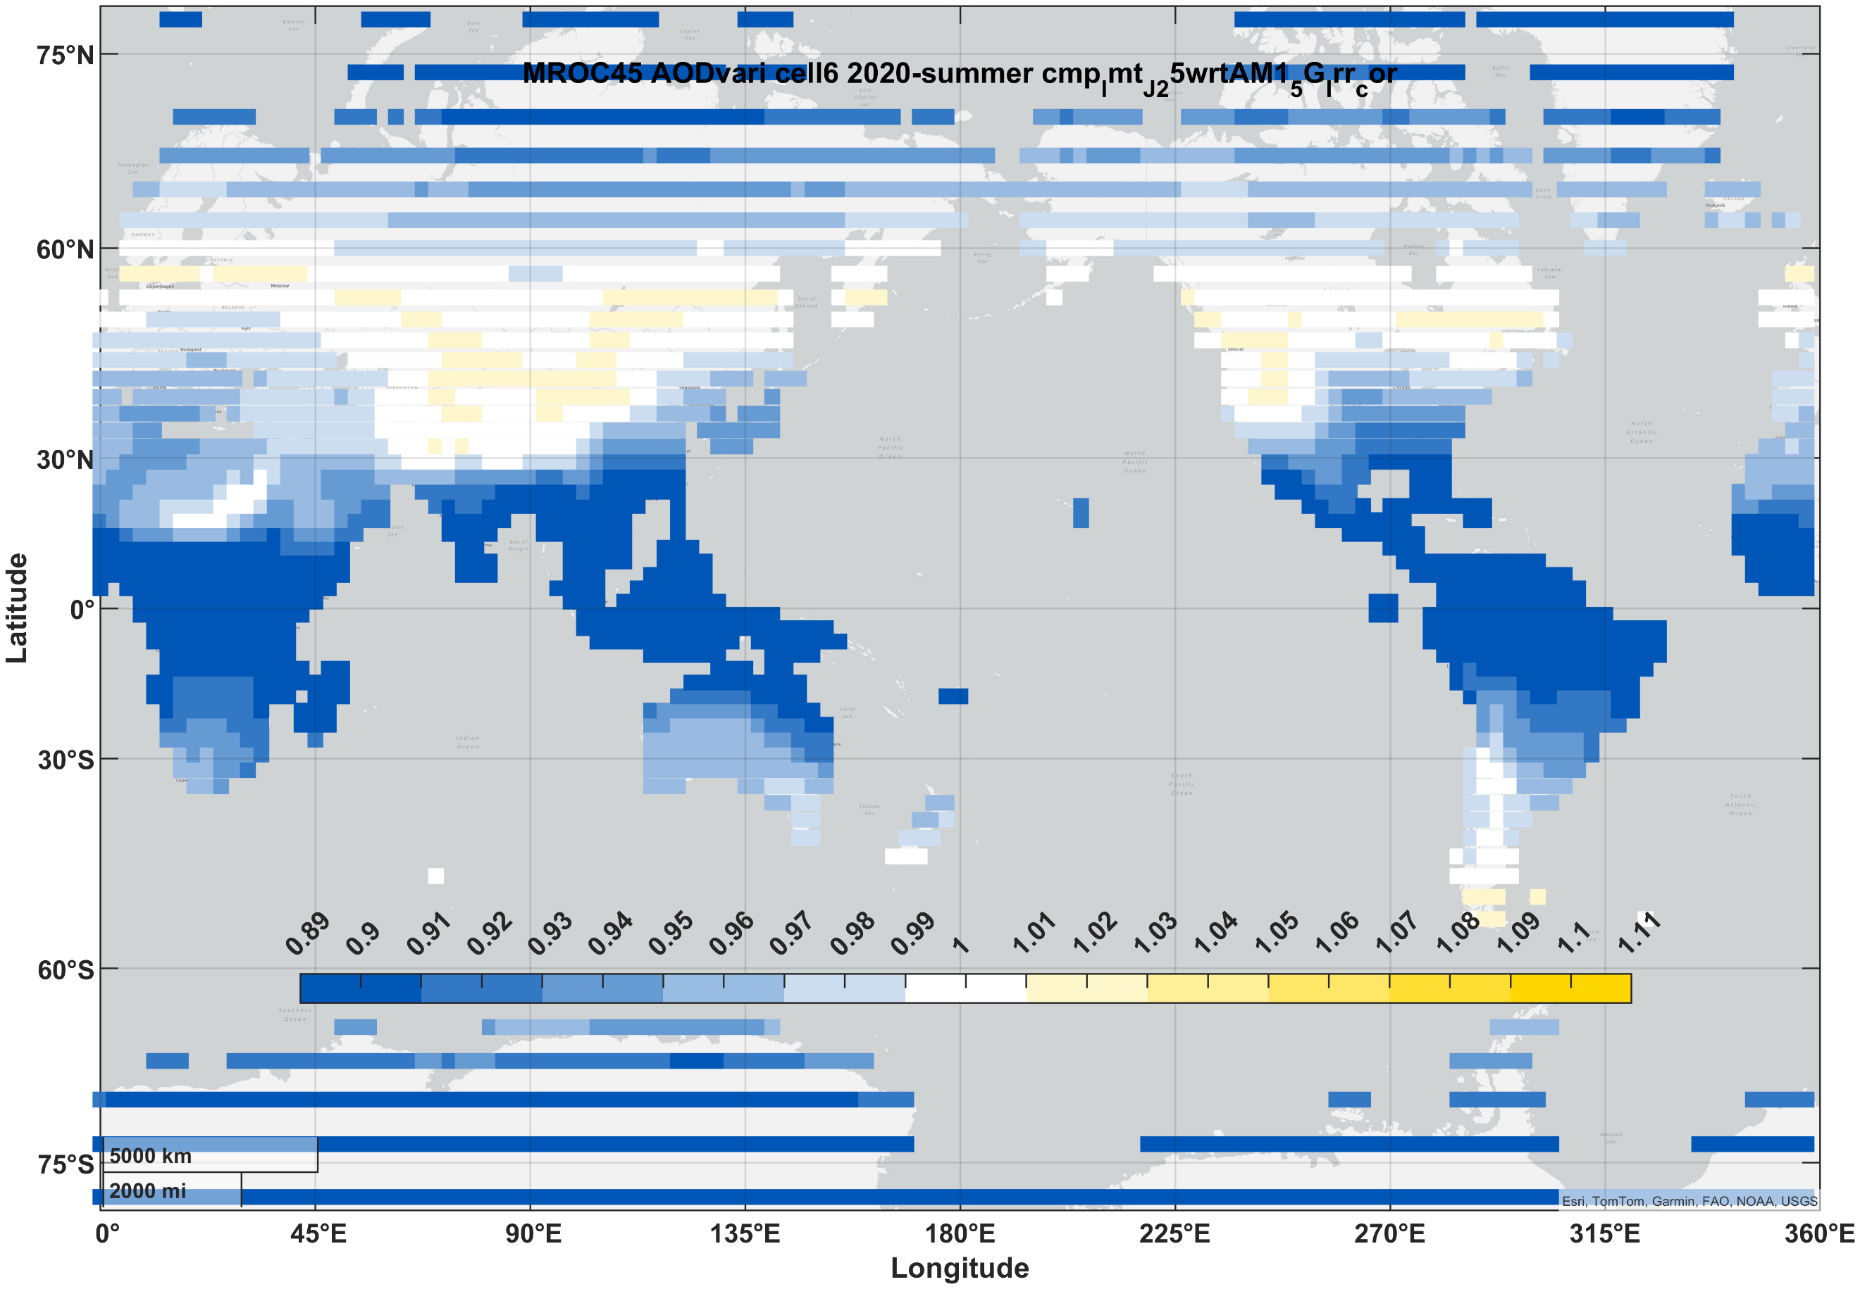 | 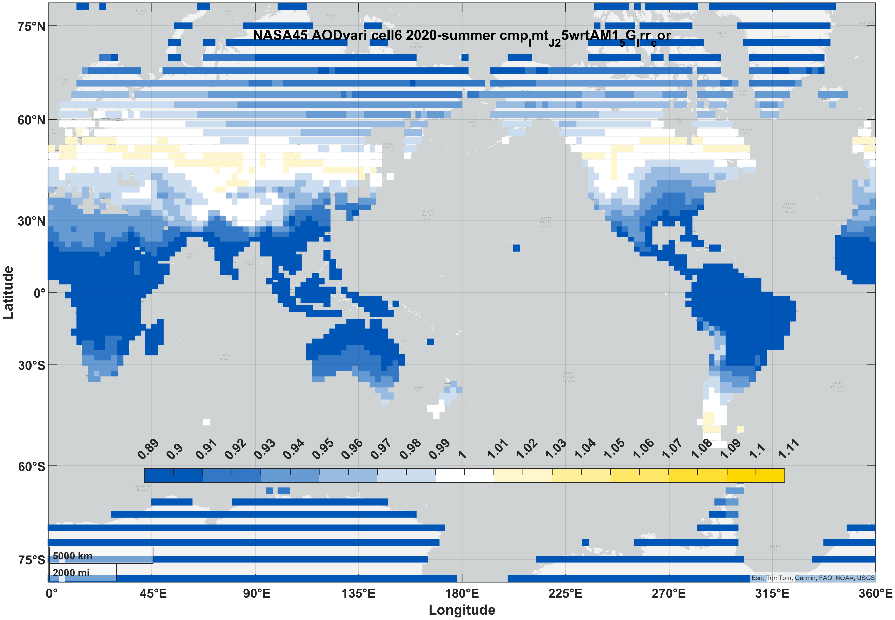 | 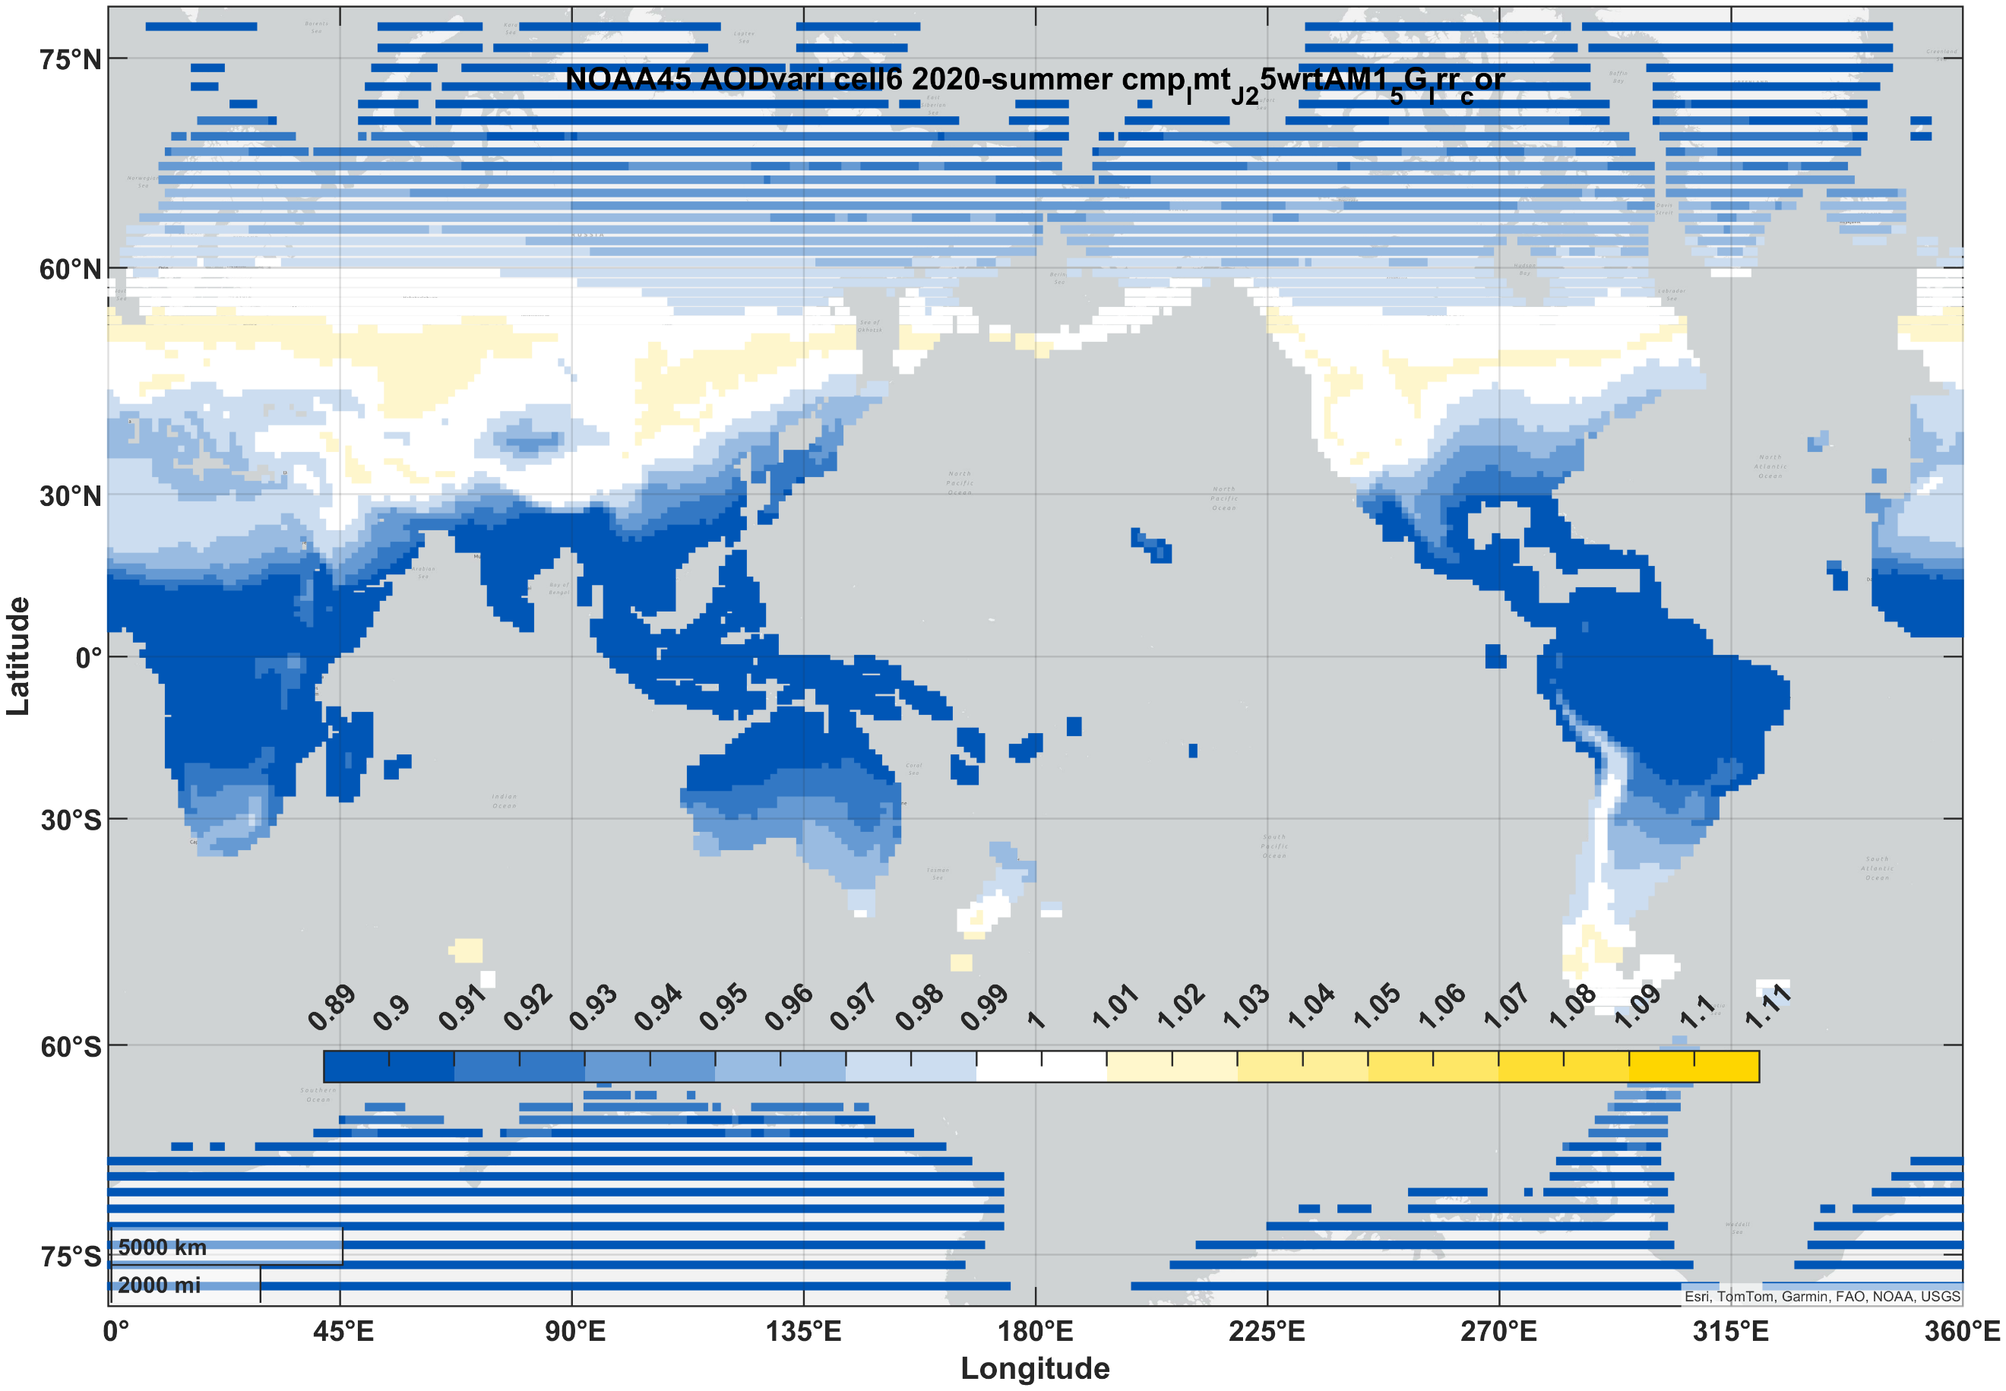

For solar cells, the spectra generated by SMARTS combined with the quantum efficiency (Figure 1a) of the solar cell gives the predicted short-circuit current of the cell. The spectral response of each cell is given by the quantum efficiency of cells with current-best efficiency^{4–6}. An analogous process using the relative quantum yield of photosynthesis (Figure 1b) provides a prediction of the growth rate that might result.

Geographic variation of photovoltaics: 2020
Using 2020 as a baseline year, the geographic distribution of photovoltaic output can be compared against the standard reference spectrum (AM1.5G). Results for the three solar cell designs are shown in Table 1. AM1.5G was established in the 1980s in the USA to represent mid-latitude (37°), fixed (non-tracking) installations. It has persisted as the go-to reference standard for laboratory efficiencies, commercial modules, and power plant performance ratings, even as PV has spread across diverse climates and tracking systems have become the backbone of utility-scale PV energy generation. As with temperature and broadband irradiance, evaluation under more than one condition would reduce forecast errors^{10,11}. Approximately 760 GW of PV was operating in 2020¹², so (assuming 1500 kWh of generation per kW of capacity) a 1% increase/decrease equates to 11 TWh of generation gained/lost, equivalent to the annual electricity consumption of the Democratic Republic of the Congo¹³.
For solar cells with more than one junction, series connection of the sub-cells means that the output current is limited by whichever junction is producing the least. The resulting increase in spectrum sensitivity makes the use of a single spectrum less predictive of operating efficiency and insufficient for comparing cells with different spectrum sensitivities^{10,11,14}. If a cell with more than one junction is tuned so that its sub-cell currents match under the standard spectrum, a performance peak is obtained but will fall off under the range of spectrum conditions found in operation. This is evident for the two-junction (2J) perovskite-silicon and the three-junction (3J) III-V multijunction cells, for which the predicted output is often more than 5% lower in latitudes below +/- 30°.

Decadal forecasts
The ability of solar PV to slow the destabilization of the climate will be altered as those changes take effect. Increases in global surface temperatures also increase evaporation and therefore the precipitable water content in the column of atmosphere above the surface¹⁵. The decrease in stability that results from thermal energy accumulating in the atmospheric system is expected to lead to both changes in magnitude and larger fluctuations. Absorption of radiation by water vapor occurs at wavelengths both within and beyond the absorption bands of solar cells, so the proportional impact on their outputs differs from what might be found from analysis of changes in the (broadband) solar irradiance alone. For example, the number of photons in the standard spectrum (precipitable water=1.42 g/cm²) is about 22% lower than that of a spectrum from an atmosphere lacking water vapor (precipitable water=0 g/cm²). The decrease in the absorption range of silicon solar cells (300-1200 nm) is 10%. The predictions for precipitable water (PrW) are given in Figure 2. Precipitable water vapor increases with temperature, so the trends over time and between seasons are expected¹⁶.
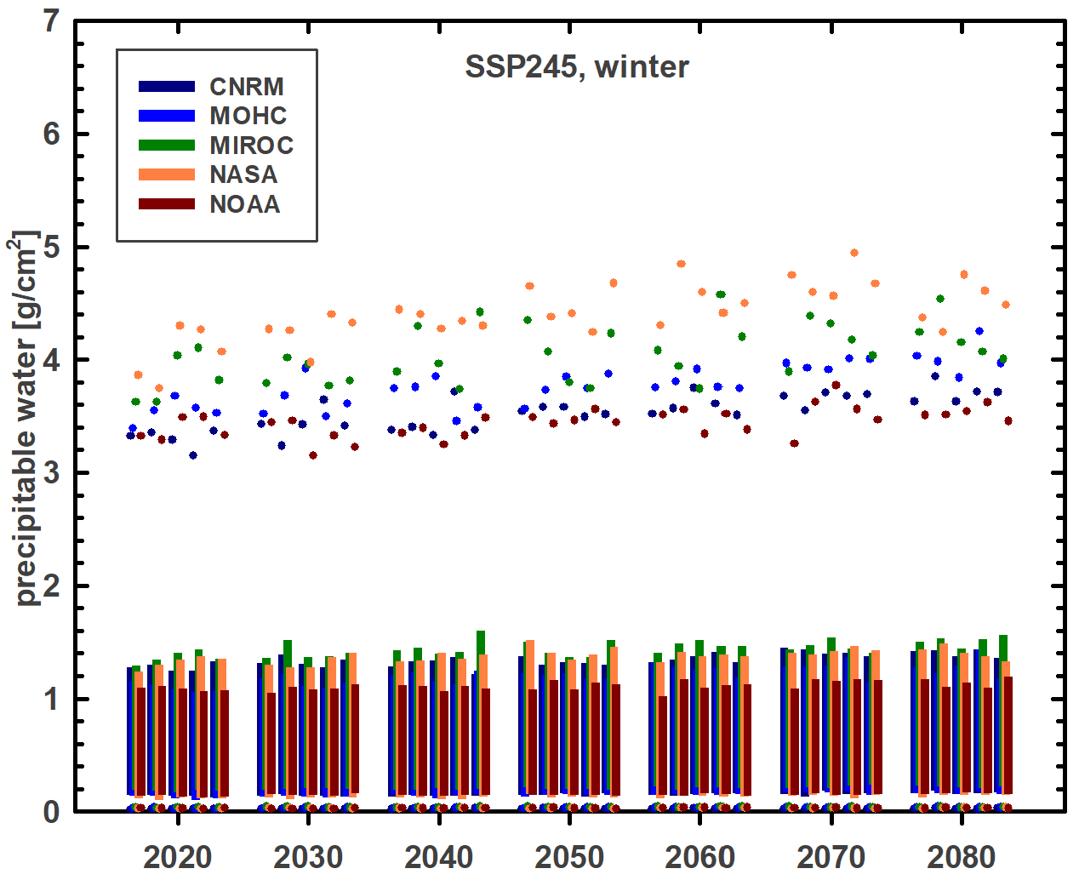 | 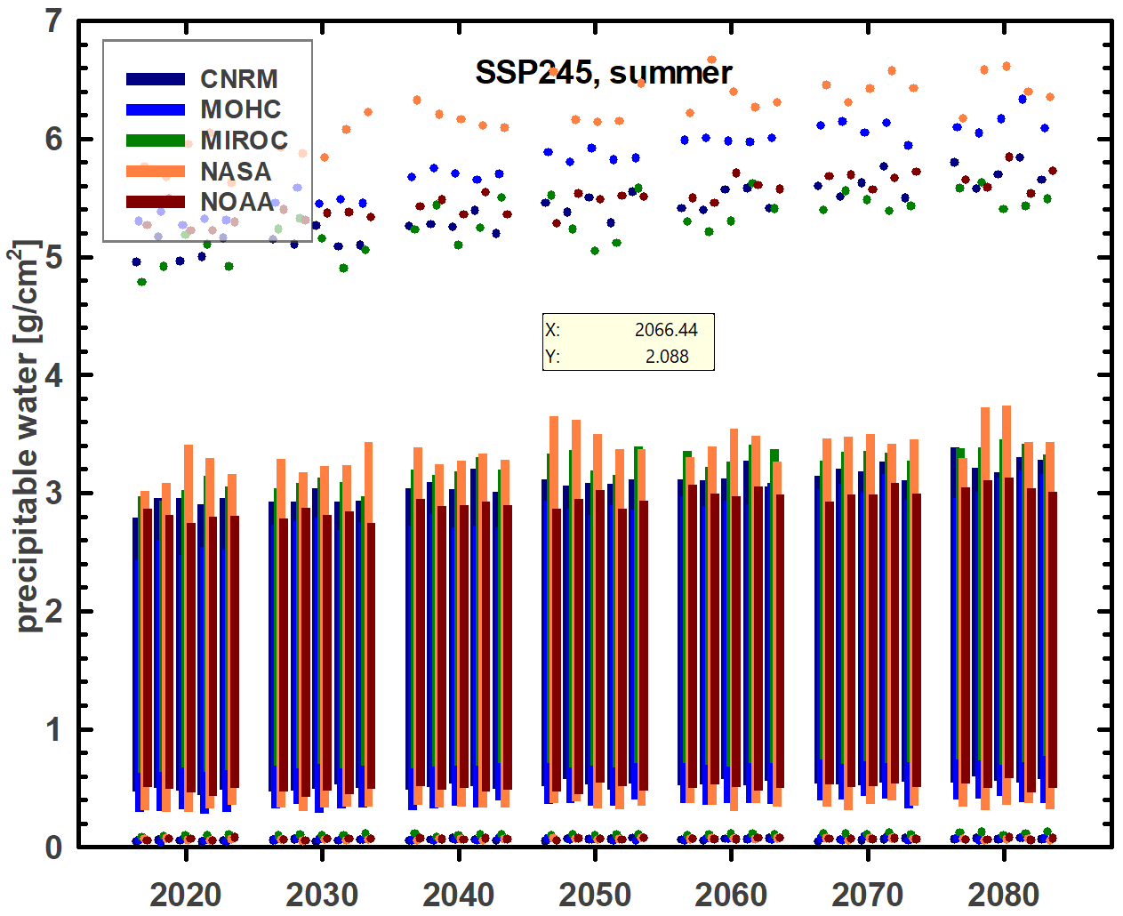 | 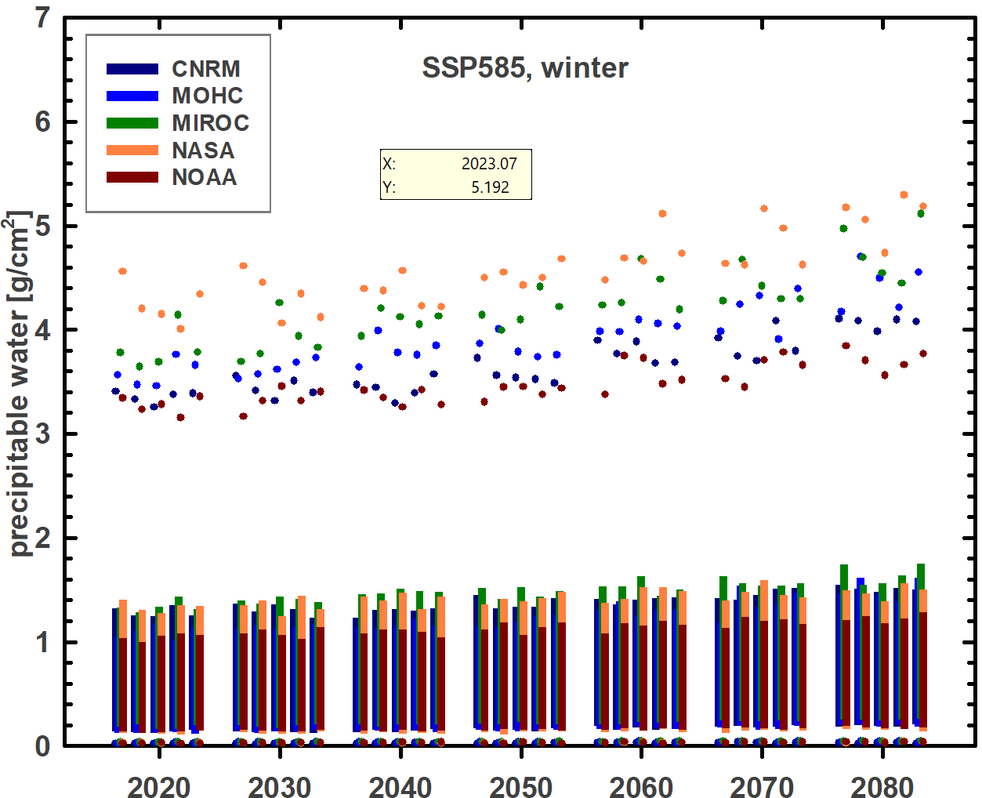 | 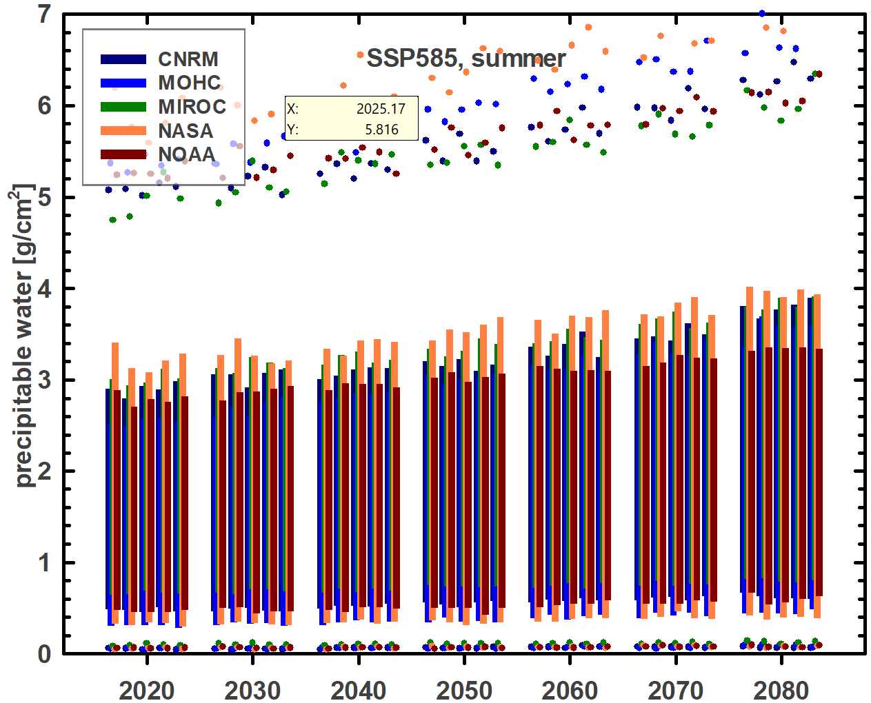
(a) | (b) | (c) | (d)
Figure 2. Precipitable water under scenarios 2 (SSP245, (a) & (b)) and 5 (SSP585, (c) & (d)) during winter and summer. Winter/summer correspond to months 1-3/7-9 in the northern hemisphere and 7-9/1-3 in the southern hemisphere.
Table 2. Decadal projections of the change in seasonal short-circuit current of single-junction (1J) silicon (Si), tandem (2J) perovskite-silicon (PVSK/Si) and three-junction (3J) III-V multijunction (III-V) solar cells relative to 2020 values. Aerosol optical depth (AOD) is held constant at 2020 values. Data is normalized by the relative irradiance.
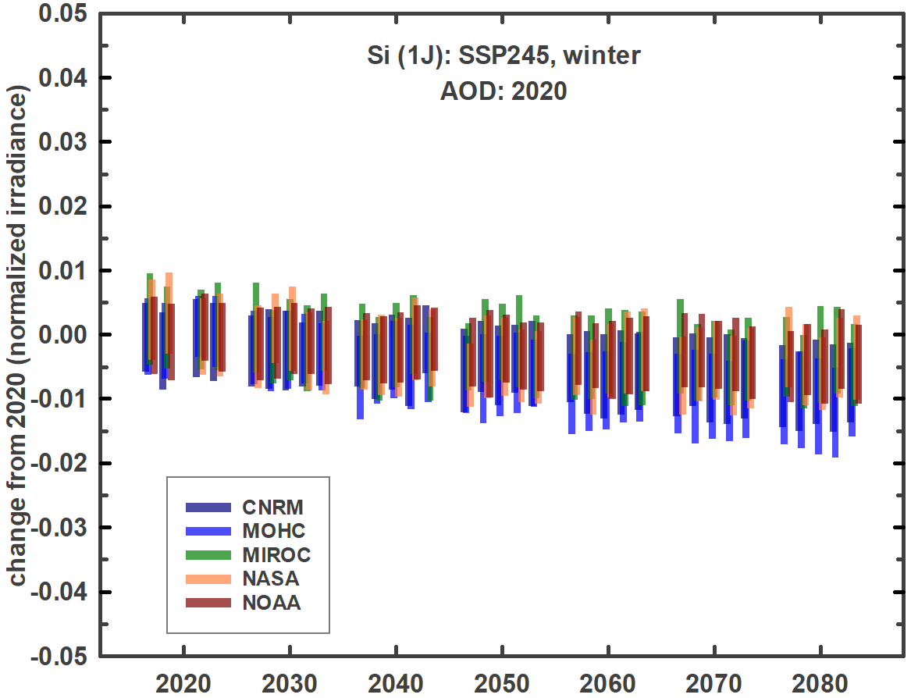 | 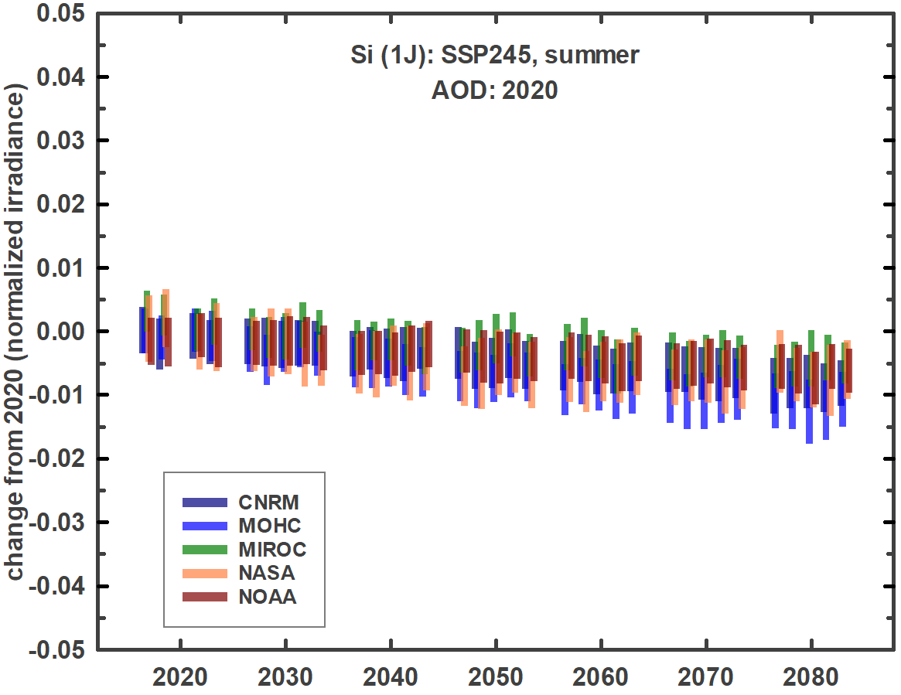 | 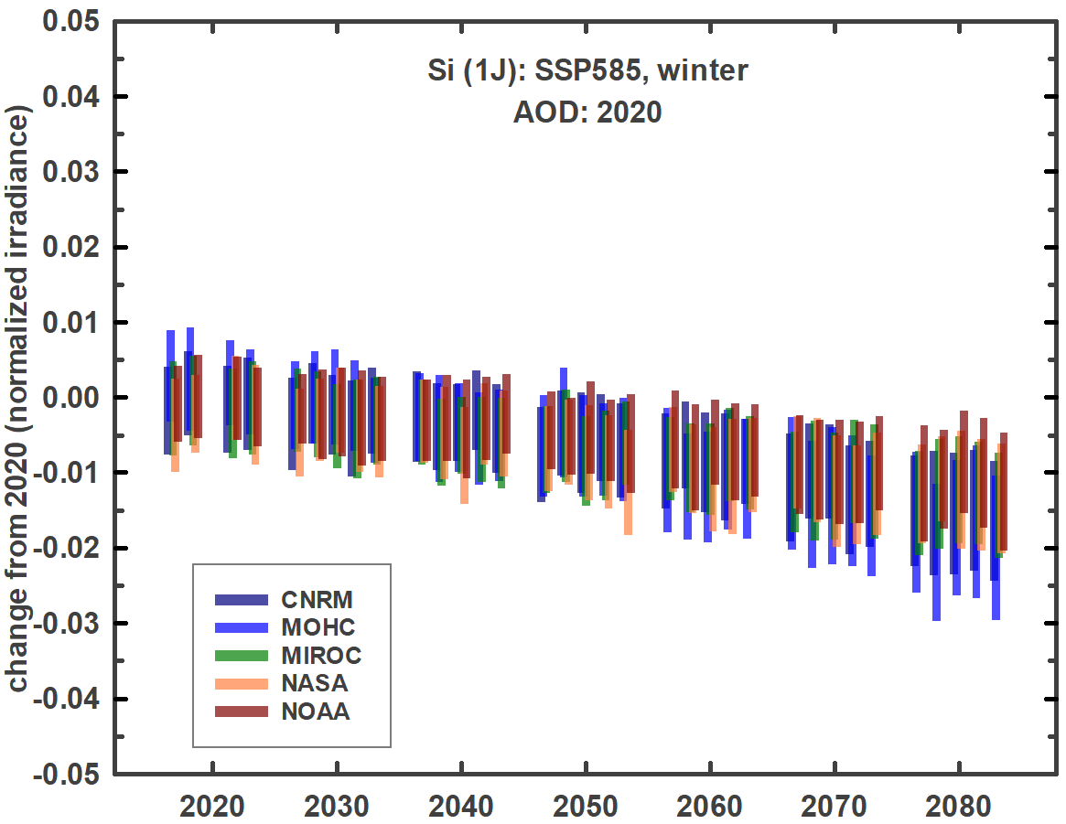 | 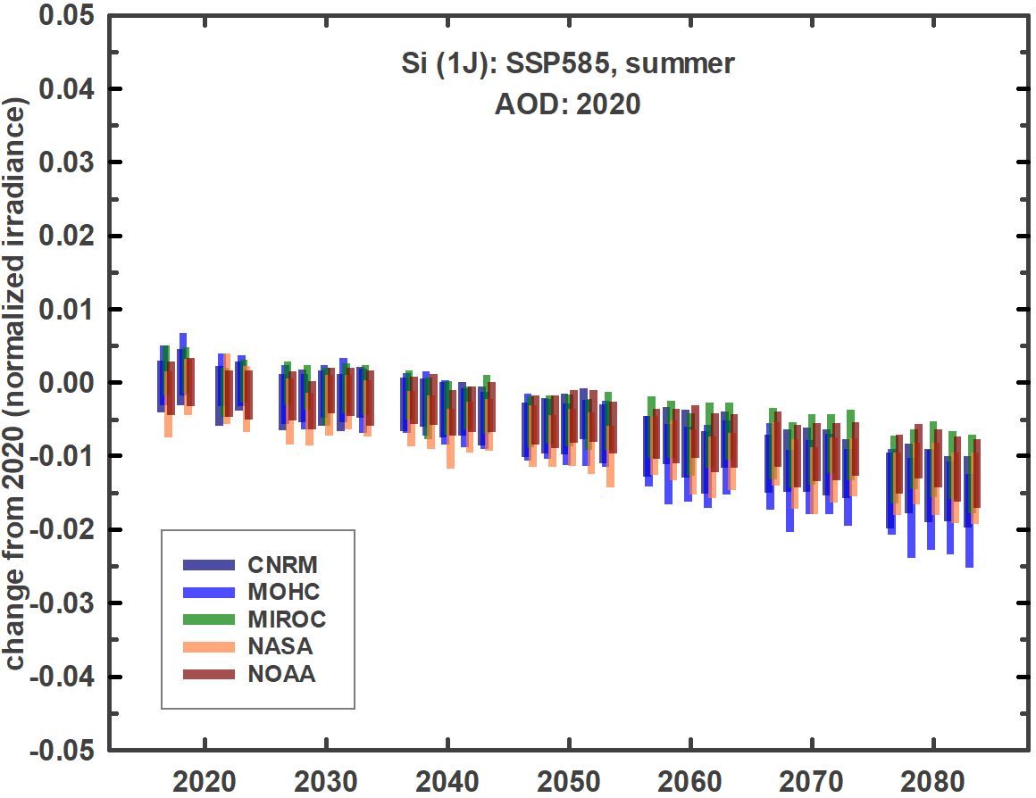
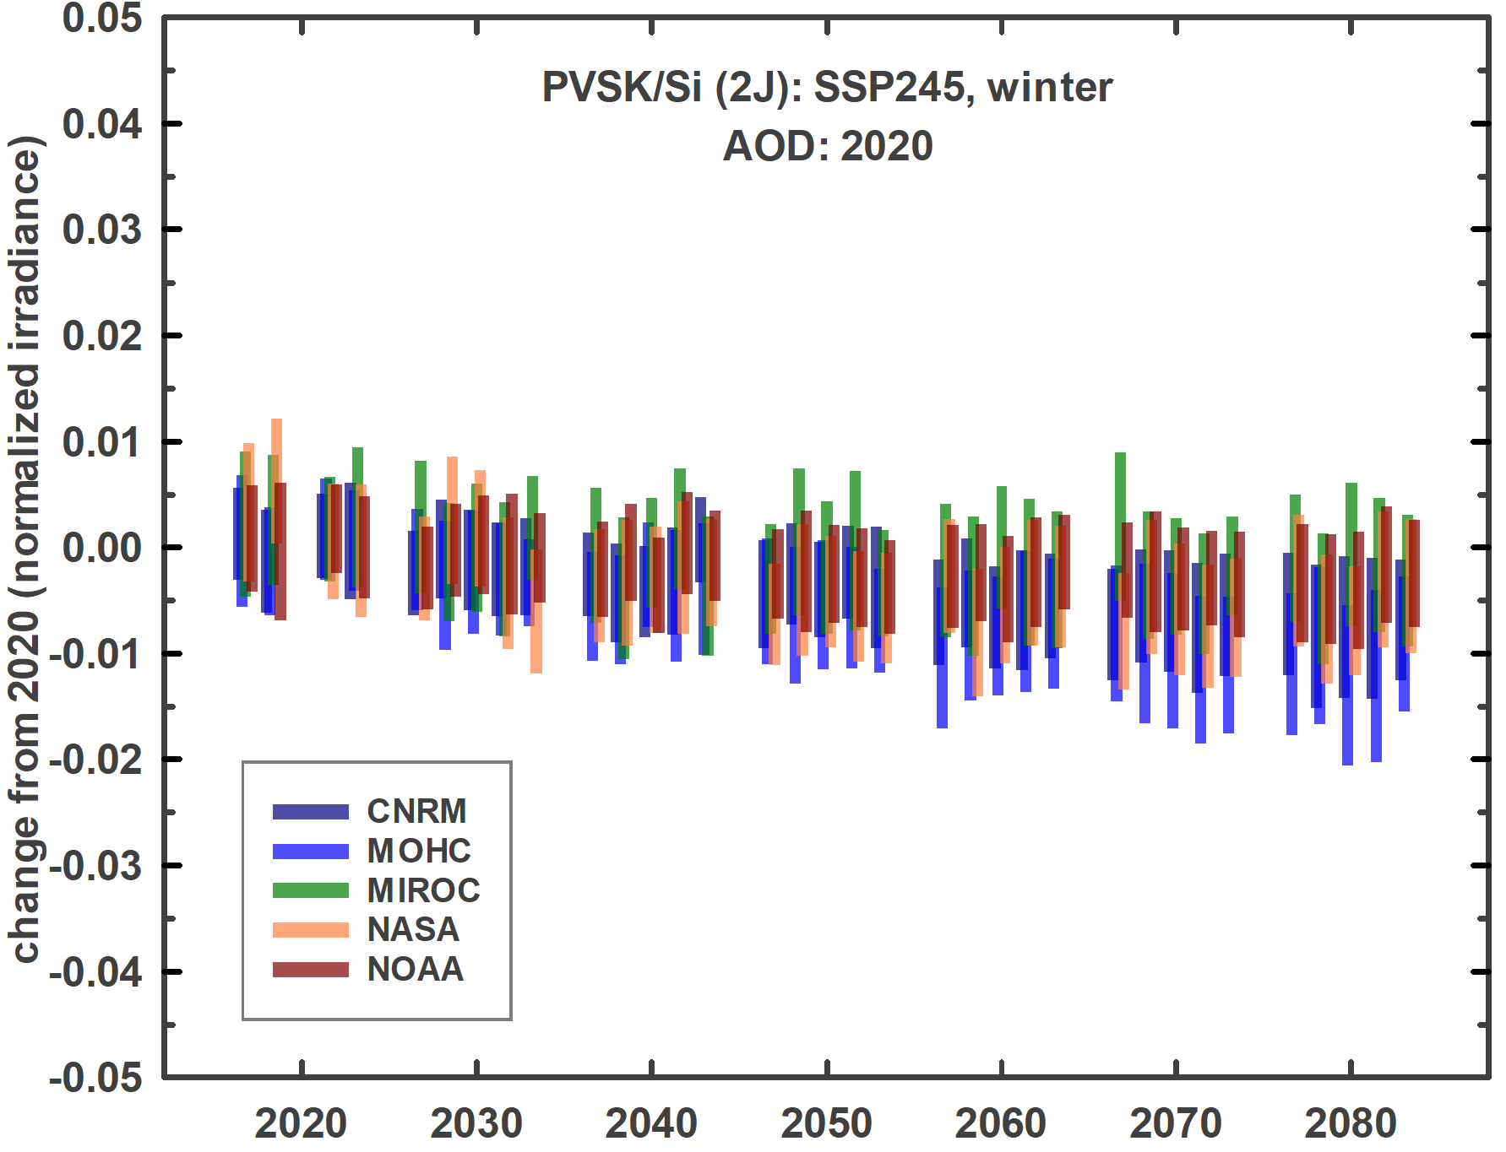 | 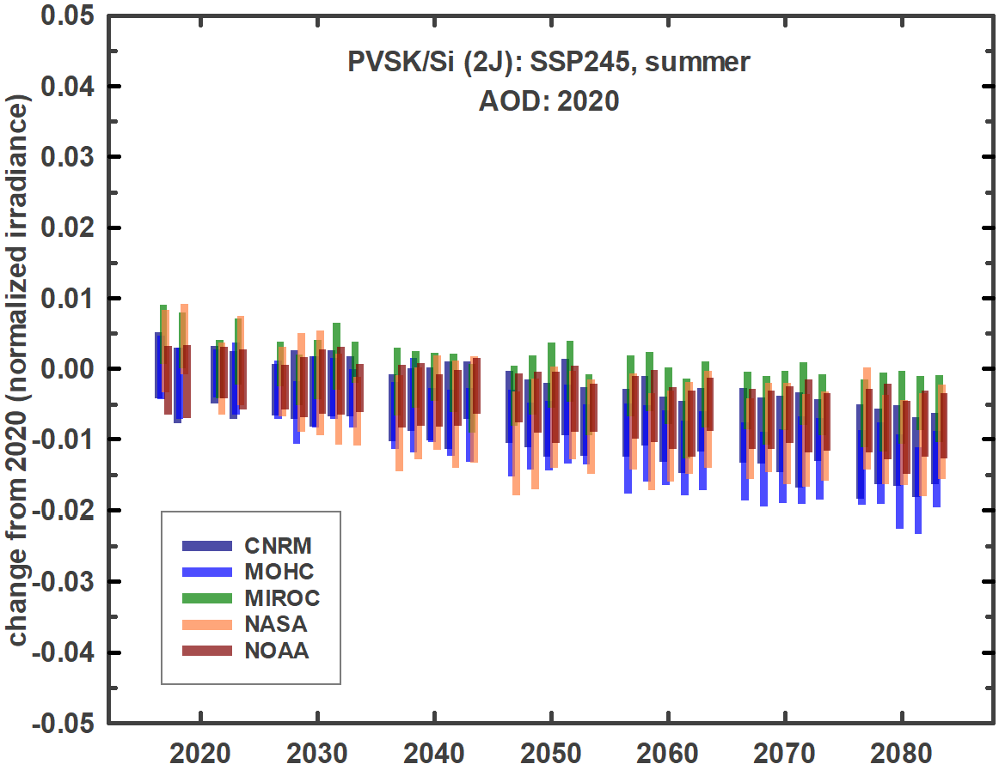 | 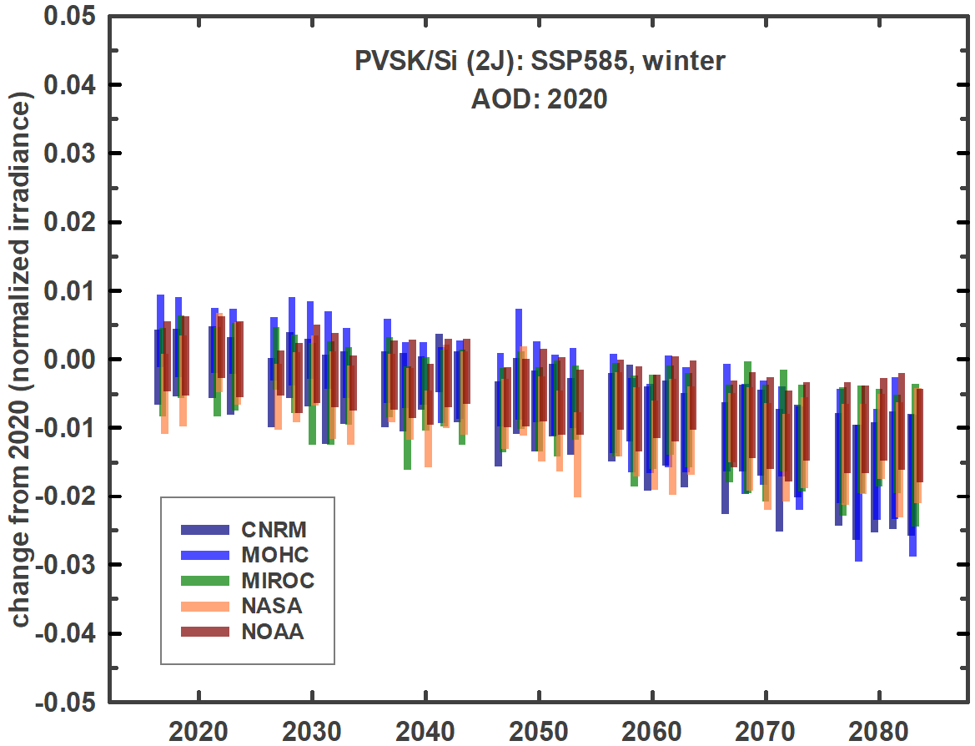 | 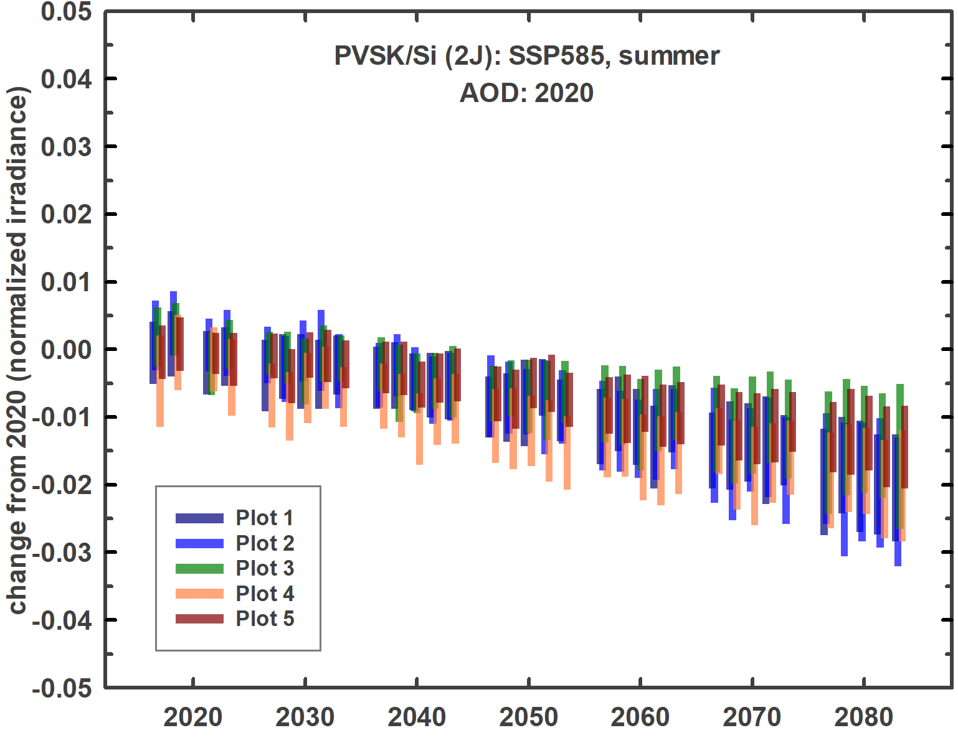
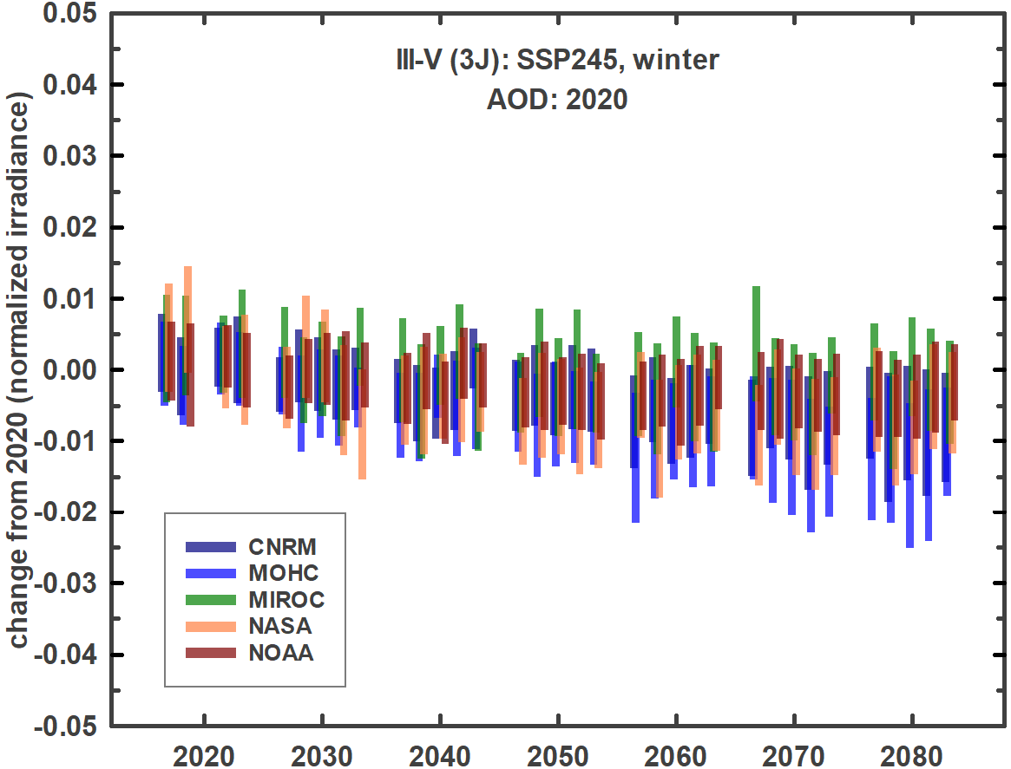 | 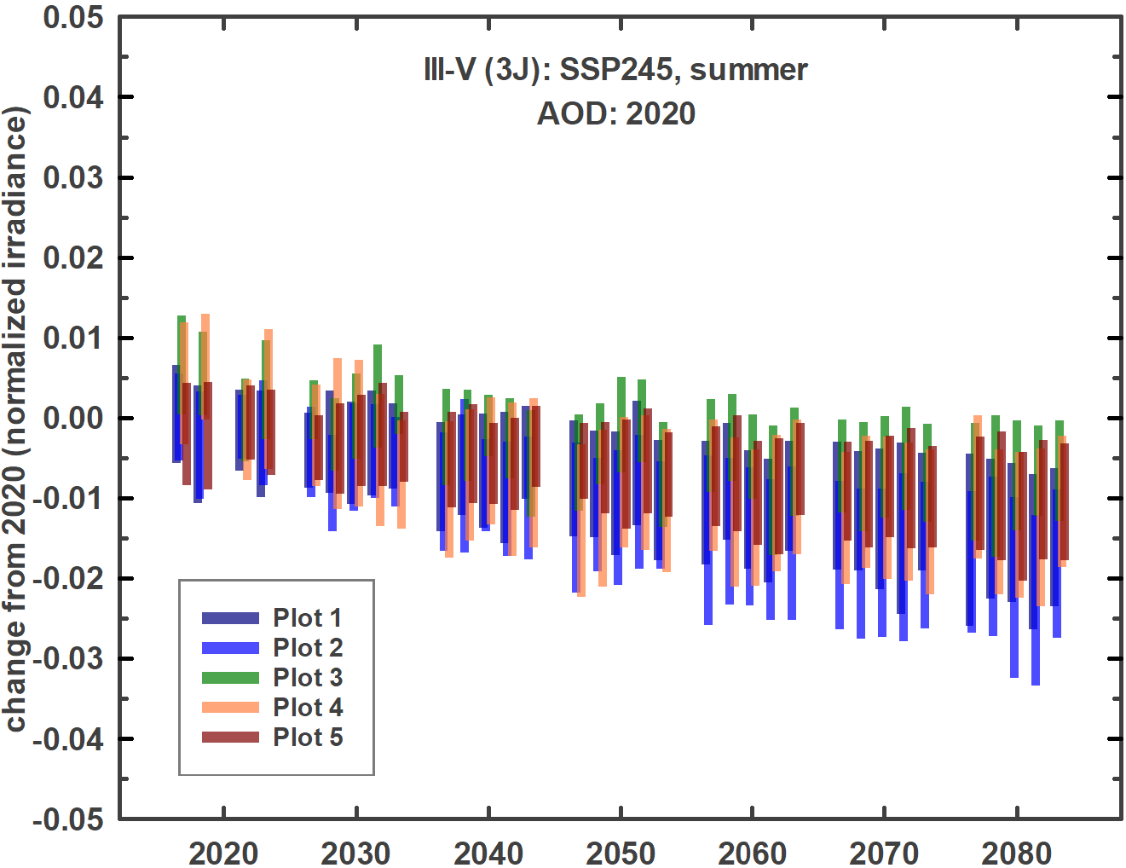 | 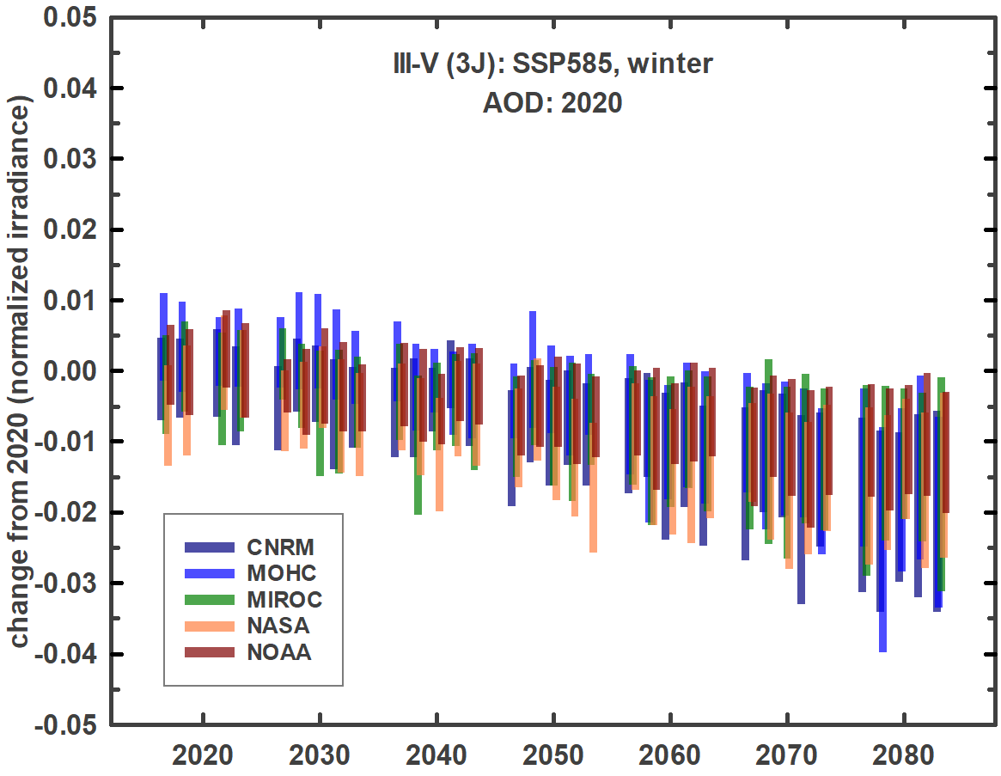 | 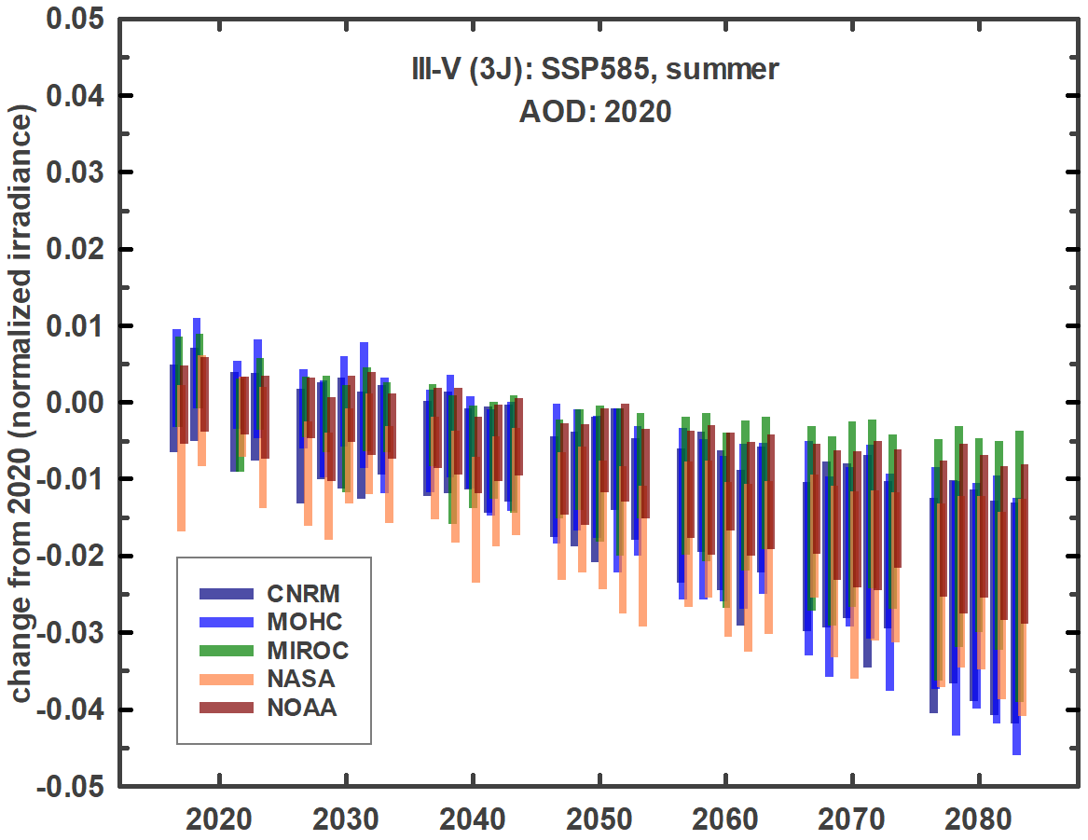

Aerosol patterns are more variable and more difficult to forecast than precipitable water vapor. Sources include combustion processes, forest fires, windborne desert dust and ocean salt, and volcanism. Patchwork climate mitigation globally may give rise to both location-dependent increases and decreases in aerosol levels over time. The model forecasts for aerosol optical depth at 550 nm (Figure 3) reflect this variability.
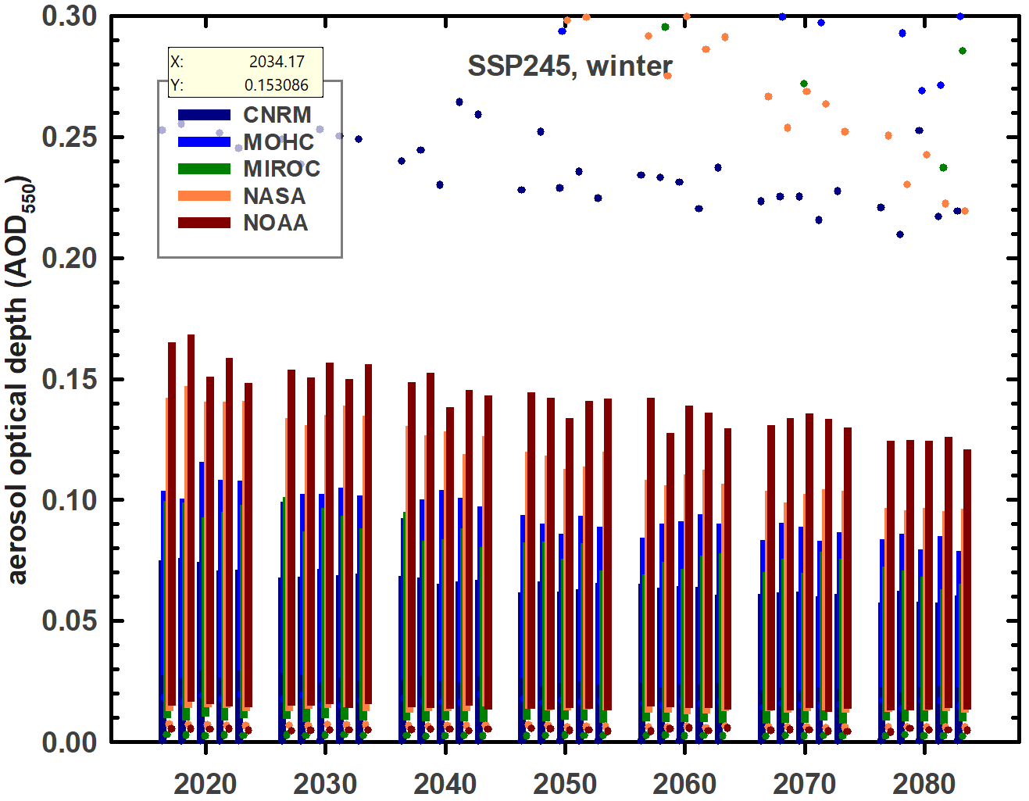 | 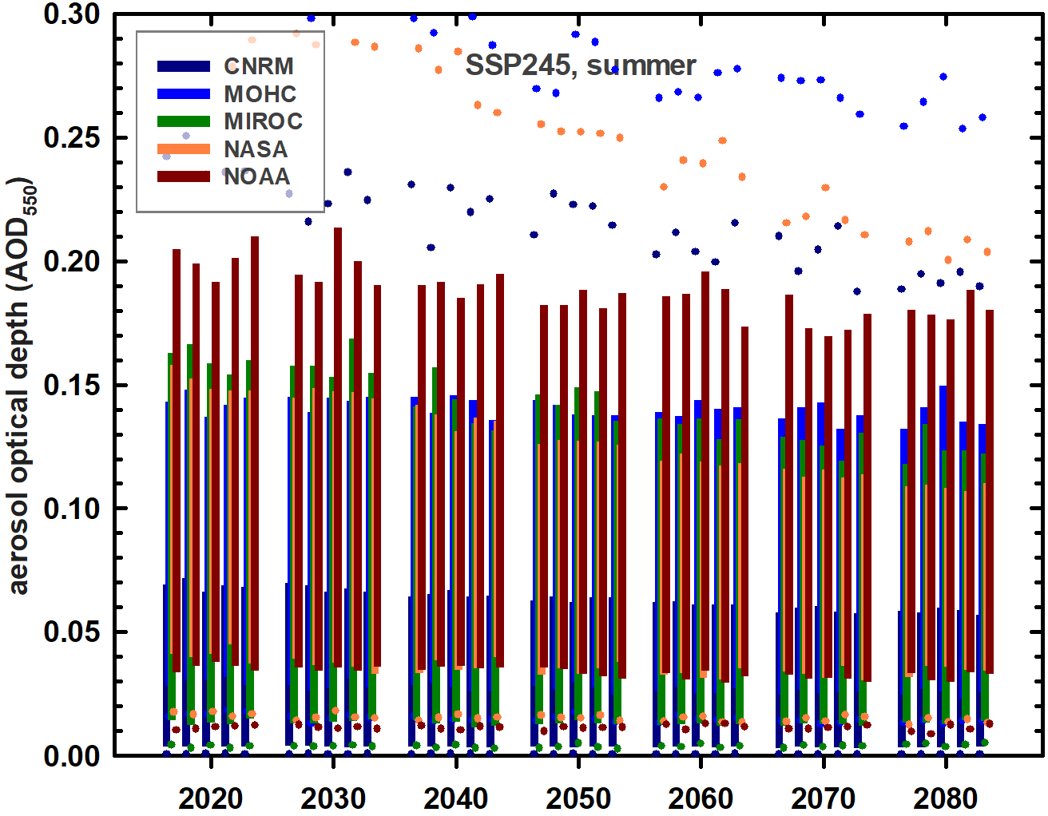 | 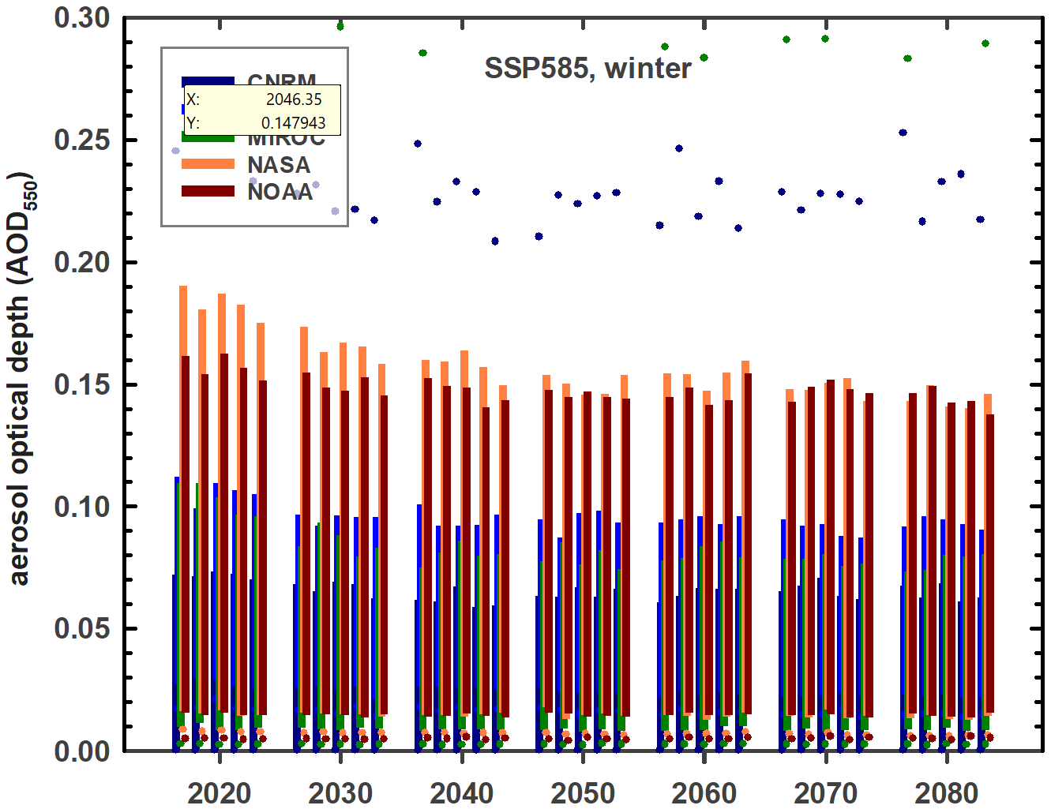 | 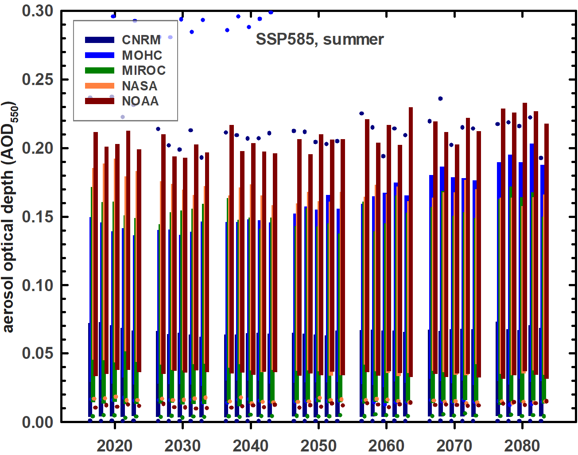
(a) | (b) | (c) | (d)
Figure 3. Aerosol optical depth at 550 nm.

Incorporation of the forecast changes in aerosols partly offsets the downward trends seen in Table 2 (with AOD held constant).

Table 3. Decadal projections of the change in seasonal short-circuit current of single-junction (1J) silicon (Si), tandem (2J) perovskite-silicon (PVSK/Si) and three-junction (3J) III-V multijunction (III-V) solar cells relative to 2020 values. Data is normalized by the relative irradiance.
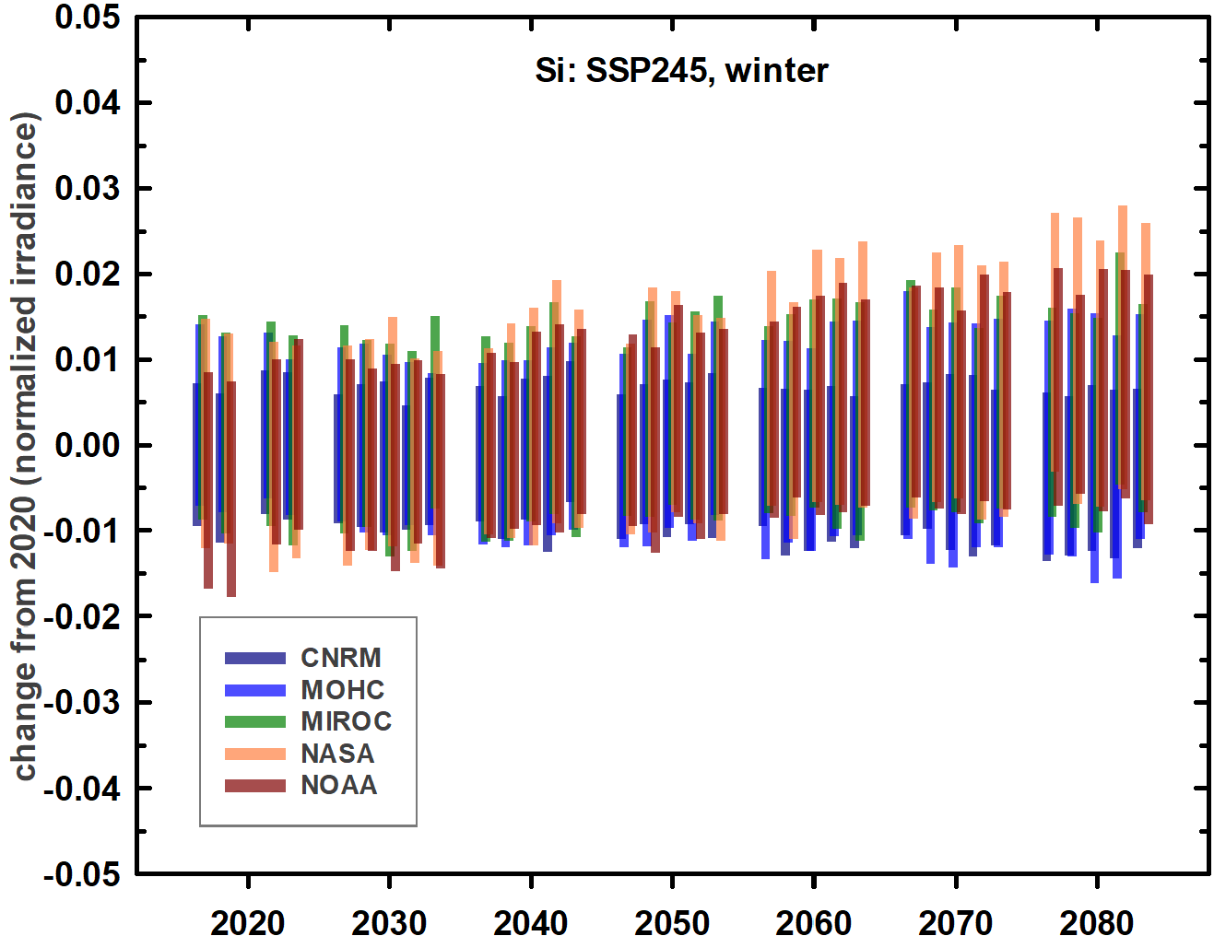 | 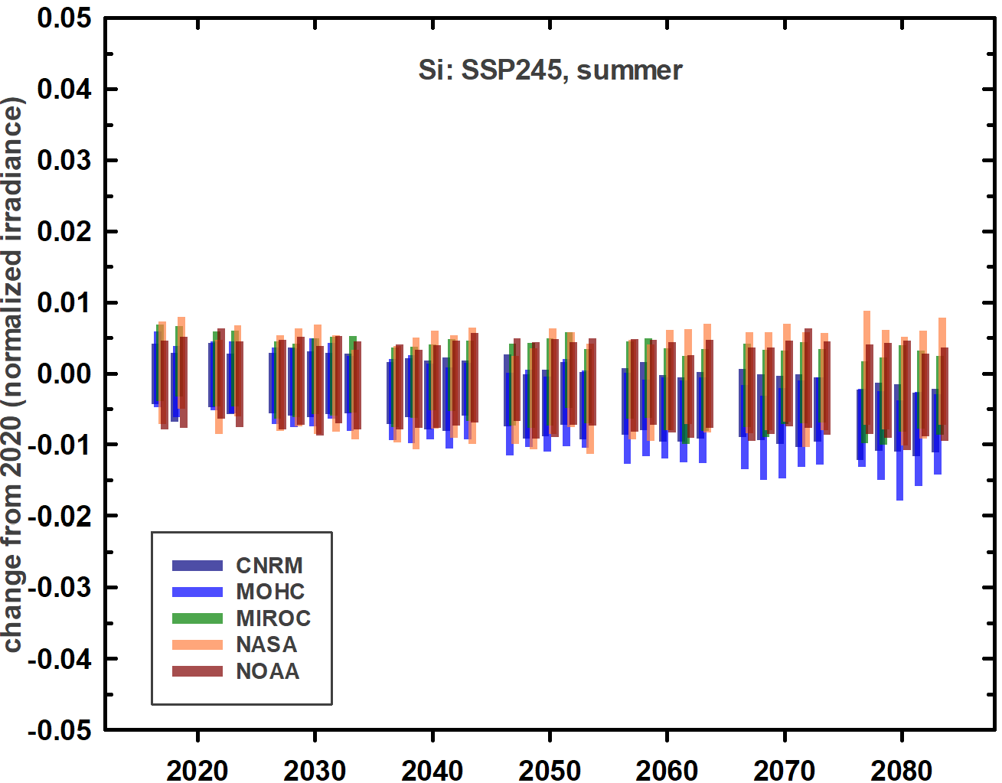 | 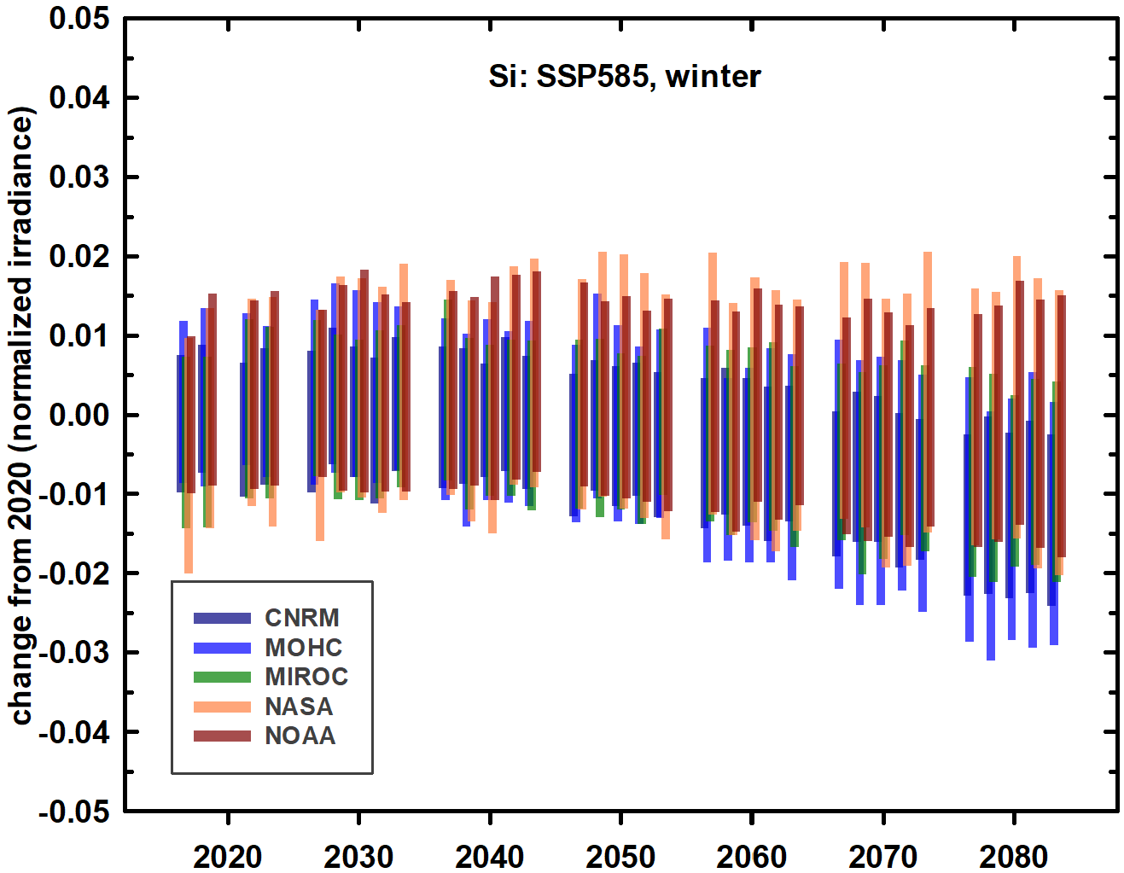 | 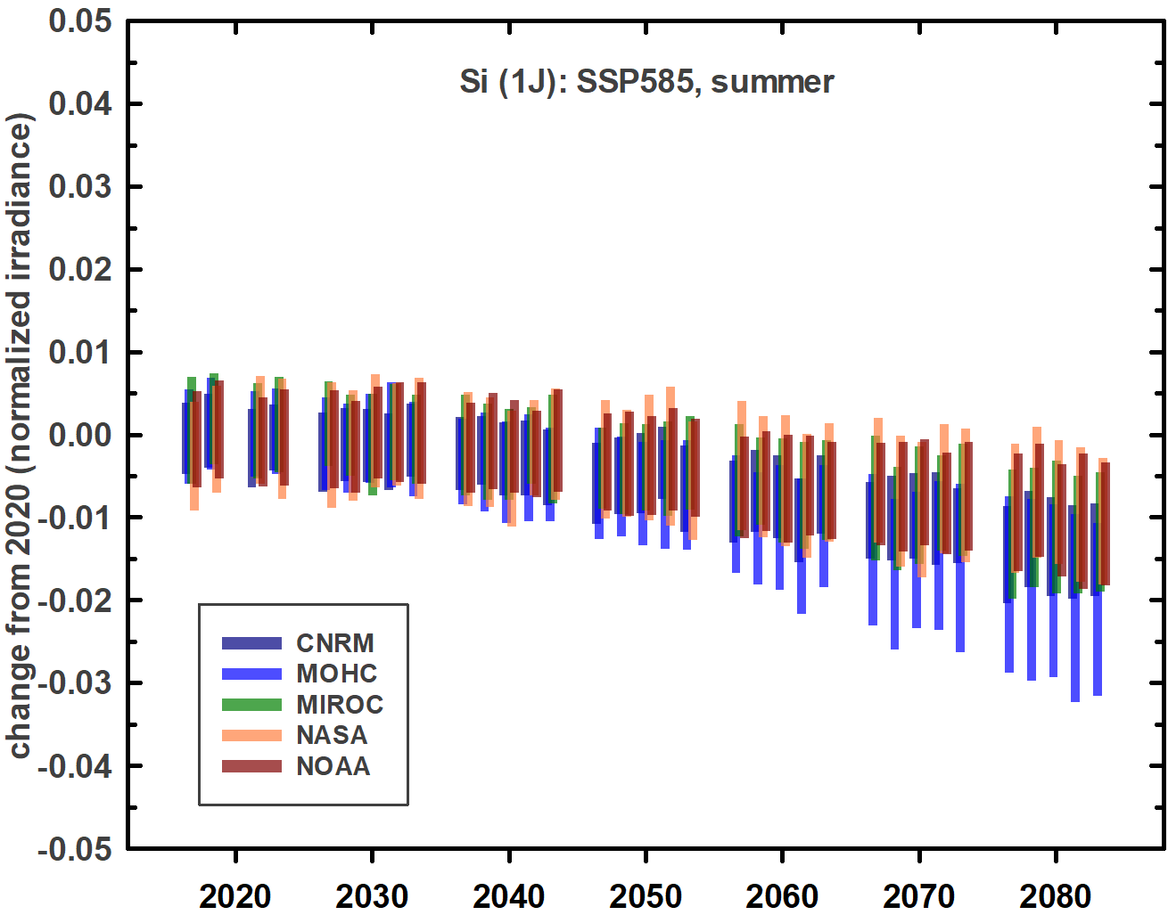
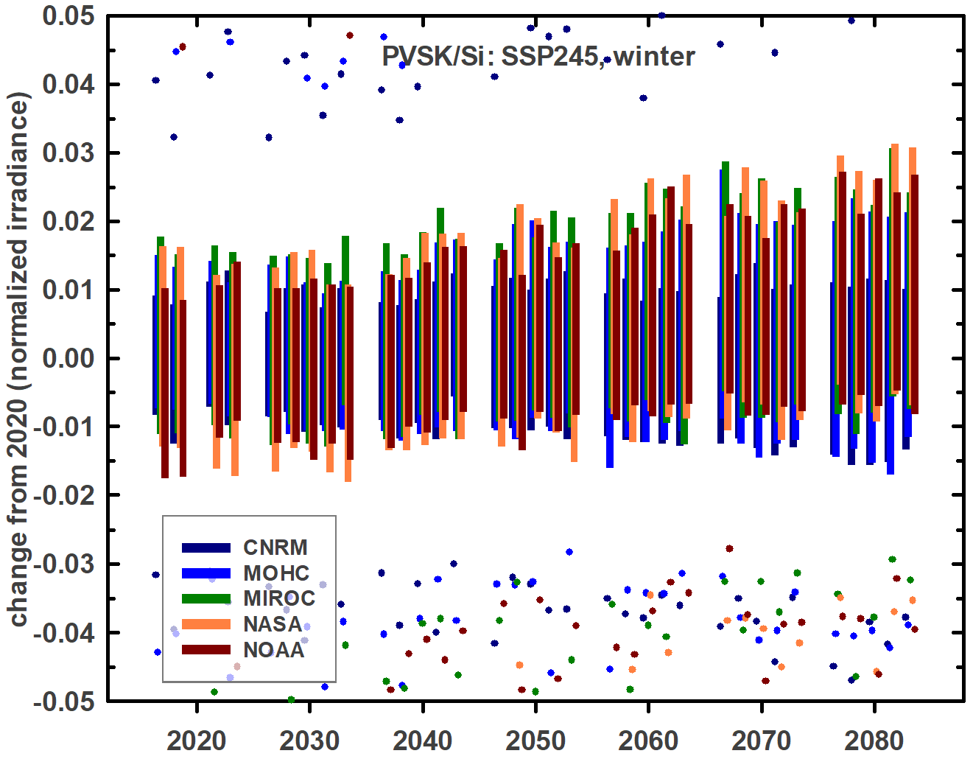 | 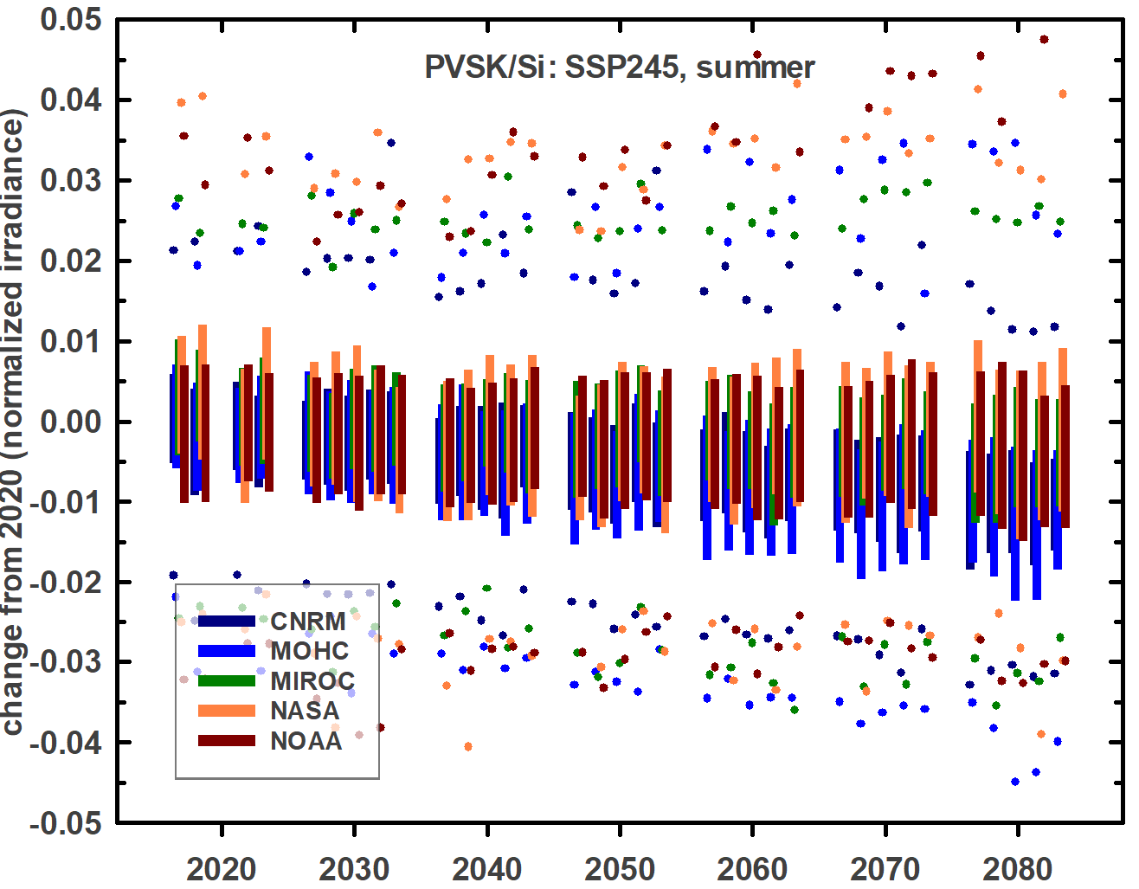 | 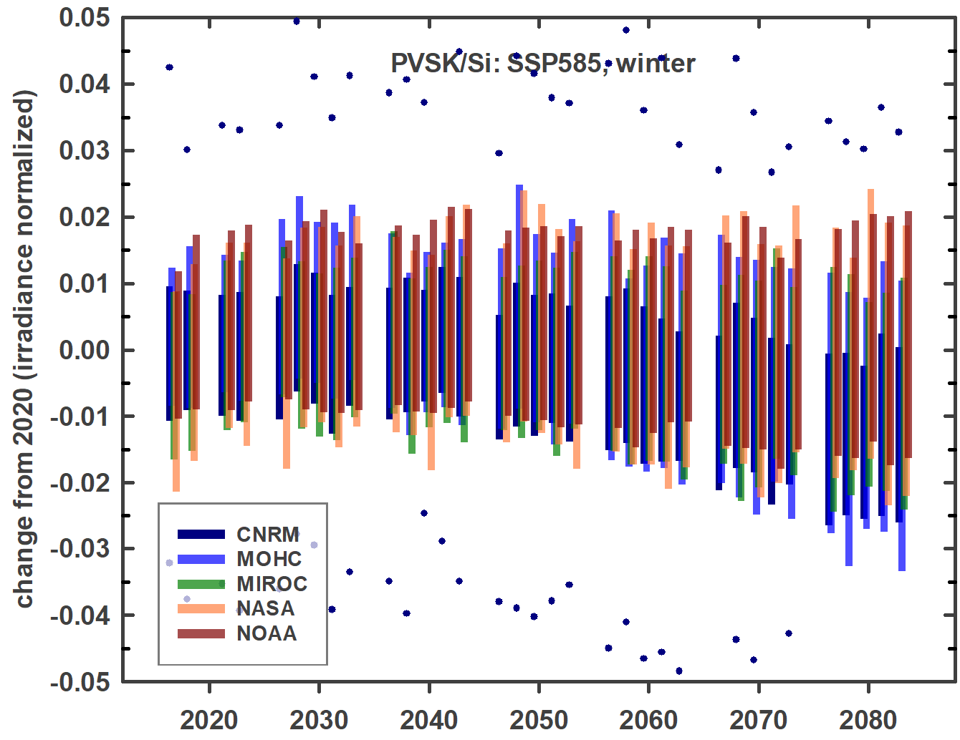 | 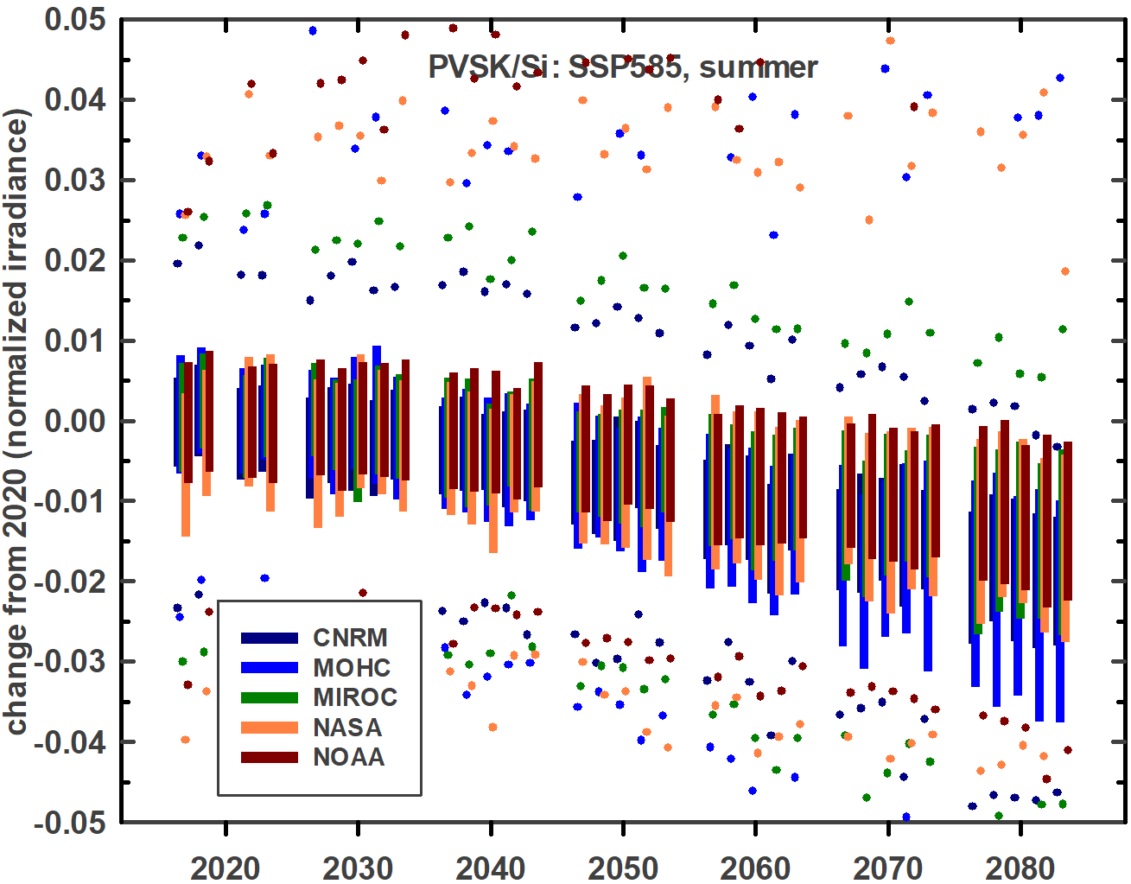
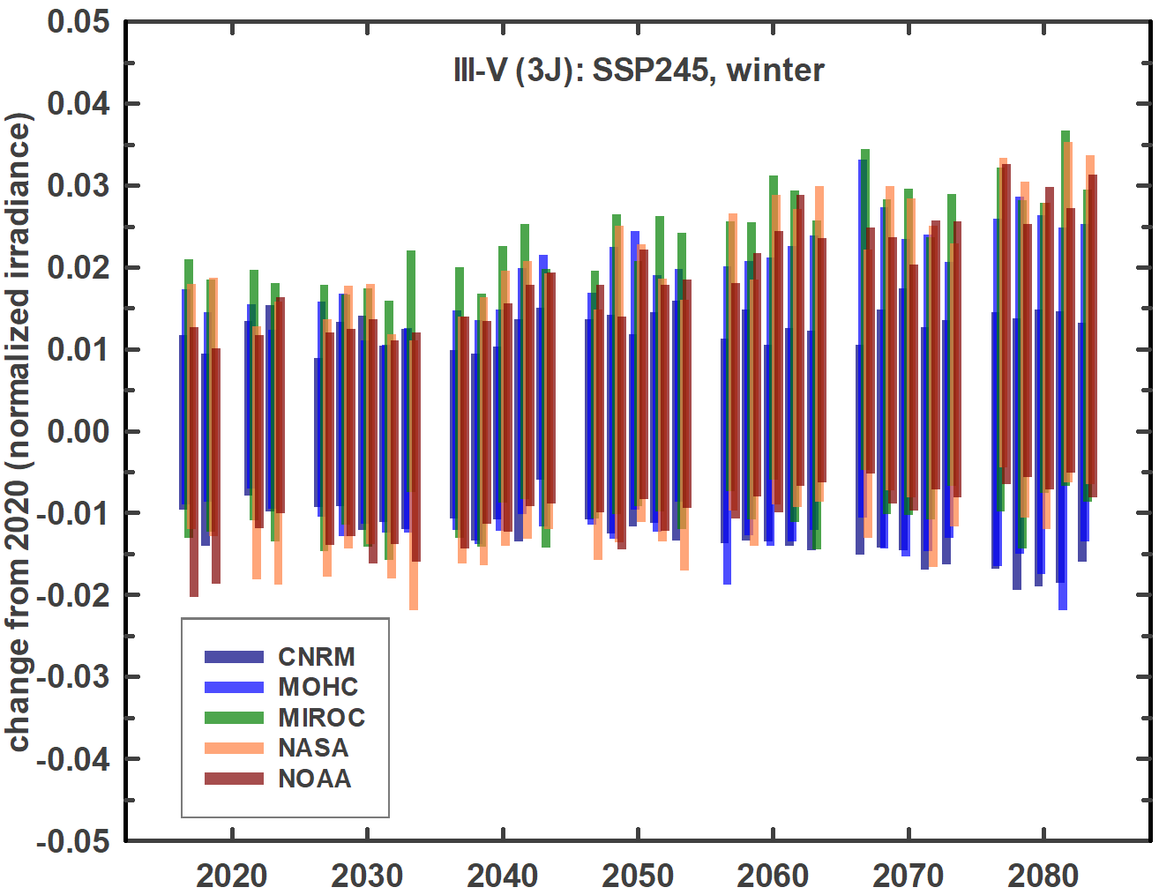 | 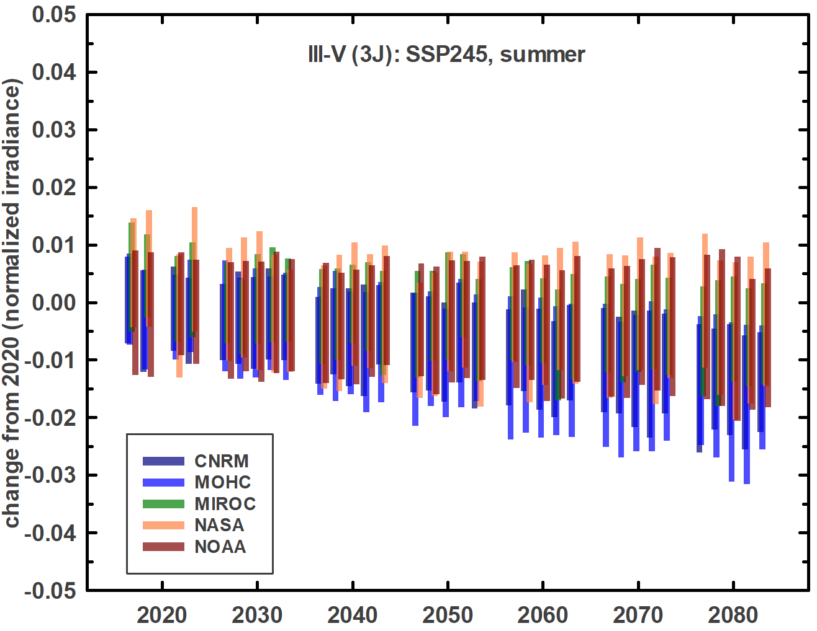 | 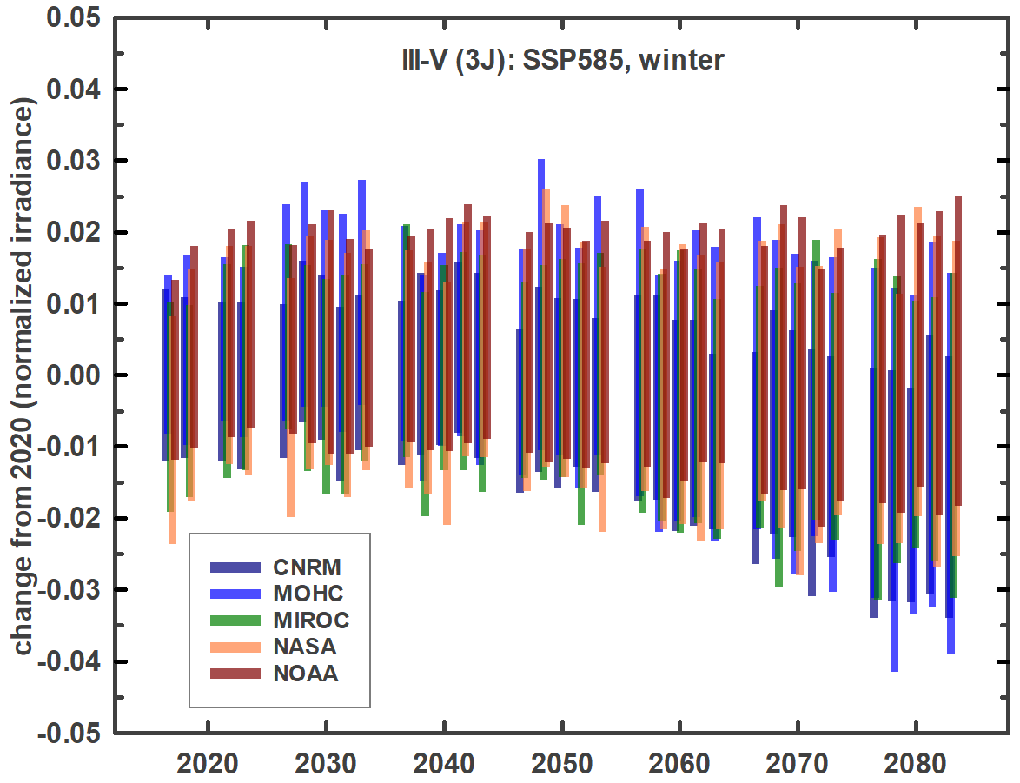 | 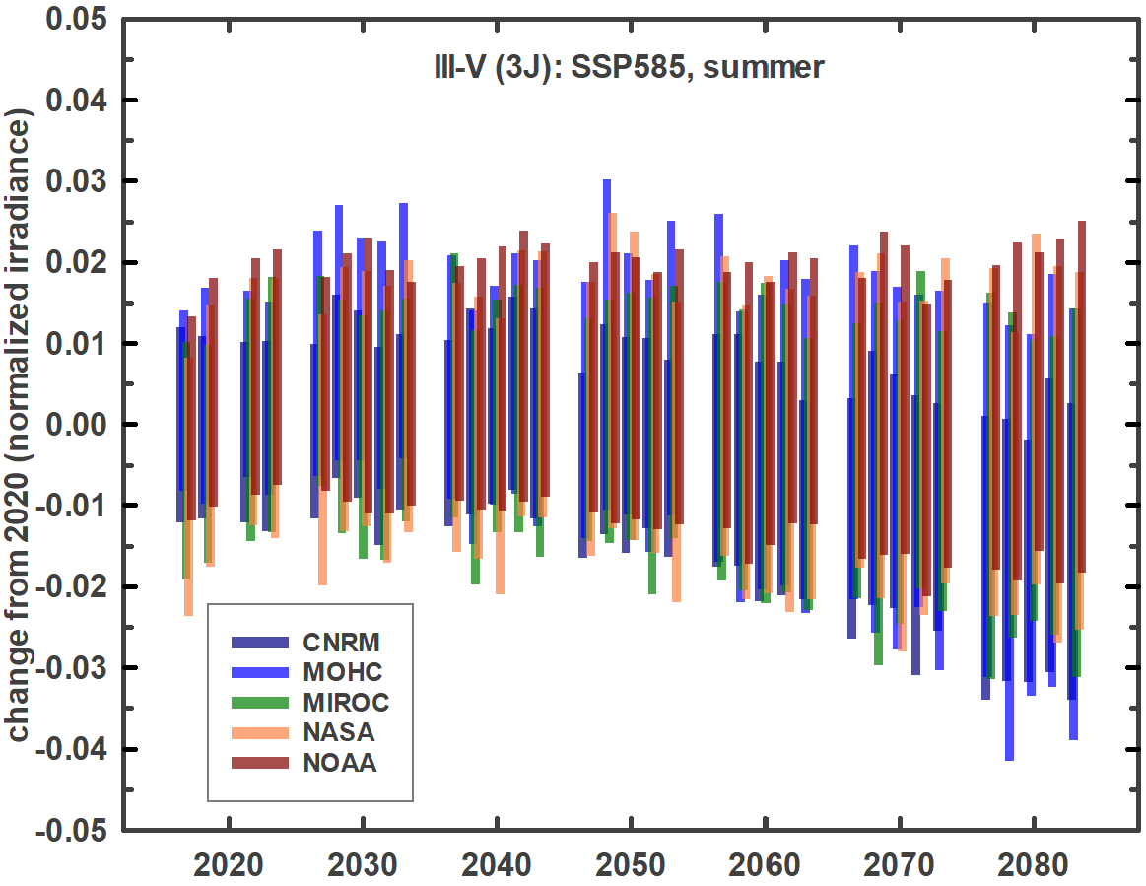

Effect on photosynthesis
For plants, an analogous metric to the quantum efficiency of solar cells is the quantum yield of photosynthesis. The quantum yield is a measure of the efficiency at which photon energy is absorbed and converted to chemical energy via fixation of carbon. Figure 1(b) shows normalized quantum yields for three widely distributed commercial crops⁷. Borrowing the standard spectrum from PV, global variation in the quantum yield for maize as predicted for 2020 is shown in Table 4. The absorption of plant pigments such as chlorophylls and carotenoids cuts off beyond ~700 nm, so is largely unaffected by variations in atmospheric water vapor.
Table 4. Predicted 2020 quantum yield of maize relative to that under the standard spectrum (AM1.5G). The magnitudes are normalized to 1000 W/m² irradiance. Winter/spring/summer/fall correspond to months 1-3/4-6/7-9/10-12 in the northern hemisphere and 7-9/10-12/1-3/4-6 in the southern hemisphere.
 |  | CNRM | MOHC | MIROC | NASA | NOAA
maize | winter | 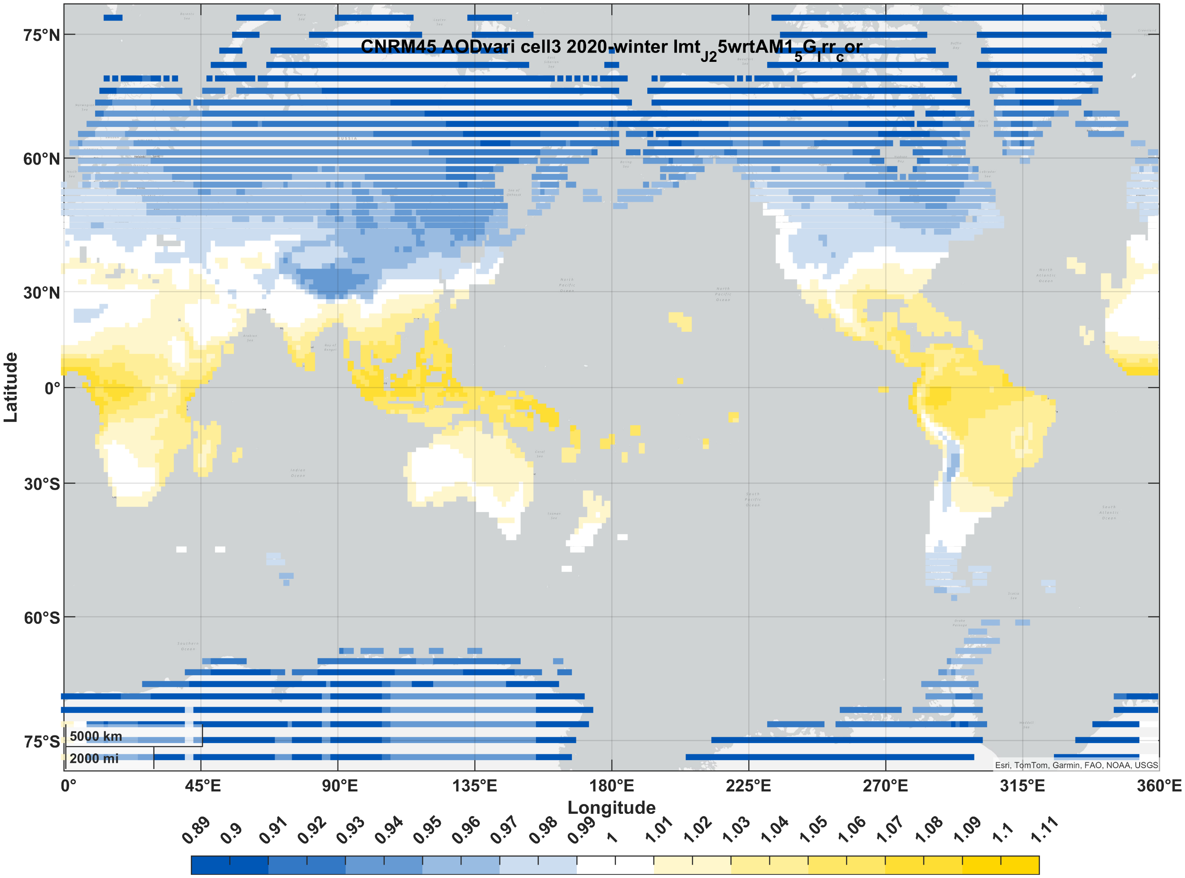 | 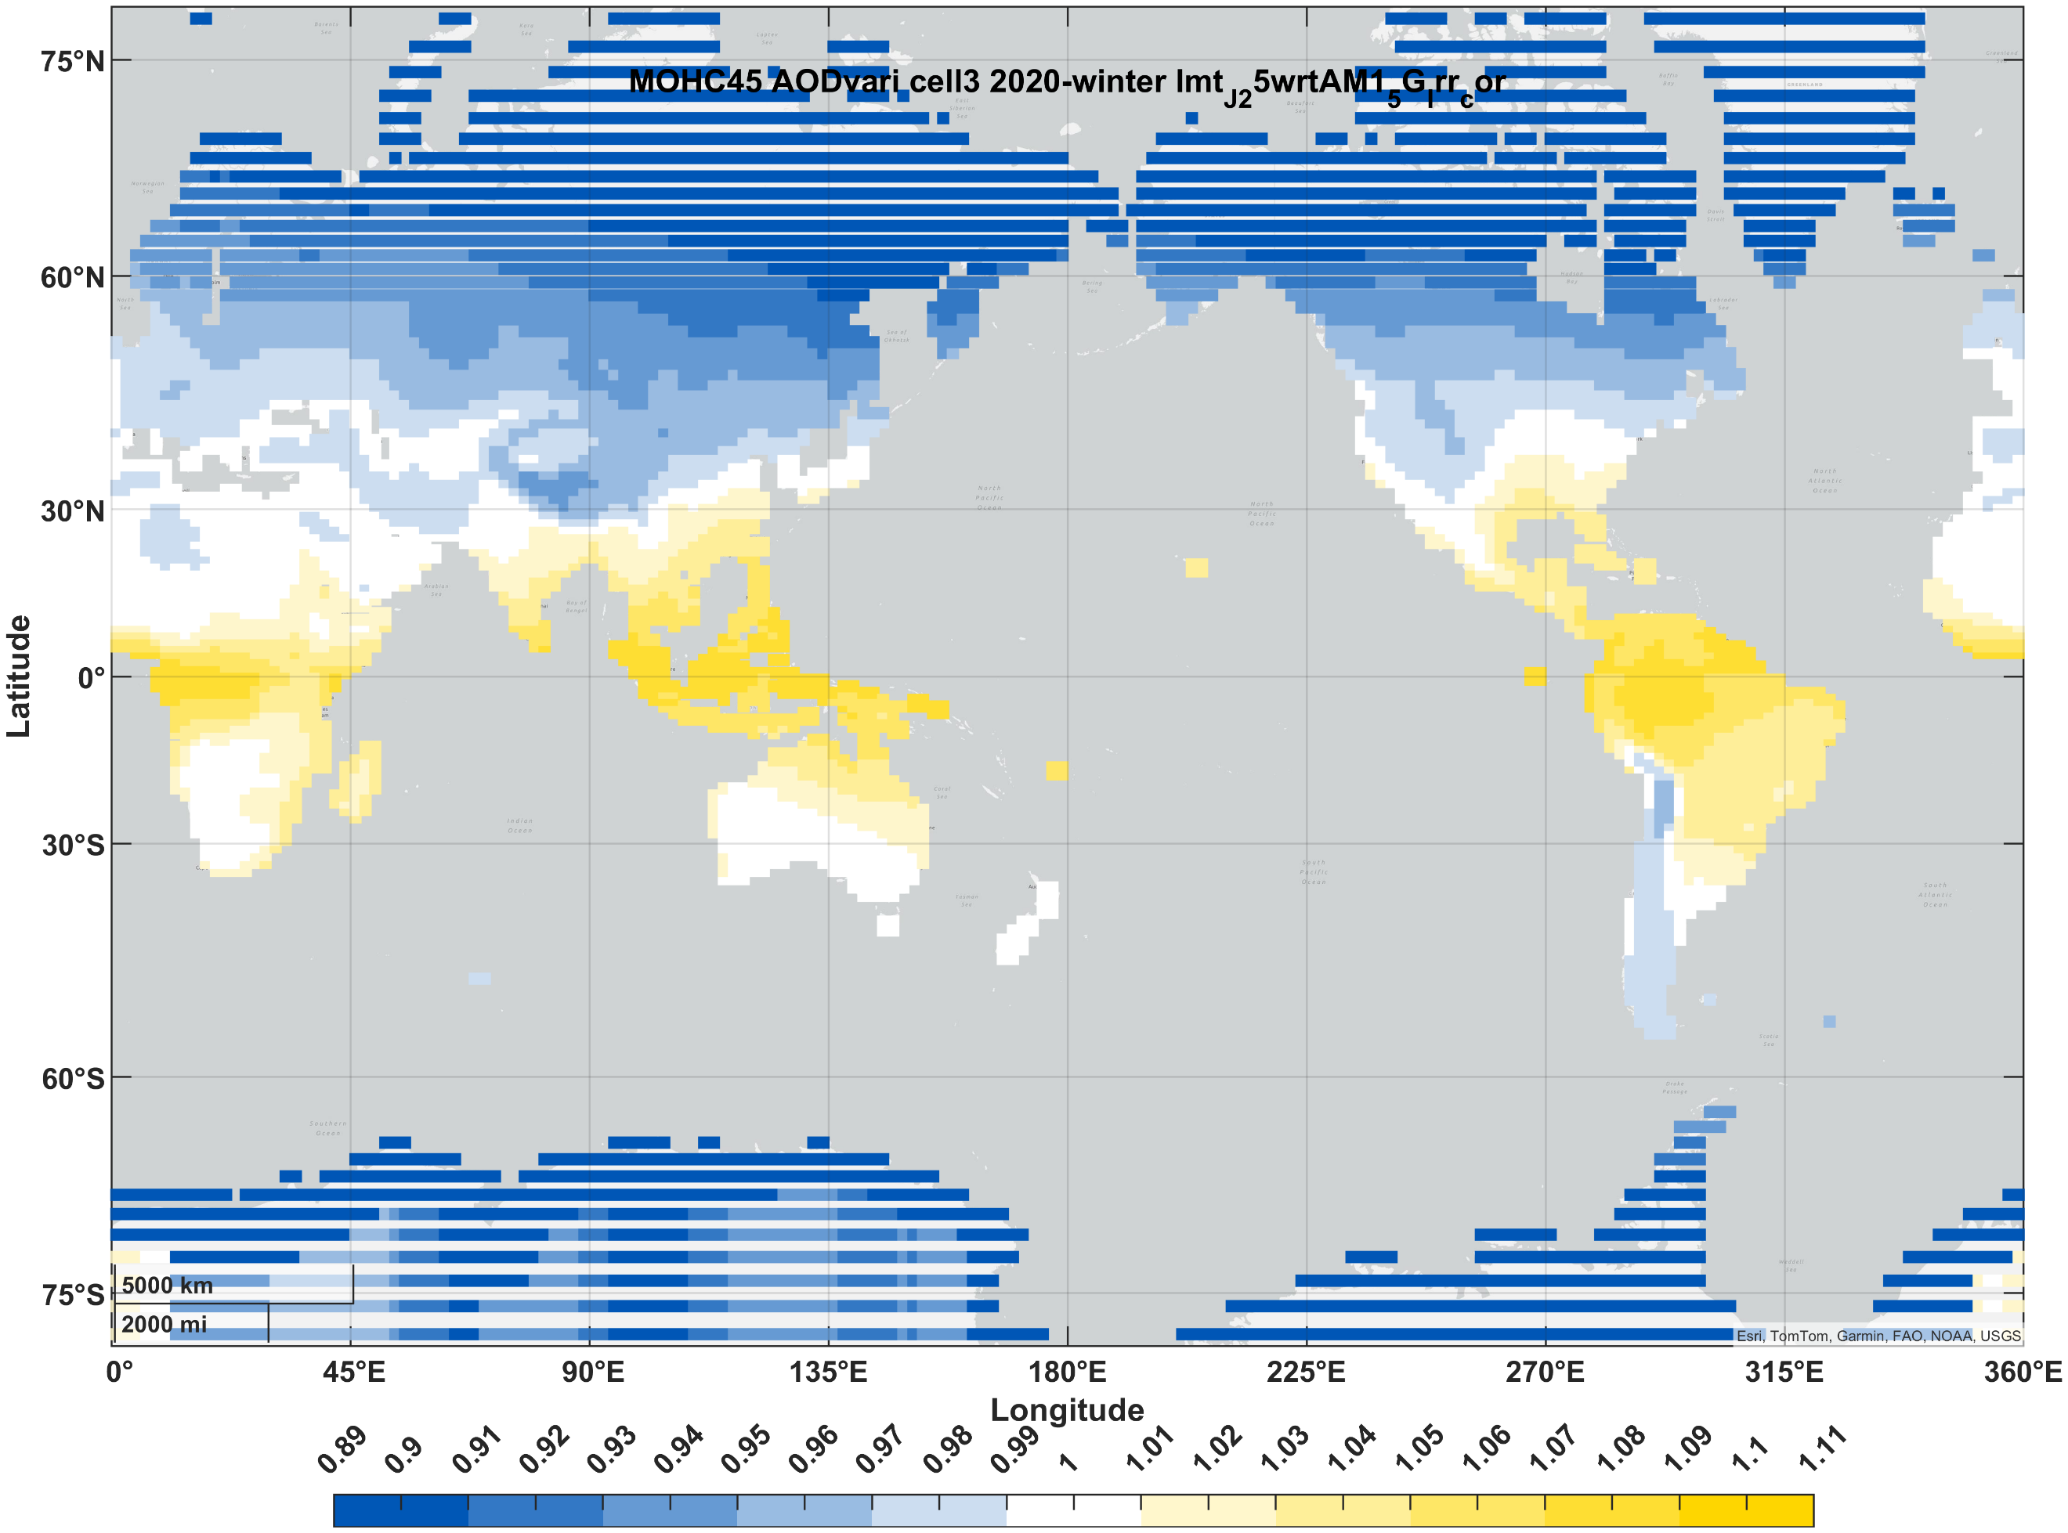 | 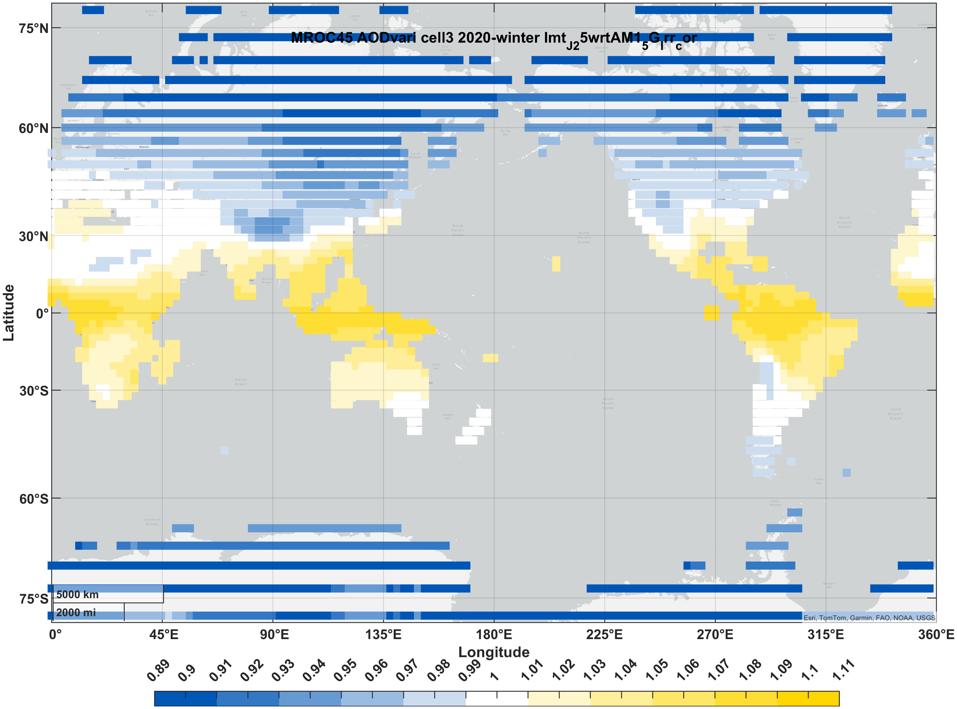 | 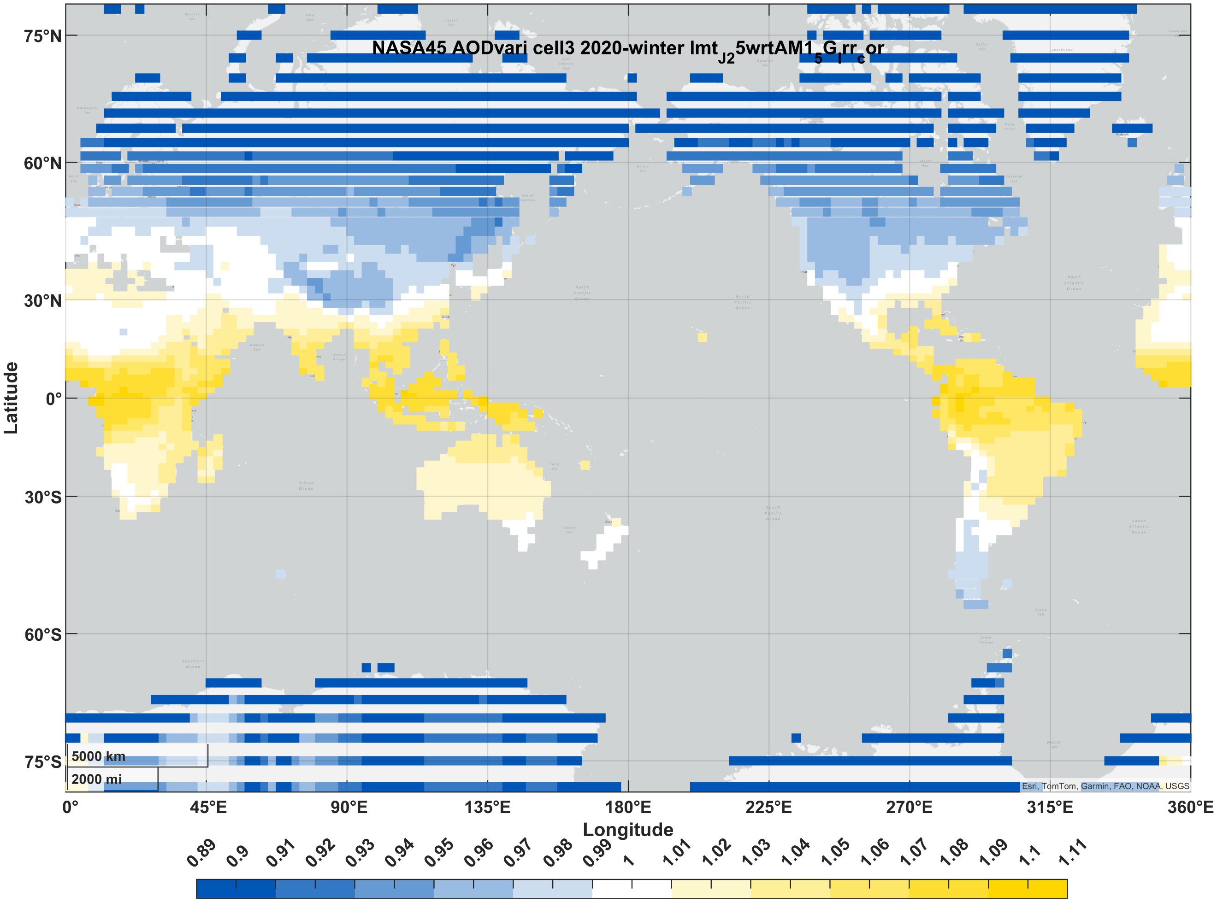 | 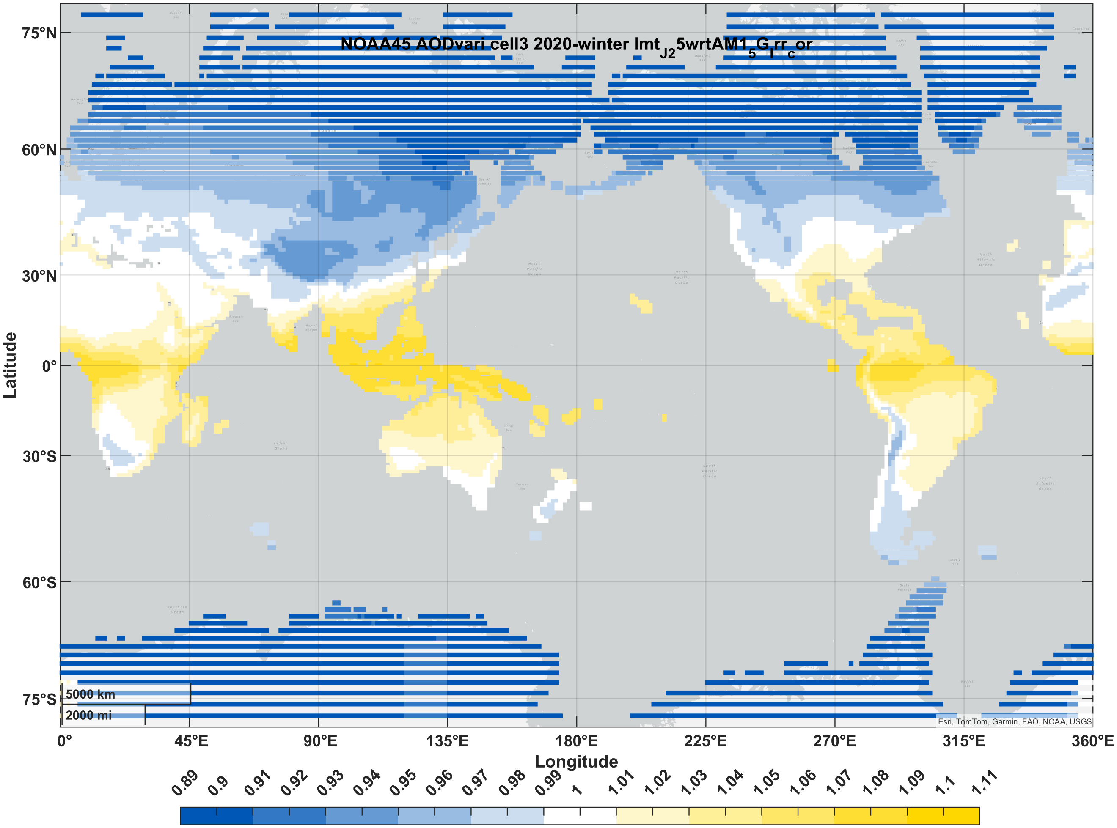
maize | spring | 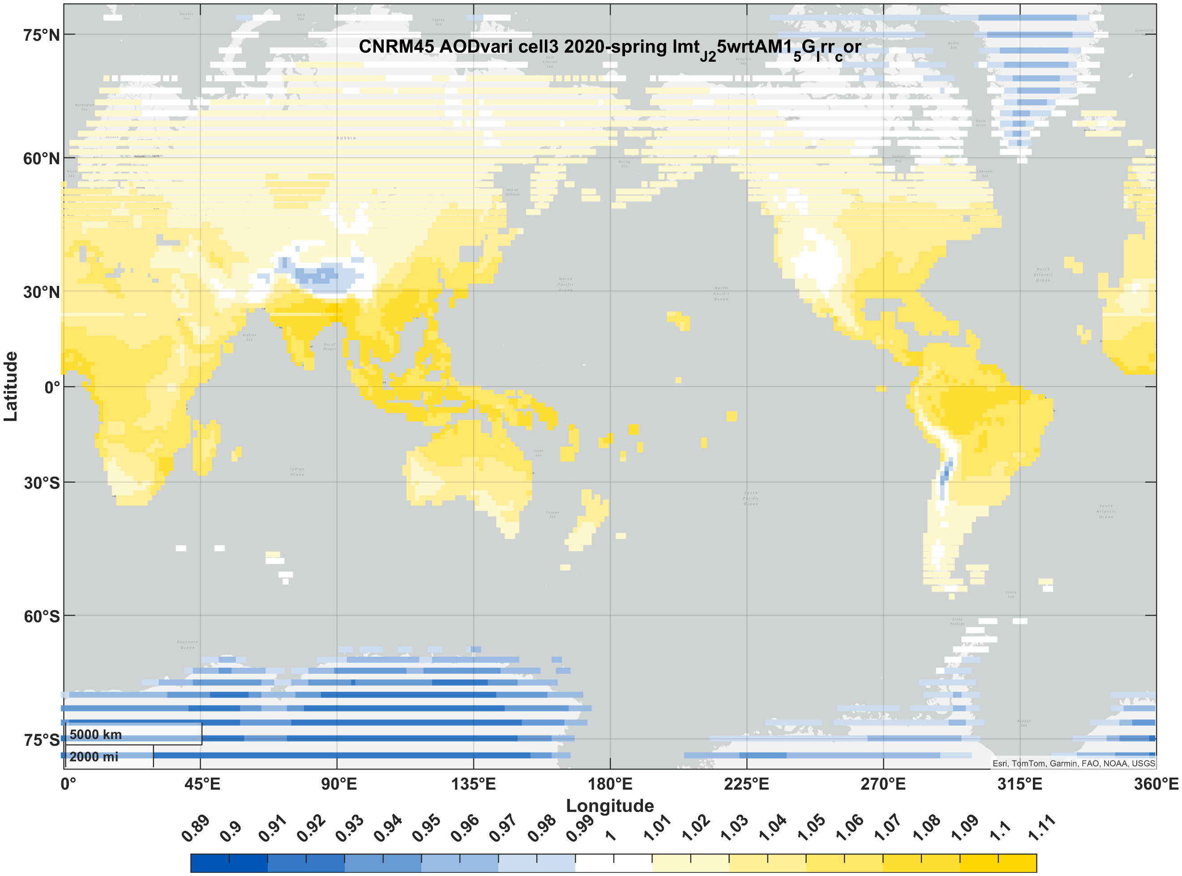 | 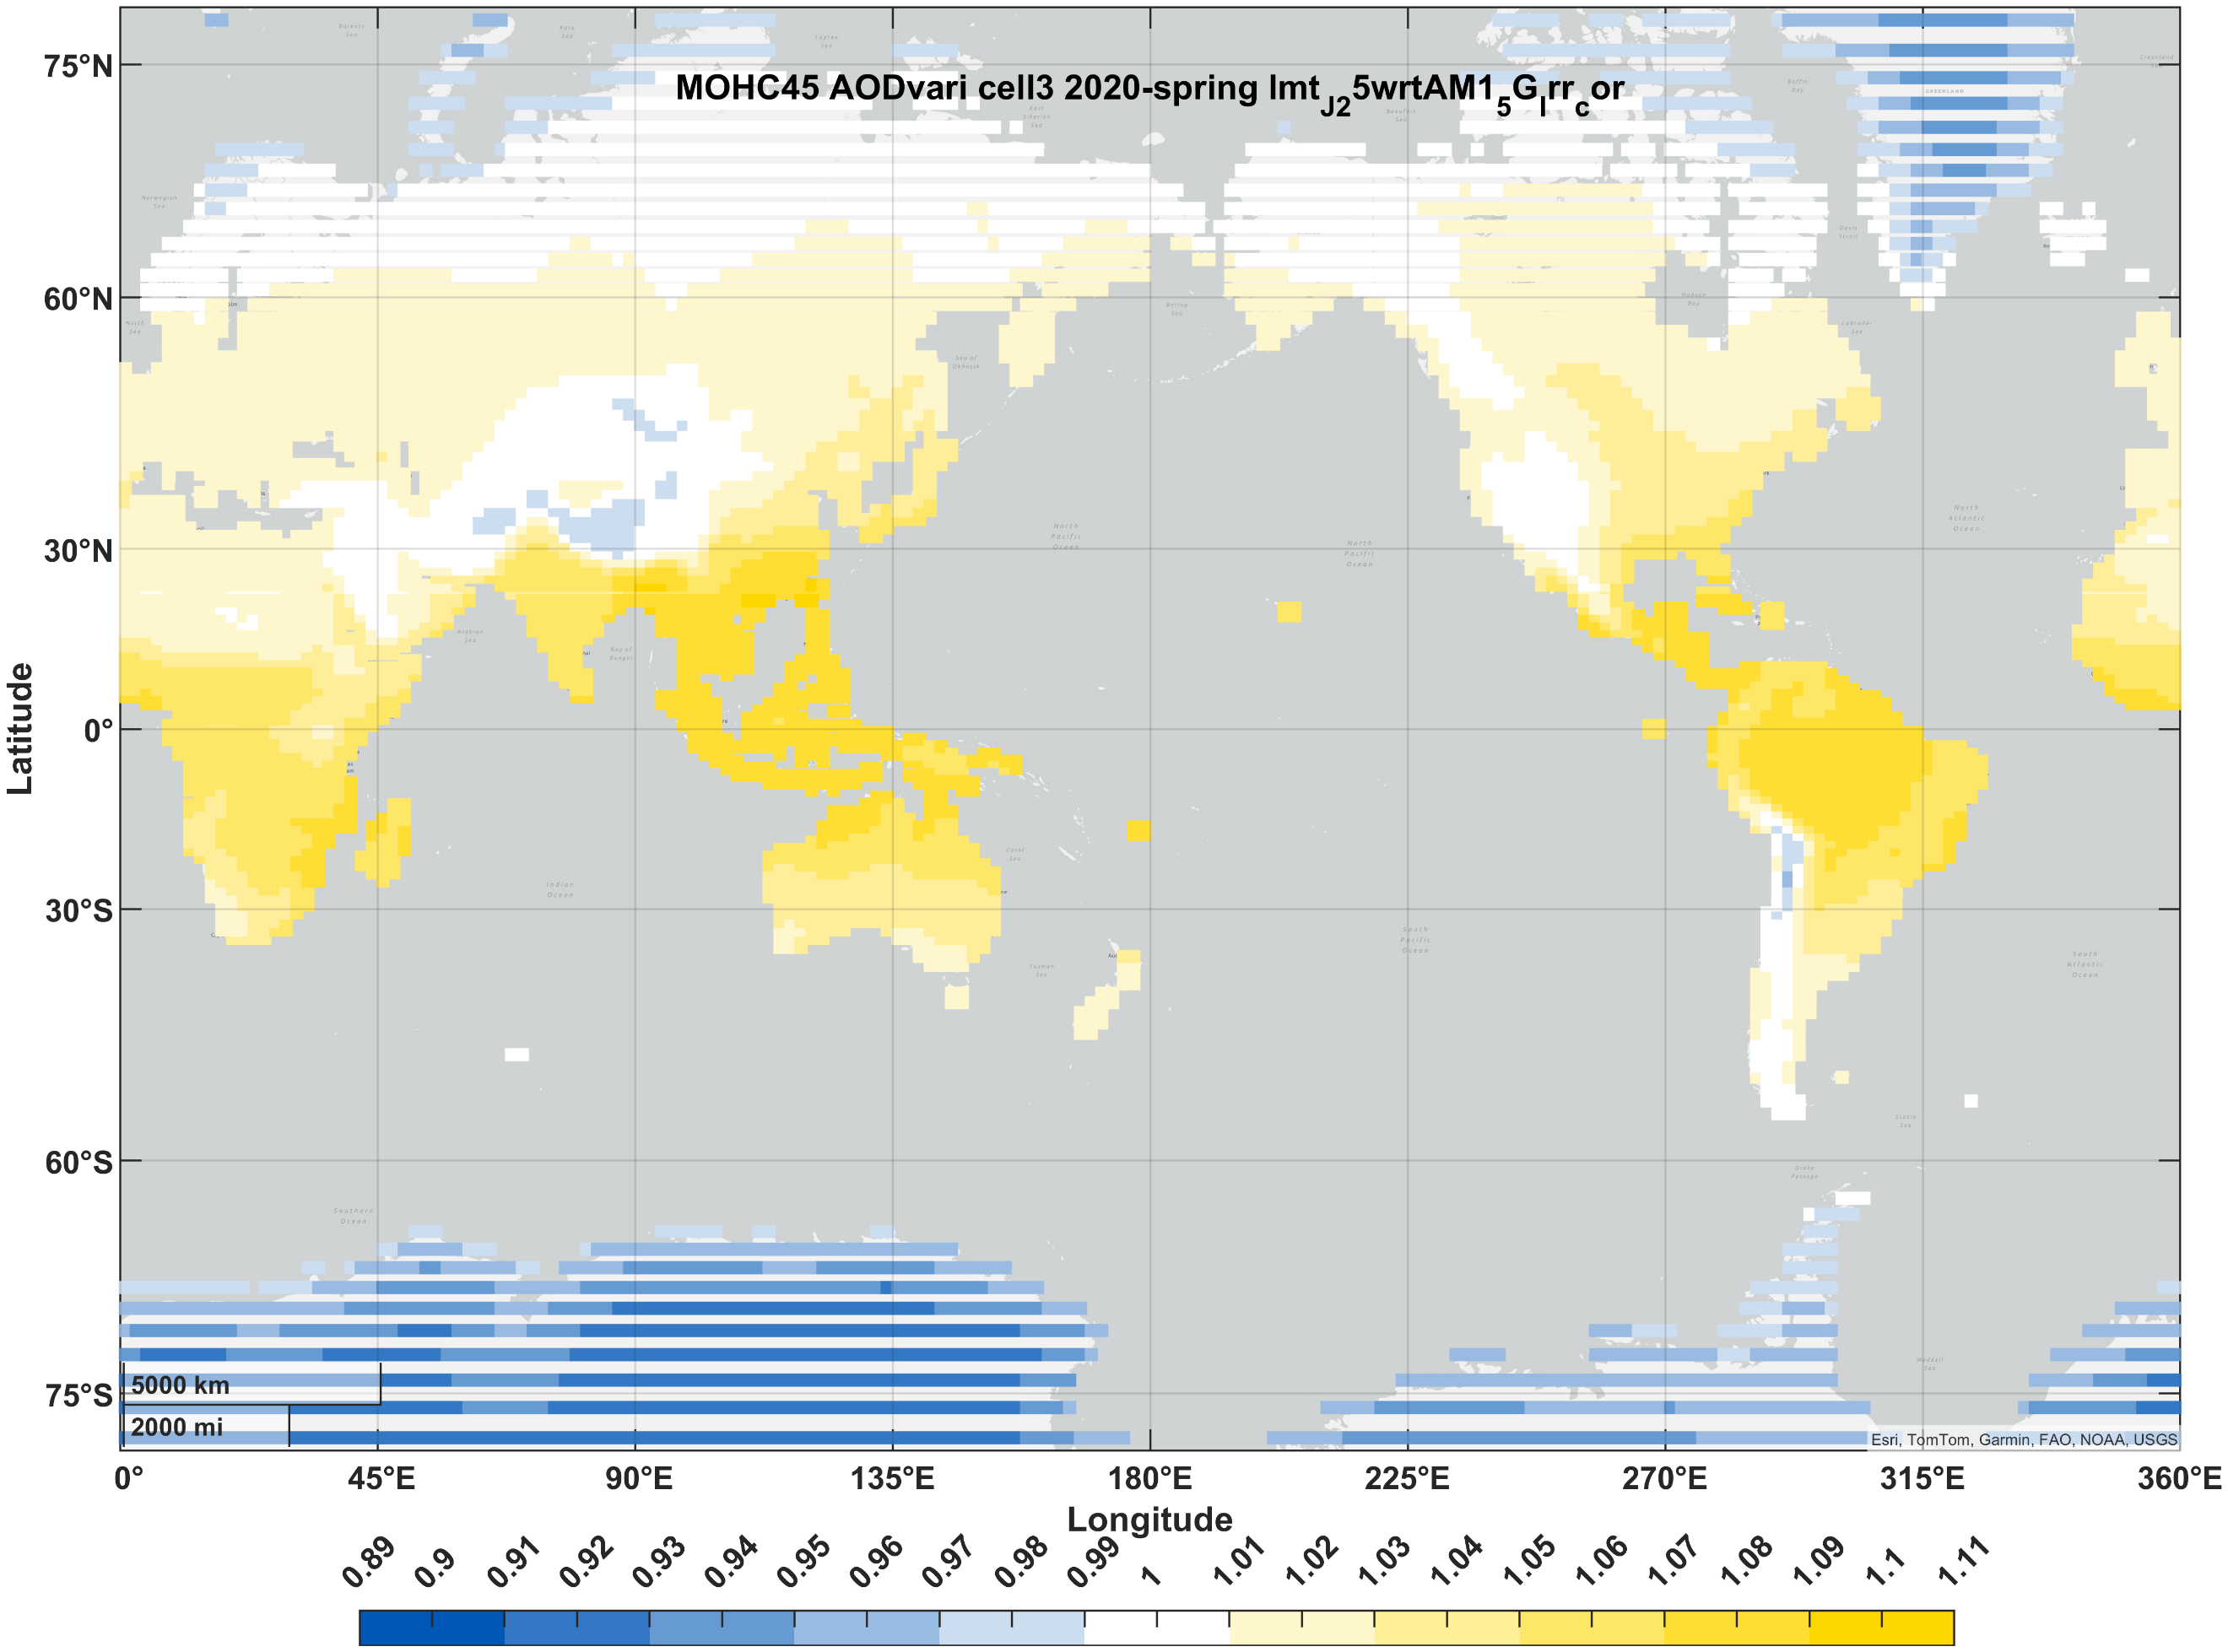 | 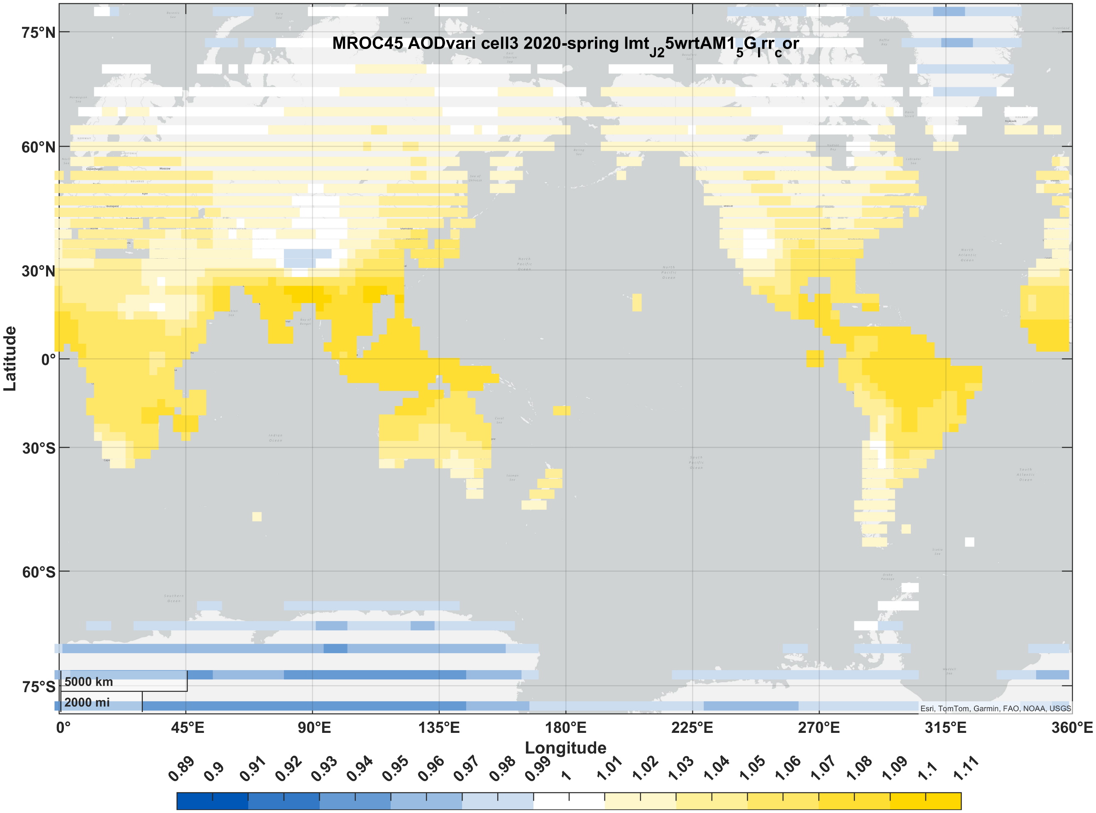 | 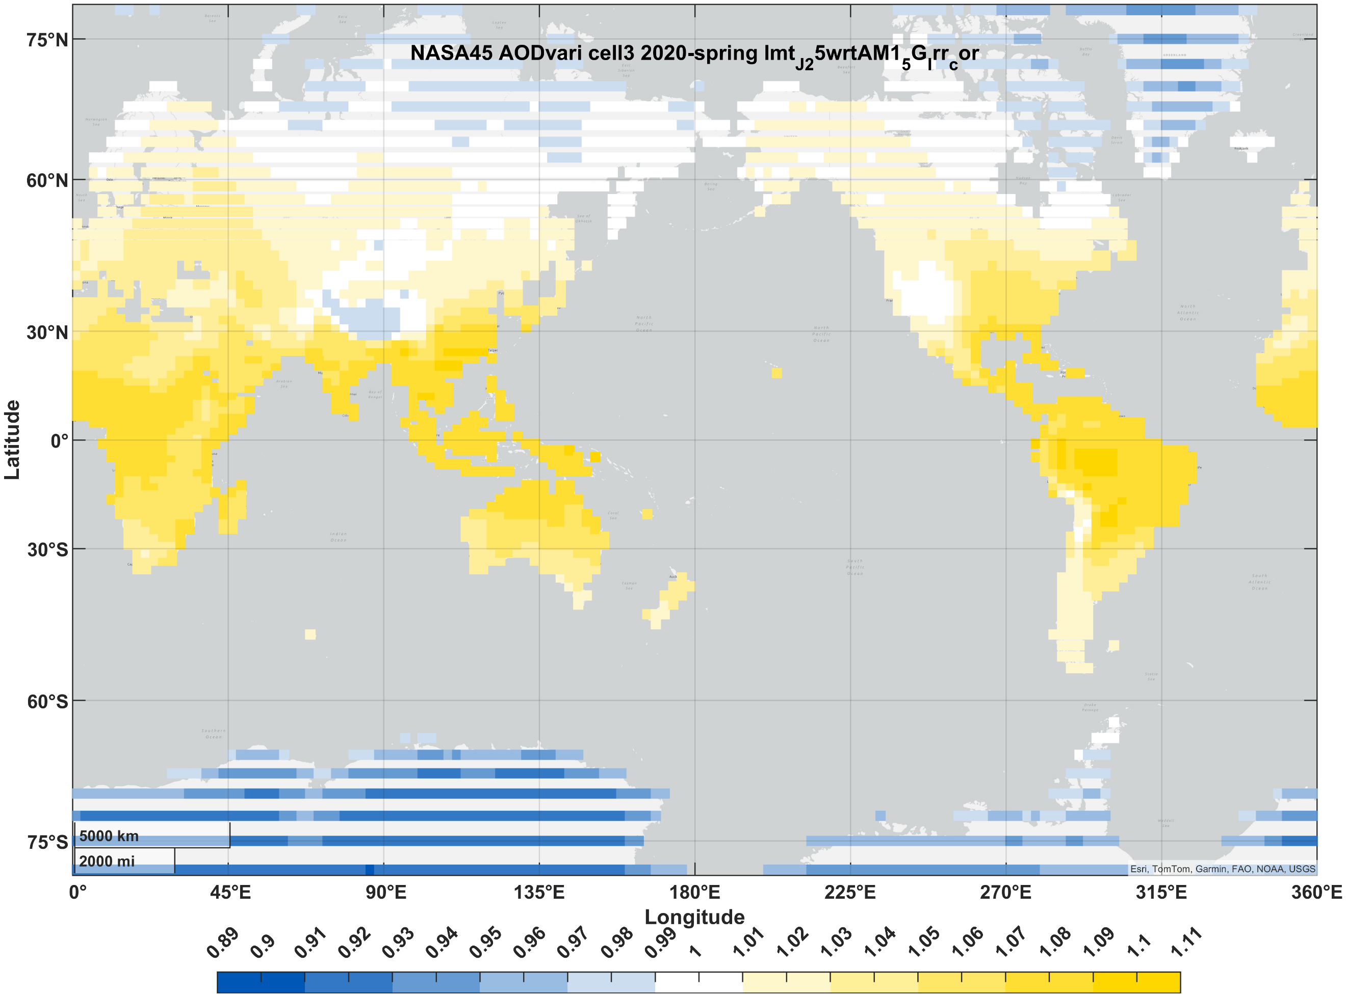 | 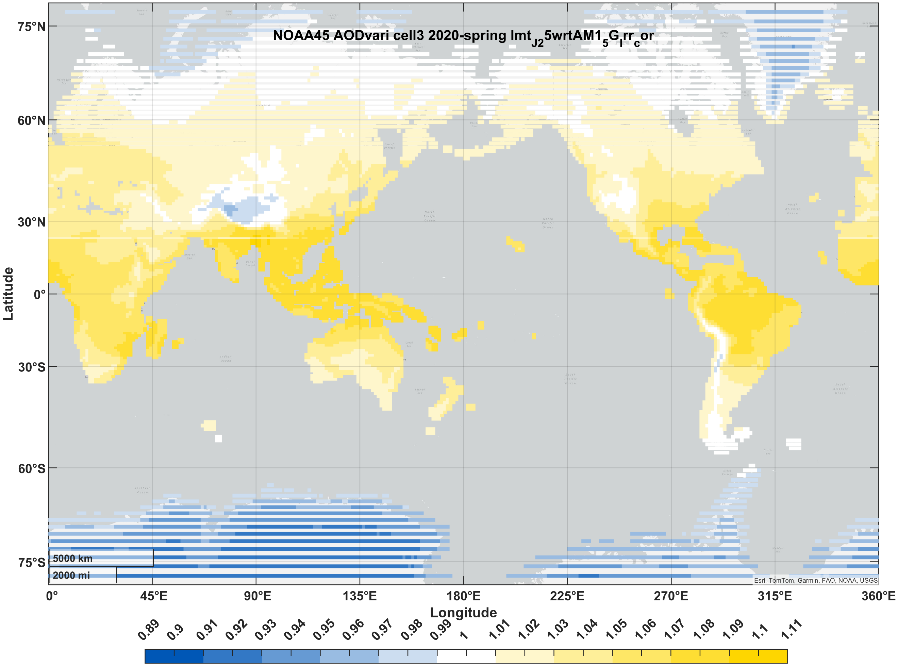
maize | summer | 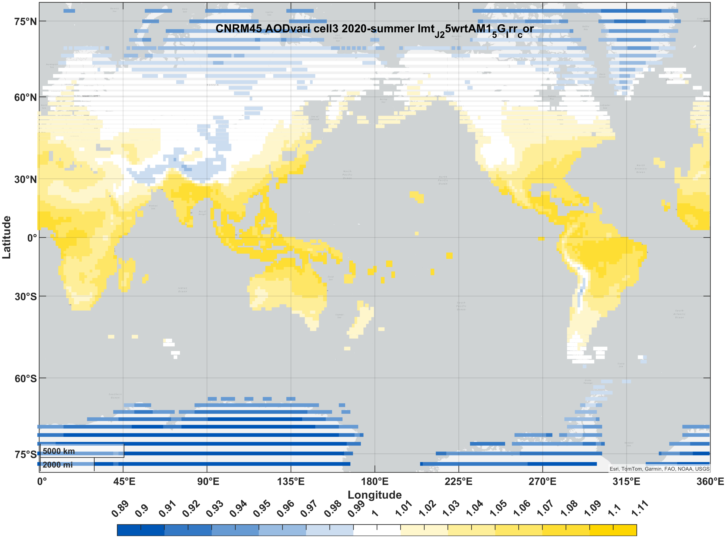 | 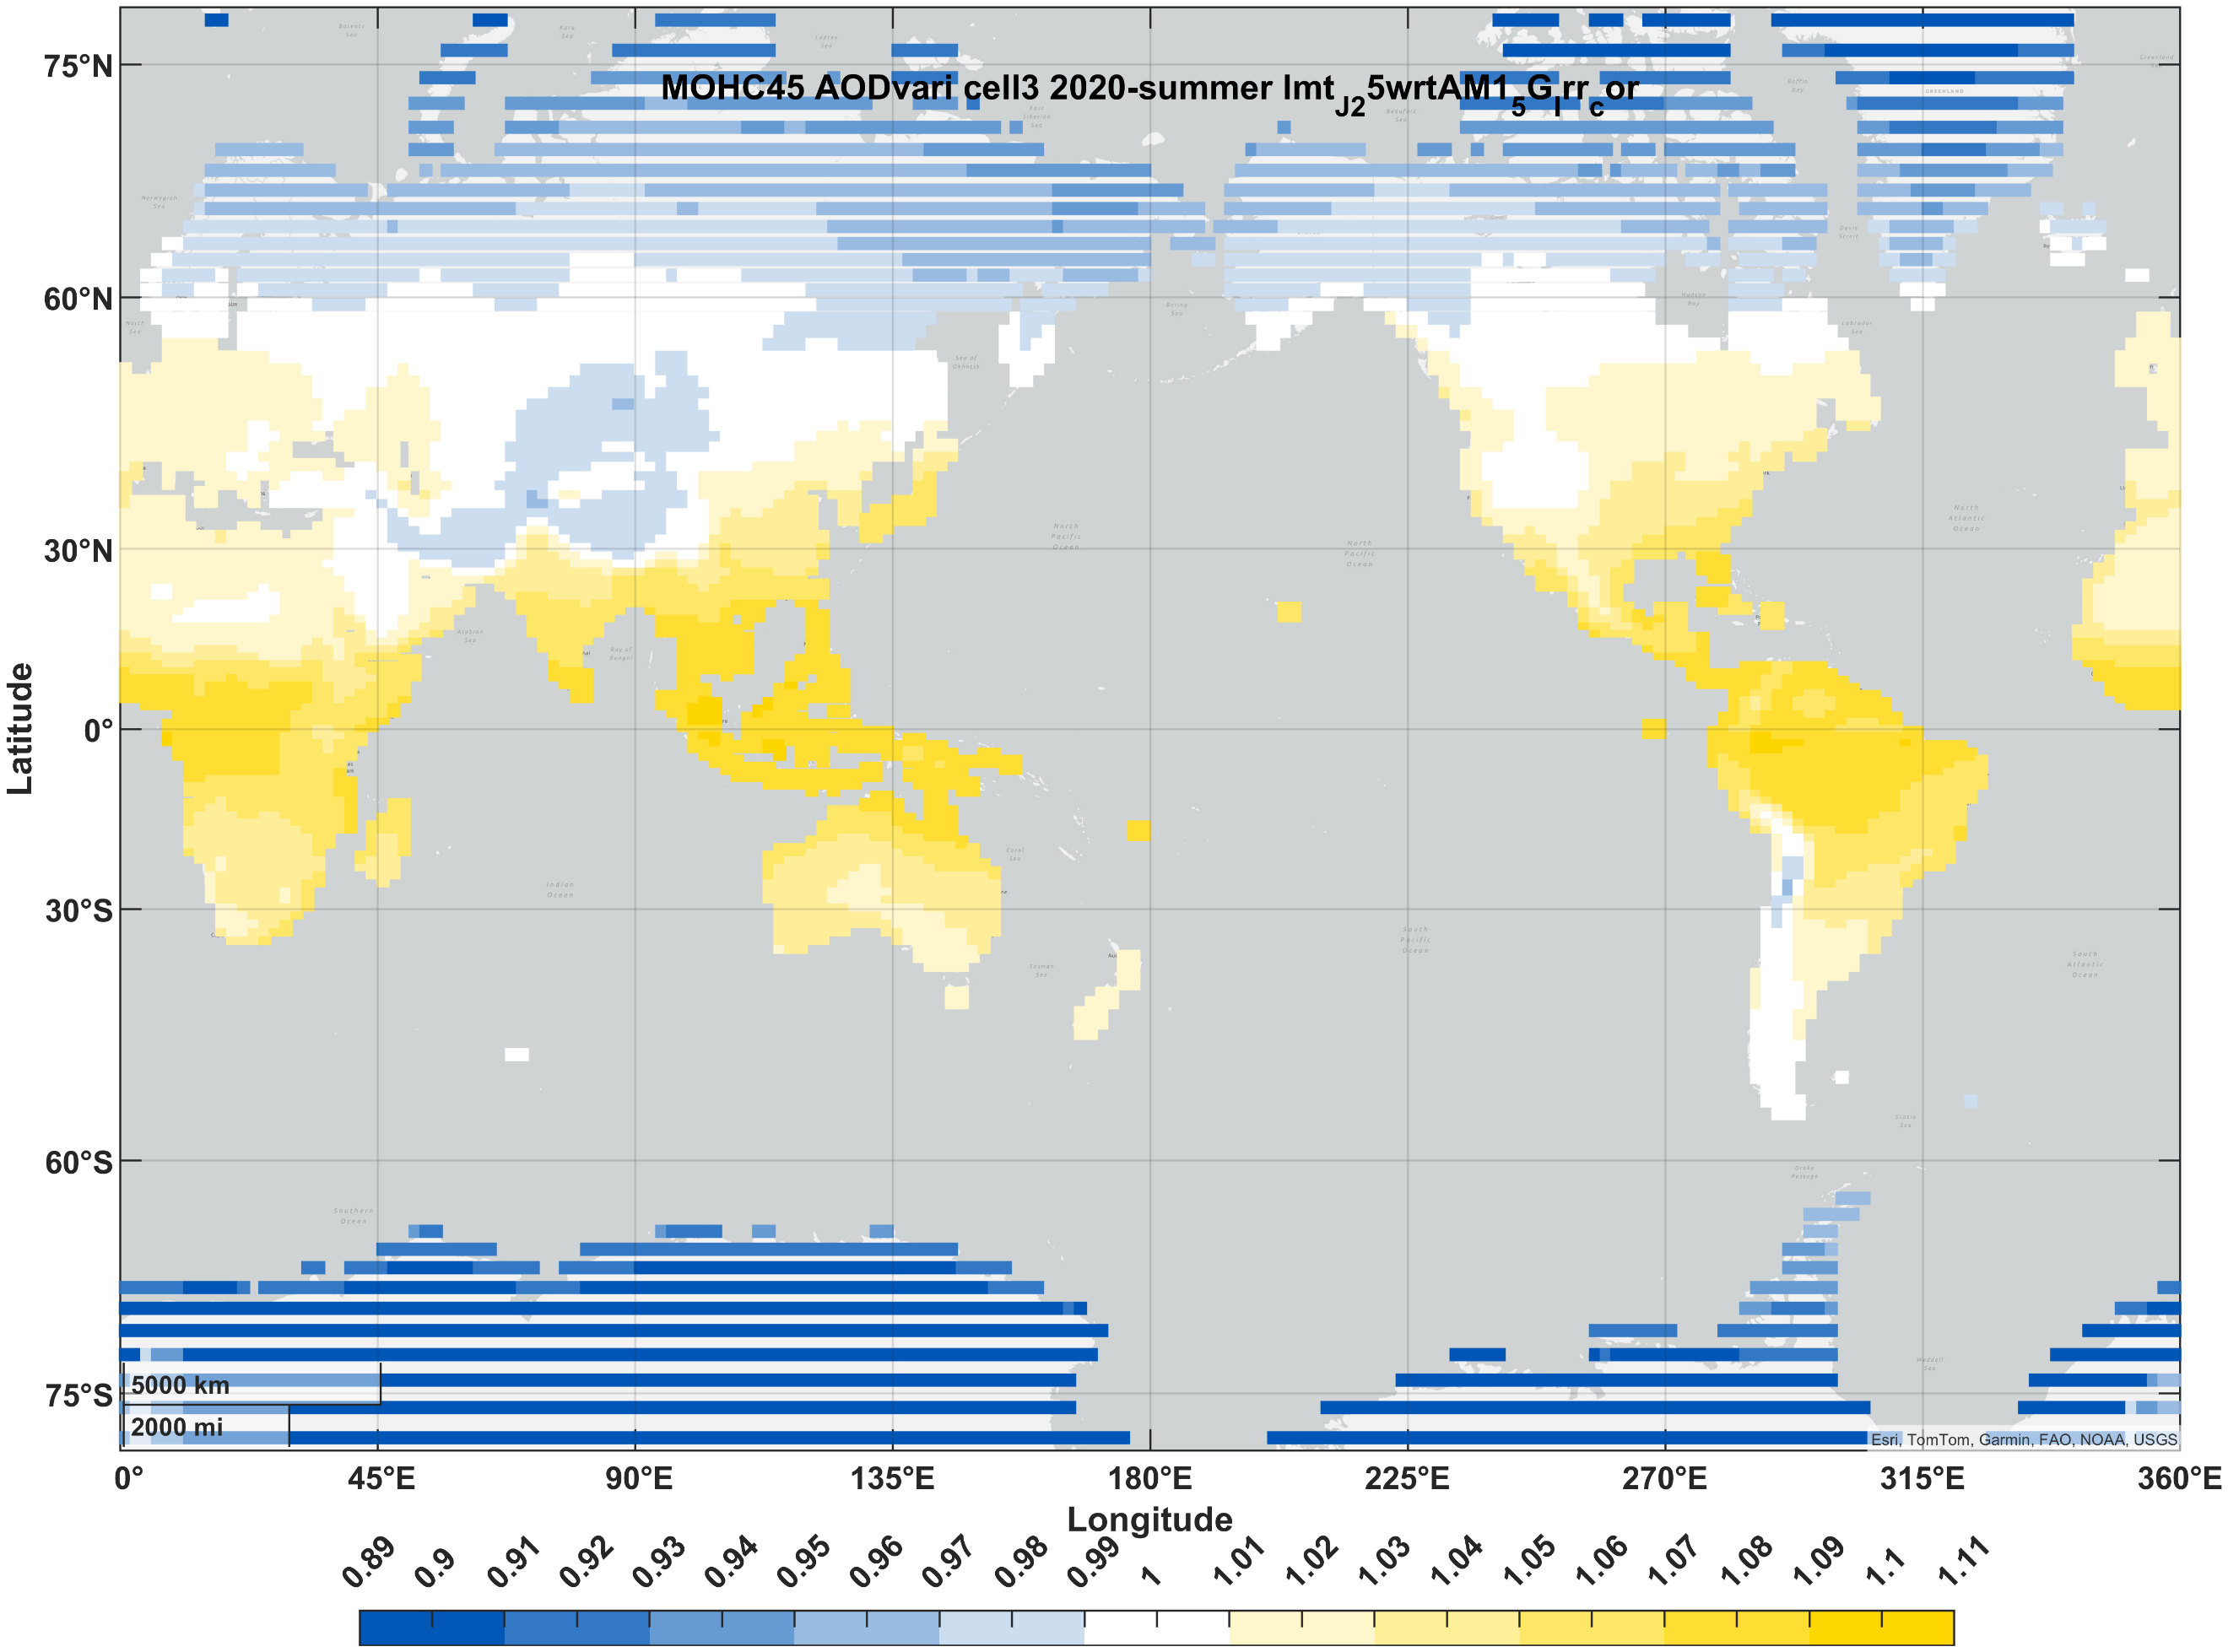 | 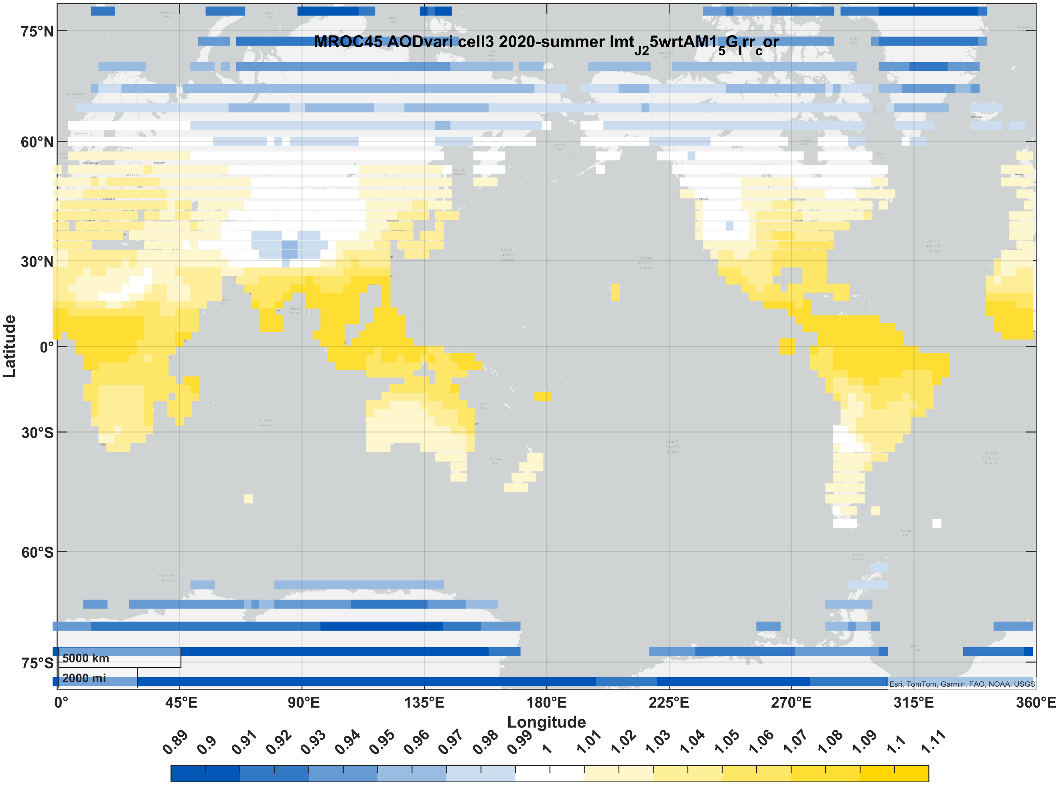 | 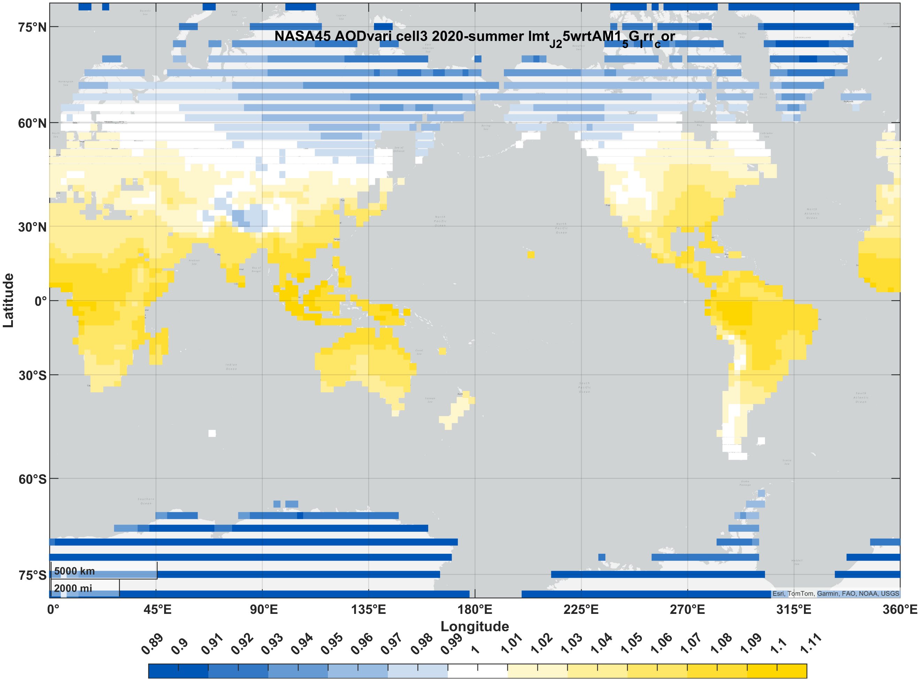 | 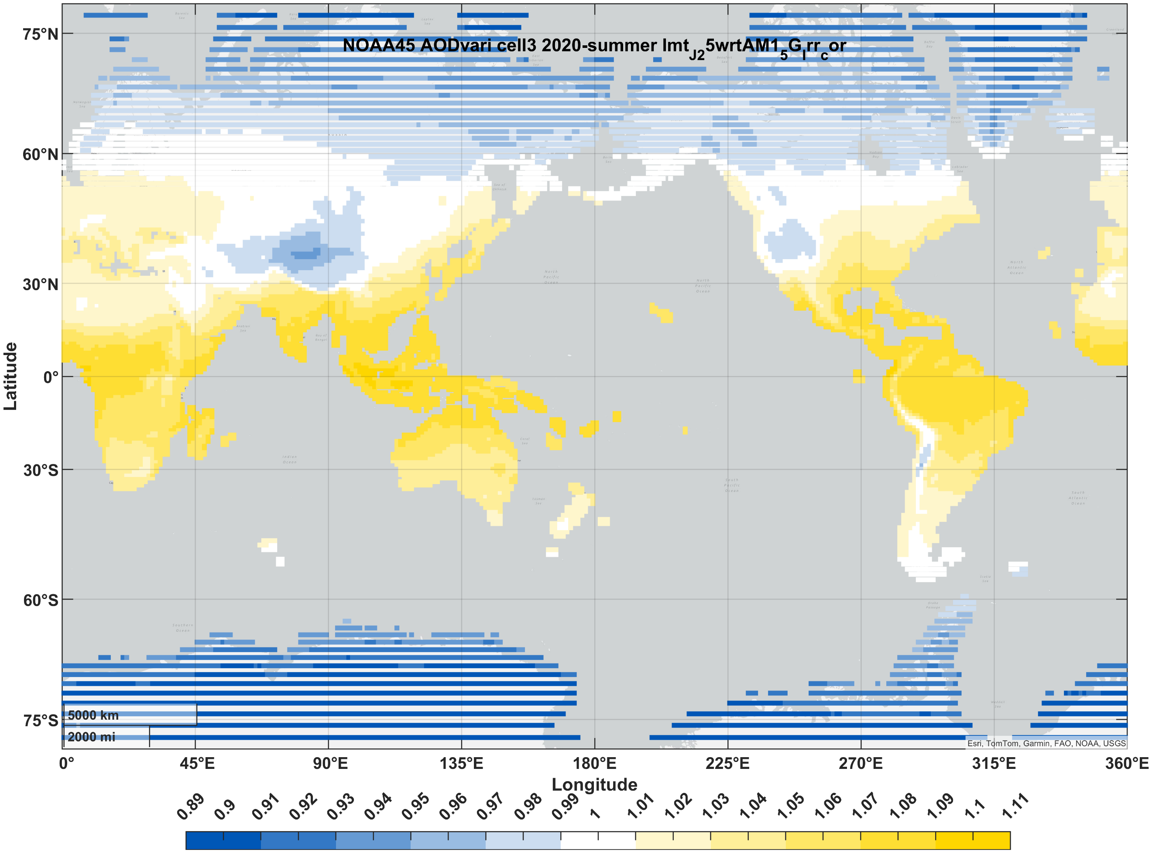
maize | fall | 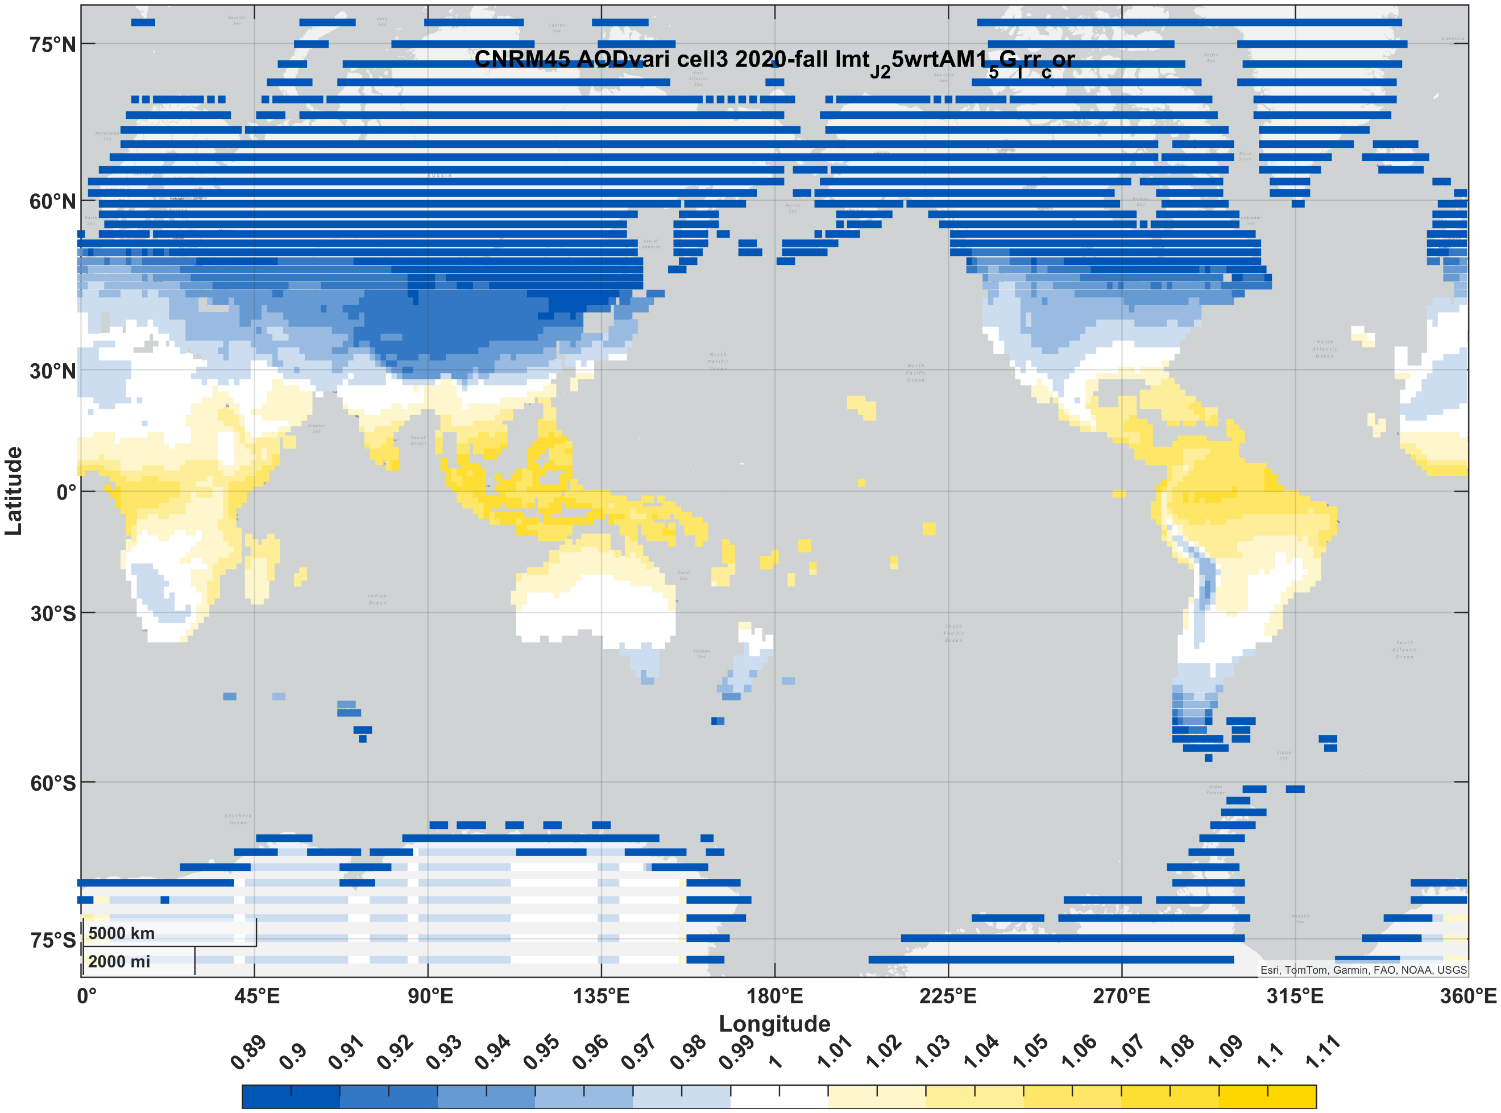 | 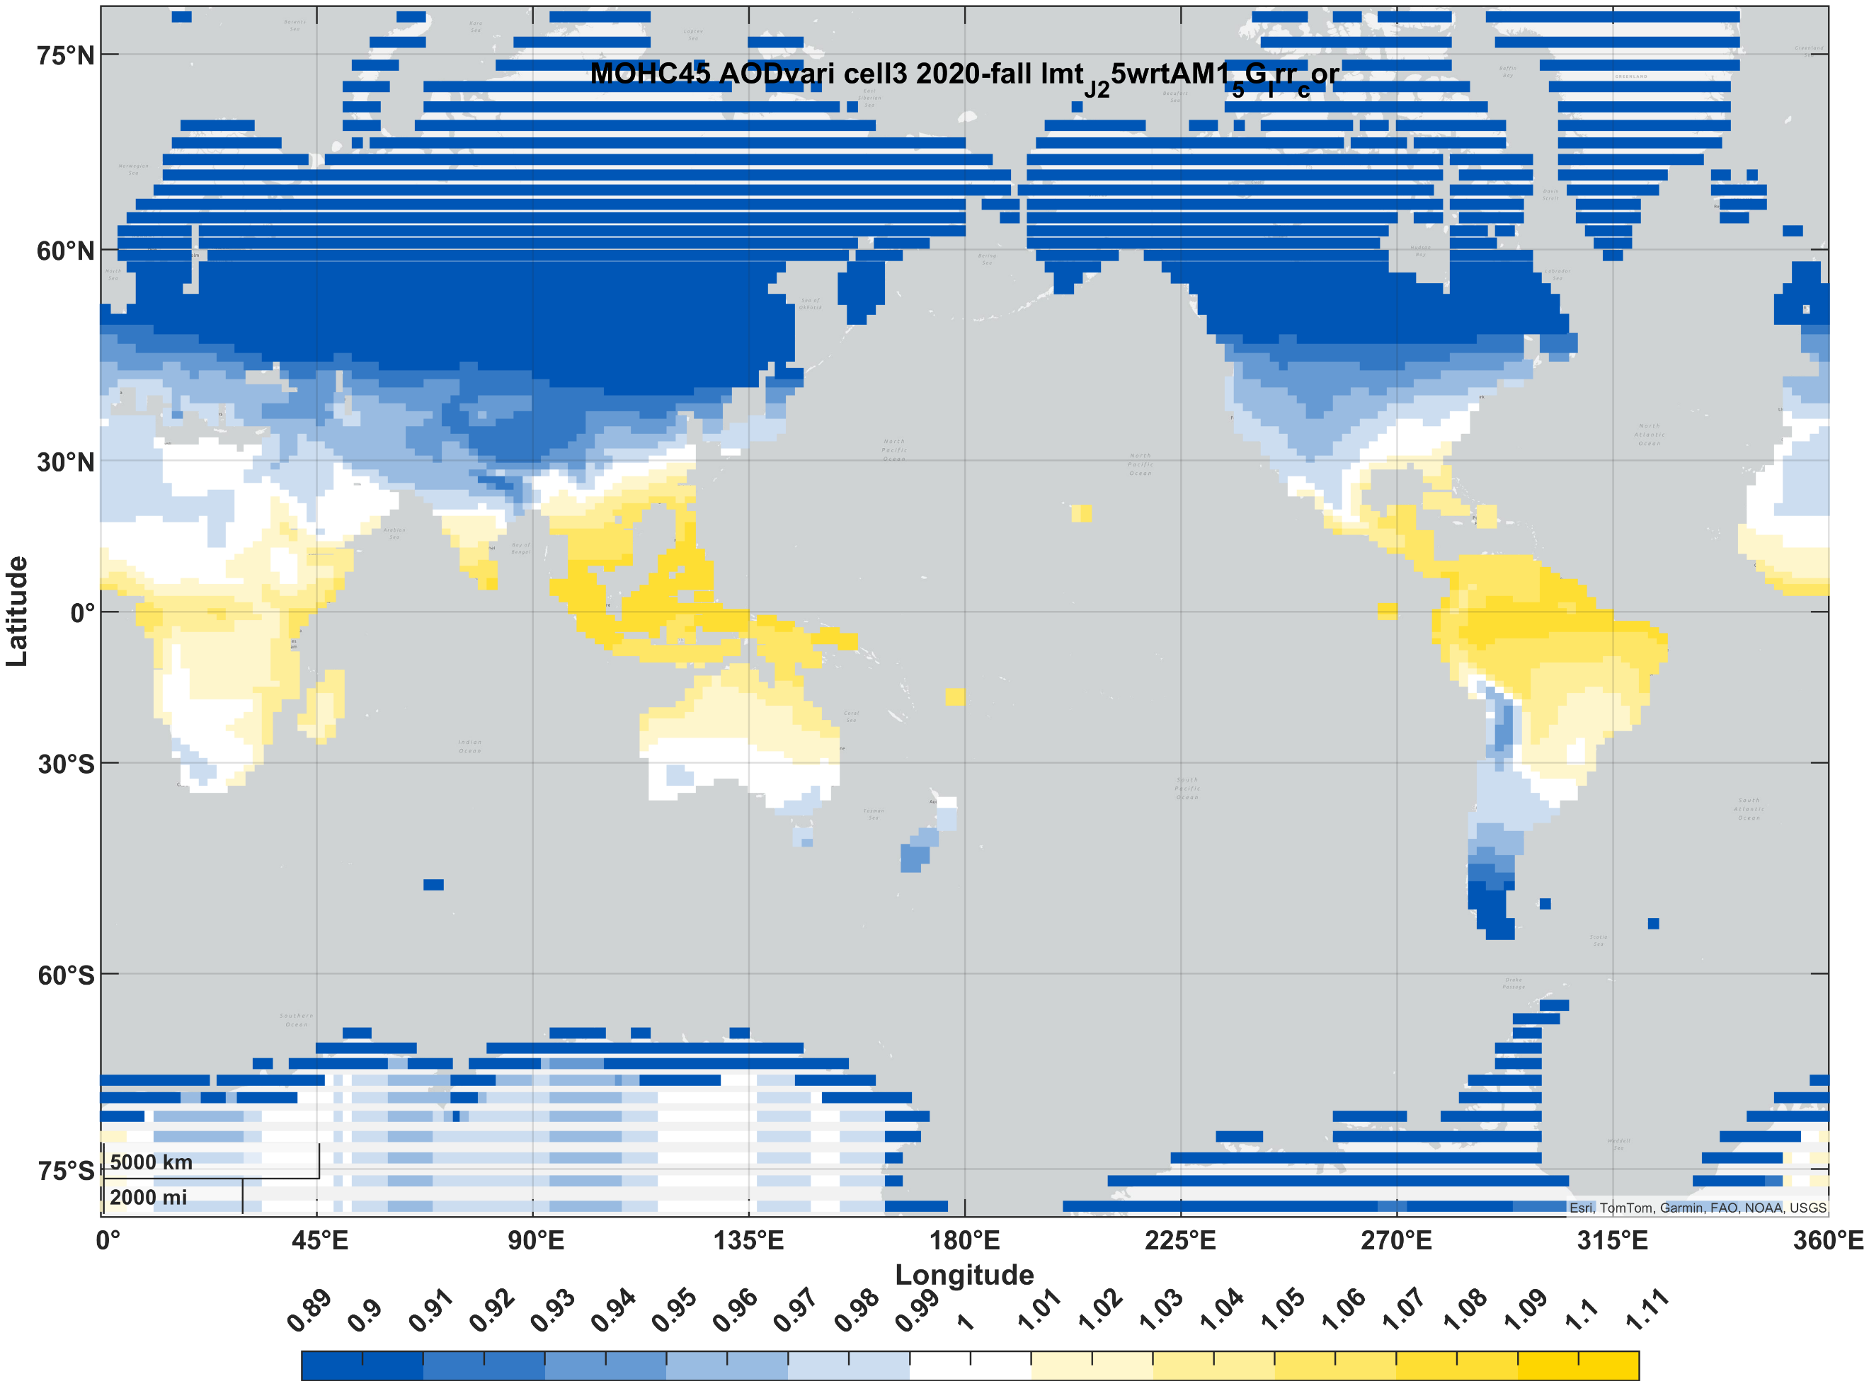 | 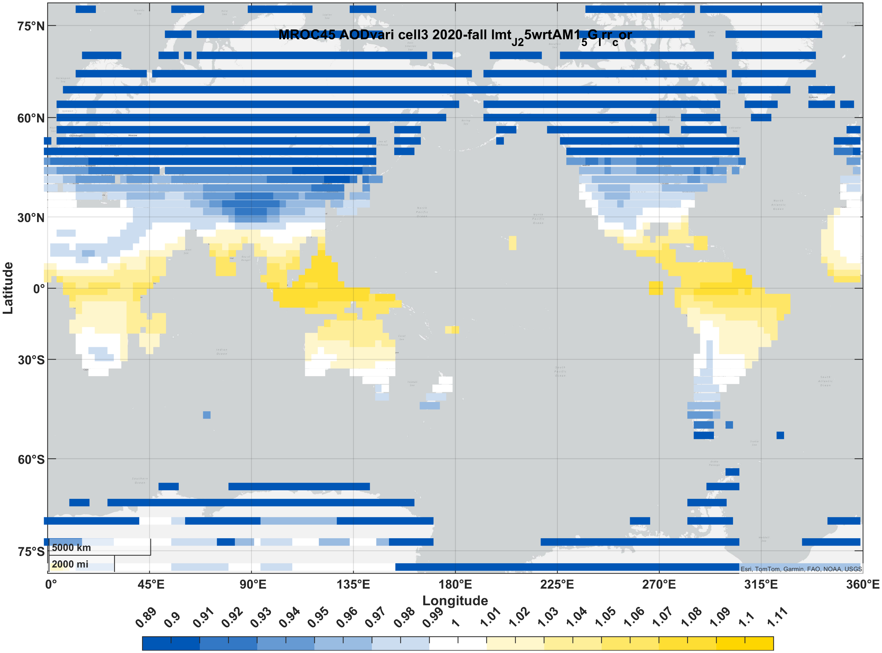 | 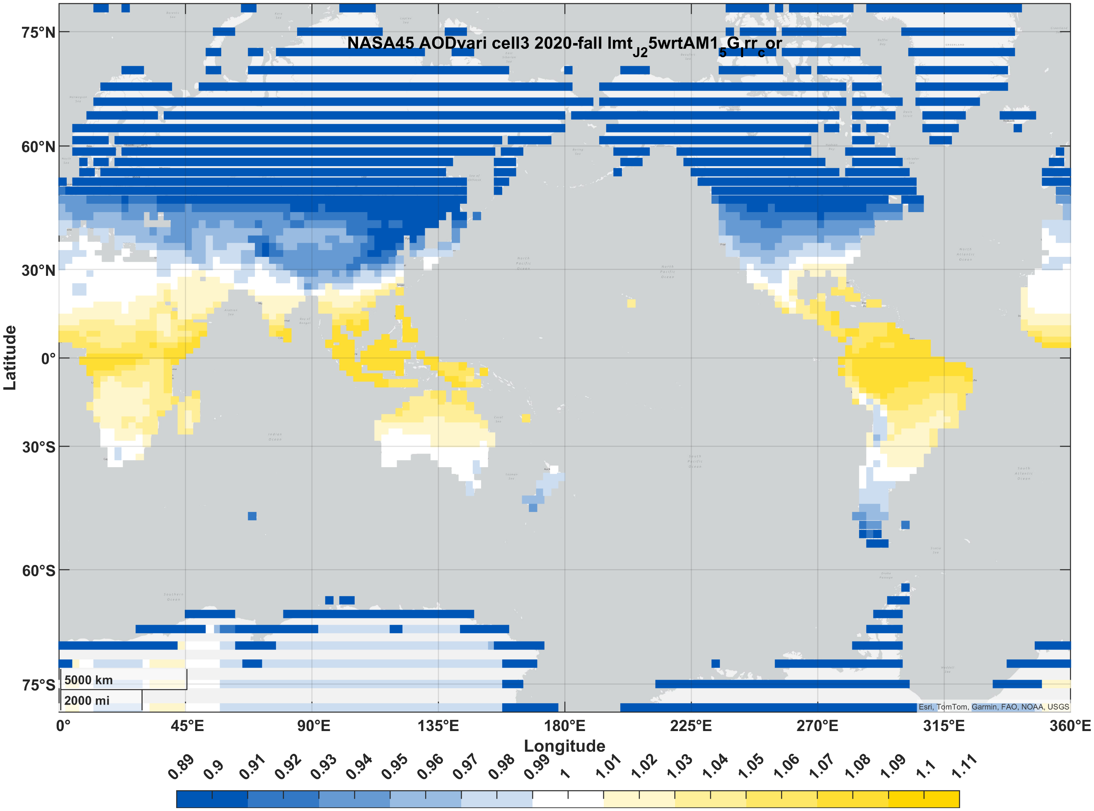 | 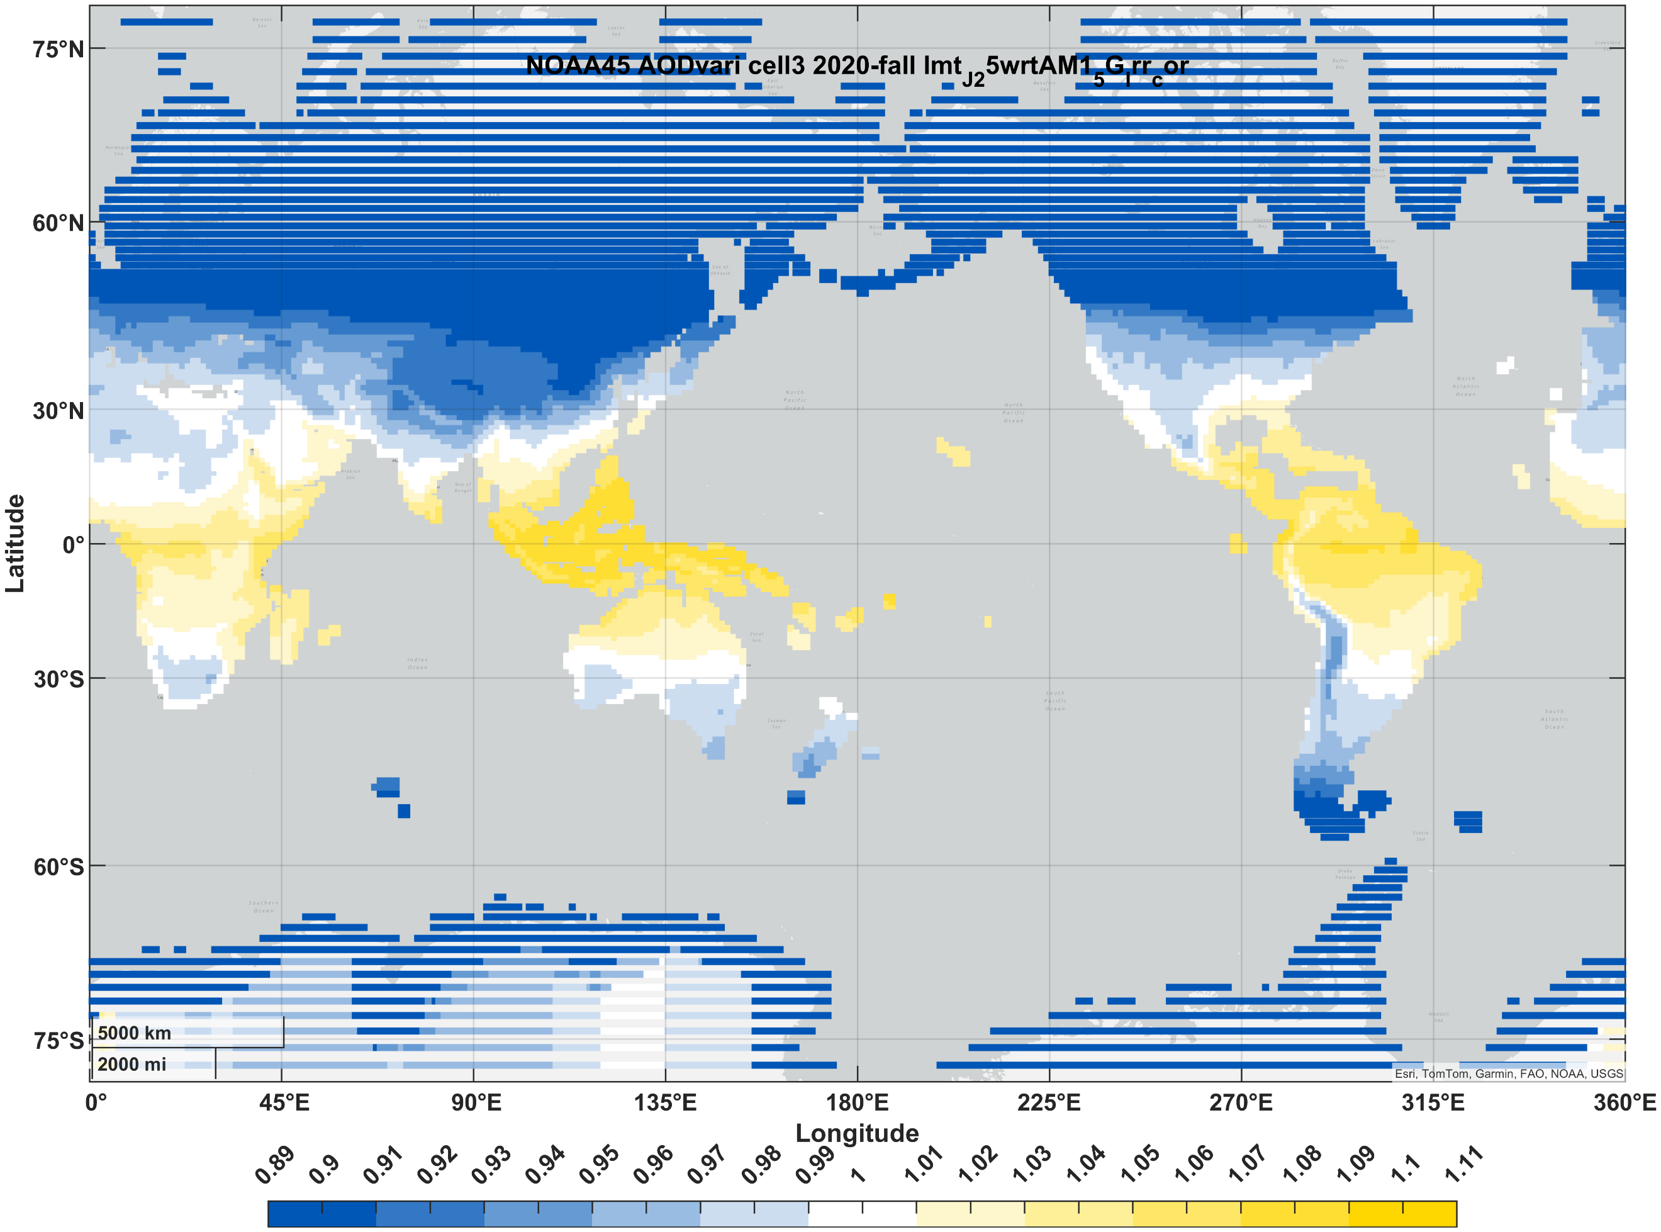

Supplemental Materials
Table 5. Predicted 2050 solar cell short-circuit current relative to that under the standard spectrum (AM1.5G). Currents are normalized to 1000 W/m² irradiance. “Summer”/ “winter” correspond to months 7-9/1-3 in the northern hemisphere and 1-3/7-9 in the southern hemisphere.
 |  | CNRM | MOHC | MIROC | NASA | NOAA
Si (1J) | winter | 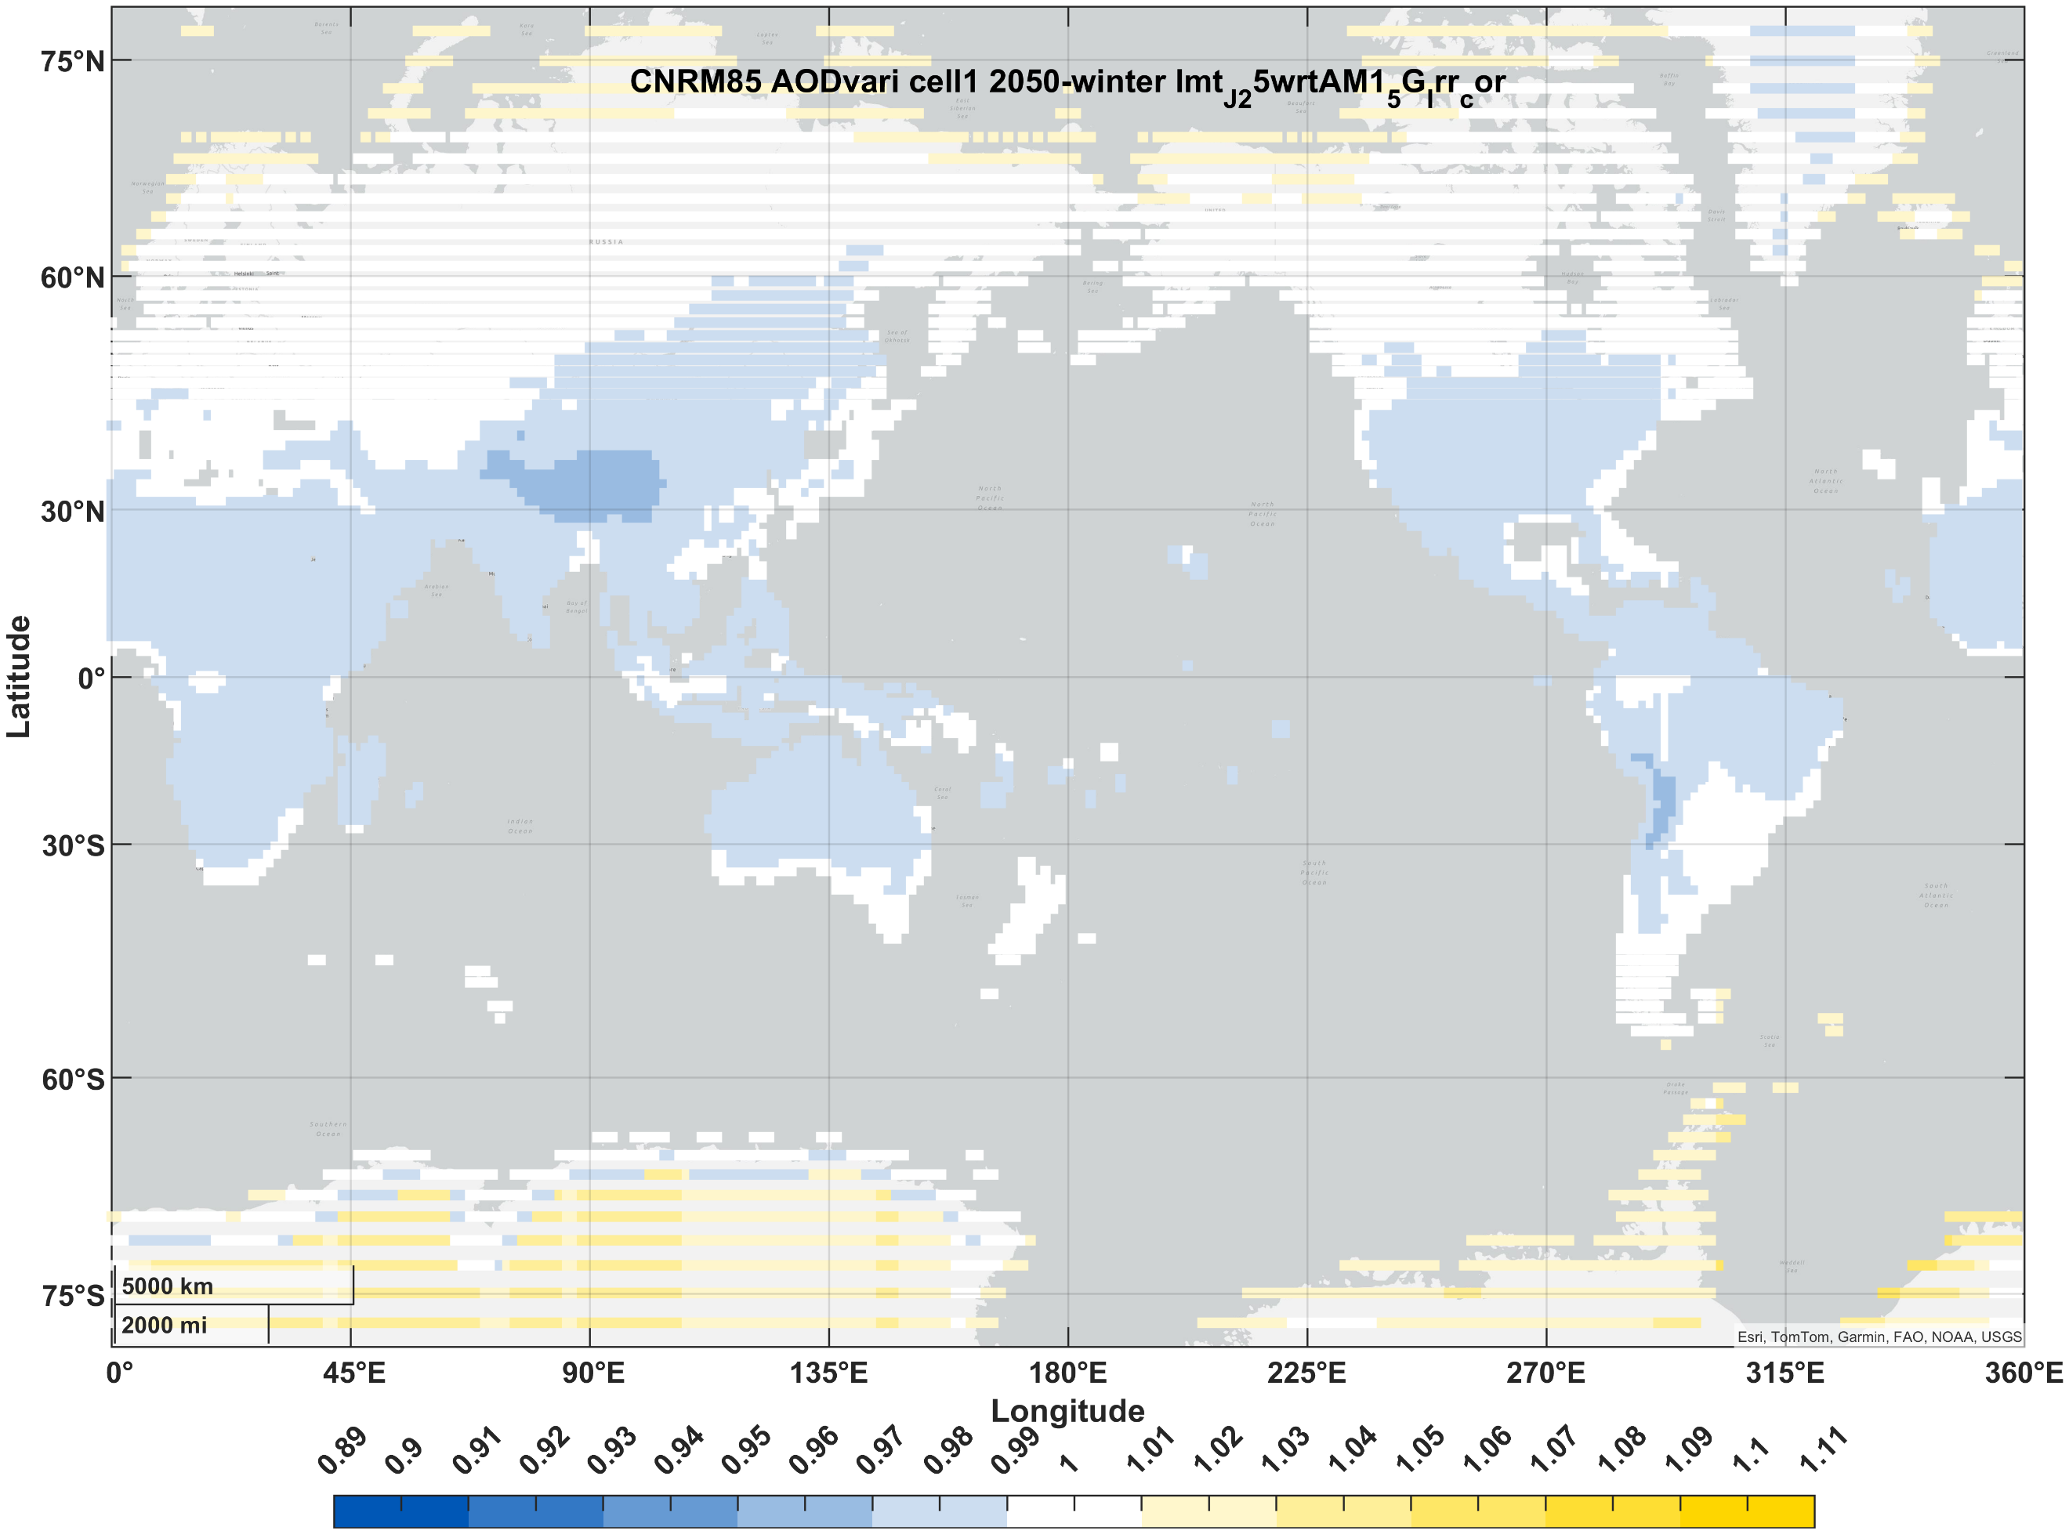 | 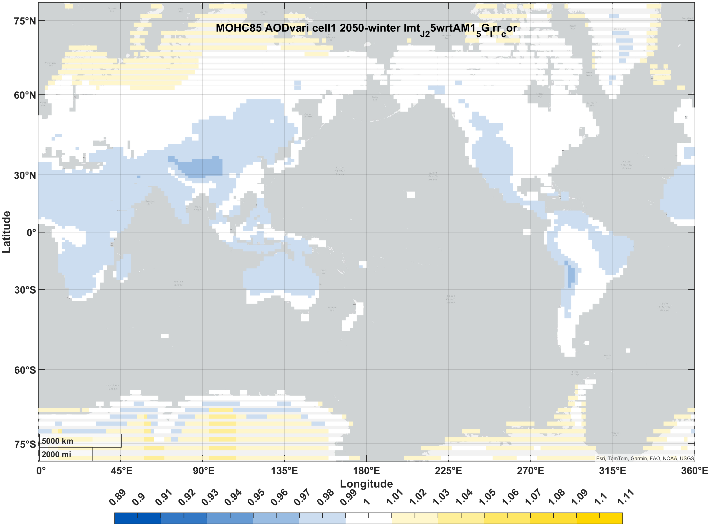 | 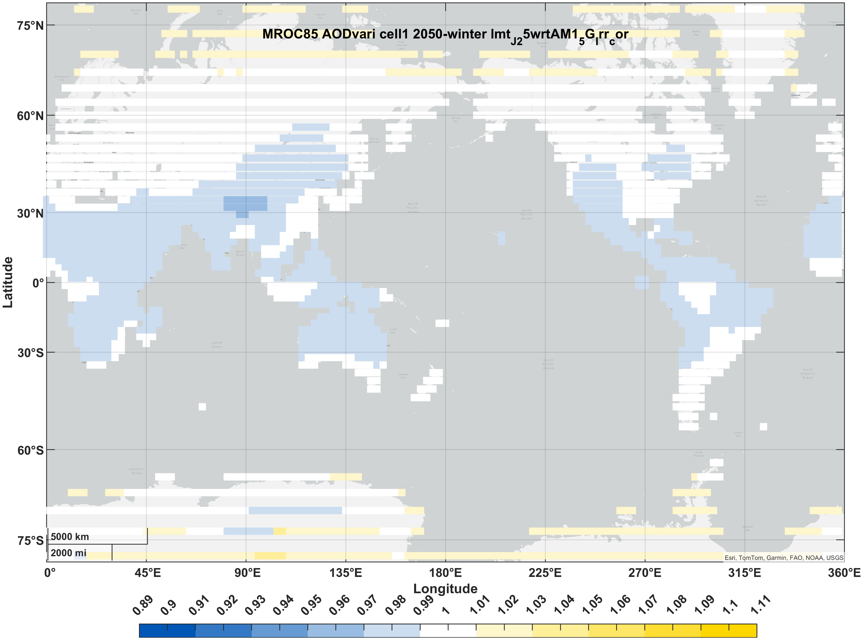 | 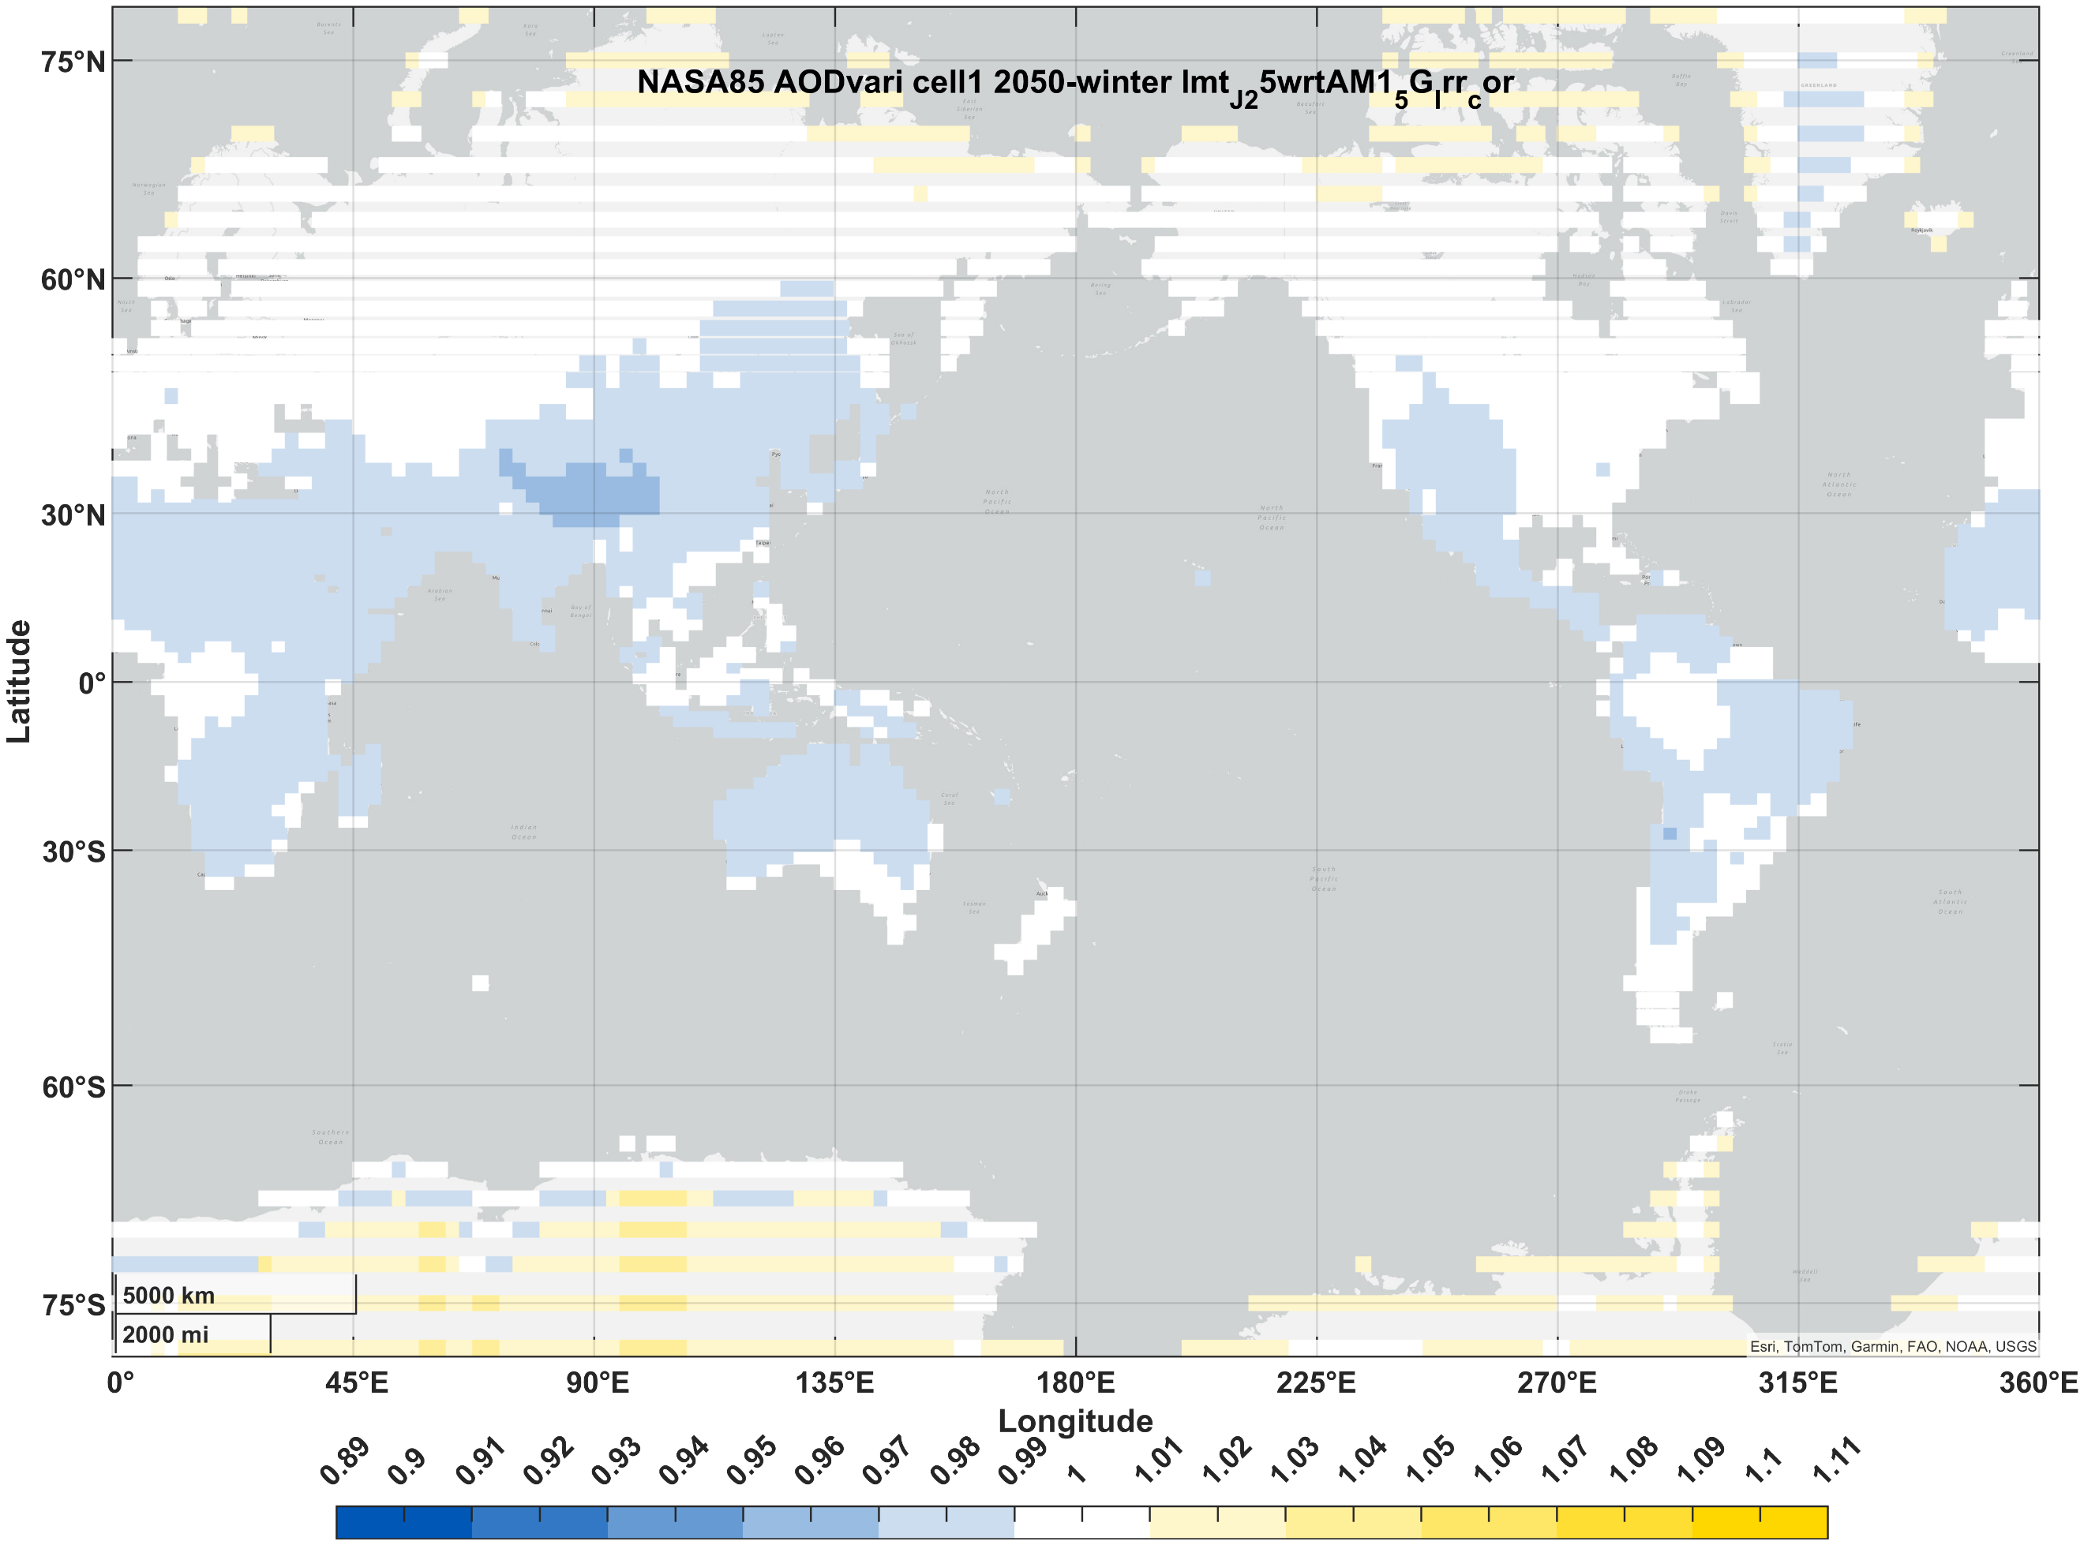 | 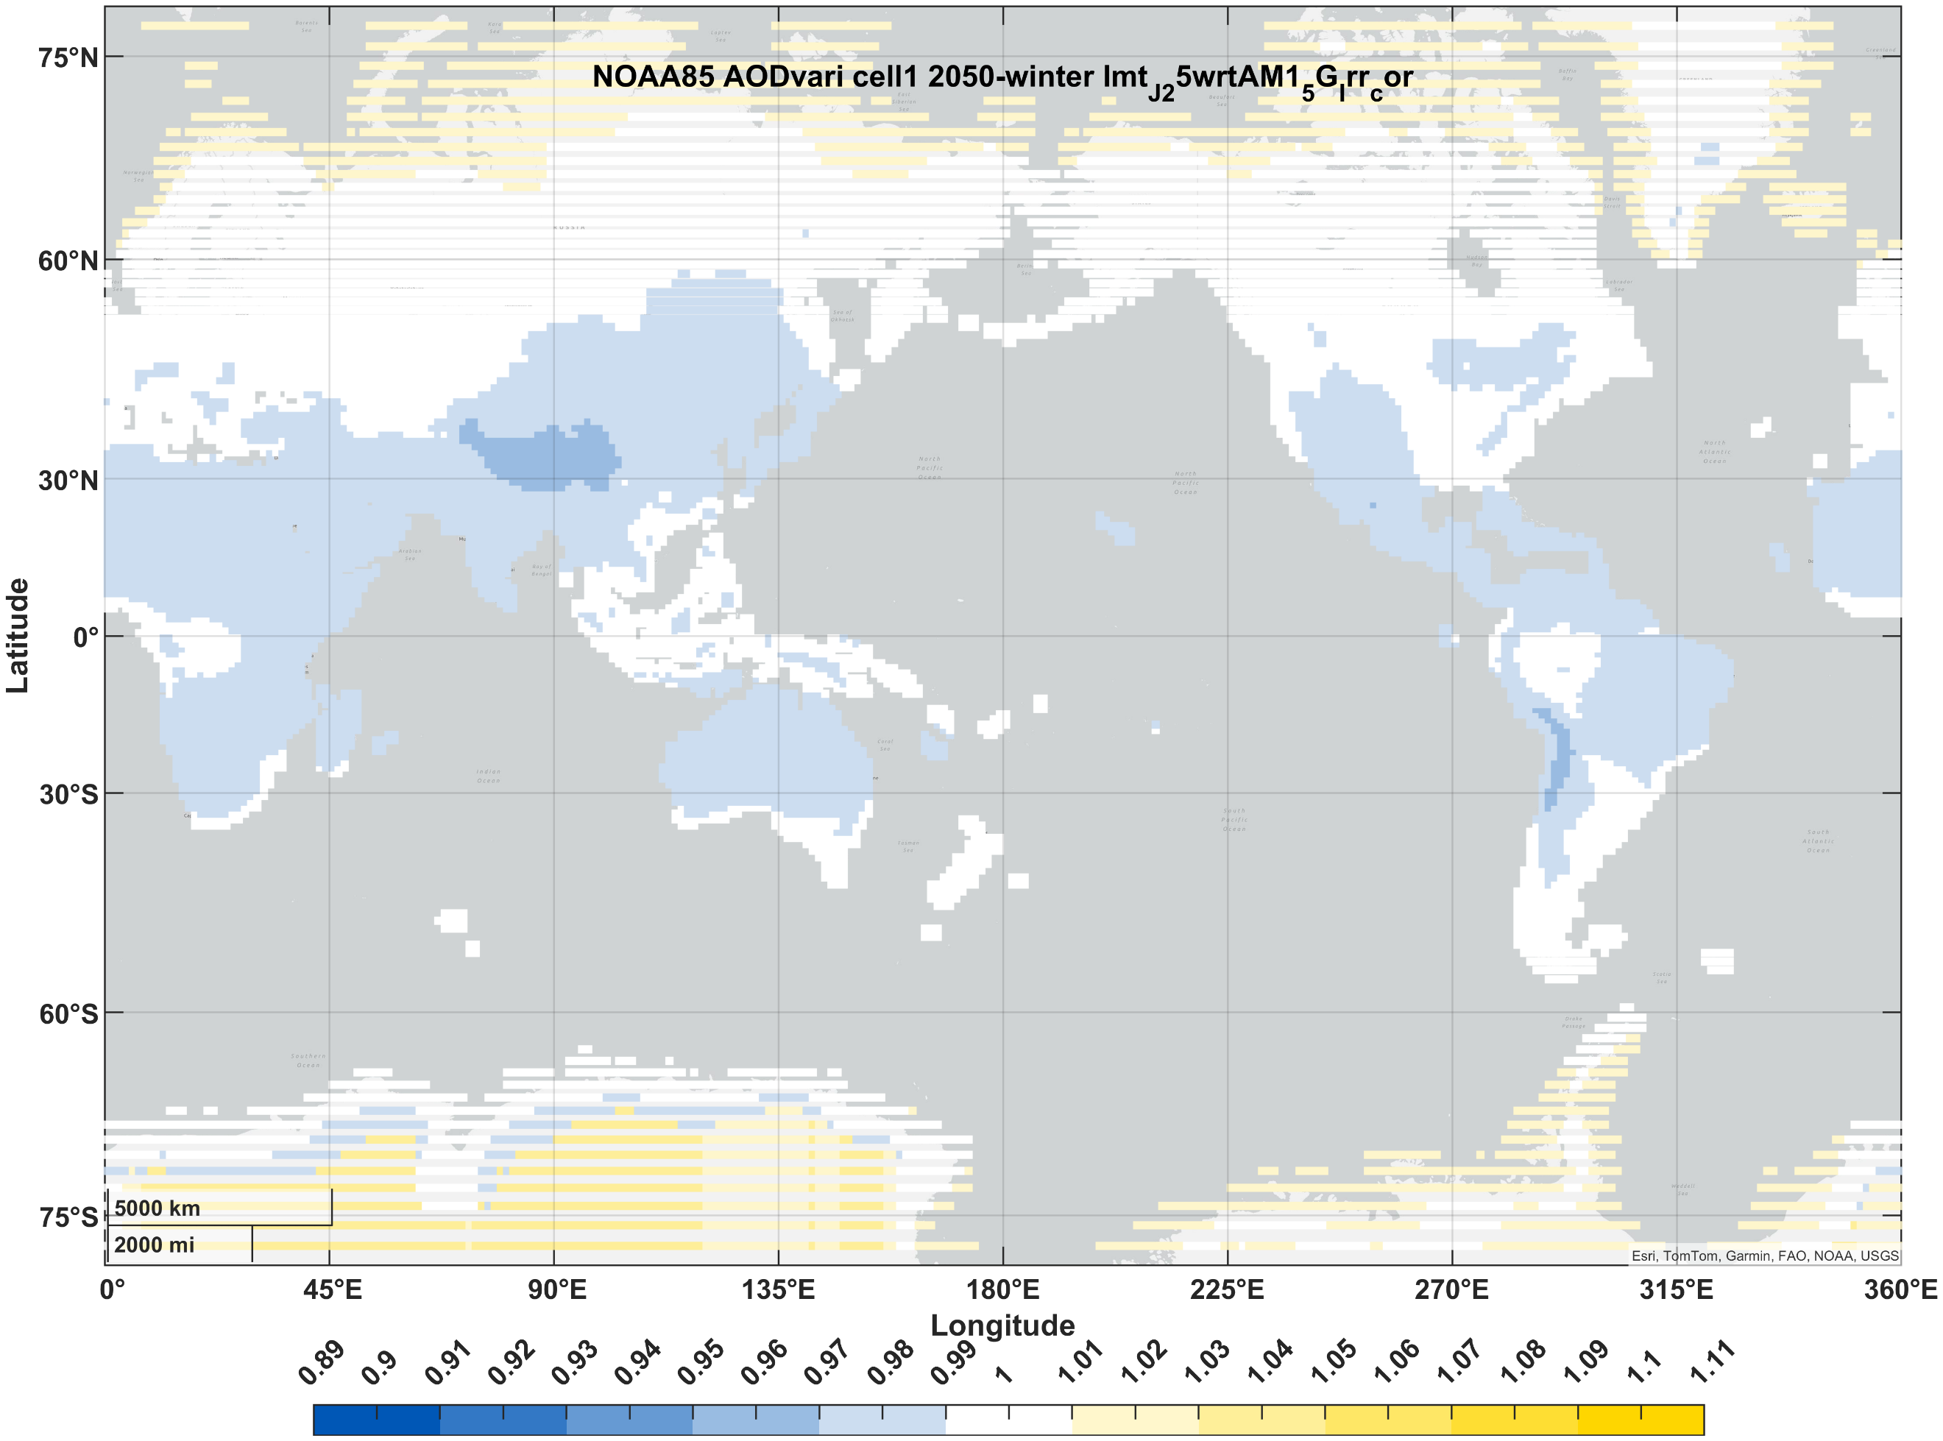
Si (1J) | summer | 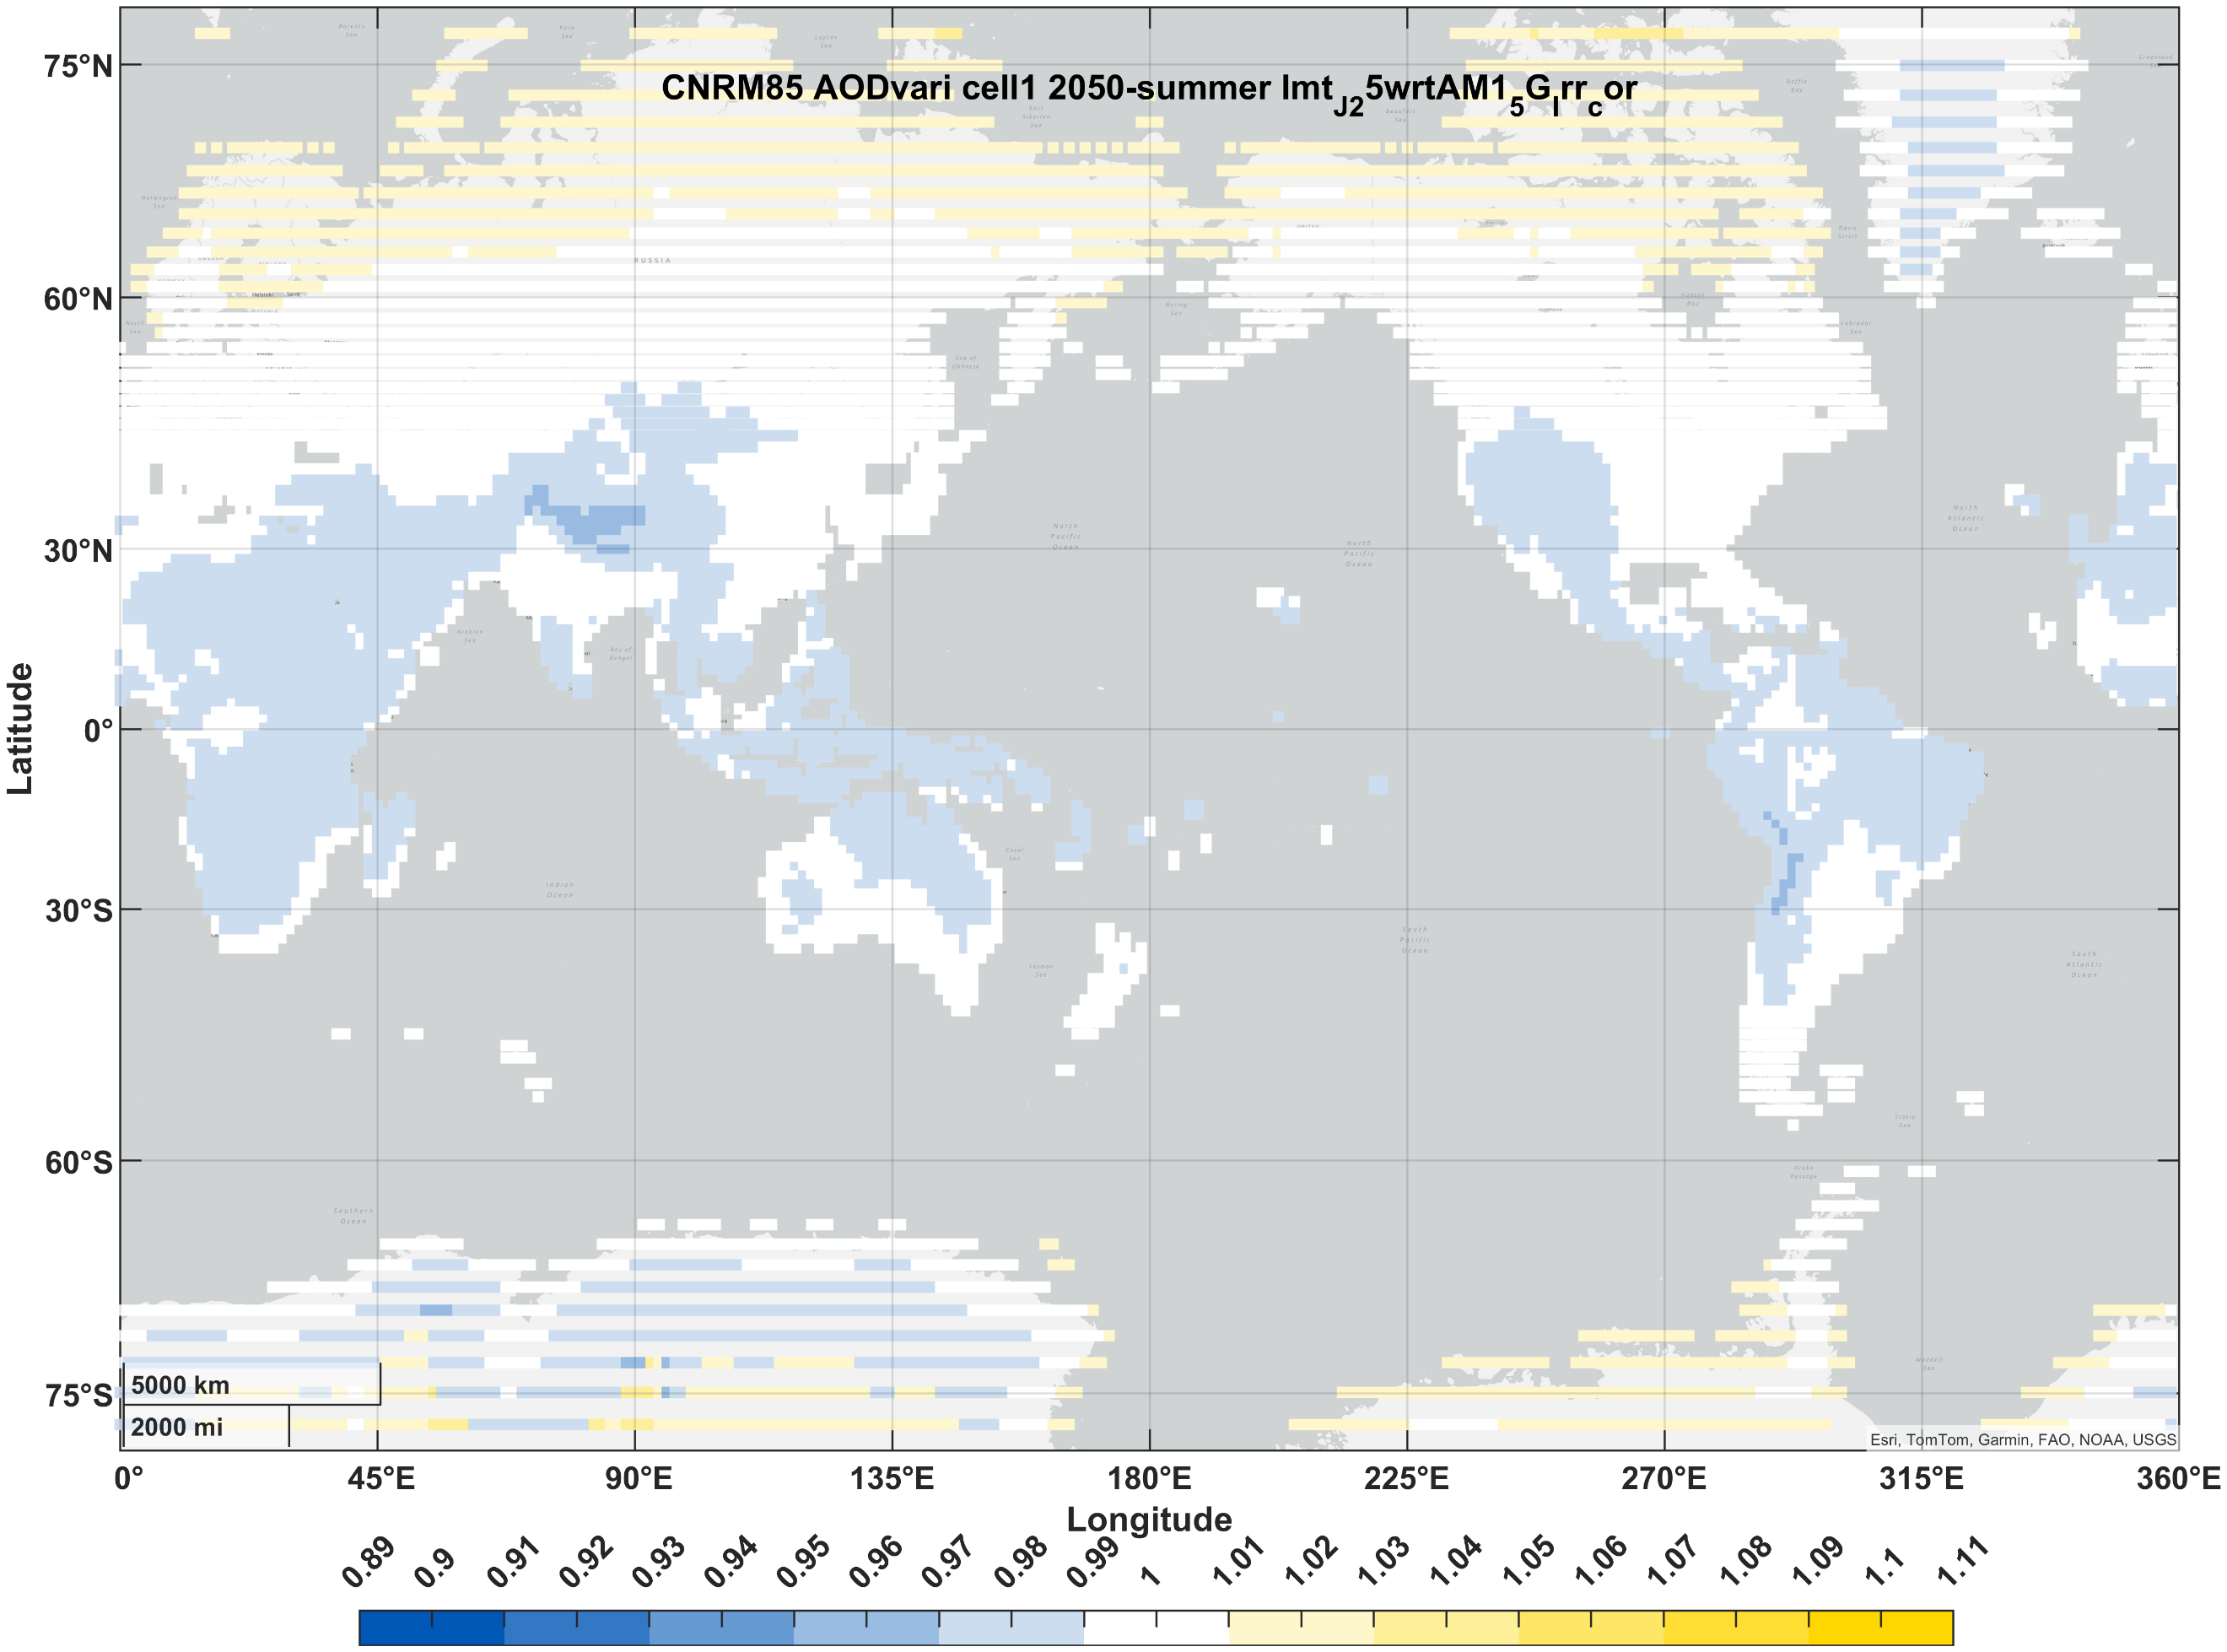 | 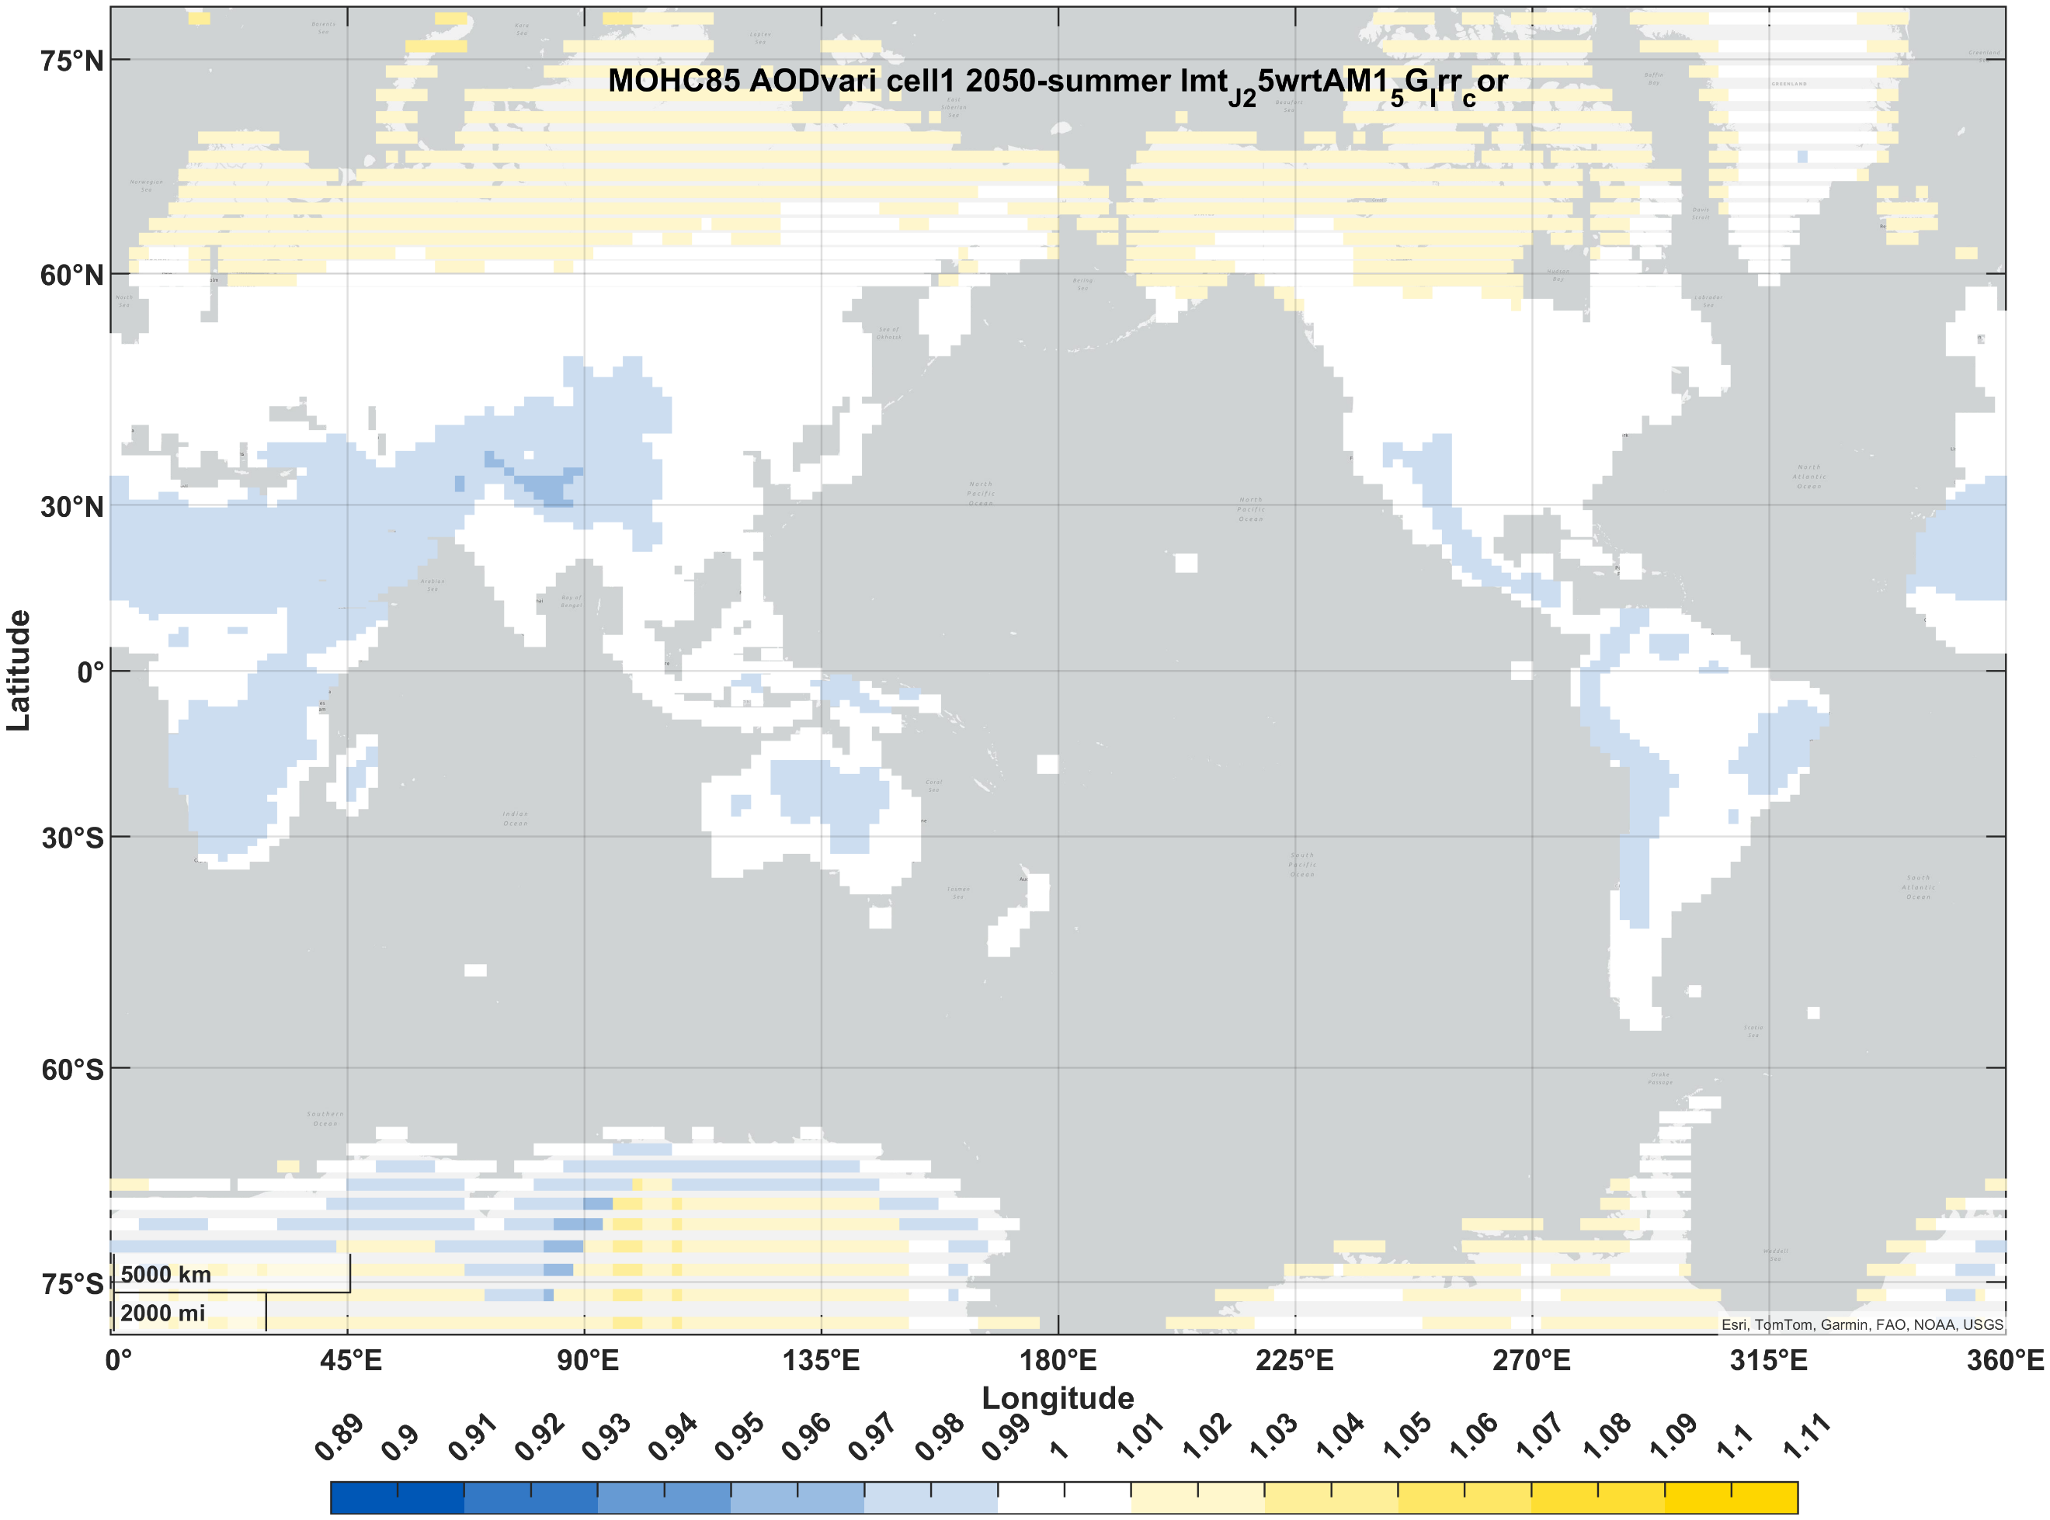 | 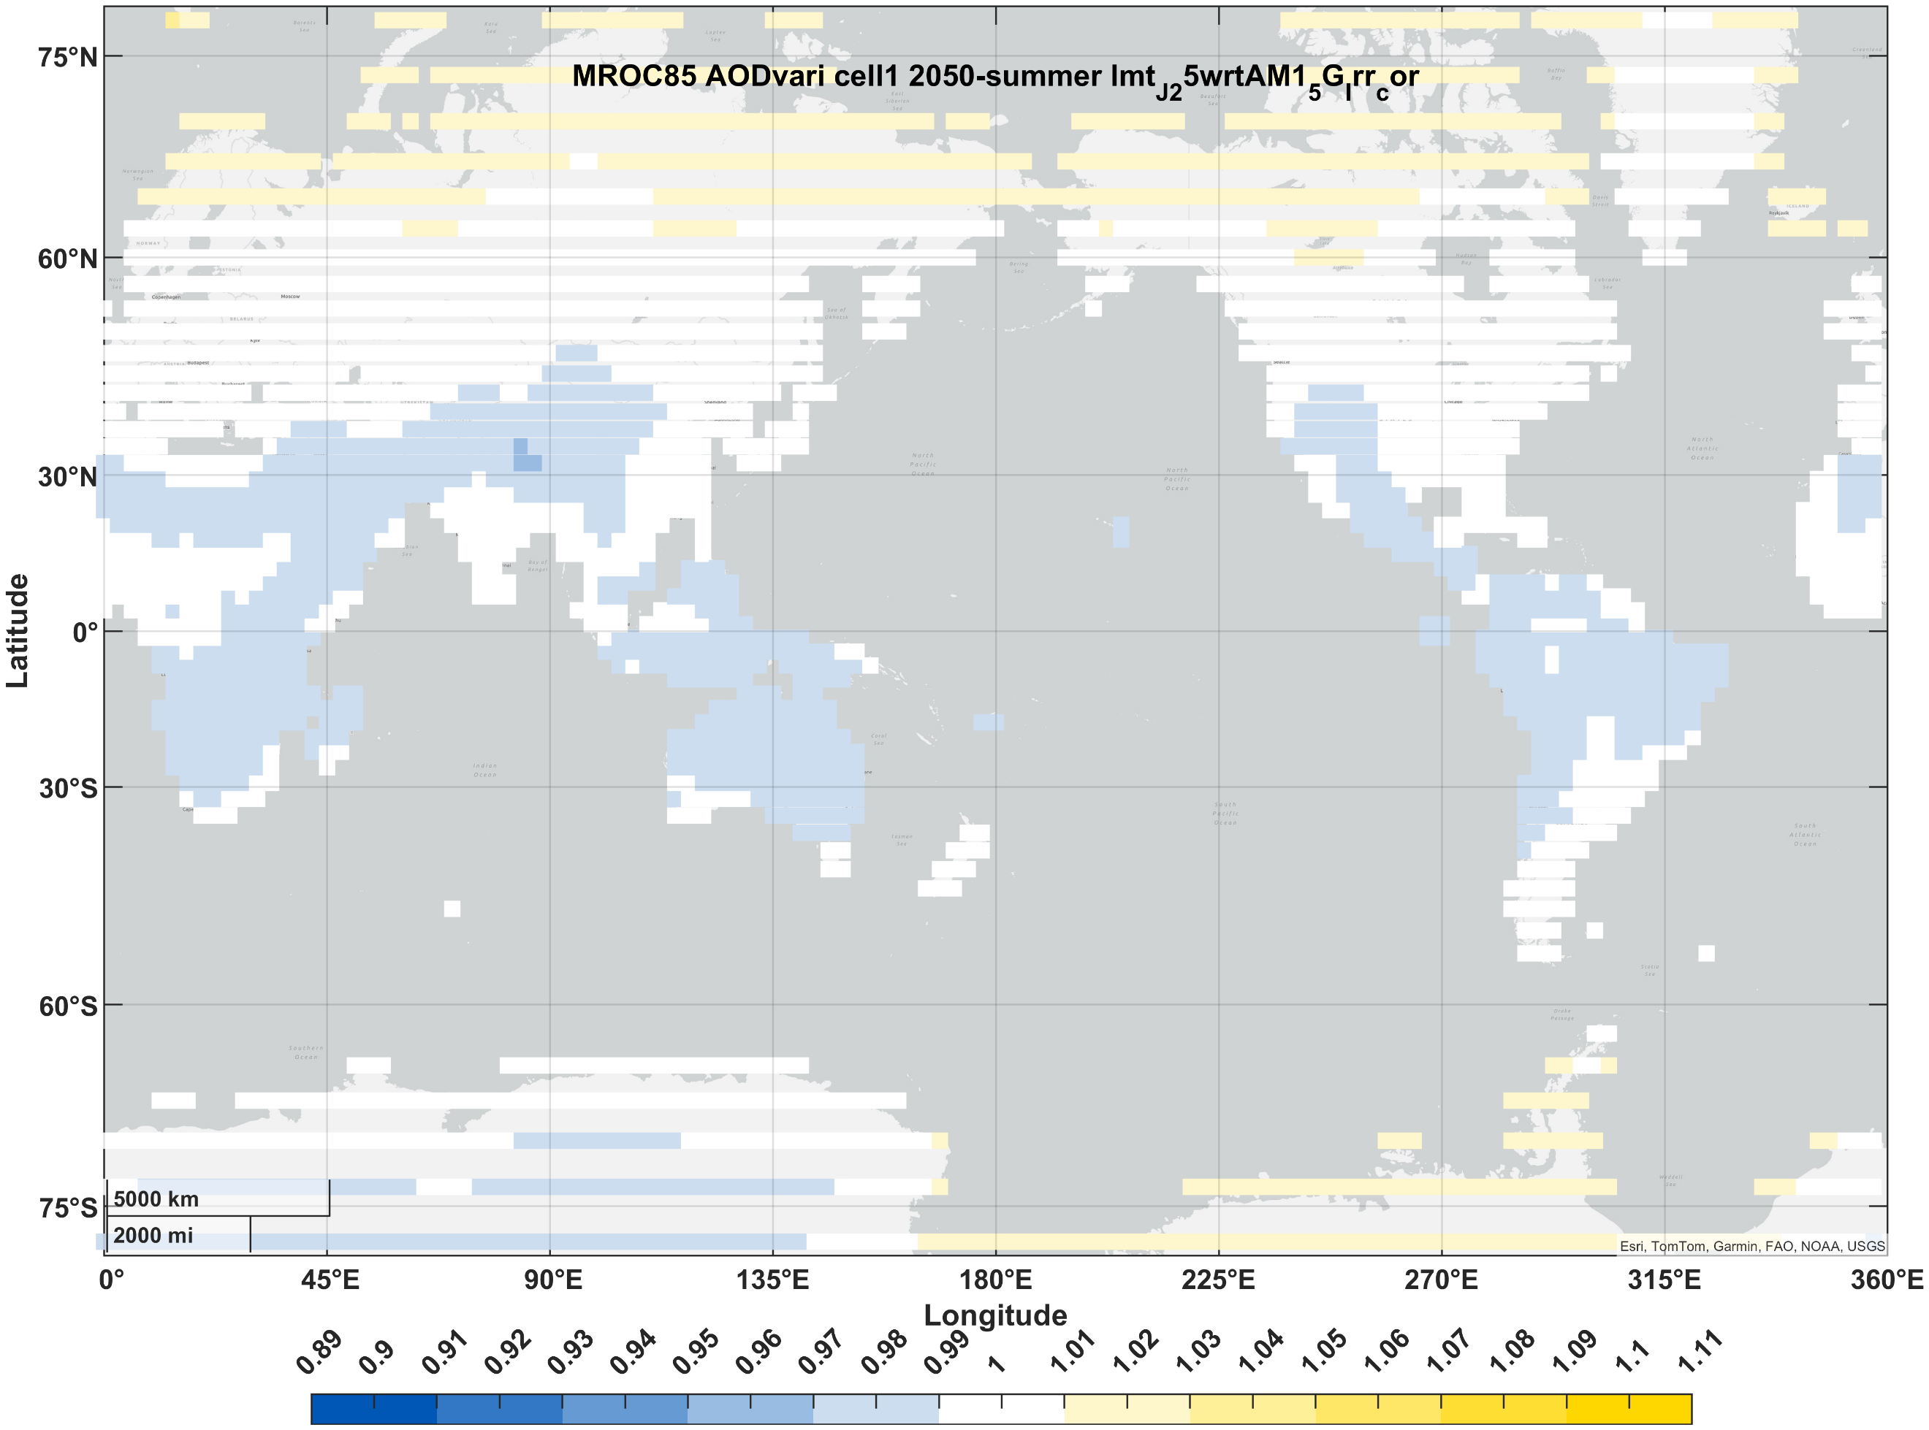 | 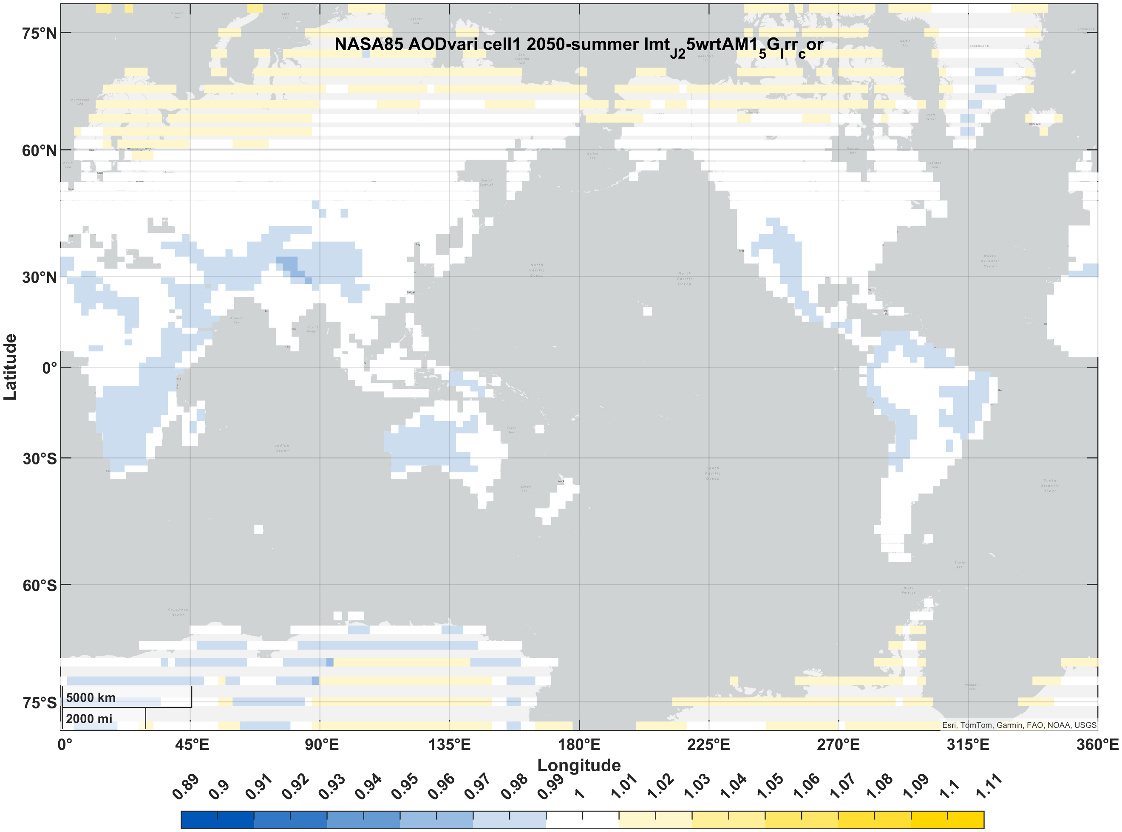 | 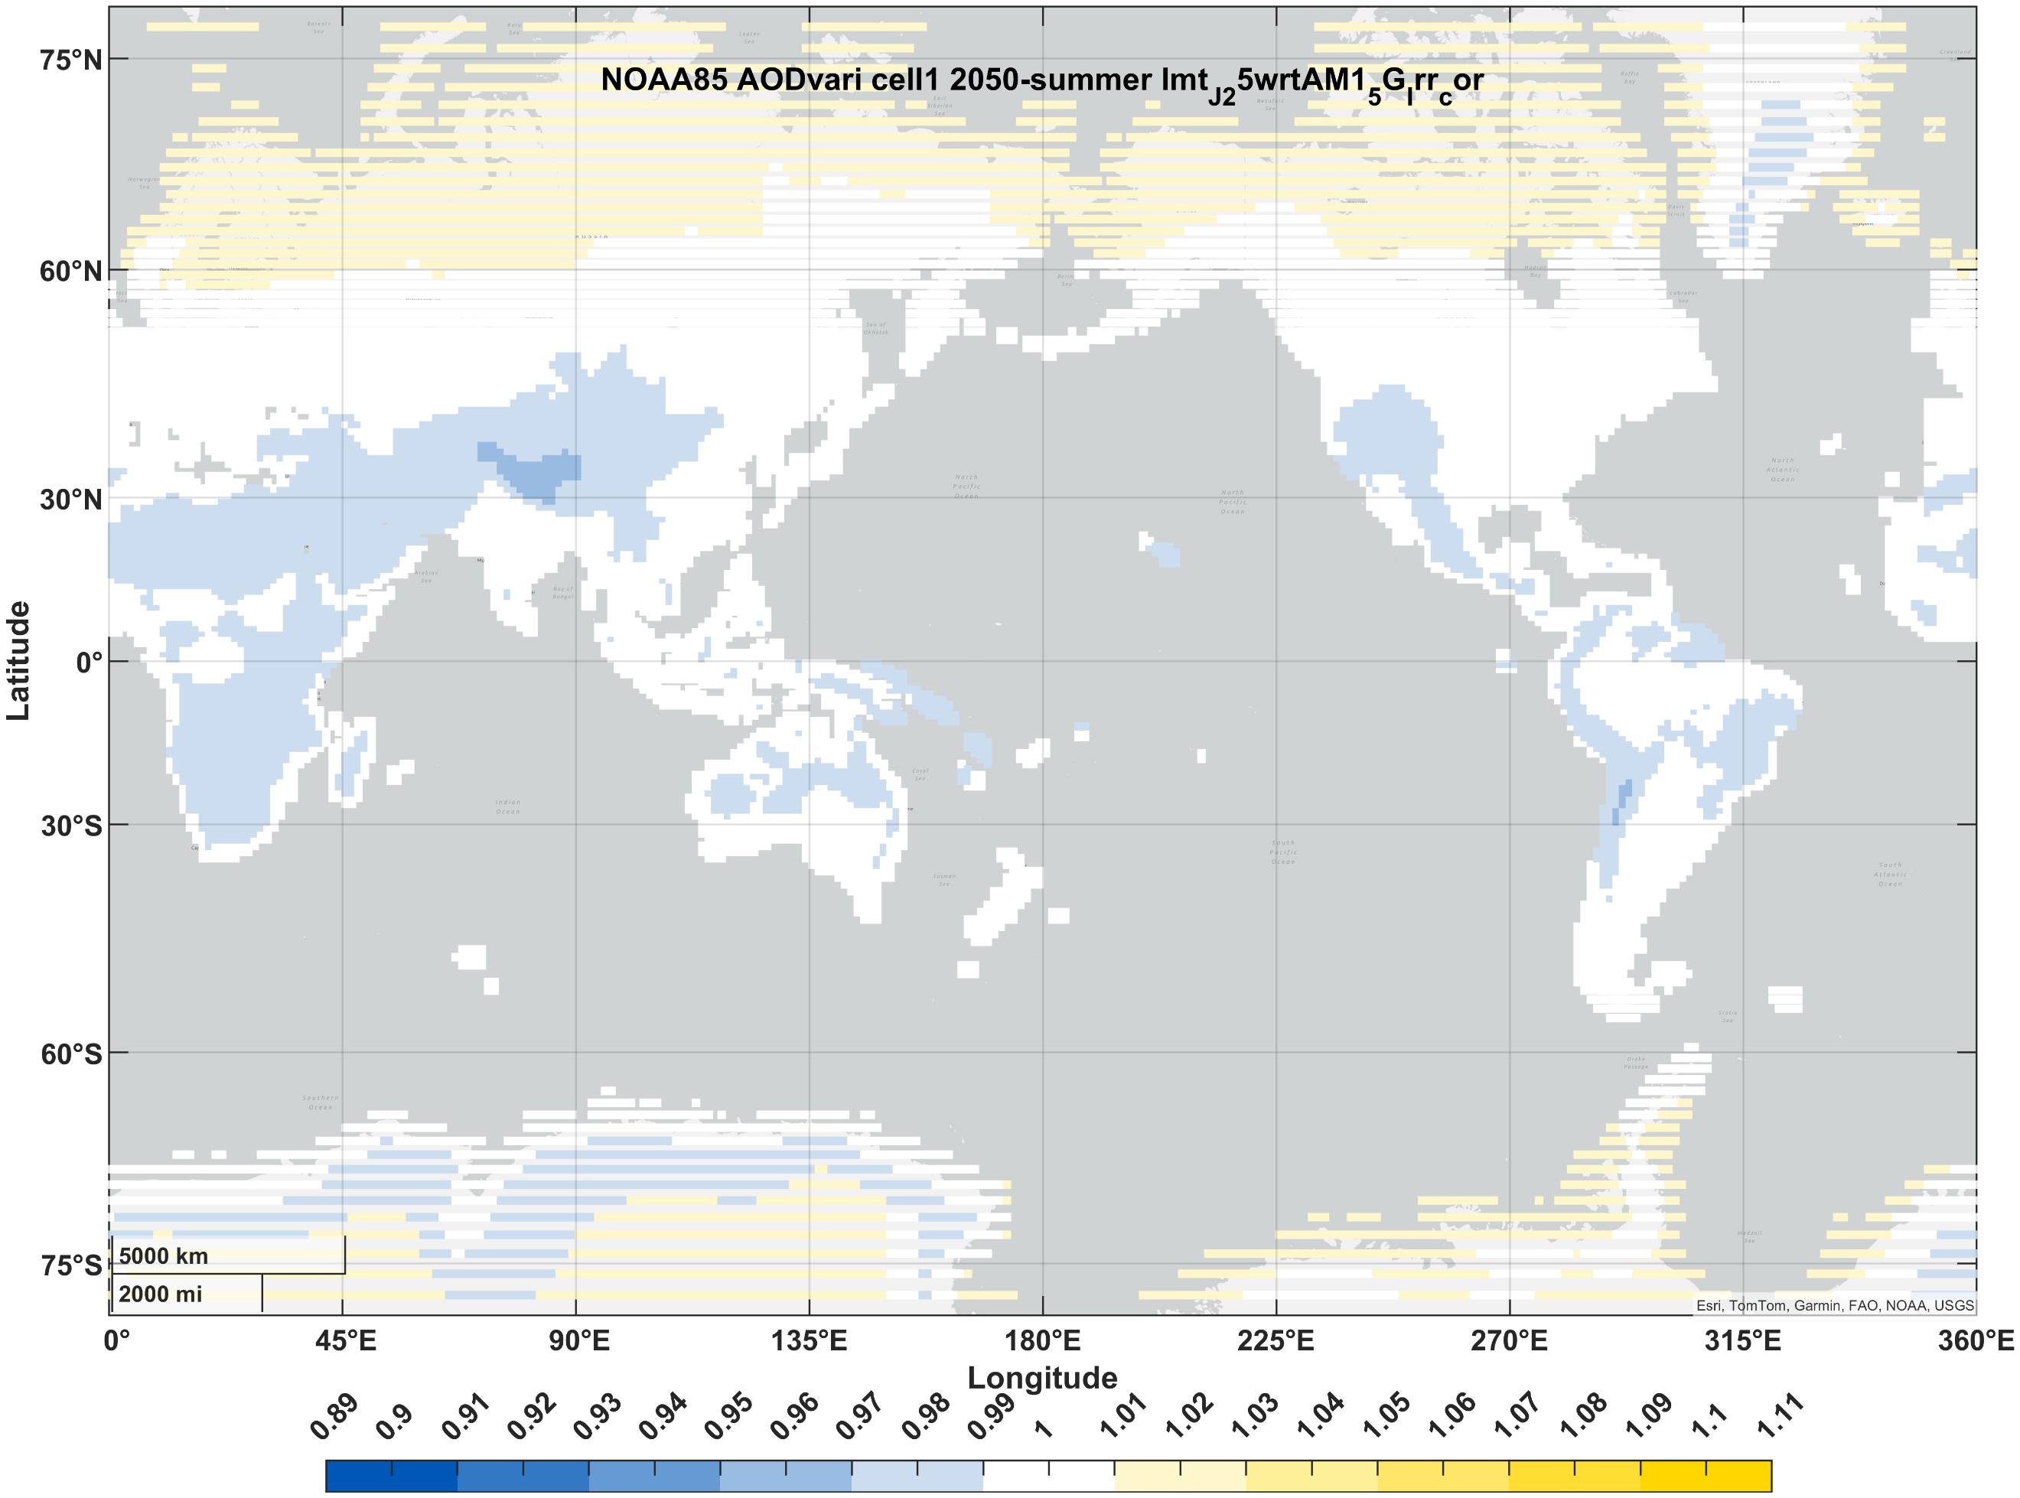
PVSK/Si (2J) | winter | 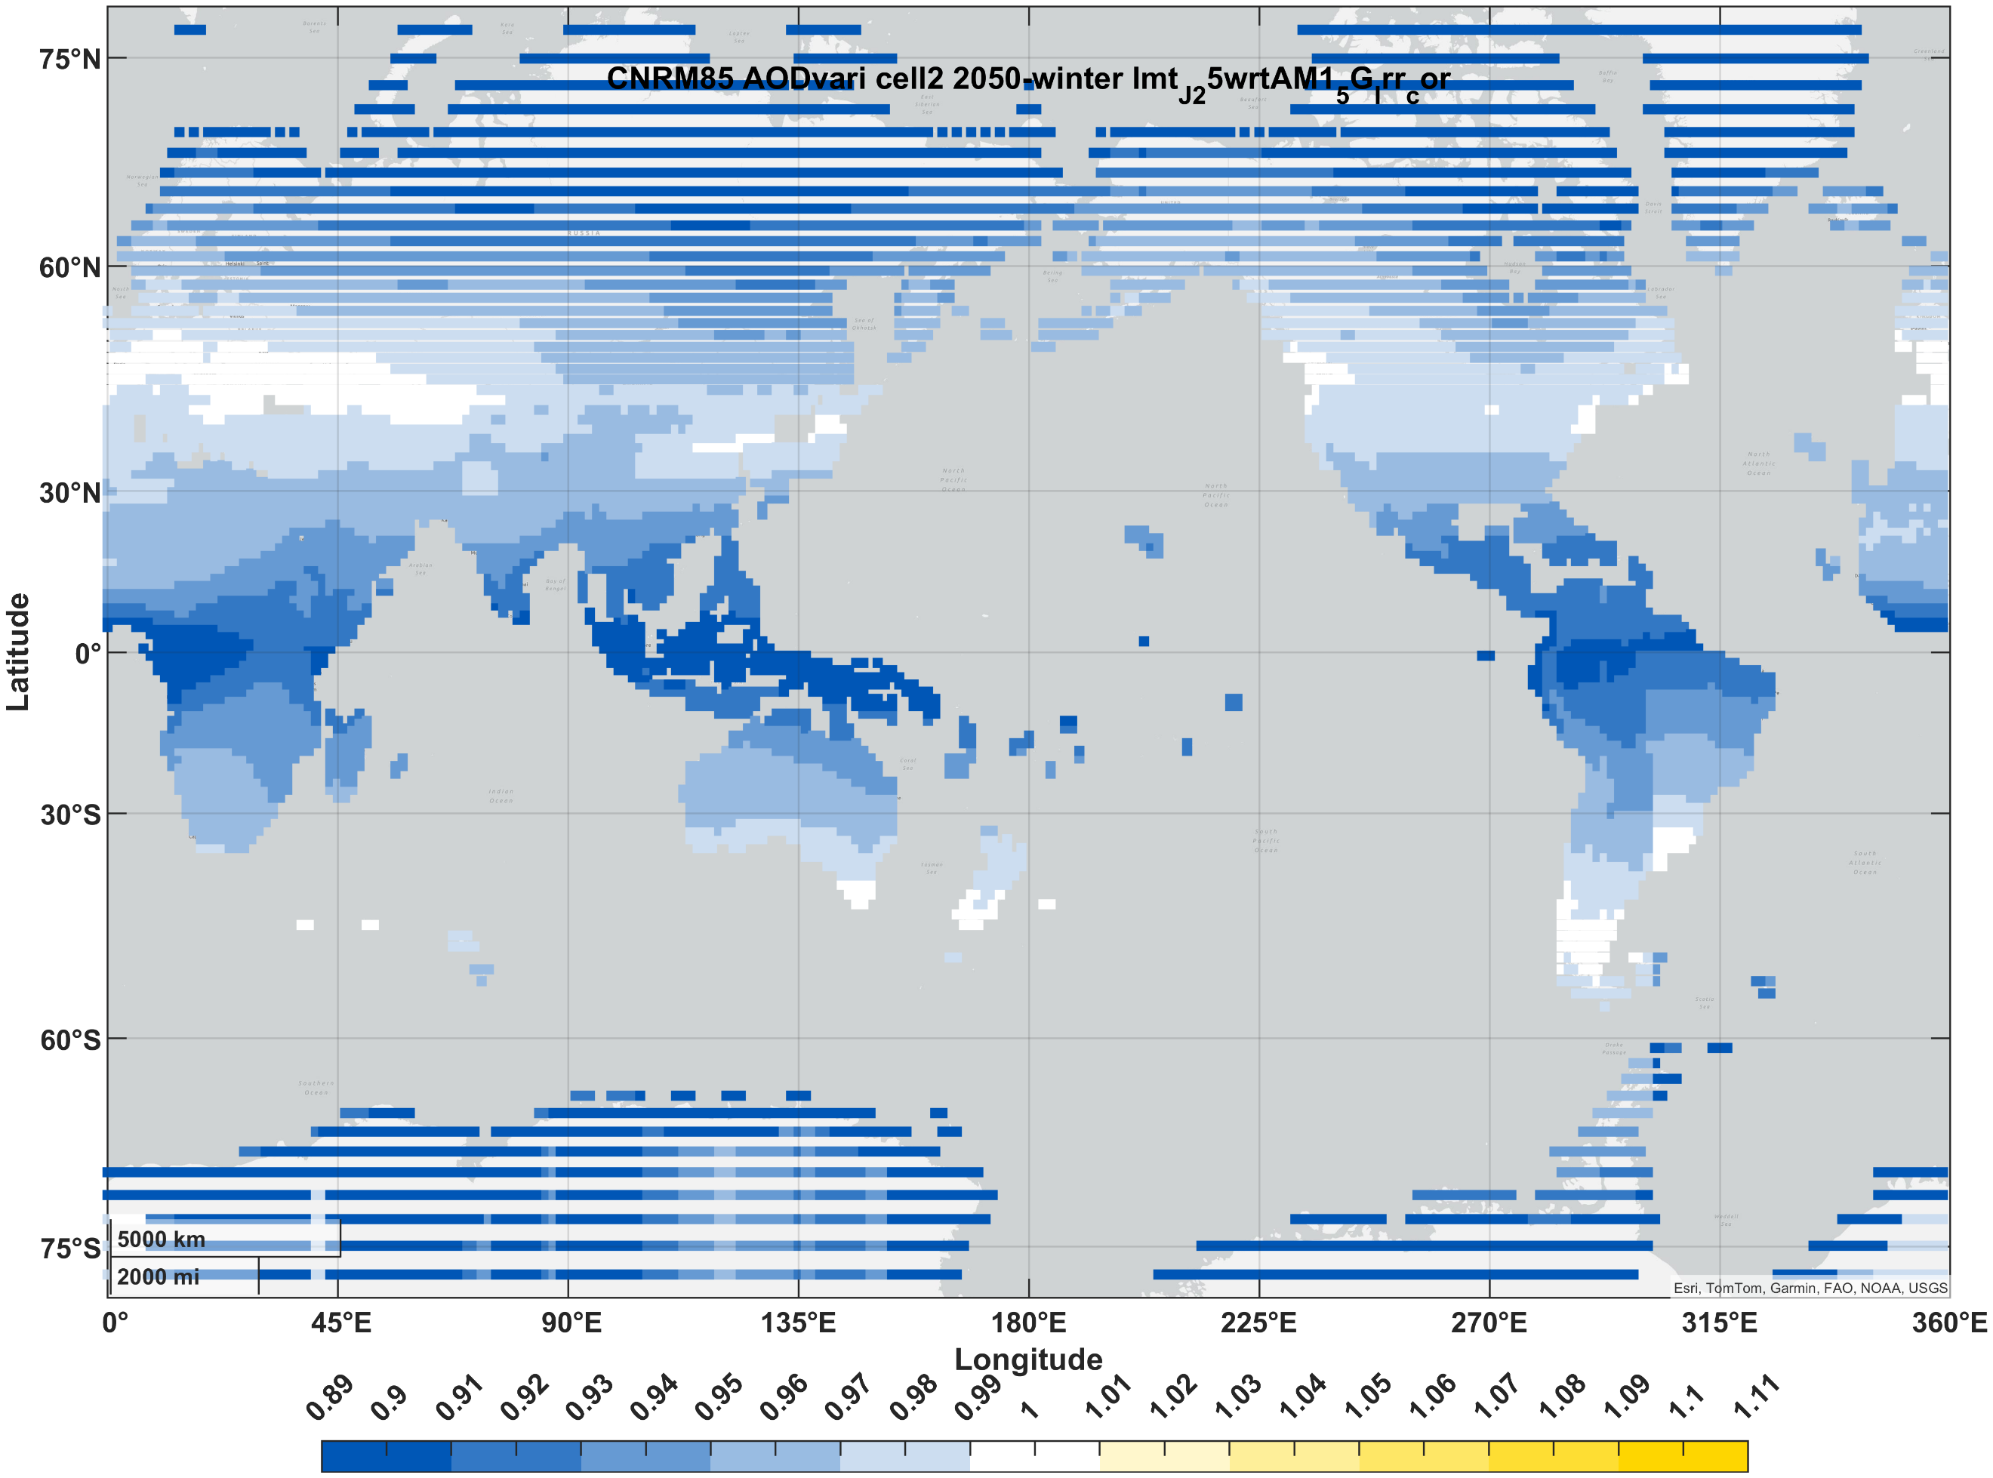 | 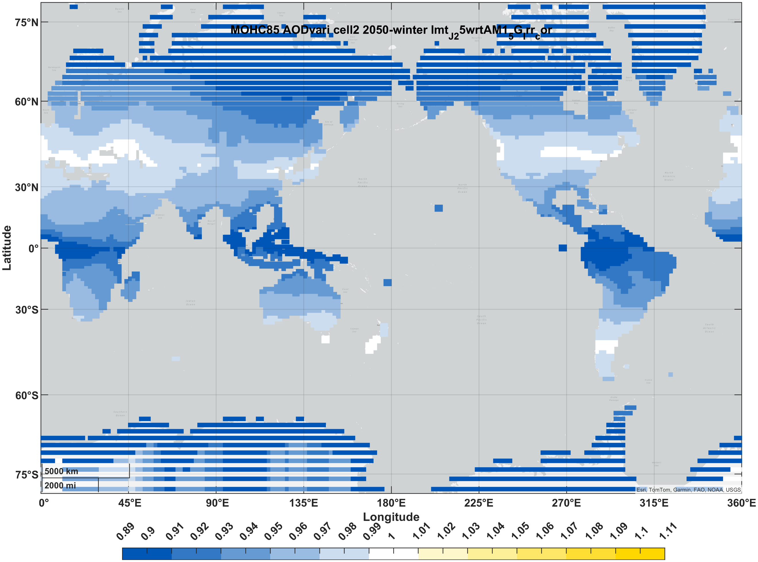 | 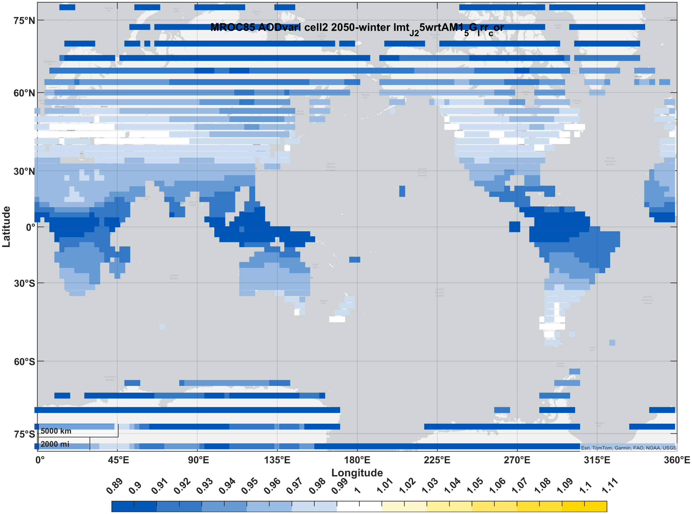 | 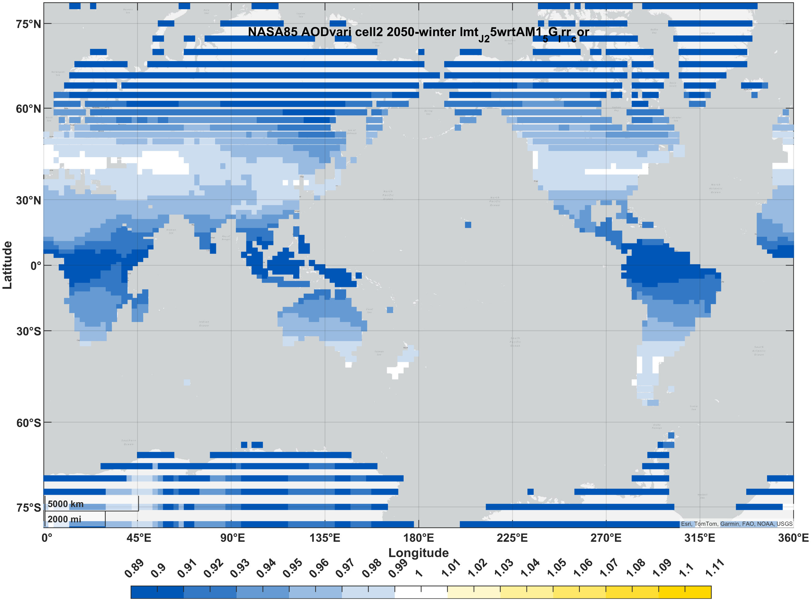 | 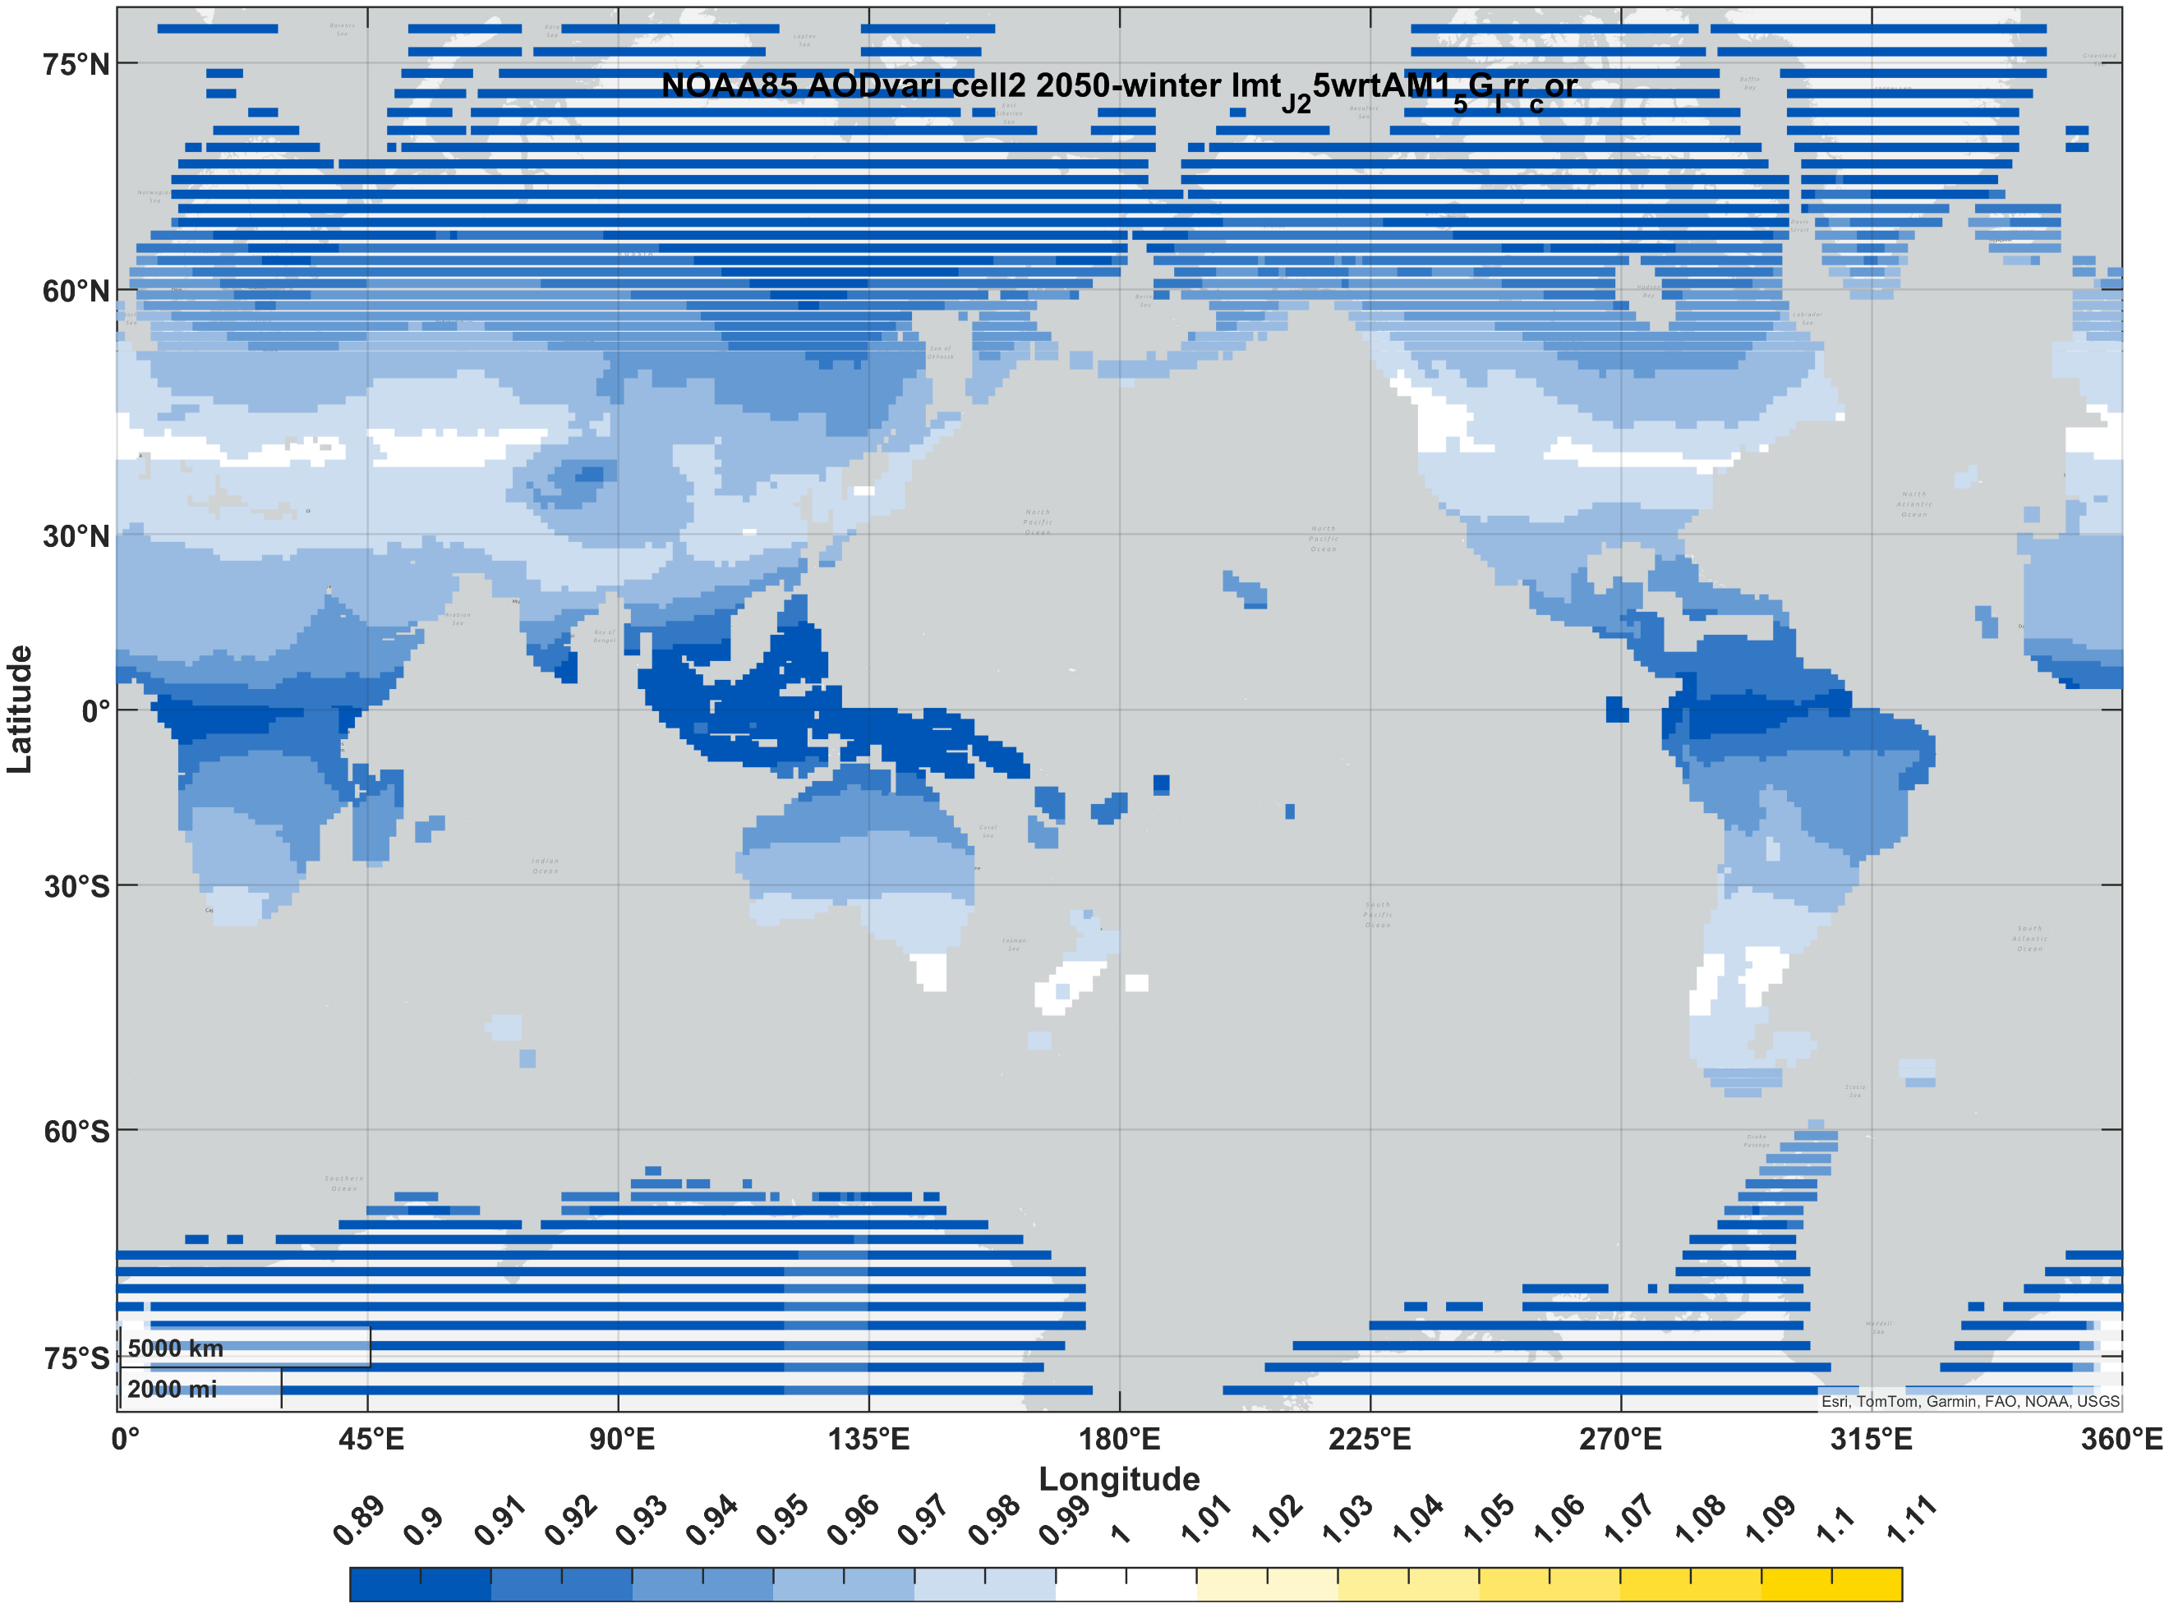
PVSK/Si (2J) | summer | 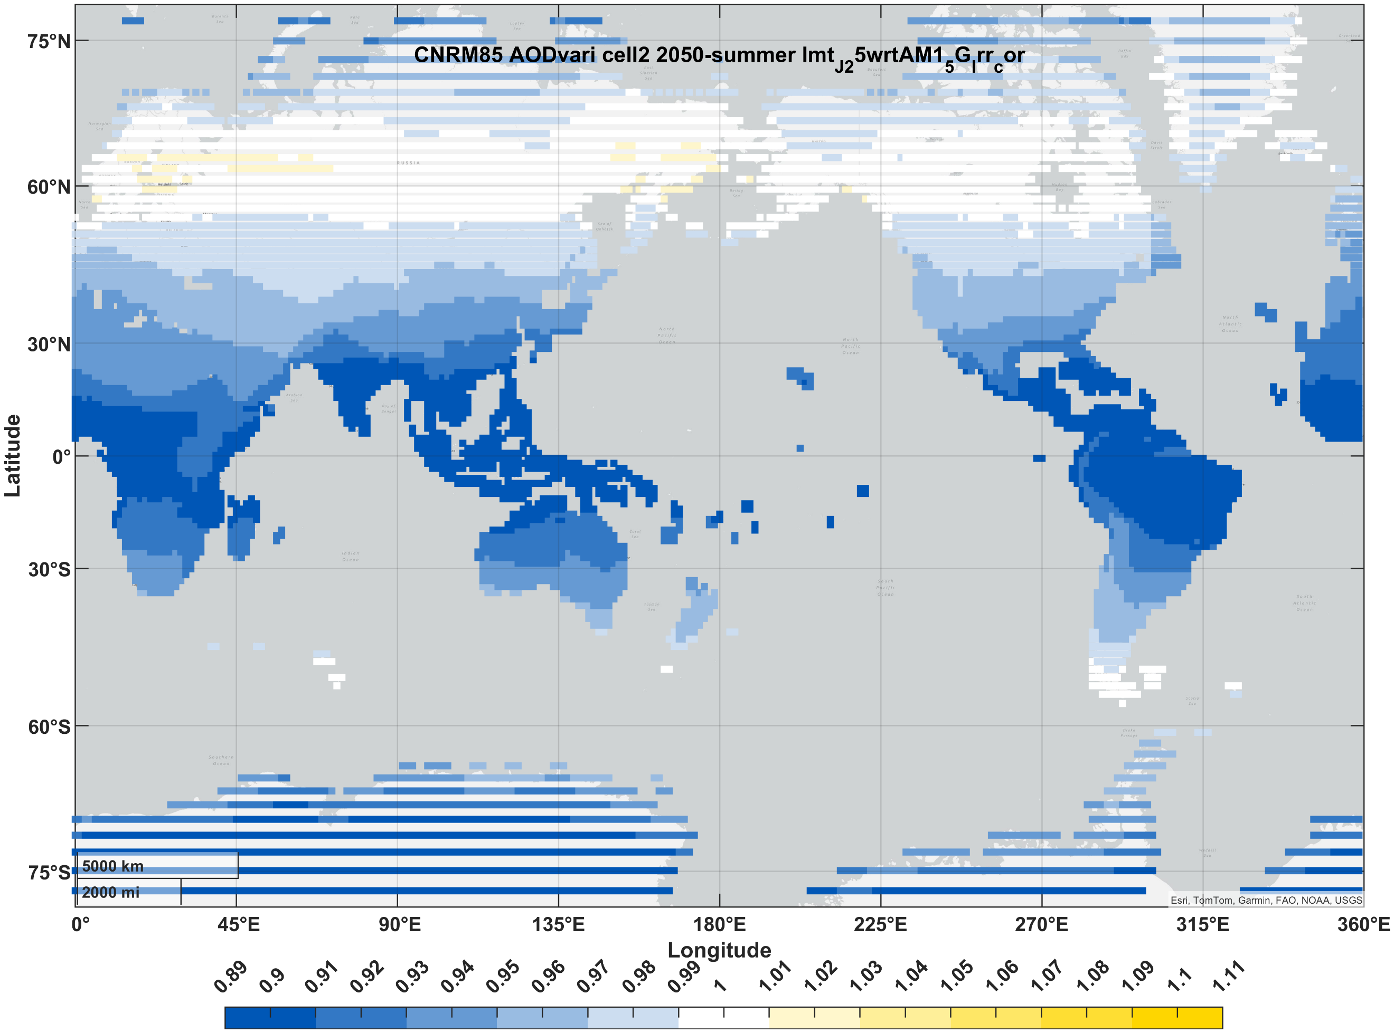 | 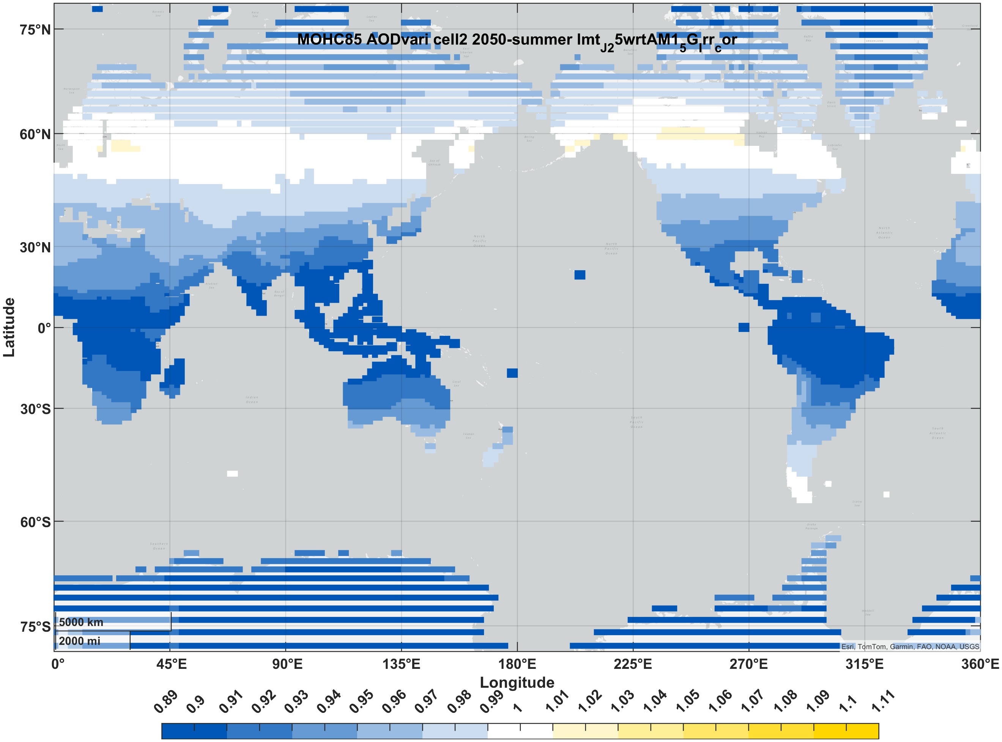 | 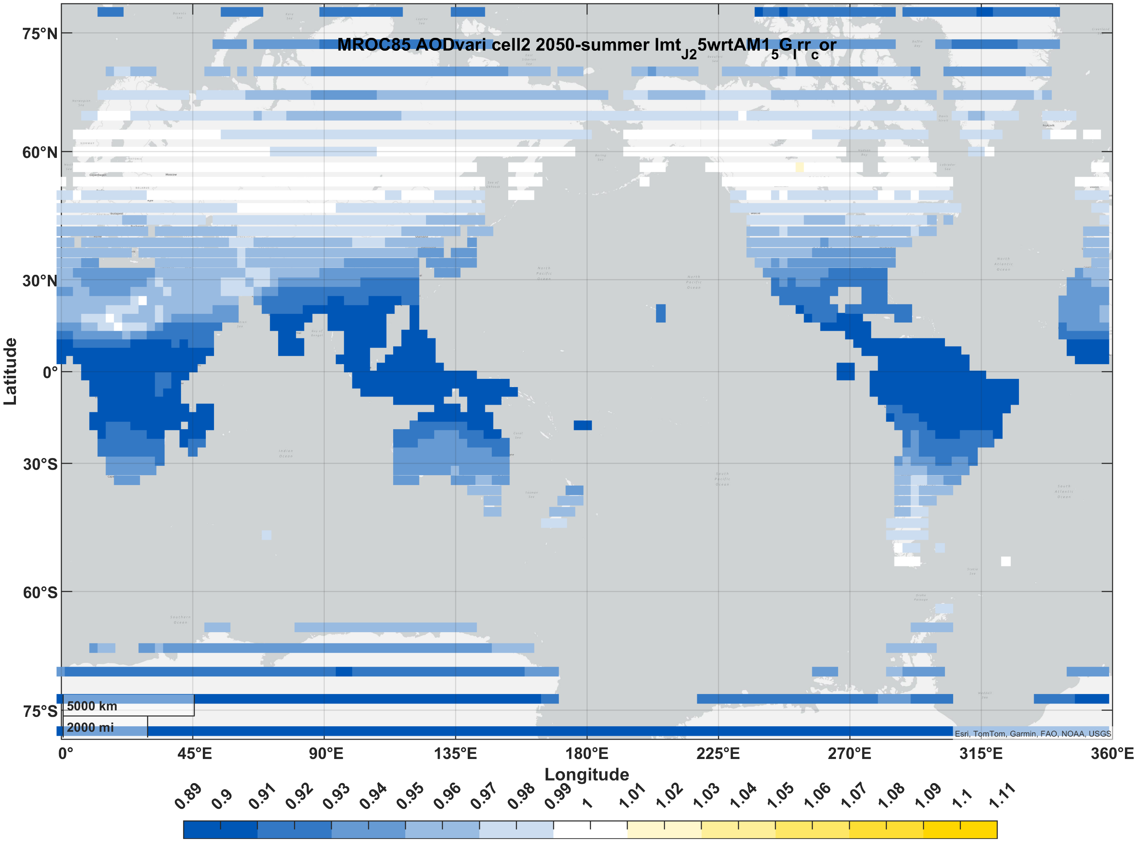 | 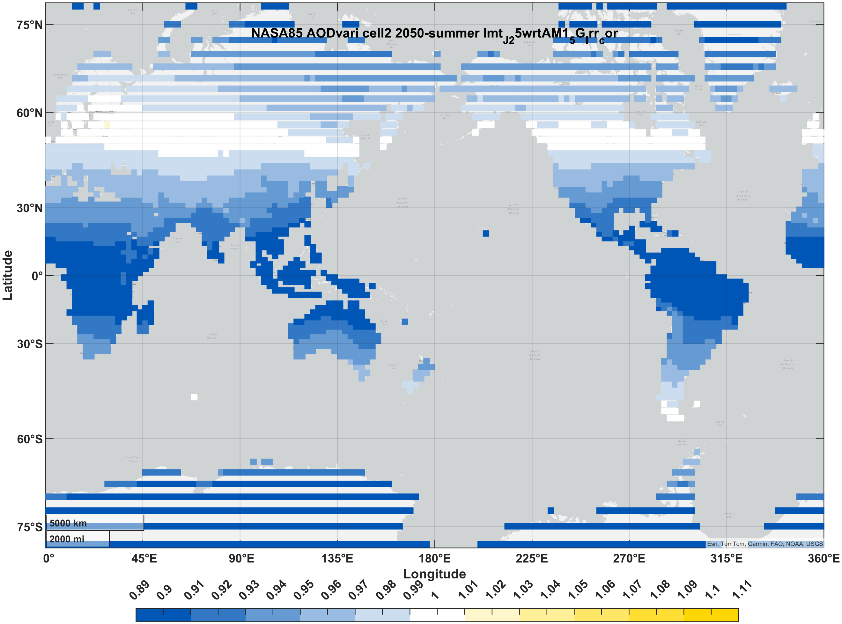 | 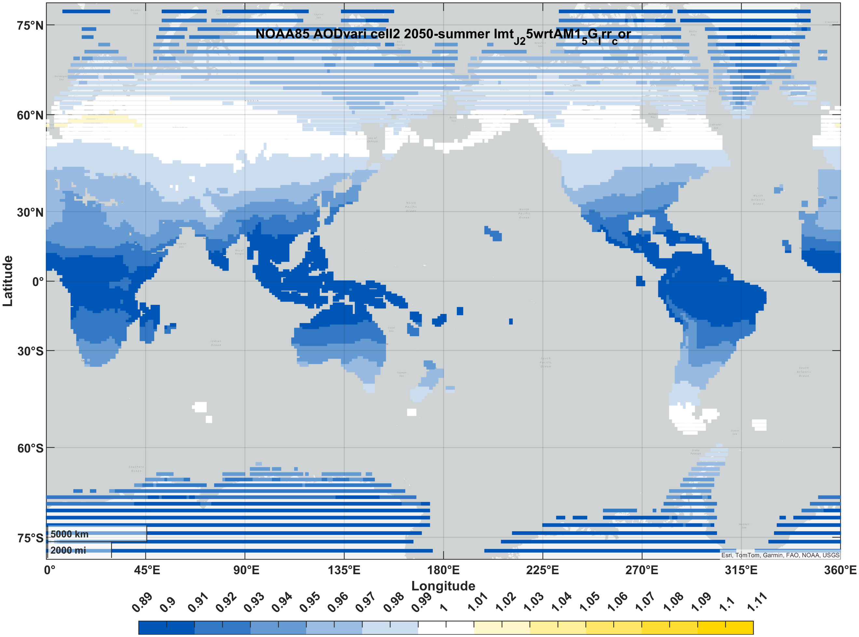
III-V (3J) | winter | 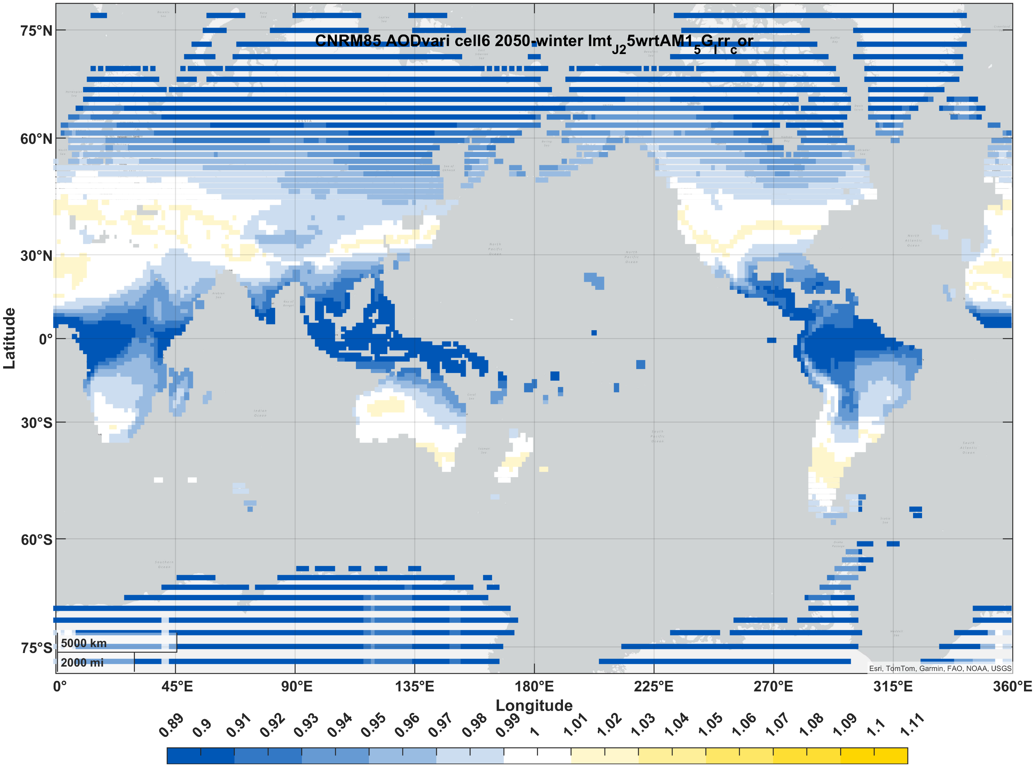 | 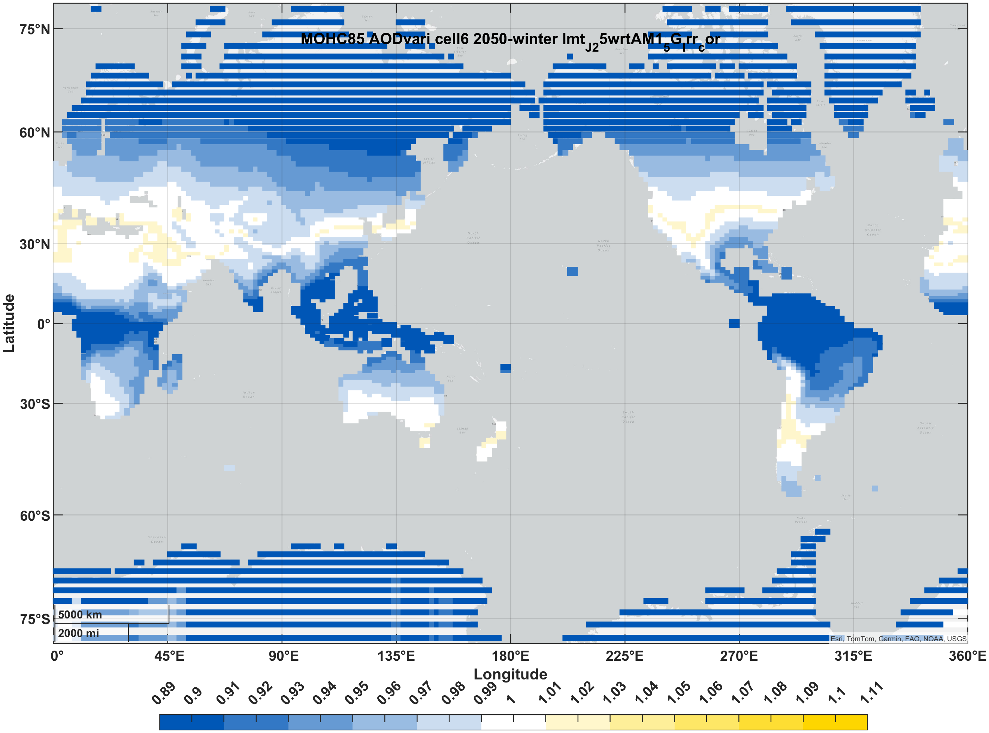 | 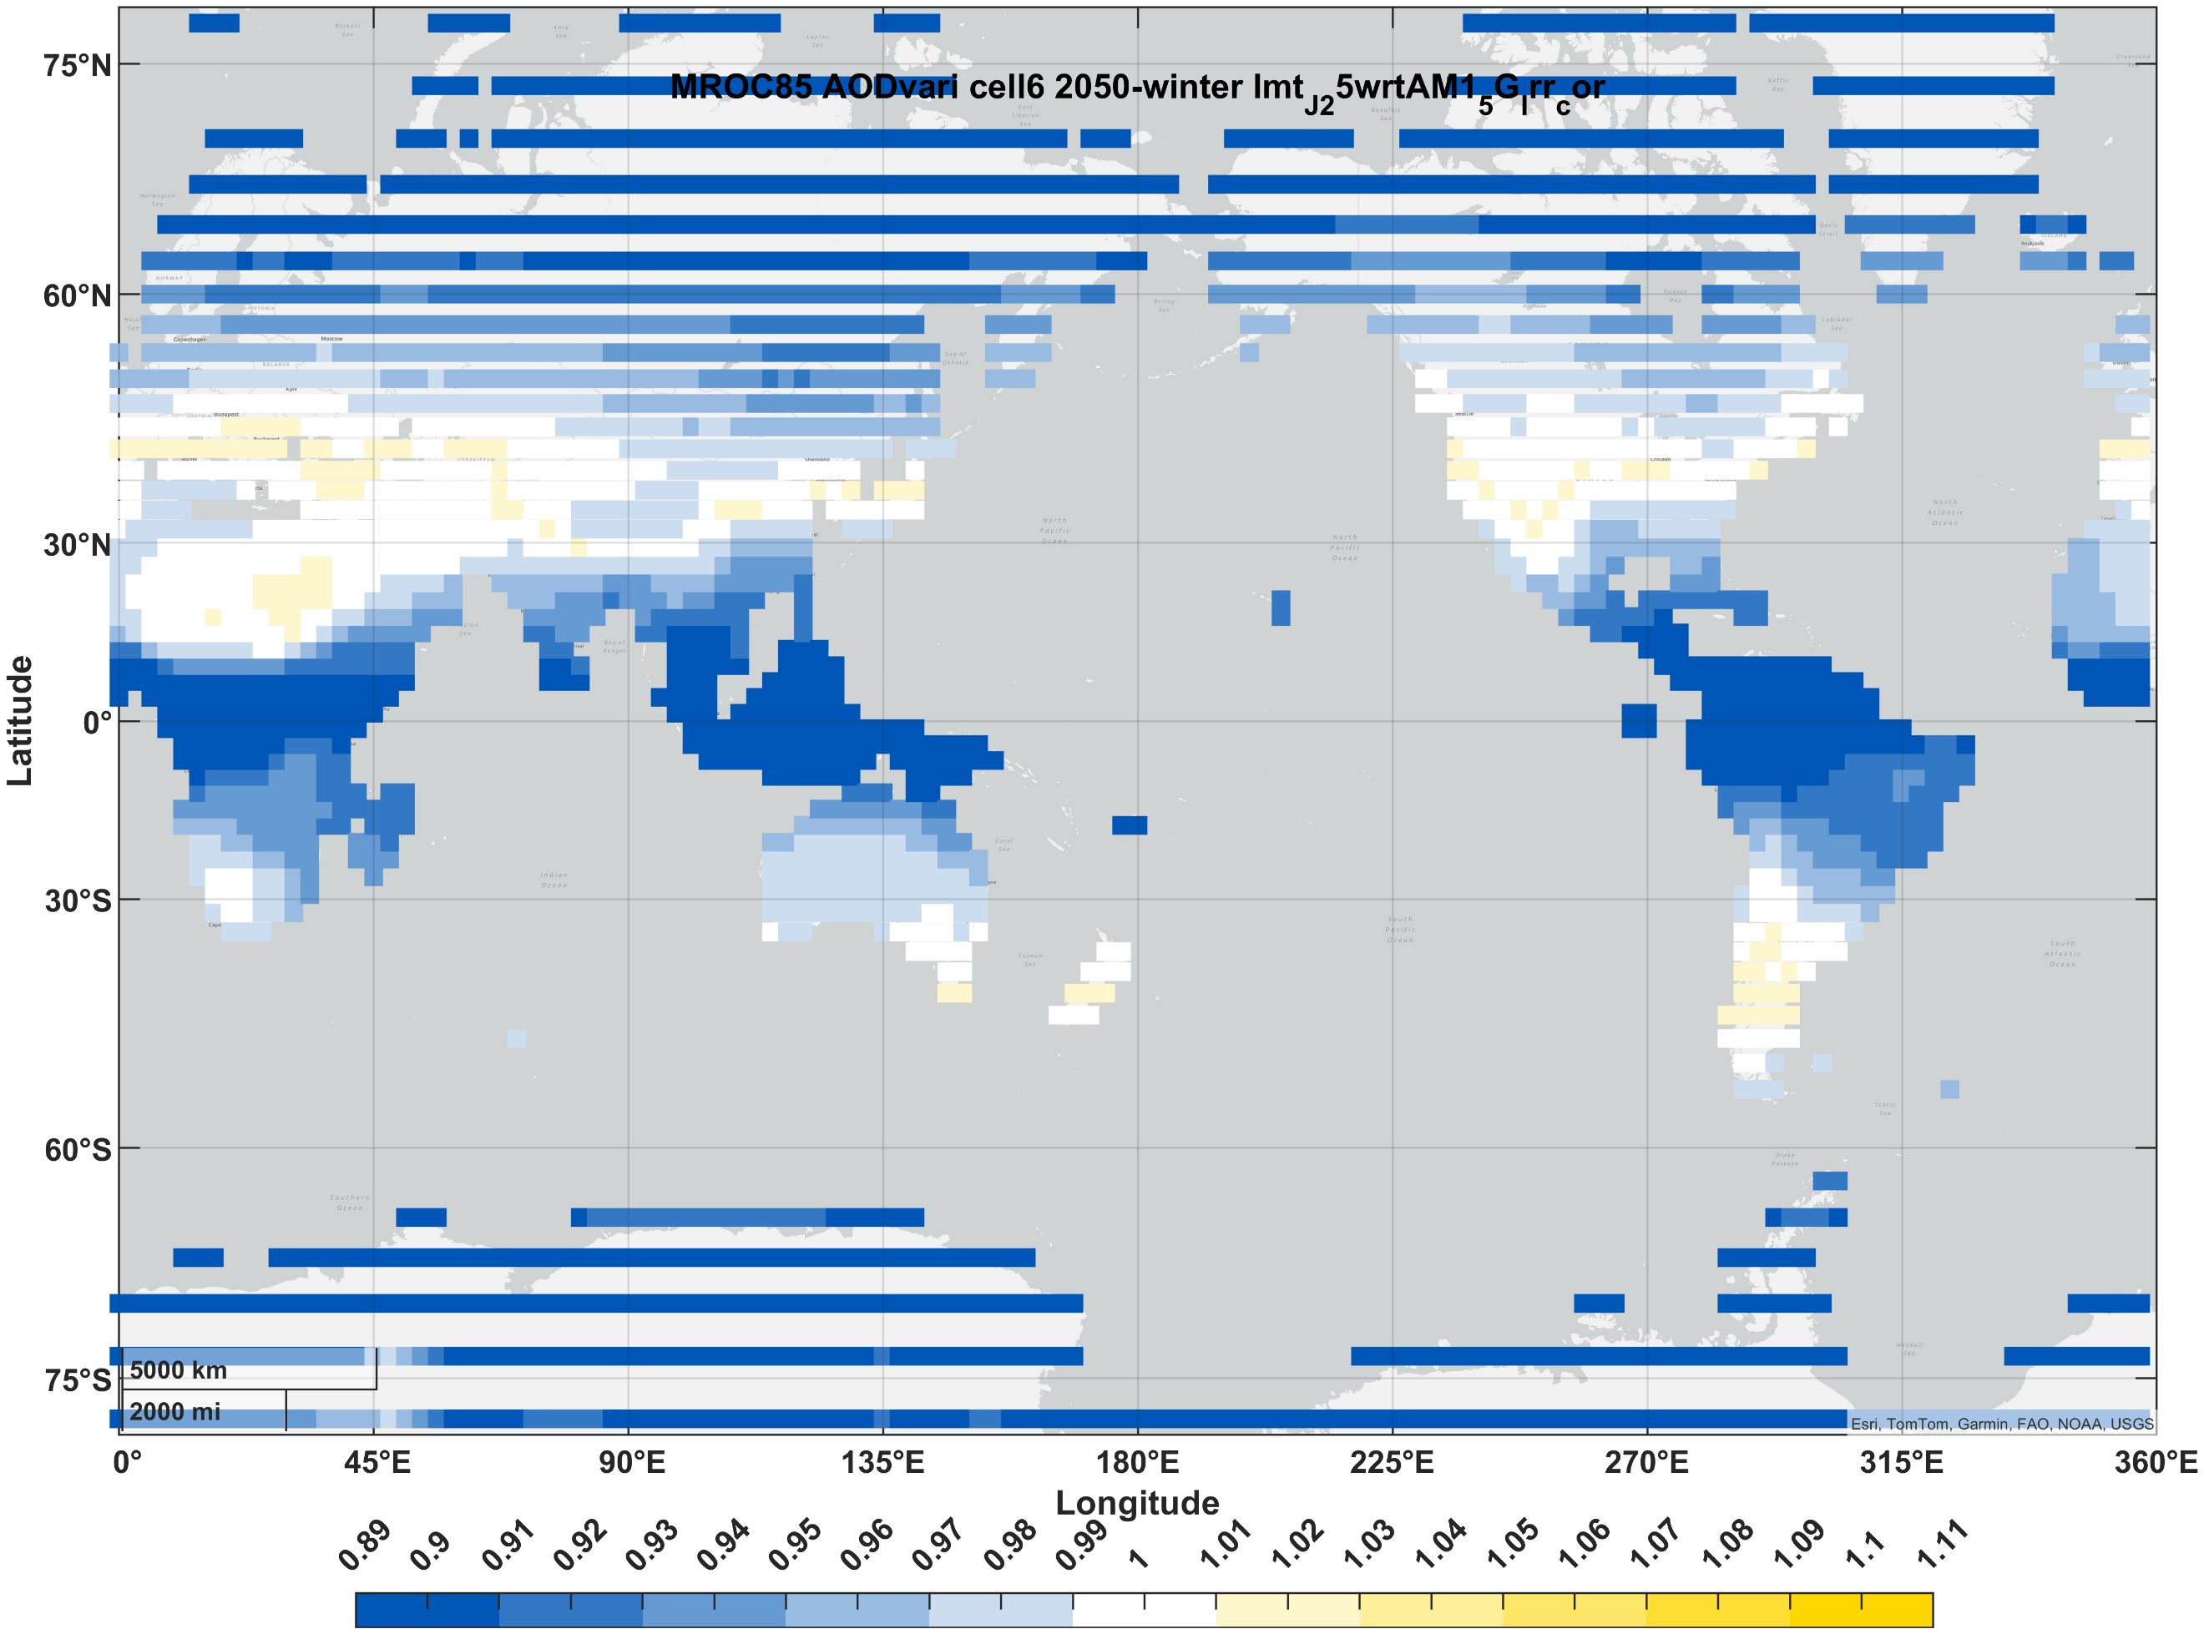 | 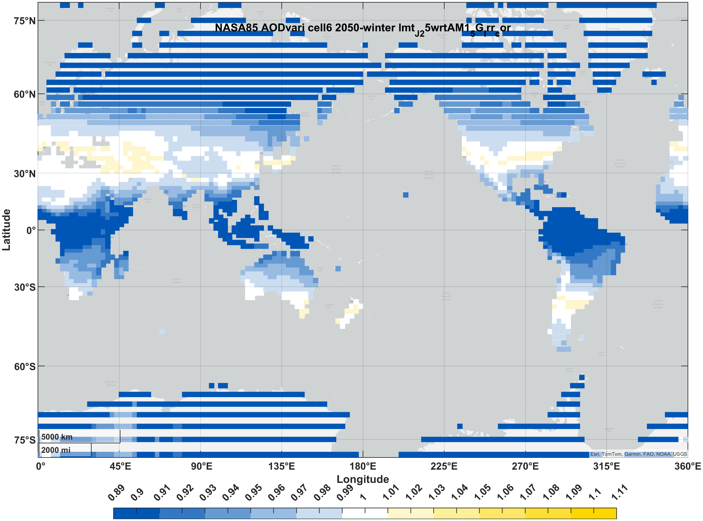 | 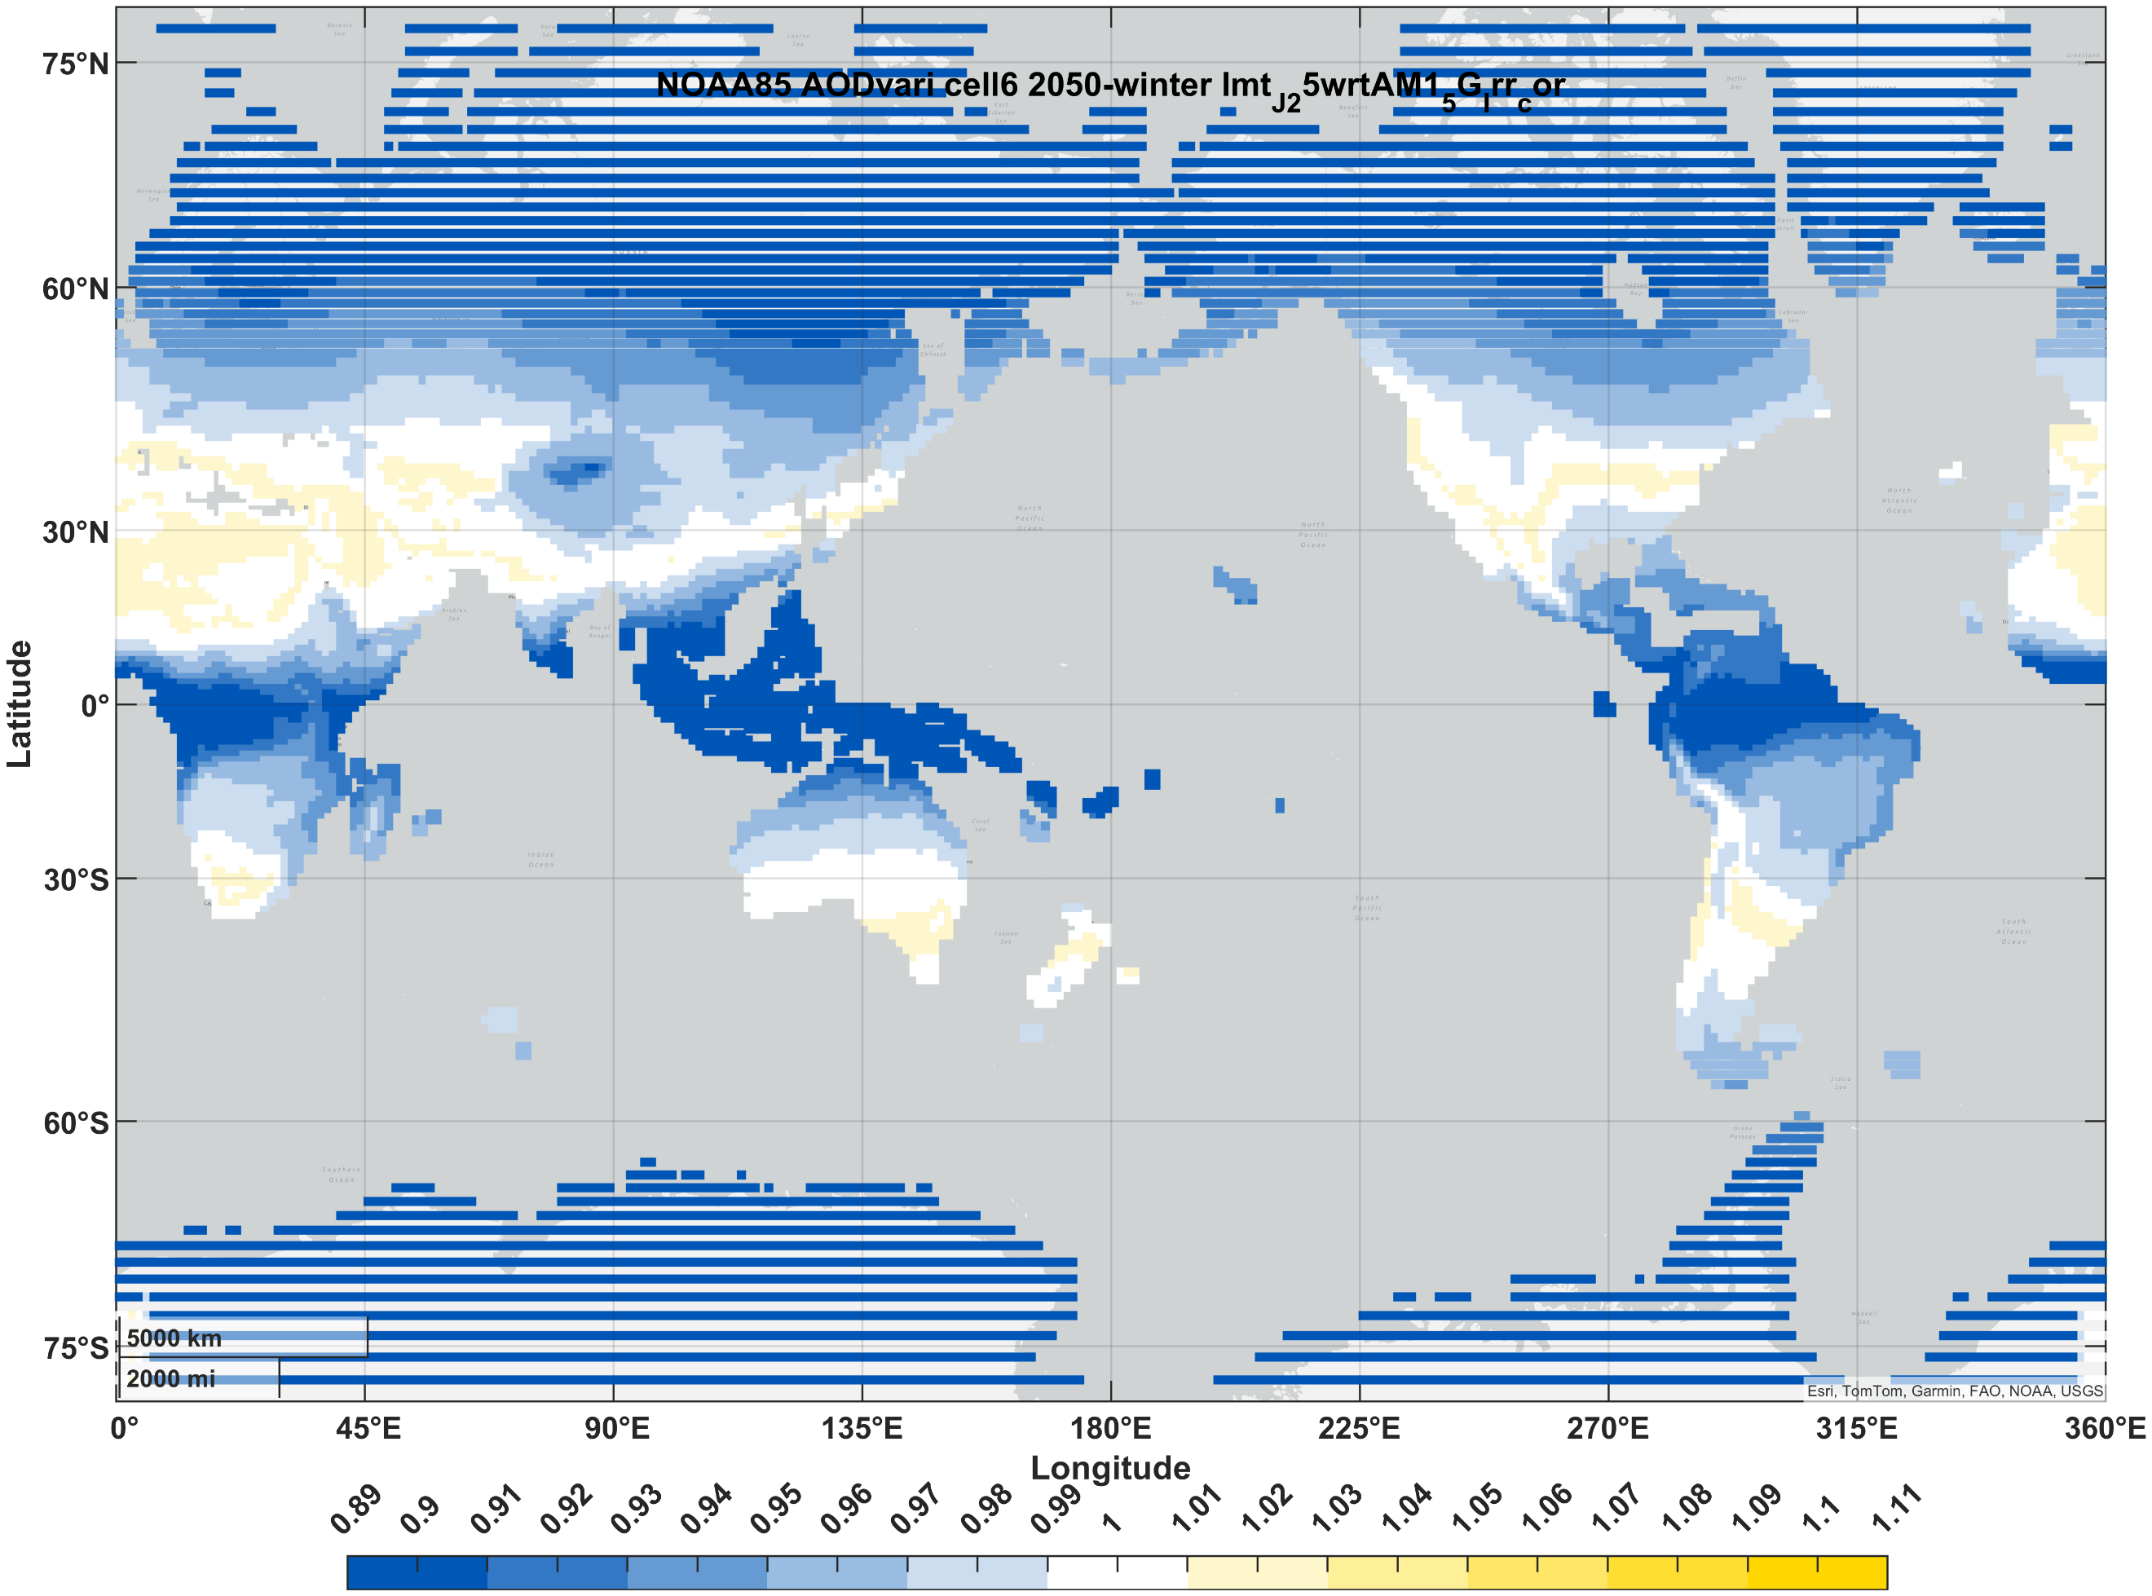
III-V (3J) | summer | 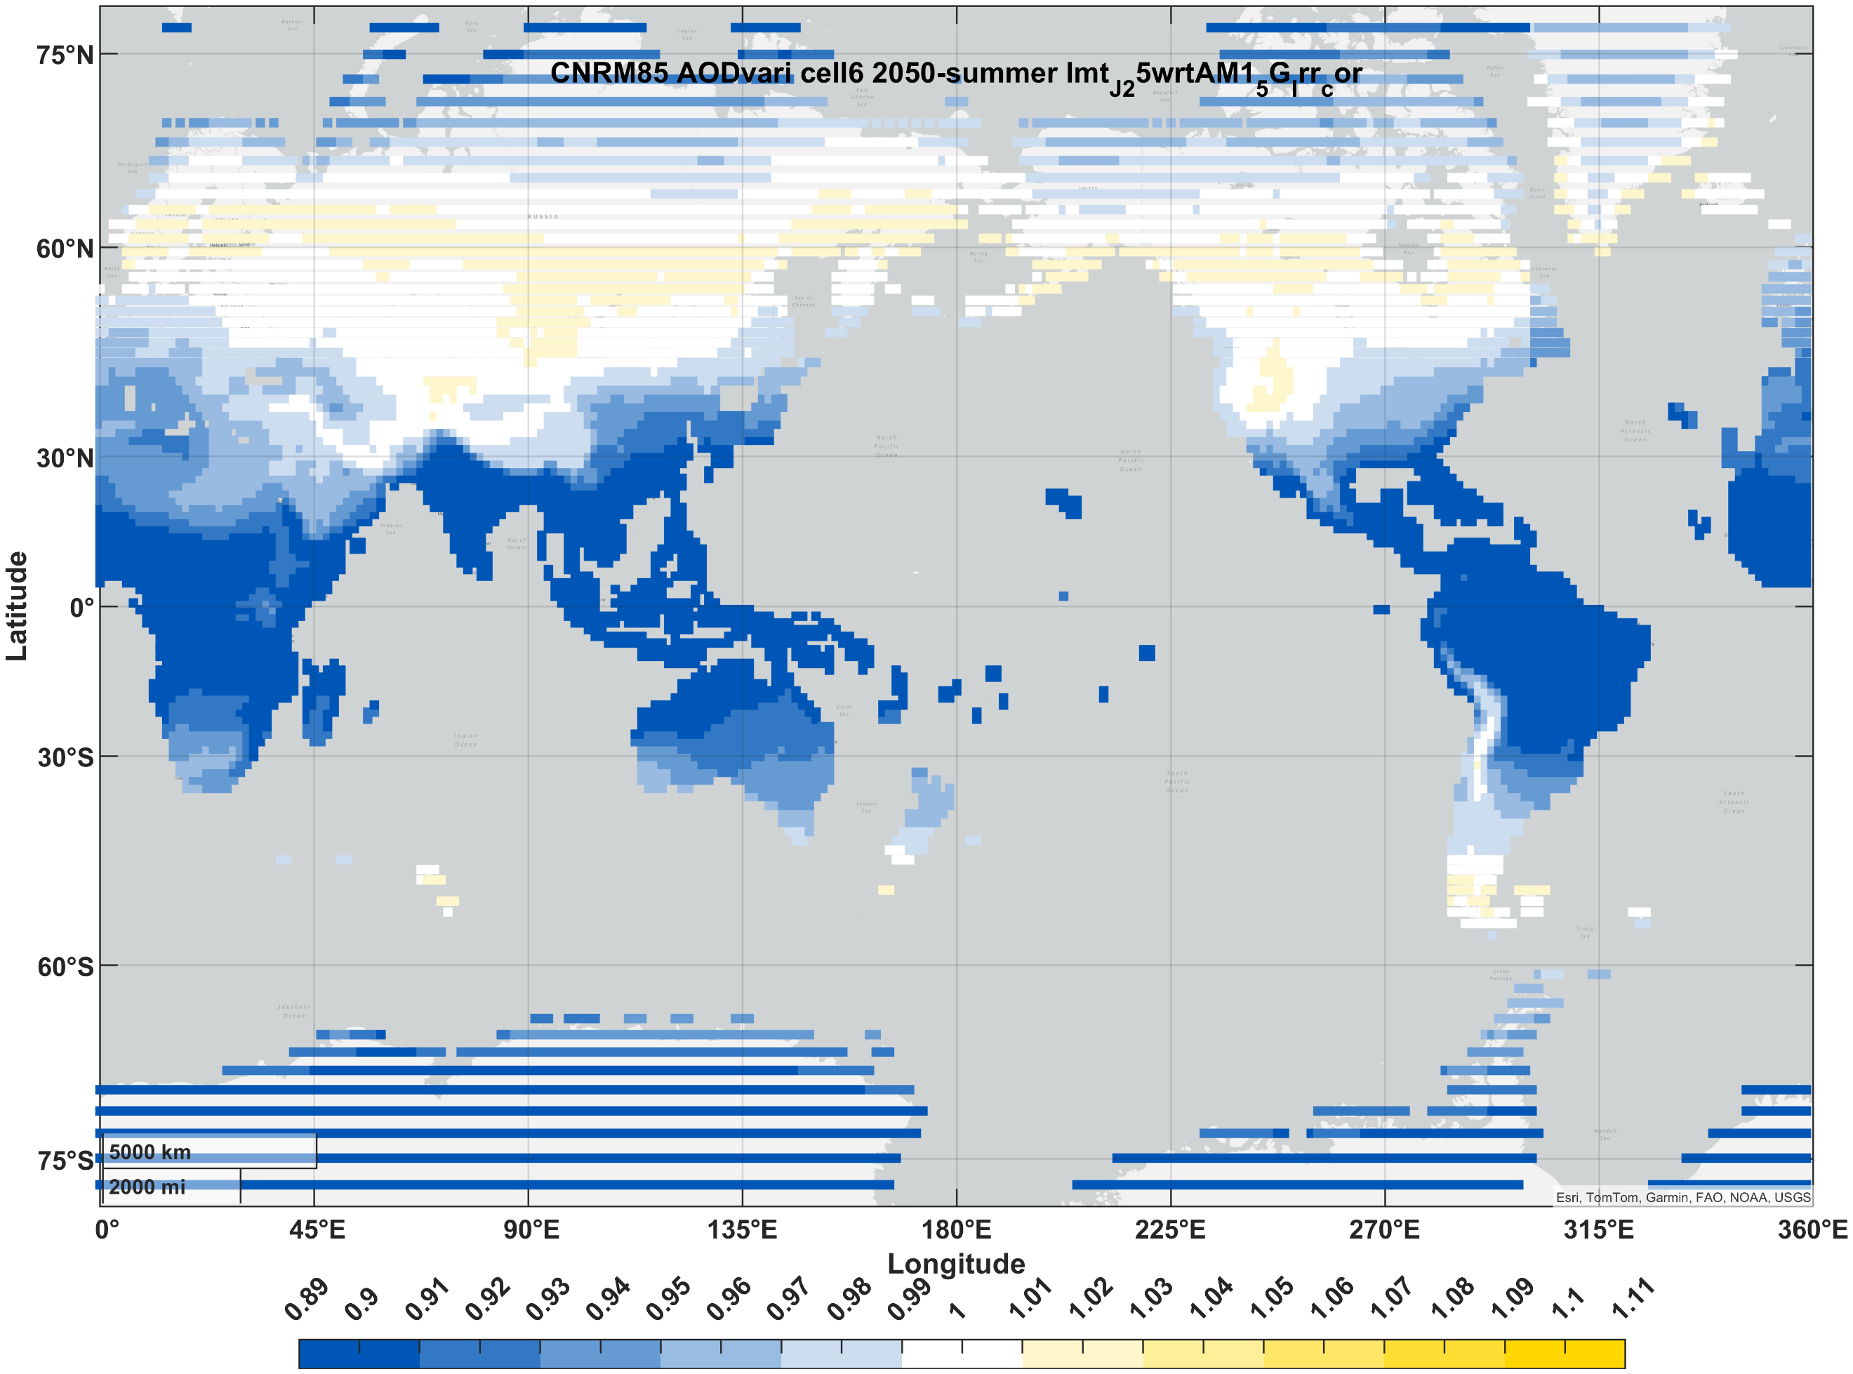 | 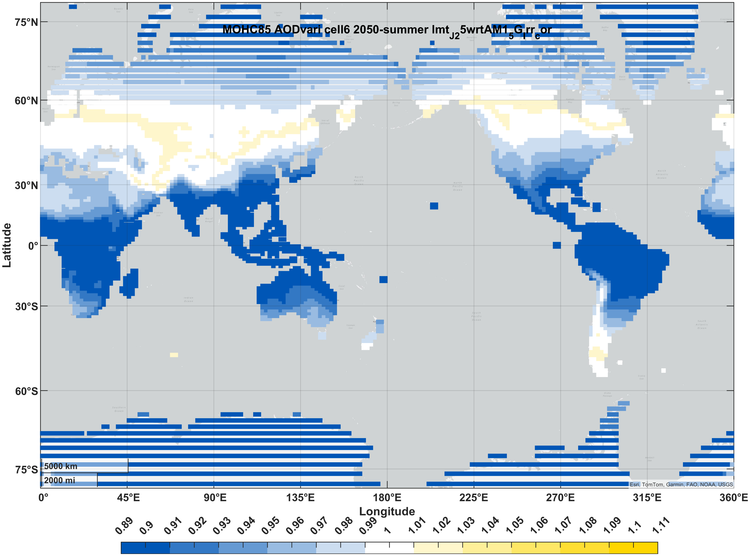 | 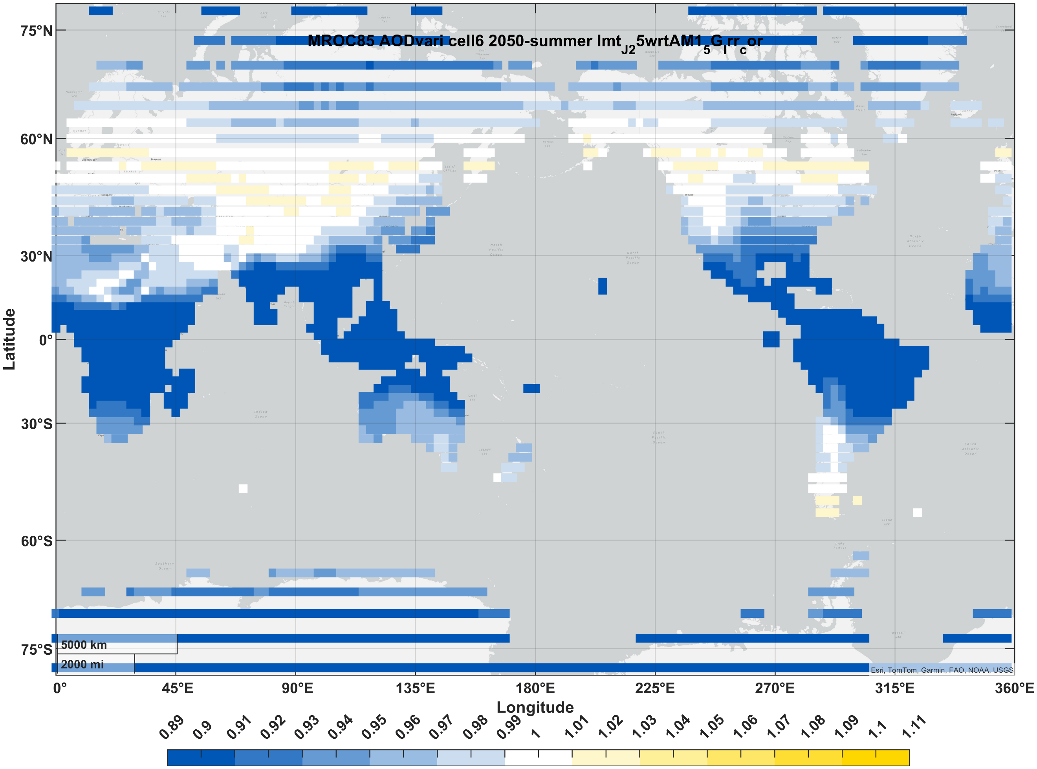 | 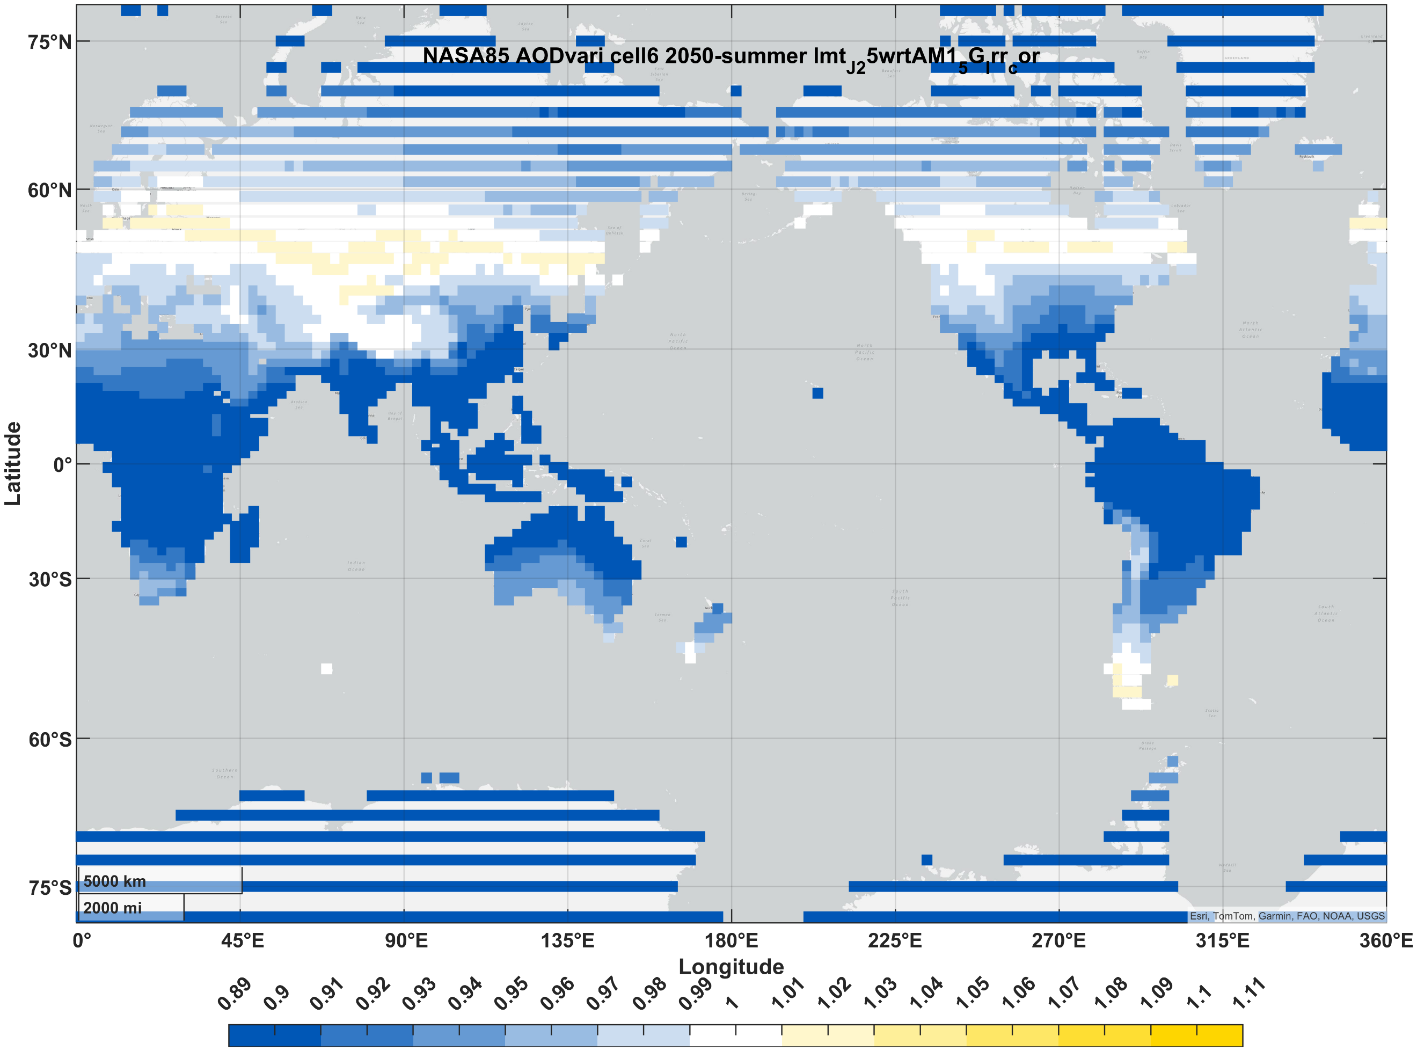 | 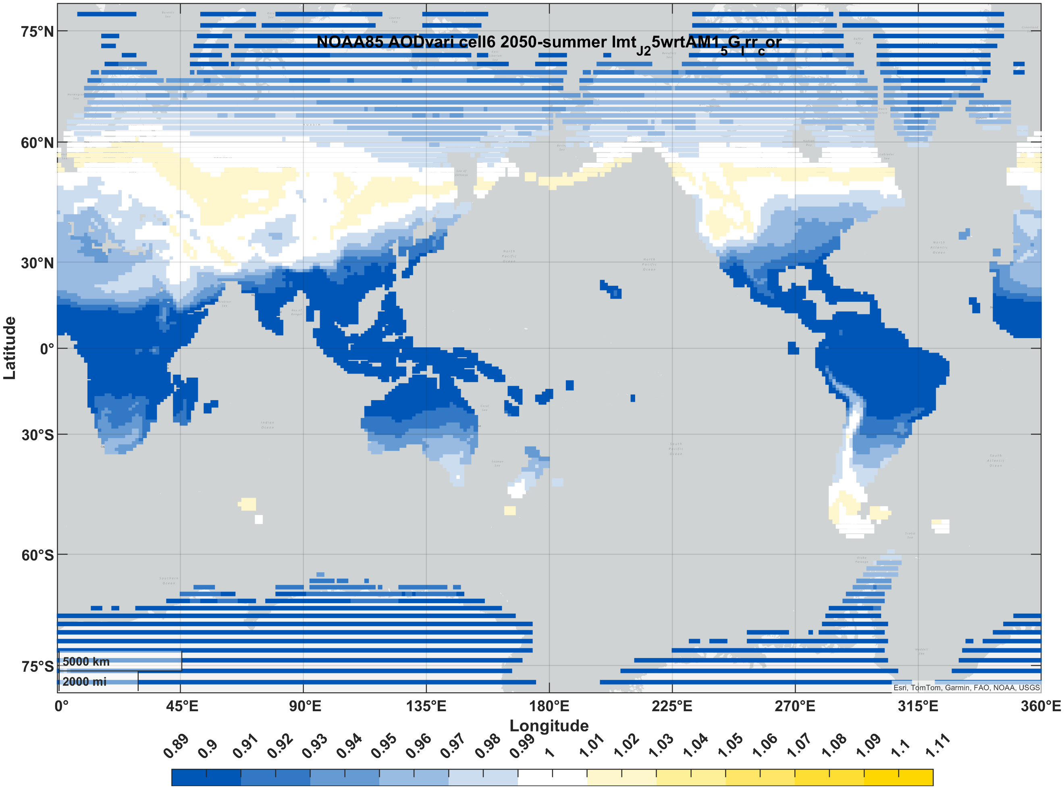

Table 6. Table 7. Predicted 2080 solar cell short-circuit current relative to that under the standard spectrum (AM1.5G). Currents are normalized to 1000 W/m² irradiance. “Summer”/ “winter” correspond to months 7-9/1-3 in the northern hemisphere and 1-3/7-9 in the southern hemisphere.
 |  | CNRM | MOHC | MIROC | NASA | NOAA
Si (1J) | winter | 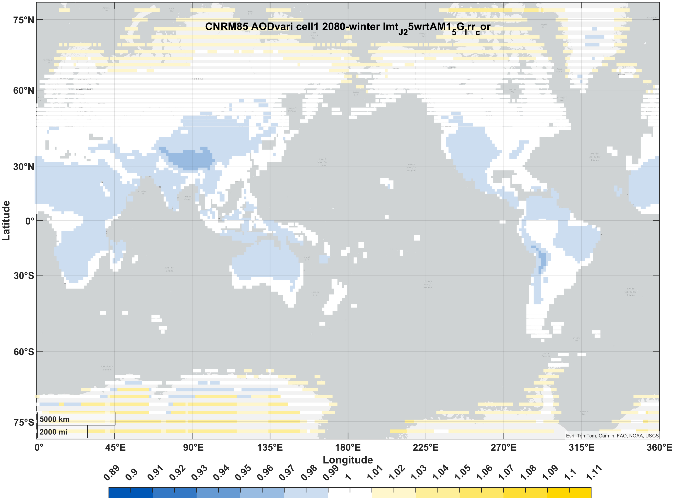 | 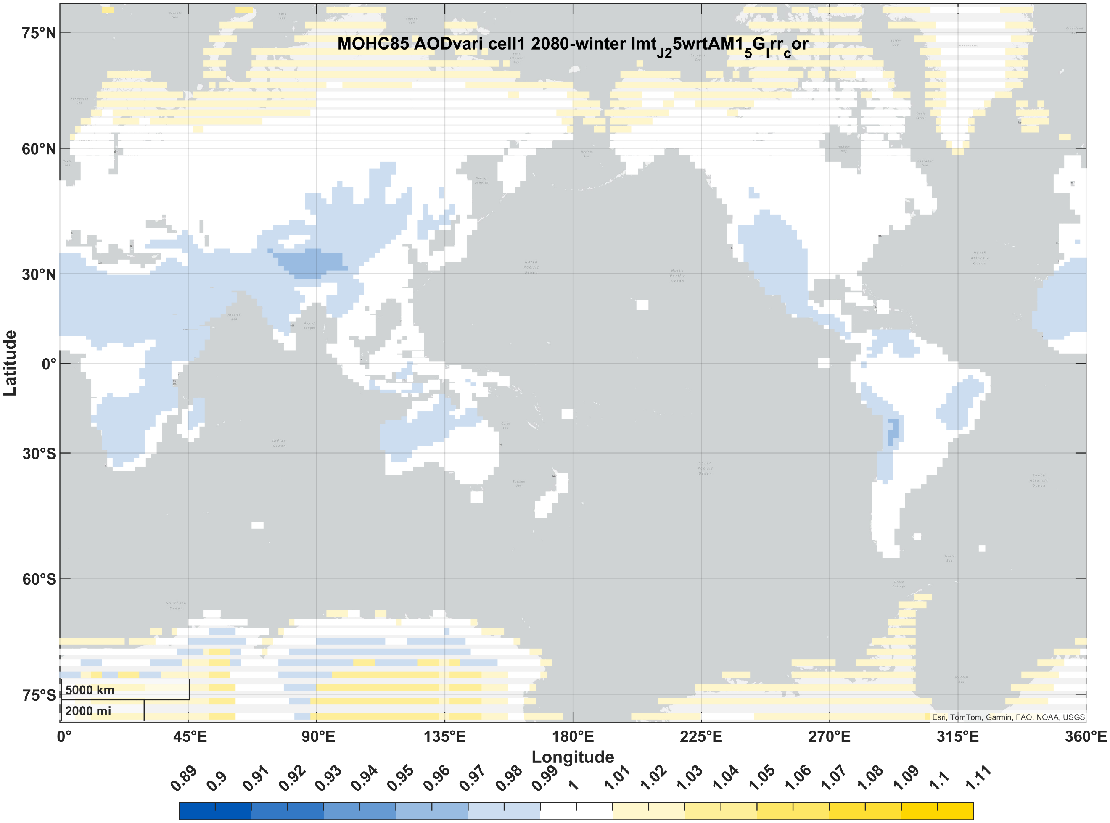 | 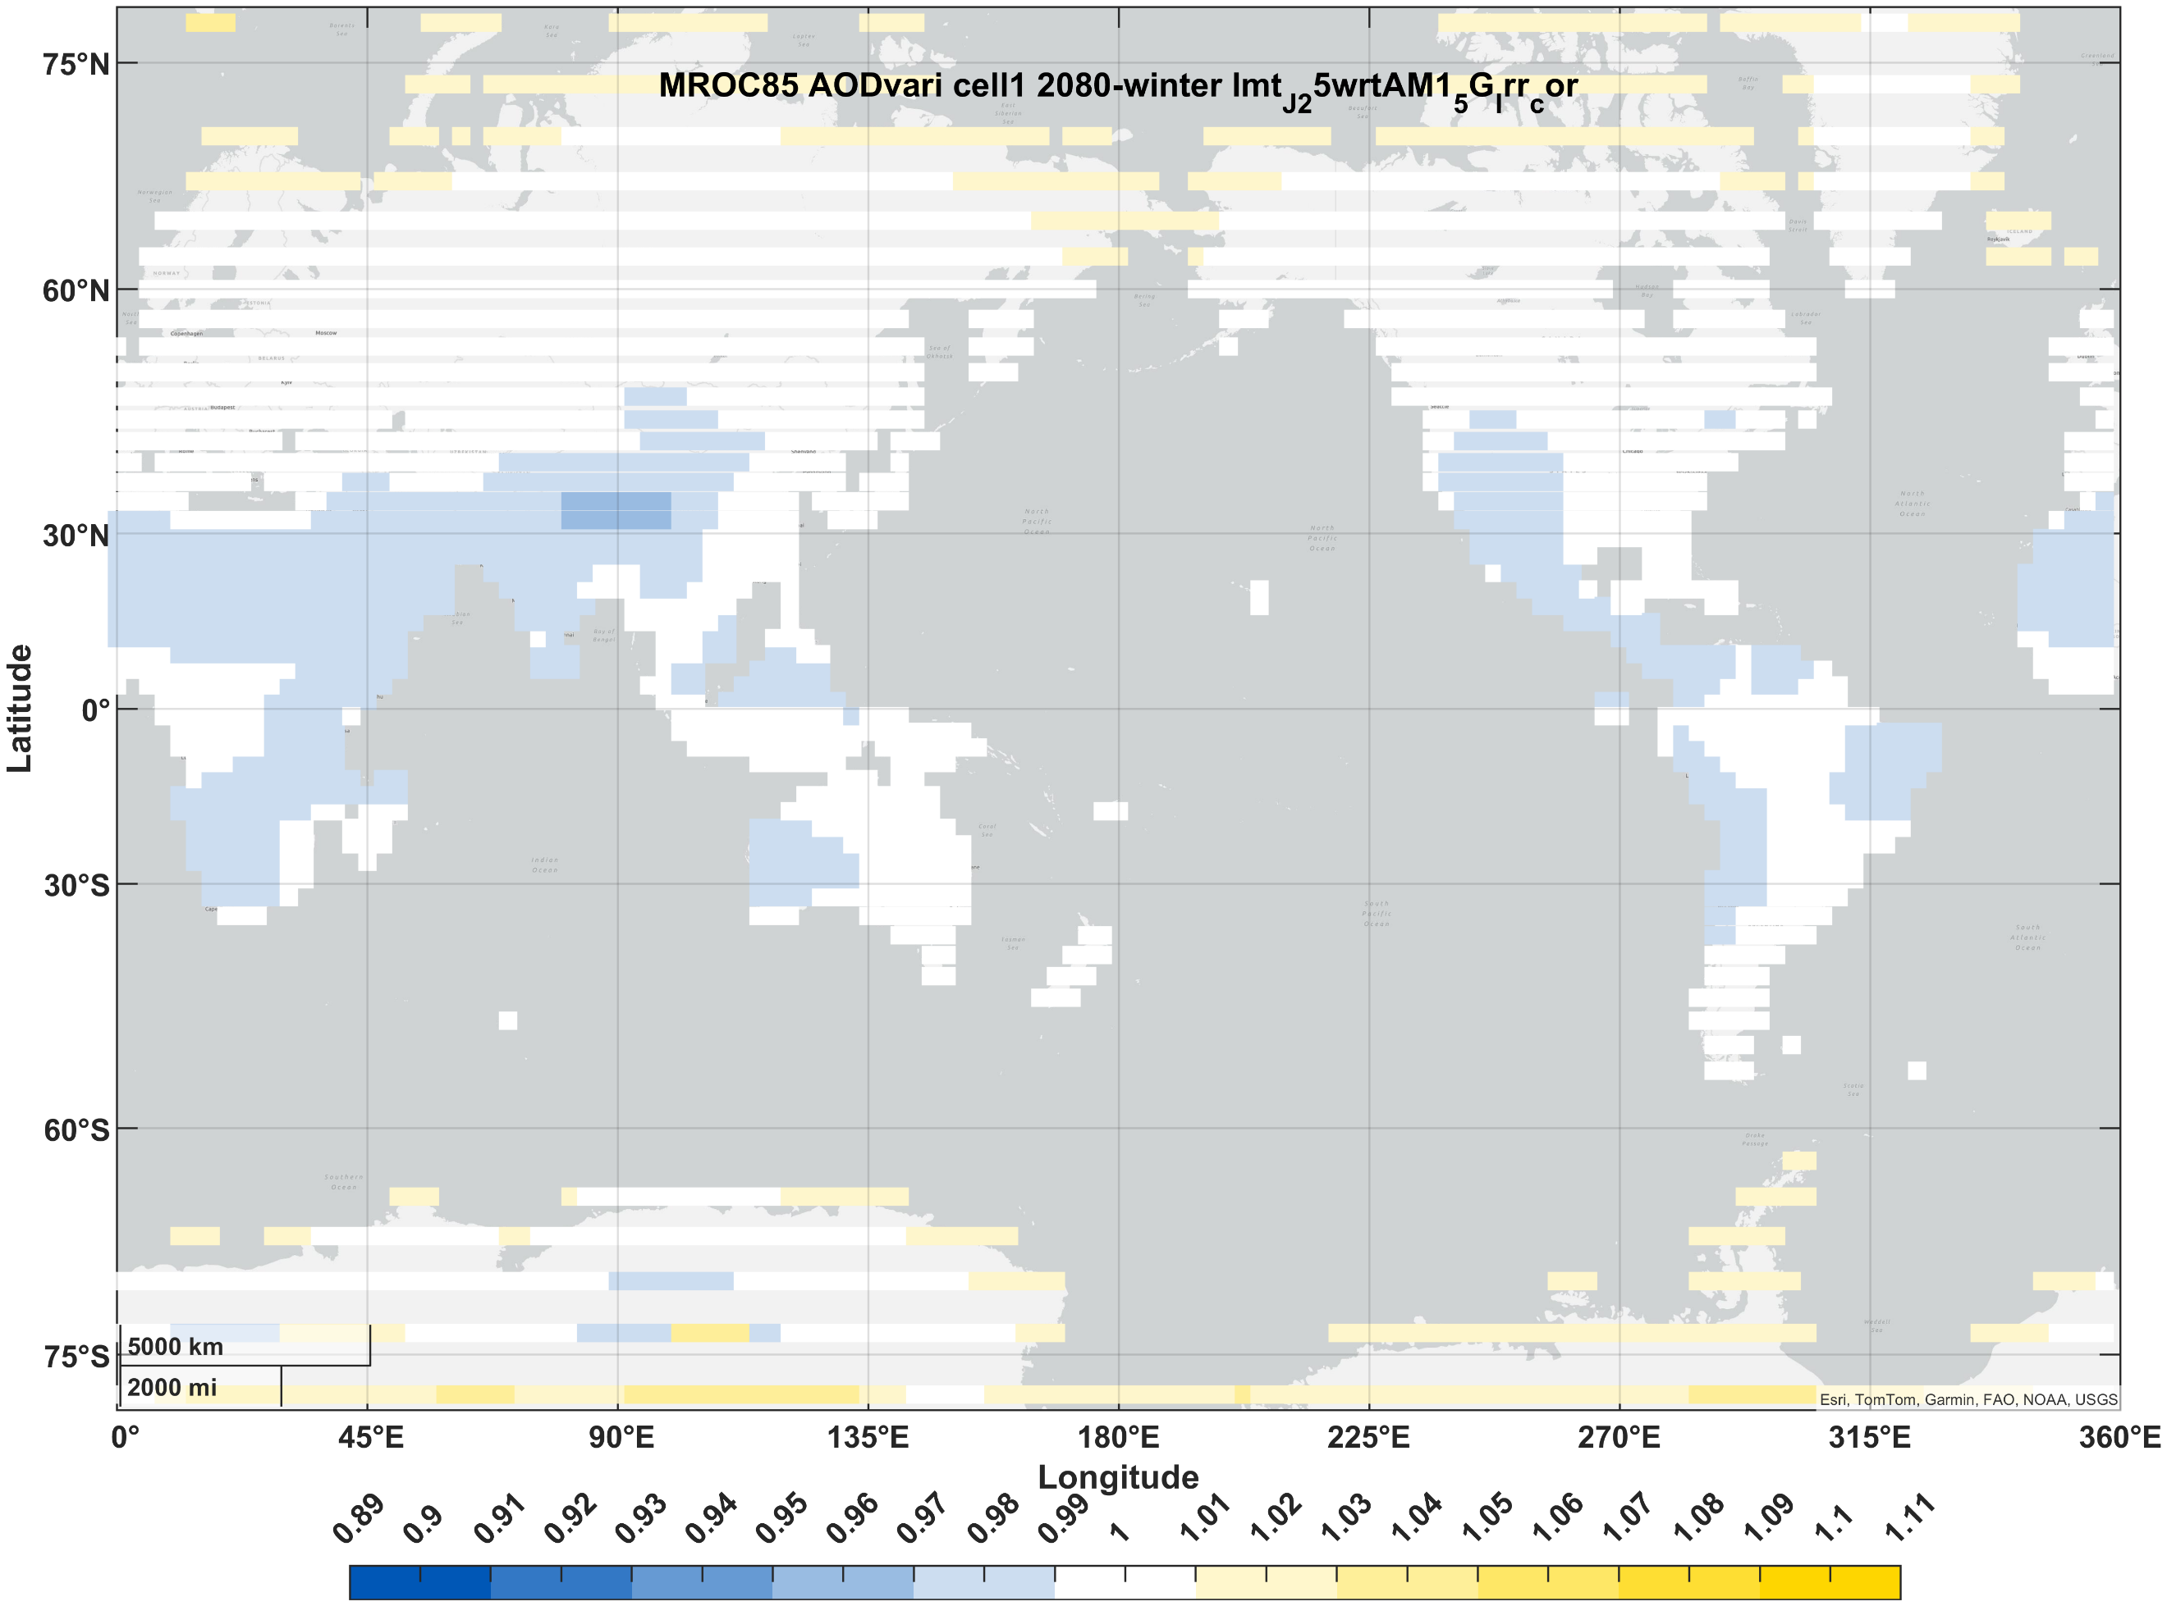 | 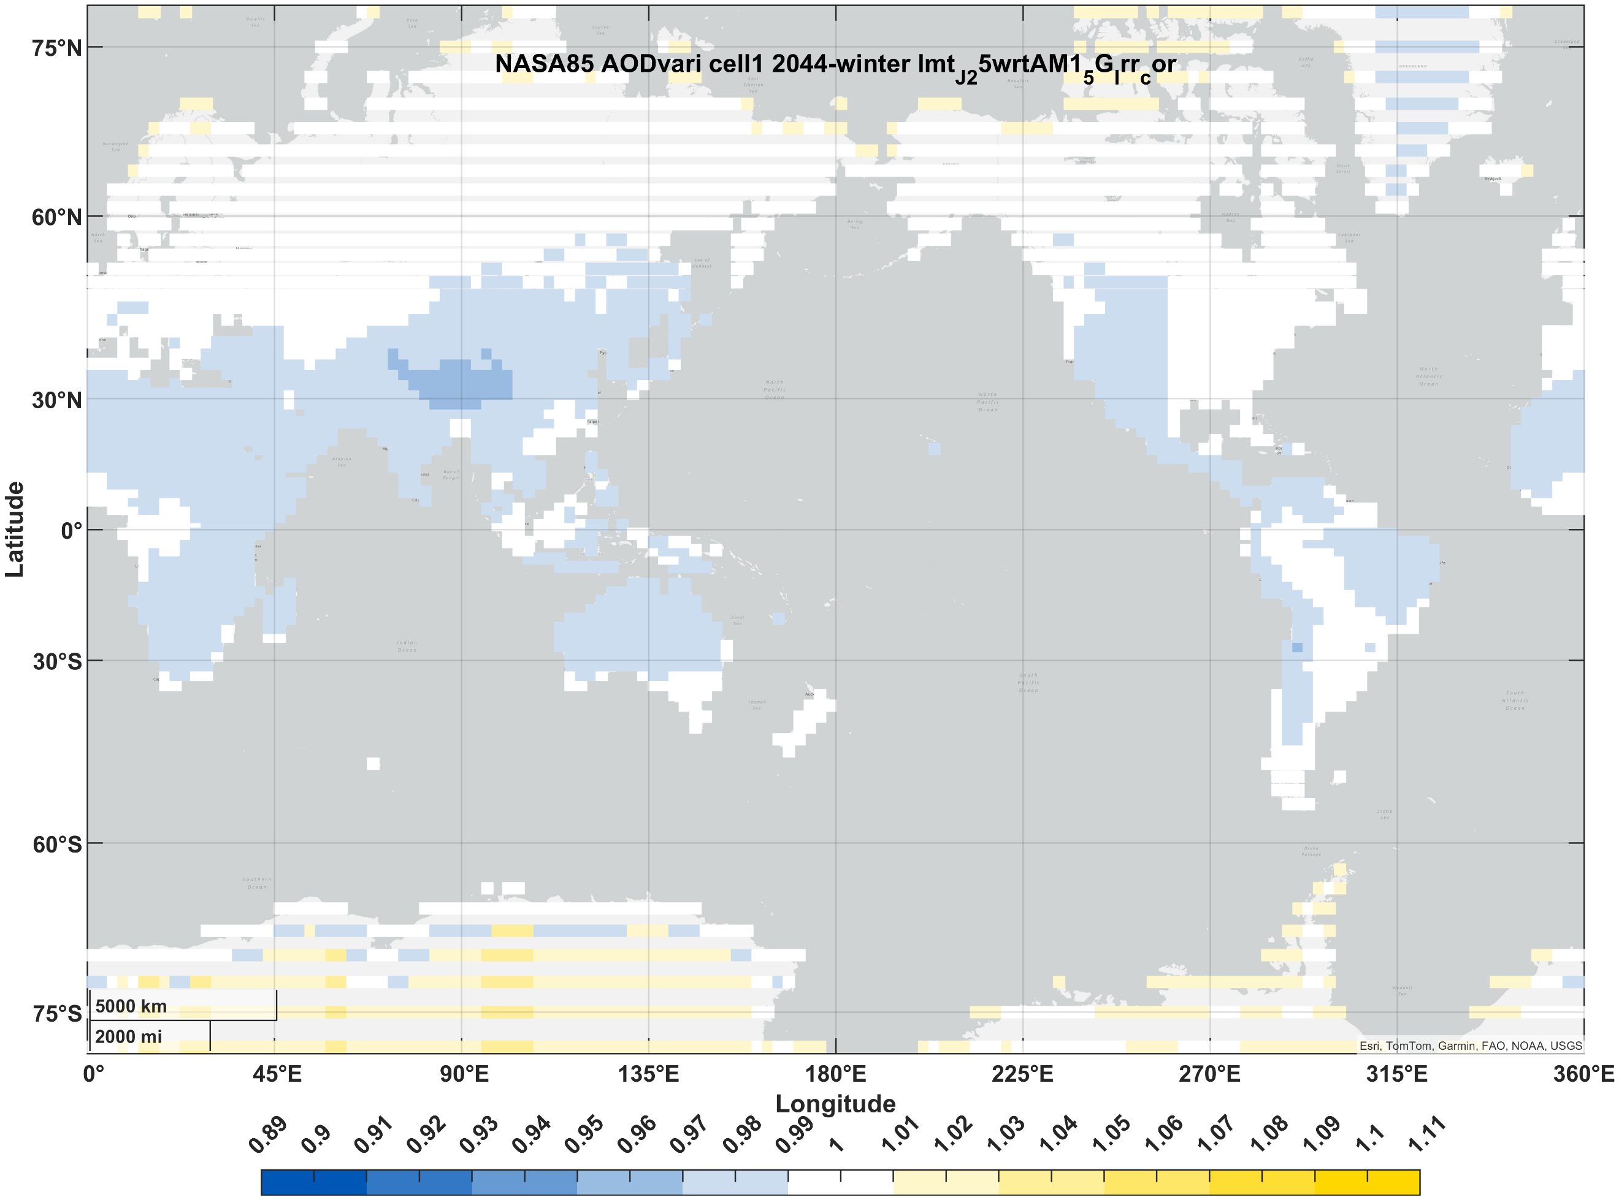 | 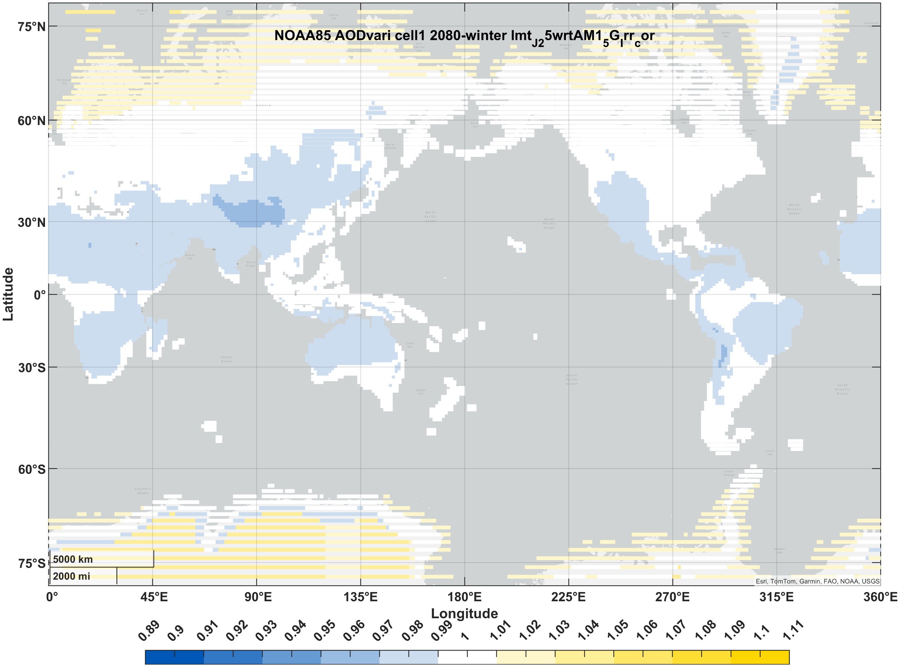
Si (1J) | summer | 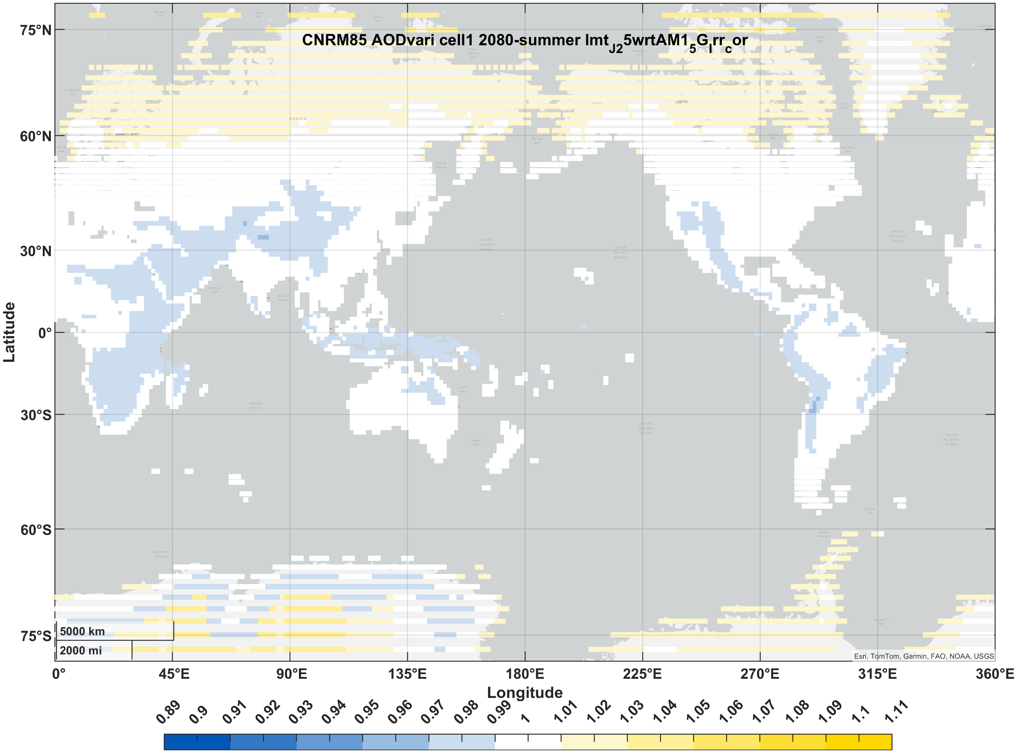 | 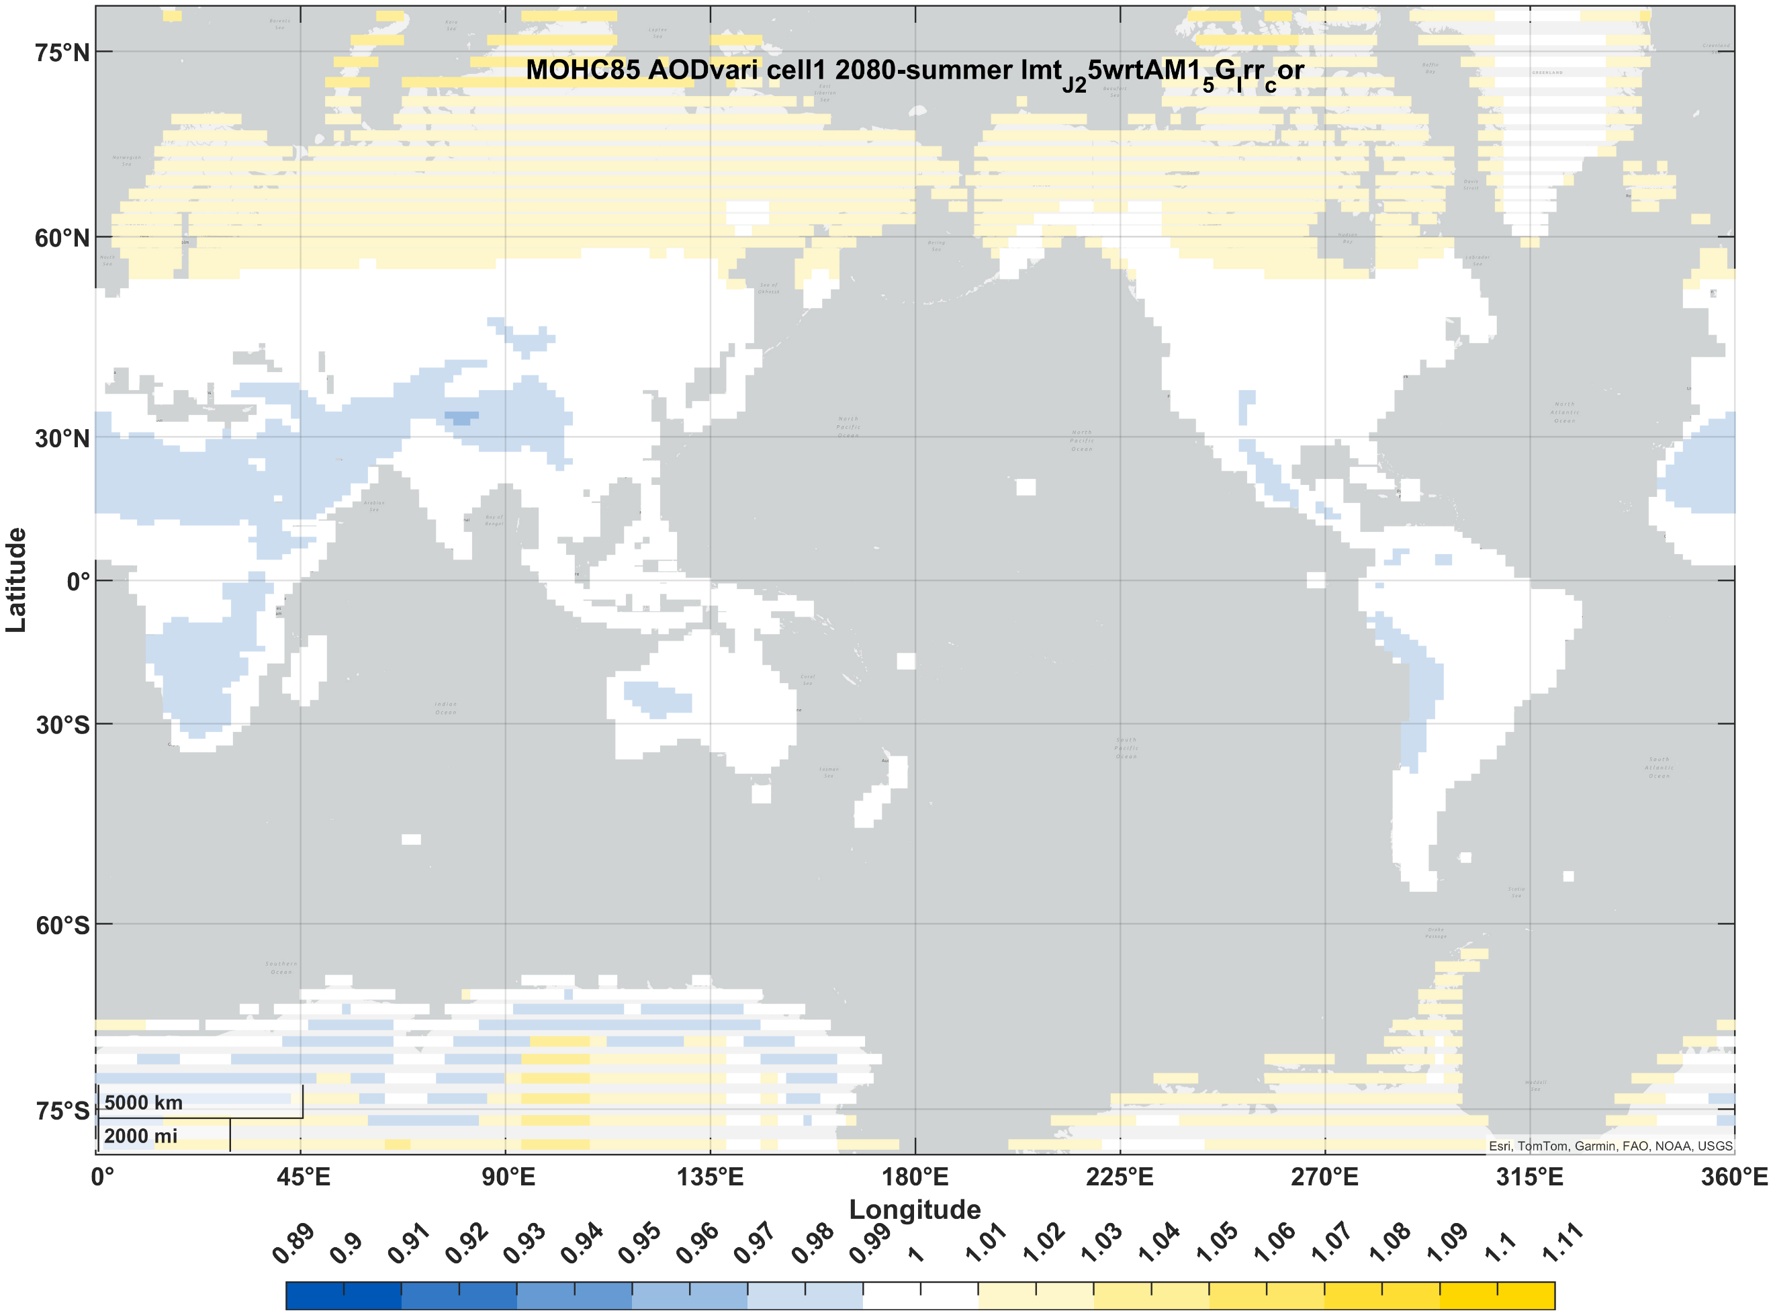 | 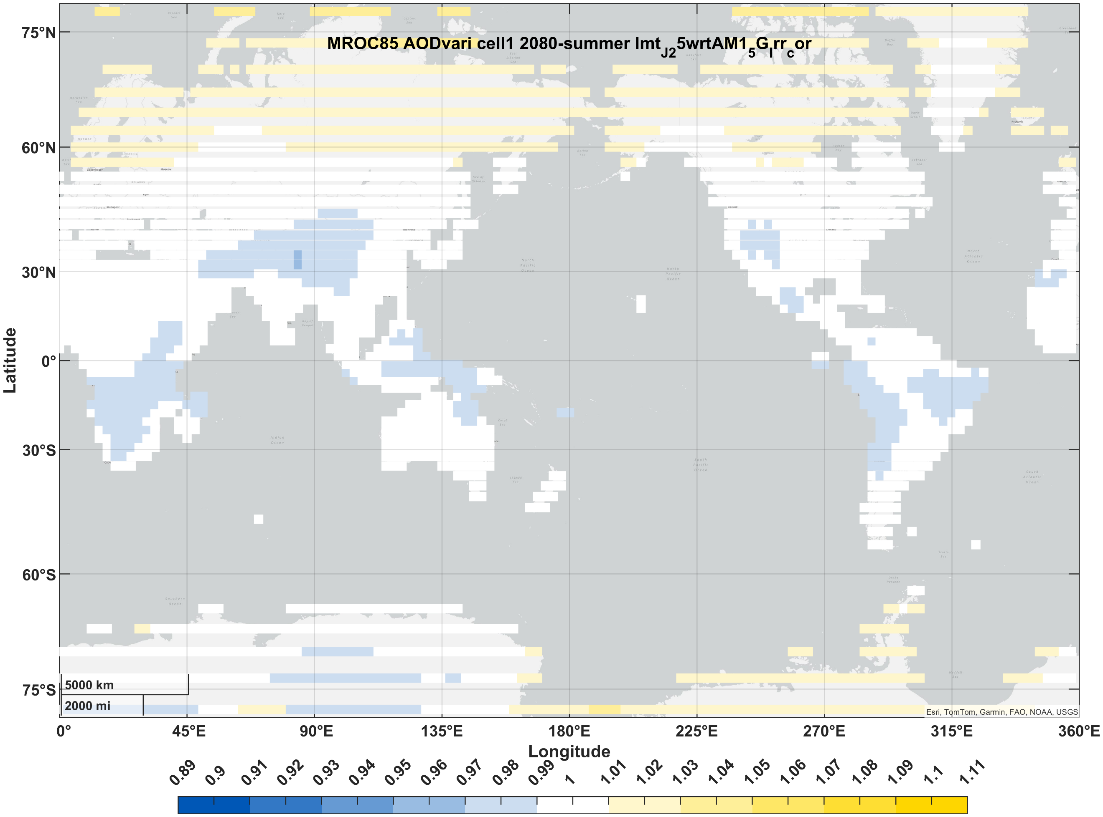 | 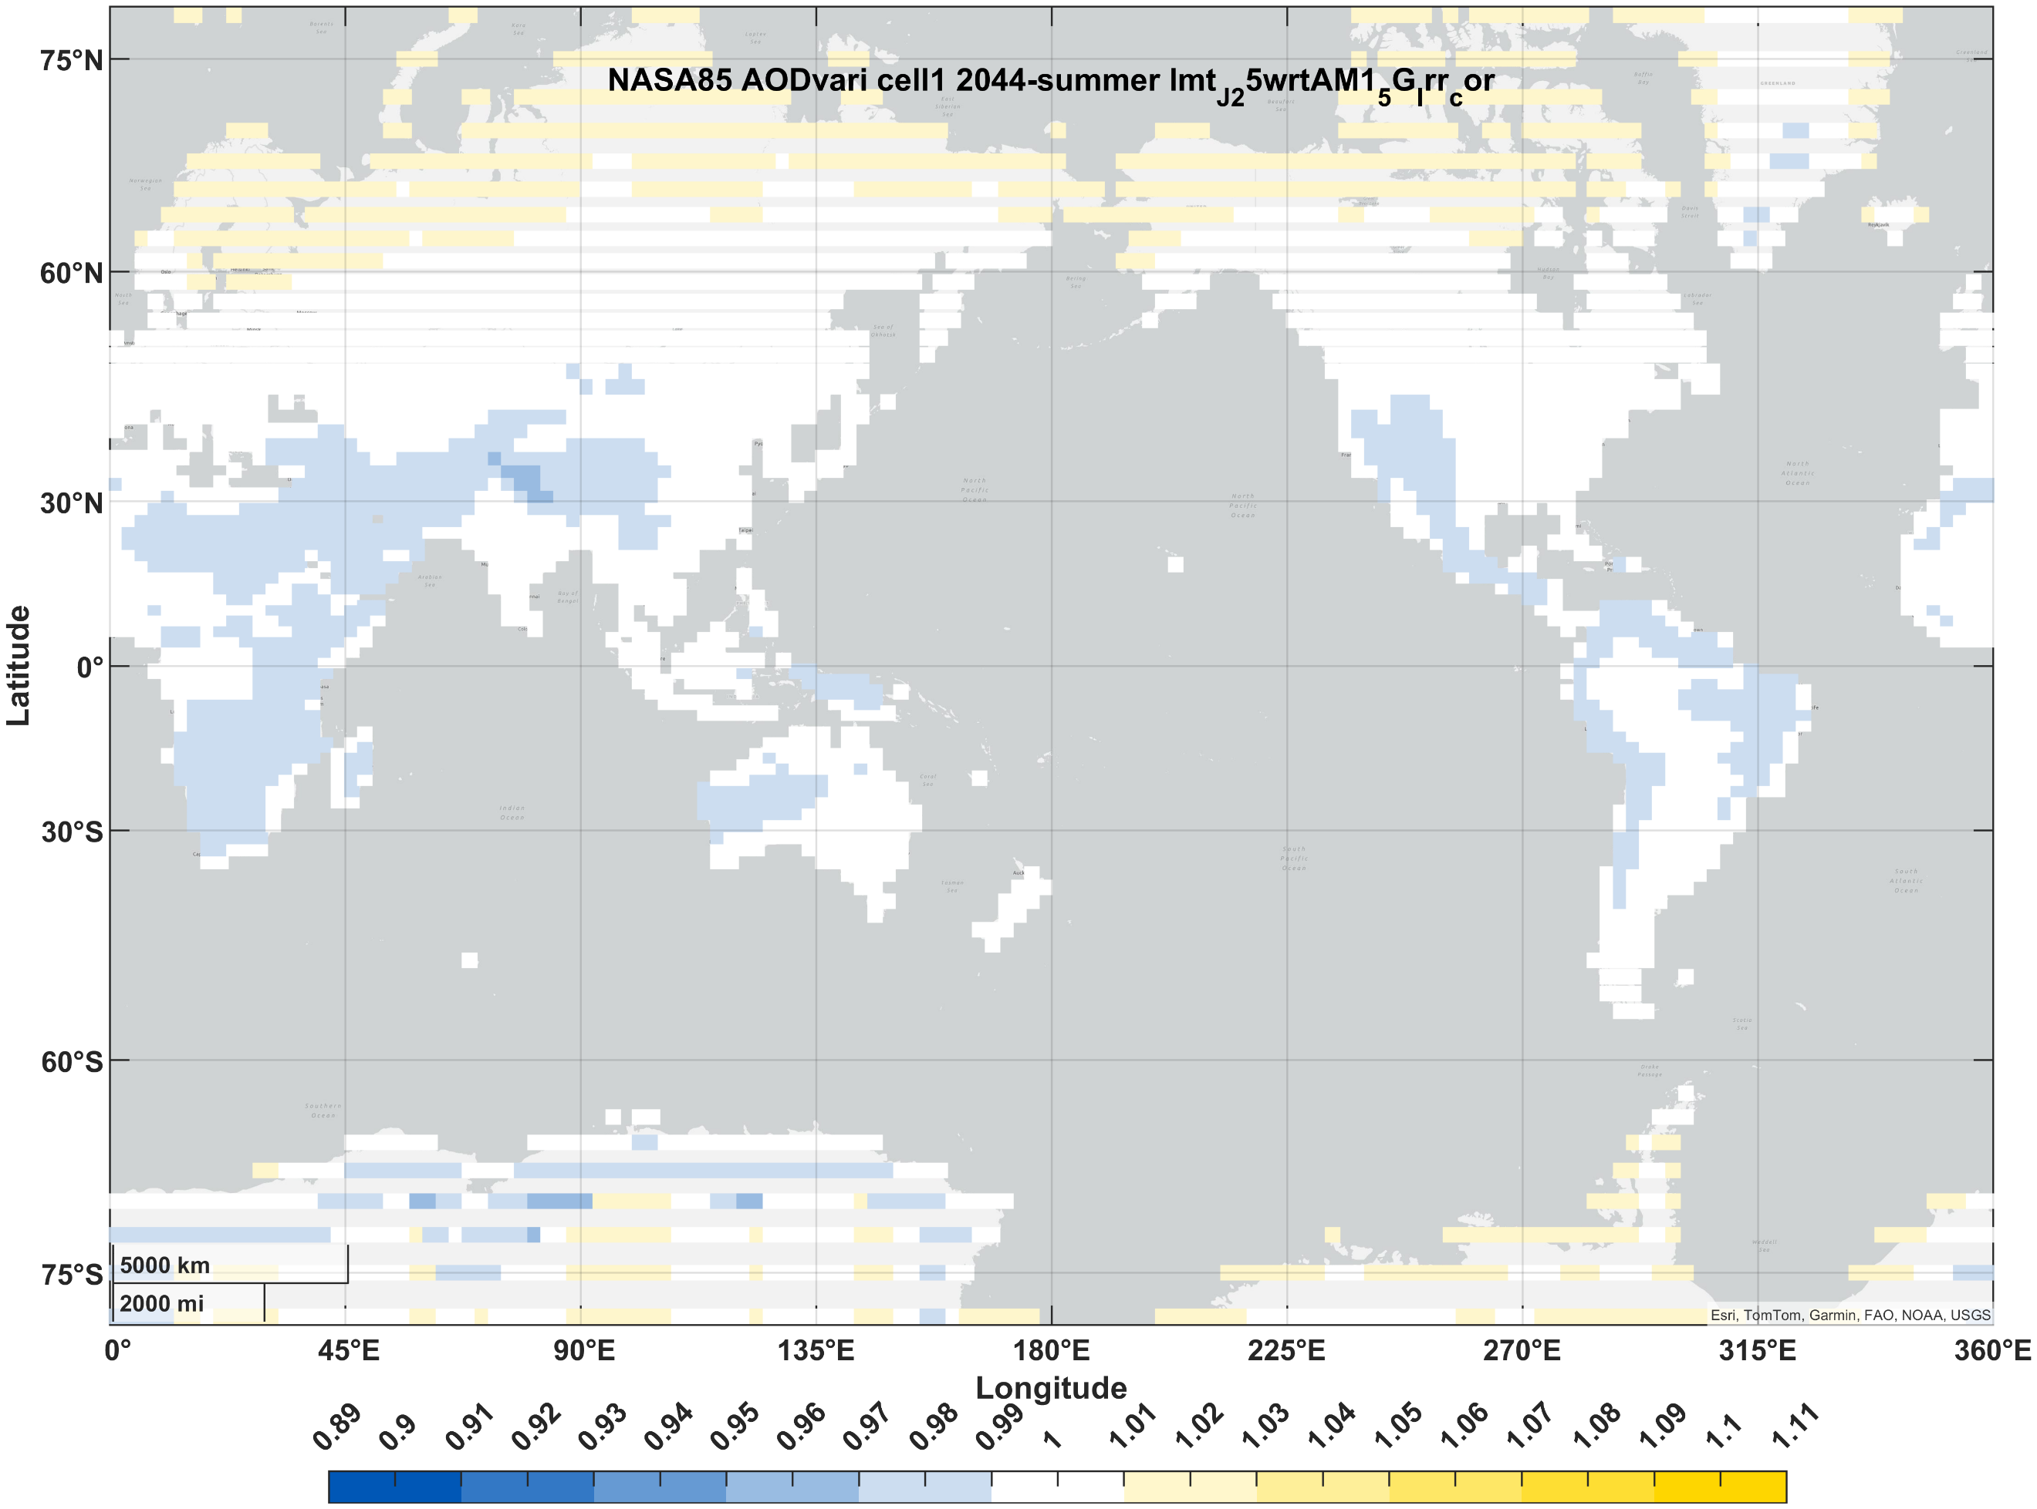 | 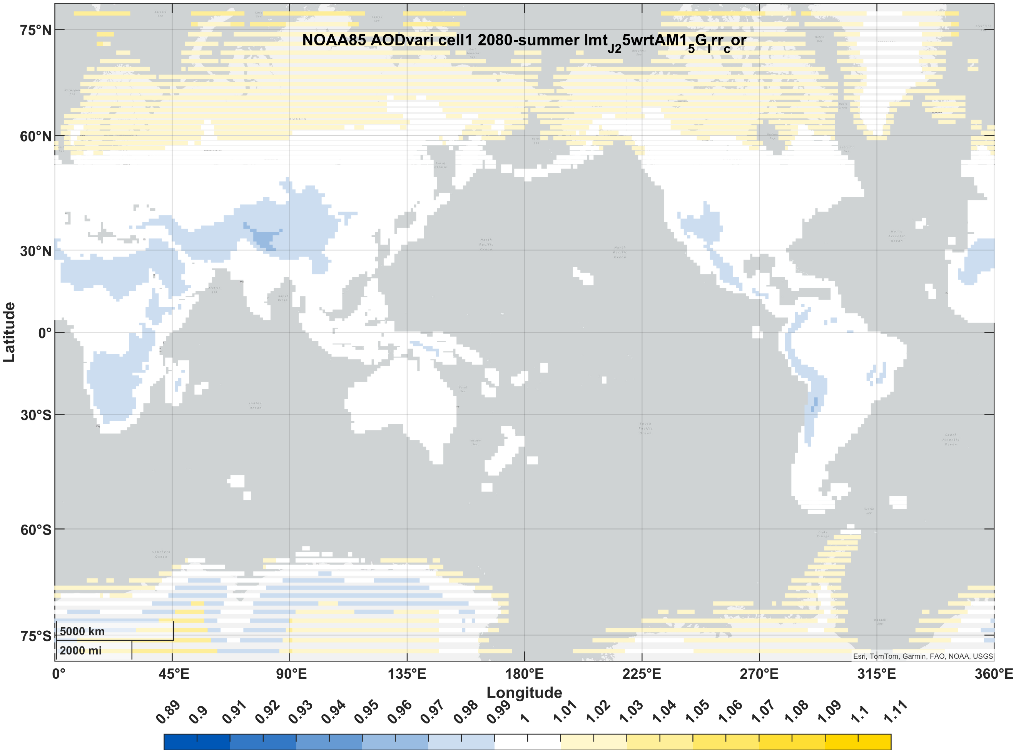
PVSK/Si (2J) | winter | 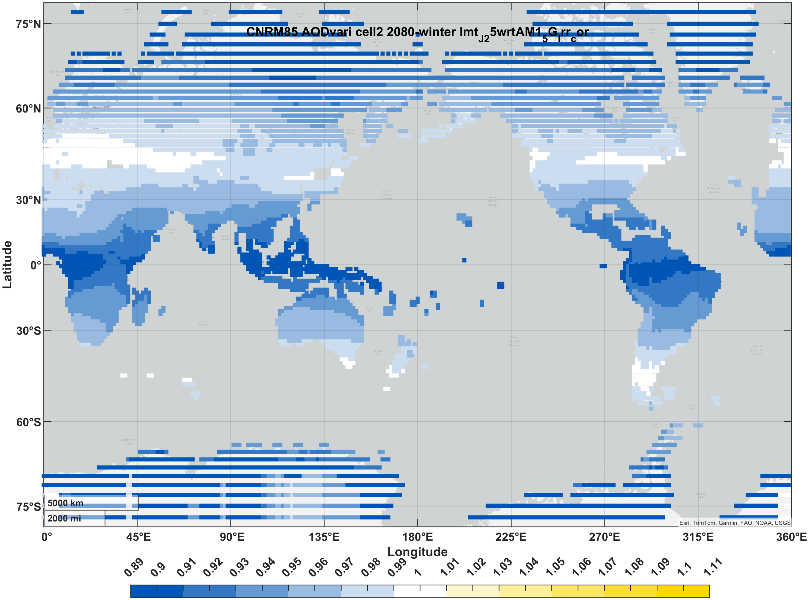 | 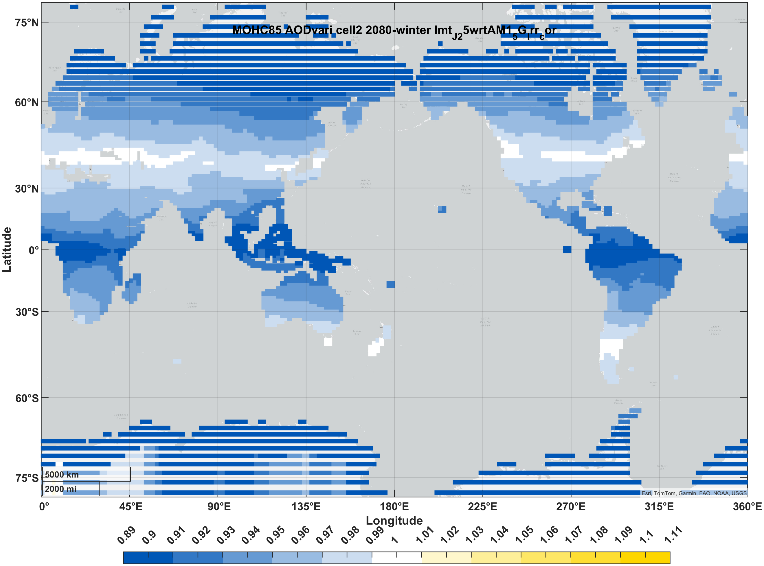 | 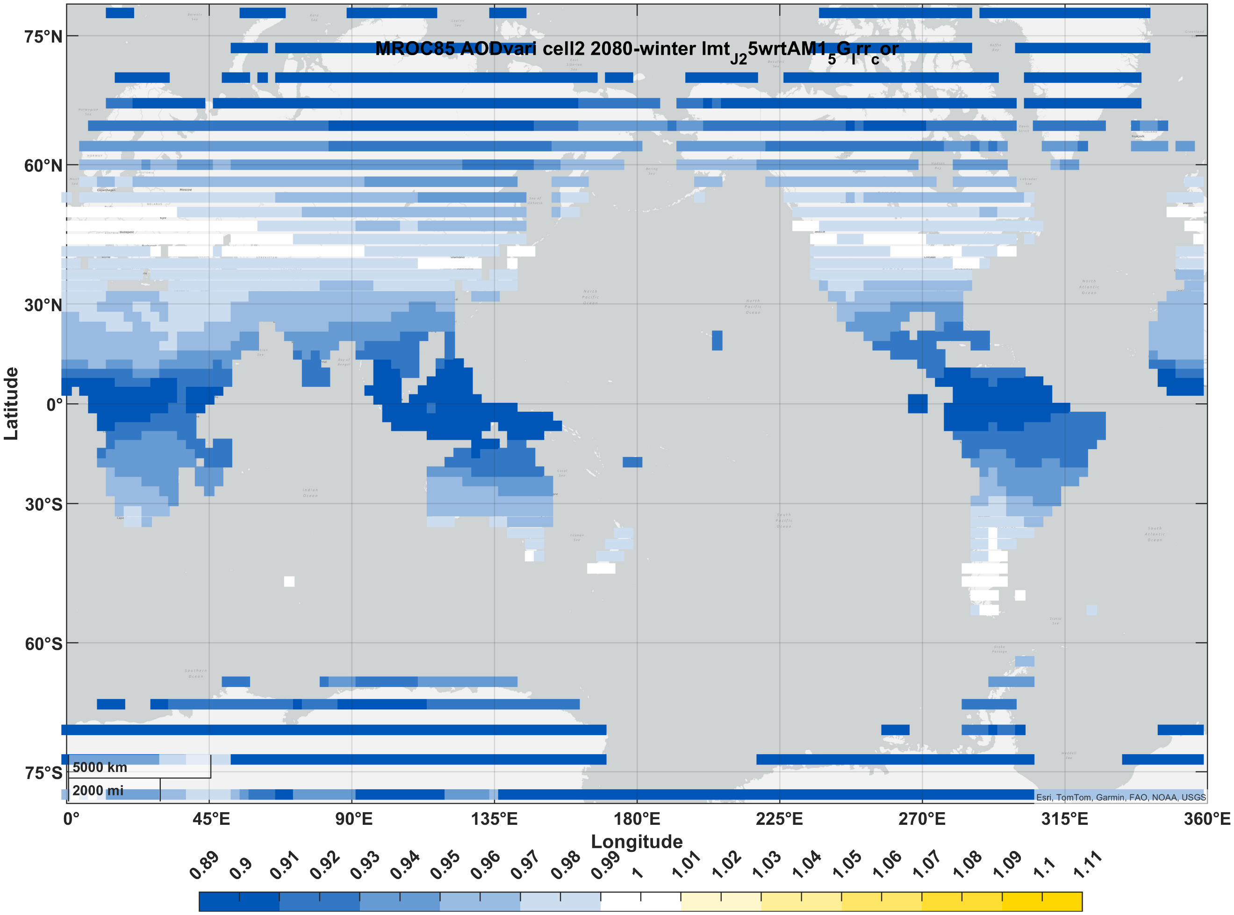 | 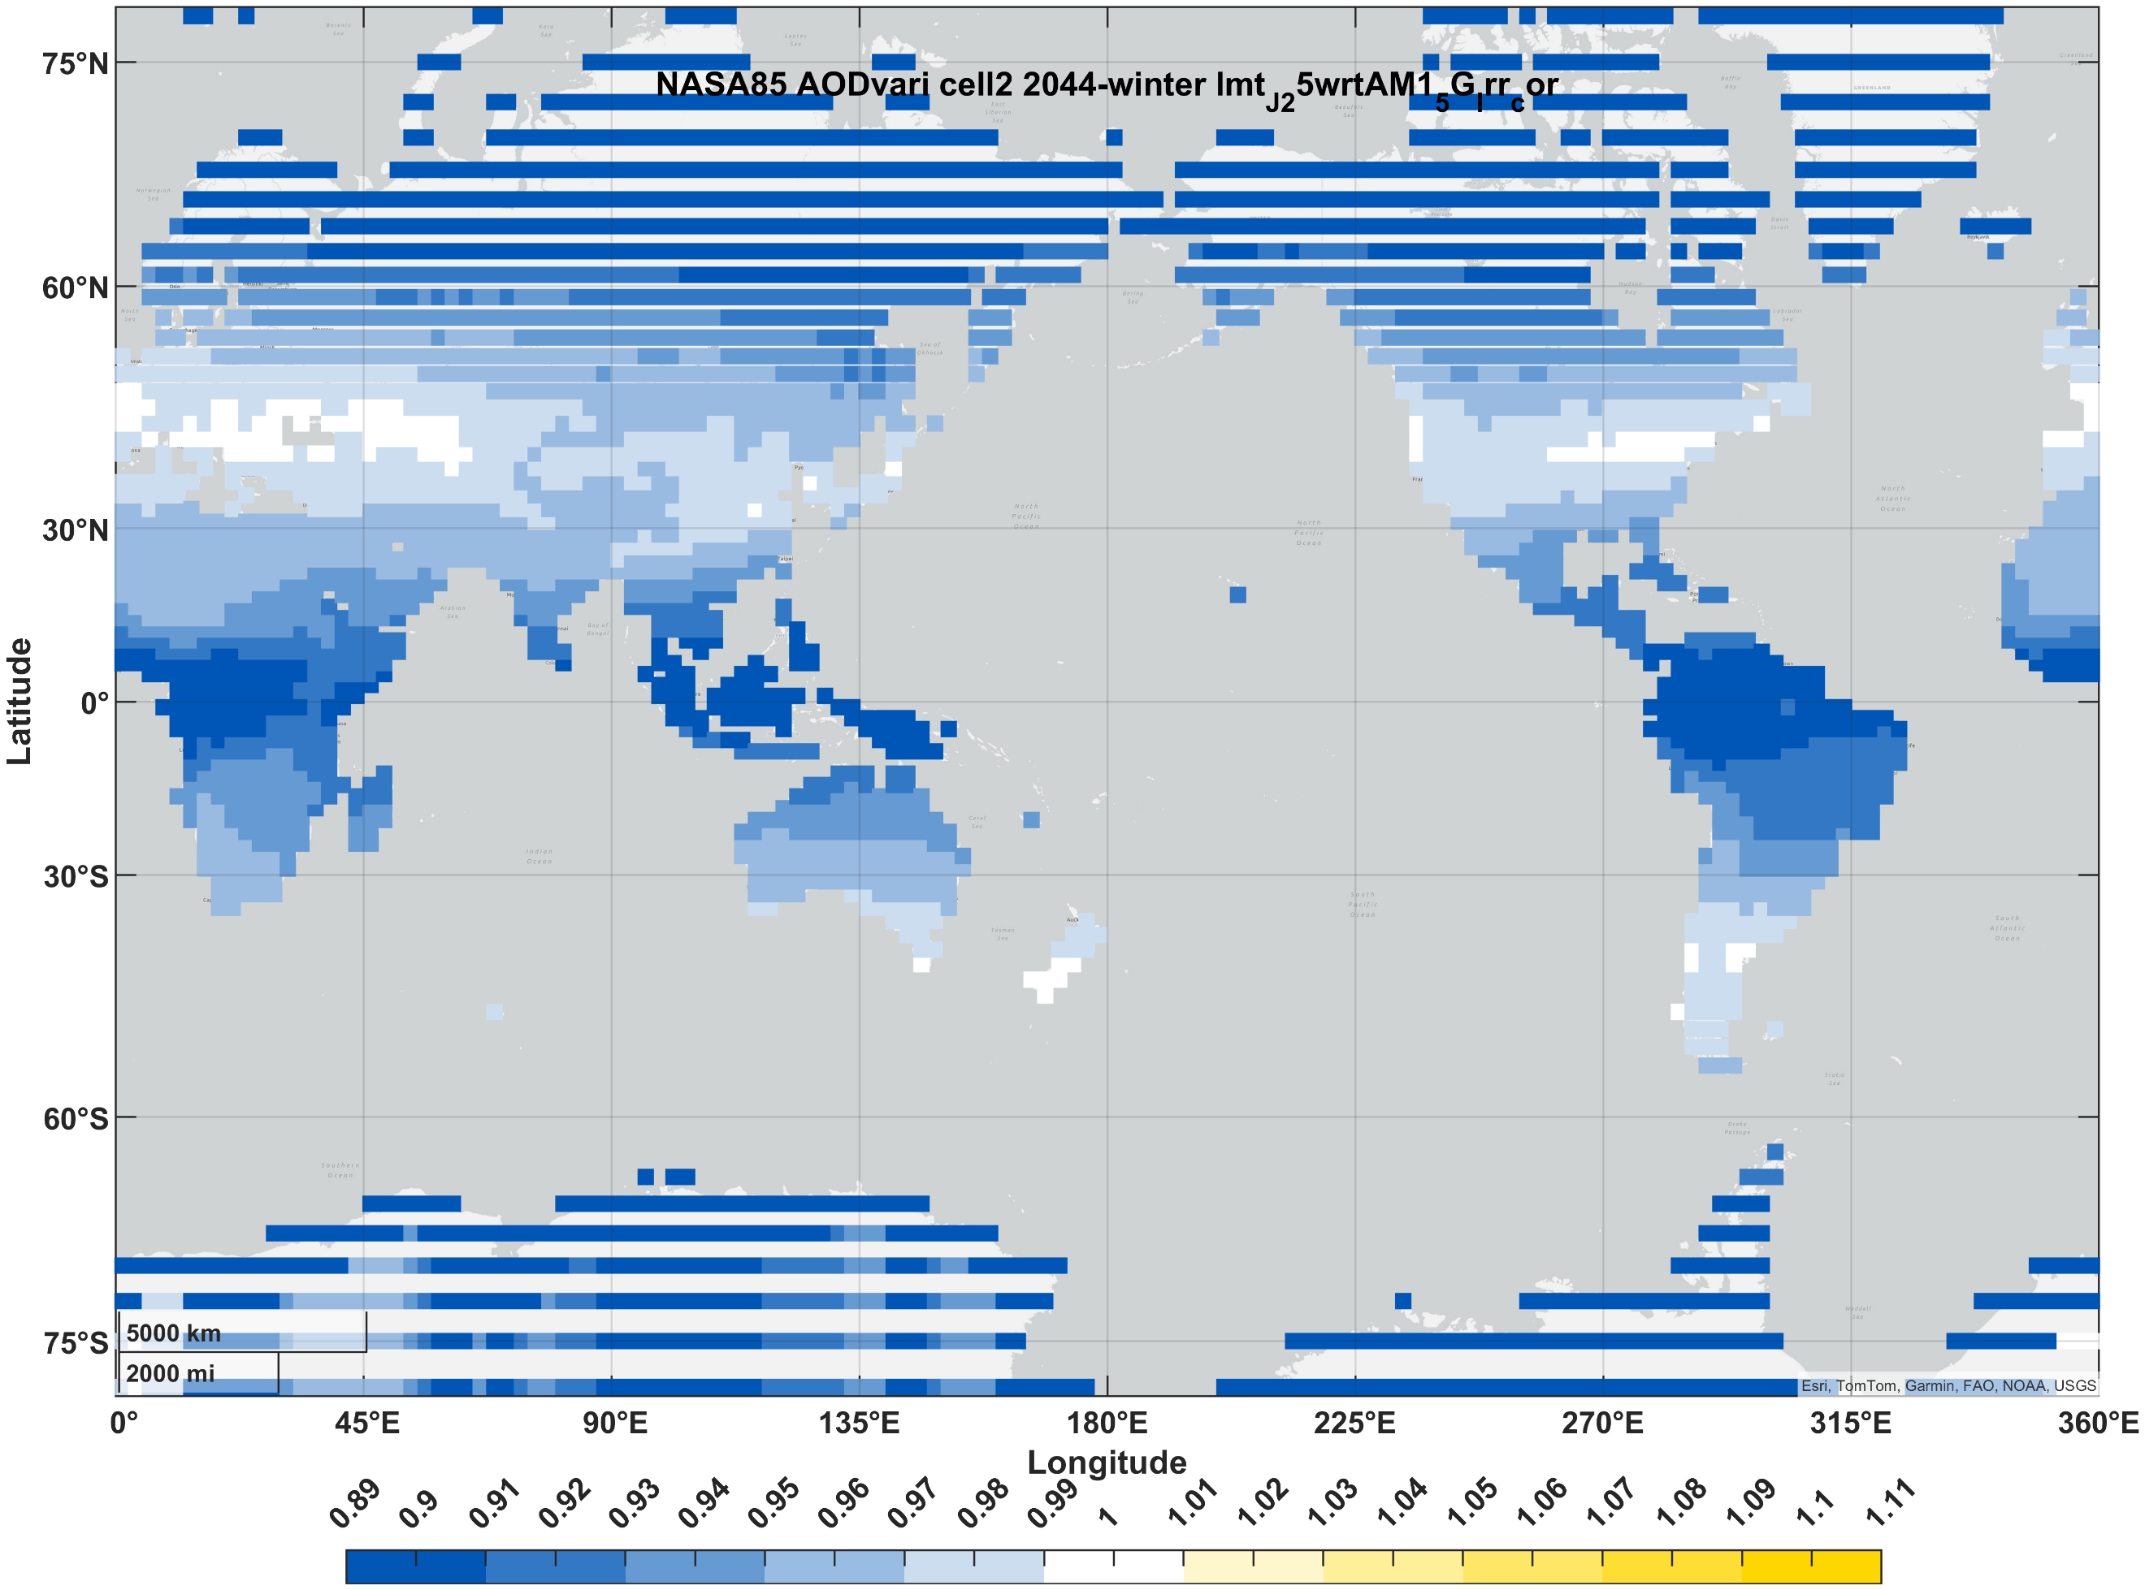 | 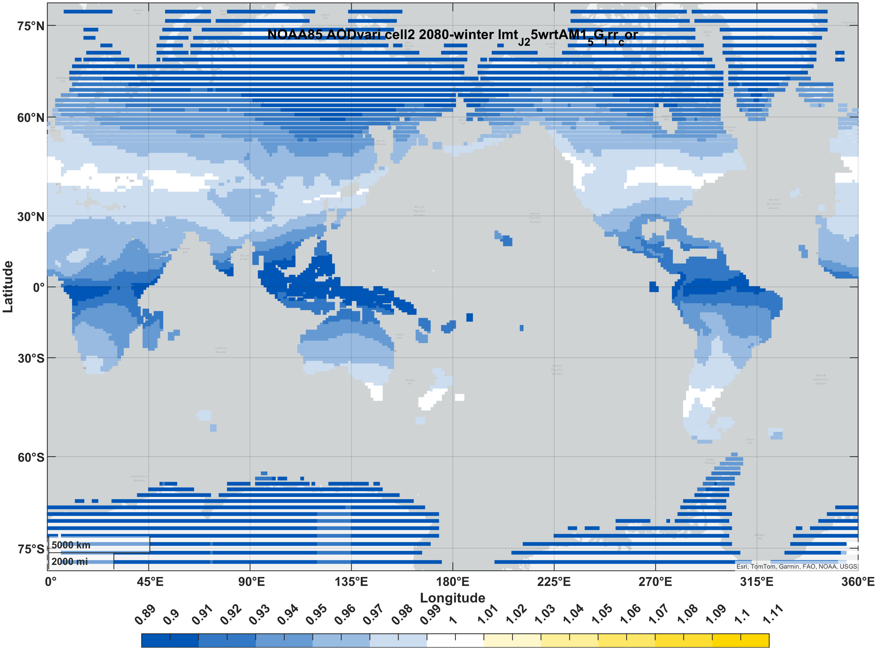
PVSK/Si (2J) | summer | 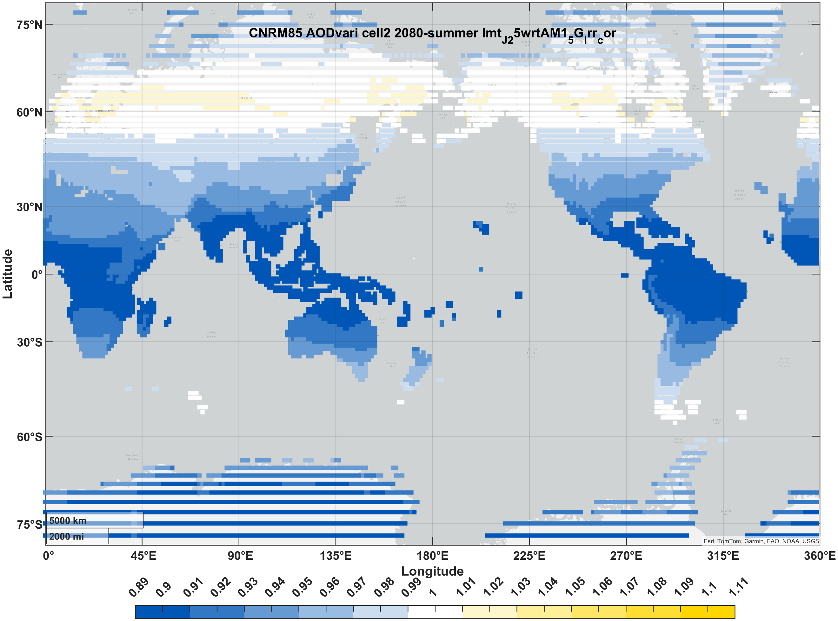 | 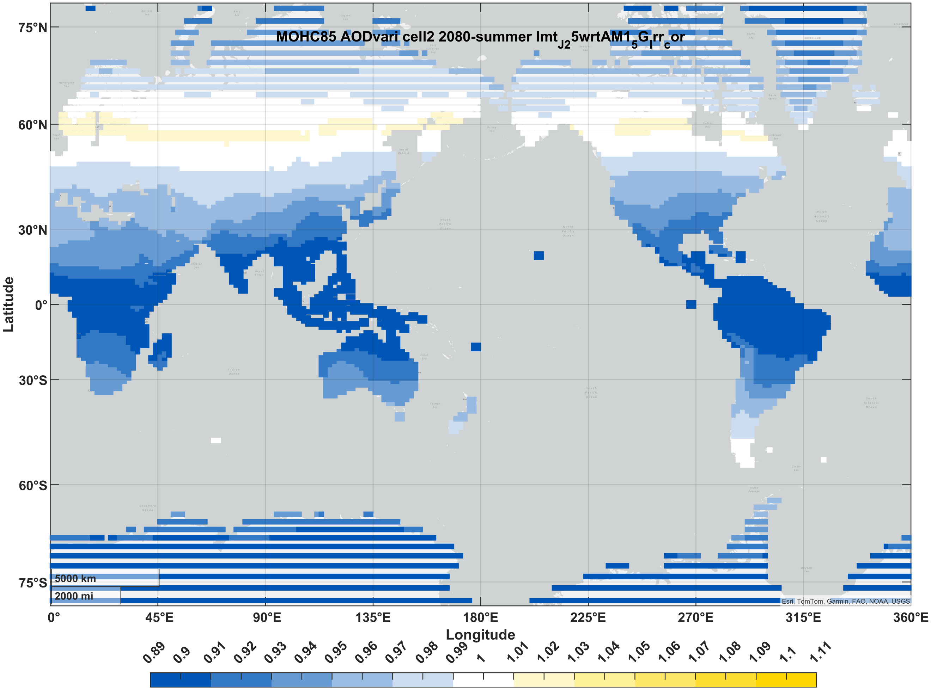 | 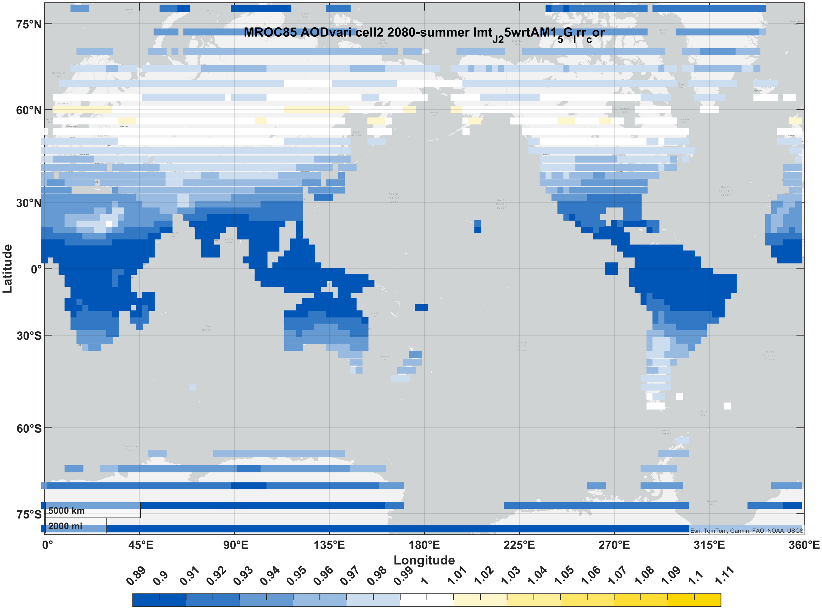 | 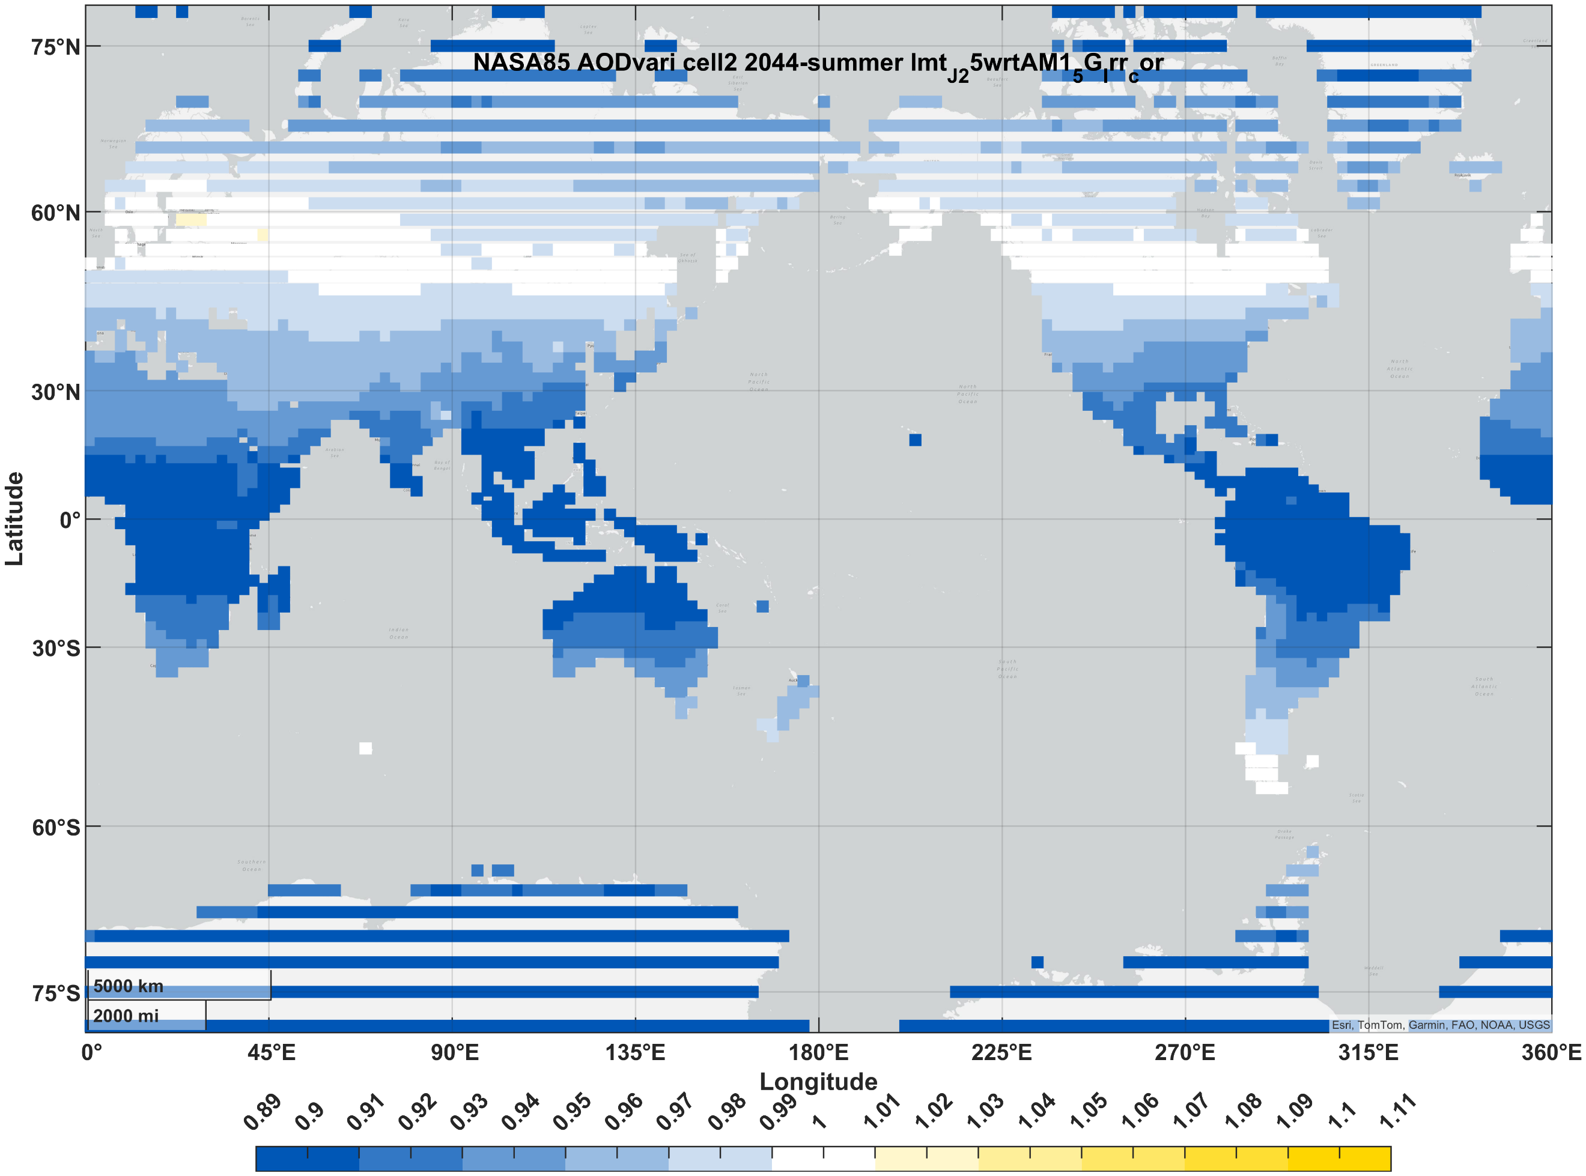 | 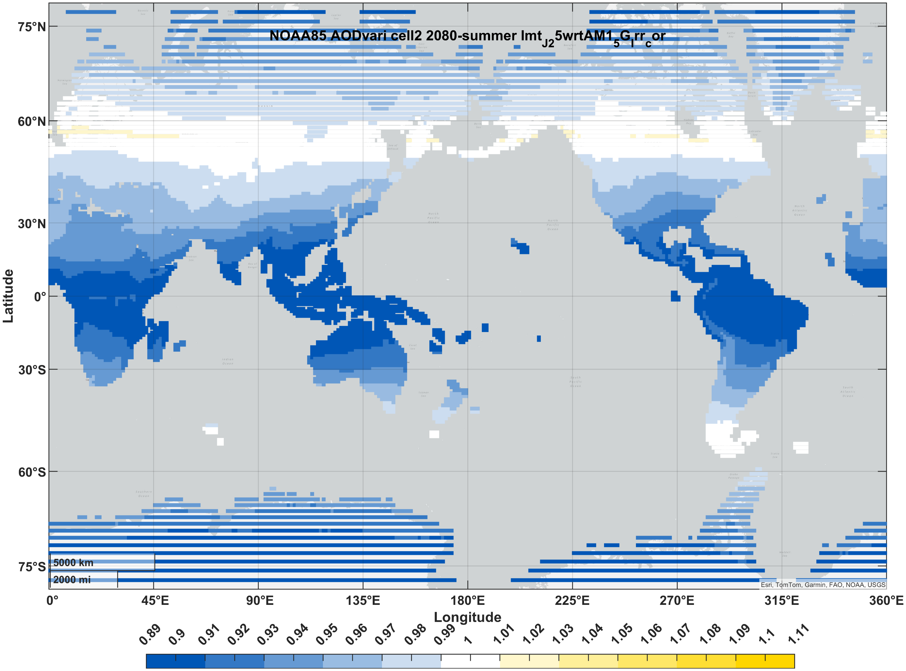
III-V (3J) | winter | 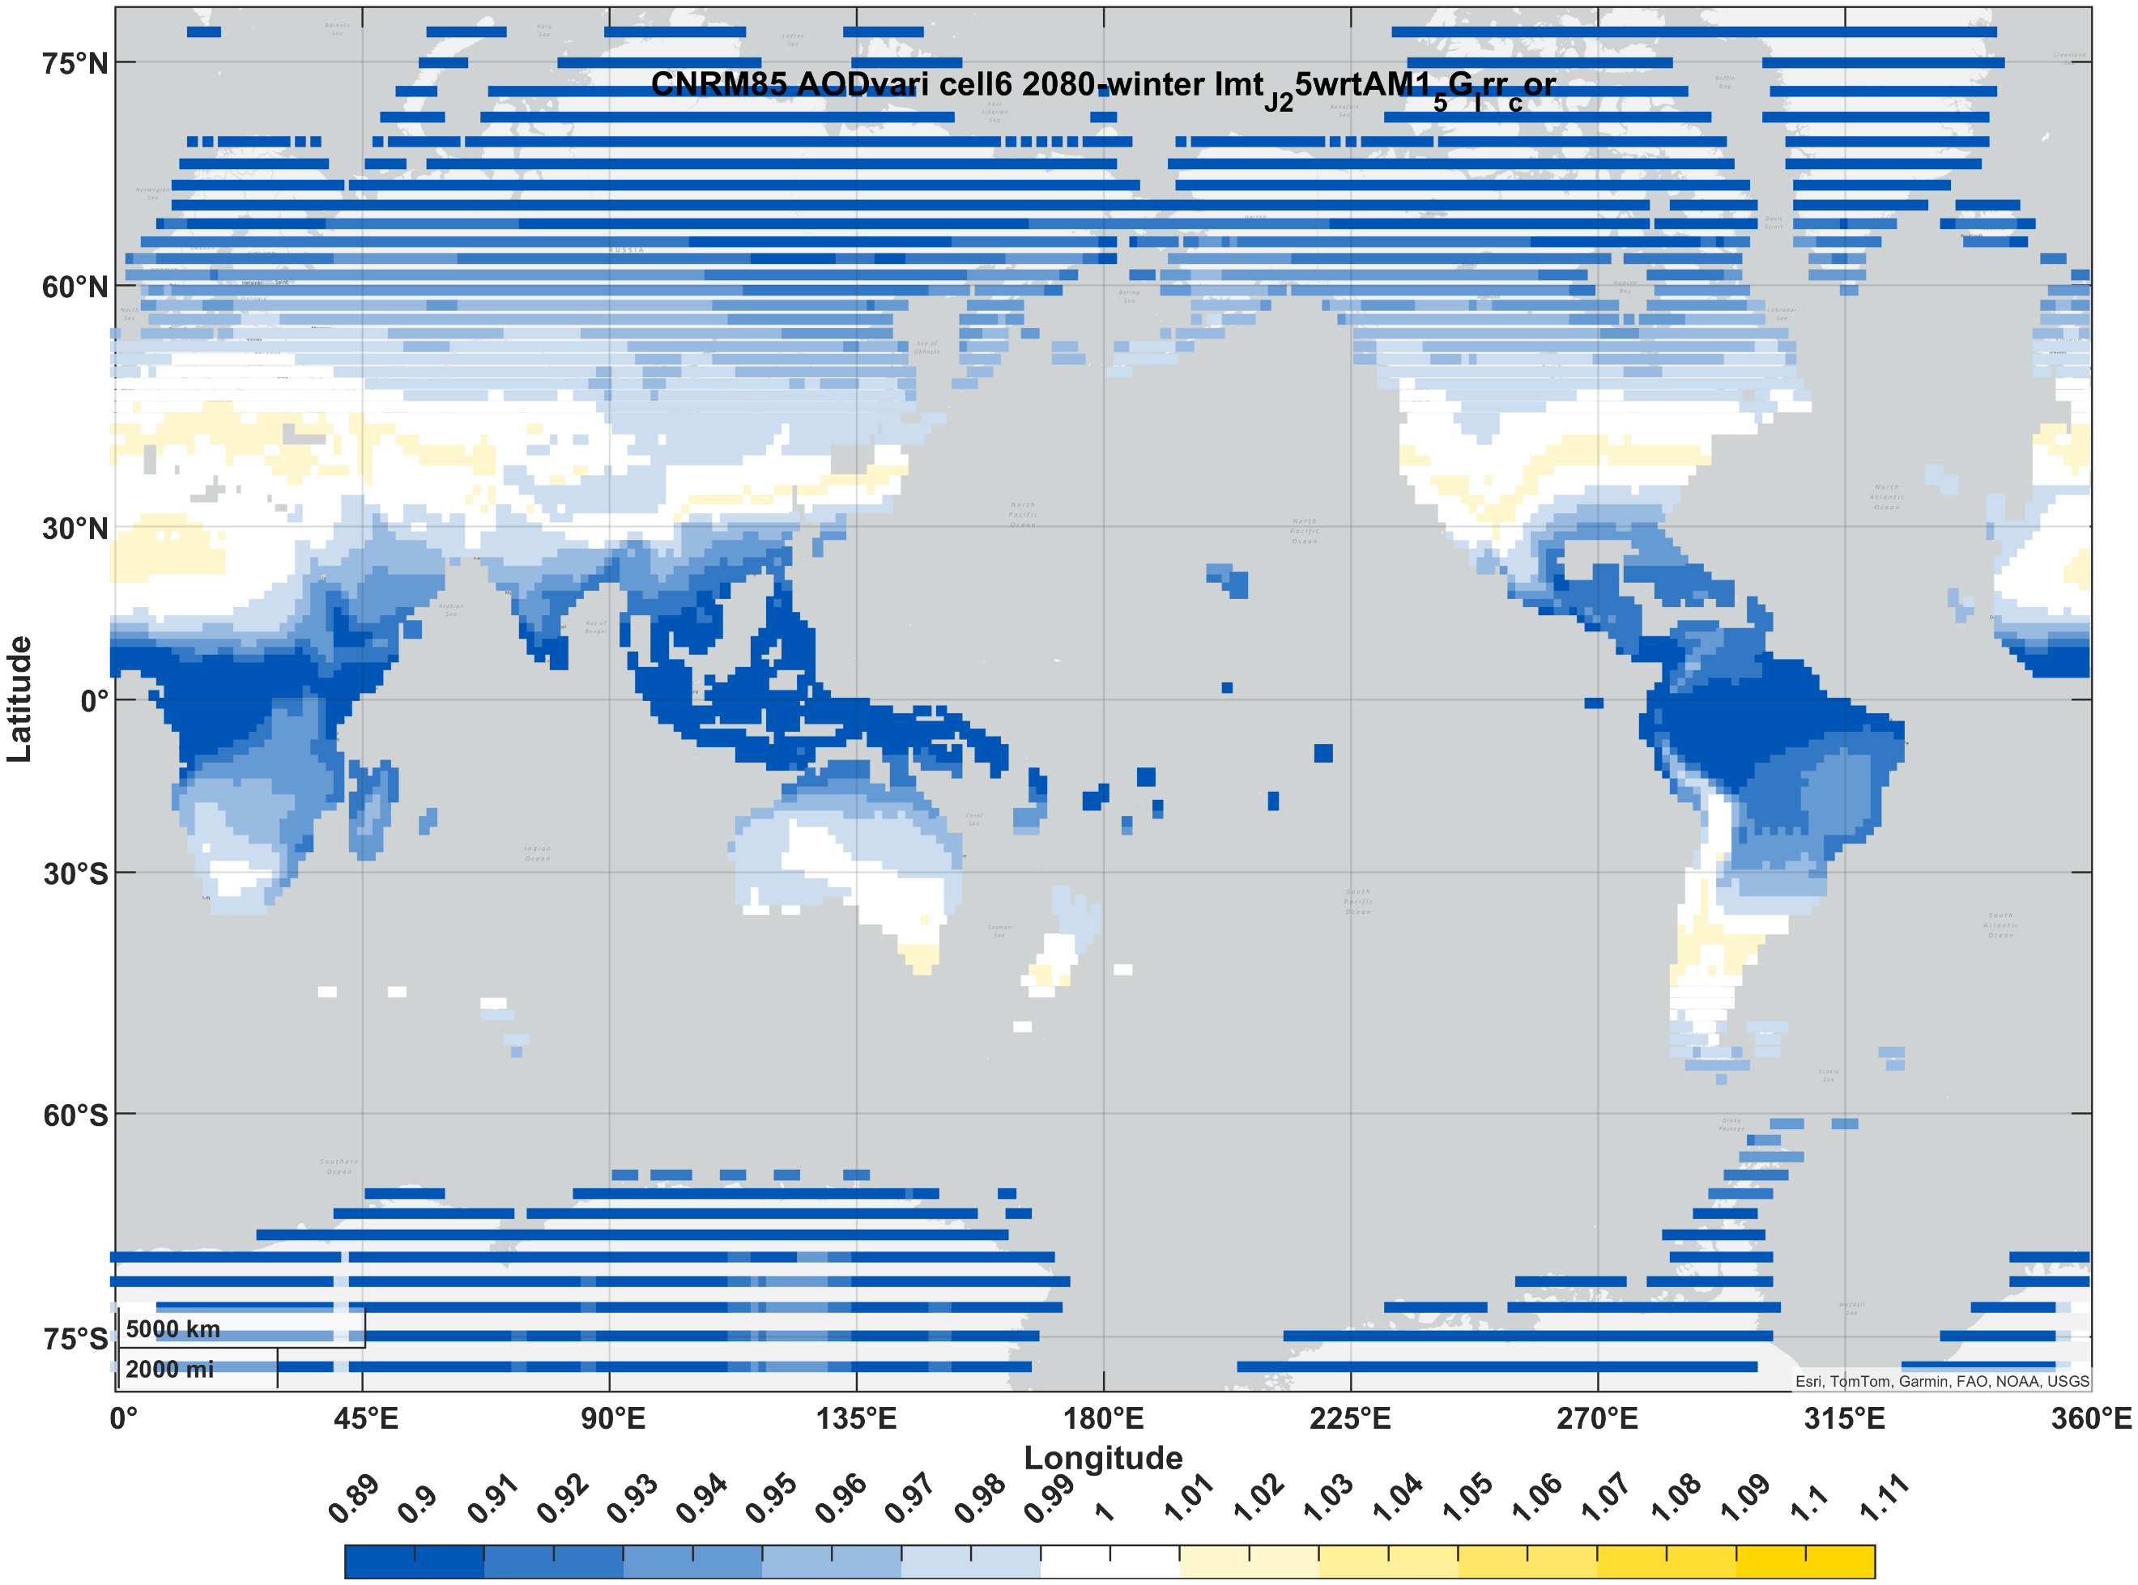 | 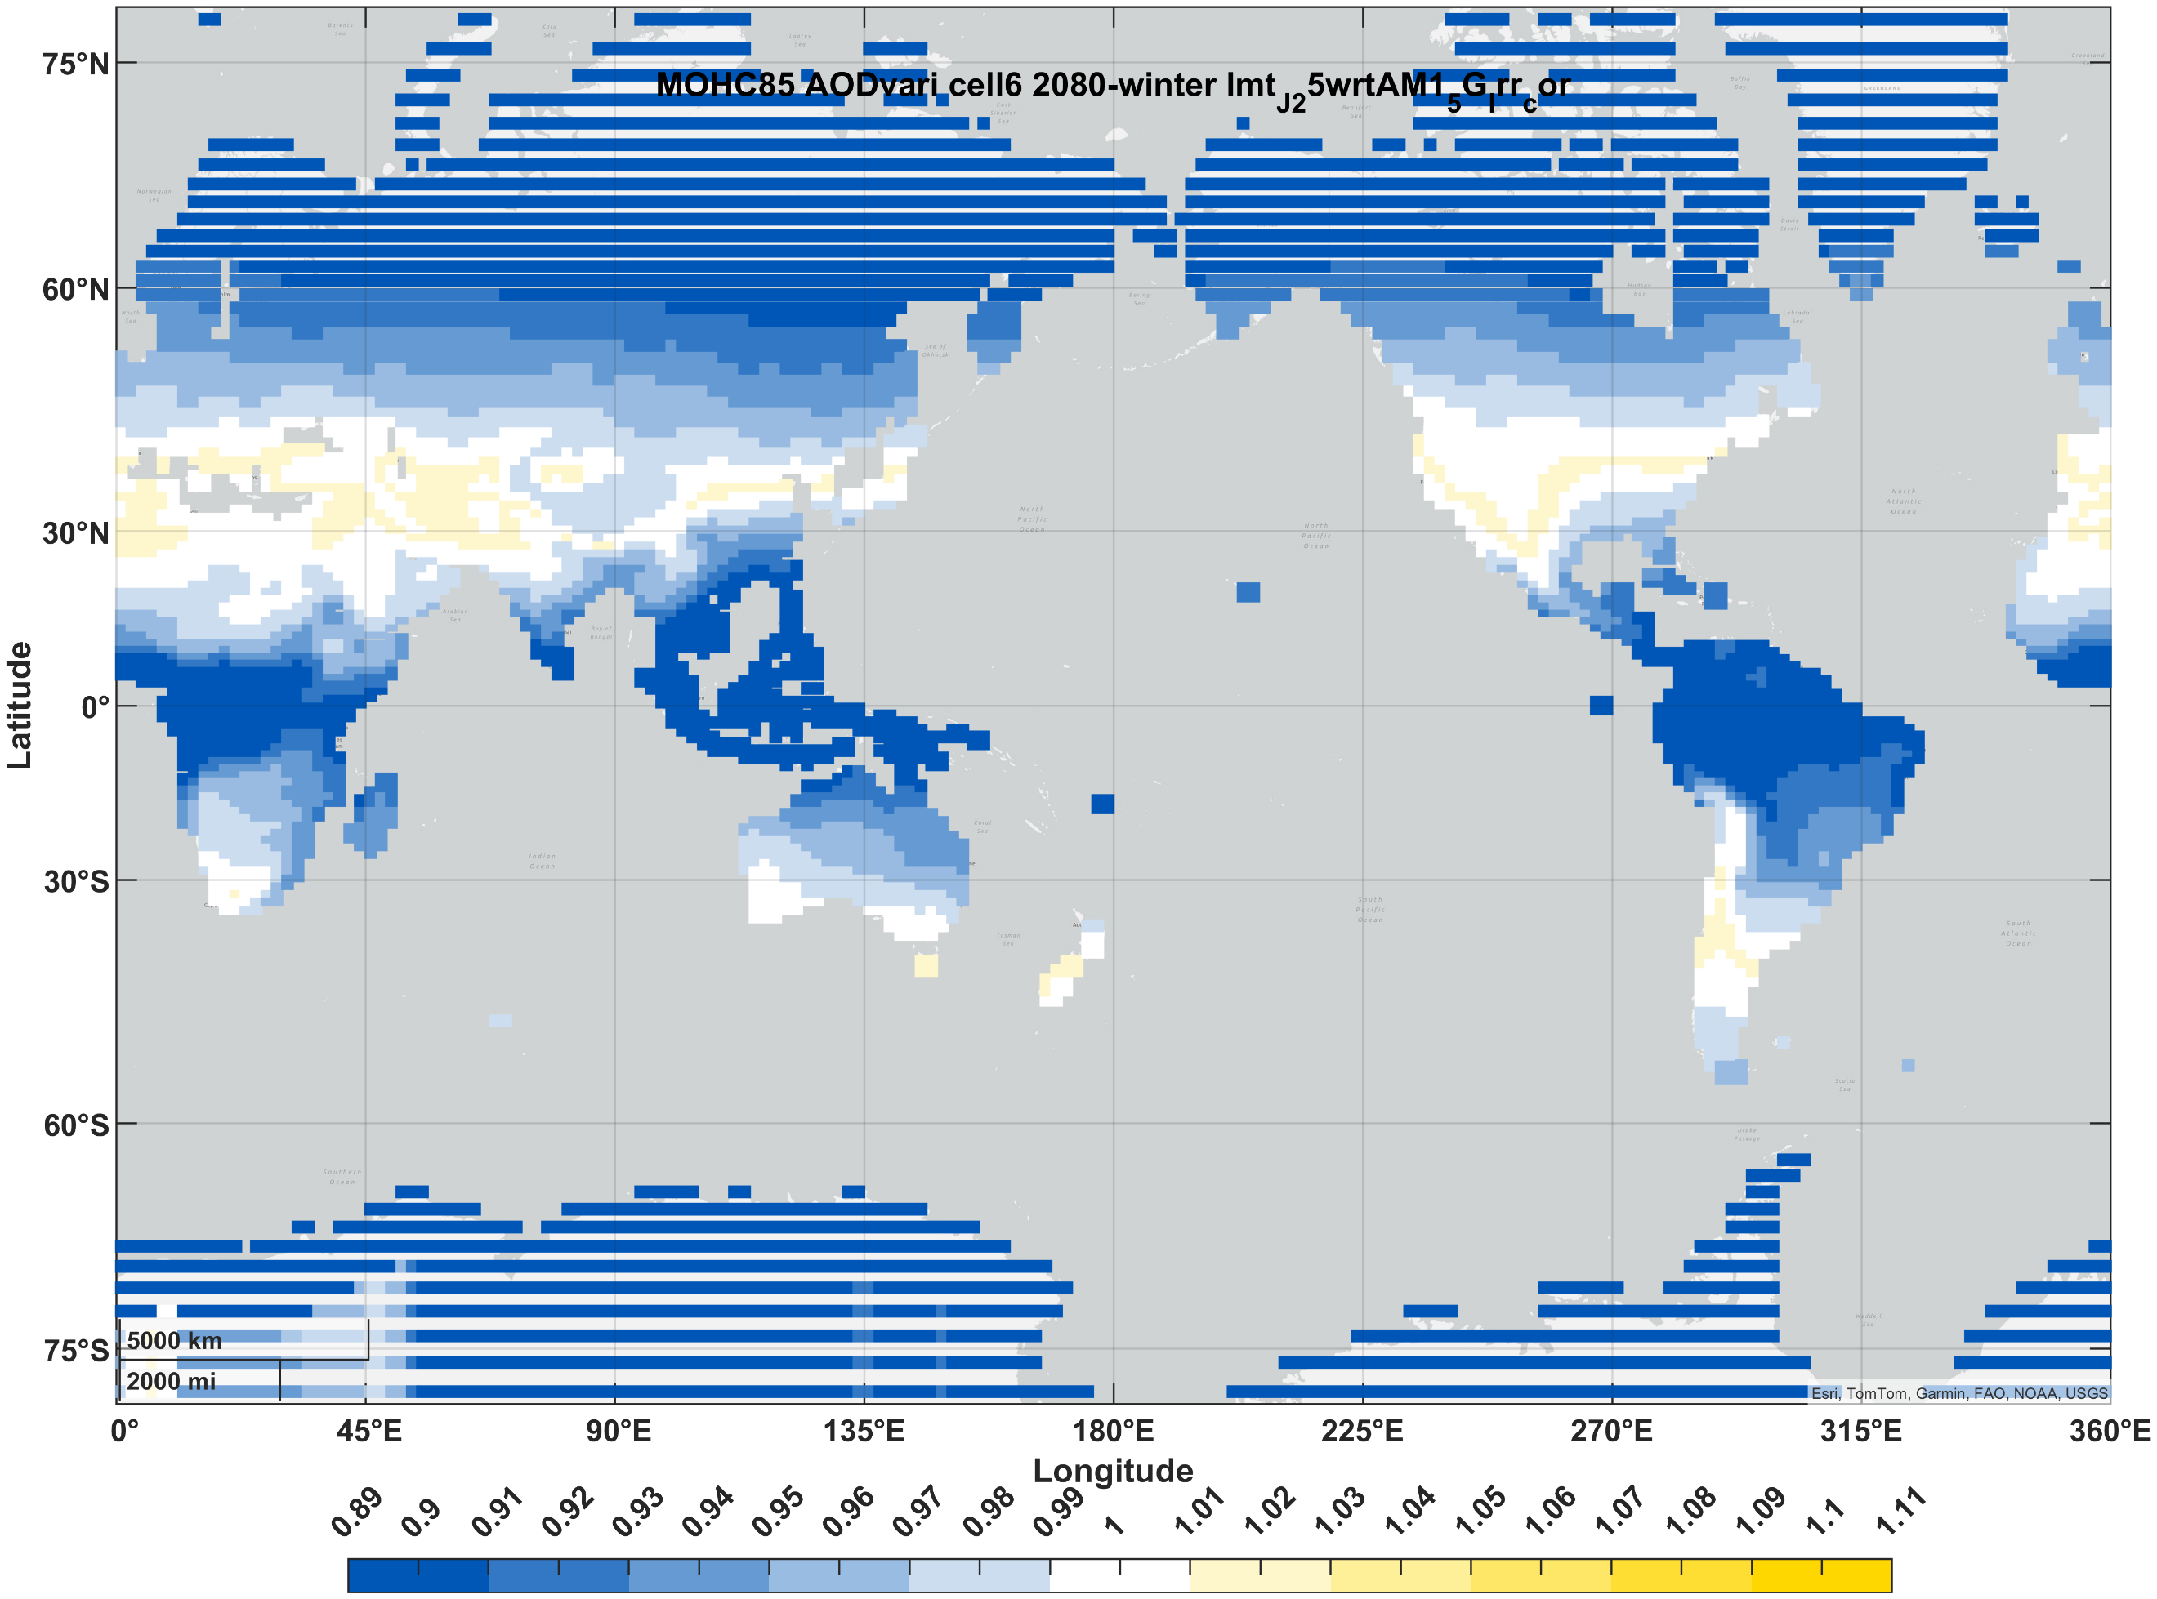 | 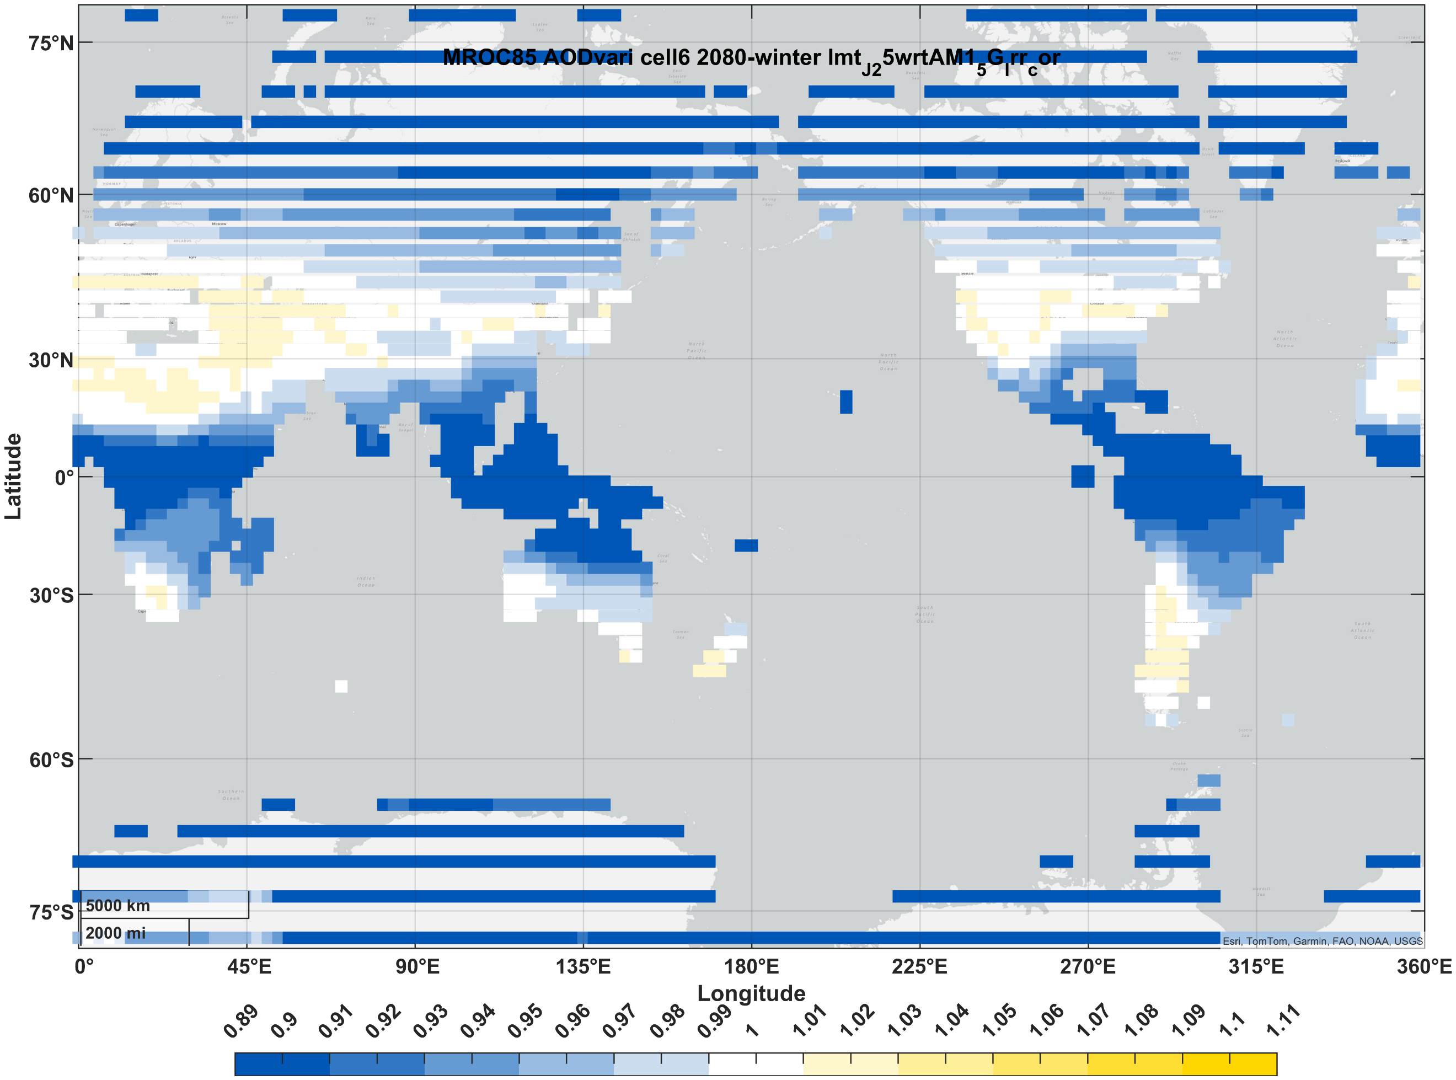 | 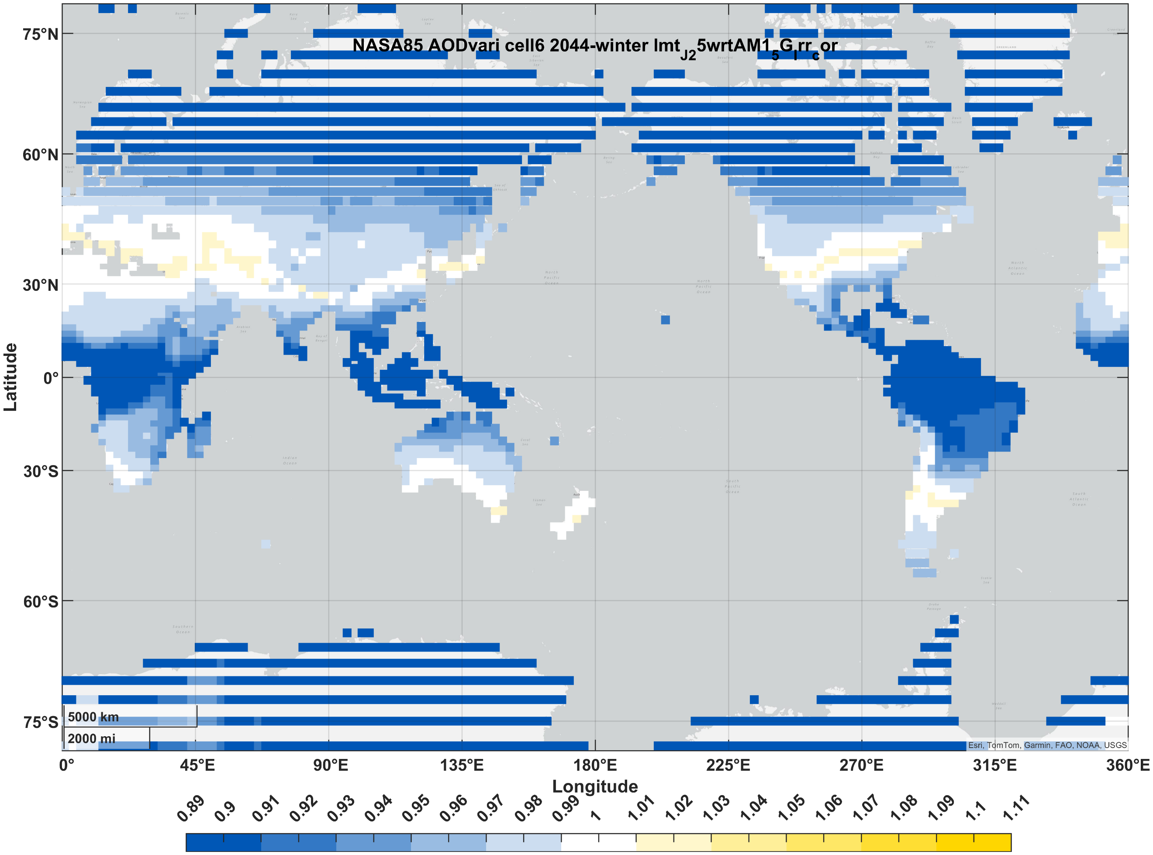 | 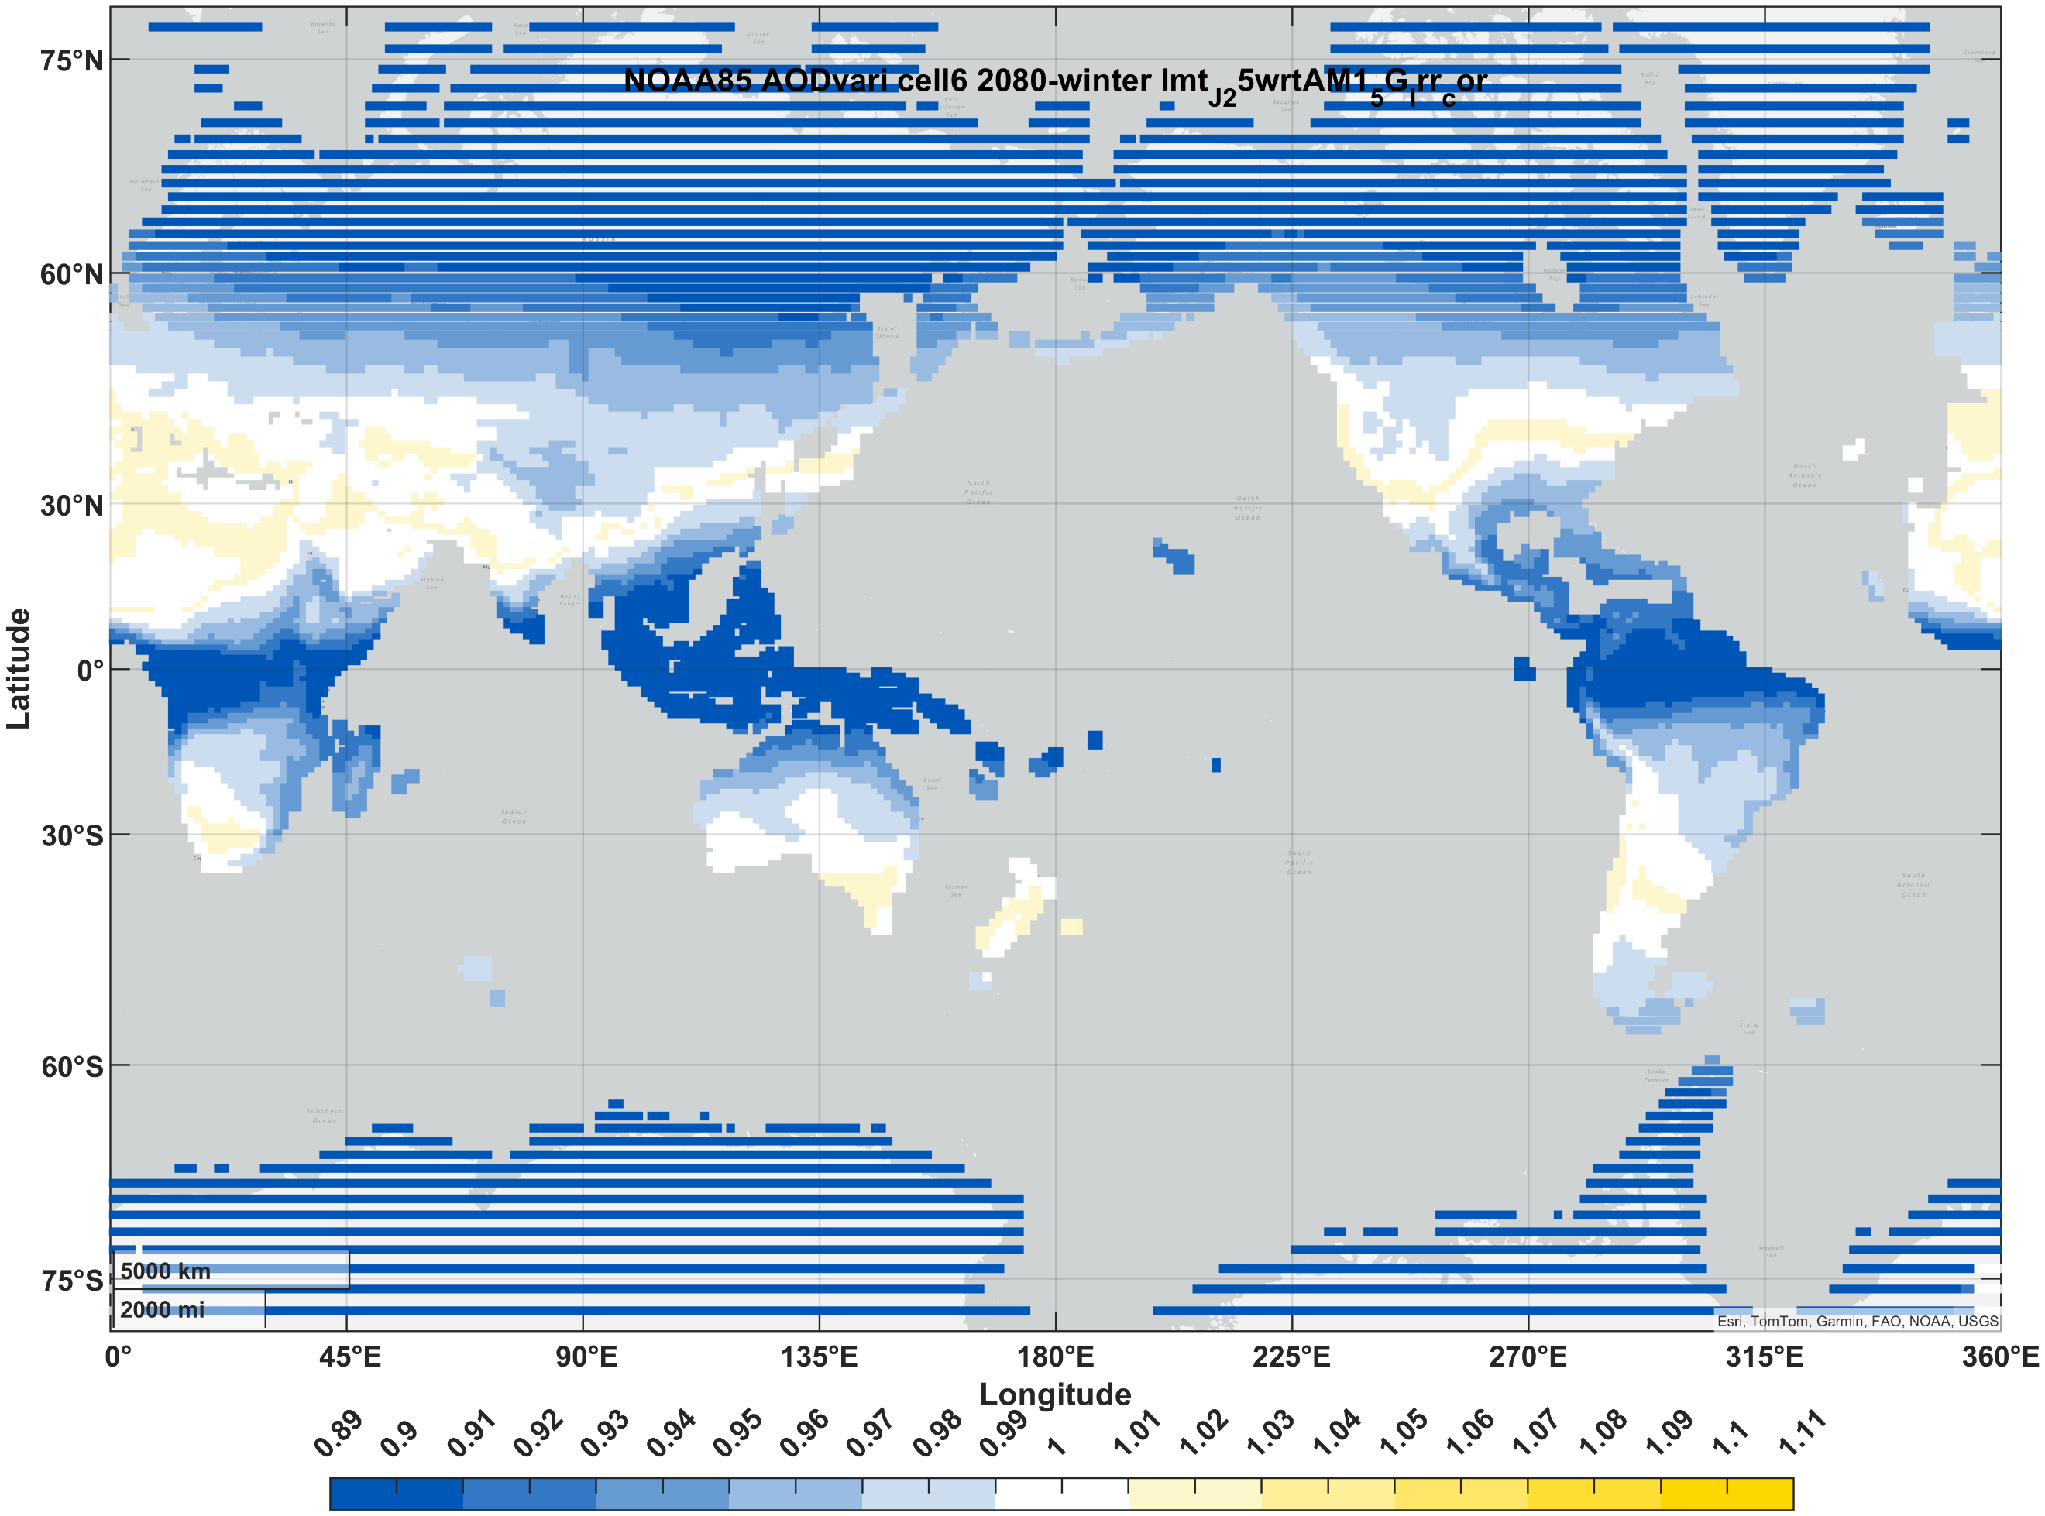
III-V (3J) | summer | 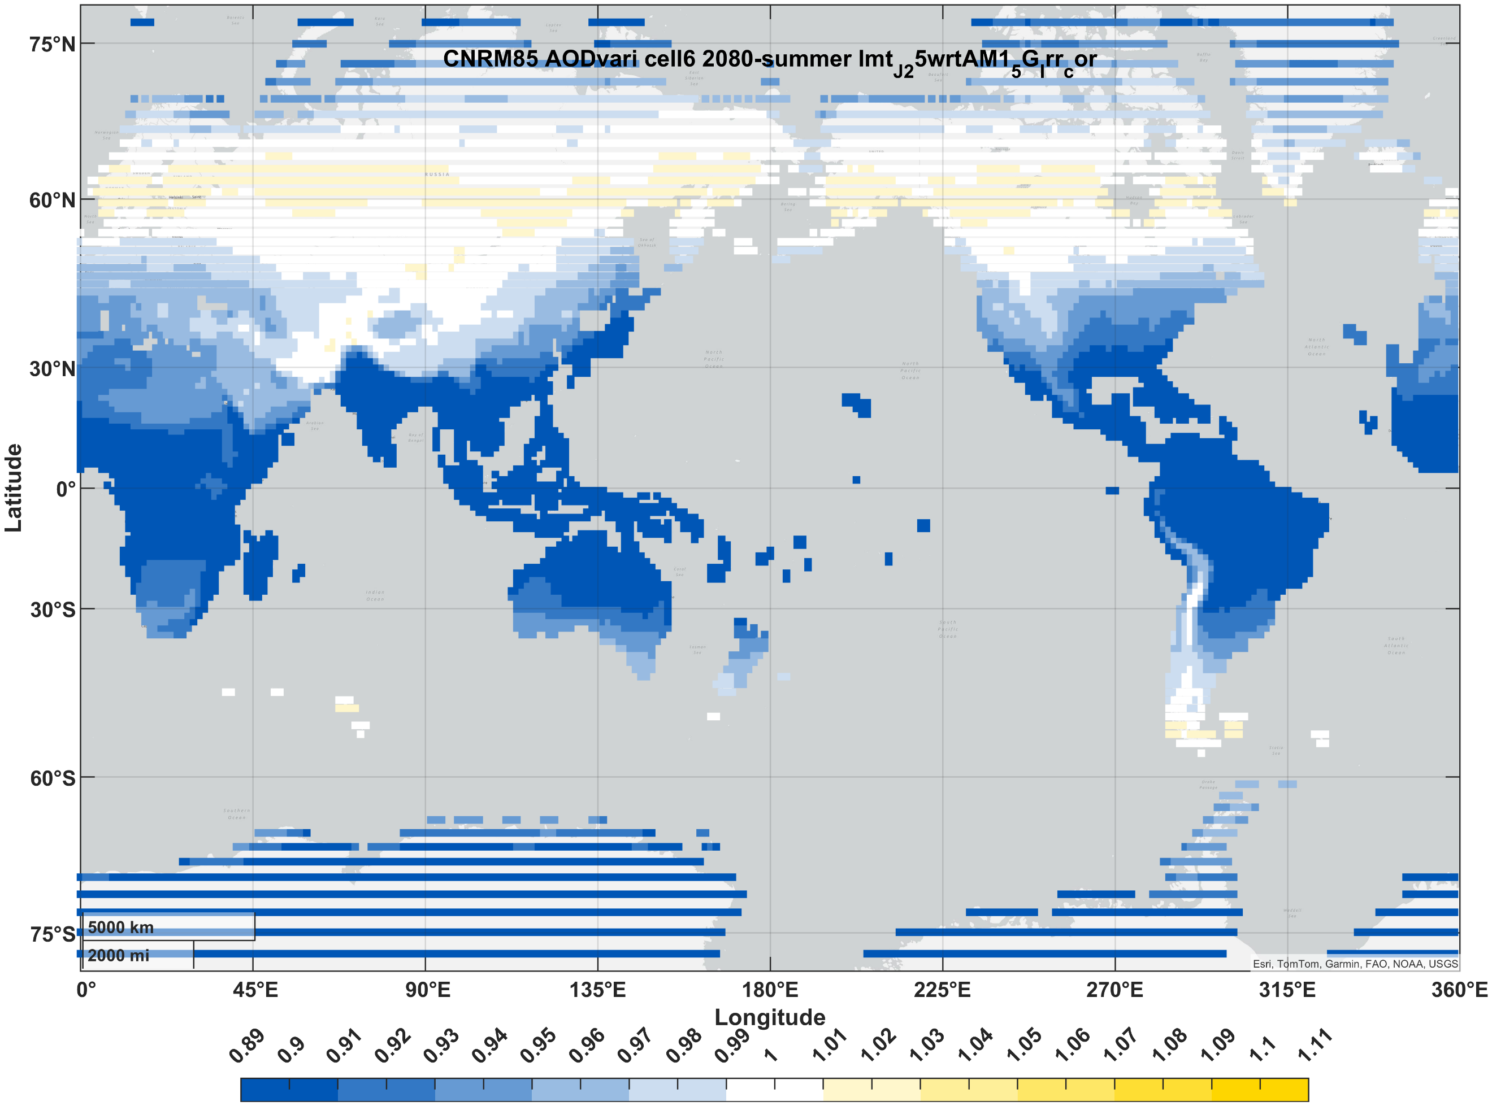 | 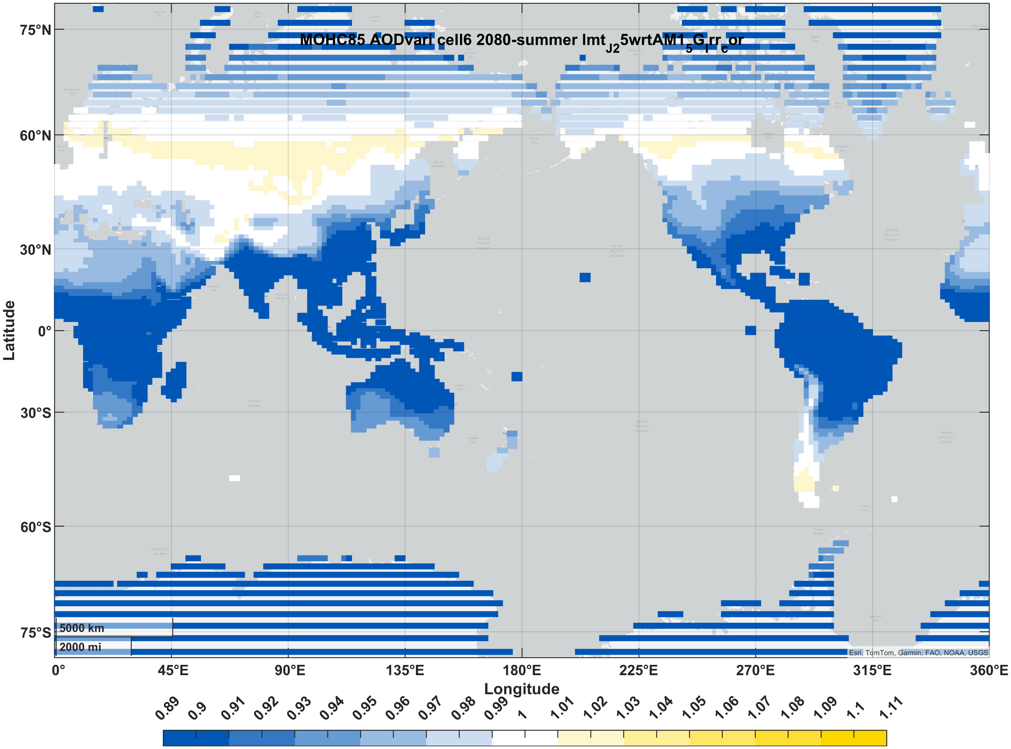 | 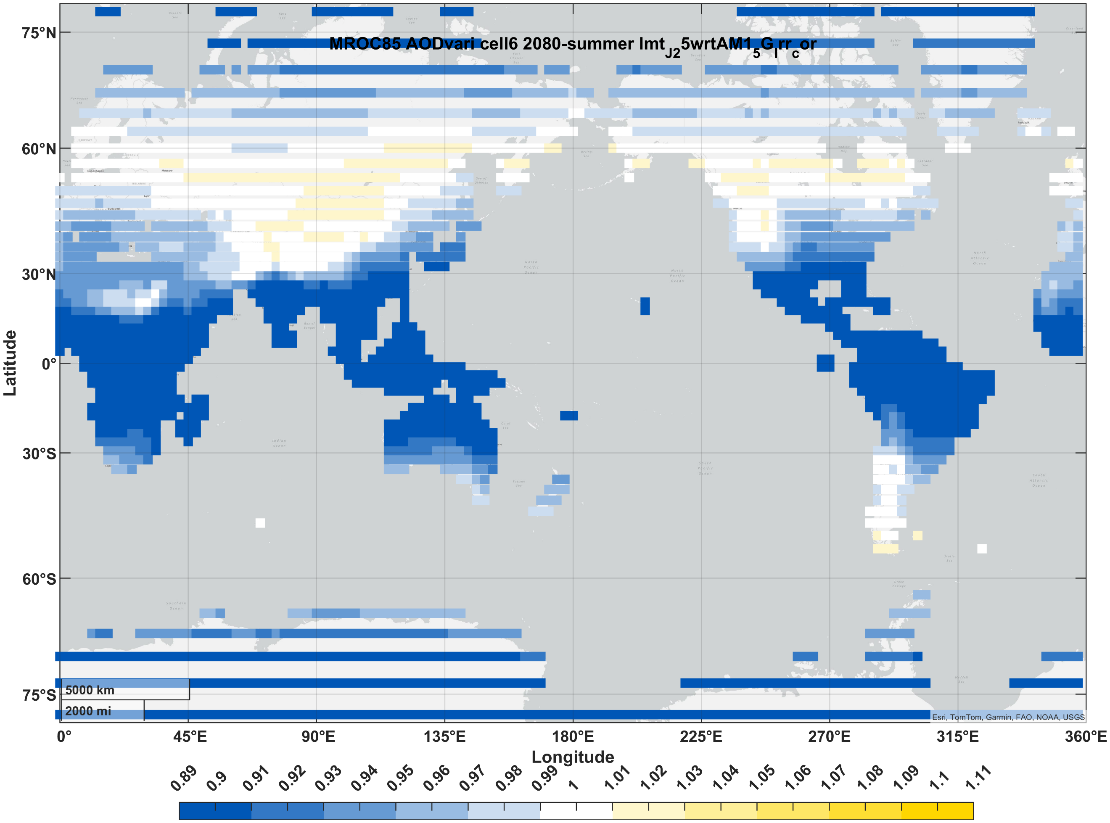 | 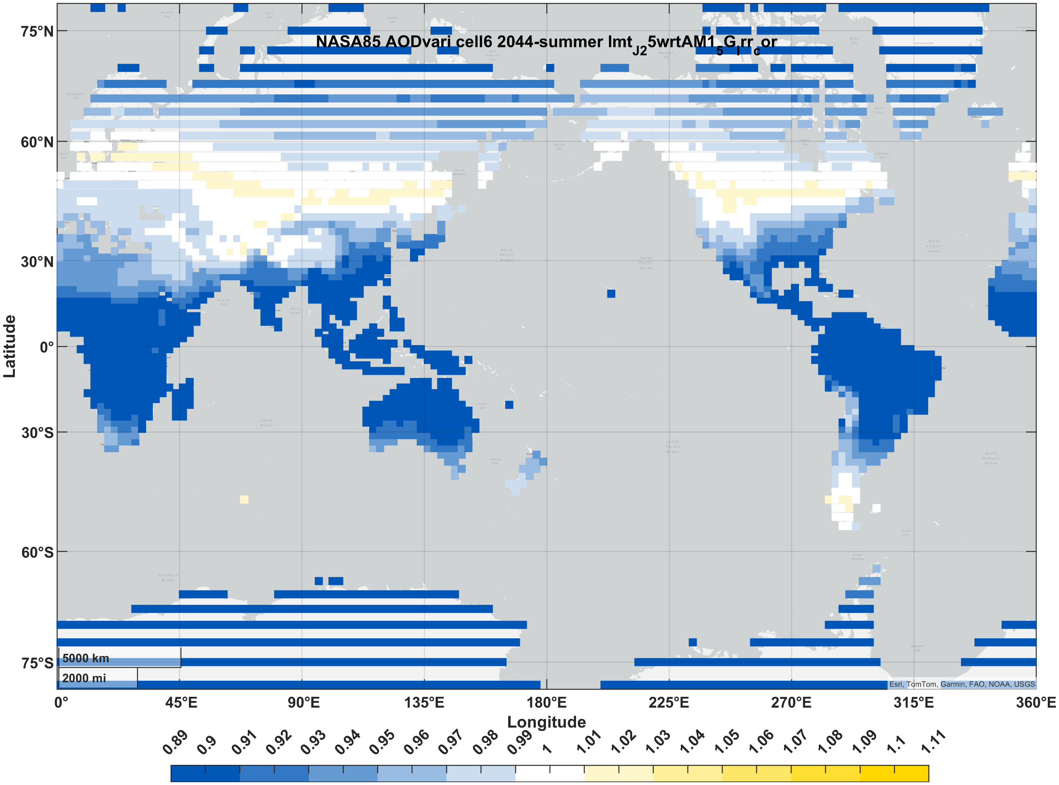 | 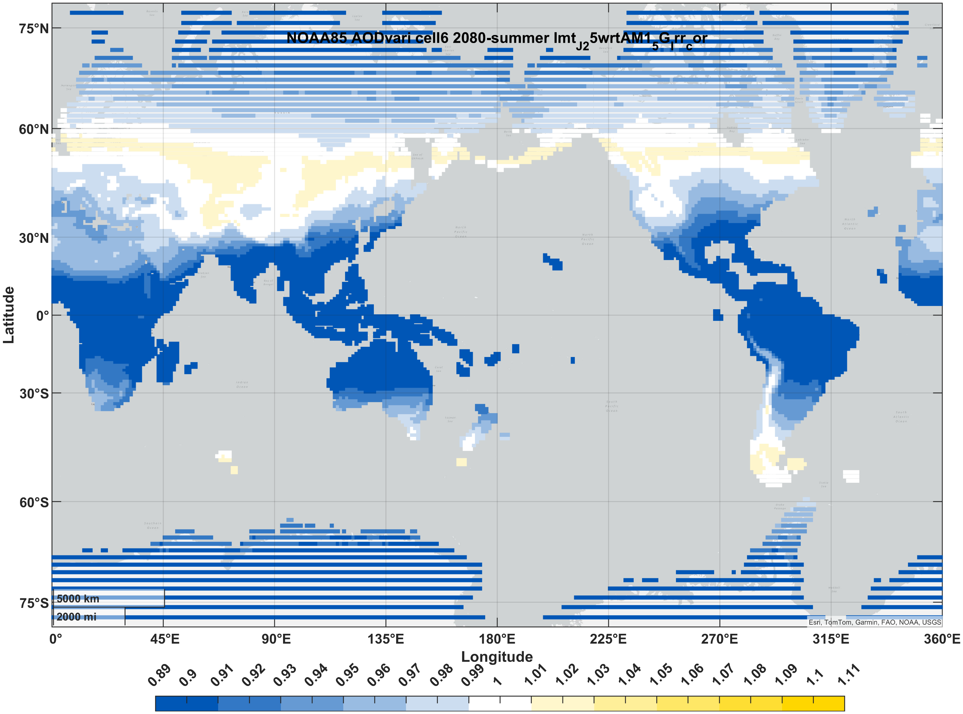

References
1. Foote, E. Circumstances affecting the heat of the Sun’s rays: Art. XXXI. The American Journal of Science and Arts 382–383 https://ia800802.us.archive.org/4/items/mobot31753002152491/mobot31753002152491.pdf (1856).
2. Gillett, N. P., Zwiers, F. W., Weaver, A. J. & Stott, P. A. Detection of human influence on sea-level pressure. Nature 2003 422:6929 422, 292–294 (2003).
3. Ren, D. Effects of global warming on wind energy availability. Journal of Renewable and Sustainable Energy 2, (2010).
4. Green, M. A. et al. Solar cell efficiency tables (version 59). Progress in Photovoltaics: Research and Applications 30, 3–12 (2022).
5. Green, M. A. et al. Solar cell efficiency tables (Version 61). Progress in Photovoltaics: Research and Applications 31, 3–16 (2023).
6. Green, M. A. et al. Solar cell efficiency tables (Version 63). Progress in Photovoltaics: Research and Applications 32, 3–13 (2024).
7. McCree, K. J. The action spectrum, absorptance and quantum yield of photosynthesis in crop plants. Agricultural Meteorology 9, 191–216 (1971).
8. CMIP6: the next generation of climate models explained - Carbon Brief. https://www.carbonbrief.org/cmip6-the-next-generation-of-climate-models-explained/.
9. Intergovernmental Panel on Climate Change (IPCC). Synthesis Report — IPCC. https://www.ipcc.ch/ar6-syr/.
10. Kinsey, G. S. Solar cell efficiency divergence due to operating spectrum variation. Solar Energy 217, 49–57 (2021).
11. Kinsey, G. S. et al. Impact of measured spectrum variation on solar photovoltaic efficiencies worldwide. Renew Energy (2022) doi:10.1016/J.RENENE.2022.07.011.
12. Snapshot 2021 - IEA-PVPS. https://iea-pvps.org/snapshot-reports/snapshot-2021/.
13. Electricity consumption by country, around the world | TheGlobalEconomy.com. https://www.theglobaleconomy.com/rankings/electricity_consumption/.
14. Kinsey, G. S. Spectrum sensitivity, energy yield, and revenue prediction of PV modules. IEEE J Photovolt (2015) doi:10.1109/JPHOTOV.2014.2370256.
15. Chen, B. & Liu, Z. Global water vapor variability and trend from the latest 36 year (1979 to 2014) data of ECMWF and NCEP reanalyses, radiosonde, GPS, and microwave satellite. Journal of Geophysical Research: Atmospheres 121, 11,442-11,462 (2016).
16. Ren, D., Wang, Y., Wang, G. & Liu, L. Rising trends of global precipitable water vapor and its correlation with flood frequency. Geod Geodyn 14, 355–367 (2023).

