A New Paradigm Of Exact Steering Mechanisms

Satvik N Wani* (201 Manorath Apts, 9 Pratapgunj, Vadodara, Gujarat, India-390002)
Ketan B Chemburkar (B-5/13, B-5/14, B.I.D.C. Estate Gorwa, Vadodara, Gujarat, India-390016)
* Corresponding Author (Email: satvik.wani@gmail.com)
Keywords: Steering, Mechanism, Ackermann, Automobile Engineering, Function Generation and Robotics

Abstract
In this theoretical work, a new paradigm of mechanisms that can trace the exact steering condition for a front-two-wheels steered car is analysed and discussed with examples. The central idea is to go beyond the four-bar-linkages to a five-bar-linkage that has a point following a—rather simple to implement—locus. The loci are calculated for small angle and large angle turns. How to choose the loci is also discussed but the practical implementation is outside the scope of this paper. Further, the standard go-to Ackermann mechanism is discussed in detail and it is shown that it fails miserably when the aspect ratio of a car beyond one.

Introduction
Road-vehicle steering itself and it’s accuracy and related vehicle stability under steering is a very old problem that dates back to Erasmus Darwin—Charles Darwin’s grandfather who wrote a note to James Watt describing a steering mechanism that was different from the traditional axles of wheels rotating about the axle’s center [1-3]. E. Darwin’s design was what we call today the Ackermann mechanism of steering. Since E. Darwin didn’t patent what he described in a sketch in his communication with Watt, the design was not known for about half-a-century—after which it was re-invented by Georg Lankensperger who applied for a patent through an agent named Rudolf Ackermann [1]. Lankensperger was the owner of the British patent but the mechanism was named the Ackermann mechanism [1]. E. Darwin’s idea was to us an isosceles trapezium linkage that sat behind the steered wheels’ axle promoting the difference in the angles of the steered wheels such that the outer steered wheel was to turn at a lesser angle than the inner steered wheel so that—as the inventors may have thought—the cart turns about a point-center of turn. The authors do not have access to a journal article that describes E. Darwin’s invention and work but it can be found in ref. [3]. Further, it turned out that the exact steering’s required mathematical condition came to be known as the Ackermann condition somehow as can be gleaned from the literature on the internet (see for example ref. [4, 5]) but here the authors choose to call it the cotangent condition because of the presence of cotangent trigonometric function in the exact steering condition.
In this work, we will only study vehicles that have the front two-wheels steered and the rear wheel(s) are on the same axel. In this situation, as shown in Fig. 1, the so called Ackermann or—what the authors’ call—Cotangent condition needs to be held in order to have a unique center of turn while including all the wheels.
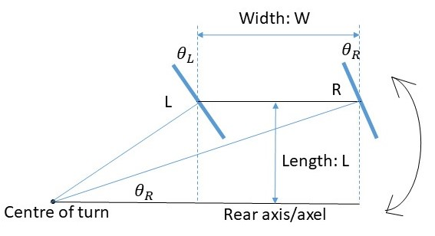
Figure 1: A car with wheel-to-wheel width W and length L is shown. The turn angles θ_{L} and θ_{R} are such that to recover length W, they are constrained by ${\cot{θ}}_{R}-{\cot{θ}}_{L}=W/L$.This means that $θ_{L}≠θ_{R}$. This inquatily of turn angles is the Cotangent condition.

The Steering Mechanisms in Literature
A good source of history of steering mechanisms can be found in ref. [2]. Further, recent advances in exact steering mechanisms can be found in refs. [4-7]. All these mechanisms are either an approximation of the cotangent condition or are exact trace mechanisms. The most popular mechanism is the Ackermann mechanism. The exact mechanisms like the Davis’s is very elegant but cumbersome and maintenance heavy. The other exact mechanisms are further more complicated—this why the car and ground vehicle industry prefers the simple and approximate Ackermann mechanism.
The Ackermann mechanism consists of a four-bar linkage that is trapezoidal in its symmetry. As shown in Fig. 2, the mechanism sits behind the steered wheel’s axle. The deviation from a rectangle is the reason for it approximating the cotangent condition. A well designed Ackermann linkage can trace the cotangent condition so well for small turn angles that it is astounding.
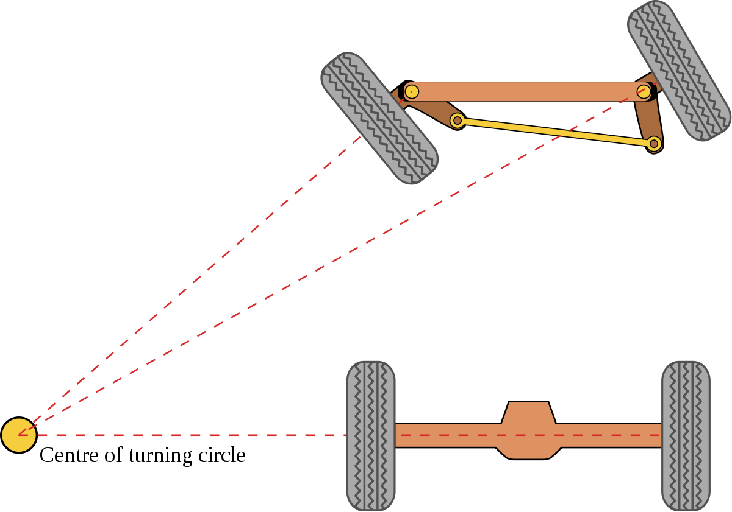
Figure 2: The isosceles trapezoidal Ackermann mechanism under a left-turn. As it will be shown, the coincidence of the turn axes occurs only at one specific turn angle of either of the steering wheels. That is, skidding will occur for all turning angles except one in straight configuration and one on each side’s turn.
We will explore the Ackermann linkage in full detail in this section because it is the go-to mechanism that has stood the test of time.
Any four-bar linkage of arbitrary design is governed by the Freudenstein equation [8]. As shown in Fig. 3, a general four-bar linkage is a scalene quadrilateral. The input and output angles are given by the following equations.
$$R_{1}\cos{φ}-R_{2}\cos{ψ+}R_{3}=\cos\left(ψ-φ\right),$$

Here, $R_{1}=1/d, R_{2}=1/b$ and $R_{3}={(1+b^{2}-c^{2}+d^{2})}/{(2bd)}$. As Mehar et al. describe, the mechanism can be used as a function generator using the least square or other kind of a fitting method [9]. Cleary, since the cotangent function is singular at zero argument, it cannot the generated by a four-bar linkage. One can, however, intuitively envisage an asymmetric quadrilateral that produces—with better approximation—the cotangent condition for only one—left or right—turn. This can work out because through the asymmetry, the singularity of the cotangent condition can be avoided.
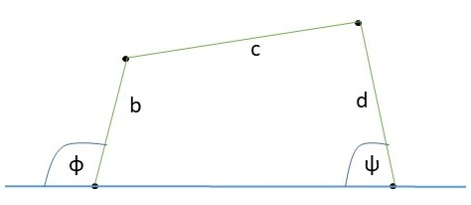
Figure 3: The four-bar linkage with its input angle φ and output angle ψ is depicted here. The sides of the quadrilateral are b, c and d and the largest side is assumed to be 1 for simplicity. The Ackermann mechanism is based on this linkage.
As shown in Fig. 2, the Ackermann isosceles trapezium sits behind the axle of the steered front wheels. Because its symmetry, the Ackermann mechanism produces the same results irrespective of the direction of turn. Here, we have computed the steering angles for a symmetric Ackermann mechanism. As shown in Fig. 4, it consists of the angel α and the ratio c of the smaller at zero turn parallel link to the link that is attached to the body of the car.
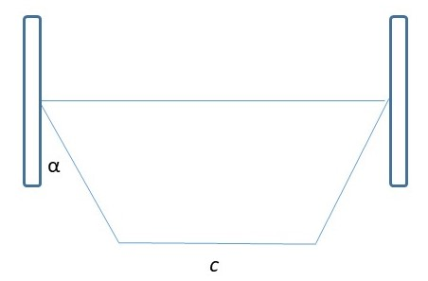
Figure 4: The typical Ackermann trapezium parameters. The angle α is usually chosen such that the non-parallel sides of the trapezium meet the center of the rear wheels’ axel. However, the parameter c is not chosen that way leading to an unknown parameter that needs to be settled in the final design.
As shown in Fig. 4, the Ackermann mechanism that as two tunable parameters—the Ackermann angle α and the ratio c between the parallel links—that can be tuned to be close to the cotangent condition in a general way. Clearly, the cotangent (also called the Wani mechanism)and Ackermann curves are under the equal wheel angle curve. Usually, as discussed in the caption of Fig. 4, α is chosen—due to symmetry and minimal parameters arguments—such that the side links traced would coincide at the center of the rear axis. There is no other way to symmetrically invoke the over-all structure of the car. As the angle α is reduced to zero value, the “Equal“ line would be traced. As α crosses the value determined by the symmetry argument discussed above, which here is approximately 20 degrees, the green curve of Ackermann condition move downward. Eventually, for α > 20 degrees, the curve would be completely below the cotangent condition. Near zero angles of turn, the proposed mechanism is at an angle with the equal condition—whearas Ackermann is tangential ot the equal curve since it only produces three exact intersections with the cotangent condition curve. This can be clearly seen in Fig. 5(b).
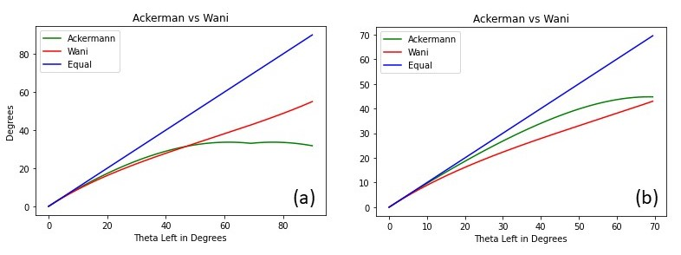
Figure 5: For a car aspect ratio (width divided by length) of 0.7 and a shorter trapezium link length divided by larger link length of 0.9, (a) shows an Ackermann angle α = 20 degrees and (b) α = 10 degrees. The Ackermann angle α = 20 is approximately the angle obtained by making the sides of the Ackermann trapezium meet at the center of the rear wheel axel.
The effect of parameter C is shown in Fig. 6. A small C tends to move the curve below the cotangent condition.
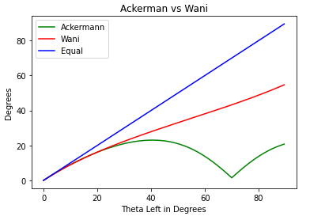
Figure 6: Every parameter is same as Fig.5(a) except C. Here C = 0.6. The green curve has a kink due to the four-bar linkage inverting at large turning angles.
Overall, it is clear that the mechanical simplicity of the Ackermann mechanism outlasts any other complicated mechanism since it can be tuned with the parameters α and c to such a good extent that for $θ_{L}<40°$ there can be a very good match with the cotangent condition. The Ackermann mechanism tends to produce a non-monotonic curve that has a maximum at approximately in the range of $30°<θ_{L}<45°$. This can be ascribed to the fact that the Ackermann trapezium inverts after saturating at a specific angle at which there is a cusp-like minimum. Clearly the parameter c decides where this cusp occurs. It turns out that the cusp-point moves towards the right side of the graph in Figs. 5 and 6 as C approaches one as shown in Fig. 7—the parameter c = 0.99.
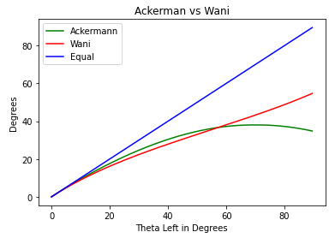
Figure 7: All parameters the same as Figs. 5(a) and 6 except c = 0.99. The cusp has moved outside of the range of the graph.
As shown in Fig. 7, the cusp has moved completely out of the graph. As c is made to approach one, the Ackermann curve becomes practically monotonic for relatively large turn angles—while the entire mechanism becomes more compact in terms of the depth required to house it in the front of the car. Anyway, as known in literature on internet, the Ackermann curve will intersect the monotonic cotangent curve only thrice as can be concluded here. The difference $∆θ_{CA,R}≡θ_{Cotangent, R}-θ_{Ackermann,R}$ tends to range from $-5°<∆θ_{CA,R}<20°$ as can be seen in Figs. 5(a) and 7. In order to fit the Ackermann parameters to the cotangent curve, there can be two approaches—one is to fit the entire range of turn angles and second is to fit it near zero properly using series expansion of both cotangent and Ackermann mechanism. In either case, at large angles, there is a significant deviation from the cotangent condition.
While all other mechanisms in literature are exact but difficult to implement or are an approximation, there is one mechanism that comes close to the proposed “Wani mechanism”—the Bollee mechanism wherein there is a bell-crank that splits the Ackermann type tie rod into two equal parts whose joint moves in a circle allowing for a supposedly better closeness to the exact steering condition [2]. Essentially, the methodology that is found in the literature and the internet for designing the steering mechanism is the following—(1) Workout a parallelogram mechanism that fits the car chassis layout and design and (2) introduce asymmetry in the mechanism so that there is an unequal amount of turn in the steered wheels. This turn inequality can be either cotangent friendly or anti-Ackermann depending on the car performance at hand.
Here the Ackermann parameters where discussed only because of the mechanism’s popularity. All other exact and inexact mechanisms would have their own parameters that need to be tuned with reference to the car chassis’ design. If one searches on Youtube.com, several different approaches that are taken by designers can be found.
As discussed by Zhao et al [4], the four-bar linkage cannot be tuned to produce the cotangent condition however, the authors think that if the linkage is made into an asymmetric non-isosceles trapezium for only one sided of the turn and its mirror image for the other side of the turn, due to an extra parameter besides α and C, there is a chance of a better fit. However, this mechanism is very impractical to implement in the authors’ opinion.

The Proposed Mechanism
In the most general form, the proposed mechanism tries to emulate the cotangent condition to the largest degree within the context of the Ackermann type design like that described by Zhao et al. [4]. Essentially, it is a modification of the Ackermann mechanism. The tie-link in the Ackermann mechanism is made into two equal or unequal parts such that their joint is made to trace a trajectory—much like the Bollee bell-crank mechanism—that creates a cotangent type difference in the steered angles of the steered two wheels. In the simplest form, the trajectory is a circle that leads to equal steering angles. A correct deflection from circularity leads to exact cotangent condition steering.
As minutely alluded before, any n-bar linkage cannot trace the cotangent condition unless there is a constraining guide. Here, we take a—one more than four—five bar linkage that is constrained like the Bollee’s bell-crank mechanism and make the central joint traverse a specific trajectory. Briefly, we analytically solve for the equation of that trajectory and unlike Zhao et al. [4], have only one non-circular cam, gear or guide rail—depending on the way practicality demands. Further, an entire class of such “guided” mechanisms could be seen as a paradigm in machine and mechanism theory.
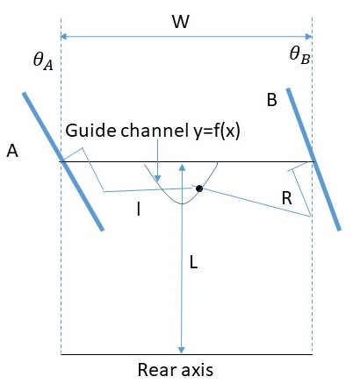
Figure 8: The proposed mechanism with the guide channel. The channel makes the front two steered wheels meet the cotangent condition wherein the axes of the front wheels coincide at the center of turn as depicted in Fig. 2. The dimensions of the mechanism’s links are R, l and W. The length of the car is L. At zero turn angle, the length of the links opposite W is 2l. The distance of these links from W is R. The shape of the guide channel shown here is ad-hoc—actual curve is shown in the figures to follow. Actual implementation is outside the scope of this paper.
As shown in Fig. 8, a guide channel is traversed by the joint connecting the third and fourth links. The equation of the guide is derived here. First, we will derive a small turn angle producing equation for the channel after which we will compute the exact curve of the channel based on given parameters. Because $θ_{L}=τ(θ_{R})$ where $τ$ is a function relating the right and left turn angles, which as shown before is the cotangent condition given by $τ(θ_{R})≡\operatorname{arccot}\left(\frac{W}{L}-\cot{θ_{R}}\right)$.
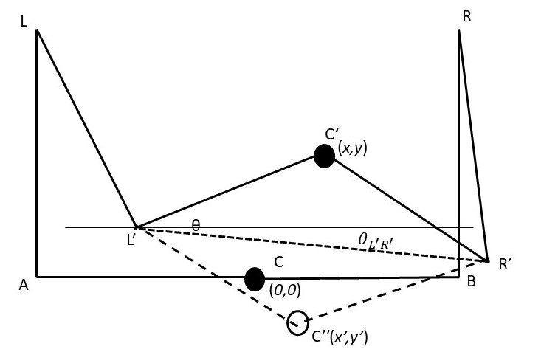
Figure 9: This is the schematic figure that shows how the point C moves to a position different position leading to turn angles that are unequal. Its clear that throughout the rotation about L’R’ that a fixed and specific set of turn angles are generated. The in-plane locations are C’ and C’—which are what we are currently interested in. While designing a practicle mechanism for a specific vehicle, this 3-dimentional aspect can be taken in account.

As shown in Fig. 9, as the vehicle makes a left turn, the point C moves to either C’ or C’’ to create the cotangent condition for a given angle $θ_{L}$. Here, we will explore the C’ or the upper curve for left turn. The coordinates (x,y) are given by the following equations: $x=-l+R\sin{θ_{L}}+l\cos{(θ-θ_{L^{'}R^{'}})}$ and $y=R(1-\cos{θ_{L})}+l\sin{(θ-θ_{L^{'}R^{'}})}$. Here, l and R are the lengths of the arms L’C’ and LL’ respectively. The most important are the angles $θ$ and $θ_{L^{'}R^{'}}$. While $θ_{L^{'}R^{'}}$ appears at larger angles of turn, $θ$ becomes significant at even the smallest angles of turn.
In order to compute the shape of the curve on which point C traverses—given by y = f(x)—here one calculates the function $τ(θ_{L})$ for a given $θ_{L}$ and then plugs it into the equation for $θ_{L^{'}R^{'}}$ given by $θ_{L^{'}R^{'}}≡\arctan\left(\frac{R(\cos{θ_{L}}-\cos{θ_{R}})}{2l+R(\sin{θ_{R}-\sin{θ_{L}}})}\right)$. Further, since the coordinates of L’ are $(-l+R\sin{θ_{L}}, R(1-\cos{θ_{L}}))$ and that of R’ are $(l+R\sin{θ_{R}}, R(1-\cos{θ_{R}}))$, $θ≡\arccos\left(\frac{L^{'}R^{'}}{2l}\right)$ can be evaluated. In this way, the function f is evaluated as will be shown in later figures. But before that, one wants to see how the function f behaves near small angles of turn. Specifically, to know whether f has a cusp near zero or not. In case there is a non-differentiability, one would choose the other solution as will be discussed below—making f asymmetric about zero.
Near $θ_{L}=0$, it is safe to assume that the equal angle motion occurs due to X-motion and unequal adjustments occur due Y-motion. Essentially, it can be said that $θ_{L}=θ_{=}+\frac{∆_{LR}θ}{2}$ and $θ_{R}=θ_{=}-\frac{∆_{LR}θ}{2}$ respectively where $θ_{=}$ is the equal part and the difference is $∆_{LR}θ≡θ_{L}-θ_{R}$. Further, it is assumed that $∆_{LR}θ=T(θ_{=})$ which can be evaluated by the fact that $\cot{z≈\frac{1}{z}+O(z^{3})}$ in the following way. Since, $\frac{1}{θ_{R}}-\frac{1}{θ_{L}}=\frac{∆_{LR}θ}{θ_{=}^{2}-\frac{{\left(∆_{LR}θ\right)}^{2}}{4}}≈\frac{W}{L}$ and because, we assume the difference in angles to be small—this can be intuited by the fact that for small angles the wheel turn angles are not very different—here, we will claim that $∆_{LR}θ=T(θ_{=})≈\frac{W}{L}θ_{=}^{2}$. The X-motion or essentially equal angles of turn requiring motion of point C is a circle about center (0, R)—assuming the zero-turn position of C is at (0, 0)—of radius R. Here, it is called the X-motion since the circle given by $x^{2}+{(y-R)}^{2}=R^{2}$ can be expanded about $x=0$ as $y=\frac{x^{2}}{2R}+HOT$, where HOT refers to higher order terms. Clearly, near zero, equal angles are created through $y=0$ motion. Futher, the angle $θ_{=}=\frac{x}{R}$ can be gleaned.
The Y-motion for small turn angles produces $+\frac{∆_{LR}θ}{2}$ and $-\frac{∆_{LR}θ}{2}$ respectively in the left and right linkages that connect to the wheels. Here, one sets $x=0$—implying that—from previous equations for x and y—that $\cos{θ=}1-\frac{R}{l}\sin{\frac{∆_{LR}θ}{2}}$. This can be further substituted into the equation for y preceded by expanding both cosine and sine functions to give $θ=\sqrt{∆_{LR}θ\frac{R}{l}}$. Eventually, one gets $y^{2}=Rl∆_{LR}θ$—implying that after applying the cotangent condition as shown before, $∆_{LR}θ=\frac{W}{L}θ_{=}^{2}=\frac{W}{L}{\left(\frac{x}{R}\right)}^{2}=\frac{y^{2}}{Rl}$. Therefore, one gets $y^{2}=\frac{Wl}{LR}x^{2}$. This equation for f is simple but has two solutions for our choice of left turning vehicle. One can either choose the positive root or negative. If, for both left and right steering, one chooses the positive roots then there is a non-differentiable cusp that the point C has to traverse. To avoid that we arbitrarily choose the negative solution for right turn. Further, it can be gleaned that the higher order terms are very difficult to arrive at.
To evaluate the curve for the other direction of steering—right-hand-side that is—we will evaluate the locus of points given by $x'=-l+R\sin{θ_{L}}+l\cos{(θ+θ_{L^{'}R^{'}})}$ and $y'=R(1-\cos{θ_{L})}-l\sin{(θ+θ_{L^{'}R^{'}})}$. However, these equations are for the left-side-turn, so, in computing we will make $x^{'}→-x'$. Further, from the linearized equation given by $y^{2}=\frac{Wl}{LR}x^{2}$, we get the following dimensionless equation given by $\frac{y}{l}=\sqrt{\frac{WR}{Ll}}\frac{x}{R}$. It is to be noted that higher order terms—while very difficult to evaluate—do not scale as $\sqrt{\frac{WR}{Ll}}$—implying that the curve outside the linearized one have to be computed.
Here, we have used Python and its libraries to evaluate the guide channel curve. As shown in Fig. 10, the turn curves are asymmetric about zero. In order to have them be symmetric, one needs to have a non-differentiable cusp at zero. It is felt that, the cusp needs to be avoided and so, the steering guide curves are as shown in green and red.
In general, if one assumes that an ordinary car has a width by length ratio of 0.7—i.e. $\frac{W}{L}=0.7$, R = 0.2m and l = 0.65m, the following curves are obtained. They are shown in Fig. 11.
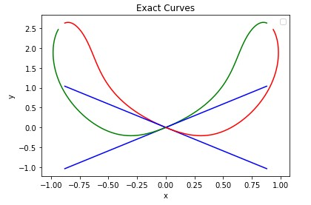
Figure 10: The curves with linear approximants for the guide channel are shown in the figure. The green curve has the left-hand-side turn taken as a reference and the red curve the opposite. Near zero, the straight-line approximants are shown in blue. Here, the parameters R=0.5, l=1 and W/L=0.7.
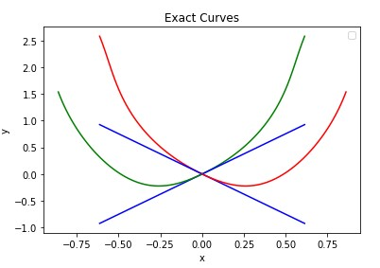
Figure 11: R = 0.2m, l = 0.65m and W/L = 0.7. The range of angles is -60 to 60 degs. The linear approximants are valid with in up to -15 to 15 degs with < 10% tolerance.
The actual implementation—although outside the scope of this theoretical work—will require choosing between either the green or the red curves for the locus of the center point C. While one intuitively expects that the guide curves must be symmetric about zero, the presence of the cusp is something that has to be dealt with while practically designing and fitting the currently proposed mechanism in an actual vehicle. If the asymmetry is not a problem then the design is straight-forward and one chooses one of the smooth curves and makes the point C move about them. If symmetry is necessary due to some design reasons, the upper or lower curves with cusps can be chosen based on compactness—if at all the concern—or other design simplicity.

Conclusion
In this work, we have shown that the traditional methods of car-steering are fraught by an inaccurate front-steered wheel’s turns that may lead to instabilities at high speed turns. Its proposed here that the steering mechanism be reviewed—especially that Ackermann steering angles were compared with exact steering angles that satisfy the cotangent condition—and a new mechanism be proposed that comprises of a guided 5-link mechanism and is accurate within the tolerances of the guiding curves. In it, we find that the guide curves are—for the sake of smoothness—asymmetric about the center position. Futher, it’s shown that, near the center position, the guide curves are a straight-line—in both directions of choice of the reference turning angle. The proposed mechanism can be made compact and can affect accurate steering at large angels that are greater than 60 degss.—thereby giving a car high-speed turn safety.
Further, in the field of Robotics where there is a need for a turn about a center, such mechanisms may become relevant as a more robust methodology as compared to electronic-motorised controlled mechanisms. It is envisioned by the authors that the existing mechanisms of car steering—whether Ackermann or others—can be retro-fitted with a locus-tracing mechanism like the one discussed in the paper.
The authors would like to conclude this theoretical work with the fact that practical implementation would be their next and future directions—this will involve the practical design for: (1) Compactness (2) guide channel actuation through a cam or a sleeve and (3) connection with the steering wheel’s axle.

References
[1] J. Walter. "The story of Ackermann steering." https://www.tiretechnologyinternational.com/opinion/the-story-of-ackermann-steering.html
[2] P. A. Simionescu, T. Hoeltgebaum, and D. Martins, "On the Evolution of Automotive Steering Mechanisms," in Proceedings of the 2022 USCToMM Symposium on Mechanical Systems and Robotics, Cham, P. Larochelle and J. M. McCarthy, Eds., 2022// 2022: Springer International Publishing, pp. 116-128.
[3] D. King-Hele, "Erasmus Darwin’s Improved Design for Steering Carriages—And Cars," Notes and Records of the Royal Society of London, vol. 56, no. 1, pp. 41-62, 2002.
[4] J.-S. Zhao, X. Liu, Z.-J. Feng, and J. S. Dai, "Design of an Ackermann-type steering mechanism," Proceedings of the Institution of Mechanical Engineers, Part C: Journal of Mechanical Engineering Science, vol. 227, no. 11, pp. 2549-2562, 2013.
[5] A. Zouelm, S. Nasiri, and H. Zohoor, "Design of two steering mechanisms for exact satisfaction of Ackermann equation," Proceedings of the Institution of Mechanical Engineers, Part D: Journal of Automobile Engineering, vol. 237, no. 6, pp. 1454-1464, 2023/05/01 2022, doi: 10.1177/09544070221085964.
[6] A. Carcaterra and W. D’Ambrogio, "A function generating differential mechanism for an exact solution of the steering problem," Mechanism and Machine Theory, vol. 33, no. 5, pp. 535-549, 1998/07/01/ 1998, doi: https://doi.org/10.1016/S0094-114X(97)00072-4.
[7] S. Shukla, S. Sharma, and P. Kumar, "Analysis of Steering Using Davis Mechanism," in Advances in Mechanical Engineering and Technology, Singapore, R. M. Singari, P. K. Kankar, and G. Moona, Eds., 2022// 2022: Springer Singapore, pp. 219-230.
[8] A. Ghosal, "The Freudenstein equation," Resonance, vol. 15, no. 8, pp. 699-710, 2010/08/01 2010, doi: 10.1007/s12045-010-0079-4.
[9] K. Mehar, S. Singh, and R. Mehar, "Optimal synthesis of four-bar mechanism for function generation with five accuracy points," Inverse Problems in Science and Engineering, vol. 23, no. 7, pp. 1222-1236, 2015/10/03 2015, doi: 10.1080/17415977.2014.993982.

