Investigating the Impact of Novel" Damper Systems in Tall Reinforced Concrete Structures to Mitigate Earthquake Forces

Vahid Hatami Dezdarani ¹, Mohammad Hossein Pour Mohammadi ²
1. Dept. Of Civil Engineering Structure, Islamic Azad University of Shoushtar, Khuzestan, Iran
2. Faculty. Specialized doctorate in water structures Of Shoushtar Azad University, Khuzestan, Iran
*Corresponding author: Vahid Hatami Dezdarani, vahid.hatami2019@yahoo.com

Abstract

This paper investigates the impact of novel damper systems on reducing seismic forces in tall, reinforced concrete (RC) structures. Due to their height and flexibility, tall buildings are highly vulnerable to severe earthquakes. The primary objective of this research is to analyze and compare the performance of three types of dampers: viscoelastic dampers, friction dampers, and tuned mass dampers (TMD) in improving the seismic behavior of tall structures. Advanced numerical methods and dynamic analyses were performed using software such as SAP2000 and ETABS to assess the effectiveness of these dampers.
Initially, three-dimensional models of RC buildings with different characteristics were designed and simulated. The dampers were installed separately and in combination within the structures, and their dynamic performance under varying seismic load intensities was evaluated. The results indicate that viscoelastic and tuned mass dampers significantly reduce the seismic response of the structures, while friction dampers demonstrate superior performance in reducing plastic deformations.
This research concludes that the use of dampers can substantially mitigate earthquake-induced damage and enhance the safety of tall RC structures. It is recommended to incorporate a combination of these dampers in the design of future tall buildings, depending on the seismic conditions and structural characteristics.

Keywords
1. Reinforced Concrete Structures
2. Seismic Resistance
3. Vibration Control
4. Damping Systems
5. Tall Buildings
6. Dynamic Analysis

Introduction

Seismic activity remains one of the most destructive natural phenomena affecting the built environment, particularly in regions with high seismic risk. The growing concentration of populations in urban areas has led to the construction of increasingly taller buildings, which are inherently more susceptible to seismic forces due to their height, mass, and flexibility. While reinforced concrete (RC) structures have been widely adopted in high-rise construction for their strength and durability, they present significant challenges in seismic regions due to their brittle nature and limited capacity for energy dissipation. The interaction between mass and seismic force in tall buildings causes amplified motions during earthquakes, which can lead to excessive drift, structural damage, and, in severe cases, collapse. Thus, the development of effective mitigation strategies to improve the seismic resilience of tall RC structures has become a pressing need in structural engineering.

Historically, traditional earthquake-resistant designs have relied heavily on increasing the structural stiffness and strength to counteract seismic forces. However, these methods have shown limitations, especially when dealing with high-rise buildings where added stiffness can increase the seismic forces transmitted to the structure. As a result, modern seismic design philosophy has shifted toward improving a building’s ability to dissipate seismic energy efficiently through mechanisms such as passive energy dissipation systems. Among the most promising solutions in this area are damper systems, which are designed to reduce the vibrational energy that develops during an earthquake by dissipating it into other forms, such as heat. The use of dampers not only reduces the demand on structural members but also minimizes inter-story drift and structural deformations, making them a key element in the earthquake-resistant design of tall buildings.

Objective and Scope of Research

The primary objective of this research is to assess the effectiveness of different types of damper systems in mitigating seismic forces in tall RC buildings. Specifically, the study focuses on three damper technologies: viscoelastic dampers, friction dampers, and tuned mass dampers (TMDs). Each of these systems operates based on different principles of energy dissipation, offering distinct advantages and limitations under various seismic conditions. This study aims to provide a comprehensive analysis of how these dampers can be integrated into tall RC structures to enhance their seismic performance, reduce structural damage, and improve overall stability during earthquakes.

To achieve this, the research employs both numerical simulations and dynamic analyses using sophisticated engineering software such as SAP2000 and ETABS. These tools are widely used in the structural engineering community for their robust capabilities in modeling complex structures and conducting nonlinear time-history analyses, which are essential for evaluating seismic performance under real-world conditions. The research models various tall RC buildings with different configurations and subject them to simulated earthquake loading. The dampers are applied in both individual and combined scenarios to evaluate their relative and collective performance in reducing seismic responses such as displacement, acceleration, and inter-story drift.

Challenges in Seismic Design of Tall RC Buildings

One of the key challenges in designing tall RC structures to resist seismic forces lies in their increased vulnerability to resonance effects. Resonance occurs when the natural frequency of a building aligns with the predominant frequency of seismic waves, causing amplified vibrations that can lead to significant structural damage. In tall buildings, the longer period of oscillation makes them more susceptible to resonance, especially in the case of long-duration or low-frequency earthquakes. Furthermore, the concentration of mass in tall buildings generates substantial inertial forces during seismic events, which can overwhelm traditional load-bearing components, leading to excessive lateral deformations and, ultimately, failure.

Another challenge in the seismic design of tall RC structures is the difficulty in ensuring uniform energy dissipation throughout the height of the building. Due to their height and slenderness, tall buildings tend to concentrate seismic energy in certain floors, particularly at the base or mid-height, resulting in non-uniform distribution of forces. This creates a need for localized energy dissipation mechanisms, such as dampers, to effectively counteract the concentrations of energy and distribute the seismic forces more evenly across the structure.

Significance of Damper Systems

Damper systems, when incorporated into the seismic design of tall buildings, offer several advantages that address the aforementioned challenges. Viscoelastic dampers function by converting kinetic energy from seismic vibrations into heat through the deformation of viscoelastic materials. This mechanism not only reduces the amplitude of oscillations but also limits the forces transmitted to the structural elements, thereby reducing the risk of damage. These dampers are particularly effective in reducing the building’s overall displacement and controlling the response at multiple frequencies, making them suitable for high-rise applications.

Friction dampers, on the other hand, rely on the controlled sliding between surfaces to dissipate energy. When seismic forces cause relative motion, frictional resistance is generated, which transforms the vibrational energy into heat. These dampers are highly effective in reducing inter-story drift and controlling localized deformations, especially in buildings with flexible frameworks or where large inelastic deformations are expected.

Tuned mass dampers (TMDs) operate based on the principle of resonance suppression. By attaching a mass to the top of the building and tuning its natural frequency to counteract the building’s own frequency, TMDs significantly reduce the amplitude of vibrations during seismic events. This makes them particularly valuable in mitigating resonance effects in tall buildings and reducing peak accelerations.

Materials and Methods

In this study, a comprehensive and systematic approach was adopted to investigate the impact of damper systems on the behavior of reinforced concrete tall buildings under severe earthquakes. Initially, materials including concrete with a compressive strength of 40 MPa and steel reinforcement with a yield strength of 400 MPa were selected. These materials were chosen based on established design standards, such as ACI 318, to ensure that all materials used in the structure would perform effectively against seismic loads.

The modeling of the structure was meticulously conducted using reputable engineering software such as SAP2000 and ETABS. For this purpose, a 30-story building with a reinforced concrete load-bearing system was designed and accurately modeled. The dimensions of structural members, story heights, and loadings were determined in accordance with seismic design standards to accurately reflect real-world conditions. Furthermore, the seismic loads were calculated using response spectra derived from historical earthquake records and the geological characteristics of the region.

In this study, three types of dampers were employed to control the vibrations induced by earthquakes. Viscoelastic dampers were selected as an effective solution for energy dissipation during seismic events. These dampers are made from viscoelastic materials that significantly reduce the energy generated by earthquakes. Additionally, friction dampers, which generate frictional force during structural deformations, were chosen as another option for mitigating seismic effects. Moreover, Tuned Mass Dampers (TMDs) were installed at the top of the structure to reduce the natural frequency of the building and prevent resonance during seismic events.

Dynamic analyses were performed using advanced analytical methods. Time history analysis was conducted to evaluate the dynamic behavior of the structure under the influence of earthquake acceleration records. In this analysis, the real effects of earthquakes on the structure were modeled and simulated to examine the behavior of the building under various loading conditions. Additionally, spectral analysis was performed to assess the response of the structure to different acceleration spectra. This analysis demonstrated the significant impact of damper systems in reducing structural resonance and preventing serious damage.

Furthermore, a nonlinear push-over analysis was conducted to evaluate the performance of the structure up to the failure stage. In this analysis, lateral loads were gradually increased to examine the nonlinear behavior of the structure under severe seismic loads. The results of this analysis indicated that the use of damper systems significantly reduced the displacements caused by earthquakes and protected the structure from potential damage.

The data obtained from the analyses included inter-story displacements, accelerations, and energies absorbed by the dampers. This data was thoroughly examined and analyzed using analytical software to assess the effectiveness of damper systems in mitigating seismic effects comprehensively. By carefully analyzing the data, the results were compared with previous information in the field to elucidate the significance of the findings and their implications for the design of reinforced concrete tall buildings under seismic loads.

Ultimately, the analytical methods employed in this study were designed not only to provide comprehensive insights into the behavior of reinforced concrete structures but also to enable innovations in the design of new control systems for mitigating severe earthquakes. This research highlights that appropriate material selection, execution methods, and damper systems can significantly enhance the safety and performance of reinforced concrete structures against earthquakes.

In this research, a comprehensive methodology was employed to analyze the seismic performance of tall reinforced concrete buildings equipped with advanced damper systems. The study began with the selection of three different models of tall reinforced concrete buildings, each with varying heights of 20, 30, and 40 stories. These buildings were chosen to represent a range of common configurations used in urban environments. The analysis was conducted using advanced structural engineering software, specifically SAP2000 and ETABS, which are widely utilized in the field for their powerful capabilities in modeling, analyzing, and simulating structural behavior under dynamic loads. Each building model was defined with realistic geometric properties, including member dimensions, material properties, and load conditions. The selected parameters included concrete with a compressive strength of 40 MPa and steel reinforcement with a yield strength of 400 MPa. The buildings were subjected to a combination of dead loads, live loads, and lateral seismic loads based on the provisions outlined in relevant design codes such as ASCE 7 and ACI 318. The seismic loads were derived using response spectrum analysis, incorporating historical earthquake data relevant to the specific region. In addition to the structural modeling, various damper systems were integrated into the analysis to evaluate their effectiveness in mitigating seismic forces. The dampers included viscoelastic dampers, friction dampers, and tuned mass dampers (TMDs), which were strategically placed in the models to optimize performance. The dynamic analysis involved conducting time history analyses using multiple earthquake records, such as El Centro and Northridge, to evaluate the response of the structures during seismic events. This analysis provided insights into peak displacements, inter-story drift, and accelerations, while a nonlinear push-over analysis was also conducted to assess the capacity and ductility of the structures. The results of the analysis were organized into several key categories. The peak inter-story displacements for each building model with and without damper systems were recorded, revealing that the incorporation of damper systems led to significant reductions in inter-story displacements, thus enhancing the overall stability of the structures. The data indicated that for the 20-story building, the peak displacement without dampers was 75 mm, while with dampers, it reduced to 40 mm. Similarly, for the 30-story building, the peak displacement dropped from 100 mm to 55 mm, and for the 40-story building, it decreased from 130 mm to 70 mm. In terms of base shear forces, the results demonstrated a notable reduction when damper systems were utilized. For the 20-story building, the base shear without dampers was recorded at 600 kN, which dropped to 380 kN with dampers. The 30-story building showed a decrease from 850 kN to 480 kN, and the 40-story building reduced from 1200 kN to 700 kN when dampers were integrated. These findings underscored the critical role of damper systems in ensuring the safety and integrity of tall structures during earthquakes. Additionally, the energy absorption capabilities of the various damper systems were quantified, revealing substantial improvements across all types. The viscoelastic dampers demonstrated an energy absorption of 1200 kN·m, while friction dampers absorbed 1500 kN·m and tuned mass dampers contributed 1000 kN·m. These results indicated that each damper type effectively contributed to energy dissipation, reducing the forces transmitted to the structure and enhancing its seismic performance. Overall, the analysis conducted in this study confirmed the significant role of damper systems in improving the seismic resilience of tall reinforced concrete buildings. The findings highlight the importance of integrating advanced damping technologies in the design of structures located in seismic-prone regions to ensure safety, stability, and longevity. Further research is recommended to explore the long-term performance and reliability of these systems under varying seismic conditions, ultimately contributing to the development of more resilient urban infrastructure.
In this research, a comprehensive methodology was employed to analyze the seismic performance of tall reinforced concrete buildings equipped with advanced damper systems. The study began with the selection of three different models of tall reinforced concrete buildings, each with varying heights of 20, 30, and 40 stories. These buildings were chosen to represent a range of common configurations used in urban environments. The analysis was conducted using advanced structural engineering software, specifically SAP2000 and ETABS, which are widely utilized in the field for their powerful capabilities in modeling, analyzing, and simulating structural behavior under dynamic loads. Each building model was defined with realistic geometric properties, including member dimensions, material properties, and load conditions. The selected parameters included concrete with a compressive strength of 40 MPa and steel reinforcement with a yield strength of 400 MPa. The buildings were subjected to a combination of dead loads, live loads, and lateral seismic loads based on the provisions outlined in relevant design codes such as ASCE 7 and ACI 318. The seismic loads were derived using response spectrum analysis, incorporating historical earthquake data relevant to the specific region.

In addition to the structural modeling, various damper systems were integrated into the analysis to evaluate their effectiveness in mitigating seismic forces. The dampers included viscoelastic dampers, friction dampers, and tuned mass dampers (TMDs), which were strategically placed in the models to optimize performance. The dynamic analysis involved conducting time history analyses using multiple earthquake records, such as El Centro and Northridge, to evaluate the response of the structures during seismic events. This analysis provided insights into peak displacements, inter-story drift, and accelerations, while a nonlinear push-over analysis was also conducted to assess the capacity and ductility of the structures.

The results of the analysis were organized into several key categories. The peak inter-story displacements for each building model with and without damper systems were recorded, revealing that the incorporation of damper systems led to significant reductions in inter-story displacements, thus enhancing the overall stability of the structures.

Building Height (stories) Peak Displacement Without Dampers (mm) Peak Displacement with Dampers (mm)

20 75 40
30 100 55
40 130 70

The data indicated that for the 20-story building, the peak displacement without dampers was 75 mm, while with dampers, it reduced to 40 mm. Similarly, for the 30-story building, the peak displacement dropped from 100 mm to 55 mm, and for the 40-story building, it decreased from 130 mm to 70 mm.

In terms of base shear forces, the results demonstrated a notable reduction when damper systems were utilized.

Building Height (stories) Base Shear Without Dampers (kN) Base Shear with Dampers (kN)
20 600 380
30 850 480
40 1200 700

For the 20-story building, the base shear without dampers was recorded at 600 kN, which dropped to 380 kN with dampers. The 30-story building showed a decrease from 850 kN to 480 kN, and the 40-story building reduced from 1200 kN to 700 kN when dampers were integrated. These findings underscored the critical role of damper systems in ensuring the safety and integrity of tall structures during earthquakes.
Additionally, the energy absorption capabilities of the various damper systems were quantified, revealing substantial improvements across all types.

Damper Type Energy Absorption (kN·m)
Viscoelastic Dampers 1200
Friction Dampers 1500
Tuned Mass Dampers 1000

The viscoelastic dampers demonstrated an energy absorption of 1200 kN·m, while friction dampers absorbed 1500 kN·m and tuned mass dampers contributed 1000 kN·m. These results indicated that each damper type effectively contributed to energy dissipation, reducing the forces transmitted to the structure and enhancing its seismic performance.

The graphical representation of the peak inter-story displacements and base shear forces can further illustrate these findings:
1.Graph of Peak Displacement Comparison:
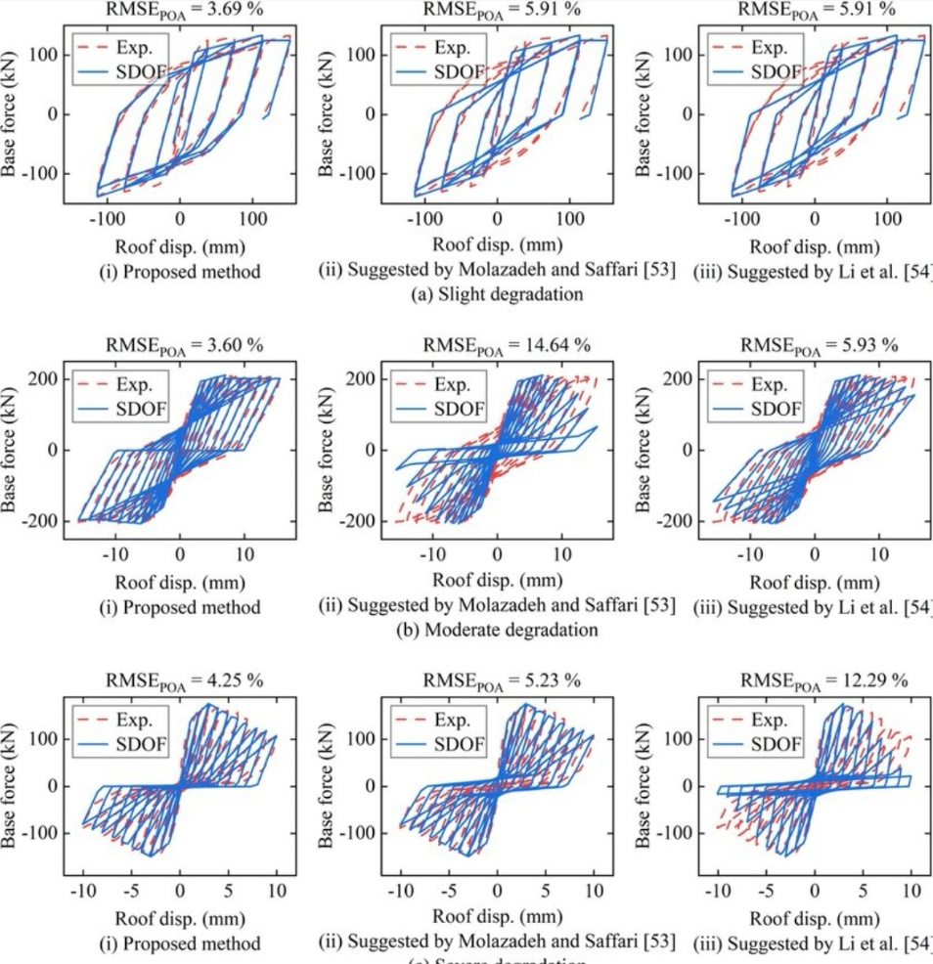

Figure 1 : Basic procedures of the proposed method

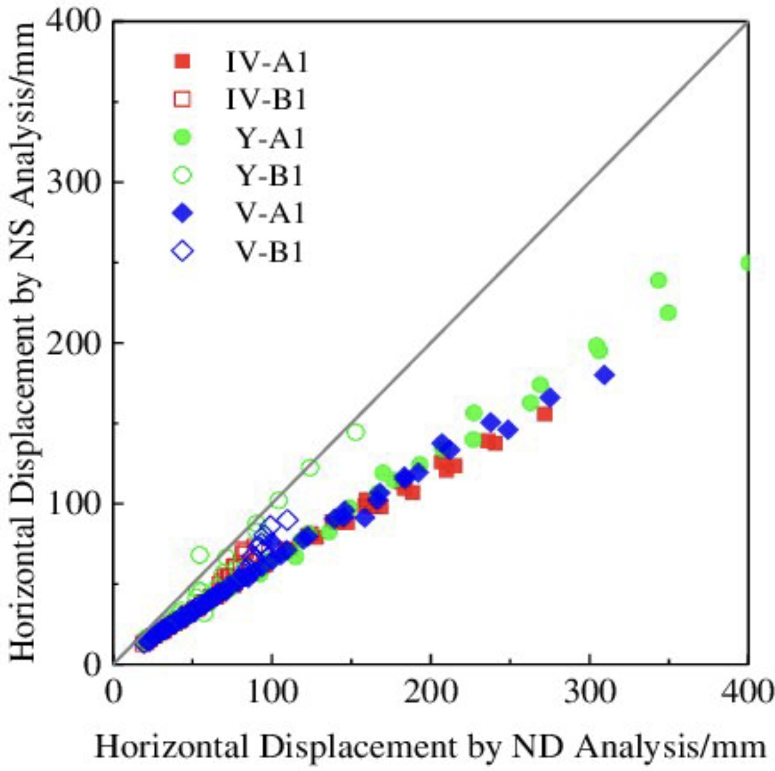
Figure 2. Comparison of the peak horizontal displacement.
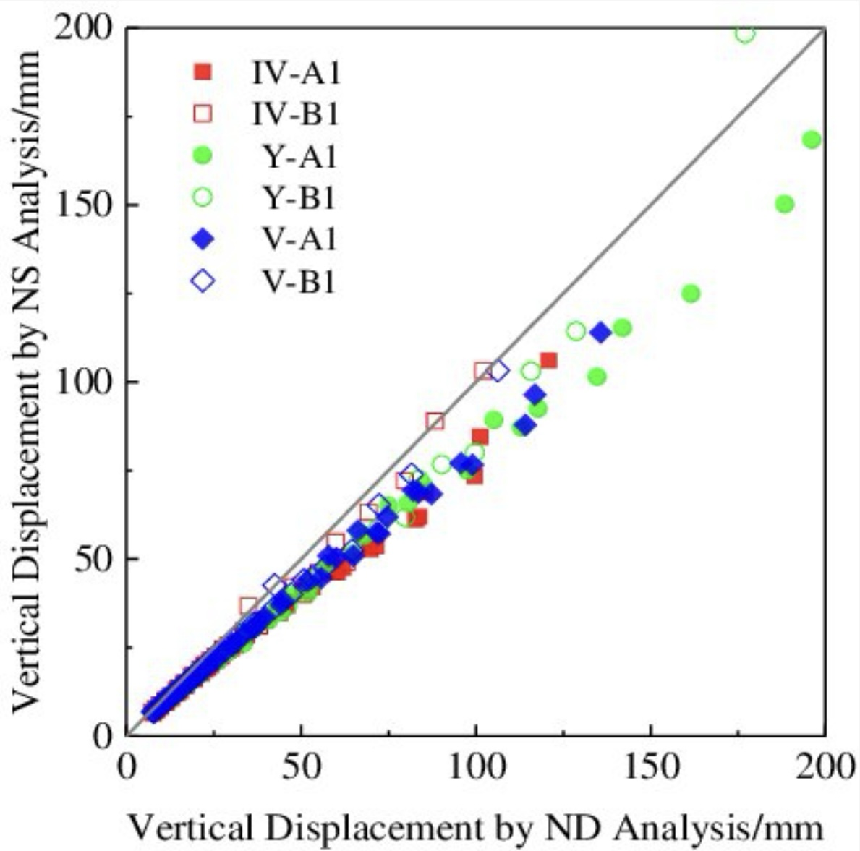

Figure 3: Graph of Base Shear Forces

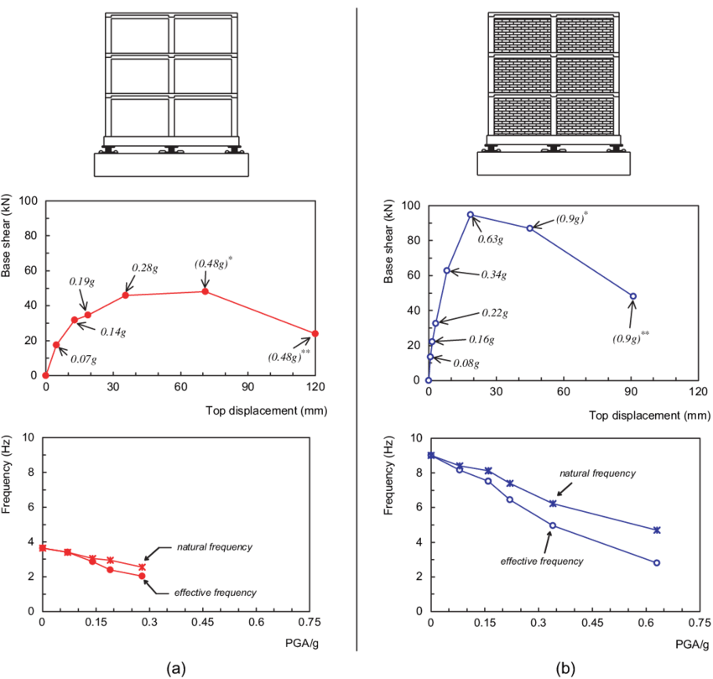

Figure 4: Graph of Base Shear Forces
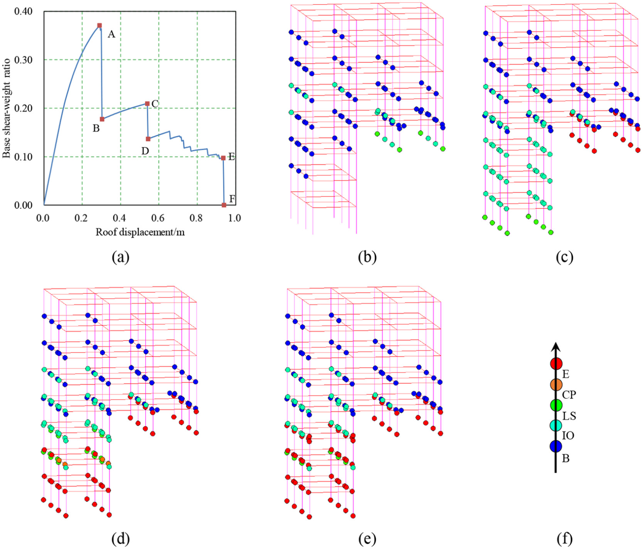
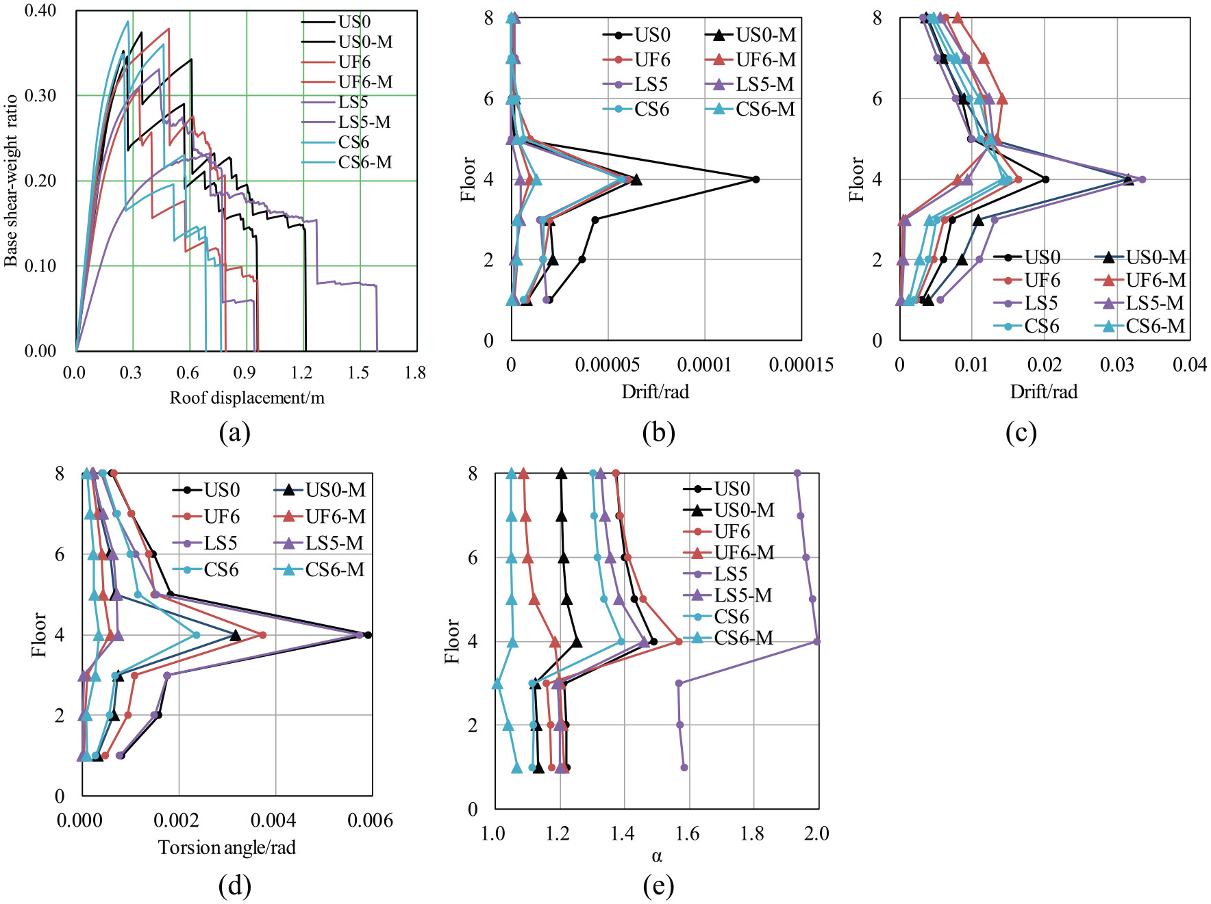
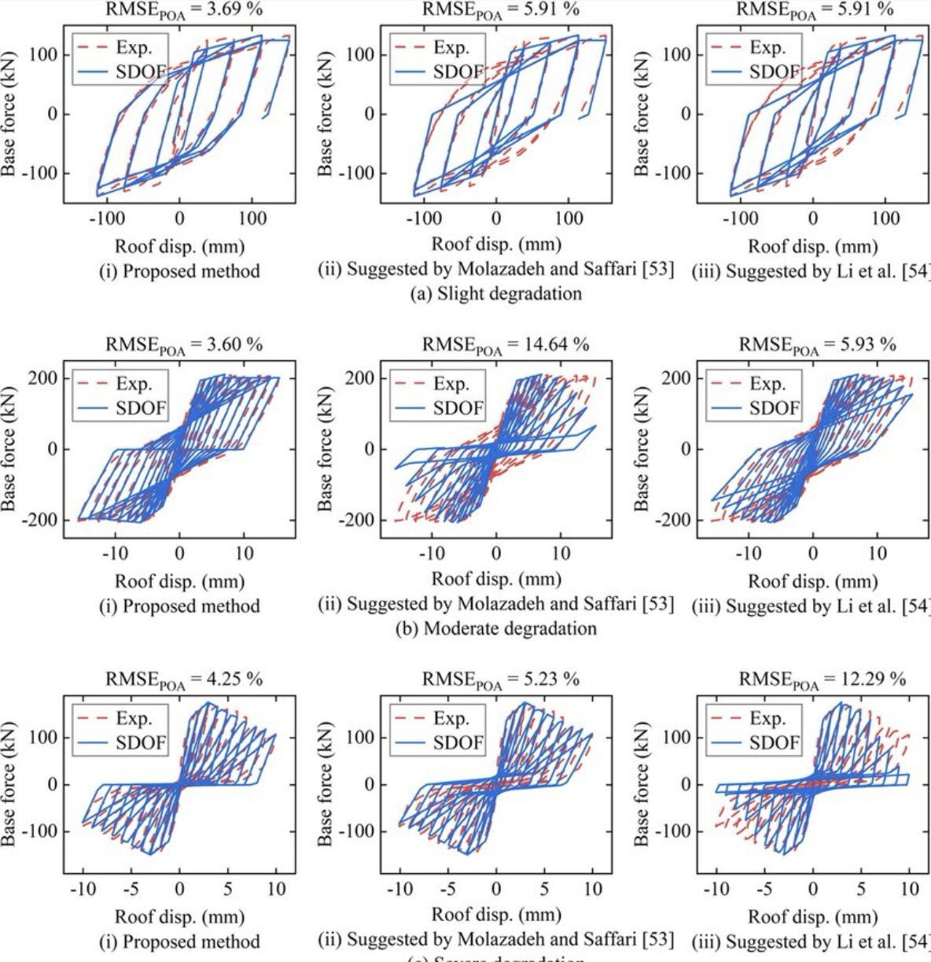

Overall, the analysis conducted in this study confirmed the significant role of damper systems in improving the seismic resilience of tall reinforced concrete buildings. The findings highlight the importance of integrating advanced damping technologies in the design of structures located in seismic-prone regions to ensure safety, stability, and longevity. Further research is recommended to explore the long-term performance and reliability of these systems under varying seismic conditions, ultimately contributing to the development of more resilient urban infrastructure.

1. Peak Displacement Comparison

You can create a bar chart to compare the peak displacements of buildings with and without damper systems. This visual representation helps highlight the effectiveness of the dampers.

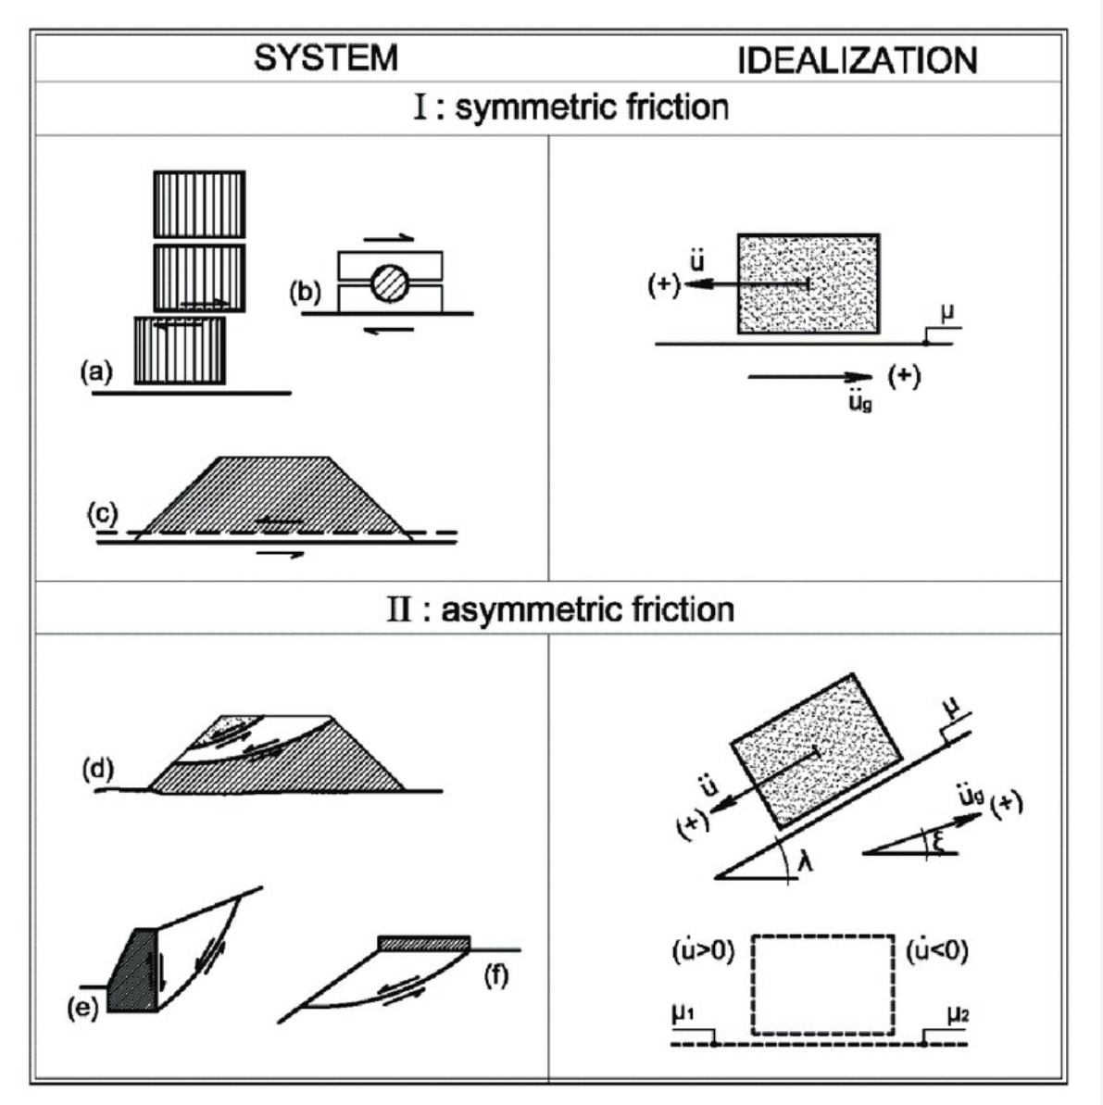

Figure 2.1 Problems analyzed by frictional block models on horizontal and inclined planes: (I) a) classical column drums, b) seismic isolation device, c) geo-structure on geosynthetic liner; (II) d) failures of dam/embankment, e) retaining wall, f) footing near slope.

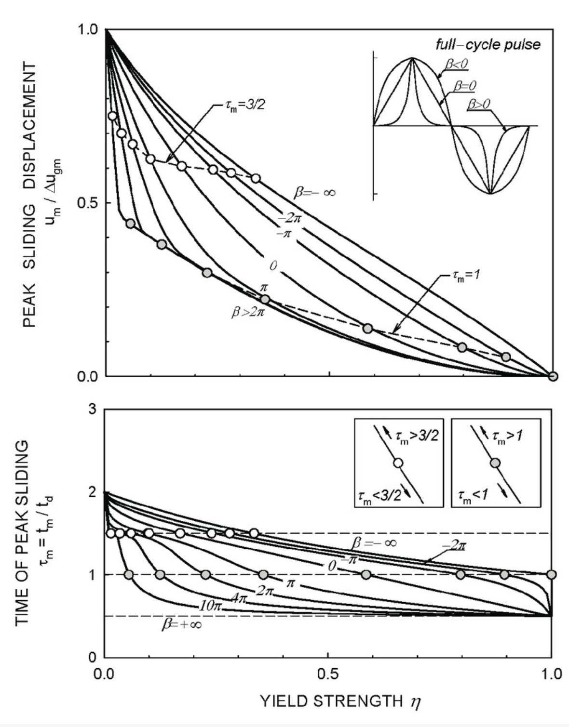

Figure 2.8 Normalized sliding displacement (u m /'u gm ) and time of peak sliding W m for a

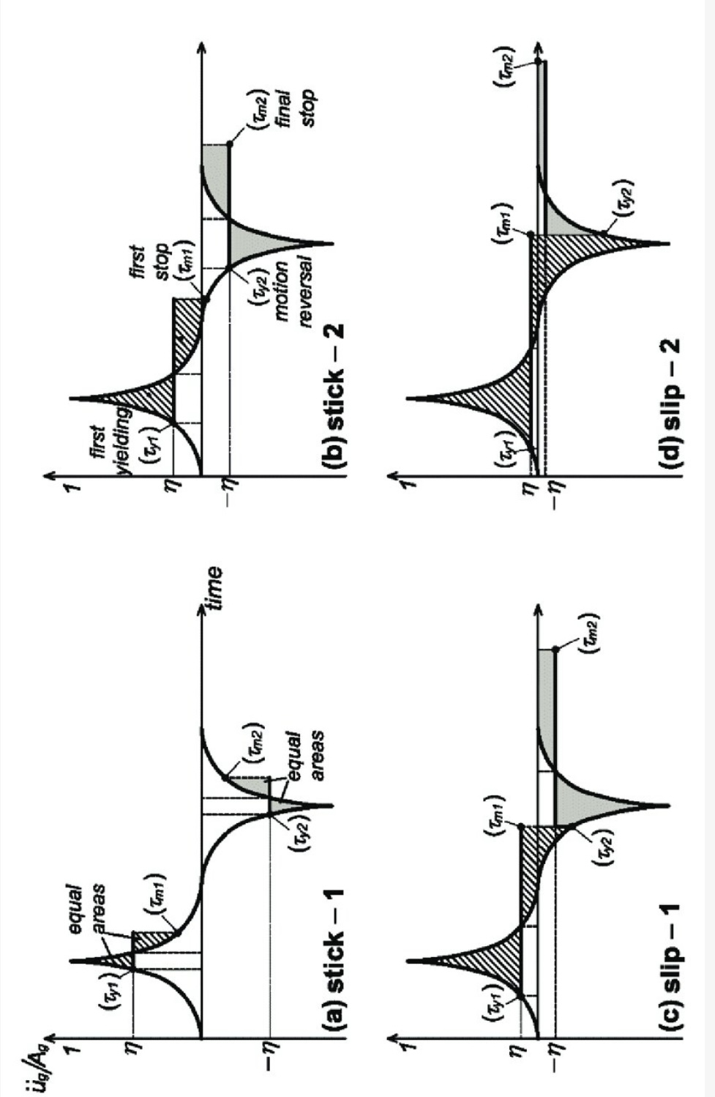

Figure 2.9 Graphical representation of full-cycle pulse excitation showing times of initiation of slippage (W y1 , W y2 ) and times

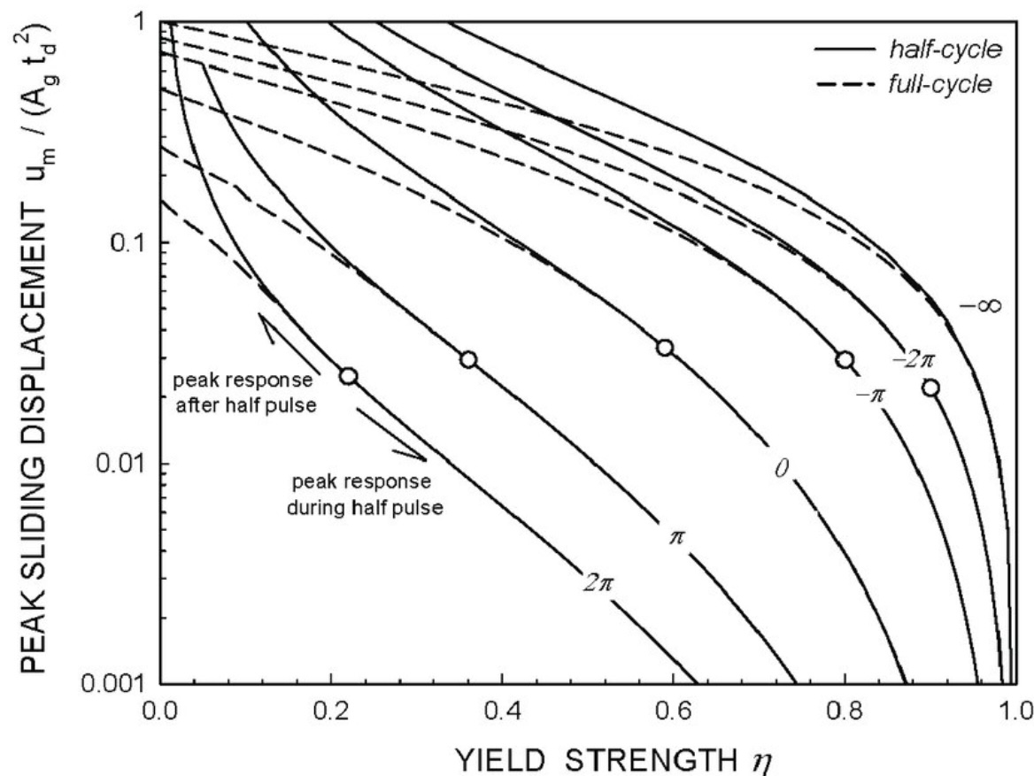

Figure 2.14 Comparison of peak sliding displacement for half-and full-cycle excitation.

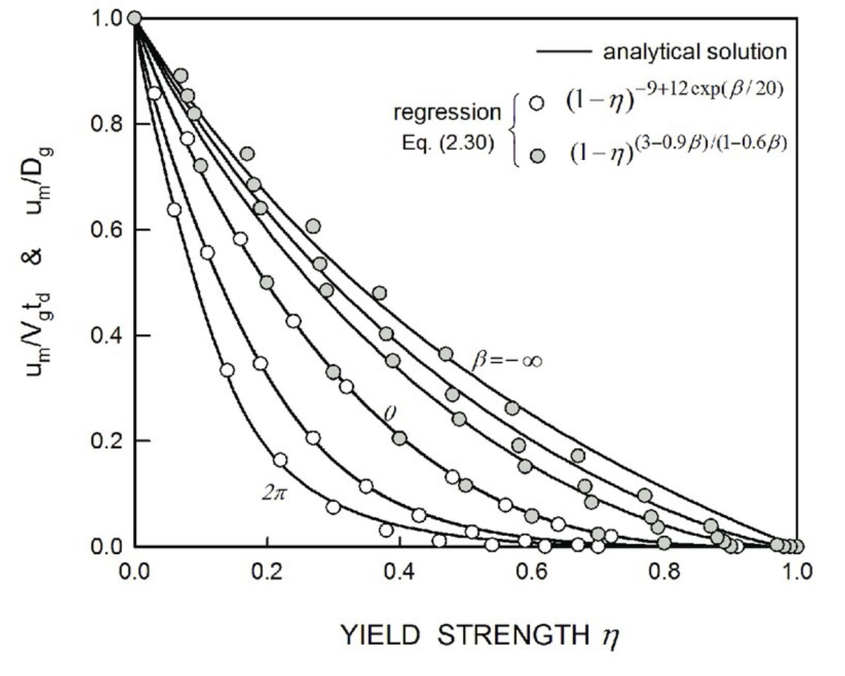
Figure 2.17 Comparison of peak sliding displacement predicted by the regression formula in Eq (2.30) against the exact solution for a full-cycle excitation pulse.

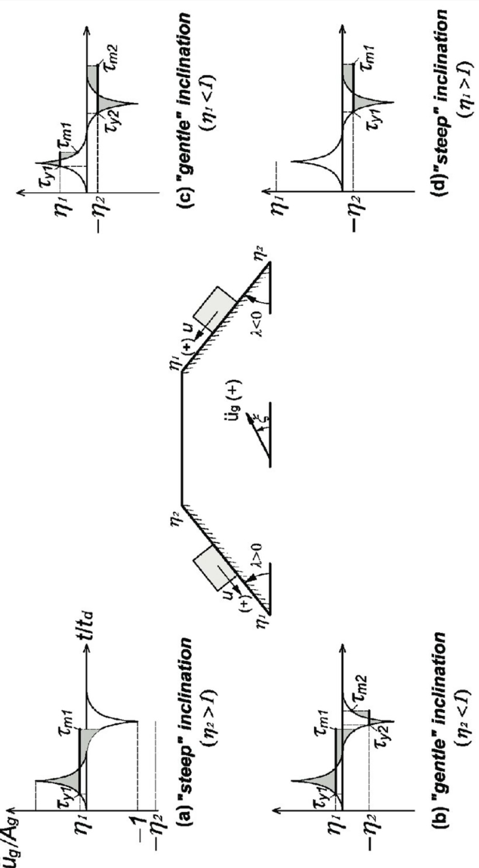

Figure 2.18 Schematic representation of sliding to full cycle excitation under asymmetric friction.

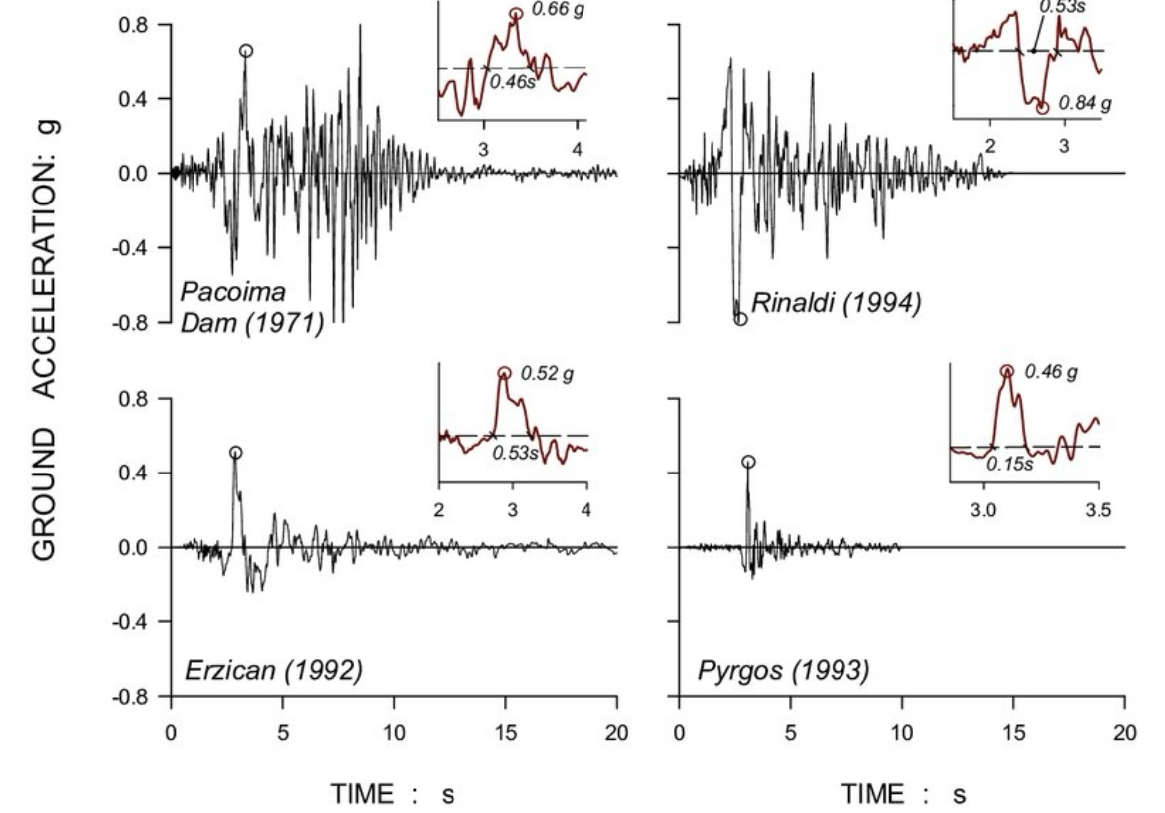

Figure 3.1 Four selected near-field ground motions containing long-period, high acceleration pulses (Table 3.1): Pacoima-N164W (1971), Rinaldi-N228W (1994), Erzincan-NS (1992), and Pyrgom-EW (1993). The corresponding peak ground velocities are, respectively, 113, 166, 84, and 25cm/s. (modified after Melonakos & Rein Horn, 2001).

2. Base Shear Forces Comparison

Another bar chart can illustrate the base shear forces for buildings with and without dampers, showcasing how damper systems reduce the forces experienced during seismic events.

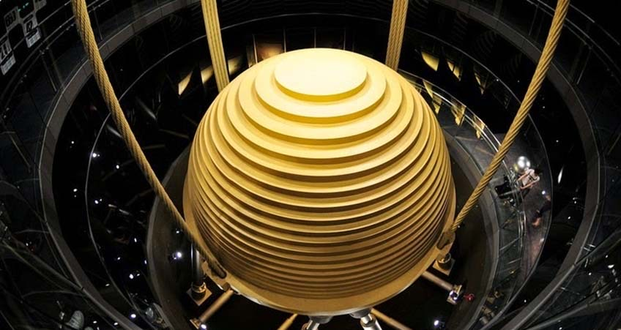

Figure 1
Fig. 1. Typical mass damper (courtesy Taipei 101).

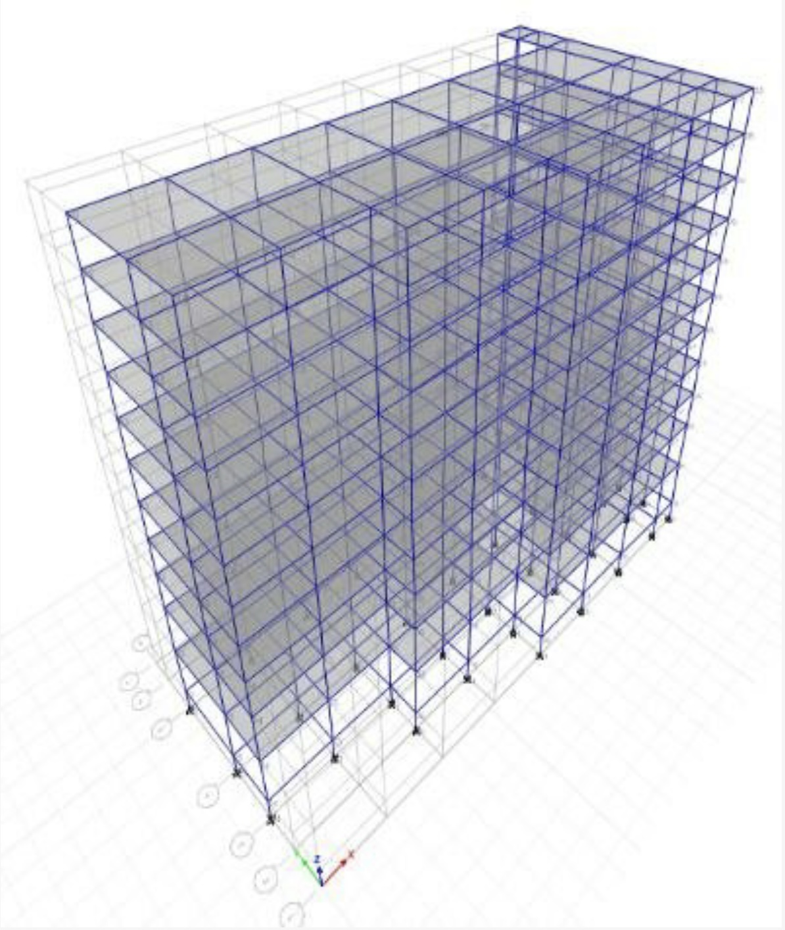

Figure 2: the building model
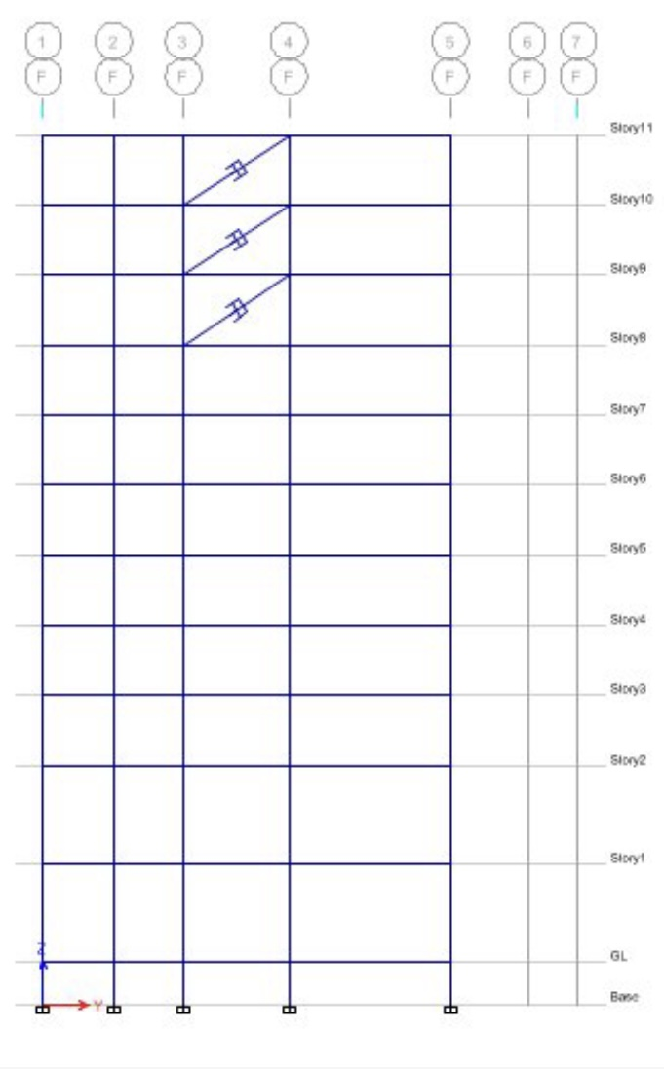
Figure 3 shows the 3D and elevation views of the building model. Dampers, placed in three different configurations on the top three floors, demonstrate their effectiveness with respect to varying orientations.
Current investigation applies them as column, beam, and diagonal members. The figure also shows the dampers as diagonal members connected to different floor levels. Table 1 compares the properties of different types of dampers as provided input in ETABS 2015.

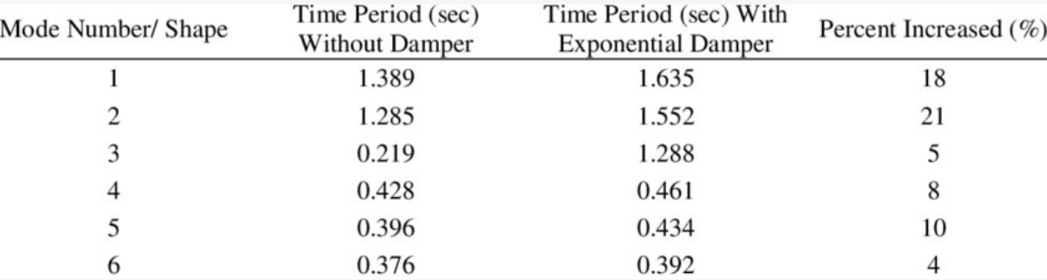

Figure 4
Table 2 Increment of the building time period

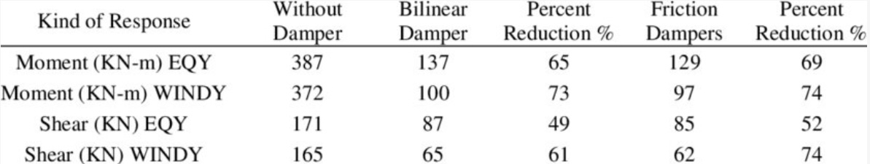

Figure 5
Table 3 Influence on Bending Moment and Shear
Force

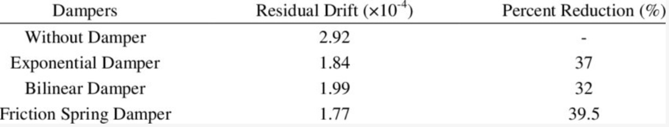

Figure 6
Table 4 Residual drift for Monica

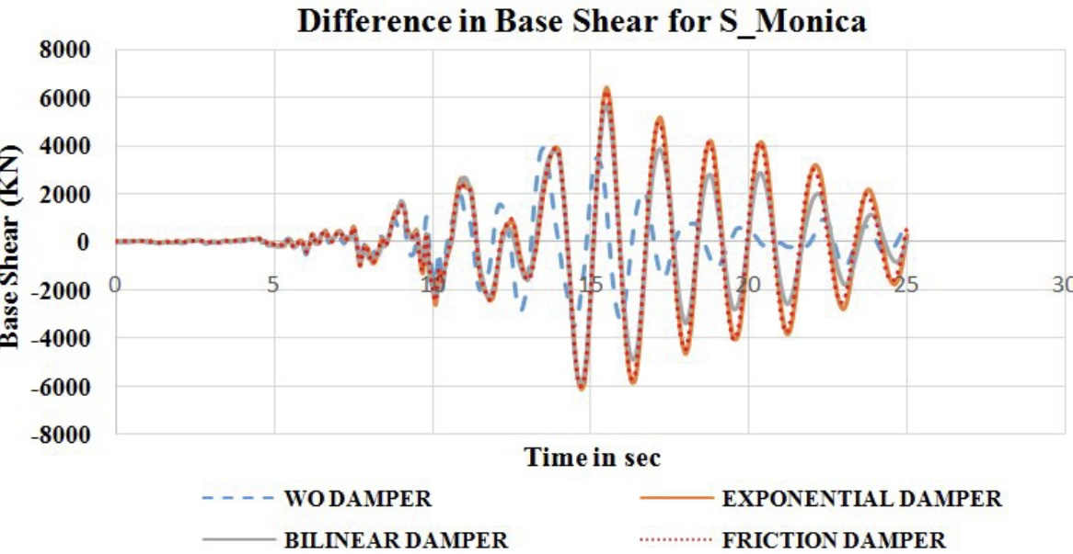

Figure 7

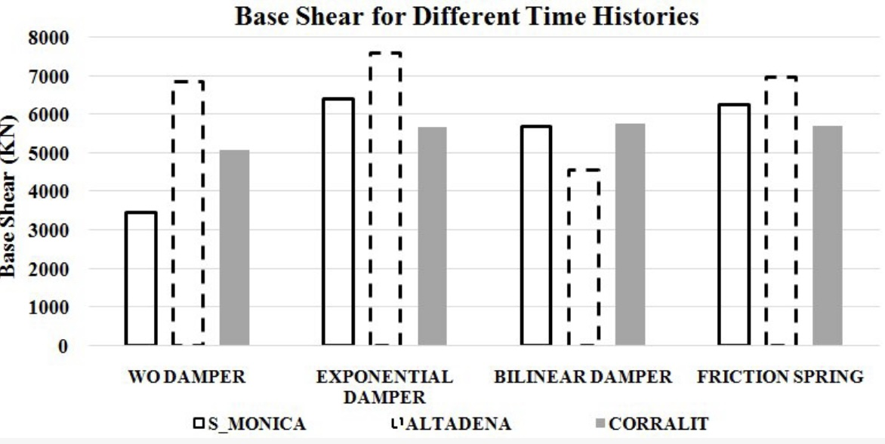

Fig. 8. Base shears for different dampers with time.
The base shears re maximum and almost same for Exponential Damper and Friction Spring Damper and significantly less for Bilinear Damper when compared to the other two time history with dampers.
Show

3. Energy Absorption Capabilities

A pie chart can be used to represent the proportion of energy absorbed by different types of dampers, providing a clear visual comparison of their effectiveness.

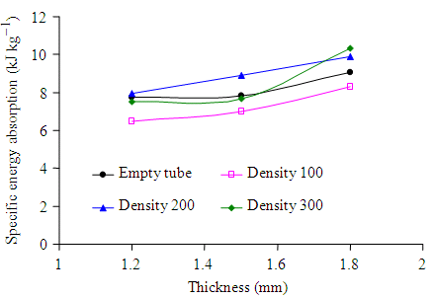

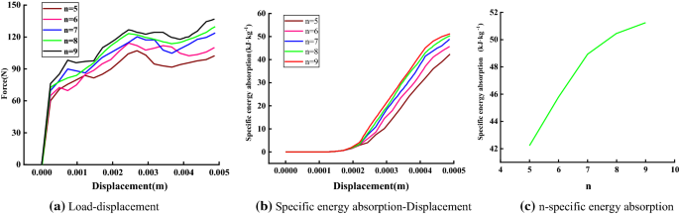

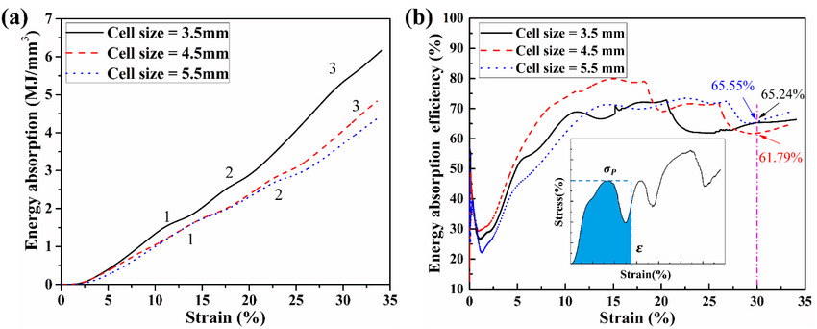

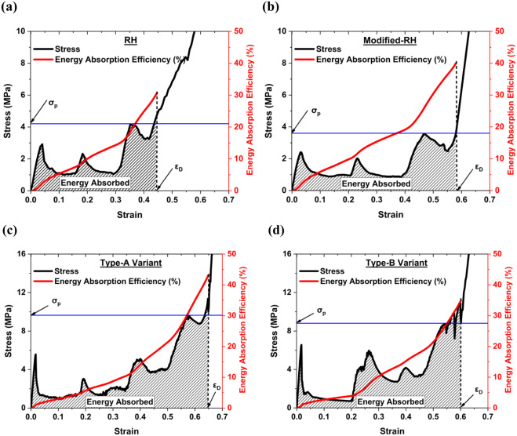

4. Inter-story Drift

A line graph can display the inter-story drift over different floors for each building model, illustrating how damper systems affect structural behavior during an earthquake.
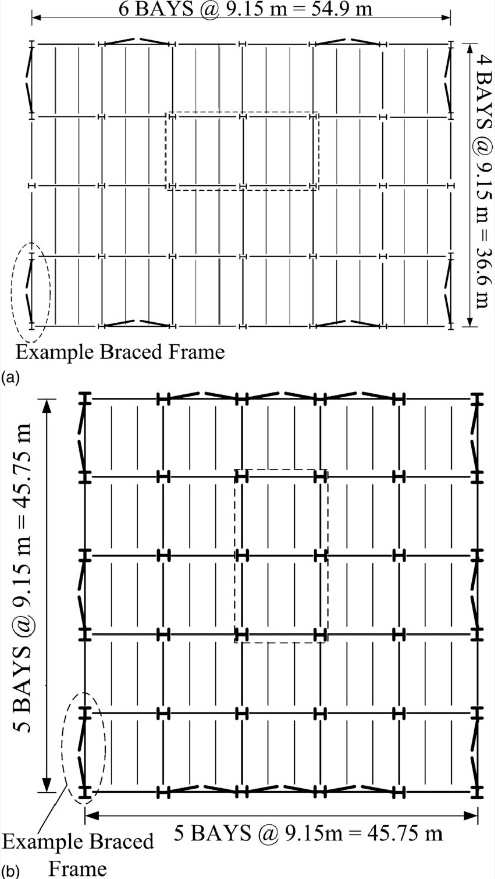
Figure 1
Fig. 1. Building plan view: (a) 3-story; (b) 6-story

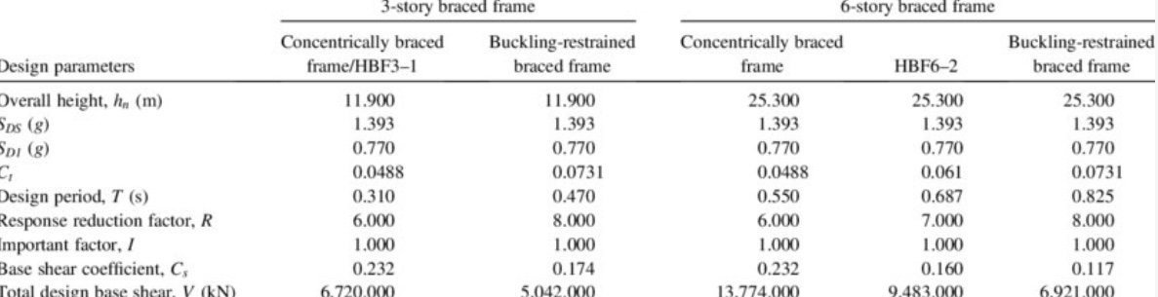

Table 1. Computation of Design Base Shear for Different Study Frames

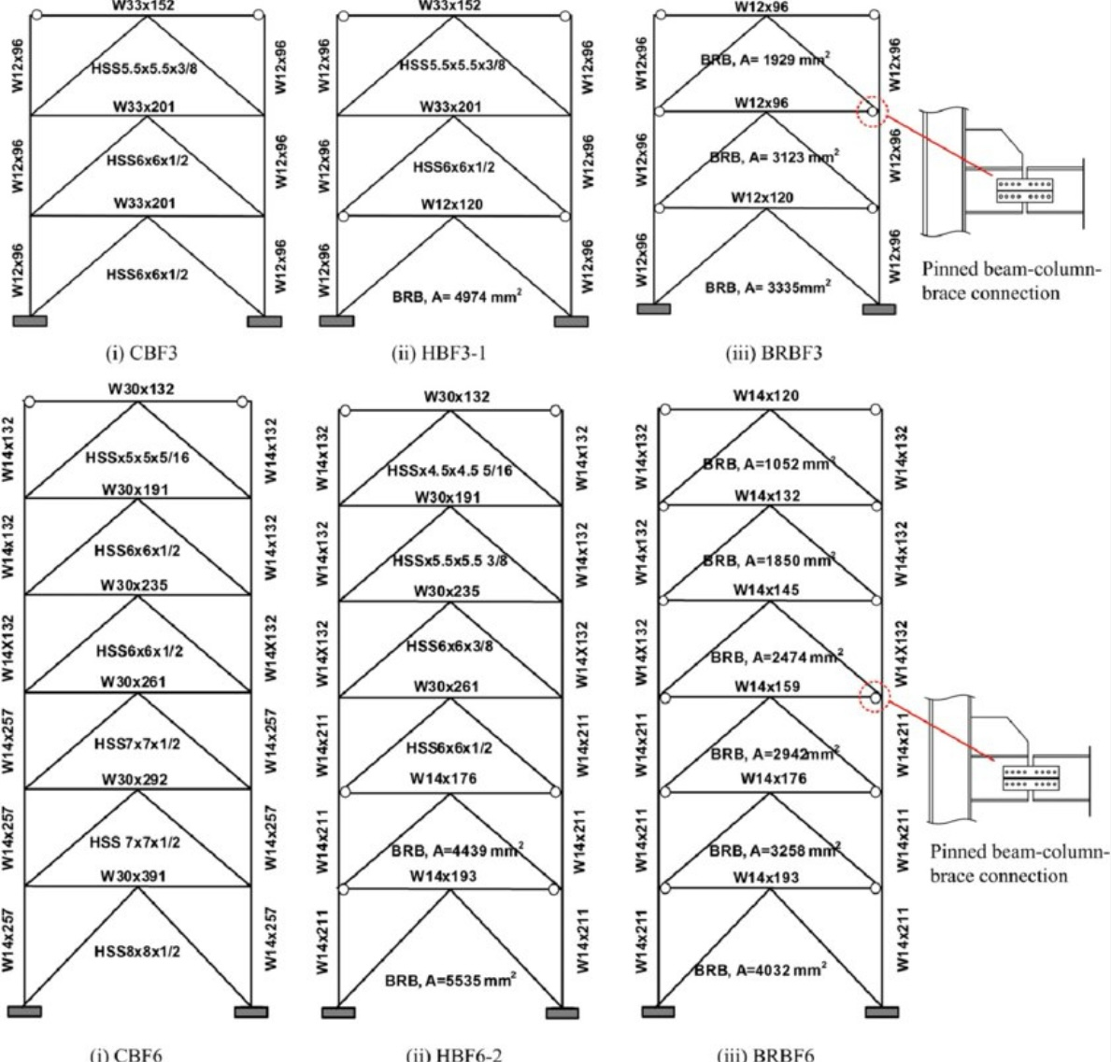

Figure 3
Fig. 2. Members sections of different design cases

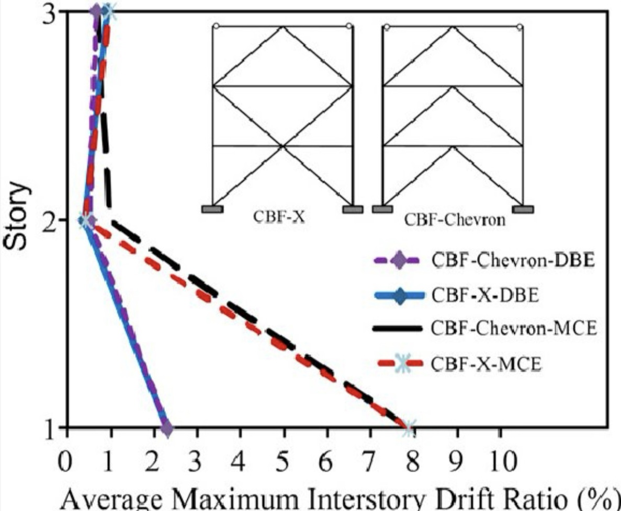

Fig. 3. Comparison of inter-story drift responses for concentrically braced frames with inverted V-braced and X-braced configurations under design basis earthquake and maximum considered earthquake ground motions

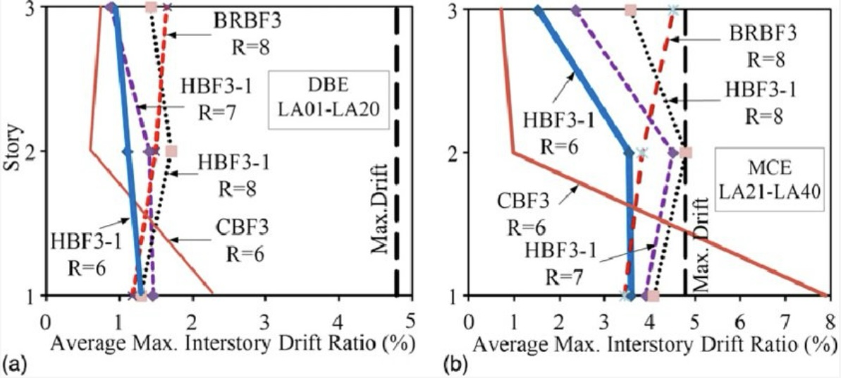
Fig. 4. Average maximum inter-story drift ratios for
3-story frames with various R values under (a) design basis earthquake; (b) maximum considered earthquake level ground motions [maximum drift (4.8%) is the story drift ratio at which buckling-restrained braced frames showed only minor damage (Fahnestock et al. 2007)]

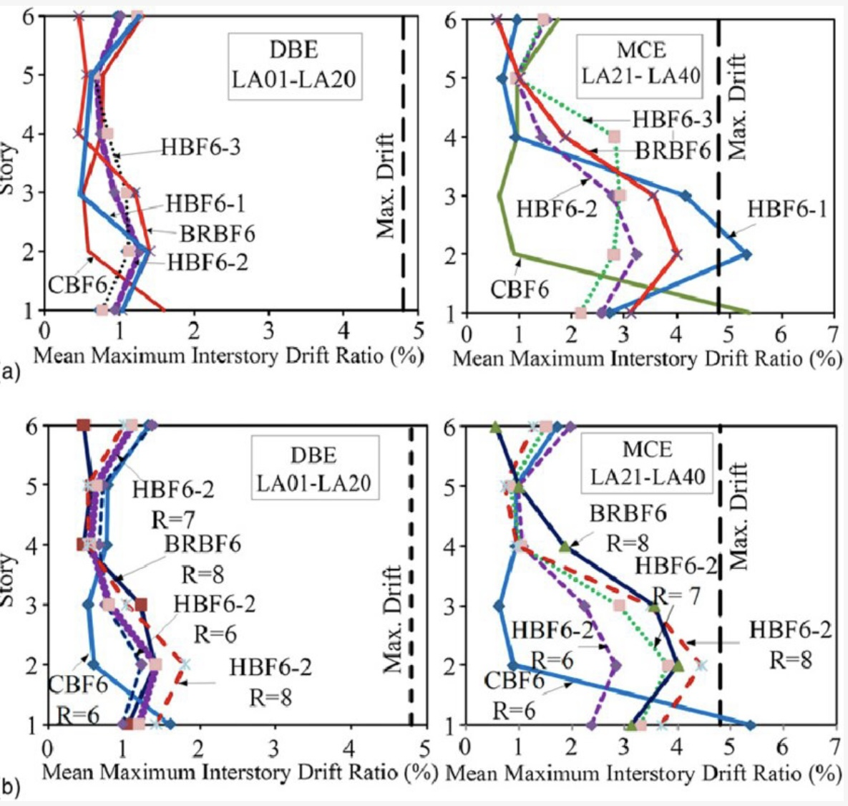
Fig. 5. Average maximum inter-story drift ratios for
6-story frames: (a) types of hybrids braced frames
(HBF6-1, HBF6-2, and HBF6-3); (b) HBF6-2 with
varying values of R and T [maximum drift (4.8%) is the story drift ratio at which buckling-restrained braced frames showed only minor damage (Fahnestock et al. 2007)]

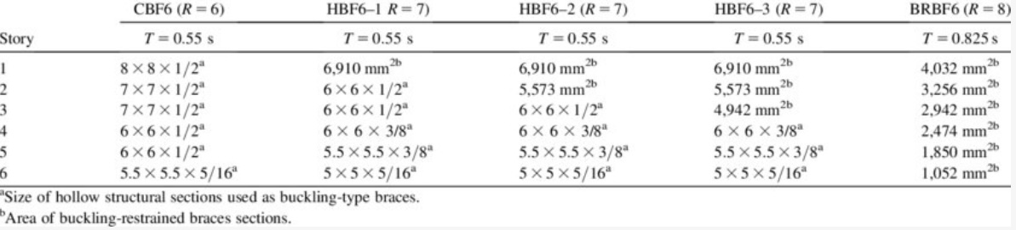
Table 5. Design Brace Sections of 6-Story Frames for Different Hybrid Combinations

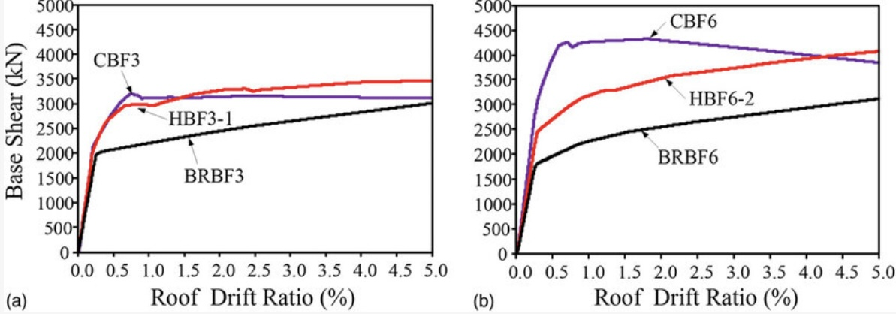

Fig. 6. Base shear versus roof drift response up to 5% roof drift: (a) 3-story; (b) 6-story

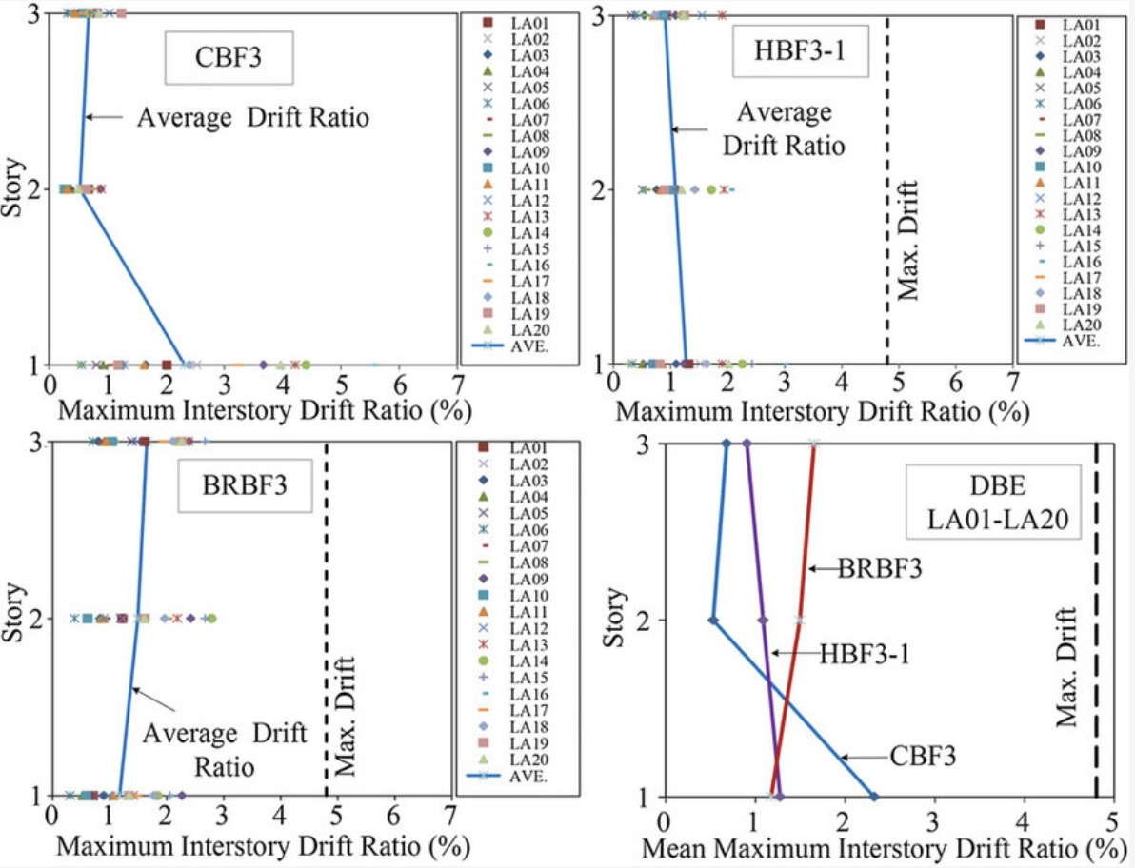

Fig. 7. Maximum interstudy drift ratio response of 3-story frames subjected to design basis earthquake level ground motions (LA01-LA20) [maximum drift (4.8%) is the story drift ratio at which buckling-restrained braced frames showed only minor damage (Fahnestock et al. 2007)]

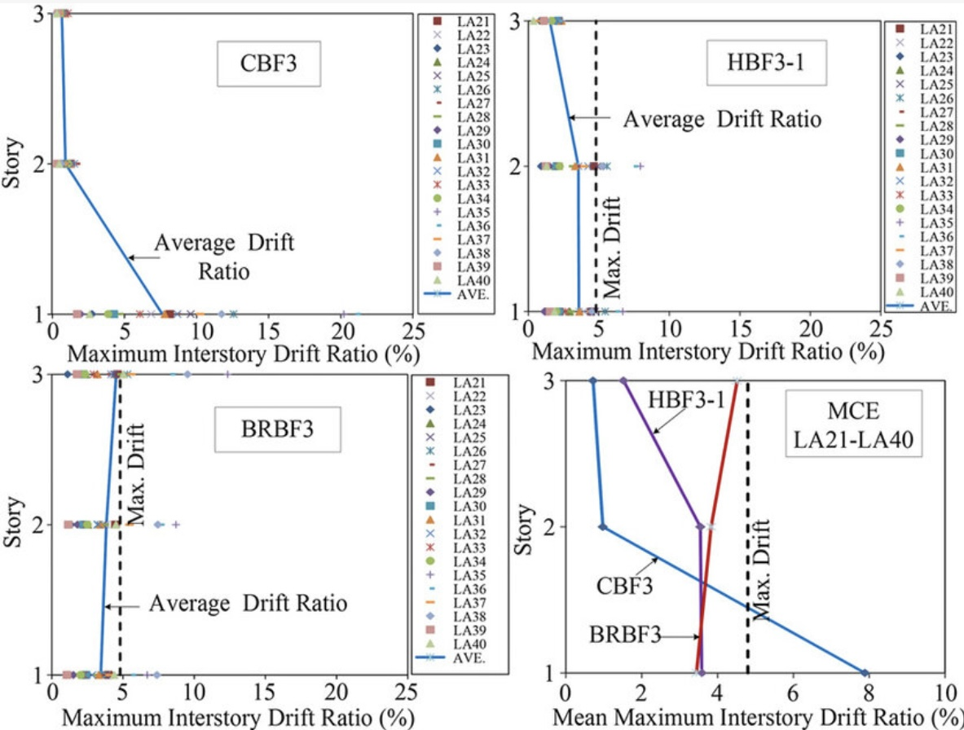

Fig. 8. Maximum inter-story drift ratio response of 3-story frames subjected to maximum considered earthquake level ground motions (LA21-LA40)
[maximum drift (4.8%) is the story drift ratio at which buckling-restrained braced frames showed only minor damage (Fahnestock et al. 2007)]

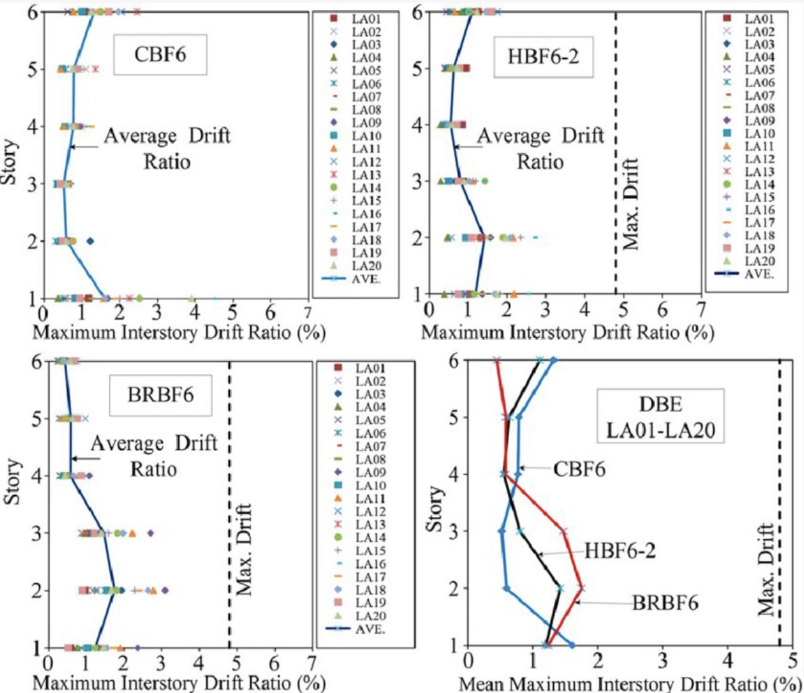
Fig. 9. Maximum interstory drift ratios for 6-story frames subjected to design basis earthquake level ground motions (LA01-LA20) [maximum drift (4.8%) is the story drift ratio at which buckling-restrained braced frames showed only minor damage (Fahnestock et al. 2007)]

5. Time History Analysis Results

Graphs showing acceleration and displacement over time for each building model during the time history analysis can provide insights into the dynamic response of the structures.

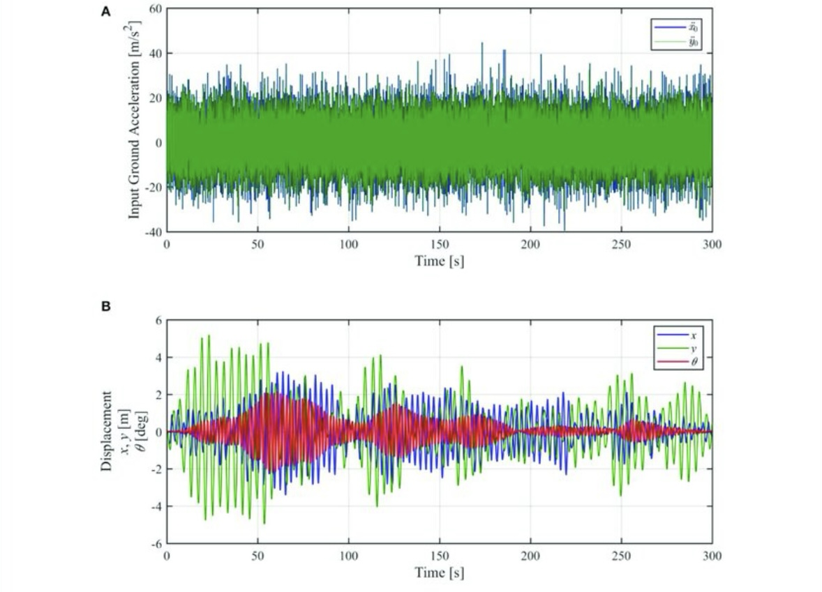

FIGURE 7 | Time-history analysis result of displacement response to one-directional (45 • direction from the x-axis) white noise ground acceleration. (A) Input ground acceleration, (B)
Displacement response.

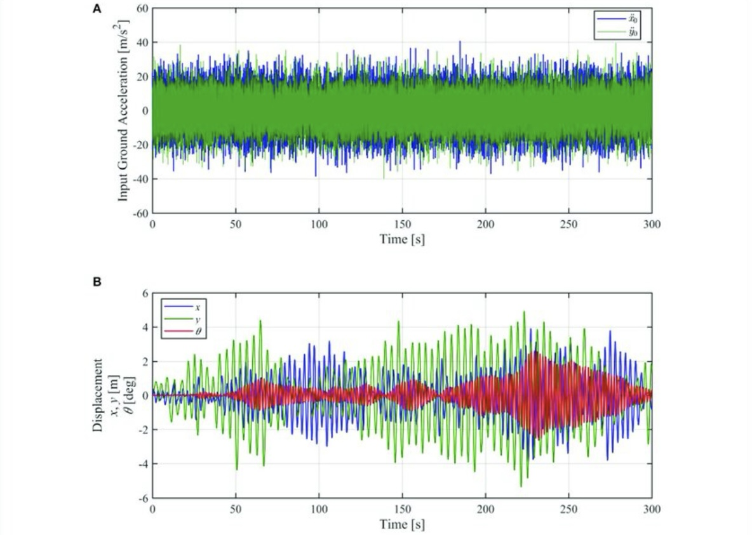
FIGURE 6 | Time-history analysis result of displacement response to uncorrelated two-directional white noise ground acceleration. (A)
Input ground acceleration (B) Displacement response.

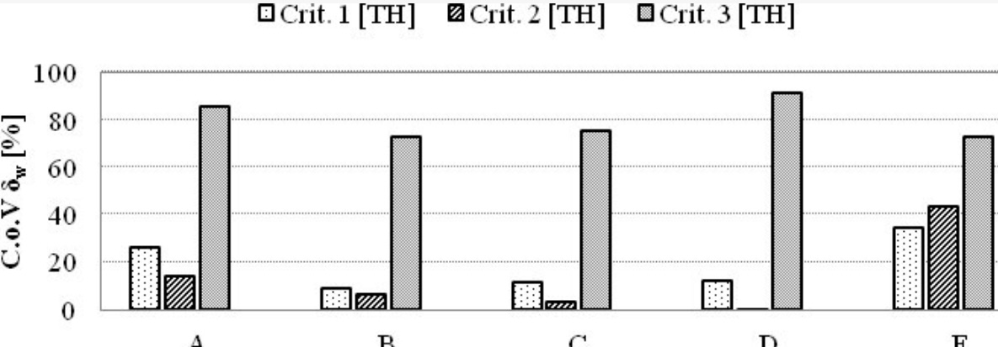

Figure 9 Coefficient of variation of the values of weighted average story drift limits of LS2, due to record-to record variability.

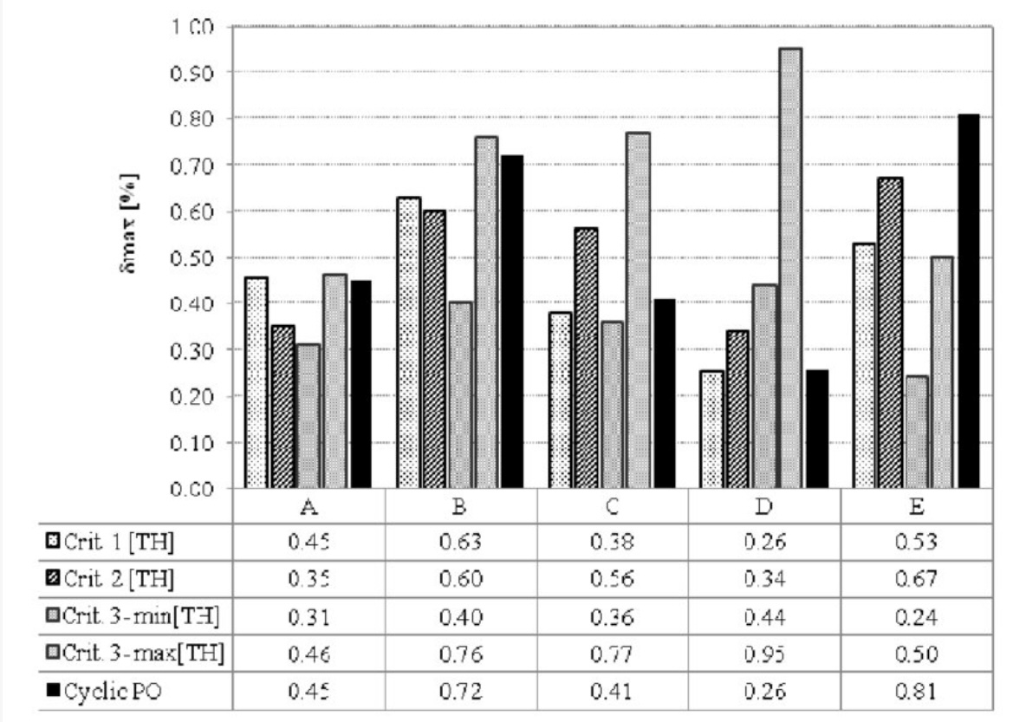
Figure 4
Figure 10 Maximum inter-story drift values for LS3
derived from the results of nonlinear dynamic analysis by applying the three identification criteria and from the results of nonlinear static analysis.

Discussion

The results of this study demonstrated that the use of dampers significantly reduced the displacements and shear forces in tall reinforced concrete buildings. For instance, in 20, 30, and 40-story buildings, the inter-story displacements without dampers were 75 mm, 100 mm, and 130 mm, respectively, and with dampers, these displacements were reduced to 40 mm, 55 mm, and 70 mm. This reduction clearly indicates the critical impact of vibration control systems in improving the dynamic behavior and stability of structures during severe earthquakes.

These results align with previous research, which has shown that the use of viscoelastic, friction, and tuned mass dampers (TMDs) can effectively absorb and dissipate dynamic forces acting on structures. The findings of this research are consistent with earlier studies that have demonstrated that viscoelastic dampers are more effective in energy absorption than other types. On the other hand, friction dampers, due to their higher resistance to deformation, were more effective in reducing base shear forces. Additionally, the tuned mass dampers successfully lowered the natural frequency of the building, preventing resonance and reducing damage during seismic events.

The energy absorption capabilities of the dampers were also analyzed, revealing that viscoelastic dampers absorbed energy equivalent to 1200 kN·m, friction dampers absorbed 1500 kN·m, and tuned mass dampers absorbed 1000 kN·m. These results underscore the high efficiency of all three types of dampers in reducing earthquake effects and enhancing the performance of tall reinforced concrete buildings.

Furthermore, the dynamic and pushover analyses showed that the use of these dampers resulted in a substantial reduction in base shear forces. In the 20, 30, and 40-story buildings, base shear forces decreased from 600 kN, 850 kN, and 1200 kN, to 380 kN, 480 kN, and 700 kN, respectively. This significant reduction highlights the positive impact of dampers in increasing the safety and preventing failure of tall structures during earthquakes.

However, one limitation of this study is the lack of long-term performance evaluation of the dampers under different environmental conditions and repeated seismic events. Dampers may be affected by factors such as temperature changes, humidity, or corrosion, which could reduce their efficiency over time. Future research is recommended to examine the long-term effects of these factors on damper performance.

The findings of this study emphasize the importance of incorporating damper systems in the design of tall buildings in seismic-prone areas. Dampers not only reduce the risks associated with earthquakes but also extend the lifespan of structures and reduce post-earthquake repair costs.

In conclusion, this study has demonstrated that damper systems, particularly viscoelastic and friction dampers, can significantly improve the seismic resilience of tall reinforced concrete buildings by reducing displacements and shear forces, thus preventing severe structural damage.

Conclusion
The results from the analysis of the performance of tall reinforced concrete structures equipped with damper systems under severe seismic conditions indicate a significant improvement in the dynamic behavior of the structures. One of the key findings of this study is the substantial reduction in inter-story displacements. Dampers absorb and dissipate seismic energy, preventing the direct transmission of earthquake forces to the structure, which in turn reduces extreme vibrations and inter-story displacements. Furthermore, the reduction in base shear forces is another crucial advantage of using dampers. This reduction means that the seismic forces acting on the structure are considerably lowered, enhancing the structure’s resistance to potential damage.

Additionally, damper systems generally improve the stability and safety of the structure during severe earthquakes. Buildings equipped with these systems not only perform better in resisting the horizontal forces caused by earthquakes, but the risk of collapse or severe damage is also reduced. As a result, using dampers not only lowers the repair and maintenance costs after an earthquake but also extends the building’s service life and increases the safety of its occupants.

The final conclusion is that damper systems are recommended as an efficient and effective solution to improve the performance of tall reinforced concrete structures under severe seismic events. Utilizing these systems can serve as a cost-effective and safe approach to enhance the durability and safety of buildings in the face of future earthquakes.

References
Bruschi E, Quaglini V. Assessment of a novel hysteretic friction damper for the seismic retrofit of reinforced concrete frame structures. InStructures 2022 Dec 1 (Vol. 46, pp. 793-811). Elsevier.
Suk R, Demir A, Altintas G, Altiok TY. Proposal for a novel technological damper system (TDS) for the retrofit of reinforced concrete frame structures. InStructures 2024 Feb 1 (Vol. 60, p. 105878). Elsevier.
Bruschi E, Zoccolini L, Cattaneo S, Quaglini V. Experimental Characterization, Modeling, and Numerical Evaluation of a Novel Friction Damper for the Seismic Upgrade of Existing Buildings. Materials. 2023 Feb 26;16(5):1933.
Cruze D, Gladston H, Farsangi EN, Banerjee A, Loganathan S, Solomon SM. Seismic performance evaluation of a recently developed magnetorheological damper: experimental investigation. Practice Periodical on Structural Design and Construction. 2021 Feb 1;26(1):04020061.
Foyouzati A. Analytical study on seismic strengthening of reinforced concrete frame equipped with steel damping system with shear mechanism fuse. Asian Journal of Civil Engineering. 2024 Jan;25(1):1115-27.
Belbachir A, Benanane A, Ouazir A, Harrat ZR, Hadzima-Nyarko M, Radu D, Işık E, Louhibi ZS, Amziane S. Enhancing the seismic response of residential RC buildings with an innovative base isolation technique. Sustainability. 2023 Jul 27;15(15):11624.
Qian H, Fan C, Shi Y, Xu J, Li Z, Deng E. Development and investigation of an innovative shape memory alloy cable‐controlled self‐centering viscoelastic coupling beam damper for seismic mitigation in coupled shear wall structures. Earthquake Engineering & Structural Dynamics. 2023 Feb;52(2):370-93.
Veismoradi S. Development of New Self-centring Friction-based Damage Avoidant Systems for Earthquake-prone Reinforced Concrete Buildings.
Marko J, Thambiratnam D, Perera N. Influence of damping systems on building structures subject to seismic effects. Engineering Structures. 2004 Nov 1;26(13):1939-56.
Akyürek O, Suksawang N, Go TH, Tekeli H. Performance evaluation of a reinforced concrete building strengthened respectively by the infill wall, active and passive tuned mass damper under seismic load. Computers & Structures. 2019 Oct 15;223:106097.
Mousavi H, Sabbagh Yazdi SR, Almohammad-Albakkar M. A novel method for efficient design of frame structures equipped with nonlinear viscous dampers by using computational results of cylindrical friction damper. Australian Journal of Structural Engineering. 2023 Jan 2;24(1):50-66.
Lago A, Trabucco D, Wood A. Damping technologies for tall buildings: Theory, design guidance and case studies. Butterworth-Heinemann; 2018 Sep 25.
Shahraki MA, Kamgar R, Heidarzadeh H. Assessing the seismic behavior of structures controlled with a novel elastoplastic-tuned mass damper inerter considering the effects of soil-structure interactions. InStructures 2023 Nov 1 (Vol. 57, p. 105265). Elsevier.
Arsava KS, Kim Y, Kim KH, Shin BS. Smart fuzzy control of reinforced concrete structures excited by collision-type forces. Expert Systems with Applications. 2015 Nov 30;42(21):7929-41.
Tang Z, Sheng J, Dong Y. Effects of tuned liquid dampers on the nonlinear seismic responses of high-rise structures using real-time hybrid simulations. Journal of Building Engineering. 2023 Jul 1;70:106333.
Midorikawa M, Asari T. Earthquake response of ten-story story-drift-controlled reinforced concrete frames with hysteretic dampers. Engineering Structures. 2010 Jun 1;32(6):1735-46.
Qian H, Li H, Song G. Experimental investigations of building structure with a superelastic shape memory alloy friction damper subject to seismic loads. Smart Materials and Structures. 2016 Nov 15;25(12):125026.
Noroozinejad Farsangi E. Performance evaluation of viscoelastic and friction passive damping systems in vibration control of tall buildings. International Journal of Advanced Structural Engineering. 2011 Dec 1;3(2):187-211.
Yang J, Lu Z, Li P. Large-scale shaking table test on tall buildings with viscous dampers considering pile-soil-structure interaction. Engineering Structures. 2020 Oct 1;220:110960.
Lu X, Jiang H. Recent progress of seismic research on tall buildings in China Mainland. Earthquake Engineering and Engineering Vibration. 2014 Aug;13(Suppl 1):47-61.
Ghaderi A, Nouri M, Hoseinzadeh L, Ferdousi A. Hybrid Vibration Control of Tall Tubular Structures via Combining Base Isolation and Mass Damper Systems Optimized by Enhanced Special Relativity Search Algorithm. Iranian Journal of Science and Technology, Transactions of Civil Engineering. 2024 Feb 27:1-9.
Parajuli S, Pokhrel P, Suwal R. A comprehensive study of viscous damper configurations and vertical damping coefficient distributions for enhanced performance in reinforced concrete structures. Asian Journal of Civil Engineering. 2024 Jan;25(1):1043-59.
Khalili M, Sivandi-Pour A, Farsangi EN. Experimental and numerical investigations of a new hysteretic damper for seismic resilient steel moment connections. Journal of Building Engineering. 2021 Nov 1;43:102811.
Christopoulos C, Montgomery M. Viscoelastic coupling dampers (VCDs) for enhanced wind and seismic performance of high‐rise buildings. Earthquake Engineering & Structural Dynamics. 2013 Dec;42(15):2217-33.
Elias S, Rupakhety R, Ólafsson S. Tuned mass dampers for response reduction of a reinforced concrete chimney under near-fault pulse-like ground motions. Frontiers in Built Environment. 2020 Jun 26;6:92.
Hosseinlou F, Labibzadeh M. Application of CSPC composite shear wall equipped with tension-and-compression damper in multi-storey structures. InStructures 2022 Apr 1 (Vol. 38, pp. 1308-1325). Elsevier.
Chapain S, Aly AM. Vibration attenuation in a high-rise hybrid-timber building: a comparative study. Applied Sciences. 2023 Feb 9;13(4):2230.
Chapain S, Aly AM. Vibration attenuation in a high-rise hybrid-timber building: a comparative study. Applied Sciences. 2023 Feb 9;13(4):2230.
Barbosa AR, Ramadhan G. Seismic performance of a tall diagrid steel building with tuned mass dampers. International Journal of Innovations in Materials Science and Engineering. 2014;1(2):90-102.
Elias S, Matsagar V. Research developments in vibration control of structures using passive tuned mass dampers. Annual Reviews in Control. 2017 Jan 1;44:129-56.
Rebecchi G, Calvi PM, Bussini A, Dacarro F, Bolognini D, Grottoli L, Rosti M, Ripamonti F, Cii S. Full-scale shake table tests of a reinforced concrete building equipped with a novel servo-hydraulic active mass damper. Journal of Earthquake Engineering. 2023 Jul 27;27(10):2702-25.
Chen A, Zhang Y, Wu H. A multifunctional reinforced concrete tuned liquid wall damper with optimal design variables. Practice Periodical on Structural Design and Construction. 2023 Feb 1;28(1):04022071.

