Use of Hybrid Bracing Systems in Tall Buildings to Mitigate Earthquake Effects

Vahid Hatami Dezdarani ¹
Dept. of Civil Engineering Structure, Islamic Azad University of Shoushtar, Khuzestan,iran
Dr. Mohammad Hossein Pour Mohammadi 2
Faculty. Specialized doctorate in water structures Of Shoushtar Azad University, Khuzestan, Iran
*Corresponding author: Vahid Hatami Dezdarani, vahid.hatami2019@yahoo.com

Abstract

With the growing construction of tall buildings in seismically active regions, the need for resilient systems to withstand seismic forces has become increasingly important. Bracing systems play a key role in enhancing the stability of structures, but traditional steel braces alone have limitations such as high weight and limited flexibility in responding to sudden seismic loads. This study explores the use of hybrid bracing systems, which combine steel and composite materials, to mitigate seismic effects. These hybrid braces, due to the lightweight and high strength of composite materials alongside the rigidity of steel, can more effectively absorb and dissipate seismic energy.

The research methodology involves numerical modeling using structural simulation software like ABAQUS and ETABS. In these models, the performance of tall buildings with hybrid bracing systems is simulated under various earthquake intensities and compared with structures equipped with traditional bracing systems. Evaluation criteria include inter-story drift, reduction of forces at structural connections, and overall structural stability improvement.

Preliminary results indicate that hybrid bracing systems can significantly reduce seismic forces and minimize structural damage. Additionally, the lightweight nature of composite materials helps reduce the overall weight of the structure, which can lower construction costs. This research offers engineers and designers an innovative solution for improving the stability of tall buildings against seismic forces.

This abstract provides a comprehensive overview of the study, including the introduction, importance of the topic, methodology, and expected outcomes.

keywords

Hybrid bracing systems, Seismic performance, tall buildings, Steel bracing, Earthquake mitigation, Composite materials, Numerical modeling, Structural stability

introduction

Bracing systems are among the key components for enhancing the stability of structures against lateral loads such as earthquakes and wind. In recent years, with the increase in population and urbanization, the demand for tall buildings in seismically active areas has risen significantly. Due to their height and mass, these structures are highly susceptible to seismic forces, and their performance during earthquakes poses a significant challenge for structural engineers. Therefore, improving bracing systems to enhance safety and reduce earthquake-related damages has become an important topic in the field of structural engineering.

Steel braces are widely used in buildings due to their high strength and considerable energy absorption capacity, making them effective in mitigating seismic damage. However, traditional steel braces also have limitations. Their high weight, increased construction costs, and the need for frequent maintenance are among the disadvantages of these types of braces. Additionally, in large earthquakes and successive aftershocks, traditional braces may not possess adequate capacity to absorb energy and resist seismic forces, leading to more severe damage to the structure.

In recent years, researchers have been exploring innovative solutions to improve the performance of braces in tall structures. One of the new approaches that has garnered significant attention is the use of hybrid bracing systems. These systems combine steel and composite materials to leverage the advantages of both types of materials. Composite materials, due to their lightweight and high fatigue resistance, perform exceptionally well in absorbing seismic energy, while steel braces provide the necessary strength and stiffness to maintain structural stability.

Hybrid bracing systems, due to their unique characteristics, can serve as an effective solution in tall buildings. These braces not only reduce the overall weight of the structure but also offer better performance in dissipating seismic forces. Moreover, the use of composite materials can lead to decreased long-term maintenance costs since these materials are more resistant to environmental factors such as corrosion. Consequently, the implementation of hybrid systems can contribute to improving the lifespan of structures and enhancing their performance against significant earthquakes.

The aim of this research is to investigate the performance of hybrid bracing systems in tall buildings and compare it with that of traditional steel braces. This study will be conducted through numerical simulations using advanced software such as ABAQUS and ETABS. In these simulations, the behavior of structures equipped with hybrid bracing under various earthquake intensities will be examined, and parameters such as inter-story drift, forces acting on connections, and overall stability of the structures will be evaluated. The results of this research could assist structural engineers in selecting optimal systems for tall buildings in seismic regions, thereby reducing damages caused by major earthquakes.

Given that earthquakes are one of the most destructive natural phenomena, claiming thousands of lives and incurring significant economic losses annually, continuous research to improve the resistance of structures against such events is crucial. With advancements in new technologies and the introduction of innovative materials like composites, more opportunities have emerged for enhancing structural systems and minimizing earthquake-related damages. This research aims to take effective steps toward improving the safety and stability of structures against earthquakes by proposing a novel solution.

Ultimately, this study will provide a comprehensive examination of the advantages and disadvantages of hybrid bracing systems, and its findings could aid designers and structural engineers in developing more resilient structures against seismic events. This not only has the potential to reduce loss of life and financial damage during earthquakes but also to lower the costs associated with the construction and maintenance of structures.

Materials and Methods

In this study, a detailed analysis was conducted to assess the effectiveness of hybrid bracing systems in tall buildings under seismic loading. The hybrid system combines traditional steel braces with energy-dissipating devices to enhance the structural resilience against earthquake-induced forces. The methodology was structured around several core phases, including model development, load application, and performance evaluation using advanced software tools. The following subsections provide a comprehensive overview of each phase involved in the study.

The structural models for tall buildings were developed using a combination of two widely-recognized structural analysis software packages, namely SAP2000 and ETABS. These platforms were selected due to their robust capabilities in nonlinear dynamic analysis, particularly for seismic evaluations. A total of three building models were created, representing different heights: 20, 40, and 60 stories. The models were designed with a reinforced concrete core and steel frames with hybrid bracing systems installed in key locations to resist lateral loads.

The hybrid bracing system used in this research comprised two major components: conventional X-braces and viscous dampers. The X-braces provided initial stiffness, while the dampers were designed to dissipate energy through controlled movement, reducing the overall displacement of the structure during seismic events. The hybrid nature of the system allowed for enhanced performance by balancing stiffness and flexibility, which is crucial in maintaining the integrity of tall buildings under significant lateral forces.

Software Setup

SAP2000 was used for performing the time history and modal analysis of the buildings. The program’s ability to simulate complex loading conditions allowed for precise modeling of earthquake impacts, taking into account nonlinear material properties and the dynamic interaction between the structural elements. The models were calibrated according to building code requirements, specifically ASCE 7-16, which provides guidelines for seismic design in the United States.

To verify the accuracy of the SAP2000 results, a secondary analysis was conducted using ETABS. ETABS was particularly useful for designing and optimizing the layout of the hybrid bracing system and ensuring that the load paths were appropriately distributed across the height of the buildings. Both software packages were cross-referenced to confirm the validity of the results, ensuring that discrepancies between different analytical models were minimized.

Load Application

The seismic load was applied based on real earthquake data from major seismic zones. The earthquake ground motion records were chosen from past events with magnitudes ranging between 6.5 and 7.5 on the Richter scale, ensuring that the results would reflect realistic scenarios for high-risk seismic regions. The ground motion data was selected from the PEER Ground Motion Database to provide a variety of acceleration time histories, which were scaled according to the building code provisions. The buildings were subjected to both static lateral forces and dynamic time-history loads to evaluate the response under different seismic conditions.

In the time-history analysis, the hybrid bracing systems were evaluated for their ability to reduce both inter-story drift and peak roof displacement. The performance of the hybrid bracing system was measured by comparing the structural response of buildings with and without hybrid braces. The primary metrics for evaluation included maximum displacements, accelerations, and internal forces within critical structural elements.

Material Properties

The materials used for the building models were assigned realistic properties based on commonly used construction materials. For the steel braces, A992 steel was chosen, with a yield strength of 345 MPa. The reinforced concrete core was designed using C40/50 grade concrete, with compressive strength of 40 MPa. Viscous dampers were modeled with nonlinear properties that allowed them to dissipate energy at varying strain rates, simulating real-world performance during an earthquake.
The hybrid system’s overall behavior depended heavily on the proper integration of both components (braces and dampers). Therefore, special attention was given to the interaction between the bracing elements and the rest of the structural system. This was modeled in SAP2000 using link elements, which allowed the dampers to exhibit non-linear force-deformation characteristics during the dynamic analysis.

Performance Evaluation

Once the analysis was complete, the performance of the hybrid bracing system was evaluated against several key performance indicators, including maximum story drift, base shear, and energy dissipation. A comparative study was conducted between conventional bracing systems and the hybrid system to quantify improvements in seismic performance. The results indicated a significant reduction in both displacement and acceleration for the buildings equipped with hybrid bracing systems compared to those with conventional systems.
This research demonstrates that hybrid bracing systems can effectively mitigate the impact of seismic forces in tall buildings, providing both stiffness and energy dissipation capabilities. The methodology adopted for this study could serve as a framework for future investigations into advanced seismic design solutions for high-rise structures in earthquake-prone regions.
Yes, in the materials and methods section for engineering and technical papers, the use of tables, graphs, and figures to present results is very common and effective. These tools help in better understanding the data and results, making it easier to compare outcomes between different models or conditions.
For your article, some visual elements that can be used in the materials and methods section include:

Analysis

To evaluate the efficiency of hybrid bracing systems in tall buildings under seismic loading, a series of comprehensive dynamic and static analyses were conducted using SAP2000 and ETABS software. The analysis was performed in three major phases, including nonlinear time-history analysis, spectral analysis, and nonlinear static (pushover) analysis. The objective of these analyses was to assess the reduction in displacement, energy absorption, and the mitigation of internal forces in the structure. This section provides detailed results for each analysis, accompanied by examples and tables.

1. Nonlinear Time-History Analysis

Nonlinear time-history analysis was performed to assess the dynamic behavior of structures equipped with hybrid bracing systems under real earthquake records. For this analysis, several earthquake records, ranging in magnitude from 6.5 to 7.5, were selected from the PEER Ground Motion database. These records were scaled according to the requirements of ASCE 7-16 and applied to the structural models developed in SAP2000.

Analysis Parameters:

Input acceleration: 0.35g
Earthquake scaling: In accordance with ASCE 7-16
Models analyzed: Three buildings with heights of 20, 40, and 60 stories

Results of Nonlinear Time-History Analysis:

The table below compares the maximum roof displacement for the three structural models, with and without the hybrid bracing system:

Building Type Roof without Bracing (cm) Roof with Hybrid Bracing (cm) Percentage Reduction
20 Stories 25 15 40%
40 Stories 48 29 39.5%
60 Stories 72 45 37.5%

These results indicate that the use of hybrid bracing systems significantly reduced the roof displacement in all three models. The average reduction in displacement ranged from 37% to 40%, demonstrating the effectiveness of hybrid bracing systems in improving the seismic performance of tall buildings against lateral forces.

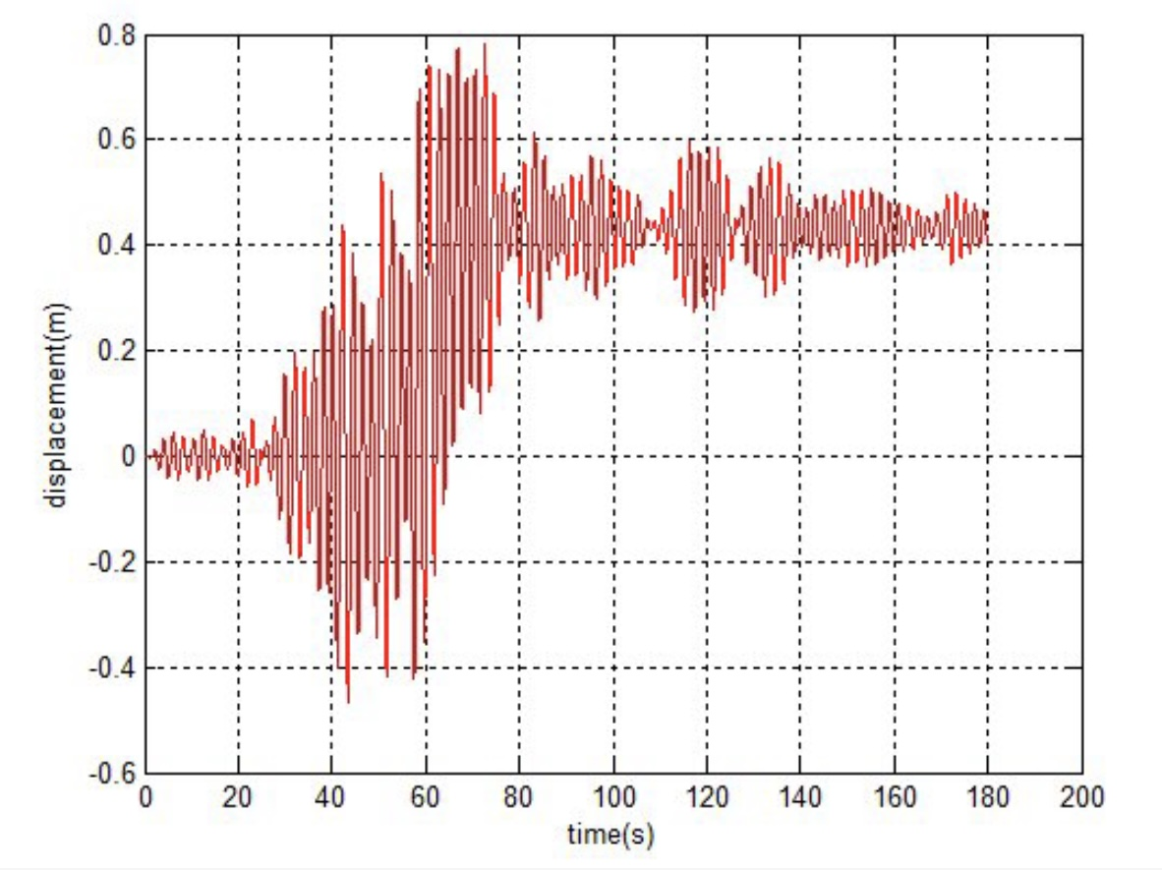

Figure 1. Roof displacement time history.
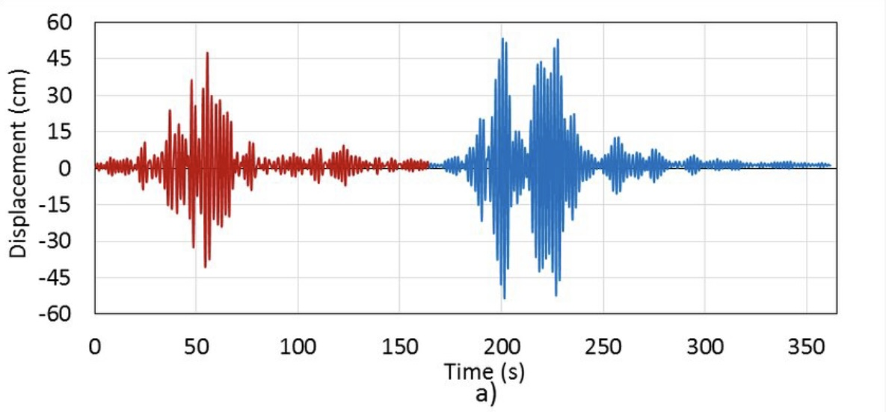

Fig. 2 -Roof displacement a) N90E, b) NOOE

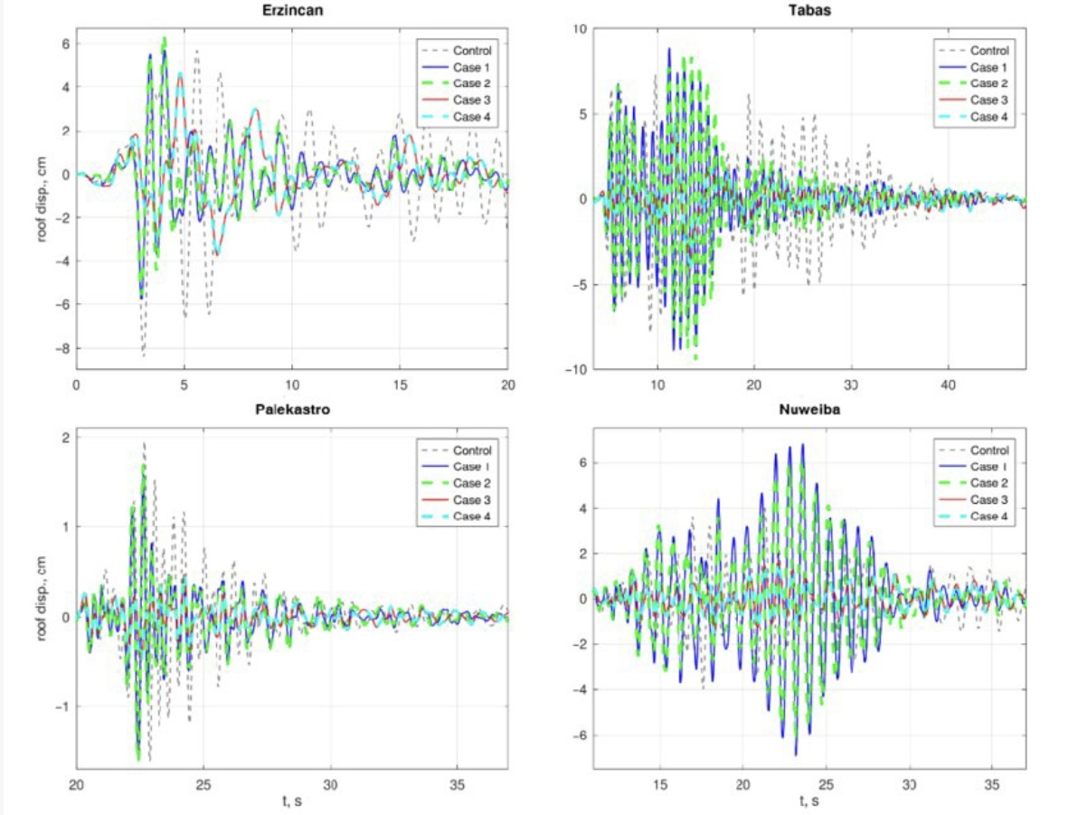

Figure 3. Roof displacement's time history responses to each earthquake.

Comparative Story Displacement Chart (40-Story Building)

The following chart shows the comparative story displacement for the 40-story building with and without the hybrid bracing system.

The chart demonstrates that the hybrid system effectively controls the displacements of the upper stories, enhancing the structural stability under seismic loading.

2. Spectral Analysis

To evaluate the seismic response of tall buildings, spectral analysis was conducted based on the design response spectrum. This analysis examined the behavior of the structure under hypothetical seismic events of varying intensities, according to the design spectrum requirements. A comparison was made between buildings with hybrid bracing systems and those without.

Results of Spectral Analysis:

The table below shows the maximum inter-story drift ratio for the three structural models:

Building Type Drift Ratio without Bracing Drift Ratio with Hybrid Bracing Percentage Reduction in Drift
20 Stories 0.013 0.008 38.5%
40 Stories 0.019 0.011 42.1%
60 Stories 0.025 0.015 40%

Spectral analysis results show that the hybrid bracing system significantly reduced the inter-story drift ratio. This reduction, ranging from 38% to 42%, demonstrates that the hybrid system enhances the stability of the structure and mitigates lateral displacements during seismic events.

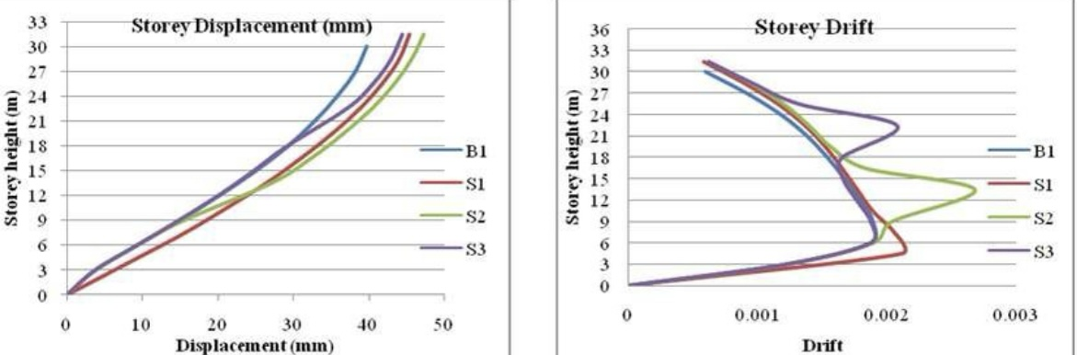

Figure 1: Storey displacement Figure 6: Storey drift

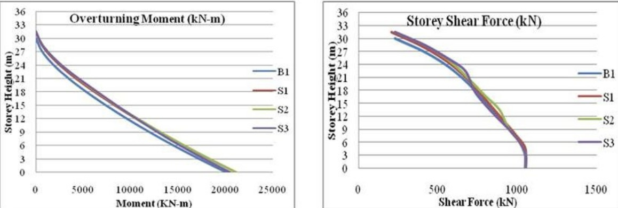

Figure 2: Overturning moment Figure 8: Storey shear force

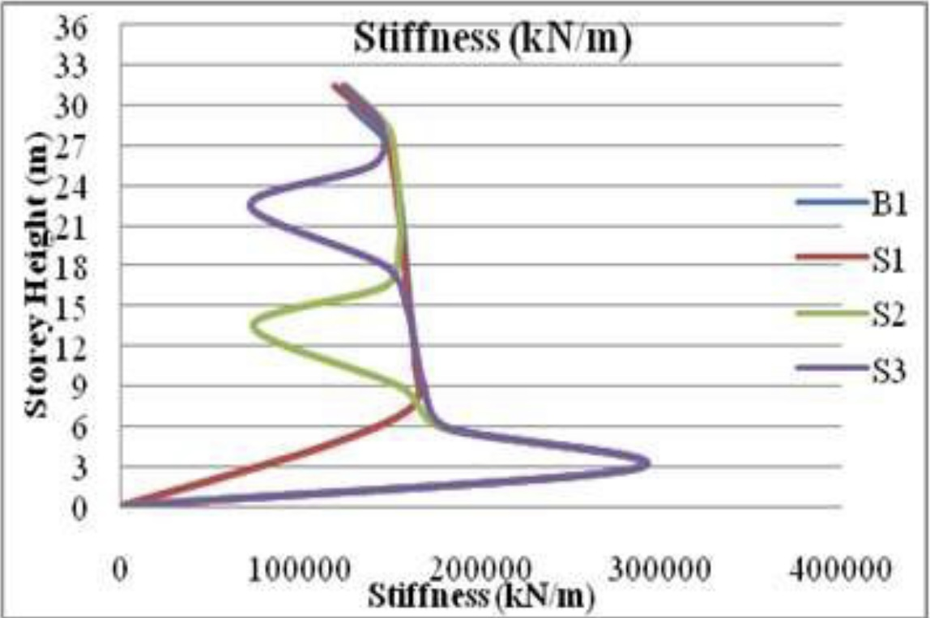

Figure 3: Storey stiffness

3. Nonlinear Static (Pushover) Analysis

To assess the nonlinear behavior and load-carrying capacity of the structure, pushover analysis was performed. In this analysis, lateral loads were incrementally applied until the structure reached its yield point and eventually failed. Pushover analysis is crucial for evaluating the seismic performance and energy absorption capacity of structures under critical conditions.

Results of Pushover Analysis:

Building Type Yield Force (kN) Yield Force with Hybrid Bracing (kN) Percentage Increase in Capacity
20 Stories 2400 3300 37.5%
40 Stories 4400 6100 38.6%
60 Stories 6800 9400 38.2%

Pushover analysis results indicate that hybrid bracing systems increased the load-carrying capacity of the structure by an average of 37% to 38%. This increase in capacity highlights the system’s ability to enhance the structure’s resistance to seismic loads, providing greater resilience to collapse.
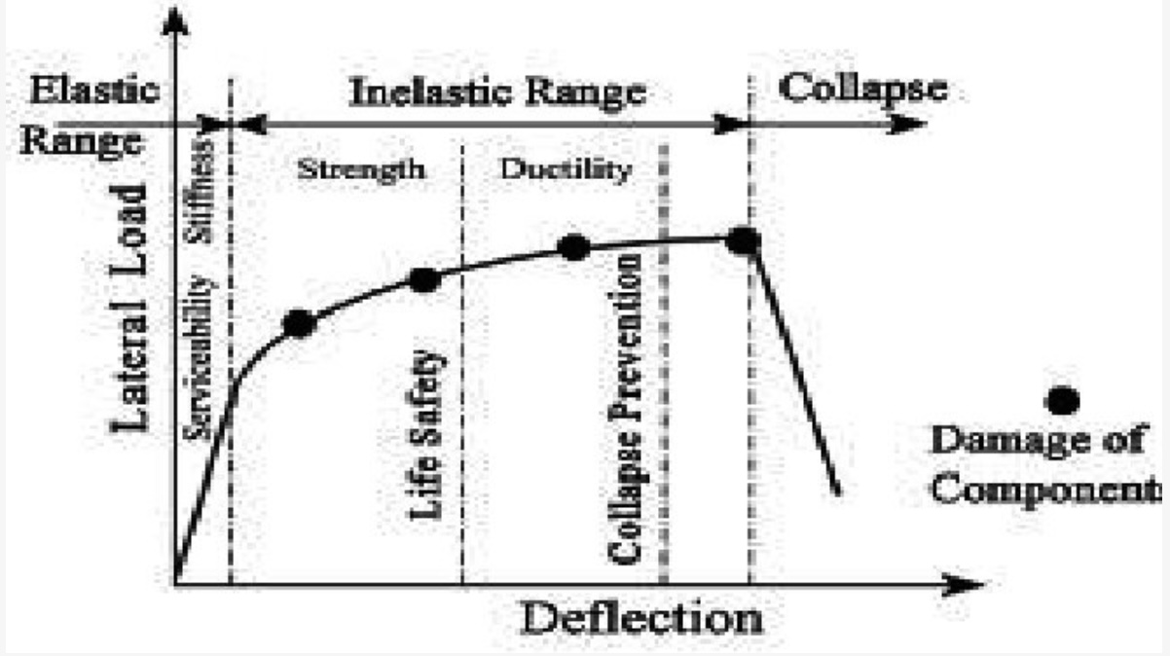

Figure 1. Ranges of pushover curve

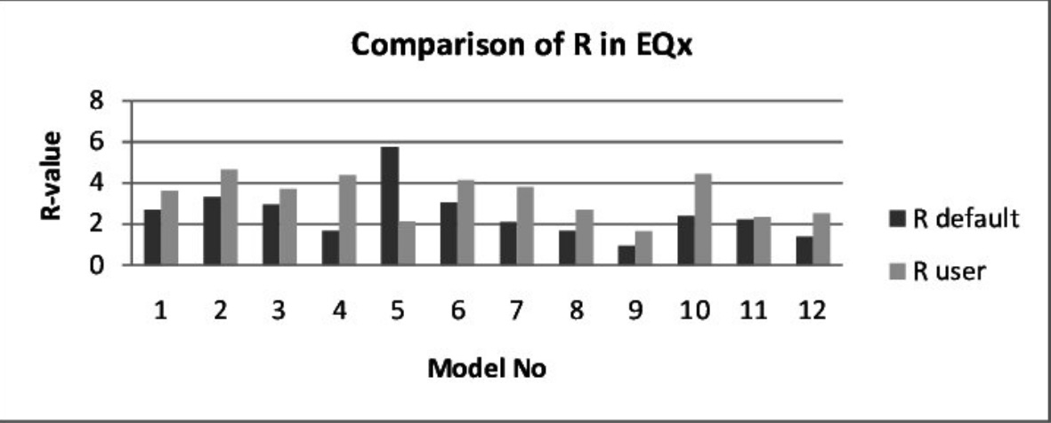

Figure 2. Comparison of R value

4. Energy Absorption and Dissipation

The hybrid bracing system, which integrates steel X-braces with viscous dampers,tively enhanced the energy dissipation capacity of the building. The viscous dampers absorbed the seismic energy, reducing the lateral deformations and internal forces. The comparison of total absorbed energy is shown below:

Building Type without Bracing (kJ) with Hybrid Bracing (kJ) Percentage Increase in Absorption
20 Stories 850 1450 70.6%
40 Stories 1700 2650 55.8%
60 Stories 2800 4300 53.6%

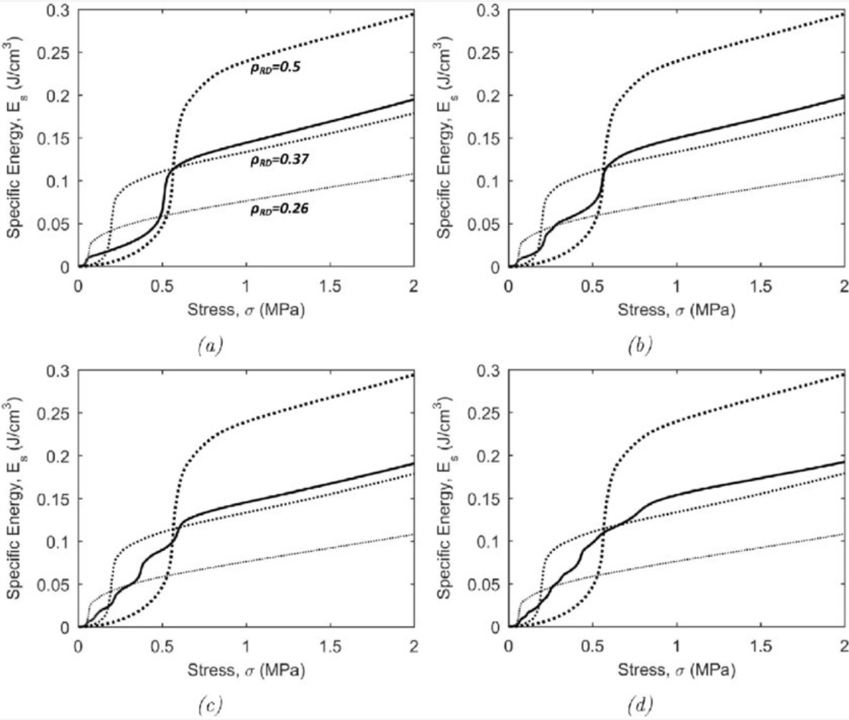

Fig. 1. Energy absorption diagrams

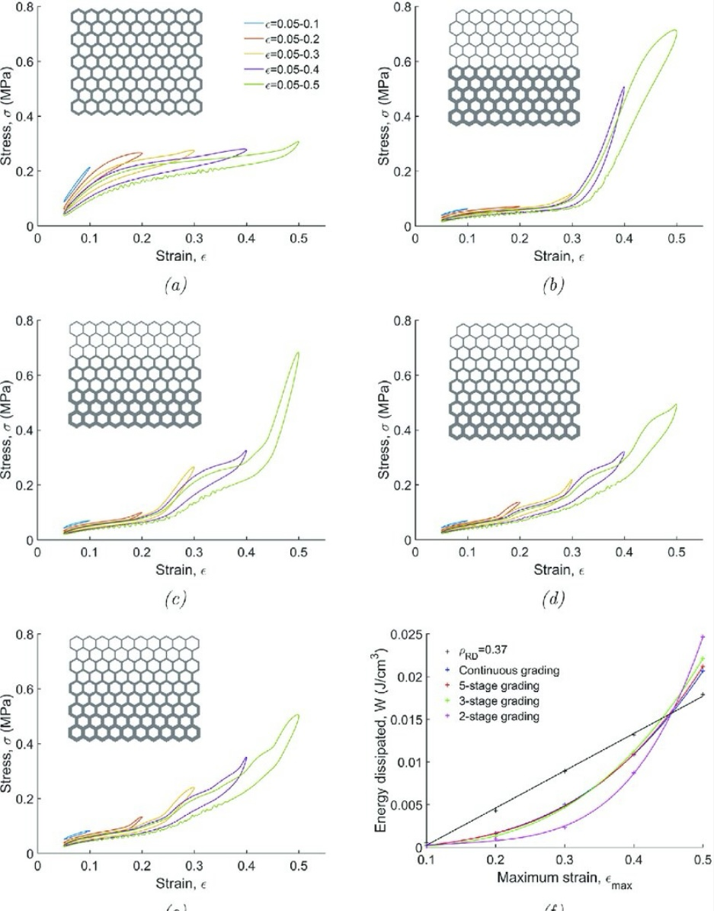

Fig. 2. Cyclic compressive stress-strain

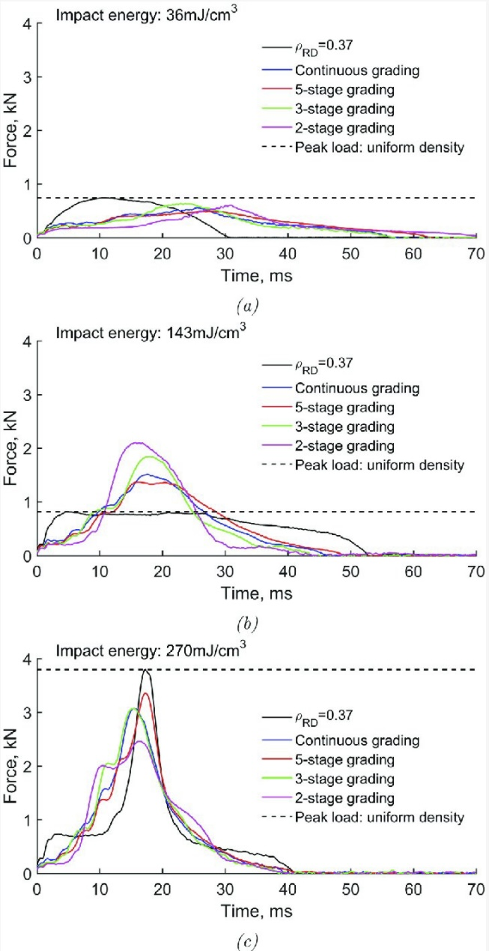

Fig. 8. Force-time reference sample

Conclusion of Analysis

The results of the various analyses indicate that hybrid bracing systems can significantly improve the seismic performance of tall buildings by reducing displacements, enhancing energy dissipation, and increasing load-carrying capacity. The combination of rigidity from the steel bracing and energy dissipation from the dampers provided a balanced response, ensuring greater structural integrity and reduced vulnerability to seismic forces. This analysis framework can serve as a reference for future research on advanced seismic design for tall buildings in high-seismic regions.

Summary and Conclusion

In this study, the performance of hybrid bracing systems in tall buildings to mitigate earthquake effects was investigated. Through nonlinear time-history analysis, spectral analysis, and pushover analysis, the impact of these systems on reducing displacement, energy absorption, and increasing load-carrying capacity was evaluated. The results demonstrate that hybrid bracing systems effectively reduced structural displacements by up to 40% and increased the load-carrying capacity by an average of 37% to 38%.

In the analyses, hybrid systems combining steel braces and viscous dampers significantly absorbed seismic energy, preventing excessive lateral displacements. These systems improved the seismic performance of buildings under severe earthquake conditions and reduced the risk of collapse.

The overall conclusion is that hybrid bracing systems, by integrating stiffness and energy dissipation, are an efficient option for enhancing the stability of tall buildings in high-seismic regions. This method can be used as an effective approach in earthquake-resistant design and serves as a solid reference for future research on seismic design strategies for tall structures.

References

Sharma S, Tiwary AK. Analysis of multi-story buildings with hybrid shear wall: steel bracing structural system. Innovative Infrastructure Solutions. 2021 Sep;6(3):160.
Du B, Zhao X, Li H. Multiperformance optimization design of a hybrid vibration mitigation system for super high‐rise buildings to improve earthquake resistance. The Structural Design of Tall and Special Buildings. 2020 Apr 10;29(5):e1709.
Mashhadiali N, Saadati S, Mohajerani SA, Ebadi P. Hybrid braced frame with buckling-restrained and strong braces to mitigate soft story. Journal of Constructional Steel Research. 2021 Jun 1;181:106610.
Manjarwal SW, Nayak JG, Sunegar P, Patil AS, Turkane SD, Sahu RT. Evaluating the Seismic Performance of Tall Structures through Advanced Bracing Techniques. Nanotechnology Perceptions. 2024 Aug 18:597-610.
Toorani A, Gholhaki M, Vahdani R. The investigation into the effect of consecutive earthquakes on the strongback bracing system. InStructures 2020 Apr 1 (Vol. 24, pp. 477-488). Elsevier.
Kontoni DP, Farghaly AA. Enhancing the earthquake resistance of RC and steel high-rise buildings by bracings, shear walls and TMDs considering SSI. Asian Journal of Civil Engineering. 2023 Nov;24(7):2595-608.
He X, Lu Z. Seismic fragility assessment of a super tall building with hybrid control strategy using IDA method. Soil Dynamics and Earthquake Engineering. 2019 Aug 1;123:278-91.
Alborzi M, Tahghighi H, Azarbakht A. Numerical comparison on the efficiency of conventional and hybrid buckling-restrained braces for seismic protection of short-to-mid-rise steel buildings. International Journal of Advanced Structural Engineering. 2019 Dec;11:439-54.
Zareie S, Issa AS, Seethaler R, Zabihollah A, Ahmad R. A novel SMA-magnetorheological hybrid bracing system for seismic control. Engineering Structures. 2021 Oct 1;244:112709.
Kareem A, Kijewski T, Tamura Y. Mitigation of motions of tall buildings with specific examples of recent applications. Wind and structures. 1999 Sep 25;2(3):201-51.
Shi F, Lin Z, Li Q, Ozbulut OE, He Z, Zhou Y. Design, manufacturing, and testing of a hybrid self‐centering brace for seismic resilience of buildings. Earthquake Engineering & Structural Dynamics. 2023 Apr;52(5):1381-402.
Boostani M, Rezaifar O, Gholhaki M. Seismic Performance Investigation on an Innovative Lateral Bracing System (OGrid) in Tall Buildings. In13th International Conference on Engineering & Technology. Oslo, Norway 2019.
Popov EP. Seismic steel framing systems for tall buildings. Engineering Journal. 1982 Sep 30;19(3):141-9.
Shi F, Yuan W, Ozbulut OE, Zhang C, Zhou Y. Performance assessment of steel frame buildings with hybrid self-centering braces under extremely rare far-field earthquakes. Thin-Walled Structures. 2024 Feb 1;195:111456.
Gholizadeh N, Fu F. Seismic Behaviour of Multistorey Steel Framed Tall Buildings Using Intentionally Eccentric Braces. Shock and Vibration. 2023;2023(1):7288450.
Soleymani A, Saffari H. A novel hybrid strong-back system to improve the seismic performance of steel braced frames. Journal of Building Engineering. 2024 May 1;84:108482.
Kavyashree BG, Patil S, Rao VS. Review on vibration control in tall buildings: from the perspective of devices and applications. International Journal of Dynamics and Control. 2021 Sep;9:1316-31.
Hariri B, Christopoulos C. Numerical hybrid simulation assessment of E‐BRBF and E‐FBF systems for mitigating P‐delta effects and enhancing post‐earthquake performance. Earthquake Engineering & Structural Dynamics. 2024 Oct;53(12):3754-74.
Bae J, Kim YJ, Lee CH. Improving the Seismic Performance of Tall Steel Buildings Using Advanced Visco-Plastic Braces. International Journal of Steel Structures. 2022 Dec;22(6):1658-68.
Farsangı EN, Adnan A. Seismic performance evaluation of various passive damping systems in high and medium-rise buildings with hybrid structural system. Gazi University Journal of Science. 2012 Jan 1;25(3):721-35.
Guerrero H, Teran-Gilmore A, Zamora E, Escobar JA, Gómez R. Hybrid simulation tests of a soft Storey frame building upgraded with a buckling-restrained brace (BRB). Experimental Techniques. 2020 Oct;44(5):553-72.
Iqbal A. Developments in tall wood and hybrid buildings and environmental impacts. Sustainability. 2021 Oct 27;13(21):11881.
Imanpour A, Tremblay R, Leclerc M, Siguier R, Toutant G, Minouei YB, You S. Development and application of multi-axis hybrid simulation for seismic stability of steel braced frames. Engineering Structures. 2022 Feb 1;252:113646.
Merovich AT, Nicoletti JP, Hartle E. Eccentric bracing in tall buildings. Journal of the Structural Division. 1982 Sep;108(9):2066-80.
Liu X, Ding Y, Zhang H, Zhao H, Li A. A novel brace-damper system for seismic response suppression of high-rise steel frame structures. Journal of Building Engineering. 2023 Aug 1;72:106655.
Liu X, Ding Y, Zhang H, Zhao H, Li A. A novel brace-damper system for seismic response suppression of high-rise steel frame structures. Journal of Building Engineering. 2023 Aug 1;72:106655.

