

Department of Chemical and Biological Engineering

Industrial scale production of Recombinant Insulin (Humulin) to combat Type-1 Diabetes Mellitus (IDDM)

Vishal Murali
- Executive Summary:
Type 1 diabetes is a common disease which affects people right from their childhood. The main cause of type-1 diabetes is the deficiency of insulin which is produced by ‘beta’ cells in the body. With destruction of ‘beta’ cells, the production of insulin which regulates the blood sugar levels in the body from the pancreas is halted which results in imbalance of blood sugar levels in the body.
In the past, diabetes, both types 1 and 2 were treated using bovine and porcine insulins or a mixture of them by extracting them directly from their respective sources and purifying them [1]. In recent times, with the rise in recombinant technology and the rise in biopharmaceutical engineering, recombinant insulin has seen a rise in market due to rise in ethical issues concerning using insulin or biopharmaceuticals produced from other life forms, mainly animals.
This design report focuses on the production of recombinant insulin using E. Coli as the host and meeting the demand of a growing and emerging market in the world. The unit operations along with the material balances to describe the scale are described in detail to justify the requirements of the demand with a focussed purity of greater than 99%. Several possible suggestions and expansions are also described later in the report which can come to aid in the growing market with a possibility of using microbubble intensified bioprocessing in the process line and good manufacturing practices (GMP).
- Scope:
2.1 Overview of Product:
Insulin dependent diabetes mellitus (IDDM) also commonly known as type-1 diabetes is an autoimmune condition where the body does not produce or produce enough amounts of insulin from the pancreas to manage the blood sugar levels in the body. The condition presents from a young age from which is managed by injecting artificial insulin into the body via subcutaneous injections.
In the recent past, the production of insulin was heavily dependent on sources from living beings like cows and pigs. With rise in recombinant proteins, insulin has found to be produced by microbial cells like E. coli. In a large-scale E. Coli is preferred as the host because of its shorter growth curve and easier downstream processing than any other type of cell [2].

2.2 Chemistry [16, 17]:
Humulin is a double amino acid chain molecule of a combined 51 amino acids wherein A chain consists of 21 acids and 30 in the B chain. The production of insulin begins from producing proinsulin which consists of an extra c-peptide chain which is removed in latter stages. The A and B chains of insulin are connected by disulphide bonds which connect at specific points. The physical appearance of insulin is cloudy and white in colour. It is a dense molecule like water with a density of 1.09 g/cc. Molecular weight of the molecule is 5808 g/mol. The pH at which insulin acts neutral also termed as isoelectric point is 5.4.
.
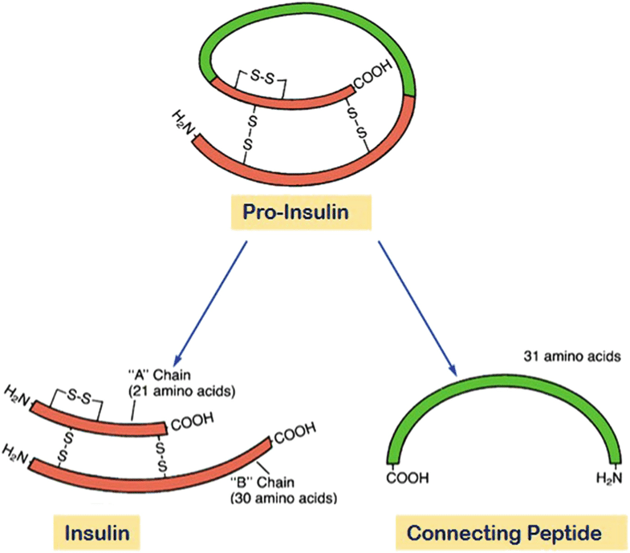
Figure 1: Humulin derived from Proinsulin.

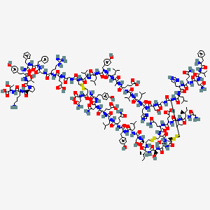
Figure 2: Chemical Structure of Insulin

Physical/ Chemical Property | Corresponding Value
Molecular Weight | 5808 g/mol
Molecular Formula | C₂₅₇H₃₈₃N₆₅O₇₇S₆
Isoelectric Point [17] | 5.4
Density | 1.09 g/cc
Appearance | Cloudy and white in colour
Table 1: Properties of Humulin

2.3 Demand:
According to the Indian Council of Medical Research (ICMR) [12] in the year of 2022, around 96,000 children under the age of 14 suffer from IDDM [4]. Over this number from 2022, it is estimated that there are 75,000 fresh cases of type 1 diabetes amongst children under the age of 14 is projected.
Keeping the demographic in mind, the target patients for the product would be the fresh cases emerging every year i.e. 75000 new cases of IDDM. Prescribers’ Digital Reference (PDR) suggests a dosage of 0.5 units of Humulin per person per kilo [18] (until the age of 14). Khadilkar et.al. [3], conducted a study on growth status of children with type 1 diabetes mellitus which concluded that on average, the weight of a child with IDDM can be averages at around 28 kilograms.
With an average weight of 28kgs, an individual patient needs around 177.317 mg of Humulin per year. Multiplied with 75,000, that brings the total demand to around 13.298 kilograms of insulin. The excess product produced can be stored and sold to other states/countries on demand.

2.4 Production Scale:
Table 2: Production Scale of process line

Batch Time (Complete Process) | 8 Days
Rundown Time including planning and preparation | 5 Days
Batches per year | 24
Volume of Bioreactor | 250 L
Working Volume | 166.6 L

- Location:
3.1 Site Selection:
Jeedimetla Industrial Development Area (IDA) located in Hyderabad, the capital city of Telangana was chosen because of its various perks and advantages. The piece of land would be acquired from an existing facility of Virchow chemicals which has their pre-clinical lab set up in the location. The location is near various facilities provided by the municipality of Jeedimetla/Hyderabad like the effluent treatment plant, various stock chemical production facilities which are essential to the production process and utilities like steam, water, and electricity. The political system though a bit weary in the state of Telangana, supports the installation of new businesses which provides employment opportunities to its skilled and unskilled workers.
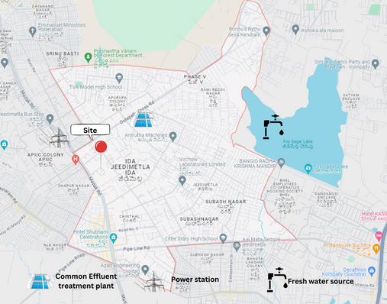
Figure 3: Site location and amenities.
3.2 Links:
The location for the production plant is very well connected by air, land and railways. Right outside the facility, the NH-765D connects the facility to the Outer Ring Road which circles around the city and leads to various highways connecting the major cities and territories across the country. The outer ring road also gives access to the international airport which is located 75 kilometres away from the facility. The produced products or the sourced raw materials can be transported via the rail to the nearest hub located 10 kilometres from the facility and transported to and from the facility by road.
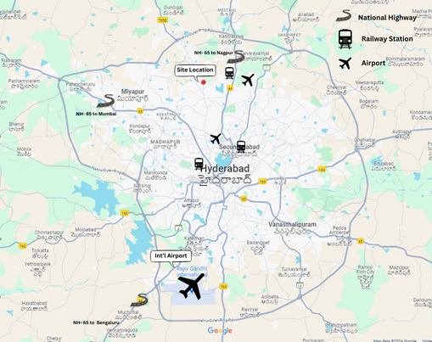
Figure 4: Major Transport links
3.3 Labour and Skilled Workforce:
The source of labour and skilled workforce is in abundance in the area. With daily casual labourers trained in various other pharmaceutical industries around the facility, the time taken by the facility managers to train and induct the new labourers would be far less.
With the presence of various engineering and science institutions in a 100-kilometre radius, the skilled workforce trained especially in biotechnology and industrial biotechnology is a gain for the production facility. With institutions like BVRIT-Narsapur focussing on chemical/ bioprocessing engineering and pharmaceutical engineering, hiring the right personnel for executing day to day affairs like operations, supply management and procurement wouldn't be much of a problem for the facility. Maintenance engineers looking after the mechanical, electrical and software aspects of the facility can be hired ranging from experts in the field to the freshers.

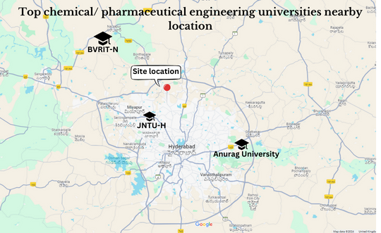
Figure 5: Educational Institutions

3.4 Utilities:
Utilities for the plant which is quintessential in its running. Common utilities include electricity, water, steam and utility chemicals like ethanol, sulfuric acid, and other acids.
IDA Jeedimetla is abundant with industries feeding pharmaceuticals/ biopharmaceutical industry with utilities like electricity, water, and steam. With the governing body’s initiative in installing effluent treatment plants for the industries around it.

- Overview of the Production Process:
4.1. Upstream Processing:
(1) Host Organism:
For the commercial production of Humulin, Escherichia Coli or E. Coli in short is chosen as the host organism due to the following reasons:
- Faster growth kinetics.
- Gram Negative Bacteria promotes the growth of Humulin.
- Easy and cheap availability of materials to produce broth to grow E. coli.
- High cell density can be achieved in E. Coli compared to other organisms [2].
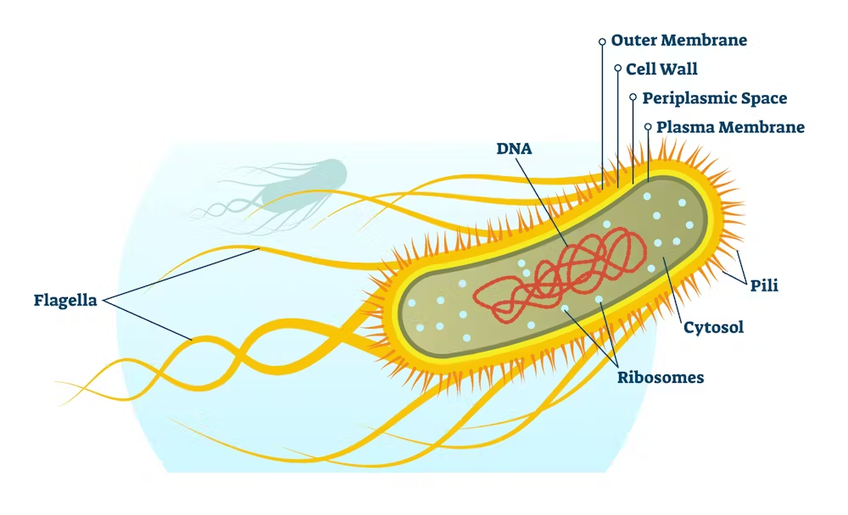
Figure 6: E. coli
The strain of E. Coli BL-21 as shown by Shin et.al [5] that the strain combined with the plasmid [pET- 3aT2M2], has a promising yield of Humulin spike protein.
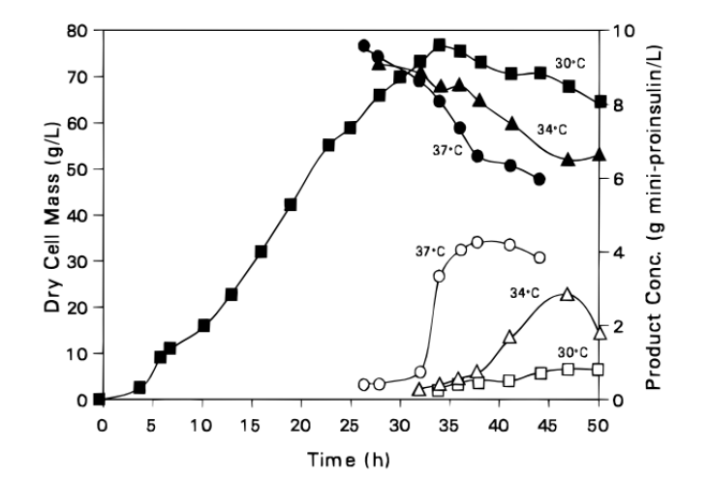
Figure 7: Growth curve of E. Coli and product concentration [5]
(Outline shapes: Proinsulin; Shaded: E. Coli)
(2) Reactor configuration:
Insulin produced using recombinant technology using E. Coli is an intracellular product where the Humulin spike protein grows inside the cell. In order to grow the transformed cells, a two-stage reactor system is used where the reactors are operated in fed-batch systems to give the highest yield [5]. The first reactor is used to grow the bacteria initially to multiply the antibiotic resistant cells produced in flask level studies. The first reactor has a design volume of 40 litres with a working volume of 25 litres to give a 50% headspace to allow foam and space for smart sensors. The bioreactor is jacketed and is lined with glass on the inside.
The second bioreactor’s main purpose is to grow the prepared cells from the first bioreactor to industrial scale. The design volume of the second reactor is 300 litres with a working volume of around 225 litres.
In both reactors, the optimal temperature maintained is 37℃ [5]. The dissolved oxygen content in the reactor is maintained above 40%. The pH inside the reactor is maintained at 6.5 to maintain a neutral environment. Once the E. coli’s dry cell weight in the reactor is around 70-80 g/L, the post induction media (IPTG) which is a T7 promoter is injected into the reactor allowing recombinant gene to be induced in the cells.
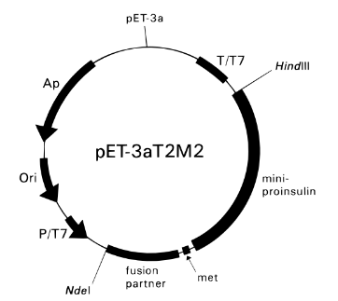
Figure 8: pET module

(3) Reactor Type and Operation:
To modify and grow the E. Coli cells to produce the product, a two reactor in series is chosen with varying volumes. The first reactor is used to modify the cells to inhibit antibiotic resistance by adding 200 mg/L of kanamycin to the LB fed in the reactor. To promote optimal growth, the bioreactor is sparged with oxygen to promote growth. The dissolved oxygen (DO) content is maintained in the range of 40-50% [5].
To reduce breach of sterility issues, a stainless-steel reactor with glass lining on the inside is used with SIP (Sterilisation in place/ steam) which is done by a jacket around the walls of the reactor which also acts as heating/ cooling jacket to maintain isothermal conditions in the reactor.
The second reactor in series is identical to the first one with respect to operation and conditions inside the reactor with exception of the volume of the reactor. The main purpose of the second reactor is to grow the antibiotic resistant cells to the forecasted demand.
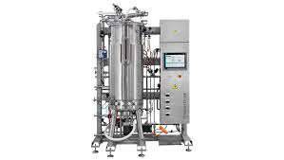
Figure 9: Bioreactor

Operation:
The reactors are operated in a single stage fed batch system where the growth of E. Coli is monitored and controlled by addition of fresh media to the reactor and buffers which alters the pH of the contents to promote proper growth. The reactor is fed periodically with fresh broth as cell growth is observed to counter acetic acid production in the reactor as it can increase drastically and becomes a significant inhibition product. The post induction media is introduced into the reactor once the cell concentration has reached an acceptable limit of 70g/L to 80g/L. The reactor is run for a time duration of 25 hours for each of the reactors including post induction media injection.
4.2. Downstream Processing [6]:
Post the growth and verification of protein content in the cells grown, the fermentation broth is further treated down the princess line to extract the insulin and purify the protein.
As the insulin produced in the cells of E. Coli is an intracellular product, an integral part of the process is to disrupt the cell wall and remove the inclusion bodies present inside.
4.2.1 Cell Isolation: The cells before passing it through further down the line have to be isolated from the fermentation broth and other buffers used during the fermentation. To isolate the cells, a centrifuge is used where it separates by using centrifugal force where the cells and cell debris are collected from the bottom. The centrifuge is operated at 8200 RPM for about 10 minutes and the supernatant is discarded as it consists mostly of fermentation broth and buffers used during fermentation.
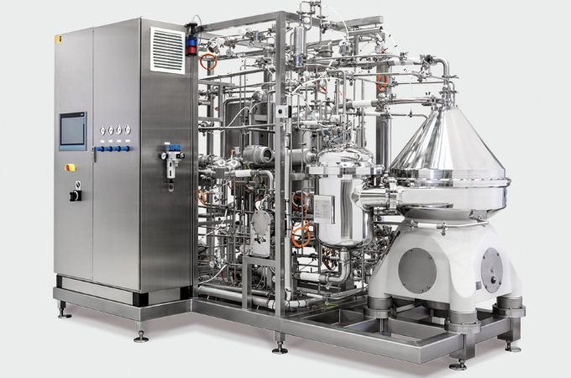
Figure 10: Centrifuge.

4.2.2. Cell Lysis:
As the product is an intracellular product, cell disruption is a vital part of the process where the cell walls of the isolated cells are broken down and the inclusion bodies are extracted using a high-powered centrifuge.
To lyse the cells, a two-step process is used to completely disrupt the cell wall. In the first step, the cell wall is weakened in the first step using 70% ethanol. Ethanol has a capacity to reduce the forces holding the peptidoglycan on the cell walls. It does not directly affect the cell wall but rather affects the hydrophobic reactions on the cell walls thereby weakening the cell wall thereby allowing the lysis of E. Coli cells.
The second step involves the removal of dissolved ethanol by extractive distillation. Extractive distillation is achieved by altering the pressure in the environment to lower pressures where the pressure is approximately 0.1 ATM where the ethanol is evaporated in room temperature of 30℃ [7].

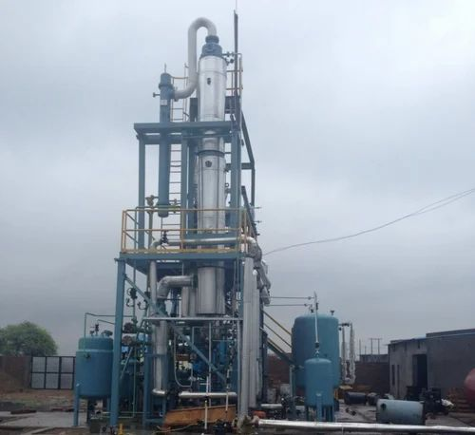
Figure 11: Distillation Column
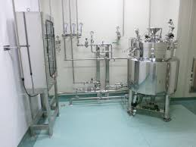
Figure 12: Sterile mixing tank.

4.2.3. Inclusion Body Separation:
Once the cells are lysed, the lysed cells consist of cell wall, cell debris and other inclusion bodies. To separate the inclusion bodies from the other materials which do not contain the protein, the stream from cell lysis stages is sent to a tubular bowl centrifuge which is also called an ultracentrifuge which has the capacity to reach ‘g’ values of 1,000,000 g. To separate the inclusion bodies from the other materials, the stream from cell lysis is centrifuges in an ultracentrifuge for 15000 g for a time span of 30 minutes. The supernatant containing the cell wall debris and other materials are discarded and the pellets collected at the bottom are further sent down the line for processing.
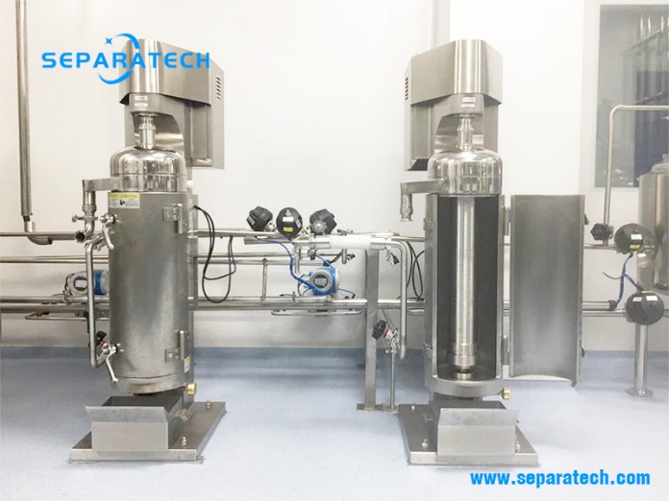
Figure 13: Tubular bowl centrifuge.

4.2.4 Inclusion body solubilization and Sulfitolysis:
Highly aggregated proteins in the inclusion bodies are insoluble. To make the inclusion bodies soluble in solvents, reducing agents are added to de-clump the inclusion bodies and thereby making inactive clumped protein useless. Agents like beta-mercaptoethanol do the work by de-clumping the inclusion proteins and activating the protein (insulin) in the cells. Urea is also added in this step to wash the solution to remove cell wall components. A sterile mixer is employed in this case to carry out solubilization. In the same sterile mixer, sodium sulphate is added for oxidation and maintains the proinsulin from forming incorrect disulphide bonds. This process is carried out along with solubilization for 6 hours.
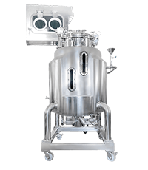
Figure 14: Sterile mixing tank

4.2.5 Primary Purification:
The stream from solubilization and sulfitolysis consists of the inclusion bodies which are solubilised. The stream is sent for primary purification where the reagents used in previous stages like sodium sulphate and urea are removed. Non-polar solvents which are relatively neutral in charge are removed using a centrifuge operating at 17,700 g for a time span of 30 minutes. Urea is removed from the inclusion body broth using a dialyser which removes the salt from the IB broth and makes the net charge of the broth relatively neutral.
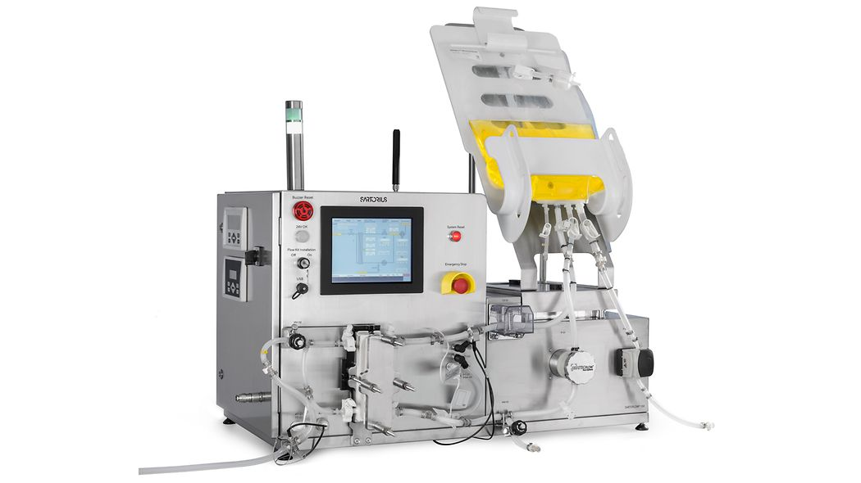
Figure 15: Diafiltration System (Sartorious - Sartoflow 150)
The desalinated stream from the dialyser is sent to a temperature-controlled vessel which is maintained at 4℃ to prevent protein degradation where glycine-sodium hydroxide of concentration 1 M is added along with beta-mercaptoethanol at a ratio of 18:1 molal ratio. This process is carried out to renature the proteins to its right structure for 20 hours. To carry out renaturing process, a stainless-steel jacketed mixing vessel is employed which is lined with glass on the interior walls with supercooled water running around the annulus of the jacket space to maintain the vessel at 4℃.
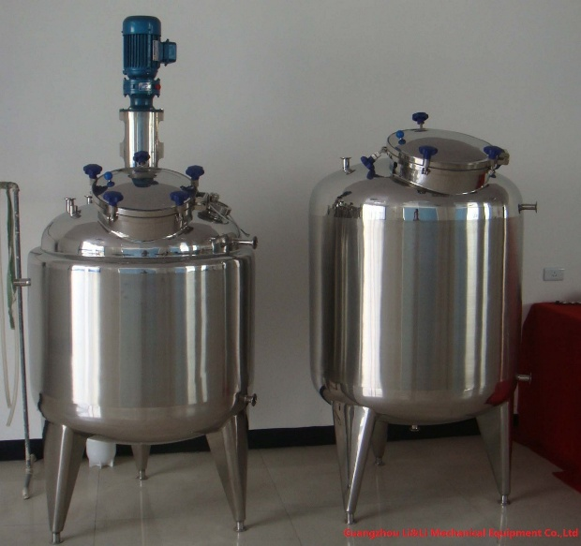
Figure 16: Pharmaceutical grade mixing tank.

4.2.6 Secondary Purification:
The renaturation step takes place at a higher pH in the range between 9-10. The pH of the mixture is adjusted in-situ by adding weak acids and the net mixture is sent to a centrifuge which removes the lighter particles (in this case the buffers and reagents) from the heavier particles. The lighter particles are discarded as it is of no use and the pellets collected at the bottom are further processed down the line. The centrifugation is carried out at an acceleration of 17,700 g for 35 minutes.
The pellets collected from the centrifuge are passed onto the chromatography column which purifies the protein initially to meet the required CQA’s. The stream is passed onto an affinity chromatography column where the column is loaded with IgG Sepharose as the media which is bound by 0.1M glycine-NaOH which acts as binding buffer. The column is later eluted with 0.3M acetic acid which is at a pH of 2.8. Approximately 70% of Insulin in pure form is recovered from the column.
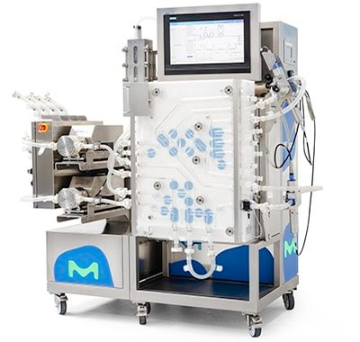
Figure 17: Affinity chromatography system (Sigma Aldrich)

4.2.7: Final purification:
The purified proinsulin (8kDa in size) is sent through a microfilter of size less than 5 micrometres which retains the larger proinsulin as retentate and the filter cake is further processed down the line into a mixer where trypsin is added along with carboxypeptidase which separates the C chain from the chains A and B. Trypsin is added in the ratio of 1:1000 (trypsin: proinsulin) for a time period of 30 minutes and stopped by adding carboxylic acid, 20% acetonitrile and trifluoroacetic acid.
The stream is sent to reverse phase HPLC to separate the C chain from the A and B chains. The C-chain is eluted first as the molecule is small compared to the other molecules. The columns once loaded are eluted with 25% ACN, 1.5% acetic acid and 73.5% water which gives a yield of 95% [6].

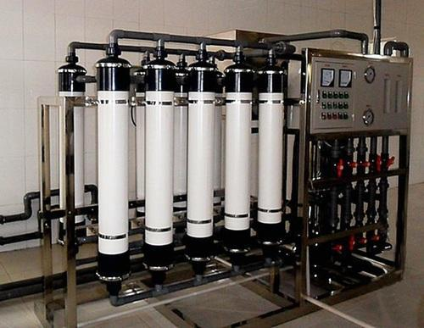
Figure 18: Ultrafiltration system

4.2.8: Polishing:
The final product from the reverse phase HPLC is sent to a final mixing tank where zinc ions are added and polished. Zinc is added to the product to form crystal complexes which slowly releases the insulin into the bloodstream over 2-4 hours for slow acting insulin. The crystals are formed using a crystalliser at 4℃ and stored at the same temperature after freeze drying the final formulated product.

- Process Flow Diagram:
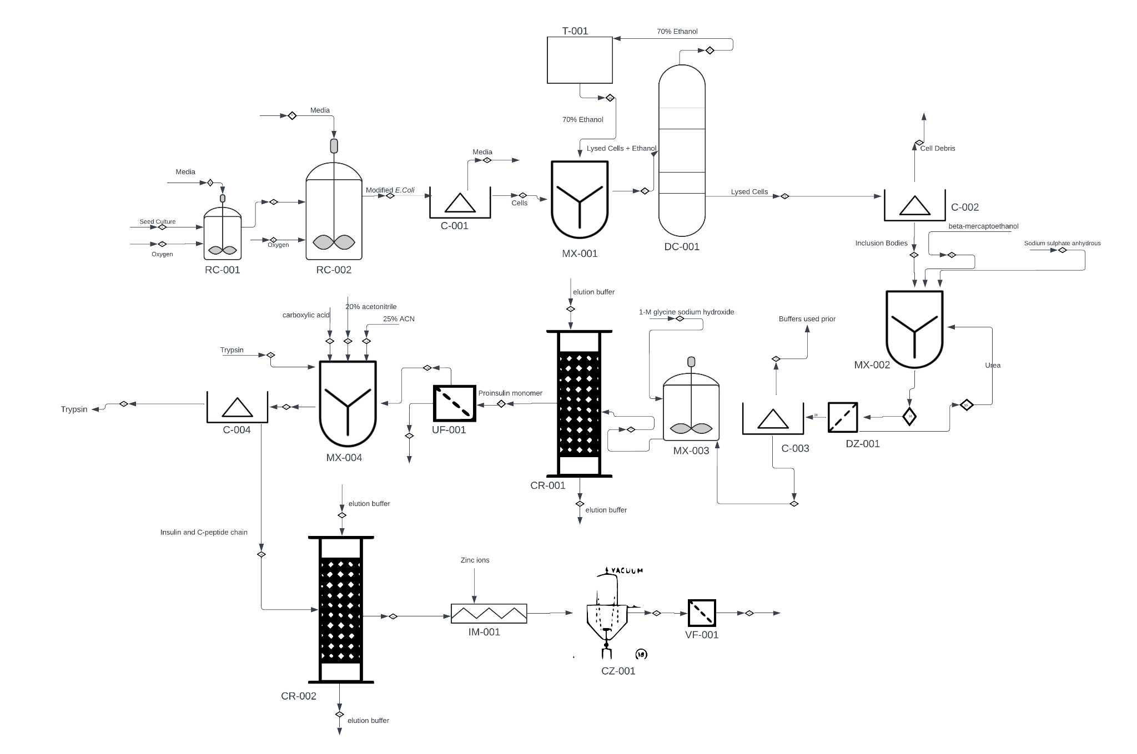

PFD LEGEND:

Table 3: PFD Legend
S. No | Equipment Tag | Equipment Name
1 | RC | Reactor
2 | C | Centrifuge
3 | MX | Mixer
4 | DC | Distillation Column
5 | T | Tank for storage
6 | DZ | Dialyser
7 | CR | Chromatography Column
8 | UF | Ultrafiltration system
9 | CZ | Crystallizer
10 | VF | Viral Filter
11 | IM | Inline Mixer
- Material Balances:
General Assumption: Density of media (LB) is considered as 1 g/cc which would yield 1kg of LB = 1 litre of LB.
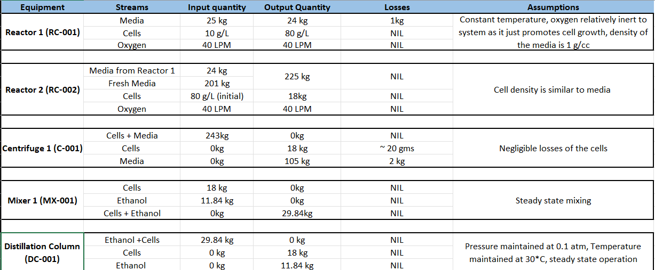
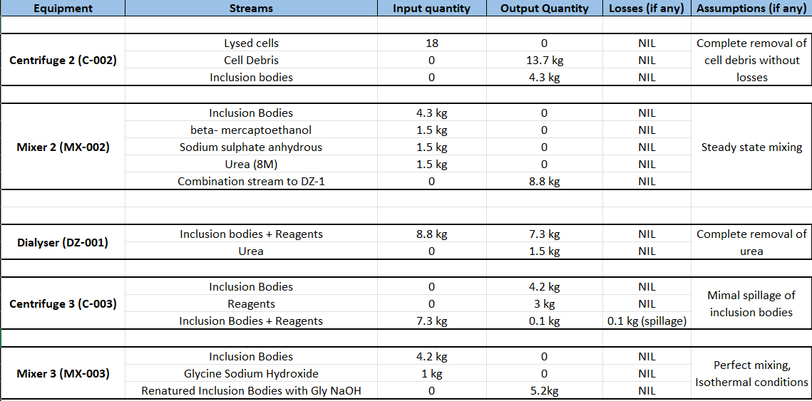
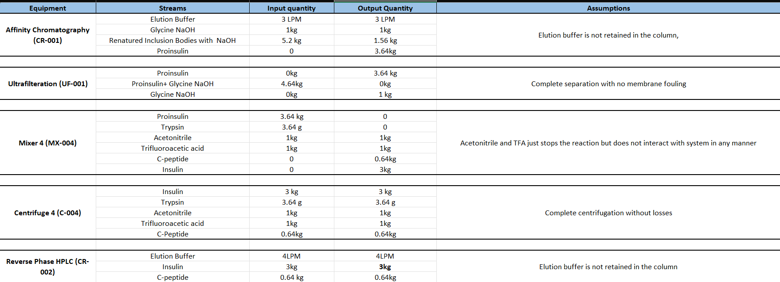

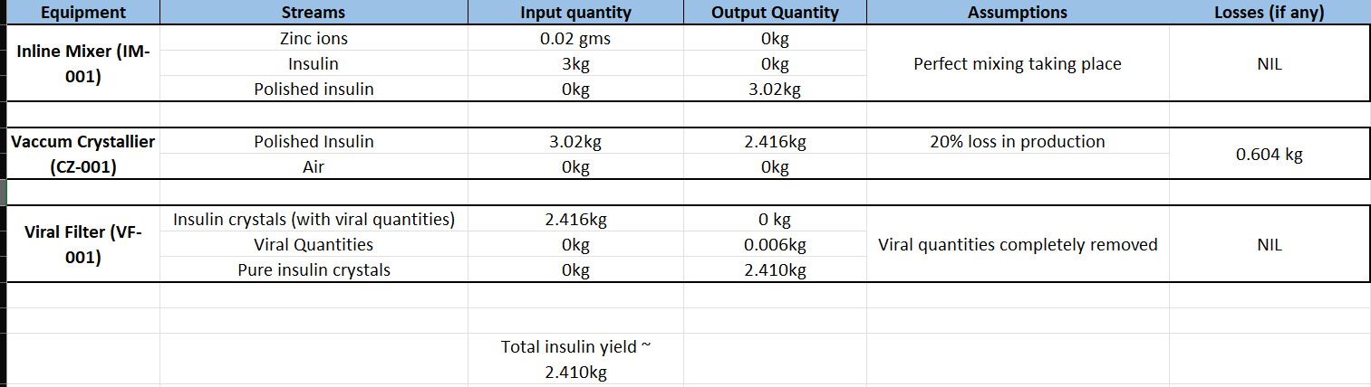

- Detailed Description of Unit Operation: Cell Lysis
In the cell lysis stage, ethanol is added into a pressure vessel which acts as a distillation column. A MATLAB code was written to estimate the theoretical height of the pressure vessel to completely extract ethanol from the mixture of E. Coli cells using the Fenske Equation. [8]
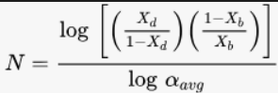
The Fenske equation as shown above gives the relation between the mole fraction of desired compound in distillate and bottoms and the relative volatility. For this process, relative volatility (averaged) is assumed to be 2 for the mixture of ethanol and cells. Using the Fenske equation, the minimum number of stages is approximated to 13.25 stages. Height of the distillation column or vessel in this case can be calculated using the following formula:
H= HETP*n
Where,
HETP = Height equivalent to theoretical plate
H = Height of column
n= number of stages
Assuming the value of HETP of 1 where every metre inside the vessel, there is a stage or a plate where products are collected, the formula can be simplified to:
H= n
Running the MATLAB code using the above two formulae gave a height of the vessel to be approximately 13.25 metres.
Since the manufacturers are manufacturing the distillation column by design provided
by its customers. The factors taken to compare the manufacturers are usually based on
The design codes followed by them to manufacture and the final designing of the
Keeping the design height in mind, it is desirable to have a 20% deviation (extra) from the design, the following parameters must be considered while deciding the column:
- 15 metres in height
- Diameter of column not exceeding 4 metres to protect structural integrity.
- Low energy consumption in pumping.
- Good automation and pressure controlling system.
- Bubble cap trays to maintain liquid holdup in trays.
- SS-316 material which is an alloy of stainless steel containing 2% molybdenum preventing corrosion.
- ASME (American Society of Mechanical Engineers) codes followed pertaining to section 8 and International Standard code 2825 (IS-2825) involving design of distillation columns operating in different pressures.

Since the manufacturers are manufacturing the distillation column by design provided
by its customers, the factors taken to compare the manufacturers are usually based on
The design codes followed by them to manufacture and the final designing of the column. Parameters like country and region of manufacture plays a vital role in selecting a supplier.
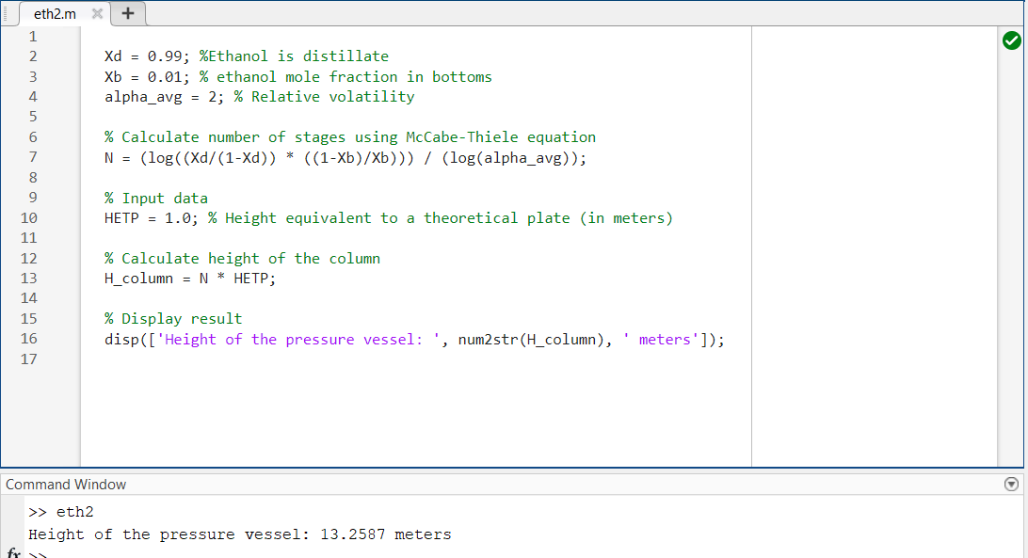
Figure 19: MATLAB code to compute height of distillation column (pressure vessel)

Table 4: Engineering organisations manufacturing distillation columns.

Supplier | ACME Process Systems [9] | KEP Engineering [10] | Pressure Vessels (India) [11]
Material | SS Alloys | SS Alloys (to order) | SS, Carbon Steel and Copper alloys
Pressure capacity range | 0-100 psi | 0-90 psi | 0-100 psi
Temperature Range | 0-300℃ | 0- 100℃ | 0-200℃
Codes followed by the manufacturer | ASME (8-2) | IS 2825 | ASME Section VIII, IS 2825
Country and Region of origin | Maharashtra, India | Telangana, India | Maharashtra, India

Geographically, KEP engineering systems gives an upper hand than the other 2 manufacturers of distillation columns due to the proximity of the supplier to the proposed site. It is also ideal if provided the extra capital to be invested on transport, Pressure Vessels (India) is also an ideal supplier due to its varied expertise in designing and manufacturing to the given specifications. For site maintenance and servicing, contracts can be given to KEP Engineering to service the columns.
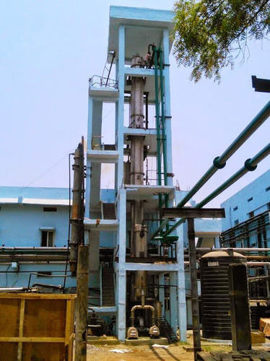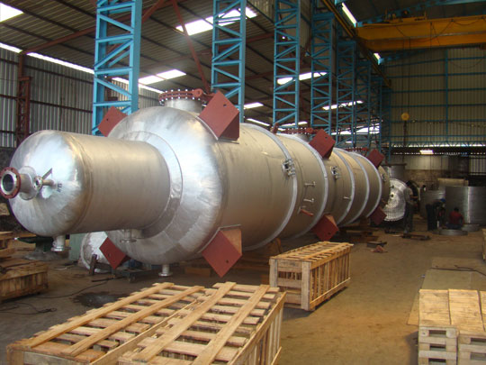
Figure 20: Distillation columns by KEP (left) and ACME Process systems (right)
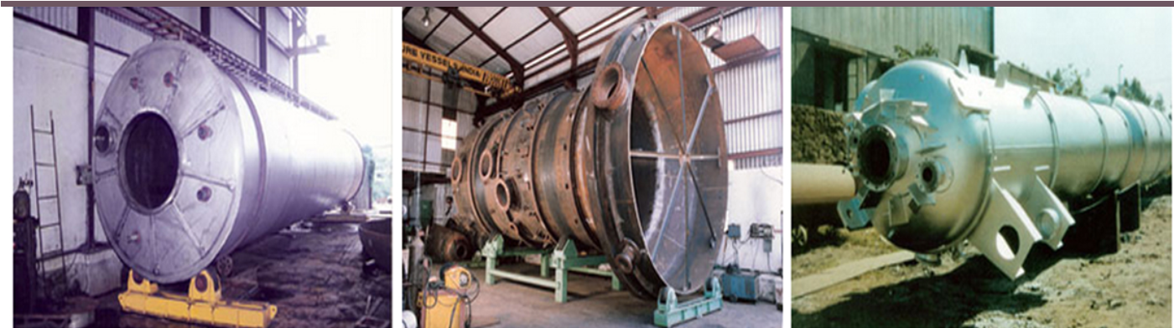
Figure 21: Distillation Columns built to custom specifications by Pressure vessels (India)

- Improvements and future expansions:
8.1 Microbubble Intensified systems:
Microbubbles has shown a promise in intensifying bioprocesses to carry out mass transfer operations in a faster and efficient manner [15]. The initial applications of microbubbles were done to intensify heat transfer applications pertaining to heating in specific. Studies shows that aeration through microbubbles has a significant boost in cell density [13] and compared to normal aeration through oxygen sparging. Relatively warm microbubbles of carbon dioxide could be introduced in lysis tank to extract ethanol in a short span of time eliminating the longer wait time to decrease pressures in the vessel and wait for ethanol to be removed from the mixture of inclusion bodies.
8.2 Good manufacturing Practises [14]:
Regulatory standards pertaining to manufacturing practises and personnel etiquettes is quite important to ensure drug safety and efficiency. From the upstream processing all the way till product purification and packing, good manufacturing practises (GMP) are to be adhered. Safety training to the personnel working in the clean room and non-clean rooms are to be given prior the allowance of the personnel. Appropriate clothing is to be worn by person(s) entering the clean room and the facility. The site is also recommended to follow regulatory laws by USFDA and EMA.

REFERENCES:
[1] Mohan, V. (2002). Which insulin to use? Human or animal? Current Science, [online] 83(12), pp.1544–1547. Available at: https://www.jstor.org/stable/24108179.

‌[2] Baeshen, N.A., Baeshen, M.N., Sheikh, A., Bora, R.S., Ahmed, M.M.M., Ramadan, H.A.I., Saini, K.S. and Redwan, E.M. (2014). Cell Factories for Insulin Production. Microbial Cell Factories, [online] 13(1). doi:https://doi.org/10.1186/s12934-014-0141-0.

[3] Khadilkar, A., Khadilkar, V., Parthasarathy, L., Mallade, B., Chiplonkar, S. and Borade, A. (2013). Growth status of children and adolescents with type 1 diabetes mellitus. Indian Journal of Endocrinology and Metabolism, 17(6), p.1057. doi:https://doi.org/10.4103/2230-8210.122623.

[4] India Today. (n.d.). Rise in type 1 diabetes among children post Covid explained. [online] Available at: https://www.indiatoday.in/health/story/world-diabetes-day-2023-rise-in-type-1-diabetes-among-children-post-covid-explained-2462752-2023-11-14 [Accessed 23 Apr. 2024].

‌[5] Shin, C.S., Hong, M.S., Bae, C. and Lee, J. (1997). Enhanced Production of Human Mini-Proinsulin in Fed-Batch Cultures at High Cell Density of Escherichia coli BL21(DE3)[pET-3aT2M2]. Biotechnology Progress, 13(3), pp.249–257. doi:https://doi.org/10.1021/bp970018m.

[6] Siew, Y.Y. and Zhang, W. (2021). Downstream processing of recombinant human insulin and its analogues production from E. coli inclusion bodies. Bioresources and Bioprocessing, [online] 8(1), p.65. doi:https://doi.org/10.1186/s40643-021-00419-w.

[7] Luna, M.A.G. (2018) Experimental Data and New Binary Interaction Parameters for Ethanol-Water VLE at Low Pressures Using NRTL and UNIQUAC, Scielo Colombia- Scientific Electronic Library Online. Available at: http://www.scielo.org.co/scielo.php?pid=S1909-36672018000100017 (Accessed: 23 April 2024).
[8] Hanley, Brian. (2001). Calculation of the HETP at Total Reflux: Generalization of the Fenske Equation. https://www.researchgate.net/publication/266490075_Calculation_of_the_HETP_at_Total_Reflux_Generalization_of_the_Fenske_Equation

[9] Acme. (n.d.). Distillators | Distillators Manufacturers in Pune, Pressure Vessel Manufacturer in Pune. [online] Available at: https://acmeprocess.net/products/distillators/ [Accessed 23 Apr. 2024].

‌[10] Kepengg.com. (2022). Welcome to KEP Engineering. [online] Available at: https://kepengg.com/distillation-column.php [Accessed 23 Apr. 2024].

[11] www.pressurevesselsindia.com. (n.d.). Pressure Vessel - Steel Pressure Vessel, Pressure Vessel Manufacturers, Pressure Vessels India. [online] Available at: https://www.pressurevesselsindia.com/columns.php [Accessed 23 Apr. 2024].

‌[12] Das, A.K. (2015). Type 1 diabetes in India: Overall insights. Indian Journal of Endocrinology and Metabolism, [online] 19(Suppl 1), pp.S31–S33. doi:https://doi.org/10.4103/2230-8210.155372.

‌[13] Raghavendran, V., Webb, J.P., Cartron, M.L., Springthorpe, V., Larson, T.R., Hines, M., Mohammed, H., Zimmerman, W.B., Poole, R.K. and Green, J. (2020). A microbubble-sparged yeast propagation–fermentation process for bioethanol production. Biotechnology for Biofuels, 13(1). doi:https://doi.org/10.1186/s13068-020-01745-5.

‌[14] Reis, C., Gouveia, B., Rijo, P. and Gonçalo, T. (2015). Good manufacturing practices for medicinal products for human use. Journal of Pharmacy and Bioallied Sciences, 7(2), p.87. doi:https://doi.org/10.4103/0975-7406.154424.

‌[15] Gilmour, D.J. and Zimmerman, W.B. (2020). Microbubble intensification of bioprocessing. pp.1–35. doi:https://doi.org/10.1016/bs.ampbs.2020.07.001.

‌[16] PubChem (n.d.). Humulin N. [online] pubchem.ncbi.nlm.nih.gov. Available at: https://pubchem.ncbi.nlm.nih.gov/compound/Humulin-N.

‌[17] Mikiewicz, D., Bierczyńska-Krzysik, A., Sobolewska, A., Stadnik, D., Bogiel, M., Pawłowska, M., Wójtowicz-Krawiec, A., Baran, P.A., Łukasiewicz, N., Romanik-Chruścielewska, A., Sokołowska, I., Stadnik, J., Borowicz, P., Płucienniczak, G. and Płucienniczak, A. (2017). Soluble insulin analogs combining rapid- and long-acting hypoglycemic properties – From an efficient E. coli expression system to a pharmaceutical formulation. PLOS ONE, 12(3), p.e0172600. doi:https://doi.org/10.1371/journal.pone.0172600.

‌[18] www.pdr.net. (n.d.). Drug Summary. [online] Available at: https://www.pdr.net/drug-summary/?drugLabelId=2911#dosing-considerations [Accessed 24 Apr. 2024].
‌

