How to design a zero-degradation battery: compensating for loss of lithium inventory in LFP cells with LFO additives
Sunil Kumar Rawat¹, Simon E. J. O'Kane¹, Ruihe Li¹, Gregory James Offer^{1,2,3}, Monica Marinescu^{1,2},

Affiliations: ¹Department of Mechanical Engineering, Imperial College London, London SW7 2AZ, UK.
²The Faraday Institution, Quad One, Becquerel Avenue, Harwell Campus, Didcot, OX11 0RA, UK.

³Corresponding author: gregory.offer@imperial.ac.uk

Abstract
Controlling lithium-ion battery degradation is a major global challenge and essential to electrify transport, deploy storage on the grid, and extend the lifetime of portable electronics. Loss of lithium inventory (LLI) caused by side reactions in lithium-ion cells is one of the primary reasons behind reduced cycle life. Researchers in the last ~15 years have demonstrated that additives such as Lithium Iron oxide Li₅FeO₄ (LFO) in LFP-based chemistries can release lithium to compensate for LLI. More recently, CATL has commercialised LFO in LFP cells, while Rimac has also reported to have used LFP-LFO composite cells. Both claim to have achieved zero degradation for extended periods compared to first-cycle capacity. However, the specifics of how they achieved this are neither fully disclosed by them nor sufficiently explored in the literature.
This work describes how LFO can be employed in commercial LFP cells using a full-cell physics-based model in PyBaMM to achieve so-called ‘zero degradation’. We first attempt to find the optimal methods to control lithium release from LFO by simulating 2000 charge/discharge aging cycles for five cases to investigate how controlled lithium release speed (slow or fast release) and timing (early or late in the cell cycle life) can impact cell degradation and its life. We then use the model to find an optimum volume fraction of LFO that can be added to the LFP cathode-based cell to maximize its life. Model results reveal that slow lithium release maintains the cell balancing and reduces the cell degradation rates. In contrast, rapid lithium release and excessive LFO content can accelerate cell degradation rates, resulting in lower cycle life. The results also reveal that having extra anode capacity can help prevent this accelerated degradation, but presents a trade-off between achieving higher cycle life and maintaining energy density. The model assumes that oxygen released during LFO delithiation can be managed by cell degassing and advanced cathode coating agents, and hence does not affect cell degradation. This work shows that achieving longer cell life requires not merely adding lithium-rich additives such as LFO, but also informed cell design changes, and can benefit from advanced lithium release control methods.

Introduction
Loss of lithium inventory (LLI) is one of the major consequences of degradation and the reasons behind capacity fade and reduced life cycle in lithium-ion batteries.^{1,2} LLI is particularly intense during formation and the first few cycles of operation because of the initial formation of the solid electrolyte interphase (SEI). As the formation of SEI continues during cycling and calendar ageing,³⁻⁷ LLI continues to occur. Other degradation mechanisms, such as lithium plating,⁸ also lead to the consumption of lithium ions and hence LLI. Recent breakthroughs in academic and industrial research have explored how LLI can be compensated by using an additive that can release additional lithium inventory, thus improving battery longevity.
Lithium iron oxide (LFO or Li₅FeO₄) is seen as an excellent lithium-rich additive due to its antifluorite structure that stores as much as four times (per gram) more lithium ions⁹ compared to many conventional active materials, enabling it to achieve significantly higher theoretical and practical capacity per gram.^{10,11} The lithium ions stored in the LFO are released irreversibly in two stages, at open circuit potentials vs. lithium (OCP) of 3.5 V and 4.0 V,^{9,10} making it traditionally suitable only for primary cells. However, in a secondary cell, lithium release from the LFO has been demonstrated to compensate for LLI.^{9,10,11,12} The use of LFO as a sacrificial agent in lab-scale coin cells showed that LFO can successfully compensate for LLI during cell formation and subsequent early charge-discharge cycles and help maintain stable cell performance. Companies such as CATL and Rimac have demonstrated the commercial-scale viability of LFO being used in this way and claimed to have achieved zero apparent degradation.^{13, 14} CATL manufactured LFP cells with LFO as a cathode additive and reported zero apparent degradation for the first 1000 cycles.¹³ They hinted at operating the cell so that the release of lithium from LFO happens in the early phase of the cell's life. Rimac Energy reported to have operated the LFP-LFO composite cells using a slightly different approach. They focused on the gradual release of lithium from LFO to achieve zero capacity fade for two years.¹⁴ Rimac has also mentioned using an advanced power conversion system to achieve such performance. This highlights that beyond the cell design, the control over operational conditions might be crucial to tap into the full potential of LFO additives. However, neither of the two companies has disclosed the exact methods, mechanisms, and strategies for successfully employing LFO as an additive in commercial cells, leaving researchers to speculate about the underlying principles. The commercial-level use of LFO and the underpinning scientific principles of how to use it are also missing in the peer-reviewed literature. Using the above innovations as motivation, our work offers a detailed insight into how LFO can be employed in commercial LFP cells with composite LFP-LFO positive electrode (PE) and Graphite negative electrode (NE). To achieve this, we use simulations run on a purpose-built full-cell physics-based model in PyBaMM¹⁵ and analysed the model predictions.
This work adds significantly to the scientific understanding and knowledge of the consequences of releasing additional lithium from LFO in a composite LFP-LFO cell, its impact on cell degradation, including SEI, lithium plating, and porosity clogging, cell discharge capacity, and cell life. Model predictions reveal that consequences are not always beneficial. Using the model, optimal methods to control lithium release from LFO, an optimum volume fraction of LFO, and the benefits of larger NE capacity/overhang in minimizing cell degradation and achieving long-lasting, zero-degradation batteries, are all explored. The work is organised into three sections: Main, Conclusions, and Methods. The Main section is divided into seven subsections. The first subsection discusses the mechanism of lithium and oxygen release from LFO in correlation with experimental half-cell open circuit potential (OCP) data for pure LFO. The second subsection provides the correlation of lithium and oxygen release to the full cell charging and discharging voltages in a single cycle. The third subsection focuses on lithium release from LFO during cell cycling with the help of a purpose-built PyBaMM model. The impact of released lithium from LFO on cell degradation, its capacity, and life is examined in the fourth subsection. A detailed analysis of control methods for optimal lithium and oxygen release, and optimal LFO volume fraction to be used in LFP-LFO cells for achieving maximum cell performance can be found in the fifth and sixth subsections, respectively. The final subsection presents a cell redesign approach to prevent cell unbalancing during an overlithiation scenario to achieve improved cell longevity. The Methods section presents and discusses the model setup and its implementation, model assumptions, setting up virtual experiments, and methods for controlled lithium release from LFO in PyBaMM.

Main

Mechanism of Lithium and Oxygen release from LFO in correlation with its experimental OCP
LFO (${Li}_{5}FeO_{4})$ material as a sacrificing agent in lithium-ion (Li⁺) cells releases its lithium inventory as a result of the following two reactions:
${Li}_{5}FeO_{4 }→ {Li}_{3}FeO_{3.5}+ 0.25O_{2}↑+ 2{Li}^{+}+2e^{-}$ (1)

$${Li}_{3}FeO_{3.5 }→ LiFeO_{2}+ 0.75O_{2}↑+ 2{Li}^{+}+2e^{-} (2)$$

Two irreversible releases of Li⁺ from LFO take place: one between LFO half-cell open-circuit potential (OCP) of 3.5 V and ~3.75 V (equation (1)) and the other between ~3.75 V and 4.5 V (equation $(2)$).¹⁰ Fig. 1 shows the half-cell OCP of pure LFO material¹⁰ vs stoichiometry, exhibiting the two plateaus that correspond to the two stages of lithium release. Overall, each mole of LFO releases 4 moles of lithium across the full OCP range.

Fig. 1: Half-cell open circuit potential (OCP) of a pure LFO material
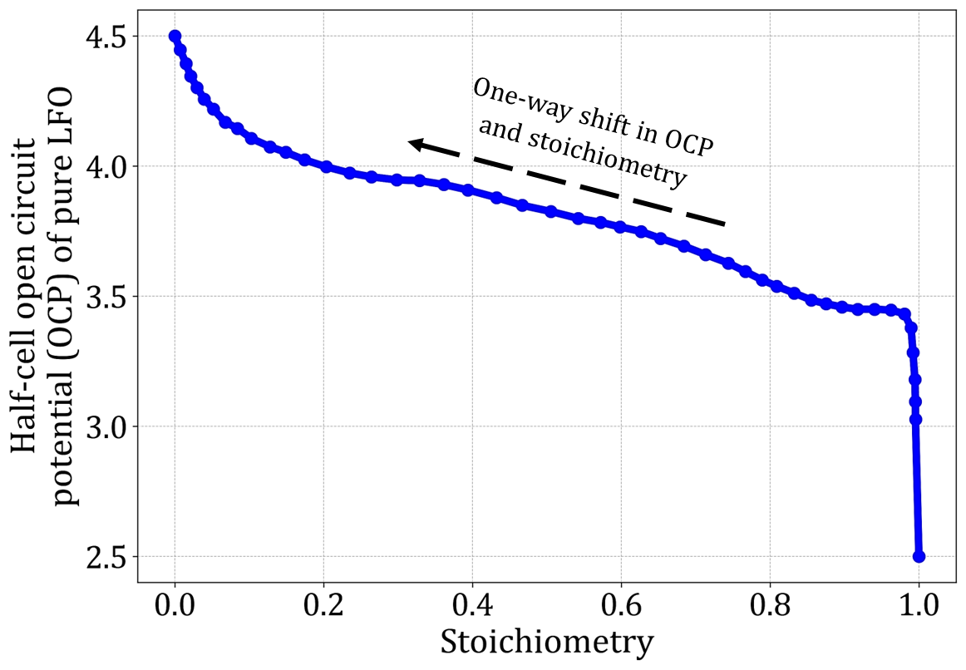

Delithiation OCP of a pure LFO material with its stoichiometry.^{10,16} The figure shows two voltage plateaus at OCP ~3.5 V and ~4.0 V, corresponding to equation (1) and equation $(2)$

We define the stoichiometry of fully lithiated LFO (i.e. ${Li}_{5}FeO_{4}$) as 1 with an OCP of 2.5 V and the stoichiometry of fully delithiated LFO (i.e. $LiFeO_{2}$) as 0 with an OCP of 4.5 V. As LFO releases its lithium irreversibly, its stoichiometry decreases monotonically from 1 to 0 and correspondingly its OCP increases from 2.5 V to 4.5 V. When the composite PE potential drops below the OCP of LFO, no Faradaic reaction occurs on the LFO interface i.e., lithium release from LFO stops until composite PE potential increases above the LFO OCP again. As apparent from equations (1) and $(2)$, oxygen is co-released each time there is lithium release from the LFO. While rarely discussed in the literature on LFO, the presence of oxygen is known to contribute to different degradation mechanisms.¹⁷⁻²⁰ In this work, the oxygen-induced degradation is ignored, as it is assumed that most oxygen released from LFO is removed through cell degassing during the formation cycles.²¹ We assume any oxygen released later in the cell's life does not impact its degradation. While unlikely to be true, there is a distinct lack of experimental data that would enable a meaningful inclusion of this mechanism in the model. It is worth noting that the moles of oxygen released depend upon the initial LFO moles and the LFO OCP. As 75% of the oxygen is released when the OCP of LFO reaches the second voltage plateau (~4.0 V), a lower LFO content and avoiding high cell charging voltages to avoid high OCPs of LFO would lead to significantly less oxygen release. Meanwhile, attempts are made to modify LFO by suitable coating layers and lattice engineering^{22,23,24} to mitigate oxygen evolution and enhance performance. Oxygen release and its precise effect on cell degradation may be worthy of further experimental and modelling studies.

Correlating the composite LFP-LFO cell charging voltage to the LFO OCP and the associated lithium-oxygen release: insights relative to pure LFP cell
Equation 1 shows that the first irreversible lithium release from LFO is triggered when the composite PE OCP exceeds the first plateau of LFO OCP of 3.5 V. Therefore, to use the Li stored in the LFO for a cell with a composite LFP-LFO cathode, the upper voltage cut-off during cell charging must be set to a value higher than 3.5 V. The operational voltage range for a pure LFP cathode-based cell is typically below 3.5 V, with the voltage plateau for normal operation located between 3.2-3.4 V, depending on state of charge and hysteresis. Even when accounting for overpotentials during operation, it is possible to keep the normal operating window for a pure LFP cathode-based cell below 3.5 V. As a result, the release of lithium and oxygen from the LFO component of a composite LFP-LFO cell can be fully controlled by carefully setting the upper cutoff voltage without affecting normal LFP cell operation. To demonstrate the above expected behaviour, a beginning of life (BoL) PyBaMM model was built (the detailed discussion on PyBaMM model can be found in the first part of the next subsection and Supplementary Note 1). The model was used to find the correlation of cell charging and discharging voltages to the lithium and oxygen release from LFO and its bulk average OCP, and the variation in bulk average OCP of LFP and Graphite. For this purpose, the two separate virtual experiments, each consisting of a single cycle of constant-current constant-voltage (CC-CV) charge followed by a constant-current (CC) discharge (both done at 0.1C with CV hold until the current reaches C/100), were simulated in the built PyBaMM model. An upper voltage cutoff for cell charging was set at 3.6 V (Fig. 2(a)), and at 4.2 V (Fig. 2(b)), for the first and second experiment, respectively. The lower discharge voltage cutoff for both experiments was kept at 2.5 V. Because the upper charging voltage cutoff of 3.6 V only slightly exceeds the first LFO OCP plateau of 3.5V, this case releases only a small percentage (~10 %) of total lithium moles in LFO (Fig. 2(a)). The released lithium moles shift the OCP of LFO slightly from ~3.5 V to ~3.65 V. On the other hand, charging the cell to an upper cutoff of 4.2 V (Fig. 2(b)) leads to the release of ~45% of the total lithium ion in LFO and a larger OCP shift (from ~3.5 V to ~3.85 V). also It is expected that the second case would cause the release of significantly more oxygen than the first case, as the OCP here is close to the second plateau of LFO OCP (equation $(2)$). The above analysis indicates that the lithium release from LFO can be fully controlled by setting the appropriate cutoff voltages during cell charging. Both figures also show that the cell discharging voltages do not impact the total lithium moles in LFO (flat dashed purple lines), which is the result of the informed assumption that cell discharging only lithiates the LFP component of the cathode, i.e. the LFO component of the cathode does not lithiate because of its irreversible sacrificial nature (equation (1) and equation $(2)$).

Fig. 2: Relating the composite cell charging and discharging voltages to the lithium release from LFO and corresponding variations in the OCP of Negative Electrode (Graphite) and Positive Electrode components (LFP and LFO)
(a)  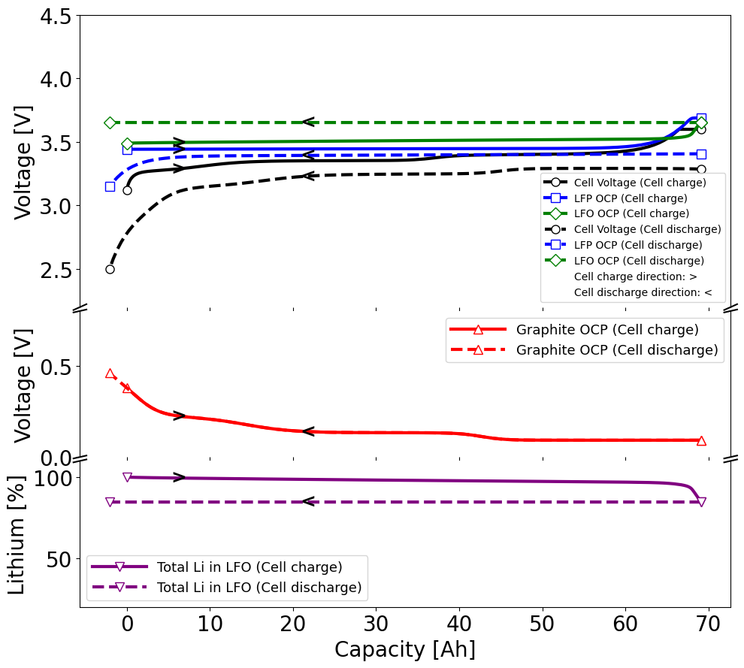 | (b)  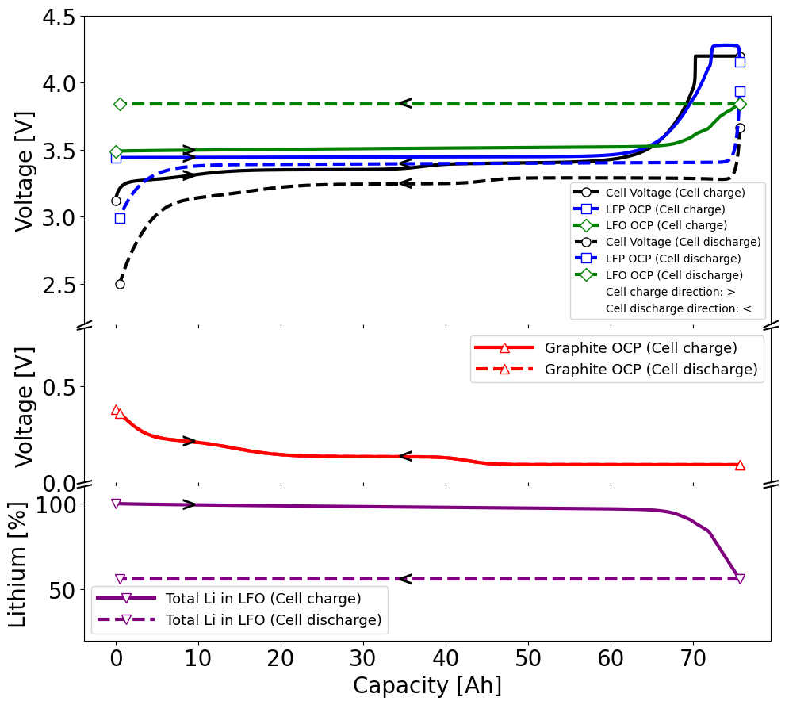
The variation intrinsic to the model assumptions in the total lithium in LFO (in percentages, purple line, lower triangular markers), its bulk open circuit potential (OCP) (green lines, diamond markers), and the bulk OCP of Graphite (red line, upper triangular markers) and LFP (blue line, square markers) during cell charging and discharging when the upper voltage cutoff for charging is set to (a) 3.6 V and (b) 4.2 V. The markers show the start and end points of the variations in the different variables during the charge and discharge process. The direction for cell charging (round markers, solid lines) and discharging (round markers, dashed lines) is represented by forward arrows (‘>’) and backward arrows (‘<’), respectively. The high upper charging voltage cutoff (4.2V in Fig. 2(b)) triggers the significant lithium release from LFO and permanently shifts the OCP of LFO to high OCP values. Cell discharging does not affect the lithium inventory in LFO and its OCP. The lower upper charging cutoff voltage (3.6 V in Fig. 2(a)) results in negligible lithium release from LFO.

Exploring lithium release from LFO during cell cycling using PyBaMM
To fulfil the goal of developing insights on how LFO can be employed and used in commercial LFP cells, we created a physics-based model in the open-source battery modelling environment, PyBaMM, which can simulate a large composite LFP-LFO cell. First, an isothermal beginning-of-life (BoL) composite full cell model was built, which was then modified to create a cell degradation model with SEI layer growth and lithium plating at the negative electrode. A brief description of the model setup and assumptions is included in part 1 of the methods section. More details on equations used in developing a composite beginning-of-life (BoL) model and degradation (ageing) model are given in Supplementary Notes 1 and 2 of the Supplementary Information document, respectively.
The final model was used to simulate lithium release from LFO and its consequences on cell degradation under 0.5C charge and 0.5C discharge. A reference performance test (RPT) was virtually performed every 25 charge-discharge aging cycles, to emulate experimentally-relevant protocols. Before each RPT, a controlled lithium release charging event was performed. During our baseline lithium release charging event, the cell is overcharged until the cell voltage reaches 4.2 V, and then the cell is rested for 1 minute. Although this represents an extreme lithium and oxygen release event, and it is possible to release them in a more controlled way by overcharging to lower voltages and/or for shorter times, this is similar to how LFO has been used and studied in most academic research to date.^{9,12,10} Five lithium release control methods/cases were developed using controlled charging events to create different patterns of lithium release from LFO. These methods were evaluated based on how their corresponding lithium release pattern impacted cell life. Cases 1 to 4 were designed to investigate the impact of lithium release speed (fast or slow) and timing (early or late in cell cycle life) on cell life, while Case 5, a non-conventional lithium release control method, was designed based on coulomb counting controlled charging (fixed capacity charging). As described previously, for each case, the simulation include a break-in cycle and an initial reference performance test (RPT) (both happen only once), followed by the set of 25 charge-discharge aging cycles, a controlled lithium release event (which is either a normal charging, an overcharging, or a coulomb counted controlled charging) and a RPT, all three repeated 80 times to achieve 2000 charge/discharge aging cycles. Detailed information on setting up virtual experiments in PyBaMM and designing all five cases can be found in Part 2 (Fig. 9) and Part 3 (Fig. 10) of the methods section, respectively.
Fig. 3: Lithium release from LFO with cycling & its effect on the open circuit potential (OCP) of LFO
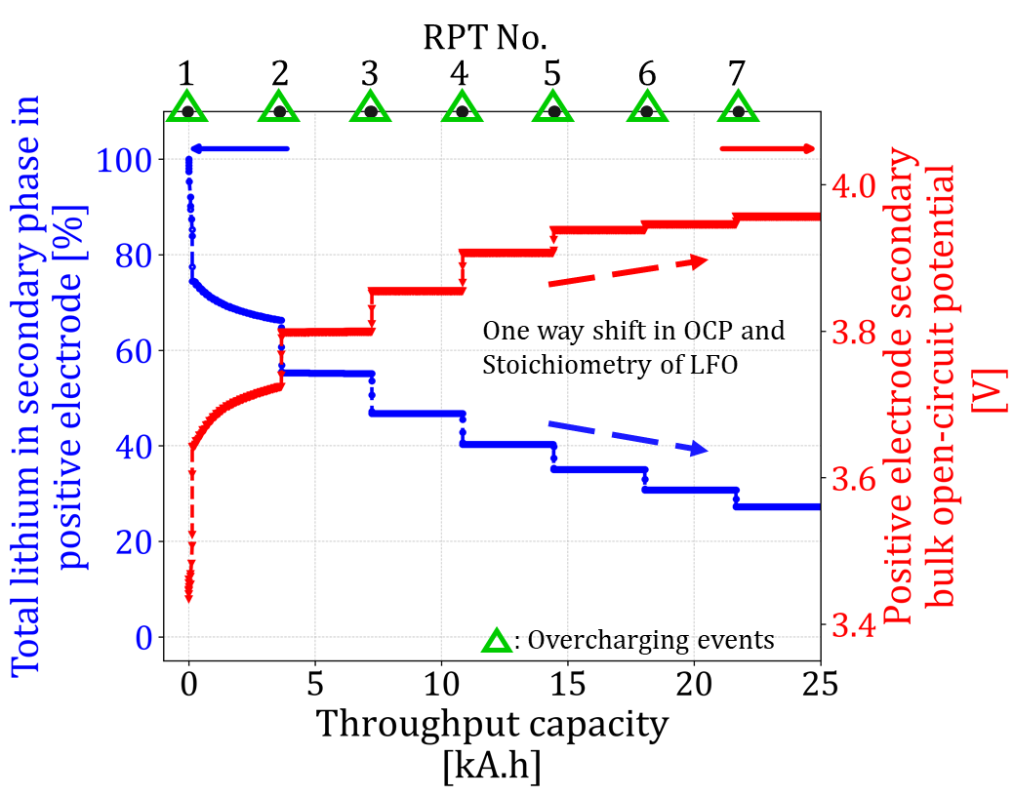
Model prediction shows how lithium release affects the bulk OCP of LFO. As lithium is released from LFO, the percentage of lithium moles in LFO (‘Total lithium in the secondary phase in positive electrode [%]’, blue line, left-hand side y-axis) drops with cycling, and that leads to increased bulk OCP (‘Positive electrode secondary bulk open-circuit potential [V]’, red line, right-hand side y-axis). The change in bulk OCP and percentage of lithium, i.e. stoichiometry of LFO is permanent and one-way; this is as expected from experiments (shown by Fig. 1). The above model result is for a cell with 4% LFO fraction, cycled as per the protocol defined for Case 1. The abrupt drop in lithium moles in LFO and the accompanying momentary spikes in its OCP of LFO are triggered by overcharging event performed before each reference performance test (RPT) in Case 1. For simplicity only first seven RPTs (175 aging cycles) are shown in this figure. For simplicity only the aging cycles (175 aging cycles) completed between the first seven reference performance tests (RPTs) are shown in this figure. The data points correspond to start of the discharge step in the aging cycles (refer virtual experiment, Fig. 9).

Fig. 3 and Fig. 4 show model predictions for a commercial cell with 4% LFO active material volume fraction (extra added LFO volume fraction as a percentage of LFP active material volume fraction, equation S11 in Supplementary Table 1), subjected to controlled lithium release via an overcharging event before each RPT, i.e., Case 1.
For simplicity, both figures display the performance during the first seven RPTs only (175 aging cycles), because nearly all LFO lithium is released in this timeframe. As discussed earlier, each mole of LFO releases 4 moles of lithium; therefore, an active volume fraction of 4% is assumed to release sufficient lithium to compensate for ~16% of LLI. This level of LLI is typically observed over the entire first life of a cell (~80% State-of-Health). Hence, 4% LFO, in principle, is sufficient to achieve zero degradation and was thus chosen in this study. This choice is also supported by announcements from CATL and Rimac, which hinted toward 4 to 5 % LFO content in their cells. Additionally, a low LFO fraction ensures that less oxygen is released, thereby avoiding oxygen-triggered degradation.
Fig. 3 shows that during the break-in cycle, first RPT and the first set of 25 normal charging-discharging aging cycles (before RPT 2), some lithium was released from the LFO (left-hand y-axis in Fig. 3), as each of these normal charges had an upper voltage cut-off of 3.6 V. This voltage exceeds the first plateau of LFO OCP of 3.5 V (equation 1), triggering irreversible lithium release from LFO, causing the stored lithium to drop from 100% to ~67%. The first overcharging event (just before RPT 2), with an upper voltage cut-off of 4.2 V, leads to a further release of ~12% lithium moles from LFO, decreasing the stored lithium percentage to ~55%. Overall, a significant amount of lithium was released (~45%) into the cell by the time the cell operation reached the end of the first overcharging event. For a cell with optimal balancing at the beginning of life, this release results in an already unbalanced cell. The consequence of this imbalance on cell degradation, its capacity, and life is explored in the next subsection (Fig. 4). The early and fast lithium release from LFO also increases its OCP significantly (right-hand y-axis in Fig. 3), with the LFO OCP rising to ~3.8 V by the end of the first overcharge. During the next 25 normal charging-discharging aging cycles, no further lithium release occurs (stored lithium in LFO lithium kept at 55%), as the upper cutoff voltage limit for normal charging remains capped at 3.6 V, which is insufficient to overcome LFO OCP of 3.8 V (flat lines between RPT 2 and RPT 3 in Fig. 3). The second overcharge event (just before RPT 3), with upper voltage cut-off of 4.2 V, exceeds the LFO OCP of 3.8V, triggering a further lithium release from LFO and dropping its storage percentage to ~47%. Note that only 8% of lithium is released in the second overcharging event (from 55% to 47%), compared to the 12% (from 67% to 55%), lithium release during the first event, and decreases significantly in the subsequent overcharging events. This indicates that, as LFO depletes its lithium inventory, further lithium release from the LFO becomes increasingly difficult. This is because the LFO OCP eventually reaches close to the cell’s upper voltage cutoff of 4.2 V, and then even higher overcharging cutoff voltage limits would be required to access the remaining lithium stored in the LFO.
Most previous academic research^{10,12} has explored the use of lithium inventory as a sacrificial agent, either in a one-off event¹⁰ (i.e., all lithium released during the first overcharge) or through the first few overcharges.¹² With the aim of explaining how LFO additives may be used optimally, we study a more controlled and gradual lithium release, the benefits of which are explained in the following subsections

Consequences of Lithium release from LFO on SEI growth, lithium plating, and cell usable capacity
When lithium is released from LFO, it can have both a positive and a negative impact on cell performance. In Case 1, the lithium is released fast and early, at a rate faster than lithium consumed by the side reactions. This disturbs the cell balancing as the electrodes are forced to host the extra unconsumed lithium inventory, leading to the over-lithiation of NE and primary phase in PE (i.e., LFP), as shown in Fig. 4(a) and Fig. 4(e). This causes the average OCP (particle surface OCP) of the NE to shift to lower potentials at the end of the charge, pushing it closer to zero (Fig. 4(b)) and increasing the reaction overpotentials (Fig. 4(c)). This accelerates the side reactions for SEI layer growth^{1525,25} and dead lithium plating,^{15,26} leading to faster degradation and faster loss of lithium inventory. Therefore, if lithium from the LFO is released too fast, it accelerates the precise problem it is there to mitigate. However, it is not all bad; the amount of lithium lost due to the accelerated side reactions does take time to equal the amount released and leads to a temporary higher discharge capacities (usable as well as cyclable lithium discharge capacity) their BoL values. As shown in Fig. 4(d) at around 25 kAh throughput, ~0.15 moles have been consumed by side reactions, whilst ~0.4 moles were released from the LFO, the remaining 0.25 lithium moles are responsible for increased usable discharge capacity than its BoL value (Fig. 4(f)).
Fig. 4: Lithium release from LFO and its impact on cell performance
(a)  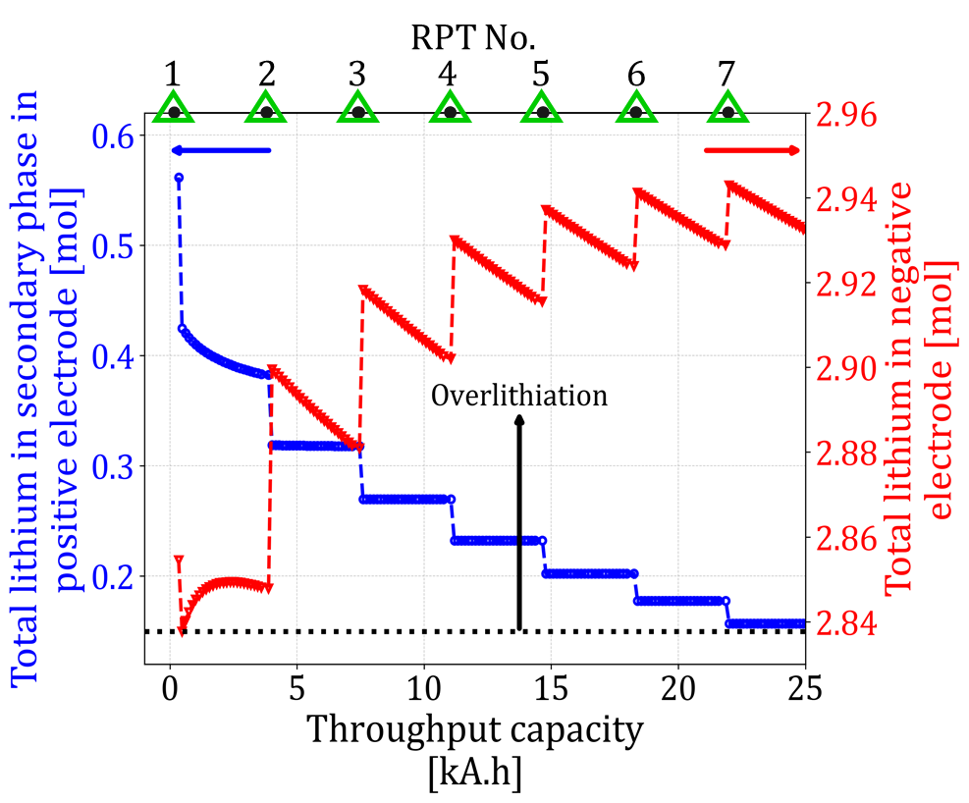 | (b)  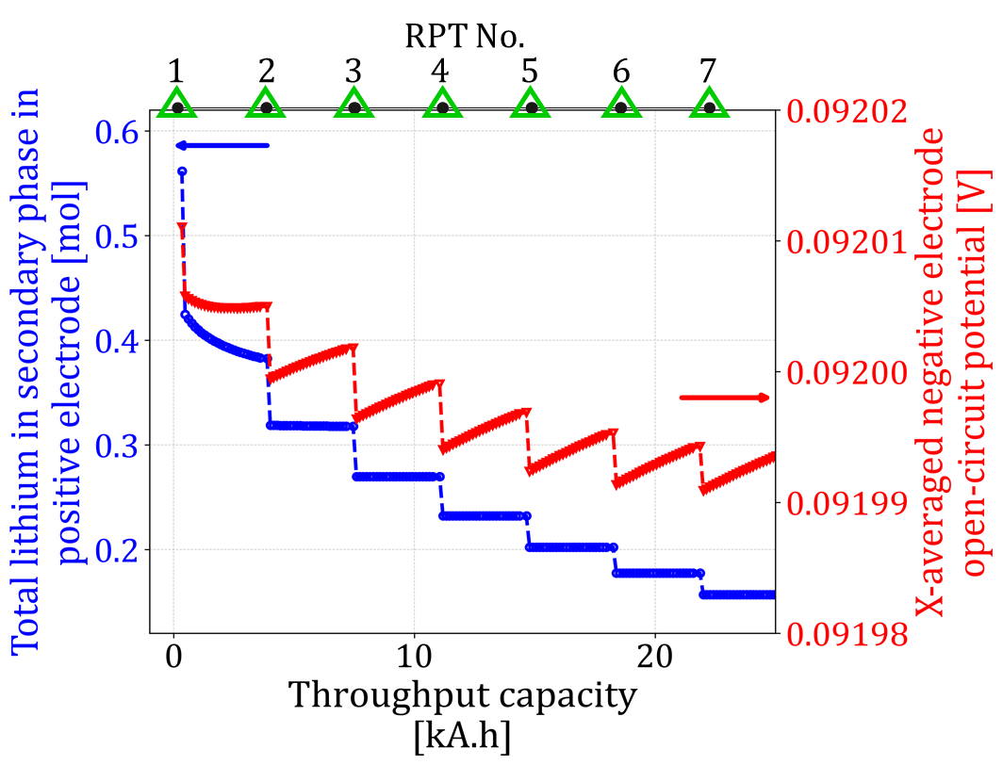
(c)  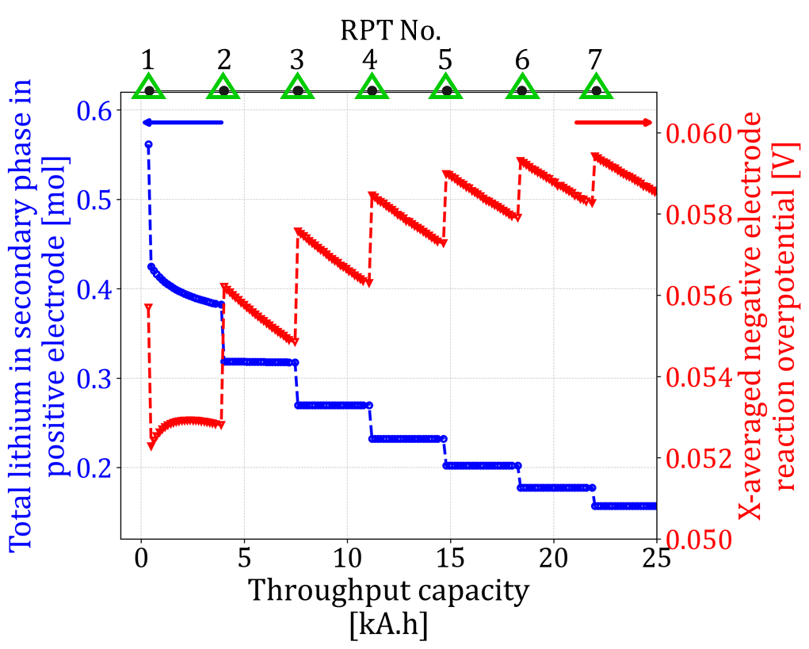 | (d)  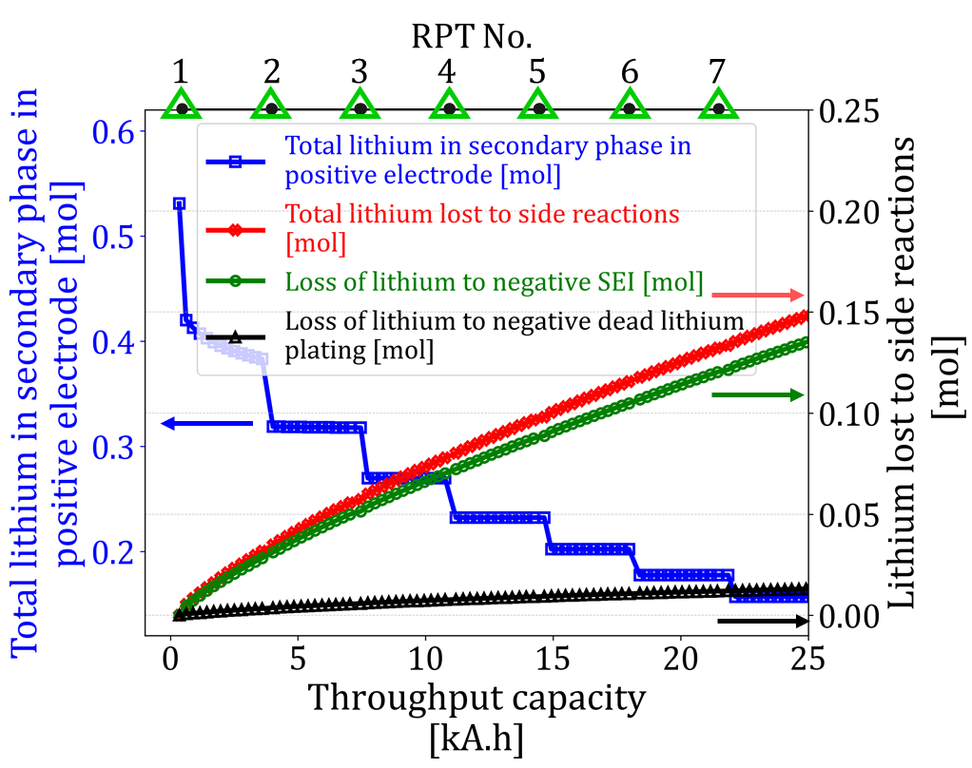
(e)  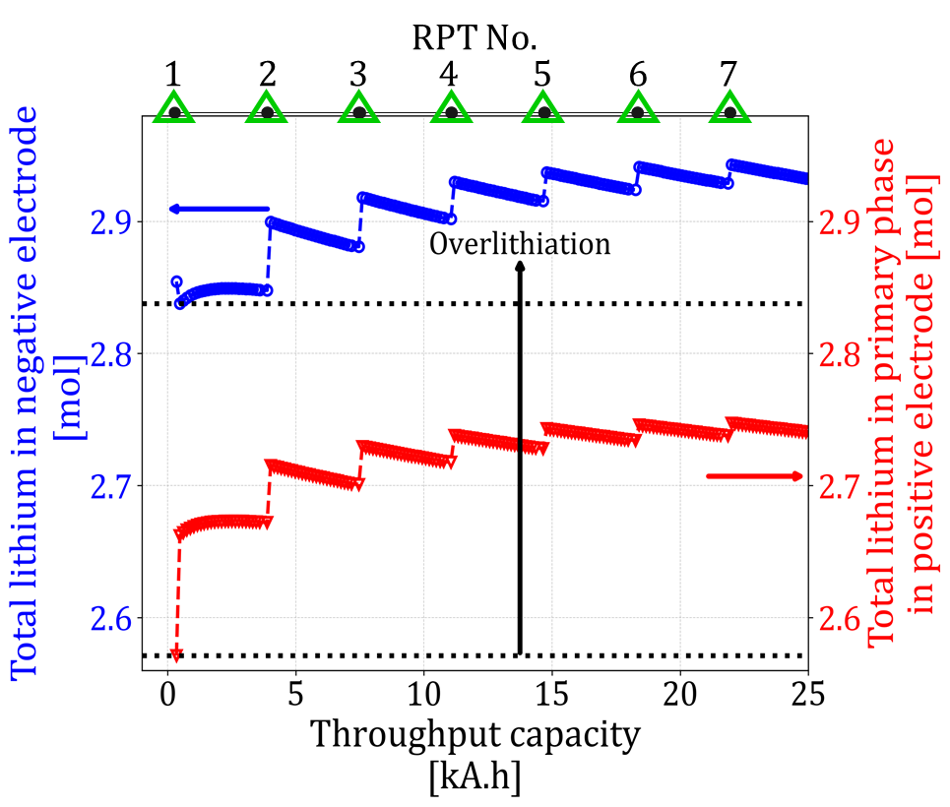 | (f)  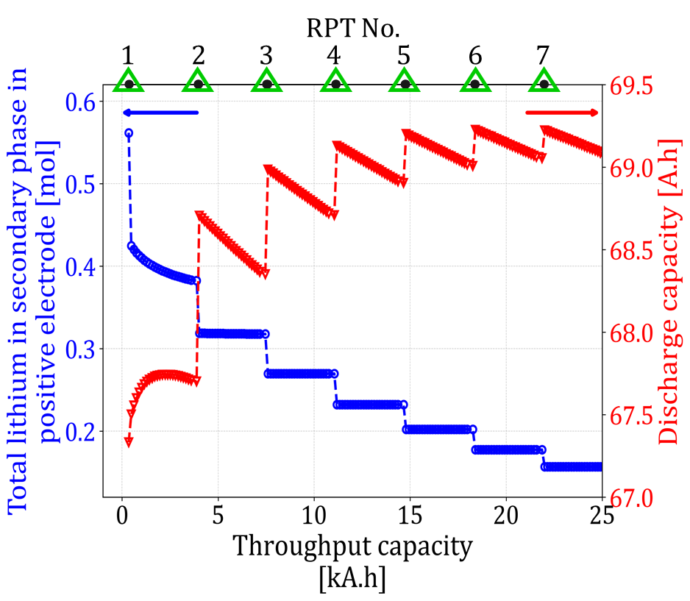
- ‘Total lithium in the secondary phase in positive electrode [mol]’(blue line, left-hand side y-axis), and ‘Total lithium in negative electrode [mol]’(red line, right-hand side y-axis) vs ‘Throughput capacity [kA.h]’. Dashed horizontal black line marks the balanced negative electrode at the beginning-of-life (BoL)
- ‘Total lithium in the secondary phase in positive electrode [mol]’ (blue line, left-hand side y-axis), and ‘X-averaged negative electrode open-circuit potential [V]’(red line, right-hand side y-axis) vs ‘Throughput capacity [kA.h]’
- ‘Total lithium in the secondary phase in positive electrode [mol]’ (blue line, left-hand side y-axis), and ‘X-averaged negative electrode reaction overpotential [V]’(red line, right-hand side y-axis) vs ‘Throughput capacity [kA.h]’
- ‘Total lithium in the secondary phase in positive electrode [mol]’(blue line, left-hand side y-axis), ‘Total lithium lost to side reactions [mol]’(red line, right-hand side y-axis), ‘Loss of lithium to negative SEI [mol]' (green line, right-hand side y-axis) and 'Loss of lithium to negative dead lithium plating [mol]' (black line, right-hand side y-axis) vs ‘Throughput capacity [kA.h]’
- ‘Total lithium in negative electrode [mol]’(blue line, left-hand side y-axis), and ‘Total lithium in primary phase in positive electrode [mol]’(red line, right-hand side y-axis) vs ‘Throughput capacity [kA.h]’. Dashed horizontal black line marks the balanced negative electrode and primary positive electrode at the beginning-of-life (BoL)
- ‘Total lithium in the secondary phase in positive electrode [mol]’(blue line, left-hand side y-axis), and ‘Discharge capacity [Ah]’(red line, right-hand side y-axis) vs ‘Throughput capacity [kA.h]’. For simplicity, plot only shows the variation in the usable discharge capacity of the cell. The discharge capacities obtained from the discharge step in aging cycles are referred to as usable discharge capacities. The discharge capacities obtained from discharge reference performance tests (RPTs) is referred to as cyclable lithium discharge capacities. Though not shown in this plot, cyclable lithium discharge capacities are usually higher than the usable discharge capacities as RPTs are done at lower c-rates than aging cycles.
In all the above plots except in Fig. 4(e), the ‘Total lithium in the secondary phase in positive electrode [mol]’ (i.e. total lithium moles in LFO ) is shown on the left-hand y-axis (blue line). The above model results are for a cell with 4% LFO fraction, cycled as per the protocol defined for Case 1. The abrupt drop in total lithium moles in LFO and the accompanying abrupt changes in the values of variables on-right hand side y-axis are triggered by overcharge event performed before each reference performance test (RPT) in Case 1. In Fig. 4(e) both the spikes i.e. spike in the value of the variable plotted on left-hand side y-axis and the variable plotted on right-hand side y-axis corresponds to the overcharge event discussed above. For simplicity only the aging cycles (175 aging cycles) completed between the first seven reference performance tests (RPTs) are shown in these figures. The data points correspond to start of the discharge step (i.e. end of charge step) in the aging cycles (refer virtual experiment, Fig. 9).

From the above analysis, it is clear that releasing too much lithium, although temporarily beneficial in proving a boost to the cell discharge capacity, eventually leads to accelerated side reactions (SEI and dead lithium plating) and therefore potentially reduced cell lifetime. In the next sections, we show that the key to achieving longer lifetimes lies in the careful control of the lithium (and thus oxygen) release from LFO. The best control method may be the one that either delays the lithium release and avoids overlithiation from the start or the one which matches the lithium release rate from LFO with the lithium lost to side reactions, without unbalancing the cell and accelerating the side reactions. This is explored in the next subsection.

Lithium release control methods and their effect on cell performance
With the help of Case 1, we showed how fast and early lithium release from LFO can impact cell performance. We now investigate four additional patterns/cases (Case 2 to Case 5) of lithium release in a cell with 4% LFO content and their impact on its performance. The cell performance was compared by studying how the discharge capacity and cell degradation indicators, such as loss of lithium inventory, SEI, lithium plating, and NE porosity, evolve with cell capacity throughput. For simplicity, only figures related to the comparison of Case 1, Case 4, and Case 5 are shown here; the figures for the comparison of Case 1 with Case 2 and Case 3 and all five Cases can be found in the Supplementary Information document (see Supplementary Fig. 1 and Fig. 2).
As for Case 1, Case 2 to Case 4, show that whenever the overcharge events occur, the release of lithium from LFO happens rapidly (Fig. 5(a)), leading to increased cyclable lithium discharge capacity (Fig. 5(b)), as well as increased total lithium loss to the side reactions (increased SEI growth and dead lithium plating) (Fig. 5(c) to 5(e)). The formation of SEI and plating clogs the porosity of the negative electrode in the model, leading to its decreasing trend in Fig. 5(f). Case 1 offers higher discharge capacities because of early and fast/frequent lithium release, but significantly accelerates cell degradation and negative electrode pore clogging. Case 2 delays the lithium release, and hence can provide higher discharge capacities later in the cell life. Case 3, due to just four overcharge events, preserves most of the available lithium inventory from LFO, resulting in relatively slower cell degradation, but also lower discharge capacity. In this latter case, the cell remains balanced due to less lithium released from LFO. Case 4 offers a better trade-off between degradation rates and discharge capacities, due to the periodic nature of its lithium release. Periodic delays in lithium release provide enough time for side reactions to consume extra lithium from LFO. This helps in maintaining the cell closer to its balanced state, despite the short imbalance caused every time an overcharge event triggers the fresh lithium release from LFO. As a result of insights gained from Case 1 - 4, Case 5 was designed, in which the cell is overcharged until the cell charge (coulomb counted charging) exactly matches its BoL cyclable lithium discharge capacity value (first RPT cycle discharge capacity), or the charging voltage reaches the maximum cutoff value of 4.2 V, whichever is earlier. This contrasts with the other Cases, in which every overcharge event has a charge voltage cutoff limit of 4.2 V. Case 5 ensures that the released lithium moles from LFO is close to equal and, most importantly, do not overly compensate the lithium lost to the side reactions since the last overcharge/RPT. This more balanced and gradual release of lithium moles from LFO (Fig. 5(a)) results in close to constant cyclable lithium discharge capacity (Fig. 5(b)), moderate degradation rates, and reduced pore clogging (Fig. 5(d) to 5(f)). For all those Cases when lithium moles from LFO get depleted and/or are not enough to compensate for lithium loss due to side reactions, the sudden drop in discharge capacity is observed. This is because of the shift from overcharging/coulomb counted charging to normal charging, where the charging is capped to the voltage cutoff limit of 3.6 V.
The maximum charging voltage during the controlled lithium release events in Case 5 is variable, as the charging is controlled by fixed capacity, i.e., until the cell’s charging capacity equals its BoL cyclable lithium discharge capacity. As a result, the average LFO OCP (particle surface OCP) increases gradually with cycling (Supplementary Fig. 3). Since the cell in this case operates below 4.2 V LFO OCP for most of the lithium release events, it is expected that the associated oxygen release would be gradual, potentially allowing cathode coating agents to effectively scavenge it. In real applications, charges are often done with a CV hold, if all five cases were to include one, Case 5 is expected to perform even better than Case 1 and Case 4 because of its lower operational LFO OCP. This is because holding the cell at high charging voltages (or high LFO OCP) is expected to accelerate oxygen evolution. For this reason, Case 1 and Case 4 would need careful consideration if implemented in real systems, while Case 5 has the most potential for real application.
These findings indicate that details of the exact control method adopted for lithium and oxygen release can significantly alter the performance of an LFO-enriched cell. Hence, based on the targeted operating conditions and cell performance requirements, LFO-aware control algorithms must be designed and implemented to tailor the timing and rate of lithium release.

Fig. 5: Comparison of cell performance for Case 1, Case 4, and Case 5 at 4 % LFO fraction

(a)  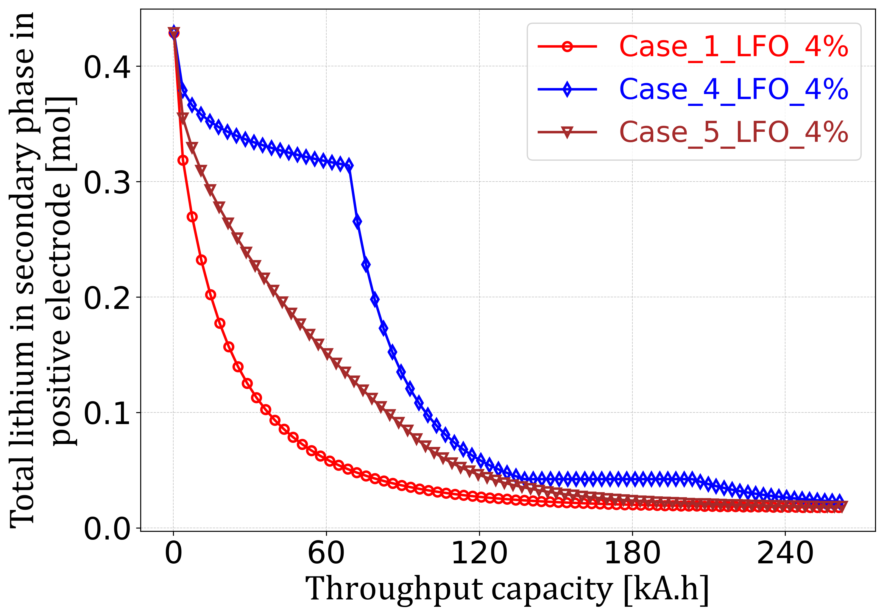 | (b)  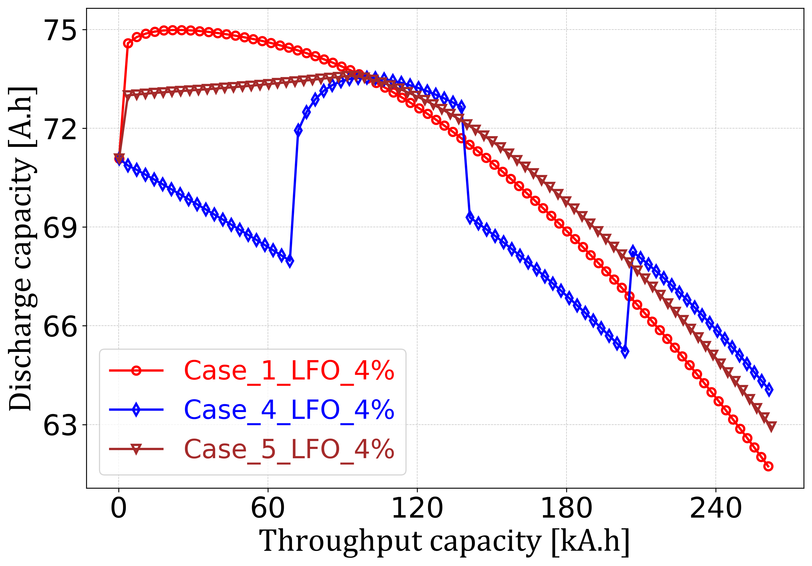
(c)  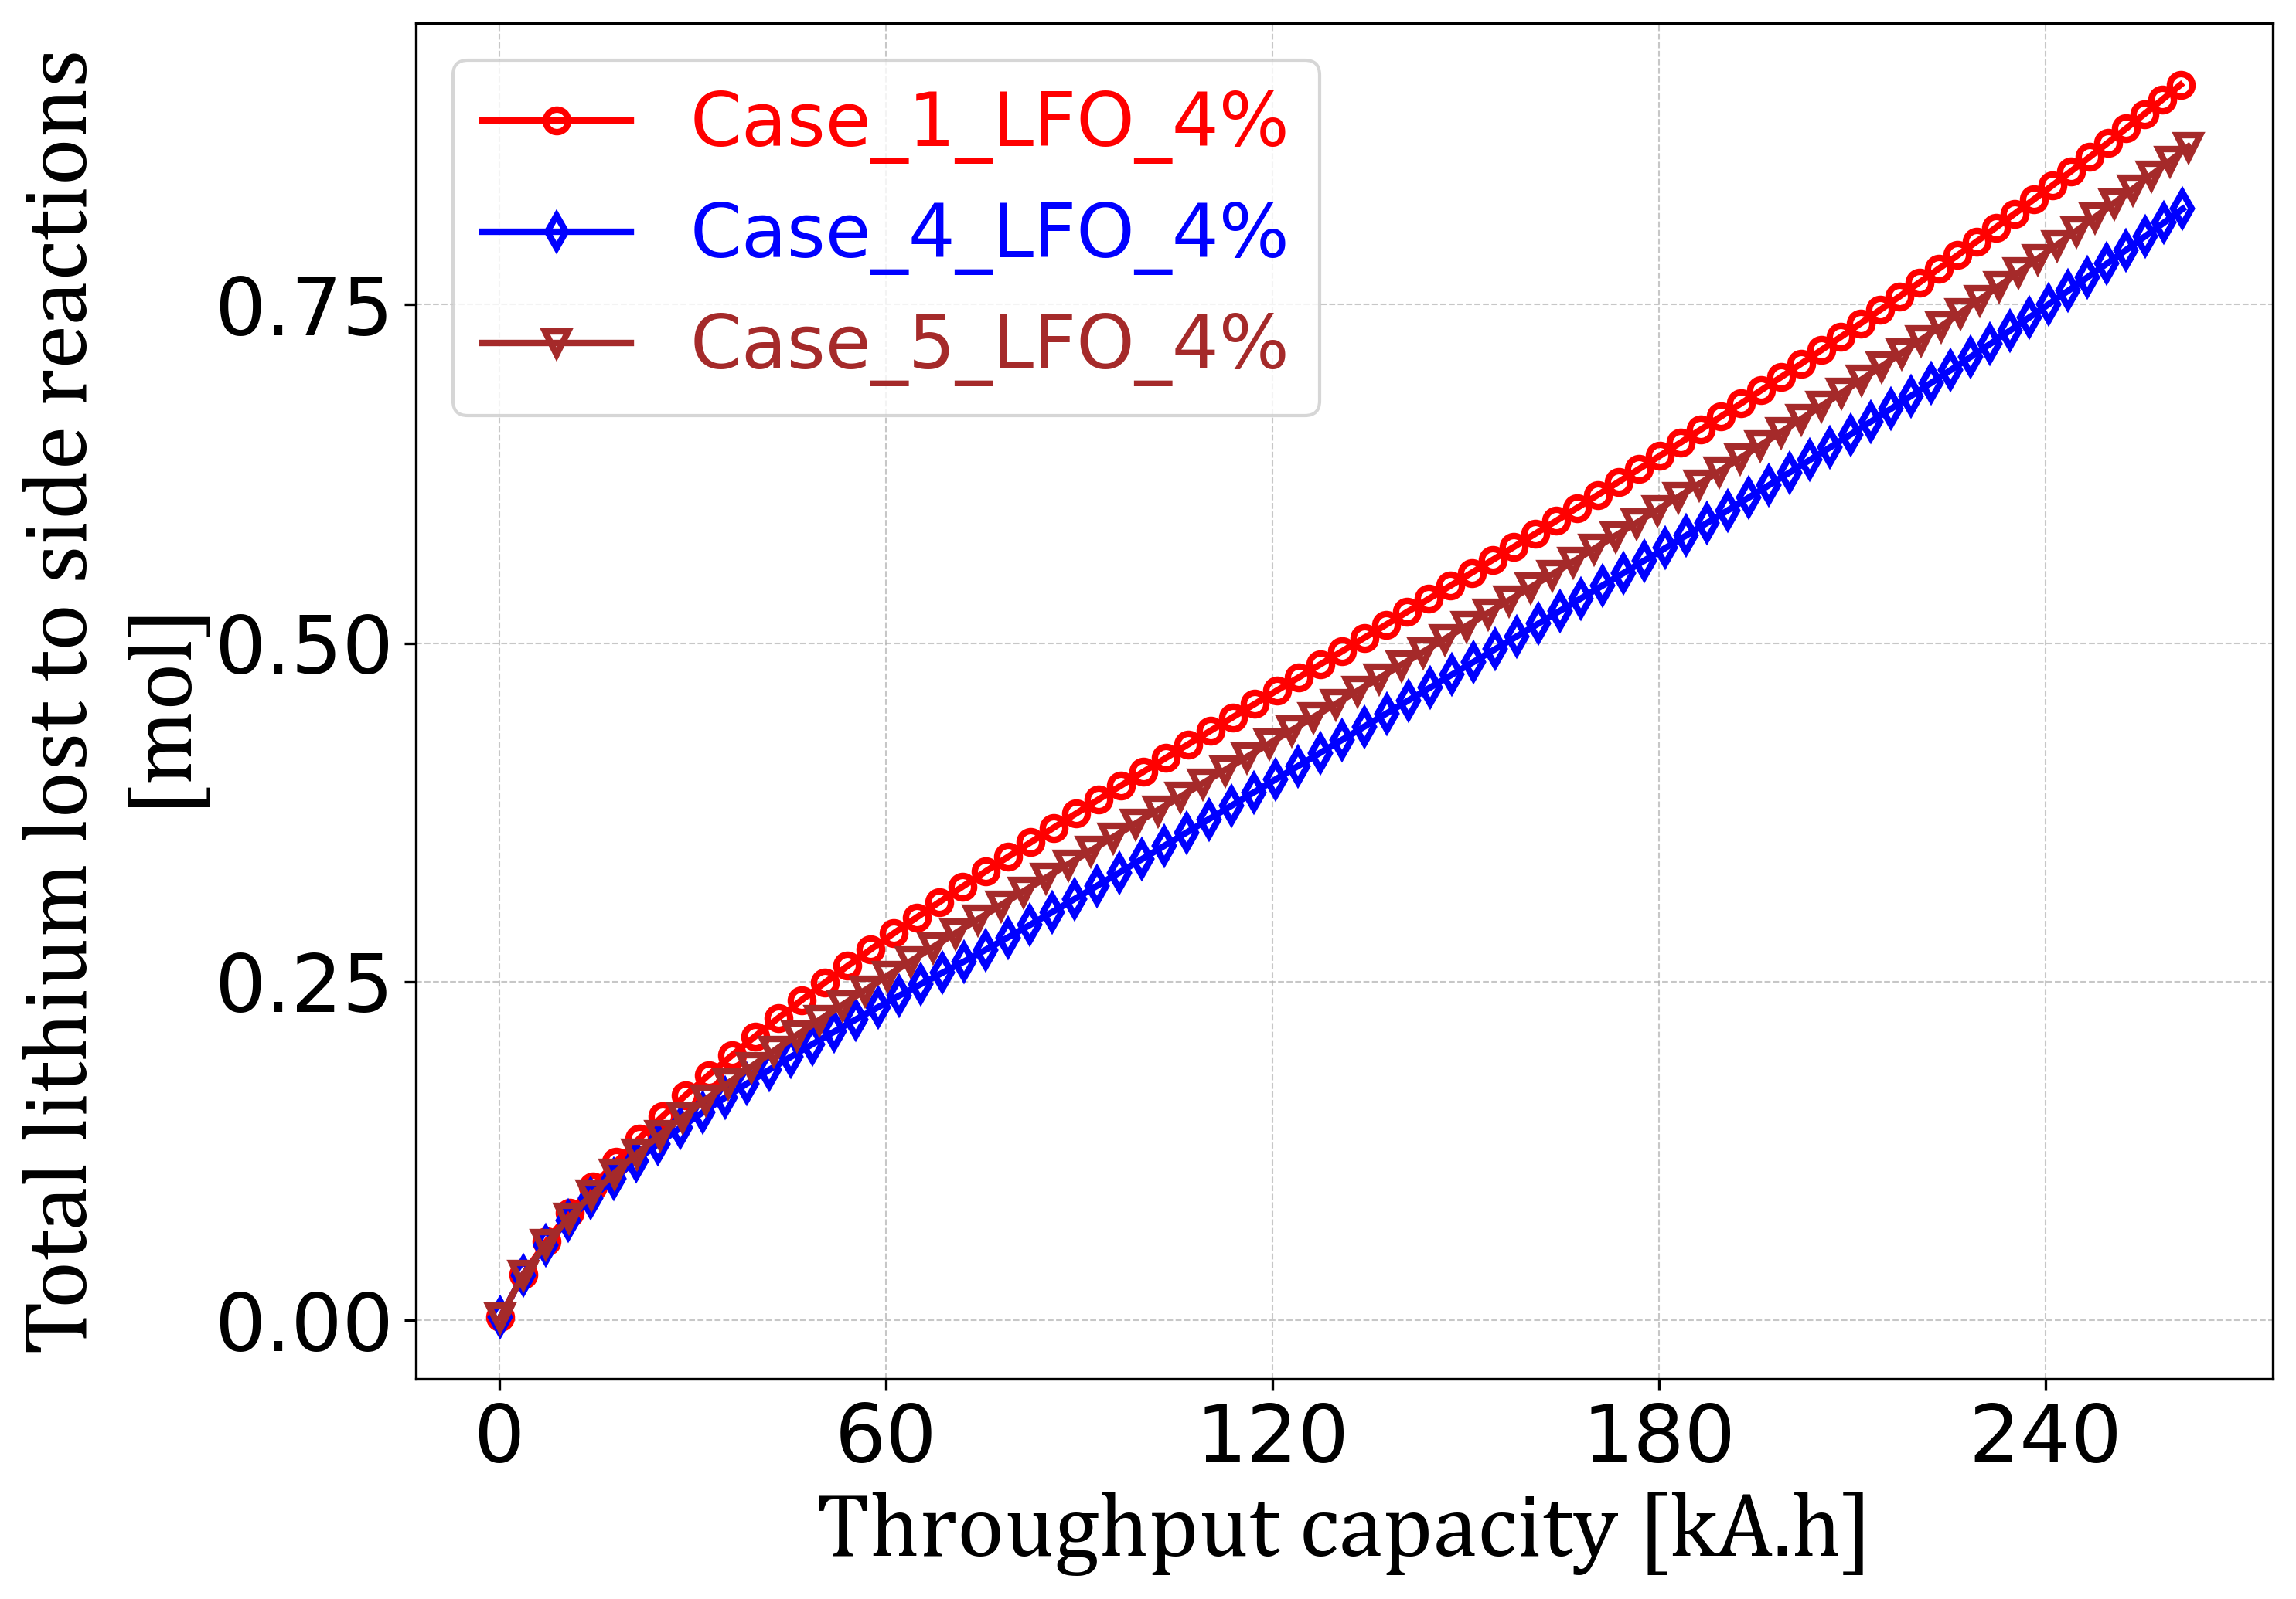 | (d)  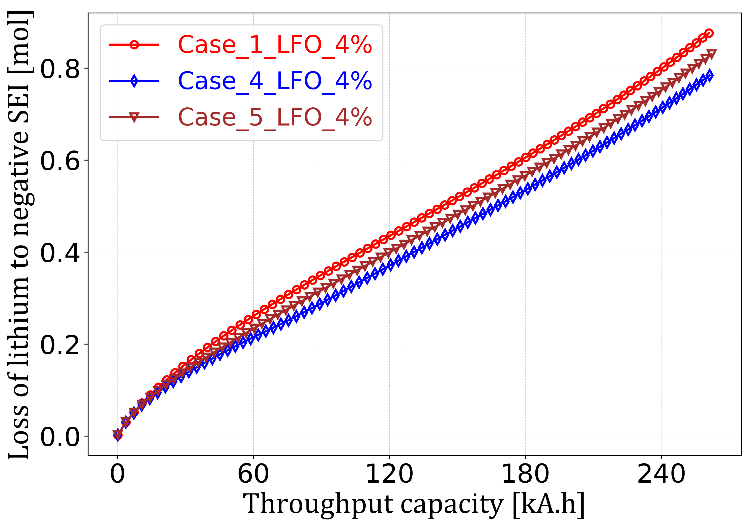
(e)  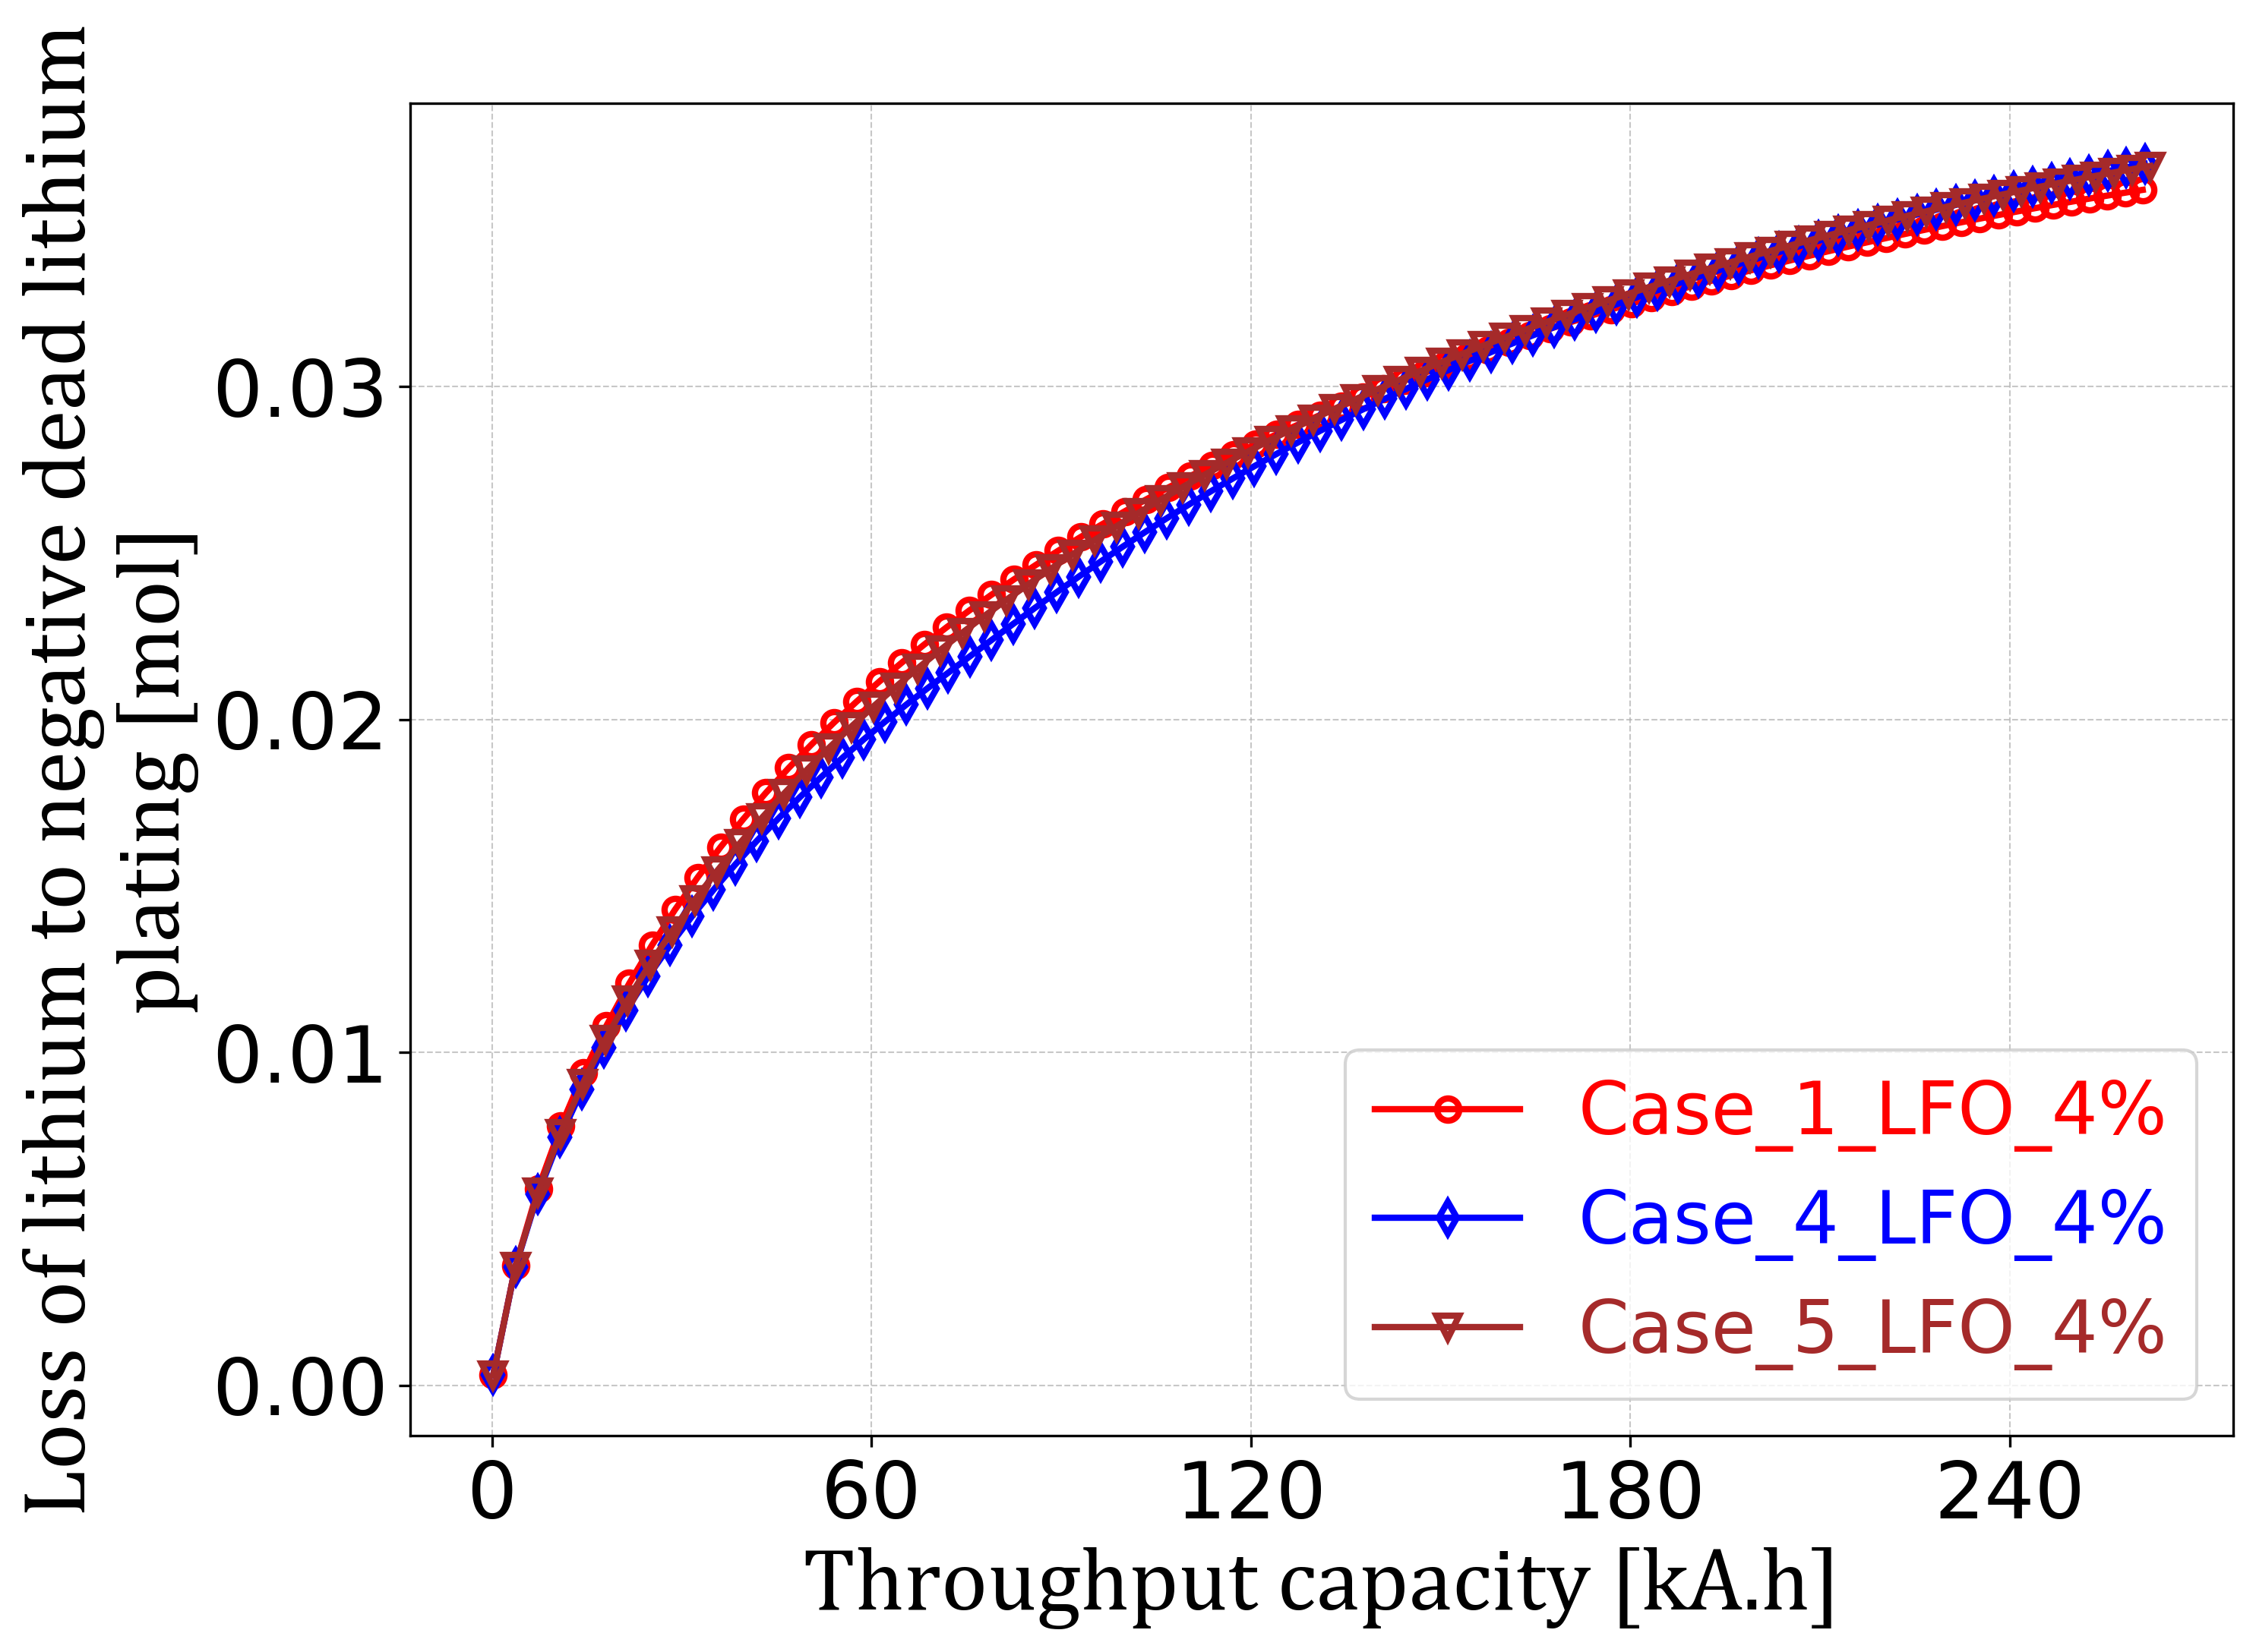 | (f)  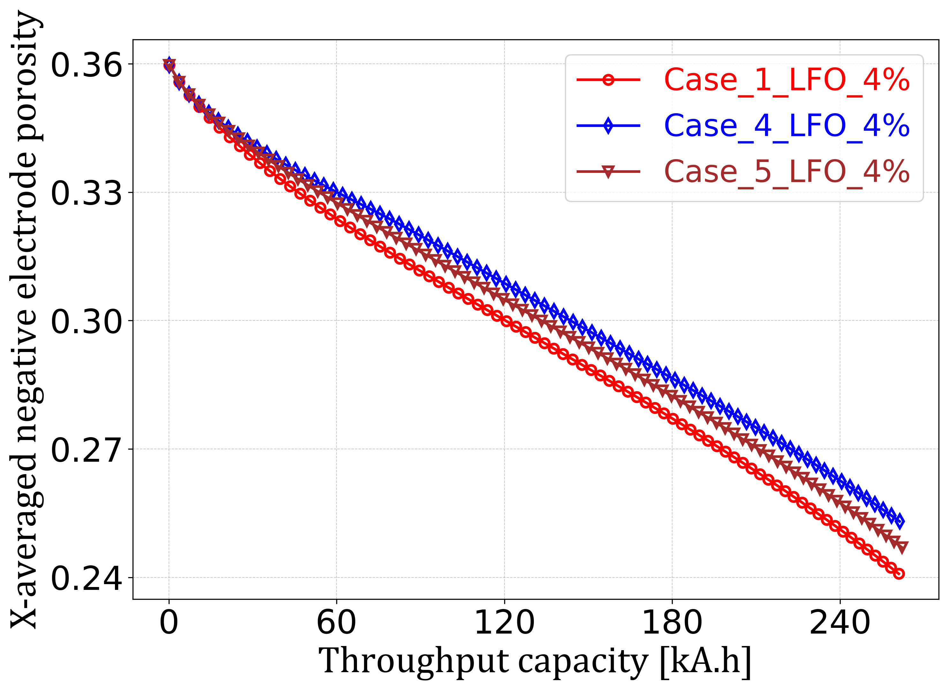
(a) Lithium release from secondary phase i.e. LFO, (b) cyclable lithium discharge capacity (RPT cycles discharge capacity), (c) total lithium lost to side reactions, (d) lithium lost to negative electrode SEI, (e) lithium lost to negative electrode dead lithium plating, and (f) the average negative electrode porosity (spatially averaged in the x-direction) in LFP-LFO composite cell; for Case 1 (red line, circle markers), Case 4 (blue line, diamond markers), and Case 5 (brown line, triangle markers).

Effect of LFO volume fraction on cell performance
In the previous section, Case 5 is shown to have relatively better performance and most potential in real applications compared to other cases at a 4% LFO fraction. Therefore, we now choose Case 5 to explore the effect of 0.1%, 1% and 10% LFO volume fractions on cell performance and compare it with the previously discussed case of 4% LFO. The case of 0.1% LFO is intentionally chosen as the cell behaviour in this case would be the close representation of the pure LFP-Gr cell.
For the 0.1% and 1% LFO, the initial available lithium inventory is low (Fig. 6(a)), and as the cell degrades, the lithium from LFO becomes depleted early and hence the added benefit is short-lived. For 0.1% LFO, all the lithium in LFO is depleted at around 90 k.Ah (Fig. 6(b)) throughput capacity and hence the sudden drop in capacity is observed. For both the fractions, the total degradation rate due to side reactions (SEI and dead lithium plating) and NE porosity clogging is comparatively lower than for the 4% and 10% LFO fraction (Fig. 6(c) and 6(d)). Because of the relatively small amount of lithium added by the LFO, the cell balancing remained relatively stable.

Fig. 6: Comparison of cell performance for Case 5 at 1%, 4 %, and 5% LFO fraction

(a)  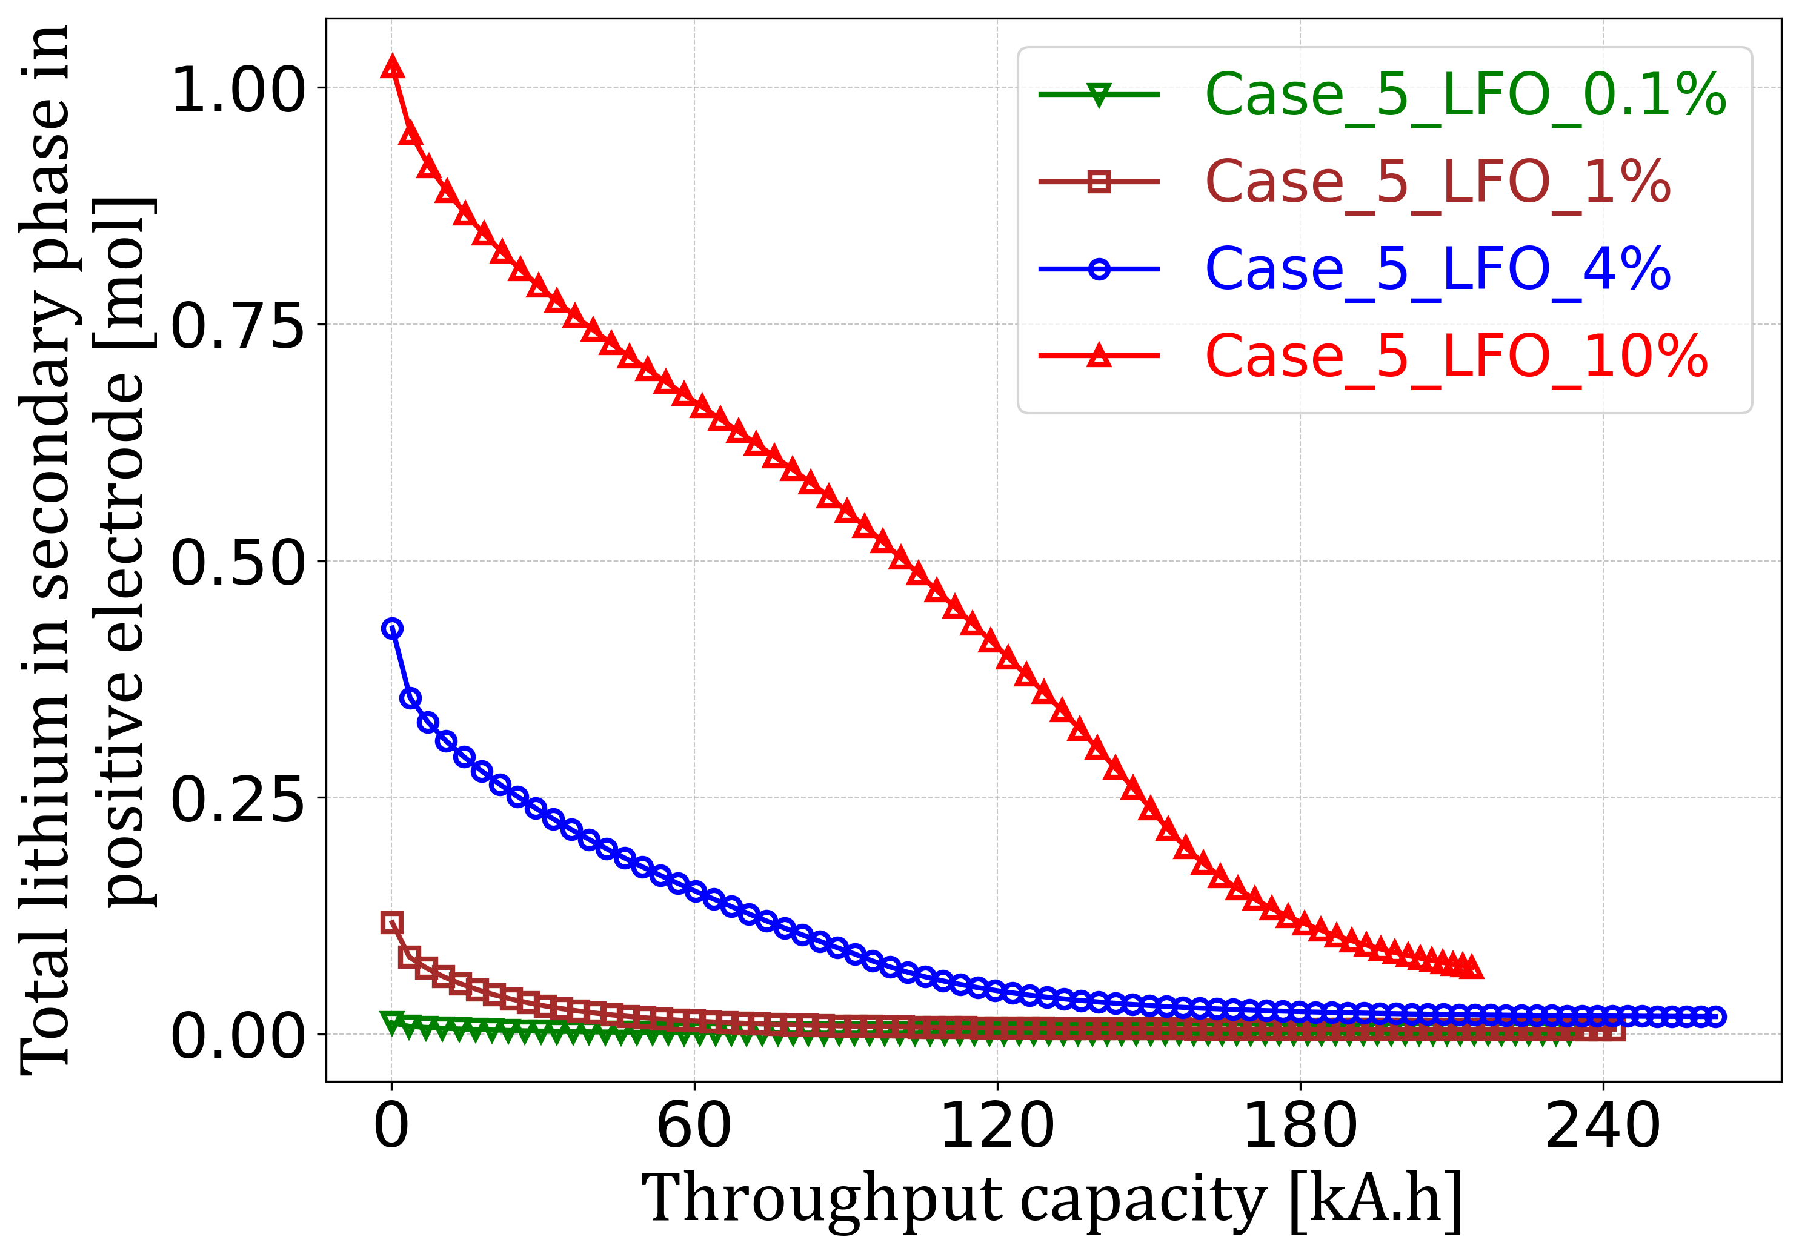 | (b)  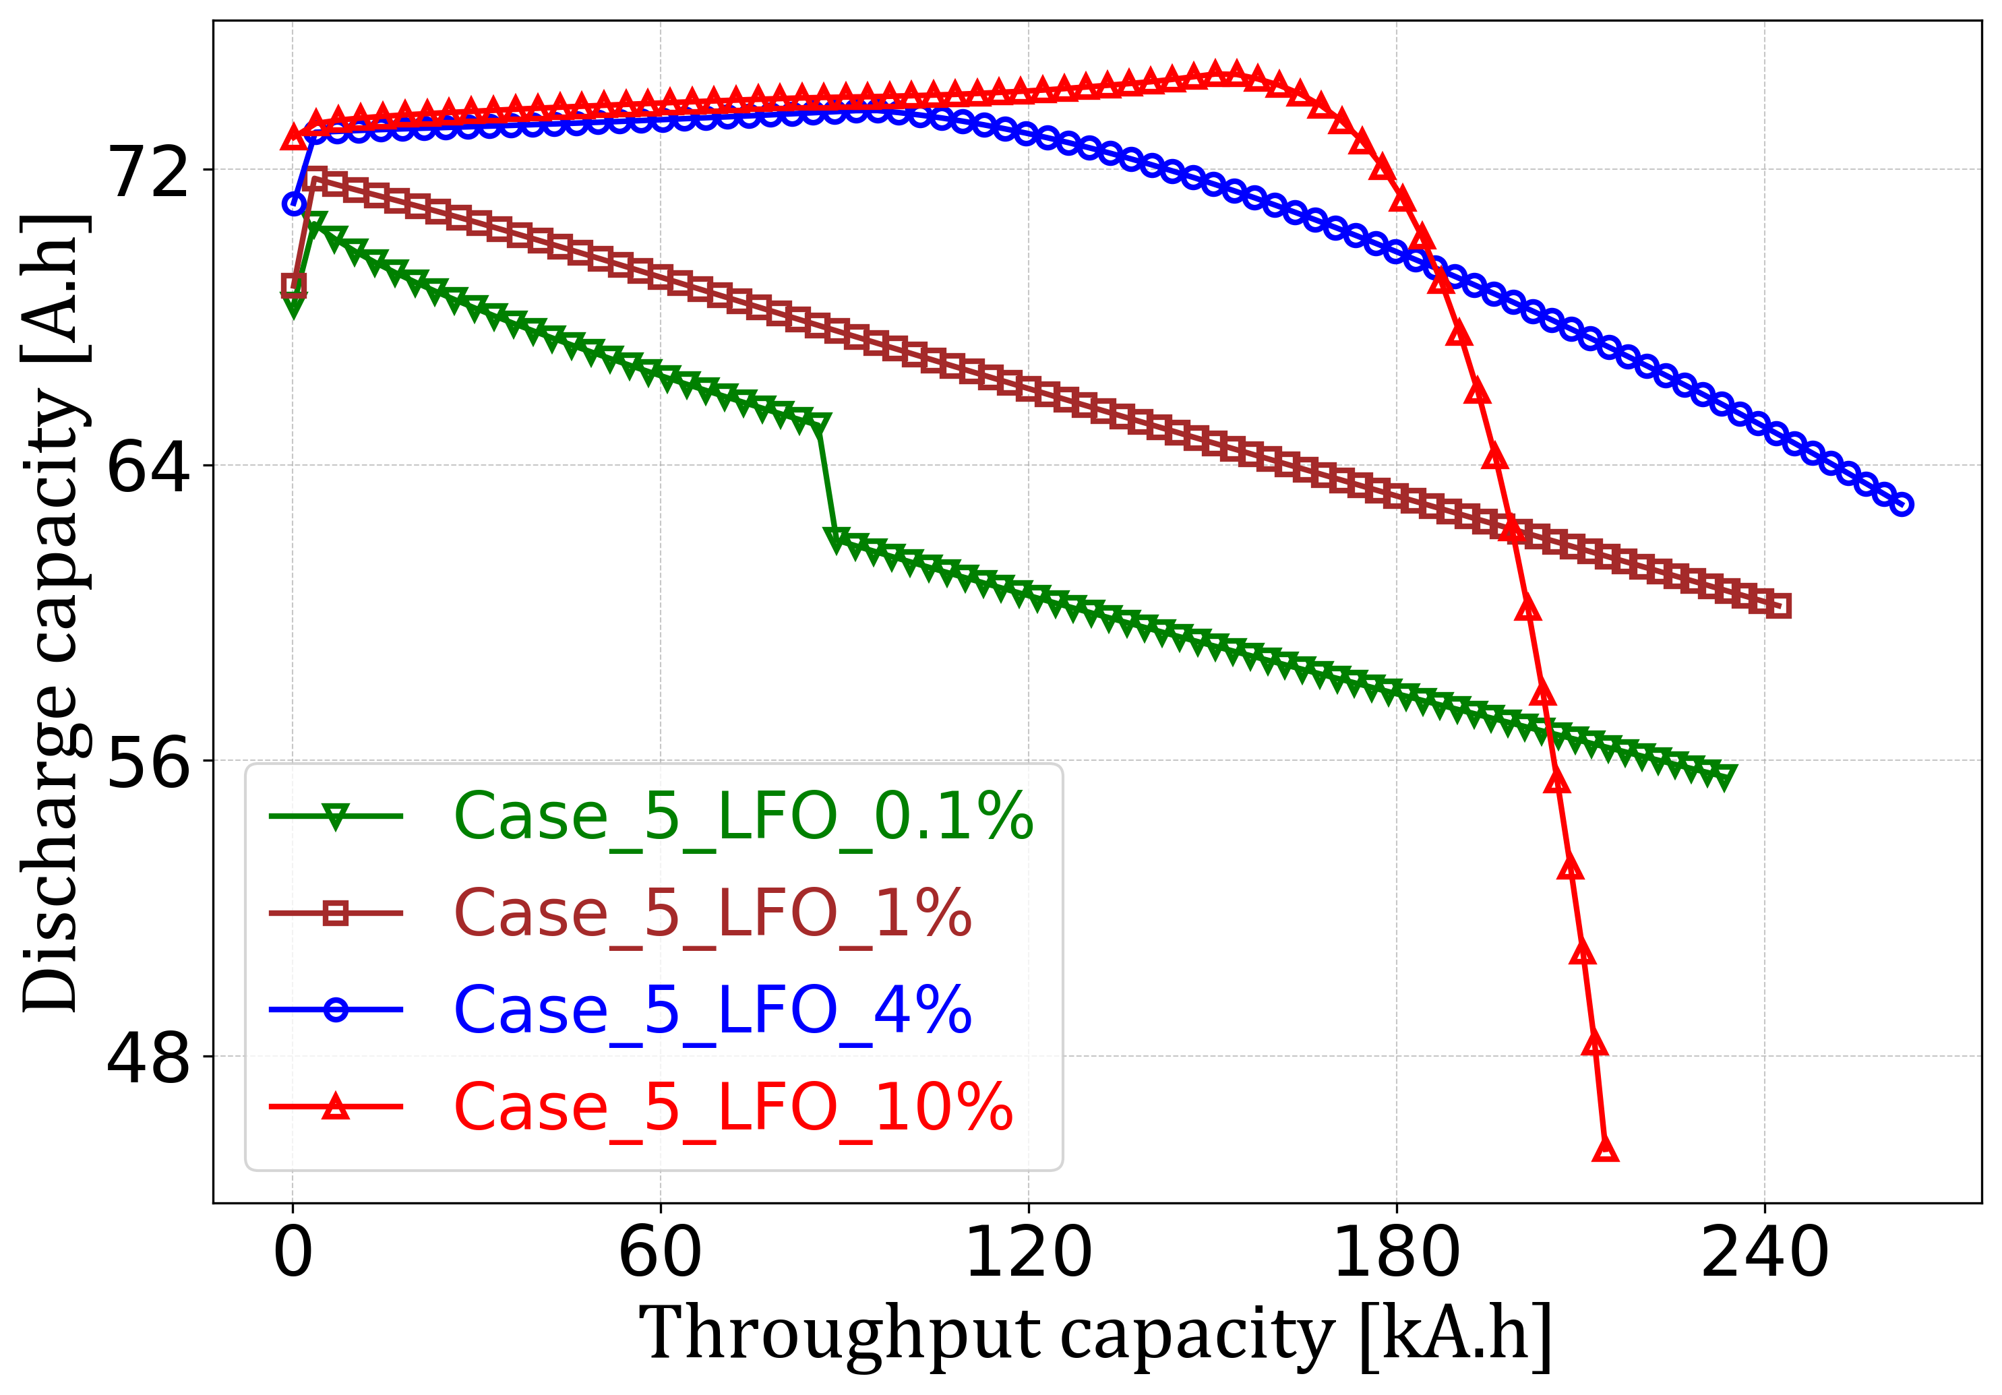
(c)  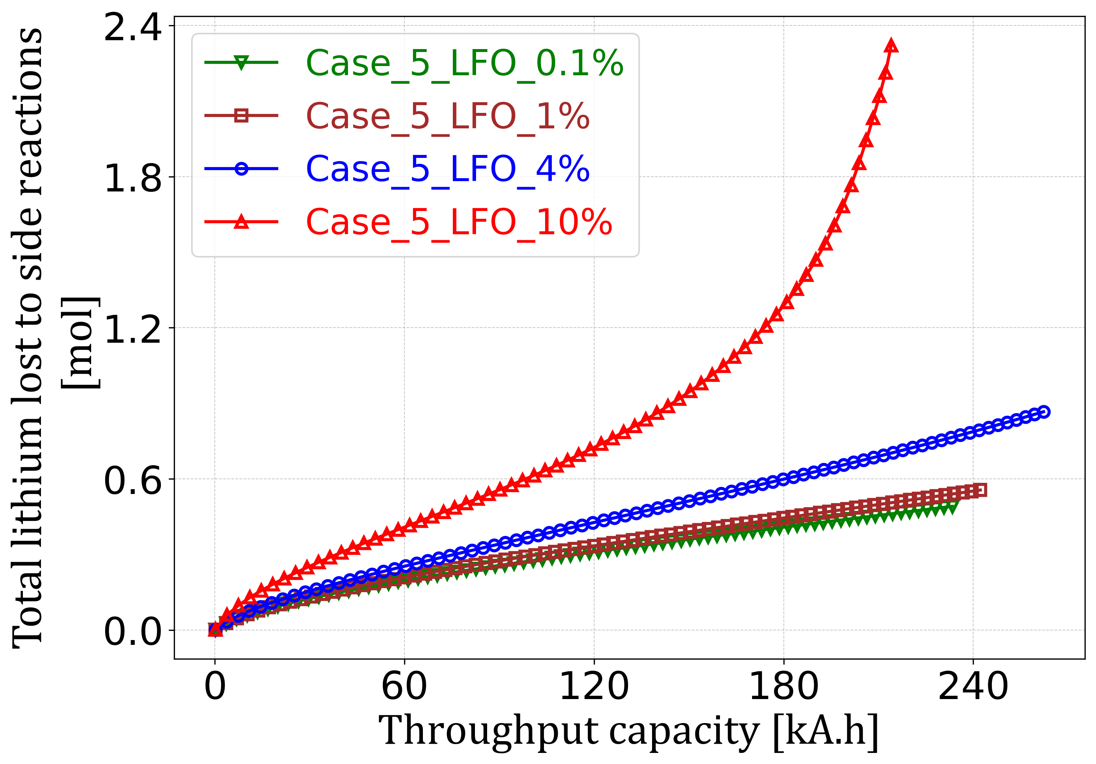 | (d)  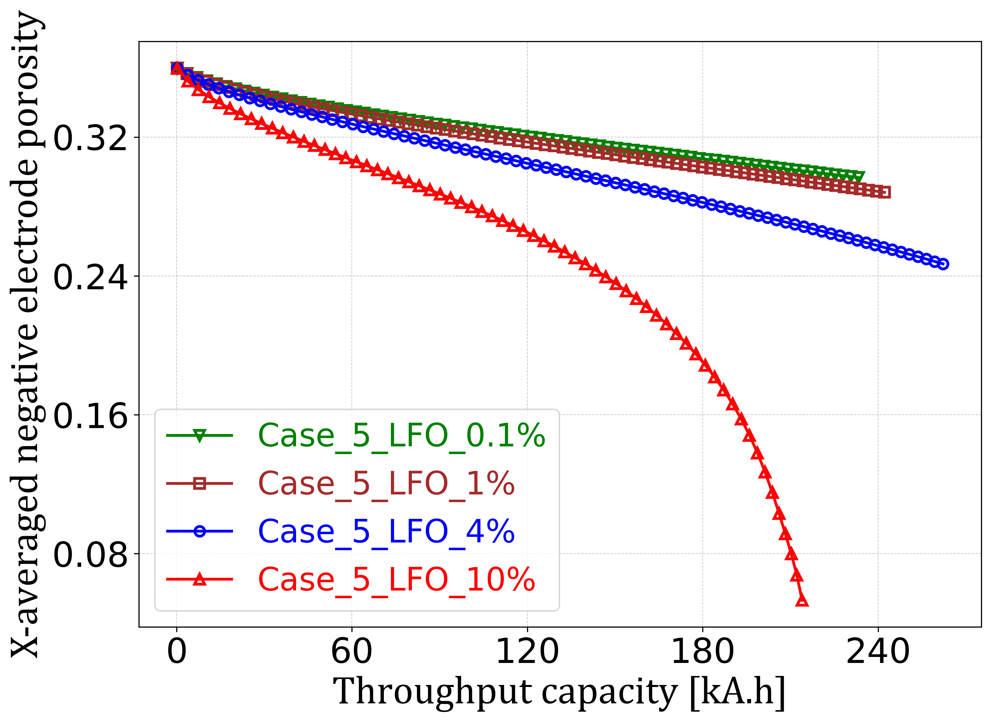
(a) Lithium release from secondary phase, i.e., LFO, (b) cyclable lithium discharge capacity (RPT cycles discharge capacity), (c) total lithium lost to side reaction (SEI + Dead lithium plating), and (d) the average negative electrode porosity (spatially averaged in the x-direction) in LFP-LFO composite cell; for 1% LFO (brown line with square markers), 4% LFO (blue line with circle markers), and 10% LFO (red line with triangle markers).
The 10% LFO cell contains significantly more lithium inventory to begin with, leading to cyclable lithium discharge capacity that is considerably higher (Fig. 6(a) and 6(b)) than 0.1%, 1% and 4% LFO cells. This benefit, however, is temporary; a steep drop in the discharge capacity is observed later in cell life (Fig. 6(b)). Also, excessive availability of lithium inventory from LFO for longer periods keeps the cell in a highly unbalanced state (highly overlithiated NE) for longer, leading to accelerated side reactions (Fig. 6(c)) and NE porosity clogging (Fig. 6(d)). This leads to cell failure when NE gets clogged completely (zero porosity). The effect of 10% LFO fraction on cell performance for all five cases can be found in the Supplementary Information document (see Supplementary Figs. 4 and 5).
These findings reveal a clear trade-off between discharge capacity and long-term cell performance for a chosen LFO fraction. Additionally, a higher fraction of LFO would also lead to excess oxygen evolution, whose effect on degradation cannot be ignored. Hence, one must carefully choose the optimal volume fraction of LFO by looking at the desired cell performance over time.

Redesigning the cell to avoid cell unbalancing due to NE overlithiation
The model results in the previous sections revealed that, when the cell is perfectly balanced for BoL, even with moderate LFO content (e.g., 4% LFO), the lithium release from LFO overlithiates the electrodes, creating an unbalanced cell and accelerating degradation. We explored some of the possible control methods to manage cell overlithiation and degradation, but even the best control could not erase the negative effect of lithium release on cell balancing. For this reason, we conclude that a cell with LFO additive must be balanced to accommodate the extra lithium to be released from LFO during controlled lithium release events, rather than for BoL performance. Here we propose a way to achieve such balancing by redesigning our composite LFP-LFO PyBaMM cell using a higher capacity NE.

Fig. 7: Comparison of cell performance when starting with perfect balancing (NP ratio of 1.1) vs starting with an imbalanced cell (NP ratio of 1.25) for Case 1 at 4% LFO fraction

(a)  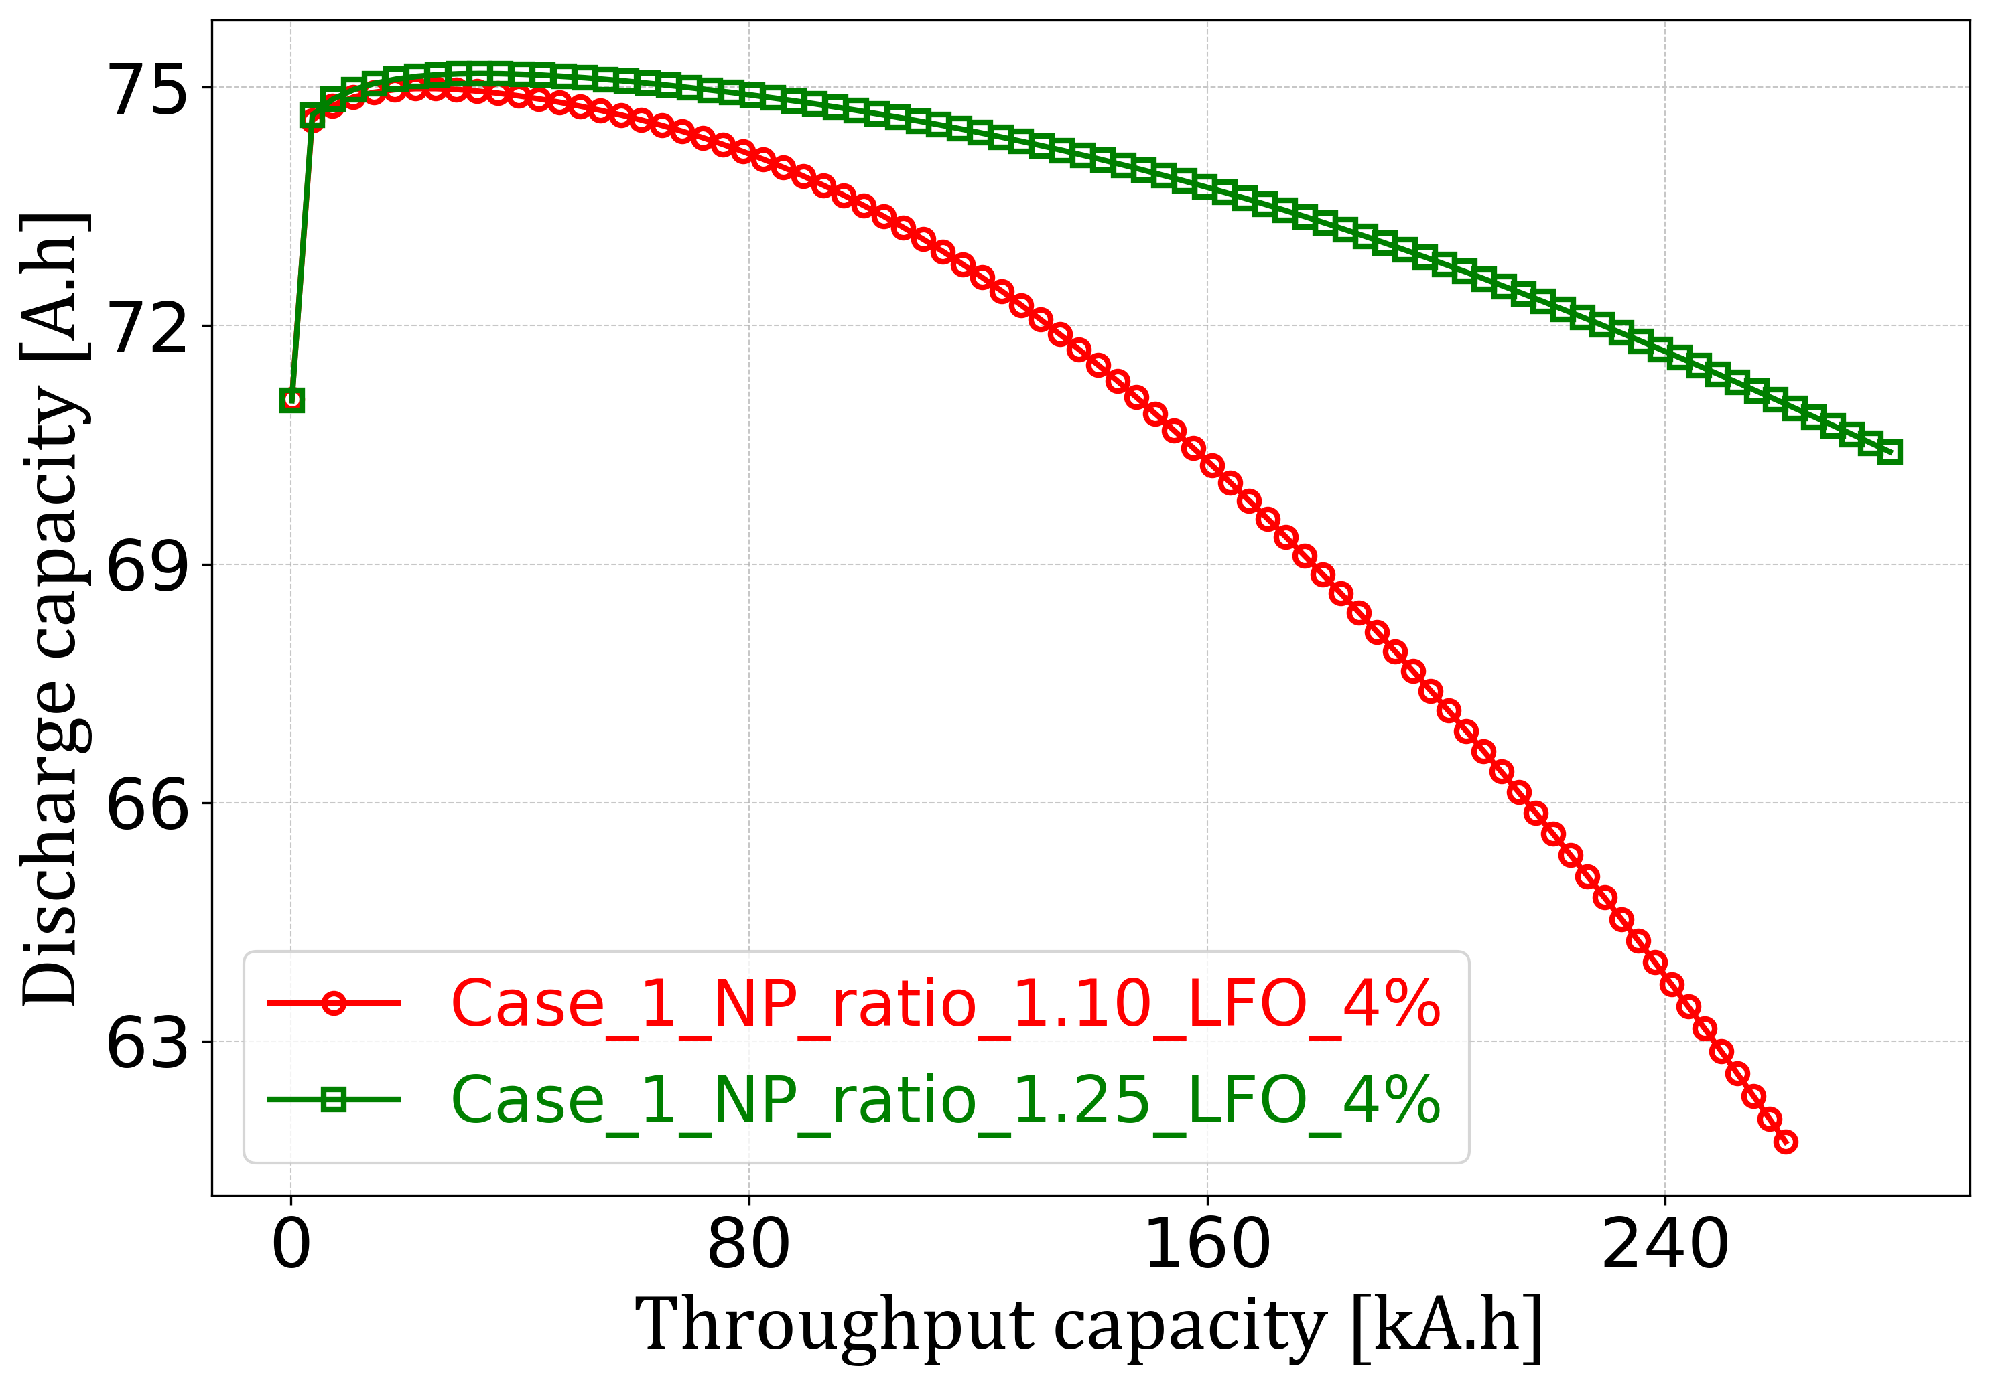 | (b)  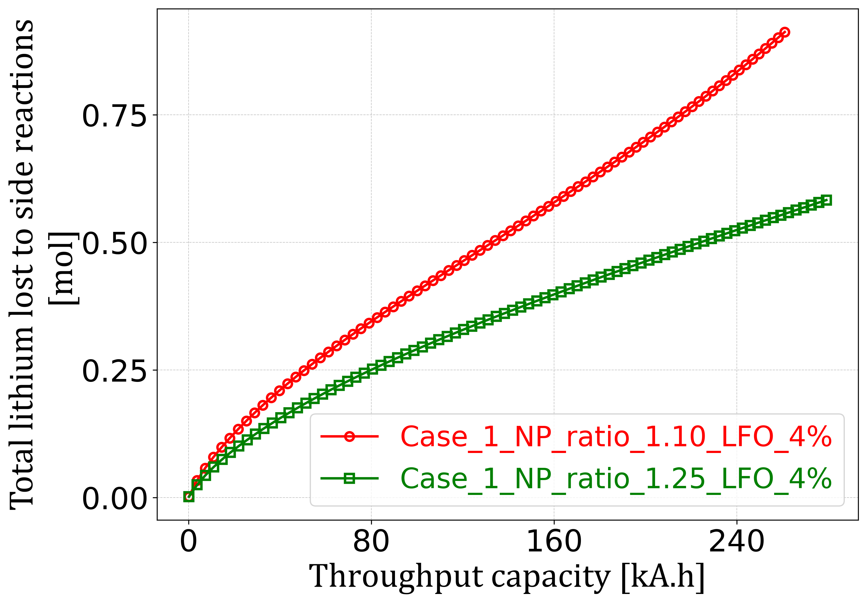
(a) cyclable lithium discharge capacity (RPT cycles discharge capacity), and (b) total lithium lost to side reaction (SEI + Dead lithium plating) for NP ratio of 1.1 (red line with round marker) and NP ratio of 1.25 (green line with square marker). The NP ratio is referred to as the ratio of negative electrode capacity (i.e., Graphite capacity) to primary phase positive electrode capacity (i.e., LFP capacity).

As an example, we increased the NE capacity by increasing the NE thickness, such that the NP ratio increases from 1.1 (reference case) to 1.25, taken as the ratio of the NE capacity (Graphite) to the primary phase of PE (LFP) capacity. The reference case is that of a BoL balanced cell, discussed in previous sections. While increasing the NE capacity, the other fundamental physical properties (maximum surface concentration, active material volume fraction, and electrode area) of the NE were kept unchanged. To compare the performance of the redesigned cell with that of the reference cell, the BoL performance of both was matched by adjusting the initial stoichiometries of NE and primary PE. To compare the long-term performance of the redesigned and reference cell, we choose Case 1 as the lithium release control method, because the frequent overcharges in Case 1 were found to cause the most severe cell imbalancing. Also, frequent overcharges, like in Case 1, are expected where the cell designers or process engineers may choose to intentionally perform frequent overcharge events (as in Case 1) so that oxygen can be released and degassed early (for example, during early cell life after formation). Moreover, CATL also hinted at releasing lithium from LFO early in cell life. This makes Case 1 a useful scenario for studying the benefits of cell redesign.
Fig. 7 compares the Case 1 performance for the reference case NP ratio of 1.1 and the redesigned NP ratio of 1.25 for 4% LFO content. A high cyclable lithium discharge capacity in case of 1.25 NP ratio was maintained for much longer cycle life than 1.1 NP ratio (Fig. 7(a)). This is due to less overlithiation and cell degradation rates, leading to lower lithium loss to the side reactions (Fig. 7(b)). The benefit of cell redesign on cell performance is expected to be more pronounced for a cell with a higher LFO fraction (e.g., 10%), as observed in Supplementary Figure 6.
Clearly, the redesign of the cell can benefit its longevity considerably. A larger NE overhang, however, would lead to lower cell energy density. While the NP ratio of 1.25 was chosen as a proof of concept, further studies should aim to find the optimal NP ratio, depending on the lithium release control strategy chosen and targeted LFO fraction.

Conclusions
We have modelled for the first time the effect of lithium iron oxide (LFO) additives on the long-term performance and degradation of lithium iron phosphate (LFP) cells to retrieve the behaviour of so-called ‘zero-degradation’ lithium-ion batteries. A composite cathode (LFP-LFO) was developed, implemented in the open-source battery modelling environment PyBaMM, coupled with a graphite anode, and parametrised to simulate a large commercial composite LFP-LFO cell. The model included degradation because of SEI layer growth and lithium plating at the negative electrode. This enabled us to study the consequences of degradation, including capacity loss, cell unbalancing, and porosity clogging on the life performance of the cell.
Different patterns of releasing the lithium from the LFO were explored to enhance capacity and to compensate for the effects of degradation. It was found that rapid release of excessive lithium could temporarily enhance cell capacity but led to intra-cell imbalances and increased degradation rates, resulting in reduced capacity in the long run. Gradual release of lithium to match and compensate for lithium lost due to degradation could maintain capacity for as long as LFO was not fully depleted of its lithium inventory. The direct consequences of oxygen evolution, associated with delithiation of LFO, were not modelled; this phenomenon is expected to affect lithium release strategies and needs to be studied further, both experimentally and in models. Various amounts of LFO, 0.1%, 1%, 4%, and 10% (by volume added LFO), were explored: 0.1% and 1% was too little to deliver a significant benefit, 4% was sufficient, but required careful control strategies, 10% was too high for a cell balanced for beginning of life and caused excessive degradation and rapid capacity loss. Finally, we explored the effect of rebalancing/redesigning the cell not just for beginning-of-life but to account for the excessive lithium that might be released from LFO later in the cell’s life. This was found to have a large positive impact on cell capacity throughout its cycle life, enabling the primary phase of positive electrode (i.e., LFP) to be fully utilised, whilst maintaining a reasonable negative electrode capacity excess/overhang to prevent accelerated degradation.
In conclusion, LFO can be a useful additive, capable of delivering zero observable degradation for significant periods of time. To ensure its benefits, however, it requires careful optimisation of: the amount of LFO, initial balancing of the cell, charging strategy and controlled lithium release rate and management of the oxygen released. The optimum combination of these factors is likely to be different for different applications and operating conditions. Multi-objective optimisation problems are expensive to explore experimentally, but ideal for a model-based approach. Therefore, the model presented in this paper should be of significant interest to anyone developing or considering the use of LFO-enriched lithium-ion battery cells. The model can also be easily adapted for other pre-lithiation or re-lithiation technologies being developed for any lithium-ion battery technology.

Methods

Part 1: PyBaMM Model setup and model assumptions
The standard Doyle-Fuller-Newman (DFN)²⁷ model was set up in PyBaMM¹⁵ using the model options listed in Fig. 8. The details about all the model options listed in Fig. 8 can be found in the PyBaMM documentation²⁸. A pure LFP ||Graphite full cell BoL model was built and parameterized using Prada et.al.²⁹ and estimated parameters, such that it represents the performance characteristics of a typical large commercial pure LFP cell. The model equations and parameter values were then adapted to simulate a large composite LFP-LFO ||Graphite full-cell. This was done by including an additional set of equations accounting for different active material volume fractions of LFO and its electrochemical behaviour. Since the NE was assumed to be graphite-only, it's considered to have a single phase, whereas the composite PE had two phases: LFP as the primary phase and LFO as the secondary phase. Charge transfer kinetics for the NE single phase and PE primary phase (LFP) were modelled using Butler-Volmer kinetics. Tafel kinetics was chosen to model the LFO kinetics, as lithium release from LFO, i.e., its delithiation is a one-way irreversible process (equations (1) and $(2)$ in first subsection). Hysteresis in LFP was accounted for by considering the current sigmoid model in PyBaMM. To ensure simplicity and not to deviate from the primary goal of showing the proof of concept for designing a zero-degradation battery, the model was made to perform such that it is a close representative of actual LFP-LFO commercial cell behaviour.

Fig. 8: Snapshot of the PyBaMM code selecting the model options
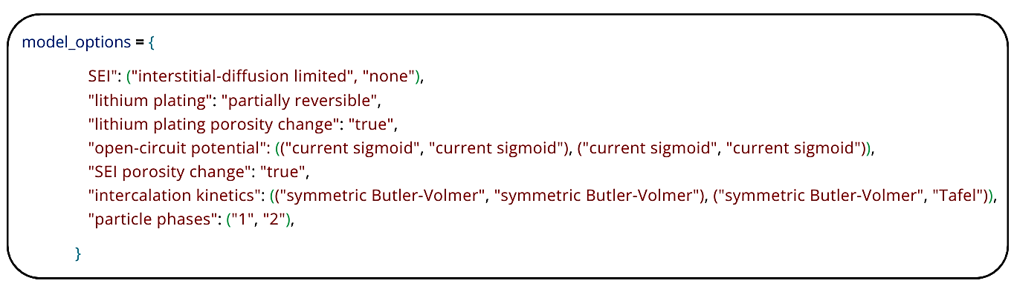

Once the BoL model was built and its performance was checked, the model was modified to create a full cell degradation model. Only negative electrode degradation is considered in this work. The degradation mechanisms, such as SEI formation, partially reversible lithium plating, and the resulting porosity clogging at the NE, were added to the PyBaMM model using the options listed in Fig. 8. The SEI model considered in this study is adopted from Single et al.³⁰ and von Kolzenberg et al.³¹. The partially reversible lithium plating model is unchanged from O’Kane et al.²⁶ Any degradation on primary phase of PE (LFP) i.e. due to its overdischarge/charge (which would have different magnitudes when different upper voltages cutoffs are chosen for LFO use) is not considered in this work.
BoL model equations are as listed in Supplementary Table 1, and the degradation model equations are as listed in Supplementary Table 2. The detailed discussion on these equations can be found in Supplementary Note 1 and Note 2. The input parameters used in the BoL model are summarised in Supplementary Tables 3 and 4. The parameter values for developing the degradation model are mentioned in Supplementary Table 5. The description of model variables, constants, their meaning, and symbols is summarised in Supplementary Table 6.
As the work specifically focuses on the electrochemical effects of LFO additives in a commercial cell, an isothermal model was considered to intentionally omit the influence of temperature evolution, thermal gradients, and inhomogeneities on cell behaviour. As the work was primarily aimed at demonstrating and explaining the science behind employing LFO by building a cell model that closely mimics the characteristics of real-life commercial LFP-LFO composite cells, hence, the work intentionally omits the influence of temperature evolution, thermal gradients, and inhomogeneities on cell degradation. Additionally, the maximum charge discharge rates in the modelled were up to 0.5C, which were assumed sufficiently low to ignore the thermal effect in LFP-LFO cells. Also, the work does not focus on experimental validation and performing a sensitivity analysis on various degradation-related parameters. These topics are recommended for future work.

Part 2: Setting up a virtual experiment in PyBaMM
The virtual experiments were designed in PyBaMM to simulate the long-term aging of a composite LFP-LFO full cell (Fig. 9). The virtual experiment performs a break-in cycle, followed by a baseline reference performance test (RPT) and then multiple repetitions of aging cycles, interspersed with characterization reference performance tests (RPTs). The test starts with a breaking cycle that involves constant-current (CC) constant-voltage (CV) charging (CC charge to upper voltage cutoff and CV hold till C/100), followed by CC discharge to a lower voltage cutoff and 1 hr rest, and then CC-CV charging again. After that, the first reference performance test (RPT 1) was done with CC discharge to a lower voltage cutoff to measure BoL discharge capacity, and then the aging cycles were performed. Aging cycles consist of a set of 25 cycles of CC charge to upper voltage cut-off-rest (1 min)-CC discharge to lower voltage cut-off-rest (1 min) steps. This set of 25 Aging cycles is followed by one controlled lithium release charging event, i.e., CC charge-rest (1 min) and a reference performance test (RPT). Depending upon the lithium release control pattern/case adopted (a discussion on cases can be found in Part 3 of the methods section), the controlled lithium release charge event could either be a normal charge, an overcharge (higher voltage cut-off), or capacity-controlled/coulomb-counted charging (fixed capacity charging). The set of 25 aging cycles, one controlled lithium release charging event, and a characterization RPT is then repeated 80 times to achieve 2000 aging cycles. The discharge capacity obtained from discharges done during aging cycles was denoted as usable discharge capacity (or aging cycles discharge capacity), whereas discharge capacity obtained from RPT 1 and the ‘80’ other RPTs is collectively referred to as cyclable lithium discharge capacity (or RPT cycles discharge capacity).
The charge & discharge rates considered for aging cycles and breaking cycles were 0.5C, whereas the discharge rate for characterization RPTs was 0.2C. For normal charging, the lower and upper cutoff voltage limits were 2.5 V and 3.6 V, respectively. For overcharging, the voltage limits considered were 2.5 V and 4.2 V, respectively.

Fig. 9: Snapshot of virtual experiment considered in the PyBaMM model
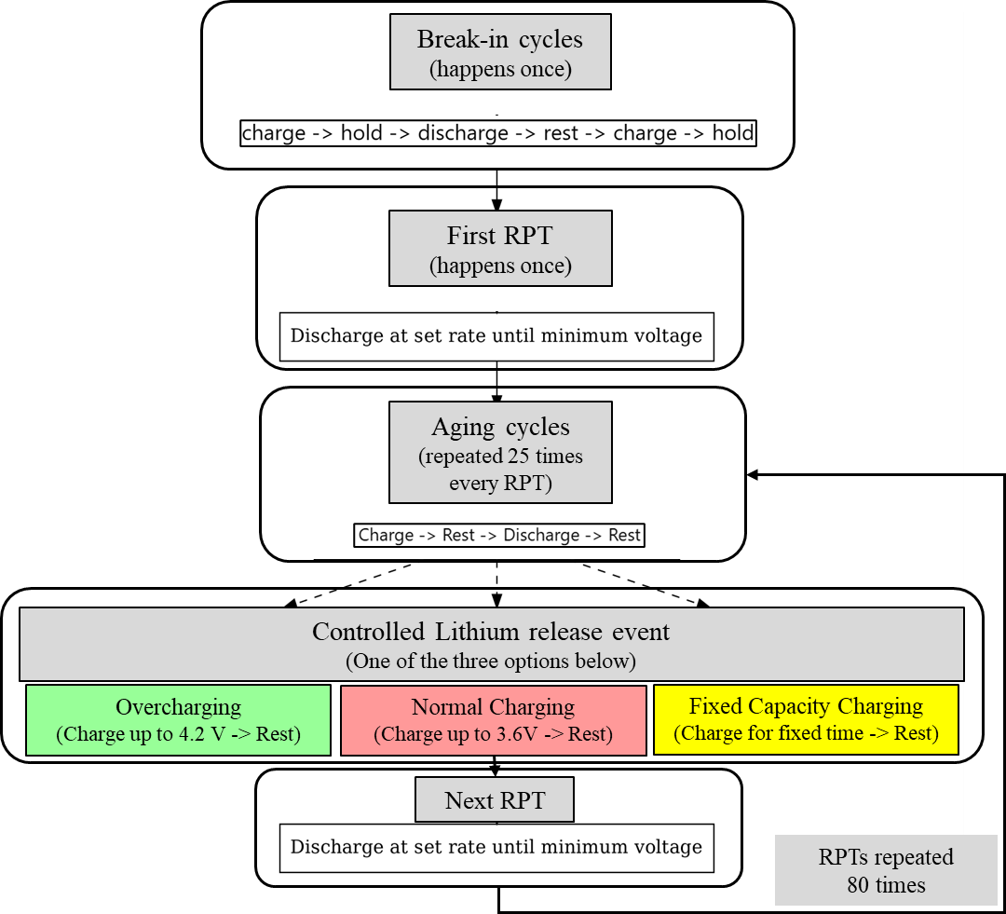

Part 3: Setting up lithium release patterns (cases) in PyBaMM
We designed five methods for lithium release, also called cases (Fig. 10). These cases are designed to control the speed (fast or slow) and timing (early or later part of cell life) of lithium release from LFO. Case 1 represents the early, fast, and frequent lithium release from LFO, in which overcharges are done before every RPT, thus totalling 80 overcharges. Case 2 illustrates fast and frequent lithium release starting later in the cell life, after cell throughput capacity becomes equivalent to 1000 aging cycles. Here, overcharge is done starting from the 40th RPT (i.e. delayed lithium release from LFO) and repeats regularly, before each RPT between 41st and 80th, thus totalling 40 overcharges. Case 3 represents slow and infrequent lithium release, in which an overcharge is done regularly, before the 20th, 40th, 60^{th,} and 80th RPTs, thus totalling only 4 overcharges. Case 4 represents the case of fast and frequent, but periodic lithium release, in which overcharges are done continuously between the 20th to 40th RPT and then the 60th to 80th RPT, with a total of 40 overcharges. Case 5 performs coulomb counted controlled charging, i.e. fixed capacity charging, in which the cell continues to charge until it achieves its BoL usable discharge capacity, or it hits the charging voltage upper cutoff safety limit of 4.2 V. This represents the case where we are indirectly calibrating lithium release to match the lithium lost to side reactions and hence avoid overlithiation of the NE.

Fig. 10: Different patterns of lithium release events and their repetition/frequency
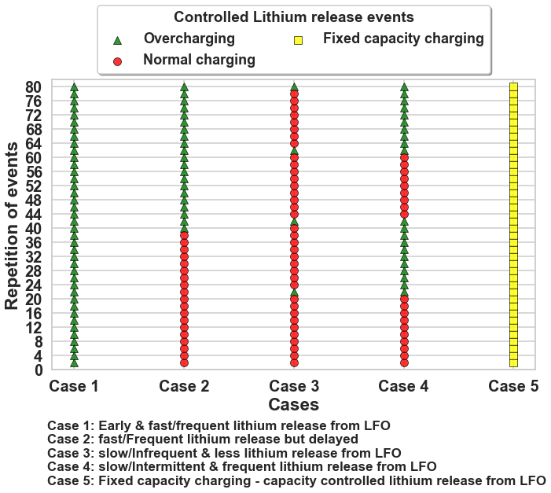
The figure shows the number of lithium release-controlled charging events just before characterization RPTs. Cases represent the different patterns of lithium release events. The green triangles represent an overcharging event, which is done just before its respective characterization RPT (RPT number on the y-axis). The red dots represent a normal charging event done before the respective characterization RPT. The yellow squares represent a Coulomb counted (fixed capacity) charging event, which is done just before its respective characterization RPT.

Data availability
The source data used for creating the plots in the manuscript is provided at Zenodo as a reference.³²

Code availability
The PyBaMM codes used to create the source data, as well as the separate custom codes used to make the plots from the source data, are provided at Zenodo as a reference.³² The PyBaMM codes would also be made available on the PyBaMM website as an example notebook (https://docs.pybamm.org/en/stable/source/examples/index.html)

References
1 Birkl, C. R., Roberts, M. R., McTurk, E., Bruce, P. G. & Howey, D. A. Degradation diagnostics for lithium ion cells. Journal of Power Sources 341, 373-386, doi:10.1016/j.jpowsour.2016.12.011 (2017).
2 Edge, J. S. et al. Lithium ion battery degradation: what you need to know. Phys Chem Chem Phys 23, 8200-8221, doi:10.1039/d1cp00359c (2021).
3 Peled, E. & Menkin, S. Review—SEI: Past, Present and Future. Journal of The Electrochemical Society 164, A1703-A1719, doi:10.1149/2.1441707jes (2017).
4 Goodenough, J. B. & Kim, Y. Challenges for Rechargeable Li Batteries. Chemistry of Materials 22, 587-603, doi:10.1021/cm901452z (2009).
5 Keil, P. et al. Calendar Aging of Lithium-Ion Batteries. Journal of The Electrochemical Society 163, A1872-A1880, doi:10.1149/2.0411609jes (2016).
6 Bischof, K., Flügel, M., Hölzle, M., Wohlfahrt-Mehrens, M. & Waldmann, T. Aging Mechanism For Calendar Aging of Li-Ion Cells With Si/Graphite Anodes. Journal of The Electrochemical Society 171, doi:10.1149/1945-7111/ad1b7c (2024).
7 Vetter, J. N., P.; Wagner, M.R.; Veit, C.; Möller, K.C.; Besenhard, J.O.; Winter, M.; Wohlfahrt-Mehrens, M.; Vogler, C.; Hammouche, A. Ageing mechanisms in lithium-ion batteries. Journal of Power Sources, doi:10.1016/j.jpowsour.2005.01.006 (2005).
8 Liu, Q. et al. Understanding undesirable anode lithium plating issues in lithium-ion batteries. RSC Advances 6, 88683-88700, doi:10.1039/c6ra19482f (2016).
9 Johnson, C. S. et al. Li2O Removal from Li5FeO4: A Cathode Precursor for Lithium-Ion Batteries. Chemistry of Materials 22, 1263-1270, doi:10.1021/cm902713m (2010).
10 Liu, X. et al. Addressing the initial lithium loss of lithium ion batteries by introducing pre-lithiation reagent Li5FeO4/C in the cathode side. Electrochimica Acta 481, doi:10.1016/j.electacta.2024.143918 (2024).
11 Dose, W. M. et al. Assessment of Li-Inventory in Cycled Si-Graphite Anodes Using LiFePO4as a Diagnostic Cathode. Journal of The Electrochemical Society 165, A2389-A2396, doi:10.1149/2.1271810jes (2018).
12 Su, X. et al. A new strategy to mitigate the initial capacity loss of lithium ion batteries. Journal of Power Sources 324, 150-157, doi:10.1016/j.jpowsour.2016.05.063 (2016).
13 Pathirana, T. CATL's SECRET to “Zero” Degradation Batteries: Unveiling the Potential of LFO Cathode Additives, <https://www.linkedin.com/pulse/catls-secret-zero-degradation-batteries-unveiling-lfo-pathirana-yfsuc/> (2024).
14 Murray, C. in Energy Storage News (Europe, 2024).
15 Sulzer, V., Marquis, S. G., Timms, R., Robinson, M. & Chapman, S. J. Python Battery Mathematical Modelling (PyBaMM). Journal of Open Research Software 9, doi:10.5334/jors.309 (2021).
16 Sepideh, A. Lithium-Ion battery SOC estimation Doctor of Philosophy thesis, University of Waterloo, (2017).
17 Leanza, D., Mirolo, M., Vaz, C. A. F., Novák, P. & El Kazzi, M. Surface Degradation and Chemical Electrolyte Oxidation Induced by the Oxygen Released from Layered Oxide Cathodes in Li−Ion Batteries. Batteries &amp; Supercaps 2, 482-492, doi:10.1002/batt.201800126 (2019).
18 Kaufman, L. A. & McCloskey, B. D. Surface Lithium Carbonate Influences Electrolyte Degradation via Reactive Oxygen Attack in Lithium-Excess Cathode Materials. Chemistry of Materials 33, 4170-4176, doi:10.1021/acs.chemmater.1c00935 (2021).
19 Adebanjo, I. T. et al. A comprehensive review of lithium-ion battery components degradation and operational considerations: a safety perspective. Energy Advances, doi:10.1039/d5ya00065c (2025).
20 Chu, Y. et al. Oxygen Release in Ni‐Rich Layered Cathode for Lithium‐Ion Batteries: Mechanisms and Mitigating Strategies. ChemElectroChem 11, doi:10.1002/celc.202300653 (2024).
21 Schomburg, F. et al. Lithium-ion battery cell formation: status and future directions towards a knowledge-based process design. Energy &amp; Environmental Science 17, 2686-2733, doi:10.1039/d3ee03559j (2024).
22 Zhu, B. et al. Defect engineering of air-stable Li(5)FeO(4) towards an ultra-high capacity cathode prelithiation additive. Chem Sci 15, 12879-12888, doi:10.1039/d4sc03052d (2024).
23 Kobayashi, H., Nakamura, Y., Yokoyama, Y., Honma, I. & Nakayama, M. Toward Cost-Effective High-Energy Lithium-Ion Battery Cathodes: Covalent Bond Formation Empowers Solid-State Oxygen Redox in Antifluorite-Type Lithium-Rich Iron Oxide. ACS Materials Letters 6, 2072-2076, doi:10.1021/acsmaterialslett.4c00268 (2024).
24 Zhu, Y. et al. Unravelling the Oxygen Evolution Mechanism of Lithium-Rich Antifluorite Prelithiation Agent Based on Anionic Oxidation. Angew Chem Int Ed Engl, e202502126, doi:10.1002/anie.202502126 (2025).
25 Reniers, J. M., Mulder, G. & Howey, D. A. Review and Performance Comparison of Mechanical-Chemical Degradation Models for Lithium-Ion Batteries. Journal of The Electrochemical Society 166, A3189-A3200, doi:10.1149/2.0281914jes (2019).
26 O'Kane, S. E. J. et al. Lithium-ion battery degradation: how to model it. Physical Chemistry Chemical Physics 24, 7909-7922, doi:10.1039/d2cp00417h (2022).
27 Doyle, M., Fuller, T. F. & Newman, J. Modeling of Galvanostatic Charge and Discharge of the Lithium/Polymer/Insertion Cell. Journal of The Electrochemical Society 140, 1526-1533, doi:10.1149/1.2221597 (1993).
28 PyBaMM. PyBaMM documentation, <https://docs.pybamm.org/en/stable/> (2024).
29 Prada, E. et al. A Simplified Electrochemical and Thermal Aging Model of LiFePO4-Graphite Li-ion Batteries: Power and Capacity Fade Simulations. Journal of The Electrochemical Society 160, A616-A628, doi:10.1149/2.053304jes (2013).
30 Single, F., Latz, A. & Horstmann, B. Identifying the Mechanism of Continued Growth of the Solid-Electrolyte Interphase. ChemSusChem 11, 1950-1955, doi:10.1002/cssc.201800077 (2018).
31 von Kolzenberg, L., Latz, A. & Horstmann, B. Solid-Electrolyte Interphase During Battery Cycling: Theory of Growth Regimes. ChemSusChem 13, 3901-3910, doi:10.1002/cssc.202000867 (2020).
32 Rawat, S. K. Raw Simulation Data from PyBaMM Modeling of Composite (LFP+LFO) Cathode and Graphite Anode in a Large-Format Lithium-Ion Cell; Data Supporting the Paper: How to Design a Zero-Degradation Battery: Compensating for Loss of Lithium Inventory in LFP Cells with LFO Additives. doi:https://doi.org/10.5281/zenodo.16583787 (2025).

Acknowledgements
This work was supported by the Faraday Institution (grant number FIRG084), and the authors gratefully acknowledge its financial support.

Author Contributions
S. Rawat: Conceptualisation, Validation, Software, Formal analysis, Visualisation, Writing – Original Draft. M. Marinescu: Conceptualisation, Investigation, Writing – Review & Editing, Primary Supervision. G. J. Offer: Conceptualisation, Writing – Review & Editing, Secondary Supervision, Funding acquisition, Project administration. R. Li: Discussion, S.E.J. O’Kane: Discussion

Competing interests
The authors declare no competing interests

