compare-folders: An Open Source Folder and File Comparison Tool

Yu Hongbo
BA DU XIN SHANG
Harbin, China

Keywords: CNOCTAVE, compare-folders, folder comparison, file comparison, open-source, Electron

Abstract
This paper introduces compare-folders, an open-source tool designed for comparing folders and files. Developed by CNOCTAVE and Yu Hongbo, compare-folders utilizes Electron to create a user-friendly interface, allowing users to easily identify differences between files and folders. This paper discusses the features, installation process, usage instructions, and development environment requirements of compare-folders, as well as its potential applications in various fields.

1 Introduction
In today's digital era, managing and comparing large amounts of data has become increasingly important. Whether it's for version control, data backup, or simply ensuring consistency across different systems, the ability to compare folders and files efficiently is crucial. compare-folders, an open-source tool created by Yu Hongbo, aims to address this need by providing a user-friendly interface for comparing folders and files.

2 Overview of compare-folders
compare-folders is designed to facilitate folder and file comparison. It offers a straightforward interface that allows users to quickly open two folders and view the differences between their contents. The tool highlights changes in files, showing added, removed, or modified lines in a clear and easy-to-understand manner.

3 Features of compare-folders
3.1 User-friendly interface
compare-folders is designed with a straightforward and intuitive interface that makes it easy for users to navigate and compare folders and files.

3.1.1 Open folder
Click the button in the upper left corner and the button on the left to open folder 1 and folder 2 (Fig. 1).
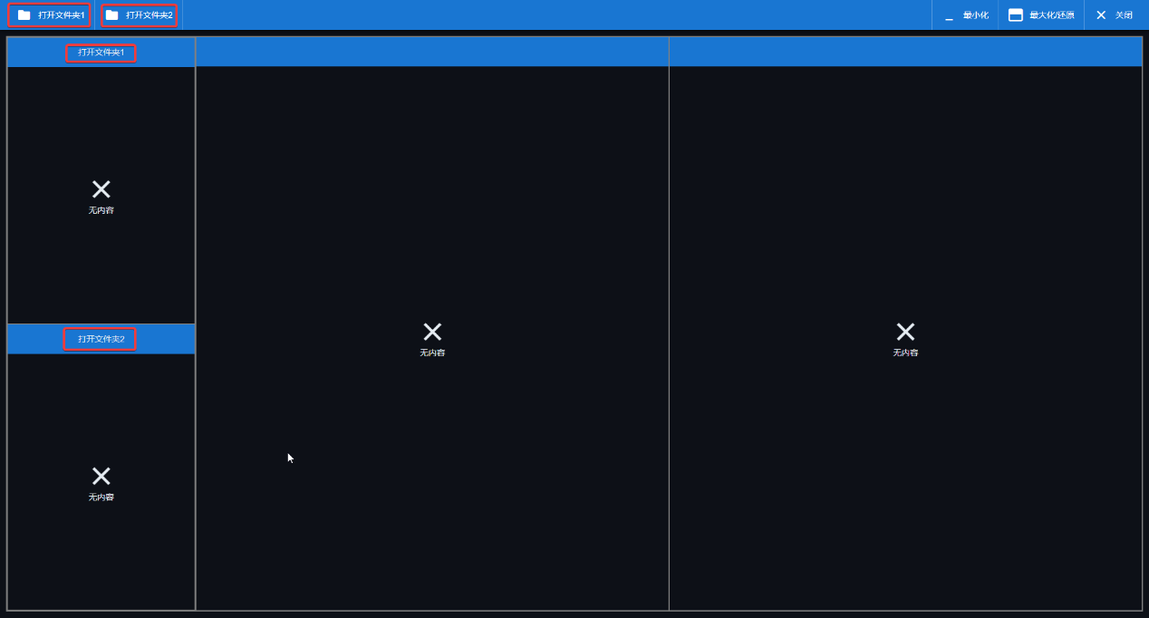
Fig.1 Open Folder

3.1.2 Open file
Click on any file name in the two file lists to compare the two files.

3.2 Real-time folder and file comparison
The tool allows users to open two folders and view the differences between their contents in real-time. Compare files by line.

3.3 Color-coded differences
compare-folders uses color coding to highlight changes in files, with green indicating files that exist in one folder but not the other, red indicating files with different contents, and black indicating files with identical contents.

3.3.1 Folder differences
After opening folder 1 and folder 2, a list of files in folder 1 and folder 2 will be displayed on the left side (Fig. 2).
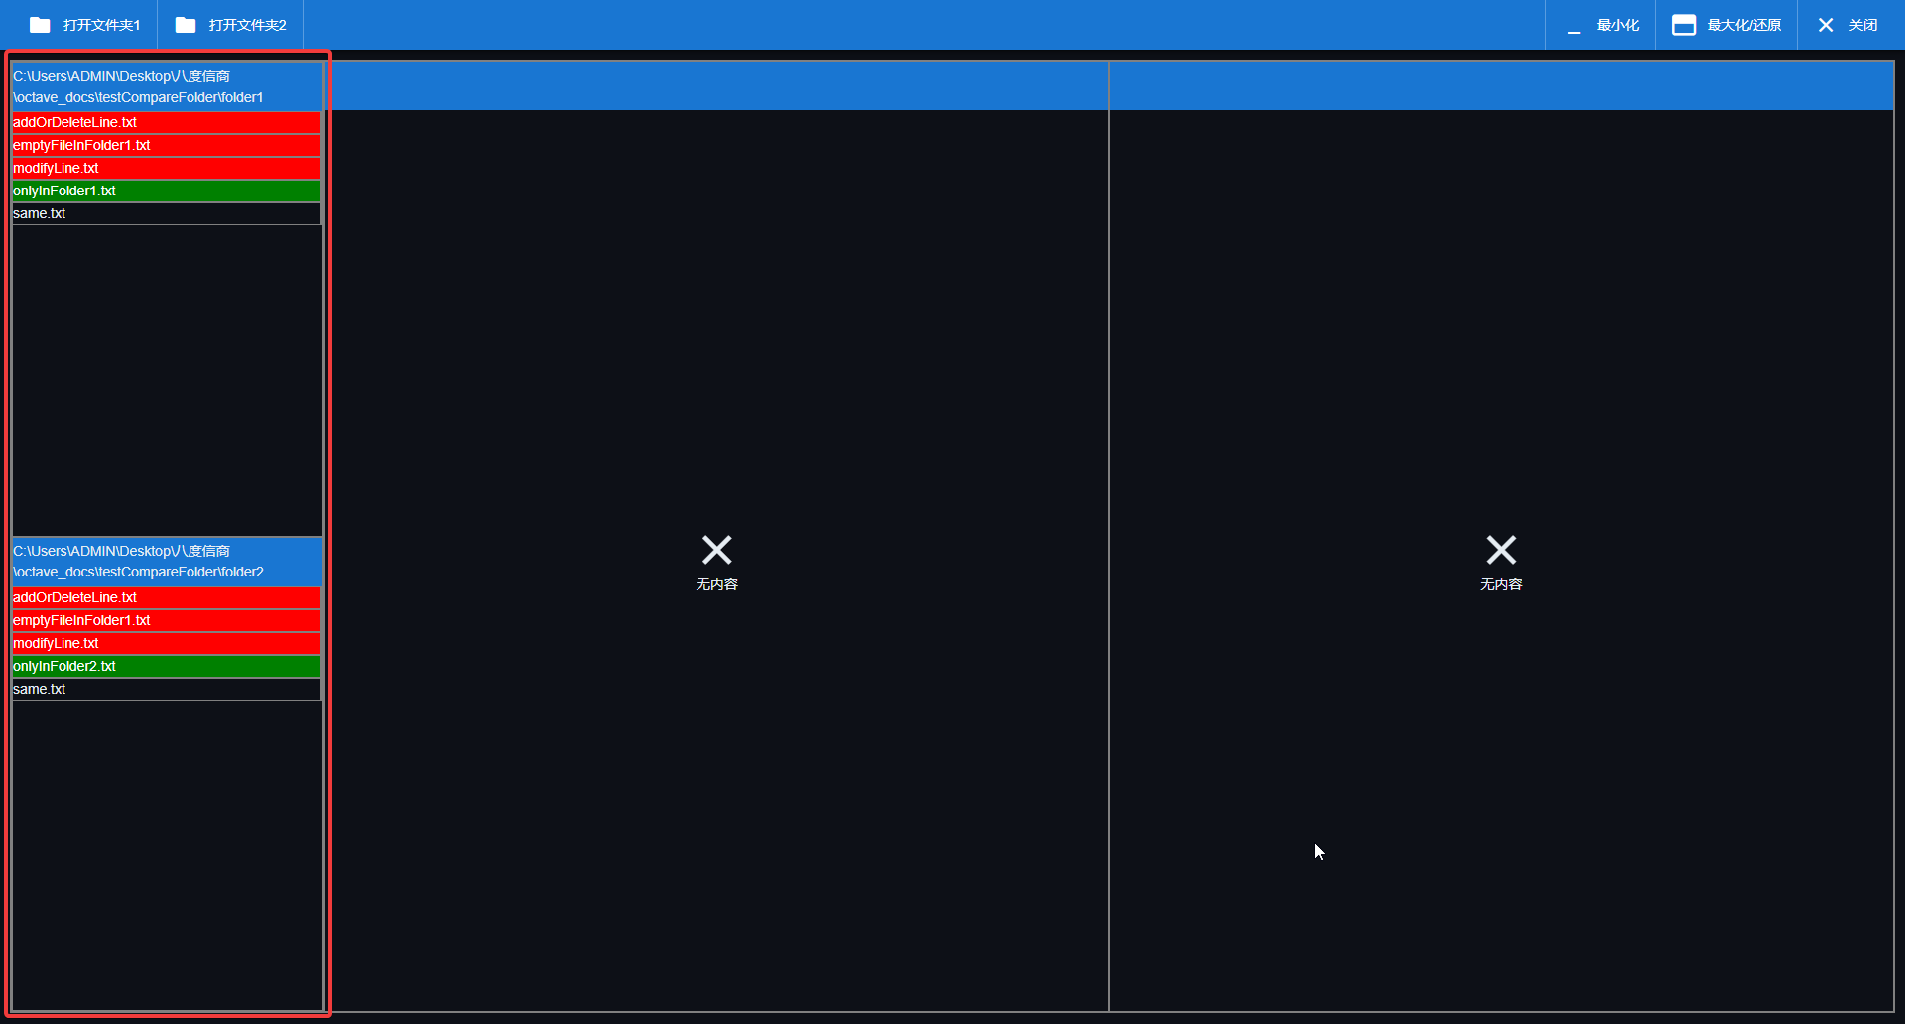
Fig. 2 Folder differences
The button on the left will display the paths of folder 1 and folder 2.
If there is a file in one folder and no file with the same name in another folder, the file name will be displayed in green in the file list.
If there are files with the same name in both folders, but their contents are different, the file name will be displayed in red in the file list.
If there are files with the same name in both folders and their contents are the same, the file name will be displayed in transparent color (black) in the file list.

3.3.2 File differences
The line number is displayed as indigo in the file window.
If there is an increase in the number of lines, a plus sign "+" will be displayed before the line number, and green will indicate this situation.
If there is a decrease in the line number, a minus sign "-" will be displayed before the line number, indicated in red.
If two lines are the same, they will be displayed in transparent color (black) in the file window.
If a file in folder 1 has added a line, or a file in folder 2 has deleted a line, this line will appear in red in file window 1 and green in file window 2 (Fig. 3).
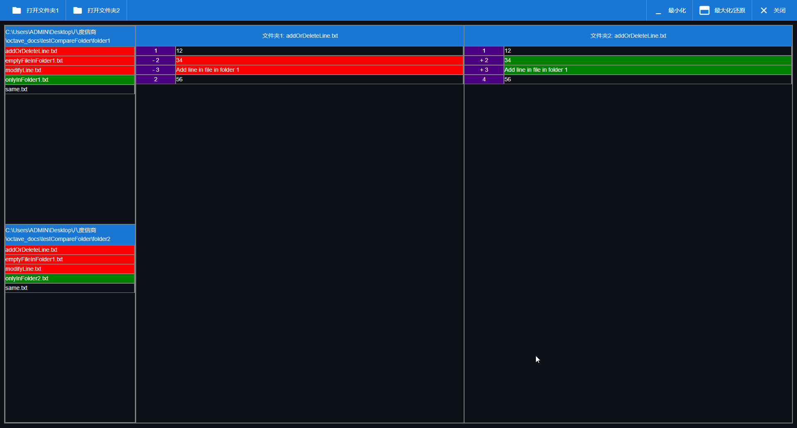
Fig. 3 Add or delete line

If a file has been modified on one line, the current file's line will be displayed in red, and the other file's line will be displayed in green (Fig. 4).
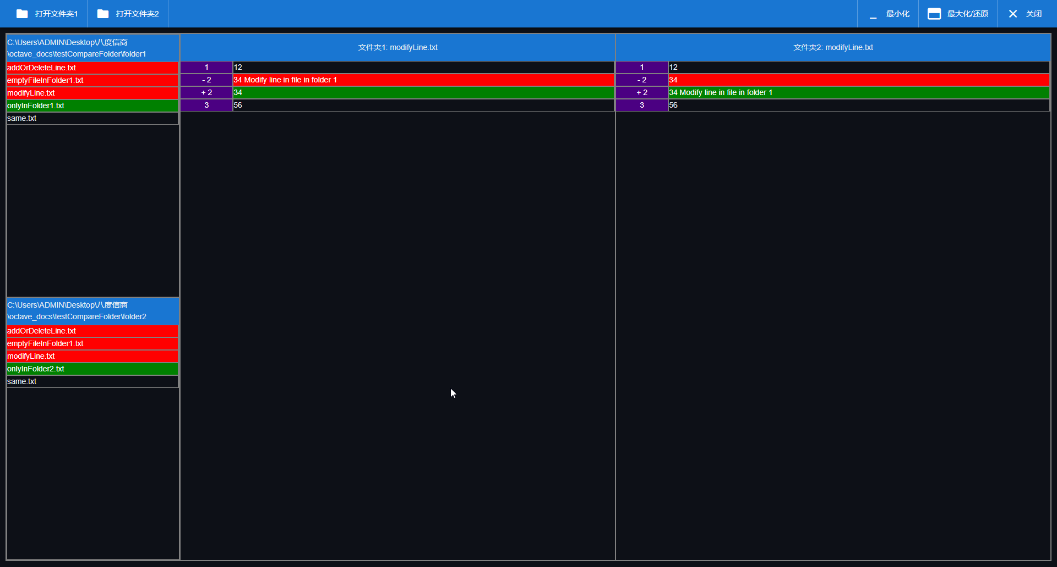
Fig. 4 Modify line

3.4 Detailed file comparison
If there are files with the same name in both folders that can be opened and are not empty, the file title bar will display "Folder 1: File Name" or "Folder 2: File Name", and the file window will display the file content.
If there are files with the same name in both folders and the files can be opened but are empty, the file title bar will display "(empty file) folder 1: file name" or "(empty file) folder 2: file name", and the file window will display an error message of "no content" (Fig. 5).
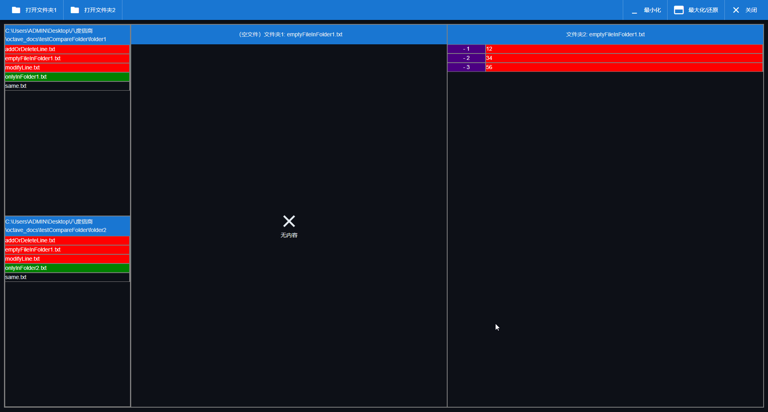
Fig. 5 File is empty

If a file error occurs when clicking on a file name (such as the file not being in the folder), the file title bar will display "(File Error) Folder 1: File Name" or "(File Error) Folder 2: File Name", and the file window will display an error message of "No Content" (Fig. 6).
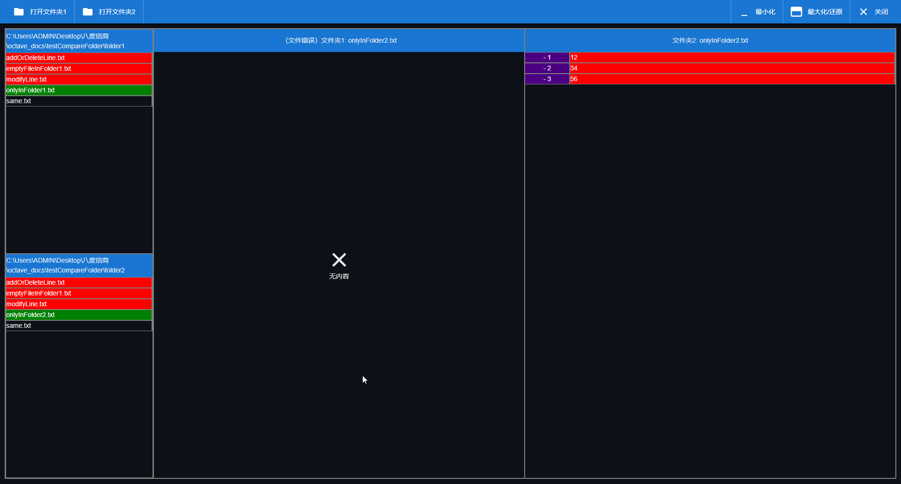
Fig. 6 File error

3.5 Practical tips
compare-folders provides practical tips for users to easily identify and understand differences between files.
The line numbers in file window 1 correspond to the actual line numbers in file 2.
The line numbers in window 2 correspond to the actual line numbers in file 1.
Removing the red line from a file and adding the green line will change it to another file.
To find a file with more lines than another file, look for the line in red.
To find a file with fewer lines than another file, look for the green line.
To find where a certain line has been modified, red represents the version of the current file, and green represents the version of another file. When there is a modification on a certain line, the red is above and the green is below, which allows you to directly see the differences between different versions of the same line.

4 Installation
compare-folders can be installed through two primary methods: NPM and Snap.

Installation through NPM: Users can install compare-folders by running the command $ npm i compare-folders in their terminal.
Installation through Snap: Alternatively, users can install the tool through Snap by running the command $ sudo snap install compare-folders --edge.
Installation through source code:
This software requires a Node version greater than or equal to 22.
Prepare the development environment with the following code:
$ npm i
The debugging code is as follows:
$ npm start
The packaged code is as follows:
$ npm run build
Before packaging, all programs occupying port 8080 must be closed, otherwise the packaging will fail.
Installation through GitHub releases:
The websites of GitHub releases are like:
https://github.com/CNOCTAVE/compare-folders/releases/tag/<version>,
where <version> is the latest release version.

5 Potential Applications
compare-folders has a wide range of potential applications, including but not limited to:

Version control: Developers can use the tool to compare different versions of their code and identify changes.
Data backup: Administrators can use it to verify the consistency of backups and identify any discrepancies.
Collaboration: Teams can use compare-folders to ensure that their files are synchronized and up-to-date.

6 Conclusion

compare-folders is a powerful and user-friendly tool for comparing folders and files. Its intuitive interface, real-time comparison capabilities, and color-coded differences make it an ideal choice for anyone needing to manage and compare large amounts of data. With its open-source nature, compare-folders also offers opportunities for collaboration and improvement, making it a valuable resource for the community.

References

1. Hongbo, Y. (2025). compare-folders. https://github.com/CNOCTAVE/compare-folders
2. Hongbo, Y. (2025). compare-folders Document. https://cnoctave.github.io/compare-folders/index.html
3. Grbovic, M., Halawi, G., Karnin, Z., & Maarek, Y. (2014, November). How many folders do you really need? classifying email into a handful of categories. In Proceedings of the 23rd ACM International Conference on Conference on Information and Knowledge Management (pp. 869-878).
4. Adamuszek, M., Dabrowski, M., & Schmid, D. W. (2016). Folder: A numerical tool to simulate the development of structures in layered media. Journal of Structural Geology, 84, 85-101.
5. Bao, X., & Dietterich, T. G. (2011). FolderPredictor: Reducing the cost of reaching the right folder. ACM Transactions on Intelligent Systems and Technology (TIST), 2(1), 1-23.
6. Singh, M., Cambronero, J., Gulwani, S., Le, V., & Verbruggen, G. (2023, October). EmFore: Online Learning of Email Folder Classification Rules. In Proceedings of the 32nd ACM International Conference on Information and Knowledge Management (pp. 2280-2290).
7. Grolimund, D., Meisser, L., Schmid, S., & Wattenhofer, R. (2006, October). Cryptree: A folder tree structure for cryptographic file systems. In 2006 25th IEEE Symposium on Reliable Distributed Systems (SRDS'06) (pp. 189-198). IEEE.
8. Wang, H., Yu, Z., Spadaro, G., Ju, C., Quétu, V., & Tartaglione, E. (2025). FOLDER: Accelerating Multi-modal Large Language Models with Enhanced Performance. arXiv preprint arXiv:2501.02430.
9. Mungmeeprued, T., Ma, Y., Mehta, N., & Lipani, A. (2022, September). Tab this folder of documents: page stream segmentation of business documents. In Proceedings of the 22nd ACM Symposium on Document Engineering (pp. 1-10).
10. Wang, Y., DeWitt, D. J., & Cai, J. Y. (2003, March). X-Diff: An effective change detection algorithm for XML documents. In Proceedings 19th international conference on data engineering (Cat. No. 03CH37405) (pp. 519-530). IEEE.
11. Ladd. (1994, September). Semantic diff: A tool for summarizing the effects of modifications. In Proceedings 1994 International Conference on Software Maintenance (pp. 243-252). IEEE.
12. Hashimoto, M., & Mori, A. (2008, October). Diff/TS: A tool for fine-grained structural change analysis. In 2008 15th working conference on reverse engineering (pp. 279-288). IEEE.
13. Xing, Z., & Stroulia, E. (2007). API-evolution support with Diff-CatchUp. IEEE Transactions on Software Engineering, 33(12), 818-836.
14. Hartung, M., Groß, A., & Rahm, E. (2013). COnto–Diff: generation of complex evolution mappings for life science ontologies. Journal of biomedical informatics, 46(1), 15-32.
15. Rhode, D. L. (2003). The difference “difference” makes. na.
16. Nugroho, Y. S., Hata, H., & Matsumoto, K. (2020). How different are different diff algorithms in Git? Use--histogram for code changes. Empirical Software Engineering, 25, 790-823.
17. Rubin, J., & Chechik, M. (2012, September). Locating distinguishing features using diff sets. In Proceedings of the 27th IEEE/ACM International Conference on Automated Software Engineering (pp. 242-245).
18. Subramonian, R. (1998, August). Defining diff as a Data Mining Primitive. In KDD (pp. 334-338).
19. Abuzaid, F., Kraft, P., Suri, S., Gan, E., Xu, E., Shenoy, A., ... & Zaharia, M. (2021). DIFF: a relational interface for large-scale data explanation. The VLDB Journal, 30, 45-70.
20. Abuzaid, F., Kraft, P., Suri, S., Gan, E., Xu, E., Shenoy, A., ... & Zaharia, M. (2018). Diff: a relational interface for large-scale data explanation. Proceedings of the VLDB Endowment, 12(4), 419-432.
21. Alanen, M., & Porres, I. (2003). Difference and union of models. In «UML» 2003-The Unified Modeling Language. Modeling Languages and Applications: 6th International Conference, San Francisco, CA, USA, October 20-24, 2003. Proceedings 6 (pp. 2-17). Springer Berlin Heidelberg.
22. Tan, W., Tata, S., Tang, Y. R., & Fong, L. L. (2014, March). Diff-Index: Differentiated Index in Distributed Log-Structured Data Stores. In EDBT (pp. 700-711).

