Parts List for the DeisBox aluminum PC-fan air cleaner
- Powder coated aluminum frames: as per designs in supplemental materials. Price per frame will vary depending on quantity ordered from fabrication shop and cost / availability of aluminum.
- Six Arctic P14 PWM PST 140mm (#ACFAN00138A) fans.
- Six fan grills: Cooler Guys 140MM #840556082101. Any 140mm fan grill should work, and others may provide optimized safety, however this is the configuration tested.
- Electrical connections:
  - One Strain Relief Grommet (part # 180.107 & 184.107 at ecl.ca)
  - One 12VDC 1.6A Barrel Plug Power Supply (RP Electronics part #RPR-121A6-P5)
  - One 4 pin PWM male to 4 pin PWM female extension cable w/ black sleeving (12 inch) (CoolerGuys part #840556098256)
  - One Panel Mount DC Plug (Adafruit Industries 5607)
- Four Adhesive feet (Part #1421T4 at ecl.ca)
- Eight 10–32 x 3/8" machine screws, to assemble the frame
- Twenty-four 4mm x 35mm black bolts & Twenty-four 4mm black nuts to secure the fans to the frame. Nylon washers can optionally be used to protect the frames’ paint.
- Two 20” x 20” x 2” MERV-13 air filters. AAF Flanders PREpleat® M13 filters were used for performance testing.
- Two 1/16” thick 20” x 20” PVC perforated plastic filter covers. In the current design, these are cut from 4' x 8' sheets obtained from Johnston Industrial Plastics Limited (https://www.johnstonplastics.com/pvc-polyvinyl-chloride/).

Build instructions for the DeisBox aluminum PC-fan air cleaner
Note: Photographs can be enlarged by dragging the corners.
Steps:
- Remove the contents of the box and separate the four (4) aluminum panels of the air cleaner: top, bottom, front, and back.
  - Bottom panel has two pairs of holes for bolts on either end (see image 1).
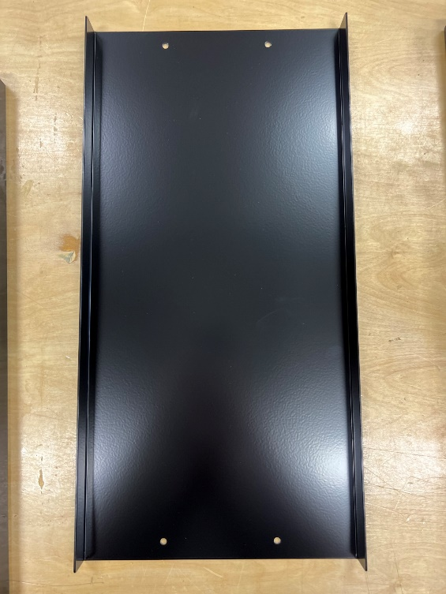
IMAGE 1: Bottom panel
  - The back panel has 90-degree lips at the top & bottom, a 7/8” hole at the bottom, four nuts pop riveted on either end, and “UP” cut into the lip on the top (see image 2). “Up” is to indicate the vertical orientation of the front & back panels.
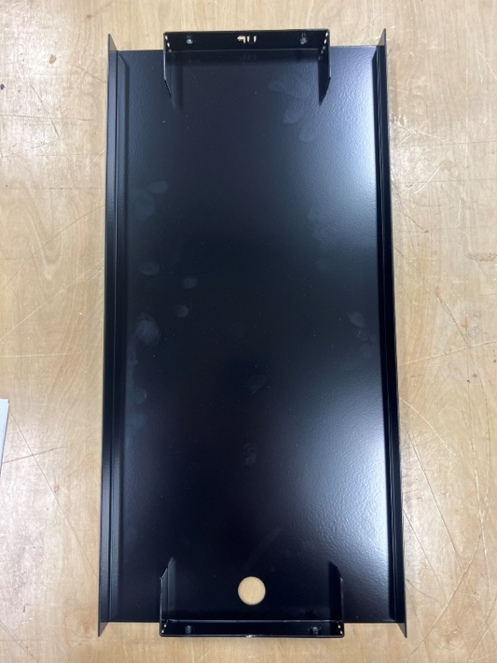
IMAGE 2: Back panel

  - The top panel has three PC fan holes for the 140mm PC fans and handles on either end (see image 3).
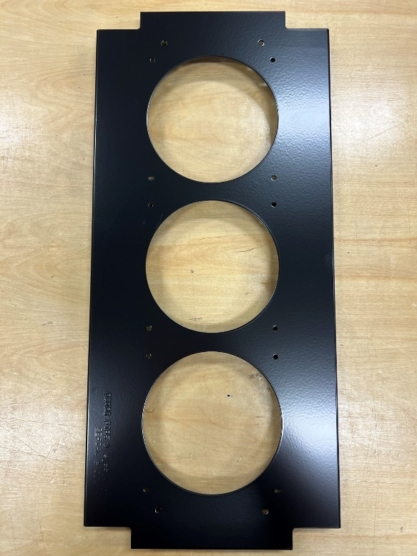
IMAGE 3: Top panel

  - Front panel has three PC fan holes, 90-degree lips at the top & bottom, four nuts pop riveted on either end, and “UP” on the top lip (see image 4).
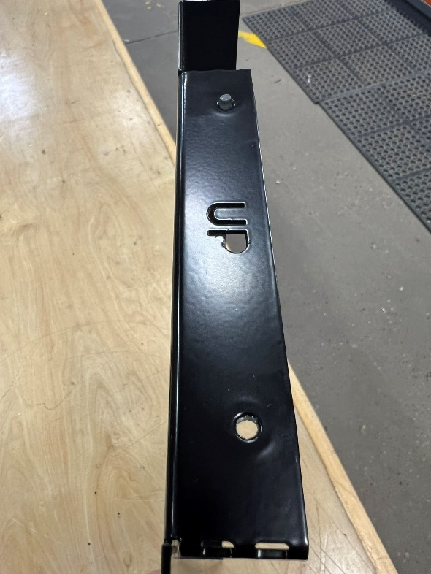
IMAGE 4: Front panel

- Find the bottom panel and attach the adhesive feet to the underside at the corners (see image 5).
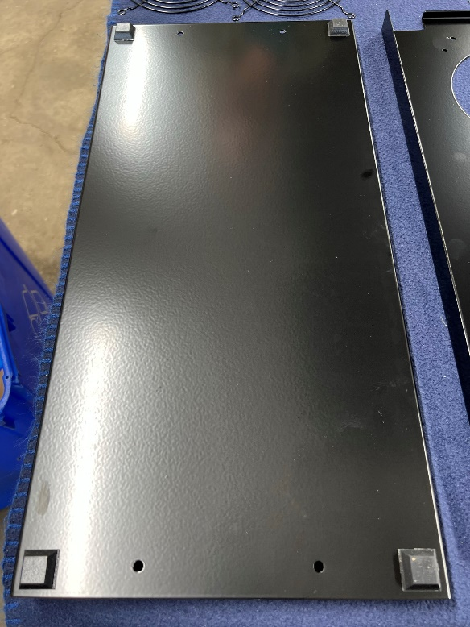
IMAGE 5: Bottom panel with adhesive feet applied

- On the back panel, connect the DC panel mount plug through the 7/8” hole at the bottom. To do this, unscrew the nut on the plug itself, then feed the male DC end through the panel from the outside, and reattach the nut securely on the inside of the panel (see images 6 and 7).

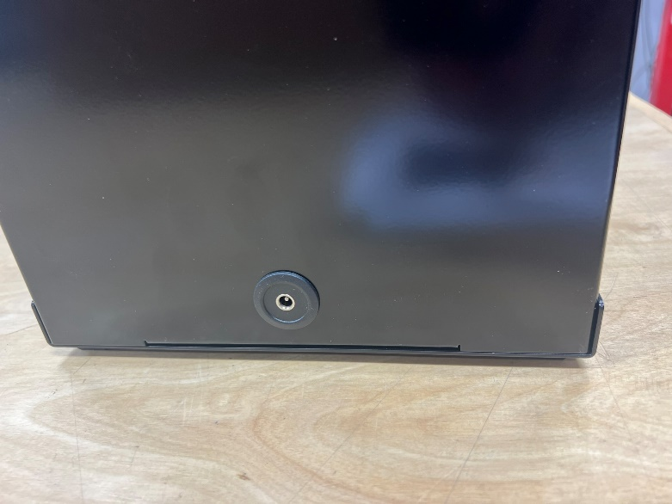
IMAGE 6: Female end of DC panel mount plug on the outside of the back panel
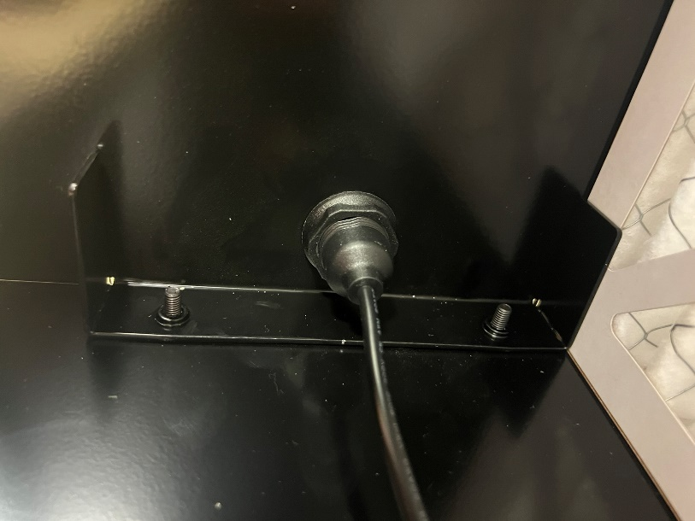
IMAGE 7: DC panel mount plug on inside of the back panel

- Locate the front panel and attach three PC fans & fan grills to the interior using the nuts & bolts (4mm x 35mm black bolts & 24 4mm black nuts).
  - To orient fans, use the directional arrows; white “Arctic” emblem in the middle of the fan should be on the inside of the filter box (see image 8). Fans should blow air out of the box.
  - Attach the top fan first and work your way down the panel to manage the PC fan power cords. The top of this panel is marked with an “UP” on the lip of the panel.
    - Don’t forget the fan grills on the outside of the frame!
  - Position fans so the cord exits the fan housing on the bottom right of the fans (see image 8).
  - Place power cords between the fan housing and the mounting bolts (see image 9). This prevents the cords from being pinched by the filters or pulled into the fans.

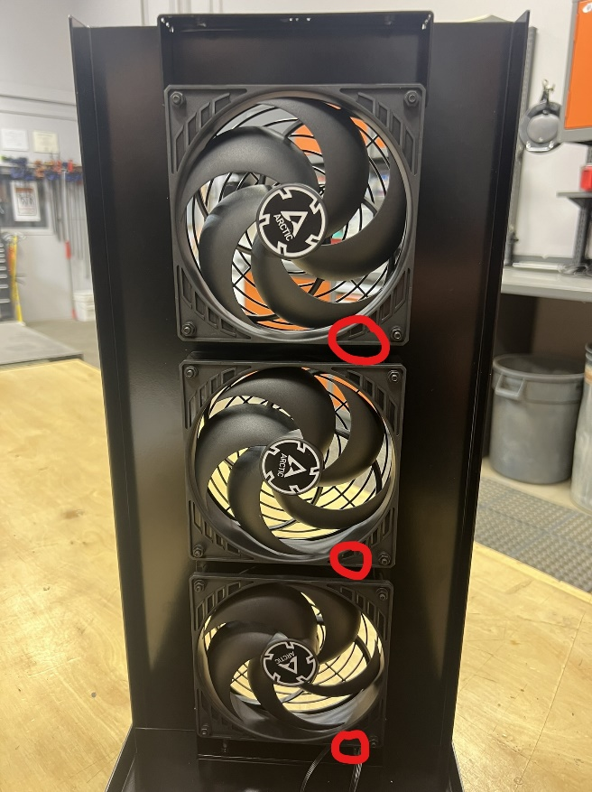
IMAGE 8: Power cords exiting top fan housing on the bottom right, running along the right side held in place by the bolts, and exiting under the bottom fan on the inside of the frame tab
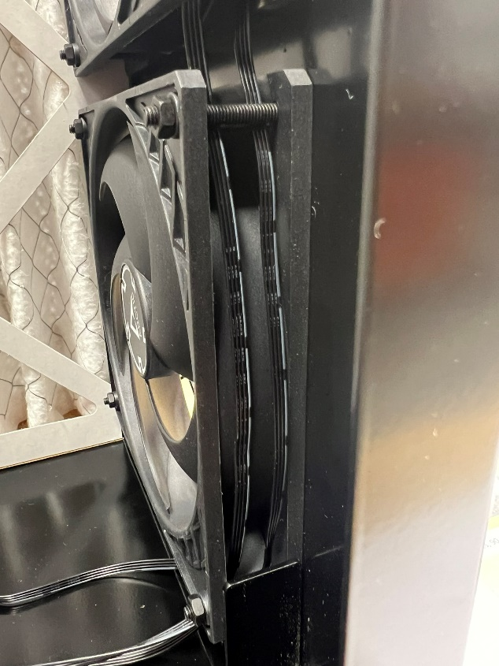
IMAGE 9: Power cords between the bolts securing the fans and the fan housing

  - Still working with the front panel, locate the shortest fan cord (should be from the top fan). Plug the male connection from the top fan into the female connection of the middle fan. Then plug the male connection from the middle fan into the female connection of the bottom fan (see image 10).

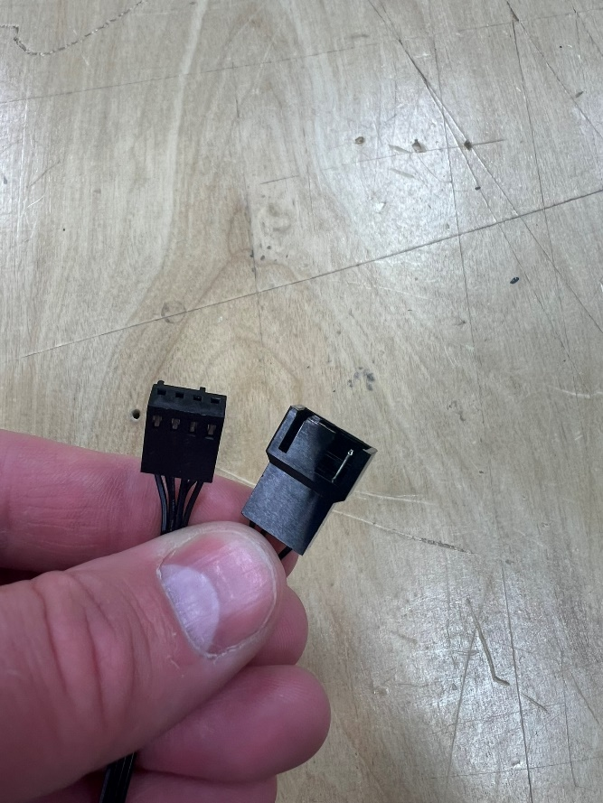
IMAGE 10: Male and female connections from each fan
  - Locate the extension cable (image 11). The male end of the extension cable will plug into the open female connection from the top fan of the front panel. The female connection of the extension cable will be connected to the ‘daisy chained” sequence of top fans
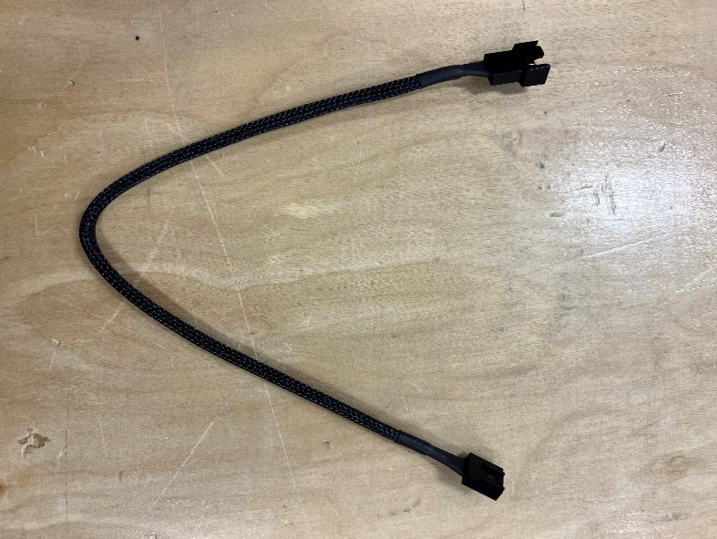
IMAGE 11: Extension Cable
  - Connect the DC plug to PC fan power adapter cable (image 12) to the male end of the panel mount plug and the remaining male connection from the front panel fans

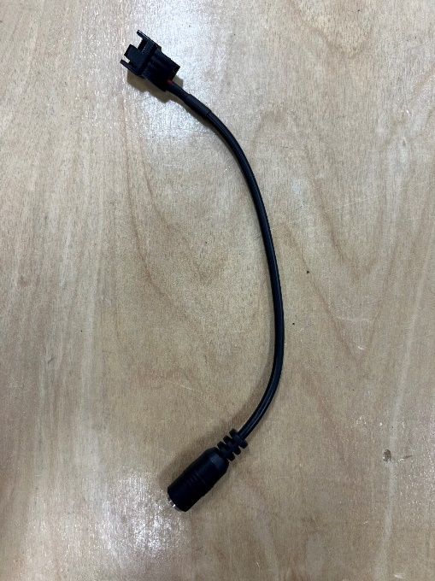
IMAGE 12: DC Plug to PC Fan Adapter Cable
  - Attach the self-adhesive zip-tie pad to the middle of the bottom panel, collect the wires, and neatly zip tie them to the pad (image 13)

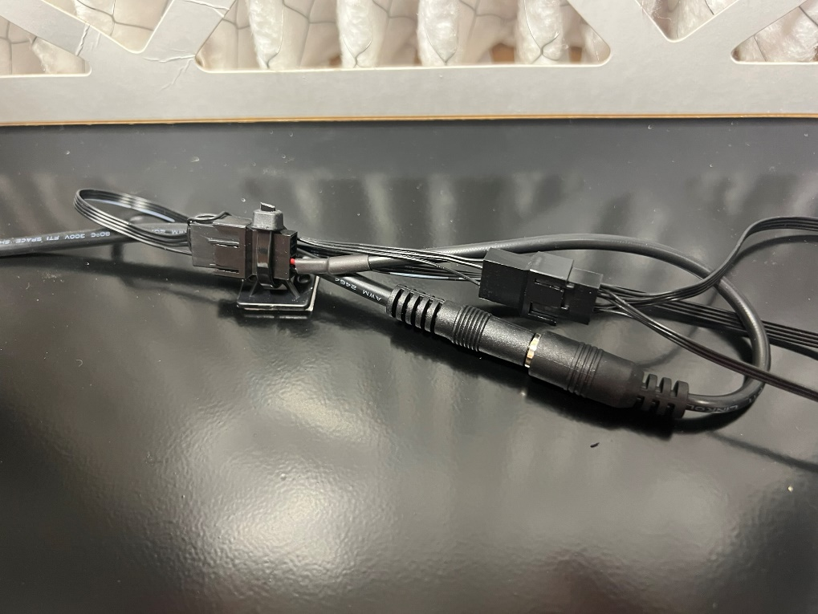
IMAGE 13: PC fan power adaptor cable and front panel PC fan cables zip tied to the self-adhesive pad

- Locate the top panel and attach the three PC fans & fan grills using the nuts & bolts (4mm x 35mm black bolts & 24 4mm black nuts)
  - Top panel can be in either orientation
  - Fans should be positioned so the cords are aligned as in image 14.
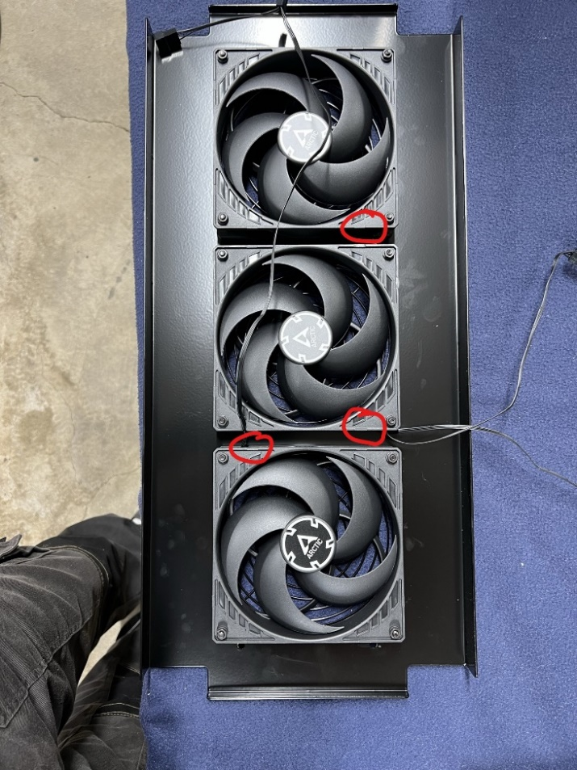
IMAGE 14: Fan positioning for top panel. Red circles are where power cords should be located

  - All cords should be coming out between the bottom & middle fans (where the two red circles are) (see image 14). This side of the top panel should be oriented towards the back panel of the air cleaner (furthest away from the fans on the front panel – see image 15)

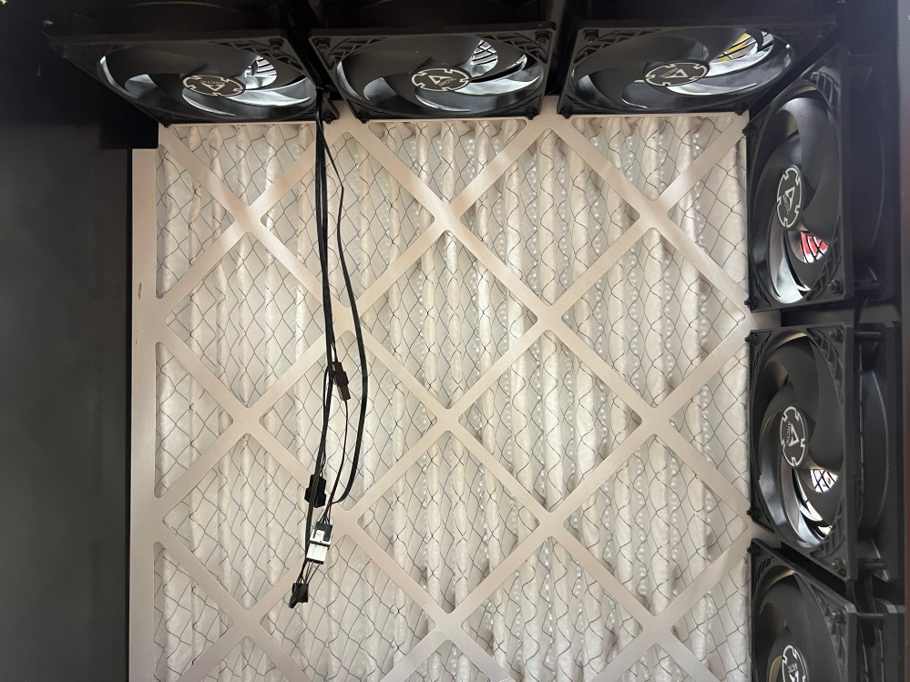
IMAGE 15: Cords from the top panel dropping down towards the rear panel

- Attach the front and back panels to the base panel using four bolts (8 - 10–32 x 3/8" machine screws) (see image 16).
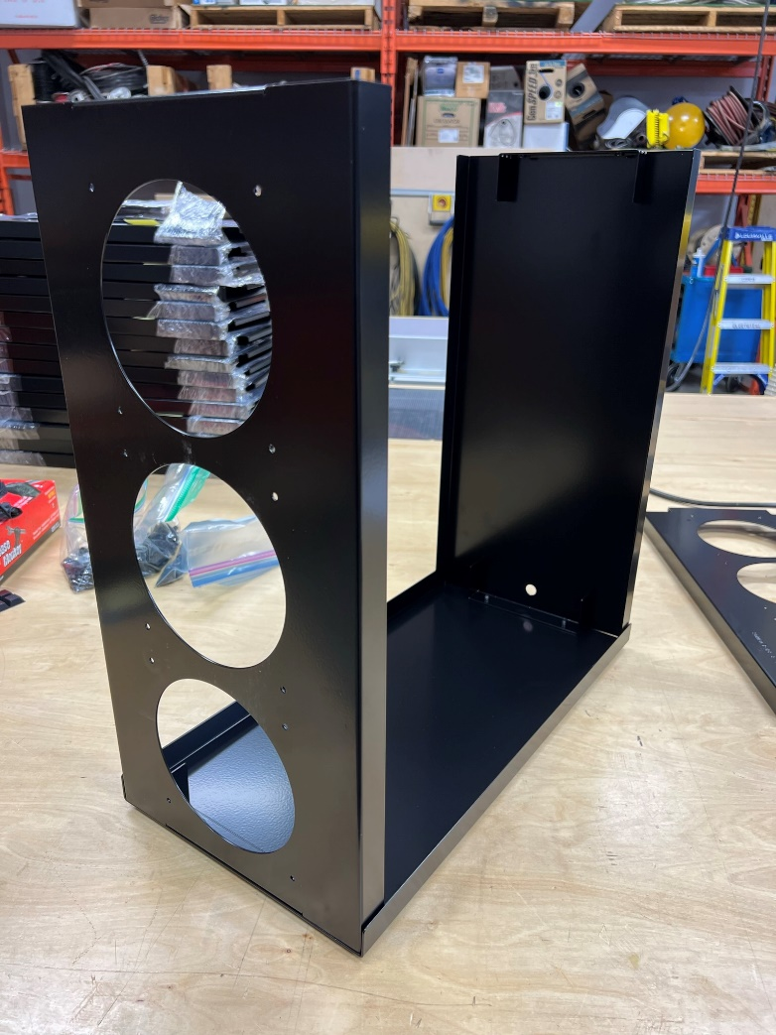
IMAGE 16

- Locate the 20”x20”x2” filters and filter covers (image 17).
  - Check the orientation of the filters, indicated by an arrow on the filters (see image 18).
  - Slide both the filter & filter cover down into the frame between the panel and the interior tabs. It’s a snug fit; make sure no wires are pinched by the air filters.
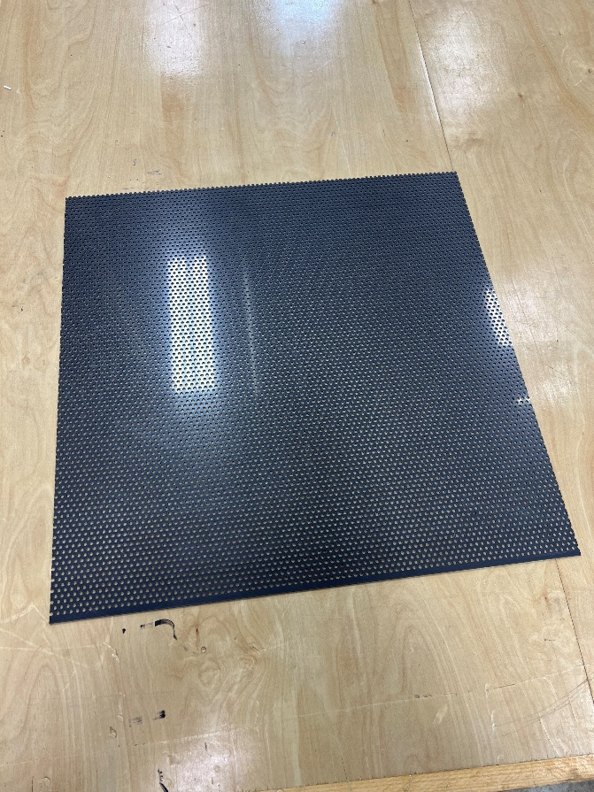
IMAGE 17: Filter Cover

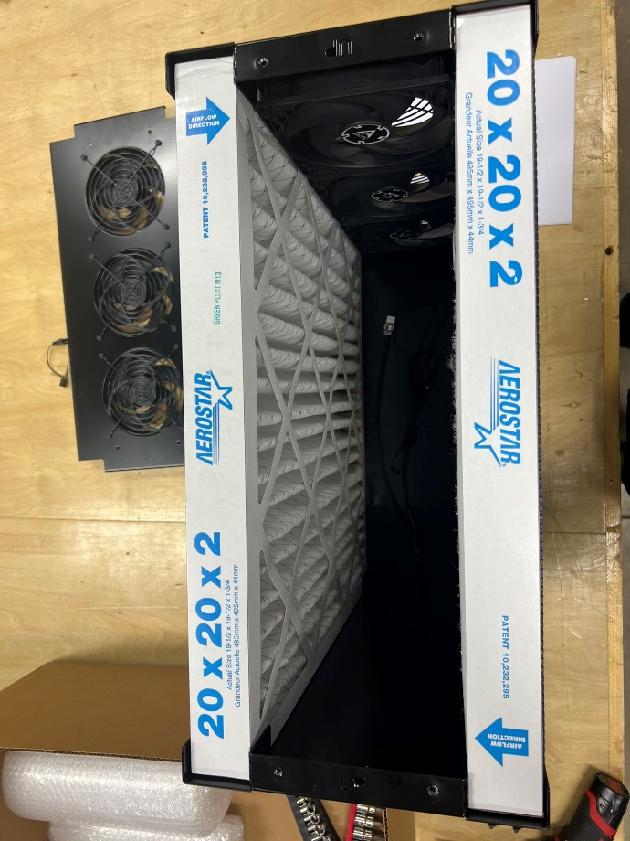
IMAGE 18: Arrows pointing towards the center of the filter unit

- Attach the female end of the extension cable to the male end of the last top fan and secure the top panel.

- Attach the appropriately rated power supply to the box, plug it in, and ensure all the fans are operational and blowing out.

