Sign Speaks
Shravani Kumbhar¹, Nandini Babar², Ayush Patil³ , Prof. M. A. Pardesi⁴
UG Students ^{[1,2,3]}, Associate Professor⁴, Dept. of CSE., D. Y. Patil College of Engineering and Technology, Kolhapur, Maharashtra, India

ABSTRACT: Deaf people and non-sign language users are handicapped in daily communication as there is a communication barrier. Sign Speaks is a new web-based software that tries to shatter this barrier by translating sign language movements into text. The technology uses computer vision and machine learning algorithms to recognize hand movements and translate them into the equivalent text in real time. The project consists of a frontend that users make sign language gestures on, which are recorded through the webcam. The backend is a deep learning model-based processing of the gestures and translates them into text form. The output is presented as readable text on the web application.
The project offers a simple and effective means to communicate for deaf and mute people, promoting inclusivity in social and business settings. The future development can include assistance for multilingual usage, voice synthesis of spoken responses, and accessibility to other assistive technologies.

KEYWORDS: Sign Language Recognition; Gesture to Text Conversion; Deaf and Mute Accessibility.
- Introduction
With the advanced technology in the modern world, communication is not only important but also crucial, but sign language users are sometimes hindered in communicating with others who do not know sign language. Sign Speaks is a groundbreaking and interactive platform that does away with this obstacle by translating sign language movements into texts real-time. The platform uses cutting-edge computer vision and deep learning technology to accurately recognize and interpret the hand movements to make communication inclusive and accessible.
Designed to provide greater interaction between sign language users and the general public, Sign Speaks provides individuals with the ability to perform gestures that are captured through a webcam and recognized through intelligent recognition algorithms. These gestures are subsequently interpreted into semantic text and read off an intuitive interface. This real-time translation provides seamless and easy communication without the necessity of an interpreter or previous knowledge of sign language.
Contrary to conventional sign language interpreting practices, Sign Speaks is an active, independent solution providing access to numerous social and work environments. Through ongoing learning and possible integrations like multilingual support and voice synthesis, the platform is a revolutionary tool for promoting inclusivity and empowerment of users dependent on sign language for everyday communication.
- Related work
Researchers proposed a deep learning architecture for sign language recognition based on CNNs to translate hand gestures into text. The research established that real-time gesture recognition enabled communication for deaf and mute people. A computer vision solution was investigated, where gestures were identified by webcams and categorized by neural networks, increasing accuracy by tracking movement.
A live feedback learning environment was created to enhance sign language recognition. Both sign-to-text and text-to-sign translation was supported by a two-way system to facilitate multi-modal communication. A model using datasets used large-scale hand gesture datasets to achieve higher accuracy, and a mobile interpreter facilitated real-time gesture translation with smartphone cameras to provide accessibility.
III. PROPOSED SYSTEM
  - Technology Stack and Core Features :

✅ Technology Stack:
- Flutter will be utilized to develop a cross-platform web and mobile application.
- Firebase will be used for user authentication, data storage, and tracking learning progress separately.
- OpenCV & MediaPipe will be employed to detect live hand gestures.
- TensorFlow/PyTorch will be utilized for sign language recognition through deep learning.
- Natural Language Processing (NLP) will be employed to improve sentence construction and context understanding.
- Integration of Text-to-Speech (TTS) will support an audio output mode for improved accessibility.

✅ Core Features:
- Real-time sign language detection through computer vision and deep learning.
- Interactive visual feedback with text and gestures corresponding to recognized gestures.
- Monitoring user progress to measure improvement and recommend customized learning paths.
- Sign language adaptive training to enable users to practice and build communication skills.
- Support for multiple languages for a number of sign languages (ASL, ISL, BSL, etc.).

  - Learning Methodology and Interactive Features

The objective of Sign Speaks is enhanced learning and communication by means of real-time interactive gesture detection, exercise-based instructions, and adaptive learning paths. The system will carry out three steps:

Step 1: Interactive Gesture Recognition

- The system will use real-time computer vision to detect hand movement and gestures.
- Users are able to interact with visual representations of how various signs are detected.
- Variations and complexities in signs will be shown in real-time to better understand.

A step-by-step execution mode will provide users with feedback on how their gestures are being interpreted.

Step 2: Adaptive Quiz and Exercise Selection

- For learning to be effective, the system will have a quiz and gesture exercise system.
- Each exercise will be associated with a particular sign, exercising areas of weakness.
- Difficulty levels will be customized by user performance, rising in difficulty steps.

A systematic tracking system will suggest the next steps for learning based on user progress.
- Working
A. User Authentication & Dashboard
✅ The users can signup/login through Firebase authentication for secure access.
✅ The dashboard shows:
- Recognized sign history
- Progress in learning and practice modules
- Personalized improvement recommendations

B. Structured Sign Language Learning Syllabus
✅ The app offers a structured syllabus for:
Alphabet signs (A-Z) and number signs (0-9)
Frequent phrases (e.g., "Hello", "Thank You", "Help")
Sentence construction using sign sequences
✅ Each subject has explanations, hand gesture drawings, and interactive learning tools.

C. Interactive Gesture Recognition & Visualization
✅ Users can interact with live gesture recognition models via a camera.
✅ The system offers:
- Step-by-step hand movement animation for every sign.
- Correct/incorrect gesture visual feedback.
- Live OpenCV and MediaPipe gesture tracking.

D. Quiz & Practice Modules
✅ Every topic has quizzes and practice exercises to confirm user understanding:
- MCQs on sign meaning and usage.
- Real-time feedback hand gesture practice exercises.
- Adaptive difficulty levels based on performance to maximize learning.

E. User Progress Tracking & Performance Analysis
✅ Firebase stores the user performance metrics, including:
- Signs detected and accuracy percentage.
- Practice modules and quizzes completed.
- Weak areas detected and recommended improvement courses.
✅ Personalized learning recommendations are provided to students based on performance.

F. Firebase Integration to Save Data
✅ Users' data, progress, and sign recognition history are saved securely in Firebase Firestore.
✅ Real-time synchronization enables users to see their progress across different devices.

G. Admin Panel to Manage Content
✅ Admins can:
- Track user performance and activity.
- Manage and update sign language content.
- Track trends to improve learning experience.

- uml diagrams

Fig 1. Flow chart

Fig 1. Flow Chart

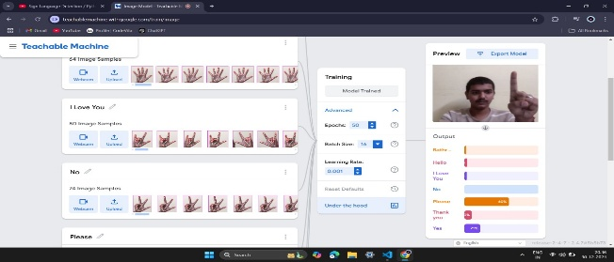
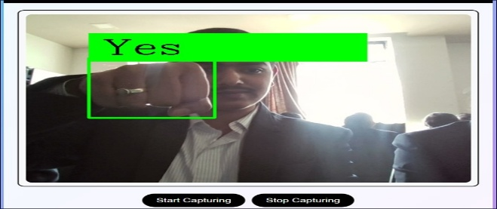
- results
Fig 2. Output Page Fig 3. Data Insertion Page

- Conclusion and Future Work
Sign Speaks Project operates on theme in which Sign language is translated into text. The project assists dumb and deaf individuals. Translating sign language into text is a new approach that facilitates communication for the deaf and mute community. Researchers have come up with models that can recognize hand movements and translate them into readable text through the use of deep learning algorithms and computer vision. Other studies note the applicability of Convolutional Neural Networks (CNNs) and gesture recognition in real-time towards higher accuracy and use. However, issues like accommodating continuous signing and regional differences continue to be areas of concern.
In the future, Sign Speaks can be enhanced by enabling support for additional sign languages, improving gesture recognition accuracy with AI updates, and adding a cloud-based learning module for customized training. Offline mode, user-able gesture addition, real-time collaboration between sign language learners, and support with assistive communication devices are some aspects that can be utilized in enabling greater accessibility. All of these enhancements will turn Sign Speaks into an even more intelligent and efficient tool for hassle-free communication.

References

Research Papers
- Sign Language to Text Conversion in Real Time using Transfer Learning
- Transforming Sign Language into Text and Speech through Deep Learning

Technological Insights
1. Sign Language Recognition (Wikipedia)
2. SignWriting (Wikipedia).

