1. Abstract
As global energy demand rises and the push for decarbonization intensifies, wind energy has emerged as a critical player in the renewable energy landscape. While modern wind turbines are often designed for variable-speed operation, fixed-speed systems remain relevant due to their mechanical simplicity, cost-effectiveness, and reliability due in specific grid or rural applications. This paper presents a customizable design technique for optimizing a 100-kW fixed-speed wind turbine system, using a rotor diameter and gear ratio as the primary design parameters. With a fixed pitch angle of 2.2 degrees, the objective is to maximize the power production by tailoring the turbine configuration to specific wind conditions.
The novelty of this approach lies in its adaptability. Rather than designing a one-size-fits-all solution, the methodology used wind data from the National Renewable Energy Laboratory, or NREL to fine-tune the system for certain environments. The turbine is modeled and simulated using a MATLAB-based script and performance outcomes are evaluated.
Simulation results show that the design that produced the best achievable outcome used a rotor diameter of 18.55 meters and a gear ratio of 22. The total energy produced by these selections is around 2.13 gigawatts. These results demonstrate that a strategic change of rotor diameter and gear ratio would lead to significant improvements in energy capture compared to the baseline configurations.

2. Introduction
As the population continues to increase, and as we proceed with our perusement of the advancements in technology, the global demand for energy consumption increases. The intensification surrounding environmental sustainability and climate change has increased significantly, since renewable sources have become a critical area of focus. In 2023, renewable sources accounted for nearly 40% of global electricity generation, marking the first time since the 1940s that clean energy sources met such a substantial portion of electricity demand. This milestone was driven primarily by rapid expansions in solar and wind capacities, with solar power alone increasing by 29% and wind contributing just over 8% to the global electricity mix [1]. Wind energy is one of the fastest growing sources of electrical generation. It offers a clean, sustainable, and increasingly cost-effective alternative to fossil fuels. Wind power also contributes significantly to reducing greenhouse gas emissions and dependence on non-renewable sources [2].
The International Energy Agency, or IEA, reports that wind energy, both onshore and offshore, is expected to account for over 25% of electricity generation in several regions by 2030 [3]. Not only is this shift driven by environmental urgency, but also by economic competitiveness. In many areas, wind energy is now cheaper than new fossil fuel generation projects [4]. However, to sustain this trajectory and further reduce the cost of energy, it is essential to continue optimizing the design and performance of wind turbines. The environmental impact of wind turbines promotes sustainability. The trade-offs between structural performance, cost, and environmental impact are examined to guide the designer towards a sustainable alternative. Ultimately, an optimal design technique can be implemented and used to automate turbine tower designs [5].
Fixed-speed wind turbines, while less complex and more robust compared to variable-speed turbines, require precise tuning to operate efficiently under varying wind conditions. The turbine’s rotor diameter and gear ratio are two of the most critical design parameters, as these factors directly impact the ability of the turbine to capture wind energy and convert it to mechanical and subsequently electrical energy. Optimizing these parameters helps in increasing the energy output while keeping the system mechanically simple and economically viable [6].
Many studies have investigated the use of optimization techniques in wind turbine designs. Methods such as generic algorithms, gradient-based optimization, and surrogate modeling have been employed to improve the aerodynamic efficiency of blades, control strategies, and mechanical configurations [7]. With the idea of balancing conflicting goals such as maximizing power output while minimizing structural stress and/or cost, in particular, multi-objective optimization has gained some traction [8]. These approaches have been shown to significantly enhance turbine performance, especially when applied in a site-specific context [9].
3. Methodology
This study employs a multidisciplinary modeling and optimization framework to analyze and enhance the performance of a horizontal-axis wind turbine (HAWT) system. The methodology builds upon the system-level design approaches established by Hall and Chen [10, 11], integrating aerodynamic, structural, and control subsystems into a unified simulation environment. The primary goal is to maximize power extraction while ensuring structural and operational feasibility.

3.1 System Modeling
The turbine system is modeled using a quasi-steady-state approach, where aerodynamic forces are calculated based on blade element momentum (BEM) theory. Key geometric parameters such as rotor diameter, blade pitch angle, and tip speed ratio are used to compute the power coefficient (Cp​) via the empirical model presented in [13], which accounts for blade twist and dynamic stall effects.
The drivetrain is represented as a lumped-parameter system, with gear ratio (GR) treated as a variable influencing both the tip-speed velocity and generator performance. The relationship between rotor and generator speeds follows the formulation established in [10], and the effective blade-tip speed (​) is computed using:
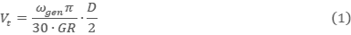

where is the generator speed, and D is the rotor diameter.

3.2 Power Curve Simulation
Wind speed data (Vw​) is imported from pre-processed datasets and used to calculate the tip-speed ratio (λ=Vt/Vw) The corresponding Cp​ values are obtained using a modified Heier formulation [13], incorporating both pitch and twist control effects. The instantaneous power output is then computed as:
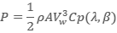 (2)
where is air density, A is the swept area, and is the blade pitch angle.

3.3 Optimization Strategy
To identify optimal system parameters, a parametric sweep is conducted over a range of gear ratios and pitch angles. Performance metrics such as maximum power output, rated wind speed, and area under the power curve are calculated to evaluate design trade-offs. The method aligns with the variable-ratio gearbox design approach described by Nejadkhaki et al. [16, 17], aiming to balance power production with structural stress mitigation.

3.4 Design Validation
The proposed design methodology is validated against existing analytical models and compared with benchmarks from the literature [12, 14, 15]. Additionally, a sensitivity analysis is performed to assess the robustness of the design under varying environmental conditions and operational constraints, in accordance with design frameworks for future turbine systems [20, 21].

4. Results and Discussion
The optimization process identified a configuration with a rotor diameter of 18.55 meters and a gear ratio of 22 as the most effective for maximizing power production. This setup resulted in a total energy output of approximately 2.13 gigawatts over the duration of the NREL dataset, compared to a theoretical maximum of 11.03 gigawatts. This corresponds to a performance efficiency of around 19.3%, which, while seemingly modest, is indicative of the challenges posed by wind intermittency and fixed-speed operation constraints.
Figure 1 illustrates wind speed recordings taken every 10 minutes over a three-year period at the test site. The data show high temporal variability, ranging from below the cut-in speed (~3 m/s) to peak speeds exceeding 20 m/s. This volatility emphasizes the difficulty in maintaining optimal turbine performance under natural wind conditions, especially with fixed-speed systems that lack the flexibility to adapt in real-time.
A closer inspection in Figure 2, showing about 30 continuous hours of wind speed readings, reveals a drop from nearly 20 m/s to below cut-in speed in just a few hours. This dramatic swing exemplifies why a static system must be carefully tuned to respond well to the average conditions, as it cannot chase fluctuating extremes.
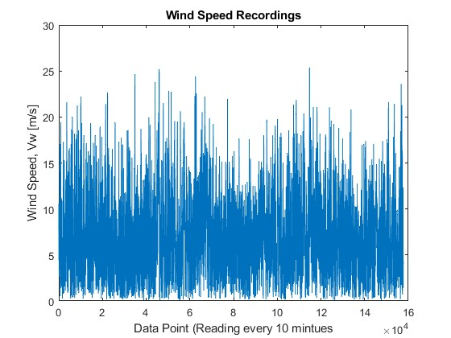
Figure 1: Wind Speed recordings taken every 10 minutes over a three year period.
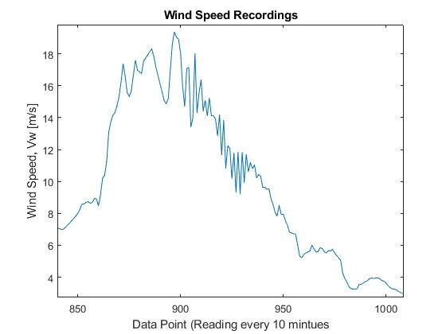
Figure 2: Data Recordings from a ~30 hour period, shows the wind speed range fluctuates greatly, highlighting the need for efficient maximum power production at any wind speed between cut in and cut out speeds.
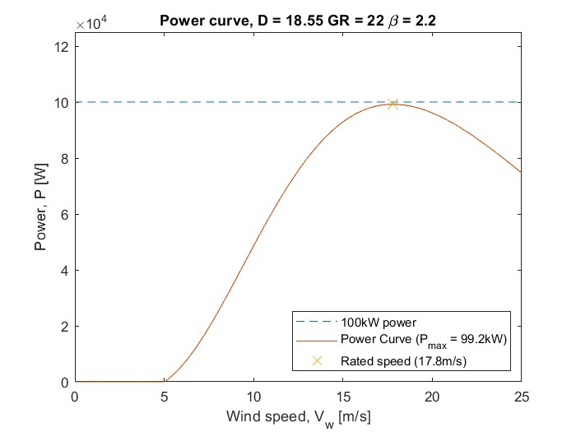
Figure 3: Power curve with lines for each data point from the NREL wind speed data. Indicates at 17.8 m/s the turbine produces the most power it can at 99.2kW.
Figure 3 presents the turbine's power curve and highlights that the rated power of 99.2 kW is achieved at a wind speed of 17.8 m/s. Beyond this point, power output begins to decline as the rotor spins faster than the generator can effectively utilize, leading to overspeed losses and system damping. This illustrates a key limitation of fixed-speed systems: an inability to modulate generator torque or blade angle in response to overspeed, leading to suboptimal performance at high wind velocities.
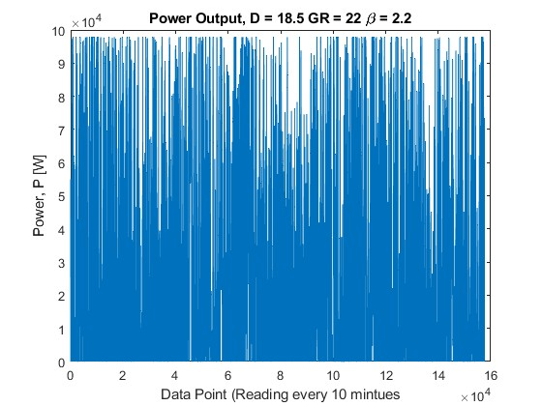
Figure 4: Power Output of optimized wind turbine for each of the individual wind speeds recorded. Summing up to a total power of 2.13 Gigawatts
The actual energy generation at each data point, as shown in Figure 4, reveals that while the turbine performs effectively within the rated wind range, significant potential energy is lost during periods of under- or over-performance. The 2.13 GWh total is substantial, but as shown by the gap between this and the theoretical maximum, over 80% of the potential energy remains untapped. This highlights opportunities for improvement via either:
- A Variable Ratio Gearbox (VRG) that dynamically adjusts drivetrain characteristics,
- Or adaptive morphing blades that can shift geometry in response to real-time conditions.
While fixed-speed systems offer simplicity, lower maintenance, and cost savings, they also face fundamental limitations in fluctuating wind environments. Thus, the optimized design shown here offers a well-tuned compromise, maximizing output under a fixed system architecture.
The study also reinforces the value of site-specific optimization. Generic turbine designs may not perform efficiently across diverse wind profiles, whereas customizing parameters such as rotor diameter and gear ratio to local wind data, like the NREL dataset used here, can lead to substantial performance improvements.
5. Conclusion
This study focused on optimizing the performance of a 100-kW fixed-speed wind turbine by adjusting two critical design parameters: rotor diameter and gear ratio. With a fixed pitch angle of 2.2 degrees, the goal was to maximize energy output across a wide range of wind conditions using a customizable, data-driven simulation approach. Wind data sourced from the National Renewable Energy Laboratory (NREL) [2] enabled high-resolution, site-specific performance modeling over a three-year period.
The optimized design, featuring an 18.55-meter rotor diameter and a gear ratio of 22, produced a total of 2.13 GWh of energy. While this accounts for just under 20% of the theoretically available wind energy, the results demonstrate that performance can be significantly improved even within the structural and operational constraints of a fixed-speed system. These findings align with the goals of cost-effective and robust system design highlighted in previous research [4], [6].
This work is particularly applicable to rural and isolated grid applications, where mechanical simplicity, low maintenance, and high reliability are more important than maximizing efficiency [4]. Fixed-speed systems, though gradually being supplanted by variable-speed counterparts in large-scale installations, remain relevant in niche contexts when paired with localized optimization strategies [9].
Nonetheless, the inherent limitations of fixed-speed systems, especially their inability to adapt to rapid wind fluctuations, point to potential future enhancements. Future research could investigate:
- Variable gear ratio (VGR) drivetrains, as explored in [10], [16], which dynamically adjust mechanical transfer functions to maximize energy capture.
- Adaptive or morphing blades that respond to real-time wind flow, as outlined in [13], [15], [17].
- Active pitch control systems and smart control architectures to extend the turbine's performance envelope beyond the rated speed [12].
- Machine learning-based optimization algorithms, which may improve system responsiveness and efficiency in real-world scenarios [8], [21].
- Physical prototyping and field validation, as recommended in turbine development frameworks [19], [20].
Ultimately, this study contributes a scalable, site-specific design methodology for fixed-speed wind turbines, supporting the global transition toward cleaner and more accessible renewable energy solutions. As wind energy continues to expand its role in the energy mix [1], [3], these adaptive approaches will be essential in delivering sustainable and context-sensitive technologies.

References
1. Ambrose, Jillian. “Clean Energy Powered 40% of Global Electricity in 2024, Report Finds.” The Guardian, April 7, 2025.
2. Iea. “Renewables 2023 – Analysis.” IEA, January 2024.
3. IRENA (2023), Renewable power generation costs in 2022, International Renewable Energy Agency, Abu Dhabi.
4. Youssef, Erhab, and Adel El Samhey. Fixed-Speed Wind Energy Conversion System, 2016.
5. Stratton, D., Martino, D., Pasquali, F. M., Lewis, K., and Hall, J. F. (May 12, 2016). "A Design Framework for Optimizing the Mechanical Performance, Cost, and Environmental Impact of a Wind Turbine Tower." ASME. J. Sol. Energy Eng. August 2016; 138(4): 041008.
6. Flores-Arias, Jose-Maria, Manuel Ortiz-Lopez, Francisco J. Quiles Latorre, Francisco Jose Bellido-Outeiriño, and Antonio Moreno-Muñoz. 2019. "A Memory-Efficient True-RMS Estimator in a Limited-Resources Hardware" Energies 12, no. 9: 1699.
7. Janczura, Joanna, and Aleksandra Michalak. 2020. "Optimization of Electric Energy Sales Strategy Based on Probabilistic Forecasts" Energies 13, no. 5: 1045.
8. Z. Ghasemi, P. Cohen, et al. “Management and Estimation of Thermal Comfort, Carbon Dioxide Emission and Economic Growth by Support Vector Machine.” Renewable and Sustainable Energy Reviews, July 6, 2016.
9. K. Maki, S. Chowdhury, S. Pookpunt, S. Rajakumar, et al. “Site Specific Optimization of Wind Turbines Energy Cost: Iterative Approach.” Energy Conversion and Management, May 18, 2013.
10. Hall, J. F., and D. Chen. "Dynamic Optimization of Drivetrain Gear Ratio to Maximize Wind Turbine Power Generation-Part 1: System Model and Control Framework." Journal of Dynamic Systems, Measurement and Control 135 (2012).
11. Hall, J. F., and D. Chen. "Dynamic Optimization of Drivetrain Gear Ratio to Maximize Wind Turbine Power Generation-Part 2: Control Optimization." Journal of Dynamic Systems, Measurement and Control 135 (2012).
12. Hall, J. F., D. Palejiya, M. L. Shaltout, and D. Chen. "An Integrated Control and Design Framework for Optimizing Energy Capture and Component Life for a Wind Turbine Variable Ratio Gearbox." Journal of Solar Energy Engineering 137, no. 2 (Apr. 2015): 021022.
13. Nejadkhaki, H. K., A. Sohrabi, T. P. Purandare, F. Battaglia, and J. F. Hall. "A Variable Twist Blade for Horizontal Axis Wind Turbines: Modeling and Analysis." Energy Conversion and Management 248 (Nov. 2021): 114771.
14. Stratton, D., D. Martino, F. M. Pasquali, K. Lewis, and J. F. Hall. "A Design Framework for Optimizing the Mechanical Performance, Cost, and Environmental Impact of a Wind Turbine Tower." Journal of Solar Energy Engineering 138, no. 4 (Aug. 2016): 041008.
15. Nejadkhaki, H. K., and J. F. Hall. "Modeling and Design Method for an Adaptive Wind Turbine Blade with Out-of-Plane Twist." Journal of Solar Energy Engineering 140, no. 5 (Oct. 2018): 051010.
16. Nejadkhaki, H. K., S. Chaudhari, and J. F. Hall. "A Design Methodology for Selecting Ratios for a Variable Ratio Gearbox Used in a Wind Turbine with Active Blades." Renewable Energy 118 (Apr. 2018): 1041–1051.
17. Nejadkhaki, H. K., A. Lall, and J. F. Hall. "A Methodology to Synthesize Gearbox and Control Design for Increased Power Production and Blade Root Stress Mitigation in a Small Wind Turbine." Journal of Mechanical Design 139, no. 8 (Aug. 2017): 081404.
18. Elavarasan, R. M., S. Afridhis, R. R. Vijayaraghavan, U. Subramaniam, and M. Nurunnabi. "SWOT Analysis: A Framework for Comprehensive Evaluation of Drivers and Barriers for Renewable Energy Development in Significant Countries." Energy Reports 6 (2020): 1838–1864.
19. Veers, Paul, Carlo L. Bottasso, Lance Manuel, Jonathan Naughton, Lucy Pao, Joshua Paquette, Amy Robertson, et al. "Grand Challenges in the Design, Manufacture, and Operation of Future Wind Turbine Systems." Wind Energy Science 8, no. 7 (2023): 1071–1131.
20. Olabi, A. G., T. Wilberforce, K. Elsaid, T. Salameh, E. T. Sayed, K. S. Husain, and M. A. Abdelkareem. "Selection Guidelines for Wind Energy Technologies." Energies 14, no. 11 (2021): 3244.
21. Balasubramanian, K., S. B. Thanikanti, U. Subramaniam, and S. Sichilalu. "A Novel Review on Optimization Techniques Used in Wind Farm Modelling." Renewable Energy Focus 35 (2020): 84–96.

