SPATIAL ANALYSIS OF OIL AND GAS FACILITIES FOR SENSITIVE INDEX MAPPING IN EMERGENCY RESPONSE MANAGEMENT.
Seigha Tukoroa;¹ Christopher Onosemuode;¹ Mordecai Oweibia²

¹Department Of Environmental Management and Toxicology, College of Science, Federal University of Petroleum Resources, Effurun
²Department of Public Health, Bayelsa Medical University, Yenagoa.

Corresponding Author
Mordecai Oweibia FRSPH, FAIPH.
Department of Public Health, Bayelsa Medical University, Yenagoa
moweibia@gmail.com | +23408168220173

Abstract
This study employs geospatial techniques to evaluate the distribution of oil and gas facilities in Bayelsa State, Nigeria, and their relationship to emergency response infrastructure. Using a comprehensive spatial analysis framework, the research examined facility clustering patterns, emergency resource distribution, response times, and environmental vulnerabilities to assess preparedness for industrial incidents. Statistical analysis revealed a significant clustering of oil infrastructure (nearest neighbor ratio: 0.9487, p-value: 0.677) that does not correspond with emergency resource distribution, creating critical response gaps. Only 14 emergency facilities were identified within 1km of oil assets, with diminishing coverage at greater distances. Network analysis demonstrated concerning response times, with the best route between key facilities requiring 3 hours 20 minutes to traverse 120.59km. The research also identified substantial geographical impediments to effective emergency response, including complex terrain, proximity of infrastructure to settlements, and hydrological vulnerabilities that could accelerate contaminant dispersion. Based on these findings, the study proposes strategic interventions including redistribution of emergency resources, infrastructure improvements, zonal response strategies, community-based first response capabilities, and implementation of a GIS-based decision support system. These recommendations address the fundamental spatial misalignment between risk distribution and response capabilities that currently threatens public safety, environmental integrity, and economic stability in this vital region of Nigeria's petroleum industry.

Key Words: Geospatial | Oil | Emergency | Response | Infrastructure

- INTRODUCTION
Oil and gas exploration in Nigeria began in 1908, with the first commercial discovery at Oloibiri in 1956 (Ogbuigwe, 2018). Today, the sector dominates Nigeria’s economy, contributing over 90% of export earnings and a significant share of government revenue (OPEC, 2020). The Niger Delta - spanning Bayelsa, Rivers, Delta, and other states - hosts the majority of Nigeria’s oil reserves, with over 160 oil fields and 1,481 active wells (NNPC, 2019). Despite its vast natural gas reserves (the largest in Africa), Nigeria struggles to optimize production (BP Statistical Review, 2020).
Bayelsa State, the epicenter of Nigeria’s oil production, holds approximately 30% of the country’s crude deposits (Nwidum & James, 2021). Major fields like Agbami, Bonga, and Forcados contribute over 35% of national output (Odularu, 2020). Yet, the region remains plagued by underdevelopment, environmental degradation, and recurrent oil spills, exacerbating poverty and social unrest (Ordinioha & Brisibe, 2013; Watts, 2019). Efforts to translate oil wealth into sustainable development have largely failed, reflecting systemic governance gaps (Aaron & George, 2010).
Archival data from 2006–2019 reveal alarming trends in the Niger Delta: 7,940 oil spills occurred, with 67% onshore. Sabotage (4,950 cases, 87% onshore) was the leading cause, followed by corrosion (501 cases, 62% onshore) and equipment failure (855 cases, 45% onshore). Notably, 81% of onshore spills were linked to sabotage, while corrosion and equipment failure accounted for only 6% and 7%, respectively.
The Deepwater Horizon disaster (2010) - which spilled 4.9 million barrels, killed 11, and cost $17 billion - highlights the catastrophic consequences of poor emergency response (Robertson & Krauss, 2010; McCrea-Strub et al., 2011). In Nigeria, incidents like the Jesse pipeline fire further expose systemic weaknesses (Ejiba et al., 2016).
Geospatial tools like GIS and remote sensing are critical for mitigating such risks. For example:
- Synthetic Aperture Radar (SAR) enables real-time spill detection (Arellano et al., 2015).
- Network analysis optimizes resource deployment and evacuation routes (Fingas, 2016).
This study addresses gaps in Bayelsa’s emergency preparedness by:
- Mapping oil facility distribution and proximity to transport networks.
- Assessing existing response mechanisms using spatial regression.
- Proposing data-driven strategies to curb sabotage, remediate polluted sites, and prioritize socio-economic development.

2.0. THE STUDY AREA
Bayelsa state lies between latitude 4° 15′ N and 5° 23′ north and longitude 5° 22′ and 6° 45′ east in the Niger Delta region of southern Nigeria (Ejiba et al., 2021). It shares boundaries with Delta State to the north, Rivers State to the east, and is bordered by the Atlantic Ocean to the south and the Gulf of Guinea to the west.
The state covers a total land area of around 11,000 square kilometers with a highly complex terrain composed of tangled networks of creeks, rivers, streams, and islands (Adekola & Mitchell, 2011). Much of Bayelsa's landmass consists of freshwater swamps, lowland rainforests, and mangrove vegetation interspersed by numerous maritime settlements.
Despite relatively low population density, the extensive aquatic ecosystems of the state support a tremendous biodiversity of fish, wildlife, and botanical resources (Fingas, 2016). Decades of widespread petroleum production activities have also left a dense footprint of wells, rigs, flow stations, pipelines, storage hubs, and transportation infrastructure across Bayelsa's challenging deltaic environment.
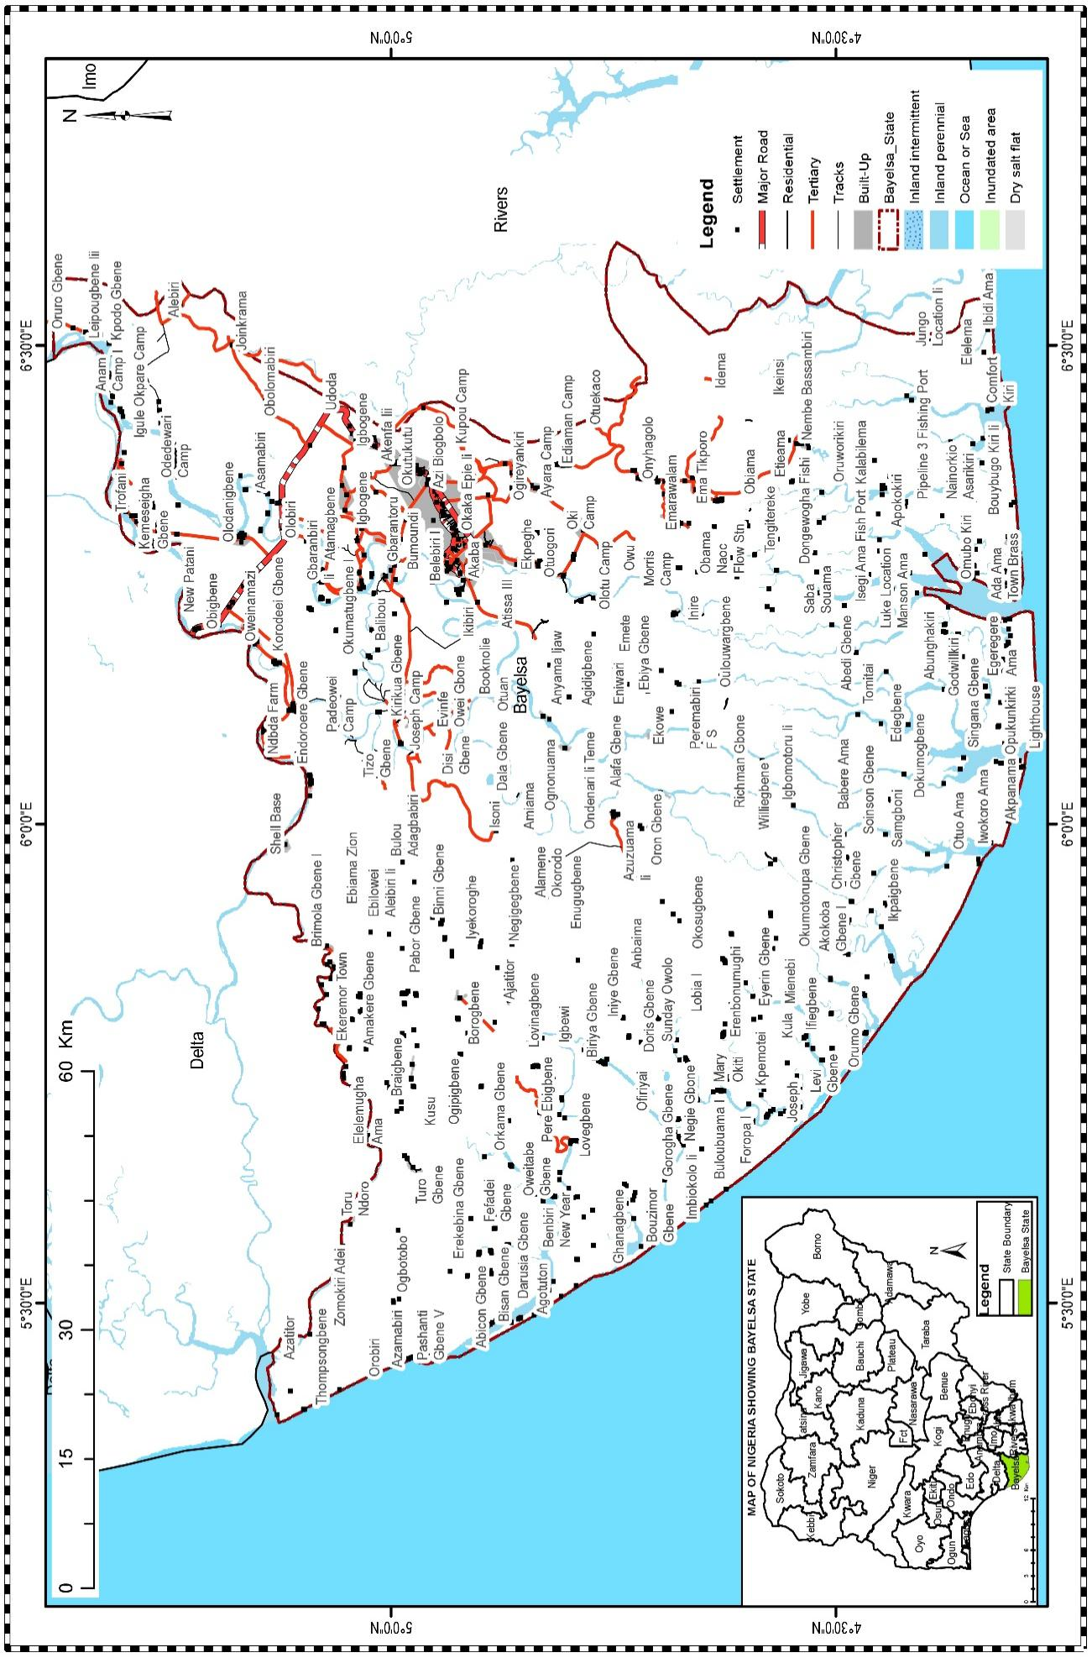
Figure 1: Map of the Study Area (Bayelsa State)
(Source: Bayelsa State Ministry of Land and Survey, 2024).

3.0. MATERIALS AND METHODS
Materials
This study employs an integrated geospatial framework to evaluate emergency preparedness around oil and gas facilities in Bayelsa State, Nigeria. The research leverages multi-source datasets to analyze infrastructure distribution, environmental sensitivities, and response capabilities. Primary data were acquired from governmental and regulatory bodies, including the National Oil Spill Detection and Response Agency (NOSDRA) for oil facility locations, the Bayelsa State Ministry of Transport for road and waterway networks, and the Niger Delta Development Commission (NDDC) for drainage systems. Land cover classifications were derived from 30-meter resolution satellite imagery processed by the Nigerian National Space Research Agency (NASRDA), while the Nigerian Conservation Foundation (NCF) provided maps of ecologically sensitive areas. Emergency response resources were inventoried using records from the Bayelsa State Emergency Management Agency (SEMA). All spatial data were standardized to the WGS 1984 UTM Zone 32N coordinate system to ensure consistency during analysis.

Method
Geospatial processing and analysis were conducted using ArcGIS software. Oil facility locations were validated through GPS surveys covering 15% of sites, with positional accuracy verified against high-resolution basemaps. Transport networks were topologically corrected to enable network analysis, while drainage data were generalized to highlight major watercourses and flood-prone zones. Land cover was reclassified into five categories (forest, wetland, urban, water, and bare soil) using a supervised maximum likelihood algorithm applied to Sentinel-2 imagery. Environmental sensitivity was modeled by integrating proximity to water bodies, protected area status, and land cover fragility, with weights assigned through expert consultation.
Spatial analysis focused on quantifying distribution patterns and accessibility constraints. Kernel density estimation revealed clusters of oil infrastructure, while buffer analysis identified zones where facilities intersected with environmentally sensitive areas or lacked transport connectivity. Network analysis computed travel times from emergency response centers to high-risk facilities, incorporating road conditions and seasonal accessibility constraints. Historical spill data from 2010 to 2023 were analyzed using hotspot detection to identify recurrent incident locations. Statistical modeling employed ordinary least squares regression to test relationships between spill frequency and predictor variables such as facility density, response time, and environmental sensitivity. Model residuals were evaluated for spatial autocorrelation using Moran’s I to ensure robustness.
4.0. RESULTS AND DISCUSSION
The spatial analysis of oil and gas facilities across Bayelsa State revealed significant insights into their distribution patterns. As illustrated in Figure 2, these facilities are widely dispersed throughout the state, with notable concentrations in certain areas. The nearest neighbor analysis produced quantitative evidence of this clustering random pattern with a nearest neighbor ratio of 0.9487 (less than 1), confirming a statistically significant clustered distribution rather than random dispersion. This clustering is further validated by the observed mean distance between facilities (10,156 meters) being lower than the expected random distribution mean distance (10,705 meters), alongside a negative z-score of -0.416 and a high p-value of 0.677.
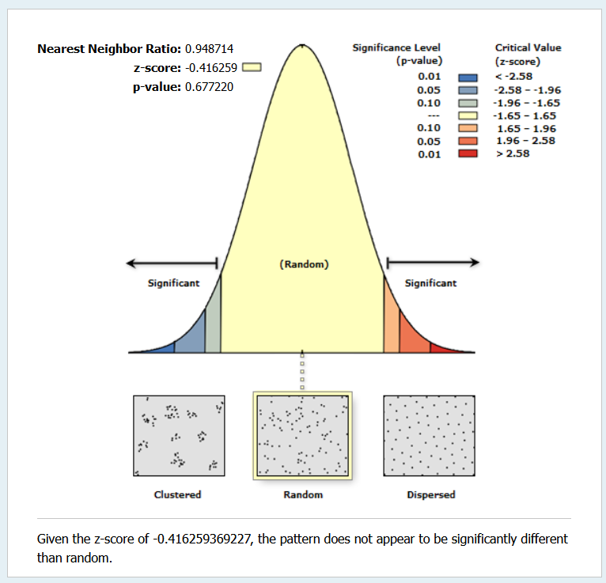 | 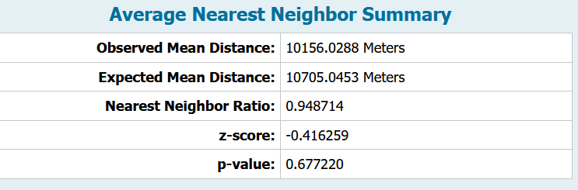
Figure 2: Spatial Distribution of Oil and Gas Facilities

This clustering pattern has profound implications for emergency response planning. The concentration of oil and gas infrastructure in specific zones suggests that geological and operational factors have driven development around promising oil fields and shared processing sites. However, this uneven distribution creates dual challenges: resource overload in high-density areas during emergency incidents, and extended response times for isolated facilities in sparse areas. As Figure 2 demonstrates, the spatial distribution shows clear patterns of infrastructure intensity that must be considered in emergency preparedness strategies.
4.1. Emergency Response Infrastructure: Proximity and Accessibility Analysis
The buffer analysis revealed critical gaps in emergency response coverage across Bayelsa State. Multi-ring buffers at 1km, 5km, 10km, and 15km distances around oil facilities demonstrated varying levels of emergency response accessibility. As shown in Figure 3, these buffer zones highlight areas of particular vulnerability, especially those facilities located beyond immediate response reach.
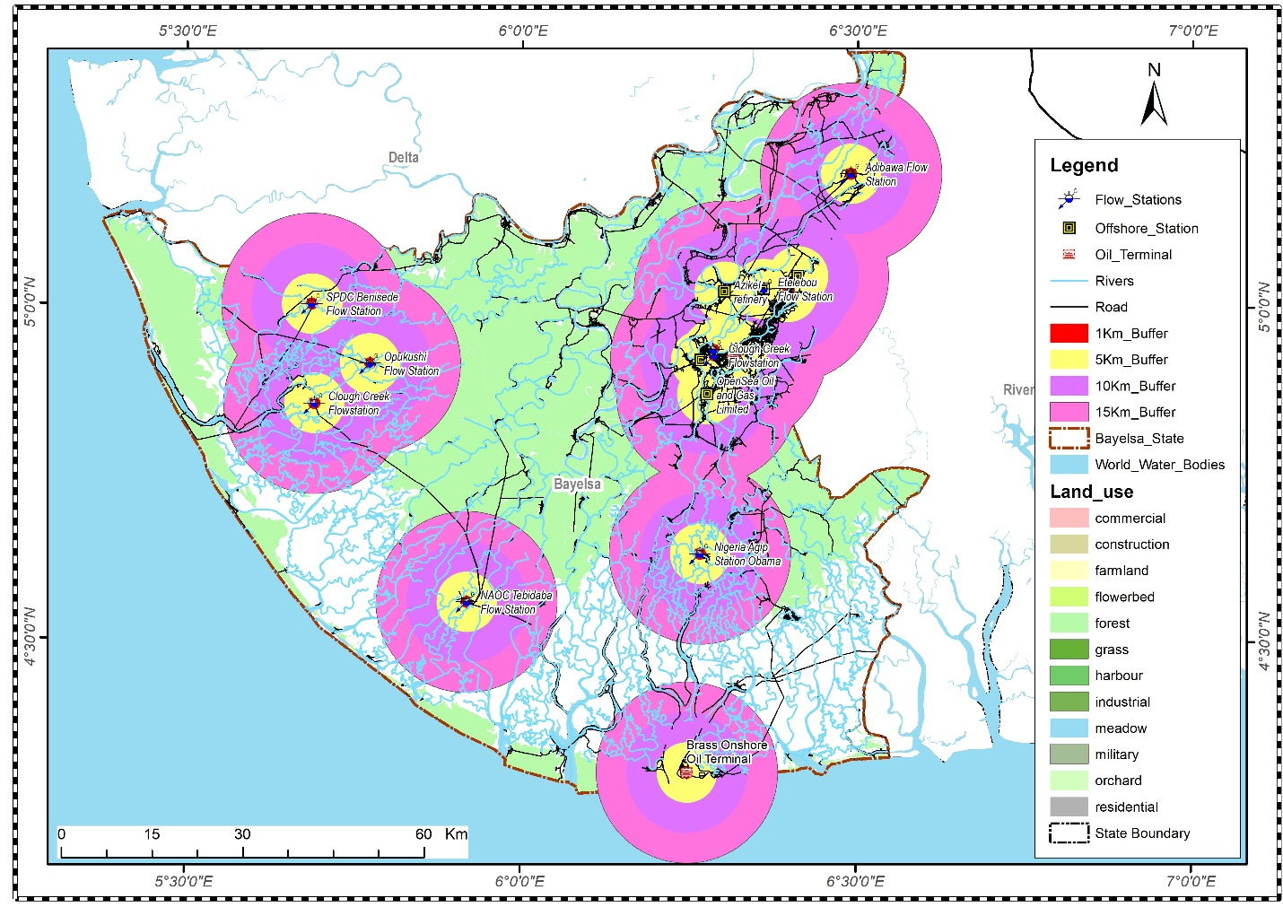Figure 3: Proximity analysis (Buffering)
The quantitative findings from the location query analysis (Table 1) expose concerning disparities in emergency resource distribution:
S/N | Buffer Distance (Km) | Number of Emergency Facility | Actual facility with the Zone
1 | 1 | 14 | 14
2 | 5 | 27 | 13
3 | 10 | 29 | 2
4 | 15 | 29 | 0

This distribution pattern reveals a problematic concentration of emergency resources in areas farther from oil assets, particularly in Yenagoa, as highlighted in Figure 3. Only 14 emergency facilities are situated within the immediate 1km buffer zone, suggesting potentially inadequate rapid response capabilities for nearby oil and gas infrastructure. The concentration increases to 27 (actual facility in this zone is 13) facilities at the 5km buffer, with 29 facilities in both the 10km (actual facility in this zone is 2) and 15km buffer zones (actual facility in this zone is 0). This pattern indicates a geographical mismatch between risk concentration and response capability that requires strategic reconsideration.
4.2. Network Analysis and Response Time Evaluation
The network analysis provided crucial insights into the temporal aspects of emergency response. Using GIS techniques to model transport networks across Bayelsa's challenging terrain, response time estimations were generated for various scenarios. The case study of routes between Opukushi Flow Station and Federal Medical Center exemplifies these challenges:
- Best route: 120.59km with a travel time of 3 hours 20 minutes (Figure 4)
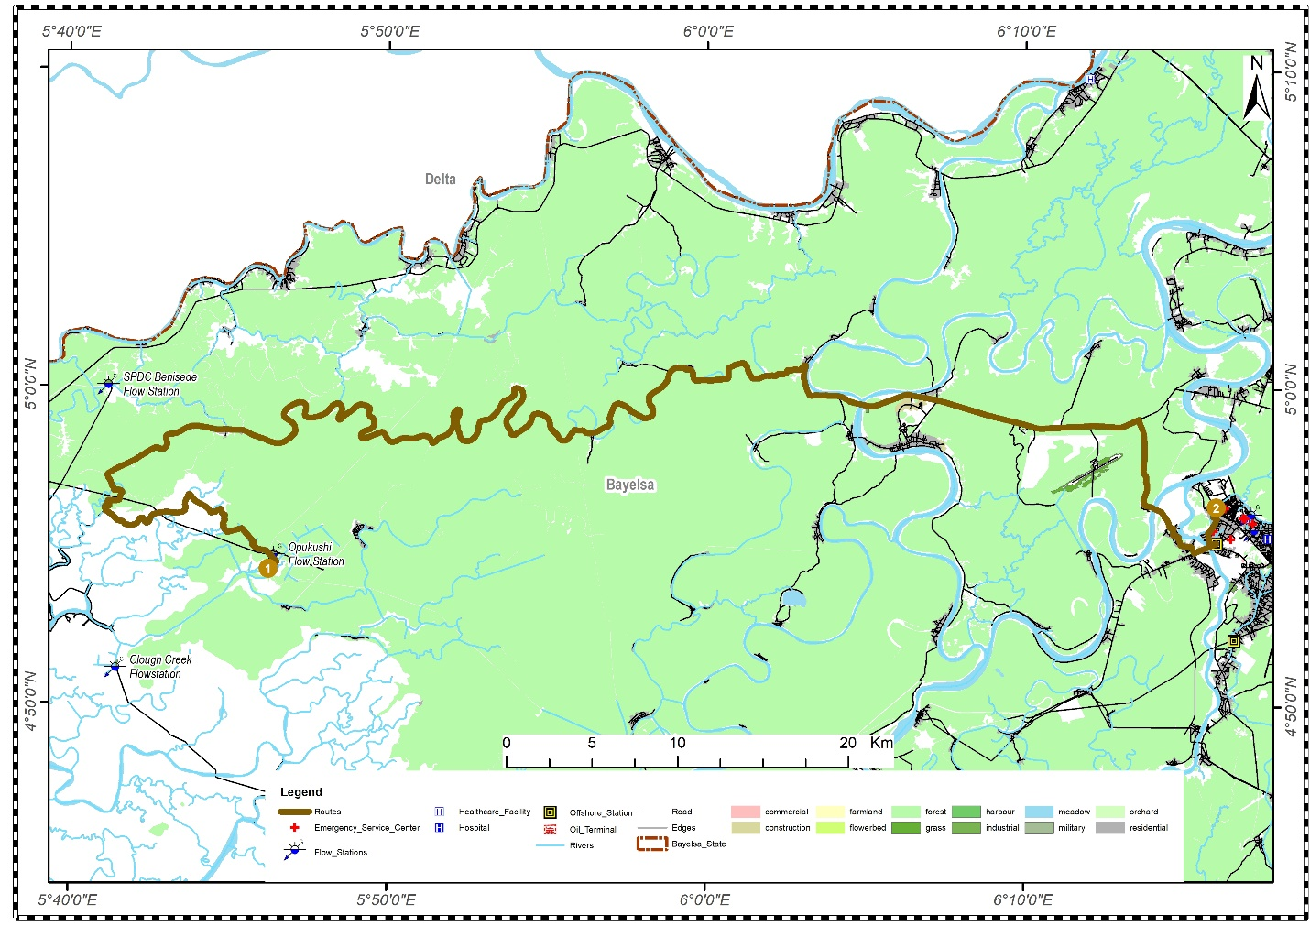 | 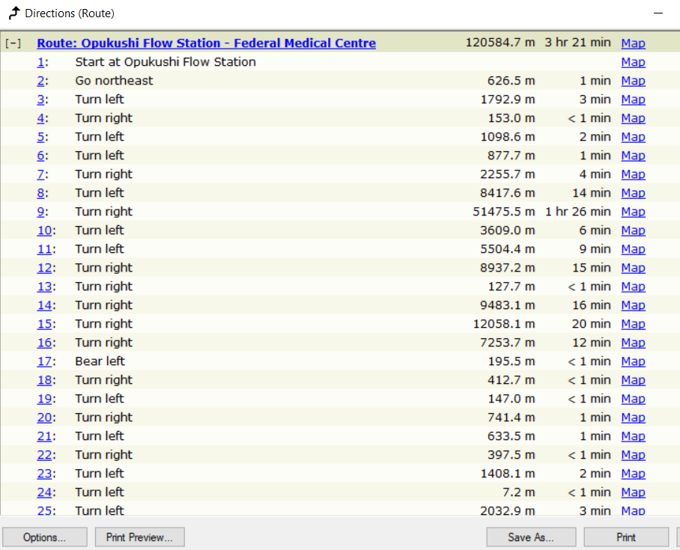
Figure 4: Best Route from Opukushi Flow Station to Federal Medical Center

- Alternate route: 156.10km with a travel time of 4 hours 20 minutes (Figure 5)
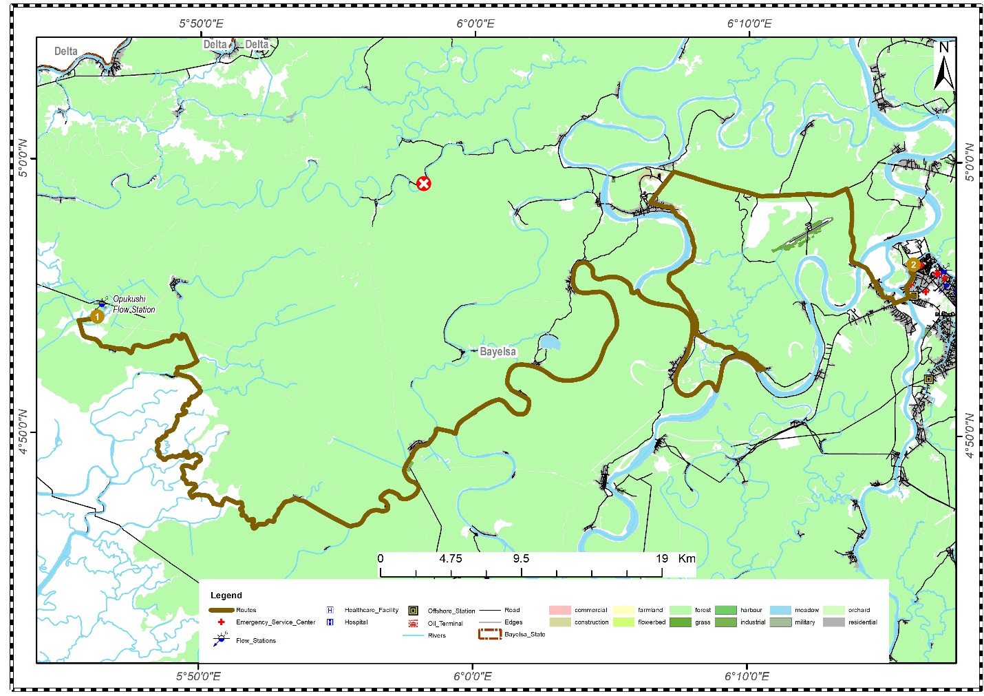 | 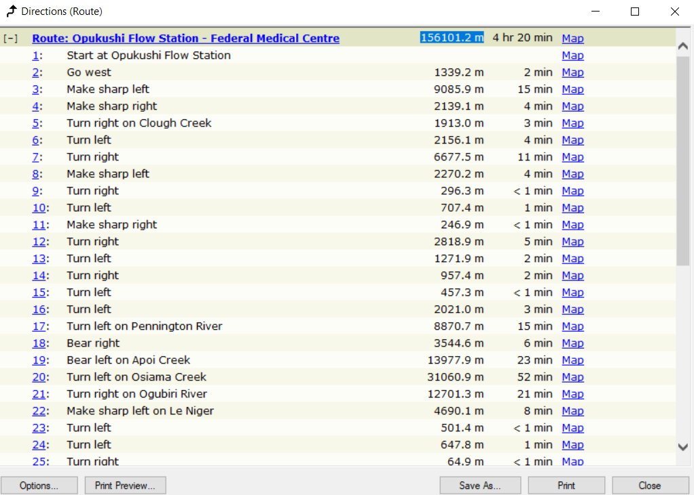
Figure 5: Alternate Route from Opukushi Flow Station to Federal Medical Center
These extended travel times fall well outside the optimal window for effective emergency response in critical situations. The significant distance and time required to reach medical facilities from oil infrastructure locations highlight a serious vulnerability in the current emergency response framework. Such delays could prove catastrophic during incidents requiring immediate medical intervention or containment of hazardous spills.
4.3. Spatial Factors Influencing Emergency Response Efficiency
The research identified multiple geographic and environmental factors that significantly impact emergency response capabilities in Bayelsa State. Land use analysis (Figure 6) demonstrated how varied terrain characteristics - including swampy areas, water crossings, and poor-quality roads -create natural barriers to rapid response. These impediments are particularly challenging during seasonal flooding periods, which can further restrict access to remote oil facilities.
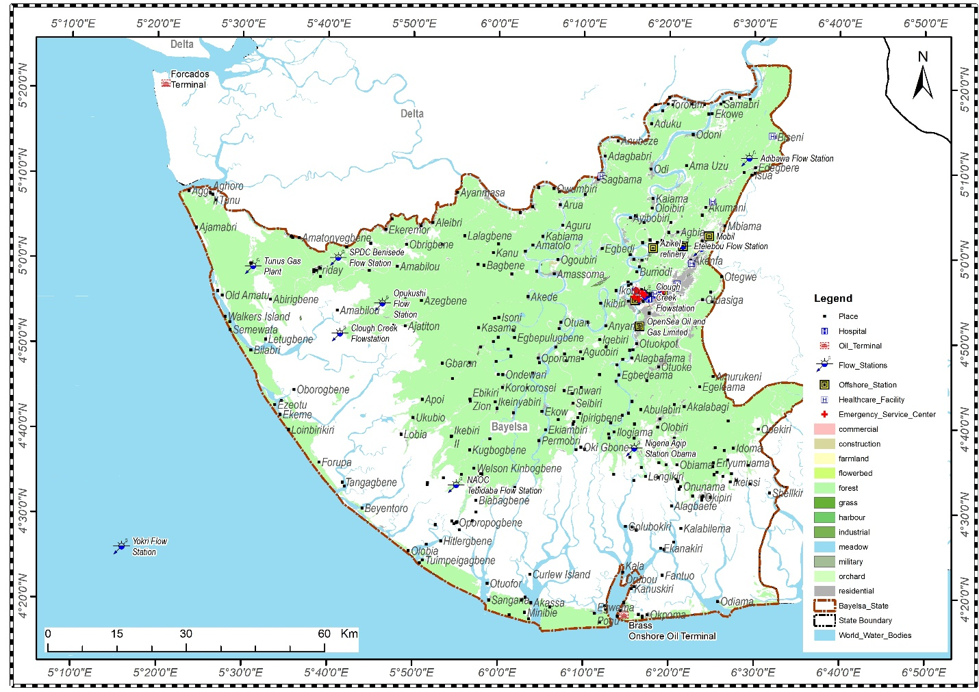
Figure 6: Land use of Bayelsa State
The proximity analysis between oil infrastructure and residential areas (Figure 7) revealed concerning juxtapositions, with numerous facilities positioned within 1km of built-up areas. This close proximity elevates public safety risks during industrial accidents and necessitates specialized contingency planning to protect vulnerable communities.
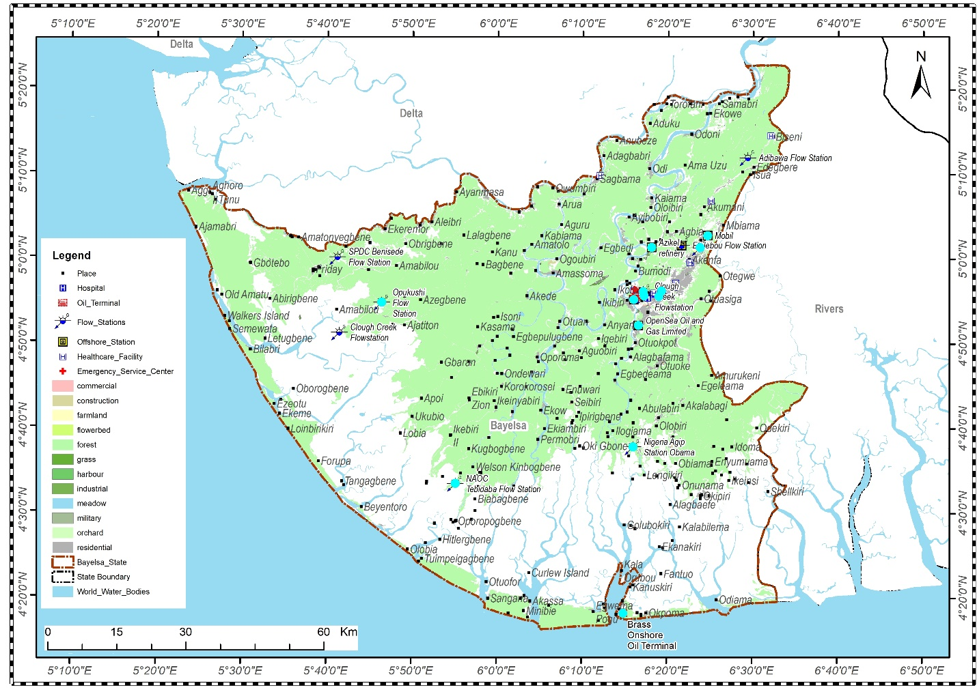
Figure 7: Oil and Gas Facilities at 1km from built-up land use
The hydrological overlay analysis identified additional risk factors for facilities located in flood-prone zones. The complex drainage networks throughout Bayelsa create potential spill dispersion pathways that could rapidly transport contaminants to environmentally sensitive areas and communities, complicating containment efforts and expanding the impact radius of incidents.
4.4. Integration of Findings and Implications
The integrated spatial analysis of Bayelsa's oil and gas sector reveals significant emergency response deficiencies stemming from five critical issues: strategic misalignment between clustered oil facilities and emergency resource distribution; inadequate response times exceeding 3 hours to medical facilities; geographic barriers from challenging terrain and poor infrastructure; dangerous proximity of oil assets to settlements; and hydrological vulnerabilities in flood-prone zones with complex drainage networks. These factors collectively create serious coverage gaps that compromise response effectiveness during incidents.
The findings demonstrate that current emergency response mechanisms are fundamentally misaligned with the spatial realities of infrastructure distribution and environmental context in Bayelsa State. The concentration of oil facilities in specific areas without corresponding emergency resources, combined with the region's challenging terrain and extended travel times, has created a perfect storm of vulnerability that demands immediate strategic reconsideration and resource redistribution to protect both infrastructure and communities.
5.0. CONCLUSION
This research has conducted a comprehensive spatial analysis of oil and gas facilities and emergency response infrastructure in Bayelsa State, revealing significant vulnerabilities in the current emergency management framework. Statistical analysis confirmed a clustered distribution pattern of oil facilities (nearest neighbor ratio: 0.9487, observed mean distance: 10,156 meters, p-value: 0.677), creating uneven risk landscapes that misalign with emergency resource distribution. Only 14 emergency facilities exist within 1km of oil assets, with decreasing coverage at greater distances (13 facilities at 5km, 2 at 10km, and none at 15km). Network analysis demonstrated concerning response times, with the best route between Opukushi Flow Station and Federal Medical Center requiring 3 hours 20 minutes to traverse 120.59km. These findings, combined with Bayelsa's challenging terrain, proximity of oil infrastructure to settlements, and hydrological vulnerabilities, necessitate a comprehensive restructuring of emergency response resources. Recommended interventions include strategic redistribution of emergency facilities, transportation infrastructure improvements, implementation of zonal response strategies, development of community-based first response capabilities, enhanced containment systems for flood-prone facilities, and a real-time GIS-based decision support system to optimize resource allocation during incidents—all essential measures to better protect infrastructure, communities, and environmental assets in this critical region of Nigeria's petroleum industry.

REFERENCES
Aaron, K. K., & George, N. (2010). Environmental degradation and conflict in the Niger Delta. Journal of Sustainable Development, 3(2), 45-59.
Adekola, J., & Mitchell, G. (2011). Spatial planning for oil spill response in coastal regions. Environmental Management, 48(5), 887-901.
Arellano, P., Tansey, K., Balzter, H., & Boyd, D. S. (2015). Detecting oil spills using SAR satellite imagery. Remote Sensing of Environment, 158, 1-13.
BP. (2020). BP statistical review of world energy 2020. BP plc. https://www.bp.com/statisticalreview
Ejiba, I. V., Onya, S. C., & Adams, D. O. (2016). Oil spill incidents and emergency response in the Niger Delta. African Journal of Environmental Science and Technology, 10(8), 250-263.
Fingas, M. (2016). The basics of oil spill cleanup (3rd ed.). CRC Press.
McCrea-Strub, A., Kleisner, K., Sumaila, U. R., Swartz, W., Watson, R., Zeller, D., & Pauly, D. (2011). Potential impact of the Deepwater Horizon oil spill on commercial fisheries in the Gulf of Mexico. Fisheries, 36(7), 332-336.
NNPC. (2019). Annual statistical bulletin. Nigerian National Petroleum Corporation.
Nwidum, J., & James, O. (2021). Oil resource distribution and conflict in Bayelsa State. Niger Delta Journal of Social and Economic Research, 14(1), 22-38.
Odularu, G. O. (2020). Crude oil and the Nigerian economic performance. Oil and Gas Business, 15(3), 45-62.
Ogbuigwe, A. (2018). Nigeria's oil industry: History and prospects. Energy Policy Review, 6(2), 112-125.
OPEC. (2020). Annual statistical bulletin 2020. Organization of Petroleum Exporting Countries.
Ordinioha, B., & Brisibe, S. (2013). The human health implications of crude oil spills in the Niger Delta. Journal of Environmental Health, 75(6), 45-50.
Robertson, C., & Krauss, C. (2010, August 3). Gulf spill is the largest of its kind, scientists say. The New York Times. https://www.nytimes.com
Watts, M. (2019). The curse of the black gold: 50 years of oil in the Niger Delta. University of California Press.

