Proceedings of the ASME 2025
International Mechanical Engineering Congress and Exposition
IMECE2025
November 16-20, 2025, Memphis, Tennessee
IMECE2025-XXXXXX

A Simulation Platform for Prostate Brachytherapy Training: Integrating Haptic Feedback, Eye tracking, and Real-Time Ultrasound Imaging

Rex Imanaka | Samantha T. Lee | Bardia Konh*
University of Hawaii at Manoa
Honolulu, HI, USA

Abstract
This study presents a novel training platform for prostate BT that enables users to perform mechanical motions that closely replicate real-world procedures, generates virtual ultrasound (US) images similar to actual US scans, and accurately assesses expertise levels. The platform comprises: (i) a haptic feedback Touch device from 3D Systems, Inc., which provides tactile feedback during needle insertion into the prostate; (ii) two cameras—a top-view camera for hand tracking and a front-facing camera for eye tracking; and (iii) simulated US imaging that visualizes needle advancement within a prostate model. Experimental results validate the system’s capability to track needle positioning, operator hand movements, and create simulated US imaging of prostate morphology and needle trajectory while simultaneously the operators’ eyes during the procedure. During needle insertion trials, maximum average needle insertion force was recorded at about 8.96 ± 1.31N and 5.63± 0.131N within the perineum and prostate, respectively. The average insertion speed for needle insertion was 5.25 ± 3.73 mm/s outside the prostate and 8.32 mm/s² inside the prostate. The max insertion speed was 28.63 ± 1.43 mm/s to a depth of 280 mm within the prostate. The findings align closely with values reported in the literature, validating the system’s accuracy and reliability.

Keywords: Ultrasound, Haptic feedback, Training system

- INTRODUCTION
Prostate cancer continues to represent a significant global health burden, ranking among the top three most commonly diagnosed cancers in men worldwide. In 2025, the U.S. alone reported over 313,780 new prostate cancer cases and more than 35,770 deaths, underscoring its persistent lethality [1]. The lifetime risk for a U.S. male to be diagnosed with prostate cancer is approximately 1 in 8. Early-stage prostate cancer is highly treatable, and with appropriate interventions and treatment methods. Brachytherapy (BT) [2–5] for prostate cancer is performed in two modalities: low-dose-rate (LDR) and high-dose-rate (HDR). LDR BT involves the permanent implantation of radioactive seeds, while HDR BT uses temporarily placed radioactive sources delivered through hollow catheters. HDR BT has gained preference in many institutions due to its favorable dosimetric characteristics, flexibility in dose planning, and reduced long-term toxicity [6,7]. However, both modalities require precise placement of multiple needles.
HDR BT is a temporary radiotherapy method in which high-dose radiation is delivered to the prostate for cancer cell irradiation [4]. Conventional methods involve the placement of 15–20 rigid needles into the prostate under transrectal US (TRUS) guidance. After implantation radioactive sources are fed through the needles and held at specific dwell positions for the prescribed dwell time [8].
Unfortunately, BT training for radiation oncology residents is hindered by two main issues: insufficient hands-on exposure to BT procedures and a shortage of faculty with adequate expertise in this modality [9–13]. In the United States, about 90 residency programs offer prostate BT training, enrolling roughly 200 new residents each year. These programs generally last five years: a one-year preliminary rotation in internal medicine or general surgery, followed by four years of dedicated radiation oncology training [14].
Graduation criteria call for involvement in a minimum of seven interstitial implants—either prostate or gynecologic—but programs do not systematically document residents’ proficiency in tasks like needle placement or contour delineation. No uniform, end‐of‐training skill assessment exists to verify technical competence. In practice, residents log a median of fewer than five prostate BT cases by the time they graduate, most of which are HDR, with LDR exposures averaging only one or two procedures. Consistent survey data place HDR and LDR prostate BT, along with gynecologic interstitial implants, among the top five procedures that trainees feel the least prepared to perform [15,16].
Existing phantom‐based simulators [17–21] present significant drawbacks: they are costly, degrade with each use as needle channels form, and are not designed for repeated practice [22]. Attempts to fabricate in-house phantoms have proven to be too expensive and not scalable across programs.
Emerging technologies such as virtual reality (VR), augmented reality (AR), and haptics offer promising avenues to revamp surgical and procedural training. These tools can recreate the physical and visual experiences of procedures in simulated environments, thereby supporting repeated practice, objective performance tracking, and risk-free failure. In the context of prostate BT, haptics and simulated ultrasound can enable trainees to practice needle insertion under guided imaging conditions.
Previous studies have shown some initial success using virtual reality (VR) for surgical training. One group used VR to train residents on transurethral resection of the prostate (TURP) and found that, despite limitations in the VR training environment, it was more effective than no training at all [23].

Given this context, we propose a novel simulation platform that addresses current gaps in BT training. The system integrates haptic feedback, eye tracking, hand kinematics monitoring, and real-time ultrasound simulation, providing a rich multimodal dataset to assess and enhance trainee performance. By combining tactile feedback with machine learning (ML) shape detection and robust performance metrics, the platform not only speeds up skill acquisition but also evaluates operator performance.
Our group has previously developed a portable robotic needle insertion system [24–26] for prostate BT. Thus far, we have performed one US-guided needle insertion test in one cadaver to evaluate the capability of our system to perform BT. The system consists of linear and rotary motorized stages for axial penetration and rotation of the needle, and two linear motorized stages attached to a transrectal ultrasound (TRUS) for its planar movement to scan the tissue. We have also recently developed an environment to transfer US images to a computer in real-time and perform image analyses for needle tracking. We compared the accuracy of needle tip tracking with vision-based tracking in phantom tissue and a beef liver tissue [27,28]. In another work [29], we developed a needle shape estimator using real-time US images. A previous study has collected in-vivo data on needle insertion force and motion during actual prostate BT procedures [30]. This dataset, derived from 20 patients, provides valuable insights into the range of needle insertion forces and speeds observed in clinical practice. These data are instrumental in developing predictive models of tissue heterogeneity, mechanical properties, and prostate deformation. The needle insertion force and speed are measured using a 6-DOF Nano 17 force and torque sensor from ATI Industrial Automation and a 3D Guidance trakSTAR electromagnetic tracking system from Northern Digital, Inc. (Waterloo, ON), respectively.
We have also previously developed an automated computational environment in MATLAB to facilitate advanced analysis of medical images, including CT, MRI, and US [31]. The environment integrates several essential capabilities to support radiotherapy planning and evaluation. It enables image segmentation, supporting both manual and automated contouring to delineate target volume (tumors) and OARs with precision. Additionally, the system enables 3D model reconstruction to create detailed anatomical models and supports 2D image extraction for enhanced visualization or further analysis, such as dose distribution. The environment includes features for motion management, accommodating organ motion for needle-induced movement, and dose planning, enabling visualization and planning of spatially non-uniform dose distributions [32,33]. Additionally, we have developed two mechanical models to characterize needle-tissue interactions [34–36].
This work presents a novel training platform for prostate BT that enables users to perform mechanical motions that closely replicate real-world procedures, generates virtual US images that resemble actual US scans, and accurately assesses expertise levels. The architecture of the simulation platform consists of three major subsystems: (i) a haptic feedback Touch device (3D Systems, Inc., Rock Hill, SC), which provides tactile feedback during needle insertion into the prostate; (ii) two cameras—a top-view camera for hand tracking and a front-facing camera for eye gaze tracking; and (iii) dynamic simulated US imaging that visualizes needle advancement within a deforming prostate model.

- MATERIALS AND METHODS
The following sections present the design, development, and performance evaluation of a real-time training system. Section 2.1 presents the training device that utilizes haptic feedback. Section 2.2 presents the real-time tracking system design and its components with ML enhancements. Finally, Section 2.3 discusses the US imaging of a prostate model.

2.1 Haptic Feedback System
The haptic Touch device uses OpenHaptics and OpenGL to provide three degrees of force feedback and six degrees of position sensing. It enables the user to engage in interactive needle insertion tasks that mimic the mechanical properties of perineal and prostate tissues. The device is calibrated to simulate variable force responses using biomechanical models and patient-specific anatomical data. Haptic feedback is programmed using needle insertion characterizations, modeling needle force as a piecewise function. The system simulates realistic needle insertion sensations across various tissue types based on anatomical variations derived from MRI scans of anonymized patients. These scans are used to create STL files of the organs which are brought into the haptic environment similar to what is shown in Figure 1. After defining the surface of the tissue using the STL files, the haptic and graphic environments are scaled and aligned to the user's field of view, and the forces are defined within the tissue. The needle is represented by a haptic proxy that aligns with the pen tip of the Touch Haptic device, and forces are applied based on the proxy’s location within the workspace. Equation 1 shows the force on the needle tip as the sum of the friction $(F_{f})$, viscous $(F_{v})$, and cutting force $\left(F_{c}\right)$. Prostate stiffness and force parameters are assigned using literature-based estimations corresponding to different cancer stages [37].
$$F_{n}=F_{f}+F_{v}+F_{c}$$ | (Eq. 1)
Cutting forces are depth-dependent and modulated based on tissue heterogeneity. Friction is influenced by the needle-tissue contact area, which varies as a function of insertion depth and prostate curvature. Viscous resistance is proportional to insertion speed and captures energy dissipation due to tissue deformation. Tissue-specific parameters for stiffness and damping are derived from published biomechanical datasets. In addition to the forces applied within the tissue, the stiffness and pop-through force were defined to ensure that the surface and piercing effects could be felt.


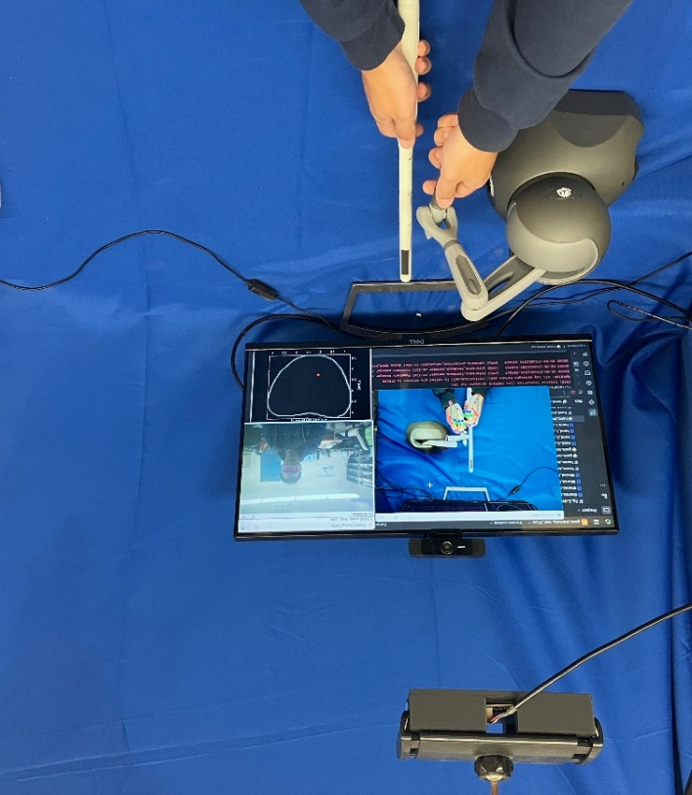
Haptic device
US probe
Simulated environment
Front-facing camera
Top-down camera
Figure 1. Haptic training environment for needle insertion tasks into the prostate.

2.2 Real-Time Tracking System with ML
The real-time operator tracking system comprises two Logitech HD cameras. The front-facing camera employs vision tracking to capture eye movements, gaze direction, and fixation points. The eye-tracking module captures gaze fixations, saccade patterns, and visual dwell time on simulated ultrasound images. These metrics serve as proxies for attentional focus and cognitive engagement. Eye data are analyzed using Python-based gaze parsing algorithms, and output is synchronized with hand motion and force feedback signals to generate a full temporal-spatial profile of the procedure. The top-down camera and haptic system monitor hand positioning. Hand tracking leverages MediaPipe and OpenCV libraries to capture the position, orientation, and velocity of the needle-driving hand. Metrics such as insertion angle, path curvature, and motion smoothness are continuously recorded. Hand tracking is utilized to assess needle trajectory and transrectal US (TRUS) probe manipulation. Figure 1 shows the top-down camera’s output as well as the iris tracking from the front-facing camera. These data streams are integrated with the haptic system to generate real-time simulated US images, depicting needle motion and prostate deformation. This comprehensive data representation replicates the information typically available to an operator during BT procedures, facilitating comparative analysis between trainees and experts to identify areas for improvement.


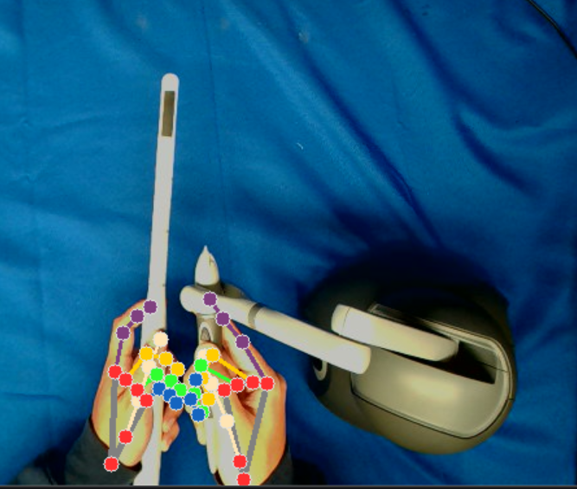
Figure 2. Haptic training environment top-down view for hand tracking and front-facing view for iris tracking.

2.3 Prostate Deformation Model Under Ultrasound
T2-weighted MRIs of an anonymized patient were acquired, and the prostate was manually contoured to generate a 3D organ model. The segmented volumes were exported as STL files for further analysis. The prostate model was then divided into 10 equidistant cross-sectional slices, as illustrated in Figures 3 and 4. Red dots in each US slice indicate the needle tip's position as it intersected the corresponding US plane.
Figure 3 displays 8 of the 10 US slices traversed by the needle, while Figure 4 depicts both the 2D and 3D needle trajectory through the prostate. Gaussian noise is introduced to simulate real-world image variability. Needle paths are tracked in 3D and intersected with image slices to render US images. As the user inserts the needle, the simulation engine updates the US view to reflect real-time changes in prostate geometry and needle position. Needle visualization includes acoustic shadowing, reflection artifacts, and prostate gland. In this trial, the needle entered from the top-right and exited through the bottom-left of the prostate gland. The simulation environment is developed using Unity 3D and integrated with Python for data analytics and machine learning modules. Communication between components is managed via socket-based networking and shared memory buffers to ensure low-latency data exchange. The haptic device runs on a 1kHz loop for smooth feedback, while tracking and rendering are executed at 60Hz.

Figure 3. Eight evenly spaced sagittal US slices of the prostate contour and needle tip position (red) from the haptic training system.

- RESULTS AND DISCUSSION
The simulation platform was evaluated through three structured trials focusing on its ability to replicate realistic tactile sensations, simulate US imaging, and track operator performance using both hand and eye motion data. The objective of these evaluations was to determine whether the platform could replicate force and movement patterns reported in the literature. The haptic feedback system effectively simulated the resistance encountered during needle passage through perineal and prostate tissues. Experimental results validate the system’s capability to track needle positioning, operator hand movements, and real-time simulated US imaging of prostate morphology and needle trajectory while simultaneously monitoring gaze behavior during the procedure.

(a)  (b) | 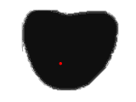  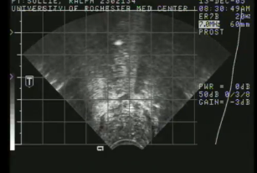  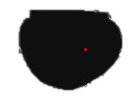
(b)
(b)
Figure 4. (a) 2D needle insertion path through the prostate with the US image slice at depths of 2.94 and 5.95 cm. (b) 3D needle insertion path through the prostate gland.

Figure 5 shows the relationship between the simulated needle tip force and the insertion depth into the perinium and the prostate. Force-depth profiles exhibited a bimodal pattern, with initial resistance corresponding to skin and subcutaneous tissue layers followed by a secondary peak upon breaching the prostate capsule. Within the gland, force fluctuations were observed that likely corresponded to variations in internal zonal anatomy. Simulated force graphs closely mirrored in vivo profiles, providing evidence for the accuracy of the system’s feedback model. The observed force at 0 mm insertion depth spiked for both the perineum and the prostate due to how the forces were defined within the tissue. Because the required force to enter the tissue was relatively small and the insertion speed was relatively fast, the haptic environment registered no deformation until the next timestep, by which point the needle was already inside the tissue (insertion depth > 0 mm). The maximum average needle insertion force between 3 trials was recorded at 8.96 ± 1.31N within the perineum and 5.63± 0.131N within the prostate from our haptic feedback system.

(a)
(b)
Figure 5. Measured force data during the needle insertion within the (a) perineum and (b) prostate.

Needle velocity was analyzed using data captured from the haptic device and the top-down camera. Figure 6 shows the hand tracking position and velocity from the top-down camera. The average insertion speed prior to reaching the tissue was 5.25 ± 3.73 mm/s. Once inside the tissue, the needle insertion speed exhibited a linear profile with a slope of 8.32 mm/s² and an intercept of -18.10 mm/s (R² = 0.96). The needle reached an average speed of 28.63 ± 1.43 mm/s at depth of 280 mm after passing through the simulated tissues. These findings align closely with values reported in the literature, validating the system’s accuracy and reliability [38].

- CONCLUSION
This study presents a fully integrated simulation platform that enhances prostate brachytherapy (BT) training through the incorporation of haptic feedback, real-time ultrasound imaging, and multimodal operator tracking. The system addresses critical gaps in radiation oncology education by offering a risk-free, repeatable environment for trainees to practice, receive feedback, and improve their procedural skills over time. The results of our pilot evaluations demonstrate that the platform accurately simulates key elements of the BT procedure, including realistic force profiles, accurate needle trajectory tracking, and meaningful visual feedback. The close alignment of measured force and speed metrics with clinical data affirms the fidelity of the system. Moreover, the integration of gaze and hand tracking provides new dimensions of training insight, revealing cognitive engagement patterns. From an educational standpoint, the system enables standardized skill assessment using objective metrics such as insertion force variability, needle path deviation, gaze entropy, and hand tremor frequency. This facilitates formative assessment and longitudinal monitoring of resident progress. The machine learning framework further augments this capability by offering predictive scoring and automatic classification of expertise level, which could streamline feedback delivery and certification processes.

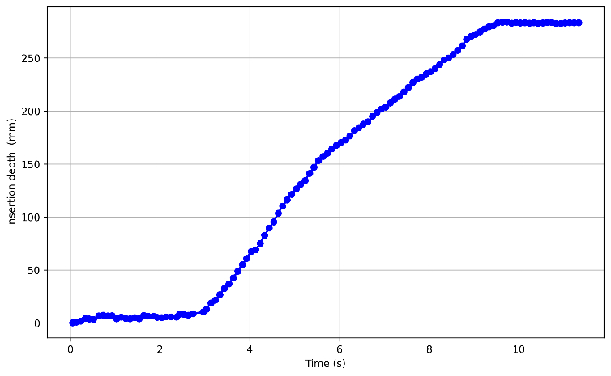
(a)
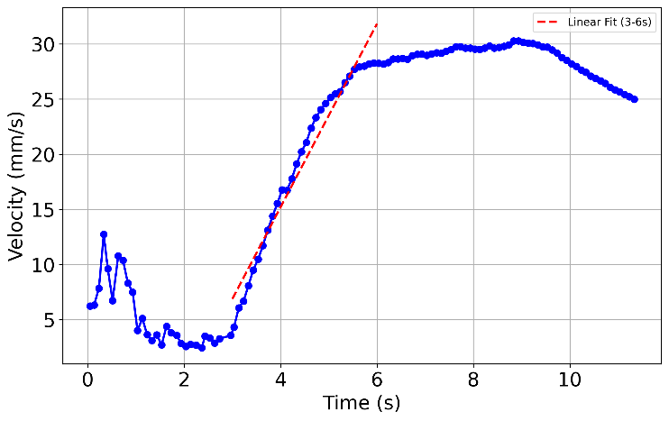
(b)
Figure 6. Hand tracking results: (a) needle insertion depth overtime, and (b) needle velocity over time.

The adaptability of the system also makes it suitable for expansion into other interventional procedures that rely on image-guided needle placement, such as gynecologic brachytherapy, liver biopsy, or stereotactic neurosurgery. Beyond needle insertion, the haptic training system can also incorporate a hand-tracking component to monitor the operator’s hands during ancillary tasks, such as reaching for instruments and ensuring they are returned to their designated positions.
Compared to commercially available prostate phantoms, our simulation system offers several advantages. It supports unlimited repetitions without wear and tear, provides objective feedback, and facilitates tracking of procedural growth over time. While phantoms offer tactile realism with actual physical needles, they lack the adaptability and measurement capabilities inherent in a digital platform.
While the simulation system provides robust feedback and procedural realism, some limitations exist. First, the fidelity of simulated US images, though realistic, may not capture all anatomical subtleties seen in real TRUS imaging. Second, the force feedback system currently models homogeneous tissue properties and does not yet account for pathological heterogeneities such as tumors or calcifications. Third, the system uses a simplified force model that only allows for a single needle insertion. A more complex model could be developed to support multiple insertions and allow the needles to remain statically within the tissue. Future extensions will focus on integrating generative modeling for ultrasound simulation, enhancing force modeling for pathological tissue, and embedding smart coaching algorithms to deliver context-specific guidance during training sessions. Future work will also focus on enhancing the system’s capabilities for patient-specific simulated procedures, integrating additional cameras such as a point-of-view (POV) camera to capture the user’s line of sight, comparing performance differences between residents and experienced physicians, and leveraging machine learning techniques to extract procedural statistics for benchmarking resident performance against expert execution.
In conclusion, the proposed haptic- and AI-integrated simulation platform represents a substantial advancement in medical education for prostate BT. It offers a scalable, customizable, and data-rich environment to improve procedural competency, accelerate learning curves, and ultimately enhance patient care outcomes. By aligning educational tools with clinical complexity and performance-based feedback, this work lays the foundation for the next generation of simulation-based training in radiation oncology.

ACKNOWLEDGEMENTS
Research reported in this publication was supported by the National Institute Of Biomedical Imaging And Bioengineering of the National Institutes of Health under Award Number K25EB030562. The content is solely the responsibility of the authors and does not necessarily represent the official views of the National Institutes of Health.
REFERENCES
[1] 2025, “American Cancer Society (ACS), Cancer Statistics Center.”
[2] Anandadas, C. N., Clarke, N. W., Davidson, S. E., O’Reilly, P. H., Logue, J. P., Gilmore, L., Swindell, R., Brough, R. J., Wemyss‐Holden, G. D., Lau, M. W., and Javle, P. M., 2011, “Early Prostate Cancer – Which Treatment Do Men Prefer and Why?,” BJU Int., 107(11), pp. 1762–1768. https://doi.org/10.1111/j.1464-410X.2010.09833.x.
[3] Gwede, C. K., Pow‐Sang, J., Seigne, J., Heysek, R., Helal, M., Shade, K., Cantor, A., and Jacobsen, P. B., 2005, “Treatment Decision‐making Strategies and Influences in Patients with Localized Prostate Carcinoma,” Cancer, 104(7), pp. 1381–1390. https://doi.org/10.1002/cncr.21330.
[4] Yoshioka, Y., Yoshida, K., Yamazaki, H., Nonomura, N., and Ogawa, K., 2013, “The Emerging Role of High-Dose-Rate (HDR) Brachytherapy as Monotherapy for Prostate Cancer,” J. Radiat. Res., 54(5), pp. 781–788. https://doi.org/10.1093/jrr/rrt027.
[5] White, E. C., Kamrava, M. R., Demarco, J., Park, S. J., Wang, P. C., Kayode, O., Steinberg, M. L., and Demanes, D. J., 2013, “High-Dose-Rate Prostate Brachytherapy Consistently Results in High Quality Dosimetry,” Int. J. Radiat. Oncol. Biol. Phys., 85(2), pp. 543–548. https://doi.org/10.1016/j.ijrobp.2012.03.035.
[6] Skowronek, J., 2013, “Low-Dose-Rate or High-Dose-Rate Brachytherapy in Treatment of Prostate Cancer - Between Options,” J. Contemp. Brachytherapy, 5(1), pp. 33–41. https://doi.org/10.5114/jcb.2013.34342.
[7] Nicolae, A. M., Venugopal, N., and Ravi, A., 2016, “Trends in Targeted Prostate Brachytherapy : From Multiparametric MRI to Nanomolecular Radiosensitizers,” Cancer Nanotechnol., 7(6), pp. 1–17. https://doi.org/10.1186/s12645-016-0018-5.
[8] Simnor, T., Li, S., Lowe, G., Ostler, P., Bryant, L., Chapman, C., Inchley, D., and Hoskin, P. J., 2009, “Justification for Inter-Fraction Correction of Catheter Movement in Fractionated High Dose-Rate Brachytherapy Treatment of Prostate Cancer,” Radiother. Oncol., 93(2), pp. 253–258.
[9] Marcrom, S. R., Kahn, J. M., Colbert, L. E., Freese, C. M., Doke, K. N., Yang, J. C., Yashar, C. M., Luu, M., and Kamrava, M., 2019, “Brachytherapy Training Survey of Radiation Oncology Residents,” Int. J. Radiat. Oncol. Biol. Phys., 103(3), pp. 557–560. https://doi.org/10.1016/j.ijrobp.2018.10.023.
[10] Orio, P. F. 3rd, Nguyen, P. L., Buzurovic, I., Cail, D. W., and Chen, Y.-W., 2016, “Prostate Brachytherapy Case Volumes by Academic and Nonacademic Practices: Implications for Future Residency Training.,” Int. J. Radiat. Oncol. Biol. Phys., 96(3), pp. 624–628. https://doi.org/10.1016/j.ijrobp.2016.07.013.
[11] Sturdza, A. E., Stephanides, M., Jurgenliemk-Schulz, I., Eriksen, J. G., Benstead, K., Hoskin, P., Vlad, S., Escande, A., Corradini, S., Knoth, J., Westerveld, H., Tagliaferri, L., Najari-Jamali, D., Konat-Baska, K., Plesinac, V., Tan, L. T., Nout, R., Strnad, V., Niehoff, P., Pieters, B. R., Tanderup, K., and Kamrava, M., 2022, “Brachytherapy Training Survey among Radiation Oncology Residents in Europe,” Radiother. Oncol., 177, pp. 172–178. https://doi.org/10.1016/j.radonc.2022.10.030.
[12] Shinde, A., Li, R., Amini, A., Vapiwala, N., Orio, P. 3rd, Vargo, J. A., Yashar, C., Chen, Y.-J., Beriwal, S., and Glaser, S., 2020, “Resident Experience in Brachytherapy: An Analysis of Accreditation Council for Graduate Medical Education Case Logs for Intracavitary and Interstitial Brachytherapy from 2007 to 2018.,” Brachytherapy, 19(6), pp. 718–724. https://doi.org/10.1016/j.brachy.2019.10.006.
[13] Kissel, M., Ollivier, L., Fumagalli, I., Pommier, P., Chargari, C., Blanchard, P., Peiffert, D., and Hannoun-Levi, J.-M., 2022, “Resident Training in Brachytherapy in France: A 10-Year Update after the First Survey of SFJRO Members.,” J. Contemp. Brachytherapy, 14(6), pp. 501–511. https://doi.org/10.5114/jcb.2022.123969.
[14] Vengaloor Thomas, T., Perekattu Kuruvilla, T., Kahn, J., Bhanat, E., Parr, A. Q., Albert, A., Chowdhary, M., Beriwal, S., and Vijayakumar, S., 2021, “Variations in Resources Among Radiation Oncology Residency Programs in the United States,” Adv. Radiat. Oncol., 6(1), p. 100544. https://doi.org/10.1016/j.adro.2020.08.001.
[15] Nabavizadeh, N., Burt, L. M., Mancini, B. R., Morris, Z. S., Walker, A. J., Miller, S. M., Bhavsar, S., Mohindra, P., Kim, M. B., and Kharofa, J., 2016, “Results of the 2013-2015 Association of Residents in Radiation Oncology Survey of Chief Residents in the United States.,” Int. J. Radiat. Oncol. Biol. Phys., 94(2), pp. 228–234. https://doi.org/10.1016/j.ijrobp.2015.10.014.
[16] Brower, J. V, Chen, S., Ritter, A., Liauw, S. L., Rosenberg, S. A., Reddy, A. V, Golden, D. W., Gillespie, E. F., and Mattes, M. D., 2021, “Comfort Level of US Radiation Oncology Graduates: Assessment of Transition to Independent Clinical Practice.,” J. cancer Educ. Off. J. Am. Assoc. Cancer Educ., 36(2), pp. 278–283. https://doi.org/10.1007/s13187-019-01625-z.
[17] Thaker, N. G., Kudchadker, R. J., Swanson, D. A., Albert, J. M., Mahmood, U., Pugh, T. J., Boehling, N. S., Bruno, T. L., Prestidge, B. R., Crook, J. M., Cox, B. W., Potters, L., Moran, B. J., Keyes, M., Kuban, D. A., and Frank, S. J., 2014, “Establishing High-Quality Prostate Brachytherapy Using a Phantom Simulator Training Program,” Int. J. Radiat. Oncol. Biol. Phys., 90(3), pp. 579–586. https://doi.org/10.1016/j.ijrobp.2014.06.036.
[18] Chiu, T., Xiong, Z., Parsons, D., Folkert, M. R., Medin, P. M., and Hrycushko, B., 2020, “Low-Cost 3D Print-Based Phantom Fabrication to Facilitate Interstitial Prostate Brachytherapy Training Program.,” Brachytherapy, 19(6), pp. 800–811. https://doi.org/10.1016/j.brachy.2020.06.015.
[19] Shaaer, A., Alrashidi, S., Chung, H., Loblaw, A., Morton, G., Paudel, M., Tseng, C.-L., and Ravi, A., 2021, “Multipurpose Ultrasound-Based Prostate Phantom for Use in Interstitial Brachytherapy.,” Brachytherapy, 20(6), pp. 1139–1145. https://doi.org/10.1016/j.brachy.2021.07.003.
[20] Nattagh, K., Siauw, T., Pouliot, J., Hsu, I.-C., and Cunha, J. A., 2014, “A Training Phantom for Ultrasound-Guided Needle Insertion and Suturing.,” Brachytherapy, 13(4), pp. 413–419. https://doi.org/10.1016/j.brachy.2014.01.003.
[21] Campelo, S., Subashi, E., Meltsner, S. G., Chang, Z., Chino, J., and Craciunescu, O., 2020, “Multimaterial Three-Dimensional Printing in Brachytherapy: Prototyping Teaching Tools for Interstitial and Intracavitary Procedures in Cervical Cancers.,” Brachytherapy, 19(6), pp. 767–776. https://doi.org/10.1016/j.brachy.2020.07.013.
[22] Sekhar, A., Sun, M. R., and Siewert, B., 2014, “A Tissue Phantom Model for Training Residents in Ultrasound-Guided Liver Biopsy,” Acad. Radiol., 21(7), pp. 902–908. https://doi.org/https://doi.org/10.1016/j.acra.2014.03.002.
[23] Schulz, G. B., Grimm, T., Kretschmer, A., Stief, C. G., Jokisch, F., and Karl, A., 2020, “Benefits and Limitations of Transurethral Resection of the Prostate Training with a Novel Virtual Reality Simulator,” Simul. Healthc., 15(1), pp. 14–20. https://doi.org/10.1097/SIH.0000000000000396.
[24] Rabiei, M., and Konh, B., 2022, “A Portable Robot to Perform Prostate Brachytherapy with Active Needle Steering and Robot-Assisted Ultrasound Tracking,” Design of Medical Devices Conference, pp. 1–3. https://doi.org/10.1115/DMD2022-1014.
[25] Lafreniere, S., and Konh, B., 2024, “Design Consideration and Development of an MRI-Compatible Robot for Prostate Interventions,” Frontiers in Biomedical Devices, BIOMED - 2024 Design of Medical Devices Conference, pp. 1–5.
[26] Lafreniere, S., Padasdao, B., and Konh, B., 2024, “Design and Development of an MRI Conditional Robot to Enable Curvilinear Transperineal Prostate Biopsy,” Int. J. Med. Robot. Comput. Assist. Surgerye, pp. 1–36.
[27] Padasdao, B., Varnamkhasti, Z. K., and Konh, B., 2020, “3D Steerable Biopsy Needle with a Motorized Manipulation System and Ultrasound Tracking to Navigate inside Tissue,” J. Med. Robot. Res., 5(03n04), p. 2150003. https://doi.org/10.1142/S2424905X21500033.
[28] Konh, B., Padasdao, B., Batsaikhan, Z., and Ko, S. Y., 2021, “Integrating Robot‐assisted Ultrasound Tracking and 3D Needle Shape Prediction for Real‐time Tracking of the Needle Tip in Needle Steering Procedures,” Int. J. Med. Robot. Comput. Assist. Surg., 17(4), p. e2272. https://doi.org/10.1002/rcs.2272.
[29] Konh, B., Batsaikhan, Z., and Padasdao, B., 2021, “3D Shape Estimation of an Active Needle inside Tissue Using 2D Ultrasound Images,” Design of Medical Devices Conference, pp. 1–4.
[30] Podder, T. K., Clark, D., Sherman, J., Fuller, D., Messing, E., Rubens, D., Strang, J., Brasacchio, L., Liao, W. S. N., Yu, Y., Brasacchio, R., Liao, L., Ng, W. S., and Yu, Y., 2006, “In Vivo Motion and Force Measurement of Surgical Needle Intervention during Prostate Brachytherapy,” Med. Phys., 33(8), pp. 2915–2922. https://doi.org/10.1118/1.2218061.
[31] Padasdao, B., Imanaka, R., Podder, T. K., and Konh, B., 2024, “Curvilinear Catheter Implantation in HDR Prostate Brachytherapy - Feasibility Study,” Med. Phys., pp. 1–16. https://doi.org/10.1002/mp.17113.
[32] Konh, B., and Podder, T. K., 2024, “Empowering Prostate HDR Brachytherapy by Curvilinear Catheter Implantation Using Active Needle Technology,” 2024 World Congress of Brachytherapy, p. 1.
[33] Padasdao, B., Imanaka, R., Podder, T. K., and Konh, B., 2024, “Feasibility of Curvilinear Catheter Implantation for Prostate HDR Brachytherapy,” AAPM 66th Annual Meeting & Exhibition, p. 1.
[34] Padasdao, B., and Konh, B., 2024, “A Model to Predict Deflection of an Active Tendon-Driven Notched Needle Inside Soft Tissue,” J. Eng. Sci. Med. Diagnostics Ther., 7(1), p. 011006. https://doi.org/10.1115/1.4063205.
[35] Datla, N. V., Konh, B., Honarvar, M., Podder, T. K., Dicker, A. P., Yu, Y., and Hutapea, P., 2014, “A Model to Predict Deflection of Bevel-Tipped Active Needle Advancing in Soft Tissue,” Med. Eng. Phys., 36(3), pp. 285–293. https://doi.org/10.1016/j.medengphy.2013.11.006.
[36] Padasdao, B., and Konh, B., 2024, “A Mechanics-Based Model for a Tendon-Driven Active Needle Navigating inside a Multiple-Layer Tissue,” J. Robot. Surg., 18(1), p. 146. https://doi.org/10.1007/s11701-024-01900-2.
[37] Ahn, B.-M., Kim, J., Ian, L., Rha, K.-H., and Kim, H.-J., 2010, “Mechanical Property Characterization of Prostate Cancer Using a Minimally Motorized Indenter in an Ex Vivo Indentation Experiment,” Urology, 76(4), pp. 1007–1011. https://doi.org/https://doi.org/10.1016/j.urology.2010.02.025.
[38] Wilby, S., 2024, “The Development of Phantoms for Prostate Brachytherapy and Biopsy,” University of Portsmouth.

