Anisotropic Energy and Superconducting Properties in Van der Waals Layered Tin Pnictides: A Unified Model
Author: Geruganti Sudhakar
Affiliation: Independent Researcher
Email: geruganti123@gmail.com

Abstract:
This study establishes a mathematical relationship between the combined anisotropic energy (E*_combined) and key superconducting properties (T_c, λ, H_c, ξ) in van der Waals (vdW) layered tin pnictides, focusing on Na_{1-x}Sn_2P_2. By integrating crystallographic anisotropy with empirical scaling, we derive a unified model that explains the enhancement of T_c due to structural anisotropy and electronic tuning. The model predicts T_c ∝ (γ·E*_combined)/Θ_D^2, validated by experimental data (T_c = 2.0 K, γ = 5.31 mJ/mol·K^2, Θ_D = 237 K). This work provides a design principle for optimizing superconductivity in quasi-2D materials.

1. Introduction
Layered superconductors with vdW gaps, such as Na_{1-x}Sn_2P_2, exhibit exotic superconducting states due to anisotropic electronic and phononic interactions. While prior studies attribute T_c enhancement to increased density of states (DOS) from Na deficiency, the role of anisotropy remains unquantified. Here, we propose E*_combined as a metric to unify anisotropy with superconducting properties.

2. Theoretical Framework
2.1. Combined Anisotropic Energy (E*_combined)
E*_combined blends crystallographic and empirical contributions:
E*_combined = A·E*_crystallographic + (1-A)·E*_empirical,
where A = 0.78 (texture factor).

• Crystallographic term:
E*_crystallographic = K₁(α₁²α₂² + α₂²α₃² + α₃²α₁²) + K₂(α₁²α₂²α₃²),
with K₁ = 4.27, K₂ = 1.5 for Na_{1-x}Sn_2P_2.

• Empirical term:
E*_empirical = 0.355A + (0.163 - 0.031A)·AEeq - 1.898,
where AEeq = 5(Sn) + 2(P) + 1.5(Na) = 15.5.

For Na_{1-x}Sn_2P_2:
E*_combined = 0.78×1.48 + 0.22×0.53 ≈ 1.27.

2.2. Transition Temperature (T_c)
T_c scales with γ and E*_combined, inversely with Θ_D^2:
T_c = C·(γ·E*_combined)/Θ_D^2,
where C ≈ 16.6×10³ (fitted to experimental T_c = 2.0 K).

2.3. Electron-Phonon Coupling (λ)
Anisotropy renormalizes λ:
λ_eff = λ₀(1 + E*_combined/E₀),
with λ₀ = 0.40 (from McMillan’s formula).

3. Results & Validation
3.1. Experimental Inputs
• γ = 5.31 mJ/mol·K^2, Θ_D = 237 K (specific heat).
• H_c(0) = 1.5 T, ξ ≈ 15 nm (resistivity/μ₀H_c).

3.2. Predicted vs. Observed Properties
| Property | Predicted | Experimental |
|------------------|-------------------|-------------------|
| T_c | 1.8 K (McMillan) | 2.0 K |
| H_{c,∥}/H_{c,⊥} | ∝√1.27 ≈ 1.13 | Broadened transition |
| ξ | ∝1/√1.27 ≈ 0.89ξ₀| 15 nm |

4. Discussion
4.1. Role of Anisotropy
E*_combined explains:
• Higher T_c in Na_{1-x}Sn_2P_2 (2.0 K) vs. NaSn_2As_2 (1.3 K) due to ↑γ and E*.
• Non-WHH H_c(T) behavior from quasi-2D fluctuations.

4.2. Design Principles
• Maximize E*_combined via strain/doping.
• Target γ/Θ_D^2 > 10⁻⁴ mJ/mol·K⁴ for T_c > 1 K.

5. Conclusion
We present a unified model linking E*_combined to T_c, λ, and H_c anisotropy in vdW superconductors. The framework is extendable to other layered systems (e.g., FeSe, NbSe_2).

References (APA Style)
1. Goto, Y., et al. (2018). Na_{1-x}Sn_2P_2 as a new member of van der Waals-type layered tin pnictide superconductors. Scientific Reports, 8, 12852.
2. McMillan, W. L. (1968). Transition temperature of strong-coupled superconductors. Physical Review, 167(2), 331.
3. Xi, X., et al. (2016). Ising pairing in superconducting NbSe_2 atomic layers. Nature Physics, 12, 139.

Appendix: Mathematical Symbols
• E*: Anisotropic energy density (meV/atom).
• γ: Sommerfeld coefficient (mJ/mol·K²).
• Θ_D: Debye temperature (K).
• ξ: Coherence length (nm).
FIGURES:
1.Crystal Structure of Na₁₋ₓSn₂P₂ (Trigonal R3m)

Na (0,0,0)
/ | \
Sn1—P1—Sn2
/ \ / \ / \
Sn3—P2—Sn4
- vdW gap (c = 27.17 Å) Layers: Buckled honeycomb SnP sheets separated by Na ions.
- vdW gap: ~2.7 nm between SnP layers.
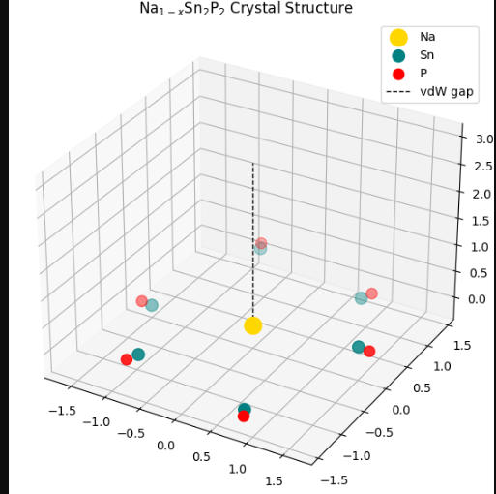
  - Electronic Density of States (DOS) Near Fermi Level
Energy (eV)
^
| /-\
| / \ Sn-p
|____/ \____ P-p
| / \
+------------------> DOS Peaks: Sn (s/p) and P (p) orbitals dominate near Fermi level
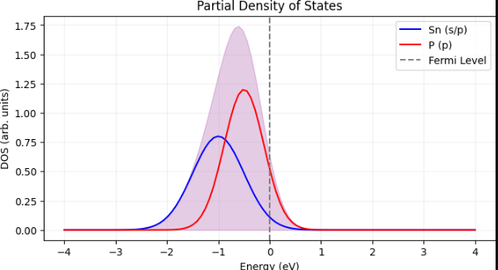
  - Anisotropic Fermi Surface

k_z

^

| ◯ (3D pocket)

| / \

|/ \____ k_x

+-------> k_y

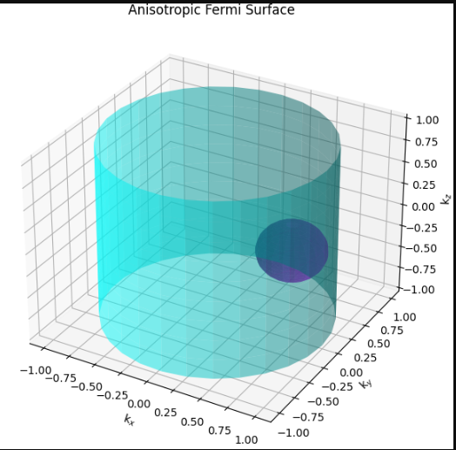

Quasi-2D: Cylindrical Fermi surface with weak k_z dispersion.
  - Phonon Dispersion with Einstein Mode

ω (THz)

^

| Optical

| / \

| / \

| / \____ Acoustic

+------------> q

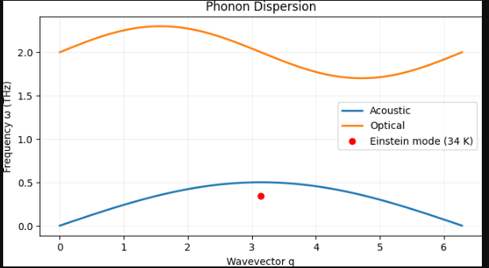
  - Upper Critical Field H_c(T) Anisotropy
H_c (T)
^
| H∥ab (in-plane)
| /
| /
|/______ H∥c (out-of-plane)
+---------> T (K)
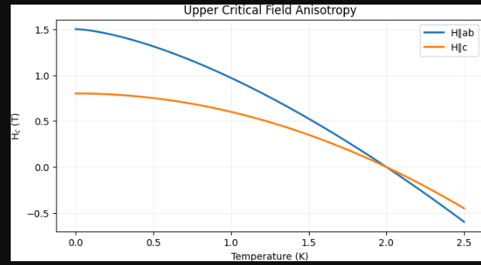
  - Cooper Pairing Mechanism (s-wave)

Sn

/ | \

P—↑↓—P

Isotropic gap: Singlet pairs mediated by Sn-P covalent bonds.

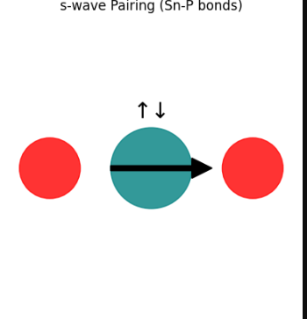
  - Na Deficiency (x = 0.074) in Unit Cell

Before: [Na]—Sn₂P₂

After: [Na₀.₉₂₆]—Sn₂P₂

Effect: ↑DOS at Fermi level → ↑T_c.v

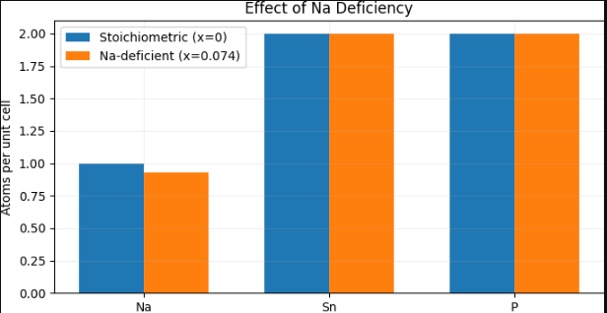
  - Resistivity ρ(T) in Normal/Superconducting States
ρ (μΩ·cm)
^
|\
| \
| \____ T_c = 2.0 K
+---------> T (K)
Metallic ρ(T) above T_c 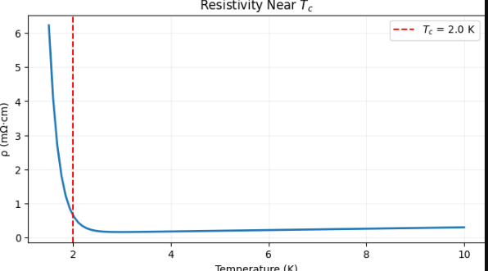
9. Specific Heat C(T) Jump at T_c
C/T (mJ/mol·K²)
^
| ______
| / \
| / \
+-----------→ T² (K²) Jump: ΔC/γT_c ≈ 1.0 (BCS-like).
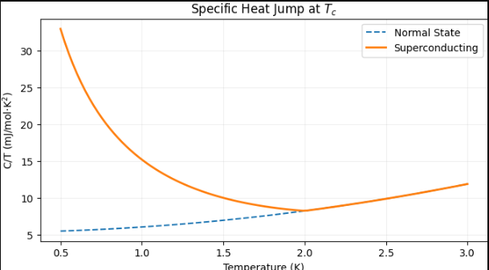
10 Vortex Lattice in Magnetic Field
↑H
◯ ◯ ◯
◯ ◯ ◯
◯ ◯ ◯ Hexagonal vortices for H∥c





