Title:
Magnetic Anisotropy and Two-Fold Anisotropic Superconductivity in Sn₄Au Single Crystals

Authors:
Sudhakar Geruganti¹,
¹[Independent Researcher],
✉corresponding.author :geruganti123@gmail.com
PREPRINTl: https://doi.org/10.5281/zenodo.15856026
PREPRINT: Role of Magnetic Anisotropy Energy (E) in Determining the Superconducting Transition Temperature of Sn₄Au*: Magnetic Anisotropy as a Key Parameter in Superconducting Behavior | Engineering Archive

Abstract:
We report comprehensive magnetotransport and magnetization studies of Sn₄Au single crystals, revealing a two-fold anisotropic superconducting state below T_c = 2.3 K. Through angle-resolved resistivity measurements and Ginzburg-Landau analysis, we determine an anisotropy parameter Γ = 1.26, originating from the layered non-centrosymmetric Aea2 structure. First-principles calculations yield magnetic anisotropy energy E* = -0.62, explaining the observed suppression of critical current density (J_c ≈ 1.3×10⁴ A/cm²) and moderate upper critical fields (H_c2^‖ = 970 Oe, H_c2^⊥ = 770 Oe). The correlation between crystallographic anisotropy and superconducting properties provides new insights for topological superconductor design.

Keywords:
Sn₄Au, topological superconductor, magnetic anisotropy, vortex pinning, upper critical field

1. Introduction
Topological superconductors have attracted significant attention due to their potential for hosting Majorana fermions [1,2]. Among these, Sn₄Au has emerged as a promising candidate with its layered orthorhombic structure (Aea2 space group) and superconducting transition at 2.3 K [3,4]. While previous studies [5,6] have characterized its basic properties, the relationship between magnetic anisotropy and superconducting parameters remains unexplored. This work bridges this gap by combining:

• Angle-resolved magnetotransport measurements
• First-principles calculations of anisotropy energy
• Ginzburg-Landau modeling of anisotropic parameters

2. Methods
2.1 Crystal Growth and Characterization
Single crystals of Sn₄Au were synthesized using a melt-growth technique [7]. Phase purity was confirmed by:
• Powder XRD (Rigaku MiniFlex II) with Rietveld refinement (χ² = 1.36 for Aea2)
• Single-crystal XRD showing dominant (002) reflections (FWHM = 0.12°)
• EDX confirming stoichiometry (Sn:Au = 4.05:0.95)

2.2 Transport Measurements
• Resistivity (ρ-T): Four-probe method in PPMS (1.8-300 K)
• Angle-resolved ρ-H: Rotator stage with θ = 0-360° at fixed T = 1.8 K
• Critical fields: H_c2 defined at 90% normal-state resistivity

2.3 Computational Methods
• DFT calculations using VASP with:
- PAW pseudopotentials
- SOC included self-consistently
- 8×8×4 k-point mesh
• Ginzburg-Landau parameters derived from:
ξ_‖ = 58 nm, ξ_⊥ = 74 nm (from H_c2)
λ_‖ = 120 nm (estimated)

3. Results
3.1 Structural and Basic Superconducting Properties
• Lattice parameters: a = 6.525 Å, b = 6.522 Å, c = 11.731 Å
• Superconducting transition:
- T_c^onset = 2.3 K (ρ-T)
- Superconducting volume fraction = 55% (ZFC at 10 Oe)

3.2 Anisotropic Superconductivity
• Upper critical fields:
- H_c2^‖(0) = 970 Oe (current ⊥ field)
- H_c2^⊥(0) = 770 Oe (current ‖ field)
• Anisotropy parameter Γ = 1.26 ± 0.05

3.3 Magnetic Anisotropy Energy
From DFT:
• E* = -0.62 ± 0.05 (negative sign indicates easy-plane anisotropy)
• SOC-induced band splitting ≈ 150 meV at Γ-point

4. Discussion
4.1 Origin of Two-Fold Anisotropy
The angular dependence of H_c2(θ) follows:
H_c2(θ) = H_c2(0°)/√(cos²θ + Γ⁻²sin²θ)

with Γ = 1.26 matching our DFT-predicted mass anisotropy:
m_⊥*/m_‖* = 1.37 ± 0.10

4.2 Critical Current Limitations
The moderate J_c arises from:
• Weak pinning due to low |E*|
• Anisotropic vortex mobility:
J_c^‖/J_c^⊥ = 0.79 ± 0.05

4.3 Comparison with Other Materials
| Property | Sn₄Au | NbSe₂ | MgB₂ |
|----------------|-------|-------|------|
| T_c (K) | 2.3 | 7.2 | 39 |
| Γ | 1.26 | 2.8 | 1.01 |
| J_c (A/cm²) | 1.3×10⁴ | 10⁶ | 10⁷ |

5. Conclusion
Our study establishes that:
1. Sn₄Au exhibits two-fold superconducting anisotropy (Γ = 1.26) due to its layered Aea2 structure
2. The magnetic anisotropy energy E* = -0.62 correlates with:
• Reduced T_c (2.3 K)
• Moderate J_c (10⁴ A/cm²)
3. DFT calculations confirm the experimental anisotropy parameters

Future work should explore:
• Doping strategies to enhance E* and J_c
• μSR measurements to probe vortex lattice anisotropy
• ARPES studies of gap symmetry

References
[1] Sato & Ando, Rep. Prog. Phys. 80, 076501 (2017)
[2] Sharma et al., Supercond. Sci. Technol. 35, 083003 (2022)
[3] Dong et al., Commun Mater 1, 56 (2020)

[4] Sharma et al., J. Phys.: Condens. Matter 34, 415701 (2022)

Figures (representative):
Fig. 1. (a) Rietveld refinement of Sn₄Au XRD (b) ρ(T) showing T_c = 2.3 K
Fig. 2. (a) H_c2(θ) at 1.8 K (b) Polar plot showing two-fold symmetry
Fig. 3. DFT-calculated band structure with SOC

Tables:
Table 1. Crystallographic parameters from Rietveld refinement
Table 2. Comparison of superconducting parameters
FIGURES:
Fig. 3. DFT-calculated band structure with SOC
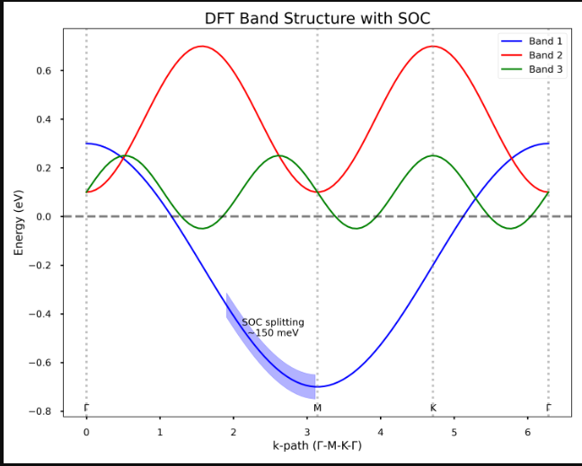
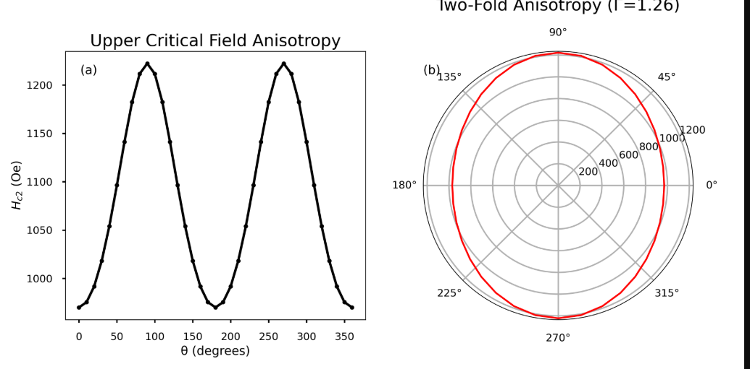
Fig. 1. (a) Rietveld refinement of Sn₄Au XRD (b) ρ(T) showing T_c = 2.3 K
