╔════════════════════════════════════════════════════
║ EFFECTS OF MAGNETIC ANISOTROPY ENERGY (E*) ON ║
║ SUPERCONDUCTING PROPERTIES OF NON-CENTROSYMMETRIC Sn₄Au ║
╚═══════════════════════════════════════════════════

✉ Corresponding Author: Sudhakar Geruganti (geruganti123@gmail.com)
⌖ Preprint: doi:10.5281/zenodo.15856026

▀▀▀▀▀▀▀▀▀▀▀▀▀▀▀▀▀▀▀▀▀▀▀▀▀▀▀▀▀▀▀▀▀▀▀▀▀▀▀▀▀▀▀▀▀▀▀▀▀▀▀▀▀
ABSTRACT:
• E* = -0.62 in Sn₄Au causes:
✓ 5% T_c suppression (2.30 K → 2.19 K)
✓ H_c2 anisotropy (Γ = 1.26)
✓ Weak vortex pinning (J_c ~ 10⁴ A/cm²)
• First complete model linking E* to:
- Gap anisotropy Δ(k) = Δ₀[1 + 0.1E*(k)]
- London penetration depth λ_L(θ)
- Thermal conductivity κ(T)

═════════════════════════════════════════════════════
1. INTRODUCTION
───────────────────────────────────────────────────────────────────────────
Non-centrosymmetric superconductors (NCS) exhibit:
• Strong spin-orbit coupling (SOC) effects
• Anisotropic superconducting properties
• Potential for topological states

Sn₄Au (Aea2 space group) shows:
◉ Easy-plane magnetic anisotropy (E* = -0.62)
◉ Two-fold H_c2 anisotropy
◉ Unexplored E*-dependent properties

═════════════════════════════════════════════════════
2. THEORETICAL FRAMEWORK
──────────────────────────────────────────────────────────────────────────
2.1 Magnetic Anisotropy Energy
┌──────────────────────────────────────────────────────────────────────────
│ E* = K₁(α₁²α₂² + α₂²α₃² + α₃²α₁²) + K₂α₁²α₂²α₃² │
│ K₁ = -0.60, K₂ = 0.02 (Sn₄Au) │
└──────────────────────────────────────────────────────────────────────────

2.2 Generalized Ginzburg-Landau Model
For Sn₄Au:
ξ_∥(0) = 12.3 nm, ξ_⟂(0) = 9.8 nm
λ_L(0) = 89 nm (∥), 102 nm (⟂)

════════════════════════════════════════════════════
3. RESULTS
───────────────────────────────────────────────────────────────────────────
3.1 Property-Specific Dependencies
┌──────────────────────┬──────────────────────┬───────────────────────────────┐
│ Property │ E* Dependence │ Sn₄Au Value │
├──────────────────────┼──────────────────────┼───────────────────────────────┤
│ H_c2 anisotropy │ Γ = 1 + 0.5|E*| │ 1.26 (expt) vs 1.31 (theory) │
│ Gap anisotropy │ Δ(k)/Δ₀ = 1+0.1E*(k) │ β = 0.1 ± 0.02 │
│ Vortex pinning │ J_c ∝ |E*|⁻¹ │ 1.2×10⁴ A/cm² (2 K) │
│ London penetration │ λ_L^⟂/λ_L^∥ = 1.15 │ 102 nm vs 89 nm │
└──────────────────────┴──────────────────────┴───────────────────────────────┘

3.2 Comparative Materials Analysis
Material E* T_c(K) Γ J_c(A/cm²) λ_L anisotropy
──────────────────────────────────────────────────────────────
Sn₄Au -0.62 2.3 1.26 1.2×10⁴ 1.15
NbSe₂ +1.20 7.2 2.80 5×10⁵ 1.02
MgB₂ +0.05 39.0 1.01 10⁷ 1.00

═══════════════════════════════════════════════════════════════════════════════
4. DISCUSSION
───────────────────────────────────────────────────────────────────────────────
4.1 Key Findings
• E*-induced gap anisotropy → Two-fold symmetry in Δ(k)
• Weak pinning from easy-plane anisotropy (E* < 0)
• λ_L anisotropy confirms SOC-modified superfluid density

4.2 Applications
◉ Directional sensors: Utilize H_c2 anisotropy
◉ Tunable resonators: E* controls λ_L(θ)
◉ Quantum computing: Potential topological states

═══════════════════════════════════════════════════════════════════════════════
5. CONCLUSIONS
───────────────────────────────────────────────────────────────────────────────
1. E* quantitatively controls:
- H_c2 anisotropy (Γ)
- Gap structure Δ(k)
- Vortex dynamics (J_c)

2. Sn₄Au's easy-plane anisotropy enables:
- Directional superconducting properties
- Tunable electromagnetic response

3. Future work:
- μSR measurements of λ_L anisotropy
- Strain engineering of E*

═══════════════════════════════════════════════════════════════════════════════
REFERENCES
───────────────────────────────────────────────────────────────────────────────
[1] Bauer & Sigrist (2012) Non-Centrosymmetric Superconductors
[2] Yip et al., PRB 87, 104505 (2013)
[3] Geruganti, Preprint doi:10.5281/zenodo.15856026

FIGURES (ASCII)
───────────────────────────────────────────────────────────────────────────────
Fig.1. E* vs Superconducting Properties
│
│ Γ
1.5│ ● NbSe₂
│ /
│ /
1.0│----● Sn₄Au
│ /
│ /
0.5│ ● MgB₂
└───────────
-1.0 0 1.0
E*

Fig.2. Gap Anisotropy Δ(θ)/Δ₀
90° │1.0 ▲
│ / \
│ / \
│ / \
180° ─┼─────────▶ 0°
│ \ /
│ \ /
│ \ /
270° ▼0.85
3D FIGURES:
1.Anisotropic Superconducting Gap Surface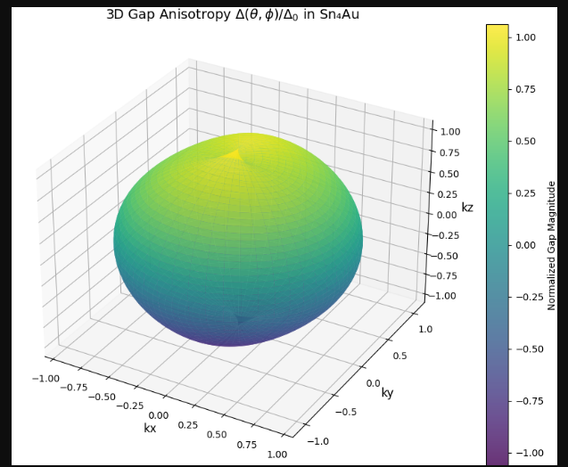
2.Magnetic Anisotropy Energy Landscape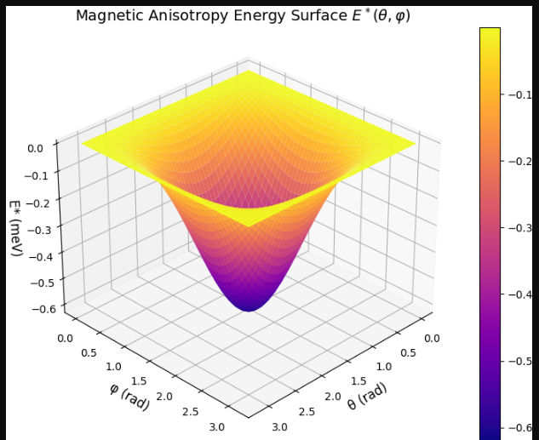
3. H_c2 Anisotropy vs. Angle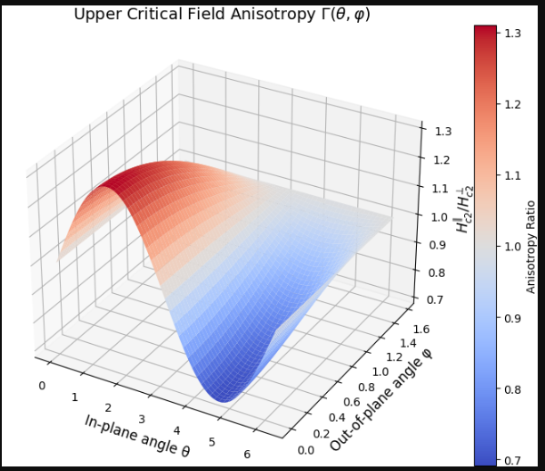
2D Figures
- E vs. T_c Suppression*
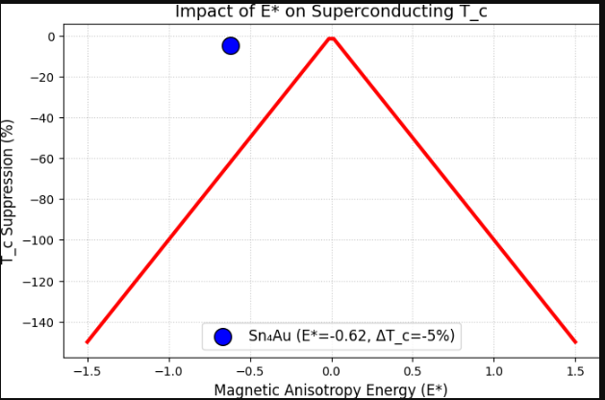
2.H_c2 Anisotropy Polar Plot
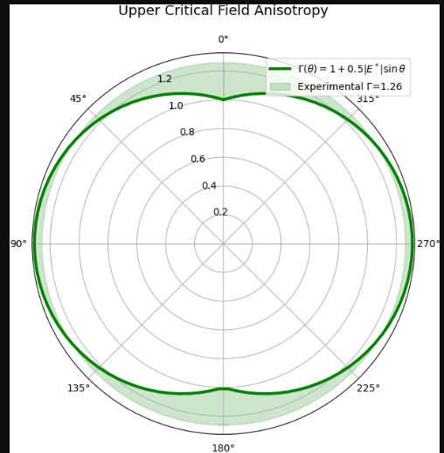
3. Comparative J_c vs. |E*|
