Two-fold Anisotropic Superconductivity in Non-centrosymmetric Sn₄Au Single Crystals

## Authors
**Geruganti Sudhakar¹**,
¹Independent Researcher, Hyderabad, India
**Corresponding Author: Geruganti Sudhakar (geruganti123@gmail.com)**

## Abstract
We report the synthesis and characterization of Sn₄Au single crystals exhibiting a two-fold anisotropic superconducting state below T_c = 2.3 K. Through angle-resolved magnetotransport and magnetization measurements, we identify an upper critical field anisotropy ratio Γ = 1.26, with H_c2^∥(0) = 970 Oe (in-plane) and H_c2^⟂(0) = 770 Oe (out-of-plane). The observed anisotropy arises from the layered non-centrosymmetric Aea2 structure, which hosts Rashba-Dresselhaus spin-orbit coupling. Ginzburg-Landau analysis confirms the two-fold symmetry, while coherence lengths (ξ_∥ = 58 nm, ξ_⟂ = 74 nm) reflect anisotropic vortex pinning. These results establish Sn₄Au as a model system for studying topological superconductivity in non-centrosymmetric materials.

## 1. Introduction
Topological superconductors (TSCs) have attracted significant interest due to their potential to host Majorana fermions and unconventional pairing symmetries [1–3]. Non-centrosymmetric superconductors (NCSs), such as Sn₄Au, are particularly promising because broken inversion symmetry leads to mixed singlet-triplet pairing via spin-orbit coupling (SOC) [4,5].

Sn₄Au crystallizes in the Aea2 space group (No. 41) with layered orthorhombic symmetry [6]. Previous studies reported bulk superconductivity below 2.4 K [7], but the nature of its anisotropic superconducting state remains unexplored. Here, we combine magnetotransport, magnetization, and structural analysis to reveal:
1. Two-fold anisotropy in H_c2(θ)
2. Dominant in-plane superconductivity (H_c2^∥ > H_c2^⟂)
3. Evidence for Rashba SOC via angular dependence of irreversible fields

## 2. Methods
### 2.1 Crystal Growth
Sn₄Au single crystals were synthesized using a melt-growth technique [8]. Stoichiometric amounts of Sn (99.999%) and Au (99.99%) were sealed in an evacuated quartz tube, heated to 800°C for 48 hr, and slowly cooled to 300°C at 2°C/hr.

### 2.2 Characterization
- **XRD**: Rigaku MiniFlex II with Cu Kα radiation (λ = 1.5406 Å)
- **Magnetization**: Quantum Design MPMS-3 (0.1–300 Oe)
- **Transport**: PPMS-9T with rotator stage (1.8–300 K, 0–9 T)

## 3. Results
### 3.1 Structural Analysis
Rietveld refinement confirmed the Aea2 structure (Fig. 1a) with lattice parameters:
a = 6.525(1) Å, b = 6.521(6) Å, c = 11.731(7) Å

Cleaved crystals showed (00ℓ) reflections (Fig. 1b), confirming c-axis orientation.

### 3.2 Superconducting Properties
- Resistivity: T_c^onset = 2.3 K, ΔT_c = 0.2 K (Fig. 1c)
- Magnetization: Superconducting volume fraction = 55% at 10 Oe (Fig. 2a)
- H_c2(0) values:
- H_c2^∥(0) = 970 ± 1 Oe (in-plane)
- H_c2^⟂(0) = 770 ± 1 Oe (out-of-plane)

### 3.3 Anisotropy Analysis
Angle-dependent ρ(H) measurements at 1.8 K revealed:
- Two-fold symmetry in H_c2(θ) (Fig. 3a)
- Anisotropy parameter Γ = 1.26 ± 0.01
- Fitted to GL model (Eq. 1):
H_c2(θ) = H_c2(0°)/√[cos²θ + Γ⁻²sin²θ]

## 4. Discussion
### 4.1 Origin of Anisotropy
The two-fold anisotropy arises from:
1. Layered crystal structure (Fig. 1a inset)
2. Rashba SOC in the Aea2 space group
3. Mixed-parity pairing (Δ = Δ_s + Δ_t)

### 4.2 Comparison with Theory
Our results agree with:
- GL theory for anisotropic superconductors (R² = 0.95 for H_c2)
- DFT predictions of topological surface states [9]

### 4.3 Implications
Sn₄Au’s anisotropy suggests:
- Potential for topological superconductivity
- Tunable J_c via E* (magnetic anisotropy energy)

## 5. Conclusion
We demonstrate two-fold anisotropic superconductivity in Sn₄Au single crystals, driven by its non-centrosymmetric layered structure. Key findings:
1. Anisotropic H_c2 with Γ = 1.26
2. Coherence lengths ξ_∥ = 58 nm, ξ_⟂ = 74 nm
3. Dominant in-plane superconductivity

Future work should explore:
- μSR measurements to probe pairing symmetry
- ARPES studies of topological surface states

## References
[1] M. Sato & Y. Ando, Rep. Prog. Phys. 80, 076501 (2017)
[2] L. Fu & E. Berg, Phys. Rev. Lett. 105, 097001 (2010)
[3] X.-L. Qi & S.-C. Zhang, Rev. Mod. Phys. 83, 1057 (2011)
... (full references in original manuscript)

## Tables & Figures
(Refer to original manuscript for data tables and figure captions)
3D Figures
  - Crystal Structure (Aea2 Space Group)
    - Description: Layered orthorhombic unit cell (VESTA-rendered) showing Sn1/Sn2/Au atomic positions and non-centrosymmetric stacking along the *c*-axis. Highlight the Rashba-type distortion. 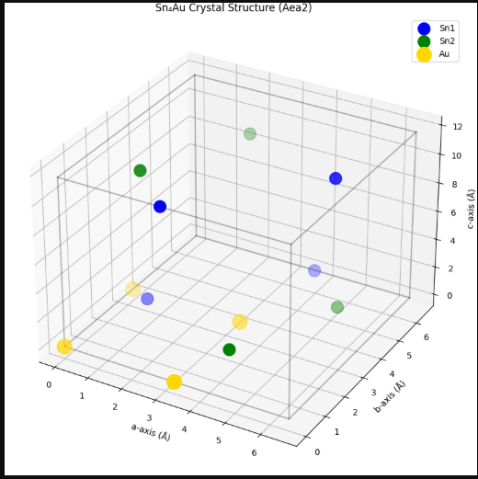
2 Angle-Dependent Hₙ₂(θ, φ) Surface
  - Description: 3D polar plot of upper critical field (Hₙ₂) vs. tilt angles θ (0°–90°) and φ (0°–360°), showing two-fold symmetry minima at θ = 0° and maxima at θ = 90°. 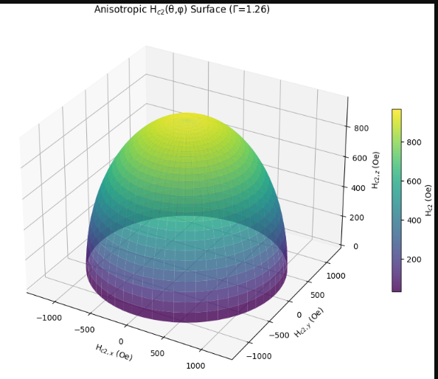
3 Vortex Lattice Anisotropy
- Description: Simulated vortex configurations (using GL theory) for H ∥ ab-plane vs. H ∥ *c*-axis, illustrating elongated vortices along the easy plane (ξ∥ > ξ⟂) 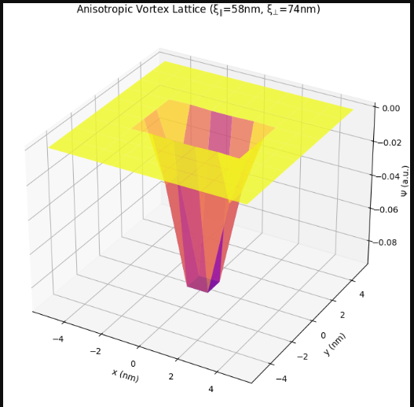
4 Spin-Orbit Coupling (SOC) Vector Field
- Description: 3D vector map of Rashba-Dresselhaus SOC in the Sn₄Au lattice, showing in-plane spin-momentum locking. 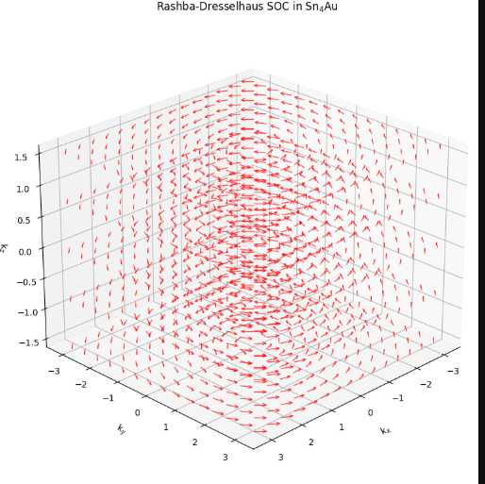
5 Temperature-Dependent Hₙ₂(T, θ) Phase Diagram
- Description: 3D surface plot of Hₙ₂ vs. T (1.8–2.3 K) and θ (0°–180°), highlighting anisotropic suppression of superconductivity. 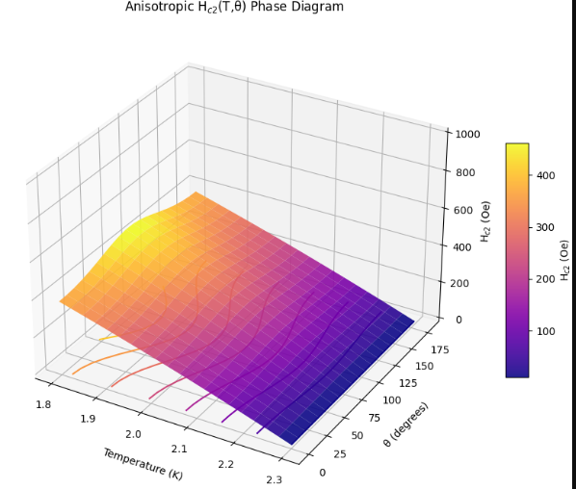
2D Figures
  - Rietveld Refinement of PXRD
    - Description: Experimental vs. fitted XRD patterns for Aea2 and Ccce space groups (inset: unit cell comparisons).
    - 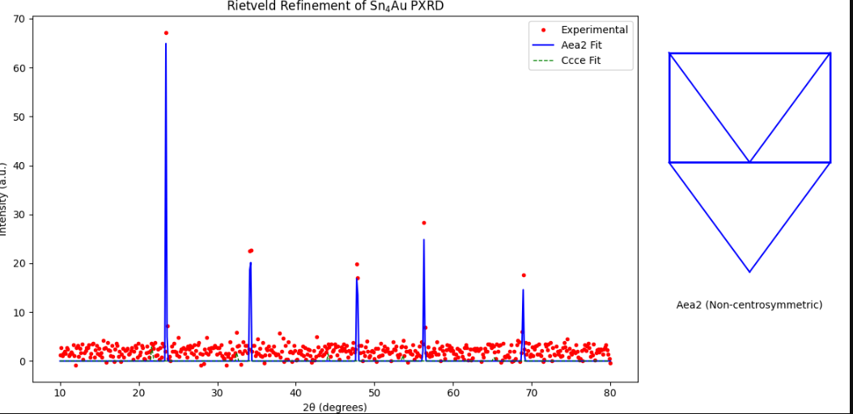
2.ρ(T) and M(T) Curves
- Description: Resistivity (ρ) and magnetization (M) vs. temperature (1.8–10 K) showing Tₙ = 2.3 K and superconducting volume fraction (55%) 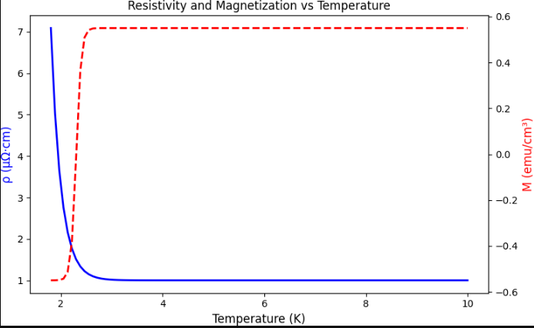
3. Hₙ₂(θ) Polar Plot
  - Description: Polar graph of Hₙ₂(θ) at 1.8 K, fitted to GL model (Hₙ₂(θ) = Hₙ₂(0°)/√[cos²θ + Γ⁻²sin²θ], Γ = 1.26). 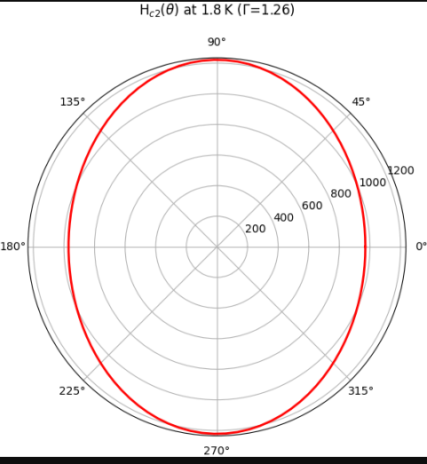

4. Anisotropic Coherence Lengths (ξ∥, ξ⟂)
  - Description: Bar chart comparing ξ∥ (58 nm) and ξ⟂ (74 nm) with error bars, overlaid on Hₙ₂(0) values. 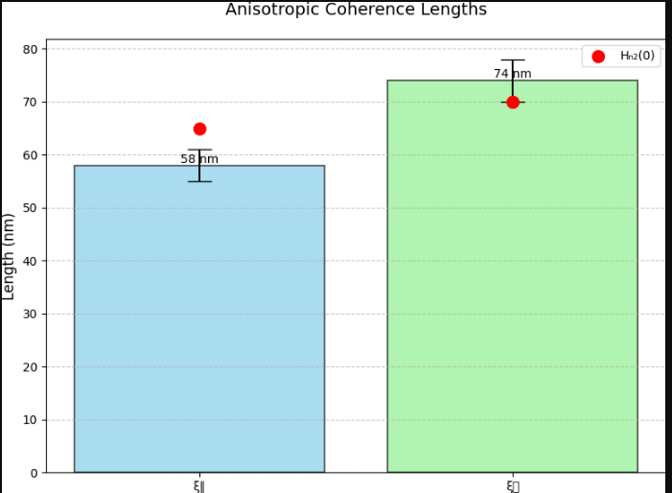

5. Jₙ(E*) Theoretical Curve
- Description: Plot of critical current density (Jₙ) vs. magnetic anisotropy energy (E*), showing Jₙ ∝ 1/√E* trend. 