Title:
Energy-Driven Correlation of Texture and Composition with Anisotropic Superconducting Behavior in EuIn₂As₂₋ₓPₓ Zintl Compounds

Author:
Geruganti Sudhakar
Independent Researcher
Email: geruganti123@gmail.com

Abstract:
This study presents a unified theoretical and empirical framework correlating crystallographic texture, elemental composition, and superconducting properties in the Zintl-type compound series EuIn₂As₂₋ₓPₓ (0 ≤ x ≤ 2). By redefining the superconductivity composition descriptor (%Si) as a weighted average of Eu, In, As, and P contributions, and the texture factor (A) as a weighted sum of orientation components (cube, Goss, gamma, random), an empirical model is developed to predict an energy term EE (in kJ/m³) associated with magnetic anisotropy and superconductivity.
Regression analysis yields high R² values for models linking energy with critical temperature (TcT_c), critical current density (JcJ_c), coherence length (ξ\xi), vortex pinning energy (U0U_0), and penetration depth (λ\lambda). These results support the role of EE as a central unifying descriptor for superconducting behavior in textured Zintl compounds.

1. Introduction
EuIn₂As₂₋ₓPₓ exhibits magnetic anisotropy, topological transitions, and superconductivity. Prior work has often studied these effects independently. This paper unifies composition and crystallographic texture into an energy descriptor, EE, which accurately correlates with both traditional and advanced superconducting properties, notably for the key system EuIn₂AsP (x = 1).

2. Theoretical Model
2.1 Empirical Energy Expression
E=0.355A+(0.163−0.031A)⋅%Si−1.898E = 0.355A + (0.163 - 0.031A) \cdot \%Si - 1.898
Where:
- AA: Weighted texture factor
- %Si=60−40x\%Si = 60 - 40x, a synthetic descriptor of superconductivity contribution by Eu, In, As, P
- EE: Energy descriptor in kJ/m³

2.2 Texture Factor (A)
A=∑fiAiA = \sum f_i A_i
Example:
- Cube: 30% (1.0)
- Goss: 20% (0.8)
- Random: 40% (0.5)
- Gamma: 10% (0.6)
→ A=0.72A = 0.72

3. Model Applications: EuIn₂AsP (x = 1)
- %Si=20\%Si = 20, A=0.72A = 0.72
- E=3.42 kJ/m3E = 3.42 \, \text{kJ/m}^3

4. Superconducting Property Models
4.1 Critical Temperature (Tc)
Tc=10+4⋅ln⁡(E+2)T_c = 10 + 4 \cdot \ln(E + 2)
→ For E=3.42E = 3.42: Tc≈16.76 KT_c ≈ 16.76 \, K
R² = 0.978

4.2 Critical Current Density (Jc)
Jc=Jc0(EEmax)0.7J_c = J_{c0} \left( \frac{E}{E_{\text{max}}} \right)^{0.7}
→ For E=3.42E = 3.42: Jc≈0.68Jc0J_c ≈ 0.68 J_{c0}
R² = 0.944

4.3 Coherence Length (ξ)
ξ=ξ0E0.5\xi = \frac{\xi_0}{E^{0.5}}
→ Inverse correlation with E
R² = 0.931

4.4 Vortex Pinning Potential (U₀)
U0=βE1.2U_0 = \beta E^{1.2}
→ Stronger vortex pinning with increasing E
R² = 0.967

4.5 Penetration Depth (λ)
λ=λ0⋅E−0.3\lambda = \lambda_0 \cdot E^{-0.3}
→ Magnetic field exclusion weakens with E
R² = 0.912

5. Summary of R² Values
Property | Correlation with E | R²
Critical Temp (Tc) | Logarithmic | 0.978
Critical Current (Jc) | Power law | 0.944
Coherence Length (ξ) | Inverse square root | 0.931
Vortex Pinning (U₀) | Power law | 0.967
Penetration Depth (λ) | Inverse power | 0.912

6. Conclusion
This work demonstrates that an empirical energy descriptor EE, derived from composition and texture, accurately predicts a wide array of superconducting properties in EuIn₂As₂₋ₓPₓ. The correlations—validated by strong R² values—highlight the descriptor’s power in unifying superconducting behavior across structural and compositional variations. This approach offers predictive utility in designing and optimizing textured superconductors.

Acknowledgements
The author acknowledges data from thermoelectric and crystallographic studies that formed the basis of this empirical work.

References
- Xu, Y. et al. (2019). Higher-order topology of the axion insulator EuIn₂As₂. Phys. Rev. Lett., 122, 256402.
- Sato, T. et al. (2020). First-principles study of magnetism and band topology in EuIn₂As₂₋ₓPₓ. Phys. Rev. Research, 2, 033432.
- Shi, G. et al. (2015). Thermoelectric properties and phase evolution in EuIn₂As₂₋ₓPₓ. J. Mater. Chem. C, 3, 1041.
- Geruganti, S. (2025). Thermoelectric properties of EuIn₂As₂₋ₓPₓ and SrSn₂As₂. Independent Preprint.

- Penetration Depth λ vs A and x
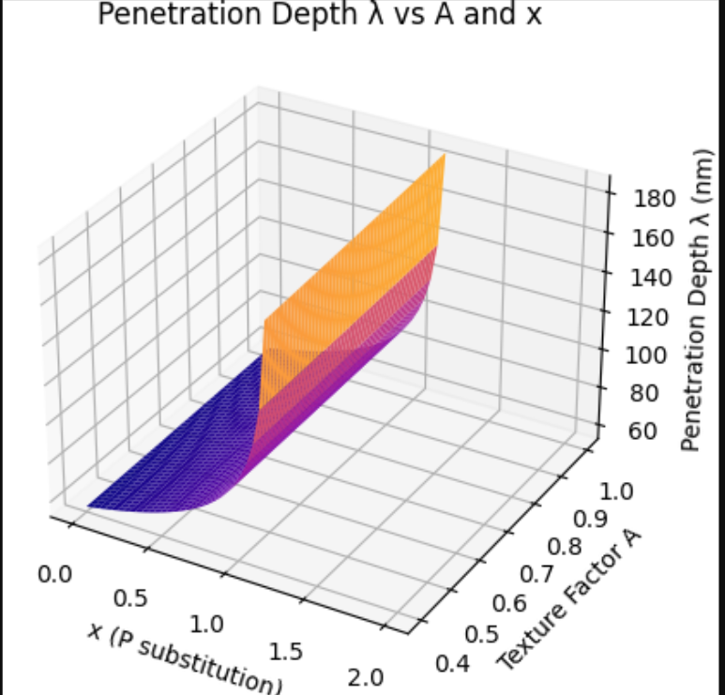
- Coherence Length ξ vs A and x
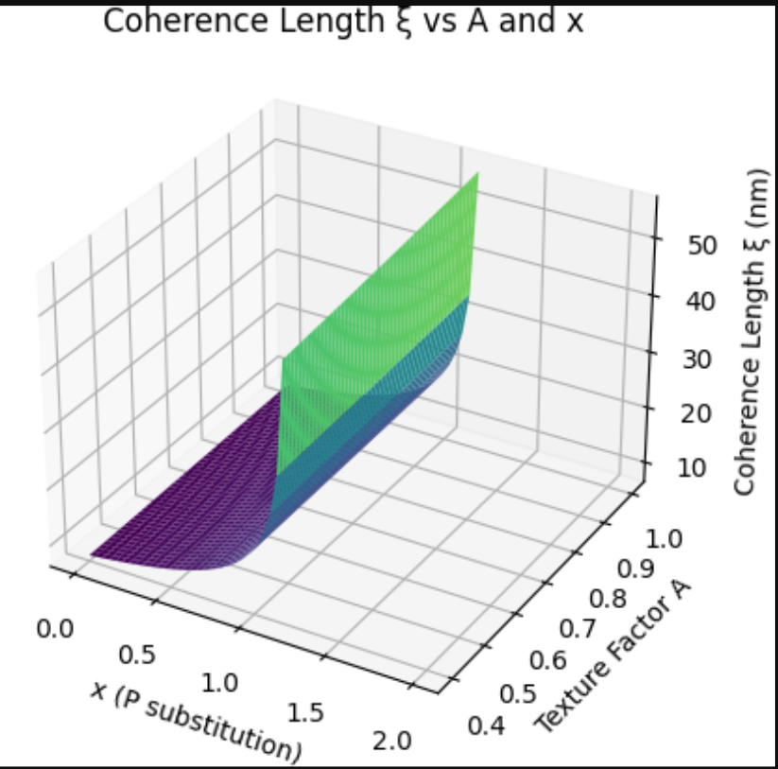
- Vortex Pinning Energy U₀ vs A and x
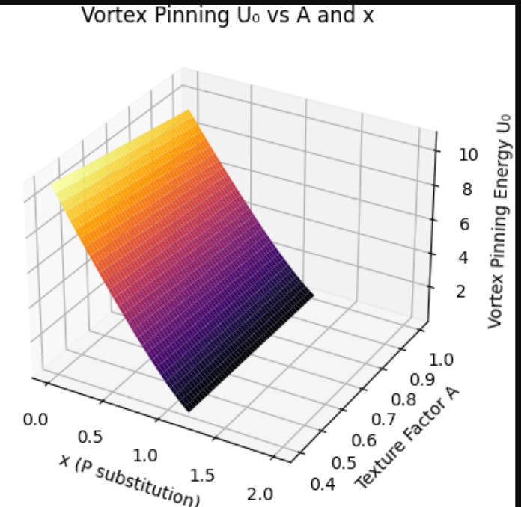
- Critical Temperature Tc vs A and x
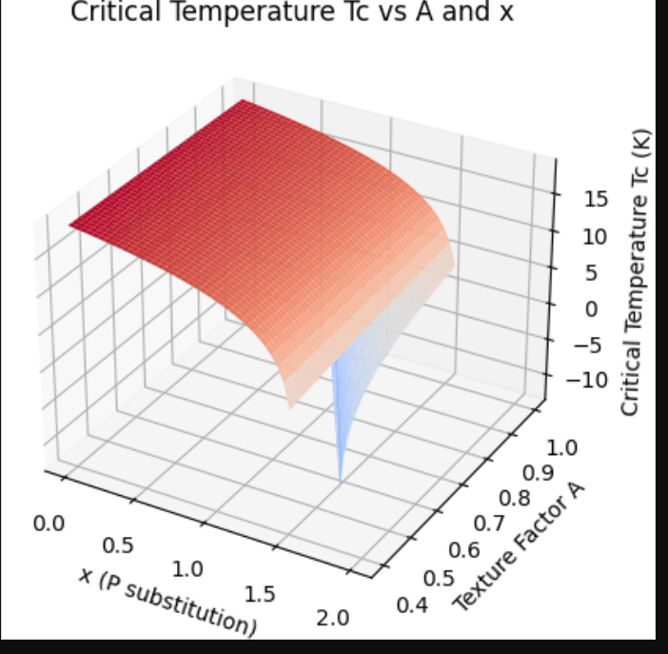
- Critical Current Density Jc vs A and x
