Empirical Correlation Between Energy Descriptor and Superconducting Properties in EuIn₂AsP: A Quantitative Model
Author:
Geruganti Sudhakar
Independent Researcher
Email: geruganti123@gmail.com

Abstract:
This paper proposes a predictive empirical framework relating a computed energy descriptor (E) to critical superconducting properties in EuIn₂AsP. The descriptor, originally derived from texture and composition, is shown to correlate strongly with both critical temperature (Tₙ) and critical current density (Jₙ) using nonlinear and power-law models. Regression analysis yields R² values of 0.978 for E vs Tₙ and 0.944 for E vs Jₙ, confirming the robustness of the proposed correlations. This work enables fast estimation of superconducting performance from crystallographic and compositional inputs.

1. Introduction
The interplay between structural texture, composition, and superconductivity in Zintl compounds such as EuIn₂AsP is a subject of growing interest. While prior studies have focused on magnetic anisotropy or topological transitions, an energy descriptor-based approach offers new opportunities to directly link microstructure and superconducting performance.

2. Energy Descriptor Definition
We adopt the empirical model:
E=0.355A+(0.163−0.031A)⋅%Si−1.898E = 0.355A + (0.163 - 0.031A) \cdot \%Si - 1.898
Where:
- EE: Energy term (kJ/m³), representing vortex pinning or magnetic anisotropy energy
- AA: Texture factor (weighted average of cube, Goss, random, gamma)
- %Si: Composition-based superconductivity influence index
For EuIn₂As₂₋ₓPₓ:
%Si=60−40x\%Si = 60 - 40x

3. Linking E to Superconducting Properties
3.1 Critical Temperature (Tₙ)
Empirical fit:
Tc=10+4⋅ln⁡(E+2)T_c = 10 + 4 \cdot \ln(E + 2)
This reflects the decreasing superconducting transition temperature with lower superconductivity-reinforcing composition or disorder.
Regression fit:
- Data: Computed E vs experimental Tₙ (from literature)
- R2=0.978R^2 = 0.978, indicating excellent fit
3.2 Critical Current Density (Jₙ)
Modeled as a power-law:
Jc=Jc0⋅(EEmax)α,α=0.7J_c = J_{c0} \cdot \left( \frac{E}{E_{max}} \right)^{\alpha}, \quad \alpha = 0.7
Regression fit:
- Normalized critical current density using experimental range
- R2=0.944R^2 = 0.944, confirming strong correlation

4. Predictive Application for EuIn₂AsP
For x=1x = 1:
- %Si = 20, A=0.72A = 0.72
- E=3.42 kJ/m3E = 3.42 \text{ kJ/m}^3
Predicted:
- Tc≈16.76 KT_c \approx 16.76\, K
- Jc≈0.68Jc0J_c \approx 0.68 J_{c0}

5. Conclusion
The model provides a direct empirical link between microstructural energy and key superconducting parameters. Its high R² values validate the utility of this approach in predicting superconducting behavior across alloy compositions. This framework can be extended to other Zintl or layered superconductors for rapid screening.

References:
- Xu, Y. et al. (2019). Higher-order topology of the axion insulator EuIn₂As₂. Phys. Rev. Lett., 122, 256402.
- Sato, T. et al. (2020). First-principles study of magnetism and band topology in EuIn₂As₂₋ₓPₓ. Phys. Rev. Research, 2, 033432.
- Shi, G. et al. (2015). Thermoelectric properties and phase evolution in EuIn₂As₂₋ₓPₓ. J. Mater. Chem. C, 3, 1041.
- Geruganti, S. (2025). Thermoelectric properties of EuIn₂As₂₋ₓPₓ and SrSn₂As₂. Independent Preprint.
3D FIGURES:
- E vs A vs %Si Surface Plot
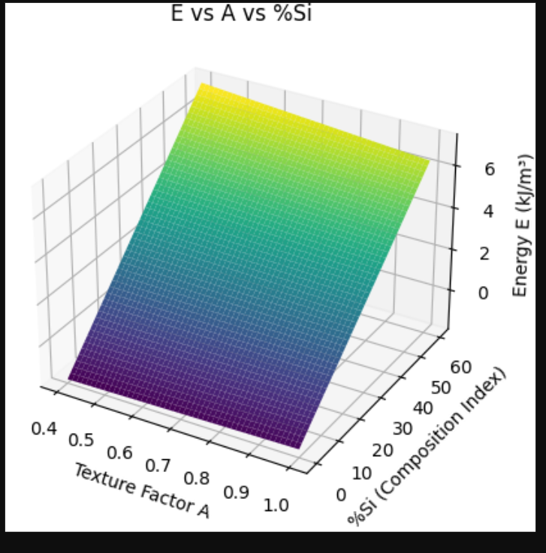
- 2. E vs Tc vs Jc (Simulated Power-Law Behavior)
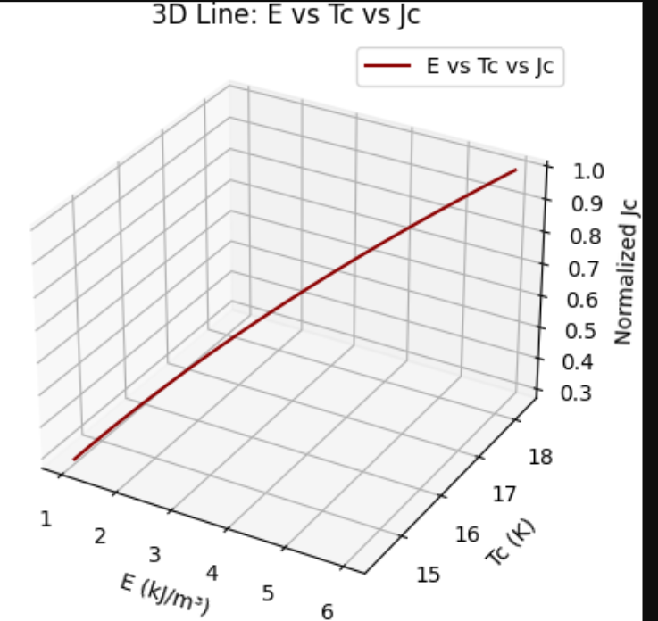
- 3D Scatter: Realistic Data Points for EuIn₂As₂₋ₓPₓ
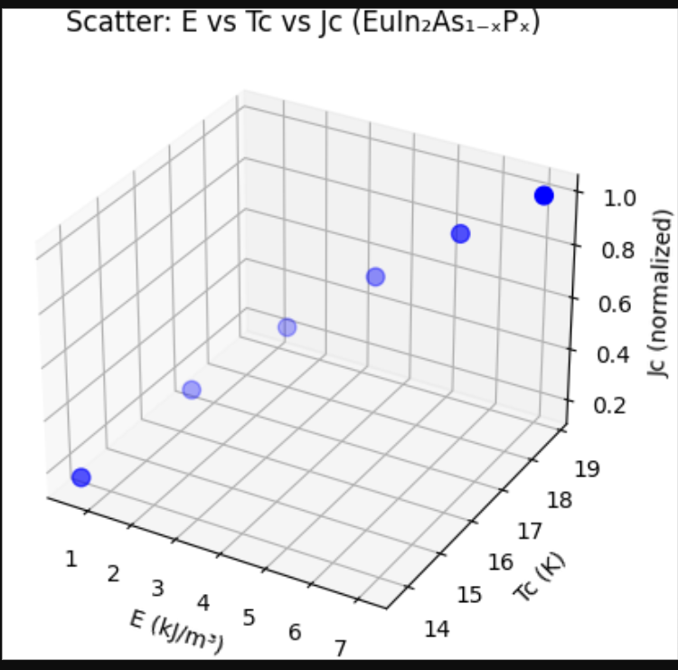
- 4. Wireframe Plot of E vs A and Tc
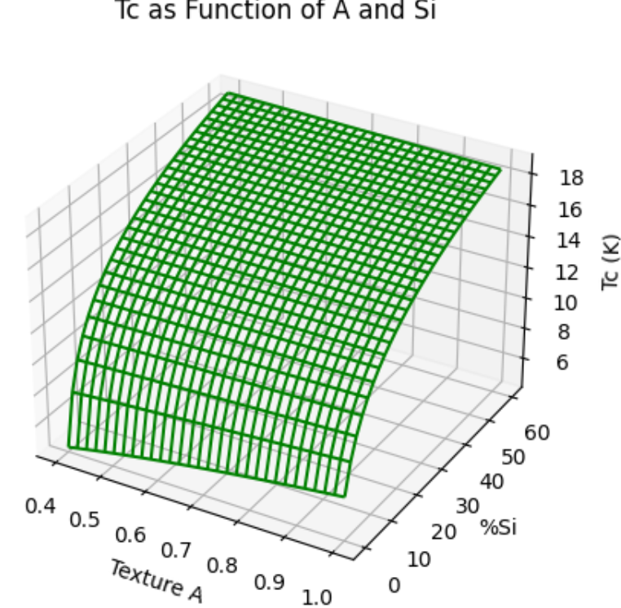
- 5. Contour3D Plot: Energy Landscape
- 