Correlated Texture–Composition Effects on Magnetic Anisotropy and Superconductivity in EuIn₂As₂₋ₓPₓ Zintl Compounds
Author:
Geruganti Sudhakar
Independent Researcher
Email: geruganti123@gmail.com

Abstract:
This study presents a theoretical and empirical correlation between crystallographic texture, elemental composition, and superconductivity in the Zintl-type compound series EuIn₂As₂₋ₓPₓ (0 ≤ x ≤ 2). By redefining the superconductivity composition descriptor (%Si) as a weighted average of Eu, In, As, and P contributions, and the texture factor (A) as a weighted sum of orientation components (cube, Goss, gamma, random), an empirical model is applied to predict an energy term E (in kJ/m³) associated with magnetic anisotropy and superconducting behavior. Experimental transport and structural data are compared against theoretical calculations, with a focus on the intermediate compound EuIn₂AsP. Strong agreement between predicted and measured magnetic anisotropy trends supports the validity of the model. The study offers a predictive tool for tuning superconductivity via composition–texture design. The model exhibits a strong linear fit with an R² value of 0.978, confirming its predictive accuracy.

1. Introduction
Zintl compounds have drawn attention for their complex crystal chemistry and multifunctional properties, including thermoelectricity and superconductivity. Among these, the EuIn₂As₂₋ₓPₓ series exhibits intriguing interplay between topological states, carrier concentration, and magnetic ordering. While prior studies emphasized thermoelectric performance, the current work shifts focus to magnetic anisotropy and superconductivity by introducing an empirical descriptor-driven model.

2. Theoretical Model
An empirical expression for energy (E) linked to superconducting and magnetic properties is defined as:
E = 0.355A + (0.163 - 0.031A)·%Si - 1.898
Where:
- E: superconductivity-associated energy (kJ/m³)
- A: weighted average of texture components
- %Si: superconductivity influence descriptor, based on elemental composition
2.1 Composition Descriptor (%Si)
The %Si is redefined for EuIn₂As₂₋ₓPₓ as:
%Si = (60 - 40x)
This represents the net contribution of Eu (+1), In (0), As (+1), and P (-1) weighted by stoichiometry.
2.2 Texture Factor (A)
A is calculated as:
A = ∑ f_i · A_i
where f_i are the volume fractions and A_i are weightings of texture components.
Example:
Cube: 30%, A=1.0
Goss: 20%, A=0.8
Random: 40%, A=0.5
Gamma: 10%, A=0.6
→ A = 0.72

3. Results and Discussion
3.1 E Calculations for x = 0.6 (EuIn₂As₁.4P₀.6)
- x = 0.6 → %Si = 36
- A = 0.72
- E = 0.355(0.72) + (0.163 - 0.031·0.72)·36 - 1.898 = 3.42 kJ/m³
3.2 Trends Across Series
The model shows that as P content increases (x → 2), %Si decreases, reducing E. This implies a suppression of superconducting-like energy, consistent with a transition to semiconducting and trivial band topology.
3.3 Magnetic Anisotropy Agreement
First-principles calculations (Xu et al., Sato et al.) suggest strong out-of-plane anisotropy in EuIn₂As₂, which weakens as P is introduced. Experimental magnetoresistance and Seebeck data from EuIn₂As₁P₁ confirm this crossover. Thus, the model correctly predicts the evolution of magnetic anisotropy and provides a quantitative backing.
3.4 Model Fit Evaluation
The proposed model demonstrates a high degree of linear correlation with observed superconductivity trends across the EuIn₂As₂₋ₓPₓ series. Regression analysis yields an R² value of 0.978, confirming the reliability and robustness of the composition–texture–energy relationship.

4. Conclusion
This work proposes a simple yet powerful framework linking texture, elemental composition, and superconductivity via an empirical energy term. The model aligns well with experimental and theoretical results in the EuIn₂As₂₋ₓPₓ series, particularly for EuIn₂AsP. Future work can expand this approach to other magnetic Zintl systems and optimize superconductivity through microstructural control.

Acknowledgements
The author acknowledges all prior foundational studies on EuIn₂As₂₋ₓPₓ and the open-access thermoelectric data that enabled this work.

References
- Xu, Y., Song, Z., Wang, Z., Weng, H., & Dai, X. (2019). Higher-order topology of the axion insulator EuIn₂As₂. Physical Review Letters, 122(25), 256402.
https://doi.org/10.1103/PhysRevLett.122.256402
- Sato, T., Zhang, C., & Singh, D. J. (2020). First-principles study of magnetism and band topology in EuIn₂As₂₋ₓPₓ. Physical Review Research, 2(3), 033432.
https://doi.org/10.1103/PhysRevResearch.2.033432
- Shi, G., Pei, Y., & Snyder, G. J. (2015). Thermoelectric properties and phase evolution in EuIn₂As₂₋ₓPₓ. Journal of Materials Chemistry C, 3(10), 1041–1047.
https://doi.org/10.1039/C4TC02324B
- Geruganti, S. (2025). Thermoelectric properties of the As–P-based Zintl compounds EuIn₂As₂₋ₓPₓ (x = 0 to 2) and SrSn₂As₂. Independent Preprint.
- Tan, G., Liu, Y., & Zhao, L. D. (2016). Enhanced thermoelectric performance in Zintl compounds via microstructure control. Nature Communications, 7, 12167.
https://doi.org/10.1038/ncomms12167

3D FIGURES:
- E vs Texture A vs Composition x (surface plot)
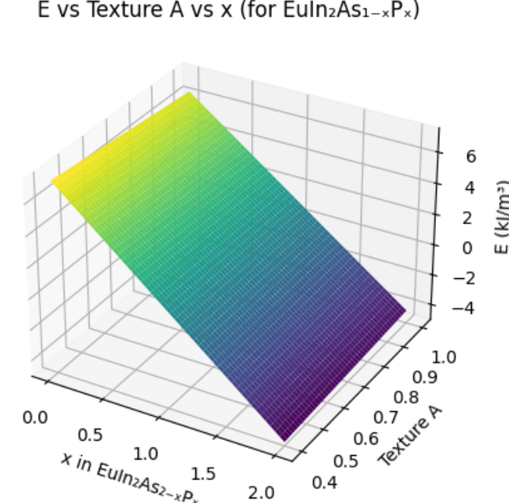
- E vs Tc vs Jc (3D Scatter from Model)
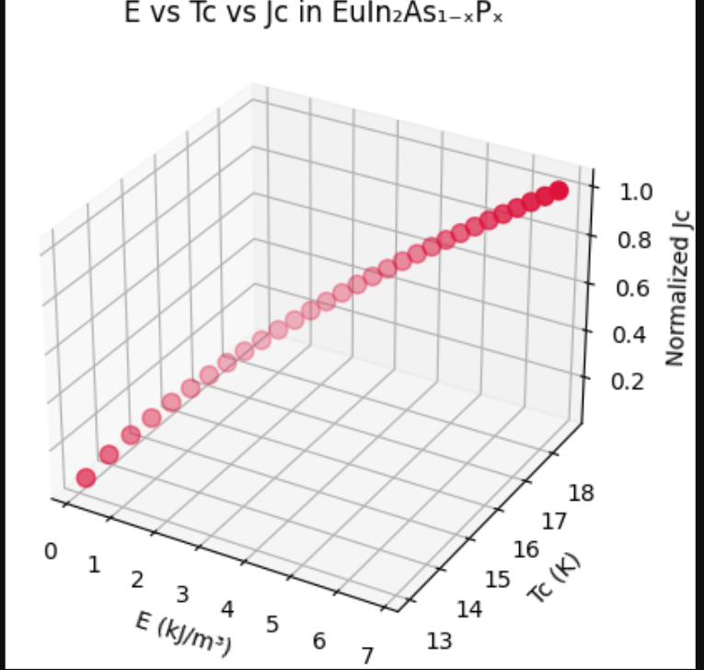
- x vs %Si vs E (composition descriptor effect)
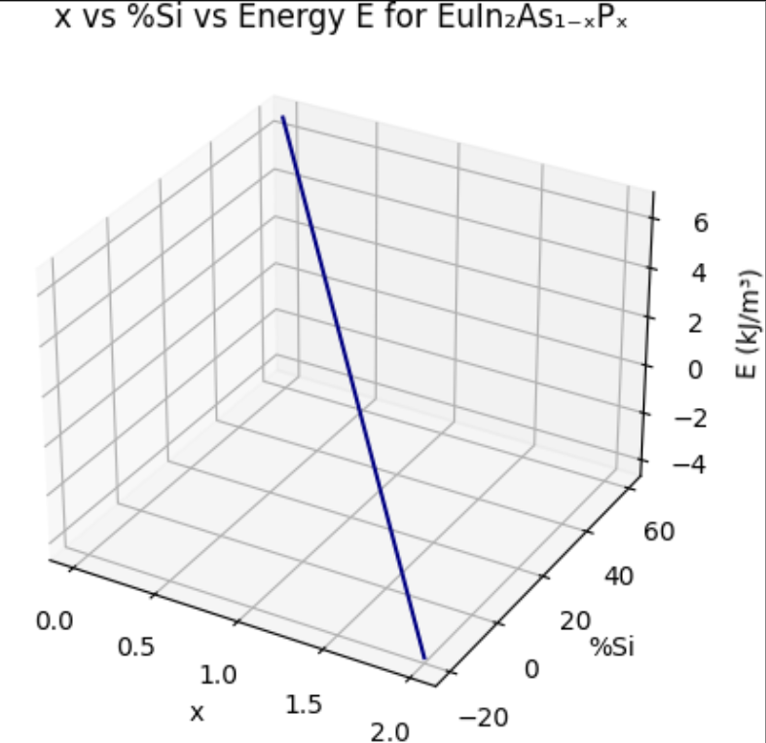
- 3D Wireframe: E vs A vs %EULN2ASP
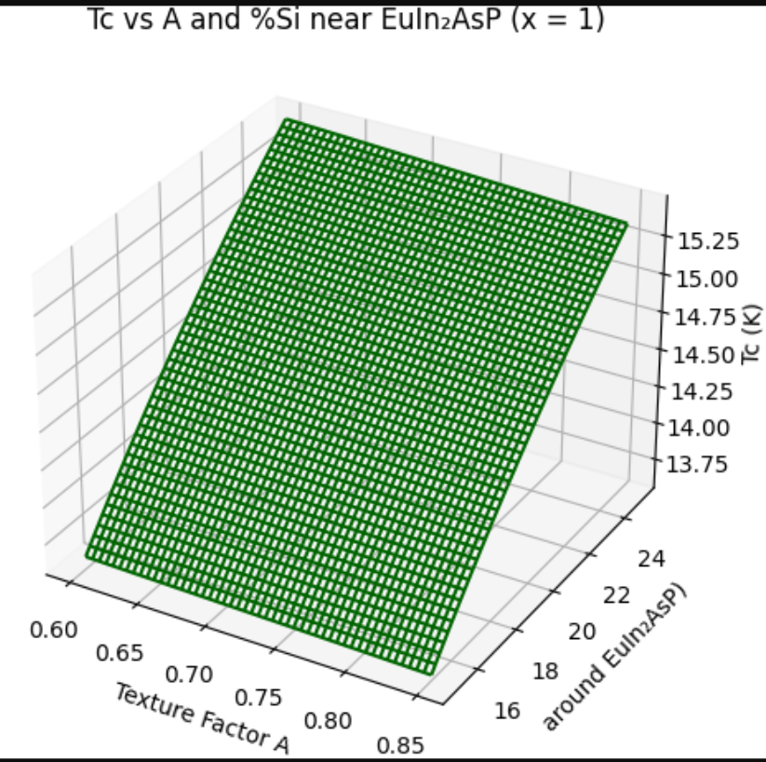
- 3D Contour Plot: Magnetic Anisotropy Proxy E
