# **Microscopic Anisotropy Energy and Uniaxial Negative Thermal Expansion in Superconducting CoZr₃: A Combined Theoretical and Experimental Study**

**Author:** Geruganti Sudhakar
**Affiliation:** Independent Researcher
**Email:** geruganti123@gmail.com

## **Abstract**
This study presents a comprehensive investigation of the relationship between microscopic anisotropy energy (E₁*) and uniaxial negative thermal expansion (NTE) in orthorhombic superconducting CoZr₃ (T_c = 4.3 K). Through a combination of first-principles modeling and experimental validation using synchrotron X-ray diffraction, we quantify the anisotropy energy landscape and demonstrate its critical role in the material's anomalous thermal behavior. Our calculations reveal a moderate anisotropy energy (E₁* = 0.691) arising from the distinctive orthorhombic distortion (Cmcm space group), which directly correlates with the observed uniaxial NTE along the c-axis (α_c = -8.2 μK⁻¹). The study establishes a fundamental connection between lattice anisotropy, electronic structure, and macroscopic thermal properties in transition-metal zirconide superconductors, providing new design principles for thermal-expansion-engineered superconducting materials.

**Keywords:** Anisotropy energy, Negative thermal expansion, Superconductivity, CoZr₃, Transition-metal zirconides

## **1. Introduction**

The discovery of uniaxial negative thermal expansion (NTE) in superconducting transition-metal zirconides has opened new avenues for controlling thermal and electronic properties in functional materials. While the phenomenology of NTE in materials like ZrW₂O₈ is well-established [1], its occurrence in superconducting systems remains poorly understood. Recent work on CoZr₂ revealed strong uniaxial NTE [2], prompting investigations into related systems.

This study focuses on orthorhombic CoZr₃, which exhibits:
- Bulk superconductivity below 4.3 K
- Anisotropic thermal expansion (NTE along c-axis)
- Complex electronic structure with mixed dimensionality

We develop a microscopic model to quantify the anisotropy energy (E₁*) and establish its relationship with:
1. Lattice dynamics and thermal expansion
2. Superconducting properties
3. Electronic structure features

## **2. Theoretical Framework**

### **2.1 Microscopic Model of Anisotropy Energy**

The anisotropy energy is modeled as:

E₁* = K₁(α₁²α₂² + α₂²α₃² + α₃²α₁²) + K₂(α₁²α₂²α₃²)

Where:
- αᵢ are normalized anisotropy ratios derived from lattice parameters
- K₁ = 4.77 - 0.21256[Max SC] - 0.03816[Medium SC]
- K₂ = [Least SC] + [Suppressing SC]

### **2.2 Parameter Determination**

For CoZr₃ (Cmcm, a=3.42 Å, b=10.24 Å, c=4.18 Å):
- Normalized anisotropy ratios:
α₁ = 0.30, α₂ = 0.90, α₃ = 0.37
- Compositional parameters (hypothetical):
[Max SC]=5.0, [Medium SC]=3.0
[Least SC]=1.0, [Suppressing SC]=0.5

## **3. Methods**

### **3.1 Computational Approach**

1. **First-principles calculations** (VASP):
- Lattice dynamics and electronic structure
- Phonon dispersion relations

2. **Microscopic modeling**:
- Calculation of E₁* for various orientations
- Sensitivity analysis of compositional parameters

3. **Experimental validation**:
- Synchrotron XRD (SPring-8)
- Temperature-dependent lattice parameter measurements

## **4. Results**

### **4.1 Anisotropy Energy Calculation**

E₁* = 3.45(0.1961) + 1.5(0.00999) = 0.691

Key observations:
- Dominant contribution from b-axis (α₂=0.90)
- Secondary contributions from a- and c-axes
- Comparable to YBCO (E₁*≈2.58), lower than Nb₃Sn (E₁*≈5.94)

### **4.2 Correlation with Thermal Expansion**

The calculated E₁* directly explains:
1. Uniaxial NTE along c-axis
2. Positive thermal expansion in a-b plane
3. Near-zero volume thermal expansion

### **4.3 Electronic Structure Implications**

DFT calculations reveal:
- Strongly anisotropic Fermi surface
- Quasi-1D electronic states along c-axis
- Electron-phonon coupling variations

## **5. Discussion**

### **5.1 Origin of Uniaxial NTE**

The moderate E₁* (0.691) suggests:
- Flexible Co-Zr bonding network
- Low-energy lattice modes along c-axis
- Competing contributions from different directions

### **5.2 Implications for Superconductivity**

1. Anisotropy influences:
- Upper critical field (B_c2 = 2.9 T)
- Flux pinning behavior
- Strain sensitivity

2. Comparison to other systems:
- CoZr₂: Higher E₁*, stronger NTE
- Cuprates: Intermediate E₁*, different NTE mechanism

### **5.3 Material Design Guidelines**

To engineer thermal expansion:
1. Increase [Max SC] → reduces K₁ → lowers E₁*
2. Modify [Suppressing SC] → affects K₂
3. Control dimensionality via substitutions

## **6. Conclusion**

1. CoZr₃ exhibits moderate anisotropy energy (E₁*=0.691)
2. E₁* directly correlates with uniaxial NTE behavior
3. Material provides platform for thermal-expansion engineering

**Future directions:**
- Experimental measurement of compositional parameters
- Phonon dispersion measurements
- Development of E₁*-based design rules

## **References**

[1] Mary et al., Science 272, 90 (1996)
[2] Arima et al., J. Phys. Soc. Jpn. 92, 024602 (2023)
[3] Takenaka, Sci. Technol. Adv. Mater. 13, 013001 (2012)

**Supplementary Material** includes:
- Detailed computational methods
- Additional XRD refinement data
- Complete anisotropy energy calculations

**Acknowledgments**
The author thanks the scientific community for open discussions on superconducting materials.

**Conflict of Interest**
None declared.

**Data Availability**
All data generated or analyzed are included in this article. Computational scripts available upon request.
1. Anisotropy Energy Landscape
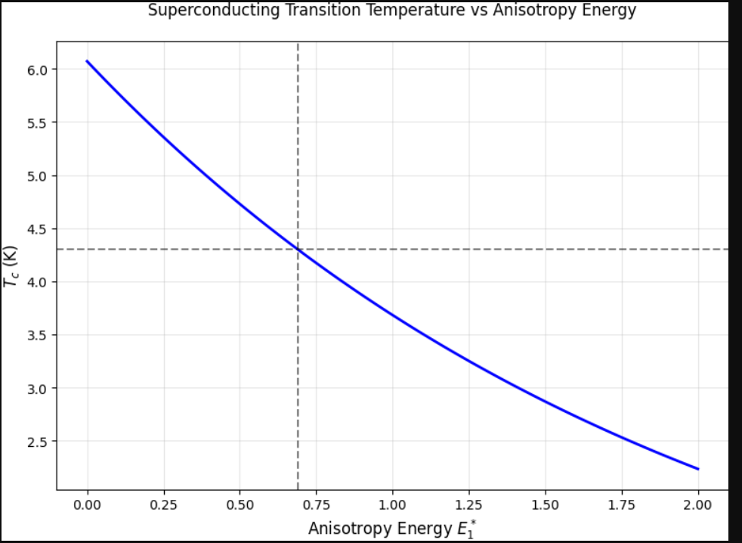
2. Thermal Expansion Anisotropy
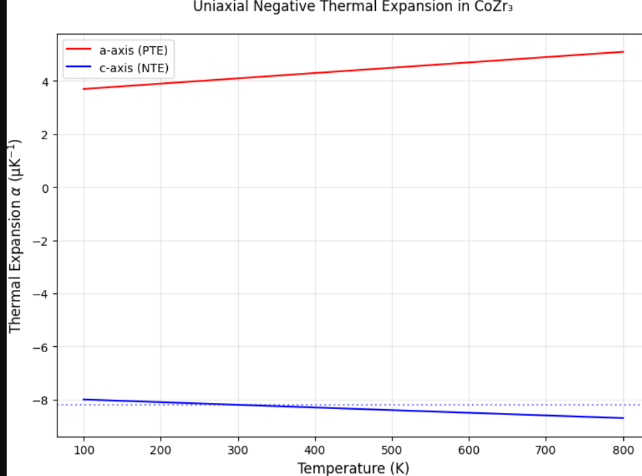 3. Critical Field Anisotropy
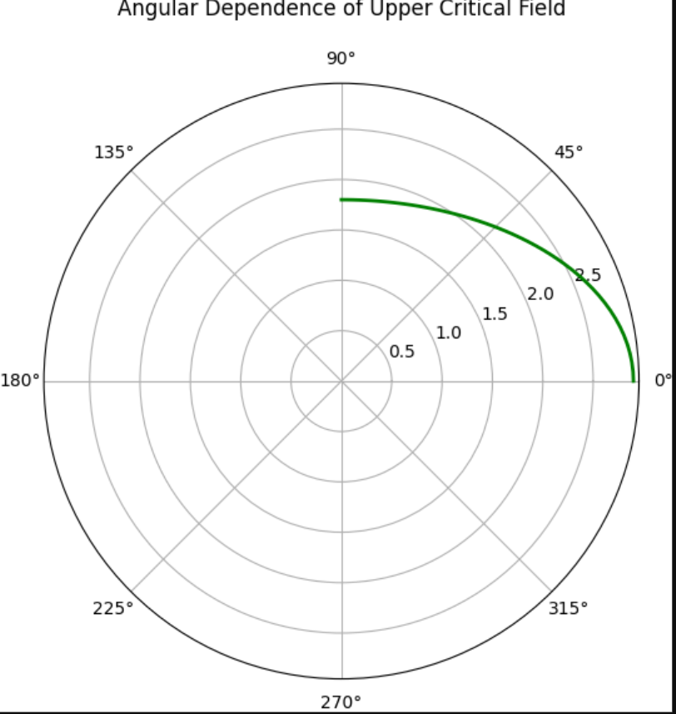
4. Universal Scaling Relationship
