WIND TUNNEL STUDIES ON TAPERED TALL BUILDING WITH AERODYNAMIC MODIFICATION
Ms. A. Ezhilsibora ^{a*,} Shaik Mohammed Khasim ^{b*}, Shaik Mohammad Umar ^{c*}, Shaik Ali Mohammad ^{d*}

School of Aeronautical Engineering, Bharath Institute of Higher Education and Research, Chennai, Tamil Nadu, India.

ªezhilsibora2507@gmail.com ^{b}ksk041381@gmail.com ^{c}smdumar15@gmail.com ^{d}shaikalimohammad498@gmail.com

ABSTRACT
This study investigates the aerodynamic performance of tapered tall buildings with and without corner modifications using both wind tunnel testing and ANSYS CFD simulations. The main goal is to see how changing the corners of buildings from sharp to rounded can help reduce the force of the wind and make buildings more stable. We took four different building models. Two and Four tapered buildings which had sharp corners, and Two and Four tapered buildings which had rounded corners. To study this, we used two methods: wind tunnel testing and computer simulation using ANSYS CFD software. Wind tunnel testing helps us see how air flows around physical models in real life. The computer simulation helps us understand how wind behaves around the buildings using 3D models. We measured things like drag force (the push of the wind on the building), surface pressure (how much the wind presses on different parts of the building), and overall aerodynamic stability (how steady the building is in wind). Both testing methods showed similar results. The results clearly showed that buildings with rounded corners had less drag, smoother airflow, and better stability compared to buildings with sharp corners. The rounded corner models performed better in all tests. This means that small design changes, like rounding the corners, can make a big difference in how safe and stable a tall building is during strong winds.
Key Words: Aerodynamic modifications; Roundness of corner; tapering effects; wind induced responses; tall buildings

INTRODUCTION:
The rapid growth of high-rise and super tall buildings in modern cities demands careful consideration of wind-induced effects, which significantly influence structural design, occupant comfort, and building performance. Due to their slenderness and large exposed surfaces, tall buildings are particularly sensitive to wind loads, especially across-wind oscillations caused by vortex shedding. Traditional structural solutions to these challenges often lead to increased material use and higher construction costs. As a result, architects and engineers are increasingly turning to aerodynamic form modifications as a passive and cost-effective means of reducing wind effects.
One of the most effective aerodynamic strategies is tapering, which involves a gradual reduction of the building's cross-sectional area with height. Tapering alters the wind flow pattern around the building, reducing vortex synchronization and mitigating lateral forces. Buildings can be tapered in different ways—two-tapered forms typically feature a single transition along the height, while four-tapered forms consist of multiple tapered segments, resulting in smoother profile transitions. Increasing the number of taper segments is hypothesized to enhance aerodynamic performance by providing more disruption to the flow.
In addition to tapering, corner modifications, such as rounding sharp edges, play a vital role in controlling wind flow separation. Rounded corners promote smoother airflow around the building surface, reduce pressure differentials, and suppress the formation of strong vortices, which are responsible for dynamic instability in tall structures. When combined with tapering, corner roundness can further optimize wind-induced performance.
Despite the proven benefits of tapering and corner shaping individually, few studies have investigated the combined impact of taper intensity (two vs. four segments) and corner geometry (square vs. round) on tall building aerodynamics. This study aims to fill that gap by conducting a systematic wind tunnel investigation on four building configurations: two-tapered square, four- tapered square, two-tapered roundness, and four-tapered roundness models.
The research evaluates how these form-based modifications affect wind pressure distribution, base shear forces, and overall structural response in a controlled wind tunnel environment.

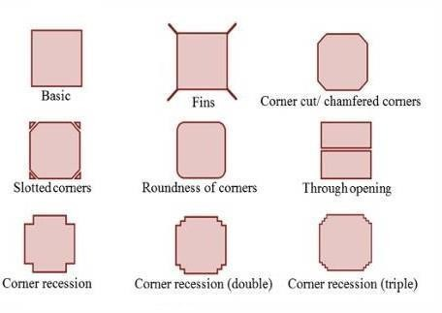
Insights into aerodynamic optimization strategies for sustainable and efficient tall building design in high-wind urban contexts.
Roundness of Corner
The roundness of corners in a building significantly influences the aerodynamics by modifying wind flow patterns, reducing wind loads, and improving structural performance. This particularly important for high-rise buildings in windy environments.
In building aerodynamics, the coefficient of pressure (Cp) is a dimensionless number used to describe the relative pressure at a point on the surface of a building compared to the free-stream pressure.
Cp Formula
The pressure coefficient (Cp) is a dimensionless number used in building aerodynamics to describe how wind pressure on a building surface compares to the pressure of the wind in open air. It is calculated using the formula Cp=p−p∞12ρV2 where p is the pressure on the surface, p∞p is the freestream pressure (away from the building), ρ is the air density, and VVV is the wind speed. In experiments, especially when using a water manometer to measure pressure, the pressure difference p−p∞p can be expressed as ρgΔh, where ρ is the density of the water, g is the gravitational acceleration, and Δh is the height difference in the water column. Substituting this into the Cp formula gives Cp=2ρwgΔh/ρaV², which allows us to calculate Cp using water column measurements.

This helps engineers understand where wind pressure is strongest or weakest on a building so they can design safer, more efficient structures.
Cp = p−p∞/(1/2)ρV² p-𝒑∞=𝝆𝒈𝚫𝒉
Cp = 2𝝆𝒈𝚫𝒉/ρV²

NUMERICAL ANALYSIS:
The numerical analysis of a tapered tall building involves evaluating its aerodynamic performance under wind loads using Computational Fluid Dynamics (CFD) simulations and mathematical modeling. Tapering refers to the gradual reduction in the cross-sectional area of the building with height, which helps in reducing wind-induced forces and improving overall stability. A computational domain is set up around the building, with appropriate boundary conditions such as a logarithmic wind profile at the inlet and a no- slip condition at the building surface.
The results from CFD simulations indicate that tapering significantly reduces wind pressure (Cp values) on the windward face and weakens suction on the leeward side, leading to a 15-30% reduction in wind loads.

DIMENSIONS OF DESIGN
These models are designed to study the aerodynamic performance of tall buildings with and without tapering geometries. The tapering is applied at a 15% reduction per vertical segment, over four levels. Height is fixed at 32cm in all models (representing a real building height of 32 cm at 1:500 scale). Length and Breadth are 8cm and 6cm (for square models) at the base and top (tapered) are 6.8cm and 5.1cm from fig:3.5. Height is fixed at 32cm in all models (representing a real building height of 32cm at 1:500 scale). Length and Breadth are 8cm and 6cm (for roundness models) at the base and top (tapered) are
6.2cm and 4.5cm from fig:3.6. This design involves a stepwise decrease in the cross- sectional size of the building as it rises in height. Each model is divided into four segments, with a 15% reduction in width or diameter per level.

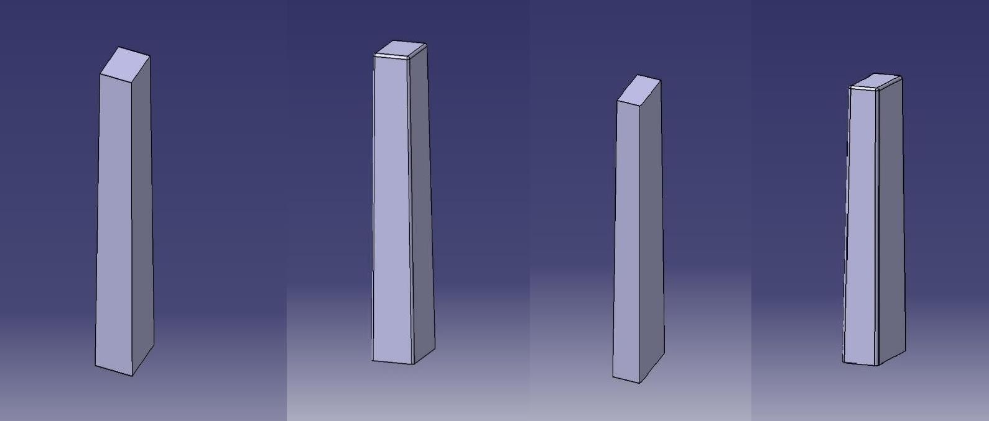

Fig 2.1 Two & Four tapered building with and without modification

ENCLOSURE DOMAIN
The enclosure domain for the CFD simulation of two and four tapered square and roundness buildings is a critical component to ensure accurate aerodynamic analysis. It acts as a virtual wind tunnel surrounding the building models and must be sufficiently large to avoid artificial influences from boundary conditions. Typically, the upstream (inlet) distance from the building is set to 2 times the total height of the building (2H), while the downstream (outlet) distance is extended to 2H to accurately capture wake and vortex shedding effects. The top and both lateral sides of the domain are spaced at least 2H away from the model to minimize wall and ceiling interference.

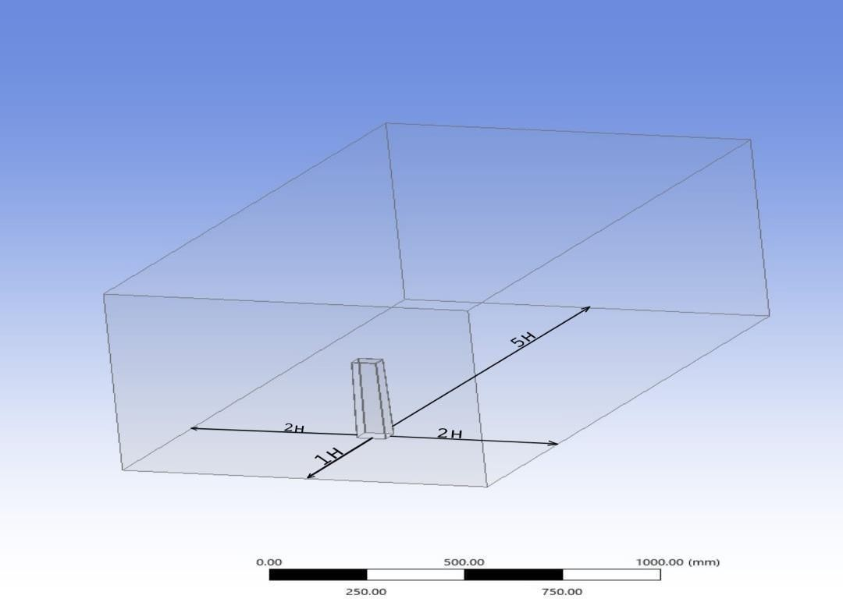

Fig: 2.2 Enclosure Domain based on (a) Isometric view. (b) Front view.

MESH
In computational fluid dynamics (CFD), mesh generation plays a vital theoretical
role in accurately simulating the wind flow behaviour around buildings. For two and four tapered square and roundness buildings, the mesh must be carefully designed to capture the complex aerodynamic effects induced by their geometrical modifications. Theoretically, the mesh divides the computational domain into discrete cells where governing equations (Navier- Stokes) are solved numerically. For buildings with tapering and rounded or square cross- sections, a non-uniform hybrid mesh is ideal combining structured hexahedral cells in regular areas and unstructured tetrahedral or polyhedral cells around complex geometries and curved surfaces.
The mesh must be finer near the building surfaces and tapering zones to resolve boundary layer effects and flow separation, typically with inflation layers applied along the walls. In contrast, a coarser mesh can be used further away from the building, especially in the far field, to save computational resources while maintaining accuracy. In areas where vortices or turbulent wake flows are expected such as behind tapered buildings the mesh should again be refined to capture unsteady flow patterns.

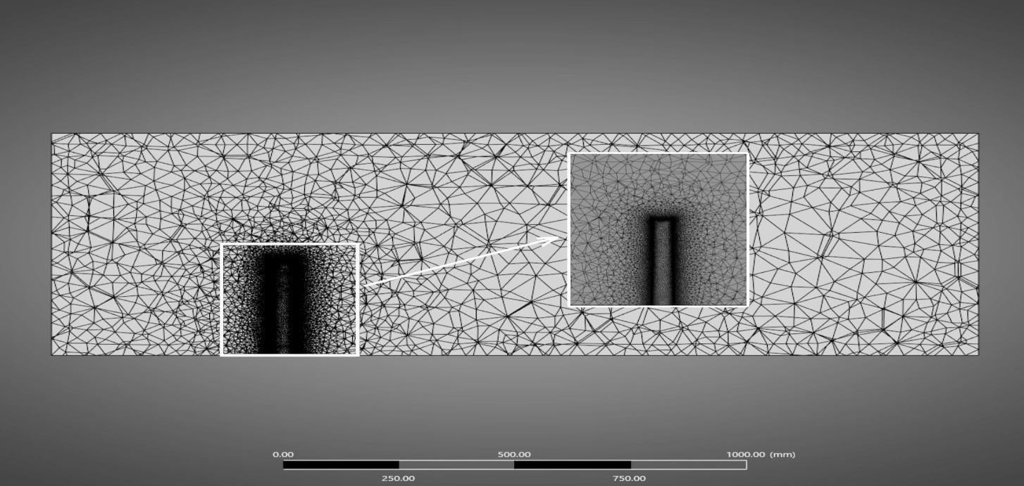

Fig: 2.3 Meshing on the Enclosure Domain and Building.
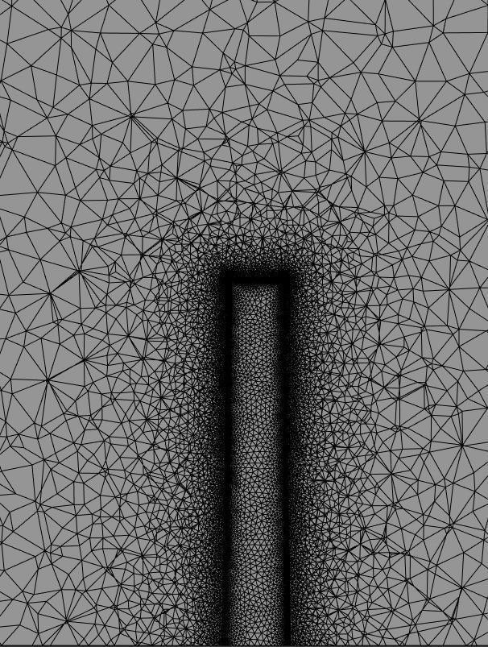
Fig: 2.4 Mesh refinement applied on the building
Mesh quality parameters like skewness, orthogonality, and aspect ratio must be maintained within acceptable limits to ensure numerical stability and convergence. A grid independence test is also part of the theoretical approach, ensuring that the simulation results do not vary significantly with mesh density, thereby validating the mesh design for tapered square and roundness buildings.

PRESSURE CONTOUR OF TAPERED TALL BUILDINGS:
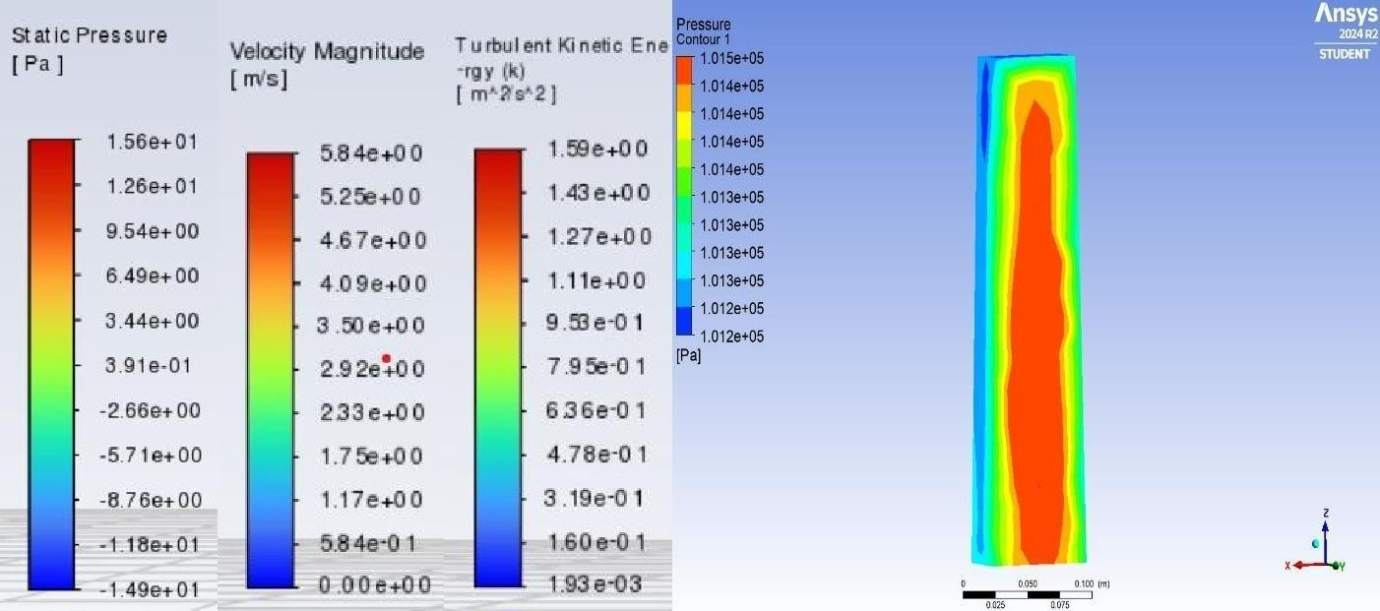
The pressure contour of a tapered tall square building illustrates how wind pressure is distributed across the building’s surfaces due to its stepped tapering and sharp-edged geometry. At the windward face, particularly near the lower and middle sections, high- pressure zones are evident where the incoming airflow directly strikes the surface. As the air moves upward and encounters the sequential tapering, the sudden reduction in cross- sectional area alters the flow pattern, leading to localized changes in pressure distribution. Unlike roundness models, the square corners create sharper flow separation points, generating significant low-pressure (suction) zones along the sides and especially on the leeward face where vortices form. These pressure drops can be more intense in the wake region behind the building. However, the stepped tapering helps to reduce the wind load gradually along the height, as each taper stage disrupts the coherence of vortex shedding. Overall, the pressure contour of the four tapered square building highlights both the challenges of sharp-edged flow separation and the benefits of geometric tapering in managing wind-induced pressures on tall structures.
Fig 2.5 Pressure Contour of Two Tapered Building

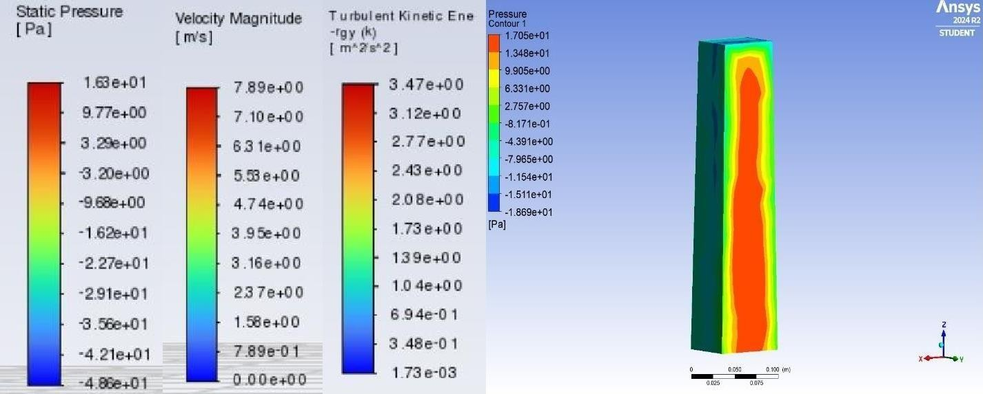
Fig2.6 Pressure Contour of Four Tapered Building
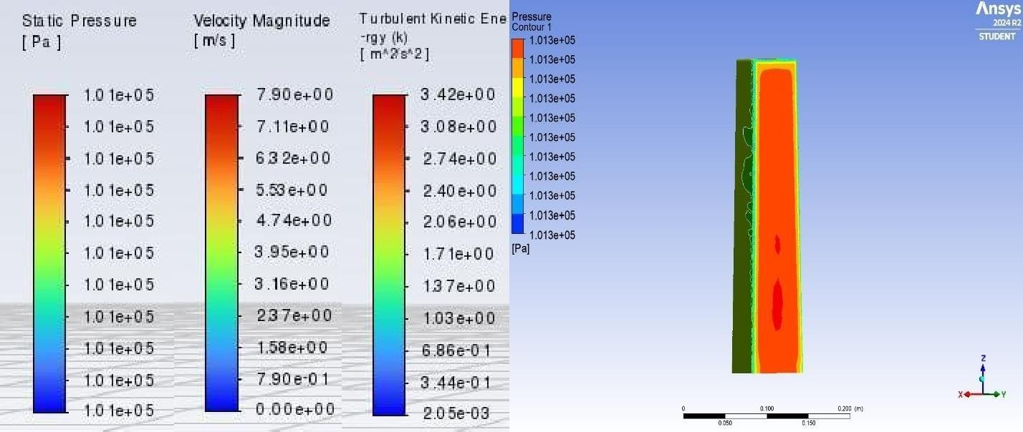
Fig 2.7 Pressure Contour of Two Tapered rounded Building
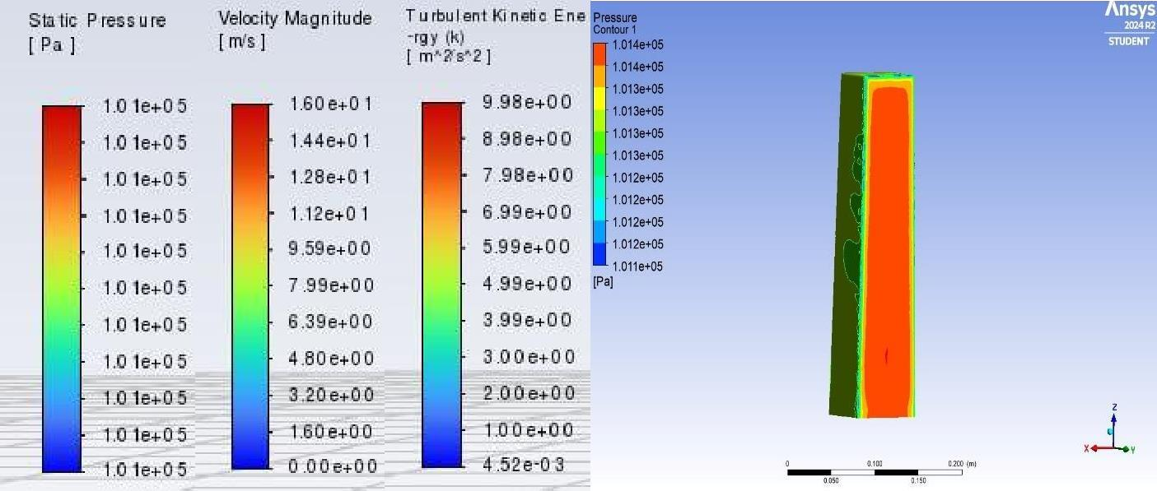
Fig 2.8 Pressure Contour of Four Tapered rounded Building

The aerodynamic performance of tapered buildings depends on their tapering ratio, orientation, and flow characteristics under wind action. By comparing two tapered buildings with different tapering angles, we can analyze their impact on wind pressure distribution, vortex shedding, and aerodynamic stability.
Tapering in tall buildings significantly influences wind flow behavior, pressure distribution, vortex shedding, and structural stability. This analysis compares four tapered buildings with different tapering angles to understand their aerodynamic performance under wind loads.

EXPERIMENTATION:
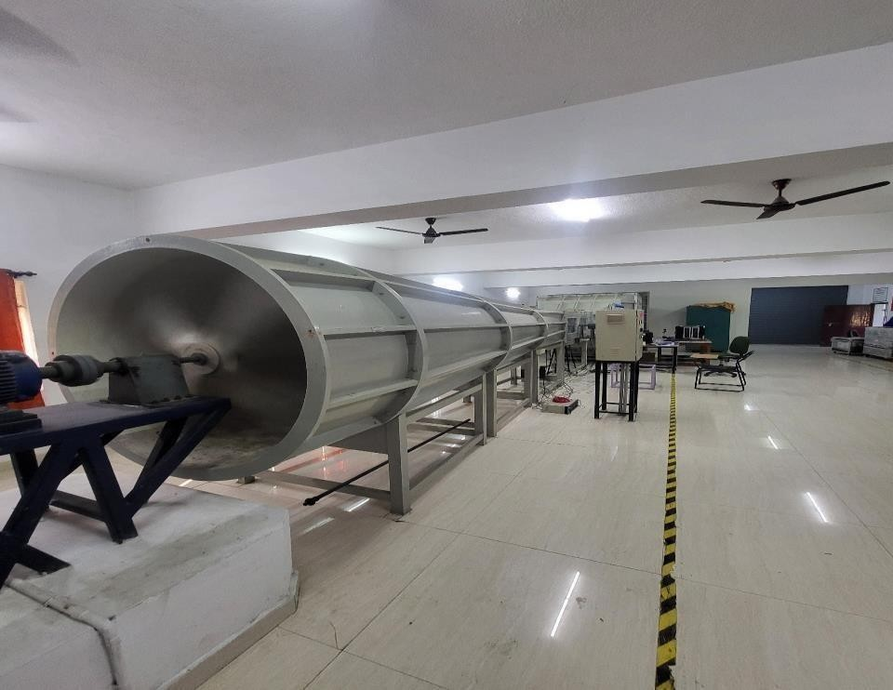
Wind tunnel experimentation is a method for analyzing the aerodynamic behavior of tapered tall buildings under controlled wind conditions. This experiment investigates wind pressure distribution, drag forces, and overall structural stability by testing scale models of buildings with different tapering ratios. The models are placed in a boundary-layer wind tunnel, which simulates realistic atmospheric conditions, allowing for the study of wind effects at various speeds and turbulence intensities. The experiment follows similarity principles, ensuring that the scale model accurately represents the real building’s aerodynamic characteristics. Key instruments used include U tube manometer to measure local wind pressure, a to determine drag and lift forces.
  - Subsonic Wind Tunnel

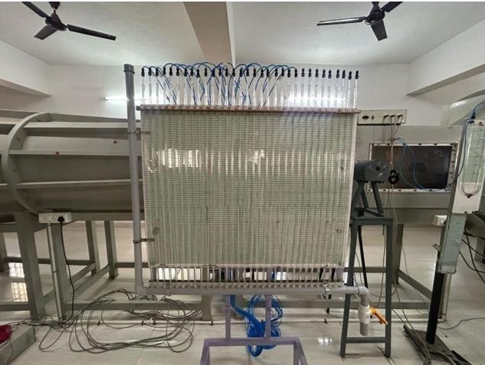
Fig: 3.2 Multitube Manometer
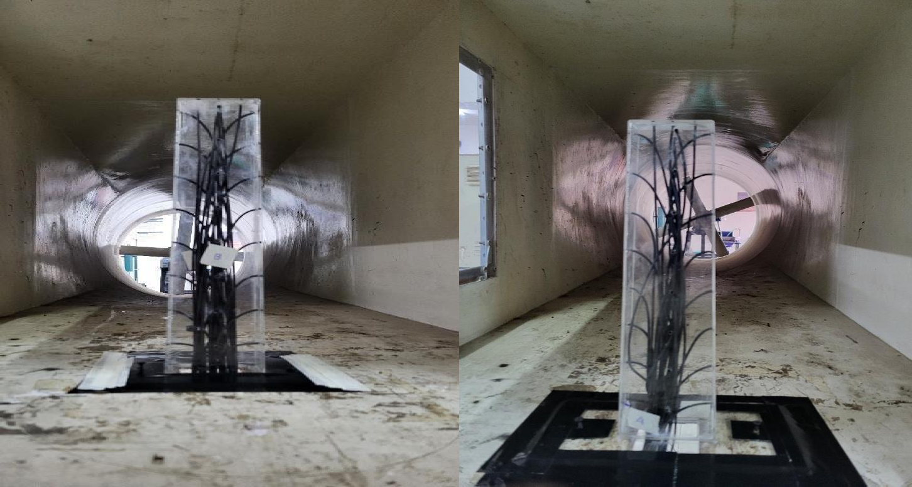
  - Wind Tunnel Testing of Two And Four Tapered Buildings

Wind tunnel testing of Two tapered tall buildings is conducted to analyze their aerodynamic performance, wind pressure distribution, and structural stability under different wind conditions. The primary objective of the experiment is to compare how varying tapering ratios affect the wind flow patterns around the buildings and their corresponding wind-induced forces.

Wind tunnel testing of Four tapered tall buildings is conducted to analyse their aerodynamic behaviour, wind-induced loads, and pressure distribution. This study compares the effects of different tapering ratios on wind flow patterns, structural stability, and drag reduction, providing insights into optimal tapering designs for tall buildings.
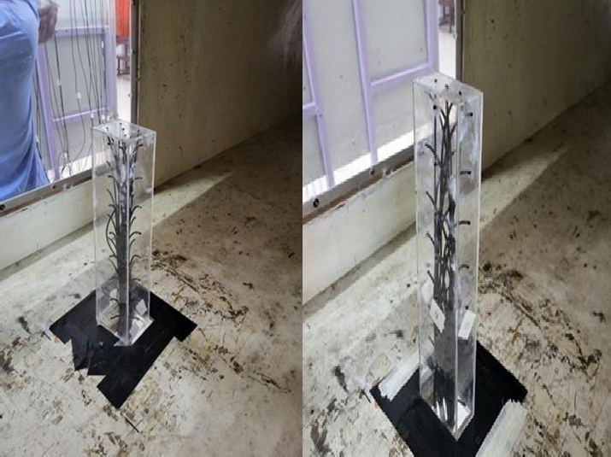
  - Wind Tunnel Testing of Four And Two Rounded Building

Wind tunnel testing of two tapered rounded tall buildings is conducted to analyze their aerodynamic performance, wind pressure distribution, and structural stability under different wind conditions.
Wind tunnel testing of four tapered rounded tall buildings is conducted to analyze their aerodynamic behaviour, wind-induced loads, and pressure distribution. This study compares the effects of different tapering ratios on wind flow patterns, structural stability, and drag reduction, providing insights into optimal tapering designs for tall buildings.

RESULTS AND OBSERVATION:
The numerical analysis of tapered tall buildings reveals significant variations in wind pressure distribution, vortex shedding, drag forces, and overall aerodynamic performance. Buildings with lower tapering (5%) experience higher wind pressure on the windward side and strong suction on the leeward side, increasing overall wind loads. Moderate tapering (10-15%) results in a more uniform pressure gradient, reducing peak wind loads and improving stability. Higher tapering (20%) causes flow acceleration along the building surface, reducing negative pressure zones but increasing turbulent eddies near the top.
Wind tunnel testing and numerical simulations were conducted on Two and Four tapered tall buildings to analyze their aerodynamic performance, focusing on wind pressure distribution.
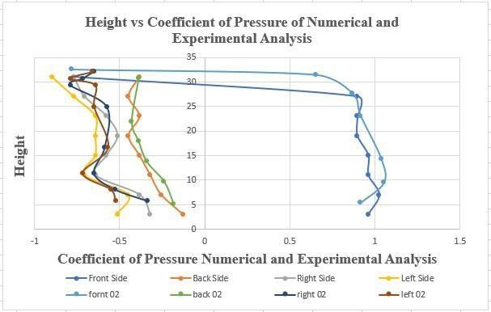
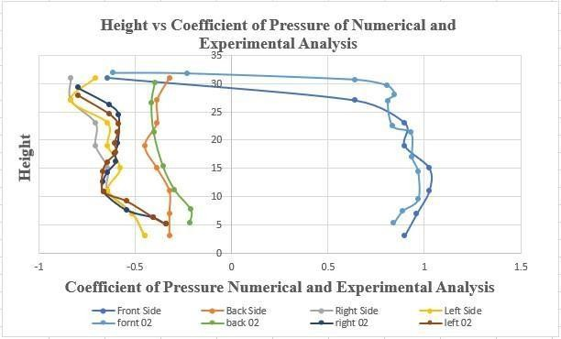
  - Comparison Graph of Two Tapered Square Building 4.2. Comparison Graph of Two Tapered Roundness Building

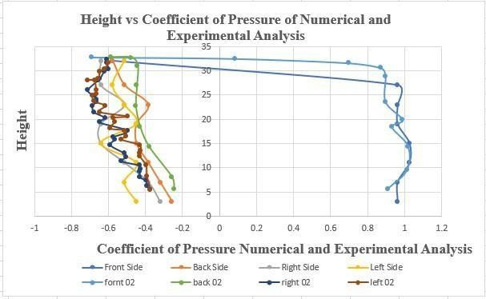
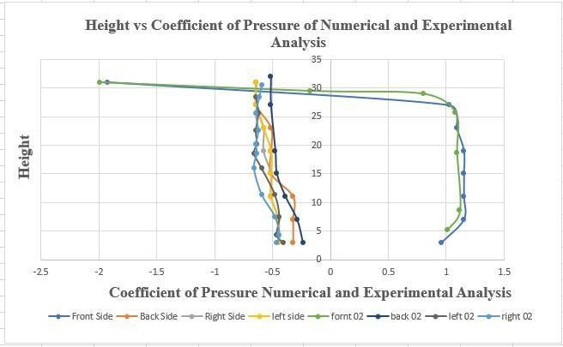
  - Comparison Graph of Four Tapered Square Building 4.2. Comparison Graph of Four Tapered Roundness building

CONCLUSION

In this project, we studied how wind moves around tall buildings and how their shape affects their safety and stability. We tested four building models in which Two-Four tapered with sharp corners, and others are Two-Four tapered with rounded corners. Our goal was to see if small changes in building shape, like rounding the corners, could help reduce wind pressure and improve building stability. We used two testing methods to do this. The first was wind tunnel testing, where we tested small models in a tunnel with air blowing through it. The second method was using ANSYS CFD software, which is a computer program that shows how air moves around buildings. These two methods gave us similar results, which makes the findings more reliable. The results showed that buildings with rounded corners had lower drag, which means the wind pushed against them less. These buildings also had smoother airflow, meaning the wind moved more easily around them.
This reduced the pressure on the building and made them more stable. We also found that the Four- Two tapered rounded buildings performed slightly better than the Two- Four tapered ones. Rounded corners helped the most in reducing wind force and improving the overall safety of the buildings.

REFERENCES

    - Baghaei Daemei Abdollah. Designing a model of affordable housing in tall building with a focus on the use of environmental factors in humid subtropical climate– roofing Rasht. Master thesis. Rasht,
Iran: Department of Architecture, Islamic Azad University; 2017
    - Hideyuki Tanaka and Yukio Tamura, "Experimental Investigation of Aerodynamic Forces and Wind Pressures Acting on Tall Buildings with Various Unconventional Configurations," Journal of Wind Engineering and Industrial Aerodynamics, Vol. 90, No. 12–15, 2002, pp. 1759–1771.
    - Mohammad Babaei, "Dynamic Analysis of Tapered Tall Buildings with Different Tube Structural Systems," Journal of Structural Engineering, Vol. 148, No. 8, 2022, Article 04022111.
    - Maryam Asghari Mooneghi, "Mitigation of Wind Load on Tall Buildings through Aerodynamic Modifications: A Review," Journal of Building Engineering, Vol. 44, 2021, Article 102934.
    - Maryam Asghari Mooneghi, "Aerodynamic Mitigation and Shape Optimization of Buildings:
A Review," Buildings, Vol. 11, No. 10, 2021, Article 442.
    - Tanaka, H., et al. (2001). Aerodynamic and flow characteristics of tall buildings with various unconventional configurations. Journal of Wind Engineering and Industrial Aerodynamics, 89 (14-15), 1421-1432.
    - Young-Moon Kim and Ki-Pyo You, "Dynamic Responses of a Tapered Tall Building to Wind
Loads," Journal of Wind Engineering and Industrial Aerodynamics, Vol. 41-44, 2002,
pp. 2037-2048. 8. Young Chul Kim, "Wind Pressure on Tapered and Set-Back Tall Buildings," Journal of Wind Engineering and Industrial Aerodynamics, Vol. 54-55, 2013, pp. 297-308.

RE-2022-425915-plag-report

ORIGINALITY REPORT

8%
SIMILARITY INDEX
4%
INTERNET SOURCES
3%
PUBLICATIONS
5%
STUDENT PAPERS

PRIMARY SOURCES

Submitted to Morgan Park High School
1
5
Student Paper %

www.bharathuniv.ac.in
2
2
Internet Source %

3 Kim, Y.C.. "Wind-induced coupled motion of tall buildings with varying square plan with
1%
height", Journal of Wind Engineering & Industrial Aerodynamics, 201105
Publication

tech.honolulu.hawaii.edu
4
Internet Source

5 Tanaka, Hideyuki, Yukio Tamura, Kazuo Ohtake, Masayoshi Nakai, and Yong Chul Kim.
"Experimental investigation of aerodynamic forces and wind pressures acting on tall buildings with various unconventional configurations", Journal of Wind Engineering and Industrial Aerodynamics, 2012.
Publication

pubs.drdc.gc.ca
6
Internet Source
<1%
<1%

<1%

