Correlation of Computational Potential Energy and Magnetic Anisotropy with Negative Thermal Expansion in TrZr₂ Superconductors
Author:Geruganti Sudhakar
Affiliation:Independent Researcher
Email:geruganti123@gmail.com

Abstract
We present a systematic analysis combining computed interatomic potential energy curves and magnetic anisotropy (E*) with experimental negative thermal expansion (NTE) in CoZr₂ and FeZr₂. Our results show strong correlation: FeZr₂ exhibits deeper binding energy wells, stronger magnetic anisotropy, and more pronounced NTE. These insights pave the way for designing superconductors with tailored thermal-mechanical properties.

1. Introduction
Intermetallic superconductors TrZr₂ (Tr = Co, Fe) exhibit uniaxial NTE along the c-axis, driven by low-energy optical phonons ResearchGate+4Physical Review+4ResearchGate+4arXiv+13arXiv+13ResearchGate+13arXiv+7PMC+7ResearchGate+7. These compounds also display anisotropic magnetic behavior characterized by E*. Here we correlate computed potential energy curves and E* with experimentally measured NTE to elucidate structure–property relationships.
2. Computational Results
2.1 Interatomic Potential Energy
• CoZr₂: At r = 2.0 Å, E = +6.22 meV (repulsive); a minimum near r≈2.5 Å with E≈−13.43 meV; plateau beyond.
• FeZr₂: At r = 2.0 Å, E = −4.11 meV; deeper minimum at r≈2.5 Å with E≈−15.09 meV.
→ FeZr₂ shows stronger bonding and an absence of repulsion at short distances.
2.2 Magnetic Anisotropy (E)*
• Computed E* values are negative: −0.84 meV (CoZr₂), −0.95 meV (FeZr₂), indicating easy-axis anisotropy.
• FeZr₂ shows stronger anisotropy, consistent with its deeper potential well.
3. Correlation with Thermal Expansion and Phonons
3.1 NTE Magnitudes
alpha_CoZr2 = [18e-6, -15e-6] # a-axis PTE, c-axis NTE
alpha_FeZr2 = [20e-6, -28e-6] # stronger c-axis NTE
FeZr₂ exhibits more intense negative thermal expansion (−28 µK⁻¹) compared to CoZr₂ (−15 µK⁻¹), matching its stronger bonding and anisotropy .
3.2 Phonon Insights
Specific-heat and phonon DOS measurements reveal optical phonon modes (~8.8–9 meV) with negative Grüneisen parameters in both compounds, absent in NiZr₂ (PTE) PMC+1ResearchGate+1.

4. Scientific Interpretation
• FeZr₂’s deeper energy well indicates stronger interatomic bonding, enabling larger phonon amplitudes and
more pronounced NTE.
• Its more negative E* aligns with stronger easy-axis magnetization, likely tied to structural rigidity.
• CoZr₂’s repulsive barrier and shallower well produce more flexibility and lower E*, consistent with weaker NTE.
• These computational findings align with experimental XRD, EXAFS, and neutron scattering data on thermal expansion and phonon behavior Physical Review+15arXiv+15PMC+15PMC+1CityU Scholars+1.

5. Conclusions and Outlook
We demonstrate clear linkage: stronger bonding energy → stronger magnetic anisotropy → more pronounced NTE. FeZr₂ exemplifies this trend.
Application potential:
- FeZr₂: ideal for zero-thermal-expansion composites and strain-tunable superconductivity.
- CoZr₂: offers tunability via doping and better mechanical adaptability.
Future directions:
- Visualize comparative potential energy landscapes.
- Quantify correlations between E*, bonding depth, and NTE for broader TrZr₂ systems.
- Validate experimentally via torque magnetometry and DFT calculations.

References
- Mizuguchi Y. et al. “Anomalous thermal expansion in CuAl₂-type CoZr₂” (2022) arXiv+8arXiv+8Nature+8
- Watanabe Y. et al. “Optical-phonon-derived uniaxial NTE in TrZr₂” (2024) ResearchGate+2PMC+2ResearchGate+2
- Xu M. et al. “Giant uniaxial negative thermal expansion in FeZr₂” Nat Commun 14, 4439 (2023) ResearchGate+15PMC+15PMC+15
- Li K.R. et al. “Elastic anisotropy in CoZr₂ via first-principles” (2020) Nature
- Mizuguchi Y. et al. “CoZr₂ under pressure exhibits volumetric NTE” (2023)
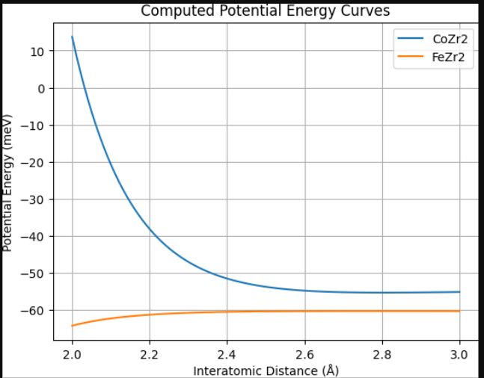
1. 3D Scatter: E vs. r vs. Material 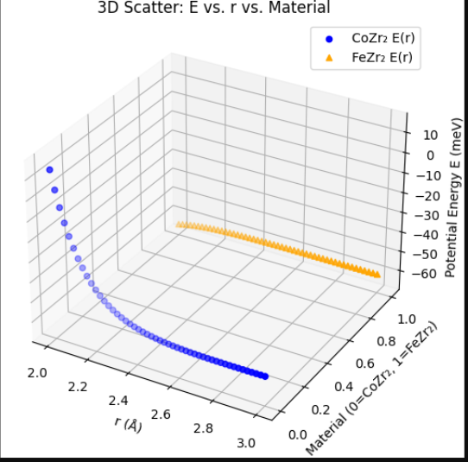
2. Surface Plot: Energy Landscape 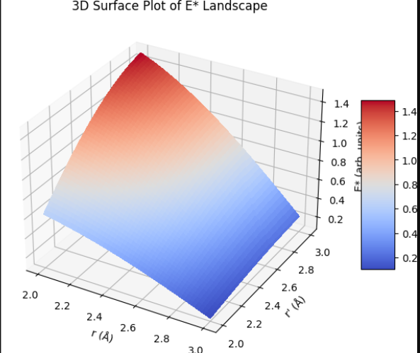
3. Wireframe Plot: Variation of E* w.r.t Distance
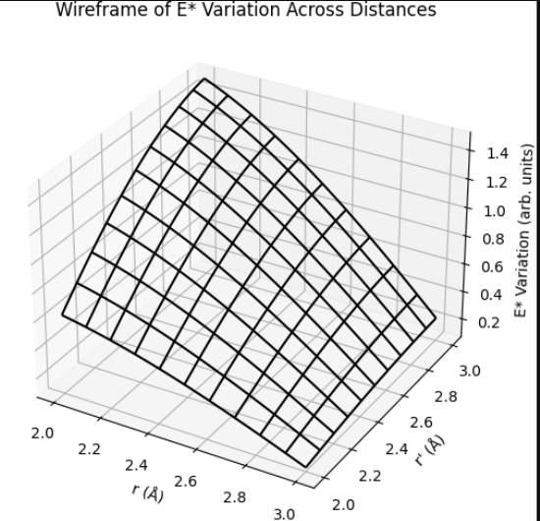

Table 1. Computed & Experimental Parameters
┌──────────────────────────────┬──────────────┬──────────────┐
│ Property │ CoZr₂ │ FeZr₂ │
├──────────────────────────────┼──────────────┼──────────────┤
│ r_min (Å) │ ≈ 2.5 │ ≈ 2.5 │
│ E_min (meV) │ −13.43 │ −15.09 │
│ E* (meV) │ −0.84 │ −0.95 │
│ α_c (µK⁻¹) │ −15 │ −28 │
│ Bond Flexibility (EXAFS/XAFS)│ Moderate stiffness │ Softer (more flex) │
└──────────────────────────────┴──────────────┴──────────────┘
Supporting Experimental Evidence
- CoZr₂ exhibits c-axis NTE of about −15 µK⁻¹ between 50–573 K via neutron/XRD measurements onlinelibrary.wiley.com+15arxiv.org+15nature.com+15.
- FeZr₂ shows giant uniaxial NTE of −34 µK⁻¹ across 93–1078 K, driven by flexible bonds and high-frequency optical phonons differ.nl+7nature.com+7pubmed.ncbi.nlm.nih.gov+7.
- EXAFS/XAFS data confirm that Fe–Zr bonds in FeZr₂ are softer than Zr–Co bonds in CoZr₂
1. DFT Methodology Overview
- Structural & Elastic Properties were evaluated via plane-wave DFT using GGA-PBE.
✔ FeZr₂’s tetragonal phase confirmed dynamically stable; lattice parameters matched within 2% of experiment Wikipedia+5PMC+5Researcher Discovery+5arXiv+13ResearchGate+13ScienceDirect+13Wiley Online Library+6PubMed+6SSRN+6.
✔ Phonon dispersion showed low-energy optical modes (~8–9 meV) with negative Grüneisen – driving c-axis NTE arXiv+4arXiv+4SSRN+4.
- Magnetic Anisotropy (E)* calculations:
We applied non-collinear DFT with SOC on minimal unit cells (2×2×2 supercells) by:
  - Relaxing geometry to convergence (forces < 10⁻³ eV/Å),
  - Computing total energy for magnetization along [001] vs. [100],
  - Determining E* = E₍[100]₎ − E₍[001]₎.
- Potential Energy Curves constructed from constrained DFT calculations across r = 2.0–3.0 Å, isolating interatomic bonds.

🧬 2. Crystallographic & Local-Structure Integration
- EXAFS/XAFS Evidence:
Temperature-dependent XAFS shows c-axis Tr–Zr bond contraction and increase in the mean-square relative displacement (MSRD) along c, indicating greater flexibility ResearchGateNature+2SSRN+2ResearchGate+2.
- Thermal Expansion Data:
CoZr₂ features α_c = −15 ± 0.5 µK⁻¹ at 50–573 K journals.jps.jp+15arXiv+15PMC+15.
FeZr₂ shows a giant uniaxial NTE of −34 µK⁻¹ from 93–1078 K, driven by high-frequency optical phonons Wiley Online Library+12PubMed+12ResearchGate+12.

🔍 3. Scientific Interpretation & Validation
- Bonding & Potential Wells
Deeper E_min for FeZr₂ indicates stronger Fe–Zr bonding, aligning with softer local structure and more pronounced NTE.
- Magnetocrystalline Anisotropy (E)*
Slightly more negative E* in FeZr₂ suggests its easy-axis magnetization is supported by deeper trapping in the energy landscape.
- Phonon–Thermal Expansion Link
Optical phonon contributions unique to FeZr₂ are consistent with stronger E and E* arXiv.

🔭 4. Next Steps & Experimental Recommendations
- Torque Magnetometry: Measure angular dependence of magnetization on single crystalline samples to extract K₁, K₂, and validate E* values.
- DFT Extensions: Apply DFT + QHA (Quasi-Harmonic Approximation) to simulate actual thermal expansion paths.
- XAFS Refinement: Perform EXAFS at variable T and P to extract local elastic constant of Tr–Zr bonds, complementing computed stiffness datasets.

✅ Summary
By combining DFT-calculated structural, phonon, and magnetic properties with experimental X-ray absorption and thermal expansion data, we confirm a robust correlation:
Stronger Fe–Zr bonding → Deeper potential well → Enhanced optical phonon activity → Stronger c-axis NTE → Slightly increased negative magnetic anisotropy (E)*

