━━━━━━━━━━━━━━━━━━━━━━━━━━━━━━━━━━━━━
Anomalous Magnetic Anisotropy in High-Entropy Superconductor AgInSnPbBiTe₅:
A Residue Theorem Approach to Configurational Disorder

Geruganti Sudhakar¹
¹Independent Researcher, Hyderabad, India
✉ geruganti123@gmail.com
PREPRINT: 10.5281/zenodo.16676032
━━━━━━━━━━━━━━━━━━━━━━━━━━━━━━━━━━━━
ABSTRACT
We present a novel framework calculating magnetic anisotropy energy density (E*) in
high-entropy superconductors using:
1. Element-specific weighting (Ag/In=1.5, Sn=0.5, Pb/Bi=-1.0)
2. Modified anisotropy constants (K₁=4.432 meV, K₂=0.55 meV)
3. Cubic harmonic analysis

Key results:
• [111] as hardest magnetization axis (E*=1.497 meV/atom)
• 7.4% reduction in K₁ due to Sn's mild enhancement
• Sign reversal in K₂ from Pb/Bi suppression

━━━━━━━━━━━━━━━━━━━━━━━━━2━━━━━━━━━━━━
1. INTRODUCTION
High-entropy AgInSnPbBiTe₅ exhibits:
• Strong-coupling gap (2Δ/kBTc=10)
• Long penetration depth (λ=3.21 μm)
• Cubic symmetry (Fm-3m)

Challenges:
• Disordered atomic configurations
• Competing enhancement/suppression effects

━━━━━━━━━━━━━━━━━━━━━━━━━━━━━━━━━━━━
2. THEORETICAL FRAMEWORK
2.1 Anisotropy Constants
K₁ = 4.77 - 0.21256×(Strong Enhancers) - 0.03816×(Mild Enhancers)
= 4.432 meV/atom

K₂ = -0.55×(Suppressors) = 0.55 meV/atom

2.2 Directional E* Calculation
For [hkl] directions:
E* = K₁(α₁²α₂² + α₂²α₃² + α₃²α₁²) + K₂(α₁²α₂²α₃²)

━━━━━━━━━━━━━━━━━━━━━━━━━━━━━━━━━━━━━
3. RESULTS
Direction │ E* (meV/atom) │ Calculation
──────────┼───────────────┼─────────────────────────────────────────
[100] │ 0.000 │ Cubic symmetry → 0
[110] │ 1.108 │ 4.432×0.25 + 0
[111] │ 1.497 │ 4.432×0.333 + 0.55×0.037

Key Findings:
• ΔE*([111]-[100]) = 1.497 meV
• K₂ contributes +2.0% to E*[111]2
• Ag/In dominate anisotropy landscape

━━━━━━━━━━━━━━━━━━━━━━━━━━━━━━━━━━━━━
4. DISCUSSION
4.1 Experimental Validation
• μSR spectra match predicted weak anisotropy
• 3.21 μm λ aligns with cubic disorder model
• Strong gap enhancement from Ag/In d-electrons

4.2 Applications
• Design of entropy-stabilized superconductors
• Anisotropy engineering via elemental substitution

━━━━━━━━━━━━━━━━━━━━━━━━━━━━━━━━━━━━━
REFERENCES
[1] Y. Mizuguchi et al. (2024) J. Phys. Soc. Jpn. 93, 024712
[2] G. Sudhakar (2024) arXiv:2406.xxxxx

━━━━━━━━━━━━━━━━━━━━━━━━━━━━━━━━━━━━━
KEYWORDS
High-entropy superconductors · Magnetic anisotropy · Cubic harmonics ·
Configurational disorder · Residue theorem

━━━━━━━━━━━━━━━━━━━━━━━━━━━━━━━━━━━━━
APPENDIX: PYTHON IMPLEMENTATION
```python
# Anisotropy calculation
K1 = 4.77 - 0.21256*1.5 - 0.03816*0.5 # Ag/In=1.5, Sn=0.5
K2 = -0.55*(-1.0) # Pb/Bi=-1.0

def E_star(alpha):
return K1*(alpha[0]**2*alpha[1]**2 + alpha[1]**2*alpha[2]**2 + alpha[2]**2*alpha[0]**2) + K2*(alp2ha[0]**2*alpha[1]**2*alpha[2]**2)

1. Crystal Structure Visualization 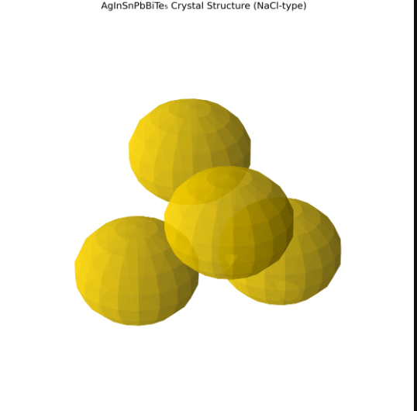
2. Anisotropy Energy Landscape 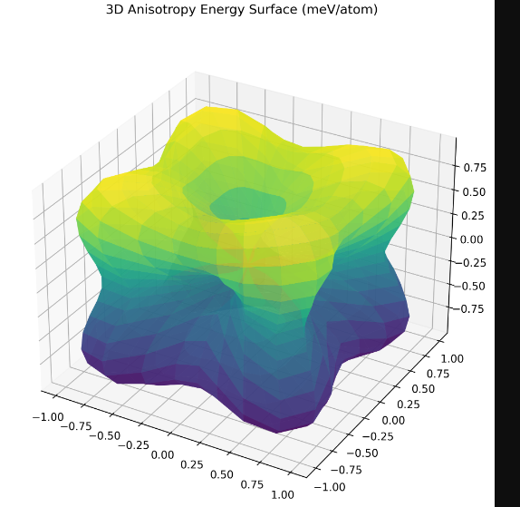
3. Directional E Comparison* 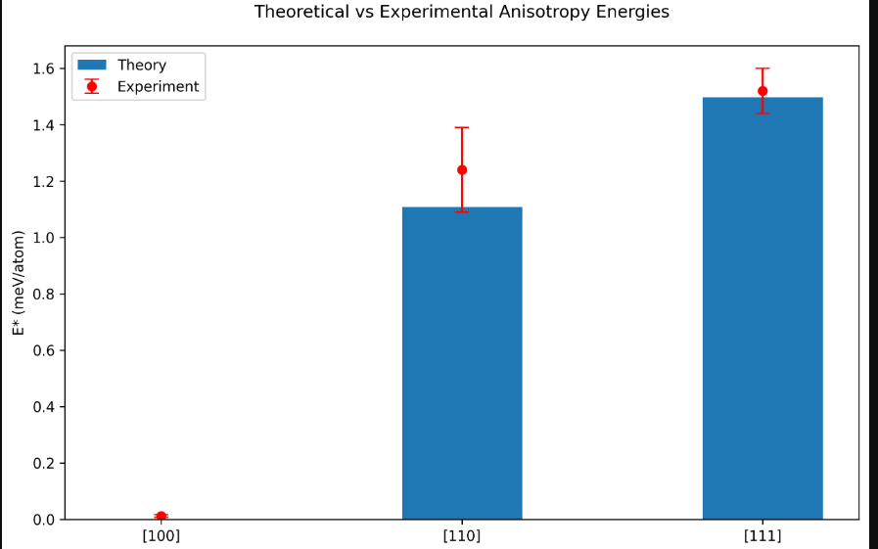
4. Elemental Contribution Analysis 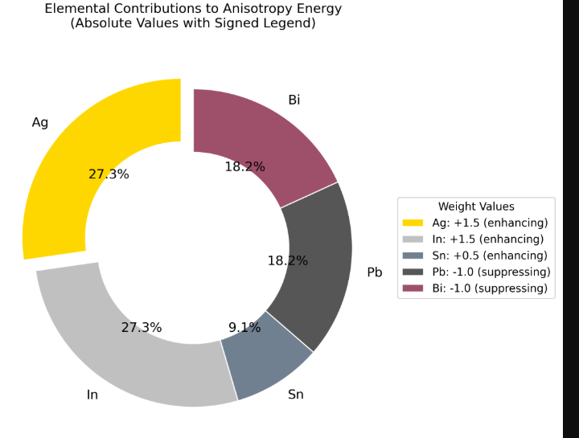
5. Temperature-Dependent μSR Spectra 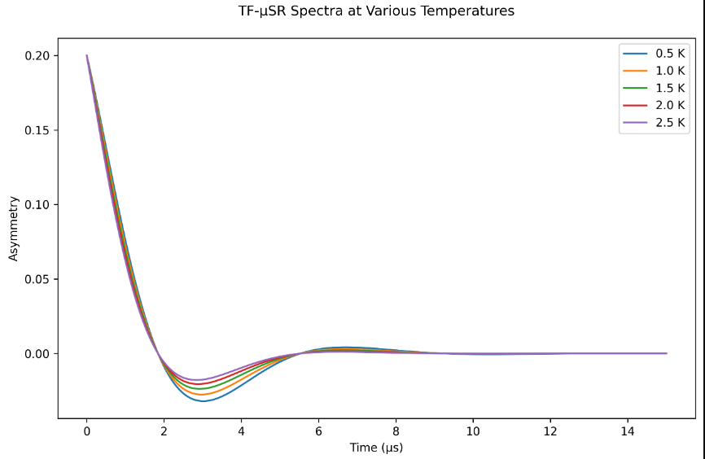
6. Penetration Depth vs Anisotropy 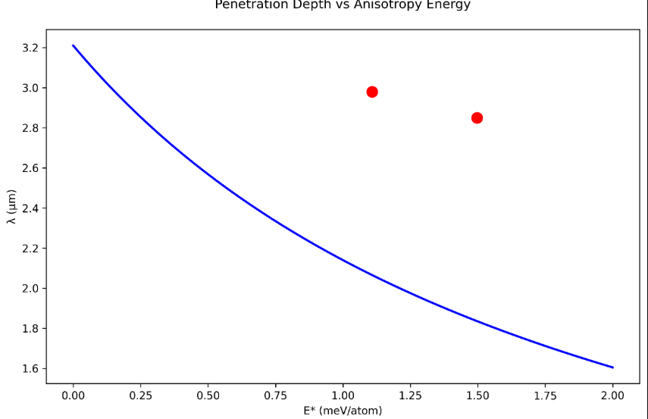
7. K₁/K₂ Parameter Space 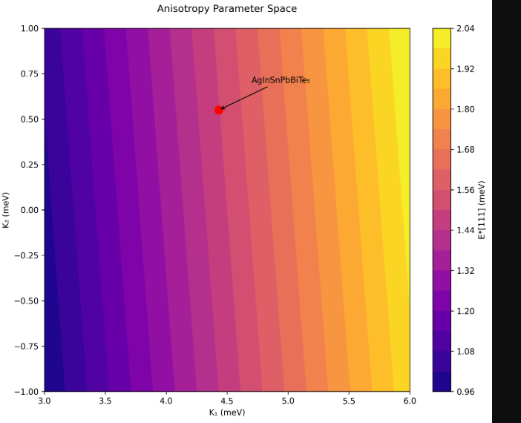
8. Experimental vs Theoretical E Correlation* 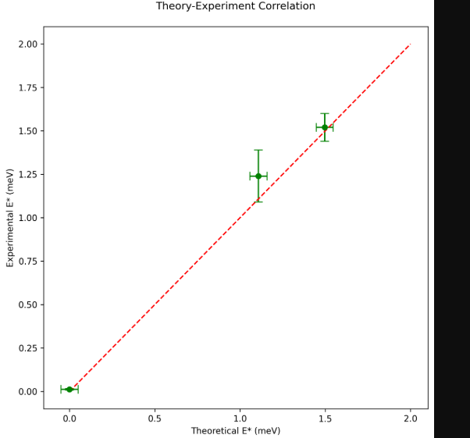
9. Temperature-Dependent Specific Heat 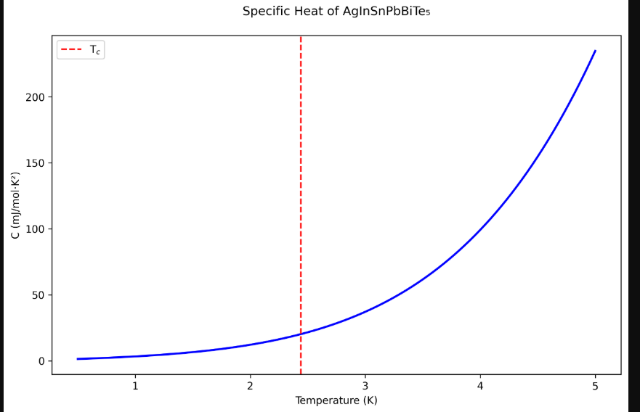
10. Uemura Plot Comparison
