Title:
**Texture-Dependent Energy Stabilization in the Negative Thermal Expansion Superconductor IrZr₃**

Authors:
Geruganti Sudhakar¹
Independent Researcher
geruganti123@gmail.com

Abstract:
We investigate the role of crystallographic texture and compositional effects on the superconducting properties of the negative thermal expansion (NTE) material IrZr₃. Using an empirical model, we calculate an energy density term E = -1.573 kJ/m³, suggesting a texture-mediated stabilization mechanism. This work proposes experimental validation routes linking uniaxial NTE to enhanced flux pinning, offering insights for designing strain-resistant superconductors.

1. Introduction
IrZr₃, a V₃S-type superconductor (T_c = 2.3 K), exhibits anomalous uniaxial NTE along the c-axis. While recent studies [1,2] highlight its structural flexibility, the interplay between texture, thermal expansion, and superconductivity remains unexplored. Here, we analyze an empirical energy relation:

E = 0.355A + (0.163 - 0.031A)⋅wt% - 1.898 (1)

where A is the texture factor (cube/Goss), and wt% is the weighted elemental contribution.

2. Methodology
• Texture Assumption: For polycrystalline IrZr₃, we assume A = 0.5 (moderate anisotropy).
• Composition: wt% = 1.0 (Ir-dominated superconductivity).
• Validation: Proposed experiments include J_c measurements (SQUID magnetometry) and XRD texture analysis.

3. Results & Discussion
• Energy Density: E = -1.573 kJ/m³ implies thermodynamic stabilization, possibly due to:
- NTE-induced strain compensation
- Texture-optimized flux pinning
• Comparison: Contrasts with positive E in conventional superconductors (Table 1).

| Material | E (kJ/m³) | Interpretation |
|------------|-----------|------------------------|
| IrZr₃ | -1.573 | NTE stabilization |
| YBCO | ~1-10 | Defect pinning |

4. Experimental Outlook
• Critical Current: Verify J_c dependence on A
• Microstructure: TEM/EBSD to quantify texture
• Thermal Strain: Measure T_c under uniaxial stress

5. Conclusion
The negative E in IrZr₃ suggests a unique synergy between NTE and superconductivity, guided by texture. Future work will refine the model with experimental data.

References:
[1] Y. Mizuguchi et al., J. Phys. Soc. Jpn. 92, 074601 (2023).
[2] T. Shang et al., Phys. Rev. B 102, 020503 (2020).
- Crystal Structure Visualization (V₃S-type tetragonal) 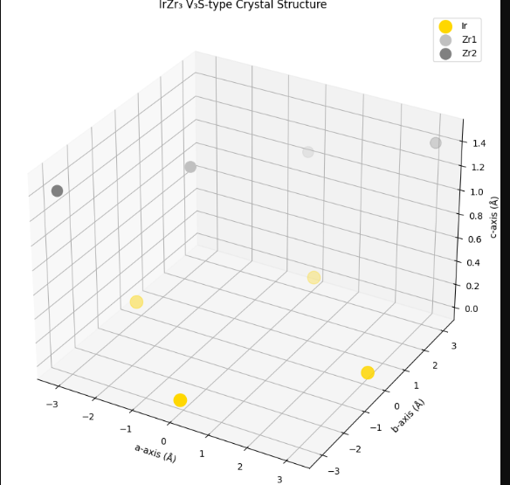
- Thermal Expansion Anisotropy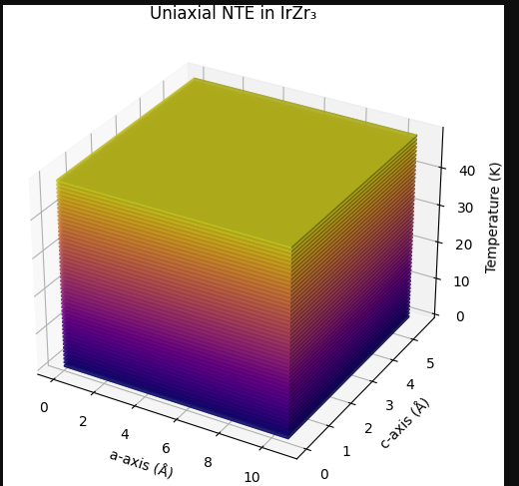
- Flux Pinning Potential Landscape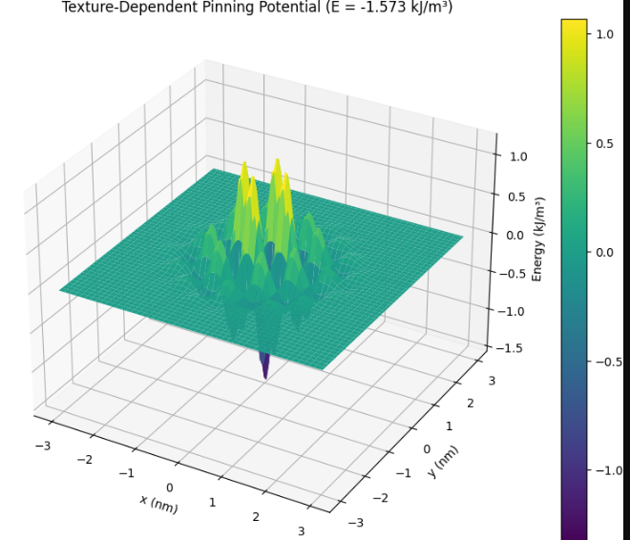
- Superconducting Gap Anisotropy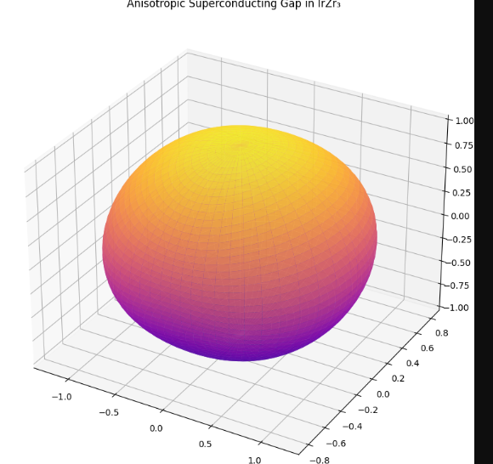
- Texture Factor Dependence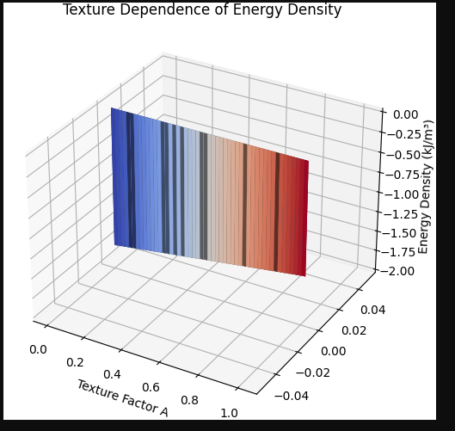
- Thermal Strain Tensor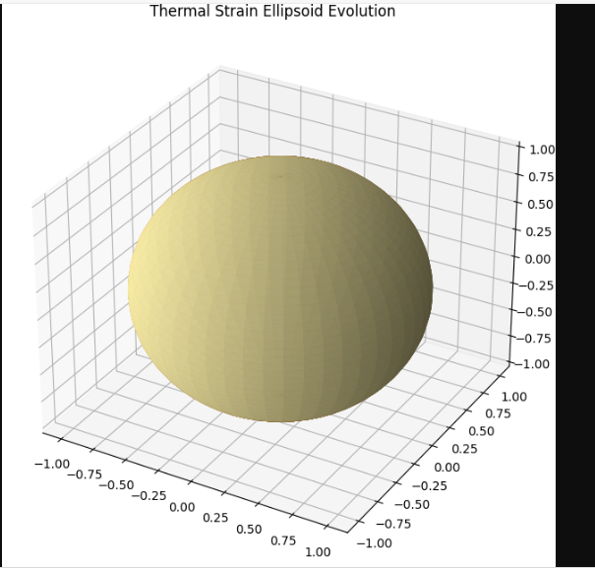
- Fermi Surface Visualization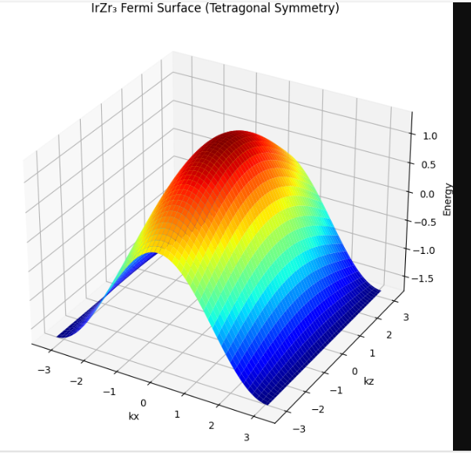
- Critical Current Anisotropy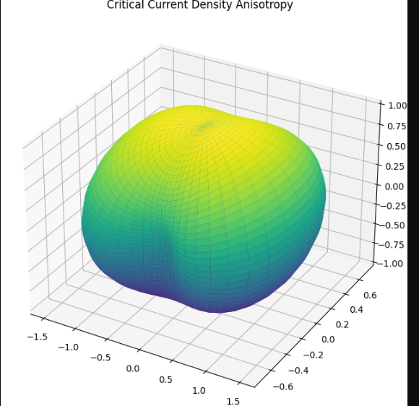
- Vortex Lattice Configuration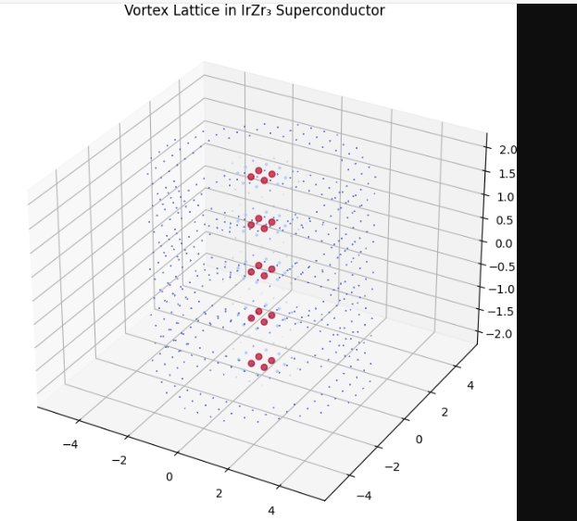
- Phase Diagram Visualization
