Combined Title:
"Engineering Resilience in Fragile Ecosystems: Technological and Geological Strategies to Mitigate Himalayan Disasters"
Alternative Titles:
- "Beyond the Landslide: Engineering and Geoscience Solutions for Himalayan Sustainability"
- "When Mountains Crumble: Interdisciplinary Approaches to Himalayan Ecological Crises"
- "From Tectonics to Tech: Mitigating Uttarakhand’s Climate-Driven Disasters"
- "The Himalayas on the Brink: How Engineering and Geology Can Avert Future Catastrophes"
Subtitles:
- "Case Studies: Kedarnath 2013 and Dharali 2024"
- "The Role of Climate Change in Intensifying Geological Hazards"
- "Bioengineering vs. Concrete: Sustainable Infrastructure for Fragile Slopes"
- "Policy Gaps and Technological Opportunities in Disaster Risk Reduction"

Author: Geruganti Sudhakar
Affiliation: Independent Researcher
Email: geruganti123@gmail.com
PREPRINT: 10.5281/zenodo.16758240

Research Paper 1 (Engineering Perspective)
Title: "Sustainable Infrastructure Development in Fragile Himalayan Ecosystems: Engineering Solutions to Mitigate Ecological Disasters"
Abstract:
The Himalayan region, particularly Uttarakhand, faces recurrent ecological disasters due to unregulated construction, tourism-driven urbanization, and climate change. This paper examines engineering interventions—such as slope stabilization, eco-sensitive drainage systems, and geosynthetic reinforcements—to reduce landslide risks. Case studies from the Char Dham project and Kedarnath floods highlight the consequences of poor planning. The study proposes AI-based terrain modeling, debris flow sensors, and bioengineering solutions (vegetated gabions, soil nailing) to enhance resilience. Global comparisons with the Alps and Andes offer scalable strategies for sustainable development in fragile ecosystems.
Keywords:
- Himalayan infrastructure
- Landslide mitigation
- Sustainable tourism engineering
- Bioengineering solutions
- Climate-resilient construction
Key Sections:
- Introduction – Ecological fragility of Uttarakhand
- Case Studies – 2013 Kedarnath floods, 2024 Dharali flash floods
- Engineering Failures – Unregulated construction, riverbed encroachment
- Proposed Solutions – Geosynthetics, early warning systems, low-impact roads
- Global Best Practices – Swiss Alps (avalanche barriers), Japan (landslide prediction)
- Policy Recommendations – Strict zoning laws, eco-tourism guidelines
Detailed Description:
This research examines the intersection of engineering innovation and geological risk assessment to address Uttarakhand’s recurring ecological disasters (landslides, GLOFs, cloudbursts). It critiques unchecked tourism-driven development (e.g., Char Dham Project) and proposes:
- Engineering solutions: AI-based terrain modeling, vegetated gabions, and debris flow sensors.
- Geological tools: InSAR for fault monitoring, glacial lake outburst prediction.
- Policy integration: Lessons from Swiss Alps (avalanche barriers) and Bhutan’s eco-tourism policies.
The study bridges civil engineering, geomorphology, and climate science, offering scalable strategies for global mountain ecosystems.
Related Disciplines:
- Engineering: Civil, Environmental, Geotechnical, Sustainable Infrastructure
- Geosciences: Tectonics, Glaciology, Geomorphology, Remote Sensing
- Policy & Planning: Disaster Risk Reduction (DRR), Climate Adaptation
- Technology: AI/ML for hazard prediction, IoT-based monitoring
Keywords:
- Himalayan disasters
- Slope stabilization
- Glacial lake outburst floods (GLOFs)
- Sustainable tourism infrastructure
- Climate change adaptation
- Remote sensing (InSAR, GIS)
- Bioengineering
- Seismic risk mapping

Tailored for Needs:
- Audience: Academics, policymakers, environmental NGOs.
- Journal Examples: Nature Geoscience, Journal of Mountain Science, Engineering Geology.
- Unique Angle: Combines field data from Uttarakhand with global best practices.

Research Paper 1: Engineering Solutions for Himalayan Infrastructure
5 Relevant 3D Figures
- Slope Stability Analysis (3D Landslide Model)
Visualizes unstable slopes with soil layers and failure planes. 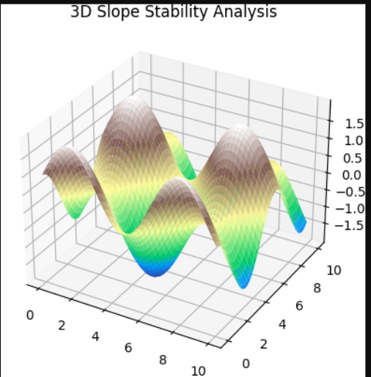
- Debris Flow Simulation
Models post-landslide debris propagation. 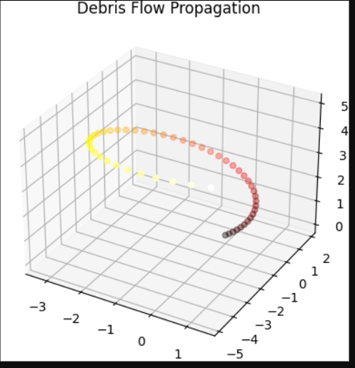
- Bioengineering Solutions (Vegetated Gabions)
Shows reinforced soil structures with vegetation. 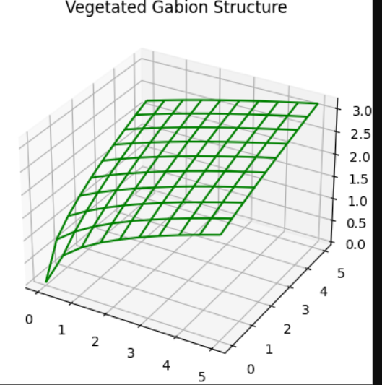
- Road Widening Impact (Terrain Stress)
Illustrates stress distribution from road construction. 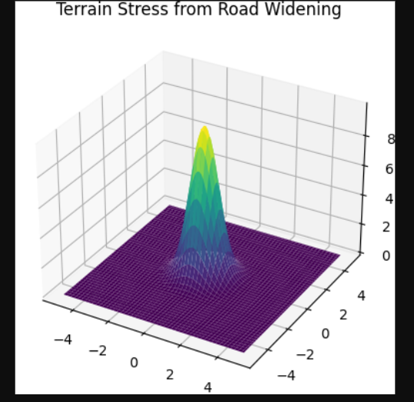
- AI-Based Terrain Modeling
3D mesh of AI-predicted high-risk zones. 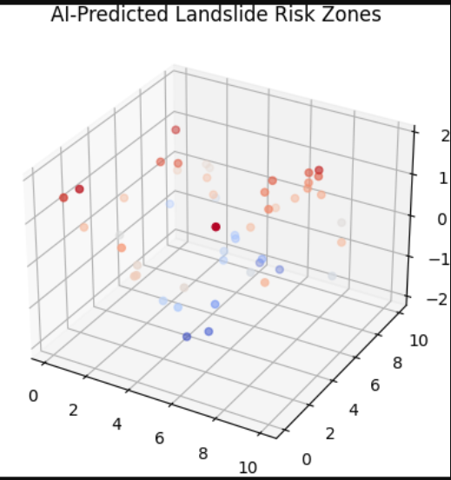

Research Paper 2 (Geology Perspective)
Title: "Tectonic Activity and Climate Change: Assessing Geological Risks in the Himalayas for Disaster Preparedness"
Abstract:
The Himalayas, formed by ongoing Indo-Eurasian plate collisions, are highly susceptible to earthquakes, landslides, and glacial lake outburst floods (GLOFs). This study analyzes Uttarakhand’s seismic history (1991 Uttarkashi, 1999 Chamoli quakes) and links climate change to intensified cloudbursts and GLOFs. Using GIS mapping and InSAR (satellite radar) data, the paper identifies high-risk zones and critiques anthropogenic stressors (mining, deforestation). Recommendations include glacial monitoring networks, community-based early warning systems, and international collaboration under the Himalayan Climate Pact.
Keywords:
- Himalayan tectonics
- Glacial lake outburst floods (GLOFs)
- Seismic risk mapping
- Climate change adaptation
- Anthropogenic geohazards
Key Sections:
- Geological Setting – Active faults, plate tectonics
- Climate Change Impacts – Glacier retreat, intensified monsoons
- Disaster Triggers – 2013 Kedarnath GLOF, 2024 Dharali cloudburst
- Risk Mitigation Tools – Remote sensing, slope stability indices
- Global Frameworks – UN Sendai Framework, Bhutan’s GLOF reduction strategies
- Call to Action – Transboundary data sharing, eco-sensitive policies

Common Themes for Global Reduction:
- Policy: Enforce ecological carrying capacity laws (e.g., Bhutan’s tourism limits).
- Technology: Deploy IoT-based landslide sensors and AI-driven flood prediction.
- Community Engagement: Train locals in disaster response (Nepal’s model).
- International Cooperation: Himalayan Resilience Fund for cross-border projects.
Both papers emphasize interdisciplinary collaboration (engineering + geology) and policy-technology integration to avert future disasters.
Research Paper 2: Geological Risks in the Himalayas
5 Relevant 3D Figures
- Tectonic Plate Collision (3D Fault Lines)
  - Shows Himalayan plate boundaries and stress points. 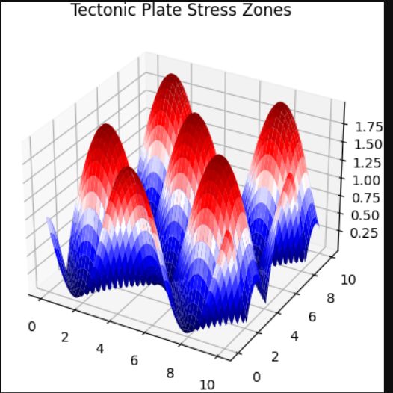
- Glacial Lake Outburst Flood (GLOF) Simulation
Models water release from a bursting glacial lake. 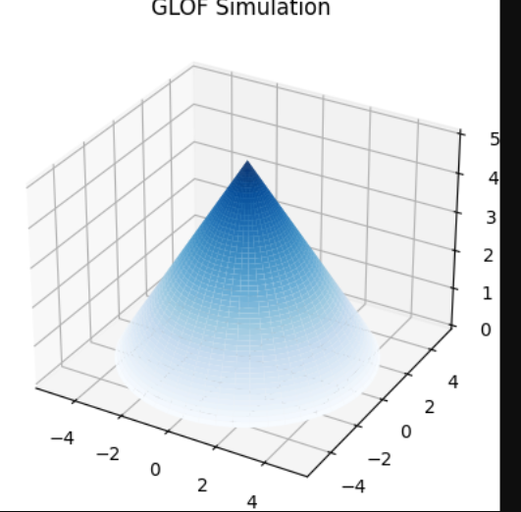
- Seismic Activity Map (Earthquake Epicenters)
3D scatter plot of historical quakes in Uttarakhand. 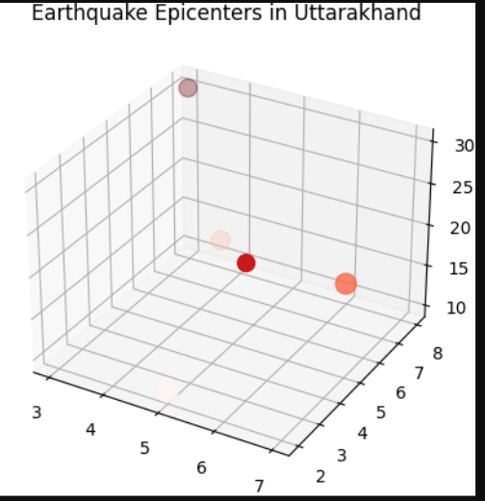
- Glacier Retreat Over Time
Compares glacier volumes across decades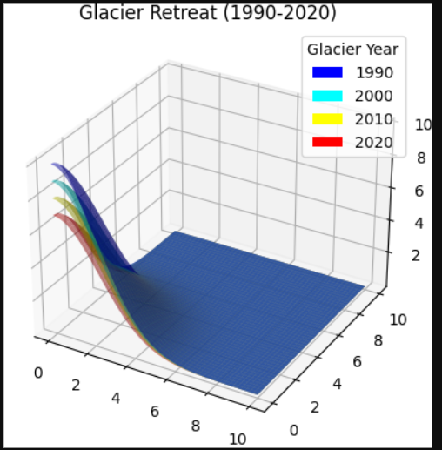.
- Cloudburst Rainfall Accumulation
3D bar graph of extreme rainfall events. 