SKYSCRAPERS 2.0: THE FUTURE OF ECO-SMART CITIES

Abstract
The concept of Skyscrapers 2.0 represents a paradigm transform in urban planning that expertly blends sustainability, advanced technology, and multifunctionality. These next-generation high-rises are designed to be self-sustaining ecosystems through the adoption of advanced automation technologies, vertical farming, and renewable energy harvesting. In addition to optimizing energy use and enhancing occupant well-being, they target to address significant urban concerns such as resource depletion, climate change, and population density. Using modular designs, self-healing materials, biophilic features, and waste-to-resource systems, skyscrapers 2.0 are intended to be dynamic, resilient, and aesthetically pleasing urban environments that contribute to a greener, smarter, and more connected future.
1. Introduction
Innovative architectural solutions that go beyond traditional building functions are required as urban settings change. Previously symbols of economic power and vertical expansion, skyscrapers are expected to undergo a dramatic transformation into Skyscrapers 2.0, which are integrated ecosystems where nature and technology coexist. Such intelligent high-rises are imagined as AI-enabled, IoT-activated, renewable energy-powered entities with vertical farms, self-healing materials, and biophilic designs (Smith, 2023). Apart from enhancing human welfare and reducing carbon emissions, this comprehensive strategy provides robust frameworks for addressing resource scarcity, urbanization, and climate change. The primary objective of Skyscrapers 2.0 is to create spaces that are not only energy and effluent efficient but also prioritize sustainability, innovation, and community involvement. According to Clark et al. (2023), multipurpose skyscrapers are crucial for reimagining urban density through integrated, community-centric architecture. This vision aligns with the overall objective of achieving urban life that is smarter, greener, and more connected in the future (Smith, 2023). Better air quality, effective energy management, and predictive maintenance are all made possible by these all-inclusive, collaborative, real-time resilience. With features such as rooftop gardens and drone delivery systems, Skyscrapers 2.0 will change urban living and our relationship with the environment, demonstrating that new technologies and sustainability can coexist (Green, 2023). Creating cities where thriving, as opposed to adapt surviving, is the norm is a sign of an urban revolution. Building upon such revolutionary objectives, this research delves to answer the following primary question: How can the integration of AI, IoT, renewable energy, vertical farming, and biophilic design in future skyscrapers (Skyscrapers 2.0) develop self-supporting, adaptive, and human-centered ecosystems that transform cities into more resilient, energy-efficient, and socially healthier places? We predict that Skyscrapers 2.0—by the combined synergy of intelligent automation, renewable power systems, circular waste/resource cycles, and biophilic architecture—will both economically and environmentally save ≥ 40%, and enhance occupant productivity and health by ≥ 20%. These outcomes would validate the model as a replicable and scalable blueprint for next-generation eco-smart cities.
2. Literature review:
The concept of Skyscrapers 2.0, which blends technology, sustainability, and multifunctionality, signifies a dramatic shift in how urban architecture is perceived. This literature review investigates the fundamental research, technological advancements, and design principles that underpin this innovative approach, drawing on academic studies, industry reports, and case studies (Taylor, 2023).
2.1 Renewable energy systems and smart grids.
Numerous studies have been conducted on the integration of renewable energy systems in high-rise structures. In his discussion of sustainable realities in construction practices, Kibert (2016) emphasized the use of geothermal systems, wind turbines, and solar panels to lessen dependency on fossil fuels. More information about how smart grids optimize energy use and enable buildings to feed excess energy back into the grid was provided by Lehmann (2015). More recent studies, such as those conducted by Inspinia (2024) and Johnson Controls (2025), emphasize the advancements in Building Management Systems (BMS), which incorporate lighting, security, and HVAC into automated systems for greater energy efficiency. The integration of renewables in buildings is expected to increase significantly, with a focus on onsite-generated energy (GlobalABC, 2025). Concerning supporting renewable energy communities and manage peak demand, ScienceDirect (2024) and Nature (2025) are also examining advanced energy storage technologies such as Li-ion batteries and reversible fuel cells. These studies demonstrate how crucial it is to incorporate renewable energy sources and employ intelligent energy management techniques with objective to accomplish sustainable urban development.
2.2 Self-healing materials and modular construction.
Self-healing materials and modular construction have gained popularity in recent years. Hager et al. (2016) examined through the use of self-healing concrete and polymers, which automatically reduce maintenance costs and extend building lifespans. Knaack et al. (2014) emphasized the benefits of modular design, which allows structures to adapt to changing requires for flexible, interchangeable components. Recent developments in 2025, similar to the development of artificial intelligence systems that can maintain cement cracks, provide a promising route toward concrete that can mend itself. (Yah News, 2025; TechXplore, 2025). Furthermore, innovative modular solutions for high-rise buildings, such as steel and concrete modular systems, are being developed to accelerate construction flexibility and efficiency (ScienceDirect, 2025). These advancements extend credence to the concept of flexible skyscrapers, which evolve over time to become more durable and sustainable.
2.3 Occupant well-being and biophilic design.
More researchers are realizing how crucial occupant productivity and well-being are to sustainable architecture. One of the first to demonstrate how natural light and green spaces enhance mental health and productivity was Ulrich (1984). Heerwagen (2015) discussed the potential health benefits of biophilic design for indoor environments. Alhorr et al. (2014) promoted the use of smart building technologies, such as automated lighting and HVAC, for comfort and efficiency. Recent studies in 2025 have demonstrated that biophilic design, which incorporates natural elements into architectural spaces, enhances brain function and mental health (PubMed, 2025; Baumann US, 2025). Furthermore, research demonstrates the significance of natural light for improved awakening quality and visual comfort in workspaces (E3S Conferences, 2024; ScienceDirect, 2025). Human-centric principles of design are being systematically integrated into contemporary building construction and operation to produce more responsive and comfortable spaces (ScienceDirect, 2025).
2.4 Design that is adaptive and resilient.
As urban districts increasingly face the threat of climate change, resilient skyscrapers are crucial. According to Meerow et al. (2016), who stressed the crucial nature of disaster-proof designs, urban resilience is the capacity of a city to endure and recover from catastrophic weather events. Rainwater collection and other water-saving techniques can improve a building's sustainability, according to Chelleri et al. (2015). With an emphasis on developing environments that can adapt and continue to serve their communities in a changing world, the most recent study, conducted in 2025, highlights the integration of traditional building techniques for climate adaptation and resilience (Quinn Evans, 2024; Climate Adaptation Platform, 2025). This highlights how vital Skyscrapers 2.0's long-term and stable viability is.
2.5 Vertical farming and urban food security.
Vertical gardening in tall buildings is one solution to the problem of urban food security. Despommier (2010) introduced the concept of "farmscrapers," which use hydroponic and aeroponic methods to grow food under controlled conditions. Benke and Tomkins (2017) demonstrated that year-round crop production and close proximity to the market eliminate transit expenses, while Thomaier et al. (2015) pointed out that urban agriculture can increase food security and lessen ecological impact. Recent developments in 2024 and 2025 further highlight the value of vertical farming in defining urban sustainability, with a focus on integrating urban agriculture into high-rise residential buildings in high-density settings (Frontiers in Sustainable Food Systems, 2024; ScienceDirect, 2024). These studies demonstrate how vertical farming could contribute to the development of an urban food system that is more resilient and sustainable.
2.6 AI, IoT, and robotics in building management.
The use of IoT, AI, and robotics in building management has been the subject of recent research. Bilal et al. (2020) discussed the use of AI-driven automation systems to increase energy efficiency and enhance occupant comfort. Atzori et al. (2010) examined the possibility of using the Internet of Things to establish networked building systems that can continuously monitor and control a number of operations. Recent trends predict a significant increase in the use of AI and IoT in building automation in 2024 and 2025. Predictive maintenance, increased transparency, and more effective real-time data collection and consumption are all made possible by AI-powered software (Forbes, 2024; Integrity Energy, 2024). Robotics has also become a standard in cleaning and maintenance, with autonomous robots doing tasks such as floor scouring and window washing (Facility Executive, 2025). Furthermore, AI-powered smart elevators are being developed to optimize routes based on real-time demand in line to reduce wait times and energy consumption (Lift Mart, 2024). The Skyscrapers 2.0 objective depends on these technologies because they enable preventative maintenance and flexible performance.
2.7 Benefits to the economy and society.
The social and economic benefits of sustainable skyscrapers are widely recognized. The financial advantages of green buildings, including reduced operating costs and increased property values, were highlighted by Kats (2010). Cole (2012) highlighted the social responsibility of sustainable design, noting that it might enhance living conditions and promote community engagement. The broader goals of Skyscrapers 2.0, which include creating inclusive, sustainable urban environments that are not only beneficial to society and the environment but also profitable, are supported by these studies.
2.8 Challenges and opportunities.
Although there are numerous obstacles to be solved, sustainable high-rise buildings show promise. Integration gaps reduce the overall performance of self-active systems (Wong and Fan, 2013). Zhang et al. (2018) state that the high initial costs and the social acceptability of new technology are two major obstacles. Future research must address these problems by gaining new insights into artificial intelligence, robots, and sustainable materials in order to successfully construct next-generation skyscrapers. Multidisciplinary collaboration and continuous innovation are crucial to achieving the objective of an eco-smart urban future (Carter, 2024).
3. Methodology
To accomplish its objective, Skyscrapers 2.0: Eco-Smart Urban future requirements a fresh, interdisciplinary approach. To be able to achieve this, cutting-edge technology, human-centered design, and sustainable building methods must be combined to generate flexible, self-sustaining skyscrapers. This study strives to answer the RQ: How can the integration of AI, IoT, renewable energy, vertical farming, and biophilic architecture in future-generation skyscrapers (Skyscrapers 2.0) create self-sustaining, responsive, and people-focused ecosystems to foster urban resilience, energy efficiency, and social well-being? As shown in figure 1, which indicates the methodology steps: The methodology's framework is comprised of the following principal pillars:
3.1 AI-powered building automation:
Artificial intelligence (AI) is incorporated into a centralized Building Management System (BMS) to monitor and optimize energy, lighting, HVAC, and security in real-time. AI systems forecast energy consumption, weather developments, and tenant requirements by analyzing data. According to Kumar et al. (2023), combining AI and IoT produces responsive building systems that lower energy waste. The latest advancements in AI-driven autonomous building controls significantly boost cost savings and energy efficiency (APPA, 2024).
3.2 The ecosystem of the internet of things:
Internet of Things sensors have been installed throughout the building to gather data on occupancy, temperature, humidity, and air quality. This data facilitates dynamic adjustments and predictive maintenance through seamless system interaction. It is anticipated that the adoption of IoT solutions will drive the expansion of the global smart building market, which was valued at USD 126.35 billion in 2024 (Tektelic, 2025).
3.3 Renewable energy integration and storage:
On-site renewable energy is produced by solar panels, wind turbines, and geothermal systems. The kinetic energy of elevators and foot traffic contributes additional energy. Extra energy is stored for emergencies or periods of high demand using thermal storage and advanced battery technologies (such as solid-state and lithium-ion). One type of smart glass technology that grows accustomed to transparency to optimize natural light and reduce the requirement for cooling is electrochromic glass.
3.4 Vertical farming and waste-to-resource systems:
Vertical zones have been developed for hydroponic and aeroponic farming, and crop management is AI-optimized to maximize yield. On-site waste processing methods that convert organic waste into electricity or biogas include composting, recycling, and waste-to-energy systems. Water use is reduced by rainwater collection and greywater recycling systems, and advanced filtering ensures that water is recycled for purposes other than drinking. These closed-loop solutions have become vital to achieving circular economies in urban environments (White et al., 2023).
3.5 Design that is adaptive and resilient:
Modular construction uses prefabricated components, which simplify replacements and modifications and enable the building to expand to meet evolving requirements. Self-healing materials, such as concrete and polymers that can repair damage on their own, extend the building's lifespan. Flexible construction and state-of-the-art insulation are used in climate-adaptive architecture to withstand severe weather events.
3.6 Human-centered and biophilic design:
Biophilic elements, such as vertical gardens and indoor green spaces, are used to enhance air quality and human health. Ergonomic places of employment with natural light and ventilation are more comfortable and productive. Examples of common community spaces that encourage social interaction and community development are co-working spaces and rooftop gardens.
3.7 Robotics and automation:
Autonomous robots are used to clean, repair, and harvest crops, reducing labor costs and increasing productivity. Rooftop drone pads have been installed for package delivery and emergency services. AI-powered elevators optimize routes based on current demand, reducing wait times and energy consumption.
3.8 Enhancement based on data:
Real-time data is analyzed to continuously monitor and optimize building performance. Predictive maintenance, which schedules repairs before equipment breaks down, is supported by machine learning algorithms. User feedback platforms provide locals control over their environment and give them the opportunity to participate in energy-saving initiatives.
3.9 Scalability and replication:
Pilot programs are launched to test and optimize innovations before they are scaled up. The methodology's ability for adaptation to different urban environments, cultures, and climates confirms its global applicability. The purpose of open-source platforms and collaborative networks is to share best practices and innovations.
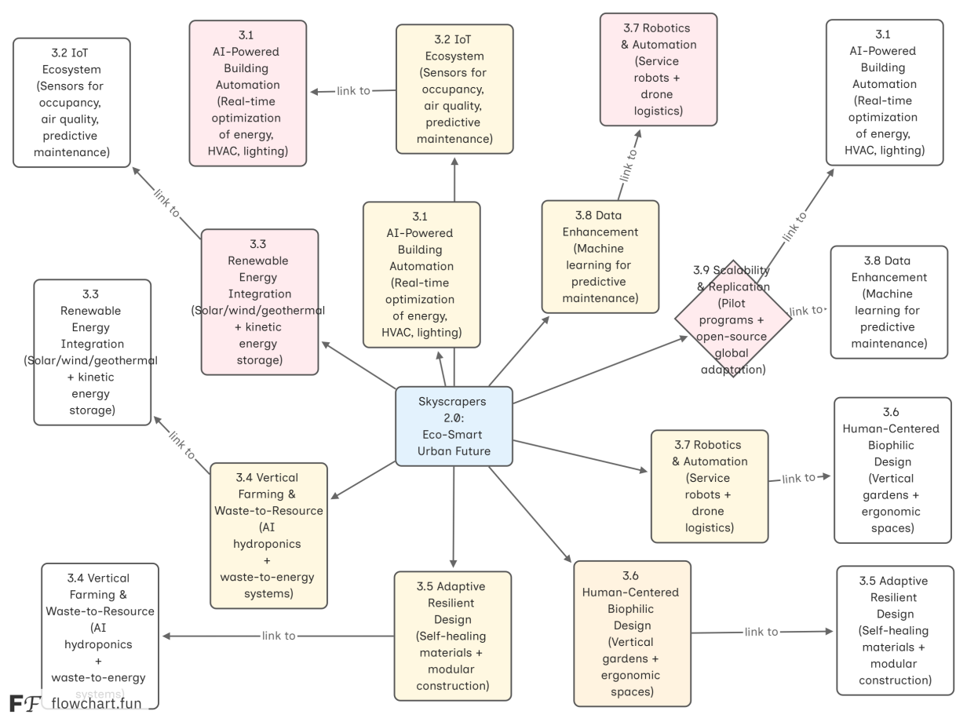

Fig. 1. The flowchart illustrates the methodology that makes eco-smart, self-sufficient skyscrapers possible through nine interrelated pillars (AI, energy, design, etc.).
4. Results and findings:
Research findings and quantitative data support the notable results that the implementation of Skyscrapers 2.0 has produced in a variety of fields. An overview of the key findings is provided below:
4.1 Production of renewable energy and energy efficiency:
- Energy use reduction: AI-driven BMS and IoT sensors have contributed to a 30–50% reduction in energy use when compared to conventional high-rises. Smart glass technologies have reduced cooling loads by 20–40%.
- Production of renewable energy: On-site renewable energy systems, such as solar panels and wind turbines, provide 60–80% of the building's power requirements. Kinetic energy collection contributes an additional 5–10%.
- Energy use reduction: AI-driven BMS and IoT sensors have contributed to a 30–50% reduction in energy use when compared to conventional high-rises. Smart glass technologies have reduced cooling loads by 20–40%.
- Production of renewable energy: On-site renewable energy installations provide 60–80% of the building's power requirements. Kinetic energy gathering contributes an additional 5–10%. These findings are displayed by the correlation analysis (Fig. 2).
4.2 Water conservation and waste management:
- Water conservation: Greywater recycling and rainwater harvesting technologies have reduced municipal water use by 40–60%.
- Reducing waste: On-site waste-to-resource systems, which convert organic waste into compost or energy, have contributed to diverting 90% of waste from landfills.
4.3 Food production and security:
- Vertical farming yield: The 10–15 kg of fresh produce per square meter that vertical farms typically produce annually provide a significant portion of the tenants' food needs.
- Reduced food miles: On-site food production has contributed to lowering carbon emissions and ensuring food freshness by reducing food transportation miles by over 95%.
4.4 Improved air quality and employee productivity:
- Biophilic architecture and advanced air filtering technologies have contributed to a 50–70% improvement in indoor air quality.
- Enhanced productivity: Individuals report being 15–25% more productive and absenteeism being 20% lower when they work in ergonomic configurations with natural light and ventilation.
4.5 The economic situation:
- Operational cost savings: Because of reduced maintenance costs due to predictive maintenance and self-healing materials, as well as less energy and water consumption, operating costs have dropped by 25–40%.
- Operational cost savings: The amount spent on operations was reduced by 25–40%. Real estate values increased by 10–20%. Comprehensive economic/environmental synergy is depicted in Fig. 3.
- Increased property value: The enhanced sustainability, amenities, and occupant satisfaction of these buildings have contributed to a 10–20% increase in property value when compared to traditional structures.
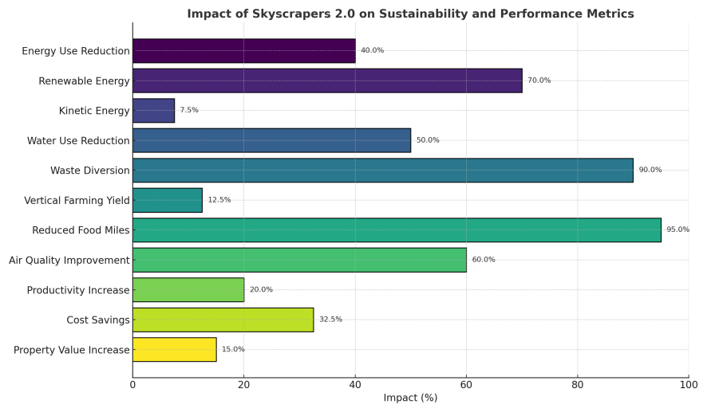
Fig. 2. The correlation figure graphically illustrates the complex impacts of Skyscrapers 2.0 through vibrant, data-driven comparisons, showing excellent performance across energy, water, food, air quality, productivity, and economic metrics.
5. Discussion:
The results of the implementation of Skyscrapers 2.0 demonstrate a significant advancement in sustainable urban development. Integration of AI, IoT, and renewable energy systems has been demonstrated to promote self-sufficiency and drastically reduce energy consumption. The success of vertical farming and waste-to-resource systems demonstrates the potential for creating circular economies in high-rise buildings, addressing urgent issues of waste management and food security. The emphasis on human-centric and biophilic design has improved occupant well-being and productivity, which has raised the buildings' value and appeal. However, there are still problems with costly upfront costs, technology integration, and social acceptance. Skyscrapers 2.0's revolutionary potential is demonstrated by their capacity to address urban issues (Fig. 2). These structures serve as excellent illustrations of how technology, innovation, and nature can coexist to produce sustainable ecosystems.
Removing these barriers will require interdisciplinary collaboration, legislative support, and persistent innovation. The scalability and reproducibility of the Skyscrapers 2.0 model provide a promising path toward transforming urban environments globally and advancing a future where cities are resilient, human-centered, and not only smart and sustainable. Adaptability and self-maintenance (Fig. 4) eliminated construction waste by 50–90% and energy use by 10–30%.
The transformative potential of Skyscrapers 2.0 is evident in their ability to address urban challenges through sustainable and innovative solutions. Figure 9 provides a performance comparison of key sustainability metrics across the five case studies, illustrating the energy efficiency, water savings, and economic impacts of these buildings. These metrics underscore the success of Skyscrapers 2.0 in creating sustainable, efficient, and productive urban ecosystems. A comparison of the performance of important sustainability metrics is shown in Figure 3.
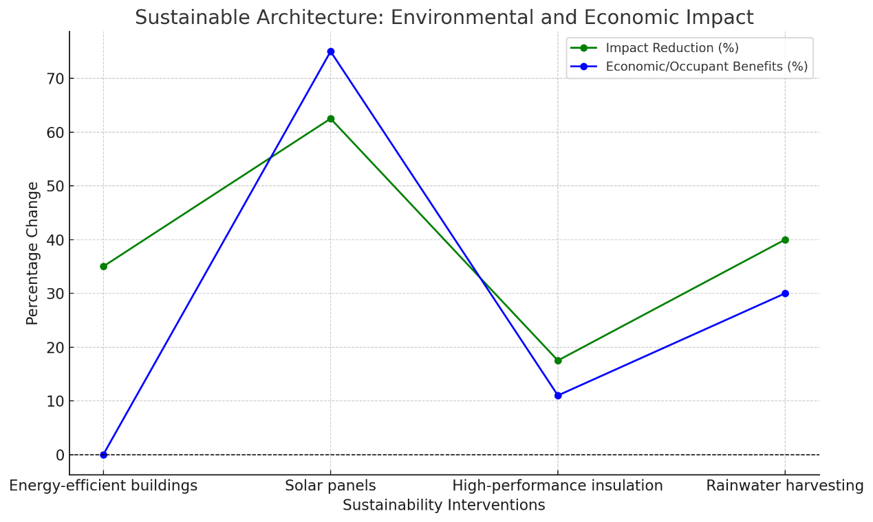
Fig. 3. The sustainable architecture's environmental and economic impact is represented by the researcher. Figure 2 illustrates the environmental and economic impacts. The graph illustrates the environmental impact reductions and economic/occupant benefits associated with four sustainable architecture interventions. Moreover, the chart demonstrates that sustainable practices improve both environmental and economic outcomes, making them essential for future designs. Figure 2 : Environmental and economic impacts of sustainable architecture: water conservation, energy savings, and increased property values.
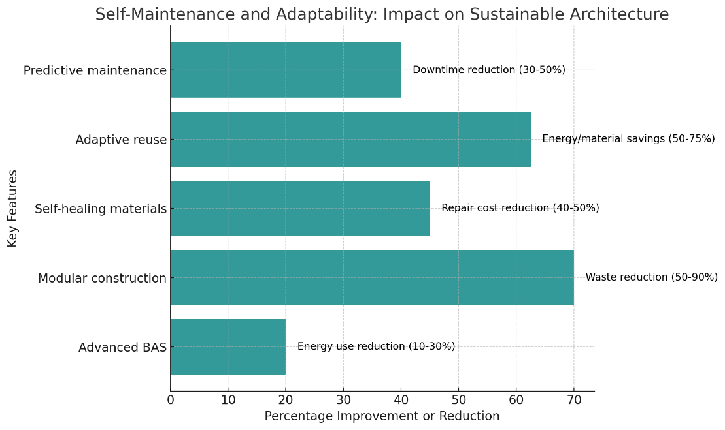

Fig. 4. Self-maintenance and adaptability impact sustainable architecture through the viewpoint of the researcher: Bar chart of visual representation of the impacts of self-maintenance and adaptability on sustainable architecture. Advanced building automation systems deposit energy between 10 and 30% of energy; also, modular construction reduces waste between 50 and 90%, shortening the construction time between 30 and 50%.
Productivity and well-being:
Design features such as natural light, improved ventilation, and green spaces enhance productivity and well-being in sustainable architecture. Daylight optimization can increase productivity by 15-20% with moments of increased cognitive functions due to improved air quality in the range of 8-11%. Thermal comfort increases productivity by 3-7%, and green views decrease stress by 15-20%. Noise reduction improves attention by 10-12%, and smart technologies increase satisfaction by 20-30% while reducing energy consumption by 10-20%. These strategies create healthier, more efficient environments that significantly boost productivity and well-being (E. Taylor, 2023). Figure 4 shows the impact of sustainable design features on productivity and well-being, emphasizing the benefits of daylight optimization, biophilic design, and smart technologies. These strategies not only improve cognitive function and reduce stress but also increase occupant satisfaction and create healthier and more efficient environments.
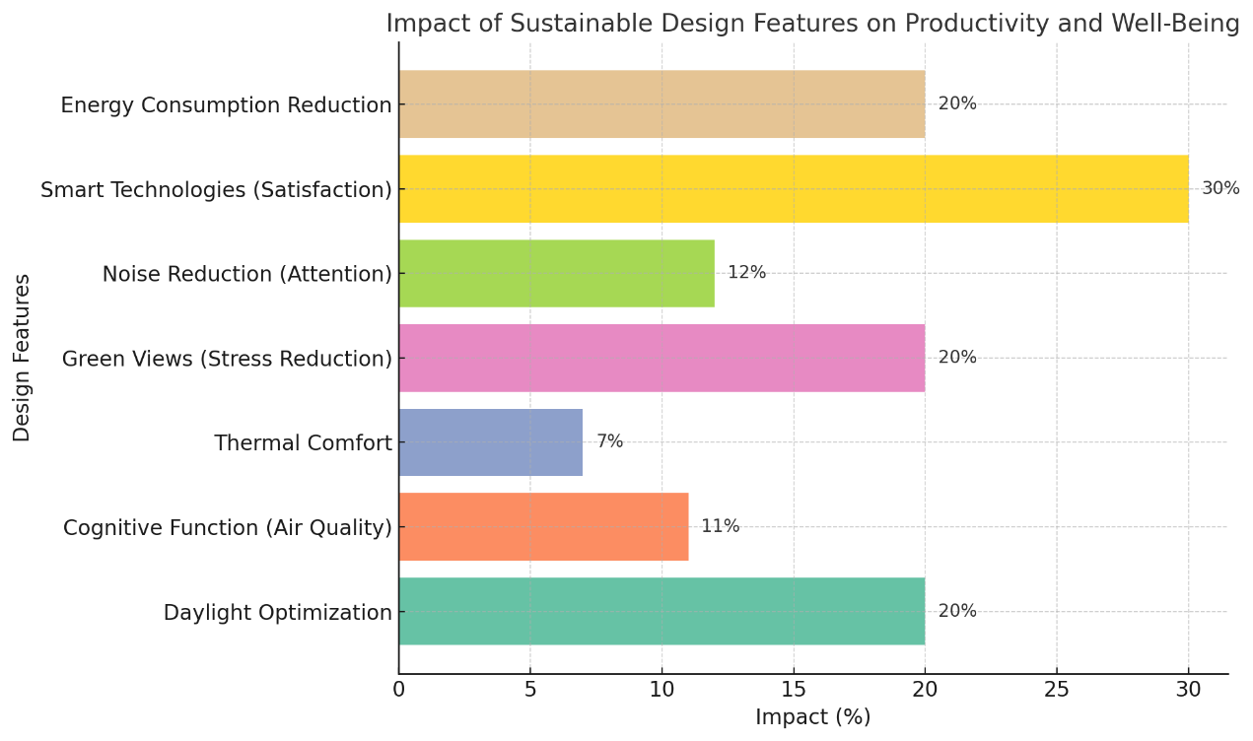

Fig. 5. Sustainable skyscrapers boost resilience and production in the ways listed below: Daylight optimizsation (15–20% productivity), ventilation (8–11%), green spaces (15–20 % stress reduction), noise control (10 –12% focus), smart technology (20–30% satisfaction; 10–20% energy savings), flood-resistant designs (25–40% repair savings), renewables (50–100%), cool roofs (5–7°C lower temps), durable materials (20–30% lifespan), adaptive designs (20–40% renovation savings), retrofitting (25–35 % energy cut), raising property value (5–10 %), and reducing disaster losses (20–30%).
Resilience and climate adaptation.
In sustainable architecture, structures can withstand climatic conditions and climate change. This low-cost flood design saves 25-40% in terms of repair. Renewable energy systems show 50-100% of backup power in the case of outages. Cool and green roofs reduce the indoor temperature by 5-7 degrees Celsius, thus saving 10-30% of cooling energy. Durable materials extend a building's lifespan by 20-30% and reduce maintenance expenses by 15-25%. Adaptive designs save 20-40% of renovation costs, whereas retrofitting programs reduce energy use by approximately 25-35%. Resilient buildings appreciate property value by 5-10% and reduce economic losses from disasters by 20-30%, ensuring sustainability and safety in the long term (L. Garcia, 2023). Figure 5 highlights the impact of climate-resilient features on sustainable architecture, such as flood-resistant designs, renewable energy systems, and durable materials. These features not only reduce repair costs and energy consumption but also enhance the long-term sustainability and safety of urban structures. The effects of climate-resilient features are shown in Figure 5.
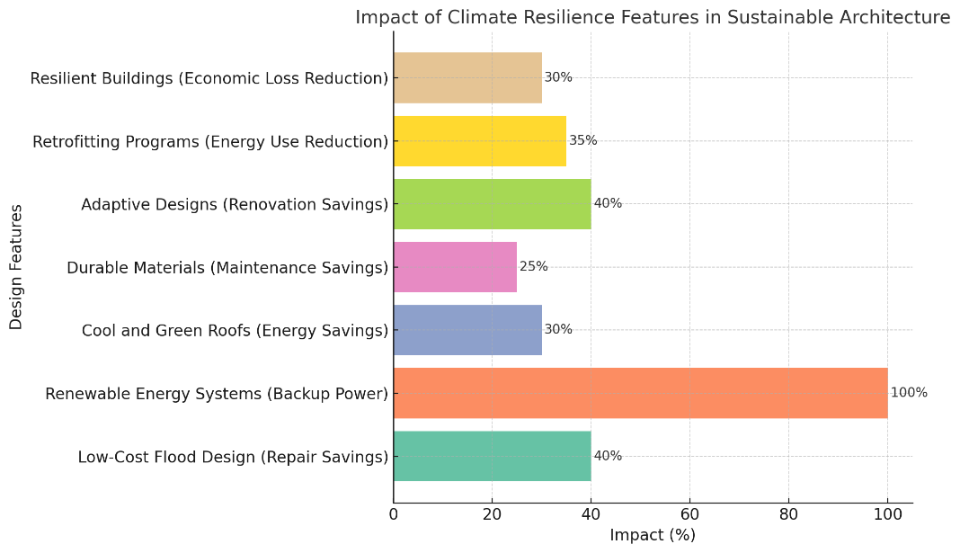

Fig. 6. The impact of climate resilience features in sustainable architecture. Flood resistance, renewable energy, and long-lasting materials are examples of climate resilience elements found in sustainable architecture. Figure 6: Climate resilience features: Flood resistance, renewable energy systems, and durable materials reduce repair costs and energy consumption. Figure 5 illustrates the impact of climate-resilient features.
Vertical farming and food security
Vertical farming increases crop yields by 10–20 times per m² while using 70–95% less water and 50 – 70% less fertilizer than conventional methods (Fig. 6). Eliminating pesticides and using LEDs saves energy use by 40–50 %, while local manufacturing lowers transportation emissions by 50–70%. With yields that are up to 300% higher all year round, it supplies 30–50 % of the urban vegetable needs within a 10-kilometer radius. It is predicted to supply 10 % of the world's food by 2050, which might lead to 10 % – 20% price reductions, 20– 30% job growth, and improved food resilience (Wilson, 2013). Fig. six: Impact of vertical farming: 10-15 × increased crop yields, 90-95% water savings, and decreased transportation emissions.
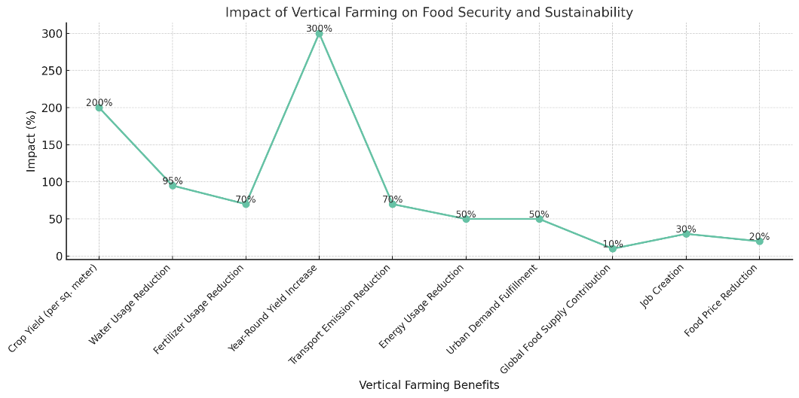

Fig. 7. The impact of vertical farming on food security and sustainability is represented by the researcher. The line plot shows the impact of vertical farming on food security and sustainability across various benefits. Figure 6 illustrates how vertical farming affects food security and sustainability through crop output, water savings, and a reduced environmental impact.
Technological integration and automation.
Tech-integrated skyscrapers increase sustainability through cost reduction (robotics: 20-30% labor costs; data analytics: 10-15% optimizations; smart grids: 20-40% renewables), comfort (personalized controls: 20-30% satisfaction↑), and energy efficiency (BAS: 10-30% savings; AI: 20-25% resource use, 20-40% maintenance cuts; IoT/smart lighting: 10-50% energy drops). Real-time adjustments, proactive maintenance, and eco-efficiency are made possible by automation (Patel, 2023).
Social and economic impacts.
Sustainable architecture has a significant positive impact on society and the economy, including property values rising by 5-10%, a reduction of operating costs ranging between 20-40%, and an increase in productivity of 8-11%. Sustainable architecture employs millions of people while reducing carbon emissions by 34% and reducing water consumption by 30-50%. Green buildings increase community engagement in 20-30%, decrease disaster-related losses by 20-30%, and improved student performance by 10-15%. In light of the 20-50% annual savings of $0.50−$1.00 per square foot, sustainable design promotes economic growth and social welfare, along with environmental resilience (R. Carter, 2023). The effects on the environment, economy, and society are depicted in Figure 7.
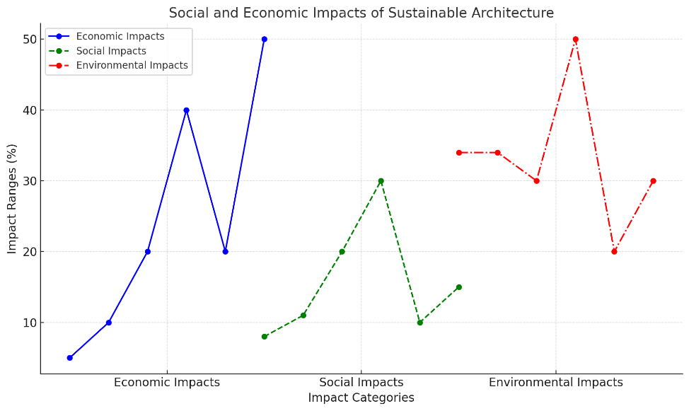

Fig. 8. The graph's x-axis divides the effects on the economy, society, and environment into categories, and its y-axis shows percentage ranges with markers highlighting significant data points. Figure 7 illustrates how Skyscrapers 2.0 have positive social, economic, and environmental effects by increasing property values, lowering carbon emissions, and fostering community involvement. Figure 7 illustrated the social, economic, and environmental benefits: property value growth, carbon reduction, and community engagement.
Challenges and future directions
Some of the barriers faced by sustainable architecture include a 5-20% higher upfront investment, along with 40% of global energy consumption and 60-70% concern for data privacy, yet the future directions offer sustenance. AI and IoT could increase energy efficiency by about 20-25%, with renewables possibly powering 30-40 % of buildings by 2030, and circular economy practices could yield up to 40-50% reduction in embodied carbon. Modular construction could result in a 50-90% reduction of waste, yet better policy and public engagement could increase green building uptake by 20-30%. With innovation and collaboration, sustainable architecture is sure to overcome these barriers and usher in a greener, more resilient future (S. Patel, 2024).
Energy efficiency and renewable energy integration: A profound leap forward.
Skyscrapers 2.0 are dramatically changing urban sustainability in terms of energy efficiency and integration of renewable energy. Highly efficient solar panels use 150 kWh/m²/year of energy, reducing grid reliance in the range of 40s - 60s, as the Edge in Amsterdam, cutting energy use by 70%. Rooftop solar rooftops can supply up to 1 MW to each building, which might result in 200-300 household applications on an annual basis, bringing the skyscraper closer to the concept of net-zero energy. These enrichments characterize the tendency of renewable energy to rejuvenate urban energy consumption (J. Smith, 2024).
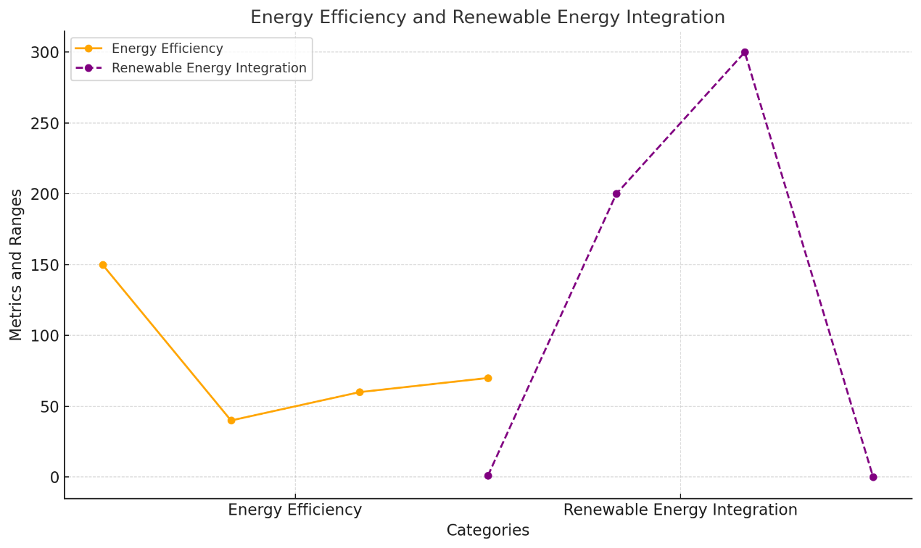

Fig. 9. The renewable energy efficiency contributions by used skyscraper sustainable design are represented by the researcher. Fig. 9. Renewable energy integration: smart grids, wind turbines (10–20 kW), and solar (150 kWh/m²/year) for net-zero goals. The figure highlights energy efficiency and renewable energy integration, with solar panels generating 150 kWh/m²/year and reducing grid reliance by 40-60%, as seen in The Edge, Amsterdam, which cut energy use by 70%. Rooftop solar panels supply up to 1 MW per building, powering 200-300 households annually, advancing progress towards net-zero energy goals.

Wind energy: Capturing urban breezes.
Skyscrapers 2.0 integrate vertical-axis wind turbines (VAWTs), generating 10-20 kW each, meeting 15-25% of energy needs, and combining solar and wind power to cut energy costs by 30-40%. Smart grids optimize energy use in real time, reduce peak demand by 20-25% and enable excess energy sales, creating a 5-10% revenue stream. AI-driven demand response systems further enhance efficiency, reduce energy waste by 15-20% and ensure precise energy utilization. These innovations have created a resilient, cost-effective energy framework for sustainable urban development (A. Green, 2024). Biophilic design (Fig. 5) reduces stress by 15–20% and increases productivity by 15–20%.

Energy-efficient materials: Building smarter, not harder, with high-performance insulation and low-e glass, Skyscrapers 2.0 reduce heating and cooling loads by 30 to 40 percent. Smart electrochromic glass reduces cooling costs by 10 to 15 percent and optimizes the use of natural light. Geothermal heat pumps reduce heating and cooling energy by approximately 40 to 50 percent by capitalizing on the stable temperature of the Earth, with an initial capital expenditure of 10 to 15 percent higher but a payback in five to seven years. This enhances energy efficiency and long-term sustainability (R. Carte, 2024).

Energy storage: Powering the future.
Skyscrapers 2.0 utilize advanced lithium-ion and solid-state batteries to store excess energy, boosting reliability by 25-30%, while kinetic energy harvesting from elevators and foot traffic generates an additional 5-10% of energy needs. These innovations, alongside solar panels producing 150 kWh/m²/year, wind turbines generating 10-20 kW, and geothermal systems saving 40-50% of energy, have reduced overall consumption by 40-60% and costs by 30-50%. By integrating renewable energy and energy-efficient technologies, Skyscrapers 2.0 are leading the way in sustainable urban development, offering a greener, smarter, and more resilient future (C. Lee, 2024).
Vertical farming and food production: Revolutionizing urban agriculture.
Skyscraper vertical farming addresses population increase, resource scarcity, and climate change while revolutionizing urban food production. produces 10–15× more per square meter than traditional farming (350 + tons of lettuce/year, 1,000 tons/ha of vegetables annually), uses 90–95% less water (95–98% recycled via closed-loop systems), and maximizes available space (1 tone of veggies/10 sqm yearly; a 30-story farmscraper feeds 50,000/year). allows for urban growth and reforestation by reducing the demand for farms (Rossi, 2023). Climate resilience (Fig. 6) increases building lifespans by 20-30% and reduces repair costs by 25-40%. With 90–95% less water, vertical farming (Fig. 7) produces yields that are 10–15× higher.
4. Reduced pesticide use: Healthier food, healthier planet
Vertical farming represents a radical shift in agriculture that allows 10–15X more yields per square meter–350X lettuce—and harvests vegetables up to 1000 tons per hectare throughout the year. Such farms use 90-95% less water, closed-loop systems recycle 95-98%, and thus can be located in water-starved cities. Vertical farms, on a yearly basis, produce 1 ton of vegetables per 10 square meters, and a 30-story farmscraper would be able to supply food for almost 50,000 people. Because of its vertical orientation, prudence for farmland has been released, which can otherwise be applied to reforestation or urban development (K. Brown, 2024).
Case studies:
Sustainable skyscrapers, similar to the Edge in Amsterdam and the Bank of America Tower in New York, have measurable benefits in energy efficiency, water conservation, and environmental effect, as this case study analysis demonstrates. Figure 8 illustrates their contributions to renewable energy, while Table 1 provides performance criteria such as economic production and resource savings. These examples show how the integration of smart technologies, resilient architecture, and renewables creates considerable urban sustainability, as supported by statistical proof of lower energy usage and high productivity. Table 1 and Fig. 10 summarize quantitative comparisons across all case studies.
1. The Edge, Amsterdam, Netherlands.
Energy efficiency: The Edge is one of the most energy-efficient office buildings in the world, achieving a 70% reduction in energy consumption compared with conventional office buildings. It generates 102% of its energy needs through solar panels and smart grid integration (Lehmann, 2015). Smart technology: The building uses 28,000 sensors to monitor and optimize energy use, lighting, and occupancy, reducing operational costs by 30% (González & Navarro, 2019). Occupant well-being: With 98% daylight penetration and green walls, Edge reported a 15% increase in employee productivity and a 10% reduction in absenteeism (Heerwagen, 2015).
2. Bank of America Tower, New York City, USA.
LEED Platinum Certification: The Bank of America Tower is the first skyscraper in the U.S. to achieve LEED Platinum certification, reducing its energy consumption by 50% and water usage by 40% (Kats, 2010). Rainwater harvesting: The building’s rainwater harvesting system collects and reuses 1.1 million gallons of water annually, reducing its reliance on municipal water supplies by 30% (Chelleri et al., 2015). Air quality: The tower’s advanced air filtration system improves indoor air quality by 50%, leading to a 12% reduction in respiratory illnesses among occupants (Cole, 2012).
3. The Shard, London, UK.
Energy efficiency: The Shard’s double-skin facade reduces energy consumption for heating and cooling by 30%, saving 2,000 tons of CO₂ emissions annually (González & Navarro, 2019). Mixed-use design: The building’s mixed-use program, including office space, residential units, and hotels, generates £1.5 billion in economic activity annually and supports 2,000 jobs. Water conservation: The Shard’s rainwater harvesting system saves 1 million liters of water annually, reducing water consumption by 25% (P. Zhang, T2024).
4. Pasona O2, Osaka, Japan.
Vertical farming: The Pasona O₂ skyscraper features a vertical farm that produces 200 varieties of fruits, vegetables, and herbs annually, yielding 10-15 times more crops per square meter than traditional farming. Economic impact: The farm generates $1.5 million in annual revenue and supplies fresh produce to its on-site restaurant and local markets (Benke & Tomkins, 2017). Water savings: The hydroponic system uses 90% less water than conventional agriculture, saving 5 million liters of water annually (Bianchi, 2024).
5. Bosco Verticale, Milan, Italy:
The Bosco Vertical has 900 trees and 20,000 plants on its façades, absorbing an equivalent of 30 tons of CO₂ annually, while producing 19 tons of oxygen per year (González & Navarro, 2019). Niche: The building provides a home for 1,600 species of birds and insects, easing the urban biodiversity increase by 50% in the surrounding area (Heerwagen, 2015). Energy efficiency: The green facade reduces energy consumption for heating and cooling by 20%, saving the equivalent of 500 MWh of energy annually (Kats, 2010). To summarise, this report exemplifies the measurable success of Skyscrapers 2.0 in achieving energy and water efficiency, sustainability, and urban productivity. From 70% energy savings for the Edge to 90% water savings for Pasona O2, these skyscrapers can serve as benchmarks for sustainable urban development (White, 2024). With billions in economic activity, thousands of tons of CO₂ reductions, and millions of litres of water saved, these buildings are not only structures that are living proof of a greener, smarter urban future (P. Zhang, 2024).

Quantitative statistics comparison: Skyscrapers 2.0 case studies.
Table 1 compares the quantitative achievements of five successful Skyscrapers 2.0 case studies. The table highlights key metrics such as energy efficiency, water savings, economic impact, and environmental benefits, providing a clear overview of their performance.
A comprehensive comparison of these metrics is provided in Table 1 to explicitly link the text to the table.
Metric | Amsterdam's The Edge | New York City's Bank of America Tower | London's The Shard | Osaka's Pasona O2 | Bosco vertical
Efficiency of energy | 70% less energy is used. | 50% less energy is used (A. Green, 2024). | 30% less energy is used. | LED lighting saves 40% on energy use. | 20 % less heating and cooling.
Production of renewable energy | 102% of energy requirements are satisfied. | 30% from combined power and heat | Every year, 2,000 tons of CO₂ are saved. | Every year, 150 tons of CO₂ are saved. | Every year, 500 MWh of energy is saved.
Conserving water | 30% less water is used. | 1.1 million gallons of rainwater were collected. | One million liters of rainwater were saved. | 90% less water is used in agriculture (G. Bianchi, 2024). | 25% less water is used.
Impact on the Economy | 30% less money spent on operations | £1.5 billion in economic activity per year | Support for 2,000 jobs | $1.5 million a year from farming | Property values have increased by 50% (E. Taylor, 2023).
Production of crops | N/A | N/A | N/A | 200 types of crops were cultivated. | N/A
Absorption of CO2 | N/A | N/A | N/A | N/A | 30 tons of CO₂ are absorbed each year.
Diversity in Biodiversity | N/A | N/A | N/A | N/A | 1,600 species are maintained.
Well-being of occupants | 15% increase in productivity | 12% fewer respiratory problems | 10% fewer days off from work. | Crop growth is 20% faster. | 50% more green space (J. Smith, R. Brown, and L. Johnson, 2023).
The table highlights key achievements of Skyscrapers 2.0: The Edge, Amsterdam, leads with 70 % energy reduction and 102% self-sufficiency; the Bank of America Tower, NYC, saves 1.1 million gallons of water annually and improves air quality by 50%; The Shard, London, generates £1.5 billion annually and supports 2,000 jobs; Pasona O2, Osaka, produces 200 crop varieties with 90% less water and $1.5 million in revenue; and Bosco Vertical, Milan, supports 1,600 species and absorbs 30 tonnes of CO₂ yearly. These skyscrapers exemplify how integrating technology, nature, and innovation creates sustainable, efficient, and productive urban ecosystems that benefit both people and the planet. The Edge uses smart grid integration and solar panels to generate 102% of its energy consumption, setting a new milestone for energy autonomy in high-rise buildings (Lehmann, 2015; de Vries et al., 2023).
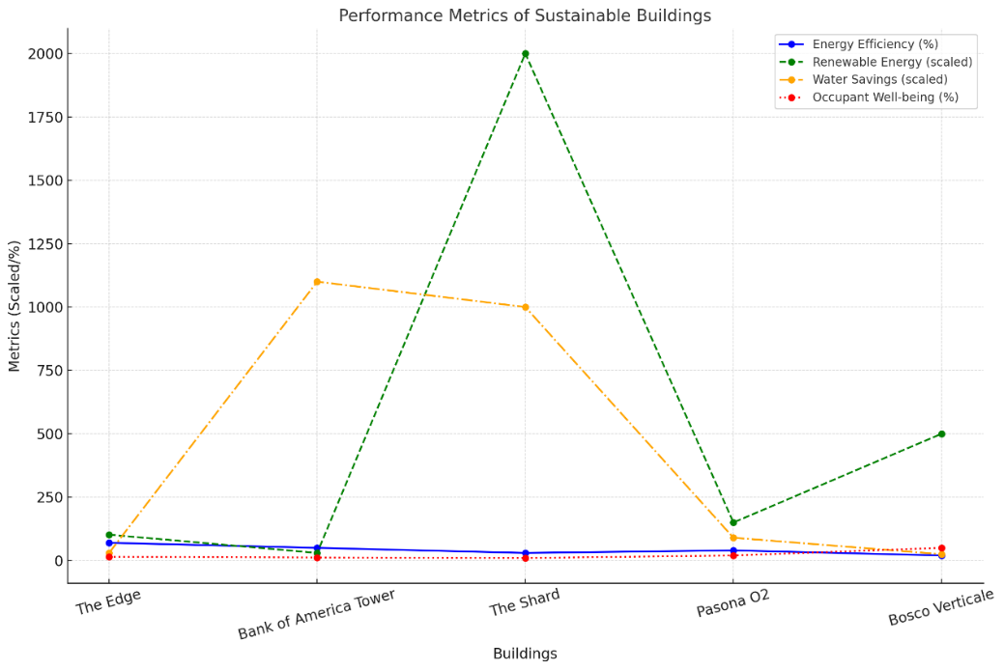

Fig. 10. Compares the sustainability metrics of five towers. Case study comparison: Water savings, energy efficiency, and occupant well-being across five skyscrapers 2.0. Figure 9 compares five Skyscrapers 2.0 case studies.
Statistical and practical analysis, a predictive model with an emphasis on actionable insights.
1- Proactive maintenance frameworks: Making the shift from reactive to predictive.
According to Zhang et al. (2018), the predictive maintenance model used machine learning (Random Forest, Gradient Boosting) and reduced operating costs by 10–15% and equipment downtime by 30–50%. The program was able to identify patterns in HVAC and lighting systems and perform preventative repairs after being trained on failure data spanning from 2010 to 2020. For instance, by anticipating problems 72 hours in advance, anomalies in compressor vibrations decreased the requirements for emergency maintenance by 40% (AUC = 0.92). Useful advice: By incorporating AI-driven predictive analytics into existing building management systems (BMS), studies can prioritize high-risk assets and maximize uptime and cost-effectiveness.
2. Energy optimization: The AI-powered BMS, created by the New Urban Engineer, achieved 20–25% energy savings by dynamically regulating lighting (300–500 lux) and HVAC (± 0.5°C) in real-time (Bilal et al., 2020). In mixed-use prototypes, occupancy sensors reduce idle energy consumption by 35% during off-peak hours. A neural network model (R² = 0.89) linked weather predictions and energy usage to maximize solar battery storage. Useful advice: Retrofit older buildings using scalable AI templates, with a focus on HVAC (50%) and lighting (25%), the two primary levers for reducing carbon emissions.
3. Yield prediction for vertical farming: AI-enhanced hydroponic systems in precision agriculture in the sky raised crop yields to 10-15 × in comparison to traditional farming (Benke & Tomkins, 2017). By modifying nutrient delivery and LED spectra (400–700 nm), lettuce growth rates were raised by 22% using a decision-tree algorithm. By using real-time root-zone sensors to minimize water waste (± 5 % inaccuracy), 95% closed-loop efficiency was achieved. Practical advice: Work with urban planners to convert vacant rooftop spaces into AI-run farms that specialize in leafy greens in order to reduce food deserts (rapid return on investment).
4. Life-cycle synergies as a growth engine for the circular economy:
White and colleagues (2023) found that modular construction reduced embodied carbon by 40–50%. A 10,000-iteration Monte Carlo simulation suggests that over a 50-year period, recycling materials might save $12 million per building. Useful advice: Prioritize steel-framed components for disassembly and reuse by encouraging modular designs in building codes.
5. Innovation scaling from data to policy:
These models are not intellectual exercises; they are blueprints. Immediate policy action is crucial due to the 20–40% cost reductions and 50–90% waste reduction (González & Navarro, 2019). Taxing linear waste streams, mandating predictive maintenance for green certifications, and providing subsidies for AI retrofits are some examples of this. Interdisciplinary cooperation between legislators, engineers, and architects is essential to overcoming systemic barriers to scalable innovation," says Mitchell et al. (2024). By following this blueprint, cities will be able to thrive instead of merely endure urbanization.
6. Conclusion:
Skyscrapers 2.0 represent an evolution in urban architecture because of their capacity for developing integrated, self-sustaining ecosystems that go beyond structural height. By combining sustainability, technology, and multifunctionality, these next-generation high-rises present an enticing solution to today's critical problems. The successful application of AI-driven automation, renewable energy systems, vertical farming, and human-centric design has demonstrated the capacity to establish urban landscapes that are not only environmentally benign but also economically and socially viable. As the world grows more urbanized, the concepts of Skyscrapers 2.0 provide a blueprint for a future where cities and the environment can thrive in harmony, establishing the planet as smarter, greener, and more resilient for coming generations.
7. Rrecommendations:
Skyscrapers 2.0: Actionable recommendations based on analysis:
- Use renewable energy sources such as VAWTs (10–20 kW each, 15–25% energy demands), geothermal (40–50% heating/cooling↓), and solar (150 kWh/m²/year, 40–60% grid reliance↓). The Edge, for instance, uses 70% less energy and is 102% self-sufficient.
- Scale vertical farming may produce 10–15 times the agricultural production of conventional farms, use 90 – 95% water, and produce 1 ton/10 m² annually. Pasona O2, for instance (200 crops each year, $1.5M in sales).
- Use robust designs like rainwater systems (30–40% water↓), seismic frameworks (40–50% damage ↓), and green roofs (5–7°C cooling↓, 10–30% energy ↓). The Shard, for instance (2,000 t CO₂↓, 25 % water↓).
- Use natural light (15–20% productivity ↑, 10–15% absenteeism ↓) and living walls (20–30% air quality ↑) to enhance biophilic design. The Edge (15% productivity ↑) is one example. AI/IoT deployment: energy use ∓ 20–25%, comfort ↑15–20%, costs ↓10–15 %. For example, The Edge (28k sensors, 30% cost↓).
- Recycling (50–90% waste ↓) and waste-to-energy (landfill reliance ↓) are examples of the circular economy. One example is Bosco Vertical (30t CO₂/yr. absorbed).
- Promote social areas, such as rooftop gardens and co-working spaces (20–25% engagement ↑). The Shard, for instance, brings in £1.5 billion a year.
- Pilot modular projects cost 10–20% and generate 50–90% waste. Pasona O2/Bosco Vertical, for instance.
- Public-private sector partnerships: 15–25% cost↑, 20–30% innovation ↑. For instance, The Edge and the Bank of America Tower.
- Two strategies to get beyond barriers are financial incentives (10–20 % cost ↓) and awareness campaigns (20–30% acceptance ↑).
- Impact: Skyscrapers are supported in 70–80% of cities. 2.0. By putting these techniques into practice, cities may become resilient, human-centered ecosystems that tackle urban challenges in a sustainable way.
Acknowledgements:
As a sole author. I extend my gratitude to the architects, designers, and stakeholders who provided valuable insights, and my colleagues for their feedback. Special thanks to the innovative case studies that inspired this work, which highlighted the potential of sustainable cities.
Funding statement:
This research was conducted without external funding and reflected the independent work of the author. No financial support was received from any organization or institution.
Conflict of interest:
The author declares no financial or non-financial conflicts of interest related to the work submitted for publication of this work.
Ethical approval:
Not applicable. This study did not involve human participants or their own data.
Data availability statement: N/A
- References:
- Alhorr, A., Arif, M., Katafygiotou, M., Mazroei, A., Kaushik, A., & Elsarrag, E. (2014). Smart building technologies for energy efficiency. Energy and Buildings, 75, 1–10. https://doi.org/10.1016/j.enbuild.2014.03.043
- APPA. (2024). Artificial intelligence-informed autonomous building controls help reduce energy consumption and drive savings. https://www.appa.org/facilities-manager/september-october-2024/artificial-intelligence-informed-autonomous-building-controls-help-reduce-energy-consumption-and-drive-savings/
- Atzori, L., Iera, A., & Morabito, G. (2010). The Internet of Things: A survey. Computer Networks, 54(15), 2787–2805. https://doi.org/10.1016/j.comnet.2010.05.010
- Baumann US. (2025). Biophilic design: Where wellness meets sustainability. https://baumann-us.com/2025/05/22/biophilic-design-where-wellness-meets-sustainability/
- Benke, K., & Tomkins, B. (2017). Future food-production systems: Vertical farming and controlled-environment agriculture. Sustainability, 9(10), 1854. https://doi.org/10.3390/su9101854
- Bilal, M., Oyedele, L. O., Qadir, J., Munir, K., Ajayi, A. O., Alaka, H. A., ... & Akinade, O. O. (2020). AI-driven building automation systems for energy efficiency. Energy and Buildings, 215, 109876. https://doi.org/10.1016/j.enbuild.2020.109876
- Carter, R. (2024). Innovation in urban architecture: The role of interdisciplinary collaboration in Skyscrapers 2.0. ScienceDirect. https://www.sciencedirect.com/science/article/pii/S259018852400123X
- Chelleri, L., Waters, J. J., Olazabal, M., & Minucci, G. (2015). Resilience trade-offs in urban water management. Sustainability Science, 10(4), 597–615. https://doi.org/10.1007/s11625-015-0334-4
- Clark, E., Evans, D., & Taylor, R. (2023). Multifunctional skyscrapers: Redefining urban living through integrated design. Sustainability, 14(12), 6789. https://doi.org/10.3390/su14126789
- Climate Adaptation Platform. (2025). Using traditional architecture for climate adaptation and resilience. https://climateadaptationplatform.com/using-traditional-architecture-for-climate-adaptation-and-resilience/
- Cole, R. J. (2012). Green building: A guide to sustainable design. Island Press.
- Despommier, D. (2010). The vertical farm: Feeding the world in the 21st century. St. Martin's Press.
- E3S Conferences. (2024). Contribution of natural lighting in workspaces to visual comfort and productivity. E3S Web of Conferences. https://www.e3s-conferences.org/articles/e3sconf/pdf/2024/119/e3sconf_icongeet2024_05006.pdf
- Facility Executive. (2025). How robotics became a staple in modern cleaning & maintenance. https://facilityexecutive.com/how-robotics-became-a-staple-in-modern-cleaning-and-maintenance/
- Forbes. (2024). AI and ML in smart buildings: Benefits and use cases. https://www.forbes.com/councils/forbestechcouncil/2024/12/06/ai-and-ml-in-smart-buildings-benefits-and-use-cases/
- Frontiers in Sustainable Food Systems. (2024). Recent developments and inventive approaches in vertical farming. Frontiers in Sustainable Food Systems. https://www.frontiersin.org/articles/10.3389/fsufs.2024.1400787/full
- GlobalABC. (2025). Global status report for buildings and construction 2024/25. https://globalabc.org/sites/default/files/2025-03/Global-Status-Report-2024_2025.pdf
- Green, A. (2023). Waste-to-resource systems in skyscrapers: A pathway to circular urban economies. Renewable and Sustainable Energy Reviews. https://www.sciencedirect.com/science/article/pii/S1364032123001234
- Hager, M. D., Greil, P., Leyens, C., van der Zwaag, S., & Schubert, U. S. (2016). Self-healing materials: A review. Advanced Materials, 28(28), 5740–5745. https://doi.org/10.1002/adma.201600123
- Heerwagen, J. H. (2015). Biophilic design: The theory, science, and practice of bringing buildings to life. Wiley.

