Final Project Report
By: Matthew Nelson, Tony Knaak, Collin Maeder, Ryan Domeier, and Marcus Meyer
On: The Simon Project
Background:
The project was designed to help others with muscular dystrophy or need to strengthen a specific muscle in the body. With this product, it will help people with this problem to strengthen their muscles and let them have fun doing it. By taking the idea of Simon Says and expanding on the idea of needing to move your arms around to target individual muscles in the body. Although this only a start to something that could be much bigger. We had decided to pursue this project and construct a successful prototype. Targeting the specific audience of people who are in the need to working on the further development of muscles. There are however products that are quite like the one that we have decided to take on. These products are the accrual Simon Says game itself, and the new Simon Says Air however both where lacking in the aspect that the buttons where located in the same general area. They’re for not helping the selected party that we have targeted when we were designing the product that we have made. However, there is many different advantages that each of the products offer. Our project offered movable lights, and can be used to exercise specific motor controls and muscles. The advantages that, Simon Game dose provide random game play and has 4 different difficulties. Then the advantages that, the Simon Air Game provides is touch-free technology, and has a fetcher that allows for 2 players or solo player. However, what comes with advantages comes disadvantages. Our project runs off a laptop, may require assistance to operate, and has preset patterns. The problems with the Simon Game is it ran on batteries, was centralized in one device, and only ran as a single player. Then lastly Simon Air Game’s problems where that it is fixed in a certain spot, ran on batteries, and sometimes touch free technology would fail. Although our project is not perfect if dose meet the needs of other to help them repair their torn or needed treatment on muscles, in the human body.
Initial design: 1-2 pages
The initial design of the project was going to be that the device would run on a battery that would randomly select buttons to make the Simon pattern. Then this would be connected with an integration of many different wires, that would all return back to a box that would house the adreno. This would also run a buzzer that would sound when each of the light to light up, and play a tone when a person would successfully complete the game. All the buttons will be connected to tripods to adjust the heights of all the buttons as needed. Finally, the original design would have had a three-way switch that would just a different difficulty for the player.

Changes made to the initial design:
The changes that we have made for the original design where that of removing the three-way switch, and just running device on a battery. We have solved this problem by running the device off a laptop to provide both power and provide different coding to change the difficulty of the game. We did run in the the problem of not much power this was resolved when we had remove the resisters that where acting on the circuits to allow the power to run through at a higher current to allow the light to light up that the right time to make the project operate correctly. This was not a change in design however it was a minor change in the circuitry of the product. Besides the changes that I have mentioned above the rest of the project was many as pained so it was nice to have a project that was well pained and didn’t run into too many difficult problems along the way.

Circuit:
The circuit that we used on the circuit board can be described by using multiple parallel circuits. That would provide power from the designated channels to power the lights, buttons, and the buzzer. The lights where powered from there channels that ran a wire from the to the lights on the buttons, then to the bread board, and then to the lights on the box to synchronizes the timing of the lights. Then completing the circuits for the lights. Then the switches/buttons on each of received their power from their designated channels, then to the bread board to complete their circuit. Then the buzzer is connected to two channels to tell it to ring at certain points, in time and at certain tones. These combination for this circuit had allowed for our project to operate correctly. All together the brains were like the Arduino, and the wires to each part and what happens at each point are like the nerves system of The Simon Project.
(2,6,9,12)-Channels that power the buttons.
(3,5,10,13)-Channels that power the lights both on the buttons, and in the box.
(4,7)-Channels that power the buzzer.
All the rest of the wiring will end in the negative side of the bread board then back to the Arduino too.
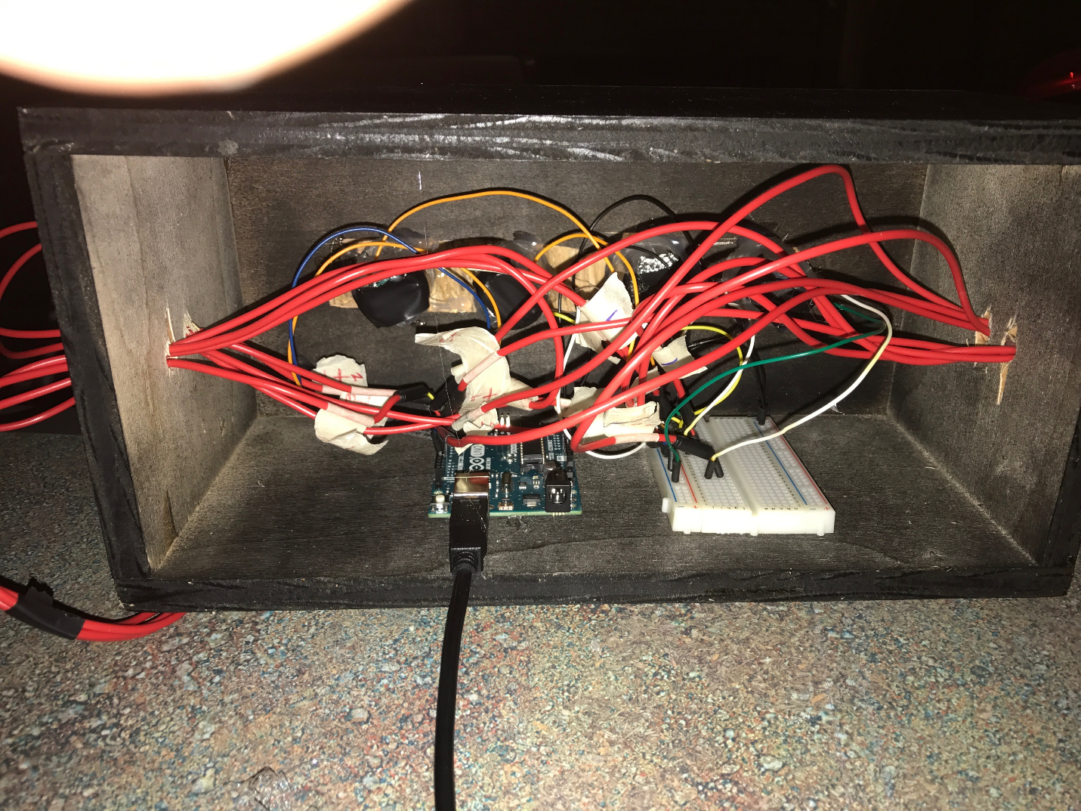

Physical construction:
The only physical construction that was done on the project was when we had assembled the box out of a half sheet of plywood that we had held together with screws, and used hidden holes to hide the screws. Then we had cut four holes for the lights, and four more holes (two on each side) for the wires to run through. Then finishing when we had painted the box black to make the finished product look good.
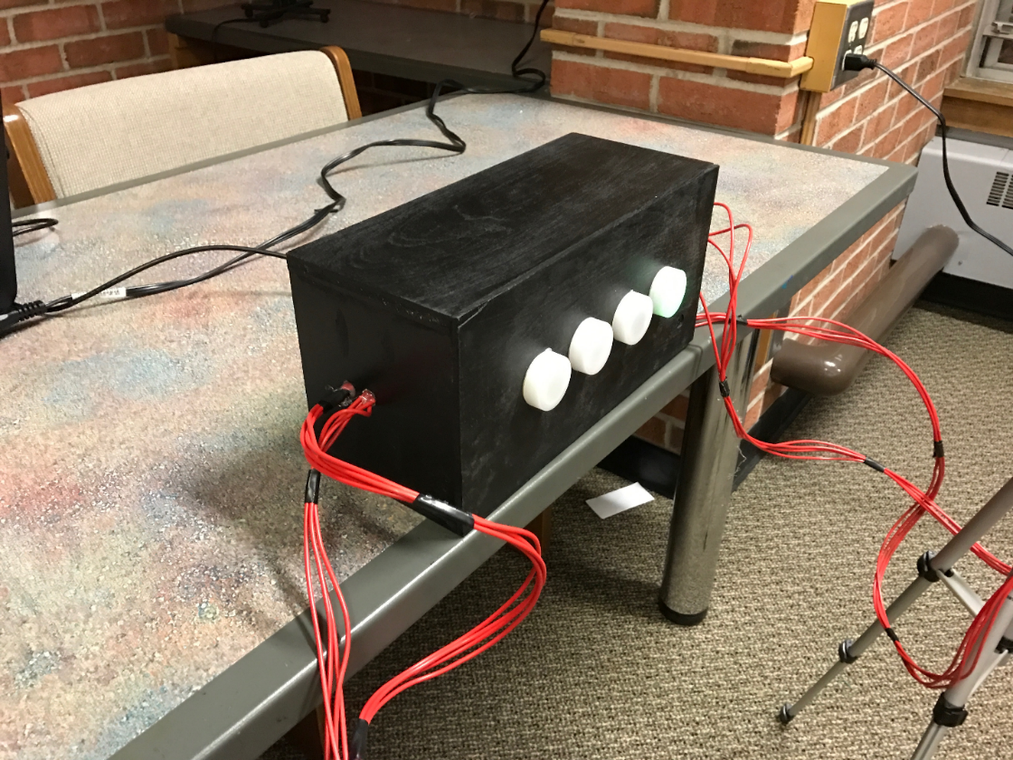
This is photo of the finished product of the box we needed to construct.

Code logic: 1paragraph and photo of the flow chart
The coding will start of by telling the lights flicker with sounds indicating that the game has been turned on. After the lights stop flickering you hit any of the four buttons which will activate the game to start. It then selects a random light that blinks on the black box. Then the player must find and press the button that is the same color as the light that just flashed. If they press the correct button the black box will repeat the light again, but adds an additional light randomly selected. The player must then repeat the pattern then back to the box. This process continues until the player completes the game or gets one pattern wrong or hits the wrong button. If the player happens to get the button wrong or they run out of time the loser tone will play which will indicate that the player has lost. For the player to win they must complete the final pattern after completing all the previous rounds prior then the winner’s tone will play. There are three different depending on the player’s skill after playing the game many of time in a row. The three differentials are easy, medium, and hard. The differences change the amount of time between button to be pressed, and the number of buttons in the pattern to win. For easy mode, the player has 10 seconds to hit the correct button, which should be enough time for someone with a muscular disability to try and choose a button and with they only needing twelve rounds to win. If the player wants more of a challenge they can go to the next difficulty which is medium mode. Medium mode has a six second delay between for the player to push a button and it takes twenty-five rounds to win. For the last difficulty, hard mode the player has a three and a half second delay between each button and has one hundred rounds to win the game. Which it impossible except for a select few people.

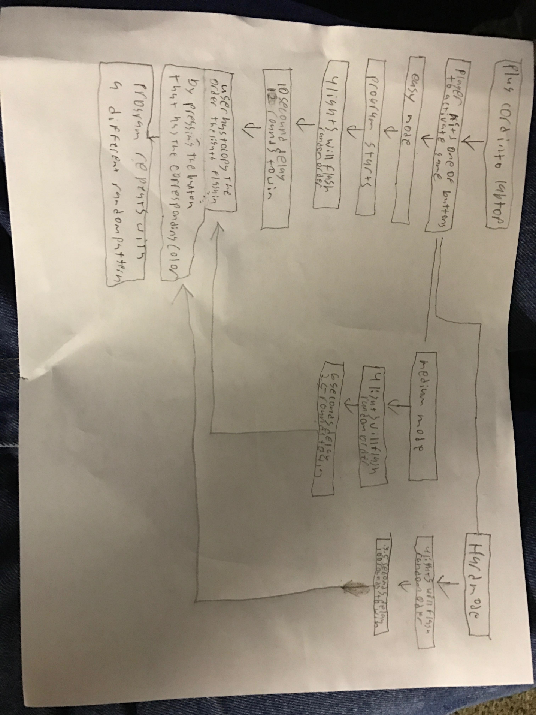
References:
- https://www.disabled-world.com/disability/types/mobility/
- http://www.disabilitysecrets.com/topics/disability-musculoskeletal-disorders
- http://www.thebay.com/webapp/wcs/stores/servlet/en/thebay/simon-air-game-0616-b69000920--24?utm_source=bing&utm_medium=cpc&utm_campaign=BSE%20-%20Shopping%20-%20Kids&utm_term=4580290563675088&utm_content=BSE%20-%20Shopping%20-%20Kids%20-%20Kids%20Toys&gclid=COLujfr3ttICFSh3MgodPlgO0w&gclsrc=ds
4. http://kidshealth.org/en/teens/muscular-dystrophy.html?WT.ac=ctg#
5. http://www.moveforwardpt.com/symptomsconditionsdetail.aspx?cid=11b647e2-58e0-4b84-9d27-61d24ff3af10
https://en.wikipedia.org/wiki/Simon_(game)
6. https://www.amazon.com/Easyget-LED-Illuminated-Self-resetting-Button/dp/B00XRC0ZEE/ref=sr_1_2?ie=UTF8&qid=1492046094&sr=8-2&keywords=100mm+5volt+
7. https://learn.sparkfun.com/tutorials/sik-experiment-guide-for-arduino---v32/experiment-16-simon-says

Appendix:
Simon Says code – Hard [7]
#define NOTE_B0 31
#define NOTE_C1 33
#define NOTE_CS1 35
#define NOTE_D1 37
#define NOTE_DS1 39
#define NOTE_E1 41
#define NOTE_F1 44
#define NOTE_FS1 46
#define NOTE_G1 49
#define NOTE_GS1 52
#define NOTE_A1 55
#define NOTE_AS1 58
#define NOTE_B1 62
#define NOTE_C2 65
#define NOTE_CS2 69
#define NOTE_D2 73
#define NOTE_DS2 78
#define NOTE_E2 82
#define NOTE_F2 87
#define NOTE_FS2 93
#define NOTE_G2 98
#define NOTE_GS2 104
#define NOTE_A2 110
#define NOTE_AS2 117
#define NOTE_B2 123
#define NOTE_C3 131
#define NOTE_CS3 139
#define NOTE_D3 147
#define NOTE_DS3 156
#define NOTE_E3 165
#define NOTE_F3 175
#define NOTE_FS3 185
#define NOTE_G3 196
#define NOTE_GS3 208
#define NOTE_A3 220
#define NOTE_AS3 233
#define NOTE_B3 247
#define NOTE_C4 262
#define NOTE_CS4 277
#define NOTE_D4 294
#define NOTE_DS4 311
#define NOTE_E4 330
#define NOTE_F4 349
#define NOTE_FS4 370
#define NOTE_G4 392
#define NOTE_GS4 415
#define NOTE_A4 440
#define NOTE_AS4 466
#define NOTE_B4 494
#define NOTE_C5 523
#define NOTE_CS5 554
#define NOTE_D5 587
#define NOTE_DS5 622
#define NOTE_E5 659
#define NOTE_F5 698
#define NOTE_FS5 740
#define NOTE_G5 784
#define NOTE_GS5 831
#define NOTE_A5 880
#define NOTE_AS5 932
#define NOTE_B5 988
#define NOTE_C6 1047
#define NOTE_CS6 1109
#define NOTE_D6 1175
#define NOTE_DS6 1245
#define NOTE_E6 1319
#define NOTE_F6 1397
#define NOTE_FS6 1480
#define NOTE_G6 1568
#define NOTE_GS6 1661
#define NOTE_A6 1760
#define NOTE_AS6 1865
#define NOTE_B6 1976
#define NOTE_C7 2093
#define NOTE_CS7 2217
#define NOTE_D7 2349
#define NOTE_DS7 2489
#define NOTE_E7 2637
#define NOTE_F7 2794
#define NOTE_FS7 2960
#define NOTE_G7 3136
#define NOTE_GS7 3322
#define NOTE_A7 3520
#define NOTE_AS7 3729
#define NOTE_B7 3951
#define NOTE_C8 4186
#define NOTE_CS8 4435
#define NOTE_D8 4699
#define NOTE_DS8 4978

#define CHOICE_OFF 0 //Used to control LEDs
#define CHOICE_NONE 0 //Used to check buttons
#define CHOICE_RED (1 << 0)
#define CHOICE_GREEN (1 << 1)
#define CHOICE_BLUE (1 << 2)
#define CHOICE_YELLOW (1 << 3)

#define LED_RED 10
#define LED_GREEN 3
#define LED_BLUE 13
#define LED_YELLOW 5

// Button pin definitions
#define BUTTON_RED 9
#define BUTTON_GREEN 2
#define BUTTON_BLUE 12
#define BUTTON_YELLOW 6

// Buzzer pin definitions
#define BUZZER1 4
#define BUZZER2 7

// Define game parameters
#define ROUNDS_TO_WIN 100 //Number of rounds to succesfully remember before you win. 100 is do-able.
#define ENTRY_TIME_LIMIT 3500 //Amount of time to press a button before game times out. 3500ms = 3 sec

#define MODE_MEMORY 0
#define MODE_BATTLE 1
#define MODE_BEEGEES 2

// Game state variables
byte gameMode = MODE_MEMORY; //By default, let's play the memory game
byte gameBoard[32]; //Contains the combination of buttons as we advance
byte gameRound = 0; //Counts the number of succesful rounds the player has made it through

void setup()
{
//Setup hardware inputs/outputs. These pins are defined in the hardware_versions header file

//Enable pull ups on inputs
pinMode(BUTTON_RED, INPUT_PULLUP);
pinMode(BUTTON_GREEN, INPUT_PULLUP);
pinMode(BUTTON_BLUE, INPUT_PULLUP);
pinMode(BUTTON_YELLOW, INPUT_PULLUP);

pinMode(LED_RED, OUTPUT);
pinMode(LED_GREEN, OUTPUT);
pinMode(LED_BLUE, OUTPUT);
pinMode(LED_YELLOW, OUTPUT);

pinMode(BUZZER1, OUTPUT);
pinMode(BUZZER2, OUTPUT);

//Mode checking
gameMode = MODE_MEMORY; // By default, we're going to play the memory game

// Check to see if the lower right button is pressed
if (checkButton() == CHOICE_YELLOW) play_beegees();

// Check to see if upper right button is pressed
if (checkButton() == CHOICE_GREEN)
{
gameMode = MODE_BATTLE; //Put game into battle mode

//Turn on the upper right (green) LED
setLEDs(CHOICE_GREEN);
toner(CHOICE_GREEN, 150);

setLEDs(CHOICE_RED | CHOICE_BLUE | CHOICE_YELLOW); // Turn on the other LEDs until you release button

while(checkButton() != CHOICE_NONE) ; // Wait for user to stop pressing button

//Now do nothing. Battle mode will be serviced in the main routine
}

play_winner(); // After setup is complete, say hello to the world
}

void loop()
{
attractMode(); // Blink lights while waiting for user to press a button

// Indicate the start of game play
setLEDs(CHOICE_RED | CHOICE_GREEN | CHOICE_BLUE | CHOICE_YELLOW); // Turn all LEDs on
delay(1000);
setLEDs(CHOICE_OFF); // Turn off LEDs
delay(250);

if (gameMode == MODE_MEMORY)
{
// Play memory game and handle result
if (play_memory() == true)
play_winner(); // Player won, play winner tones
else
play_loser(); // Player lost, play loser tones
}

if (gameMode == MODE_BATTLE)
{
play_battle(); // Play game until someone loses

play_loser(); // Player lost, play loser tones
}
}

//-=-=-=-=-=-=-=-=-=-=-=-=-=-=-=-=-=-=-=-=-=-=-=-=-=-=-=-=-=-=
//The following functions are related to game play only

// Play the regular memory game
// Returns 0 if player loses, or 1 if player wins
boolean play_memory(void)
{
randomSeed(millis()); // Seed the random generator with random amount of millis()

gameRound = 0; // Reset the game to the beginning

while (gameRound < ROUNDS_TO_WIN)
{
add_to_moves(); // Add a button to the current moves, then play them back

playMoves(); // Play back the current game board

// Then require the player to repeat the sequence.
for (byte currentMove = 0 ; currentMove < gameRound ; currentMove++)
{
byte choice = wait_for_button(); // See what button the user presses

if (choice == 0) return false; // If wait timed out, player loses

if (choice != gameBoard[currentMove]) return false; // If the choice is incorect, player loses
}

delay(1000); // Player was correct, delay before playing moves
}

return true; // Player made it through all the rounds to win!
}

// Play the special 2 player battle mode
// A player begins by pressing a button then handing it to the other player
// That player repeats the button and adds one, then passes back.
// This function returns when someone loses
boolean play_battle(void)
{
gameRound = 0; // Reset the game frame back to one frame

while (1) // Loop until someone fails
{
byte newButton = wait_for_button(); // Wait for user to input next move
gameBoard[gameRound++] = newButton; // Add this new button to the game array

// Then require the player to repeat the sequence.
for (byte currentMove = 0 ; currentMove < gameRound ; currentMove++)
{
byte choice = wait_for_button();

if (choice == 0) return false; // If wait timed out, player loses.

if (choice != gameBoard[currentMove]) return false; // If the choice is incorect, player loses.
}

delay(100); // Give the user an extra 100ms to hand the game to the other player
}

return true; // We should never get here
}

// Plays the current contents of the game moves
void playMoves(void)
{
for (byte currentMove = 0 ; currentMove < gameRound ; currentMove++)
{
toner(gameBoard[currentMove], 150);

// Wait some amount of time between button playback
// Shorten this to make game harder
delay(150); // 150 works well. 75 gets fast.
}
}

// Adds a new random button to the game sequence, by sampling the timer
void add_to_moves(void)
{
byte newButton = random(0, 4); //min (included), max (exluded)

// We have to convert this number, 0 to 3, to CHOICEs
if(newButton == 0) newButton = CHOICE_RED;
else if(newButton == 1) newButton = CHOICE_GREEN;
else if(newButton == 2) newButton = CHOICE_BLUE;
else if(newButton == 3) newButton = CHOICE_YELLOW;

gameBoard[gameRound++] = newButton; // Add this new button to the game array
}

//-=-=-=-=-=-=-=-=-=-=-=-=-=-=-=-=-=-=-=-=-=-=-=-=-=-=-=-=-=-=
//The following functions control the hardware

// Lights a given LEDs
// Pass in a byte that is made up from CHOICE_RED, CHOICE_YELLOW, etc
void setLEDs(byte leds)
{
if ((leds & CHOICE_RED) != 0)
digitalWrite(LED_RED, HIGH);
else
digitalWrite(LED_RED, LOW);

if ((leds & CHOICE_GREEN) != 0)
digitalWrite(LED_GREEN, HIGH);
else
digitalWrite(LED_GREEN, LOW);

if ((leds & CHOICE_BLUE) != 0)
digitalWrite(LED_BLUE, HIGH);
else
digitalWrite(LED_BLUE, LOW);

if ((leds & CHOICE_YELLOW) != 0)
digitalWrite(LED_YELLOW, HIGH);
else
digitalWrite(LED_YELLOW, LOW);
}

// Wait for a button to be pressed.
// Returns one of LED colors (LED_RED, etc.) if successful, 0 if timed out
byte wait_for_button(void)
{
long startTime = millis(); // Remember the time we started the this loop

while ( (millis() - startTime) < ENTRY_TIME_LIMIT) // Loop until too much time has passed
{
byte button = checkButton();

if (button != CHOICE_NONE)
{
toner(button, 150); // Play the button the user just pressed

while(checkButton() != CHOICE_NONE) ; // Now let's wait for user to release button

delay(10); // This helps with debouncing and accidental double taps

return button;
}

}

return CHOICE_NONE; // If we get here, we've timed out!
}

// Returns a '1' bit in the position corresponding to CHOICE_RED, CHOICE_GREEN, etc.
byte checkButton(void)
{
if (digitalRead(BUTTON_RED) == 0) return(CHOICE_RED);
else if (digitalRead(BUTTON_GREEN) == 0) return(CHOICE_GREEN);
else if (digitalRead(BUTTON_BLUE) == 0) return(CHOICE_BLUE);
else if (digitalRead(BUTTON_YELLOW) == 0) return(CHOICE_YELLOW);

return(CHOICE_NONE); // If no button is pressed, return none
}

// Light an LED and play tone
// Red, upper left: 440Hz - 2.272ms - 1.136ms pulse
// Green, upper right: 880Hz - 1.136ms - 0.568ms pulse
// Blue, lower left: 587.33Hz - 1.702ms - 0.851ms pulse
// Yellow, lower right: 784Hz - 1.276ms - 0.638ms pulse
void toner(byte which, int buzz_length_ms)
{
setLEDs(which); //Turn on a given LED

//Play the sound associated with the given LED
switch(which)
{
case CHOICE_RED:
buzz_sound(buzz_length_ms, 1136);
break;
case CHOICE_GREEN:
buzz_sound(buzz_length_ms, 568);
break;
case CHOICE_BLUE:
buzz_sound(buzz_length_ms, 851);
break;
case CHOICE_YELLOW:
buzz_sound(buzz_length_ms, 638);
break;
}

setLEDs(CHOICE_OFF); // Turn off all LEDs
}

// Toggle buzzer every buzz_delay_us, for a duration of buzz_length_ms.
void buzz_sound(int buzz_length_ms, int buzz_delay_us)
{
// Convert total play time from milliseconds to microseconds
long buzz_length_us = buzz_length_ms * (long)1000;

// Loop until the remaining play time is less than a single buzz_delay_us
while (buzz_length_us > (buzz_delay_us * 2))
{
buzz_length_us -= buzz_delay_us * 2; //Decrease the remaining play time

// Toggle the buzzer at various speeds
digitalWrite(BUZZER1, LOW);
digitalWrite(BUZZER2, HIGH);
delayMicroseconds(buzz_delay_us);

digitalWrite(BUZZER1, HIGH);
digitalWrite(BUZZER2, LOW);
delayMicroseconds(buzz_delay_us);
}
}

// Play the winner sound and lights
void play_winner(void)
{
setLEDs(CHOICE_GREEN | CHOICE_BLUE);
winner_sound();
setLEDs(CHOICE_RED | CHOICE_YELLOW);
winner_sound();
setLEDs(CHOICE_GREEN | CHOICE_BLUE);
winner_sound();
setLEDs(CHOICE_RED | CHOICE_YELLOW);
winner_sound();
}

// Play the winner sound
// This is just a unique (annoying) sound we came up with, there is no magic to it
void winner_sound(void)
{
// Toggle the buzzer at various speeds
for (byte x = 250 ; x > 70 ; x--)
{
for (byte y = 0 ; y < 3 ; y++)
{
digitalWrite(BUZZER2, HIGH);
digitalWrite(BUZZER1, LOW);
delayMicroseconds(x);

digitalWrite(BUZZER2, LOW);
digitalWrite(BUZZER1, HIGH);
delayMicroseconds(x);
}
}
}

// Play the loser sound/lights
void play_loser(void)
{
setLEDs(CHOICE_RED | CHOICE_GREEN);
buzz_sound(255, 1500);

setLEDs(CHOICE_BLUE | CHOICE_YELLOW);
buzz_sound(255, 1500);

setLEDs(CHOICE_RED | CHOICE_GREEN);
buzz_sound(255, 1500);

setLEDs(CHOICE_BLUE | CHOICE_YELLOW);
buzz_sound(255, 1500);
}

// Show an "attract mode" display while waiting for user to press button.
void attractMode(void)
{
while(1)
{
setLEDs(CHOICE_RED);
delay(100);
if (checkButton() != CHOICE_NONE) return;

setLEDs(CHOICE_BLUE);
delay(100);
if (checkButton() != CHOICE_NONE) return;

setLEDs(CHOICE_GREEN);
delay(100);
if (checkButton() != CHOICE_NONE) return;

setLEDs(CHOICE_YELLOW);
delay(100);
if (checkButton() != CHOICE_NONE) return;
}
}

