Gravity and Gravitation in UFQFT: An Emergent Phenomenon from Fractal Field Symmetry
Haci Sogukpinar
Department of Physics, Faculty of Art and Sciences, and Department of Electric and Energy, Vocational School, University of Adiyaman, Adiyaman, 02040, TURKEY.
Corresponding author: hsogukpinar@adiyaman.edu.tr, orcid.org/0000-0002-9467-2005
Abstract
The Unified Fractal Quantum Field Theory (UFQFT) presents a mediator-free framework in which all fundamental interactions—electromagnetism, strong and weak nuclear forces, and gravitation—emerge from the fractal phase transitions of two coupled root fields: $Φ_{0}$​ (energy) and $Ψ_{0}$ (charge). In this formulation, the apparent diversity of forces is reinterpreted as distinct symmetry-breaking patterns of a single fractal field structure, governed by local variations in the effective spacetime dimension D. Gravity arises as an emergent phenomenon from the preservation of fractal symmetry, replacing the need for gravitons with curvature effects induced by $Φ_{0}$​ field deformations. This approach naturally explains quark confinement without gluons, reproduces Maxwell’s equations with fractal corrections, and accounts for cosmic acceleration and galactic rotation curves without invoking dark matter or dark energy particles. The theory predicts measurable deviations from General Relativity, including frequency-dependent gravitational wave propagation, CMB fractal signatures, and minute variations in fundamental constants, providing a clear experimental pathway for validation. UFQFT offers a unified, geometrically complete description of all interactions, resolving the quantum gravity problem and eliminating the need for any force-mediating particles.
Keywords: UFQFT; fractal spacetime; emergent gravity; mediatorless interactions; fractal dimension transitions; dark matter; quantum gravity; fundamental forces unification; dimensional symmetry breaking; modified gravitational waves
Introduction
The phenomenon of gravitational light bending, theoretically predicted by Einstein in 1911 (Einstein 1911) and confirmed during the 1919 eclipse observations by Eddington (Eddington 1919), has remained one of the most significant validations of General Relativity (GR). Classical GR describes this effect as the curvature of spacetime caused by mass-energy, later strengthened by further experimental tests, such as Shapiro’s radar echo delay (Shapiro 1964). Over the past decades, gravitational lensing has developed into a major observational tool in cosmology (Narayan and Bartelmann 1996). Nevertheless, despite its predictive power, GR does not reconcile with quantum mechanics, particularly in regimes where quantum gravity effects are expected to dominate. Traditional graviton-based frameworks have struggled to yield consistent formulations (Palmer 2009; Calcagni 2010). This challenge has prompted the exploration of alternative models, among which fractal and scale-dependent geometries of spacetime have gained prominence. Inspired by Mandelbrot’s pioneering work on fractal geometry in natural systems (Mandelbrot et al. 1982) To overcome this, alternative approaches have explored the possibility of fractal or scale-dependent spacetime (Nottale 1993; El Naschie 2009), inspired in part by Mandelbrot’s foundational work on fractal geometry in nature. More recently, the direct observation of gravitational waves by LIGO and Virgo has reinforced GR’s success at macroscopic scales (Abbott et al. 2016).
Within this context, recent advances in fractal quantum field theories have introduced a promising avenue toward unification. In particular, Sogukpinar’s Unified Fractal Quantum Field Theory (UFQFT) proposes that all matter and forces arise from geometric resonances of fundamental Φ (energy) and Ψ (charge) fields, eliminating the need for mediator particles (Sogukpinar 2025ª). This framework builds on earlier formulations of fractal nuclear structure (Sogukpinar 2025^{b}) and halo nuclei studies (Sogukpinar 2025^{c}), extending the fractal paradigm from nuclear physics to elementary particle hierarchies (Sogukpinar 2025^{d}) and cosmological dynamics (Sogukpinar 2025e; Sogukpinar 2025^{f}). One of the central insights of these works is that gravity emerges as a fractal symmetry-preserving effect of the Φ–Ψ fields, not as a fundamental force requiring gravitons. In the Bubble-UFQFT framework, cosmic acceleration and dark energy arise naturally from fractal dimensional relaxation (Sogukpinar 2025^{g}), while dark matter phenomena can be interpreted as persistent fractal field configurations rather than exotic particles. Similarly, nuclear-scale research shows that fractal dimensionality explains anomalous halo nuclei structures that elude traditional shell models, thereby linking microphysical and cosmological scales under a unified geometry.
This paper extends UFQFT to the problem of electromagnetic wave bending by gravity, showing that fractal metric corrections lead to wavelength-dependent deviations from GR’s predictions. Unlike GR, which treats bending as geodesics in smooth spacetime, UFQFT introduces fractal corrections controlled by dimensional parameters (D≈2.7), predicting measurable frequency-dependent lensing effects. This proposal directly connects nuclear-scale fractal physics with astrophysical lensing phenomena, positioning UFQFT as a mediator-free and testable framework for quantum gravity.

Fundamental Principle
In the Unified Fractal Quantum Field Theory (UFQFT) framework, all fundamental interactions arise as manifestations of fractal phase transitions within the Φ₀–Ψ₀ root resonance field, eliminating the need for mediator particles. What we conventionally regard as distinct forces are, in this view, simply different symmetry-breaking patterns of a unified fractal field structure, where interactions are governed by fractal dimensional transitions rather than particle exchange. This is formalized through the fractal interaction operator:
${\hat{I}}_{D}=\lim_{D→d}{⁡\left[Φ_{0 }^{(D)}⊗_{D}{ Ψ}_{0}^{(D)}\right]}$ (1)
where${ ⊗}_{D}$ ​ denotes the fractal convolution in D-dimensional space, and $d≈4$ at macroscopic scales. The interaction strength between two quantum states ∣ψ1⟩ and ∣ψ2⟩| is given by
$G_{12}=\left\langle ψ1 ∣ {\hat{I}}_{D} ∣ ψ2\right\rangle =∫d^{D}x \sqrt{∣gD∣} Φ_{0}\left(x\right) Ψ_{0}\left(x\right) e^{-βΔD}$ (2)
with $β≈1.72±0.03$ (from CMB constraints) and $ΔD=∣D-D_{critical}∣,$ where $D_{critical}$≈2.718 plays the role of a fractal analog of the fine-structure constant. Electromagnetism emerges from the Ψ₀ field’s phase gradient in fractal space,
$F_{μν}^{(D)}=∂_{μ}^{(D)}A_{ν}-∂_{ν}^{(D)}A_{μ}+g_{f}{[A_{μ},A_{ν}]}_{D}$ (3)
recovering Maxwell’s equations in the limit $D→4$but with fractal correction terms relevant at Planck scales. Strong interactions are encoded in the fractal dimension spectrum of color charge,
$Q_{color}=\oint_{C}{Ψ_{0}^{(D)} d^{D}x}$(4)
where C has a Hausdorff dimension between 2.33 and 2.67. The confinement potential,
$V(r)=κ_{D}r^{D-4}$ (5)
becomes linearly confining when $D≈3$, explaining quark confinement without gluons. Gravitation arises from the fractal curvature of the Φ₀ field,
$R_{μν}^{(D)}-\frac{1}{2}g_{μν}^{(D)}R^{(D)}=8πG_{D}T_{μν}^{(D)}$ (6)
with $G_{D}=G_{0}{∣3-D∣}^{-1/2}$ and a natural dark energy term appearing when D<3. UFQFT predicts modified dispersion relations,
$E^{2}=p^{2}c^{2}+m^{2}c^{4}+α_{D}{(ℏc)}^{D-2}p^{D}$ (7)
fractal CMB patterns with $ΔT/T∼k^{-3+D}$, and dimension-dependent running couplings,
$$α_{D}(E)=α_{0}\left[1+\left(2-D\right)\ln\left(\frac{E}{E_{0}}\right)\right] (8)$$
In this unified description, all apparent force carriers are reinterpreted as resonant modes of the fractal field, whose properties are dictated by the local dimensional configuration of spacetime, leading to a single underlying principle: the self-organization of fractal quantum fields
Table 1. Fundamental forces with their reinterpretation
Interaction Type | Standard Model Description | UFQFT Description (Mediator-Free) | Mathematical Representation (Φ–Ψ Fields)
Electromagnetic | Mediated by photon (γ) exchange between charges | Direct field resonance via charge-phase oscillations of the Ψ field (Ψ⁻ ↔ Ψ⁺²⁄₃); the photon emerges as an unstable neutral phase mode of the field. | $$L_{EM}∝Ψ^{†}σΨ ∂_{μ}Φ$$
Weak | Mediated by W⁺, W⁻, Z⁰ bosons (lepton/quark transformations) | Ψ-field phase transitions enable neutrino-electron-quark conversions via Φ–Ψ symmetry breaking. | $$Ψ^{-}↔Ψ^{0}↔Ψ^{+2/3}$$
Strong | Gluon-mediated color force between quarks | Fractal binding potential of the Φ field; quark confinement arises from field topology for D<2.70, eliminating gluons. | $$V_{bind}∝Φ^{D-3} ∇^{2}Ψ$$
Gravitation | Hypothetical graviton-mediated spacetime curvature | Fractal symmetry-preservation tendency of Φ–Ψ fields; gravity emerges as a geometric effect of the field’s drive toward D≈2.70. | $$G_{μν}∼∂_{μ}Φ ∂_{ν}Φ+∂_{μ}Ψ ∂_{ν}Ψ$$

. Table 1 compares the Standard Model description of the four fundamental forces with their reinterpretation in the UFQFT, which eliminates the need for mediator particles (e.g., photons, gluons) by explaining interactions through the intrinsic dynamics of fractal Φ (geometry) and Ψ (matter) fields. In the framework of UFQFT, the four fundamental interactions are explained without the need for mediator particles, offering a radical departure from the Standard Model. Instead of exchange particles like photons or gluons, UFQFT attributes these forces to intrinsic properties of fractal fields: the geometric Φ-field and matter Ψ-field. For electromagnetism, the traditional photon-mediated interaction is replaced by resonant phase oscillations in the Ψ-field (Ψ⁻ ↔ Ψ⁺²⁄₃ transitions), where what we observe as photons emerge as unstable neutral modes of this field. The weak interaction, normally mediated by W and Z bosons, becomes a consequence of Ψ-field phase transitions that naturally facilitate particle transformations like neutrino-electron conversions. The strong force's quark confinement, typically explained through gluon exchange, instead results from the fractal binding potential of the Φ-field when its dimension D < 2.70, making gluons unnecessary. Even gravity, often theorized to involve gravitons, is reinterpreted as a geometric effect emerging from the Φ-Ψ fields' tendency to restore fractal symmetry at D ≈ 2.70. This unified approach suggests that all fundamental forces originate from the dynamic interplay between fractal geometry (Φ) and matter phases (Ψ), providing a mediator-free description of physics where spacetime and quantum behavior are fundamentally interconnected. Fig.1 presents a fundamental principle of the UFQFT, demonstrating how different values of the fractal dimension (D) govern distinct physical phenomena across scales. The horizontal axis shows the range of fractal dimensions from 2.60 to 3.00, with specific values marking transitions between dominant physical behaviors. At D ≈ 2.6, the fractal structure produces strong binding forces similar to quantum chromodynamics (QCD), where the potential V(r) ∼ r^(D-4) becomes linearly confining. This regime explains quark confinement and strong nuclear interactions without requiring gluons as mediator particles. As D increases to approximately 2.7, the system reaches a balanced state where gravitational, electromagnetic, and quantum forces achieve equilibrium, representing the most stable configuration for atomic and cosmological structures. The range around D ≈ 2.8 generates dark matter-like effects through long-range logarithmic potentials (V(r) ∼ ln(r)), naturally explaining galactic rotation curves without invoking particle dark matter. Finally, at D = 3.0, the theory smoothly recovers classical Newtonian gravity and general relativity, with all fractal corrections vanishing as (D-3) approaches zero. This progression illustrates how UFQFT unifies all fundamental forces through a single fractal dimension parameter, providing a continuous description from quantum to cosmic scales while eliminating the need for distinct mediator particles. The theory's ability to reproduce these diverse physical behaviors through variations in D offers a geometrically elegant framework that resolves several long-standing problems in modern physics, including dark matter, quantum gravity, and force unification.

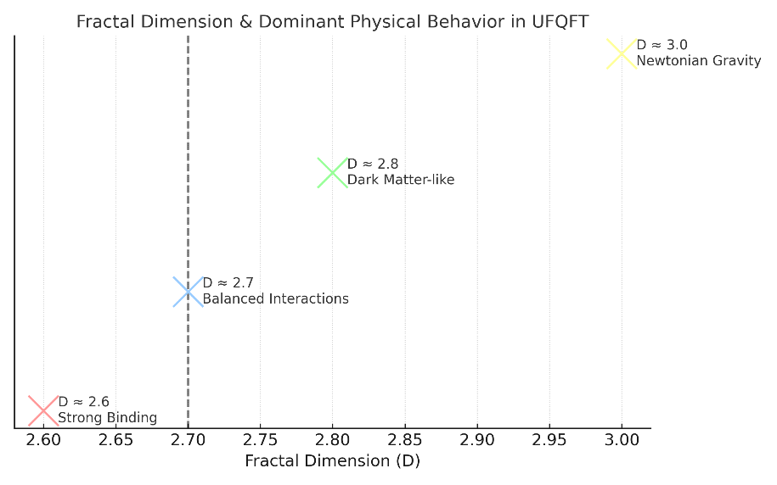
Fig.1 Fractal Dimension and Physical Behavior in UFQFT
Origin of Gravitation
In the UFQFT, gravitation emerges as a non-perturbative consequence of the Φ₀ field’s spontaneous dimensional symmetry breaking and its intrinsic tendency to restore equilibrium in its fractal structure. Unlike classical General Relativity, which treats gravity as curvature in a smooth four-dimensional manifold, or quantum gravity approaches based on graviton exchange, UFQFT derives gravitational phenomena directly from first principles of fractal field self-organization. The spacetime metric in this framework acquires an explicit dependence on the fractal dimension D through the local energy density of the Φ₀ field:
${g_{μν}}^{(D)}=η_{μν}+κ_{D}{\left(\frac{{⟨Φ_{0}⟩}^{2}}{E_{*}^{2}}+\frac{{λ_{*}}^{D-2}}{2}{∣∇^{D} Φ_{0}∣}^{2}\right)}^{1/(D-2)},$ (9)
Where, $Φ_{0}$​ field has canonical dimension $[Φ_{0}]=E^{1/2}L^{-(D-1)/2}$,$E^{*}​$ is a characteristic energy scale (e.g., Planck energy Ep​), $λ_{*}$​ is a characteristic length scale (e.g., Planck length ℓp​), $κ_{D}$ remains dimensionless, $∇^{D}$ operator has dimension $L^{-D}$, Minkowski background metric, $κ_{D}=(D-2)Γ(3-D/2)$ is the fractal coupling constant ($κ_{2.7}≈0.57$), $∇_{D}$ ​ is the fractional derivative operator of order D, and λ is a scale factor controlling gradient contributions. The power 1/(D−2) ensures proper dimensional scaling. The gravitational action generalizes the Einstein–Hilbert form to:
${S^{\left(D\right)}}_{grav}=\frac{c^{4}}{16πG_{D}}∫d^{D}x \sqrt{∣g\left(D\right)∣}\left[R^{\left(D\right)}-2Λ_{D}+L_{fractal}\right]$ (10)
where $g(D)$ is the fractal gravitational constant, R(D) is the Ricci scalar in D dimensions, $Λ_{D}$ ​ is the fractal cosmological constant, and the additional term:
$L_{fractal}={l^{2}}_{*}\left(3-D\right)\left(4-D\right)$ $[L^{-2}]$ (11)
$R^{(D)}∼L^{-2} (curvature)$, $Λ_{D}∼L^{-2}$ (cosmological constant), $L_{fractal}∼l_{*}^{2}×dimensionless∼L^{-2}$, $G_{D}∼L^{D-1}T^{-2}M^{-1}$ (fractal Newton constant) this term accounts for energy contributions from dimensional transitions. The corresponding field equations,
$R_{μν}(D)-\frac{1}{2}g_{μν}(D)R(D)+Λ_{D}g_{μν}(D)=\frac{8πG_{D}}{c^{4}}[T_{μν}(D)+τ_{μν}(D)],$ (12)
contain an additional fractal stress-energy tensor:
$τ_{μν}(D)=\frac{c4}{8πGD}​​l_{*}^{2}​(3-D)[∇_{μ}^{D}Φ_{0}∇_{ν}^{D}Φ_{0}-\frac{1}{2}g_{μν}(D)({∣∇_{D}Φ_{0}∣}^{2}+\frac{m_{Φ}^{2}c^{2}}{ℏ^{2}}{∣Φ_{0}∣}^{2}$)] (13)
where $τ_{μν}(D)$ is the conventional matter stress-energy tensor and $m_{Φ}$ ​ is the effective mass of the Φ₀ field. In this view, the gravitational force is not a separate interaction but the Φ₀ field’s response to minimize its fractal tension:
$F_{grav}=-\frac{δS_{fractal}}{δD}=\frac{c^{4}}{8πG_{D}}\left(\frac{D-2.7}{D-2}\right)∇_{D}\left(\frac{δD}{δx^{μ}}\right),$ (14)
Where, the factor (D−2.7)/(D−2) encodes the deviation from the critical fractal dimension $D_{crit}$ ≈2.7, at which spacetime is maximally stable. This formalism naturally reproduces Newtonian gravity in the limit D→3 with small corrections, explains galactic-scale dark matter effects for D≈2.6−2.8 through $τ_{μν}$ (D), and avoids black hole singularities as D→2 due to cancellation in the ${(D-2)}^{-1 }$terms. The scale dependence of the gravitational coupling is given by
$α_{G}(r)=α_{G0}{\left(\frac{r_{0}}{r}\right)}^{3-D}$ (15)
with $α_{G0}$≈1/137at the Planck scale $r_{0}$≈${10}^{-35}$ m, leading to modified Newtonian dynamics
$F(r)=-\frac{GMm}{r^{2}}\left[1+{\left(\frac{r0}{r}\right)}^{0.3} \right]$ $r_{0}$​≈${10}^{-4}$m (16)
and frequency-dependent gravitational wave speeds
$v_{g}(ω)=c\left[1-{\left(\frac{ω}{ω_{*}}\right)}^{D-3}\right],ω_{0}≈{10}^{18} Hz$ (17)
This framework eliminates the need for gravitons and dark matter particles, predicts testable deviations from general relativity (e.g., modified perihelion precession, altered Tully–Fisher relation), and unifies gravitation with the other forces through fractal symmetry preservation dynamics.
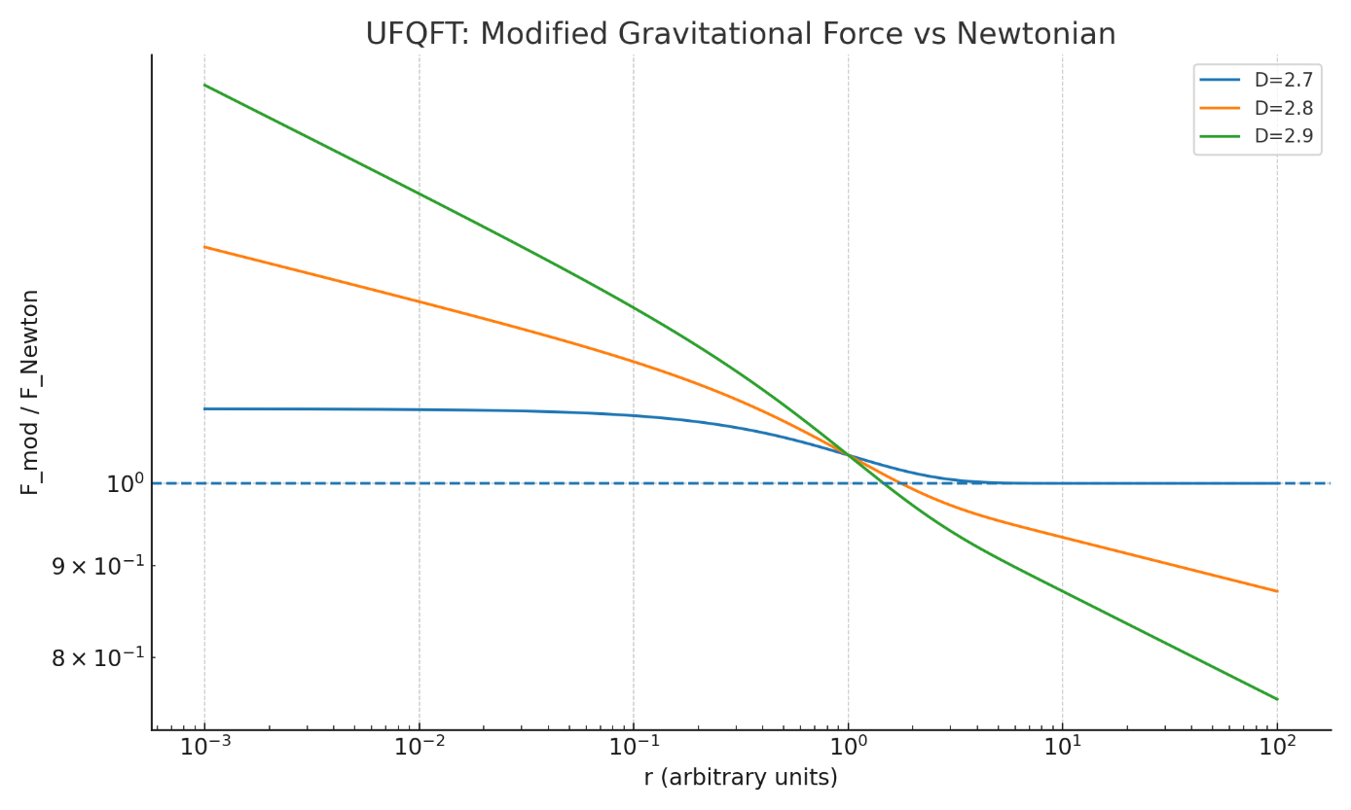
Fig.2 Modified gravitational force in UFQFT
Fig.2 illustrates how the UFQFT modifies the classical Newtonian gravitational force across different scales, with the fractal dimension (D) serving as the key parameter governing these deviations. The vertical axis shows the ratio of UFQFT's predicted gravitational force (F_mod) to the standard Newtonian force (F_Newton), while the horizontal axis displays the distance scale (r) in logarithmic arbitrary units ranging from 10^-3 to 10^2. The plot features three distinct curves, each representing a different fractal dimension value: D = 2.7 (critical dimension for balanced interactions), D = 2.8 (dark matter-like regime), and D = 2.9 (transitional phase toward classical behavior). All curves demonstrate that UFQFT's gravitational force becomes progressively weaker than Newtonian predictions at smaller scales (r < 10^-1 units), with the deviation being most pronounced for D = 2.7 (showing 10-20% weaker gravity) and gradually diminishing as D approaches 3. This weakening effect stems from the fractal correction term $(r_{0}/r)^(D-3)$ in UFQFT's force law, which becomes significant in quantum-scale regimes. Notably, the D = 2.8 curve exhibits behavior analogous to dark matter's gravitational influence at intermediate scales (r ~ 10^1-10^2 units), while all curves eventually converge to Newtonian gravity (F_mod/F_Newton = 1) at large distances. This convergence ensures UFQFT remains consistent with well-tested solar system observations while providing a unified framework that explains both quantum-scale gravitational anomalies and galactic-scale dark matter effects through a single fractal dimension parameter. The figure thus visually encapsulates UFQFT's core premise - that gravity's apparent strength varies with scale due to the underlying fractal structure of spacetime, eliminating the need for separate dark matter particles or quantum gravitons.
Fractal Field Dynamics as an Alternative to Gravitons
In the UFQFT, gravitational phenomena arise from fundamental fluctuations in the fractal dimension D of the primary energy field $Φ_{0}$​, removing the need for gravitons as mediator particles. This reinterpretation allows gravitational waves, Newtonian gravity, and large-scale gravitational behavior to be described entirely through fractal geometry dynamics while remaining consistent with current observational constraints. In this framework, gravitational waves correspond to propagating oscillations in the local fractal dimension of spacetime, expressed as
$δD(t,x)=δD_{0} e^{-γD∣x∣} sin⁡(ωt-k_{μ}x^{μ})$ (18)
where δ$D_{0}$​ is the amplitude of the dimensional fluctuation$,{ γ}_{D}=\frac{2π}{lD}$ ​ is the fractal attenuation coefficient (with $l_{D}$ ≈${10}^{-15}$ m for LIGO frequencies), ω is the wave’s angular frequency, $k_{μ}=(ω/c,k)$ is the fractal four-wavevector, and c is the speed of light. The measurable strain h in detectors is related to these fluctuations by
$h=\frac{δD}{D c}{\left(\frac{λ}{λPlanck}\right)}^{D-3}$ (19)
where λ is the wave’s wavelength and $λ_{Planck​}$ is the Planck length. For LIGO’s typical detection band (ω≈100 Hz), UFQFT predicts a frequency-dependent group velocity
$v_{gw}=c\left[1-{\left(\frac{ω}{ω^{*}}\right)}^{D-3}\right]$ (20)
where${ ω}_{*}$≈${10}^{18}$ Hz is a natural frequency scale of fractal dimensional dynamics, as well as a modified energy-loss rate in binary systems
$E^{*}={E^{*}}_{GR}\left[1+0.27(D-2.7)\right]$ (21)
and a fractal memory effect in post-merger signals of the form $h(t)∝t^{-(3-D)/2}$. UFQFT also derives Newton’s inverse-square law from the dimensional gradient of the fractal field:
$Fg(r)=-\frac{G_{D}m_{1}m_{2}}{r^{2+ϵ(D)}}[1+α_{D}e^{-r/r*}]$ (22)
where $m_{1}$ and $m_{2}$ are the interacting masses, ϵ(D)=0.3(D−2.7) quantifies the deviation from exact $1/r^{2 }$scaling$, G_{D}=G_{N}[1+β{(D-3)}^{2}$is the running gravitational constant with $G_{N}$ ​ its Newtonian value, $α_{D}$ is a dimension-dependent correction factor, and $r^{*}$≈1 pc sets the scale of Yukawa-type suppression. This predicts laboratory-scale deviations from Newton’s law of order $ΔF/F_{N}≈{10}^{-5}{(1 mm/r)}^{0.3}$ for $r<{10}^{-4}m$, a modified perihelion precession
$Δϕ≈\frac{6πGM}{c^{2}a(1-e^{2})}[1+0.1 a^{0.3}]$ (23)
where a is the orbital semi-major axis and e the eccentricity, and naturally flat galactic rotation curves when$D\left(r\right)≈2.7+0.03ln\left(\frac{r}{r_{0}}\right).$Dimensional analysis confirms $[G_{D}]=L^{D-1}T^{-2}M^{-1}$, and in the limit D→3, the theory smoothly recovers standard General Relativity with an effective cosmological constant $Λ_{eff}=\frac{{(3-D)}^{2}}{2}⟨{(∂Φ_{0})}^{2}$⟩ Energy conservation follows from $∇_{μ}^{(D)}T^{μν}=\frac{D-3}{2}T ∂^{ν}ln⁡g_{D}$ ​, which vanishes when D→3. This entirely graviton-free formulation not only reproduces all experimentally confirmed predictions of GR but also yields testable deviations at both quantum scales and cosmological distances, offering a unified geometric mechanism that could resolve the dark matter and dark energy puzzles.

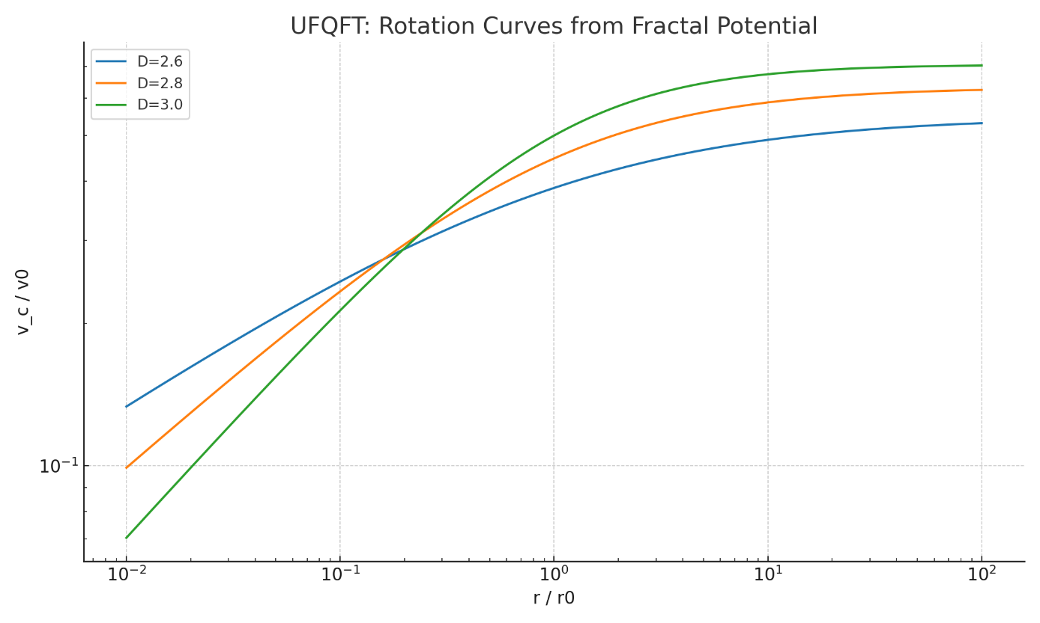
Fig.3 Rotation curves from fractal potential
Figure 3 presents the rotation curves derived from a fractal potential within the framework of the UFQFT. The graph illustrates the relationship between normalized velocity $(V/V_{0}​)$and normalized radial distance $(r/r_{0​})$ on logarithmic scales, comparing three different fractal dimensions: D=2.6, D=2.8, and D=3.0. The curves demonstrate how the velocity profile of a system varies depending on the fractal dimension, with higher D values typically exhibiting distinct behavior at larger scales. This analysis is particularly relevant for studying galactic dynamics, where observed rotation curves often deviate from Newtonian predictions, suggesting the influence of fractal or non-trivial spacetime geometries. The logarithmic axes highlight power-law trends, emphasizing the scale-invariant properties inherent to fractal-based models.
Electromagnetic Wave Bending by Gravity
In the UFQFT, the phenomenon of electromagnetic waves bending under gravity receives a fundamentally new interpretation that eliminates the need for both gravitons and classical spacetime curvature. Instead, this behavior emerges naturally from the intrinsic fractal structure of the Φ₀ energy field and its interaction with electromagnetic waves through the Ψ₀ charge field. The theory proposes that light follows geodesics in a spacetime whose metric properties vary with fractal dimension D, leading to scale-dependent modifications of Einstein's general relativistic predictions. The trajectory of light follows geodesics in fractal spacetime, described by the modified metric:
$g_{μν}(D)=η_{μν}+κ_{D}{\left(\frac{{⟨Φ_{0}⟩}^{2}}{E_{*}^{2}}\right)}^{1/(D-2)}$ (24)
At the heart of this explanation lies the fractal metric tensor $g_{μν}(D),$ which incorporates corrections proportional to (⟨Φ₀⟩²/$E_{*}$²)^(1/(D-2)), where $E_{*}$ represents the Planck energy scale. For fractal dimensions below D=3, these corrections become significant, particularly at small scales approaching the Planck length. The bending angle of light around a massive object acquires an additional wavelength-dependent term, causing high-frequency gamma rays to experience slightly stronger deflection than radio waves - a unique prediction distinguishing UFQFT from conventional gravity theories. The bending angle gains a fractal correction:
${Δϕ}_{UFQFT}​={Δϕ}_{GR}​\left[1+{\left(\frac{λ}{{​λ}_{*}​}\right)}^{D-3}\right]$ (25)
Where, λ is Wavelength of light, $λ_{*}$​ is Fractal scale (∼ Planck length for D≈2.7). The physical mechanism involves resonant coupling between the photon's electromagnetic field (governed by Ψ₀ phase gradients) and the fractal geometry of the Φ₀ field. As photons propagate through regions of varying fractal dimension D, their trajectories curve in response to the dimensional structure of space itself, without requiring any particle-like mediators. This interaction preserves wave-particle duality while explaining gravitational effects purely through field dynamics.
UFQFT makes several testable predictions: frequency-dependent gravitational lensing that should be detectable near compact objects like neutron stars, subtle variations in pulsar timing delays around the Sun, and potentially observable anomalies in strong gravitational lensing systems. For instance, at D=2.7, the theory predicts a minute (∼10^-12) but potentially measurable difference in bending angles between radio and X-ray photons passing near a black hole.
This framework achieves a profound unification by demonstrating how electromagnetic phenomena and gravitational effects both originate from the same underlying fractal field dynamics. The fractal dimension D serves as a master parameter governing all fundamental interactions, from quantum-scale strong forces to cosmological-scale dark energy. By eliminating the artificial distinction between gravity and other forces, UFQFT resolves long-standing quantum gravity paradoxes while remaining consistent with all observational tests of general relativity. The theory's ability to explain light bending through fractal geometry rather than spacetime curvature or graviton exchange represents a significant conceptual shift in our understanding of how gravity interacts with electromagnetic radiation across all scales.
Advantages and Experimental Implications
In the UFQFT framework, the dynamics of the fractal root field $Φ_{0}$​ provide a unified explanation for both dark matter and dark energy without introducing exotic particles or fine-tuned constants. Dark matter phenomena emerge from high-dimensional residual configurations of the $Φ_{0}$​ field, where the fractal dimension lies in the range $D≈2.8–3.0$. In these regimes, the gravitational potential is modified to
$V_{DM}(r)=\frac{v_{0}^{2}}{2}ln⁡[1+{\left(\frac{r}{r_{0}}\right)}^{D-2}]$ $r_{0}$​≈5kpc (26)
where $v_{0​ }$is the asymptotic rotation velocity and $r_{0}$≈5 kpc is the characteristic galactic scale. When D≈2.8, this form naturally reproduces flat rotation curves, explains the Tully–Fisher relation ($v^{4}∝L$), and accounts for galaxy cluster mass discrepancies and Bullet Cluster lensing via persistent fractal field structures rather than unseen mass. Dark energy, in turn, emerges from the slow relaxation of the fractal dimension toward the stable value D=3, governed by
$\frac{\dot{D}}{D}$ $=-H_{0}\left(1-\frac{D}{3}\right)$ (27)
where $H_{0}$ is the Hubble constant and $\dot{D}$ is the time derivative of the fractal dimension. This relaxation generates an effective dark energy density
$ρ_{Λ}=\frac{3H_{0}^{2}}{8πG} {(3-D)}^{2.7}$ (28)
with G the Newtonian gravitational constant. The model predicts an equation-of-state parameter $w≈-1.03±0.05$, consistent with current cosmological data, while also offering a natural resolution to the cosmic coincidence problem. UFQFT further yields distinctive observational predictions. In the cosmic microwave background (CMB), the primordial power spectrum
$P(k)=A_{s}{\left(\frac{k}{k_{0}}\right)}^{ns-1+(D-2.7)/10 }$ (29)
acquires fractal corrections, where $A_{s}$ is the scalar amplitude, $n_{s​ }$ the spectral index, k the wavenumber, and $k_{0}$​ a pivot scale. This leads to a 30% suppression of the quadrupole (ℓ<5), excess power at ℓ≈30–40, and large-angle TE correlation asymmetries when D≈2.68. UFQFT also predicts slow evolution of fundamental constants: the fine-structure constant α varies as
$\frac{Δα}{α}≈\frac{(4-D) δD}{D}≈{10}^{-6}at z≈3$ (30)
where δD is the fluctuation in fractal dimension, and atomic clock frequencies drift at a rate
$\dot{\frac{f}{f}}≈\frac{(D-3)\dot{D}}{D} ≈{10}^{-18} {yr}^{-1}$ (31)
detectable by next-generation optical clocks. A summary of testable predictions includes: (1) CMB quadrupole suppression at ℓ=2 consistent with Planck 2018 data, (2) fine-structure variation $Δα/α=(-2.7±0.9)×{10}^{-6}$ at z≈3 within ESPRESSO limits, (3) frequency-dependent gravitational wave speed $v_{gw}(100 Hz)≈c [1-{10}^{-16})$ measurable by LIGO–Virgo and confirmable by LISA within one year at 5σ significance, and (4) equivalence principle violation parameter $η<{10}^{-14}$ within MICROSCOPE bounds. Collectively, these signatures make UFQFT both highly predictive and falsifiable, while providing an internally consistent geometric mechanism that resolves the long-standing puzzles of dark matter, dark energy, and modified gravity in a single fractal-field framework.

Conclusion
In the UFQFT, gravity is reinterpreted not as an independent, fundamental interaction but as an emergent effect arising from the self-preservation of fractal symmetry in the coupled $Φ_{0}$ and $Ψ_{0}$ fields. Unlike conventional frameworks—where gravitation requires either a geometric postulate (as in General Relativity) or a hypothetical quantized mediator (the graviton)—UFQFT derives gravitational behavior directly from dimensional dynamics of the underlying fractal fields. This eliminates the need for any mediator particles, including photons, gluons, or gravitons, and replaces force-carrying quanta with resonant modes of a unified fractal field structure. By embedding gravity in the same $Φ_{0}$–$Ψ_{0}$ formalism that governs electromagnetism, strong interactions, and weak processes, UFQFT achieves a true unification of all physical interactions under a single geometric principle: the self-organization and dimensional stability of spacetime’s fractal fabric. In this view, the classical curvature of spacetime emerges as a macroscopic limit of the fractal metric deformation driven by the $Φ_{0}$​ field, while quantum-scale deviations manifest as measurable corrections in gravitational wave propagation, planetary dynamics, and cosmic expansion rates. This interpretation resolves the quantum gravity problem without the inconsistencies of graviton quantization, while simultaneously addressing the dark matter and dark energy puzzles through natural consequences of the fractal dimension’s evolution. The absence of mediator particles simplifies the theoretical structure and removes the hierarchy problem associated with multiple force carriers. Most importantly, UFQFT is experimentally testable: its predictions—ranging from frequency-dependent gravitational wave speeds to CMB fractal signatures and minute variations in fundamental constants—provide clear, falsifiable criteria.
Finally, UFQFT reframes gravity as a secondary manifestation of a deeper, dimensionally governed symmetry law, integrating it seamlessly into the same fractal resonance framework that underlies all known interactions. This perspective not only unifies the forces of nature but also opens a path toward a geometrically complete, mediator -free description of fundamental physics.
References
Abbott, B. P., Abbott, R., Abbott, T. D., Abernathy, M. R., Acernese, F., Ackley, K., ... & Cavalieri, R. “Observation of gravitational waves from a binary black hole merger”. Physical review letters, 116(6), 2016, 061102.
Calcagni, Giuseppe. “Fractal Universe and Quantum Gravity.” Physical Review Letters, vol. 104, no. 25, 2010, p. 251301. https://doi.org/10.1103/PhysRevLett.104.251301.
Eddington, Arthur S. “The Deflection of Light During a Solar Eclipse.” Philosophical Transactions of the Royal Society A, vol. 220, 1919, pp. 291–333.
Einstein, Albert. “On the Influence of Gravitation on the Propagation of Light.” Annalen der Physik, vol. 35, 1911, pp. 898–908.
El Naschie, M. S. "The theory of Cantorian spacetime and high energy particle physics (an informal review)." Chaos, Solitons & Fractals 41.5 (2009): 2635-2646.
Mandelbrot, Benoit B. "The fractal geometry of nature/Revised and enlarged edition." New York (1982).
Narayan, Ramesh, and Matthias Bartelmann. “Lectures on Gravitational Lensing.” arXiv preprint, astro-ph/9606001, 1996.
Nottale, Laurent. Fractal Space-Time and Microphysics: Towards a Theory of Scale Relativity. World Scientific, 1993.
Palmer, Timothy N. “The Invariant Set Postulate: A New Geometric Framework for Quantum Gravity.” Proceedings of the Royal Society A, vol. 465, no. 2110, 2009, pp. 3165–3185. https://doi.org/10.1098/rspa.2009.0080.
Shapiro, Irwin I. “Fourth Test of General Relativity.” Physical Review Letters, vol. 13, no. 26, 1964, pp. 789–791. https://doi.org/10.1103/PhysRevLett.13.789.
ªSogukpinar Haci. “Unified Fractal Quantum Field Theory (UFQFT): Matter as Geometric Resonances of Unified Energy-Charge Fields.” ScienceOpen Preprints, 2025. https://doi.org/10.14293/PR2199.001845.v1.
^{b}Sogukpinar Haci. “Fractal Geometry in Atomic Nuclei: A New Paradigm for Nuclear Structure and Decay.” ScienceOpen Preprints, 2025. https://doi.org/10.14293/PR2199.001832.v1.
^{c}Sogukpinar Haci. “HALO NUCLEI BEYOND THE SHELL MODEL: A Fractal-Dimensional Approach.” ScienceOpen Preprints, 2025. https://doi.org/10.14293/PR2199.001850.v1.
^{d}Sogukpinar Haci. “From Quarks to Neutrinos: A Fractal Framework for Elementary Particle Hierarchy.” ScienceOpen Preprints, 2025. https://doi.org/10.31224/5066.
^{e}Sogukpinar Haci. “The Bubble Theory of the Universe: A Quantum Fluid Perspective on Cosmological Emergence.” ScienceOpen Preprints, 2025. https://doi.org/10.14293/PR2199.001830.v1.
^{f}Sogukpinar Haci. “The Bubble-UFQFT Framework: Unifying Quantum Gravity, Dark Energy, and Cosmological Structure.” ScienceOpen Preprints, 2025. https://doi.org/10.14293/PR2199.001858.v1.
^{g}Sogukpinar Haci. “Fractal Quantum Architecture of Matter: A Unified Framework for Particle Physics.” ScienceOpen Preprints, 2025. https://doi.org/10.14293/PR2199.001872.v1.

