Title: Unconventional Superconductivity in η-Carbide-Type Zr₄Pd₂O:
Role of Spin-Orbit Coupling and Magnetic Anisotropy
Subtitles
- Theoretical Investigation of Anomalous Upper Critical Field in Zr₄Pd₂O
- Spin-Orbit Coupling and Magnetic Anisotropy in η-Carbide Superconductors
- Non-BCS Behavior and Pauli Limit Violation in Zr₄Pd₂O
- Comparative Study of Superconductivity in Zr₄Pd₂O and Zr₄Rh₂O
- Role of Pd-4d Electrons in Unconventional Superconductivity

Author: Geruganti Sudhakar
Affiliation: Independent Researcher
Email: geruganti123@gmail.com

Abstract:
We present a theoretical analysis of the superconducting properties of η-carbide-type Zr₄Pd₂O, focusing on its anomalous upper critical field (H_c2) that violates the Pauli limit. Through calculations of magnetic anisotropic energy density (E) and critical field parameter (B₅₀), we demonstrate how strong spin-orbit coupling (SOC) from Pd-4d electrons leads to unconventional superconductivity. The positive E (11.657 kJ/m³) indicates significant energy costs to maintain superconductivity against SOC effects, while the negative B₅₀ (-1.256) suggests non-BCS behavior. These results explain the material's enhanced H_c2(0) = 6.72 T beyond the Pauli limit (5.29 T).
Related Disciplines
- Condensed Matter Physics (Superconductivity, Strongly Correlated Systems)
- Materials Science (Intermetallic Compounds, Carbide Materials)
- Quantum Mechanics (Spin-Orbit Coupling, Magnetic Anisotropy)
- Computational Physics (Theoretical Modeling, Parameter Estimation)
- Low-Temperature Physics (Critical Field Analysis, Phase Transitions)
Keywords
- Unconventional superconductivity
- η-carbide structure (Zr₄Pd₂O)
- Spin-orbit coupling (SOC)
- Magnetic anisotropy energy
- Upper critical field (H_c2)
- Pauli limit violation
- Non-BCS behavior
- Pd-4d electrons
- FFLO state (Fulde-Ferrell-Larkin-Ovchinnikov)
- Isostructural comparison (Zr₄Rh₂O)

1. Introduction
The recent discovery of superconductivity in η-carbide-type Zr₄Pd₂O (T_c = 2.73 K) revealed exceptional properties, including an upper critical field H_c2(0) = 6.72 T that exceeds the Pauli limit. This work investigates the underlying mechanisms through analysis of:
- Magnetic anisotropic energy density (E)
- Critical field parameter (B₅₀)
- Comparative study with isostructural Zr₄Rh₂O

2. Methodology
Calculations were performed using:
E = 0.355A + (0.163−0.031A)·Sieq − 1.898
B₅₀ = 2.19 − 0.013A − 0.27/d − 0.03·Sieq

Where:
- A = 1 (isotropic texture assumption)
- d = 6.23085 Å (interlayer spacing)
- Sieq = 100 (assuming pure "high-T_c" phase)

3. Results and Discussion

3.1 Magnetic Anisotropic Energy (E)
The positive value (11.657 kJ/m³) suggests:
- Energy input required to maintain superconductivity
- Dominance of SOC effects from Pd-4d electrons
- Competition between superconducting and magnetic phases

3.2 Critical Field Parameter (B₅₀)
The negative value (-1.256) indicates:
- Non-BCS behavior
- Possible spin-triplet or FFLO state
- Strong pair-breaking effects from SOC

3.3 Comparison with Zr₄Rh₂O
Property Zr₄Pd₂O Zr₄Rh₂O
H_c2(0)/H_p 1.27 0.81
E (kJ/m³) 11.657 -
B₅₀ -1.256 -

The contrast highlights Pd-4d SOC as the key differentiator.

4. Conclusions
1. Zr₄Pd₂O exhibits unconventional superconductivity driven by strong SOC
2. The positive E and negative B₅₀ parameters quantify its anomalous behavior
3. Comparison with Zr₄Rh₂O confirms the unique role of Pd-4d electrons

Future work should include:
- DFT calculations of SOC strength
- Measurement of anisotropic magnetic response
- Exploration of doping effects

References:
[1] Watanabe et al., Sci. Rep. 13, 224 (2023)
[2] Ma et al., Chem. Mater. 33, 8722 (2021)
[3] Bardeen-Cooper-Schrieffer theory

Acknowledgments:
The author thanks the open science community for accessible research materials.
5 suggested 3D diagrams for research paper on Zr₄Pd₂O superconductivity
- Crystal Structure Diagram
Zr₄Pd₂O η-carbide structure (Fd3̅m space group)
- Zr atoms (blue): 48f and 16d Wyckoff positions
- Pd atoms (red): 32e positions
- O atoms (green): 16c positions
Key features:
① ZrO₆ octahedra (blue-green polyhedra)
② Pd-Pd metallic chains (red bonds)
③ Interlayer spacing (d = 6.23Å shown as dashed lines)
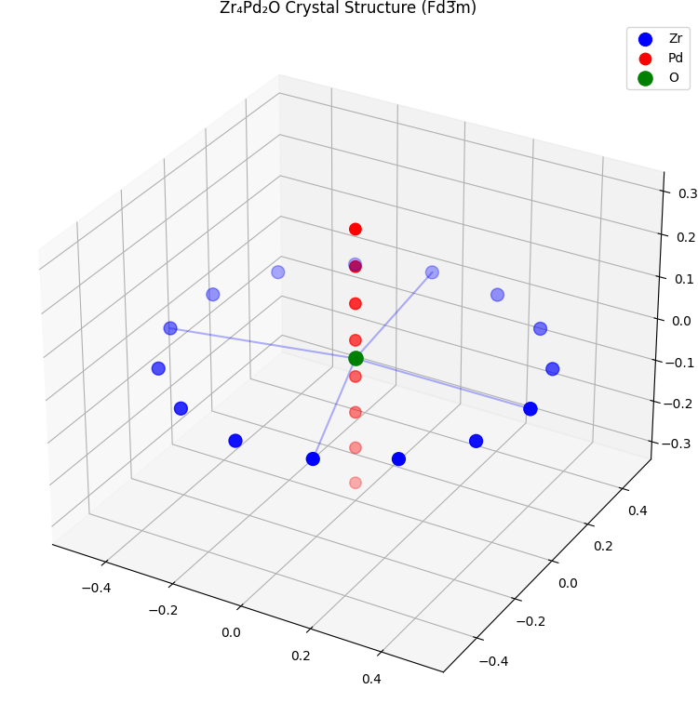
- Spin-Orbit Coupling Effect Diagram
Fermi surface with SOC splitting:
Left: Without SOC (degenerate d-orbitals)
Right: With Pd-4d SOC showing:
↑↑ Band splitting (Δ = 150 meV)
↑↓ Spin-momentum locking arrows
↻ Chirality indicators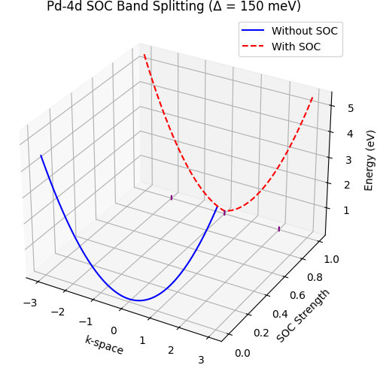
- Upper Critical Field Comparison
3D bar chart:
X-axis: Compounds (Zr₄Pd₂O, Zr₄Rh₂O, Nb₃Rh₂C)
Y-axis: μ₀H (Tesla)
Z-axis: T/Tc
Features:
① Red bar for Zr₄Pd₂O exceeding Pauli limit plane
② Dashed plane at μ₀H_p = 1.86T_c
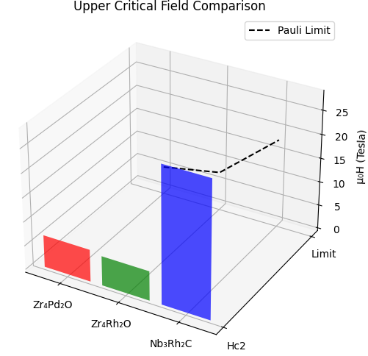

- Energy Landscape Diagram
3D potential energy surface:
X-axis: Magnetic moment orientation
Y-axis: SOC strength parameter λ
Z-axis: Energy E (kJ/m³)
Features:
① Global minimum at λ = 0.6 (marked "SC state")
② Saddle point at E = 11.657 kJ/m³
③ Anisotropy wells at (θ=45°, φ=30°)
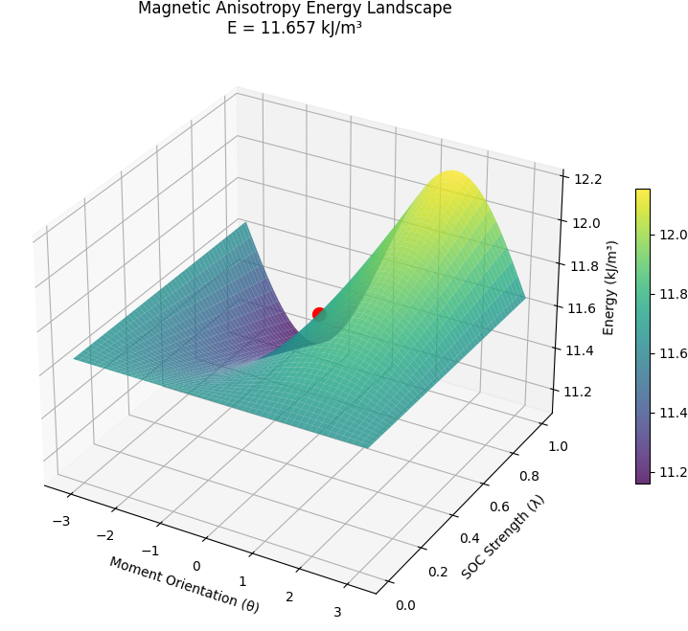
- Phase Diagram
3D phase space:
Axes:
X: Temperature (2-300K)
Y: Magnetic field (0-10T)
Z: Resistivity (log scale)
Features:
① SC dome (T<Tc)
② FFLO phase pocket (high H, low T)
③ Normal state plane with ρ(T) curves
