Optimal Location of Service Uses Using a Fuzzy Combined Model and Geographic Information System (Case Study: Kerman City)

Moslem Ghasemi^{1*}, Mitra Rostamzadeh², Fatemeh Pour Soltani³
- PhD in Geography and Urban Planning, Faculty of Literature and Social Sciences, Yazd University, Yazd, Iran.
Email; Moslemghasemi93@gmail.com
- Graduated in Architecture, Faculty of Architecture, Payam Noor University, Kerman, Iran. Email;Mehr.miture@gmail.com

ABSTRACT | ARTICLE DETAILS
Taking up a large amount of urban space, service uses are regarded as one of the city's most crucial service hubs. As a result, it is crucial to make sure that service uses are situated in the city in the right places. The location of service uses in Kerman City is intended to be optimized by this study. In order to achieve its goal, this study uses a combined methodology that combines survey and documentary methods. Residents of Kerman City, city officials, and academic elites make up the research's statistical population. 384 people make up the sample size, and the sampling technique is random. As a result, the Geographic Information System (GIS) and the fuzzy combined model DANP for the ideal location of service uses have been used to analyze the current state of service uses in Kerman City. The current distribution of service uses within Kerman City's hierarchical structure was found to be appropriate after an analysis of the current state of service uses. Of Kerman City's total service uses, 3,677 are at the neighborhood level, 4,765 are at the district level, and 6,860 are at the regional level. Compatibility, desirability, efficiency, and safety matrices were used to examine use locations and assess how adjacent uses were positioned with service uses. It was discovered that 25% of nearby uses with service uses are comparatively inappropriate, while 75% of them are entirely appropriate.  Keywords: Optimal Location, Service Uses, GIS, DANP Model, Kerman City | Published On:  Publication date

1. Introduction
Optimal and correct allocation of urban land uses can solve many urban issues and problems (service, traffic, etc.). This allocation is significantly important considering the rank and physical size of cities; the larger the city, the more complex the allocation of necessary urban uses and spaces becomes (Gholi Ali et al., 2009,10). Given that the case study of this research is the historical fabric of Kerman City, and that the development of this fabric is also an escalating process, precision in locating the necessary urban spaces is very important and essential. Historical spaces are considered one of the main parts of the city. These spaces are situated within the framework of habitats and can be distributed at various scales throughout the city, creating focal points (Chen, 2010,11). Urban spaces are subject to human goals and collective activities, and the urban ensemble serves as a tool for enhancing collective thinking, cooperation, understanding, and creating a safe, comfortable, and identity-rich environment (Fernández, 2010,24). Therefore, attention to the location of service uses, which ensures the physical and mental well-being of citizens, seems essential in urban planning and structure (Najati, 2006, 7). The optimal distribution of service uses in Kerman City can have a direct impact on the desirable model and functional efficiency of the fabric. On the other hand, the diversity and appropriate, complete distribution of uses increase the choice and power of selection in utilizing various spaces, thereby enhancing the quality of life in the city (Fazelnia, 2011). Optimal location aims to assist decision-makers and planners in selecting suitable locations for activities by regulating the indicators and influencing factors in decision-making and providing logical solutions (Salehi, 2006). Based on this, the main research question is posed as follows: How is the distribution of service uses across Kerman City, and what is the status of Kerman City concerning the matrices of compatibility, desirability, efficiency, and safety related to the location of services and uses?
Location selection in land-related sciences is an operation through which a specialist presents needs, goals, and current information to other experts in fields such as traffic, economics, sociology, psychology, geography, geology, meteorology, biology, and synthesizes them into their opinions and objectives in pursuit of the best choice among available options for the desired use (Talayi, 2011, p. 12). Optimal and appropriate location selection is possible when the researcher can establish a scientific and logical connection between the information and data obtained from relevant experts regarding location selection, considering priorities (Razavian, 2002, p. 50). Undoubtedly, one of the most important functions in today's cities manifests in the form of service delivery. In this context, the balance between service centers and individuals benefiting from services is considered a key characteristic and element. The vital arteries of the city, given their distribution, should be arranged in a way that minimizes costs for users (Salimi et al., 2012, p. 157). Studies indicate that the greater the availability of facilities and services, the higher the level of physical activity among community members. The construction of new spaces requires scientific and precise location studies, and neglecting this issue not only leads to inefficiency in constructed spaces but also results in the waste of significant budgets (Silbeman, 2009, p. 19). With the growth and development of cities, the necessary information for urban management and planning has significantly increased and become more complex. Extensive networks of urban services, population distribution and density, land uses, and many such factors add to the complexity of this planning, leaving no option but to use GIS to gather this information and process it within the framework of new theories of urban management and planning (Hadiani, 2010, p. 10). Urban development location methods differ based on geographical location, the extent and size of development, and the type of proposed uses. If the location is to be considered for use, the optimal location must be identified along with the conditions and status of neighboring uses and possibly some proposals for changing uses to align with the selected location (Kashani Jo, 2010, p. 7). If multiple uses are to be located, after determining the theories and assessing the compatibility, desirability, capacity, and all neighboring uses, the best location and optimal uses are presented (Christian, 2006, p. 13). Factors such as economic quality and quantity, environmental impacts, communication networks, geographic and network accessibility, types and levels of urban and infrastructural service equipment, and factors determined by the type of uses are among the influential factors (Nosal, 2009, p. 124). Space organization is one of the determining dimensions of human societies and reflects social events and the manifestation of social interactions. Therefore, analyzing the interaction between space and society is essential for understanding social injustices and how to formulate planning policies to reduce or resolve them (Dufaux, 2008, p. 2). Some define spatial justice solely as equal access to public facilities, measuring justice by the distance from services. Others define spatial justice as the equal distribution of services based on the needs, priorities of residents, and service standards (Liao et al., 2009, p. 138). In any case, spatial justice, based on the idea derived from social justice, means that residents should be treated equally wherever they live (Tsou et al., 2005, p. 425). When low income combines with poverty due to reduced access to goods and services provided by the public sector, it leads to the underdevelopment of regions (Samimi, 2011, p. 11). The optimal distribution of facilities and services needed by citizens across the city, ensuring that all citizens have adequate access, not only meets the needs of citizens but also prevents unnecessary movement and relocation, thus saving time and costs for citizens. The critical issue in the fair distribution of facilities as a strategy for social justice is how to distribute services and capabilities among urban areas (Hekmatnia et al., 2011, p. 167). Considering the aforementioned points and the necessity of addressing them in the optimal location selection of service uses in Kerman City, multiple studies have been conducted to examine the status of optimal location selection for service uses. Initially, the current status of Kerman City regarding the optimal spatial distribution of service uses will be examined, followed by an analysis of optimal service uses based on location selection criteria, ultimately displaying the status of location selection criteria in Kerman City.
Zarabi and Mousavi, in a study titled "Location Selection and Spatial Analysis of Population Distribution and Service Distribution in the Historical Areas of Yazd," examined the spatial distribution of population and services in eleven districts of the city, considering 15 urban service indicators. The results indicated that there was no logical and coordinated relationship between the spatial distribution of population and services, as areas with low population density were identified (Zarabi and Mousavi, 2010, pp. 27-46). Additionally, Zakerian, Mousavi, and Keshkooli, in a research titled "Location Selection of Population Distribution and Service Distribution in Urban Neighborhoods of Meybod from a Sustainable Development Perspective," considered 12 urban service indicators and addressed the topic of urban service distribution and its expansion, concluding that there is a weak relationship in the distribution of population in the neighborhoods of Meybod (Zakerian et al., 2010, pp. 84-66). Tirband and Azani (2010), in an article titled "Distribution of Urban Facilities and Services Based on Social Justice in Yasuj City," concluded that the areas of Yasuj City do not differ significantly in terms of access to urban services, and services are distributed fairly based on the mode of development and the city's location. Deniz Akgol (2012), in an article measuring citizen satisfaction with services provided by the municipality, examined and measured the level of citizen satisfaction with the services offered by the city of Qir. The results indicated that the Qir municipality did not meet citizens' expectations, and satisfaction levels varied based on different variables, including income level, marital status, gender, and education level, with no significant relationship between age and services provided. Longford et al. (2008), in a study titled "Examining the Population Distribution Model and Changes in Access to Public Services in the Cardiff Area of South Wales," concluded that the general tendency of people is to report less access to public services. Chang and Liao (2011), in a study titled "An Integrated Model for Measuring Spatial Justice of Urban Public Facilities in Terms of Urban Parks," utilized two integrated models of accessibility and mobility based on the gravity model to measure spatial justice of urban parks in Tainan, Taiwan. The results indicated that unequal spatial development in the region has adverse effects among urban park services

2. Methodology
Given the nature of the subject and the objectives of the research, the approach taken in this study is descriptive and analytical-survey in nature. Data collection is summarized in two methods: documentary-library and field (collecting data related to land uses). Nine public service indicators have been studied to evaluate access to services, distributed throughout Kerman City. The statistical population of the research includes the residents of Kerman City, urban officials, and academic elites. The sampling method is random, with a sample size of over 384 individuals. In this article, the spatial distribution of the population is first evaluated using the entropy coefficient model, and then the distribution of services across Kerman City is calculated using a fuzzy DANP method combined with Geographic Information Systems (GIS).
2.1. Case Study
Kerman City has a population of approximately 722,484 people and an area of 13,000 hectares. It is divided into four municipal districts and serves as the capital of Kerman Province. The city is located between latitudes 26 degrees 24 minutes to 32 degrees 32 minutes and longitudes 56 degrees 6 minutes to 59 degrees 18 minutes. The population density in Kerman City is about 46 people per hectare, which is roughly half the average density of cities in Iran (100 people per hectare), based on current national statistics.
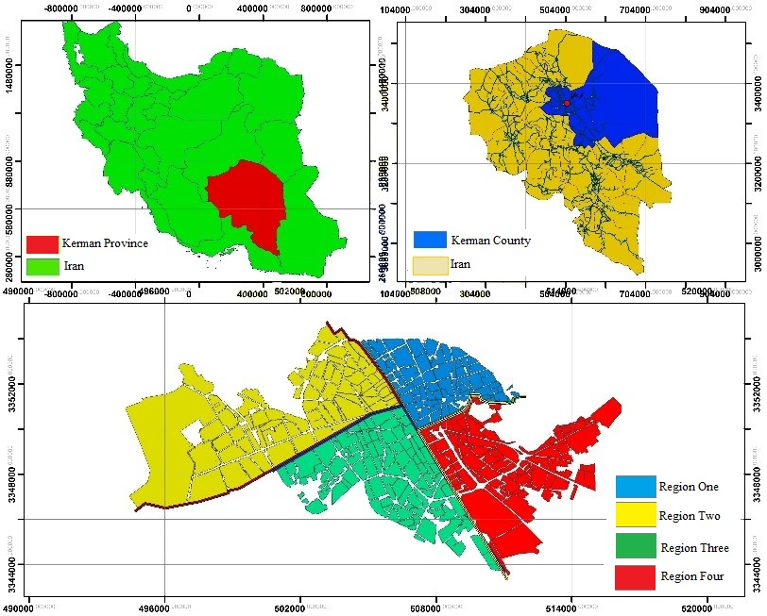
Figure 1. Location of Kerman city

3. Results and Discussion

3.1. Population Distribution in Kerman City
To analyze the characteristics of the spatial distribution of the population in Kerman City, the entropy coefficient model has been utilized. This model allows for an understanding of the spatial balance of population settlement and the number of cities at the urban, provincial, regional, and national network levels (Hekmatniya, 2006, p. 190). The entropy coefficient ranges from zero to one. The closer the value is to one, the more it indicates an equitable distribution; conversely, the closer it is to zero, the more it signifies an imbalance in population distribution (Tsou, 2005, p. 145). This model reflects the balance or imbalance of the population index in urban areas within the study area (Ahadnejad et al., 2012, p. 6).
Table1. Spatial distribution of population in Kerman city
Row | Entropy | Value
1 | Pi | 0/638
2 | Ln pi | 0/638
3 | Pi lnpi | -0/34
The obtained entropy coefficient for the population distribution in Kerman City is 0.638. Given that this value is close to one, it indicates a relatively complete balance in the spatial distribution of the population.
Table 2. Mean Matrix A
Distance from transmission lines | Distance from high-voltage substations | Distance from industrial centers | Fuel stations | Distance from healthcare centers | Distance from administrative centers | Distance from educational centers | Population density | Distance from main streets
2/3214 | 0666/3 | 4666/1 | 2/1 | 2666/1 | 1/2 | 8/2 | 1333/4 | 0 | Distance from main streets
3/1487 | 8666/2 | 2/1 | 2666/1 | 8666/1 | 3/4512 | 8666/2 | 0 | 1333/4 | Population density
1/4698 | 7333/2 | 3333/2 | 9333/3 | 7333/2 | 5/6325 | 0 | 1333/3 | 2/2 | Distance from educational centers
1/7852 | 1/9623 | 4/8563 | 3/5412 | 2/8963 | 0 | 1/8563 | 2/3698 | 2/7456 | Distance from administrative centers
2/7845 | 8666/1 | 4/2 | 3333/2 | 0 | 1/5623 | 7333/2 | 2/2 | 4666/2 | Distance from healthcare centers
2/9856 | 2/1 | 1333/2 | 0 | 1333/4 | 2/4758 | 4666/2 | 5333/1 | 4666/2 | Fuel stations
2/7452 | 7333/2 | 0 | 6666/1 | 1333/2 | 3/9652 | 7333/2 | 1333/2 | 8666/2 | Distance from industrial centers
3/7895 | 0 | 9333/3 | 1333/2 | 4666/1 | 2/1 | 6/1 | 0666/3 | 7333/2 | Distance from high-voltage substations
0 | 1/2 | 3/9856 | 2/9658 | 2/7854 | 1/7 | 1/9854 | 3/7845 | 2/7845 | Distance from transmission lines

Weight Calculation: To calculate the weights, the fuzzy AHP (Analytic Hierarchy Process) technique has been used.
Table 3. Weights of criteria and sub-criteria in the Fuzzy AHP model
Normalized weight | Non-normalized weight | Underweight
2024/0 | 5/0 | 3167/0 | Distance from main streets
2538/0 | 1383/0 | 6833/0 | Population density
5438/0 | 0576/0 | 2269/0 | Distance from educational centers
0/4586 | 0/0569 | 0/5632 | Distance from administrative centers
0/5354 | 0823/0 | 3242/0 | Distance from healthcare centers
0/0841 | 0823/0 | 4489/0 | Fuel stations
0/5632 | 0823/0 | 5/0 | Distance from industrial centers
0/3245 | 2719/0 | 5/0 | Distance from high-voltage substations
0/8456 | 0/5412 | 0/2541 | Distance from transmission lines
Data Standardization: Now, the dependency among the sub-criteria is taken into account. The normalized vector of these matrices can be seen in the table below. The data in the table below indicates the relative impact of the sub-criteria on each other. The relative importance of the criteria, considering the dependencies, is obtained by combining the results and using the following relationship.
Table 4. Dependency Matrix Among Sub-Criteria
 | Distance from Power Transmission Lines | Distance from High Voltage Substations | Distance from Industrial Centers | Fuel Stations | Distance from Healthcare Centers | Distance from Administrative Centers | Distance from Educational Centers | Population Density | Distance from Main Streets
Distance from Main Streets | 0.0874 | 0.1062 | 0 | 1 | 0 | 0.5 | 0.647 | 0.748 | 0.5
Population Density | 0.1263 | 0.1062 | 0 | 0 | 0 | 0.0458 | 0.748 | 0.5 | 0.11
Distance from Educational Centers | 0.0145 | 0.9180 | 0.1358 | 0.1429 | 0.1605 | 0.1635 | 0.5 | 0.1007 | 0.0826
Distance from Administrative Centers | 0/1652 | 0/06985 | 0/1589 | 0/1236 | 0/1458 | 0 | 0 | 0/1785 | 0/0658
Distance from Healthcare Centers | 0/1651 | 0 | 1 | 1 | 0.6988 | 0/6258 | 0/1007 | 0/0647 | 0/0698
Fuel Stations | 0 | 0 | 0/8571 | 0.1407 | 0 | 0 | 0/1148 | 0/0876 | 0/0698
Distance from Industrial Centers | 0/9523 | 0/9180 | 0/7753 | 0 | 0 | 0/7452 | 0/0876 | 0/0574 | 0/072
Distance from High Voltage Substations | 0 | 0/6040 | 0/0889 | 0 | 0 | 0/1263 | 0/0574 | 0/1148 | 0/0958
Distance from Power Transmission Lines | 0/8421 | 0/7456 | 0/0658 | 0/1563 | 0 | 0/03689 | 0/05632 | 0 | 0/0454
Determination of Final Weights: The table below shows the final results of the weights corresponding to each of the criteria effective in identifying the optimal location for service land uses in Kerman City, using the fuzzy analytic network process.
Table 5. Final Weights for Each Criterion and Sub-Criterion
Weight | Criterion | Row
0/1705 | Distance from Main Streets | 1
0/1812 | Population Density | 2
0/1529 | Distance from Educational Centers | 3
0/1695 | Distance from Administrative Centers | 4
0/1055 | Distance from Healthcare Centers | 5
0/1168 | Fuel Stations | 6
0/1583 | Distance from Industrial Centers | 7
0/1148 | Distance from High Voltage Substations | 8
0/1625 | Distance from Power Transmission Lines | 9

3.2. Distance from Main Streets
The selected network of main roads in the process primarily consists of the main streets of the city. As observed in the conducted analysis, service land uses are relatively evenly distributed concerning the distance from each of the main streets in Kerman City. As shown in Figure 2, according to the 5-class classification spectrum of service land uses based on distance from the main streets, spectrum 5 receives the highest score, while spectrum 1 receives the lowest. It is noted that only the roads within the historical context have the highest score, and as we move further away from the historical area, this score decreases, indicating the distance of each of the service land uses from the main streets.
Table 6. Impact of Distance from Main Streets
Distance from Main Street (in meters) | 100-200 | 200-300 | 300-400 | 400+
Value | 1-3 | 3-5 | 5-7 | 7-9
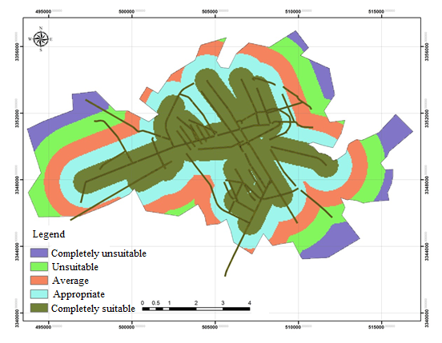
Figure 2 . Classification of Service Uses Based on Main Streets Index

3.3. Population Density
Accordingly, the population density in the historical context is significantly higher due to the presence of service land uses, and it is adjacent to other sensitive land uses such as commercial and healthcare facilities, resulting in a more favorable situation. As we move from this area toward the outer centers of the context, this distance and accessibility will decrease.

Table 7. Impact of Distance from Population Density
Distance | Value
<1000 | 0
1000-2000 | 0-0/2
2000-3000 | 0/2-0/4
3000-4000 | 0/4-0/6
4000-5000 | 0/6-0/8
>5000 | 0/8-1
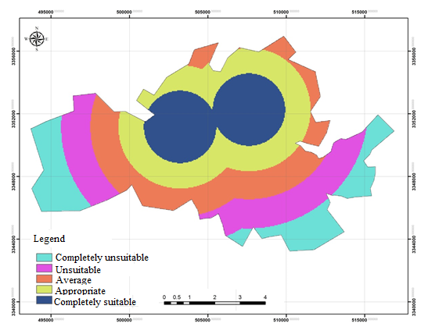
Figure 3 . Classification of Service Uses Based on Population Density Index
3.4. Distance from Educational Centers
The spatial distribution of educational centers within the context is balanced, and they are in a relatively stable position concerning their distance from service land uses. Overall, the entire area is in a relatively favorable condition in this regard. However, the centers located in the northeastern and northwestern areas, specifically along Imam Khomeini and Taleghani streets, have significantly better conditions due to their geographical location.
Table 8. Impact of Distance from Educational Centers
Distance from Educational Centers (in meters) | <1000 | 1000-2000 | 2000-2500 | >2500
Value | 1-3 | 3-5 | 5-7 | 7-9
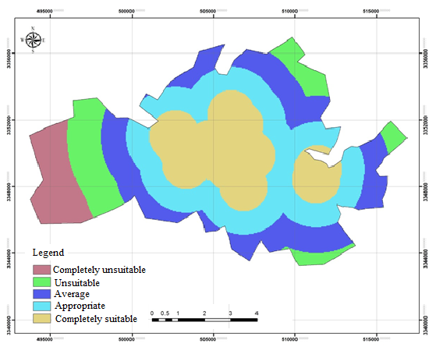
Figure 4 . Classification of Service Uses Based on Educational Centers Index
3.5. Distance from Administrative Centers
The distribution trend of these centers compared to other service land uses indicates that the eastern and northern sections of the area have significantly better conditions regarding their distance from service land uses than the southern sections. This evidence can be observed in Figure 5, where levels 5 and 9 represent the shortest and optimal distances, while level 1 indicates the worst conditions and the farthest distance of administrative centers from service land uses.
Table 9. Impact of Distance from Administrative Centers
Distance from Administrative Centers (in meters) | <2000 | 2000-2500 | 2500-3000 | >3000
Value | 1-3 | 3-5 | 5-7 | 7-9
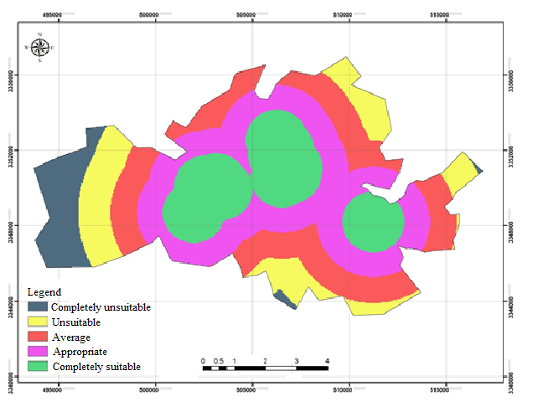
Figure 5 . Classification of Service Uses Based on Administrative Centers Index
3.6. Distance from Healthcare Centers
The eastern and western sections of the historical context have a favorable spatial distribution of healthcare facilities. Most importantly, the distance of these centers to service land uses is shorter and better compared to other centers in the area. Therefore, service land uses at levels 5 and 9 have the best conditions regarding their distance from healthcare centers, while level 1 represents the worst conditions.
Table 10. Impact of Distance from Healthcare Centers
Distance from Healthcare Centers (in meters) | <500 | 500-1000 | 1000-2000 | 2000-3000 | >3000
Value | 1 | 3 | 5 | 7 | 9
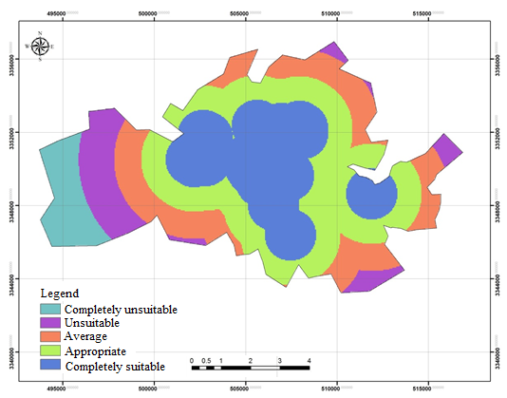
Figure 6 . Classification of Service Uses Based on Healthcare Centers Index
3.7. Distance from Fuel Stations
Fuel stations are among the land uses that require consideration of distance, compatibility, safety, and convenience during their location planning. These types of land uses are always considered incompatible, and the further away they are, the better. Based on the findings from Figure 7, service land uses that are farther from these stations will have the best conditions. Accordingly, most land uses in the western section of the area are close to fuel stations and have shorter distances to them, resulting in an unfavorable classification. Conversely, the fuel stations located in the eastern and southern sections have the best conditions regarding their distance from service land uses.
Table 11. Impact of Distance from Fuel Stations
Distance from Fuel Stations (in meters) | <5000 | 5000-6000 | 6000-7000 | 7000-8000 | >8000
Value | 9 | 7 | 5 | 3 | 1
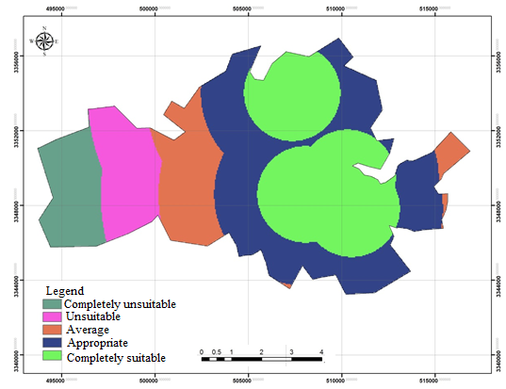
Figure 7 . Classification of Service Uses Based on Fuel Station Index
3.8. Distance from Industrial Centers
Industries, like fuel stations, are classified as incompatible land uses and should be located away from service land uses. Accordingly, as seen in Figure 9, industries situated around the perimeter of the area, rather than in the center or within the context, and at a suitable distance from service land uses, will have significantly better conditions for the safety and health of individuals. The closer we get to level 1, the worse the conditions will be.

Table 12. Impact of Distance from Industrial Centers
Distance from Industrial Centers (in meters) | <3500 | 3500-4500 | 4500-5500 | 5500-6500 | >6500
Value | 9 | 7 | 5 | 3 | 1
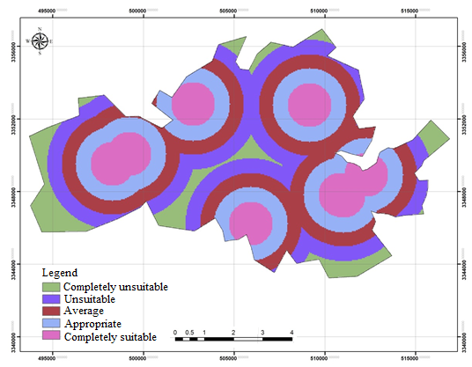
Figure 8 . Classification of Service Uses Based on Industrial Centers Index
3.9. Distance from High Voltage Power Stations
Service land uses should always avoid proximity to high voltage power stations, as being close to them poses health and safety risks for individuals. Therefore, the greater the distance of service land uses from these centers, the better the conditions; conversely, the closer they are, the worse the conditions will be. According to the findings presented in Figure 10, level 1, which primarily encompasses the northern sections of the area, is in a favorable condition regarding the distance of service land uses from high voltage power stations. The closer this distance is to levels 5 and 9, the more unfavorable and hazardous the situation will be.
Table 13. Impact of Distance from High Voltage Substation
Distance from High Voltage Substation (in meters) | <5000 | 5000-6000 | 6000-7000 | 7000-8000 | >8000
Value | 9 | 7 | 5 | 3 | 1
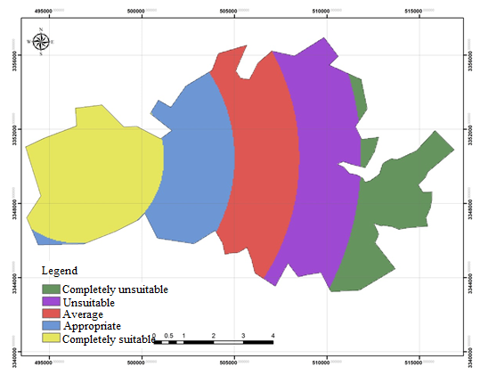
Figure 9 . Classification of Service Uses Based on High Voltage Substation Index

3.10. Distance from Power Transmission Lines
Power transmission lines, like high voltage power stations, are centers that service land uses should maintain distance from. Based on the results obtained and as shown in Figure 11, these lines are located along the northern, southern, and southwestern paths of the area. Accordingly, service land uses within levels 5 and 9, due to their close proximity to the power transmission lines, are considered unsuitable. In contrast, those located at level 1, which are farther away from the transmission lines, will have better conditions.
Table 14. Impact of Distance from Power Transmission Lines
Distance from Power Transmission Lines (in meters) | <3200 | 3200-4000 | 4000-5200 | 5200-6000 | >6000
Value | 9 | 7 | 5 | 3 | 1

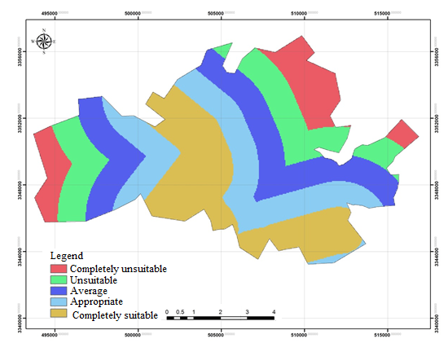
Figure 10. Classification of Service Uses Based on Power Transmission Line Index
After gathering the opinions of experts, a fuzzy direct relation matrix Ẍ is formed. The simple fuzzy average method is used to aggregate the experts' opinions. If there are n experts and each element of the fuzzy direct matrix is represented as Ẍij, then Ẍij is calculated as follows:
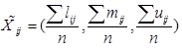 (1)
Table 15. DEMATEL Decision Matrix
 | C1 | C2 | C3 | C4 | C5 | C6 | C7 | C8 | C9
C1 | Average | High | Average | Average | Low | Average | Very High | Average | 0
C2 | High | Average | Very High | Very High | Low | High | High | 0 | Very High
C3 | Average | Very High | Average | High | Average | Very High | 0 | Low | Average
C4 | Very High | Average | High | High | Average | 0 | Very High | Average | High
C5 | Very High | Low | Very High | High | 0 | Average | Average | Very High | Very High
C6 | High | Average | High | 0 | High | Average | Average | Average | High
C7 | Low | Low | 0 | Average | Low | High | Very High | Low | Very High
C8 | Average | 0 | Average | Very High | Average | Low | Average | Very High | Average
C9 | 0 | High | Low | Average | Low | Average | Low | High | Very High
To reflect the internal relationships among the main criteria, the fuzzy DEMATEL method has been used. Using an appropriate fuzzy scale, the linguistic variables are presented in fuzzy form. In this example, the fuzzy scale is based on the table described in the fuzzy DEMATEL method section. The result of the calculation will be as follows:
Table 16. Final Results of the Deterministic Matri T_{l}
 | T_{l}
C₁ | 0/06 | 0/24 | 0/13 | 0/25 | 0/16 | 0/08 | 0/26 | 0/08 | 0/26
C₂ | 0/24 | 0/08 | 0/42 | 0/45 | 0/25 | 0/42 | 0/16 | 0/36 | 0/27
C₃ | 0803 | 0/14 | 0/24 | 0/28 | 0/29 | 0/41 | 0/35 | 0/25 | 0/26
C₄ | 0/27 | 0/42 | 0/24 | 0/21 | 0/25 | 0/46 | 0/02 | 0/34 | 0/36
C₅ | 0/08 | 0/36 | 0/14 | 0/25 | 0/45 | 0/27 | 1/42 | 0/27 | 0/24
C₆ | 0/25 | 0/26 | 0/08 | 0/45 | 0/25 | 0/08 | 1/25 | 0/26 | 0/25
C₇ | 0/16 | 0/36 | 1/24 | 1/25 | 0/23 | 0/24 | 0/45 | 0/36 | 0/28
C₈ | 1/26 | 0/24 | 0/09 | 0/08 | 1/14 | 0/26 | 0/26 | 0/27 | 0/26
C₉ | 1/36 | 0/16 | 1/24 | 1/45 | 0/26 | 0/42 | 1/45 | 0/28 | 0/28
Table 17. Final Results of the Deterministic Matri Tm
 | Tm
C₁ | 0/42 | 0/16 | 0/26 | 0/35 | 0/44 | 0/09 | 1/42 | 0/09 | 0/06
C₂ | 0/26 | 0/23 | 0/22 | 0/02 | 0/21 | 0/45 | 1/15 | 0/15 | 0/24
C₃ | 0/29 | 0/08 | 0/42 | 0/26 | 0/25 | 0/36 | 0/26 | 0/16 | 0/03
C₄ | 0/28 | 0/42 | 0/43 | 0/44 | 0/36 | 0/41 | 0/16 | 0/25 | 0/08
C₅ | 0/23 | 0/41 | 0/36 | 0/38 | 0/45 | 0/36 | 0/35 | 0/35 | 0/15
C₆ | 0/36 | 0/46 | 0/45 | 0/44 | 0/42 | 0/14 | 0/02 | 1/15 | 1/42
C₇ | 0/25 | 0/27 | 1/26 | 1/17 | 0/26 | 0/26 | 0/08 | 0/34 | 1/12
C₈ | 0/26 | 0/35 | 0/36 | 0/42 | 0/41 | 0/23 | 0/14 | 0/42 | 0/23
C₉ | 0/26 | 0/35 | 0/38 | 0/14 | 0/15 | 0/28 | 1/16 | 0/08 | 0/41
Table 18. Final Results of the Deterministic Matri Tu
 | Tu
C₁ | 0/41 | 0/25 | 0/29 | 0/36 | 1/16 | 0/08 | 0/26 | 0/36 | 0/08
C₂ | 0/09 | 0/14 | 1/16 | 1/15 | 0/25 | 0/27 | 0/25 | 0/45 | 0/25
C₃ | 0/45 | 0/48 | 0/23 | 0/26 | 0/24 | 0/08 | 0/35 | 0/12 | 0/26
C₄ | 0/36 | 0/41 | 0/08 | 0/16 | 1/14 | 0/25 | 0/44 | 0/41 | 0/27
C₅ | 0/41 | 0/23 | 0/26 | 0/35 | 1/17 | 0/16 | 0/38 | 1/14 | 0/29
C₆ | 0/36 | 0/26 | 0/39 | 0/02 | 1/17 | 1/26 | 0/44 | 0/08 | 0/16
C₇ | 0/23 | 0/27 | 1/45 | 1/42 | 0/08 | 0/35 | 1/17 | 0/36 | 1/14
C₈ | 0/12 | 0/09 | 1/17 | 1/19 | 1/24 | 0/41 | 0/42 | 0/35 | 1/42
C₉ | 0/36 | 0/08 | 1/16 | 0/14 | 0/09 | 0/12 | 0/42 | 0/25 | 0/08
To finalize the values, the simple method (L+M+U)/3(L+M+U)/3 has been used. The complete relation matrix (T) of the criteria will be as follows:
Table 19. Complete Relationship Matrix
 | C₁ | C₂ | C₃ | C₄ | C₅ | C₆ | C₇ | C₈ | C₉
C₁ | 0/354 | 0/541 | 0/562 | 0/354 | 0/654 | 0/365 | 0/254 | 0/478 | 0/652
C₂ | 0/452 | 0/256 | 0/874 | 0/365 | 0/615 | 0/369 | 0/365 | 0/354 | 0/654
C₃ | 0/589 | 0/365 | 0/658 | 0/365 | 0/254 | 0/365 | 0/325 | 0/365 | 0/587
C₄ | 0/368 | 0/258 | 0/365 | 0/541 | 0/254 | 0/354 | 0/354 | 0/254 | 0/452
C₅ | 0/658 | 0/547 | 0/254 | 0/478 | 0/365 | 0/325 | 0/387 | 0/247 | 0/365
C₆ | 0/547 | 0/478 | 0/458 | 0/652 | 0/325 | 0/245 | 0/457 | 0/586 | 0/323
C₇ | 0/563 | 0/698 | 0/365 | 0/325 | 0/254 | 0/236 | 0/485 | 0/478 | 0/369
C₈ | 0/365 | 0/547 | 0/254 | 0/365 | 0/256 | 0/325 | 0/236 | 0/365 | 0/547
C₉ | 0/589 | 0/245 | 0/365 | 0/254 | 0/258 | 0/365 | 0/254 | 0/652 | 0/478
Average | 0/358
To draw the Network Relationship Map (NRM), the threshold value must be calculated. The threshold value of the relationships, which is the average of the values in matrix T, has been obtained as 0.358. All values in matrix T that are less than 0.358 are set to zero, meaning that those causal relationships are not considered. Therefore, the pattern of meaningful relationships is as follows:
Table 20. Pattern of Meaningful Relationships
 | C₁ | C₂ | C₃ | C₄ | C₅ | C₆ | C₇ | C₈ | C₉
C₁ | - | 0/541 | 0/562 | - | 0/654 | - | - | 0/478 | 0/652
C₂ | 0/452 | - | 0/874 | 0/365 | 0/615 | 0/369 | 0/365 | - | 0/654
C₃ | 0/589 | 0/365 | 0/658 | 0/365 | 0/254 | 0/365 | - | 0/365 | 0/587
C₄ | 0/368 | - | 0/365 | 0/541 | 0/254 | - | - | - | 0/452
C₅ | 0/658 | 0/547 | - | 0/478 | 0/365 | - | 0/387 | - | 0/365
C₆ | 0/547 | 0/478 | 0/458 | 0/652 | - | - | 0/457 | 0/586 | -
C₇ | 0/563 | 0/698 | 0/365 | - | - | - | 0/485 | 0/478 | 0/369
C₈ | 0/365 | 0/547 | - | 0/365 | - | - | - | 0/365 | 0/547
C₉ | 0/589 | - | 0/365 | - | - | 0/365 | - | 0/652 | 0/478
The final output of the fuzzy calculations and the causal diagram can be interpreted as follows:
Table 21. Final Output of Fuzzy Calculations
 | D | R | D+R | D-R
C₁ | 4/21 | 4/48 | 8/69 | -0/27
C₂ | 4/30 | 3/93 | 8/23 | -0/37
C₃ | 3/87 | 4/15 | 8/02 | -0/28
C₄ | 3/21 | 3/69 | 6/09 | -0/48
C₅ | 3/62 | 3/23 | 6/86 | 0/39
C₆ | 4/07 | 2/94 | 7/01 | 1/13
C₇ | 3/77 | 3/11 | 6/88 | 0/66
C₈ | 3/26 | 3/77 | 7/03 | -0/51
C₉ | 3/46 | 4/42 | 7/88 | -0/96
As mentioned in the DEMATEL method, the sum of the elements in each row (D) indicates the extent of the influence of that factor on other factors in the model. Accordingly, population density with a value of 4.30 has the highest influence. The criterion of distance from main streets ranks second with a value of 4.21. The criterion of distance from fuel stations also ranks next in terms of influence. The sum of the elements in the column (R) for each factor indicates the degree of influence that factor receives from other factors in the system. Based on this, the criterion of distance from main streets, with a value of 4.48, has a very high degree of influence. The horizontal vector (D + R) represents the degree of influence and interaction of the considered factors in the system. The higher the value of D + R for a factor, the more it interacts with other factors in the system. Accordingly, the criterion of distance from main streets (8.69) and population density (8.23) have the highest interactions with the other studied criteria.
The vertical vector (D - R) indicates the power of influence of each factor. Generally, if D - R is positive, the variable is considered causal, and if it is negative, it is considered a result. In this model, the distance from healthcare centers, fuel stations, and distance from industrial centers are causal, while the others are considered results.
3.11. Qualitative Assessment of Location Criteria
Matrix for Qualitative Evaluation of Uses: As mentioned, in this stage, the qualitative features are determined, and their relationships are examined based on four matrices: consistency, desirability, capacity, and dependency.

Table 22. Qualitative Assessment of Service Land Uses Based on Compatibility Criteria
Type of Matrix Definition | Land Use States Relative to Each Other | Features to be Examined in the Matrix
Compatibility of Different Adjacent Land Uses | Completely Compatible  Relatively Compatible  Indifferent  Relatively Incompatible  Completely Incompatible | Size and dimensions of the land, slope, communication network, facilities and equipment, dependent land uses, air quality, noise, light, odor, view and landscape
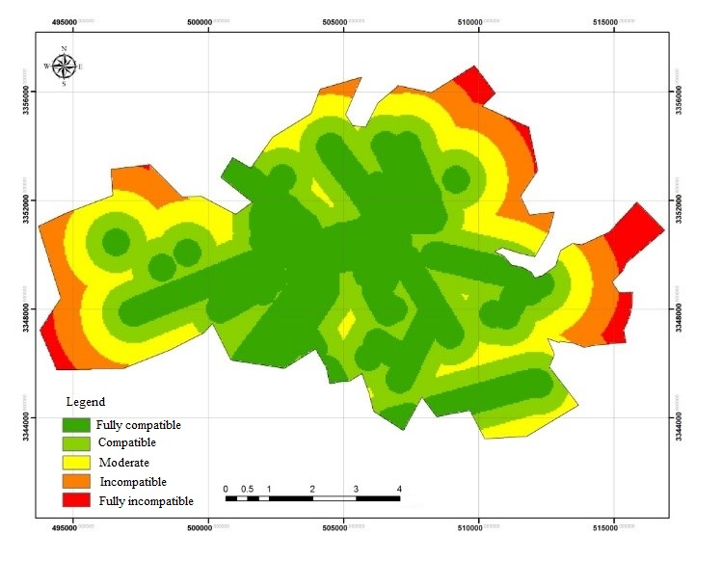
Figure 11. Compatibility of Service Land Uses
Table 23. Qualitative Assessment of Service Land Uses Based on Suitability Criteria
Type of Matrix Definition | Land Use States Relative to Each Other | Features to be Examined in the Matrix
Compatibility Between Land Use and Location | Completely Suitable  Relatively Suitable  Relatively Unsuitable  Completely Unsuitable | Size and dimensions of the land, location, slope, physical characteristics of the land, communication network, facilities and equipment, dependent land uses, air quality, noise, light, odor, neighboring land uses
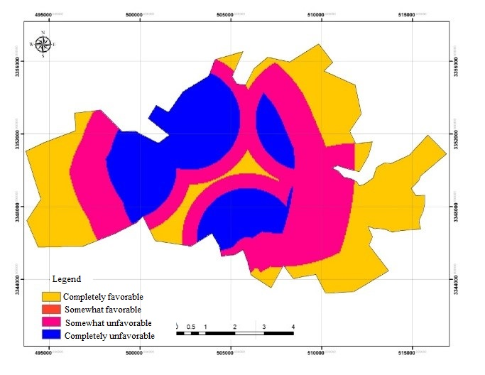
Figure 12 . Suitability of Service Land Uses
Table 24. Qualitative Assessment of Service Land Uses Based on Capacity Criteria
Type of Matrix Definition | Land Use States Relative to Each Other | Features to be Examined in the Matrix
Compatibility of Land Use with Capacity and Functional Scale | Completely Suitable  Relatively Suitable  Relatively Unsuitable  Completely Unsuitable | Kindergarten, Primary School, Guidance School, High School, College, Small and Large University, Health and Therapeutic Activities, Structure of Spatial Divisions
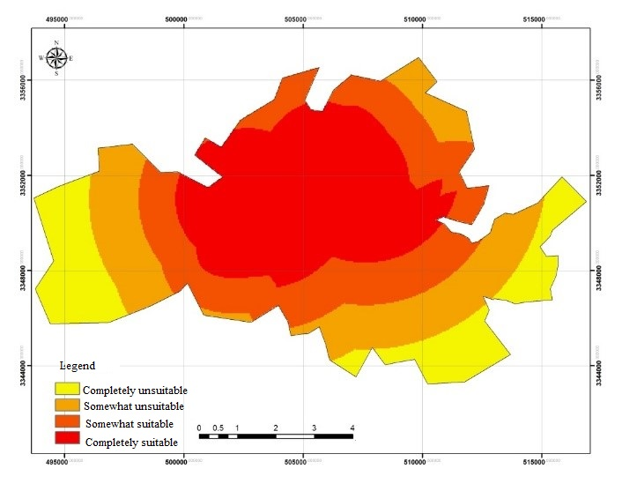
Figure 13 . Capacity of Service Land Uses

Table 25. Qualitative Assessment of Service Land Uses Based on Efficiency Criteria
Type of Matrix Definition | Land Use States Relative to Each Other | Features to be Examined in the Matrix
Dependency of Different Land Uses on Each Other and the Necessity of Their Proximity | Completely Dependent  Relatively Dependent  Relatively Independent  Completely Independent | Degree of dependency of neighboring functions and land uses on each other, such as the dependency of residential use on educational and commercial uses.
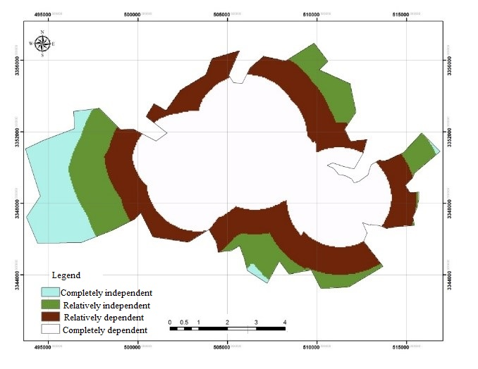
Figure 14 . Efficiency of Service Land Uses

4. Conclusion
Optimal and correct allocation of urban land use can solve many urban issues and problems (services, traffic, etc.). This allocation is significantly important, considering the rank and physical size of cities; the larger the city, the more complex the allocation of uses and necessary urban spaces becomes. Since the case study of this research focuses on the historical fabric of Kerman city, and the development of this fabric is also exponential, accuracy in locating the necessary urban spaces is very important and essential. Historical spaces are considered one of the main urban components. These spaces are situated within the framework of habitats and can be distributed at various scales throughout the city, creating focal points. Therefore, attention to the location of service uses that ensure the physical and mental health of citizens seems essential in urban planning and structure. The optimal distribution of service uses in the historical fabric of Kerman can directly impact the desirable pattern and functional efficiency of the fabric. On the other hand, appropriate and complete diversity and distribution of uses increase the choice and power of selection in utilizing different spaces, thereby enhancing the quality of life in the city. Optimal location aims to assist decision-makers and planners in selecting suitable locations for activities by regulating the indicators and factors influencing decision-making and providing logical solutions.
In this research, the current status of service uses in Kerman city was examined using Geographic Information System (GIS) and the combined fuzzy DANP model for optimal location of service uses in Kerman. After studying the current status of service uses, it was determined that the existing distribution of service uses at the hierarchical level of the historical fabric is appropriate. Out of all service uses in Kerman, there are 3,677 service uses at the neighborhood scale, 4,765 at the district scale, and 6,860 at the regional service scale. To analyze the location of uses and evaluate the positioning of adjacent uses with service uses, matrices of consistency, desirability, efficiency, and safety were utilized. It was found that 75% of adjacent uses with service uses are completely suitable, while 25% are relatively unsuitable. This research aims to thoroughly examine, analyze, and evaluate the necessary service uses at the city level of Kerman to determine how these services are distributed across the city and how these uses relate to their surrounding lands in terms of compatibility, capacity, efficiency, and desirability. Accordingly, after selecting and categorizing these service uses at the city level, an analysis and evaluation were conducted using GIS software and existing fuzzy models in the research process.

References
- Ahadnejad, Mohsen; Zolfi, Ali; and Norouzi, Mohammad Javad (2012), "Evaluation of Population Distribution and Service Allocation in Urban Areas with a Focus on Sustainable Development and Social Justice Using VIKOR and TOPSIS Models" (Case Study: Zanjan City), Scientific-Research Journal of New Perspectives in Human Geography, Year 5, Issue 2, pp. 182-169.
- Chen, Y. ; Yu, J. and Khan, S, (2010), Spatial sensitivity analysis of multi-criteria weights in GIS-based land suitability evaluation, Environmental Modelling & Software, Volume 25, Issue 12, December 2010, Pages 1582-1591.
- Christian, M, Rogerson., (2006). Creative industries and urban Tourism: South African perspectives. Urban Forum, Vol.17, No. 2.
- Deniz, A. (2012). Measuring the satisfaction of citizens for the services given by the municipality: the case of Kirsehir municipality. Procedia Social and Behavioral Sciences, 62(24).
- Dufaux, Frederic.(2008), "Birth announcement ",justice spatial/spatial justice, www.jssj.org.
- Fazelnia, Qarib. Kiani, Akbar. Rastegar, Mousa. (2011), Optimized localization of sport spaces in Zanjan by GIS and AHP, Journal of urban research & planning, 1, 1- 20. (persian).
- Fernández, D.S. and Lutz, M.A, (2010), Urban flood hazard zoning in Tucumán Province, Argentina, using GIS and multicriteria decision analysis, Engineering Geology, Volume 111, Issue 1-4, February 2010, Pages 90-98.
- Gholi Ali, Alfat Laya; and Fokardi Rahim (2010), "Location of ATMs Using the Analytic Hierarchy Process Method, Case Study: Agricultural Bank Branches in District 10 of Tehran Municipality," Geography and Development Quarterly, Year 8, Issue 18, University of Sistan and Baluchestan, Zahedan.
- Hadiani, Zahra; and Kazemizad, Shamsollah (2010), "Location of Fire Stations Using Network Analysis and AHP Model in GIS Environment (Case Study: Qom City)," Geography and Development Journal, Issue 17.
- Hakimnia, H.; Givachi, S.; Heydari Nooshahr, N.; and Heydari Nooshahr, M. (2011), "Analysis of Spatial Distribution of Urban Public Services Using Data Normalization Method, Numerical Taxonomy, and Feature Coefficient Model," Case Study: Ardakan City, Research in Human Geography, (77) 43, pp. 179-165.
- Jafari Samimi, Ahmad (2011), "Examining the Comparative Advantage of Urban Service Value Added in Mashhad (Razavi Khorasan Province) Compared to Other Provincial Centers in the Fourth Development Plan," Urban Management Quarterly, pp. 83-98.
- Kashani Joo, Khashayar (2010), "Recognition of Theoretical Approaches to Urban Public Spaces," City Identity Journal, Year 4, Issue 6.
- Langford, Mitchel; Gary Higgs; Jonathan Radcliffe and Sean White (2008), Urban population distribution models and service accessibility estimation, Computers, Environment and Urban Systems 32.
- Liao, Chin-Hsien, Chang Hsueh-Sheng, Ko-Wan Tsou.(2009 ) Explore the spatial equity of urban public facility allocation based on sustainable development, Real Corp,(http://www.corp.at/).
- Liao, Chin-Hsien, Chang Hsueh-Sheng, Ko-Wan Tsou.(2011 ) Explore the spatial equity of urban public facility allocation based on sustainable development, Real Corp,(http://www.corp.at/).
- Najati, Hamid (2006), "Designing Sports Spaces in Cities," First National Conference on City and Sports, Tehran.
- Nosal, H., (2009). Creating walkableand transit supportive ommunities in Halton. Region Health Department of Halton University.
- Razavian, Mohammad Taqi (2002), "Land Use Planning in the City," Publisher: Maneshi, Tehran.
- Salehi, Rahman. Reza Ali, Mansour. (2006), Space organization of educational places in Zanjan by GIS, Journal of geographical research, 52. (persian).
- Salimi, Mahdi; and Soltan Hosseini, Mohammad (2012), "Site Selection of Locations Using Continuous and Discrete Spatial Models Based on a Combination of TOPSIS and AHP Models," Journal of Sports Management Studies, Issue 13, Spring, pp. 157-180.
- Silbeman, Jordan A.; Rees, Peter W. (2009). Reinventing mountain settlements: A GIS model for identifying possible ski towns in the U.S. Rocky Mountains Department of Geography, University of Delaware, 222 South Chapel Street, Newark, DE 19716, USA.
- Talayi, Reza (2011), "Application of Combining Multi-Criteria Decision-Making (MCDM) Methods with Geographic Information Systems (GIS) and Presenting an Optimal Location Model for Facilities," Master's Thesis in Sports Management, Urmia University.
- Tsou, Ko- Wan, Yu-Ting Hung , and Yao-Lin Chang. (2005), An accessibility based integrated measure of relative spatial equity in urban public facilities, Cities, Vol.22 No. 6.
- Tsou, Ko-Wan, Yu-Ting Hung , and Yao- Lin Chang. 2005, "An accessibilitybased integrated measure of relative spatial equity in urban public facilities", Cities, Vol.22 No. 6, pp: 424–435.
- Zakerian, Maliheh; Mousavi, Mirnajaf; and Bagheri Kashkooli, Ali (2010), "An Analysis of Population Distribution and Service Allocation in the Urban Neighborhoods of Meybod from the Perspective of Sustainable Development," Urban Research and Planning Journal, Year 1, Issue 2, pp. 84-61.
- Zarabi, Asghar; and Mousavi, Mirnajaf (2010), "Spatial Analysis of Population Distribution and Service Allocation in Urban Areas of Yazd," Geographical Research, Issue 97, pp. 46-27.

