Internal Lighting Alarm System for the Hearing Impaired
Jennifer Kleinschmidt, Nicholas Leebens, Connor Mattoon, Erzsi Saly, Yang Vang
ETECH 100 Lab 003
University of Wisconsin-Stout

I. Abstract
Those who are hard of hearing face challenges in their daily lives in answering audio alarms around them. The most common technologies for those with hearing disabilities are products that provide stimulus to the remaining senses to gain the user's attention and convey outside stimuli. The main problem with most of these available lighting technologies is that they usually indicate only specific stimuli such as a knock and only in one space such as the front door. Our technology seeks to bridge that gap between in-home alarms in appliances, like Microwave timers, and the lack of assistive technology available for those who are hard of hearing.

II. Introduction
Based on a 2012 study, approximately ⅓ of adults ages 61-70 and 80% of adults ages 85 or older are affected by hearing loss and stems from many different issues, the most common is aging¹. Another study on hearing loss indicated that hearing disabilities are increasing in adolescents². Based on these statistics, hearing disabilities are increasing in our country which means there is a growing market for assistive technologies in this field. As more people start to age there will be a greater need for this technology. This not only increases the need for assistive technology but also a need for newer technology. As more technology is advancing in all areas of life, the older equipment will need to be able to be upgraded to accommodate with newer software.
The most common technologies for those with hearing disabilities are products that provide stimulus in the remaining senses to gain the user's attention and convey outside stimuli. Examples of these include visual alarms to indicate environmental input such as knocking or audio alarms like smoke detectors to keep safe³. The common ways these alarms are given are by converting sound vibrations to electric signals that then strobe LEDs⁴. However, some of the alarms that notify a person visually might not be useful if the person leaves a room where the sensor and indicator is placed. Depending on where and how the LEDs are placed around the room this could allow the person to miss the indication of the signal.
Other devices that have been designed for the safety of hearing impaired individuals include vibrating wearable or attachable accessories and strobe lighting throughout the environment⁵. Ambient lighting systems are increasing in popularity for elderly care and assisted living solutions for those who do not necessarily need to be in a living community⁶. Strobe lighting is a noticeably favored as an indicator system due to its effective ability to catch attention and be translated around and environment through electrical outlets or be battery run. They are also less likely to be misplaced or broken as wearable pieces are and usually far less expensive.
The main problem with most of the available lighting technologies is they usually indicate specific stimuli only in one space and require a very specific outside source, like a knock on a specific door or the press of a certain button. This limits both the range the outside stimuli can be conveyed to the individual and does not account for the presence of stimuli inside an environment. An example of this is through a group member’s experience with their father who has extreme hearing loss. He constantly is unable to take in environmental noises like timers on appliances which complicates cooking and creates a fire hazard. Internal alarms in appliances are hard to indicate to people with hearing disabilities because they often lack compatible light strobe indicators. It is also impractical to merely suggest using a cell phone timer since so many people with hearing impairments are the elderly, who have trouble using cellular technology.
With the elderly, possibly not being able to understand how to work the newer technology it is important for the system to be effective and simple. While many people are learning to use cell phones, the older generations are not as efficient working this new technology. According to the Pew Research Center 92% of all American adults own a cell phone or a smartphone⁷. While many adults have a cell phone or smartphone, using the timer on that device is impractical. That device is easy to carry around with a person in their home, it still sends out an audio signal when the timer is done. If a person cannot hear and they do not have the phone directly on them it is almost as useless as the kitchen appliance’s alarm.
As the National Fire Protection Association has found, being unaware of an alarm for a cooking appliance is the largest lead to house fires can lead to fires⁸. Being able to cook safely is complicated due to hearing impairments due to the lack of available technologies which poses a risk to their lives. The technology that our group designed would help those to know when the kitchen appliances alarm is sending signals.
This technology will help those who have kitchen appliances have freedom to move without the risk of a fire. Whenever cooking food in any appliance there is a risk of fire is food is left too long. The lighting system allows people to continue cooking but not be in the kitchen the whole time. If the person loses track of how long their food has been in the appliance this lighting system will help to signal when the timer is done. Not only will that help to decrease the number of kitchen fires but also help those with hearing impairments cook and provide freedom them to use other appliances with built in alarms.

III. Similar Designs

Properties | Weighted Score | CALCO Edwards Signaling Device (7007B-N5)⁹ | CentralAlert Tabletop Notification System (CA-360)¹⁰ | Our Product
Alarms person of the appliances being set off. | 4 | (2) This device is designed to alert the user; however, it is a signal tripped by human input (button) | (4) The CentralAlert system does have a built-in audio detection system that would work well in the kitchen. | (4) The Arduino circuit we have built is specifically designed to pick up the sound of appliance alarms.
Portable, easy to carry or place signaling device around the house | 3 | (1) Must be installed in the wiring of a house, and cannot be moved afterwards. | (3) “All operations are wireless” (from the site). This system is built like a clock so it is portable. | (3) Our design uses a module specifically to be placed or carried around to help notify the person of the appliance.
Inexpensive | 3 | (2) $69.34 | (1) $179.95 | (2) approx. $75.10
Easy to use and install into the home. | 2 | (2) This product, and similar alarm systems are popular and made easy to install with simple tools. | (2) The CentralAlert is basically a clock with programming abilities. Easy to use, and all in one. | (2) Two parts: one piece mounts to the wall within range of the appliances.
Requires little maintenance | 2 | (2) After installation only batteries for the transmitter need to be changed. | (2) The clock comes with batteries and can be plugged in. Other than that, the system is self-sufficient. | (2) After installation, the batteries need to be changed seldom.
Total | 14 | 9 | 12 | 13

The CALCO Edwards Signaling Device is the simplest version of a home alarm system and therefore we sought to extract some of the elements for our own device in this matter; however, the 7007B-NS is too simple to be used as a detection system for the kitchen⁹. The CentralAlert system is much better than the simple alarm system and when compared to the goals set by our own project it compares well in every category except for the cost¹⁰. One of the more important reasons we set to build our device was to cut the cost of expensive systems such as the compared to the goals set by our own project it compares well in every category except for the CA-360.

IV. Initial Design
Our initial direction to this project was with a two Arduino system, one for processing and one for displaying our output using bluetooth modules to communicate between them. Our input would therefore be an analog sound signal from an electret amp microphone with adjustable gain that would be on the first Arduino which would be posted near the source, such as in a kitchen near the stove or microwave. The sound signal would then be processed through a Goertzel equation that would indicate if a predetermined frequency from the alarm is present. This arduino would also have a bluetooth transceiver that would then be used to send a signal to the other bluetooth module on the second Arduino if the specific alarm frequency is found. The second arduino would then turn on either the blue or green light on an RGB LED (the output) depending on the source. The light would then flash until a touch button has been pressed and then the board would reset.
Initial Schematics
First Arduino:
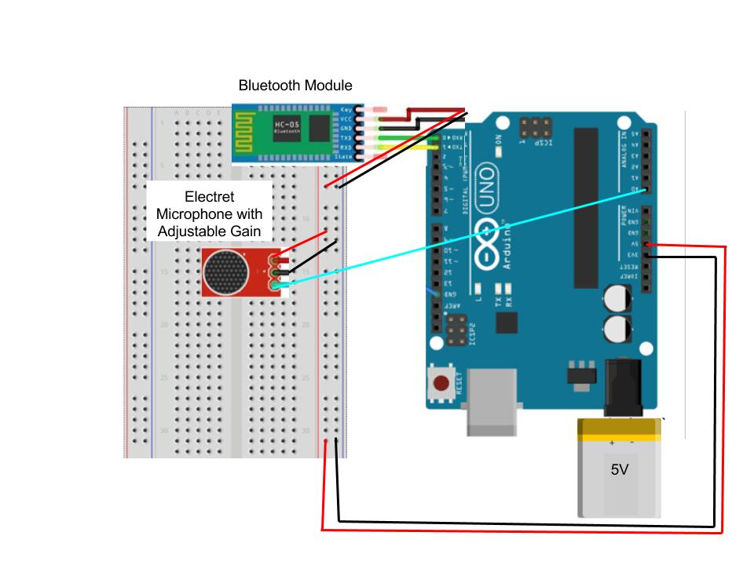
Second Arduino:
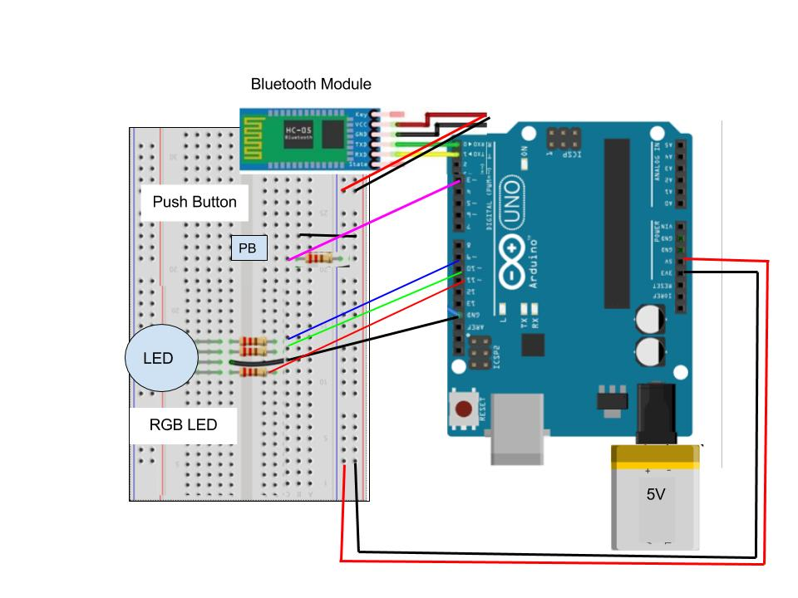

V. Design Changes
During the fabrication process, our initial design underwent adjustments. Currently, this project still uses a two Arduino Uno system, one for processing in one location and another to display the output in a separate location like originally planned. However, communication between the two Arduinos will occur using 315 Hz Radio Transmitter and Receiver Module, not the Bluetooth modules. This was changed due the lack of sufficient sample code for the bluetooth modules and the ease of use that the radio modules allowed with the abundance of online resources. The first arduino is still envisioned to be placed near the sound sources for example, in a kitchen near the stove and microwave. The microphone system we used was also changed from the Electret due to malfunctions. Once an alarm beep pattern is detected using the different type of microphone, a SMAKN 3.3V MAX9812 Mic with Amplifier, the first arduino sends the alarm signal to the second. The adjustable gain feature was not crucial to this project and the new microphone function has the same capacity as the previous one with less maintenance.
The processing of the analog sound signal from the microphone also had to be altered due to the lack of success the Goertzel equation approach had. The signal from the microphone is not initially a frequency, and all attempts to track a specific frequency have failed. Therefore, the processing has switched to characterize and track “beep” patterns of the alarm itself by using delayed if/else statements that will look for characteristic analog values that are present when the microwave alarm “beeps”.
When the pattern is detected, the first arduino will then send a radio signal to the second which will turn the LED on and then reset. Due to the difficulty of coding a strobing LED with a push button to override it, we are currently going for a simple on/off LED indication method. The push button is still included but with the function of powering down the second board until the button is released and power is then reapplied to the arduino. The second arduino will then reset.
Through these changes the result of our project has shifted slightly. The input has not changed but the processing and output have. The processing is more reliant on mathematical characterization of the sound input into patterns while the output is a simpler indication process due to the complexity of lacing the code of the button, radio, and light together. This will cause the output to be less striking because it lacks the eye-catching strobe feature. Even so, the project still manages to fit the criteria to provide an assistive technology for those with hearing impairments and does not stray too far from its initial concept.

VI. Parts
* (2) Arduino Unos
One to process the sound and the other to display output.
* (2) Breadboards
To accompany each Arduino.
*(1) LED
Placed on the second Arduino. If on, the first Arduino has detected an alarm.
* (1) 560 Ohm Resistor
Used in tandem with the push button on the second Arduino.
* (1) 433 MHz GoWoops Radio Transmitter
On the first Arduino, this will be send a signal to the second to indicate a detected alarm.
* (1) 433 MHz GoWoops Radio Receiver
On the second Arduino to receive a signal from the first to turn on the LED due to an alarm going off.
* (1) SMAKN 3.3V MAX9812 Microphone
This will be how the alarm of the appliance is detected by processing its analog signal.
* (1) Touch Button
Allow the user to switch the LED off, acknowledging they are aware and alarm has gone off.
* Kick Stand
Allows the portable Arduino module to be stood upright which will give the user a better awareness of when the LED is triggered and an alarm being detected by the first Arduino.

VII. Wiring Schematics
First Arduino:
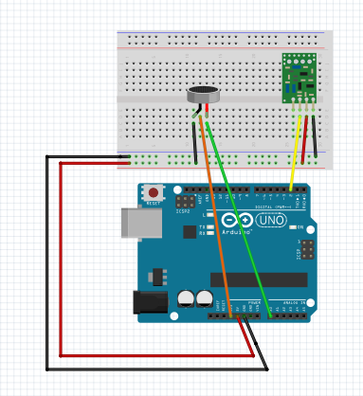
The Microphone is attached to Analog 0, 3.3V, and ground so that the Arduino will recognize the signal. The RF Transmitters is attached to the 5V, ground and digital 12. The LED is connected to digital 13 and ground. The LED does not turn on this board, but was used as a placeholder in the in the code.

Second Arduino:
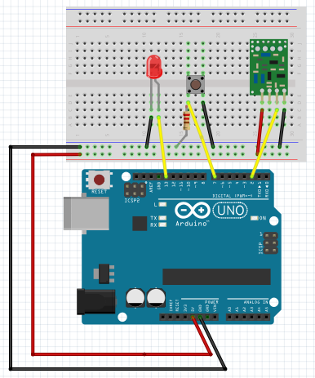
The LED is connected to digital 13 and ground while the button has a 560 Ohm resistor on the same connection to digital 8. This helps control the power distribution to the button. The RF receiver has a connection to 5V, ground and digital 11.

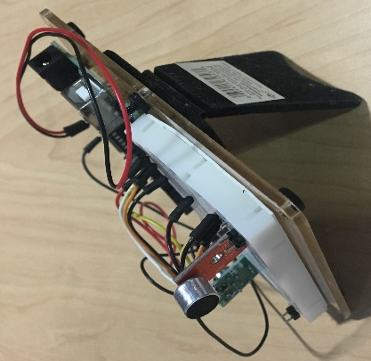
VIII. Physical Construction
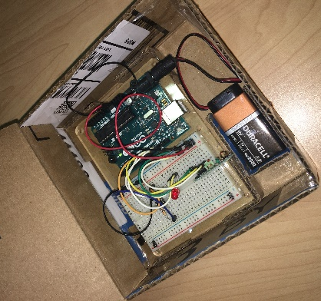
For our project, we decided to have minimal physical construction due to the complexity of the coding. The first Arduino board that contains the microphone would eventually be encased in a container that would be placed near the alarm source. Our prototype is made from cardboard that has a top so all of the wiring is concealed. For a final model the box would be made from a durable material, like plexiglass, that also looks professional. This box has a section in the interior that holds the battery and arduino board in place so if the box is moved or bumped the parts will be held in place. The second Arduino board has a kickstand that allows the user to set the lighting system up for the light to be projected better into the room. This kickstand points the board into the room allowing the person to have a better chance to detect when the light starts flashing. Since this was just a prototype the overall physical construction was not the main focus as compared to the coding.

IX. Flow of Logic
First Arduino:
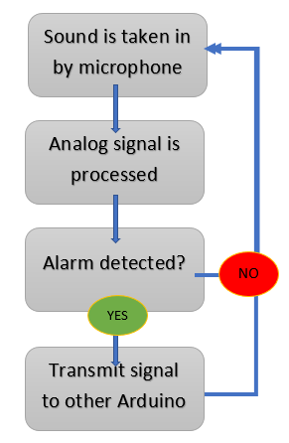
This Arduino board is responsible for processing sound input detected by the microphone and sending the signal to the other board if a beep pattern is detected. The sound is processed using delayed if/else statements that look for a range of input values that are characteristic to the beep sound we used. If the beep pattern is detected the RF transmitter will send a signal to the RF receiver on the other board. If the noise that is detected is not an alarm then the microphone will continue to search for a beep pattern until one goes off.

Second Arduino:
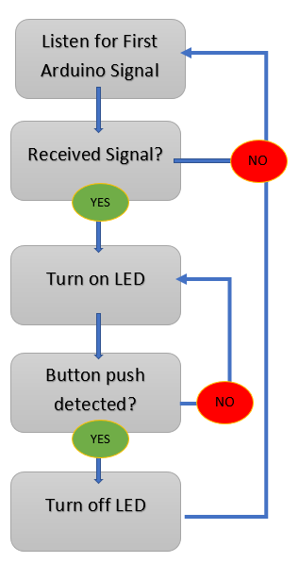
This Arduino board is responsible for displaying the output, a flashing LED. When the RF receiver receives a signal the board then turns on a red LED. The LED is programmed to blink for approximately 3 seconds and then turn off. If the button is pushed during this time, the LED will turn off. After the button is released or if no signal is initially received, the Arduino will continue to search for another signal from the first Arduino. If there is no signal then the Arduino will continue listening for a signal.

References
[1] Walling, A. D., & Dickson, G. M.
(2012). Hearing Loss in Older Adults. American Family Physician, 85(12), 1150-1156. Retrieved from https://www.clinicalkey.com/#!/content/playContent/1-s2.0-S0002838X12602081.
[2] National Institute of Health. (2016).
Noise-Induced Hearing Loss Among Adolescents. Retrieved from https://www.nidcd.nih.gov/health/statistics/noise-induced-hearing-loss-among-adolescents
[3] NFPA. (2016). People who are deaf or
hard-of-hearing. Retrieved from http://www.nfpa.org/public-education/by-topic/people-at-risk/people-with-disabilities/educational-materials/people-who-are-deaf-or-hard-of-hearing
[4] Ott, J. H. (1971). U.S. Patent No.
US3582671A. Washington, DC: U.S. Patent and Trademark Office.
[5] Menchel, R. S., & Ritter, A. (1984).
Keep deaf workers safe. Personnel Journal, 63(8), 49-51. Retrieved from http://psycnet.apa.org/psycinfo/1984-32855-001
[6] Al-Shaqi, R., Mourshed, M., & Rezgui,
Y. (2016). Progress in ambient assisted systems for independent living by the elderly. SpringerPlus,5(1). doi:10.1186/s40064-016-2272-8
[7] Anderson, Monica. “Technology Device
Ownership: 2015.” Pew Research Center: Internet, Science & Tech. Pew Research Center, 29 Oct. 2015. Web. 08 Apr. 2017.
[8] NFPA, S. (2015). Safety messages about
cooking. Retrieved from http://www.nfpa.org/public-education/by-topic/top-causes-of-fire/cooking/safety-messages-about-cooking
[9] Edwards Signaling. (n.d.). Edwards
Signaling Combination Signaling Devices 7007B-N5 Buzzer Strobe. Retrieved from http://www.galco.com/buy/Edwards-Signaling/7007B-N5?source=googleshopping&gclid=Cj0KEQjw5sHHBRDg5IK6k938j_IBEiQARZBJWheE9F1ydCADaylX-WnThVBTq9TORjg-TWq5QMcX72YaAlAu8P8HAQ
[10] Serene Innovations. (n.d.). Serene
Innovations CentralAlert CA-360 Alarm Clock with Audio Sensor. Retrieved from http://www.harriscomm.com/serene-innovations-centralalert-ca-360-alarm-clock-with-audio-sensor.html

Appendix

Microwave Sound Used:
https://drive.google.com/file/d/0B5v2eVDutGVXa3FLTVBZaG5rYUk/view?usp=sharing

First Arduino Code:
#include <VirtualWire.h>

const int receive_pin = 11;
const int transmit_en_pin = 12;
int led = 13;
const int inputPin = A0;

// size of the window
const int inputWindow = 200;
// placeholder for a single measurement
unsigned int inputSample;

void setup() {
// initializing the analog input
vw_set_tx_pin(transmit_pin);
vw_set_rx_pin(receive_pin);
vw_set_ptt_pin(transmit_en_pin);
vw_set_ptt_inverted(true); // Required for DR3100
vw_setup(2000);
pinMode(inputPin, INPUT);
pinMode(led, OUTPUT);
// initializing the serial communication
Serial.begin(9600);
}

byte count = 1;

void loop() {
// two variables for minimum and maximum values in window
unsigned int inputMax = 0;
unsigned int inputMin = 1024;
// loop for the window
for (unsigned int i = 0; i < inputWindow; i++) {
// read in a single value
inputSample = analogRead(inputPin);
// get the minimum and maximum value
inputMin = min(inputMin, inputSample);
inputMax = max(inputMax, inputSample);
}

// send the values on serial
if ( (25 < (inputMax-inputMin)) && ((inputMax-inputMin)<30) ){
Serial.print(inputMax-inputMin);
delay(1700);
if ( (20 < (inputMax-inputMin)) && ((inputMax-inputMin)<30) ){
delay(1700);
if ( (20 < (inputMax-inputMin)) && ((inputMax-inputMin)< 30) ){
digitalWrite(led, LOW);
sends();
}
else {
digitalWrite(led, LOW);
}
}
else {
digitalWrite(led, LOW);
}
}
else if ((inputMax-inputMin) <= 25){
digitalWrite(led, LOW);
}
else if ((inputMax-inputMin) >= 30){
digitalWrite(led, LOW);
}
}

void sends(){
char msg[7] = {'h','e','l','l','o',' ','#'};
msg[6] = count;
vw_send((uint8_t *)msg, 7);
vw_wait_tx(); // Wait until the whole message is gone
count = count + 1;
}

Second Arduino Code:
#include <VirtualWire.h>

const int transmit_pin = 12;
const int receive_pin = 11;
const int transmit_en_pin = 3;
int inPin = 8;
int outPin = 13;
int state = HIGH;
int reading; int previous = LOW;
long time = 0;
long debounce = 200;

void setup() {
delay(1000);
Serial.begin(9600);
// Debugging only
Serial.println("setup");
// Initialise the IO and ISR
vw_set_tx_pin(transmit_pin);
vw_set_rx_pin(receive_pin);
vw_set_ptt_pin(transmit_en_pin);
vw_set_ptt_inverted(true);
// Required for DR3100
vw_setup(2000);
// Bits per sec
vw_rx_start();
// Start the receiver PLL running
pinMode(inPin, INPUT);
pinMode(outPin, OUTPUT);
}

void loop() {
uint8_t buf[VW_MAX_MESSAGE_LEN];
uint8_t buflen = VW_MAX_MESSAGE_LEN;
if (vw_get_message(buf, &buflen))
// Non-blocking

{
int i; digitalWrite(led_pin,LOW);
// Flash a light to show received good message
// Message with a good checksum received, dump it.
Serial.print("Got: ");

for (i = 0; i < buflen; i++)
{
Serial.print(buf[i], HEX);
Serial.print(' ');
digitalWrite(led_pin,HIGH);
delay(50);
digitalWrite(led_pin,LOW);
delay(50);
digitalWrite(led_pin,HIGH);
}

Serial.println();
digitalWrite(led_pin,LOW);
}

else {
digitalWrite(led_pin, LOW);
}
digitalWrite(outPin, state);
previous = reading;
reading = digitalRead(inPin);

//switch code
if (reading == HIGH && previous == LOW && millis() - time > debounce)
{
if (state == HIGH)
state = LOW;

else
state = HIGH;
time = millis();
}
}

