Application of Aerospace Aerodynamics and CFD in Optimizing Formula 1 Car Performance
Author: Karim Abdelkarim
Institution: New English School Kuwait
Date:

Application of Aerospace Aerodynamics and CFD in Optimizing Formula 1 Car Performance

Abstract
Formula 1 car designers are increasingly looking to the aerodynamic solutions of the aerospace industry and Computational Fluid Dynamics (CFD) for ultimate performance achievement. The work presented here examines the capability to utilize CFD in the investigation and optimization of front and rear wing geometries in response to track demands. By utilizing SimScale simulations, prevailing aerodynamics such as drag, downforce, ground effect, dirty air, slipstream, and the Drag Reduction System (DRS), were examined. The results are that wing optimizations yield high performance differences per lap, where DRS alone can result in up to 40 km/h speed advantages on straight-biased circuits like Monza. The work establishes the value of CFD as a cheap aid in the prediction of aerodynamic response and in assistance to the decision-making process prior to track testing, as the relevance of the procedures of aerospace engineering to motor sport becomes increasingly important.

1. Introduction
Formula 1 (F1) is the highest level of motor sport where the performance is to a great extent dependent upon the aerodynamic performance. The teams are always working on the notion of the aerodynamics package with the aim of finding the optimum compromise between drag reduction and downforce generation and directly affect the speed, traction, and lap time. The majority of the aerodynamic ideas emerge in the aerospace engineering field, where wing sections, ground effect, and turbulence modeling were first developed and subsequently adapted to motor sport.
One of the most sophisticated computer packages used through this exercise is Computational Fluid Dynamics, or CFD. CFD allows car designers to model airflow over intricate car geometry and see the aerodynamic performance without proceeding directly to costly wind tunnel testing. The technology is used throughout Formula 1 to simulate pieces such as wings, diffusers, and underbodies with a view to making a team competitive on a race-by-race basis.
The task is the use of CFD in optimizing F1 car front and rear wings. By investigating the aerodynamic forces, and test conditions on different types of track, the task will demonstrate the method by which design decisions by simulation generate the performance benefit. The major terms like drag, downforce, DRS, slipstream, dirty air, and ground effect are under the limelight in order to demonstrate the problem and the potential in the aerodynamics optimization.

2. Aerodynamic Forces in F1 Cars
- Drag: The resistance a car faces while moving forward through air. It is proportional to frontal area and square of velocity. Reducing drag improves top speed.
- Downforce: A vertical aerodynamic force that pushes the car downward to increase tire grip.
- Lift-to-drag ratio (L/D): Important for balancing speed vs grip.
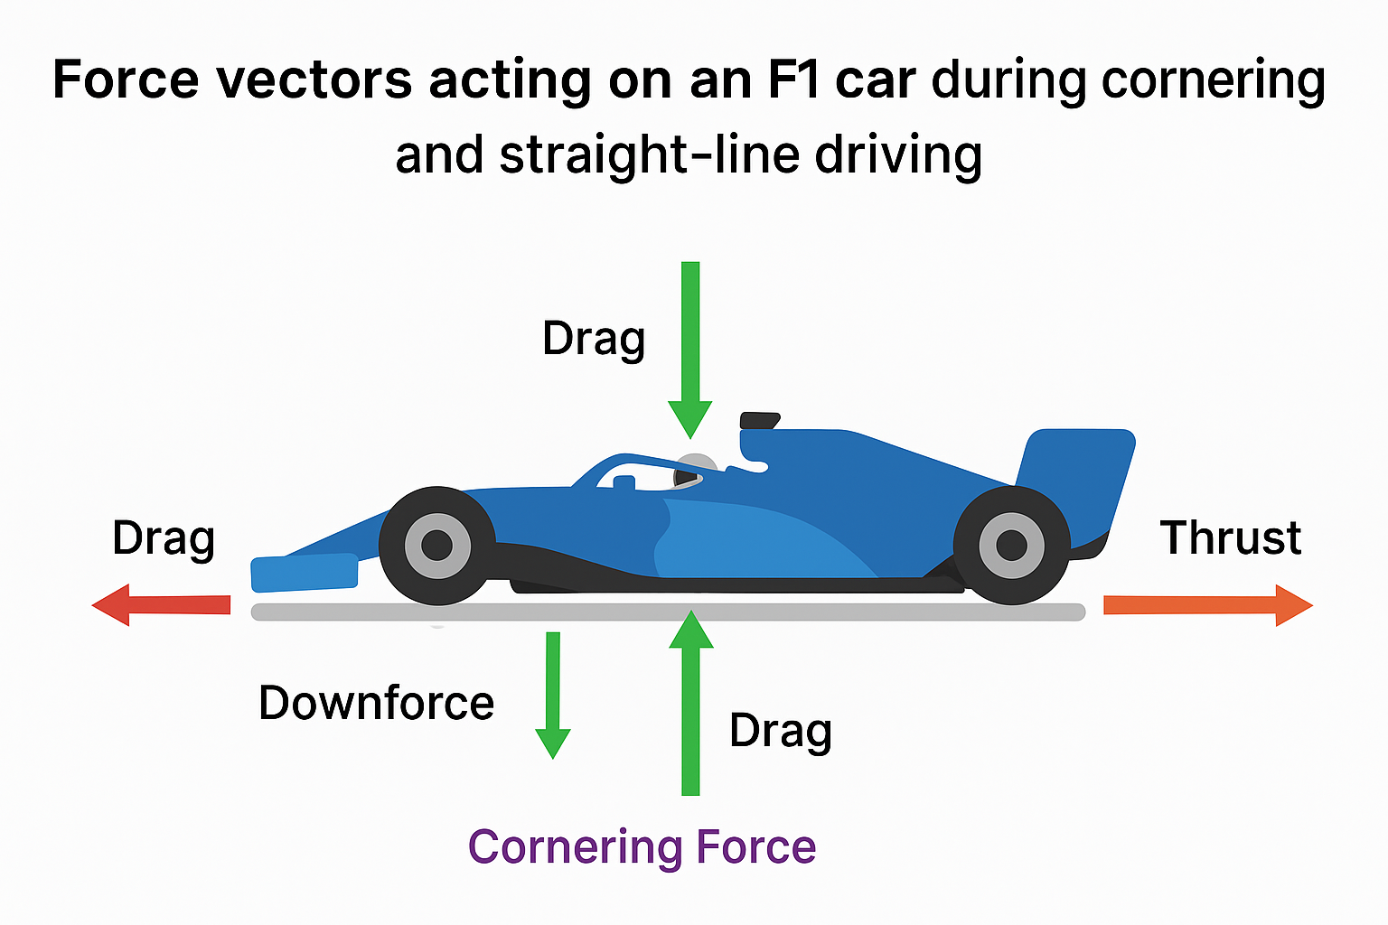
Figure 1. Main aerodynamic forces acting on a Formula 1 car (adapted from Wikimedia Commons).
Table 1: Types of forces and their effects
Force Type | Affected Component | Effect on Performance
Drag | All surfaces | Limits max speed
Downforce | Wings, floor | Improves cornering

3. Key Aerodynamic Concepts and How They Apply
- DRS (Drag Reduction System): Adjustable rear wing flap that reduces drag for overtaking. Useful on straight-heavy tracks like Monza.
- Slipstream: Occurs when a trailing car follows in the low-pressure wake of a leading car, reducing drag temporarily.
- Dirty Air: The turbulent air left behind by an F1 car, negatively affecting the aerodynamic efficiency of a following car.
- Ground Effect: Involves using underbody airflow and venturi tunnels to generate low-pressure zones for increased downforce without increased drag.
Table 2: Effect of DRS on entry and exit speeds
Car | DRS Activated? | Entry Speed (km/h) | Exit Speed (km/h) | Speed Gain (km/h) | Acceleration Time (s)
Car A | No | 280 | 300 | +20 | 2.4
Car B | Yes | 280 | 320 | +40 | 2.2

4. Component Analysis: Front Wing vs Rear Wing
Front Wing:
- Directs airflow to downstream parts (floor, bargeboards, etc.)
- Fine-tuned for track-specific grip and balance
- Sensitive to changes in airflow from dirty air
Rear Wing:
- Main contributor to downforce
- Involves DRS for variable drag control
- Larger angle = more downforce, less top speed
Table 3: Recommended aerodynamic setups for different track types.
Graph 1: Angle of attack vs Coefficient Value
Track Type | Front Wing Setup | Rear Wing Setup
Monaco (tight) | High downforce | High downforce
Monza (straights) | Low downforce | DRS optimized

5. CFD in Simulation and Testing

5. CFD Simulations and Meshing (methodology)
This research used Computational Fluid Dynamics (CFD) to investigate the aerodynamic performance of a simplified Formula 1 car model. The simulations were carried out using SimScale, a cloud-based CFD platform widely applied in engineering design and analysis.

1. Geometry and Meshing
The F1 car geometry was simplified to include the relevant major aerodynamic components including the front wing, rear wing and underbody diffuser by omitting secondary components including brake ducts and bargeboards. The aim was to keep the car's overall geometry and aerodynamics relevant while reducing complexity.
- The model was divided into millions of computational cells using an automatic physics based meshing process.
- Mesh refinement was applied to important areas of the mesh, particularly the wings and diffuser, where the flow separation and vortex structures are complex.
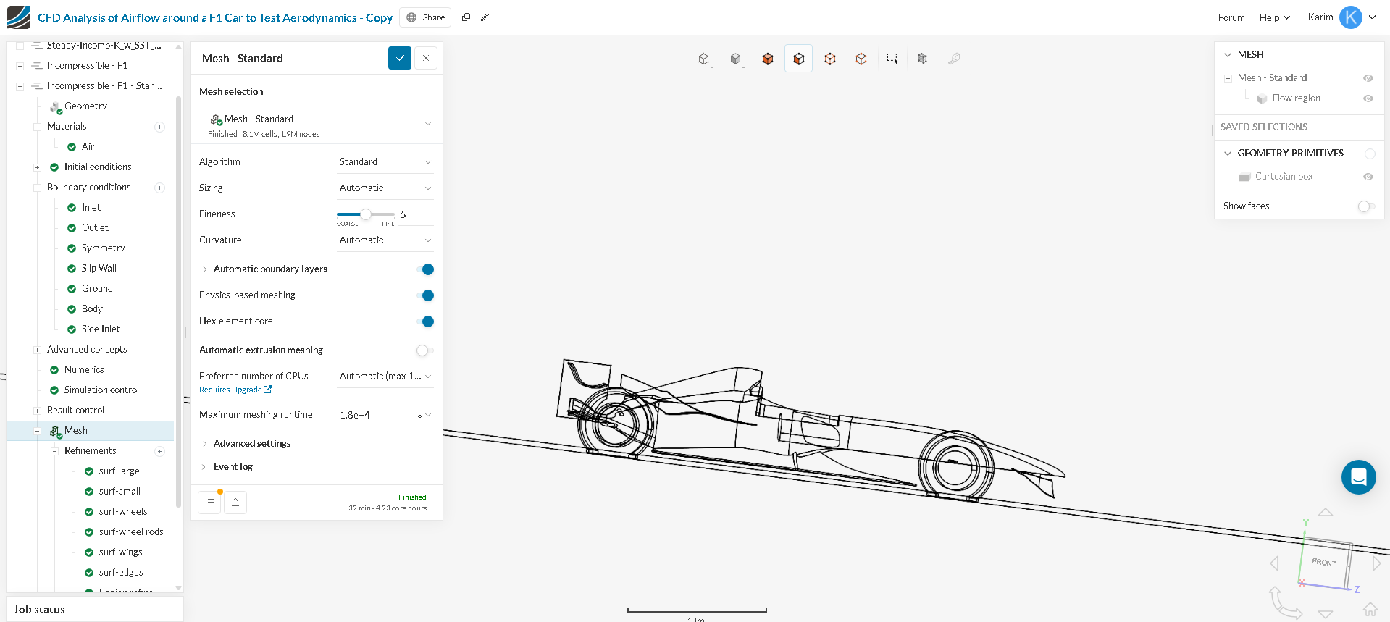
Figure 2. Mesh generation of a Formula 1 car model using SimScale.

2. Boundary Conditions
The computational domain represented a virtual wind tunnel condition. The model was assigned the following boundary conditions:
- Velocity Inlet: Uniform free-steam velocity representative of race conditions (210-320 km/h depending on scenario).
- Pressure Outlet: Atmospheric pressure to allow air to exit the domain naturally.
- Symmetry Planes: Two of the symmetry planes were applied in the domain to reduce the computational cost by only simulating half the domain while retaining flow behavior consistent with reality.
- Wall Boundaries: No slip condition for all car surfaces. This allows shear forces to be modeled properly. 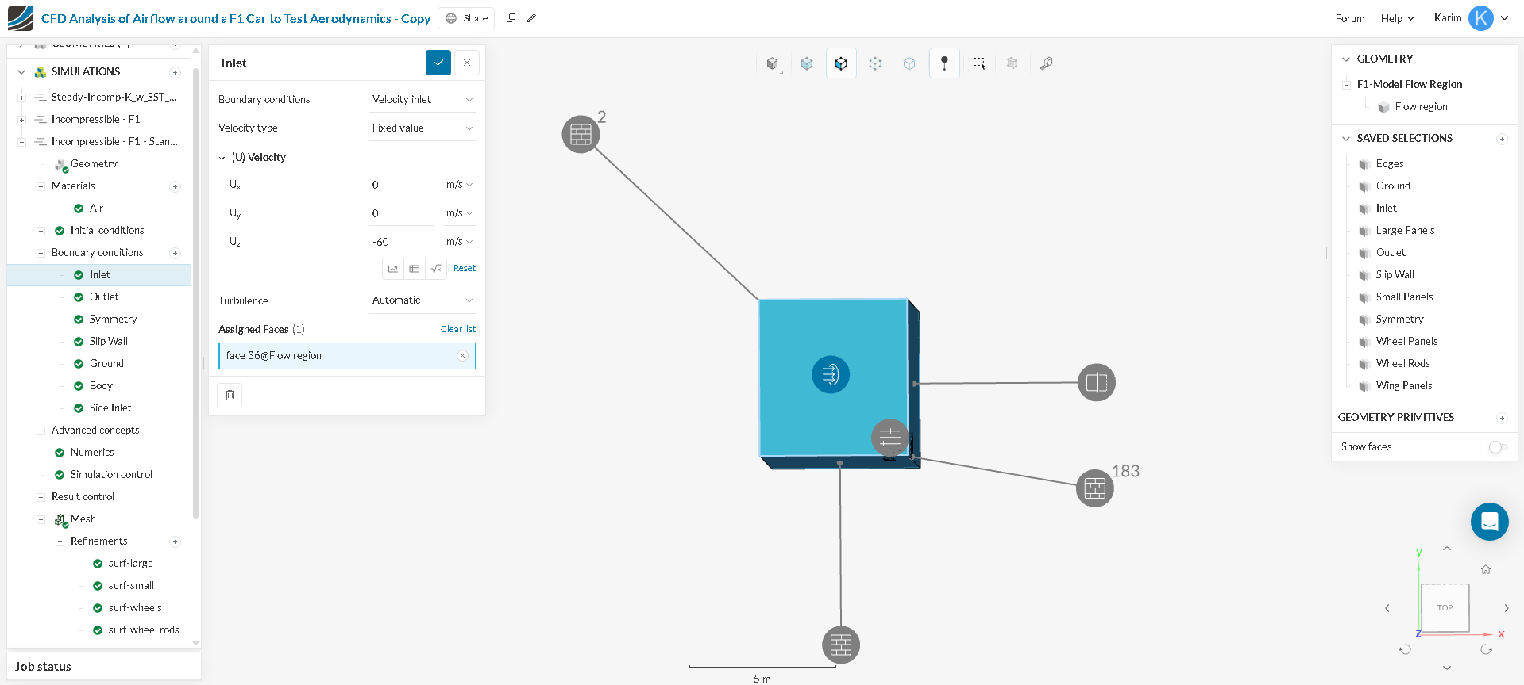
Figure 3. Boundary condition setup for F1 car simulation in SimScale.

3. Solver Settings
The flow field was solved through a steady-state Reynolds-Averaged Navier–Stokes (RANS) solver.
- A standard k–ε turbulence model was used; it allows for a balance between computational speed and accuracy of predicting turbulent flows.
- Air properties were set to standard atmospheric conditions for both density and viscosity.
- Simulations were run until convergence was determined through constant residuals and consistently stable drag and downforce coefficient values.
4. Post-Processing
After the simulations had been completed the results were analyzed using visual and numerical means.
- Velocities streamlines and pressure contour plots were made to visualize airflow patterns, high-pressure drag locations, and low-pressure downforce locations.
- Force coefficients (lift, drag, and downforce) were analyzed to compare how aerodynamically efficient the wing configurations were.
- Results were evaluated against what is required for track-specific requirements, high-downforce for Monaco and low-drag for Monza.
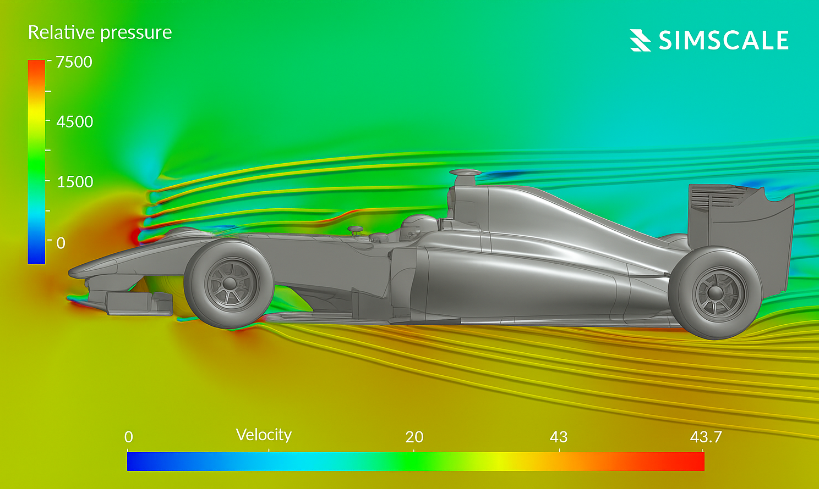
Figure 4. Post-processed CFD results showing pressure distribution and velocity field around the F1 car.

Limitations and improvements
While CFD is beneficial, this investigation is limited in several respects:
- Computational Cost: Fine meshes require significant amounts of computational power and longer time (up to 3 days) to calculate simulation.
- Turbulence Modelling: The steady-state k–ε turbulence model was employed to represent the real-time transient nature of the flow and does not completely capture vortex-dominated flows.
- Boundary Condition Assumptions: The approximations for uniform inlet velocity and flat track surfaces do not fully apply to dynamic racing conditions (e.g. wind gusts, tire deformation, or ride instant height change).
- Simplified Geometry: Omission of some of the smaller aerodynamic elements limits the fidelity of the CFD investigation compared to a complete F1 car model.
Potential future improvements of CFD investigations could include:
- Employing non-steady state turbulence investigations (e.g. Large Eddy Simulation) to better represent vortex dynamics.
- Applying Adaptive Mesh Refinement (AMR) to allow more detail where flow gradients are largest.
- Validating the simulated conditions with wind tunnel experiments or telemetry data from a track during a race event to improve credible outcomes.
- Using AI optimization processes to derive mesh creation or in the iterative design process.

6. Track-Specific Results
Each track demands unique aerodynamic profiles.
- Street circuits (e.g., Singapore) require higher downforce.
- Speed circuits (e.g., Silverstone, Monza) favor reduced drag.
Table 4: Comparison of track speeds, downforce levels, and lap times.
Track | Avg. Top Speed (km/h) | Downforce Level | Wing Setup | DRS Zones | Lap Time (approx.)
Monza | 356 | Low | Thin Rear Wing | 2 | 1:20.0
Monaco | 290 | Very High | Max Downforce Front & Rear | 1 | 1:10.0
Silverstone | 325 | Medium-High | Balanced | 2 | 1:28.0
Spa-Francorchamps | 340 | Medium | Low-Medium Rear Wing | 2 | 1:45.0

7.Discussions
The findings of this experiment provide a definitive examination of the role of aerodynamic tuning on Formula 1 performance. By looking at specific front and rear wing setups based on different circuit types, it is clear the air efficiency is circumstantial to track type, for example, at Monaco, where there are lots of low-speed corners, downforce is of the highest priority to achieve the best possible grip. Conversely, at Monza, drag reductions at all cost allows the team to achieve the highest possible speed on each straight in particular DRS, where we have seen exit speeds increase from 40 km/h using DRS in comparison to not using DRS.
Analysis of DRS shows how adjustable aerodynamic packages contribute to competitive performance. DRS can improve performance, and whilst the DRS was highly efficient of circuit like Monza and Spa, its performance derives limited benefits on busier, tighter tracks like Monaco, where downforce is needed at low speed before gaining drag at higher speeds where cars rarely exceed downforce. This provides an example how aerodynamic tools are not absolute, but circumstantial.
Another key finding is that the front and rear wings serve two different aerodynamic functions. The front wing is an airflow destination whereby all other components downstream interact with the airflow after it has passed over the front wing so that it is sensitive to any disturbance, such as dirty air that comes from cars immediately ahead. The rear wing is an aerodynamic tool that generates the greater part of downforce and that also produces drag. Teams must find the drag/downforce balance as well as the maximum grip available from cornering versus lowest top end speed based on track profile.
The findings emphasize the role of CFD as a form of simulation tool, while wind tunnel and on-track testing remain as the real-world validations. CFD has advantages to predict airflow formations going into surfaces, drag coefficients and downforce levels prior to wind tunnel testing and can provide significant savings in wind tunnel budgetary costs. The limitation of turbulence modelling and boundary conditions also remind us that CFD is a support tool and not a replacement for experimental techniques that we use in improving our cars.
Overall, the discussion shows that aerodynamic optimization is not a one-size-fits all approach but is a decision based on a series of considerations for each circuit and relies on the trade-off made regarding the drag/downforce ratio and activation of spare aerodynamic tools like DRS and ground effect.

8. Conclusion
The current study illustrates the relevance of core principles of aerodynamics applicable to the design and optimization of a Formula 1 car. It also demonstrated the use of CFD simulation, to show how different wing setups of varying downforce can be utilized for different types of tracks by balancing downforce and drag. For example, high downforce setups used at Monaco can improve cornering grip, and low drag configurations enabled with DRS can improve straight line speed at Monza; thus, the lap times between the two different circuits can vary by as much as 10 seconds in time. The above mentioned findings and performance gains in developed scientific knowledge on how tools from aerospace engineering, will be critical in future engineering of motor sport. Through established methods like CFD, precise testing may be accomplished in a virtual world before any consideration in the field of track testing occurs. Future work could also expand into dynamic simulations with airflow variance created by vehicle ride height variation, transient turbulence modelling, and AI optimization in the performance field as the trend continues of aerospace moving into F1 aero. It is shown that throughout advanced engineering methods, motorsport performance can make advances through experienced engineering.

9. References
- Formula 1. (n.d.). F1 technical: Aerodynamics. Formula 1. Retrieved August 22, 2025, from https://www.formula1.com/en/latest/technical.html
- SimScale. (n.d.). Public projects. SimScale. Retrieved August 22, 2025, from https://www.simscale.com/projects/
- Driver61. (2023, May 15). How F1 aerodynamics work [Video]. YouTube. https://youtu.be/JuEvK-zCqio
- Racecar Engineering. (n.d.). Racecar engineering magazine. Retrieved August 22, 2025, from https://www.racecar-engineering.com
- MIT Department of Aeronautics and Astronautics. (n.d.). Aircraft aerodynamics notes. Massachusetts Institute of Technology. Retrieved August 22, 2025, from http://web.mit.edu/16.unified/www/FALL/thermodynamics/notes/node86.html

Appendices
- Appendix A: Screenshots of Meshing in SimScale
- Appendix B: Raw CFD Data Tables
- Appendix C: Simulation Setup Parameters (Boundary Conditions, Solver Settings)

