Mechanical arm and claw with servo

Abdul Alaklabi
alaklabia0548@my.uwstout.edu
Robert Lindemann
lindemannr1606@my.uwstout.edu

Elliott Johnson
johnsone7328@my.uwstout.edu
Dylan Olson
olsond4022@my.uwstout.edu

Abstract—Muscular dystrophy is a disease that debilitates the muscle function of those afflicted with the disease. While it is a terminal condition, the early stages still prove to be a struggle. By weakening grip, strength, and reach, early muscular dystrophy makes it difficult for those with the disease to do everyday tasks. Our project is a solves these problems by giving those with muscular dystrophy a lightweight arm with a claw that opens and closes with a switch. This gives them an extended reach and relatively strong grip while minimizing strain on their arms.
Keywords—arm; mechanical; claw; servo; Arduino, servo, Muscular dystrophy

Background

Muscular dystrophy (MD) is a decrease in muscular membranes in human muscle tissues. Mayo Clinic defines MD as “a group of diseases that progressively weakening or losing muscle mass” [1]. Kiichi Arahata emphasizes the diversity in types of MD [2], and the diseases, which number in the thirties, affect a wide range of muscle groups and in differing levels of debilitation [3]. According to [4], one of the most common types of MD is Duchenne muscular dystrophy (DMD), a fatal strain that affects children. Life expectancy has never been very high for this type, and there is no cure, but strides have been made to increase the lifespan of those affected by DMD, which has increased by over fifteen years since 1970 [5]. With our project, we hope to add to those gains by increasing the quality of life for those with MD. The arm allows them to be more independent and not feel as reliant on others to take care of themselves. With a cheap cost of production, the arm would be readily available for people with MD.

Design and Design Analysis

Materials Used
The project is composed of PVC pipe for the primary structure, with pine wood being used for the more intricate parts of the arm, and an assortment of miscellaneous pieces including screws, eye bolts, string, and a spring, which are used to make the device function. The project is held together by PVC cement, wood glue, and hot glue, as well as the screws. The cement and glues were used to hold the design in place, while the screws are used to place the circuit and breadboard on the arm itself, making the device portable. The technical aspect of the arm is composed of the circuit, wires, and the servo. The original arm that was done for getting a basic vision of how the project would turn out used a copper pipe and elbow instead of PVC. The specific items used include a 1”x6”x4’ board of standard pine, a 0.75”x10’ PVC pipe, a 0.75” 90º PVC elbow, a 0.75”x4’ wooden dowel, a 0.375”x4’ wooden dowel, 0.8125” eye hooks, small screws, a spring, wood glue, hot glue, PVC cement, and string. The price to construct the arm was inexpensive. The pine board cost $1.47, the pipe cost $1.09, the elbow cost $0.56, the PVC primer and cement cost $6.96, the large dowel cost $2.98, the small dowel cost $0.98, the eye hooks cost $2.19, and the spring cost $2.19, for a total cost of $18.42, plus $1.01 in tax in Wisconsin. The string, hot glue, wood glue, and screws were available for us without purchase, as was the Arduino, servo, and wires, so these items are not figured into the total cost of the project.

Procedure
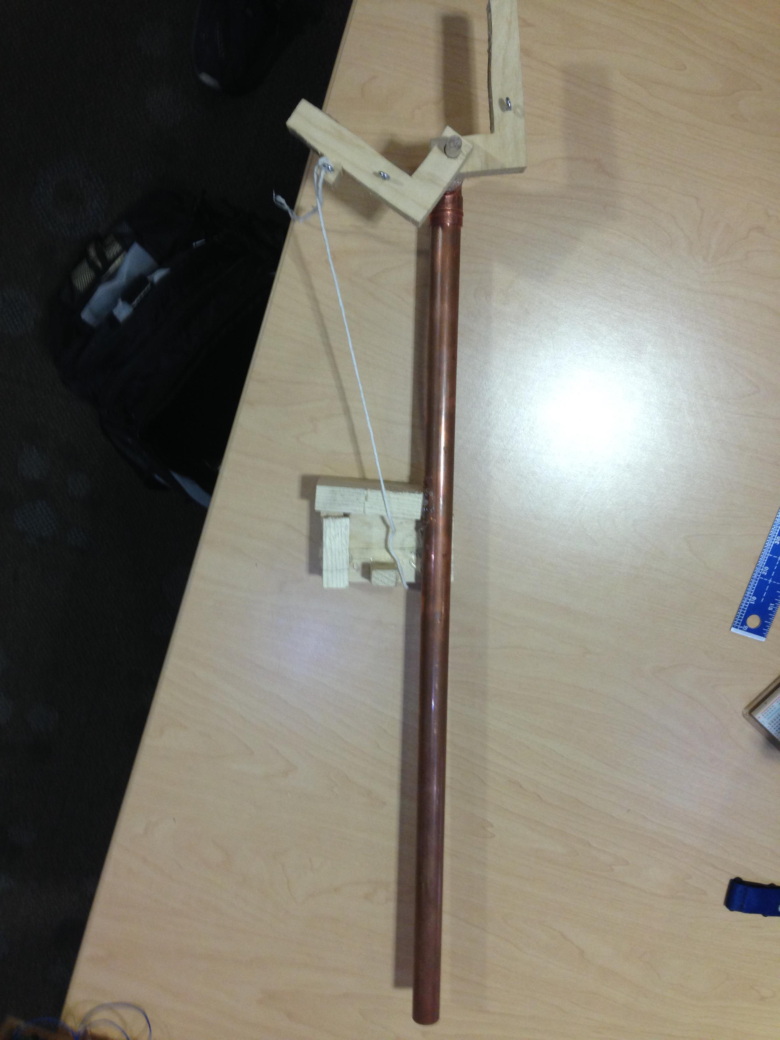
Fig. 1. Copper arm prototype
The first copper arm we did was not very scientific because we did not use precise measurements or careful planning. We simply got our ideas going into the project and then refined them on the second PVC arm, properly measuring out the pieces before placing them on the device. The final device procedure is the procedure detailed here.
First, the 10’-long PVC pipe was cut to 3.5’. The elbow was then cemented to the shortened pipe. The claw tongs were the next pieces cut out. The tongs are L-shaped, with the base being 1.25” and the extension being 3.5”, while maintaining a thickness of 0.75”. Each tong has a hole drilled into the end of the base. These holes were drilled prior to cutting to avoid cracking. The hole in the right tong is 0.375”, while the hole in the left tong is a slightly bigger 0.4218”. This was to ensure that the left tong could swivel. Eye hooks were hand-screwed into both tongs 0.25” above the base, and the left tong also had a second eye hook hand-screwed into the side 0.375” from the end of the tong. The next step was to cut a 1”-long piece of PVC pipe out, followed by a 1.5”-long dowel off the thick dowel. This dowel was then slightly sanded so it could fit into the PVC pipe. A 3.25”-long piece was cut from the thin dowel. After that, a 0.375” hole was drilled 1” into the piece from the thick dowel. The thin dowel was then placed through the hole in the right tong, leaving an inch at the end. The 3.25” thin dowel and right tong were wood glued into the hole in the 1.5” thick dowel. After the glue set, the new piece was hot glued into the 1” piece of PVC pipe that had previously been cut out. Next, the piece was cemented into the other end of the PVC elbow. This completed the base of the arm.
The second major part of the project was the stand for the servo. We put the servo on a 2”x2.5” piece of pine positioned 2.875” down the pipe from the end of the elbow. This piece was hot glued so that the end of the piece was aligned with the far side of the pipe. The servo was held in place by a 0.75”x1.375” piece of wood that was placed vertically directly next to the pipe, and by a 1.0625”x2.8125” piece positioned horizontally on top of the larger piece of pine. These pieces were hot glued in place. This makes the servo stay in place very well.
The final major aspect of the arm to be constructed was the platform for the Arduino circuit. This makes the arm portable. The piece of wood that was cut out for this part was 4.1875”x5.5”. Screws were drilled through this piece so the Arduino could be placed on them. However, these screws were not measured out; instead the Arduino was placed on the board first and markings were made in the holes in the base to ensure that the circuit would stay on. The piece of wood was hot glued to the pipe in a manner that makes both the servo platform and the Arduino board flush when set on a flat surface. Finally, a hole was drilled next to both the servo platform and the Arduino board so that the wiring that runs from the breadboard to the servo could be hidden. The hole drilled next to the platform is .25” in diameter, and the hole drilled next to the board is 0.375” in diameter.
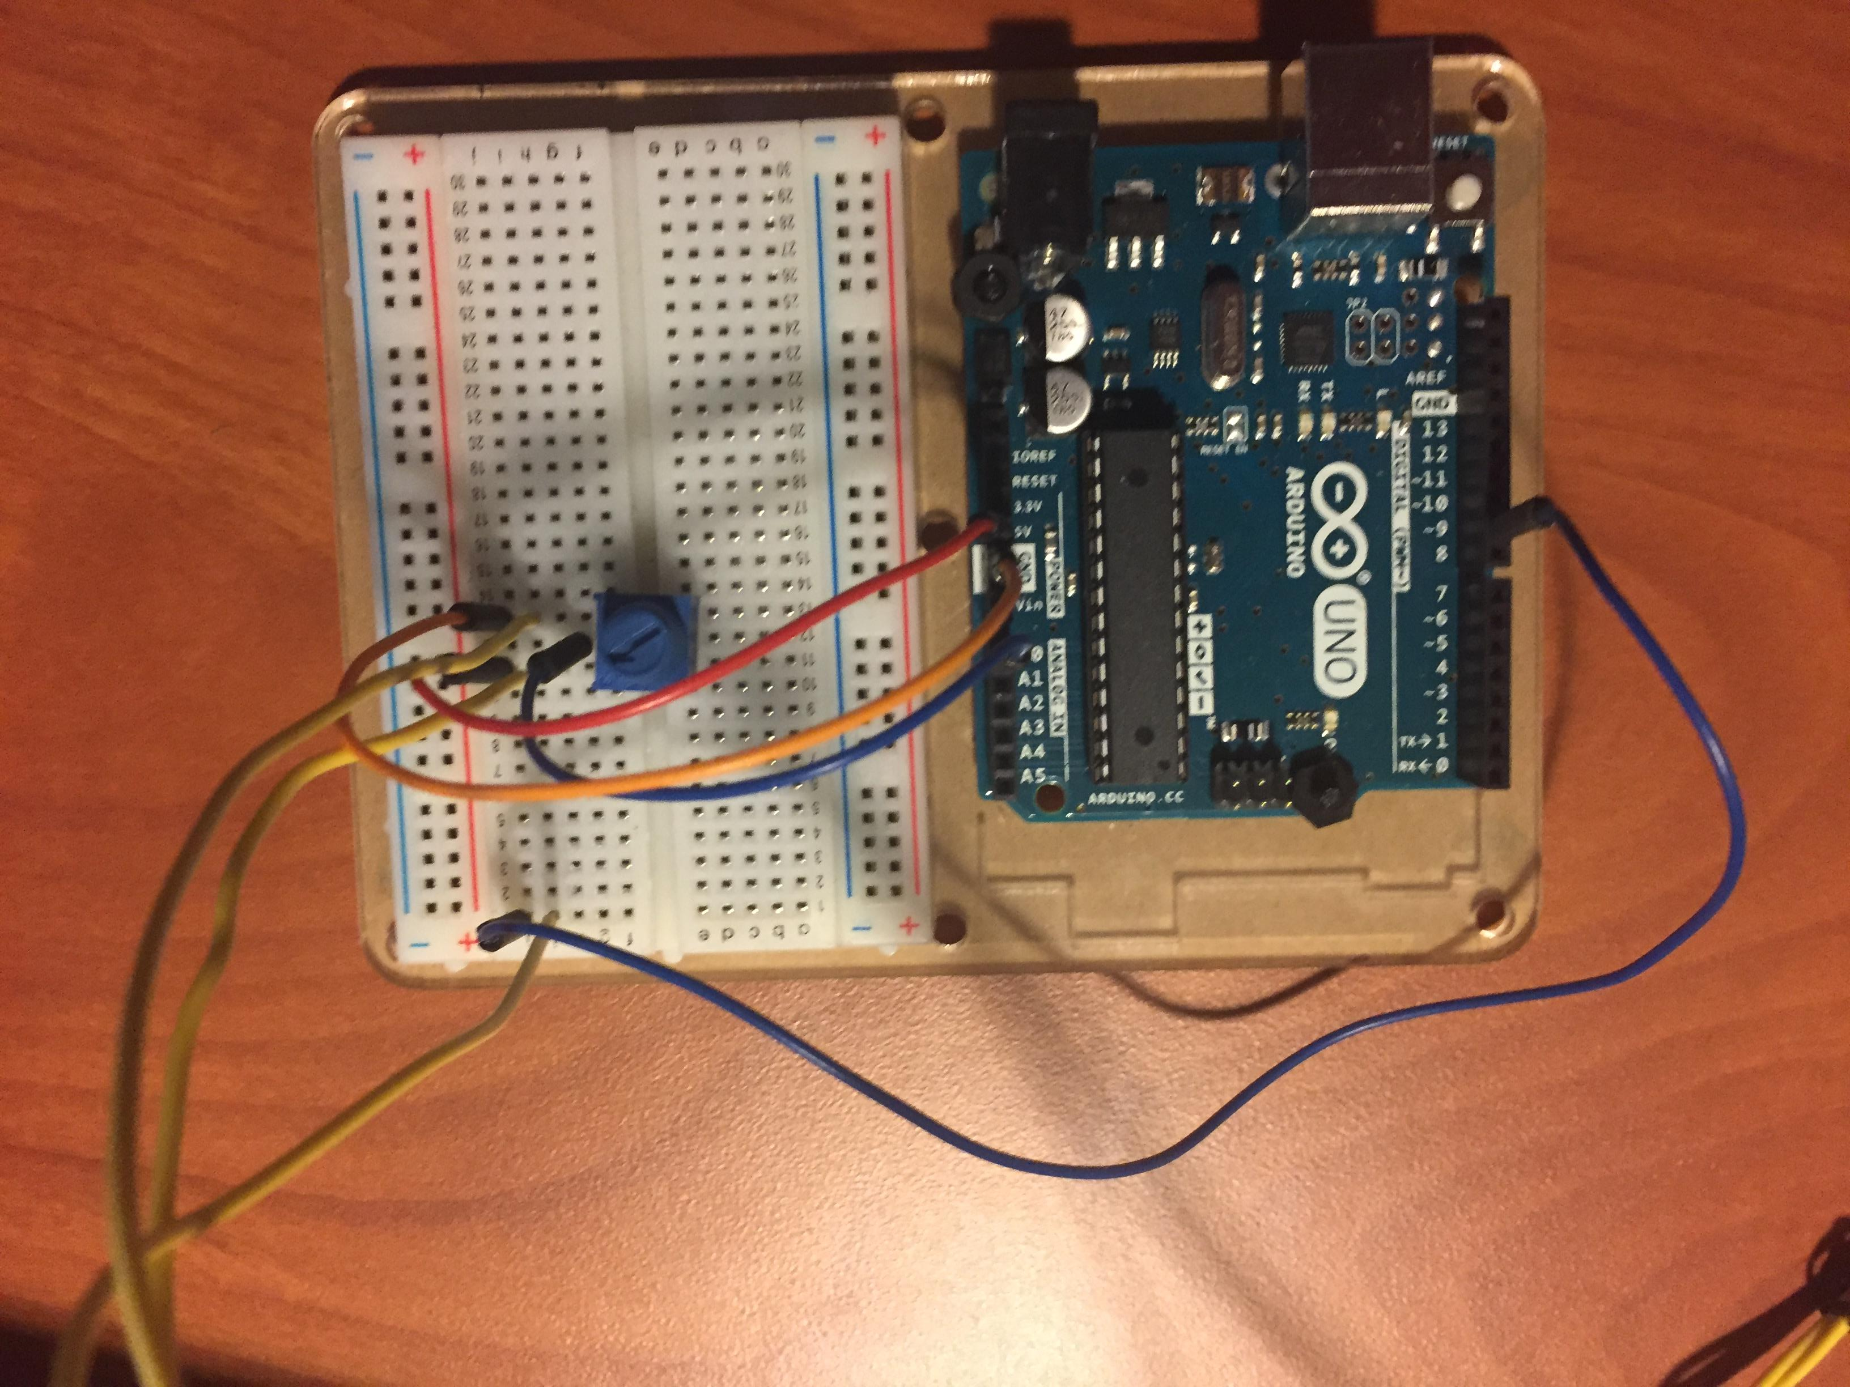
Fig. 2. Breadboard layout for both programs
The circuit for our project is battery powered, using a 9-volt battery as the source. Using the 5-volt power supply on the motherboard with proper grounding, the digital input nine provides the information to the circuit that the Servo interprets when you turn the potentiometer and it follows suit to match it using its own power and information wires, which are mounted in the breadboard to allow the servo to interpret the same information that the potentiometer is given. The circuit and program were borrowed from [6]. In addition, we wrote a program that utilized the pressure sensor, but we decided against using this one in the final project because it would still require hand strength to determine how far the claw could open.
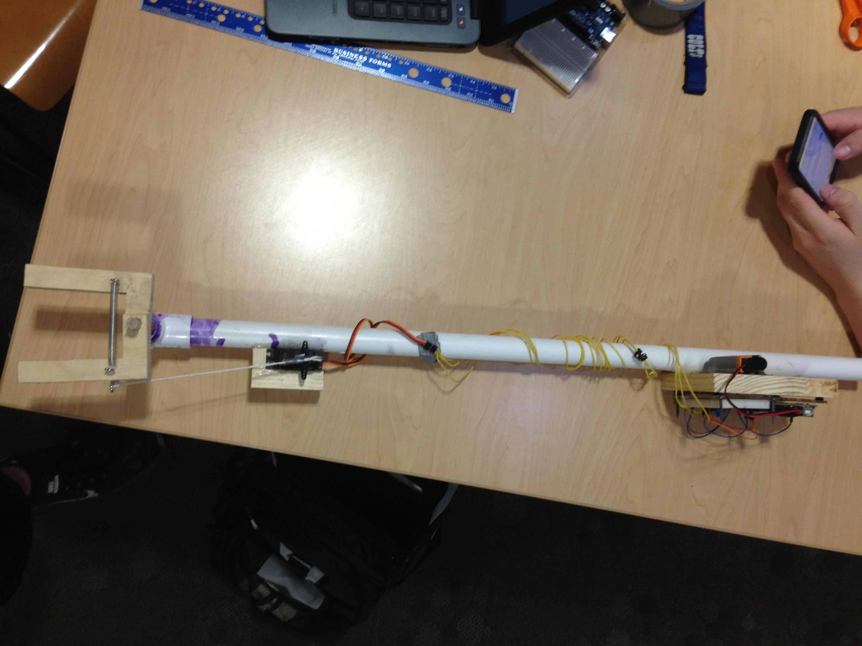
Fig. 3. Final PVC arm
The circuit is wired up to the servo, which is tied by a string to the eye hook that is in the side of the right tong. When the switch is turned, the servo turns, which pulls the string back and the tong. When the flip is switched back, the servo turns back to its original position and the spring brings the tongs back together around the object.

Analysis
The design works by turning a switch, which makes it simple to use. Our design seemed best fit for our problem, because it is for people who are at early stages of muscular dystrophy. The patient would have enough force to lift up the hand, and to push a knob. At under $20, the arm is relatively inexpensive. The arm is able to lift up a cup of water filled with water with a mass of 355 grams. With a length of 2.5’, the arm allows a person to at least double their reach. The grips on the claw could be better, but they work well for lighter objects. The spring is an integral part of the design, because it brings the tongs together and keeps the force on the object, as well as keeping the string taught when the servo goes back to its original position. The design is intentionally lightweight by using materials like PVC and pine instead of copper and oak. The claw has decent grip strength; stronger materials would be needed to increase this. Another aspect of our design that could be improved is the placement of the spring, which may get in the way while trying to grab larger objects. Finally, we tried to put the Servo sideways and inside the PVC pipe, but this did not work out. This could be fixed by using a bigger pipe. As far as the environmental aspect of our project is concerned, it should not have a large negative impact on the environment. The major problem would be the PVC pipe, which we used out of convenience and security. To minimize environmental impact, we could bore a hole into long, thin piece of light wood for the arm instead of PVC. This would also allow us to use more screws and wood glue instead of hot glue.

Acknowledgment
We would like to thank the YouTube account Mert Arduino and Tech for giving us the inspiration to make a grabbing device. Our device is not as humanoid theirs, but ours does have an arm that theirs lacks.

References
- Mayo Clinic Staff, “Muscular dystrophy,” unpublished.
- K. Arahata, “Muscular dystrophy,” in Neuropathology, vol. 20. Oxford, UK: Wiley Blackwell, September 2000, pp. S34-S41.
- United States National Library of Medicine, “Muscular dystrophy,” unpublished.
- J. Dooley, K. E. Gordon, L. Dodds, J. MacSween, “Duchenne muscular dystrophy: A 30-year population-based incidence study,” in Clinical Pediatrics, vol. 49, issue 2. New Orleans, LA: Ochsner Children's Health Center, 14 January 2010, pp. 177–179
- P. Kieny, et al. “Evolution of life expectancy of patients with Duchenne muscular dystrophy at AFM Yolaine de Kepper centre between 1981 and 2011,” in Annals of Physical and Rehabilitation Medicine, vol. 56, issue 6. Amsterdam, Netherlands: Elsevier Masson, September 2013, pp. 443–454.
- S. Monk. “The Breadboard Layout for 'Knob’,” unpublished.

