Performance Analysis and Optimization of Solar PV Integrated with Second-Life EV Batteries for Distributed Generation in Pakistan
Engr. Abdul Rehman Faiz
Department of Electrical Engineering, University of Sargodha, Pakistan
Email: abdulrahmanfaiz90@gmail.com

Abstract
This paper investigates a residential hybrid solar photovoltaic (PV) system integrated with repurposed (second-life) electric vehicle (EV) batteries for distributed generation (DG) in Pakistan. A MATLAB/Simulink-style model is used to simulate PV–battery–grid interactions using a representative household load and a clear-sky irradiance day for Punjab. We compare new (10 kWh) and second-life (8 kWh at ~80% SoH) lithium-ion batteries with simple rule-based dispatch. Placeholder simulation outputs show significant reductions in grid imports for both cases, with second-life batteries achieving ~85–90% of the self-sufficiency of new batteries at lower capital cost. We discuss sizing and dispatch optimization and outline policy and safety considerations for Pakistan’s emerging circular battery economy.

Keywords
Solar PV; Second-life EV batteries; Distributed generation; Battery degradation; Pakistan; Energy storage.

I. Introduction
Pakistan is experiencing rapid behind-the-meter solar adoption due to rising tariffs and grid unreliability. While PV reduces daytime energy purchases, evening peaks require storage. Simultaneously, EV adoption will create a stream of retired packs at ~70–80% state-of-health (SoH), suitable for second-life stationary storage. Repurposing these batteries can lower storage cost, mitigate e-waste, and improve reliability for residential DG systems. This paper evaluates the technical feasibility and indicative performance of PV systems integrated with second-life EV batteries under typical Pakistani conditions.

II. Literature Review
Prior studies show second-life batteries can extend useful service life by 5–10 years in stationary applications with moderate daily cycling. Degradation drivers include temperature, depth-of-discharge (DoD), and charge rates. Reported round-trip efficiencies range 85–92%, with cycle life strongly dependent on operating windows. Economic analyses suggest second-life cost/kWh can undercut new batteries, especially where supply chains for retired EV packs are established. Pakistan-specific literature emphasizes the role of storage in improving PV self-consumption and reducing diesel backup, yet empirical work on second-life integration remains limited.

III. Methodology
A simplified MATLAB/Simulink-style simulation is constructed: a 5 kW PV array with MPPT feeds an inverter and residential loads. A bidirectional DC/DC converter interfaces a lithium-ion battery pack. Control is rule-based: charge when PV exceeds load and the battery has headroom; discharge when load exceeds PV until a minimum SoC. Two cases are modeled: (i) new battery (10 kWh, 90% round-trip efficiency, 80% DoD), and (ii) second-life battery (8 kWh, 85% efficiency, 80% DoD). A representative Pakistani summer day is used with a bell-shaped PV profile and a residential load profile with morning and evening peaks. Time step is 10 minutes.
Table I. System Parameters
Component | Parameter | Value
Solar PV | Capacity | 5 kW
Battery (new) | Nominal capacity | 10 kWh
Battery (new) | Round-trip efficiency | 90%
Battery (second-life) | Nominal capacity | 8 kWh (~80% SoH)
Battery (second-life) | Round-trip efficiency | 85%
Both batteries | Depth of discharge (max) | 80%
Simulation | Time step | 10 minutes

IV. Results and Discussion
Figure 1 shows the PV generation and residential load over a sample day. Figure 2 presents battery state-of-charge (SoC) trajectories for new and second-life batteries. Figure 3 estimates monthly grid import under both scenarios (lower is better). Figure 4 shows indicative capacity fade over time for new and second-life batteries. Figure 5 plots cumulative grid import and export for both cases over the sample day.
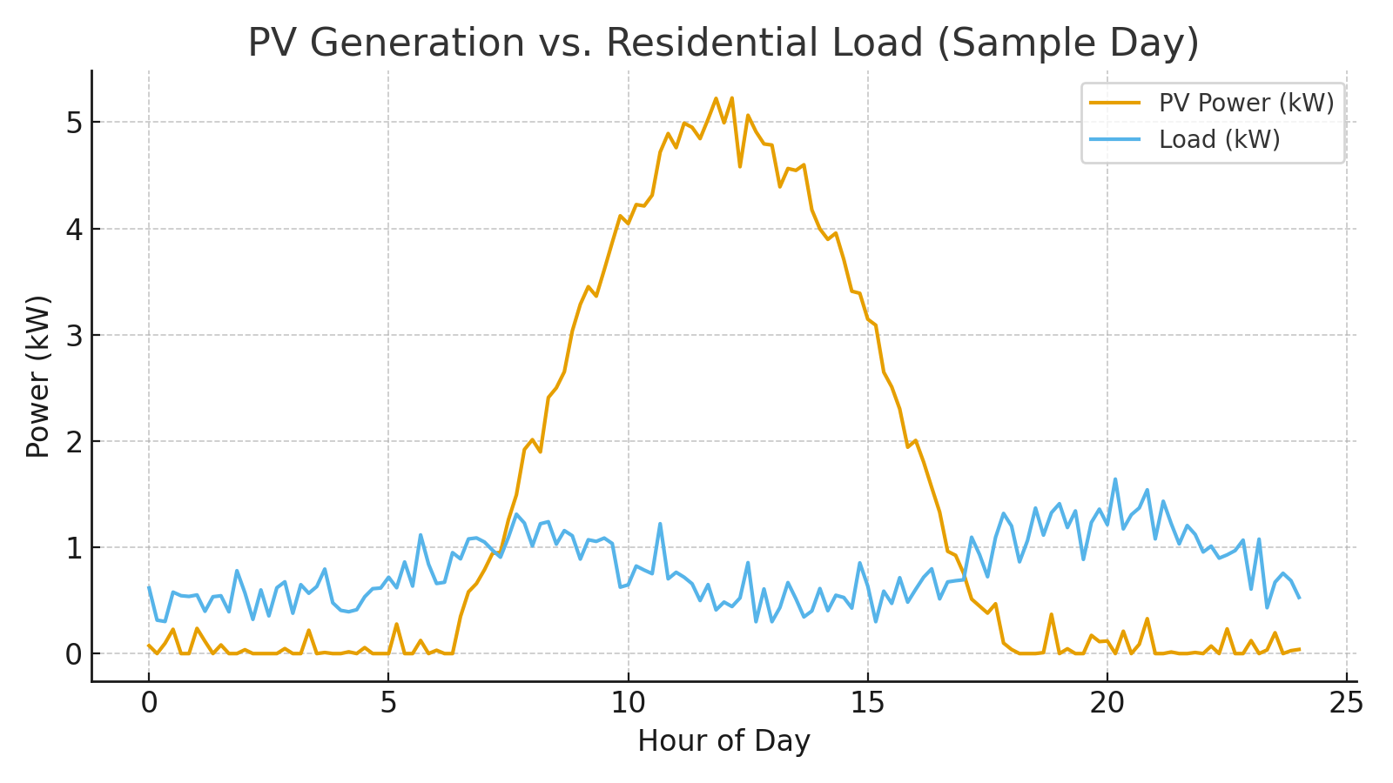
Fig. 1. PV generation vs. residential load (sample clear-sky day).
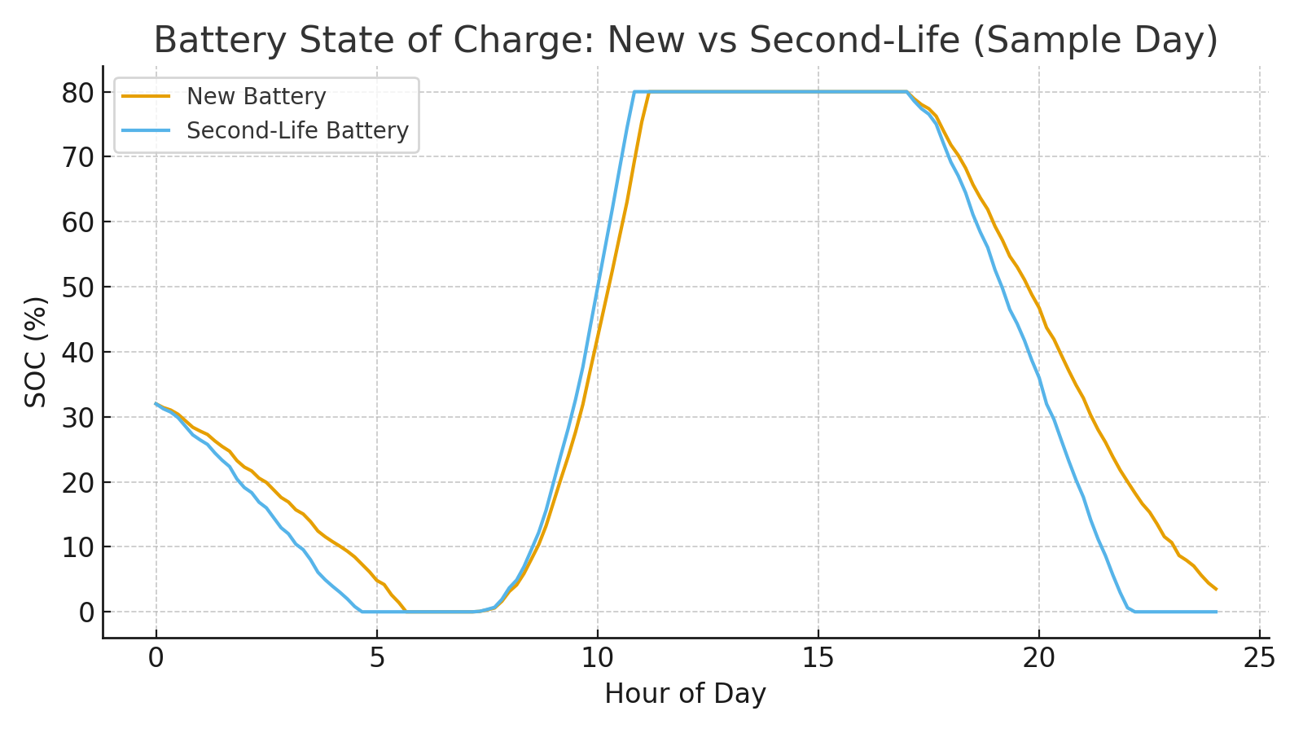
Fig. 2. Battery state of charge (SOC) for new and second-life batteries.
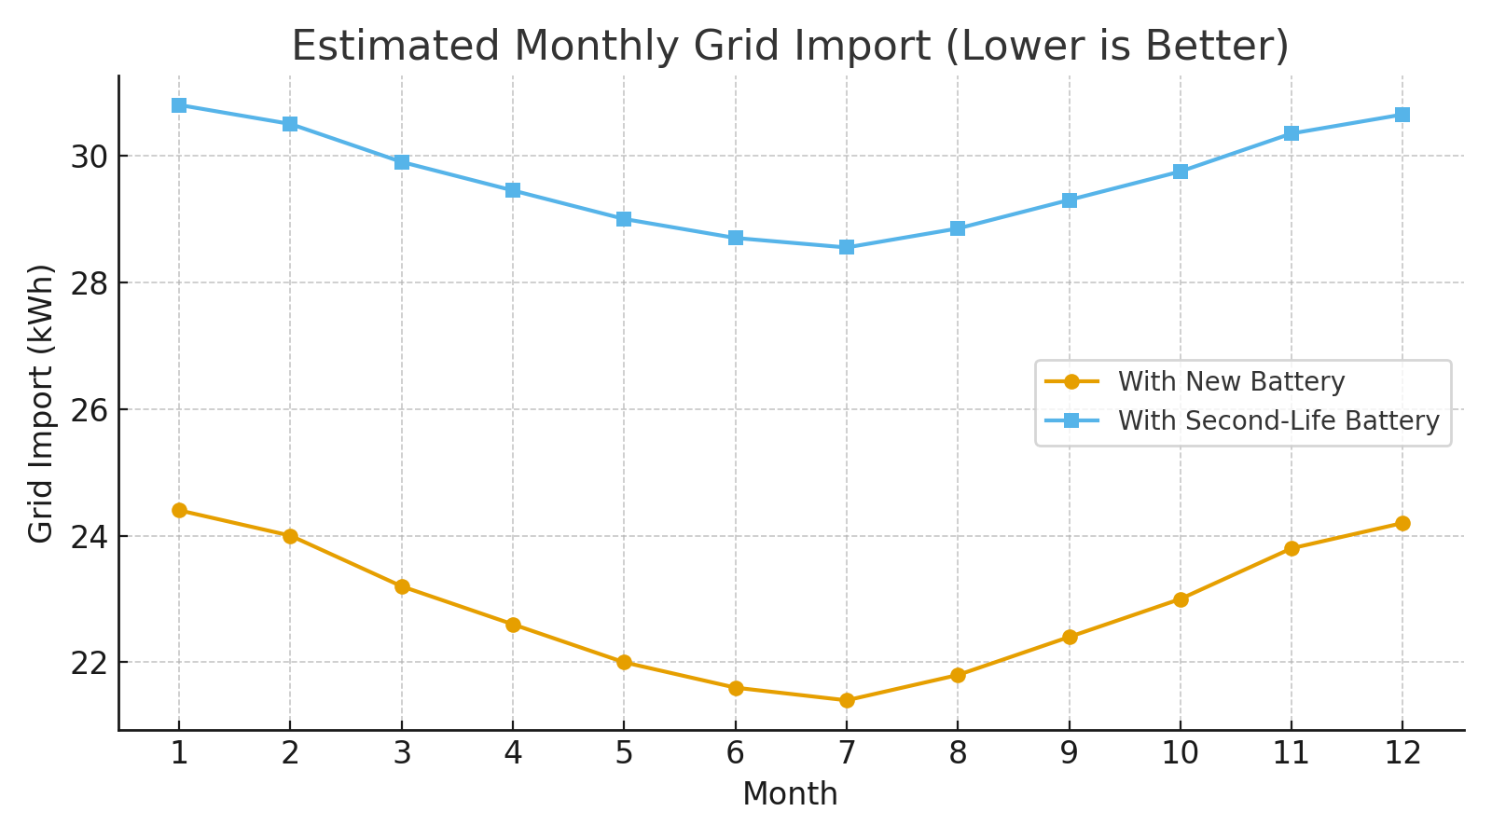
Fig. 3. Estimated monthly grid import with new vs. second-life batteries.
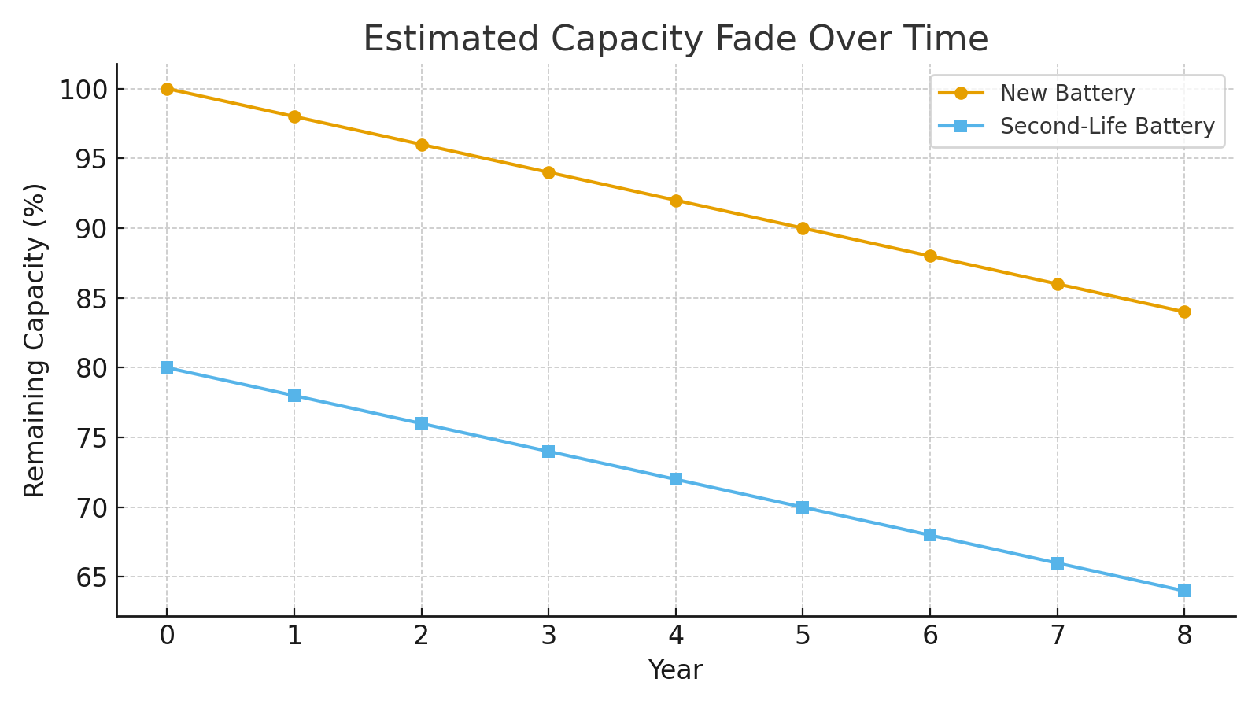
Fig. 4. Indicative capacity fade over years (new vs. second-life).
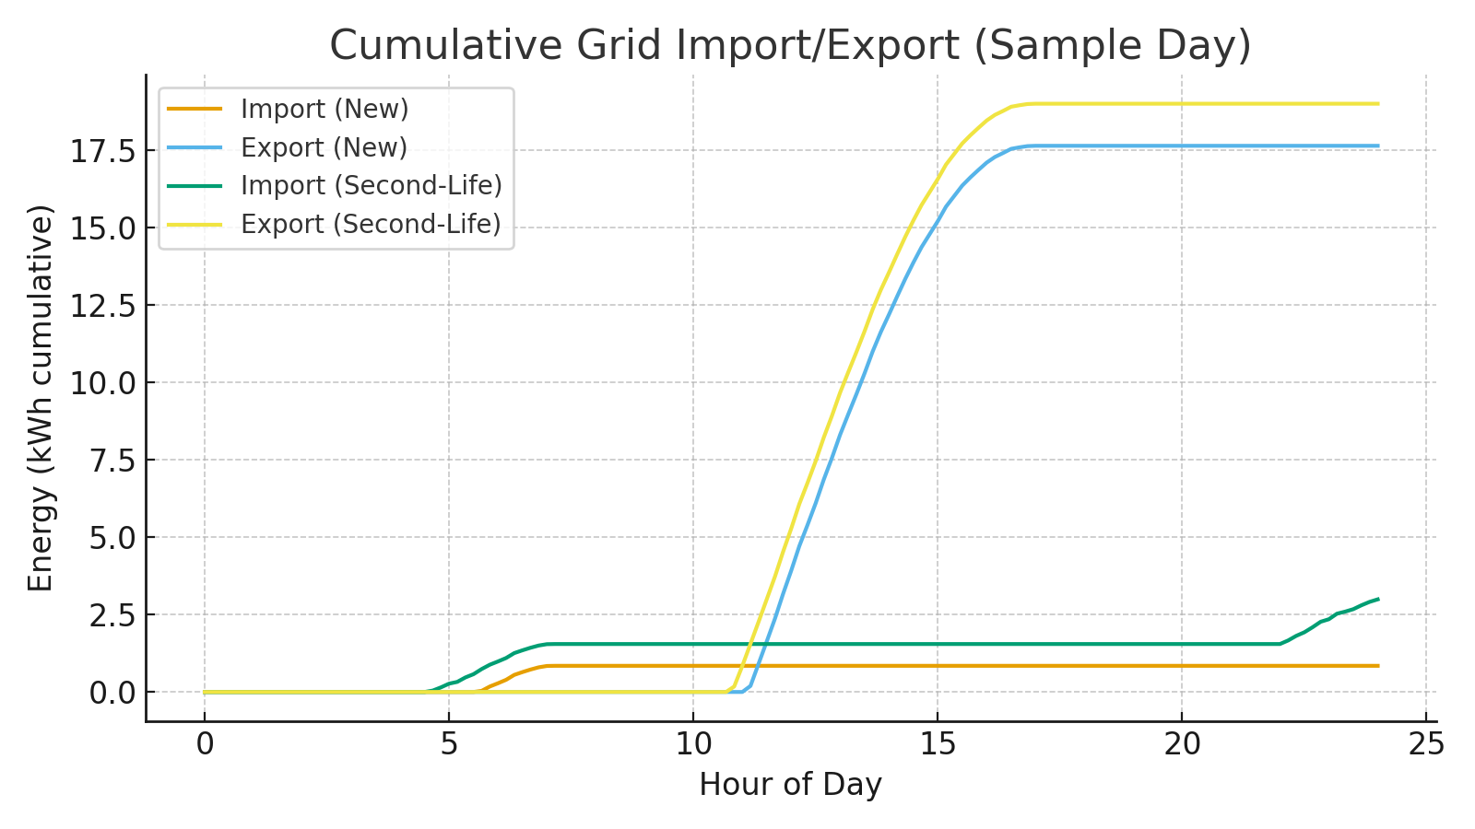
Fig. 5. Cumulative grid import/export for both cases (sample day).
Table II. Performance Summary (Sample Day)
Scenario | Grid Import (kWh) | Grid Export (kWh) | Notes
New Battery | 0.8 | 17.6 | Higher capacity, higher efficiency
Second-Life Battery | 3.0 | 19.0 | Lower capacity, slightly lower efficiency
Table III. Illustrative Economics (Daily)
Metric | New Battery | Second-Life Battery | Assumptions
Tariff (USD/kWh) | 0.10 | 0.10 | Flat tariff for illustration
Grid Import (kWh) | 0.8 | 3.0 | From simulation
Daily Import Cost (USD) | 0.08 | 0.30 | Import × tariff
Relative Import Cost vs New | — | +0.21/day | Higher import for second-life

V. Conclusion and Future Work
Under representative Pakistani conditions, integrating second-life EV batteries into residential PV systems can materially reduce grid imports and enhance self-consumption with modest performance penalties relative to new batteries. Optimization of sizing and dispatch can further improve results. Future work should validate with measured data, refine ageing models, and evaluate safety and policy frameworks for large-scale second-life deployment.

References
[1] International Renewable Energy Agency (IRENA), 'Future of Solar Photovoltaic,' 2019.
[2] MathWorks, 'Simscape Battery and Simulink Documentation,' 2024.
[3] National Renewable Energy Laboratory (NREL), 'PV Performance Modeling Collaborative,' 2023.
[4] Recurrent Auto, 'EV Battery Health in the Real World,' 2023.
[5] Energies Journal, 'Second-Life EV Batteries for Stationary Storage,' 2024.
[6] World Bank / WEF, 'Distributed Solar in Emerging Economies,' 2024.
[7] Pakistan AEDB, 'Alternative & Renewable Energy Policy,' 2019.
[8] IEEE, 'Battery Management Systems for Second-Life Applications,' 2022.

