An In Vitro Phantom Study for the Development of Novel Reconstructive Flap Monitoring Systems
Hiroki Kodama, MD, PhD^{1,2}, James May, MSc, PhD ², Dariush Nikkhah, FRCS (Plast) ¹, Panicos A Kyriacou, MSc, PhD ²

1. Research Centre for Biomedical Engineering, City, University of London, London, United Kingdom
2. Department of Plastic and Reconstructive Surgery, Royal Free London NHS Foundation Trust, London, United Kingdom

Corresponding author: Hiroki Kodama (ORCID: 0009-0005-3970-0770)
Address: Northampton Square, London, EC1V 0HB, United Kingdom
Email: Hiroki.Kodama.2@city.ac.uk

Abstruct

Background: Free flap monitoring remains reliant on clinical observation, which is subjective and may delay detection of vascular compromise. Photoplethysmography (PPG) offers promise as a non-invasive tool, but suitable in vitro models to evaluate its utility are lacking.

Methods: Custom silicone artery and vein phantoms were fabricated using adjustable ratios of deadener and hardener to replicate the mechanical properties of human forearm vessels. These were embedded in a tissue phantom at a depth of 3 mm to simulate pedicle positioning and integrated into a perfusion system. Internal pressure was modulated to reproduce normal, ischemic, and congested states. Red (660 nm) and infrared (940 nm) PPG signals were recorded, and amplitude differences between conditions were analyzed using Kruskal–Wallis and Dunn’s post hoc tests.

Results: Mechanical testing confirmed that a hardener ratio of 0.6 reproduced arterial properties, while a deadener ratio of 0.4 matched venous characteristics. PPG amplitude increased under ischemia and decreased under congestion compared with normal flow. These changes were statistically significant for both red and infrared signals (p < 0.001).

Conclusion: This study demonstrates the feasibility of a customizable vascular-tissue phantom for simulating perfusion states and detecting flow abnormalities via PPG, providing a platform for future flap monitoring technologies.

1. Introduction
Free flap surgery is a powerful reconstructive technique that involves transplanting the patient's own tissue to another site, commonly used for complex defects in the head and neck¹, breast², and limbs³. A major postoperative risk is blood flow insufficiency, with a 3-5% incidence of thrombosis occurring^{1,4} within the first 48 hours^{5–7}. Delayed diagnosis of vascular compromise can lead to flap loss, necessitating re-operation and delaying recovery. Past research has shown that timely salvage surgery, performed within 24 hours of identifying a vascular issue, can rescue 70-80% of compromised flaps^{4,8–10}.
Currently, the gold standard for monitoring is clinical observation, which involves assessing skin color, temperature, and capillary refill. While this method is a valuable tool, it is subjective and labour-intensive¹¹, making it prone to missing subtle, early changes. An ideal monitoring system must be accurate, reliable, safe, and capable of distinguishing between arterial and venous abnormalities¹². To meet these criteria, a variety of monitoring devices have been developed. These include pinpoint measurement devices like near-infrared spectroscopy (NIRS) ¹³, laser Doppler flowmetry (LDF) ¹⁴, and implantable Doppler¹⁵, as well as imaging-based devices such as indocyanine green angiography¹⁶ and thermography¹⁷. However, each of these technologies has its own strengths and limitations, and a universal consensus on their use remains to be reached¹⁸.
In vitro studies in a controlled environment offer a promising pathway for the development of new non-invasive technologies and signal processing algorithms for free flap monitoring. Specifically, photoplethysmography (PPG) sensor technology has been discussed for its potential to provide information directly related to blood flow abnormalities in free flaps¹⁹. Prior studies have attempted to create artificial blood vessels using techniques such as 3D bioprinting^{20–22}, laminar flow-based microfluidics^{23,24}, and coaxial scale-up printing²⁵. While these approaches have shown promising results, they have limitations. For example, printing often relies heavily on specific types of ink, and techniques related to laminar flow-based microfluidics can be complex²⁶.
In this paper, we describe the fabrication, mechanical testing, and PPG feature extraction of custom silicone blood vessel and tissue phantoms to simulate the human vascular system in an in vitro setup using silicone additives. This method builds on a previous approach outlined at the Centre for Biomedical Engineering Research at City, University of London^{27–29}. Researchers successfully created arteries of varying stiffness to simulate arteriosclerosis, but the elasticity required to model free flap arteries and veins has not yet been addressed.
Custom blood vessels were created using PlatSil silicone³⁰, based on the previously reported compliance of arteries and veins. Furthermore, this silicone contains scattering bodies to diffuse sensor light in a manner more similar to human tissue³¹. The custom vessels were embedded in a tissue phantom that mimics the surrounding tissue to create a vascular-tissue phantom. The resulting phantom was integrated into an in vitro model emulating blood circulation and used for PPG signal measurement and statistical analysis. This device was used to pump fluid throughout the entire system and observe changes in PPG signals in response to vascular volume changes during free flap ischemia and congestion.
There have been no prior reports of free flap phantom development. This study’s purpose is the first to create a phantom that mimics the arteries, veins, and subcutaneous tissue from inorganic materials. The novelty of this work also lies in its ability to simulate ischemic and congested states by adjusting intravascular pressure.

2. Methods
The experimental setup utilised a custom-built flow phantom to replicate the microcirculation of a free flap. Two main experiments were conducted: one simulating arterial flow and the other simulating venous congestion.

2.1. Free Flap Phantom Creation
We created custom artery and vein phantoms with mechanical properties highly similar to those of human forearm vessels. These were integrated into an in vitro system to introduce various blood flow states (ischemia, normal flow, and congestion) while maintaining a heart rate of 66 bpm. The resulting PPG signals were observed and subsequently analysed for statistical significance.
The phantom creation was based on previous research conducted in our laboratory^{27–29}.
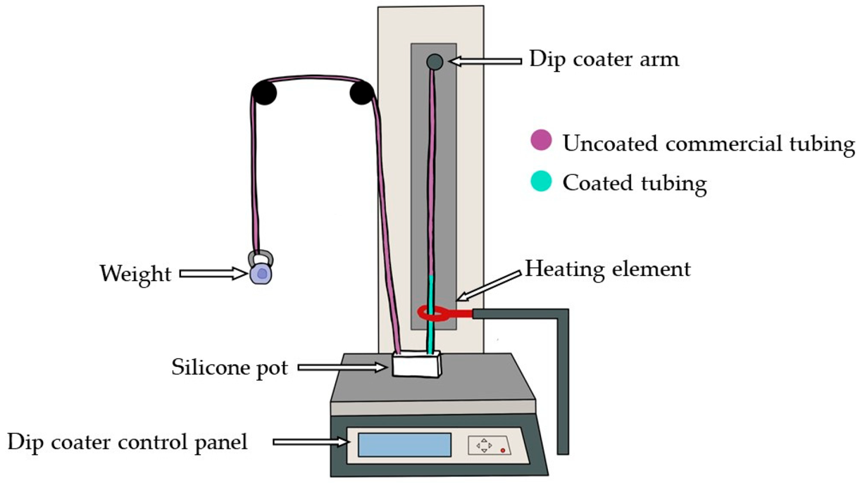
Figure1. Schematic diagram of the dip-coating stage to produce customised vessels.
The mechanical properties of the vessels were determined by measuring the inflation ratio in response to internal pressure changes during a hydrostatic pressure test. To determine compliance, vessels were cut into 5-10.5 cm lengths and connected to a closed-loop circuit with adjustable internal pressure. The elasticity of the vessels was assumed to be uniform and homogeneous along their entire length. Internal pressure was increased within the ranges of 60-120 mmHg for arteries and 10-30 mmHg for veins to simulate systolic and diastolic pressures³². During this process, images were captured using a digital microscope (Celestron, Torrance, CA, USA). Changes in diameter were precisely measured using a 0.01 mm micrometre scale.
The relationship between the circumferential strain ($εθ$) and longitudinal strain ($εz$​) of a tube is defined by Poisson's ratio ($v$)³³:
$$εθ= εz ∙2 ∙\frac{1-v/2}{1-2v}$$
For soft silicones, where $v$ is approximated as 0.49, $εz$ is negligibly small.
$$εθ≅75.5∙εz$$
Before conducting the experiment, the elongation rate of the soft tube was actually measured to confirm that this process was applicable.
From the changes in the fabricated vessels in response to pressure, the cross-sectional area (CSA) and compliance (C) were calculated. Assuming the wall thickness (d), outer diameter (OD), inner diameter (ID), and cross-sectional area (CSA) at a given internal pressure x are d_{x}​, OD_{x}​, ID_{x}​, and CSA_{x}​ respectively, they can be calculated as follows³⁴:
$$d_{x}= d_{0}∙(\frac{{OD}_{0}}{{OD}_{x}})$$
$${ID}_{x}={OD}_{x}-2d_{x}$$
$${CSA}_{x}= π∙{\left(\frac{{ID}_{x}}{2}\right)}^{2}= π∙\frac{{({OD}_{x}-{2d}_{x})}^{2}}{4}$$
$$C= \frac{{CSA}_{max}-{CSA}_{min}}{∆Pressure}$$
The measured values of d₀, OD₀, and OD_{x} were applied to these formula to calculate ΔCSA andC for both the artery (60-120 mmHg) and the vein (10-30 mmHg).
Following this, a vascular-tissue phantom was created by embedding these vessels in a surrounding tissue matrix, mimicking the vascular tissue environment, in a procedure similar to what was previously outlined.

2.2. In Vitro Cardiovascular System Configuration
The fabricated phantom artery was incorporated into an in vitro vascular system. To simulate blood flow, a liquid composed of deionized water and methylene blue powder (Thermo Fisher Scientific, UK)³⁵ was circulated throughout the system using a pulsating pump (PD-1100, BDC Laboratories, Wheat Ridge, CO). operating at 66 bpm. The phantom vein was assumed to have minimal pulsation and was therefore connected to a closed circuit with adjustable internal pressure. A reflective-mode PPG sensor with two wavelengths (red: 660 nm, infrared: 940 nm) was placed on top of the phantom to record the signals³⁶, which were displayed and recorded in LabVIEW (Version 2023 Q1, National Instruments, Austin, TX).
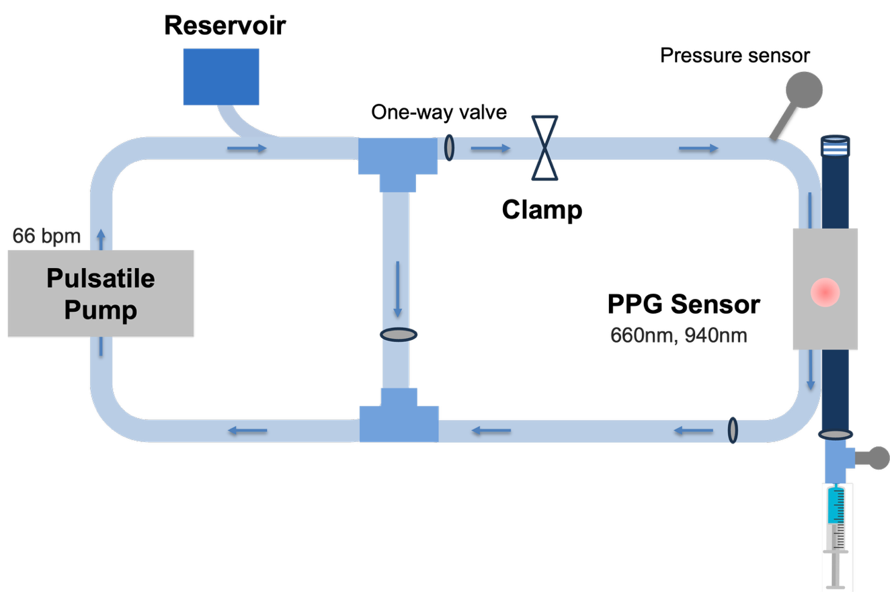
Figure 2. Schematic Diagram of the Cardiovascular System. A PPG sensor is applied to a tissue phantom (grey) containing an artery connected to a pump and a vein connected to a closed circuit.

2.3. Induction of Ischemia and Congestion
Arterial internal pressure was set to 60-120 mmHg for the normal state, 30 mmHg for the ischemic state, and 60 mmHg for the congested state^{37,38}. The adjustment of internal pressure was done by adjusting a clamp within the circuit. The venous internal pressure, on the other hand, was set to 10 mmHg for the normal and ischemic states and 30 mmHg for the congested state, which was adjusted by injecting fluid via a syringe through a valve.

2.4. PPG Signal Analysis
PPG signals were extracted for the three conditions: normal, ischemic, and congested. For ischemia, a decrease in arterial blood volume was expected, while for congestion, an increase in venous blood volume was anticipated. This was expected to result in fewer absorbed photons and a greater number of detected photons by the photodetector during ischemia, and the opposite during congestion.

2.5. Statistical Analysis
Statistical analysis of the recorded signals was performed using the Kruskal-Wallis test³⁹, a non-parametric one-way analysis of variance designed to evaluate differences among three or more independent groups. This test serves as an extension of the Mann-Whitney U test, allowing for the comparison of multiple independent samples^{40,41}. In this study, we analyzed the extracted features from the tissue phantoms under various states (normal, ischemic, and congested) to determine if a statistically significant difference existed between them. Significance was defined as p < 0.05 ⁴². This analysis aimed to evaluate whether the extracted features could successfully differentiate between normal circulation and states of ischemia and congestion.

3. Results

3.1. Phantom Fabrication and Mechanical Characterization
Based on previous research, the mechanical properties of the vessels were reproduced by mixing equal parts of Gel-00 (Polytek Development Corp., Easton, PA, USA) Part A and Part B with appropriate ratios of deadener (D) and hardener (H), along with a 2% retarder²⁹.
To demonstrate that the longitudinal strain was negligible, a soft 10 cm tube intended to represent a vein was placed in a horizontal water-filled circuit.
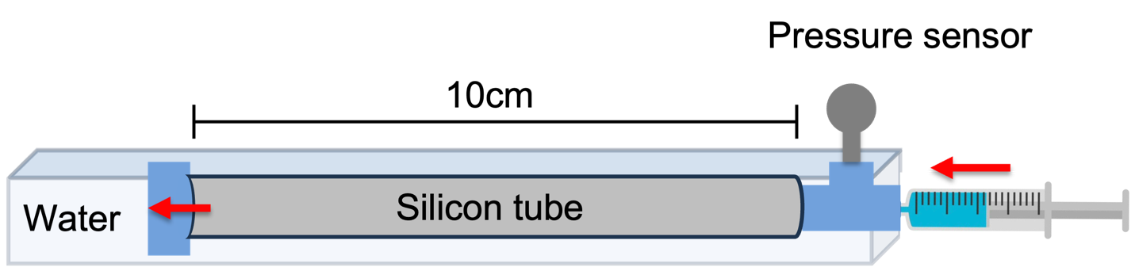
Figure 3. To measure the longitudinal strain, the tube was placed in water to avoid friction with the floor.
The length of the tube was measured as the pressure was increased up to 30 mmHg. As shown in the table below, the change in longitudinal strain was less than 1% for the softest vein phantom. Therefore, longitudinal strain was considered negligible for our calculations, and changes in wall thickness after pressurization were calculated based on the circumferential strain.
Mixture Ratio (A:B:D) | 0 mmHg | 10 mmHg | 30 mmHg
1:1:0.6 | 10 cm | 10 cm | 10.1 cm
1:1:0.4 | 10 cm | 10 cm | 10 cm
1:1:0.2 | 10 cm | 10.0 cm | 10cm
Table 1: Longitudinal Strain Test
Given that the change in longitudinal strain in a soft vein is minimal—less than 1% even at maximum internal pressure—we decided to disregard longitudinal strain in our calculations. This means that the change in wall thickness after pressurisation was calculated solely based on circumferential strain.
The fabricated tube was thinly sliced, stained black, and placed on a 0.01 mm micrometer scale. Its wall thickness was then measured under a microscope.
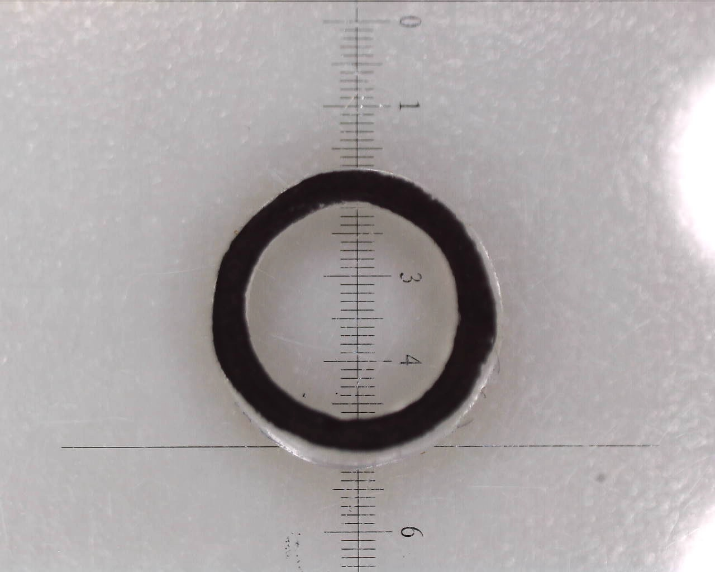
Figure 4. The wall thickness of the fabricated tube was measured under a microscope.
The fabricated tube was connected to a closed circuit, and its outer diameter (OD) was measured under a microscope while an appropriate internal pressure was applied.
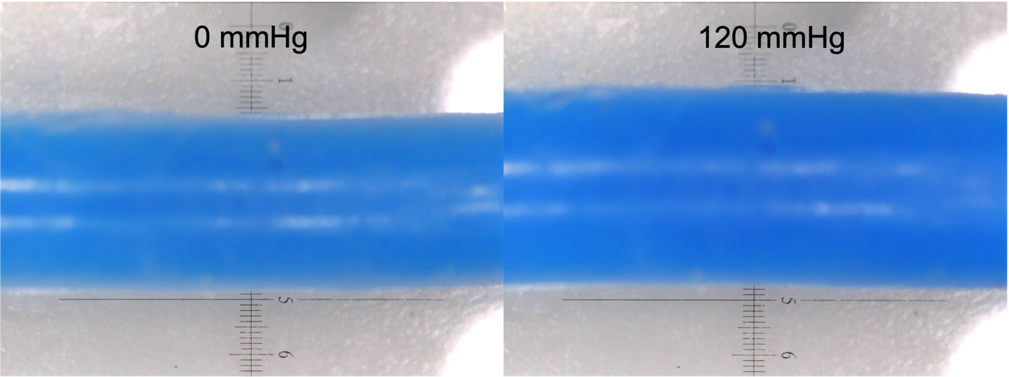
Figure 5. Using a 0.01 mm micrometer scale, the outer diameter corresponding to the internal pressure was measured accurately. The outer diameter was measured three times at various points, and the average value was taken as the final result.
An investigation was conducted to determine the appropriate silicone mixing ratio to mimic the mechanical properties of arteries. Previous studies have reported that the change in cross-sectional area (ΔCSA) for the radial and brachial arteries is 23.5% and 25.9%, respectively, with a corresponding compliance of 1.30 and 3.52 ($×{10}^{-4}$ cm²/mmHg)³⁴. To identify an A:B:H blend that approximates these values, the mechanical properties of tubes from several different mixtures were measured.
A:B:H | d₀ | ID₀ | OD₀ | OD₆₀ | OD₁₂₀ | CSA₆₀(mm²) | CSA₁₂₀(mm²) | ΔCSA(%) | C(10⁻⁴*cm²/mmHg)
1:1:0.4 | 0.68 | 2.78 | 4.14 | 4.42 | 4.96 | 7.77 | 11.5 | 47.8 | 6.19
1:1:0.5 | 0.57 | 2.63 | 3.77 | 4.03 | 4.41 | 6.89 | 9.27 | 34.4 | 3.95
1:1:0.6 | 0.63 | 2.72 | 3.98 | 4.24 | 4.52 | 7.34 | 9.14 | 24.4 | 2.99
1:1:0.7 | 0.56 | 2.8 | 3.92 | 4.08 | 4.25 | 7.09 | 8.13 | 14.7 | 1.73
Table 2. Investigation of Silicone Mixing Ratios For Artery.
Meanwhile, previous studies have reported that the ΔCSA for the cephalic and basilic veins is 41.8% and 27.2%, respectively, with a corresponding compliance of 5.6 and 17.4 ($×{10}^{-4}$ cm²/mmHg)³⁴.
A:B:D | d₀ | ID₀ | OD₀ | OD₁₀ | OD₃₀ | CSA₁₀(mm²) | CSA₃₀(mm²) | ΔCSA(%) | C(10⁻⁴*cm²/mmHg)
1:1:0.6 | 0.95 | 2.8 | 4.7 | 4.88 | 5.65 | 7.31 | 13.0 | 78.0 | 28.5
1:1:0.4 | 1.05 | 3.19 | 5.29 | 5.48 | 5.88 | 9.36 | 12.5 | 33.6 | 15.7
1:1:0.2 | 1.26 | 2.17 | 4.69 | 4.77 | 44.97 | 4.13 | 5.28 | 27.9 | 5.7
Table 3. Investigation of Silicone Mixing Ratios For Vein.
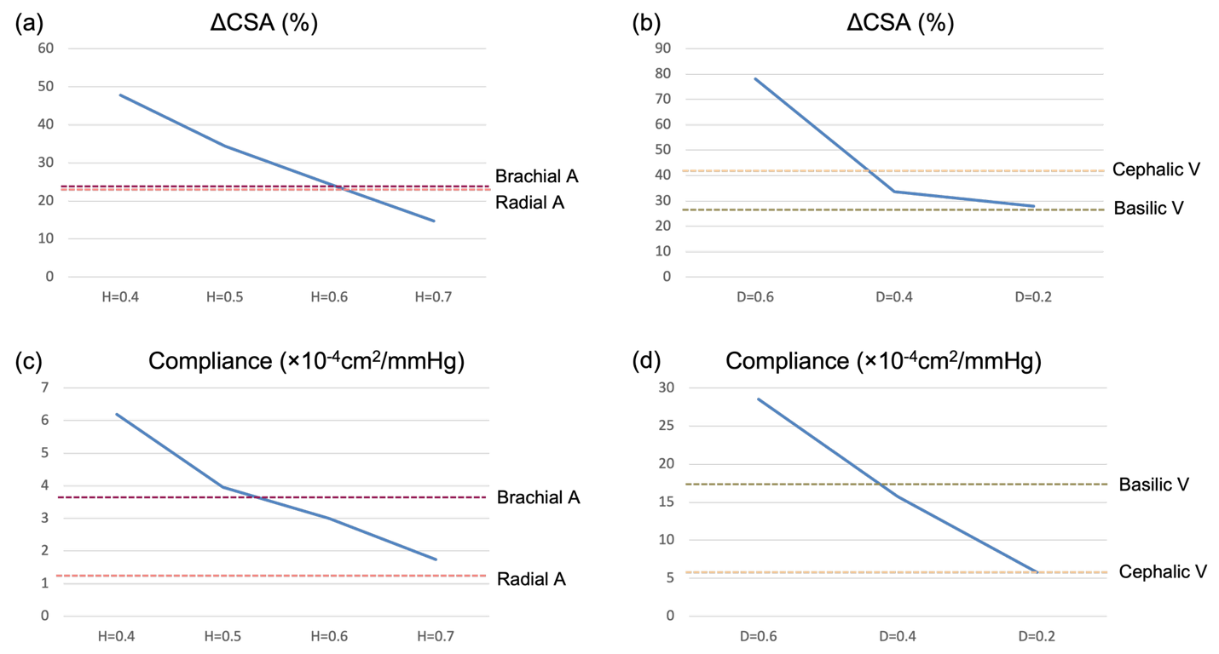
Figure 6. (a) The blending ratio of H = 0.6 reproduces the target ΔCSA. (b) The blending ratios of H = 0.6 and 0.7 reproduce the target compliance. (c)The blending ratios of D = 0.2 and 0.4 reproduce the target ΔCSA. (d) The blending ratios of D = 0.2 and 0.4 reproduce the target compliance.
Based on these results, the silicone formulations adopted for the phantom were A:B:H = 1:1:0.6 for the artery and A:B:D = 1:1:0.4 for the vein. These artery and vein phantoms were then embedded 3 mm deep within a subcutaneous tissue phantom (A:B:D=1:1:1) created based on a previous report^{43,28,29}.

3.2. Pressure Adjustment
Based on a review of previous literature^{37,38}, the arterial and venous pressures for normal, ischemic, and congested conditions were set as shown in Table 4.
 | Normal | Ischaemia | Congestion
Artery | 60-120 | 30 | 60
Vein | 10 | 10 | 30
Table 4. Arterial and Venous Pressure Settings for Normal, Ischemic, and Congested Conditions.
Arterial pressure was adjusted by controlling the volume of solution in the circuit and by using a clamp. Venous pressure was adjusted by injecting a solution through a one-way valve. Graphs of the actual measured arterial and venous pressures are shown in Figures 7 and 8.
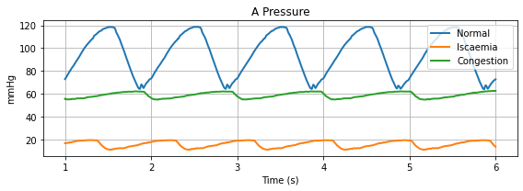
Figure 6. Arterial pressure for 3 conditions
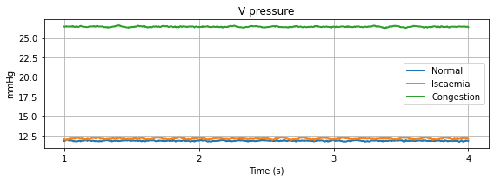
Figure 7. Venous pressure for 3 conditions

3.3. PPG Signal Acquisition and Analysis
A graph overlaying the signals for normal, ischemic, and congested conditions is shown in Figures 9 and 10.
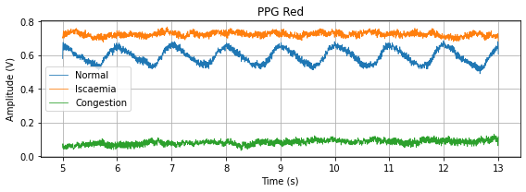
Figures 9. PPG signals (Red) between each state
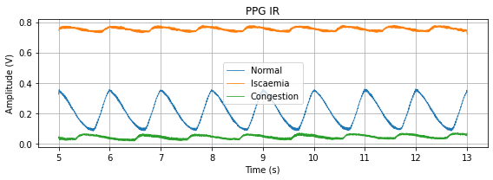
Figures 10. PPG signals (IR between each state

There were visual changes in the PPG signal between each state. Amplitude increased during ischemia, while it decreased during congestion. In the normal state, the cardiac waveform was clear. Comparing the Red and IR signals, the amplitude of the normal waveform in IR was closer to the congestion value than the ischemia value.
The systolic PPG amplitude was quantified through feature extraction and is shown in the box plot in Figure 11, illustrating the change in amplitude between the vascular tissue phantoms.
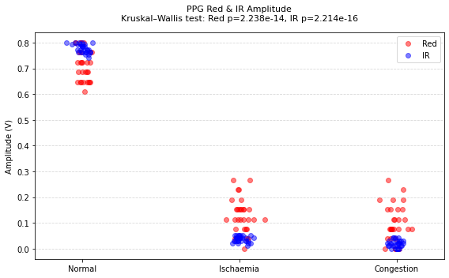
Figures 10. Quantified Systolic PPG Amplitude for Each Condition and Wavelength
This change was analysed for statistical significance using a Kruskal-Wallis analysis (Table 5).
Comparison | Chi-Squared | df | p-Value
Red | 62.861 | 2 | 2.238×10⁻¹⁴
IR | 72.093 | 2 | 2.214×10⁻¹⁶
Table 5. Kruskal–Wallis analysis of red and infrared PPG amplitudes.
P-values of 2.238×10⁻¹⁴ for Red and 2.214×10⁻¹⁶ for IR indicate a significant difference in amplitude between the phantoms (p<0.001). To determine the extent of the difference between each phantom, a Dunn's test was applied as a post-hoc analysis (Table 6). The multiple-comparison adjusted p-values suggest that the PPG amplitudes of all three phantoms are significantly different (p<0.001).
Comparison | Z (Red/IR) | p (Unadjusted)(Red/IR) | p (Adjusted)(Red/IR)
N vs I | 5.74 / 4.89 | <0.001 / <0.001 | <0.001 / <0.001
N vs C | 7.61 / 8.46 | <0.001 / <0.001 | <0.001 / <0.001
I vs C | 1.87 / 3.57 | <0.001 / <0.001 | <0.001 / <0.001
Table 6. Dunn test of PPG amplitudes between each condition. N: Normal, I: Ischaemia, C: Congestion

4. Discussion
This study proposes an innovative approach to investigate the effect of vascular stiffness on PPG signals using a novel vascular tissue phantom. The process outlined in this paper allows for the mechanical properties of both arteries and veins to be replicated by modifying the elastomeric characteristics of the phantom, making it possible to simulate both ischemic and congested states. The stiffness of the vessels and surrounding tissue can be adjusted by adding a hardener or deadener. Preliminary PPG signal analysis confirmed that changes in blood flow conditions within the phantom led to significant amplitude variations. When the concentration of the deadener was increased to a maximum of 0.6 parts, the tube's length increased by only 1%. This indicates that while the deadener affects the composition of the material, it has a negligible effect on the longitudinal strain.
In this study, the mechanical properties of the tubes were evaluated using internal pressure testing. Although uniaxial tensile testing of Young’s modulus is commonly employed in vascular graft research, it has inherent limitations in replicating the multi-axial mechanical environment of native vessels⁴⁴. In particular, it cannot capture circumferential compliance or the nonlinear, anisotropic behaviour that is central to physiological function. By contrast, internal pressure testing directly assesses compliance and pressure–diameter relationships under conditions resembling blood flow, thereby providing more appropriate insights into circumferential mechanics⁴⁵. The circumferential compliance assessment conducted here represents a core element of the ISO 7198:2016 framework and provides fundamental knowledge regarding the pressure–diameter behaviour of vascular constructs⁴⁶. Future studies should expand this approach to include comprehensive compliance characterisation, incorporating cyclic pressurisation across multiple pressure ranges and temperature-controlled conditions, in order to achieve direct alignment with international benchmarks. Furthermore, this method enables comparison with previous findings, such as ultrasound-based assessments of pressure-dependent cross-sectional area changes in arteries and veins, by applying the same calculation formulas to evaluate differences in cross-sectional area and compliance relative to healthy forearm vessels³⁴.
As expected, increasing the proportion of deadener led to greater cross-sectional area changes and compliance in response to pressure, whereas increasing the proportion of hardener produced the opposite effect, reducing both parameters. The arterial models best reproduced the mechanical properties of the radial and brachial arteries when the hardener was used at a ratio of 0.6 (30% of total weight), while the venous models most closely mimicked the cephalic and basilic veins when the deadener was used at a ratio of 0.4 (20% of total weight). In terms of size, arterioles are reported to have a diameter of 1–6 mm and a wall thickness of 0.125–0.8 mm. The models we fabricated fell within this range⁴⁴. Furthermore, the internal diameter of the deep inferior epigastric vein perforator, the drainage vein for the abdominal flap, has been reported to be 0.50 to 4.32 mm⁴⁷, which was also within the range of our fabricated models. According to Cappelletti et al., under normal blood pressure conditions, the mean cross-sectional area change in healthy adults is 3.4 to 4.2 mm² (+23.5%) for the radial artery and 8.1 to 10.2 mm² (+25.9%) for the brachial artery³⁴. In comparison, the arterial model with a hardener ratio of 0.6 exhibited a cross-sectional area change of 7.34 → 9.14 mm² (+24.4%), indicating that the mechanical properties were reproduced within an appropriate range. Compliance values reported for the radial and brachial arteries are 1.3×10⁻⁴ and 3.52×10⁻⁴, respectively³⁴, while the compliance of the arterial model was 2.99×10⁻⁴, again falling within a comparable range. Similarly, under normal blood pressure conditions, the mean cross-sectional area change in the cephalic and basilic veins of healthy adults is 5.5 to 7.8 mm² (+41.8%) and 16.9 to 21.5 mm² (+27.2%), respectively³⁴. The venous model with a deadener ratio of 0.4 demonstrated a change of 9.36 to 12.5 mm² (+36.6%), reproducing venous mechanical behaviour within an appropriate range. Reported compliance values for the cephalic and basilic veins are 5.6×10⁻⁴ and 17.4×10⁻⁴, respectively³⁴, and the compliance of the venous model was 15.7×10⁻⁴, also consistent with physiological values.
These arterial and venous models were embedded at a depth of 3 mm within a tissue phantom composed of deadener mixed at an equal ratio (50% by weight), thereby reproducing the mechanical properties of human tissue. Previous reports indicate that the combined thickness of the epidermis and dermis is approximately 1–2 mm⁴⁸; thus, a depth of 3 mm corresponds to the subcutaneous tissue layer, consistent with the pedicle depth simulated in this phantom. The phantom was connected to a perfusion circuit in order to investigate how photoplethysmography (PPG) signals differed between normal, ischemic, and congested states.
Red and infrared PPG signals were recorded and analyzed on a cycle-by-cycle basis, revealing a reduction in PPG amplitude under both ischemic and congested conditions. Kruskal–Wallis analysis followed by Dunn’s post hoc test demonstrated that these changes were statistically significant (p < 0.001), supporting the hypothesis that PPG signals, particularly amplitude variations, can discriminate between normal and abnormal perfusion states. Moreover, amplitudes were relatively higher in ischemia and lower in congestion, a trend consistent with the physiology of vascular behaviour and PPG measurement. As PPG is a volumetric method, suppressed vascular expansion results in smaller local blood volume changes and thus reduced signal amplitude. In addition, ischemia decreases intravascular volume, increasing the amount of reflected light detected, whereas congestion increases intravascular volume, thereby reducing detected light intensity.
Signal quality is of particular importance in in vitro studies. One major factor influencing signal quality is sensor contact. While firm and consistent contact has been shown to yield higher-quality signals, vasoconstriction may lead to quality deterioration^{49,50}. In the present in vitro setup, the phantom and sensor were housed in a custom case designed to minimise movement and ensure consistent contact force during measurements. Another factor is pump performance. The pump employed in this study (PD-1100, BDC Laboratories, Wheat Ridge, CO) was unable to generate a bimodal waveform, highlighting the need for future setups to incorporate more physiologically accurate waveforms to allow detailed morphological analysis.
5. Conclusion
With recent advancements in PPG technology, an in vitro device that can simulate normal, ischemic, and congested states would be a beneficial tool for applications in free flap monitoring. This paper describes the construction of customizable silicone arteries and veins, fabricated using a dip-coating method, for use in an in vitro vascular system. By adjusting the blend of deadener and hardener, the desired vessel thickness and mechanical properties can be achieved.
The purpose of this study was to develop a custom-made silicone phantom that simulates a free flap and to replicate ischemic and congested states. PPG signals obtained from this model were recorded and analyzed, allowing us to detect the morphological changes caused by each condition. A statistically significant change in amplitude was detected, which demonstrates the potential of PPG technology for detecting flap blood flow impairment.
Future work should aim to further improve the similarity of the phantom to human tissue by exploring different materials and generating signals that are even closer to those found in the human body. It is also necessary to investigate more advanced signal feature extraction and highly accurate anomaly detection methods.
6. References
1. Nakatsuka T, Harii K, Asato H, et al. Analytic Review of 2372 Free Flap Transfers for Head and Neck Reconstruction Following Cancer Resection. J reconstr Microsurg. 2003;19(06):363-368. doi:10.1055/s-2003-42630
2. Harashina T, Imai T, Nakajima H, Fujino T. Breast reconstruction with microsurgical free composite tissue transplantation. British Journal of Plastic Surgery. 1980;33(1):30-37. doi:10.1016/0007-1226(80)90048-X
3. Taylor GI, Miller GDH, Ham FJ. THE FREE VASCULARIZED BONE GRAFT: A Clinical Extension of Microvascular Techniques. Plastic and Reconstructive Surgery. 1975;55(5):533-544. doi:10.1097/00006534-197505000-00002
4. Caine P, Jeevaratnam JA, Misky A, Nikkhah D. Post-operative Monitoring. In: Core Techniques in Flap Reconstructive Microsurgery - A Stepwise Guide. Springer Nature Switzerland AG; 2023:39-46.
5. Tran NV, Buchel EW, Convery PA. Microvascular Complications of DIEP Flaps: Plastic and Reconstructive Surgery. 2007;119(5):1397-1405. doi:10.1097/01.prs.0000256045.71765.96
6. Bui DT, Cordeiro PG, Hu QY, Disa JJ, Pusic A, Mehrara BJ. Free Flap Reexploration: Indications, Treatment, and Outcomes in 1193 Free Flaps: Plastic and Reconstructive Surgery. 2007;119(7):2092-2100. doi:10.1097/01.prs.0000260598.24376.e1
7. Kroll SS, Schusterman MA, Reece GP, et al. Timing of Pedicle Thrombosis and Flap Loss after Free-Tissue Transfer: Plastic and Reconstructive Surgery. 1996;98(7):1230-1233. doi:10.1097/00006534-199612000-00017
8. Disa JJ, Cordeiro PG, Hidalgo DA. Efficacy of conventional monitoring techniques in free tissue transfer: an 11-year experience in 750 consecutive cases. Plast Reconstr Surg. 1999;104(1):97-101.
9. Chen KT, Mardini S, Chuang DCC, et al. Timing of Presentation of the First Signs of Vascular Compromise Dictates the Salvage Outcome of Free Flap Transfers: Plastic and Reconstructive Surgery. 2007;120(1):187-195. doi:10.1097/01.prs.0000264077.07779.50
10. Al-Dam A, Zrnc TA, Hanken H, et al. Outcome of microvascular free flaps in a high-volume training centre. Journal of Cranio-Maxillofacial Surgery. 2014;42(7):1178-1183. doi:10.1016/j.jcms.2014.02.005
11. Patel UA, Hernandez D, Shnayder Y, et al. Free Flap Reconstruction Monitoring Techniques and Frequency in the Era of Restricted Resident Work Hours. JAMA Otolaryngol Head Neck Surg. 2017;143(8):803. doi:10.1001/jamaoto.2017.0304
12. Creech B, Miller S. Evaluation of circulation in skin flaps. Skin Flaps Boston: Little, Brown. 1975;21.
13. Kagaya Y, Miyamoto S. A systematic review of near-infrared spectroscopy in flap monitoring: Current basic and clinical evidence and prospects. Journal of Plastic, Reconstructive & Aesthetic Surgery. 2018;71(2):246-257. doi:10.1016/j.bjps.2017.10.020
14. Yuen JC, Feng Z. Distinguishing laser Doppler flowmetric responses between arterial and venous obstructions in flaps. Journal of reconstructive microsurgery. 2000;16(8):629-635. doi:10.1055/s-2000-9381
15. Wu KG, Chong CT, Hanlon H, et al. Implantable arterial doppler efficacy in free flap reconstruction: A systematic review and meta‐analysis. Head & Neck. Published online August 29, 2023:hed.27500. doi:10.1002/hed.27500
16. Burnier P, Niddam J, Bosc R, Hersant B, Meningaud JP. Indocyanine green applications in plastic surgery: A review of the literature. Journal of Plastic, Reconstructive & Aesthetic Surgery. 2017;70(6):814-827. doi:10.1016/j.bjps.2017.01.020
17. Hudson T, Hogue E, Mullner D, Herrera F, Scomacao I. The Utility of Smartphone-Based Thermal Imaging in the Management and Monitoring of Microvascular Flap Procedures: A Systematic Review and Meta-Analysis. Ann Plast Surg. 2023;90(6S Suppl 4):S420-S425. doi:10.1097/SAP.0000000000003343
18. Kwasnicki RM, Noakes AJ, Banhidy N, Hettiaratchy S. Quantifying the Limitations of Clinical and Technology-based Flap Monitoring Strategies using a Systematic Thematic Analysis. Plastic and Reconstructive Surgery - Global Open. 2021;9(7):e3663. doi:10.1097/GOX.0000000000003663
19. Kyriacou PA, Zaman T, Pal SK. Photoplethysmography in postoperative monitoring of deep inferior epigastric perforator (DIEP) free flaps. Physiol Meas. 2020;41(12):124001. doi:10.1088/1361-6579/abc4c8
20. Datta P, Ayan B, Ozbolat IT. Bioprinting for vascular and vascularized tissue biofabrication. Acta Biomaterialia. 2017;51:1-20. doi:10.1016/j.actbio.2017.01.035
21. Schöneberg J, De Lorenzi F, Theek B, et al. Engineering biofunctional in vitro vessel models using a multilayer bioprinting technique. Sci Rep. 2018;8(1):10430. doi:10.1038/s41598-018-28715-0
22. Gao Q, Xie C, Wang P, et al. 3D printed multi-scale scaffolds with ultrafine fibers for providing excellent biocompatibility. Materials Science and Engineering: C. 2020;107:110269. doi:10.1016/j.msec.2019.110269
23. Nie J, Gao Q, Wang Y, et al. Vessel‐on‐a‐chip with Hydrogel‐based Microfluidics. Small. 2018;14(45):1802368. doi:10.1002/smll.201802368
24. Du X, Li Q, Wu G, Chen S. Multifunctional Micro/Nanoscale Fibers Based on Microfluidic Spinning Technology. Advanced Materials. 2019;31(52):1903733. doi:10.1002/adma.201903733
25. Liang Q, Gao F, Zeng Z, et al. Coaxial Scale‐Up Printing of Diameter‐Tunable Biohybrid Hydrogel Microtubes with High Strength, Perfusability, and Endothelialization. Adv Funct Materials. 2020;30(43):2001485. doi:10.1002/adfm.202001485
26. Zhou L, Li Y, Tu Q, Wang J. A 3D printing mold method for rapid fabrication of artificial blood vessels. Colloids and Surfaces A: Physicochemical and Engineering Aspects. 2023;662:130952. doi:10.1016/j.colsurfa.2023.130952
27. Nomoni M, May JM, Kyriacou PA. Novel Polydimethylsiloxane (PDMS) Pulsatile Vascular Tissue Phantoms for the In-Vitro Investigation of Light Tissue Interaction in Photoplethysmography. Sensors. 2020;20(15):4246. doi:10.3390/s20154246
28. Ferizoli R, Karimpour P, May JM, Kyriacou PA. Arterial stiffness assessment using PPG feature extraction and significance testing in an in vitro cardiovascular system. Sci Rep. 2024;14(1):2024. doi:10.1038/s41598-024-51395-y
29. Karimpour P, Ferizoli R, May JM, Kyriacou PA. Customisable Silicone Vessels and Tissue Phantoms for In Vitro Photoplethysmography Investigations into Cardiovascular Disease. Sensors. 2024;24(5):1681. doi:10.3390/s24051681
30. Available online: https://polytek.com/content/pdf/technicalbulletin/Polytek_TB_PlatSilGels_5-5-2021.pdf (accessed on 15 January 2025).
31. Tuchin VV, ed. Chapter 5 Tissue Phantoms. SPIE; 2016. doi:10.1117/3.2219603
32. Hesse B. VENOUS PRESSURE CHANGES DURING CONGESTION: Venous Pressure in the Great Saphenous Vein during Congestion with a Blood Pressure Cuff Proximal to the Knee. Journal of Internal Medicine. 1970;188(1-6):447-449. doi:10.1111/j.0954-6820.1970.tb08065.x
33. Pajic-Lijakovic I, Milivojevic M, McClintock PVE. Compressibility of biological systems: the viscoelastic Poisson’s ratio. Advances in Physics: X. 2025;10(1):2440023. doi:10.1080/23746149.2024.2440023
34. Cappelletti S, Caimi A, Caldiroli A, et al. Non-invasive estimation of vascular compliance and distensibility in the arm vessels: a novel ultrasound-based protocol. Quant Imaging Med Surg. 2022;12(7):3515-3527. doi:10.21037/qims-21-987
35. UV-Vis Spectrum of Methylene Blue Solution, with Maximu|Open-i. Available online: https://openi.nlm.nih.gov/detailedresult?img=PMC2808005_ijms-10-04707f6&req=4 (accessed on 16 January 2025).
36. Budidha K, Rybynok V, Kyriacou PA. Design and Development of a Modular, Multichannel Photoplethysmography System. IEEE Trans Instrum Meas. 2018;67(8):1954-1965. doi:10.1109/TIM.2018.2810643
37. Matsumine H, Mogami M, Fujiwara O, Hasegawa M, Ito H, Sakurai H. Improvement of the salvage‐rate of flap after venous thrombosis with intraparenchymatous venous pressure monitoring. Microsurgery. 2018;38(5):498-503. doi:10.1002/micr.30293
38. Saiga A, Kubota Y, Yamaji Y, Mitsukawa N. Intraflap Vascular Catheterization Method for Monitoring, Prevention, and Intervention of Thrombogenesis in Free-Flap Surgery. Ann Plast Surg. 2022;88(1):68-73. doi:10.1097/SAP.0000000000003049
39. Theodorsson-Norheim E. Kruskal-Wallis test: BASIC computer program to perform nonparametric one-way analysis of variance and multiple comparisons on ranks of several independent samples. Computer Methods and Programs in Biomedicine. 1986;23(1):57-62. doi:10.1016/0169-2607(86)90081-7
40. Whitley E, Ball J. Statistics review 6: Nonparametric methods. Crit Care. 2002;6(6):509. doi:10.1186/cc1820
41. Bewick V, Cheek L, Ball J. Statistics review 10: Further nonparametric methods. Crit Care. 2004;8(3):196. doi:10.1186/cc2857
42. Concato J, Hartigan JA. P Values: From Suggestion to Superstition. Journal of Investigative Medicine. 2016;64(7):1166-1171. doi:10.1136/jim-2016-000206
43. Falanga V, Bucalo B. Use of a durometer to assess skin hardness. Journal of the American Academy of Dermatology. 1993;29(1):47-51. doi:10.1016/0190-9622(93)70150-R
44. Camasão DB, Mantovani D. The mechanical characterization of blood vessels and their substitutes in the continuous quest for physiological-relevant performances. A critical review. Mater Today Bio. 2021;10:100106. doi:10.1016/j.mtbio.2021.100106
45. Macrae RA, Miller K, Doyle BJ. Methods in Mechanical Testing of Arterial Tissue: A Review. Strain. 2016;52(5):380-399. doi:10.1111/str.12183
46. Recognized Consensus Standards: Medical Devices. Available online: https://www.accessdata.fda.gov/scripts/cdrh/cfdocs/cfStandards/detail.cfm?standard__identification_no=34732 (accessed on 26 April 2025).
47. Ayhan S, Oktar SO, Tuncer S, Yucel C, Kandal S, Demirtas Y. Correlation between vessel diameters of superficial and deep inferior epigastric systems: Doppler ultrasound assessment. Journal of Plastic, Reconstructive & Aesthetic Surgery. 2009;62(9):1140-1147. doi:10.1016/j.bjps.2008.02.012
48. Olsen LO, Takiwaki H, Serup J. High‐frequency ultrasound characterization of normal skin. Skin thickness and echographic density of 22 anatomical sites. Skin Research and Technology. 1995;1(2):74-80. doi:10.1111/j.1600-0846.1995.tb00021.x
49. Karimpour P, May JM, Kyriacou PA. Photoplethysmography for the Assessment of Arterial Stiffness. Sensors. 2023;23(24):9882. doi:10.3390/s23249882
50. May JM, Mejía-Mejía E, Nomoni M, Budidha K, Choi C, Kyriacou PA. Effects of Contact Pressure in Reflectance Photoplethysmography in an In Vitro Tissue-Vessel Phantom. Sensors. 2021;21(24):8421. doi:10.3390/s21248421

