Power-to-Thrust Analysis: Investigating feasibility of Ionic Thruster Performance for Space Launch
Author: Said Zeki Gökmen
Subject: Physics
02.07.2025

Innhold
I - Abstract and introduction 3
II – Literature Review 5
III – Methodology 7
IV – Results 10
V – Analysis & Evaluation 12
VI – Conclusion 14
VII – Sources 15

I - Abstract and introduction

Abstract
This research essentially aims to investigate the power-to-thrust ratio of a smaller sized ionic thruster designed and built by me and ultimately aims to explore its feasibility for space launch missions by scaling it up to traditional sizes by looking at the ratio. Furthermore, the report will also investigate its scalability, compare theoretical data with the experimental ones for experimental validation, and potential optimizations for maximum thrust. Estimating for larger sized models in vacuum will be essential to understand this type of thruster systems application in space launch, and together with theoretically discussing the variations that could be implemented into the model, this report will investigate if this type of electric propulsion, propulsion systems that use electric or magnetic fields to accelerate charged particles (ions) or plasma, can be an alternative for traditionally used chemical propulsion. In the end, this report will discuss, and potentially challenge, the common view on electric propulsion and its unapplicable design for space launch.

Introduction
The exploration of space and its methods has always been a discussion point in terms of aerospace and astronautical engineering. It has been driven by the need for efficient and reliable propulsion systems. The traditionally used chemical propulsion, particularly liquid propulsion, has been the main way-to-go regarding space launch, owing to its capability of producing reliable high thrust. Liquid propulsion systems use the chemicals carried in external tanks for combusting reactions to produce thrust, creating significant advantages of high thrust-to-weight ratio, ability of throttling and restarting. They can either use a single fuel type (called monopropellant, e.g. liquid hydrazine) or two chemically combined types (e.g. hydrazine and oxidizers). However, it comes with some considerable limitations, low specific impulse which causes higher fuel consumption and increased mission cost stands as a challenge for space launch. Liquid propulsion systems have ranging specific impulse values, ranging from 285 s (for monopropellants) to 310 s (for bipropellants) (NASA, 2024). Specific Impulse ($I_{sp})$ is the thrust produced per unit used up over time, it is used as an indication of engine efficiency (Glenn Research Center).
In contrast, electric propulsion systems (EP), including ionic thrusters (which is the focus in this paper), have come up as a promising alternative to chemical propulsion systems, particularly for in-space propulsion. EP accelerates the propellant through the conversion of electrical energy to kinetic energy, thus achieving high velocities and much higher specific impulse compared to the traditional methods. The reason why EP has a higher specific impulse than chemical propulsion is because chemical propulsion is limited by the amount of energy that can be produced in a chemical reaction, which limits its $I_{sp}$ to around 500, while EP is only limited by the electrical power it can generate, which is dependent on the energy input and the resistance of the materials used, so theoretically limitless, which generates specific impulse up to 5000 s of (MIT, n.d).
For instance, ionic thrusters can achieve specific impulses ranging from 1,500 to 10,000 seconds (Wikipedia, 2025). These high values are advantageous due to lower propellant mass required and making the type favorable for long-duration and deep-space explorations. Ionic thrusters come with a significant disadvantage, which is the production of lower thrust, ranging in millinewtons to a few newtons. This makes them unapplicable for space-launch missions. Today’s technology isn’t able to address the existing gap in this research field, and the material or the power demanded to make them function in higher thrusts is currently in-feasible (Karabeyoglu, 2019). Despite these flaws due to today’s technology, ionic thruster seems promising due to their propellent-to-thrust conversion efficiency and their ability to function in extended periods, making them valuable and propitious enough for further research to improve.
In this research paper, we are aiming to answer the research question of “How does the power-to-thrust ratio of an ionic thruster scale, and what are the feasibility limits of its application for space launch propulsion?” We are seeking to understand the potential and constraints of ionic thrusters in achieving necessary thrust for space launches by investigating the correlation between the power input and thrust output. It is aimed to contribute to the broader understanding of propulsion technologies and their potential applications in space exploration, particularly in space-launch, and further point out the gaps in the research of efficient thrust. Their potential application to space-launch missions would be beneficial in many ways, such as increased payload capacity, increased efficiency, lowered fuel and launch cost, more precise and controlled thrust, and longer operational lifespan, all due to their specific impulse and our ability to control electricity better than combustion engines.

II – Theory
An ion thruster ionizes neutral atoms of propellant (in this case dry air, but in real life situations, mostly xenon) and produces ions. The ionization process involves removing electrons from the neutral atoms to produce positively charged ions. These ions are then accelerated out of the thruster by an electric field created by the collector electrode as an ion beam, which produces thrust (Patterson, 2015). Kinetic energy partakes, converted from electrical energy, since momentum is conserved.
Relevant instruments used in this experiment are voltage step up converter (power module) (Wikipedia), emitter and collector electrodes. Power module is a tool that creates high voltage, which will later be sent to emitter electrode to ionize the air. The voltage applied between the emitter and collector electrodes ionizes the air and accelerates the ions, through the circularly sat copper collector electrode, allowing ions to reach high speeds. An electrode is a solid electric conductor that carries electric current into non-metallic (gas in this case), it moves from the positively charged emitter electrode (also called cathode) to the negatively charged collector electrode (also called anode).
Essential Equations
We need to use a series of equations and assumptions to have an overview of the performance and efficiency of the small sized ionic thruster we are going to craft.
- Velocity of exhaust:
The exhaust velocity $v_{ex}$ of an ion can be derived from the energy supplied to the ion due to the voltage V applied across the electrodes. This will be used to calculate hypothetical values. We can derive the exhaust velocity by firstly equating electrical energy with kinetic energy and then isolating $v_{e}$on one side.
$v_{e}=\sqrt{\frac{2eV}{m}}$ (1)
Where:
$v_{e}$: Exhaust velocity (m/s)
$e$: Charge of the ion (C), since air particles are positively charged, we are going to use negatively charged electrons value, $1.602∙{10}^{-19}$ C (Wikipedia)
$V$: voltage applied across the electrodes, (V, volts)
$m$: Mass of the ions (kg), molecular mass of air is $4.81*{10}^{-26}kg$ (Wikipedia)

- Thrust Equation:
The basic expression for thrust (F) in any propulsion system is given by:
$F=\dot{m}v_{ex}​$ (2)
Here, $\dot{m}​$ is the mass flow rate of the ions (or exhaust), and $v_{{ex}_{}}$ is the effective exhaust velocity. In ionic thrusters, both parameters are typically much smaller than in conventional chemical engines.
Mass flow rate:
$$\dot{m}=ρ×A×v_{ex}​$$
Where:
p: air density, $1.293kg×m^{-3}$, (NASA)
A: Cross-sectional area

- Power-to-Thrust Relation:
The kinetic power imparted to the exhaust can be written as:
$P=V∙I​$ (3)
Where:
V: Voltage (V)
I: Current (amperes)
Dividing this by the thrust ($T=\dot{m}v_{{ex}_{}}$) will give us an ideal power-to-thrust ratio:
$\frac{P}{T}​=\frac{V∙I}{{\dot{m}∙v}_{ex}}​$ (4)
This ratio highlights the efficiency of the thrusters, and is expected to be high, since ionic thrusters traditionally produce low thrust. This ratio will give us a linear relationship.
- Specific Impulse:
Specific impulse $(I_{sp}​​)$is a measure of propulsion efficiency, defined as the exhaust velocity over gravitational acceleration (Glenn Research Center):
$I_{sp}=​\frac{v_{ex}​​}{{​g}_{0}}$ (5)
By using the specifics of our instruments, we are aiming to use the essential formulas to calculate theoretical value, a hypothesis, and then comparing it to the experimental value obtained in the evaluation part of the paper. This will be essential to understand our model’s limits, and its potential promises regarding both maximum thrusts to be produced and possible efficiency to be obtained. Since we have a power-to-thrust ratio, it will be feasible to compare it to traditionally larger sized models in use.
We are also going to investigate the conversion of the data obtained under atmospheric conditions to vacuum conditions, since there will be no air resistance in space, this will give us a more expanded insight of this propulsion systems pathway to space. It is a fact that ionization efficiency in vacuum can reach up to 90% (P.J. Hockley, 2005), while in atmospheric conditions it is around ten times lower. This will highlight the efficiency of our model under space conditions. But a considerable challenge arises, no ambient air means air needs to be conserved in the mission, usually xenon. It is expected that power to energy conversion will significantly increase under vacuum conditions.

III – Experiment
We are going to use a 800kv power step up module (a high voltage generator, G in Figure 1), two batteries with 3.7 V and 2.6 amperes each, a toggle switch, the wire of the power module as an emitter electrode and a ring formed copper wire (0.31 mm diameter) as a collector electrode. We are twisting the wire and forming another wire with a thickness of four, to have thicker electrode and better electron-catch, and to prevent arcing. A single stranded collector electrode was also used to show variety. We are going to measure the exhaust velocity with an anemometer which has units of km/h and an absolute uncertainty of ±0.05 km/h.

Figure 1
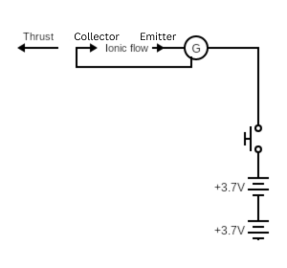
Figure 2
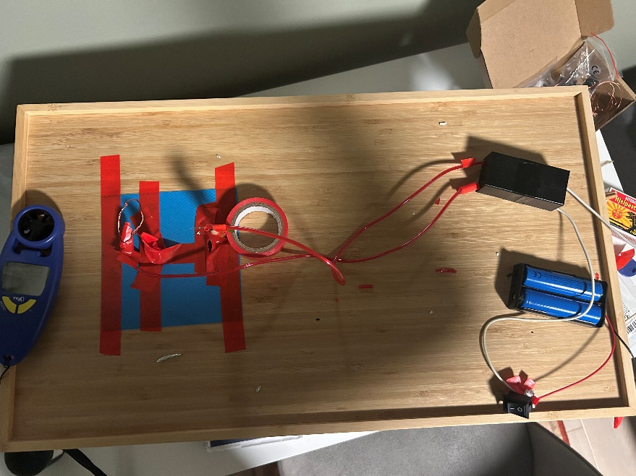
The circuit in the Figure 2 is prepared similarly to the planned one in Figure 1, a spacing of 4 cm between the electrodes (shown in Figure 3) will be implied due to reliance on previously done experiments using greater distances for greater voltages, and to minimize the disturbance of the ionic flow, since the flow could be disrupted by other conductive materials along the way if the spacing is too wide. The anemometer will be used to measure the ionic wind created and accelerate through the ring-formed collector electrode.

Figure 3
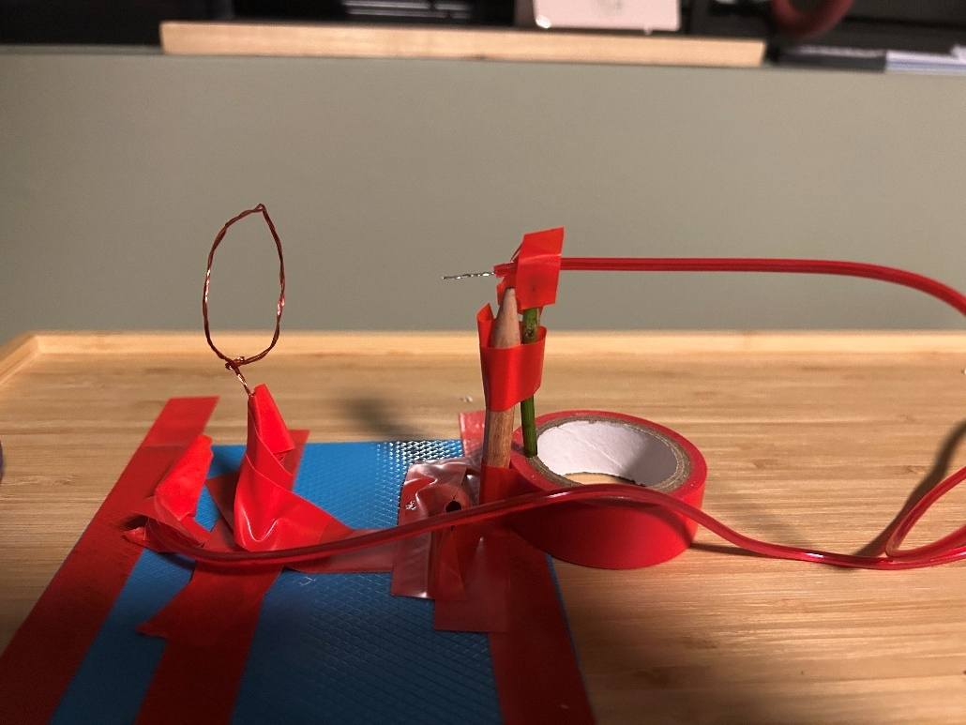
The diameter of the collector electrode is formed to be 2.5 cm, this is specifically optimized for collecting the most out of the ionic wind in one place to generate and measure the thrust efficiently.
Figure 4
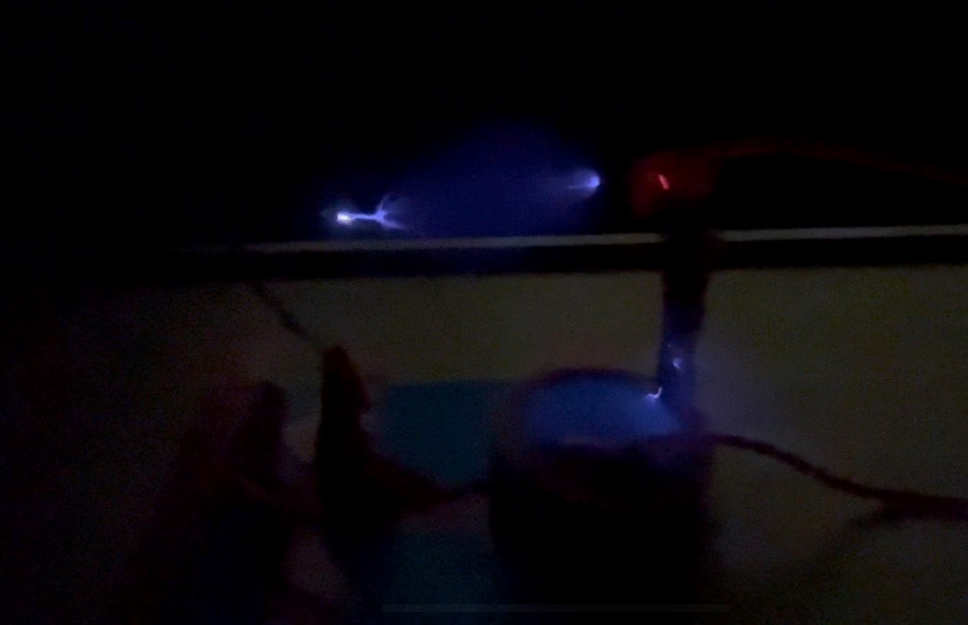
Our model Ionic thruster in act, shown in Figure 4, a purple arc is visible.

IV – Results
The following table shows the measures obtained in each trial and average of them.
Wire type | Trial 1 (±0.05 km/h) | Trial 2 (±0.05 km/h) | Trial 3 (±0.05 km/h) | Average (±0.05 km/h)
Single-stranded | 0.7 | 0.6 | 0.8 | 0.7
Quadruple-stranded | 1.7 | 1.8 | 1.8 | 1.76≈1.8

Figure 5
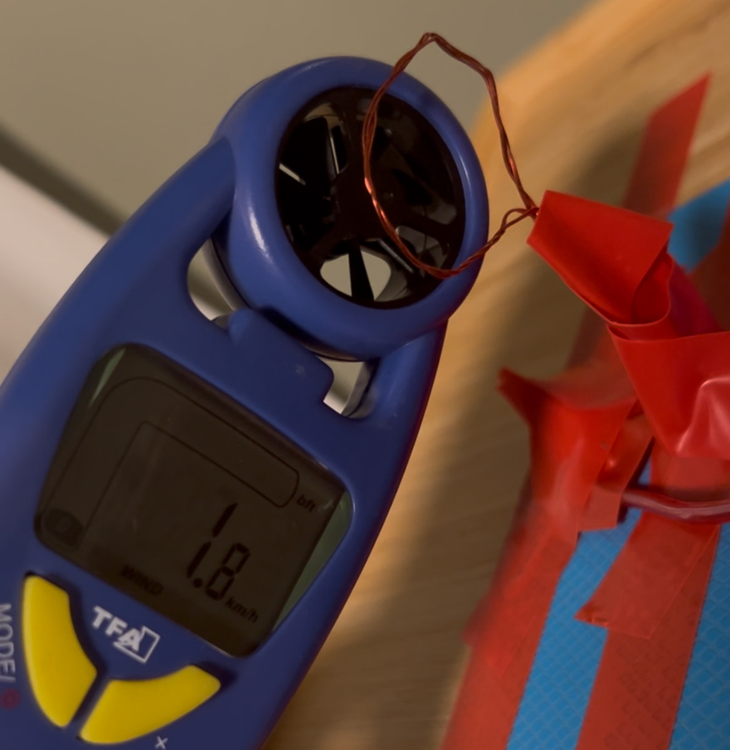
The record result measured from anemometer is 1.8 km/h.
The voltage and current levels held constant, the only variable was the strand trials, which is not related to what we are looking for. The trend shows that the quadruple strand fits better with this voltage than the single strand, likely connected to creating higher electrostatic attraction for the ionic flow between the electrodes. The most important outcome we want to use out of the results is the record exhaust velocity measured, since we are looking for the potentials and the limitations, and it is reliable to do that since it is relatively close to the average value and no offset data point is visible.

V – Analysis & Evaluation
The experiment demonstrated the feasibility of ionization to generate thrust. The collected data shows that an applied voltage of 800kV and a current of 0.5A could generate a record exhaust velocity of 1.8km/h, which is 0.5m/s, under atmospherically limited conditions. We can use the exhaust velocity formula and assumed values to calculate the theoretical exhaust velocity value and then look at the difference. This will also give us the maximum thrust possible with this circuit under perfect conditions.
$$v_{e}=\sqrt{\frac{2eV}{m}}=\sqrt{\frac{2∙1.602∙{10}^{-19} C∙800kV}{4.81∙{10}^{-26}kg}}=2.31∙{10}^{6}m/s$$
This value is an ideal value, and it is unattainable, since this would mean that all of the electricity was converted into energy, which is unachievable under real-life conditions. However, VASIMR can achieve exhaust velocities from 30,000 m/s to over 100,000 m/s, which is closer to this value than experimentally obtained value (Wikipedia, 2025). The anemometer introduced air resistance, underestimating actual exhaust velocity, which was very insignificant to begin with, which likely distorted the results on a bigger scale. Ion recombination, air drag, and electrical losses reduced the effective transfer of energy into thrust, these types of random errors are the biggest shareholders when it comes to making the ideal value unattainable.
Furthermore, the calculation of power to thrust ratio will be necessary to investigate the efficiency of the model and compare it to existing models.
$\frac{P}{T}​=\frac{V∙I}{{\dot{m}∙v}_{ex}}=\frac{800000V×0.5A}{{(((2.5cm/100)/2)}^{2}×π)×1.293kg×m^{-3}×{(0.5m/s)}^{2}}=\frac{400000W}{{(((0.025cm)}^{2}×π)×1.293kg×m^{-3}×{(0.5m/s)}^{2}}=315MW/N​​$
This means that 315 megawatt was used per newton, which is highly inefficient. A typical ionic thruster has around $5×{10}^{4}$W/N compared to our model having $3.2×{10}^{8}$W/N.
Now there is to calculate the specific impulse:
$$I_{sp}=​\frac{v_{ex}​​}{{​g}_{0}}=\frac{0.5m/s}{9.81m/s^{2}}=0.051s$$
0.051 specific impulse is much lower than a typical ionic thruster, which are around 10000 seconds. This signals that there has been a significant efficiency loss in the circuit.
Limitations:
a) Inefficient Energy Conversion:
Ionization Efficiency: In our system, much of the electrical power may not be used for ionizing air molecules or accelerating ions effectively. Energy losses can occur during ionization, and a sizable portion of the power could be lost as heat rather than contributing to propulsion.
Thruster Design: The efficiency of the thruster design itself may be a limiting factor. If the collector electrode and emitter electrode are not professionally designed to maximize ion acceleration and minimize energy loss, the system would be inefficient. For example, if the voltage applied is too high, it could lead to increased power losses due to factors like electric field leakage, excessive ion scattering, or imperfect ionization.
Uncertainty of units: These results arise a considerable uncertainty about the actual voltage and current in the system, a voltmeter and ammeter would be beneficial to validate the products descriptions, since there might be significant inefficiencies due to leakage, arcing, resistance in the materials used etc.
Now we are going to look at the theoretically obtainable value in vacuum. Through literary assumptions, we know that the ionization efficiency is ten times better than of atmospheric conditions.
- Calculate the Power Input (P):
  - Voltage (V) = 800 kV = 800,000 V
  - Current (I) = 0.5 A
  - Power (P) = V×I = 800,000V×0.5A=400,000W=400kW
- Calculate the Thrust (F):
  - Exhaust velocity ($v_{e}$​) = 1.8 km/h = 0.5 m/s
  - Cross-sectional area (A) = $π×{(d/2)}^{2}=π×{(2.5/2)}^{2}=4.91cm^{2}$
  - Mass flow rate ($\dot{m}$) = ρ×A×$v_{e}$
    - Assuming the propellant is xenon with a density (ρ) of approximately 5.9 kg/m³ (Wikipedia):
  - $\dot{m}=5.9 kg/m^{3}×4.91 {cm}^{2}×0.5 m/s=14.5 kg/s$
  - Thrust (F) = $\dot{m}×v_{e}=14.5 kg/s×0.5 m/s=0.00145 N$
- Calculate the Power-to-Thrust Ratio:
  - Power-to-Thrust Ratio =$400,000 W/0.00145 N≈275 MW/N$
So, the power-to-thrust ratio for the existing ion thruster parameters is approximately 275 MW/N, which is partially closer to the literary values.

VI – Conclusion
Conclusively, the homemade ionic thruster reached an efficiency of 315 MW/N and a specific impulse of 0.051 s, which are significantly below the traditional ionic thrusters. This is both owing to simplicity of the circuit (related to heat loss and ionic resistance) and some uncertainties about the actual measures (it wouldn’t be wrong to suspect that the voltage and current values were lower inside the circuit). Throughout the paper, the potentials of EP thrusters and their advantages and disadvantages against chemical propulsion systems have been investigated and compared. Ultimately, it wouldn’t be wrong to say that materials are the only limitation when it comes to ionic thrusters’ efficiencies. A homemade version has produced significantly lower values than a professional model, but through calculations, it was shown that it was possible to reach up those levels theoretically. An ideal ionization efficiency was calculated, and through that, we’ve scaled our data to the theoretical exhaust velocity data, and seen both the limitations, but also the big potential to be further investigated. Throughout this paper, both math and practical implementations have played their part to show that electricity and material limitations should be addressed in order to reach a both efficient and high thrust producing ionic thruster model, that could go head to head against chemical propulsion systems. Conclusively, yet again, a more professionally designed model with well-insulated wires and known measures would be a better representation of potential of EPs.

VII – Sources
Glenn Research Center. (n.d.). Specific Impulse. Retrieved 02 09, 2025, from NASA: https://www.grc.nasa.gov/www/k-12/airplane/specimp.html
K. Holste, P. D.-T.-G. (2020, 06 25). Ion thrusters for electric propulsion: Scientific issues developing a niche technology into a game changer . Review of Scientific instruments. Retrieved from https://pubs.aip.org/aip/rsi/article/91/6/061101/957865/Ion-thrusters-for-electric-propulsion-Scientific
Karabeyoglu, A. (2019, Fall). Lecture 17 . Retrieved from Stanford: https://web.stanford.edu/~cantwell/AA284A_Course_Material/Karabeyoglu%20AA%20284A%20Lectures/AA284a_Lecture17.pdf
MIT. (n.d). What is Electric Propulsion? Retrieved 2 9, 2025, from Space Propulsion Labratory MIT: https://spacepropulsion.mit.edu/electric-propulsion/
NASA. (2024, 3 17). 4.0 In-Space Propulsion. (S. Weston, Ed.) State-of-the-Art of Small Spacecraft Technology, pp. 67-68. Retrieved from NASA: https://www.nasa.gov/smallsat-institute/sst-soa/in-space_propulsion/
NASA. (n.d.). Air mass density. Retrieved 2 9, 2025, from NASA: https://www.earthdata.nasa.gov/topics/atmosphere/air-mass-density
P.J. Hockley, M. T. (2005). High Density Plasma Deposition. Retrieved from svc: https://www.svc.org/clientuploads/directory/resource_library/05_125.pdf
Patterson, M. (2015, 08). Ion Propulsion . Retrieved from NASA: https://www.nasa.gov/wp-content/uploads/2015/08/ionpropfact_sheet_ps-01628.pdf
Sforza, P. M. (2012). Chapter 14 - Space Propulsion. Theory of Aerospace Propulsion, pp. 541-565. Retrieved from https://www.sciencedirect.com/topics/engineering/specific-impulse
Wikipedia. (2025, 2 7). Wikipedia. Retrieved from Spacecraft electric propulsion: https://en.wikipedia.org/wiki/Spacecraft_electric_propulsion
Wikipedia. (n.d.). Boost Converter. Retrieved 09 02, 2025, from Wikipedia: https://en.wikipedia.org/wiki/Boost_converter
Wikipedia. (n.d.). Density of air. Retrieved 2 9, 2025, from Wikipedia: https://en.wikipedia.org/wiki/Density_of_air
Wikipedia. (n.d.). Elementary charge. Retrieved 2 9, 2025, from Wikipedia: https://en.wikipedia.org/wiki/Elementary_charge
Wikipedia. (n.d.). Xenon. Retrieved 2 8, 2025, from Wikipedia: https://en.wikipedia.org/wiki/Xenon

The part of a vehicles load

